SMART HOME AUTOMATION SYSTEM WITH IoT-BASED LIGHTING CONTROL, SOLAR ENERGY MONITORING, AND ENERGY STORAGE FOR ENERGY EFFICIENCY

BY

AYOMIDE OLUWATUNMISE AKINBAMI
ND/23/COM/PT/0152

SUBMITTED TO THE DEPARTMENT OF COMPUTER SCIENCE, INSTITUTE OF INFORMATION AND COMMUNICATION TECHNOLOGY
KWARA STATE POLYTECHNIC, ILORIN

IN PARTIAL FULFILLMENT OF THE REQUIREMENTS FOR THE AWARD OF NATIONAL DIPLOMA (ND) IN
COMPUTER SCIENCE

JULY, 2025.
CERTIFICATION
This is to certify that this project was carried out by Ayomide Oluwatunmise Akinbami with matriculation number ND/23/COM/PT/0152 in the Department of Computer Science, Institute of Information Communication Technology, Kwara State Polytechnic, Ilorin, Kwara State.

…………………………………. ….………………………
MRS. ADEDOTUN, J. K. Date
Project Supervisor

…………………………………. ….………………………
MR. OYEDEPO, F. S. Date
Head of Department

…………………………………. ….………………………
External Examiner Date

DEDICATION
I dedicate this project work to Almighty God who inspired me and directed my ways during my academic stay in the polytechnic.

ACKNOWLEDGEMENT
All praise is due to Almighty God the Lord of the universe. I praise him and thank him for giving me the strength and knowledge to complete my ND program and also for our continued existence on Earth.
I appreciate the utmost effort of my supervisor, Mrs. Adedotun, J. K. whose patience, support, and encouragement have been the driving force behind the success of this research work. She gave useful corrections, constructive criticisms, comments, recommendations, and advice and always ensures that excellent research is done. My sincere gratitude goes to the Head of the Department Mr. Oyedepo F. S., and other members of staff of the Department of Computer Science, Kwara State Polytechnic, Ilorin, for their constant cooperation, constructive criticisms, and encouragement throughout the program.
Special gratitude to my parents, who exhibited immeasurable financial, patience, support, prayers, and understanding during the period in which I was busy tirelessly with my studies, special thanks go to my lovely siblings
My sincere appreciation goes to my friends and classmates.

TABLE OF CONTENTS
Title page i
Certification ii
Dedication iii
Acknowledgments iv
Table of Contents v
Abstract vi
CHAPTER ONE: GENERAL INTRODUCTION
1.1 Background to the Study 1
1.2 Statement of the Problem 2
1.3 Aim and Objectives 3
1.4 Significance of Study 3
1.5 Scope of Study 3
1.6 Organization of the Report 4
CHAPTER TWO: LITERATURE REVIEW
2.1 Review of Related Past Works 5
2.2 Review of General Studies 11
CHAPTER THREE: RESEARCH METHODOLOGY AND
ANALYSIS OF THE SYSTEM
  - Research Methodology 19
  - Analysis of the Existing System 25
  - Problem of the Existing System 26
  - Analysis of the Proposed System 27
  - Advantages of the Proposed System 29
CHAPTER FOUR: DESIGN, IMPLEMENTATION AND
DOCUMENTATION OF THE SYSTEM
  - Design of the System 30
    - Output Design 30
    - Input Design 33
    - Database Design 30
    - Procedure Design 38
  - Implementation of the System 38
    - Choice of programming language 38
    - Hardware support 39
    - Software Support 39
    - Changeover Techniques 40
  - System Documentation 40
    - Operating the System 40
    - Maintaining of the System 41

CHAPTER FIVE: SUMMARY, CONCLUSION AND RECOMMENDATIONS
5.1 Summary 42
5.2 Conclusion 42
5.4 Recommendations 43
References 45

ABSTRACT
The growing need for sustainable energy management and the increasing cost of electricity have driven the development of intelligent home automation systems. This project presents the design and implementation of a smart home automation system that integrates Internet of Things (IoT)-based lighting control, solar energy monitoring, and energy storage management to enhance energy efficiency in residential environments. The system utilizes sensors such as Passive Infrared (PIR) for motion detection, Light Dependent Resistor (LDR) for ambient light measurement, and voltage/current sensors for monitoring solar power generation and battery status. A NodeMCU ESP8266 microcontroller serves as the core processing unit, controlling the lighting system based on real-time sensor inputs and managing power flow between solar panels, battery storage, and grid supply. The system connects to a cloud-based platform (e.g., Blynk or ThingSpeak) for real-time data visualization and remote control via a mobile application. Results from system testing show that the proposed solution successfully reduces energy waste, enhances power reliability, and supports the utilization of renewable energy. The system proves to be scalable, cost-effective, and environmentally friendly, making it a suitable solution for smart residential energy management in modern homes.

CHAPTER ONE
GENERAL INTRODUCTION
  - BACKGROUND TO THE STUDY
With the increasing demand for energy and the urgent need to reduce carbon emissions, energy-efficient technologies have become critical in both residential and commercial sectors. Smart home automation systems, powered by the Internet of Things (IoT), provide a promising solution by enabling intelligent control over electrical appliances and energy resources. These systems can automate functions such as lighting, heating, and security, improving comfort while optimizing energy use (Vincent 2019). This abundance makes a good case for investment in the harnessing of solar energy. Considering the nature of solar energy, two components are primarily required to properly harness and make use of this energy. These are the collecting units and storage units. The collecting unit simply collects the radiation that falls on it and converts it to other forms of energy (like heat or electricity). The storage unit is required because of the nonconstant nature of solar radiation.
At certain times, such as when the sky is clear, available radiation can reach an average value of 1000W/m2 while at other times such as during heavy cloud cover or at night, little or no radiation is available. The storage unit can hold the excess energy generated during the periods of maximum productivity, and release it when the productivity drops (Dabbagh et al., 2020). In practice, a backup power supply is usually added for situations when the amount of energy required is greater than both what is being produced and what is stored by the storage unit. However, in most of the present solar energy harnessing systems, there are huge inefficiencies during collection and storage. A relatively large amount of energy is lost when arrays of solar panels are used to charge banks of lead-acid batteries (being the most common storage systems), Besides the fact that solar panels are expensive, and a very large number of them are required to harness significant amount of energy, the mechanism used in storing collected energy in many of the present systems employ dumb bruteforce charging systems whereby all the batteries within a battery bank are charged simultaneously irrespective of individual battery state of charge (SOC) and usage.( Unwana 2019).
In particular, integrating renewable energy sources like solar power with IoT devices can further enhance the efficiency of smart homes. By monitoring solar energy production in real time and storing excess energy in batteries, households can significantly reduce reliance on public power grids. Smart lighting control, which adjusts lighting based on occupancy and daylight availability, also plays a vital role in reducing unnecessary energy consumption. This project focuses on developing a smart home automation system that combines three key components: IoT-based lighting control, solar energy monitoring, and efficient energy storage. It aims to provide a sustainable solution that minimizes energy waste and maximizes the use of green energy.

  - STATEMENT OF THE PROBLEM
Many homes today still rely on manual methods of controlling lighting and depend solely on grid electricity, which results in significant energy wastage and high utility bills. There is often no effective mechanism to monitor energy usage or to optimize power consumption based on availability and need. Additionally, although solar power is widely available, many systems lack the intelligence to manage and store energy efficiently. Without an integrated system that automates lighting, monitors solar energy generation, and manages energy storage, users are unable to make real-time, informed decisions about their energy use. This results in inefficiencies, underutilization of renewable energy, and increased environmental impact.

  - AIM AND OBJECTIVE
The research aim to design and implement a smart home automation system with IoT-based lighting control, solar energy monitoring, and energy storage for energy efficiency and the specific objectives of this project are to:
- Develop an IoT-enabled system for automated lighting control based on occupancy and ambient light.
- Design a system that monitors real-time solar energy generation using sensors and microcontrollers.
- Integrate a battery storage system for storing surplus solar energy and using it during low generation periods.
- Create a web/mobile interface for remote monitoring and control of the smart home system.
  - SIGNIFICANCE OF THE STUDY
This study contributes to the growing field of smart home technology and renewable energy utilization. The proposed system offers a practical solution to the challenges of energy inefficiency, high electricity costs, and environmental degradation. It serves as a model for households seeking to adopt green energy practices and modern home automation. The project is also significant in academic and research contexts, providing a foundation for further work in IoT applications, energy management, and smart infrastructure development. Additionally, the system can be scaled or customized for commercial or industrial use, broadening its impact.
  - SCOPE OF THE STUDY
This study is focused on the design and implementation of a smart home automation system that integrates IoT-based lighting control, solar energy monitoring, and energy storage management to improve energy efficiency in residential buildings. The system is designed to automatically control lighting based on occupancy and ambient light levels using sensors, monitor real-time solar power generation, and manage energy storage in rechargeable batteries to ensure uninterrupted power supply.

1.7 ORGANIZATION OF THE STUDY
For easy study and proper understanding of this project write-up, It is planned and organized into five chapters. The description of what each chapter contains is explained below:
Chapter One: This contains an Introduction to the whole write-up, the problem of the study, aim and objectives of the study, the significant of the study, the scope and limitation of the study, and organization of the report. Chapter Two: It focuses on the literature review of the study, organization of the board of director, computerization of the current state of the art. Chapter Three: It presents data collection method employed, analysis of data and existing system, advantages of the proposed system, design and implementation, programming language used with reasons, hardware and software support. Chapter Four: It deals with the system design implementation and documentation, design of the system, output design, input design, file system, procedural design, and documentation of the new system. Chapter Five: This centres the summary, experienced gained, recommendation and conclusion.

CHAPTER TWO
LITERATURE REVIEW
2.1 REVIEW OF RELATED WORKS
Vincent et al (2019) The increasing demand for clean electrical energy coupled with recent advances in power electronic devices has driven researchers to seek better ways to harness electrical energy from renewable sources. One of such renewable energy sources is solar energy and this paper documents the efforts that have been put into the development of a Smart Solar Energy Management System (SSEMS). SSEMS has been designed to effectively harness the sun‘s energy, utilise the energy to drive electrical loads and store any excess energy for use when demanded. The paper provides a preliminary documentation of the design, simulation, construction and testing stages of the energy conversion and supply subunits of the SSEMS.
Abhishek et al (2017) Energy saving is a hot topic due to the proliferation of climate changes and energy challenges globally. However, people's perception about using smart technology for energy saving is still in the concept stage. This means that people talk about environmental awareness readily, yet in reality, they accept to pay the given energy bill. Due to the availability of electricity and its integral role, modulating consumers’ attitudes towards energy savings can be a challenge. Notably, the gap in today's smart technology design in smart homes is the understanding of consumers’ behaviour and the integration of this understanding into the smart technology. As part of the Paris Climate change agreement (2015), it is paramount for Singapore to introduce smart technologies targeted to reduce energy consumption. This paper focused on the perception of Singapore households on smart technology and its usage to save energy. Areas of current research include: (1) energy consumption in Singapore households, (2) public programs and policies in energy savings, (3) use of technology in energy savings, and (4) household perception of energy savings in smart homes. Furthermore, three case studies are reviewed in relation to smart homes and smart technology, while discussing the maturity of existing solutions.
Rumsch et al (2018) One approach to smart energy management is that the detailed energy consumption of individual devices is known, and feedback and energy management systems are implemented on the basis of this information. The energy consumption of individual devices can be determined with sub-metering or load disaggregation algorithms. We follow another approach: Energy aware devices. Such devices know their own energy consumption and can communicate it to the outside world. We expand the concept of energy awareness: In addition to the current energy consumption, the devices can also provide a forecast of their energy consumption for the next few hours and receive control commands from outside. We consider this a necessary extension to reap all the benefits of having Energy Aware devices. With this extended concept we analyse different scenarios in the living area and estimate the use of energy aware devices. In particular, we deal with the scenarios “Energy Saving”, “µ-Grid” and “Balancing Power”.
NITHISH et al (2022) Smart Based Solar Powered House System Design, The design of a solar-powered smart home with a wireless sensor network is presented in this study, which addresses smart energy management, smart health care, smart ventilation, and smart people management. The sensor network is stretched throughout the building, including the entrance gate, corridor, living room, and kitchen. For wireless communication, two Internet of things (IoT) design prototypes is used: one using Bluetooth for shortrange offline communication and the other using Global system for mobile communication (GSM) for long-range offline communication. For online control and monitoring, ZigBee and Wi-Fi are employed. The solar panel provides energy to the smart house via an Optimum PowerPoint tracking (MPPT) controller, which ensures maximum efficiency. When the owner is unavailable, internal infrastructure can intervene in some unanticipated situations.
Unwana et al (2019) Development of a Smart Solar Energy Management System, The problem of inadequate electrical energy is becoming critical in the world today, especially in a developing country such as Nigeria. Year after year, the consumption of electricity increases as more domestic, commercial and industrial appliances are built and installed. This increased consumption, more often than not, is not matched by increased investment in electrical energy generation, transmission and distribution systems as reported in. Therefore, the need to increase the utilization of available electrical energy supply takes on an added importance. In terms of generation, traditional sources of electricity such as fossil fuels have been progressively receiving less favourable attention because of their adverse environmental impact.
Yuanyuan et al (2016) Review of Smart Home Energy Management Systems, Recently smart home energy management systems (SHEMS) have been developed very fast. The relevant techniques enable SHEMS to support network controlling via demand responses, maybe including peak shaving and load shifting, as well as some ancillary services. This paper reviews the concept of SHEMS and looks into its background. It highlights SHEMS’ major components, and comparatively analyzes various technological approaches. It also discusses some of the concerns and challenges, and suggests a framework for future systems.
Nupur et al (2015) Renewable Energy Management System for Smart Home, Energy consumption increases day by day as more appliances used in today’s home. Increasing energy demand and limitations of fossil fuels, time to use the renewable resources for energy generation in domestic areas. This paper proposes renewable energy management system architecture for smart homes in which energy consumption and generation simultaneously for efficient energy, minimization of cost and environment friendly. Microcontroller based energy management module with ZigBee is used to control and monitor the energy consumption of smart home. The propose system is used the solar and wind resources as these are not always available, also introduce water resources to generate the electricity. The charge controller, battery bank and battery level monitoring are used to provide stable energy module for smart home. Energy consumption should be minimized by users, can access home energy information through smart devices. The propose system save the limited fossil fuels, generated efficient energy and minimize energy consumption.
MURAD et al (2016) Internet of Things Based Energy Aware Smart Home Control System, The concept of smart home is widely favored, as it enhances the lifestyle of the residents involving multiple disciplines, i.e., lighting, security, and much more. As the smart home networks continue to grow in size and complexity, it is essential to address a handful among the myriads of challenges related to data loss due to the interference and efficient energy management. In this paper, we propose a smart home control system using a coordinator-based ZigBee networking. The working of the proposed system is three fold: 1) smart interference control system controls the interference caused due to the co-existence of IEEE 802.11x-based wireless local area networks and wireless sensor networks; 2) smart energy control system is developed to integrate sunlight with light source and optimizes the energy consumption of the household appliances by controlling the unnecessary energy demands; and 3) smart management control system to efficiently control the operating time of the electronic appliances. The performance of the proposed smart home is testified through computer simulation. Simulation results show that the proposed smart home system is less affected by the interference and efficient in reducing the energy consumption of the appliances used in a smart home.
Murad et al (2016) Internet of Things based Energy Aware Smart Home Control System, The concept of smart home is widely favored, as it enhances the lifestyle of the residents involving multiple disciplines i.e. lighting, security and much more. As the smart home networks continue to grow in size and complexity, it is essential to address a handful among the myriads of challenges related to data loss due to the interference, efficient energy management, etc. In this paper, we propose a smart home control system using a coordinator based ZigBee networking (CoZNET). The working of the proposed system is three fold, 1) smart interference control system controls the interference caused due to the co-existence of IEEE 802.11x based wireless local area networks (WLAN) and Wireless Sensor Networks (WSN), 2) smart energy control system is developed to integrate sunlight with light source and optimizes the energy consumption of the household appliances by controlling the unnecessary energy demands, and 3) smart management control system to efficiently control the operating time of the electronic appliances. The performance of the proposed smart home is testified through computer simulation. Simulation results show that the proposed smart home system is less affected by the interference and efficient in reducing the energy consumption of the appliances used in a smart home.
Buhari et al (2021) development of iot based smart inverter for energy metering and control, Insufficient power generation has facilitated the search for alternative power generation, as the world is gradually making the transition to renewable green energy sources as a replacement for fossil fuels and other conventional power generation methods that causes environmental pollution. One of these methods is the use of solar energy for electricity generation through the use of the photovoltaic solar inverter which harnesses the power from the sun to generate electricity. The inability of electricity distributors to provide enough and sustainable power supply for homes and businesses, coupled with the need to live a smart life has made humans sort for an easier control method of electricity generation and usage. Hence, this research presents a smart voice and mobile application control modular inverter integrated with a smart metered energy distribution system, which equally distributes power amongst the users for effective and smart energy usage. A test of applied load on the inverter as compared to normal electricity usage deduced an 8% error rate giving a 92% accuracy for the inverter. The mobile app was tested for both online and offline usage and a 67% accuracy was deduced as the overall accuracy of the software. This gives an inference that the system can be fully operated by a user in the luxury of their comfort. For smart meter monitoring and energy allocation, 93.33% and 96.8% accuracy and precision were achieved respectively. This research makes the usage of green energy more efficient with its feature which allows for equal distribution of energy. The system also helps prevent energy theft or misuse by providing only the proper user with alerts and administrative control.

2.2 REVIEW OF GENERAL STUDY
Smart home systems utilize digital technology and automation to enhance convenience, safety, and energy efficiency in households. With the rise of IoT, devices can now communicate with each other through wireless networks, enabling real-time control and monitoring. IoT technologies commonly used include microcontrollers (e.g., Arduino, NodeMCU), sensors (PIR, LDR), and communication protocols (Wi-Fi, MQTT, Bluetooth). Lighting automation is a key application in smart homes. Using occupancy sensors and light sensors, systems can determine when to turn lights on or off, optimizing energy consumption without human intervention. This helps reduce electricity bills and ensures lighting is used only when needed. Solar energy monitoring systems involve tracking power generated by solar panels through voltage and current sensors. These systems provide real-time insights into energy production, enabling homeowners to adjust consumption or identify faults in solar modules. When integrated with battery storage, excess energy can be stored for use during periods of low solar generation, such as at night or during cloudy weather.
Energy storage systems, particularly lithium-ion and lead-acid batteries, allow for the temporary storage of electricity generated from solar panels. An intelligent energy management unit can automate the switch between solar, battery, and grid sources to ensure continuous power supply while minimizing costs. Overall, the integration of IoT with renewable energy in smart home systems represents a significant advancement in achieving sustainable living. With increased focus on automation, efficiency, and user control, modern smart homes can contribute meaningfully to global energy conservation efforts.

2.3 SMART HOME AUTOMATION SYSTEM
Smart home automation refers to the use of digital technologies to control and monitor household systems and appliances remotely or autonomously. This includes lighting, HVAC (heating, ventilation, and air conditioning), security systems, and energy management. The core aim is to improve convenience, safety, and energy efficiency. Smart home systems typically rely on a central controller (e.g., microcontroller or smart hub) and a network of sensors and actuators. These devices interact via wireless protocols such as Wi-Fi, Zigbee, or Bluetooth. The intelligence of the system allows it to make decisions based on sensor inputs, predefined rules, or user preferences. In recent years, the integration of smart home automation with mobile apps and voice-controlled assistants like Alexa and Google Assistant has enhanced user experience and control. These advancements have expanded the application of smart homes from luxury solutions to practical tools for energy conservation, accessibility for the elderly and disabled, and environmental sustainability.
Despite the technological progress, challenges such as interoperability, security, high setup costs, and complexity in design remain significant barriers. Nevertheless, smart home automation continues to evolve, especially with the growing demand for sustainable and efficient energy systems.

2.4 IOT-BASED LIGHTING CONTROL
Lighting control systems are among the most common and impactful applications of IoT in smart homes. IoT-based lighting systems use various sensors such as Passive Infrared (PIR) sensors for motion detection and Light Dependent Resistors (LDR) for detecting ambient light levels. These systems automatically switch lights on or off based on occupancy and daylight, thus minimizing unnecessary energy consumption. At the core of an IoT lighting system is a microcontroller (e.g., NodeMCU or Arduino) connected to relays or smart bulbs, which can be controlled programmatically. Real-time data from sensors is used to trigger lighting events, and users can override or monitor the system remotely via a smartphone application or web dashboard.
IoT lighting systems not only improve energy efficiency but also offer features like brightness adjustment, scheduling, and scene control. For example, lights can dim automatically during daylight or be programmed to turn on at specific times. Moreover, cloud integration enables data logging and analytics, allowing homeowners to evaluate usage patterns and optimize energy consumption further. The combination of automation, accessibility, and control makes IoT-based lighting a vital component of energy-efficient smart homes.

2.5 SOLAR ENERGY MONITORING AND ENERGY STORAGE FOR ENERGY EFFICIENCY
Solar energy monitoring systems track the generation, usage, and efficiency of solar photovoltaic (PV) systems. They use voltage and current sensors to measure power output in real-time. This information is crucial for detecting underperformance, maximizing energy yield, and making informed decisions about energy usage. Integrating solar energy monitoring with IoT allows for remote tracking of system performance through mobile or web applications. Users can view dashboards that display data such as total energy generated, energy saved, and battery levels. IoT-enabled monitoring also supports predictive maintenance by detecting anomalies in solar panel output.
Energy storage, often in the form of batteries, plays a critical role in ensuring power availability even when solar generation is low (e.g., during nighttime or cloudy weather). Efficient energy storage systems are equipped with smart charge controllers and battery management systems (BMS) that regulate charging, discharging, and load balancing. By combining solar monitoring with energy storage and IoT automation, households can optimize power consumption, reduce dependency on the grid, and lower electricity costs. This integrated approach also supports environmental goals by reducing greenhouse gas emissions and promoting the use of renewable energy. Overall, solar energy monitoring and smart energy storage are indispensable in building resilient and energy-efficient smart homes.

CHAPTER THREE
RESEARCH METHODOLOGY AND ANALYSIS OF THE NEW SYSTEM
3.1 RESEARCH METHODOLOGY
The research methodology adopted for this project is a design and implementation-based approach, focusing on the development of a functional prototype system that integrates IoT-based lighting control, solar energy monitoring, and energy storage management for smart home energy efficiency. The project involves a combination of hardware development, software programming, and system testing to achieve the desired objectives.
The methodology follows these key phases:

1. Requirement Analysis
This phase involves identifying the system’s functional and non-functional requirements based on the research objectives. The hardware components required include microcontrollers (e.g., NodeMCU ESP8266), sensors (PIR, LDR, voltage and current sensors), relays, solar panels, batteries, and connecting modules. Software requirements include Arduino IDE, IoT dashboard tools (e.g., Blynk, ThingSpeak), and possibly a web-based or mobile interface for remote monitoring.

2. System Design
The system architecture is designed to illustrate how components interact. This includes:
- Hardware architecture, detailing how sensors connect to the microcontroller.
- Power flow architecture, explaining how solar energy is generated, stored, and distributed.
- Control flow diagrams, showing how sensor inputs affect lighting and battery management.

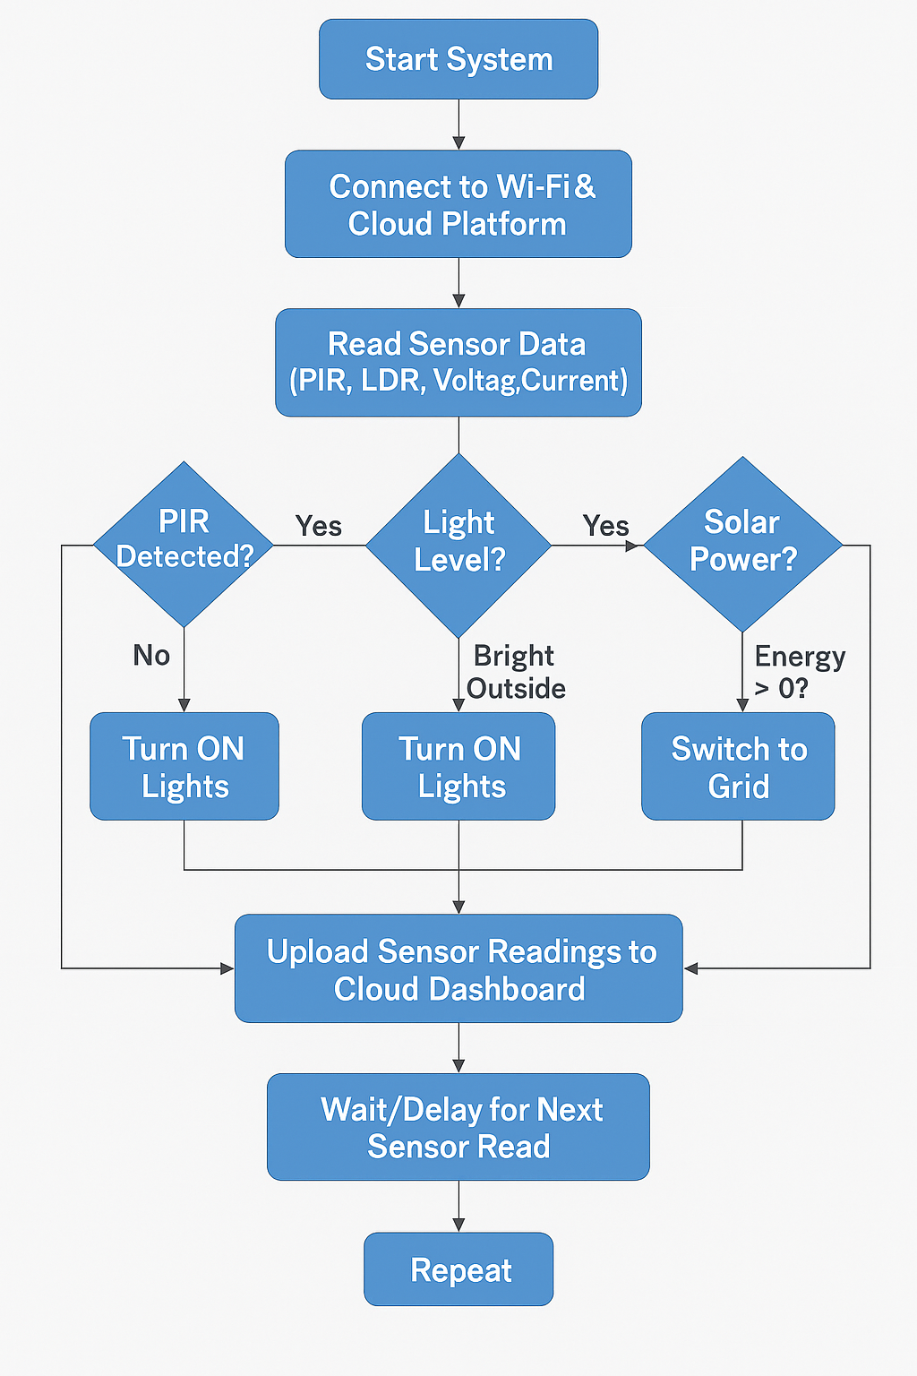

Figure 3.1: Flowchart of the Smart Home Automation System with IoT-Based Lighting Control, Solar Energy Monitoring, and Energy Storage

3. Hardware Implementation
The hardware components are assembled and connected:
- PIR and LDR sensors are used to automate lighting based on motion and light levels.
- Voltage and current sensors are connected to the solar panel and battery system to monitor energy generation and usage.
- Relay modules are used to switch lighting and manage power flow.
All components are interfaced with the NodeMCU, which serves as the central processing and communication unit.

4. Software Development
The microcontroller is programmed using the Arduino IDE with embedded C/C++ code. The code handles sensor readings, decision logic for automation, and communication with the cloud platform for data visualization and remote control. IoT platforms like Blynk or ThingSpeak are used to create a real-time monitoring dashboard where users can observe energy levels, lighting status, and battery usage from a mobile or web application.

5. Testing and Evaluation
Once the system is developed, functional and performance testing is carried out:
- Unit testing of each component (e.g., sensors, relays, Wi-Fi connection)
- Integration testing to ensure smooth communication between hardware and cloud platforms
- System testing under different lighting and energy conditions to validate performance
The system’s effectiveness in automating lighting, monitoring solar energy, and managing storage is evaluated based on response time, accuracy, and energy savings.

6. Documentation
The final phase involves compiling all processes, designs, codes, and test results into a well-documented report to demonstrate how the system was built and how it meets the initial goals.
3.2 ANALYSIS OF THE EXISTING SYSTEM
Current smart home systems primarily focus on automating routine tasks, enhancing security, and improving comfort. While some systems offer energy monitoring capabilities, they often operate independently of renewable energy inputs. Solar energy systems typically function as standalone units without integration into home automation. This segregation results in inefficiencies, as smart home systems may not capitalize on periods of high solar energy generation, leading to unnecessary grid electricity consumption (Wang et al., 2019). Moreover, the lack of real-time data exchange between these systems limits the potential for dynamic energy management.

3.3 PROBLEMS OF THE EXISTING SYSTEM
The current state of smart home systems and solar energy integration is marked by several significant challenges that hinder the efficient utilization of renewable energy and the optimization of residential energy consumption. One of the primary issues is the lack of integration between solar energy systems and smart home automation. In many cases, these systems operate in isolation, with solar panels generating electricity independently of the smart home system that controls household appliances. This disconnect results in missed opportunities to align energy consumption with periods of high solar energy production, leading to inefficiencies and increased reliance on grid electricity.
Another major problem is the inefficient utilization of solar energy. Without real-time awareness of solar energy generation, smart home systems often fail to optimize appliance operations to coincide with peak solar production. For example, energy-intensive appliances such as washing machines or dishwashers might be scheduled to run during times when solar generation is low or non-existent, necessitating the use of grid electricity. This not only increases energy costs for homeowners but also diminishes the environmental benefits of installing solar panels.
User engagement is also a critical issue in the existing system. Many smart home systems lack intuitive interfaces that allow homeowners to easily monitor and manage their energy consumption. As a result, users may not fully understand how their energy usage aligns with solar energy generation, leading to suboptimal decisions regarding appliance operation and energy management. Without clear insights into energy patterns, homeowners are less likely to take proactive steps to reduce their reliance on grid electricity or to maximize the use of renewable energy.
3.4 DESCRIPTION OF THE PROPOSED SYSTEM
The proposed system is a smart home automation solution designed to enhance energy efficiency through the integration of IoT-based lighting control, solar energy monitoring, and battery energy storage. The system leverages sensor technologies, microcontroller-based control units, and cloud platforms to automate decision-making, monitor system performance, and allow remote user interaction. At the core of the system is a NodeMCU ESP8266 microcontroller, which acts as the central processing unit. It receives input from multiple sensors including a Passive Infrared (PIR) sensor for motion detection, a Light Dependent Resistor (LDR) for measuring ambient light intensity, and voltage and current sensors for monitoring the solar energy system. These inputs enable the system to make intelligent decisions about when to activate or deactivate lighting and whether to store or draw energy from the battery or the power grid.
When the PIR sensor detects motion and the LDR determines low ambient light, the system automatically switches on the lights using a relay module. If no motion is detected or there is sufficient natural light, the system turns off the lighting to conserve energy. This dynamic control prevents unnecessary power usage and extends the lifespan of lighting fixtures. For energy generation, solar panels are used to convert sunlight into electrical energy. The output is continuously monitored by the sensors, and the energy is stored in a battery bank via a charge controller. When solar power is insufficient or unavailable (e.g., at night), the system seamlessly switches to the battery or utility grid to maintain an uninterrupted power supply. The system is equipped with IoT capabilities, allowing real-time monitoring and control through cloud platforms such as ThingSpeak or Blynk. Users can access energy consumption data, lighting status, and battery levels remotely via a mobile app or web interface. Alerts and analytics help users understand energy usage patterns and optimize consumption further.
3.5 ADVANTAGES OF THE NEW SYSTEM OVER THE EXISTING SYSTEM
The proposed smart home automation system offers several improvements over traditional and existing systems that rely on manual control and lack integration with renewable energy sources. Below are the key advantages:
- Enhanced Energy Efficiency: Aligning appliance usage with solar energy availability reduces reliance on grid electricity.
- Cost Savings: Optimized energy consumption translates to lower electricity bills for homeowners (Bari et al., 2019).
- Environmental Impact: Increased utilization of renewable energy sources minimizes carbon footprint.
- User Empowerment: Intuitive interfaces promote user engagement, fostering proactive energy management behaviors.
- Scalability: Modular design allows for easy integration of additional renewable energy sources or expansion to larger residential setups.
- Real-time Adaptability: The system dynamically adjusts to variations in solar energy generation, ensuring continuous optimization.

CHAPTER FOUR
DESIGN AND IMPLPEMENTATION OF THE SYSTEM
4.1 DESIGN OF THE SYSTEM
The proposed smart home automation system integrates multiple technological components to achieve an energy-efficient and intelligent home environment. The design phase focused on combining Internet of Things (IoT) features with solar energy monitoring and lighting control, facilitated through a microcontroller, sensor technologies, cloud connectivity, and energy storage mechanisms. The system is designed to perform automated functions and support remote control through a user-friendly interface.
4.1.1 Output Design
The output design focuses on delivering feedback and control signals from the system to both the environment and the user. The key outputs include the user interface introduces a platform for the users of the Solar Helper software for input and output of data. All the functions proposed were included in the user interface and were programmed accordingly.

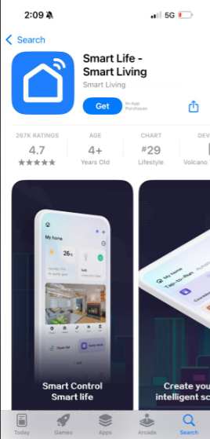

Figure 4.1 Smart life leaving App
Figure 4.2: Home screen of the SolarHelper software
Figure 4.3. Monitoring and control workstation
Figure 4.4: Component data collection interface
Figure 4.5 Load collection interface

4.1.2 Input Design
The input design involves collecting data from environmental and electrical parameters to inform system behavior. The primary inputs include:
- Motion Detection (PIR Sensor): Triggers lighting when human presence is detected.
- Ambient Light Detection (LDR Sensor): Determines natural light intensity to assist in lighting decisions.
- Voltage and Current Sensors: Monitor solar panel output and battery status to manage energy storage and switching.
- User Inputs: Received through mobile or web interfaces to allow control over system functions like lighting schedules or manual switching.
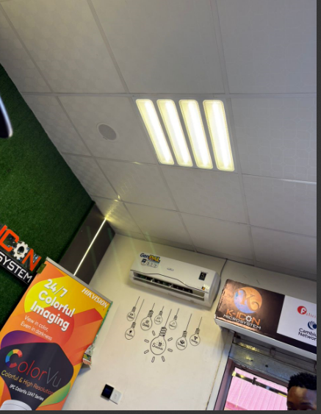
Figure 4.6: Home Appliances
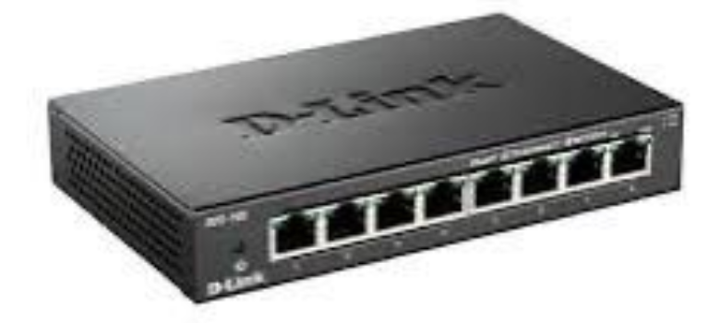
Figure 4.7: Ethernet Splitter
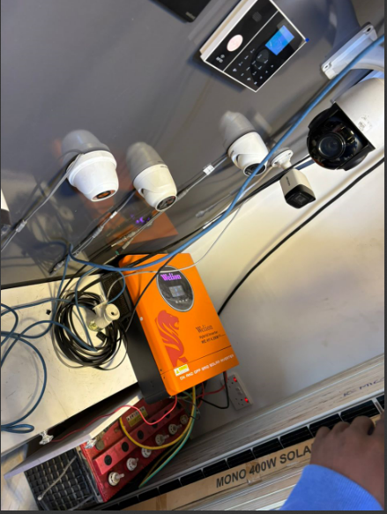
Figure 4.8: Charge Controller

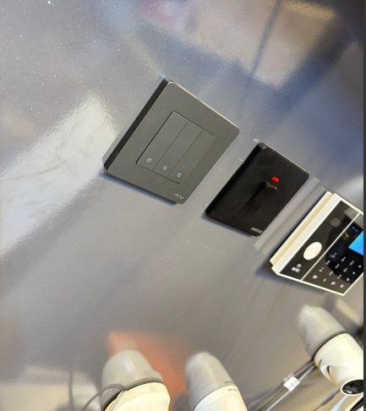
Figure 4.9: Switch

4.1.3 Database Design
Although the system does not rely on a traditional relational database, it utilizes cloud-based storage platforms such as ThingSpeak or Blynk. These platforms serve as lightweight databases, storing sensor readings and user settings. Features include:
- Real-time data logging (voltage, current, motion, light).
- Visual analytics (graphs, charts).
- Data export for further analysis.
- Support for API-based integrations and remote access.

4.1.4 Procedure Design
The system operation follows a structured procedure:
- System Initialization: On boot-up, the NodeMCU connects to a Wi-Fi network and initializes all sensors and modules.
- Sensor Monitoring: The microcontroller continuously monitors motion, ambient light, and solar energy parameters.
- Decision Making: Based on predefined conditions (e.g., motion detected + low light), the controller activates or deactivates lighting.
- Energy Management: Depending on the solar generation and battery level, the system decides whether to charge the battery or switch to grid power.
- Data Transmission: All sensor readings and control decisions are sent to the cloud dashboard for real-time display.
- User Interaction: Users can monitor and control the system remotely via the dashboard.

4.2 IMPLEMENTATION OF THE SYSTEM

4.2.1 Choice of Programming Language
The system was implemented using a combination of programming languages and tools:
- C/C++ (Arduino IDE): Used to program the NodeMCU ESP8266 microcontroller to interface with sensors and control modules.
- Blynk/ThingSpeak Interface: Utilizes built-in APIs and graphical components to communicate with the microcontroller and display sensor data on mobile/web interfaces.
- Optional HTML/JavaScript: For customizing the web dashboard if required beyond built-in features of the IoT platform.

4.2.2 Hardware Support
The system utilizes a variety of electronic components to achieve its functionality. These include:
- NodeMCU ESP8266: A Wi-Fi-enabled microcontroller that processes input data and connects to the cloud.
- PIR Sensor: Detects motion within a defined range to trigger lighting.
- LDR Sensor: Measures ambient light to determine whether artificial lighting is needed.
- Voltage/Current Sensors: Monitor solar panel output and battery condition.
- Relay Module: Acts as a switch for controlling lighting based on control logic.
- Solar Panel: Captures solar energy and supplies it to the battery.
- Battery Storage Unit: Stores solar energy for later use, especially during nighttime or cloudy conditions.

4.2.3 Software Used
- Arduino IDE: Used for writing, compiling, and uploading code to the NodeMCU.
- Blynk Mobile App or ThingSpeak Dashboard: Provides a user interface for remote monitoring and control.
- Serial Monitor: For real-time debugging and testing of sensor data during development.
- Wi-Fi Network Configuration: Ensures communication between the microcontroller and cloud server.

4.2.4 Implementation Technique Used
The implementation follows a modular and iterative development approach, ensuring each part of the system was independently developed, tested, and validated before integration. Key steps included:
- Building and testing the lighting control subsystem with PIR and LDR sensors.
- Implementing solar energy monitoring using voltage and current sensors.
- Integrating the IoT dashboard and confirming successful data transmission.
- Performing full system integration and running test scenarios to ensure expected behavior.

4.3 SYSTEM DOCUMENTATION

4.3.1 Program Documentation
The microcontroller’s firmware is well-documented and structured as follows:
- Setup Functions: Initialize all pins, sensors, and establish Wi-Fi connectivity.
- Loop Function: Continuously reads sensor values and applies logic for lighting and energy management.
- Control Functions: Manage relay states and battery switching.
- Cloud Sync Functions: Handle the transmission of data to the IoT dashboard via APIs.
Inline comments and function headers explain the purpose and flow of each code segment.

4.3.2 Operating the System
To operate the system, the following steps are taken:
- Connect the hardware components and power up the NodeMCU and sensors.
- Ensure the Wi-Fi credentials are configured for cloud connectivity.
- Open the Blynk or ThingSpeak mobile app/web dashboard.
- Observe real-time data updates including lighting status, solar output, and battery charge.
- The system will function automatically based on sensor inputs, but users may override functions via the dashboard as needed.

4.3.3 System Maintenance
Maintaining the system involves:
- Hardware Checks: Periodic inspection of wiring, connections, and sensor functionality.
- Firmware Updates: Enhancing features or correcting bugs using the Arduino IDE.
- Cloud Account Monitoring: Ensuring cloud service limits are not exceeded and updating credentials as necessary.
- Battery Health Monitoring: Checking for deep discharge, overcharging, and performing capacity tests to ensure reliability.

CHAPTER FIVE

SUMMARY, CONCLUSION, AND RECOMMENDATIONS

5.1 SUMMARY
This project focused on the development of a smart home automation system that integrates IoT-based lighting control with real-time solar energy monitoring and energy storage management to promote efficient energy use in residential environments. The system was designed to automate home lighting based on motion and ambient light conditions, while also monitoring solar power generation and storing surplus energy in a battery for later use. The project began with a detailed analysis of the existing system, identifying limitations such as high energy consumption, lack of real-time monitoring, and total dependence on grid electricity. The proposed system addressed these gaps through automation, solar integration, and remote access via cloud-based platforms. It utilized hardware components such as the NodeMCU ESP8266, PIR and LDR sensors, voltage/current sensors, relay modules, solar panels, and rechargeable batteries. The implementation involved writing embedded code using the Arduino IDE, integrating cloud platforms such as ThingSpeak and Blynk, and conducting testing to validate the system’s responsiveness, reliability, and efficiency. The result was a modular and scalable system that supports sustainability, reduces energy costs, and provides users with greater control over their home energy systems.

5.2 CONCLUSION
The successful implementation of the smart home automation system demonstrates the potential of combining IoT technology with renewable energy sources to enhance energy efficiency in residential settings. The automated lighting control significantly reduces energy wastage by responding intelligently to environmental and occupancy conditions. The solar energy monitoring and storage module not only ensures the effective utilization of clean energy but also provides a backup source during power outages. Furthermore, the integration of a cloud-based dashboard offers users real-time access to system performance, enabling proactive decision-making and energy-saving behaviors. The system’s design proves to be both cost-effective and environmentally friendly, aligning with global efforts to reduce carbon emissions and reliance on fossil fuels. Overall, the project presents a viable solution for modern homes seeking automation, sustainability, and energy resilience.

5.3 RECOMMENDATIONS
Based on the outcomes of this project, the following recommendations are proposed:
- Scalability for Whole-Home Integration: Future improvements can expand automation to include other home appliances such as fans, air conditioners, and security systems.
- Enhanced User Interface: A custom mobile application with advanced control features and personalized alerts can improve user interaction and usability.
- Data Analytics and Machine Learning: Integrating AI/ML models to analyze historical data can help predict user behavior and optimize energy usage even further.
- Solar Panel Efficiency Tracking: Including more advanced environmental sensors (e.g., temperature, sunlight intensity) would allow for more accurate solar performance analytics.
- Improved Battery Management System: A smart BMS with deep discharge protection and adaptive charging algorithms can prolong battery life and improve safety.
- Offline Functionality: Implement local storage and decision-making capabilities in the system to ensure functionality in the absence of internet connectivity.
- Commercial Deployment: With modifications, the system can be adapted for use in small offices, schools, or rural health centers to improve energy reliability.

REFERENCE
Abhishek et al (2017). Energy conservation through smart homes in a smart city: A lesson for Singapore households, energy Policy 104 (2017) 230–23
Andreas et al (2018). Potential of Energy Aware Devices and the IoT for a Smart Energy Management, Department of the Environment, Transport, Energy and Communication DETEC
NITHISH (2022) Smart Based Solar Powered House System Design, | IRE Journals | Volume 5 Issue 11 | ISSN: 2456-8880
Vincent, et al (2019) Development of a Smart Solar Energy Management System, International Journal of Advanced Research and Publications ISSN: 2456-9992
Unwana et al (2019) Development of a Smart Solar Energy Management System, International Journal of Advanced Research and Publications ISSN: 2456-9992
Yuanyuan (2016) Review of Smart Home Energy Management Systems, Energy Procedia 104 ( 2016 ) 504 – 508 is an open access article under the CC BY-NC-ND http://creativecommons.org/licenses/by-nc-nd/4.0/
Nupur et al (2015). Renewable Energy Management System for Smart Home, International Journal of Innovative Science, Engineering & Technology, Vol. 2 Issue 9
MURAD et al (2016). Internet of Things Based Energy Aware Smart Home Control System, 6 IEEE. Translations and content mining are permitted for academic research only. Personal use is also permitted, but republication/redistribution requires IEEE permission. See http://www.ieee.org/publications_standards/publications/rights/index.html for more information.

