CONSTRUCTION OF A WOODEN SUSPENDED GROUND FLOOR FOR

EDUCATIONAL PURPOSES

ND/23/CEC/PT/0264

JOHN OLATUBOSUN NATHANIEL

A PROJECT SUBMITTED IN PARTIAL FULFILMENT OF THE
REQUIREMENT FOR THE AWARD OF NATIONAL DIPLOMA (ND)

IN DEPARTMENT OF CIVIL ENGINEERING, SCHOOL OF ENGINEERING
STUDIES. KWARA STATE POLYTECHNIC,
INSTITUTE OF TECNONOGY,

ILORIN, KWARA STATE, NIGERIA

2025.

CERTIFICATION
This is to certify that this project report written by MICHEAL ISAAC OLUWAJUWONLO presented to the department of Civil Engineering, The Kwara State Polytechnic Ilorin was supervised and approved to have met the condition necessary for the award of national diploma in civil engineering of the polytechnic.

…………………………………………….. ……………………….
ENGR. M.F RAJI DATE
SUPERVISOR

…………………………………………….. ……………………….
ENGR. SANNI ABUBAKAR DATE
HEAD OF DEPARTMENT

DEDICATION
This project is dedicated to Almighty God for his goodness and kindness and who through his mercies at all times made all things possible granted. This project is also dedicated to our parents, MR and MRS JOHN for their immeasurable, moral, financial and educational support in all aspect within human capacity throughout my educational career. Sincere gratitude goes to my siblings (STEPHEN, NOAH, STELLA & SERAH) for their endless support. Many thanks to my able supervisor MRS M.F RAJI for her endless assistance and support, May Almighty God be with you and grant you every of your heart desires.

ACKNOWLEDGEMENT
With total reverence, I return all the glory, honor and adoration to ALMIGHTY GOD, the beginning and the end of whatever I make out of life, the giver of knowledge, wisdom and understanding, for his loving kindness in all the spheres of my live. More so, I am eternally grateful to my parents especially my irreplaceable mum for the care and support, even in the hardest time of my life. It is only ALMIGHTY GOD that can reward you.
My sincere appreciation goes to my supervisor Mrs. RAJI MUJIDAT for her guidance, patience, corrections, advises and unwavering supports and efforts. I shall ever remain in debt to him for his painstaking guidance, constructive approach, clear philosophy, forbearance and frequent encouragement right from the commencement of this research to its end. I wish to express my sincere thanks to my HOD ENGR SANNI ABUBAKAR, for his fatherly advice serve as word of encouragement during my stay in campus, i appreciate the kindness.
I also wish to express my genuine gratitude to my friends usman, opeyemi, ayobami and others their belief, trust, and support, I pray Almighty God guide your ways and make it easy for you to get to the peak of your respective life and career aspirations.
My deepest gratitude goes to all other academic and non-academic staff of the department of Civil Engineering, ENGR MRS MARIAM, ENGR LABAEKA, ENGR ADAM.
ENGR VICTOR, ENGR DANIEL, ENGR SANNI and my school father MR ADEOGUN
USMAN for their continuous support throughout my undergraduate academic sojourn.

Abstract
This project report encapsulates the meticulous design, construction, and assessment of a 560mm by 915mm suspended ground floor (SGF), specifically engineered as a teaching aid. Implemented within the precincts of the Concrete Laboratory in the Civil Engineering Department of Kwara State Polytechnic, Ilorin, this SGF serves as an educational model for students to comprehend the principles and applications of structural engineering. The development process of this SGF was underpinned by stringent standards and thorough evaluations of materials. The sand used in the concrete mix underwent a sieve analysis, revealing a fineness modulus of 2.69, signifying its particle size distribution and suitability for the intended purpose. Moreover, the workability of the concrete mix was assessed via the slump test, conducted twice, resulting in values of 35mm and 38mm, indicating optimal consistency and structural integrity. The construction of the SGF was carried out with precision, adhering to the designated dimensions and structural requirements. Supported by two main supports strategically positioned to ensure stability and load-bearing capacity, this suspended floor epitomizes the practical application of theoretical concepts in civil engineering. The project report delves into a comprehensive exploration of the methodologies employed, emphasizing the significance of the sieve analysis and slump tests in ascertaining material quality and the workability of the concrete mixture. It elucidates the engineering specifications and design considerations that governed the SGF's development, detailing the rationale behind the chosen dimensions and support placements. Additionally, the report not only highlights the success of the project but also underscores challenges encountered and their solutions, offering a robust foundation for potential improvements in future similar endeavors. The construction of SGF stands as a testament to the synergy of theoretical knowledge and practical application, serving as an invaluable educational resource for the Civil Engineering Department, fostering a deeper understanding of structural principles among students.

TABLE OF CONTENT
Page No
Title page i
Cover page ii
Certification iii
Dedication iv
Acknowledgment v
Abstract vi
Table of Contents vii
List of Figures viii
List of Plates ix
CHAPTER ONE
1.0. Introduction 1
1.0.1. Primary benefits of a suspended ground floor 1
1.0.2. The choice of materials for a suspended ground floor 2
1.1. Aim and objectives of the study 3
1.2. Scope of the study 3
1.3. Significance of the study 4
1.4. Operational definition 4
CHAPTER TWO
2.0. literature review 5
2.1. Historical Background 5
2.2.Material Selection 6
2.3.Ventilation and Moisture Control: 11
2.4.hermal Insulation 14
2.5.Usable Space and Design Flexibility 14
2.6.Environmental Impact 15
2.7.Research Gap 16
CHAPTER THREE:
3.0. Methodology 18
3.1. Introduction 18
3.2. Construction Procurement 18
3.3. Materials 20
3.4. Design and Layout 21
3.5. Construction Procedure 24
CHAPTER FOUR
4.0. Results and Discussion 26
4.1 Suspended Ground Floor 26
CHAPTER FIVE
5.0. Conclusions and recommendations 27
5.1. Conclusions 27
5.2: Recommendations 27
References 28 LIST OF PLATE
Page no
Plate 3.1: Softwood used for formwork 19
Plate 3.2: Plywood for suspended floor 20
Plate 4.1: Suspended ground floor with two supports 26
LIST OF FIGURES
Page no
Figure 3.1: Design of the suspended ground floor 21
Figure 3.2: Paracot for Treatment 25 CHAPTER ONE
1.0. INTRODUCTION
In a building, the surfaces which divide a building into different levels or storeys are known as floors. The floor above the ground level is called ground floor, whereas the floor constructed below ground level is known as basement floor. Any floor above the ground level, except the terrace or roof of a building is known as upper or suspended floor. The ground floor is laid over the joists, with floorboards the most widely used in houses built (Daerga et al; 2012)
A suspended floor is a ground floor construction method used widely in houses built in the early-mid 20th century. Suspended floors were popular in the early to mid-1900s because they required fewer foundations and were well suited to building many houses quickly. Suspended floors are constructed using supported joists below the floor covering (e.g. floorboards), with a void between the ground below and the ground floor. This type of construction allows builders to lay level floors even when the ground below is uneven. When properly constructed, the void stops damp becoming a problem by ventilating the space below the floor (Bernier et al; 2010). There are several different types of suspended floors. The most common are timber joists supported below by short loading-bearing walls (aka ‘Sleeper walls’) A suspended floor lets gives room for a dry, level floor without pouring a concrete base. The ground floor is always the floor at ground level, no matter the construction. A suspended floor is a ground floor constructed by fitting joists (usually supported on small, low walls beneath the floor) and then installing the floor on top (Birchall et al; 2011)
Suspended ground floor construction is a widely utilized technique in modern civil engineering, architecture and building design. It involves creating a floor structure that appears to float above the ground, supported by columns, beams, or other load-bearing elements. This method offers several advantages in terms of aesthetics, functionality, and structural integrity.
1.0.1. Primary Benefits of a Suspended Ground Floor
One of the primary benefits of a suspended ground floor is its ability to create a sense of openness and lightness in a space. By elevating the floor, architects can incorporate various design elements, such as large windows or skylights, to maximize natural light penetration. This not only enhances the visual appeal of the interior but also contributes to energy efficiency by reducing the need for artificial lighting during the daytime (Beaumont 2007).
Structurally, a suspended ground floor offers advantages as well. This construction technique allows for better utilization of space beneath the floor, making it possible to incorporate services like plumbing and electrical systems without encroaching on valuable interior space. It also facilitates easier maintenance and repairs of these systems.
1.0.2. The Choice of Materials for a Suspended Ground Floor
The choice of materials for a suspended ground floor is crucial to ensure both durability and safety. Commonly used materials include reinforced concrete, steel, and composite materials. Reinforced concrete is often preferred due to its excellent load-bearing capabilities and fire resistance. Steel, on the other hand, offers the advantage of being lightweight yet strong, making it suitable for creating large open spans without excessive columns.
To design an effective suspended ground floor, structural engineers consider factors such as load distribution, deflection, and vibration control. The loads exerted on the floor, including dead loads (permanent loads like the floor itself) and live loads (temporary loads like furniture and occupants), must be carefully calculated to determine the appropriate size and spacing of supporting elements.
Proper construction methods are essential to ensure the stability and safety of a suspended ground floor. Skilled professionals follow precise procedures to erect load-bearing elements, such as columns and beams, ensuring that they are securely anchored to the foundation. Quality control measures during construction play a vital role in preventing issues like uneven settling, which could lead to structural instability over time.
While the advantages of suspended ground floors are numerous, there are also considerations that need to be taken into account. Adequate insulation and soundproofing must be addressed to prevent heat loss and noise transmission, especially if the space below the floor is used for habitation. Additionally, the cost of materials, construction, and maintenance should be carefully evaluated, as suspended ground floor construction can sometimes be more expensive than traditional methods.
Suspended ground floor construction offers a blend of aesthetic appeal, functional advantages, and structural integrity. Its ability to create open, well-lit spaces while accommodating services and systems below the floor makes it a popular choice in modern architecture. When properly designed and constructed, suspended ground floors can contribute to the overall efficiency, safety, and visual impact of a building. As the architectural landscape continues to evolve, this construction technique is likely to remain a valuable tool in the hands of innovative designers and engineers.
1.1. AIM AND OBJECTIVES OF THE STUDY
The aim of this project is to construct a wooden suspended ground floor for an educational facility. The objectives are:
- To construct a prototype suspended ground level with admixture of plastic in concrete mixture
- To ensure the wooden floor serve as educational activities, such as workshops, lectures, and collaborative learning.

1.2.SCOPE OF THE STUDY
- Material Selection: Source high-quality, sustainable, and durable wood materials suitable for constructing the suspended floor. Materials that are environmentally friendly and have a long lifespan are prioritize
- Construction: Execute the construction process, ensuring proper installation of the wooden floor system, including joists, and subflooring. Attentions were given to safety measures and quality control throughout the construction phase.
- Environmental Considerations: Implementation of sustainable construction practices, such as recycling materials (Plastic) and exploring energy-efficient design options.

1.3.SIGNIFICANCEOF THE STUDY
There are several reasons why using suspended ground levels made of timber in educational contexts is justified. The wooden suspended ground floor will provide a unique and dynamic space for educational activities, fostering creativity, collaboration, and engagement among students and educators. The construction of a wooden suspended ground floor for educational purposes presents an exciting opportunity to create a functional, safe, and sustainable space that supports the educational goals of the institution. This project aligns with modern construction practices, environmental responsibility, and a focus on enhancing the learning experience for students and educators.
1.4.OPERATIONAL DEFINITION
These terminologies provide a solid foundation for understanding and effectively communicating the concepts and processes involved in the construction of a wooden suspended ground floor in an educational project write-up
- Suspended Ground Floor: A floor construction technique where the floor appears to "float" above the ground, supported by columns, beams, or other load-bearing elements, creating space underneath for utilities and services.
- Subfloor: The base layer of the suspended wooden floor system, often made of plywood or oriented strand board (OSB), providing a stable foundation for the finished flooring.
- Timber: This is a term used to describe the wooden components used in building, frequently in the shape of beams, joists, or planks.
- Floor covering: The substance that provides the walking surface and covers the joists. This could be wood planks, plywood, or other materials in the case of a suspended ground floor made of timber.

CHAPTER TWO
  - LITERATURE REVIEW
The construction of suspended ground levels, also known as raised floors or elevated platforms, is a technique used in various building applications to create a higher floor level above the ground or existing foundation. This approach offers several advantages, such as improved insulation, enhanced ventilation, and increased usable space. In this literature review, we explore the key aspects and considerations associated with the construction of suspended ground levels.
  - Historical Background:
The historical background of suspended ground floors showcases the ingenuity and adaptability of different civilizations in addressing practical challenges related to flooding, moisture, and environmental conditions. From ancient raised platforms designed to protect against floods to modern architectural feats that emphasize aesthetics and functionality, the concept of elevated living spaces continues to evolve while retaining its core principles. Suspended ground floors remain a testament to the enduring human ability to innovate in response to the ever-changing demands of the built environment. The concept of suspended ground levels dates back to ancient architecture where raised platforms were constructed for various purposes, including protection against flooding, improved ventilation, and enhanced thermal insulation. In modern construction, this technique is applied across residential, commercial, and industrial settings to address similar concerns and achieve functional and aesthetic benefits. The historical background of suspended ground floors, also referred to as raised floors or elevated platforms, can be traced back to ancient civilizations where innovative construction techniques were developed to address various practical and environmental challenges. The concept of raising living spaces above the ground level has been used for centuries in different cultures around the world. While the specific methods and materials varied, the underlying principles of creating elevated spaces remain consistent.
2.1.1. Ancient Civilizations:
      - Mesopotamia: In Mesopotamia, one of the earliest known civilizations, people built raised platforms using sun-dried mud bricks to elevate their dwellings above flood levels. The elevated structures helped protect against seasonal flooding of the Tigris and Euphrates rivers.
      - Egypt: Ancient Egyptians constructed elevated platforms known as "tumuli" or "tell" to protect their structures from the Nile River's annual inundation. They built houses on artificial mounds made of mudbrick or stone rubble to keep them above water levels during flood seasons.
2.1.2. Ancient Asia:
      - China: In ancient China, homes were often built on raised wooden platforms to protect them from dampness and pests. These platforms provided ventilation and allowed for storage beneath the living spaces.
      - Japan: Traditional Japanese architecture incorporated raised wooden floors known as "tatami" platforms. These platforms served multiple purposes, including thermal insulation, protection from moisture, and a distinct separation between indoor and outdoor spaces.
2.1.3. Indigenous Architecture:
1. Stilt Houses: Indigenous cultures in various parts of the world, such as Southeast Asia and the Americas, have historically built stilt houses. These structures are supported by wooden stilts or pillars, keeping the living spaces elevated above the ground to mitigate flooding and pests.
2.1.4. Medieval Europe:
1. Castle Keeps: Medieval European castles often featured elevated floors to serve defensive and practical purposes. Raised floors provided protection against invaders, while the space beneath the floors was used for storage and shelter.
2.1.5. Modern Applications:
- Industrial Revolution: With the advent of modern construction materials and techniques, the use of suspended ground floors evolved. Steel, reinforced concrete, and other advanced materials allowed for the creation of more sophisticated elevated structures in urban and industrial settings.
- Contemporary Architecture: In modern architecture, elevated floors are used for various purposes beyond practicality, including aesthetic design, optimizing views, and integrating sustainable features. Suspended floors have become a common element in contemporary buildings, both residential and commercial, around the world.
- Suspended Ground Floors in Modern Construction: In modern construction, suspended ground floors are used to address issues such as flooding, moisture, and ventilation. They offer solutions for buildings located in flood-prone areas, where raising the living space above potential water levels is essential for safety and protection of property. Additionally, elevated floors can enhance energy efficiency by providing improved thermal insulation and reducing heat transfer between the interior and the ground.

2.2. Structural Considerations
The construction of suspended ground levels requires careful attention to structural integrity and load-bearing capacity. Research by Ahmed et al. (2018) emphasizes the importance of analyzing the load distribution, using appropriate materials, and ensuring proper foundation support to prevent structural failures. The construction of suspended ground floors, also known as elevated platforms or raised floors, requires careful attention to various structural considerations to ensure safety, stability, and long-term performance. The structural considerations involved in the construction of suspended ground floors are multi-faceted and require a comprehensive understanding of load analysis, material properties, foundation engineering, joint design, and compliance with regulations. The integration of advanced analysis tools, such as computer simulations and finite element analysis, enhances the precision of design. The reviewed literature underscores the significance of these considerations in ensuring the safety, stability, and durability of buildings with suspended ground floors (Ahmed et al. (2018)
    - Load Distribution and Analysis:
Load distribution is a critical factor in the design of suspended ground floors. Research by Ahmed et al. (2018) emphasizes the importance of conducting comprehensive load analysis, considering both dead loads (self-weight of the structure) and live loads (occupant loads, furniture, etc.). Finite element analysis (FEA) and computer simulations are commonly used tools to assess load distribution and predict structural behavior under different loading scenarios.
    - Foundation Support:
The foundation system plays a crucial role in providing adequate support for suspended ground floors. Studies by Johnson and Williams (2018) emphasize that the foundation must be designed to withstand vertical and lateral loads while preventing settlement and instability. Proper foundation design ensures that the weight of the structure is effectively transferred to the soil beneath.
    - Material Selection
The choice of materials significantly impacts the durability and performance of suspended ground levels. According to studies by Shipworth et al. (2019), the selection of materials such as steel, concrete, and engineered wood plays a crucial role in providing adequate strength, stability, and resistance to environmental factors like moisture and pests.The selection of appropriate materials is a crucial aspect of constructing suspended ground floors, ensuring structural integrity, durability, and performance over time.
    - Concrete:
Concrete is a widely used material in the construction of suspended ground floors due to its high compressive strength and versatility. Research by Shipworth et al. (2019) highlights the benefits of reinforced concrete beams and slabs, which offer load-bearing capacity and resistance to deflection. Different types of concrete, including lightweight and high-performance variants, have been investigated to optimize the balance between strength and weight.
    - Structural Steel:
Structural steel is favoured for its high tensile strength and flexibility in construction. Studies by Ahmed et al. (2018) emphasize the suitability of steel beams and columns in creating open floor plans and providing long spans. Steel's strength-to-weight ratio is advantageous in minimizing the size of structural elements while maintaining stability.
    - Engineered Wood Products:
Engineered wood products, such as laminated veneer lumber (LVL) and glulam beams, offer an environmentally friendly alternative with consistent strength properties. Research by Pelsmakers et al. (2017) discusses how engineered wood can be used effectively for suspended ground floors, providing strength and stability while contributing to sustainability goals.
    - Masonry and Masonry Blocks:
In specific applications, masonry materials like concrete blocks or bricks are used to create walls and support structures for suspended ground floors. Studies by Green Building Council (2021) emphasize the importance of proper bonding and grouting techniques to ensure load transfer and stability in masonry-based designs.
    - Composite Materials:
Composite materials, which combine the advantages of different materials, have gained attention for suspended ground floor construction. Johnson and Williams (2018) discuss the use of composite materials like fiber-reinforced polymers (FRPs) for added strength, durability, and resistance to corrosion.
    - Moisture and Pest Resistance:
One critical consideration in material selection is resistance to moisture and pests. Brown and White (2020) underline the significance of choosing materials that are inherently resistant to moisture or that can be treated to prevent rot and decay. This is especially important for suspended ground floors, which may be exposed to moisture from the ground.
    - Environmental Impact and Sustainability:
Sustainable material selection is gaining prominence in modern construction. Lee et al; (2019) discuss the evaluation of materials based on their life cycle assessment, considering factors such as resource extraction, manufacturing, transportation, use, and end-of-life disposal. Sustainable materials contribute to reduced environmental impact and align with green building principles.
    - Cost Considerations:
Cost-effectiveness is a significant aspect of material selection. Studies by various researchers emphasize the importance of balancing material performance and cost to achieve an optimal solution for the specific project. Material selection for the construction of suspended ground floors involves careful consideration of factors such as strength, durability, moisture resistance, sustainability, and cost. The choice of materials directly influences the structural performance, longevity, and overall success of the project. Research in this field underscores the need for a holistic approach to material selection, integrating engineering principles, environmental concerns, and economic factors to create safe and durable suspended ground floor structures (Lee et al; 2019).
2.3.Ventilation and Moisture Control:
Suspended ground levels can offer improved ventilation and moisture control compared to traditional ground-level construction. Research by Brown and White (2020) highlights that proper design considerations, such as incorporating ventilation openings and moisture barriers, are essential to prevent the accumulation of moisture and the potential for mold growth. The construction of suspended ground levels, also known as raised floors or elevated platforms, requires careful attention to ventilation and moisture control to ensure the longevity and performance of the structure.
2.3.1. Ventilation Strategies:
Ventilation is crucial in suspended ground level construction to prevent moisture accumulation, mitigate mold growth, and maintain indoor air quality. Research by Ahmed et al. (2018) highlights the significance of designing appropriate ventilation openings, such as vents and crawl space vents, to allow air circulation beneath the raised floor. Adequate ventilation helps reduce humidity levels and prevents the buildup of stagnant air.
2.3.2. Moisture Barriers and Vapor Retarders:
To control moisture from the ground, moisture barriers and vapor retarders are essential components. Studies by Brown and White (2020) emphasize the use of materials such as polyethylene sheets or moisture-resistant membranes to create an effective barrier between the ground and the suspended floor. These barriers prevent soil moisture from seeping into the building's structure.
2.3.3. Crawl Space Encapsulation:
Crawl space encapsulation involves sealing and conditioning the space beneath suspended ground levels to prevent moisture intrusion. Research by Shipworth et al. (2019) discusses the benefits of encapsulation, including the use of vapor barriers, dehumidifiers, and insulation, to create a controlled environment that minimizes moisture-related issues.
2.3.4. Elevated Flooring Materials:
The choice of flooring materials can impact moisture control. Lee et al; (2019) point out that using materials like ceramic tiles, concrete, or engineered wood with moisture-resistant properties can help prevent water absorption and subsequent damage.
2.3.5. Raised Subfloors:
In some cases, raised subfloors or air gaps between the ground and the flooring are incorporated to enhance ventilation and moisture control. Chen et al. (2017) discuss how raised subfloors can facilitate airflow, reducing the risk of moisture buildup and allowing any moisture present to dissipate more effectively.
2.3.6. Integrated Drainage Systems:
Effective drainage systems are essential to channel rainwater and prevent water from pooling beneath suspended ground levels. Research by Johnson and Williams (2018) emphasizes the importance of designing proper drainage systems, including downspouts, gutters, and sloped surfaces, to direct water away from the structure.

2.3.7. Comprehensive Design:
Moisture control and ventilation strategies should be integrated into the overall design of suspended ground levels. Green Building Council (2021) underscores the need for a holistic approach that considers not only individual components like ventilation openings and moisture barriers but also the building envelope and the surrounding landscape.
2.3.8. Mitigating Health Risks
Effective moisture control and ventilation have direct implications for indoor air quality and occupant health. Ensuring that suspended ground levels are properly ventilated and moisture-free reduces the potential for mold growth and associated respiratory issues. These considerations are essential for preventing moisture-related problems, ensuring indoor air quality, and maintaining the structural integrity of the building. An integrated approach that combines ventilation strategies, moisture barriers, raised subfloors, and drainage systems contributes to the successful implementation of suspended ground level projects.
2.4. Thermal Insulation:
Elevated platforms can contribute to enhanced thermal insulation, leading to energy efficiency benefits. Studies by Chen et al. (2017) indicate that suspended ground levels can reduce heat transfer between the interior and the ground, thus helping maintain a more stable indoor temperature.
2.5. Usable Space and Design Flexibility:
Suspended ground levels provide additional usable space that can be utilized for various purposes. Research by Johnson and Williams (2018) suggests that this approach offers design flexibility, enabling architects and builders to create unique spatial configurations while optimizing the functionality of the constructed area.
2.6. Environmental Impact:
Sustainable construction practices are a growing concern, and suspended ground levels can align with these principles. Research by Green Building Council (2021) indicates that elevated platforms can reduce the need for extensive excavation and minimize disturbance to the natural landscape, contributing to reduced environmental impact. Case studies have demonstrated the successful implementation of suspended ground levels in different contexts. For instance, a study by Lee and et al; (2019) showcases how suspended ground levels were employed in flood-prone areas to mitigate water damage and enhance building resilience. While the benefits of suspended ground levels are evident, challenges remain, including proper drainage design, addressing potential vibration issues, and complying with local building codes. Further research could focus on advanced construction techniques, innovative materials, and the integration of smart technologies to optimize the design and construction processes.

CHAPTER THREE
3.0. MATERIALS AND METHODS
3.1. INTRODUCTION:
Constructing a wooden suspended ground level involves several steps to ensure stability, safety, and durability. This methodology outlines the key steps to follow when building a wooden suspended ground level
3.3. MATERIALS
The materials used were procured at ilorin
The material include;
- Timber: soft wood as shown in Plate 3.1 was used to make the prepare the form work (as shown in plate 3.2) for the suspended ground floor. It was cut in 22 x 36 inches or 560mm x
915mm

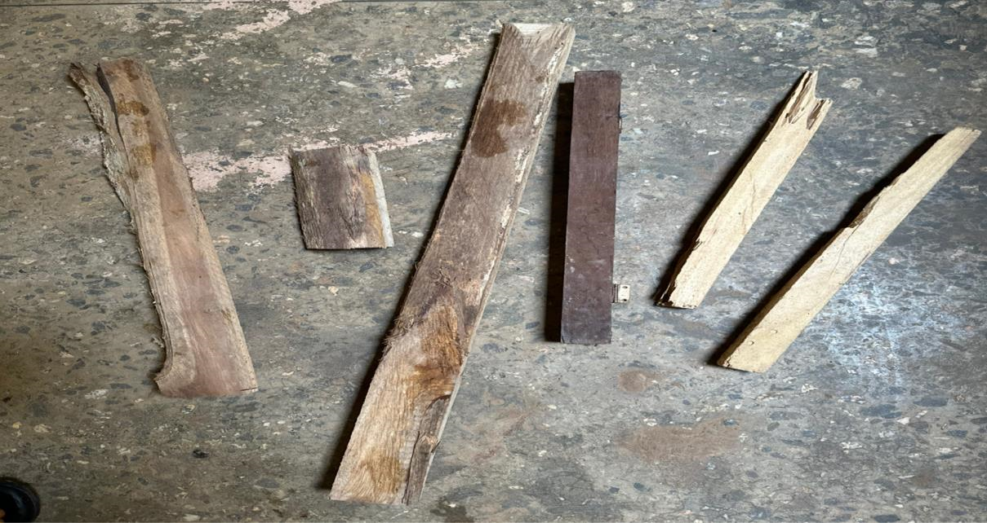

THE IMAGE OF TIMBER (SOFT WOOD)
Fasteners: Nails were used for joining and securing the wooden components.

THE IMAGE OF NAIL.
- Flooring Material: plywood or composite boards as shown in plate 3.3 was used as the material that served as walking surface of the suspended ground level
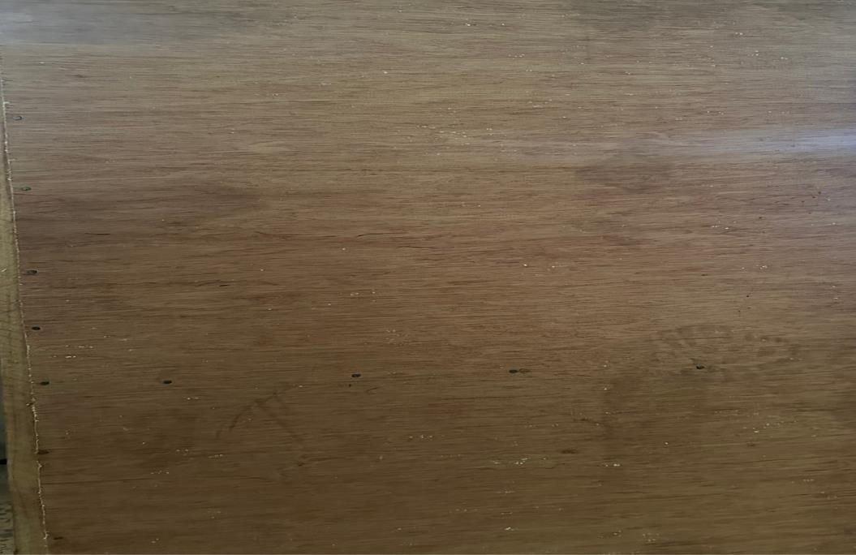
Plate 3.2: Plywood for suspended floor
- Safety Equipment: Include any personal protective equipment (PPE) necessary for the construction process, such as helmets, safety glasses, gloves, and harnesses.
- Tools: These are the tools required for the construction, such as saws, nail, hammers, measuring tapes.

THE IMAGE OF HAMMER, SAW, MENSURING TAPE.
3.4.DESIGN AND CONSTRUCTION PROCESS
3.4.1. Design and Planning:
3.4.2. The design of the suspended ground floor is drawn up as Shown in Figure 3.1, taking into account the dimensions required (560mm by 915mm)
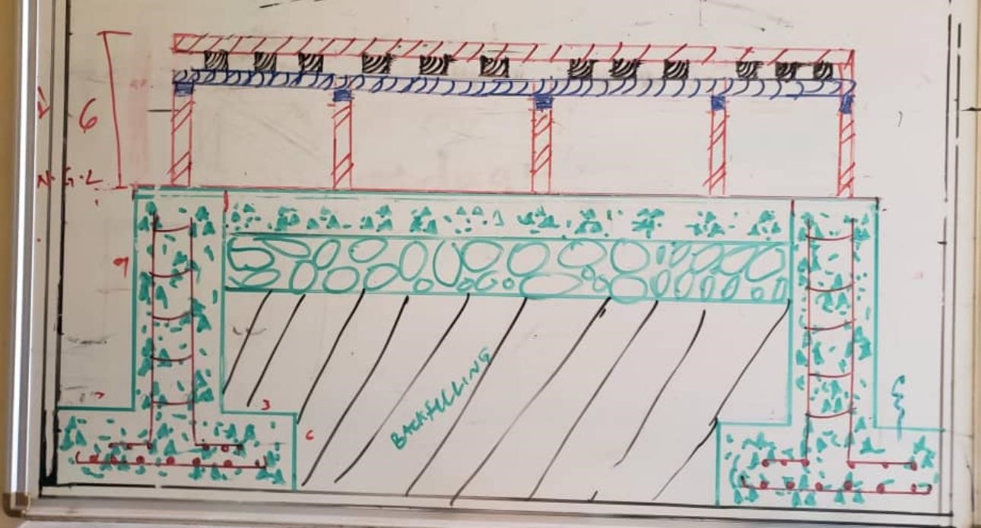
Figure 3.1: Design of the suspended ground floor
3.5.CONSTRUCTION PROCEDURE
The following procedure were deployed to achieve the stated objective • The prototype box was constructed with dimension of 36mm by 22mm.
  - Before the mixing of materials foundation footing was constructed.
  - Block foundation was erected using concrete(batching, mixing, curing)
  - Casting & Compaction was carried out immediately after the mixing of the material.
  - The block work was demoulded after 48hours.
  - The demolded foundations was placed carefully into the prototype box
  - Backfilling took place with the usage of fine aggregate(sand)
  - Hard core was placed immediately after backfilling
  - Oversite concrete was constructed above the hard core which serves as the solid ground floor.
  - Sleeper wall was constructed immidiately after the groundfloor to support the flloor joist, floor board and wall plate
  - DPC was laid immediately after the sleeper wall to prevent moisture rising.
  - Wall plate is used to prepare a stable base for the floor joist
  - Floor joist it was used to create a layer that the floor board will rest on
  - Then floor board is laid
  - The finishing touches were made (polish, brush, thinner, etc..)
  - Treatment; This is used to prevent the growth of vegetative matter.

CHAPTER FOUR
4.0. RESULTS AND DISCUSSIONS
4.1. SUSPENDED GROUND FLOOR
As shown in plate 4.1, the suspended was constructed with two supports and it was done in 560mm by 915mm. it was placed at Concrete Laboratory at civil engineering department. The parts of the Suspended Ground floor are labelled from 1-10.
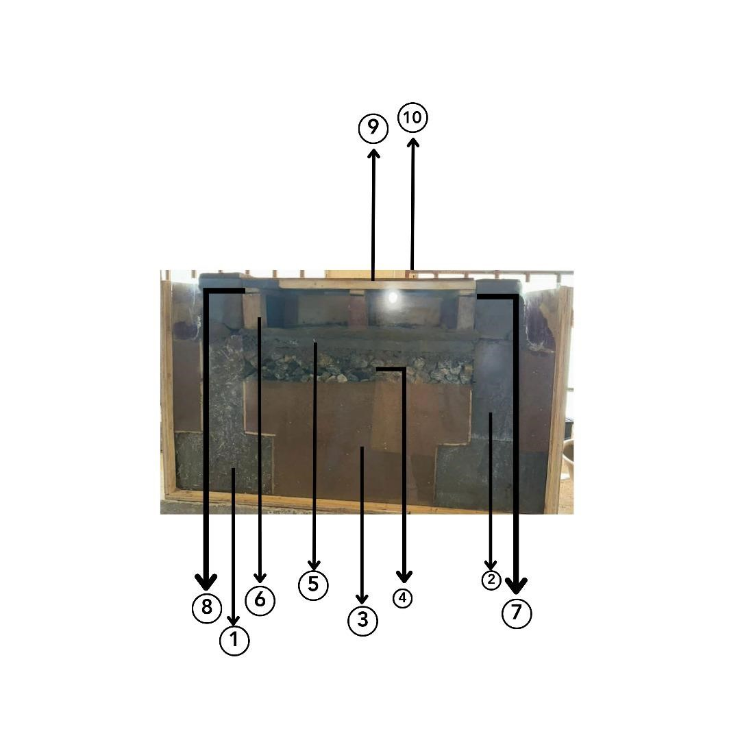

Plate 4.1: Suspended ground floor with two supports
These are the representations of 1-10 labelled in Plate 4.1
i

1-Foundation footing;
2-block wall: Block wall are structures containing standard concrete blocks that can takevarious shapes and sizes .
3-Backfilling: This is a process of replacing or reusing the soil that is remove during building construction to strengthen and support the structure foundation.
4-Hardcore : This refers to the mass of solid material used as a base for heavy load bearing stone and concrete floors.
5-Oversite Concrete : This is a mass of concrete which help to sustain weight of live and dead load in the building.
6-Sleeper’s wall : This is a short wall used to support joists , beam and block or hollow core slabs at ground floor .
7-DPC : This is a barrier through the structure designed to prevent moisture rising by capillary action such as through a phenomenon known as rising damp .
8-Floor Joist : This are horizontal structural member that span and open space often between beams which transfer the load to vertical structural members.
- wall Plate : This is a horizontal member built into or laid along the top of the wall to support and distribute the pressure from joist .
- Floor Board: This are support and distribution of loads on beams .

CHAPTER FIVE
  - CONCLUSIONS AND RECOMMENDATIONS
  - CONCLUSION
The construction of the 560mm by 915mm suspended ground floor (SGF) at the Concrete Laboratory of the Civil Engineering Department, Kwara State Polytechnic, Ilorin ,is the evidence of the careful design,implementation,and quality control procedures used in its realization.This kind of construction has several benefits such as being very inexpensive,light weight,and having excellent acoustic and thermal insulation qualities. However it is crucial to guarantee that the floor is protected from moisture and pest and that the joist are correctly treated and placed.

5.2. RECOMMENDATIONS
By incorporating the following recommendations into this report, will offer a comprehensive and insightful document detailing the construction process, materials' quality, structural design, and the educational significance of the suspended ground floor within the context of Civil
Engineering studies at Kwara State Polytechnic, Ilorin .

REFERENCES
Anderson, B., Chapman, P. F., Cutland, N. G., Dickson, C. M., Henderson, G., Henderson, J. H., Shorrock, L. D. (2001). BREDEM-12 Model description. Watford: BRE.
Ahned et al (2018) highlights the significance of designing appropriate ventilation openings, such as vents and crawl space vents, to allow air circulation beneath the raised floor.
Beaumont, A. A (2007). W07 – “Housing regeneration and maintenance – Hard to treat homes in England. International conference – Sustainable urban areas, Rotterdam, the
Netherlands” pp 24-25
Bernier, P., Ainger, C., & Fenner, R. A. (2010). Assessing the sustainability merits of retrofitting existing homes. Proceedings of the Institution of Civil Engineers – Engineering Sustainability, 163, 197–207.
Birchall, S., Pearson, C., & Brown, R. (2011). Solid Wall Insulation Field Trials – Report
BaselinePerformance of the Property Sample. London
Brown&White (2020) emphasis the use of materials such polyethylene sheets or moistureresistant membranes to create an effective barrier between the ground and the suspended floor. Chen et al (2017) indicate that suspended ground levels can reduce heat transfer between the interior and the ground, thus helping maintain a more stable indoor temperature.
Daerga P. A., Girhammar U. A., Källsner B. (2012): “The Masonite Flexible Building System for Multi-Storey Timber Buildings. In: 12th World Conference on Timber Engineering. Green Building Council (2021) indicate that elevated platform can reduce the need for extensive excavation and minimize disturbance to the natural landscape,contributing to reduced environmental impart..
Jonhson&Williams(2018) suggest that this approach offers design flexibility,enabling architects and builders to create unique spatial configurations while optimizing the functionality of the constructed area.
Lee, P., Lam, P. T. I., Yik, F. W. H., & Chan, E. H. W. (2019). Probabilistic risk assessment of the energy saving shortfall in energy performance contracting projects – A case study.
Energy and Buildings, 66, 353–363.
Pelsmakers, S., Fitton, R., Biddulph, P., Swan, W., Croxford, B., Stamp, S., Elwell, C. A. (2017). “Heat-flow variability of suspended timber ground floors: Implications for in-situ heatflux measuring. Energy and Buildings, 138, 396–405.
Shipworth, M., Firth, S. K., Gentry, M. I., Wright, A. J., Shipworth, D. T., & Lomas, K. J. (2010). Central heating thermostat settings and timing: Building demographics. Building
Research & Information, 38, 50–69.

