FACIAL DETECTION AND NOTIFICATION SYSTEM USING DEEP LEARNING

BY

ADEBAYO FAVOUR SAMUEL

ND/23/COM/PT/0243

A PROJECT SUBMITTED TO:
DEPARTMENT OF COMPUTER SCIENCE INSTITUTE OF INFORMATION AND COMMUNICATION TECHNOLOGY (IICT), KWARA STATE POLYTECHNIC, ILORIN.

IN PARTIAL FULFILLMENT OF THE REQUIREMENTS FOR THE AWARD OF NATIONAL DIPLOMA (ND) IN COMPUTER SCIENCE

2025

CERTIFICATION
This is to certify that this project was carried out by ????? with Matriculation Number ND/23/COM/PT/0243 in the department of Computer Science, Institute of Information and Communication Technology, Kwara State Polytechnic, Ilorin.

__________________ __________________
MR. ISIAKA, O.S. DATE
Project Supervisor

__________________ __________________
MR. OYEDEPO F.S. DATE
Head of Department

__________________ __________________
External Supervisor DATE

DEDICATION
This project is dedicated to God Almighty for His guidance over my life.

ACKNOWLEDGMENT
All glory be to Almighty God for making this project to be a successful one, and for His infinite mercies over us throughout our stay on this campus. We also appreciate the efforts of my dear and caring parents Mr. and Mrs. Adebayo for their advice and support throughout programme.
My sincere appreciation goes to my reputable supervisor (MR. ISIAKA, O.S) in person of for his moral support, guidance and word of encouragement throughout the course of this project, and also for his fatherly advice. God bless you sir
(Amen).
I also want to acknowledge our head of department (HOD) in person of (MR.OYEDEPO F.S) and all other lecturers in the department

May God bless you all.

TABLE OF CONTENTS
Title page i
Certification ii
Dedication iii
Acknowledgements iv
Table of Contents v
Abstract vii
CHAPTER ONE
1.1 Introduction 1
1.2 Aim and Objectives of the Study 2
1.3 Statement of the Problem 2
1.4 Significance of the Study 3
1.5 Scope of the Study 3
1.6 Organization of the Report 3
CHAPTER TWO
2.1 Review of Related Past Works 4
2.2 3-Dimensional Recognition 4
2.3 Components of Face Recognition Systems 5
2.4 Face Detection Approaches. 5
2.5 Face Verification Approach 5
2.6 Feature Extraction Approach 6
CHAPTER THREE
3.1 Research Methodology 8
3.2 Analysis of Data and the Existing System 8
3.3 Problem of Existing System 9
3.4 Description of the Proposed System 9
3.5 Advantages of the proposed System 9
CHAPTER FOUR
4.1 Design of the System 10
4.1.1 Output Design 10
4.1.2 Input Design 11
4.1.3 Database Design 12
4.1.4 Procedure Design 12
4.2 System Implementation 12
4.2.1 Choice of Programming Language 12
4.2.2 Hardware Support 13
4.2.3 Software Support 13
4.2.4 Implementation Techniques Used in Detail 13
4.3 Documentation of the System 13
4.3.1 Program Documentation 13
4.3.2 Operating the System 13
4.3.3 Maintenance of the System 13
CHAPTER FIVE
5.1 Summary 15
5.2 Conclusion 15
5.3 Recommendation 15
Reference 16
Flowcharts 17
Source Code 23
ABSTRACT
By creating a facial recognition and detection system, this project aimed to create an interactive system that will monitor, coordinate, and control a system's security activities. Every system administrator and user has been concerned about system security in terms of distinguishing between authorized and unauthorized users of a system in terms of authentication provision. The current security system has several flaws/setbacks in terms of consistency, dependability, and accuracy, as well as the speed of the process and the time required to complete an authorization and verification. Considering all of these setbacks, it is justified to propose the development of a new system with higher efficiency and improved features and functionalities to improve system security through the use of facial recognition. The program's design will be based on Microsoft Visual Basic and will include all necessary components, such as a webcam to take pictures for validation and verification. Further enhancements will be provided if the need arises in the future. This system will be built with Visual Studio 2019 and the MYSQL database.

CHAPTER ONE
GENERAL INTRODUCTION
1.1 INTRODUCTION
Face detection has received a lot of attention in recent decades. We can recognize a person's face without the assistance of a human. In this paper, a system for evaluating human face detection is implemented. Face detection is a model that can be used in a variety of devices to detect digital images. It is a subset of object-class detection that looks for the location and size of all features in a given class. This model's main focus will be on frontal face detection. This face-detection model first detects expected human eye areas by evaluating all possible valley regions in a given gray-level frame or image. A feature's fitness value is determined by its projection on the eigen-faces. The symmetry of the face is determined after many iterations, and the presence of various facial features is tested and confirmed. In other words, face detection is face-priority AF (auto focus), a function that detects human faces and sets the focus as well as the appropriate exposure (Näslund, 2008).
Face recognition research began in the early 1960s and has continued to this day. Face recognition has become increasingly important following the problem of personal identification, and it has a wide range of applications in modern life. Face recognition problems pique the interest of pattern recognition and computer vision researchers. Aside from biometrics, several face recognition algorithms are used in a variety of other applications such as video compression, indexing, and so on. Face recognition can also be used to classify multimedia content, allowing for quick and efficient searching for material of interest to the user. Face recognition systems can be very useful in forensic sciences, identification for rule enforcement, surveillance, authentication for banking and security systems, and granting privileged access to authorized users (access control for secured areas). Unlike iris scans or fingerprints, facial biometrics are understandable to human operators, and the validity of a machine's decisions can be quickly verified by a human.
The problem of face recognition has become even more pressing in light of the recent increase in extremism-related incidents. The use of face recognition for authentication also reduces the need to remember passwords and can provide much greater security when combined with other security methods for access control. Face appearance representation systems are classified as either local or global based on whether the face is represented as a whole or as a series of small regions. Face recognition is a major topic of research in the image processing and pattern recognition fields. Face recognition systems can be used for a variety of purposes, including access control, video surveillance, credit card user identification, and automatic video indexing. Many methods for face recognition have been developed in recent years.
The face is one of the most important graphical objects in our lives, as it plays a significant role in assigning identity and emotion. Face recognition is a vast research area in computer image, pattern recognition, and plays an important role in image analysis and comprehension requests. Face recognition is a broad term that encompasses feature extraction, feature reduction, and recognition or classification. The goal of feature extraction is to find the most representative sketch of the faces so that they can be distinguished from others. The aim of face reduction is to not only decompose and compress the original features, but also to avoid destroying the most important information. Recognition or classification is the process of selecting an available measure method, such as Euclidean distance, to organize the features of images in the database and test image. Because face images are frequently high in dimension, it is difficult to use the original data directly, making it risky to select effectively distinguished features for extraction and reduction. Principle Component Analysis (PCA) is an active feature extraction method based on the face as a global feature in all types of face recognition algorithms. It effectively reduces the image dimension while retaining the primary information.
1.2 STATEMENT OF THE PROBLEM
Biometric systems are increasingly becoming an important component (gateway) for information security systems. As a result, biometric systems must meet stringent security requirements. Unfortunately, manufacturers of biometric technologies do not always take security precautions into account. The disadvantages and weaknesses of biometric technologies have been discussed in publications. Since biometrics are the technology foundation for large-scale and highly sensitive identification systems (e.g., passports, identification cards), the issue of assessing the security of biometric technologies is a current one. Other issues with face detection and recognition systems include individuals with identical faces, such as identical twins and others; in such cases, it is possible for the system to make a mistake or error in processing the person image in order to grant access to the rightful owner.
1.3 AIM AND OBJECTIVES OF THE STUDY
The aim of this project is to implement a face recognition and notification system using deep learning while the objectives are as follows:
- One of the goals of this system is to create a system that will assist the organization in maintaining a high level of security in the workplace.
- Draw attention to areas of vulnerability in the new system.
- Develop a ridged and secure database for the organization to secure sensitive data and records.
1.4 SIGNIFICANCE OF STUDY
This study is primarily aimed at increasing security efficiency; this research work will assist users in data maintenance. This system will reduce the rate of fraudulent activities because it can also keep track of registered users and grant them access upon completion of face recognition. Also, the knowledge gained from this research will help the management to grow, and this research work will be of assistance to upcoming researchers in this field of study, as well as academic students on their studies.
1.5 SCOPE OF THE STUDY
The scope of this study is limited to face detection and recognition, accessing previous records and matching data, updating records, and deleting.
1.6 ORGANIZATION OF THE REPORT
This project is divided into five chapters. The first chapter describes the introduction, goals and objectives, significance of the study, scope of the study, as well as the organization of the report and definition of key terms. The second chapter discusses the literature review, historical context, and review of related projects. The third chapter discusses the methodology, analysis of the existing system, problems with the existing system, description, and advantages of the proposed system. The fourth chapter is concerned with the system's design, which includes the output. Input, database, and procedure design of the system; implementation of hardware and software support; and documentation of how to use the system and system maintenance. The final chapter contains the summary, conclusion, and recommendation.
CHAPTER TWO
LITERATURE REVIEW
2.1 REVIEW OF RELATED PAST WORKS
The proposed model by Manik, Anuradha, Manne & CKashyap (2017) can recognize faces correctly, but it takes longer to process videos. This model has the advantage of being able to recognize blurred images as well as side face images, which other traditional models are incapable of recognizing in such cases. The only disadvantage is that it does not recognize glasses-wearing eyes. In the future, this can be extended to recognize people using video capture, which will aid in obtaining identities from CCTV cameras, allowing police to quickly identify the person. It is also suitable for use in home security systems.
Gurel and Erden (2012) designed and implemented the Robot Vision Laboratory at Atilim University's Department of Mechatronics Engineering. The larger project's (umbrella project's) ultimate goal is to create a humanoid robot with a specific application, such as a Guide robot, Guard robot, Office robot, and so on. The developed system has been tested for a large number of live acquired images, and the results have been satisfactory for such a pioneering work in the department. Better performance necessitates advancements.
Andrew (2018) provided a critical examination of modern face recognition methodologies, advancements, and challenges. It also provided a comparison of the available databases as well as related benchmarks. It highlighted flaws in current methods and evaluated responses designed to address these limitations, emphasizing outstanding issues that needed to be addressed. Despite significant improvements in representation accuracy due to the non-linearity of deep feature representations, we can confidently conclude that no known ideal facial feature is sufficiently robust for face recognition in unconstrained environments.
2.2 3-DIMENSIONAL RECOGNITION
The 3-dimensional face recognition claimed higher accuracies. The following are some advantages of 3D facial recognition:
- Unlike previous methods, it is not affected by variations in lighting.
- It can also detect a face from a variety of viewing angles, as well as a profile view.
- Three-dimensional statistics points from a face vastly improve the accuracy of facial recognition.
- 3D research is improved through the development of refined strategies that perform a better job of capturing (3D face images) (Lummus et al., 2016)
2.3 COMPONENTS OF FACE RECOGNITION SYSTEMS
Face recognition systems design generally involves the three following tasks:
- Face Acquirement (Recognition, Tracking of face-like imageries).
- Feature extraction.
- Face Recognition.
2.4 FACE DETECTION APPROACHES.
The goal of face detection is to determine whether or not there are faces in an image. Face detection methods are classified into four categories: knowledge-based methods, template matching, invariant feature methods, and statistics/learning-based methods. Although the distinctions between them are not always clear, this taxonomy can still be used to briefly review the majority of the approaches to face detection. The following are some of the most common face detection methods:
- Knowledge-based methods: These methods are based on guidelines derived from the scholar's knowledge of human faces. The difficulty in converting human knowledge into well-defined guidelines is a problem with this method.
- Template matching: The input image is compared to a predefined face template. However, the performance suffers due to differences in scale, pose, and shape.
- Invariant Feature Methods: Many works in this category use invariant features such as gray values, edges, textures, color, or a combination of these features. Color is the most widely used among them for both face detection and lip reading.
- Appearance-based method: The templates in appearance-based methods are predefined by experts. The templates in appearance-based methods, on the other hand, are learned from examples in images. To determine the relevant characteristics of face and non-face images, statistical analysis and machine learning techniques can be used (Monczka, et al., 2017)
2.5 FACE VERIFICATION APPROACH
It is difficult to review all of the face verification technologies that have been developed by thousands of researchers since the 1970s. Rather than discussing individual face recognition approaches, the relevant technologies are discussed in terms of three aspects: identity models, feature extraction methods, and classification methods.
- Geometric Features: Early researchers such as Poggio and others frequently exploited geometric features of a face. The idea is to define a face based on the relative position of distinguishing facial features such as the eyes, mouth, nose, and chin, as well as other parameters. Because pure geometry alone is insufficient for recognition, it is usually combined with other features such as gray-level templates and so on.
(b) Holistic or Analytic Templates: The face is represented as a bi-dimensional array of intensity values sampled from the entire face region in the most basic version of template matching, which is a template. A probe template is then compared to stored ones using a suitable metric (typically the Mahalanobis distance). To account for recognition from different perspectives, several full templates per face may be used.
(c) ISO-Density Maps: After quantifying an image, ISO-density lines define the boundaries of constant gray level areas. Consider the following geological analogy to better understand the concept of ISO-density lines: If the brightness of a photograph is compared to the height of a mountain, the equal altitude contour lines correspond to ISO-density lines. The gray level histogram is used to extract ISO density lines. The histogram is divided into eight sections. To represent the 3D structure of the face, contour line tracing on ISO-density levels is performed, and outlines based on 4-connectivity pixels are extracted as ISO-density lines (Stevens, 2015).
2.6 FEATURE EXTRACTION APPROACH
This identity addresses the issue of how to model a face. This section focuses on how to construct and apply the models mentioned above. One-to-one correspondence between identity models and model-building algorithms is obviously difficult to establish. Several different feature extraction algorithms can be used to build specific models of identity, whereas one feature extraction algorithm can provide results that can be used to build several different models of identity.
- Template Matching: One of the most common techniques for feature extraction is template matching. Correlation is frequently used to assess the similarity between a previously saved template and the window image under consideration. Templates should be purposefully designed to cover a wide range of possible image variations. Scale and rotation should be carefully considered during the search in the entire image to speed up the process. Beymer used template matching to find the most important features (eyes, nose, and mouth) in a face image. To process matching with pose variations, affine transforms are introduced.
- Hough Transform: The Hough Transform (HT) is a widely used method for detecting features. It necessitates an explicitly chosen class of objects for detection (e.g., lines, circles, or ellipses) as well as parameterization of this class to describe all possible “i deal” instances of the object. Since there are few “ideal” mathematical curves in the contour of a face.
- Deformable Template: Yuille (2016) proposed a feature extraction algorithm called deformable template (DT), which extracts geometric features from images. As a global information-based algorithm, DT is effective in accurately and robustly extracting the locations and shapes of salient facial organs such as the eyes, mouth, and chin in the presence of noise. In DT, templates are specified by a set of parameters that allow the detection process to be guided by knowledge about the expected shape of the features. The templates are adaptable, allowing them to change their sizes and other parameters to match the data. The parameters' final values are used to describe the features. This method works regardless of scale, tilt, rotation, or lighting conditions. The template can be customized to fit any normal instance of the feature by changing the parameters. (Stock, 2019)

CHAPTER THREE
METHODOLGY AND ANALYSIS OF THE SYSTEM
3.1 RESEARCH METHODOLOGY
Deep learning (also known as deep structured learning) is a machine learning method that combines Artificial Neural Networks (ANN) with representation learning. Supervised, semi-supervised, and unsupervised learning are all options. Deep-learning architectures such as deep neural networks, deep belief networks, recurrent neural networks, and convolutional neural networks have been used in fields such as computer vision, machine vision, speech recognition, natural language processing, audio recognition, social network filtering, machine translation, bioinformatics, drug design, medical image analysis, material inspection, and board game programs, producing results comparable to and better than humans.
Artificial neural networks (ANNs) were inspired by biological systems' information processing and distributed communication nodes. ANNs differ from biological brains in a variety of ways. Neural networks, in particular, are static and symbolic, whereas the biological brain of most living organisms is dynamic (plastic) and analog. The term "deep learning" refers to the use of multiple layers in the network. Early research demonstrated that a linear perceptron cannot be a universal classifier, but that a network with a nonpolynomial activation function and one hidden layer of unbounded width can. Deep learning is a modern variation concerned with an unbounded number of layers of bounded size, allowing for practical application and optimized implementation while retaining theoretical universality under mild conditions. For the sake of efficiency, trainability, and understandability, deep learning layers are also allowed to be heterogeneous and deviate widely from biologically informed connectionist models, hence the "structured" part.
3.2 ANALYSIS OF DATA AND THE EXISTING SYSTEM
It is very rare in Nigeria today to see biometrics installed in institution organizations, regardless of how large they are or how busy and serious their activities are. Every management of any institution or organization believes in the uniqueness of an individual signature, despite the fact that this has been proven false by many employees in almost every sector. So far, the nature of the recognition system is such that a staff member comes to the office and records their names, time of arrival, and signature, and this process is repeated every day at closing time.
3.3 PROBLEM OF THE EXISTING SYSTEM
The existing system has a number of shortcomings that necessitate the development and implementation of the proposed system. The following problems have been identified:
- The current facial extraction system is inefficient.
- Prone to errors.
- Wastage of Time
3.4 DESCRIPTION OF THE PROPOSED SYSTEM
The proposed system is capable of determining the best facial motion features. The best characteristics are those that result in the most discrimination. In each video frame, first detect the face region. Following registration of successive face regions by global motion compensation, the lip region for each frame is segmented. At each frame, the initial face feature vector is composed of the 2D-DCT coefficients of the optical flow vectors within the face region. The discriminate analysis is divided into two stages. In the first, the most discriminate features are chosen from the full set of DCT coefficients of a single lip motion frame using a probabilistic measure that maximizes the ratio of intra-class and inter-class probabilities. At the second stage, the resulting discriminative feature vectors are interpolated and concatenated for each time instant within a neighborhood before being analyzed by LDA to reduce dimension, this time taking temporal discrimination information into account. While some may consider face detection to be merely pre-processing for a face recognition system, it is by far the most important process in a face detection and recognition system. A fully automated face detection system, however, can be used for more than just face recognition. In automated color film development, information about the exact face location is useful for determining exposure and color levels during film development. They are even used in the film and television news industries for face tracking and automated camera control.

3.5 ADVANTAGES OF THE PROPOSED SYSTEM
Based on the following advantages, the proposed system can be easily implemented:
- Simple to implement, efficient and effective.
- A minimal or non-existent impersonation process.
- Less manpower is needed.
- In comparison to the existing system, the cost is minimal.
CHAPTER FOUR
DESIGN AND IMPLEMENTATION OF THE SYSTEM
4.1 DESIGN OF THE SYSTEM
After conducting a thorough analysis of the current system, the proposed system's software is designed using a specific design methodology. Most engineering designers have found that the top-down approach works best. This entails dividing the project topic itemized as system into subsets referred to as subsystems. The proposed system is broken down into modules and subsystems. Each of these subsystems has a specific function. Finally, the entire system is integrated in accordance with the stated objectives.
4.1.1 OUTPUT DESIGN
The accuracy of the developed system was determined or calculated by computing the percentage of faces correctly verified across the total number of tested images, which is given as; Percentage (%) accuracy = Face(s) correctly verified ÷ Total number of tested images x 100. Out of the 20 images used for testing, 18 successfully authenticate the students' faces, and the accuracy is calculated as follows;
18÷20 × 100 = 90%

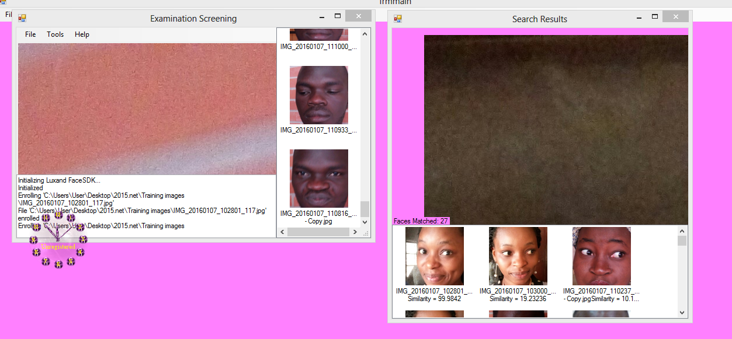
Figure 4.1: Successful Face Matching or Verification
The Mahalanobis distance was also calculated, and the image with the highest percentage value was shown first, followed by images with lower percentage values. Because the person image and information were not saved in the database during the enrollment phase, the developed system was unable to find a face. The formula given below was used to calculate the face that could not be found.
(%) percentage failure = Number of Unfound face(s) ÷ Total number of images tested × 100
Therefore; 1÷20 × 100 = 5%. Figure 4.2 shows the face was not found.
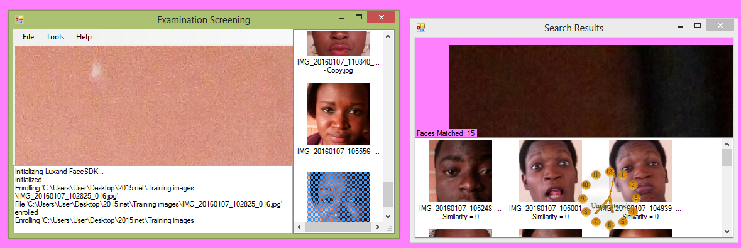
Figure 4.2: Face not found in the database
4.1.2 INPUT DESIGN
When capturing the student's face, the student must not be too far away from the system in order for the two eyes to be captured accurately; thus, failure may occur during the verification period. There is one flaw in the developed system because the student's two eyes were not accurately captured during the enrollment phase. The phrase "face not found, try lowering the minimal face quality parameter" indicates that some features were not captured and extracted. Figure 4.3 depicts the image failure.
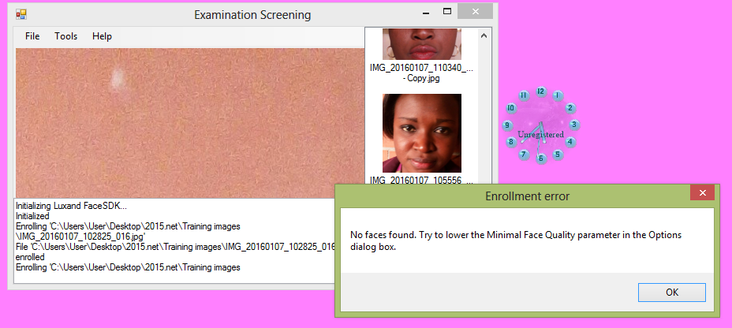
Figure 4.3: Failure in image verification
4.1.3 DATABASE DESIGN
The database was designed using a relational database management system (RDBMS). RDBMS organizes large amounts of data and defines the relationships between them in a consistent and understandable manner. RDBMS also provides a structure that is adaptable enough to handle almost any type of data. To provide definitions of the data used, data dictionaries were used; these included the final data structures for the various tables and their corresponding data fields, descriptions, and sizes.
4.1.4 PROCEDURE DESIGN
This refers to the method of using the proposed system in a step-by-step manner. The proposed system consists of two parts: verification and enrollment. So far, the various modules have been tested, and each has proven to be effective as a standalone entity (i.e. module). Though the modules can perform their respective functions on their own, when combined, they can function as a unit. As a result, this test ensures that when the modules are integrated, they can work together to perform their respective functions. As a result, integration testing was performed on the entire program structure to uncover errors related to interfacing. These errors were debugged in order to achieve the desired results. The purpose of integration testing is to ensure that these modules retain their efficiency and dependability. The main form, which acts as a coordinator and driver for the other modules, was involved in the integration.
4.2 SYSTEM IMPLEMENTATION
    - CHOICE OF PROGRAMMING LANGUAGE
Microsoft Visual Studio (C# programming language) was used to create the new system. This is due to the programming language's ease of development and flexibility. It also has the capability of providing hints to the developer/programmer and producing a graphical user interface. Microsoft Visual Studio (C# programming language) is a graphical user interfaced, event-driven object oriented programming environment. Structured programming enables the development of a program in presented modules, either top-down or bottom-up. The object hierarchy is in Microsoft Visual Studio (C# programming language), and it runs the objects (such as controls) that are placed in frames (another object that virtually groups other objects together) and can be placed on the form (windows which open up to display information, or receive input from the user). To create a finished visual basic application, these forms are linked together by code modules.
Forms, as objects, have their own properties and methods, including caption (which displays text centered at the top of the form), control box (which allows one to minimize, maximize, remove, resize, restore, or close the form), and desktop. There are also two boxes where the desktop can change the color of the form. There is also a toolbox that allows you to design the screen by selecting from various options such as label text, checkbox, and command button. Considering all of these features and more, the most popular choice for use was the Visual Basic for Windows environment, which was quite rewarding.
    - HARDWARE SUPPORT
The minimum hardware requirements are as follows.
- Processor: 1.2 GHZ Processor Speed
- Memory: 128 MB RAM (256 preferable)
- Disk space: 60 gigabyte
- Display: 800x600 Colors (1024x768 High color16-bit recommended)

    - SOFTWARE SUPPORT
The proposed system employs Macromedia Fireworks for graphics work on the system's images and background, Macromedia Dreamweaver (a text editor), and MYSQL as the database.
- Operating System: Window 2000 or later
- Database Management System: MySQL
- Run-time Environment: Microsoft Visual Studio 2010
    - IMPLEMENTATION TECHNIQUES USED IN DETAIL
System conversion examines the benefits and drawbacks of various approaches to system conversion from the old to the new system and recommends the best one for the current study. It also goes above and beyond to plan a strategy for the conversion. The researcher used parallel change over procedures in this project work. It is a situation in which the old system and the new system both process data.
  - DOCUMENTATION OF THE SYSTEM
    - PROGRAM DOCUMENTATION
The proposed system can be used on any computer system in the following ways:
- Boot the system
- Put the software in the CD or flash drive into its appropriate drive.
- Open the content from “my computer” icon on the desktop or clicking the start button.
- Double click the set up icon from the content of the package folder in the device (flash, CD).
- Follow the instruction and click on the appropriate button and the installation will be completed in a few moments.
    - OPERATING THE SYSTEM
- Click on start button on the desktop.
- Point to all programs
- Select Visual Studio and launch it
    - MAINTAINING THE SYSTEM
This program can be maintained in the Visual Studio environment. Any future changes can be made by re-compiling the source program in the development environment and making the necessary changes to the existing version of the system.

CHAPTER FIVE
CONCLUSION AND RECOMMENDATIONS

5.1 SUMMARY
The new system is a facial detection system that uses beep learning to verify faces in order to control access (impersonation). Impersonation will be discouraged. This system does not encourage people to impersonate or falsely represent one another.

5.2 CONCLUSION
Through the development of a facial recognition and detection system using a deep learning facial recognition algorithm, this study provides a solution to insecurity. The methodology employed entails the development of facial recognition biometrics using an object-oriented programming language, Visual Studio 2010 (C#), which is supported by a.Net framework, as well as the implementation of an eigen facial recognition algorithm (PCA) that is optimized using Visual Studio 2010 (C#). As a result of this work, a secure facial recognition system has been developed.

5.3 RECOMMENDATIONS
Through the development of a facial recognition system, this study addresses insecurity. Because of the threat posed by facial recognition expertise, plans and rules must be endorsed that will, if not prohibit their use, at the very least provide the necessary safeguards to limit the obvious risk these systems pose to personal privacy. There are currently no rules governing facial recognition expertise, but federally mandated rules are clearly required. The issues that must be addressed are numerous and diverse, but at the very least include the following:
- To avoid making a mistake when adding images to the database, what will be done?
- Who acquires images to be added to the database of required faces?
- What safeguards are required to keep the database secure?
- What options do people have if they are mistakenly entered into the database?
- How will the database be shared with other organizations or corporations?
In the interest of a person's right to privacy, the use of facial recognition tools should be prohibited unless these most basic questions are answered and alternatives to correct misidentification are available.
REFERENCES
Ajay, Pankaj (2013). Performance Evaluation of Face Recognition using PCA and N-PCA, Department of Electrical Engineering Poornima College of Engineering, Jaipur.
Jahanbin, Ranas, Alan (2013).:Passive Three Dimensional Face Recognition Using Iso-Geodesic Contours and Procrustes Analysis, international journal of computing Vol. 105:87–108
Lummus, R.R., Alber, K.L. (2016). Biometric Management: Balancing the Biometric with Customer Demand, the Educational and Resource Foundation of APICS, Falls Church, VA.
Lummus, R.R., Alber, K.L. (1997). Biometric Management: Balancing the Biometric with Customer Demand, the Educational and Resource Foundation of APICS, Falls Church, VA.
Monczka, R.M. & Morgan, J. (2013). What's wrong with Biometric management? Purchasing.
Näslund, D. and Williamson, S. (2008). Biometric Integration: barriers and driving forces in an action research based industry intervention. Biometric Forum – An International Journal.
Näslund, D. and Williamson, S. (2018). Biometric Integration: barriers and driving forces in an action research based industry intervention. Biometric Forum – An International Journal.
Priya K. , Rajesh, S. (2012). Score-Level Fusion of Local Spatial, Scale and Directional Features Based Face Recognition Approach for Single Sample Problem, the National Academy of Sciences, India
Poon. B, & Amin, M.(2011). Performance evaluation and comparison of PCA Based human face recognition methods for distorted images, international journal, Mach Learn & Cyber. 2:245–259
Stevens, G.C. (2015). Successful Supply-Chain Management. Management Decision. Chopra, Sunil and Peter Meindl. Biometric Management. 2 ed. Upper Saddle River: Pearson Prentice Hall.
Stock, J. Stefanie L. Boyer, S. & Harmon, T. (2010). Research opportunities in Biometric management. Journal of the Academy of Marketing Science.
Stock, J. Stefanie L. Boyer, S. & Harmon, T. (2010). Research opportunities in Biometric management. Journal of the Academy of Marketing Science.
Tan, K.C., Lyman, S., & Wisner, J. (2012). Biometric management: a strategic perspective. International Journal of Operations and Production Management.
FLOWCHART
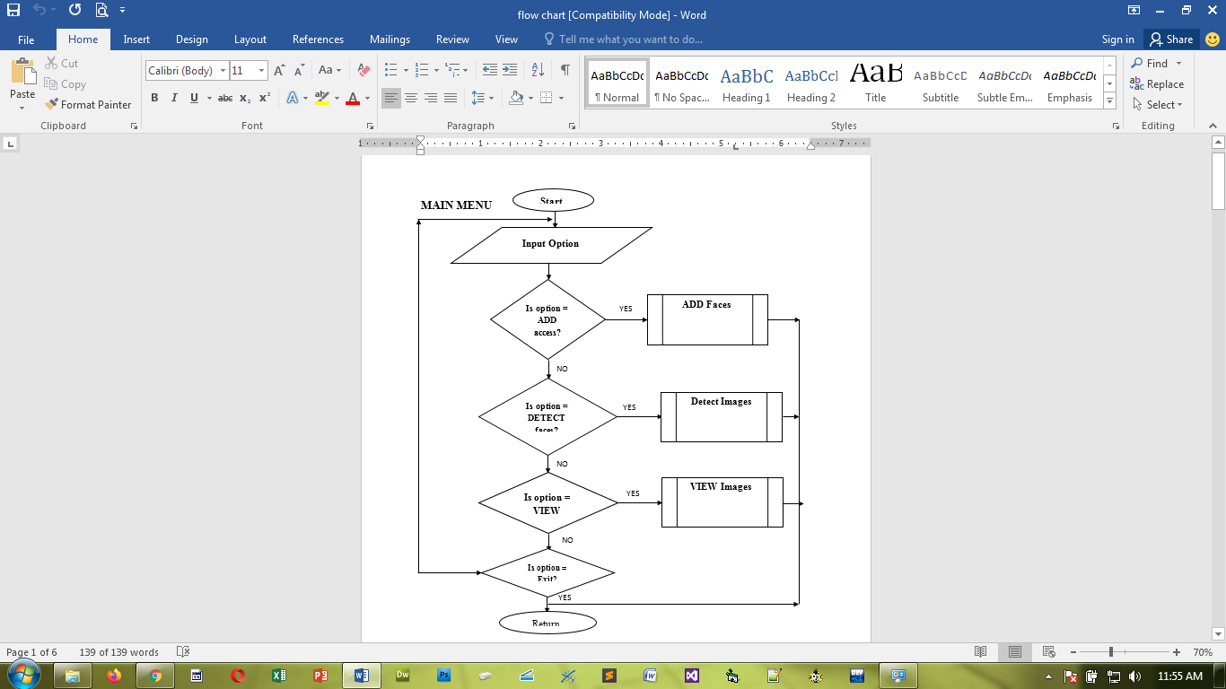

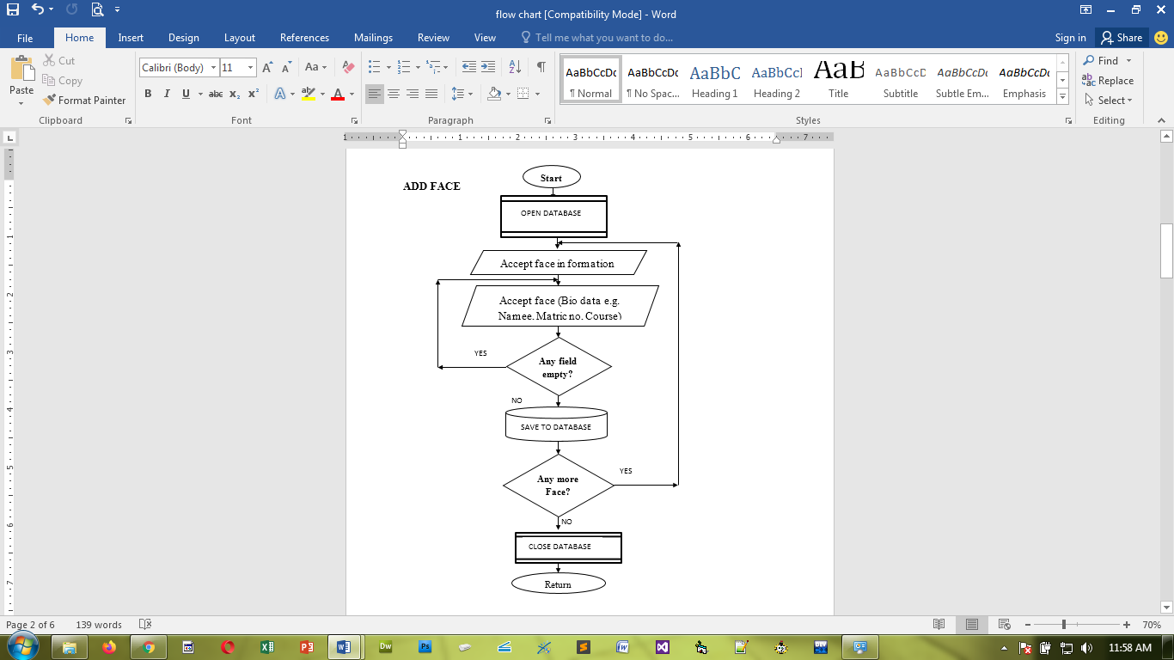

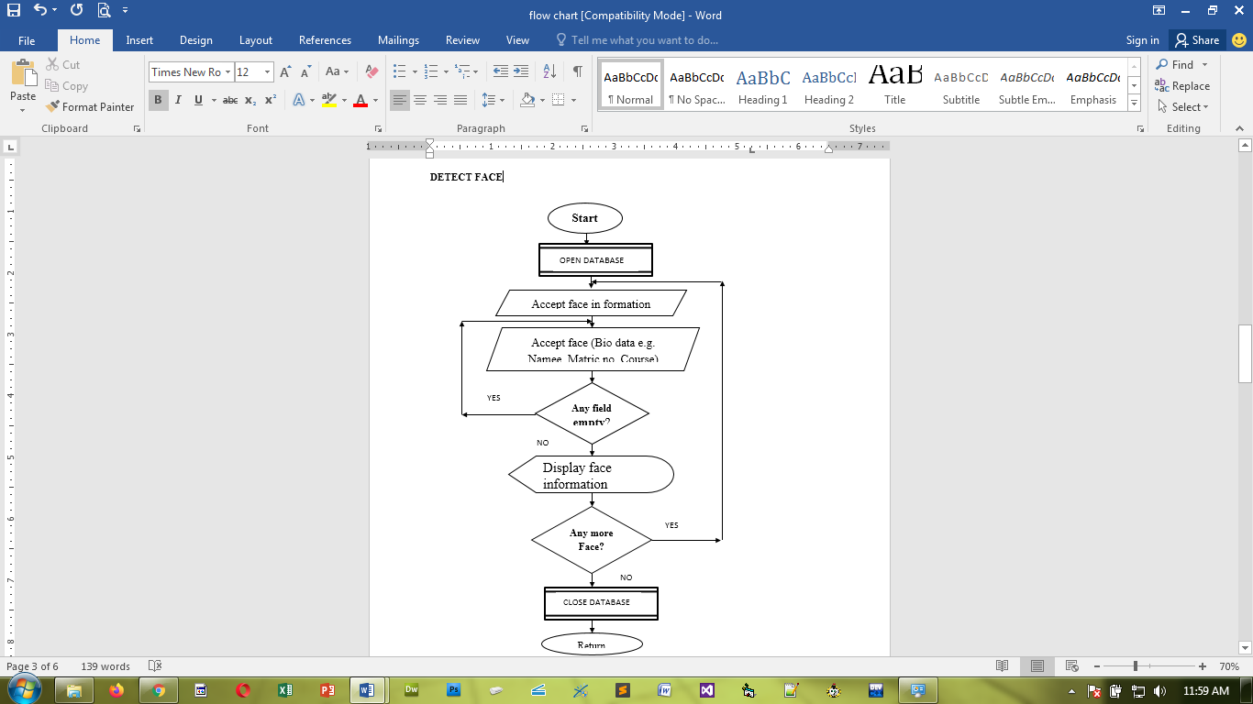

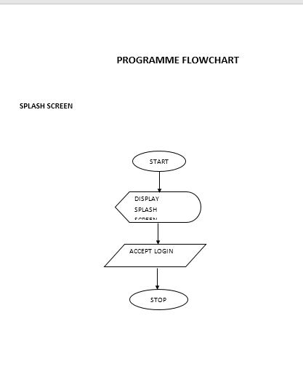

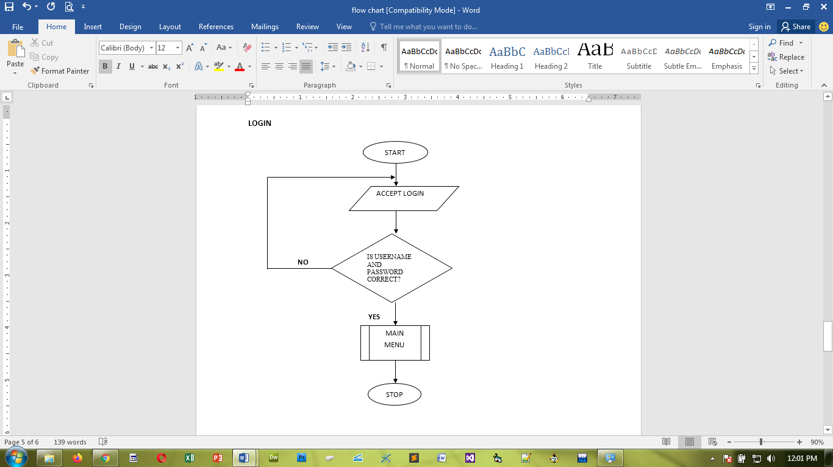

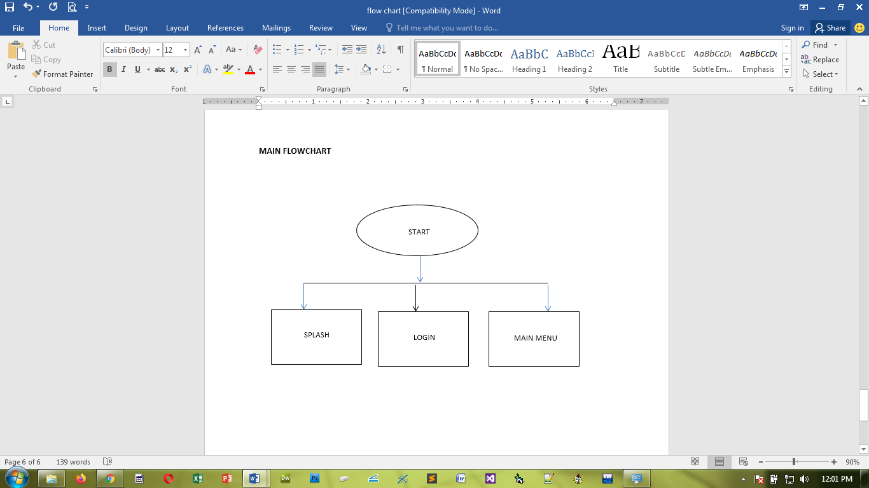

SOURCE CODE
using System;
using System.Collections.Generic;
using System.ComponentModel;
using System.Data;
using System.Drawing;
using System.Linq;
using System.Text;
using System.Windows.Forms;
using MetroFramework;
using MetroFramework.Forms;
using nClam;
using System.IO;
using System.Diagnostics;
using System.ServiceProcess;
using System.Threading;
using System.Collections;
using System.Media;
using TejashPlayer;
using System.Security.AccessControl;
using System.Security.Principal;
using BrightIdeasSoftware;
using System.Runtime.InteropServices;
using Microsoft.Win32;
using System.Management;

if (!silent)
MetroFramework.MetroMessageBox.Show(this, "The file is clean, it's not infected!", "Fine", MessageBoxButtons.OK, MessageBoxIcon.Information);
ret = 0;
break;
case ClamScanResults.VirusDetected:
{
if (!silent)
{
DialogResult dr = MetroFramework.MetroMessageBox.Show(this, "The file is infected\nVirus: " + scanResult.InfectedFiles.First().VirusName + "\nDo you want to delete?", "Virus Found", MessageBoxButtons.YesNo, MessageBoxIcon.Question);
if (dr == DialogResult.Yes)
try
{
File.Delete(loc);
}
catch { }
}
ret = 1;
}
break;
}
return ret;
}
else
{
if(!silent)
MetroFramework.MetroMessageBox.Show(this, "Invalid file to scan", "Error", MessageBoxButtons.OK, MessageBoxIcon.Error);
ret = 3;
return ret;
}
}

// infected file details to list
private void AddToResult(string file, string vir_name)
{
string[] row1 = { vir_name };
Invoke(new Action(() =>
{
ListViewItem item = objectListView1.FindItemWithText(file);
if(item==null)
{
objectListView1.AddObject(new InfectionObject(file, vir_name));
if (historyToggle.Checked)
{
his.AddHistory(file, vir_name); // add to history
objectListView2.AddObject(new InfectionObject(file, vir_name)); //adds it to history list
}
}
}));
}

//scan a folder
private void ScanFolder()
{
if (av_service_error)
{
MetroFramework.MetroMessageBox.Show(this, "Antivirus services are not running, kindly restart the software or see the help manual to troubleshoot", "Error", MessageBoxButtons.OK, MessageBoxIcon.Error);
try
{
Invoke(new Action(() =>
{
metroProgressSpinner1.Visible = false;
metroProgressBar1.Value = 0;
metroLabel8.Text = "No scan is going on...";
infec.Text = "Infected Files: 0";
metroTile2.Enabled = false;
metroTile3.Enabled = false;
metroTile1.Enabled = true;
curr_File.Text = "...";
metroRadioButton2.Enabled = true;
metroRadioButton3.Enabled = true;
metroRadioButton4.Enabled = true;
}));

scanning = false;
search.Abort();
}
catch { }
}

scanning = true;
bool error = false;
int infected = 0;

//if it's a quick scan, first check all the running processes
if (metroRadioButton2.Checked)
{
metroLabel8.Text = "Scanning running processes";
notifyIcon1.ShowBalloonTip(5, "Quick scan", "Scanning all running processes", ToolTipIcon.Info);
foreach(string proc in GetAllRunningProcesses())
{
if (File.Exists(proc))
{
try
{
var clam = new ClamClient("localhost", 3310);
var scanResult = clam.ScanFileOnServer(proc);
Invoke(new Action(() =>
{
curr_File.Text = proc;
}));

switch (scanResult.Result)
{
case ClamScanResults.VirusDetected:
infected++;
Invoke(new Action(() =>
{
infec.Text = "Infected Files: " + infected.ToString();
}));
AddToResult(proc, scanResult.InfectedFiles.First().VirusName);
break;
}
}
catch { error = true; }
}
}
Invoke(new Action(() =>
{
curr_File.Text = "...";
}));
}//end of process scanning

// normal scan process follows...

Invoke(new Action(() =>
{
metroTile1.Enabled = false;
metroTile2.Enabled = true;
metroTile3.Enabled = true;
metroLabel8.Text = "Please wait, while we prepare a list of files to be scanned. It may take some time...";
metroProgressSpinner1.Visible = true;
metroProgressSpinner1.Show();

metroRadioButton2.Enabled = false;
metroRadioButton3.Enabled = false;
metroRadioButton4.Enabled = false;
}));

if(smart_Toggle.Checked)
files= getFiles(loc_to_search, smart_ext, SearchOption.AllDirectories);
else
files = getFiles(loc_to_search, wildcard, SearchOption.AllDirectories);
int total = files.Length;

Invoke(new Action(() =>
{
metroProgressSpinner1.Visible = false;
metroLabel8.Text = "Scanning: " + loc_to_search + " (" + total.ToString() + " file)";
metroProgressBar1.Maximum = total;
metroProgressBar1.Minimum = 0;
metroProgressBar1.Value = 0;
notifyIcon1.ShowBalloonTip(5, "New Simple Antivirus Scanning...", "Virus scan has been started", ToolTipIcon.Info);
}));

foreach(string file in files)
{
if (File.Exists(file))
{
try
{
var clam = new ClamClient("localhost", 3310);
var scanResult = clam.ScanFileOnServer(file);
Invoke(new Action(() =>
{
curr_File.Text = file;
}));

switch (scanResult.Result)
{
case ClamScanResults.VirusDetected:
infected++;
Invoke(new Action(() =>
{
infec.Text = "Infected Files: " + infected.ToString();
}));
AddToResult(file, scanResult.InfectedFiles.First().VirusName);
break;
}
}
catch { error = true; }

}
Invoke(new Action(() =>
{
metroProgressBar1.Value = (metroProgressBar1.Value + 1);
}));

}
if (infected > 0)
{
// virus found
SoundPlayer snd = new SoundPlayer(Properties.Resources.virfound);
snd.Play();
Invoke(new Action(() =>
{
objectListView1.Visible = true;
objectListView1.Show();
//listView1.Visible = true;
//listView1.Show();
metroTabControl1.SelectedIndex = 2;
}));

}

if(error)
{
/*
Invoke(new Action(() =>
{
metroTabControl1.SelectedIndex = 0;
pictureBox1.Image = Properties.Resources.unsecured;
pictureBox3.Image = Properties.Resources.cross;
}));

MetroFramework.MetroMessageBox.Show(this, "There is a problem with scanner engine, kindly restart the antivirus", "Error", MessageBoxButtons.OK, MessageBoxIcon.Error);
*/
}

files = null; // allow garbage collector to collect it
Invoke(new Action(() =>
{
metroProgressSpinner1.Visible = false;
metroProgressBar1.Value = 0;
metroLabel8.Text = "No scan is going on...";
infec.Text = "Infected Files: 0";
metroTile2.Enabled = false;
metroTile3.Enabled = false;
metroTile1.Enabled = true;
curr_File.Text = "...";
metroRadioButton2.Enabled = true;
metroRadioButton3.Enabled = true;
metroRadioButton4.Enabled = true;
}));

scanning = false;

try
{
search.Abort();
}
catch { }
}

// check if a path is drive or not
public static bool IsLogicalDrive(string path)
{
bool IsRoot = false;
DirectoryInfo d = new DirectoryInfo(path);
if (d.Parent == null) { IsRoot = true; }
return IsRoot;
}

// get the files from the given path
public string[] getFiles(string SourceFolder, string Filter, System.IO.SearchOption searchOption)
{
ArrayList alFiles = new ArrayList();
string[] MultipleFilters = Filter.Split('|');

if (IsLogicalDrive(SourceFolder))
{
foreach (string d in Directory.GetDirectories(SourceFolder))
{
foreach (string FileFilter in MultipleFilters)
{
try
{
alFiles.AddRange(Directory.GetFiles(d, FileFilter, searchOption));
}
catch { continue; }
}
}
}
else
{
foreach (string FileFilter in MultipleFilters)
{
try
{
alFiles.AddRange(Directory.GetFiles(SourceFolder, FileFilter, searchOption));
}
catch { continue; }
}
}

return (string[])alFiles.ToArray(typeof(string));
}

//delete the found virus
private void metroTile4_Click(object sender, EventArgs e)
{
string path = string.Empty;
for (int i = 0; i < objectListView1.Items.Count; i++)
{
path = objectListView1.Items[i].SubItems[0].Text;
try
{
KillProcess(this.Handle, path); // try to kill the process before deleting it
File.Delete(path);
}
catch { }
}
objectListView1.Items.Clear();
}

//pause the on going scanning
private void metroTile2_Click(object sender, EventArgs e)
{
if (scanning)
{
if (suspended)
{
try
{
search.Resume();
suspended = false;
metroTile2.Text = "Pause";
}
catch { }
}
else
{
try
{
search.Suspend();
metroTile2.Text = "Resume";
suspended = true;
}
catch { }
}
}
}

//stop the on going scanning
private void metroTile3_Click(object sender, EventArgs e)
{
if(scanning)
{
try
{
files = null;
metroProgressSpinner1.Visible = false;
metroProgressBar1.Value = 0;
scanning = false;
curr_File.Text = "...";
metroLabel8.Text = "No scan is going on...";
infec.Text = "Infected Files: 0";
curr_File.Text = "...";
metroTile2.Enabled = false;
metroTile3.Enabled = false;
metroTile1.Enabled = true;
metroRadioButton2.Enabled = true;
metroRadioButton3.Enabled = true;
metroRadioButton4.Enabled = true;
search.Abort();
}
catch { }
}
}

//show about from system tray
private void aboutToolStripMenuItem_Click(object sender, EventArgs e)
{
this.Show();
this.Visible = true;
metroTabControl1.SelectedIndex = 4;
}

//exit from system tray
private void exitToolStripMenuItem_Click(object sender, EventArgs e)
{
this.Close();
}

//show hide from system tray
private void showHideToolStripMenuItem_Click(object sender, EventArgs e)
{
if (this.Visible)
this.Hide();
else
{
this.Show();
this.Visible = true;
}
}

//mouse double click on system tray icon
private void notifyIcon1_MouseDoubleClick(object sender, MouseEventArgs e)
{
showHideToolStripMenuItem_Click(sender, e);
}

// handles the new usb disk add
private void DoStateChanged(UsbStateChangedEventArgs e)
{
if (e.State == UsbStateChange.Added)
{
if(!scanning)
{
if (listenUSB.Checked)
{
loc_to_search = e.Disk.Name;
search = new Thread(new ThreadStart(ScanFolder));
search.Start();
metroTabControl1.SelectedIndex = 1;
}
}
}
}

//real time scanning, toggle event
private void realToggle_CheckedChanged(object sender, EventArgs e)
{
if (realToggle.Checked)
{
metroLabel14.Text = "Realtime scanning...";
pictureBox6.Image = Properties.Resources.fine;
pictureBox3.Image = Properties.Resources.fine;
pictureBox1.Image = Properties.Resources.secured;
}
else
{
metroLabel14.Text = "Realtime scanning is disabled";
pictureBox6.Image = Properties.Resources.cross;
pictureBox3.Image = Properties.Resources.cross;
pictureBox1.Image = Properties.Resources.unsecured;
}

}

//auto usb scan toggle
private void listenUSB_CheckedChanged(object sender, EventArgs e)
{
if (listenUSB.Checked)
pictureBox7.Image = Properties.Resources.fine;
else
pictureBox7.Image = Properties.Resources.cross;
}

//update
private void metroTile5_Click(object sender, EventArgs e)
{

}

//Real time scanner
private void RealTime(object sender, FileSystemEventArgs e)
{
if (av_service_error)
return;
if (exclusion.isExclusion(e.FullPath))
return;

FileAttributes attr;
int inf = 0;
try
{
if (realToggle.Checked)
{
Invoke(new Action(() =>
{
metroLabel13.Text = e.FullPath;
}));

attr = File.GetAttributes(e.FullPath);
if ((attr & FileAttributes.Directory) == FileAttributes.Directory)
{
//give some to create the whole dir at once...
Thread.Sleep(3000);
//Now start scanning the folder
}
else
MetroFramework.MetroMessageBox.Show(this, "The selected item does not exists now! It can not be restored", "Unable to restore", MessageBoxButtons.OK, MessageBoxIcon.Stop);
}
}
}

//clear all quarantine
private void metroTile9_Click(object sender, EventArgs e)
{
quaran.ClearQuarantine();
listBox2.Items.Clear();
}

//scheduled scanning
private void scheduledToggle_CheckedChanged(object sender, EventArgs e)
{
if (scheduledToggle.Checked)
{
if(metroRadioButton1.Checked)
{
//custom folder
folderBrowserDialog1.Description = "Select your folder or drive";
if (folderBrowserDialog1.ShowDialog() == DialogResult.OK)
{
sch_loc = folderBrowserDialog1.SelectedPath;
sch_time = dateTimePicker1.Value;
timer1.Interval = 1000;
timer1.Start();
dateTimePicker1.Enabled = false;
metroRadioButton1.Enabled = false;
metroRadioButton5.Enabled = false;
metroLabel22.Text = "Custom scan: " + sch_loc;
return;
}
}
if(metroRadioButton5.Checked)
{
//quick
sch_loc = Path.GetPathRoot(Environment.SystemDirectory);
sch_time = dateTimePicker1.Value;
timer1.Interval = 1000;
timer1.Start();
dateTimePicker1.Enabled = false;
metroRadioButton1.Enabled = false;
metroRadioButton5.Enabled = false;
metroLabel22.Text = "Quick scan scheduled";
return;
}
scheduledToggle.Checked = false;
MetroFramework.MetroMessageBox.Show(this, "Please select a scan type to schedule a scan", "Error", MessageBoxButtons.OK, MessageBoxIcon.Exclamation);
}
else
{
dateTimePicker1.Enabled = true;
metroRadioButton1.Enabled = true;
metroRadioButton5.Enabled = true;
metroLabel22.Text = "No scan scheduled";
timer1.Stop();
}
}

//scheduled scanning timer
private void timer1_Tick(object sender, EventArgs e)
{
if (sch_time.Hour == DateTime.Now.Hour && sch_time.Minute == DateTime.Now.Minute && sch_time.ToString("tt") == DateTime.Now.ToString("tt"))
{
//time matched...
if(!scanning)
{
dateTimePicker1.Enabled = true;
metroRadioButton1.Enabled = true;
metroRadioButton5.Enabled = true;
metroLabel22.Text = "No scan scheduled";
scheduledToggle.Checked = false;
timer1.Stop();
metroTabControl1.SelectedIndex = 1;
loc_to_search = sch_loc;
search = new Thread(new ThreadStart(ScanFolder));
search.Start();
if (metroRadioButton1.Checked)
metroRadioButton4.Checked = true;
if (metroRadioButton5.Checked)
metroRadioButton2.Checked = true;
}
}
}

//returns all the running processes path
private List<string> GetAllRunningProcesses()
{
List<string> list = new List<string>();
var wmiQueryString = "SELECT ProcessId, ExecutablePath, CommandLine FROM Win32_Process";
using (var searcher = new ManagementObjectSearcher(wmiQueryString))
using (var results = searcher.Get())
{
var query = from p in Process.GetProcesses()
join mo in results.Cast<ManagementObject>()
on p.Id equals (int)(uint)mo["ProcessId"]
select new
{
Process = p,
Path = (string)mo["ExecutablePath"],
CommandLine = (string)mo["CommandLine"],
};
foreach (var item in query)
{
list.Add(item.Path);
}
}
return list;
}

//add folder in exclusion
private void metroTile11_Click(object sender, EventArgs e)
{
folderBrowserDialog1.Description = "Select a drive or folder";
if(folderBrowserDialog1.ShowDialog() == DialogResult.OK)
{
exclusion.AddExclusion(folderBrowserDialog1.SelectedPath);
listBox3.Items.Add(folderBrowserDialog1.SelectedPath);
}
}

//add a file in exclusion
private void metroTile10_Click(object sender, EventArgs e)
{
openFileDialog1.Title = "Select the file please";
openFileDialog1.Multiselect = false;
openFileDialog1.CheckPathExists = true;
openFileDialog1.FileName = "";
openFileDialog1.Filter = "All files|*.*";
openFileDialog1.SupportMultiDottedExtensions = false;

if (DialogResult.OK == openFileDialog1.ShowDialog())
{
exclusion.AddExclusion(openFileDialog1.FileName);
listBox3.Items.Add(openFileDialog1.FileName);
}
}

//clears all the exclusion
private void metroTile12_Click(object sender, EventArgs e)
{
exclusion.ClearExclusion();
listBox3.Items.Clear();
}

//remove a selected exclusion
private void removeToolStripMenuItem_Click(object sender, EventArgs e)
{
if (listBox3.Items.Count > 0)
{
if (listBox3.SelectedItems.Count > 0)
{
string path = listBox3.Items[listBox3.SelectedIndex].ToString();
exclusion.DelExclusion(path);
listBox3.Items.RemoveAt(listBox3.SelectedIndex);
}
}
}

//remove the vault
private void metroTile14_Click(object sender, EventArgs e)
{
if (locker.no_valut)
MetroFramework.MetroMessageBox.Show(this, "There is no vault to remove", "Error", MessageBoxButtons.OK, MessageBoxIcon.Information);
else
{
DialogResult dr = MetroFramework.MetroMessageBox.Show(this, "Deleting a vault will delete all the files inside the vault. Kindly take a backup of your files first\nDo you want to delete the vault?", "Confirm", MessageBoxButtons.YesNo, MessageBoxIcon.Question);
if (dr == DialogResult.Yes)
locker.DestroyFolder(this);
}
}

//vault lock or create
private void metroTile13_Click(object sender, EventArgs e)
{
locker.CreateOrUnlockFolder(this);
}

//lock the opened vault
private void metroTile15_Click(object sender, EventArgs e)
{
locker.LockFolder(this);
}

private void metroLabel7_Click(object sender, EventArgs e)
{

}

} //end of class

