EFFECT OF OWNERSHIP RIGHT ON LANDED PROPERTY DEVELOPMENT
(A CASE STUDY OF IFELODUN LOCAL GOVERNMENT AREA ,KWARA STATE)

BY

ABDULRAHMAN ABDULAZEEZ OMOALFA
HND/22/ETM/FT/280

BEING A RESEARCH PROJECT SUBMITTED TO THE
DEPARTMENT OF ESTATE MANAGEMENT AND VALUATION
INSTITUTE OF ENVIRONMENTAL STUDIES,
KWARASTATE POLYTECHNIC, ILORIN

IN PARTIAL FULFILLMENT OF THE REQUIREMENT FOR
THE AWARD OF HIGHER NATIONAL DIPLOMA IN
ESTATE MANAGEMENT AND VALUATION

July 2025

CERTIFICATION
This is to certify that this project is written by ABDULRAHMAN ABDULAZEEZ OMOALFA with Matriculation Number HND/22/ETM/FT/280, it has been work on, read and approved by the undersigned on behalf of Estate Management Department, Institute of Environmental Studies, Kwara State Polytechnic, Ilorin.

____________________ __________________
ESV. OLADOJA L.O (ANIVS) Date
(Project Supervisor)

_____________________________ __________________
ESV. DR. (MRS.) Uwaezuoke Ngozi Date
Ifeanyi (ANIVS, RSV.)
(Project Coordinator)

_________________________ __________________
ESV. ABDULKAREEM RASHIDAT A Date
(FNIVS RSV)
((Head of Department)

_______________________ __________________
ESV. LUKMAN MUSIBAU (Phd, RSV) Date
EXTERNAL SUPERVISOR

DEDICATION
This project is dedicated to Almighty Allah in His Hemisphere, the great programmer of the programmes and master builder of the universe, for His hounty blessing and mercy bestowed on me throughout this programme.
It is also dedicated to my lovely parents Mr. and Mrs. for their love and parental advice when he was alive, may your soul rest in perfect peace.

ACKNOWLEDGEMENTS
My appreciation goes to Almighty Allah for His love, mercy and protection all through my life span, which cover the period of my academic pursuit especially in Kwara State Polytechnic, Ilorin. The good Almighty who is the Allah and Omega the beginning and the end, started with me in the course of this programme and end with me, despite all odd his with me throughout. I give Him all Glory and Adoration.
With sincere gratitude, to my Incomparable supervisor, ESV. OLADOIA LO (ANIVS)for her moral and support throughout the beginning of this project till the end. I pray Go will help you in all activities of your lives (Amen)
My appreciation goes to my amiable Head of Department ESV.ABDULKAREEM RASHIDAT A (ANIVS.RSV) appreciate him fot imparting so much to my life. Also to all my lecturer at the Department of Estate Management and Valuation, Esv. Abel Afolayan (FNIVS), Esv.Dr Ngozi, U.I, ESV. Olawale Oladoja, Esv. Simiat Lawal, Esv. Rasheedat Abdulkareem, Mr. Muhammed S Akewula, Mr. Abdulmumeeni. And other nom academic staff may Almighty Allah be with you all.
Also to my parents Mr and Mrs Sheu alsa my lovely sister Rukayat and my brother Quadrl,

TABLE OF CONTENTS
Title page ………………………………………………………………………… i
Certification………………………………………………………………………...ii
Dedication…………………………………………………………………………iii
Acknowledgements……………………………………………………………….iv
Table of contents…………………………………………………………………..v
List of table…………………………………………………………………………ix
List of Figure……………………………………………………………………………...xi
Abstract……………………………………………………………………………xii
CHAPTER ONE
1.0 Introduction …………………………………………………………………………….1
1.1 Background to the Study………………………………………………………………..2
1.2 Statement of the Problem…………………………………………………………………..3
1 .3 Aim and Objectives………………………………………………………………………..4
1 .4 Scope of the Study…………………………………………………………………………4
1.5 Justification of the Study……………………………………………………………………5
1.6 Study Area………………………………………………………………………………….5
1.7 Definition of Terms…………………………………………………………………….5
CHAPTER TWO
2.0 LITERATURE REVIEW
2.1 CONCEPTUAL FRAMEWORK…………………………………………………………..6
2.2 INTRODUCTION………………………………………………………………………7
2.2 CONCEPT OF OWNERSHIP RIGHTS IN LANDED PROPERTY……………………….7
2.3 LAND OWNERSHIP IN NIGERIA…………………………………………………………7
2.4 ENABLING LAWS…………………………………………………………………………..8
2.5 TYPES OF OWNERSHIP RIGHTS IN LANDED PROPERTY…………………………….9
2.6 REASONS WHY OWNERSHIP RIGHTS IS NECESSARY………………………………..9
2.7 SIGNIFICANCE OF OWNERSHIP RIGHTS IN LANDED PROPERTY…………………..10
CHAPTER THREE
RESEARCH METHODOLOGY
3.1 INTRODUCTION……………………………………………………………………………11
3.2 RESEARCH DESIGN………………………………………………………………………11
3.3 SOURCE OF DATA…………………………………………………………………………12
3.3 POPULATION OF THE STUDY……………………………………………………………13
3.4.1 PRIMARY SOURCE………………………………………………………………… ..14
3.4.2 SECONDARY SOURCE…………………………………………………………………14
3.6 SAMPLE SIZE………………………………………………………………………………14
3.7 SAMPLING PROCEDURE…………………………………………………………………15
3.8 INSTRUMENT FOR DATA COLLECTION………………………………………………16
3.8. 1 Direct Interview…………………………………………………………………………17
3.8.2 Questionnaire:………………………………………………………………………18
3.9 DATA ANALYSIS…………………………………………………………………….18
CHAPTER FOUR
4.() DATA PRESENTATION AND ANALYSIS
4.1 Introduction……………………………………………………………………………20
CHAPTER FIVE
SUMMARY OF FINDINGS CONCLUSION AND RECOMMENDATION
5.1 SUMMARY OF FINDINGS…………………………………………………………….23
5.2 CONCLUSION…………………………………………………………………………...26
CHAPTER FIVE
SUMMARY OF FINDINGS CONCLUSION AND RECOMMENDATION
5.1 SUMMARY OF FINDINGS………………………………………………………………28
REFERENCES………………………………………………………………………………..30

ABSTRACT
project effect on how landed property land use act of 1978, section 6). "The law makes provision Ibr granting customary rights of occupancy to individuals, communities or corporate bodies are for the use of land in the local Government Areas Ibr Agricultures, Residential and other purposes. This is done with the power of eminent domain vested on the Local Government Chairman of all the states in Nigeria over land in their jurisdiction. This have necessitated the desire of people to own, purchase, sells and acquire interest in land and landed property. These interests are to supervise, control, use of land and enjoyment are recognized and protected by law. The research will be divided into live (5) chapters, chapter one will deals with general introduction, statement of problem, aim and objectives, significance of the study, historical background of the study and definitions of terms. Chapter two will discusses about literature review and conceptual method of framework. Chapter three will contain the research methodology and data collection information from the study area will be collected through primary and secondary source. Primary sources will be collected by the use of questionnaires and field survey. The questionnaire will be analyzed using descriptive method of analysis; respondent in the study area will be selected and sampled. The respondents will be sampled using simple random sampling. Result from the findings will indicate the effect of ownership right on landed property development. Chapter four will deal with the data interpretation and analysis of results and discussion of findings, while chapter five will deal with the summary, conclusion and recommendation

CHAPTER ONE
- Introduction
  - Background to the Study

The term land has many interpretations, it must however be that list of definition is almost endless. Land means solid portion of the earth surfaces to a layman. Land can be defined as man's very existence. That is, land is covered by people to an extent that there is struggle for land in every available space at least for the creation of swelter. Also, land is fixed in supply (limited) and can neither be expanded nor increased to meet up with the ever - increasing populace. Thus, to the individual, land can mean privacy and security, therefore it was been refer to as the earth, soil or ground. (Smith, 2003)
I lowever, conventional economist considered land as a factor of production which is absolutely a free gift of nature i.e. man did not create nor work for its existence.
Legally, land can be defined as the physical dimension to within variety and collection of rights is attached. In other words, it can be said to be any portion or part on the surface over which ownership right can be exercised. (Oseni, 2006)
Furthermore, it is said to be that the whole, economy of the nation resets upon. It is also regarded as the main source of wealth and an important source of economic power, which in turn is based on political power. While professionals in building industry gave diverse definitions to land in accordance with the way they view it and its functions to them. (Lawal, 2005)
Because of important of land, the exercise of ownership rights gives rise to some problems within some communities, villages and towns in Nigeria today. Many homes were destroyed and many people lost their lives. The on - availability of a well - defined ownership right led to these crises. (Odudu, 2006)
However, the study will examine the past and present ownership rights and look ways by which crisis associated with ownership right can be solved.
1.2 Statement of the Problem
Landed property development plays a crucial role in urban planning, economic growth, and societal well-being. However, the effectiveness and efficiency of such development are significantly influenced by the rights of ownership associated with the land. The statement of the problem aims to address the multifaceted impact of ownership rights on landed property development. Uncertain ownership structures: The prevalence of unclear or disputed ownership rights often leads to delays and complications in property development projects. Lack of transparent ownership structures may deter potential investors and developers from engaging in development initiatives. Legal and regulatory frame work: Variability in ownership laws and regulations across regions may impede the streamlined development of landed properties. Inconsistent legal frameworks can create ambiguity, decision-making processes and the overall of development projects. Access to Financing: Ownership rights influence the ability of property owners to secure financing for development projects. Insecure or unclear ownership titles may pose challenges in obtaining loans, hindering property owners from maximizing the development potential of their land.
1 .3 Aim and Objectives
This project dissertation is aimed at critically examining the way by which ownership rights is being exercised on landed property development within Iiuodun Local Government Area Kwara State.
To achieve the aim objectives are adopted:
To examine the process and procedure by which ownership right in landed property are obtained.
ii. To examine the past and present ownership right ill. To examine the properties developed within 201 1 to 2022 in the study area
To examine the efféct of ownership right on properties development in the study area.
1 .4 Scope of the Study
I he scope of the study is to examine how the ownership rights for the people and residence within the jurisdictions of ifelodun Local Government Area was either he inherited, gifted, issued or granted.
In the light of these, is was limited only to the chief, head of the each family and department of land as ease may being Ifelodun Local Government Area in Kwara State..
1.5 Justification of the Study
In view of present rapid urbanization and population growth, the need arises for general public that are already owned or anticipate to own land, to know the important of ownership
This study is just as well enabling the people of Ifelodun Local Government their various uses in the areas. These uses may be for residential, industrial, recreational, or agricultural use. It will equally enlighten the people within the area to know their rights and also know who to go to when the need of land is arises for their various purposes.
The study will further give direction towards the rights channels in processing the appropriate ownership rights in landed property.
1.6 Study Area
Ifelodun is a local government area in kwara state whereby the council is made up of district and communities. The headquarter of ifelodun is share town.
Ifélodun is also among one of the local government area in kwara state that is occupied by Yoruba and the local government practice Islam, Christianity and traditional religion. Most of the Ituodun domain was overtake by the Aforju/Alimi era. There working hour is always between 8am-4pm from Monday to Friday
There are various Nigeria business that was been registered in the local government and
Ilélodun is also been different in two regional (town and village)

1.7 Definition of Terms
Estate management profession uses phraseologies that are employed by its professionals. I'his write up will employ such terms and so, these are defined below:
• Certificate of Occupancy: A certificate of occupancy is a land title document that is issued by the government to the land owners, as a legal proof of land ownership in Nigeria. A plot of land or property without a C of O can be confiscated at any time without any compensation paid. (Patunola, 2006)
Development: is defined as a process rather than an outcome, it is dynamic in that involves a change from one state or condition to another. Ideally, such change is a positive one, an improvement of some sort (for instance, an improvement in material health) Furthermore, development is often regarded as something that is done by one group (such as a development agency) to another (such as rural farmers in a developing country). This demonstrates that development is a political process, because it rises, because it raises question who has the power to do what to whom (Adans, 2009),
Estate: An estate is the net worth of a person at any point in time alive or dead. It is the sum of a peso's assets - legal rights, interest and entitlement to property of any kind, less all liabilities at that time ( Ogunba, 2007).
Land: land is not merely land in the strict sense of the word, but whole of the material and forces which nature gives freely for man's aid in land, water, in air, light and heat (Marshall, 2010).
Ownership: ownership is the state or fact of legal possession and control over properly, which maybe, any asset, tangible or intangible ownership can involve multiple rights, collectively referred to as title, which may be separated and held by cliilérent parties (Smith, 2003)
Possession: possession, in law, the acquisition of either a considerable degree of physical control over a physical thing, such as land or chattel, or the legal right to control intangible property, such as a credit with the definite intention of ownership with respect to land and whittle, possession today is often an abstraction (Anthony, 20()8)
Real Property: real property is the land, everything that is permanently attached to the land, and all of the rights of ownership, including the right to possess. sell, lease and enjoy the land. Real property can be classified according to it general use residential, conmercial, agriculture, industrial or special purpose. In order to understand it you have the right to sell your home, you need or cluster of right. It is the binding of various rights such as the rights to the use and enjoys land, the right to take income arising from land and also to alienate or transfer land to know which nights you posses or don't possess in the property (Ifediora, 2002)
Right of Occupancy: right of occupancy is an intermediate form between a rental apartment and an owner occupied apartment, for the resident, it is as secure a way to live as living in a home they own. as the owner of the building cannot terminate the right of occupancy or make it only has been built in Finland since 1991 (Ajayi, 2009)
• Title: is an intangible construct representing a bundle of rights in (to) a piece of property in which a party may own either a legal interest or equitable interest (Osaji, 2006)
- Right: rights are legal, social, or ethical principle of freedom or entitlement, that is right are the fundamental nor mature rules about what is allowed of people or owed to people according to some legal system, social convention, or ethical theory, (Adeniji, 2007)


5 9 13
 |   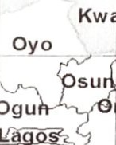  Kw | 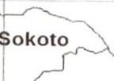 | 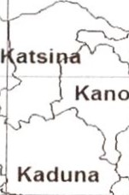 |  | 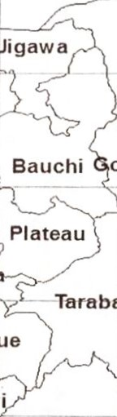 | 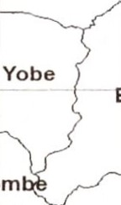 | 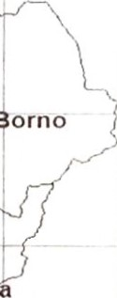
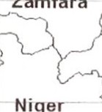
Zamfara
Nige
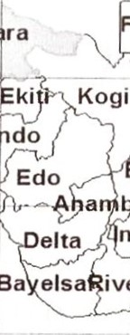
 |  |  |  | 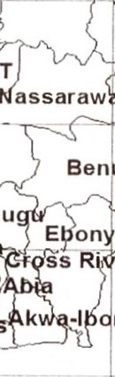  Ben |  | 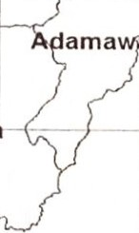
er
m
3 5 9 11 13

Kilometers
600
Legend

 D NIGERIA
C]KWARA STATE
Fig 1: MAP OF NIGERIA SHOWING KWARA STATE.
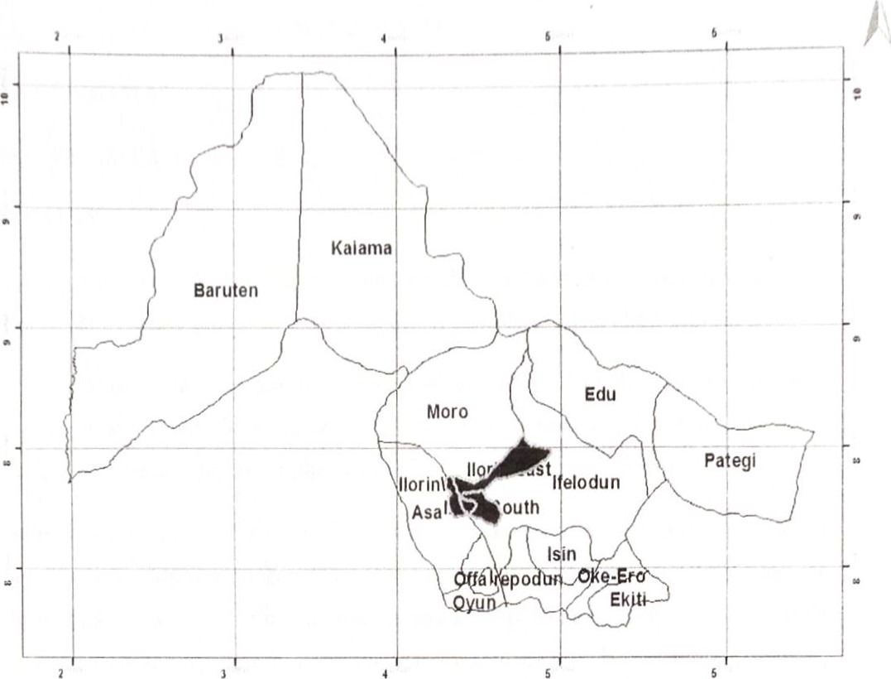
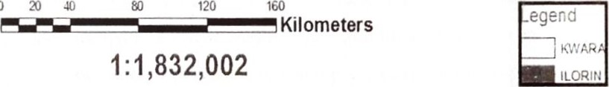
0
Fig 2: MAP OF KWARA STATE SHOWING IFELODUN CHAPTER TWO
CHAPTER TWO
LITERATURE REVIEW
2.1 CONCEPTUAL FRAMEWORK
INTRODUCTION
The law of property regulated rights or interest on land. Land in its physical state is not capable ol' ownership. Land rights exist in varying degrees usually denoted the world title.
In legal parlance, title connotes the existence of facts from which the right of ownership and possession can be intu•red, limitation being only in terms of' time. It is the degree of control and forms of control, use and enjoyment that are recognized and protected by law.
'Ville may be absolute or restricted. The former is synonymous with ownership, while the latter may amount to possession, a mere subtraction from, but part of a superior title. A claim to title may be original or derivative. Original title creates a right "de novo" and may be acquired through self help, such as settlement. A derivative title is acquired through transfer of an existing right to another, either absolutely or subject to condition. In other cases, however, the fact, which vests the right in holder, is title. A more occupational right does not vest title in any way. Except, there isN "animus possi "dendi" (i.e the intention to exercise exclusive possession) amounting to a single and exclusive possession in law.
2.2 CONCEPT OF OWNERSHIP RIGHTS IN LANDED PROPERTY
To further expound on ownership rights, there are conditions necessary for example for ownership rights over land. They are:
l . OWNER: a group of people or a person who must be capable of exercising the right of ownership. The owner is he who has dominion of a thing real or personal, corporeal or incorporeal, which he has a right to enjoy and to do with as please, even to spoil or destroy it, as far as the law permits, unless he is been prevented by some agreement which restrains his rights (Wikipedia)
- OBJECT TO BE ()WNED: object must have economic values. An object such as land that is free in supply does not command value. There are no special privileged accorded to the owner of object lacking value. The modern world has advanced such that the states (Nations) claim ownership of all "free" land within their regions or territories. The move restricts its supply to private owners, thereby according value to lands, buildings and property generally
- INTENTION TO OWN: intentions are mental states in which the agent commits themselves to a course of action. The action plan is the content of the intention, while the commitment is the attitude towards the content (Wikipedia)
- PERSON WITH COMPETITIVE RIGHTS: in general, competing human right involve situation where parties to a dispute claim that the enjoyment of an individual or group's human right and freedom, as protected by law, would interfere with another right and freedoms. This complicates the normal approach to resolving a human rights dispute where only one side claims human right violation. In some cases, only one party is making a human right claim, but the claim conflicts with the legal entitlement of another party or parties (Ontario Human Right Commission).
- LAW: property right can only be exercised within the jurisdiction of the laws and customs prevailed in that geographical territory. Legal codes are postulated by the court of law, whilst enforcing agencies such as the town planning authority are constituted which impose legal decisions made by the judiciary. Therefore, the essence of ownership lays in rights which law or custom will uphold
In Nigeria, the land use Decree (ACT) No. 6 of 1978 controls land and its appendetures. Herein, all legal issues such as powers of local government in relation to land not in urban areas, power of the military government in relation to land. Restriction on right at person under age 21 : special contracts, certificate of occupancy, power of military governor to grant licenses to take building materials, duty of occupier of statutory right of occupancy to maintain beacons, exclusive rights of occupier, the right to improvements.
All ol' these are according to section I l of the Decree No, 6 of 1978. These are the conditions which are necessary tor ownership in landed property.
Furthermore, ownership connotes an inlinite and absolute right on land. When the right ol' a claitnant to possess use and dispose of land is not subject to or restricted by the superior right of another person, the right of ownership is said to be vested in him it has been said however, that the owner of a thing is not necessarily the person who at a given time has the whole power of use and disposal, since there may be no such person, it sullices if the person has the residue of all such powers. 'A' the owners of Blakacre does not necessarily lose his right of ownership on the merely because "B' is let into possession and use of then land as a tenant since "A' still has a reconcile right to possession and may come into occupation and put the land to use by terminating tenancy
Every legal system design for itself the incidents of ownership for example, the concept of ownership in modern English law has an allodia character. The allodia ownership of all land in England is vested in the crown and in the result, a subject can have no more than a right to occupy and use land for period of time which may be finite and infinite. The right to occupy and use land is by the complimentary doctrine of estate transformed into ownership with all the incident of that concept. Thus, while a subject can own an estate in land, he cannot own the physical land.
2.3 LAND OWNERSHIP IN NIGERIA
In Nigeria, the concept of ownership varies in concrete application. Before the land use act 1978, there were at least Ii)ur source of ownership land namely, communal, thmily, individual and state ownership respectively.
- COMMUNAL AND FAMILY OWNERSHIP
Communal and family ownership of land are often connected with the indigenous of land holding in Nigeria, like in other African countries. Whilst in Amodu Tijani V. secretary of southern Nigeria the statement of his Lordship on individual ownership of land is accurate representation of the indigenous ownership structure in Nigeria. The emphasis on communal and Ihmily ownership is widely acclaimed as a true reflection on the indigenous system of land holding. Communal ownership evolved from communal land acquired för the use of the entire community through settlement in the distant past by a named founder, exercising the right of ownership jointly with the entire community, or through conquest following a war in which case, the conqueror through uninterrupted acts of possession. The land however ensures for the benefit of members of the community, who are entitled to acquire positions of the said land usually for agricultural purposes with the formal on sent of the community followed by a formal grant made to the individual by the political authority.

- INDIVIDUAL OWNERSHIP
Individual ownership of land under customary law has been known to exist from the outright grants often made by the chief or head of the family. The fact that a plaintiff in an action for declaration of title to land is expected to trace his right back to a point in time when the position was allotted to his ancestor out of communal property lends credence to the existence of that source of ownership ol' that source of ownership under the indigenous system or land holding. Outside customary law, individual ownership may evolve by act of government in the form of state or the exercise of executive power. Examples are crown grants made in the Lagos area after the treaty ofcession and state grants to individuals of poltion of the state land.
- STATE OWNERSHIP
State ownership of land in Nigeria dates back to the treaty off cession of 1861, which ceded the colony of Lagos to the British crown, subject to the customary right of the local people. The need 10 acquire land för agriculture and industrial development led to the promulgation of different land acquisition statutes under which individuals and communal land rights were compulsorily acquired in different parts of the country.
2.4 ENABLING LAWS
Due to the importance attached to the right of ownership, various laws had been promulgated in the past and have been in operation before the advent of the present law in force throughout the (Land Use Act No. 6 of 1978).
In 1992, the land and native right ordinance was replaced in the former northern Nigeria and replaced by the land. law governing the land tenure system in that area before the enactment of the land use act. Under that law, all native lands including rights over them are under the control and subject to the disposition ofthe permanent secretary
The land was held and administered tar use by the natives, but non natives acquired no title to the occupation and use of such land without the consent of the permanent secretary.
With the advent of the land use act 1978, the ownership structure in Nigeria has been radically transformed. The radical title to all land within the territory of a state in Nigeria having been invested in the Governor of the state, what Nigerians enjoy are rights of occupancy, so that the concept ol' ownership of land in Nigeria today may be constructed in terms of right of occupancy
A claim to ownership of land may be established in any of the five main ways laid down by the Supreme Court in Idundun V. Okumagba as 10110ws:
- By traditional evidence in the Ibrm of traditional history
- By production of document of title which must be proved, unless they are produced from proper custody in the circumstance giving rise to the presumption in favour of the execution in the case of document 20 years old or more at the date.
- Acts of persons claiming the land such as selling, leasing or renting out all or part of the land, or ilirming on its or on a portion of it, provided the act extend over a suflicient length of time and are numerous and positive enough as to warrant the inférence that the person is the true owner.
- Acts ol' long possession and enjoyment ofthe land
- Proof of possession of connected or adjacent land, in circumstance rendering it probable that the owner of such connected or adjacent land would in addition, be the owner of the land in dispute.
2.5 TYPES OF OWNERSHIP RIGHTS IN LANDED PROPERTY
In Nigeria, the forms of ownership in Northern and Southern part are difTerent from each other and are discussed below.
l . NORTHERN NIGERIA
In Northern Nigeria, these are native laws guiding land ownership. But in 1962 their native rights was cancelled and replaced by the land tenure law cap. 59, laws of Northern Nigeria 1963.
l'his new law declared all land in the community to be native lands
l'he administration and ownership belong to evewbody IOr use and common benefit of the populace. The ministry ol' town and regional planning was in charge to give a legal consent to whatever use that will be suitable. There were only two titles recognized to native land
    - Customary title of native conununity using land in accordance or in agreement with native custom.
    - A standing title granted by a public oilieers or native authority under the provision the law to any person. This is defined in the law that is used in the Northern part of Nigeria. It is granted on prescribed terms for a period of ninety-nine year. Depending on the type of improvement and backup by a certificate of occupancy
Right of occupancy would not be granted outside approved government layouts, unless Ibr certain special purpose. All laws must have been complied with before the consent is granted, Approval, the ministry ol' town and regional planning prepared a plan and description ol' the land that are enclosed certificate of occupancy
2. SOUTHERN NIGERIA
Illis is just custonutry land tenure system in southern Nigeria, other local statues concerning land before the promulgation of land use. Decree include the property and conveyance law cap
ACE, of western Nigeria 1959, the land registration Act cap 99, law of the of
Nigeria and Lagos 1 958, the land instrurnent registration law cap 56 (west); cap 72 (East), cap 58 (North) cap 64 (Lagos) the registration of title land tor the use Of the whole community. As earlier stated. the land use decree brought in stability and put an end to the on ending question relating to ownership and control of land and its rights
2.6 REASONS WHY OWNERSHIP RIGHTS IS NECESSARY
Ownership rights are necessary on landed property due to the importance of land itself to both govermnent and individual. Because man activities are conducted or carried out on land.
l.and is a platiörm on which all human activities are perlörmed without land, there is no life From the economic point of view, the demand for land cannot be met with adequate supply due to it characteristics, that is fixed in location and limited in supply
[hese therefore, can be seen as one reason Il)r issuing and granting ownership right.s in landed property due to the inadequacy of the market to make available land needed ii)r both government and individuals in sufficient quantities and in the required location at the appropriate time
More so, where a person does not have a valid title on his land, he cannot assets or effC•ctiveIy transfers some on the strength of a certificate of occupancy, since the certificate is only evidence of title
Ownership rights are necessary on landed property for settlement Of dispute that are normally arise in the absence of ownership rights. A right of occupancy whether statutory or customary creates priority of estates, so as to render null and avoid any subsequent certificate of occupancy issued in respect of the same parcel of land, unless the right of occupancy is usually revoked by the appropriate authority, belöre the issuance of a certificate of occupancy in respect of that same parcel of land to another person.
It also serves as security Ibr any form of assignment. Mortgage, sublease or transiZ•r of possession of landed property. As seen above, the reason iör ownership right is inevitable as Far as development is concerned. It is also a form Of public control over land and landed properties.
2.7 SIGNIFICANCE OF OWNERSHIP RIGHTS IN LANDED PROPERTY
Ownership is the rights vested in one person referred to as the owner to exclude other. It also consists of legal requirements bordering on the owner. While the right is usually referred 10 as cluster of rights. It is the binding of various rights such as the right to the use and enjoys land. [he right to take income arising from land/landed and also to alienate or transfer land/ landed property
Since land has been established as an indispensable basic need of man and a source of wealth, therefore ownership rights is a guard on how to make conveyance simple, cheap, speed and reliable by obviating most of the difficulties and hazard which both vendor and purchaser of land is exposed under the absence of ownership rights
By the issuance of ownership right, a land/landed owner wishing to alienate his land/landed property must be able to demonstrate proof of his title to the satisfaction of his purchase, which necessarily entails the training of his title from the first owner of the land or to a •person whose membership is undisturbed In the case of ownership rights once the title has been investigated and on the certificate of occupancy proof of title becomes easy, as the ownership rights is the evidence of title.
1.11 SUMMARY OF LITERATURE REVIEW
S/N | AUTHOR DATE | OBJECTIVE OF STUDY | FINDINGS
1. | Nwanbuize B.()  1972 | Nigeria land law. Family property is describe as the smallest unit in the body policy which is variously composed of a man, his or wives and children | This talks about the formation of family which could be created in any of this Klhen a laud owner dies his property becomes the family property of his heirs partidoning of family property i.e. division of laud for purpose like ownership
2. | Olawoye (1974) | Acquisition of original little to land and how to derive  title | Land may be acquire through  - Conquest  - Grant e.t.c. - First settlement  - Inheritance  - Gift  - Allocation  The attitude to land owner has led to observe to the view that land was inalienable under customary law

3. |  | Druker P.F (1980) |  | term development generally a material picture of erection of building and other structures upon laud warrauted by a change or significant intensification of the uses of laud |  |  | This means anything of any quality permanently attached to kind directly from the expenditure of capital or labour by an occupier
4. |  | ()dudu |  | Impact of student population on commercial property value |  |  | - Disparity in wealth  - Loss of fhrmland  - Poor air Quality  - Increase in temperature  - Energy inefliciency (vi) Impact on water quality and quantity
5. |  | Aloko |  | I lousing and urban development |  |  | - Population  - Spatial expansion  - reversing the trend (iv) Population growth rate  - Impact of urban growth  - distribution of population
6. |  | Adebayo |  | Causes of urban growth and sprawl |  |  | - Speculation  - Expectations of land appreciation  - Industrialization
(iv) Economic growth (v) Physical geography
(vi) Expectation of land appreciation
(v) Land hunger attitude
 | 7. |  | Ajayi |  | Concept of property development | Property development involve a wide range of activities and processing [Orm purchasing land to building and developing facility on the continue reconfiguration ol' the bault environment to meet society need, property development also called estate development is essentially the process of developing building or land into high like value.
Source: Authors compilation (2025)

CHAPTER THREE
RESEARCH METHODOLOGY
3.1 INTRODUCTION
I'he research methodology is designed purposely to achieve the aim of this project and it obtains useful information for this research work, and this chapter generally deals with the
Inethod and procedures adopted in carrying out the study
3.2 RESEARCH DESIGN
Research design is simply the process of arriving at a dependable solution to problem through planned systematic collection and analysis and interpretation of data. It involves organizing, collecting and analyzing of data to fulfill the purpose of the research and also to provide the necessary information required (Davidson 2004)
3.3 SOURCE OF DATA
To achieve the aim and objective earlier above there was the need för the Writer to collect adequate information, which will enable him to achieve or arrive at reasonable and Ineaningflll report as regard to the topic "An effect of ownership right on landed property" for collection of information used for this research work were obtained mainly from both primary source and secondary source
3.3 POPULATION OF THE STUDY
Population is a set of individual case or object with some common observable characteristic that difTerenciate it from other population, the target population of the study are some of the staff of the staffs of the land department, with their answer, I can be able to get in sight into the process and procedure insuring of ownership right on landed property.
3.4.1 PRIMARY SOURCE:
Information were gathered by conducting local interview with some of the staff of land department, with their answer, i can be able to know more about the processes and procedure Ibr insuring of ownership rights on landed property

3.4.2 SECONDARY SOURCE
The secondary source employed during the preparation of this write up were from intense literature review some relevant textbooks, journals, concerning the project topic and consultation of inlbrlnation already prepared by the stalT of the department of land in IlC•lodun local government area, concerning the effective of ownership right on landed property.
3.5 SAMPLE FRAME
This is the source material or device from which a sample is order i.e. individual, households or institution, in order to have reliable and adequate information for the purpose of this research (l questionnaire were administered for the individual owner of the land within the study area (Ifelodun local government area) and staff of Kwara state ministry of land which was considered the representative of the whole population
3.6 SAMPLE SIZE
In any research work there must be a specified number of people the researcher will need to give questionnaire and interview for the research work In this research work, questionnaire was prepared for this research, data collecting and information for the usefulness of the research work which (18) questionnaire will be given to the land owner and estate surveyor within the study area.
3.7 SAMPLING PROCEDURE
Sampling procedure adopted for this research is simple random sample been that of the study area is specified and due to population
3.8 INSTRUMENT FOR DATA COLLECTION
There is various method of data collection, the research instrument adopted in the course of this project works include the following
- Direct interview
- Questionnaire

3.8. 1 Direct Interview:
Direct interview was conducted at the Ilélodun Local Government area in the department of land for the officers that are in charge of insuring and granting of ownership rights in landed property, the writer conduct most of his interview with the profC•ssional in the field of land Inatters, especially such professional listed below, Estate Surveyors and Valuers, Quantity Surveyors, l,and Surveyor, Town Planner as well as the individual owner with in the study area
During this process, a lot of useful information was collected which served as guide throughout this write up.
3.8.2 Questionnaire:
Questionnaire survey was administered on the individual owner of the land within the study area (Ifelodun Local Government Area) and this led to the revelation of sotne vital information concerning the problems and obstacles encountered during the processing of ownership right on landed property.
3.9 DATA ANALYSIS
The method of data analysis in a research work determine such work. The procedure of data collection is vital concept to any project because it shows how information are gathering and processed for a set up goal

CHAPTER FOUR
4.() DATA PRESENTATION AND ANALYSIS
4.1 Introduction
"I'his chapter entails the presentation and analysis of data's collected data throughout the research work in a form to make it more meaningful and understandable easy reference and better comprehension. In the of this research work, questionnaire were distributed to two groups of respondent, the urban and regional board, and owners/occupants of protest at the study area.
l'wo hundred (200) questionnaires were was distributed to the owners/occupants as the case study and one (l) questionnaire was given to the urban and regional planning board.
The datas collected through these questions are presented and analyzed through various statistical techniques and tables. Mode of presentation are shown below.
Table 4.2 Showing Land Use Classification in Ifelodun Local government, Kwara State.
Uses | Description
Residential | Medium and low
Conunercial | Office, and shopping complex
Public use | Schools, hospitals and police post
Semi-public | Church and Mosque
Circulation | Road, walk ways, bicycle tracks
Recreational | Parks, playground, open spaces etc.
Source Field survey 2025
The table above indicates the types of land use and their classification in the study area.
l'able 4.2: I Total Number of Questionnaire Administered
Respondent | No. of Questionnaire | Percentage ( ⁰/0)
()wners/()ccupant | 200 | 99.5%
IJrban and regional planning board | 1 | 0.5%
l'otal | 201 | 100
Source Field Survey 2025
From the analysis above, the total numbers of questionnaires administered are Two hundred and one (201), Two hundred (200) was administered to the owners/occupant which carries 99.5% and one (l ) was given to the Urban and regional planning board with 0.5%.
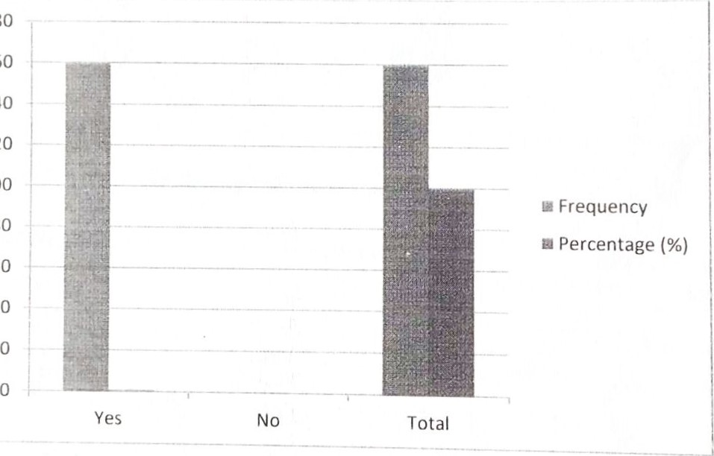
180
80
60
160
Table 4.2:2 Total Number of Questionnaires Retrieved
Respondent | No. of Questionnaire | Percentage (%)
()wners/()ccupant | 160 | 99.50/0
Urban and regional planning board |  | 0.5%
 | 161 | IOO
Source:- Field Survey 2025 |  | IOO
From the above analysis, the total number of questionnaires retrieved are one hundred and sixty-one (161). One hundred and sixty were retrieved from the owners/occupant in the study area, which carries 99.5% and one (l ) was retrieved from urban and regional planning board which carries 0.5%
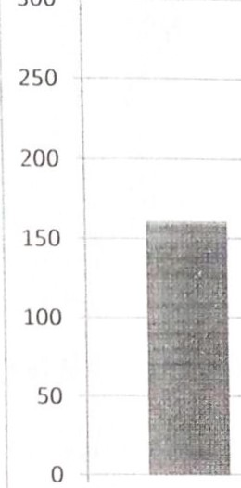

300
s Percentage (%) u Frequency
Yes No Total
Table 4.2:3 Showing the Age of the respondent
Age of Respondent | Frequency | Percentage (%)
20 - 30 years | 12 | 7.5%
Above 50 years | 88 | 37.5%
31 —40 years | 60 | 55%
Total | 160 | 100
Source> Authors Field Survey 2025
The above table shows the age range of the respondents at the study area, the people between the age of 31 — 40 years of age have the highest percentage which is carries 55% ii)llowed by the range of above 50 years which have37.5%. above 20-30 years has the lowest percentage which is 7.5%.
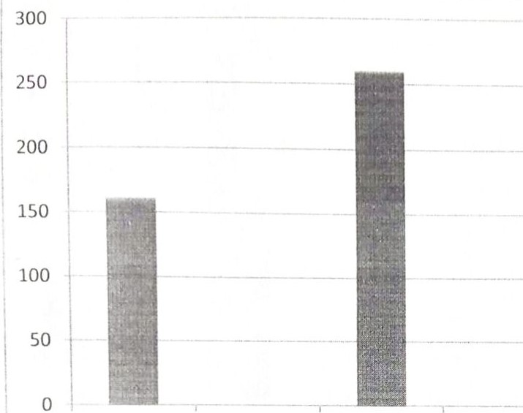
Yes No Total 
u
Percentage
u
Frequency
Table 4.2:4 Showing Educational Background of the respondent
Education Status | Frequency | Percentage (%)
Primary certificate | 8 | 5%
Secondary certificate | 22
Tertiary | 130 | 81%
Total | 160 | 100
Source- Authors Field Survey 2025
The above tables shows the educational status of the respondents. The people with tertiary institution certificate has the highest percentage which carries 81% followed by secondary certificate which carry 14% while primary school certificate has the lowest percentage which carries 5%.


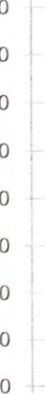
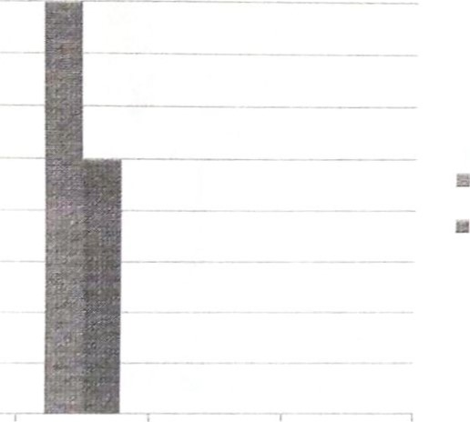
120
100
Frequency 160
80
Percentage (%) 100%
60
40
20
No Total
Table 4.2:5 Showing the Occupation of the respondent
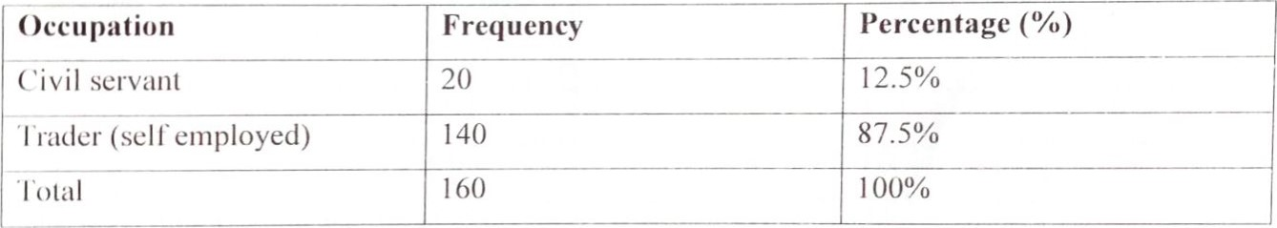
Source- Authors Field Survey 2025
From the above, the traders take so has the largest percentage of occupation of the total population of the respondent with a total number of 140 which carries 87.5%, followed by the civil servant with 12.5% of the total respondent. The traders who are self employed represents the owners of those shops. From the observation and intewiew carried out, the traders are largely responsible Ibr changes in land use and conversion of building for their small scale business, such as sales of clothing materials, electronics, offices i.e. Estate firm financial institution and business canters. The categories of the civil servant are government workers, who also have small business like estate firms, computers, to complement their wages.
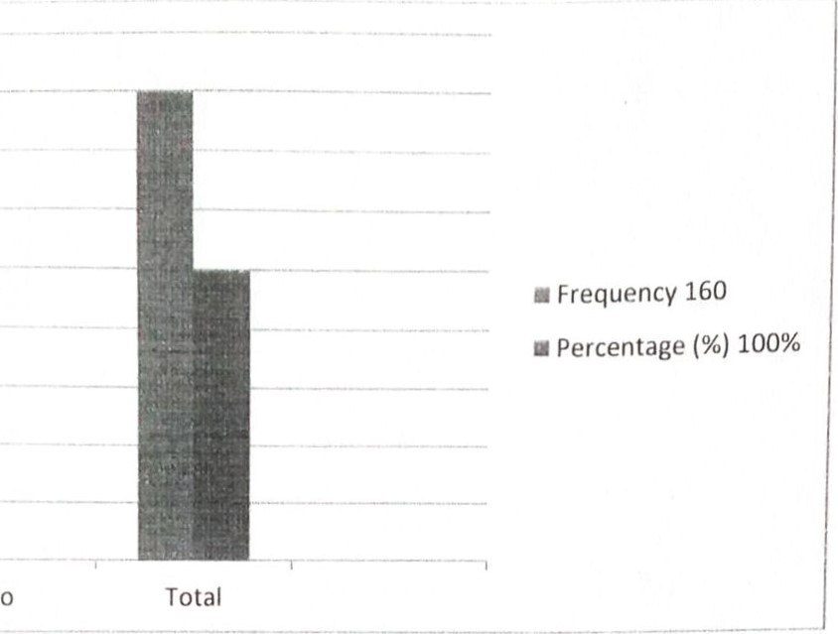
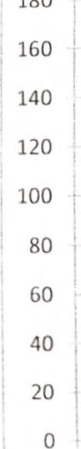
No
Table 4.2:6 Showing the respondents awareness about land use zoning
Land use zoning | Frequency | Percentage (%)
Yes | 70 | 44%
No | 90 | 56%
l'otal | 160 | 100
Source:- Authors Field Survey 2025
The table shows the population of respondents which has an idea about the awareness of land use zoning. The population of respondents which has the idea of zoning awareness was 44% while those who they are not aware of any zoning within the area is 56%. Therefore, it was observed that people were just changing the use of their property to what suits their present use.
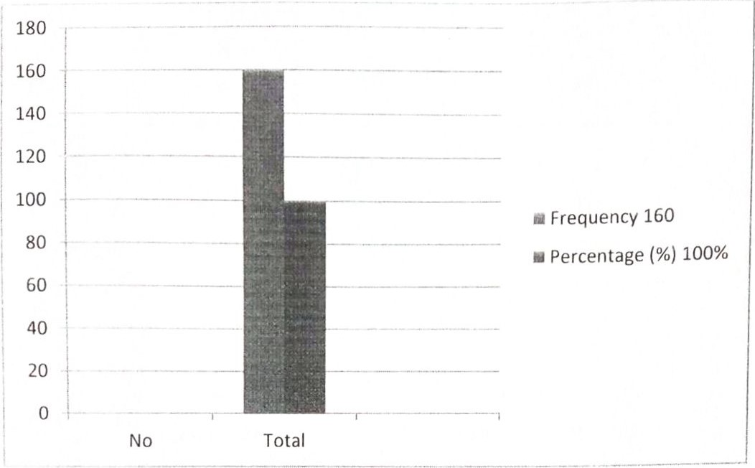
Table 4.2:7 Showing Different kinds of Conversion
Types of Conversion | Frequency | Percentage (%)
Residential to commercial | 160 | 100%
Commercial to residential
Others specify
rotal | 160 | 100
Source:- Field Survey 2025
The above table shows that building were seriously converted from residential building to commercial building i.e. office space, shops and financial institution (banks).
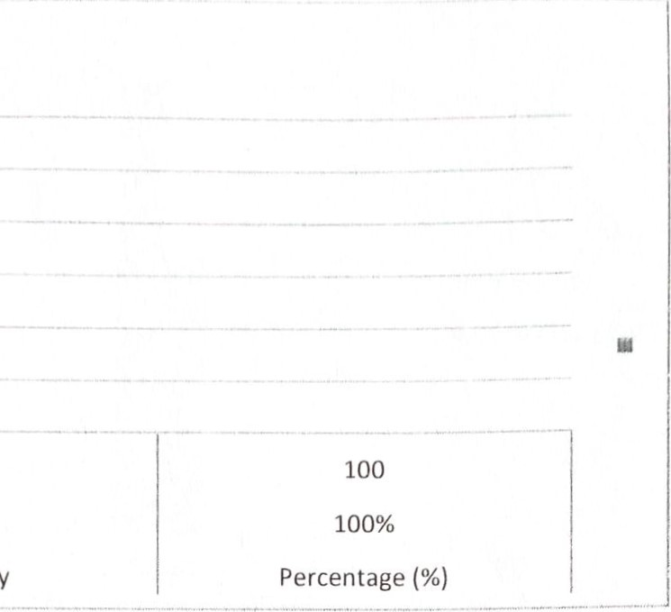


Table 4.2:8 Showing the time conversion efTected on their property.
Land use change time | Frequency | Percentage (%)
I — 4 years | 20 | 12.5%
5 — 8 years | 90 | 56.3%
Above 8 years | 50 | 31.2%
Total | 160 | 100
Source:- Field Survey 2025
The above analysis shows the time in which the change in use was effected. The conversion that took place for the past 5-8years has the highest percentage followed by 8years while I-4years has the lowest percentage which is 12.5%.
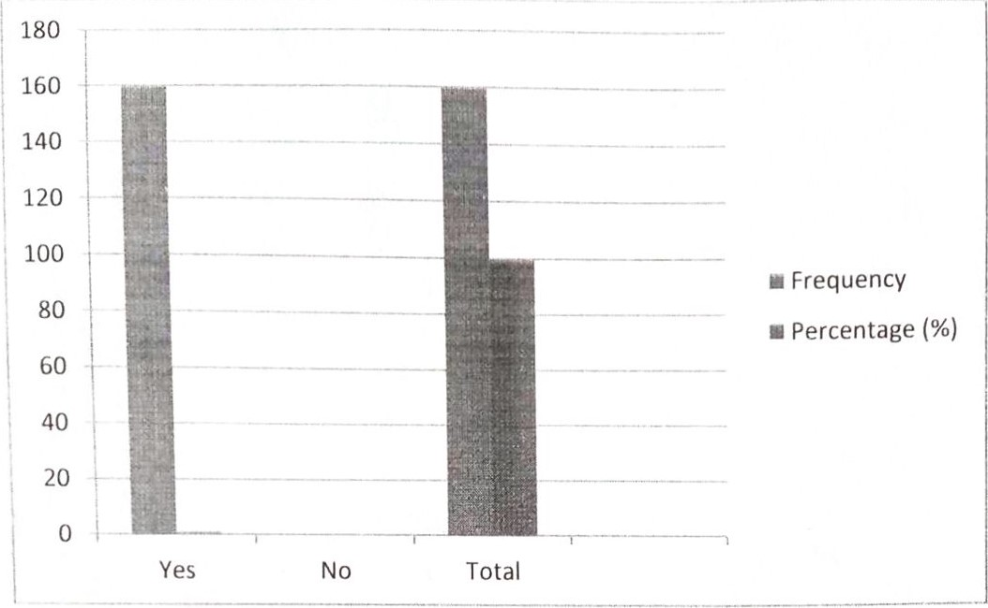
Table 4.2:9 Showing the reason for Change in use
Reasons | No of respondent | Percentage (%)
Rental alterative | 80 | 50%
Demand Ibr new use | 2 | 1.5%
Obsolescence | 6 | 3.5%
()ther specify | 72 | 45%
Iotal | 160 | 100.
Source:- Field Survey 2025
The above analysis shows the reason why people are making change in use, rental alterative have the highest percentage, which is 50% followed by other peoples opinion on there major aim of conversion with carry 45%, 3.5% said use is been changed the to obsolescent stage of the properties by obsolescence while people demand for new use has the lowest percentage with I .5%. The above shows that people are changing use majorly because of the return from the investment.

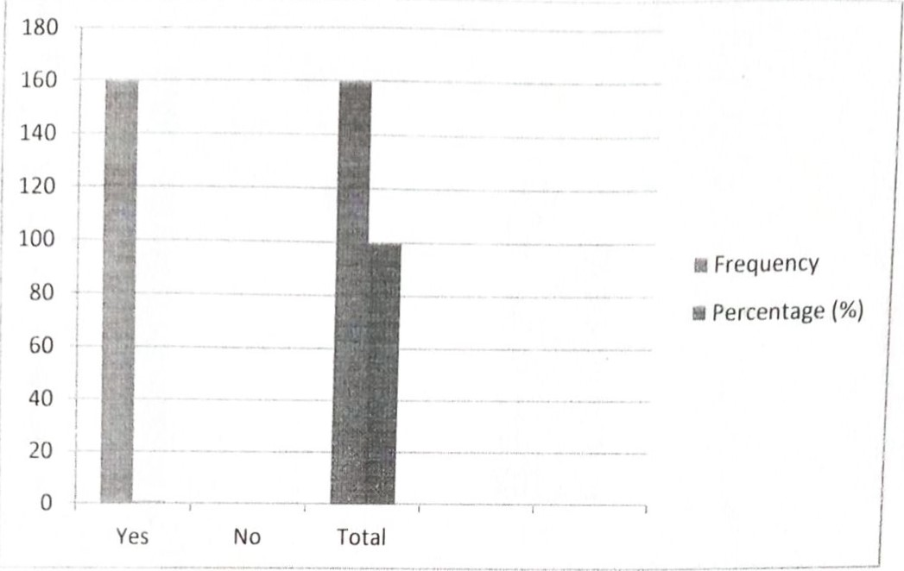
Table 4.2:10 Showing Effect on Increase in Rental Value
Effect on value | Frequency | Percentage (%)
Yes | 150 | 94%
No | 10
•rotal | 160 | 100
Source:- Field Survey 2025
The above table show that the changes in use as lead to increase in both rental and capital

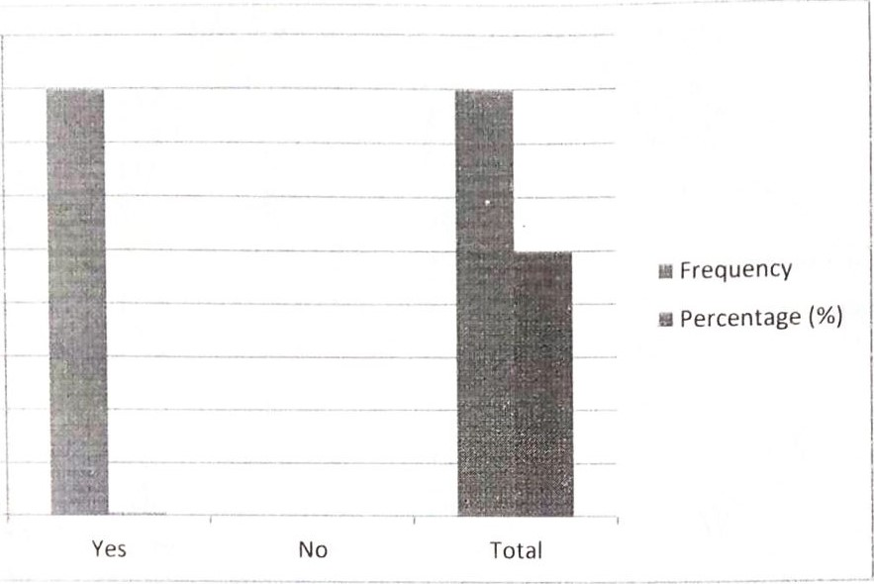

value of majority of the properties al the study area.
l'able 4.2:11 Showing the change of use approved by the planning authority
Approved for change in use | Frequency | Percentage (%)
Yes | 20 | 12%
No | 90 | 56%
()thers specify' | 50 | 32%
Total | 160 | 100
Source:- Field Survey 2025
The table above shows the number of property that has approval from the planning authority before embarking on change in use. This is indicates/indicated that only 12% of the respondent seek for approval. While 56% doesn't have the approval.
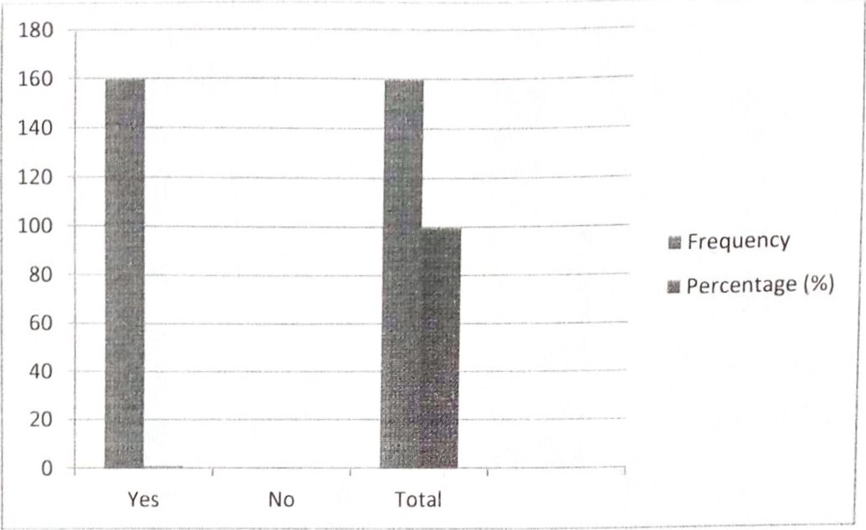
Table 4.2:12 Showing the level of traffic.
Increase  Congestion | in | Traffic | Frequency | Percentage (%)
Yes |  |  | 160 | 100%
No
Rotal |  |  | 160 | 100
Source:- Field Survey 2025
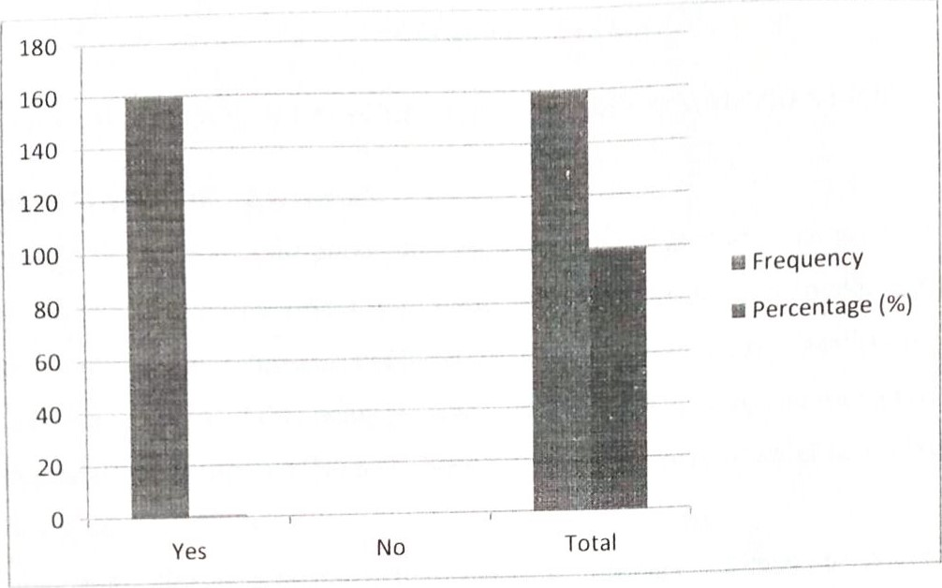

The table above shows the number of property that has approval from the planning authority before embarking on change in use. This is indicates/indicated that only 12% of the respondent seek for approval. While 56% doesn't have the approval.

CHAPTER FIVE
SUMMARY OF FINDINGS CONCLUSION AND RECOMMENDATION
5.1 SUMMARY OF FINDINGS
So much has been said about the effect that the degradation is having on the value of properties in any given area which it is started. The ever increasing human population in' the world has prompted his continuous exploitation of resources to satisfy man's need
l. The result revealed that many persons have been affected by the impact of environmental degradation. A total 86.7% have been affected by environmental degradation in one way or the other ll. Sanchez (2002) confirmed this that the primary effects of degradation on the environment are generally stated to be in the form of desertification, deforestation, watershed degradation, soil erosion and soil fertility decline. This are also the product of human activities
Ill. Environmental degradation is a seasonal phenomenon that always occur mostly during raining season due to rampant flooding and erosion induced by human activities in minimal during dry season.
- The effects are mostly effk.•ctive in the rainy season, where? 1.6% of the respondents are susceptible to the efTects of degradation. For instance Beusen (2023), has discovered that the primary source of soil degradation in the tropics is soil erosion; it is loss of production of topsoil as a result of the transportation of topsoil by wind, rain or gravity.
- I-lence rainy season is usually the season for most activities especially that has to do with tillage. The high rate of activities in the dry season such as deforestation, bush burning, excavation, dumping in flood plains likely have a synergistic effective in the dry season. For example the blocking of flood plains will increase flood in the rainy season
- Furthermore, 3.9% of respondents observed the causes of the high rate of environmental degradation as a result of natural processes on the contrary, 66.1% opined that human activities caused the greatest degradation. In a good example Uchegbu (2022) has said that solid waste has become the number one serious environmental problem facing the country with its consequent elects in the pollution of water, air and land. Man's activity
on the environment can be said to be a reversible reaction where his action aflC•ct the environment and the reaction of the environment affect man back
5.2 CONCLUSION
I laving critically investigated into the elTect of ownership right on landed properties, within llZ•lodun local government area in Kwara State. There is a strong need for development the econorny also needs to b revitalized so that the real Estate sector is more buoyant. The national development is hinged to a large extent on the types of properties, level of land nvanagement, the type of uses to which they are put. The general populance of the Nigeria a society is medium income earners. This is a major reason why the ownership title in the country is not processed for the rich tend to hold/owned large/Estate are owned occupied or privateoriented. The prior or low-income earners on the other land, do not have the ability to owned/ hold estate/land.
Finally, the bottlenecks and limitations involved in the processing and procedures of ownership rights in lands and landed properties which been analyzed should be worked by the IZ•deral government and other ancillary bodies
This dissertation has examined the relationship between ownership rights and its influence on the nation's development have also ascertained that the real properties investors provide revenue for the government through the taxes on the land and the legal structures
The land use Act of 1978 is seen as an instrument affecting nation's land and development. The public and private sector has been the major participant in the real sector and their impact. Also, the constraints militating against ownership title have also been analyzed. The suggestion and recommendations have been made on improved activities and process of ownership right in landed properties.

5.3 RECOMMENDATIONS
The following are recommendation hope would influence the level of ownership rights in landed properties.
    - The government should enlighten all its citizens, and Estate surveyors and values should also educate and enlighten the families or communities on the important and the significant of ownership title of their land and on their behalf. By this better and easy deal would enhance. Also, the purchaser should use professional advisers on all their transaction related to land matters, to curb the risk of losing their hard-earned income
    - It is obvious that most of the land sold to individual are usually abandoned, due to lack of fund and proper feasibility repolt which is most cases are encroached upon. TO overcome this, the buyers should make sure that they are financially okay to develop such land before paid for such plots, to avoid reselling of the Piot to another person by the customary
    - Government should expunge or refine the land use Act of 1978 from the constitution and make it easy, to amend on renocations and reallocation of land which the act have failed to adjust. In fact, the Act is bundle of confusion, because pay people that owned or purchased land privately pay double amount especially when wanting to cover the land with tile eg,C of O. in essence, the land use Act should be abrogated and let each region practice what was an operation beföre. Although the decree provided for the establishment of land committee where cases of land dispute are to be referred to, it is a known fact that most state are yet to established such committee. Government should make it mandatory all state that is yet to establish such committee to set up a committee to handle depute relating to lands. The committee consists of Estate Surveyors and values, legal practioners, director of land and some traditional rulers. This will reduce so many land cases in our courts

REFERENCES
Abdulsalam, A. (2()08): Public-Private Partnership in Ilousing Finance at a seminar organised by the Nigerian Institute of Estate Surveyors and Valuers (Ondo State Branch), held on the 1 3th of November, 2008, at Owena-Nicon Luxury Hotels, Akure.
Agbola, S. B. (2013) Major problems of housing in Nigeria. A paper presented at a Workshop on Housing Problems in Nigeria. Green Spring Ilotel, Ibadan, Nigeria, 13-15 December.
Adejlllno, Akintokumbo (2008). Social Housing in Nigeria — An Imminent Mass Housing Revolution? Retrieved on March 18, 2010 from http://www.nigerianmuse.com/2()081101 14261325/articles/social-housing-in-Nigeria-animinent-mass-housing-revolution.
Atolagbe, A. M. O. (2007) Affordable shelter for the urban low-income classes in Nigeria: Local Resources Strategies. Bayo Amole (Ed.) The I-louse in Nigeria Conference Proceedings, Obafemi Awolowo University (O.A.U.) Ile-lfe, Nigeria, 23-24 July; pp. 274-279.
Babade, Tope (2007). Affordable Housing Programme as Agenda for the Federal Ministry of I-lousing in Timothy Olugbenga Nubi, Modupe MoronkeOmirin& Akintade Samuel Atölayan eds. Private Sector Driven Housing Delivery. Issues, Challenges and Prospects: Lagos, Department of Estate Management, University of Lagos. International Journal of
Civil Engineering, Construction and Estate Management Vol.3, No.2, pp.36-47, June
2015 Published by European Centre for Research Training and Development UK
(www.eajournals.org) 46 ISSN 2055-6578(Print), ISSN 2055-6586(online)
Centre African Settlement Studies and Development. (CASSAD) (1993) Impact of structural adjustment programme (SAP) on housing investment, environmental quality and urban productivity in Nigeria. Research Report. Ibadan, Nigeria: CASSAD.
Freedman, L. (2009). Public Housing: The Politics of Poverty. New York, Holt Rinehart & Winston Inc.
.Jiboye, A.D (2009), The challenges of sustainable housing and urban development in Nigeria. Journal of Environmental Research and Policies. 4(3), 23-27.
Ikekpeazu, F. (2004): New Trends in Low-cost I lousing delivery systems in Nigeria: An Overview of the public-private partnership approach. Housing Today, I (8), 30 36.
Mabogunje AL, JE Hardoy, PR Misra (2008): Shelter Provision in Developing Countries. Surrey: The Gresham Press.
Oduwaye, L. (2004): Problems and Prospects of Primary Mortgage Institutions (PMIs) in Nigeria: Case of selected PMIS in Lagos. Housing Today, I (8) 14-18
.()ladapo, B. O. (2006): Mortgage Financing In Nigeria: Issues And Challenges, a paper presented at the 9th John Wood Ekpenyong Memorial Lecture, organised by the Nigerian Institute of Estate Surveyors and Valuers, January 29, 20030kupe, L. (2000). The Role of the Private Sector in Housing Delivery in Nigeria. Paper presented at the 2-Day National Seminar of the NIOB, at Premier Ilotel, Ibadan on 29-30 March.
()latubara, C. O. &Agbola, S. B. (1992). Cost Recovery in Nigeria Public Housing. Habitat International, 16(1), 83-94
()lotuah, A.O. &Ajenif11jah A. O. (2009) Architectural Education and Housing Provision in
Nigeria" In CEBE Transactions, Journal of Centre for Education in the Built Environment, Cardiff University, UK, 6 (l). 86-102. [Online]. Available at: http://www.cebe.heacademy.ac.uk/transactions/index.php (May 12, 2011 ).
()luwaluyi, A. (2()08). Workable Housing Delivery Strategies in a Developing Economy. A paper presented at Lagos International Housing Conference organized by Lagos State Branch of the Nigerian Institution of Estate Surveyors & Valuers. Lagos.
()tegbulu, Austin C. (2007). Improving Private Sector Constitution in Housing Delivery through
Tero-Value Technology in Timothy Olugbenga Nubi, Modupe MoronkeOmirin&
Akintade Samuel Afolayon eds. Private Sector Driven Housing Delivery", Issues, Challenges and Prospects. Lagos, Department of Estate Management, University of Lagos.
Philips, D. (2()()7). Why economic policies have failed in Nigeria. Sketch of Presentation at the Vision 2010 Committee Workshop. Abuja, Nigeria.
U-JNCHS (Habitat) 2006 - National Trends in Housing-Production Practices Volume 4: NigeriaUnited Nations (1976). Housing Policy Guidelines for Developing Countries, Nairobi, STIESA/SA, Department of Economics and Social Allhirs, New York.
Windapo, A. O. (2007). Evaluation of the Roles of Private Developers in the Housing Delivery
System in Lagos State in Timothy Olugbenga Nubi, Modupe Moronke()mirin& Akintade Samuel Afolayan eds. Private Sector Driven Housing Delivery. Issues, Challenges and Prospects: Lagos, Department of Estate Management, University of Lagos.

