Design and Implementation of an IoT-Based Smart Street Light System with Real-Time Monitoring and Control

BY

ADEPOJU BAKARE SEGUN
ND/23/COM/FT/0089

Submitted to the

Department of Computer Sciences, Institute of Information and Communication Technology (IICT), Kwara State Polytechnic, Ilorin

In Partial Fulfilment of the Requirements for the award of National Diploma (ND) in Computer Sciences

June, 2025

APPROVAL PAGE
This is to certify that this project was carried out by ADEPOJU BAKARE SEGUN with Matric Number ND/23/COM/FT/0089 has been read and approved by the Department of Computer Science, Kwara State Polytechnic Ilorin, in partial fulfillment of the requirements for the award of National Diploma (ND) in Computer Science.

___________________ __________________
Dr. Ayeni, J.K.
Project Supervisor Date

______________________ _________________
Mr. Oyedepo, F.S.
Head of Department Date

______________________ _________________
External Examiner Date

Dedication
This project work is dedicated to Almighty God the most beneficent and the most merciful, the creator of the heaven and the earth.

Acknowledgement
All praise, adoration, thanks and glory to Almighty God for bestowing his mercy and blessings upon me throughout my stay in the campus anf for the complexion of my National Diploma (ND) programme.
My profound gratitude also goes to my supervisor in person DR. AYENI, J.K whose supervision and guidance has contributed immensely to the success of the project, Thank you very much, May Almighty God continue to shower his abundant blessings upon you and your family.
And my sincere appreciation goes to my parent MR & MRS ADEPOJU for your care and support both financially and spiritually, May you live long to reap the fruit of your labour in sound health and abundant blessings. And also to my siblings, thank you very much. And to all the entire family, may Almighty God bestowed his blessing and mercy upon every one of us (Ameen).

TABLE OF CONTENTS
Title page
Certification
Dedication
Acknowledgement
Table of contents
List of Tables
List of Figures
List of Abbreviations
Abstract
Chapter One: General Introduction
1.1 Background to the Study
1.2 Statement of the Problem
1.3 Significance of the Study
1.4 Scope of the Study
Chapter Two: Literature Review
2.1 Review of related works
2.2 Review of General Text of Overview Smart Streetlight
2.3 Characteristics of Internet of Things (IOT)
2.4 Technologies that support the Internet of Things
Chapter Three Methodology
3.1 Introduction
3.2 Analysis of the Existing System
3.3 Problem of the Existing System
3.4 Description of the Proposed System
3.5 Advantage of Proposed System
3.6 Components Required
3.7 Tools Requires
3.8 Nodemcu esp8266
3.9 LDR sensor
3.10 Relay Sensor
3.11 Bulb
3.12 IR Sensor
3.13 Software Required
Chapter Four: Design, Implementation and Documentation Of The System
4.1 Design of the System
4.2 System Implementation
Chapter Five Conclusion
5.1 Summary of Findings
5.2 Conclusion
5.3 Recommendation
References
Appendix I
Appendix ii

List of Figures
Figure 3.1: Block diagram of the proposed wirelessly diagnostic system
Figure 3.2: WiFi module ESP8266
Figure 3.3: Light Dependent Resistor (LDR) sensor
Figure 3.4: Relay Board
Figure 3.5: Bulb
Figure 3.6: Light Dependent Resistor (LDR) sensor
Figure 3.7: Resistor
Figure 3.8: LED
Figure 3.9: Solar Panel
Figure 3.10: PCB Board
Figure 3.11: Blynk Mobile Apps
Figure 3.12: Flowchart of working system
Figure 4.1: Prototype of the IoT- Based Smart Street Light System
Figure 4.2 Circuit diagram for this IoT based Smart Street Light System
Figure 4.3: Testing the Led Bulb
Fig 4.4: Led Bulb ON
Fig 4.5: Led Bulb OFF
Figure 4.6: Home Page Design for Blynk
Figure 4.7: Blynk - Web Dashboard
Figure 4.8: Blynk- Device information

Abstract
The integration of IoT technology and urban infrastructure has led to a new era of smart city development. This abstract presents a Smart Street Light Monitoring System for urban sustainability and safety. The proposed system aims to transform conventional street lighting into an intelligent and efficient network of connected devices. It leverages IoT sensors and devices to monitor and control street lights in real-time, optimizing energy consumption and reducing operational costs. Through a centralized control center, the system enables remote dimming, scheduling, and fault detection, ensuring that street lights are always operating at their full potential. In addition to energy efficiency, the integration of surveillance security enhances public safety within urban areas. The system employs high-resolution cameras and motion sensors, strategically positioned on street light poles, to capture real-time video footage and detect unusual activities. This surveillance data is transmitted to a secure cloud server, allowing law enforcement and city officials to respond promptly to incidents, ensuring a safer environment for citizens. In conclusion, the Smart Street Light Monitoring System presented in this abstract represents a significant step towards creating smarter, safer, and more sustainable cities. By harnessing the power of IoT technology and surveillance security, it not only improves energy efficiency but also enhances urban security, making it a valuable asset for modern city planning and development
CHAPTER ONE
INTRODUCTION
1.1 Background to the Study
The rapid advancement of Internet of Things (IoT) technology has revolutionized various industries, including urban infrastructure management. One notable application of IoT in the urban setting is the Streetlight Monitoring System. This system leverages the capabilities of IoT devices and sensors to monitor, control, and manage streetlights more efficiently, resulting in improved energy efficiency, reduced maintenance costs, and enhanced public safety. According to a recent study by Smith and Johnson (2022), the global adoption of IoT in smart cities has gained significant momentum, with streetlight monitoring being one of the key focus areas. Traditional street lighting systems suffer from several limitations, including inefficient energy consumption and the lack of real-time monitoring capabilities. These drawbacks lead to unnecessary energy waste and increased maintenance expenses. Moreover, the inability to promptly detect and resolve faults compromises public safety, as malfunctioning streetlights can result in dark and unsafe areas in the city. (Smith & Johnson 2022). Street lighting plays a pivotal role in urban infrastructure by providing visibility, security, and aesthetics to public spaces. However, the traditional street lighting systems are often inefficient and lack smart features that can adapt to changing conditions. With the rise of IoT, there is a unique opportunity to transform conventional street lights into intelligent systems that respond to real-time data, ensuring optimal operation and resource utilization. The proposed Smart Street Light Monitoring System addresses these challenges by integrating IoT technologies and motion detection mechanisms.
The Internet of Things (IoT) is a network of connected gadgets, cars, and other objects that have various hardware and software components inside them that enable two-way communication between them. With the aid of the internet, the integrated computing system enables each item to be uniquely identifiable. IoT street light control and monitoring system is a project on intelligent control of street lights to optimize the issue of power consumption and street illumination in the late-night hours. Today, LED street lighting systems are replacing traditional street lights since they use less energy. The ease of controlling intensity is another benefit of LED. Consequently, it is simple to build motion detection-based street light control.
A street light monitoring system has been developed using microcontroller and GSM technology to enhance precision and efficiency in managing street lights. The system allows users to control lights remotely, reducing the need for electricity in public street lighting infrastructure in cities. Its client-server architecture allows users to respond to web-based requests for control at any location. It has been integrated with network-usable protocols and tested circuits for both discrete and street lighting. The majority of light versions use appropriate hardware with specific protocols (Ravishankar, 2020).
The Automatic Street Light Control System is a powerful and easy-to-use technique that uses relays as automatic switches, releasing manual work up to 100%. It switches on lights when sunlight falls under the visible region of our eyes, using Light Dependent Resistor (LDR) sensors. This system reduces energy consumption by informing the EB section about human usage, light intensity, and street light on/off status. The system uses artificial energy sources like solar and battery backup, and the PIR and LDR sensors sense people and light intensity in a specific area. The data is transmitted wirelessly to the EB section via Zigbee, and the controller then turns on/off street lights based on the received data.The system is designed for street lighting in remote urban and rural areas with low traffic. It uses a radio and GPRS communication between the control center and the RTU, enabling real-time centralized management and control for all RTUs. However, the system only detects individual lamp status at the streetlight transformer station. To control, monitor, and diagnose hundreds of thousands of lamps, a wireless sensor network is used. An experimental system was developed to study the feasibility of using wireless sensor networks for streetlight control. The Internet of Things (IoT) refers to devices connected to the internet that interact with the physical world by gathering, processing, and sharing data. These devices follow a sense-think-act cycle and communicate through an internet or network connection. In this project, intelligent light sensing is used to create public street lighting that adapts to movement by pedestrians, cyclists, and cars. The lighting dims when no activity is detected, but brightens when movement is detected.
1.2 Statement of the Problem
The existing traditional streetlight systems in urban areas lack intelligent monitoring and control capabilities, leading to inefficiencies in energy consumption and limited scope for enhancing public safety. These conventional systems do not leverage the potential of emerging Internet of Things (IoT) technologies, resulting in suboptimal urban management and response to safety hazards. As a consequence, there is a pressing need for a smart IoT-based streetlight surveillance system that can offer real-time monitoring, data analysis, and remote control functionalities to ensure better public safety and energy efficiency. According to Al-Fuqaha et al. (2015), the lack of intelligent monitoring and control in traditional streetlight systems is a significant drawback in achieving energy efficiency and public safety.
1.3 Aim and Objectives of the Study
The aim of this study is to design, develop, and evaluate a Smart Street Light Monitoring System that leverages IoT technology to enhance the efficiency, sustainability, and management of urban street lighting infrastructure. The objectives are:
- To design and develop a robust and scalable Smart Street Light Monitoring System that integrates IoT sensors, connectivity, and control mechanisms.
- To enable remote monitoring and control capabilities, allowing for timely detection and resolution of faults, thus reducing downtime and maintenance costs.
- To improve safety by ensuring well-lit areas during peak hours while minimizing light pollution and energy wastage during off-peak hours, contributing to environmental sustainability.
  - Significance of the Study
The study on enhancing public safety with a smart IoT-based streetlight surveillance system using NodeMCU and Blynk holds several significant contributions:
- Improved Public Safety: By integrating IoT technologies into streetlight surveillance, the system can detect and respond to safety hazards in real-time. This capability can lead to faster emergency response times and crime prevention, ultimately creating safer urban environments for residents and visitors.
- Energy Efficiency and Sustainability: The smart streetlight system's ability to adjust brightness based on real-time data optimizes energy consumption, leading to reduced carbon emissions and lower operational costs for municipalities.
- Enhanced Urban Management: The data collected by the system offers valuable insights into traffic flow, pedestrian activity, and urban dynamics. This information can aid city planners and policymakers in making informed decisions to improve traffic management and overall urban infrastructure.
- Scalability and Flexibility: The proposed system's scalability allows for the integration of additional sensors and functionalities in the future, making it adaptable to evolving urban requirements and advancements in technology.

1.5 Scope of the Study
The scope of this study encompasses the design, development, and evaluation of a Smart Street Light Monitoring System utilizing Internet of Things (IoT) technology. The primary focus is on improving urban street lighting infrastructure with an emphasis on energy efficiency, sustainability, and data-driven management. The study will include the design and implementation of hardware and software components, including IoT sensors, connectivity solutions, control mechanisms, and data analytics tools. Energy optimization strategies, remote monitoring capabilities, and cybersecurity measures will be explored.
1.6 Limitations of the Study
While the proposed smart IoT-based streetlight surveillance system holds significant potential, there are some limitations that should be acknowledged:
- Cost Constraints: The implementation of IoT technologies and sensors may incur initial setup costs, which could be a challenge for some municipalities or communities with limited budgets.
- Network Connectivity: The system's reliability depends on stable and robust network connectivity. In areas with poor internet coverage or network outages, the system's effectiveness may be affected.
- Geographical Variability: The system's performance may vary depending on the geographical location and urban environment, and adjustments may be required for optimal functionality in different settings.
  - Definition of Related Terms
- Internet of Things (IoT): The Internet of Things is a network of physical devices, vehicles, and appliances that use sensors, software, and connectivity to collect and exchange data over the internet.
- Smart City: A smart city is an urban area that uses information and communication technologies (ICT) and IoT-based solutions to enhance the quality of life for its residents, improve urban services, and optimize resource management.
- NodeMCU: NodeMCU is an open-source firmware and development kit for IoT applications, based on the ESP8266 Wi-Fi SoC (System on a Chip). It enables easy integration of Wi-Fi capabilities into IoT devices and facilitates seamless communication with cloud platforms.
- Blynk: Blynk is an IoT cloud platform that allows users to create customized mobile applications for interacting with their IoT devices. It provides a user-friendly interface to monitor, control, and visualize data from connected devices.
- Streetlight Surveillance System: A streetlight surveillance system is a network of streetlights equipped with sensors and cameras that can monitor various parameters, such as traffic flow, ambient light levels, and safety hazards, to enhance public safety and optimize energy usage.
- Real-time Monitoring: Real-time monitoring involves continuously collecting and processing data as events occur, enabling immediate responses and interventions. In the streetlight surveillance system, real-time monitoring ensures swift actions in response to safety threats or changes in environmental conditions.
- Remote Control: Remote control refers to the ability to manage and manipulate devices or systems from a distance. In the context of the streetlight system, remote control allows users to adjust streetlight brightness and other settings through a mobile application.
1.8 Organization of the Study
This project write-up presents an overall organizational structure, with Chapter one introducing the project, outlining its problem, aim, objectives, significance, scope, limitations, and report organization. Chapter two discusses the review of related journals and books, historical background, and current state of computerization, as well as the study's historical background and current state of the art.
Chapter three discusses data collection methods, current procedures, existing system problems, proposed system, and advantages of web-based application. Chapter four covers system design, implementation, and documentation. Design includes output and input design forms, database structure, and procedure. Implementation details techniques, programming language choice, hardware and software support. Documentation covers system operation and maintenance. Chapter five concludes with summary, experience gained, conclusion, and recommendations.

CHAPTER TWO
LITERATURE REVIEW
2.1 Overview of Internet of Things (IoT)
The Internet of Things (IoT) was first introduced in 1999 by a member of the RFID development community. It has gained relevance due to the growth of mobile devices, cloud computing, and data analytics. IoT envisions a world where billions of interconnected objects sense, communicate, and share information, providing intelligence for planning, management, and decision-making. The Internet of Things (IoT) is a network of physical objects, including vehicles, smart phones, home appliances, toys, cameras, medical instruments, industrial systems, animals, people, and buildings. It communicates and shares information based on protocols for smart reorganizations, positioning, tracing, safety, control, and real-time monitoring. It encompasses online upgrades, process control, and administration.
- People to people,
- People to machine /things,
- Things /machine to things /machine, interacting through internet.
The Internet of Things revolutionizes the internet by enabling objects to communicate information about themselves, enabling them to make context-related decisions. The Internet of Things aims to connect things anytime, anywhere, with anyone, using any path/network and any service. This transformation is driven by cloud computing capabilities and the transition of the Internet towards IPv6 with unlimited addressing capacity. It allows for the access of aggregated information and complex services.
2.2 Characteristics of Internet of Things (IoT)
The fundamental characteristics of the IoT are as follows:
- Interconnectivity:
The Internet of Things (IoT) allows for the interconnection of various aspects of the global information and communication infrastructure.
- Things-related services:
The Internet of Things (IoT) offers services like privacy protection and semantic consistency between physical and virtual things, requiring a shift in both physical and information technologies.
- Heterogeneity:
IoT devices are diverse, based on various hardware platforms and networks, and can interact with other devices or service platforms via various networks.
- Dynamic changes:
Device states, context, and number can change dynamically, including sleeping, waking, connected/disconnected, location/speed, and the number of devices.
2.3 Technologies Enabling Internet of Things
The Internet of Things (IoT) is a global infrastructure that connects physical and virtual objects using interoperable technologies, extending communication to all-encompassing objects through the internet. The Internet of Things encompasses various technologies such as wireless sensor networks, 2G/3G/4G, GSM, GPRS, RFID, WI-FI, GPS, microcontrollers, and microprocessors, which enable the development of applications.
Enabling technologies for the Internet of Things are considered and can be grouped into three categories:
- Technologies that enable “things” to acquire contextual information,
- Technologies that enable “things” to process contextual information, and
- Technologies to improve security and privacy.
The IoT consists of three categories: functional building blocks, which involve integrating "intelligence" into "things," and de facto requirements, which are essential for its penetration and reduce its dependence on the Internet.
2.3.1 Future Challenges for IoT
There are key challenges and implications today that need to be addressed before mass adoption of IOT can occur.
2.3.1.1 Privacy and Security
The IoT's role in the Future Internet necessitates effective trust and security measures for large-scale, mission-critical systems, addressing new challenges for privacy, trust, and reliability.
- offering trust and quality of-information in shared information models to allow reuse across many apps.
- Making sure that the sharing of data between IoT devices and people who use them is safe.
- Giving weak devices ways to be protected
2.3.1.2 Cost versus Usability
IoT technology connects physical objects to the internet, requiring affordable components for sensing, tracking, and control mechanisms to grow adoption.
2.3.1.3 Device Level Energy Issues
The challenge in IoT is ensuring interoperable interconnection of devices while considering energy constraints, as communication is the most energy-consuming task on devices.
2.3.2 Benefits of Internet of Things
The Internet of Things (IoT) offers numerous benefits across various industries and daily life. Here are key benefits of IoT:
- Improved Efficiency and Productivity: IoT devices enable automation and real-time data collection, leading to improved operational efficiency and increased productivity (Huang et al., 2019).
- Cost Savings: IoT-driven automation and predictive maintenance help reduce operational costs and optimize resource utilization (Atzori et al., 2010).
- Real-Time Monitoring and Control: IoT devices allow remote monitoring and control of processes, systems, and environments, enabling proactive responses to changing conditions (Guo et al., 2020).
- Improved Customer Experience: IoT-enabled services and applications enhance the customer experience by providing personalized and context-aware interactions (Kumar et al., 2015).
- Predictive Maintenance: IoT-based sensors and analytics enable predictive maintenance, reducing downtime and extending the lifespan of equipment (Zhao et al., 2019).
- Energy Conservation: IoT-enabled smart energy management systems optimize energy usage in buildings, industries, and transportation, contributing to energy conservation (Li et al., 2019).
2.4 Introduction to Smart Lighting
Smart lighting is an innovative technology that connects Wi-Fi bulbs to smartphone apps and smart home hubs like Google Nest or Amazon Alexa. It allows users to control lights, dimming, changing colors, and schedules, allowing for convenient and efficient home automation. Smart lighting research focuses on energy saving, as lighting systems contribute up to 40% of energy consumption. Strategic options like light sensors can reduce energy consumption by up to 25% by automatically dimming when natural light is sufficient. Poor lighting quality can lead to user complaints when energy efficiency strategies are implemented on targeted systems, as frequent dimming is beneficial for energy conservation (Putrada, et. al., 2022).
Some offices set minimum light intensity standards in lux units to ensure employee productivity, contradicting the human need for adequate lighting (Stefani & Cajochen, 2021). Machine learning is utilized in smart lighting systems, such as convolutional neural networks and K-means, to automatically generate solutions to complex problems. DBSCAN method detects anomalies in lighting systems, while smart lighting systems use supervised and adaptive reinforcement learning methods for optimization.
Emerging technologies have significantly impacted the electronics and mechatronics sector, leading to significant development in automation, reducing human interaction and labor costs by enabling systems to operate independently. This research article discusses the implementation of Light-Distributed Resonance (LDR) in various applications, highlighting its potential as a replacement for conventional switches. LDR directly controls light based on natural light, triggering a transistor during dark periods to activate lights, and shutting them down during daylight.
IoT is crucial for smart cities, transforming street light systems into smarter ones. It allows automatic ON/OFF from distant locations, utilizing Arduino, WI-FI, relay, phones, and websites. This reduces labor, energy consumption, and light pollution, while saving lives. The smart street light system, intalled remotely, is crucial for long-term use and energy conservation. The initial cost is high, but the benefits outweigh the disadvantages. The system operates reliably even with efficient sensors, highlighting the need for a more efficient street light management system in our nation.
2.5 Review of Related Work on Smart Streetlight
Füchtenhans et al. (2021) explore smart lighting's potential in warehouse order picking, its relevance in different stages, and its connection to managerial issues. Cui et al. (2018) explore machine learning's application in IoT security, edge computing, SDN, and IoT deployment, focusing on smart lighting rather than smart lighting. Chew et al. (2017) explore smart lighting products, communication, and visible light communication in the market, concluding that efficiency in smart lighting is achieved through a combination of methods. Mora et al. (2019) explore smart city applications using multimedia data from cameras, comparing image-based and motion sensor-based lighting concepts, and evaluating architecture layer performance. Wagiman et al. (220) analyze existing smart lighting studies and identify the dominant techniques in smart lighting compared to other methods. The survey results suggest that future research should enhance the optimization technique for visual comfort. In 2019, Qolomany et al. (2019) explored machine learning and big data in smart buildings, highlighting the potential of data mining in managing vast amounts of data. This survey paper explores market-ready smart building products, machine learning methods, their categorization, advantages, disadvantages, and potential applications in smart buildings.
Tobiloba et al (2019) examined the implementation of smart street lighting systems using sensors, aiming to reduce energy consumption and automate operations, thereby reducing the risk of mechanical faults and equipment breakdowns. Technological advancements have necessitated automation in various systems, offering ease, comfort, and reduced costs. The smart street lighting system integrates automation into street lighting worldwide, featuring motion detectors, light detectors, and an online management system for remote monitoring and control. The system compares energy consumption savings between LED and halogen bulbs, finding that LED bulbs save 86.67% more energy. Implementing a smart street lighting system results in a 14.59% reduction in energy cost consumption. Streetlights are crucial for road layouts, illuminating roads, reducing nighttime accidents, and ensuring pedestrian safety. They are raised sources of light on poles, providing proper illumination for drivers and pedestrians. Smart street lights are automated versions of traditional street lights that integrate sensors and LED bulbs, providing proper illumination at specific times. These lights bridge gaps in automation and energy conservation, allowing for better lighting and reduced maintenance by the technical unit responsible for these tasks.
The enhanced smart street lighting system using IoT addresses limitations and difficulties in traditional street lighting systems. The system is a real-time, web-based system that detects visible light/darkness, movement at night, and reports faults on a graph. It uses two primary sensors: the Light Dependent Resistor (LDR) sensor to determine day/night time and the passive infrared sensor (PIR) to detect vehicle movement. The nodemcu (esp8266) is used as both the server and controller, utilizing C++, HTML, and CSS programming. The sensor sends information to a microcontroller, which instructs the LED to turn on or off based on movement. The system has been tested and proven to conserve energy, as confirmed by the energy graph on the application interface. Chilumula and Ramesh (2019) propose an intelligent street light system using IoT technology. The system uses an IR sensor to detect objects on the street and a microcontroller to control the intensity of light. The system uses two sensors: light sensor and photoelectric sensor. When the sun light is below the visible region, the light switches ON, and when it is visible, it switches OFF. This innovative approach allows for transparent implementation of heterogeneous end systems and open access to data. The Smart light system uses artificial energy to reduce energy consumption. It uses LDR sensors to detect human activity and light intensity in specific areas, transmitting data wirelessly to the EB section. This system is ideal for street lighting in remote urban and rural areas with low traffic.
2.6 Smart Streetlight Architecture
A smart streetlight architecture is designed to incorporate advanced technologies and systems to make street lighting more efficient, adaptive, and intelligent. The architecture can vary depending on the specific goals and requirements of a smart streetlight project, but here are some key components commonly found in such systems:
- LED Lighting Fixtures: Smart streetlights often use energy-efficient LED fixtures. LEDs are not only more energy-efficient but can also be dimmed or brightened as needed.

- Communication Infrastructure:
- Wireless Connectivity: Smart streetlights typically rely on wireless communication technologies such as Wi-Fi, cellular, or low-power wide-area networks (LPWANs) to connect and transmit data.
- Mesh Networking: Some systems use mesh networking to create a network of interconnected streetlights. This allows for data to be relayed from one light to another, extending the range of communication.
- Sensors:
- Light Sensors: Light sensors detect ambient light levels and adjust the brightness of the streetlights accordingly to save energy.
- Motion Sensors: Motion sensors detect the presence of pedestrians or vehicles and can trigger the streetlights to brighten when activity is detected.
- Environmental Sensors: These sensors monitor environmental conditions such as temperature, humidity, and air quality, providing valuable data for city planning and management.
- Control and Management System:
- Centralized Control: A centralized management system allows operators to monitor and control individual streetlights remotely. This enables on-demand adjustments and real-time monitoring.
- Automation: The system can be programmed to automatically adjust brightness levels based on predefined criteria, such as time of day, traffic density, or weather conditions.
- Energy Management:
- Energy Monitoring: Smart streetlights can track energy consumption, allowing for better energy management and cost optimization.
- Solar Power Integration: In some cases, streetlights may be equipped with solar panels and energy storage to reduce reliance on the grid.
- Data Analytics:
- Data Collection: Streetlights can collect various types of data, such as traffic patterns, pedestrian movement, and environmental conditions.
- Data Processing: Data collected from sensors can be processed and analyzed to gain insights into urban dynamics and inform decision-making.
- Security and Privacy Measures:
- Surveillance Cameras: Some smart streetlights may include surveillance cameras for security and monitoring purposes. Privacy measures are essential to ensure responsible use.
- Data Encryption: To protect sensitive data, encryption is used to secure communications and stored data.
- Integration with Other Systems:
Smart streetlights can be integrated with other city systems, such as traffic management, public transportation, and emergency services, to create a more connected and responsive urban environment.
- User Interface:
A user-friendly interface for administrators and city officials to configure and monitor the smart streetlight system.
2.6.1 Key Components of Streetlight Monitoring System
- Sensors: Streetlight monitoring systems utilize various sensors to collect data on streetlight status, energy consumption, environmental conditions, and occupancy. These sensors can include light sensors, motion sensors, power meters, and environmental sensors. They gather real-time data that is essential for monitoring and control
- Connectivity: The system relies on connectivity technologies to establish communication between streetlights, sensors, and the central monitoring system. Wireless communication protocols like Wi-Fi, Zigbee, or cellular networks enable seamless data transmission from the sensors to the monitoring system. This connectivity allows for remote monitoring and control of streetlights.
- Central Monitoring and Control System: The central monitoring and control system is the heart of the streetlight monitoring system. It consists of a software platform that receives data from the sensors, analyzes it, and provides real-time insights and control options. The system enables administrators to monitor streetlight performance, adjust lighting parameters, schedule operations, and receive alerts or notifications for maintenance needs or faults.
- Remote Control and Management: Streetlight monitoring systems enable remote control and management of streetlights. Administrators can adjust lighting levels, switch lights on or off, and schedule operations through the central monitoring system. This remote control capability improves operational efficiency, reduces maintenance costs, and allows for quick response to changing requirements.
2.7 Challenges of Streetlight Monitoring System
While Streetlight Monitoring Systems using IoT offers numerous benefits, its design and implementation can pose several challenges. It is important to address these challenges to ensure the successful deployment and operation of the system. Some of the key challenges include:
- Sensor Placement and Coverage: Determining the optimal placement and coverage of sensors on streetlights can be challenging. Factors such as the height of the streetlights, obstructions, and variations in lighting requirements need to be considered to ensure accurate data collection and reliable monitoring.
- Connectivity and Communication: Establishing a robust and reliable connectivity infrastructure for the Streetlight Monitoring System can be challenging. Streetlights are often spread across a wide area, and ensuring seamless communication between sensors, IoT gateways, and the central monitoring system requires careful consideration of connectivity technologies and protocols.
- Data Security and Privacy: Streetlight Monitoring Systems collect sensitive data, including streetlight performance, energy consumption, and potentially location-based information. Ensuring the security and privacy of this data is crucial. Implementing robust security measures, such as encryption, access control, and secure communication protocols, is essential to protect the system from unauthorized access and potential data breaches.
- Power Supply and Energy Efficiency: Streetlights rely on a stable power supply for their operation. Ensuring uninterrupted power supply and implementing energy-efficient practices, such as using energy-saving LED lights and intelligent control algorithms, are crucial to optimize energy usage and reduce operational costs.
- System Maintenance and Upgrades: Maintaining and upgrading the Streetlight Monitoring System can be a complex task. Regular maintenance activities, firmware updates, and hardware replacements may be required to ensure the system's smooth operation. Planning for long-term maintenance and considering the system's scalability and flexibility for future upgrades are important considerations.
- Cost Considerations: Implementing a Streetlight Monitoring System involves costs associated with sensor deployment, connectivity infrastructure, data storage, and system maintenance. Balancing the costs with the potential benefits and return on investment is essential for project viability and sustainability.
2.8 Benefits of Streetlight Monitoring System
The Streetlight Monitoring System offers several benefits that contribute to improved public safety, energy efficiency, and overall urban living. Below are some of the key benefits:
- Enhanced Public Safety: The integration of surveillance cameras in smart streetlights allows for real-time monitoring of public spaces, helping to deter criminal activities and provide early detection of potential security threats (Calderoni, et al., 2017). The presence of cameras can act as a deterrent, reducing the likelihood of crimes like vandalism, theft, and assault (Saad, et al., 2019).
- Faster Emergency Response: With motion detection algorithms and remote access capabilities, the system can automatically send alerts to authorities in the event of suspicious activities or emergencies (Tian et al., 2018). This enables faster emergency response times and enhances the safety of residents and visitors (Xu, et al., 2020).
- Energy Efficiency: Smart streetlights equipped with automatic brightness adjustment based on ambient lighting conditions can significantly reduce energy consumption (Zhang et al., 2016). By dimming or brightening the lights as needed, energy wastage during low-traffic periods is minimized, leading to cost savings for municipalities (Raza, et al., 2019).
- Smart City Integration: Streetlight monitoring systems can be integrated with other smart city initiatives and systems, such as traffic management, environmental monitoring, and public safety systems, creating a more interconnected and efficient urban environment.
- Remote Monitoring and Control: The Blynk-based mobile application provides authorities with remote access to the streetlight system, allowing them to monitor the status of streetlights and camera feeds from anywhere (Akbar et al., 2020). This enhances operational efficiency by facilitating timely maintenance and addressing technical issues promptly (Ma, et al., 2017).
- Data-Driven Decision Making: The system generates valuable data on streetlight usage, traffic patterns, and crime incidents (Singh, et al., 2021). This data can be analyzed to make informed decisions regarding urban planning, resource allocation, and public safety strategies (Tomas et al., 2018).
- Cost Savings: By optimizing energy consumption and improving maintenance efficiency, streetlight monitoring systems result in cost savings for municipalities and local governments.
- Improved Urban Living: A well-lit and safe environment enhances the quality of life for residents and visitors (Shariff et al., 2019). The presence of smart streetlights and surveillance systems can increase the sense of security and promote community engagement (Kusumaningrum, et al., 2019).

CHAPTER THREE
METHODOLOGY
  - Research Methodology
Research methodology refers to the process of planning, designing, and conducting research. It outlines the methods, techniques, and procedures used to collect and analyze data in order to answer research questions or test hypotheses. A well-designed research methodology is critical to ensuring that research is valid, reliable, and credible. In this extensive write-up, we will discuss the key elements of research methodology. The research methodology employed in the design and implementation of the Streetlight Monitoring System using the Internet of Things (IoT) involves the following steps:
- Requirement Analysis: This step involves understanding the requirements and objectives of the streetlight monitoring system. It includes identifying key parameters to monitor, such as light intensity, energy consumption, and fault detection, as well as the desired functionalities, scalability, and integration with existing infrastructure.
- System Design: Based on the requirement analysis and literature review, the system design is formulated. It includes selecting appropriate sensors, connectivity options, and data analytics techniques. The architecture and communication protocols are determined to facilitate seamless data collection, transmission, and analysis.
- Prototype Development: A prototype of the proposed system is developed to validate the design and functionalities. This involves implementing the selected sensors, connectivity components, and data analytics algorithms. The prototype is tested in a controlled environment to ensure its performance and reliability.
- Data Collection and Analysis: Once the prototype is ready, data collection is initiated by deploying the sensors on streetlights. Data on light intensity, energy consumption, and other relevant parameters are collected in real-time. Data analysis techniques, such as statistical analysis and machine learning algorithms, are applied to derive meaningful insights and identify patterns or anomalies.
- System Integration: The proposed system is integrated into the existing infrastructure, including streetlights, connectivity infrastructure, and the central monitoring system. Compatibility testing and integration of different components ensure seamless data flow and effective control and management of streetlights.
- Deployment and Field Testing: The fully developed Streetlight Monitoring System is deployed in a real-world environment for field testing. This allows for assessing its performance under actual conditions, identifying any implementation challenges, and making necessary adjustments or improvements.
3.2 Analysis of Existing System
The analysis of existing streetlight monitoring systems reveals their limitations and shortcomings. These systems often rely on manual inspections and maintenance, leading to delayed fault detection and inefficient energy usage. Lack of real-time monitoring and control capabilities, limited data analytics functionalities, and inadequate integration with other smart city systems hinder their overall performance and effectiveness.
3.3 Problem of the Existing System
The existing streetlight monitoring systems face several problems, including:
- Inefficient Energy Usage: Traditional systems do not have intelligent control mechanisms to optimize energy consumption based on real-time conditions, resulting in wastage of energy during off-peak hours or when lighting requirements are low.
- Delayed Fault Detection: Manual inspection methods make it challenging to detect faults or failures promptly. This leads to prolonged periods of non-functioning or poorly functioning streetlights, impacting public safety and energy efficiency.
- Limited Data Analytics: Existing systems often lack advanced data analytics capabilities, making it difficult to gain meaningful insights from the collected data. This restricts the ability to proactively identify maintenance requirements, predict faults, or optimize energy usage.
- Lack of Remote Monitoring and Control: Manual control and monitoring processes limit the ability to remotely monitor streetlight status, adjust lighting parameters, and schedule operations. This hampers operational efficiency and timely response to changing requirements.
3.4 Description of the Proposed System
The proposed Streetlight Monitoring System aims to overcome the limitations of the existing systems by leveraging IoT technologies. The system comprises a network of sensors deployed on streetlights, connected through a wireless communication infrastructure. The proposed system incorporates the following key components:
- Sensor Deployment: Sensors are strategically placed on streetlights to capture data such as light intensity, energy consumption, environmental conditions, and fault detection. These sensors continuously monitor and collect data in real-time.
- Connectivity Infrastructure: The system utilizes IoT communication protocols, such as Wi-Fi, LoRaWAN, or cellular networks, to enable seamless data transmission from the sensors to the central monitoring system. This ensures reliable and efficient data communication across a wide area.
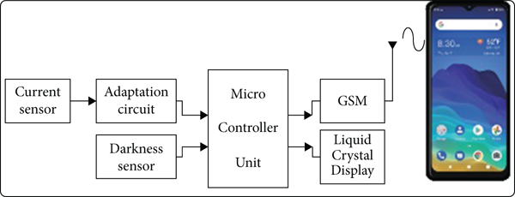
- Central Monitoring System: The collected data is transmitted to a centralized platform or cloud-based system for storage, processing, and analysis. The central monitoring system provides a user-friendly interface for administrators to monitor streetlight status, access real-time data, and control the system remotely.

Figure 3.1: Block diagram of the proposed wirelessly diagnostic system
3.5 Advantages of the Proposed System
The proposed Streetlight Monitoring System using IoT offers several advantages over existing systems:
- Energy Efficiency: The system employs intelligent control algorithms to optimize energy usage by adjusting lighting levels based on real-time conditions and demand. This results in significant energy savings and reduced operational costs.
- Real-time Monitoring and Control: The proposed system provides real-time monitoring of streetlight operations, allowing administrators to promptly respond to changing conditions, adjust lighting parameters, and address any issues remotely.
- Cost-effectiveness: Although initial implementation costs may be involved, the long-term benefits, including energy savings, reduced maintenance costs, and improved operational efficiency, make the proposed system cost-effective in the long run.
3.6 Components Required
Table 4.1 indicates the components required for this project work.
Table 4.1: Components Required
Components Name | Quantity
Nodemcu Microcontroller | 1
IR Sensor | 4
USB Cable | 1
LED | 5
LDR | 1
Resistor | 1
PCB Board | 1
9V Power Supply | 1
Wires
Solar Panel | 1

3.6.1 NODEMCUESP8266
The ESP8266 is a low-cost System-on-a-Chip (SoC) with complete TCP/IP capabilities, enabling IoT panels to connect to the web and providing independent Wi-Fi. It is based on the NodeMCU, an open-source software and hardware development environment, and requires low-level machine instructions. NodeMCU is an open-source programming environment based on the ESP8266, an affordable SoC from Espressif Systems. It includes a CPU, RAM, Wi-Fi, and modern operating system, making it ideal for IoT projects.

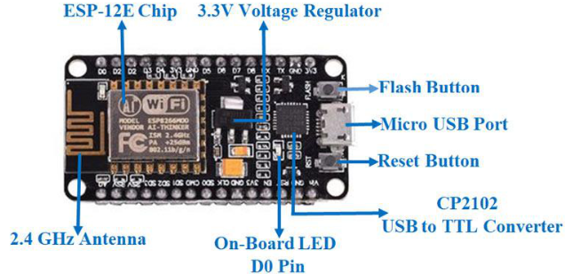

Figure 3.2: WiFi module ESP8266
3.6.2 LDR sensor
A device that senses light is known as an LDR Sensor (Figurer 4.4). It has varying resistance depending on how much light is incident upon it. Light-sensitive electronics known as Light Dependent Resistors (LDR) are widely used to determine if light is present or absent as well as its intensity. The LDR perceives and measures sunlight for the CPU, which then transmits data about its intensity.
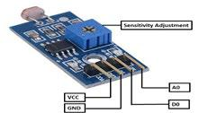

Figure 3.3: Light Dependent Resistor (LDR) sensor
3.6.3 Relay Board
Relay boards are computer boards with various relays and switches that manage voltage supply and have input and output terminals. They can be programmed and controlled in real time. Relays are electrical switches that can be activated by turning a switch ON or OFF, allowing current flow. Low voltages, like 5V supplied by NodeMCU pins, make controlling relay modules as easy as controlling any other output.
Relays are reliable, long-lasting, and resembling remote control switches. They come in various types, including pneumatic and hydraulic ones, and are connected to electrical circuits. They perform two main tasks: high voltage in one application and low voltage in the other, with low voltage applications focusing on reducing circuit noise and high voltage applications reducing arcing.
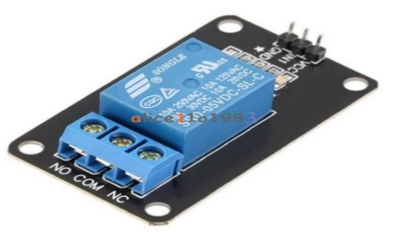

Figure 3.4: Relay Board
3.6.4 Bulb
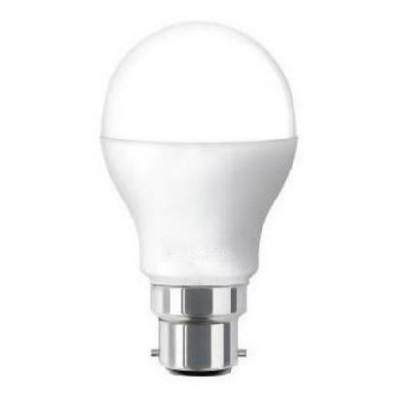
LEDs use significantly less energy than incandescent lights due to their power-efficient diode light, with over 75% less energy consumption. Additionally, LEDs have a lower "hassle factor" compared to conventional bulbs.

Figure 3.5: Bulb

3.6.5 IR Sensor
An infrared sensor uses infrared radiation to detect and emit environmental properties, determine object temperature, and detect motion. It detects heat radiation that changes in space and time within a specific angle range, covering the infrared spectrum from 0.75 to 1000 m. An infrared sensor uses infrared radiation to detect and emit environmental properties, determine object temperature, and detect motion. It detects heat radiation that changes in space and time within a specific angle range, covering the infrared spectrum from 0.75 to 1000 m.

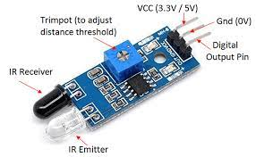

Figure 3.6: Light Dependent Resistor (LDR) sensor
3.6.6 Resistor
A resistor is an electrical component that regulates the flow of current in an electronic circuit, providing specific voltage for an active device like a transistor.


Figure 3.7: Resistor
3.6.7 Light-Emitting Diode (LED)
Light-emitting diode (LEDS) are widely used in electrical equipment, ranging from mobile phones to large advertising billboards, for time and data display in devices like mobile phones and billboards.


Figure 3.8: LED
3.6.8 Solar Panel
Solar panels, composed of photovoltaic cells arranged in a grid-like pattern, convert sunlight into electricity or heat through the photovoltaic effect.
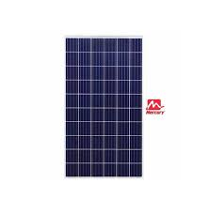

Figure 3.9: Solar Panel
3.6.9 Printed Circuit Board (PCB)
A printed circuit board (PCB) is an electronic assembly that uses copper conductors to create electrical connections between components, providing mechanical support for devices in enclosures. It's a non-conductive material with printed or etched conductive lines.
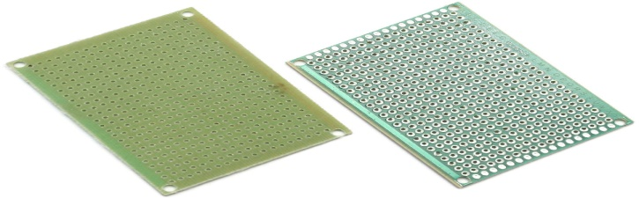

Figure 3.10: PCB Board
3.7 Software Required
3.7.1 Arduino Sketch Programming
Arduino sketch programming is the creation of software for Arduino microcontrollers using the Arduino IDE, enabling various electronic projects from simple LED lights to complex robotic systems.The Arduino platform is especially popular among beginners, educators, hobbyists, and professionals due to its ease of use, versatility, and extensive community support. Arduino sketch programming involves writing code that runs on an Arduino microcontroller. The Arduino IDE offers a user-friendly platform for creating, compiling, and uploading code to the Arduino board, using a simplified version of C++ programming.
3.7.2 Blynk Mobile Application
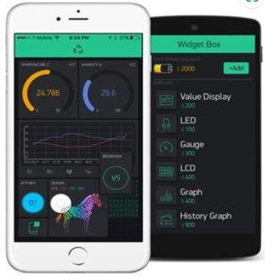
Blynk is an iOS or Android platform that enables remote operation of Arduino, Raspberry Pi, and NodeMCU devices, allowing users to create graphical or HMI interfaces using widgets.

Figure 3.11: Blynk Mobile Apps

3.7.3 Thingspeak
ESP8266 Thingspeak is an IoT platform service that enables the analysis of live data streams in the cloud. It's an open-source utility and API that facilitates record acquisition and retrieval via hypertext transfer and MQTT protocols. ThingSpeak supports sensor-based work programs, location tracking packages, and status updates.
3.8 Flowchart of Smart Streetlight System
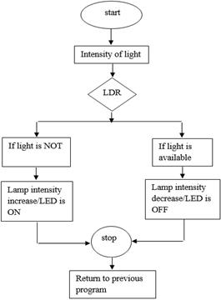

Figure 3.12: Flowchart of working system

CHAPTER FOUR
DESIGN, IMPLEMENTATION AND DOCUMENTATION OF THE SYSTEM

4.1 Introduction
Street lights are crucial in cities and highways to prevent accidents and thefts, but they consume 25-30% of the city's total energy, despite their widespread installation. The project aims to create a "Smart Street light system" that reduces electric power consumption by adjusting the intensity of street lights based on vehicle or human movement, thereby reducing the amount of electricity consumed. This system automatically turns on street lights in the evening and day, saving electricity and money, which can be used to light up homes in rural areas by automatically turning on lights during sunlight.
4.2 Design of the System
This lighting control system's user interface is an integrated platform that allows for remote management and control of the lighting fixtures. Its operations are contained in the command center's hardware. The user can take control and disable automatic control by using the user-friendly interface. A system is made up of a number of parts, each of which serves a specific purpose. The components make up the entire system when they are connected to one another. Input, controller, and output are common components of microcontroller systems. This smart street light controller uses a microcontroller as the controller, a light sensor as the input, and a bulb powered by a transistor that is relay-isolated from the main circuit as the output.

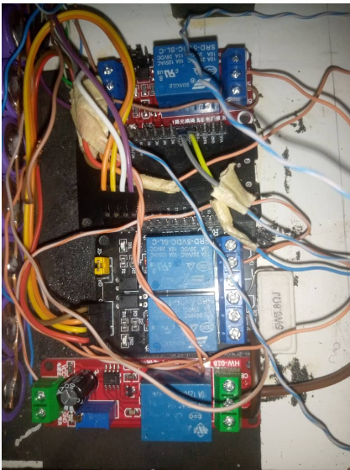

Figure 4.1: Prototype of the IoT- Based Smart Street Light System
4.2.1 Smart Street Light Circuit Diagram and Working
Figure 4.2 depicts the circuit diagram for this Internet of Things-based Smart Street Light. LDR sensor, IR sensor, LEDs, and ESP8266 make up the majority of this circuit. To determine whether it is day or night, an LDR sensor is employed. The LDR sensor must be linked similarly to a potentiometer since it produces changing resistance depending on the amount of light that strikes it. The LDR sensor has two connections: one end to 5V and the other to a fixed resistance that is further connected to ground. According to the circuit design, the NodeMCU's single ADC pin (A0) is linked to a place where a fixed resistance and one end of an LDR sensor meet. Due to the varied resistance the LDR sensor exhibits, fluctuating voltage will be produced at A0 in accordance with the amount of light hitting the LDR.
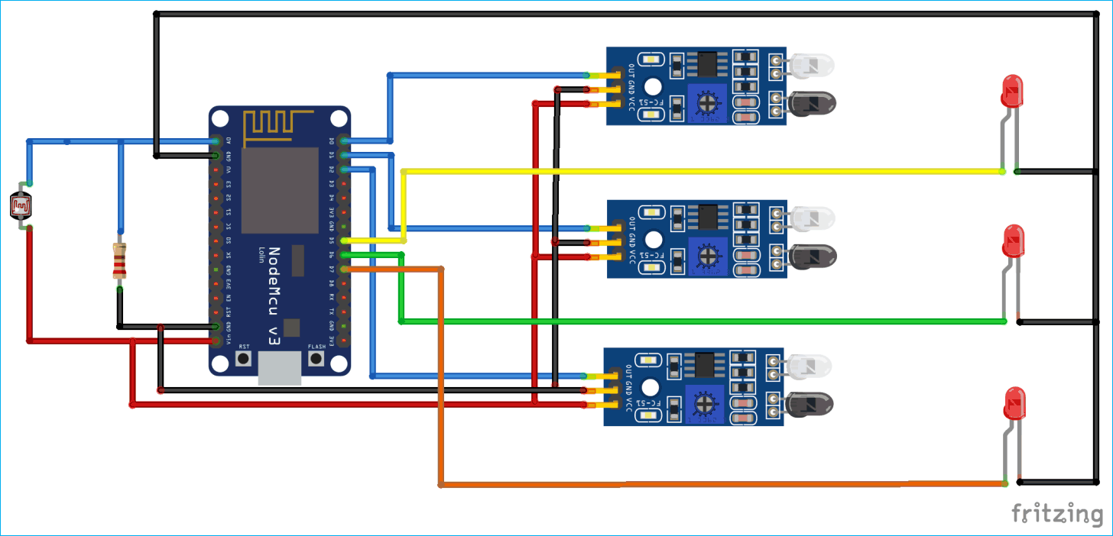

Figure 4.2 Circuit diagram for this IoT based Smart Street Light System
4.2.2 Output Design
The output to the proposed system refers to the result produced the proposed system. The output is as follows
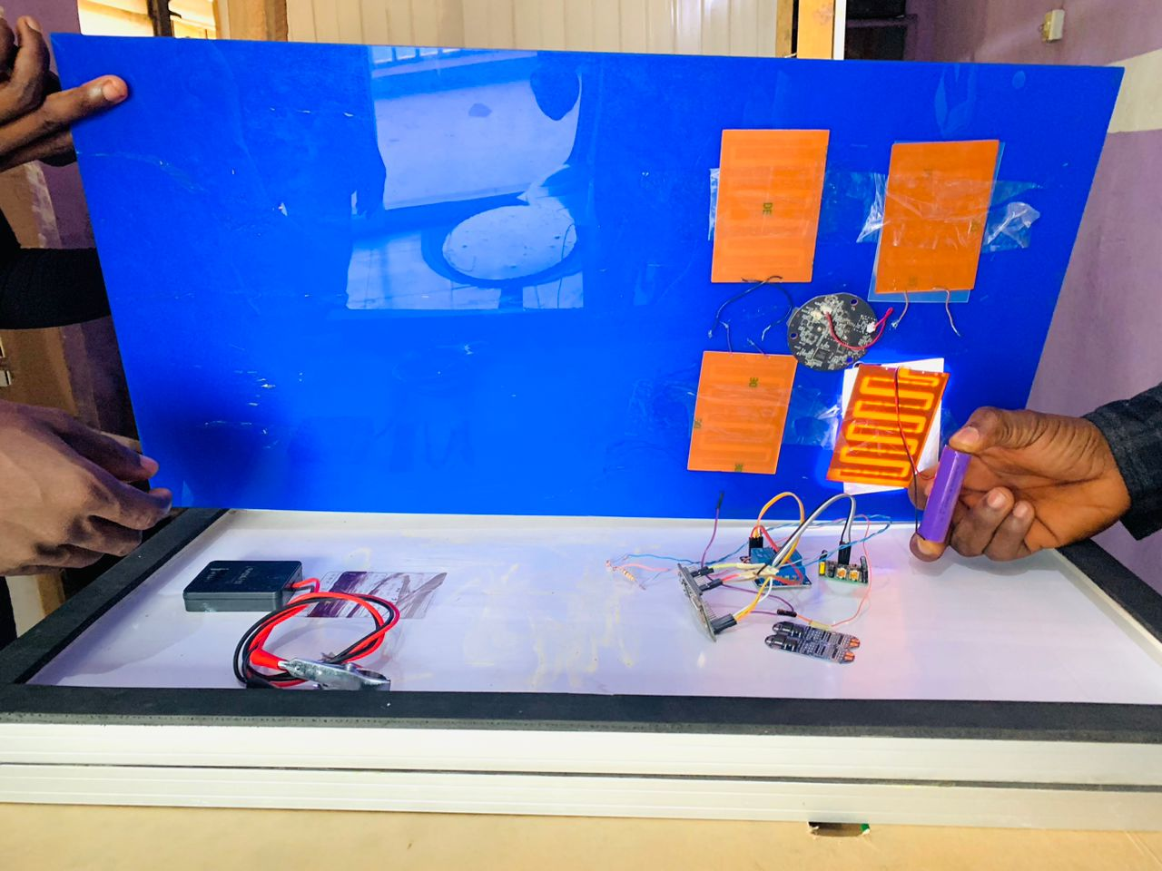
Figure 4.3: Testing the Led Bulb

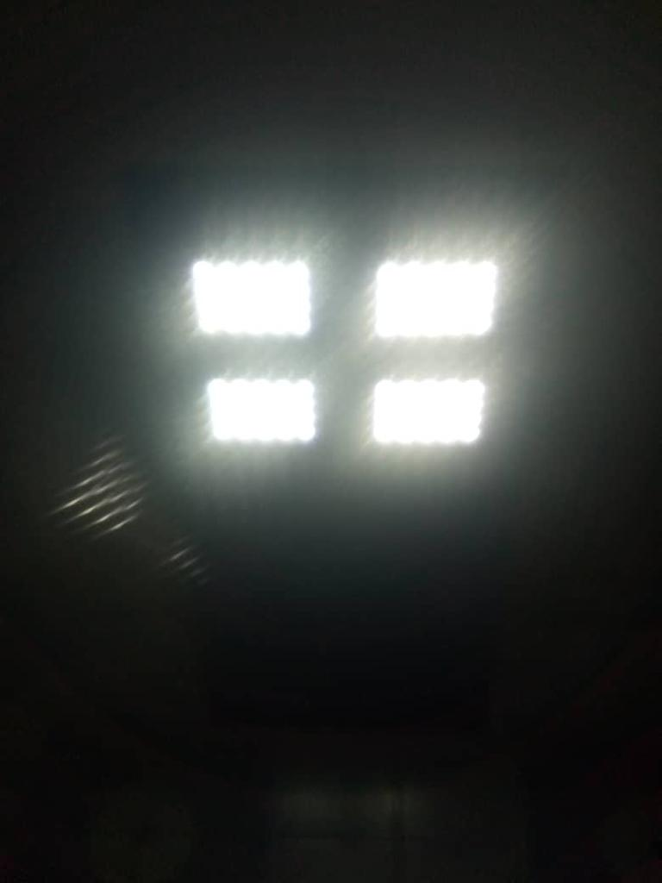
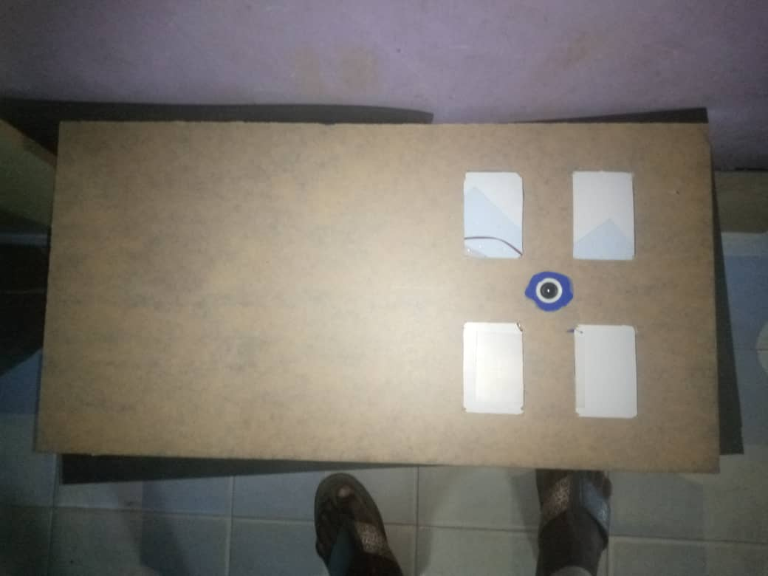
Fig 4.4: Led Bulb ON

Fig 4.5: Led Bulb OFF
In modern times, a smart city infrastructure's key component is a smart street light system. The crucial role of sensors is to light up city streets while conserving power or current.Using standard street lamps with the current system. It costs more and consumes more current. Use LED lighting instead to conserve current by using little power. Worldwide, IoT systems are being used. It was once used to monitor all kinds of urban areas. With this smart street light system, energy efficiency is good. It provides greater reliability while lowering costs. This diagram includes a power system, light, and sensor. The vehicles are sensed and responded to using this design. In this figure, sensors are used to control the street lights. Data is obtained from the object. When a vehicle is detected by a sensor, the lights turn on automatically, the thing moved away from sensors, causing the lights to turn off. This diagram shows how the Smart Street Lighting System operates. Street lights turn on automatically when sensors detect the presence of items or moving vehicles. When an object crossed a sensor, the lights turned off. It is employed in order to conserve energy.
4.2.3 Input Design
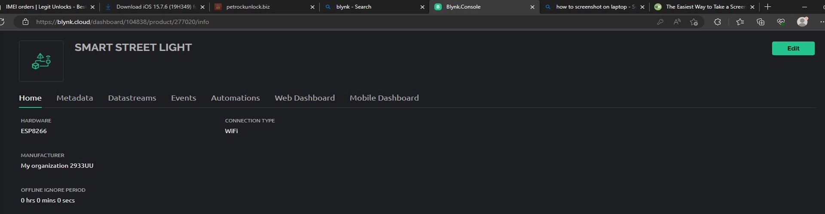

Input design converts user-oriented inputs into computer-based formats, preventing errors in data processing due to inaccurate data. It aims to make data entry simple, logical, and error-free. The system is driven by menus and is effective for designing interactive content, helping users understand choices and preventing incorrect decisions. Each entrance screen is interactive, considering end-user limitations.
Figure 4.6: Home Page Design for Blynk

Some other features included are
- The form title clearly states the purpose of the form
- Adequate space is given for data entry
Home Page: The control app was built using the online app builder provided by MIT app inventor. The app reads data from the thingspeak channel to know the status of each components and sensors analyses the data, and send a return command at the will of the user
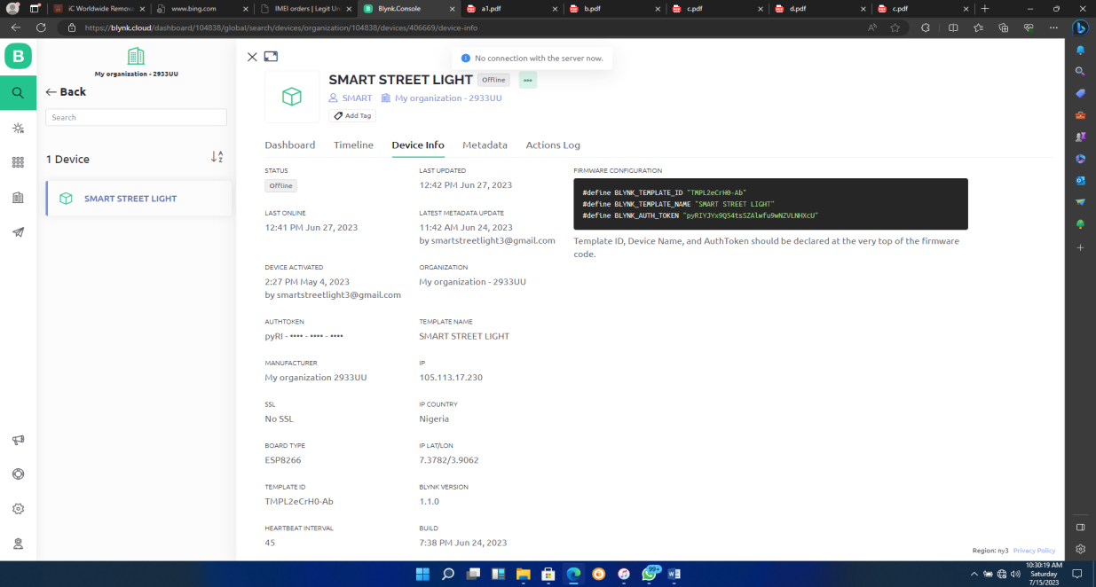
Figure 4.7: Blynk - Web Dashboard

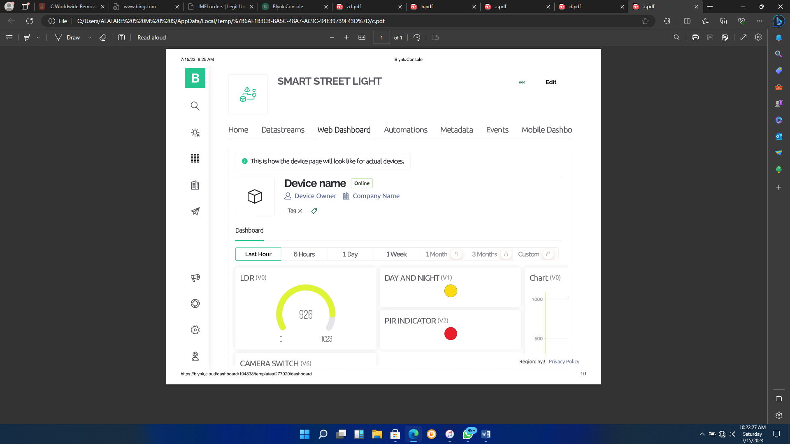
Figure 4.8: Blynk- Device information

The proposed system's output design shows streets filled with atmospheric light, with all streetlights turned off, resulting in bright ambient light and idle motion status in Fig 4.8.
4.2.4 Connecting the Light Dependent Resistor (LDR)
The LDR pins are connected by connecting one of the pins to a 10K ohms resistor to the ground, the second pin was connected to 5V terminal. The node between the 10k resistor and the pin of the LDR was connected to one of the analog port (A1) of the Arduino board to receive signal from the LDR. The signal is processed by the microcontroller to give instructions to the LEDs.
4.2.5 Connecting ESP8266 WI-FI Module
The ESP8266's VCC and GND pins are connected to 3.3V and GND of Arduino, while Tx and Rx pins are connected to pins 2 and 4. The Software Serial Library enables serial communication for Wi-Fi module data transmission to the cloud.
4.2.6 Connecting the Current Sensor
The current sensor VCC and GND pins are connected directly to the 5V and GND, while the output was connected to the analog pin of the Arduino board to receive signal/input from the sensor. The wire IN and OUT of the current sensor was connected in series to the LED2 output pin and the LED, to capture the current flowing through it.
4.3 Software testing
Software testing is a critical phase in the software development life cycle that ensures the quality and reliability of a software application. It involves systematically evaluating a software system to identify and rectify defects or issues. There are various levels and types of software testing, each serving a specific purpose.

CHAPTER FIVE
CONCLUSION
5.1 Summary
The development of Smart Street Light Monitoring Systems using Internet of Things (IoT) has yielded promising results in revolutionizing urban lighting infrastructure. This research has unveiled several key findings and implications. Firstly, the IoT-based system offers substantial energy efficiency gains. By leveraging real-time data from sensors like traffic density and ambient light levels, street lights can be dynamically adjusted, leading to significant energy savings and reduced operational costs. This not only benefits municipal budgets but also aligns with sustainability goals by reducing carbon footprints.
In conclusion, IoT-based Smart Street Light Monitoring Systems hold immense potential in transforming urban lighting networks. However, they also present challenges, such as cybersecurity and initial setup costs, which must be addressed. Future research should prioritize cybersecurity measures, explore integration with broader smart city initiatives, and investigate advanced technologies like machine learning and alternative energy sources for further improvements. Ultimately, these systems have the capacity to enhance sustainability, safety, and efficiency in urban environments while contributing to the broader goals of smart cities.
5.2 Conclusion
It is clearly seen from this project that streetlight can indeed be monitored and controlled remotely using Internet of Things. The data gotten from the sensors can be analyzed and used for prediction and decision making, which has greatly reduced man power and increased efficiency by reducing the time taking to process a fault or monitor the streetlights for its daily operations
In conclusion, the development of a Smart Street Light Monitoring System using the Internet of Things (IoT) represents a significant advancement in urban infrastructure management. This research has demonstrated the system's potential to revolutionize the way cities illuminate their streets, with key findings highlighting its benefits and areas for improvement. The implementation of IoT-based street lighting has showcased its remarkable energy efficiency. By utilizing real-time data and intelligent algorithms to adjust lighting levels, cities can realize substantial reductions in energy consumption and associated costs. This not only contributes to economic savings for municipalities but also aligns with sustainability objectives by reducing greenhouse gas emissions.
However, it is essential to acknowledge the challenges and areas for further research. Cybersecurity remains a critical concern, as the system's connectivity exposes it to potential threats. Robust security measures must be continuously developed and integrated to safeguard the integrity and functionality of the system. Additionally, cost considerations, including the initial setup expenses and ongoing maintenance, need to be addressed to ensure the system's viability for municipalities of all sizes and budgets. In terms of further research, exploration into integrating smart street lighting into broader smart city initiatives is crucial. This could lead to more seamless and efficient urban management. The incorporation of advanced technologies such as machine learning and alternative energy sources like solar panels could also enhance the system's capabilities and sustainability.
5.3 Recommendations
Recommendations for the implementation and improvement of Smart Street Light Monitoring Systems using the Internet of Things (IoT) are essential for optimizing their functionality and realizing their full potential in urban environments:
- Enhance Cybersecurity Measures: Strengthen cybersecurity protocols to protect the system from potential cyber threats and unauthorized access. Continuous monitoring and updates are necessary to ensure the system's integrity and data security.
- Community Engagement: Involve residents and stakeholders in the decision-making process and communicate the benefits of smart street lighting. Public support and feedback are essential for successful implementation and acceptance.
- Expand Coverage: Consider expanding the coverage of smart street lighting systems to cover larger urban areas and underserved communities. Assess the scalability of the infrastructure to accommodate the growing demands of cities.
- Regulatory Compliance: Ensure compliance with local regulations and standards related to lighting, data privacy, and environmental impact. Adhering to legal requirements will prevent potential legal and regulatory challenges.

REFERENCES
Abinaya B., Gurupriya S. & Pooja M., (2017). “IOT based smart and adaptive lighting in street lights”, 2nd International Conference on Computing and Communications Technologies (ICCCT).
Aji G. P., Maman A., Doan P. & Hilal H. N. Machine Learning Methods in Smart Lighting Toward Achieving User Comfort: A Survey. IEEE Access, 2022, vol 10, pp. 45317 - 45178. DOI:10.1109/ACCESS.2022.3169765.
Archana G., Aishwarya N., & Anitha J. (2015). Intelligent Street Light System‖. International Journal of Recent Advances in Engineering & Technology, Vol-3,
Chaohua W.U., Yunfei L.I., & Jianfeng Y. (2018). Design of streetlight control system based on nb-iot. Modern Electronics Technique, 41 (24). pp. 5-9
Chew I., Karunatilaka D., Tan C. P. & Kalavally V. (2017). Smart lighting: The way forward? Reviewing the past to shape the future. Energy Buildings, vol. 149, pp. 180 191, Aug. 2017.
Cui L., Yang S., Chen F., Ming Z., Lu N., & Qin, J. (2018). A survey on application of machine learning for Internet of Things. Int. J. Mach. Learn. Cybern., vol. 9, no. 8, pp. 1399 1417, Aug. 2018.
DeBeer A.S., Emleh A., Ferreira H.C., & Vinck A.H. (2013). Effects of LED lamps on the power-line communications channel 2013 IEEE 17th International Symposium on Power Line Communications and Its Applications, IEEE pp. 209-213 (March).
Füchtenhans M., Grosse E. H., & Glock C. H. (2021). Smart lighting systems: State-of-the-art and potential applications in warehouse order picking. Int. J. Prod. Res., vol. 59, no. 12, pp. 3817 3839.
Geisz. J.F., France. R.M., Schulte. K.L., Steiner. M.A., Norman,. A.G., Guthrey, H.L., & Moriarty. T. (2020). Six-junction III–V solar cells with 47.1% conversion efficiency under 143 Suns concentration, Nat. Energy 5(4) 326–335.
Mora H., Peral J., Ferrandez A., Gil D., & Szymanski J. (2019). Distributed architectures for intensive urban computing: A case study on smart lighting for sustainable cities. IEEE Access, vol. 7, pp. 58449 58465.

APPENDIX
Source Code
#define BLYNK_TEMPLATE_ID "TMPL2eCrH0-Ab"
#define BLYNK_TEMPLATE_NAME "SMART STREET LIGHT"
#define BLYNK_AUTH_TOKEN "pyRIYJYx9Q54tsSZAlwfu9wNZVLNHXcU"
#define BLYNK_PRINT Serial
#include <ESP8266WiFi.h>
#include <BlynkSimpleEsp8266.h>
char auth[] = BLYNK_AUTH_TOKEN;
char ssid[] = "David"; // Enter your Wifi Username
char pass[] = "homeiot123"; // Enter your Wifi password
// $$$$$$$$$$$$$$$$$$$$$$$$$$$$$$ PIR $$$$$$$$$$$$$$$$$$$$$$$$$$$$$
int PIR_SENSOR = D2; // output of PIR sensor VCC TO 5V
const int LDR_RELAY = D0;
const int PIR_RELAY = D1;
int LDR_Threshold = 500;
/£££££££££££££££££££££££££ LDR ££££££££££££££££££££££££££££££££
int sensorValue = analogRead(A0);
// print out the value you read:
Serial.println(sensorValue);
if (sensorValue <= LDR_Threshold) // reading PIR output sensor
{
led1.off();
Serial.println("DUSK");
digitalWrite(LDR_RELAY, LOW); // setting LDR_RELAY to high
}
if (sensorValue >= LDR_Threshold) // reading PIR output sensor
{
led1.on();
Serial.println("DAWN");
digitalWrite(LDR_RELAY, HIGH); // setting LDR_RELAY to high
}
//£££££££££££££££££££££££££££££ PIR £££££££££££££££££££££££££££
if ((digitalRead(PIR_SENSOR) == HIGH)and (sensorValue <= LDR_Threshold)) // reading PIR output sensor
{
Serial.println("PIR,LIGHT ON");
digitalWrite(PIR_RELAY, LOW); // setting LDR_RELAY to high
led2.on();
}
else
{
digitalWrite(PIR_RELAY, HIGH); // setting LDR_RELAY to low
Serial.println("scanning");
led2.off();
}
Blynk.virtualWrite(V0, sensorValue);
Blynk.run();
}
#define BLYNK_TEMPLATE_ID "TMPL2eCrH0-Ab"
#define BLYNK_TEMPLATE_NAME "SMART STREET LIGHT"
#define BLYNK_AUTH_TOKEN "pyRIYJYx9Q54tsSZAlwfu9wNZVLNHXcU"
#define BLYNK_PRINT Serial
#include <ESP8266WiFi.h>
#include <BlynkSimpleEsp8266.h>
char auth[] = BLYNK_AUTH_TOKEN;
char ssid[] = "David"; // Enter your Wifi Username
char pass[] = "homeiot123"; // Enter your Wifi password
// $$$$$$$$$$$$$$$$$$$$$$$$$$$$$$$$$ PIR $$$$$$$$$$$$$$$$$$$$$$
const int LDR_RELAY = D0;
const int PIR_RELAY = D1;
const int PIR_SENSOR = D2; // output of PIR sensor VCC TO 5V
const int CAM_RELAY = D3;
int LDR_Threshold = 500;
//int Switch_Delay = 5000;
WidgetLED led1(V1);
WidgetLED led2(V2);
void setup() {
pinMode(PIR_SENSOR, INPUT);// setting PIR output as arduino input
// $$$$$$$$$$$$$$$$$$$ CHANNELS RELAY $$$$$$$$$$$$$$$$$$$$$$$$
pinMode(PIR_RELAY, OUTPUT);
pinMode(LDR_RELAY, OUTPUT);
pinMode(CAM_RELAY, OUTPUT);
digitalWrite(LDR_RELAY, HIGH);
digitalWrite(PIR_RELAY, HIGH); // setting LDR_RELAY to low
digitalWrite(CAM_RELAY, HIGH); // setting LDR_RELAY to low
Serial.begin(115200);
Blynk.begin(auth, ssid, pass);
}
void loop()
{
//£££££££££££££££££££££££££££££ LDR £££££££££££££££££££££££££££££
int sensorValue = analogRead(A0);
// print out the value you read:
Serial.println(sensorValue);
if (sensorValue <= LDR_Threshold) // reading PIR output sensor
{
led1.off();
Serial.println("DUSK");
digitalWrite(LDR_RELAY, LOW); // setting LDR_RELAY to high
}
if (sensorValue >= LDR_Threshold) // reading PIR output sensor
{
//£££££££££££££££££££££££££££££ PIR ££££££££££££££££££££££££££££££
if ((digitalRead(PIR_SENSOR) == HIGH) and (sensorValue <= LDR_Threshold)) // reading PIR output sensor
{
Serial.println("PIR,LIGHT ON");
digitalWrite(PIR_RELAY, LOW); // setting LDR_RELAY to high
led2.on();
}
else
{
digitalWrite(PIR_RELAY, HIGH); // setting LDR_RELAY to low
Serial.println("scanning");
led2.off();
}
Blynk.virtualWrite(V0, sensorValue);
Blynk.run();
}
/*
AnalogReadSerial
Reads an analog input on pin 0, prints the result to the Serial Monitor.
Graphical representation is available using Serial Plotter (Tools > Serial Plotter menu).
Attach the center pin of a potentiometer to pin A0, and the outside pins to +5V and ground.
This example code is in the public domain.
https://www.arduino.cc/en/Tutorial/BuiltInExamples/AnalogReadSerial
*/
// the setup routine runs once when you press reset:
void setup() {
// initialize serial communication at 9600 bits per second:
Serial.begin(9600);
}

