DESIGN AND IMPLEMENTATION OF A SECURE MEDICAL RECORD AND MANAGEMENT SYSTEM USING CRYPTOGRAPHY

BY
OLAWUYI BASHIT OLAMIDE
ND/23/COM/PT/0140

A Project Submitted to the
Department of Computer Science,
Institute of Information and Communication Technology
Kwara State Polytechnic, Ilorin

In Partial Fulfillment of the Requirements for the award of National Diploma (ND) in Computer Science

July, 2025
CERTIFICATION
This is to certify that this project was carried out by OLAWUYI BASHIT OLAMIDE with matriculation number ND/23/COM/PT/0140 as part of requirement for the award of National Diploma (ND) in the department of Computer Science.

------------------------------------- ----------------------
MR SAKA T. O. Date
(Project Supervisor)

--------------------------------- ----------------------
MR OYEDEPO F.S. Date
(Head of Department)

----------------------------------- ---------------------
External Supervisor Date

DEDICATION
I dedicate this project to Almighty God who's protect me, guide me through this work a big thanks to Almighty God.

ACKNOWLEDGMENT
All praise is due to Almighty God for His grace, guidance, and strength throughout the course of this project. I am profoundly grateful to numerous individuals and institutions whose support and contributions were vital to the successful completion of this work.
Foremost, I extend my sincere appreciation to Mr. Saka T. O. whose exceptional guidance, expertise, and unwavering support were instrumental in navigating the complexities of this research. His valuable insights and constructive feedback greatly shaped the direction and quality of this project. I am deeply thankful to my parents, Mr. and Mrs. Olawuyi, for their constant encouragement, prayers, and moral support throughout this journey. Their words of wisdom and emotional backing kept me focused and motivated during challenging periods. My heartfelt appreciation also goes to my entire family and friends, whose patience and uplifting presence provided strength and inspiration at every stage of this endeavor.
I would also like to acknowledge the Head of the Department of Computer Science, Mr. Oyedepo F. S., along with other dedicated staff members of the department. Their insightful critiques and academic support were invaluable in refining the scope and content of this work.
Lastly, I am sincerely grateful to all the participants and respondents who willingly provided their time, data, and perspectives for this research. Their contributions played a crucial role in the empirical validation and practical relevance of this study.

ABSTRACTS
The successful storage, manipulation and retrieval of electronic medical records are some of the important functions of Electronic-Health Record (EHR) Systems. More so, the confidentiality and integrity of health information is of paramount importance to healthcare management organizations. Unfortunately, the occurrence of information security breaches with regards to EHR, which include loss of valuable data as a result of theft by unauthorized users, is increasingly becoming worrisome situations. Furthermore, these security challenges have led to cases of intentional or unintentional disclosure of vital patients’ information among others. Interestingly, previous studies attempted to implement secure systems in domains like finance, communication and commerce using asymmetric or visual cryptography. However, based on reviewed literatures, this security techniques are yet to be combined and applied as worthwhile approach to address authorization challenges in the EHR domain. Thus, a prototype web-based e-health record system was developed and combination of asymmetric and visual cryptographies were incorporated into the system as authorization mechanism to ensure confidentiality and integrity of pertinent health information. Subsequently, the fortified E-health record system provided important functionalities of a typical EHR record system, as well as prevent unauthorized users from accessing vital information.

TABLE OF CONTENTS
PAGE
TITLE PAGE i
CERTIFICATION ii
DEDICATION iii
ACKNOWLEDGEMENT iv
ABSTRACTS v
TABLE OF CONTENTS vi
CHAPTER ONE: GENERAL INTRODUCTION
1.1 BACKGROUND TO THE STUDY 1
1.2 STATEMENT OF THE PROBLEM 3
1.3 AIM AND OBJECTIVES 4
1.4 SIGNIFICANT OF THE STUDY 4
1.5 SCOPE AND LIMITATION 4
1.6 ORGANIZATION OF REPORT 5
CHAPTER TWO: LITERATURE REVIEW
2.1 REVIEW OF RELATED PAST WORKS 6
2.2 ELECTRONICS HEALTH INFORMATION PRIVACY AND SECURITY8
2.2.1 THREATS TO HEALTH INFORMATION PRIVACY 9
2.2.2 MODERN HEALTH INFORMATION SECURITY 11
2.3 CRYPTOGRAPHY TECHNIQUES 13
2.4 CRYPTOGRAPHY ALGORITHMS 15

CHAPTER THREE: RESEARCHMETHODOLOGY AND ANALYSIS OF THE EXISTING SYSTEM
3.1 RESEARCH METHODOLOGY 18
3.2 ANALYSIS OF THE EXISTING SYSTEM 19
3.3 DESCRIPTION OF THE EXISTING SYSTEM 19
3.4 DESCRIPTION OF THE PROPOSED SYSTEM 20
3.5 ADVANTAGES OF THE PROPOSED SYSTEM 20
CHAPTER FOUR: DESIGN, IMPLEMENTATION AND DOCUMENTATION OF THE SYSTEM
4.1 DESIGN OF THE SYSTEM 21 4.1.1 OUTPUT DESIGN 21 4.1.2 INPUT DESIGN 22 4.1.3 DATABASE DESIGN 23
4.1.4 PROCEDURE DESIGN 23
4.2 IMPLEMENTATION OF THE SYSTEM 4.2.1 CHOICE OF PROGRAMMING LANGUAGE 24 4.2.2 HARDWARE SUPPORT 24 4.2.3 SOFTWARE SUPPORT 25 4.2.4 CHANGE OF TECHNIQUE 25
4.3 DOCUMENTATION OF THE SYSTEM 26
4.3.1 PROGRAM DOCUMENTATION 26 4.3.2 OPERATING THE SYSTEM 27 4.3.3 MAINTAINING THE SYSTEM 27
CHAPTER FIVE: SUMMARY, CONCLUSION AND RECOMMENDATION
5.1 SUMMARY 28
5.2 CONCLUSION 28
5.3 RECOMMENDATION 29
REFERENCES
FLOWCHAT
SOURCE CODE
CHAPTER ONE
GENERAL INTRODUCTION
1.1 BACKGROUND TO THE STUDY
Medical Record and Management Systems Society defines electronic health record (EHR) as “a secure, real-time, point-of-care, patient centric information resource for clinicians” (HIMSS, 2020). EHR is on the verge of receiving widespread adoption as an instrument for improving the understanding of the state of health of individuals as it contains useful, legal and computerised historical health data from a variety of sources. Over time, a patient’s EHR accumulates significant information, such as identifying information, hospital visitations, laboratory data, surgery, radiology reports, allergies, vital signs, immunisations, prescriptions, sexual preference, psychological profiles, physician progress notes and among other relevant data that defines a medical record (Mercuri, 2018; Tiwari and Kumar, 2021). The importance of these data to healthcare providers, patients and cybercriminals made it necessary that the EHR designs be responsible for securing patients’ personal data, health records and managing the access rights to them (IMIA, 2020; Brumen et al., 2021; CTI, 2022).
Recently, technology faces various modes of intrusion which include; the integration of incorrect data or destructive programs into information systems, theft resulting to loss of important data or programs from a system and overall takeover and manipulation of a system's set-up and performance. Usually, hackers carryout these security breaches as a means of satisfying their own agenda. More so, criminals use it to improve their own interests, as well as commercial organizations that utilize it as mechanisms for neutralizing rivals or terrorists whose attacks can spread over a wide geographical range, eventually producing related effects irrespective of the criminal (Onuiri, Idowu, &Komolafe, 2020). In several studies, patients’ participation has been identified as crucial to manage records, because patients’ growing concern over the privacy and security of their personal and sensitive data stored in EHR has been a contributing factor to the slow adoption of this technology (Escarfullet et al., 2021; Dinev et al., 2020). Based on a survey report, 73% of information privacy and security issues reported by health organization over the years involved electronic data (Hewapathiranae, 2019). Studies have shown that millions of patient records have been breached and are at the risk in the hands of malicious users (Robertson, 2018; Harris, 2020). In the USA alone, since 2005, more than 300 data breaches in which 100,000 or more records were compromised have been publicly disclosed in the health industry (Collins and Robertson, 2021). Also, since 2009, the annual number of cyber-attacks against the healthcare sector has drastically increased; often the number of attacks exceeds the previous year’s count by at least 40% (ICIT, 2020). Similarly, more often than expected, the majority of threats that healthcare organisations face are internal among other sources of threats (Gordon et al., 20120). With inside attacks either continuously outnumbering or being the leading cause of external threats, most research still paid more attention to outsiders. The cost of privacy and confidentiality breaches is very difficult to recover for both the healthcare provider and patient (Appari and Johnson, 2022).
Asymmetric cryptography otherwise known as public key cryptography is a data security technique, which uses two distinct keys in cryptographic process. Unlike symmetric cryptography that uses same key for encryption and decryption, asymmetric process includes generations of the two distinct keys (private and public) from complex mathematical algorithm. The public key is made available to all message senders for encryption purpose, whereas, the private key is reserved as secret and only known to the receiver (owner of the public key) for message decryption. While key generation is faster with symmetric cryptography, the reverse is the case with asymmetric cryptography. Nevertheless, safeguarding a key from unauthorised user during transfer among legitimate users is the main setback for symmetric cryptography, while such challenge does not arise in asymmetric cryptography.

1.2 STATEMENT OF THE PROBLEM
Information security issues with regards to Electronic-Health Records (EHR’s) is increasingly becoming worrisome, this brings about the urgent need to mitigate these challenges so as to curb unauthorized manipulation, storage and retrieval of information, thereby, retaining required confidentiality, availability and integrity of the EHR’s. Otherwise, any interception or interruption, may result to issues such as inaccurate diagnosis and medication, and in the worst case, death.
For privacy reasons, patients at some point may be unwilling to disclose important information about some health problems such as psychiatric behaviour and HIV as their violation or disclosure may lead to social stigma, unfair treatment by employers and possibly irreversible damage to their professional reputation (Carroll, 2021). Privacy and security are crucial factors in electronic healthcare; cryptography is the science of information scrambling and it has been recommended to be used everywhere for ensuring privacy and security (Grunwel and Sahama, 2021). Through cryptography, a number of autonomous patients controlled health record systems have been proposed and were discussed in Omotosho and Emuoyibofarhe (2022). Cryptographic-based-EHR has become very popular but patients’ privacy could still be violated, if in a patient controlled system, encryption keys are not efficiently managed. Likewise, clinician work flow would be hampered, if in the course of ensuring privacy, health data are not available in decrypted form for authorised access. Therefore, this project develop a secure medical records system using cryptography.

1.3 AIM AND OBJECTIVES
The aim of this research work is to develop a secure medical records system using cryptography. In other to achieve this aim, the following specific objectives were formulated to:
- Design a secure system for a Medical Records System (MRS).
- Implement system developed in (i) using Cryptography Techniques.
- Evaluate the performance of secure Cryptography system in medical record.
1.4 SIGNIFICANCE OF THE STUDY
This system significantly provides a medium through which the privacy of a patient’s electronic healthcare record could be preserved by enhancing the security measures using cryptography on the EHR’s since they are sensitive to patients and their caregivers.
These techniques protect a secret key using cryptography feature or generate a key from cryptography features. There are two popular approaches to implement bio-cryptography: the key binding approach – which is the binding of cryptographic keys along with cryptography template and the key generating approach – which involves generating cryptographic keys from cryptography templates (Stavroulakis and Stamp, 2020; Scheirer et al., 2020; Das, 2021).
1.5 SCOPE OF THE STUDY
Modern encryption offers a powerful set of methods to guarantee information access for authorized users while thwarting the adversary's malicious objectives. There is a need data privacy in health record on unsecured channel. To solve the issue of information threats, several methods have been proposed in the area of systems security under information hiding and encryption (Cheddad, Condell, Curran, Mc Kevitt, 2020).

1.6 ORGANIZATION OF THE THESIS
The thesis is organized into five chapters. Chapter one gives the background to the study, statement of the problem to be addressed, the aim and the formulated objectives. It also discuss the scope of the study, the significance of the study, definitions of some necessary terms and organization of the report. Chapter two presents the review of related literature. A review security system in health record, and cryptography, the area of their applications, benefits, and the algorithms.
More so, chapter three focused on the methodology of the research, the proposed system,. The algorithm of cryptography with the advantages. Chapter Four presents the discussion of the results and evaluation of the system. Lastly, chapter five discussed the summary of findings, conclusions and some recommendations to improve the study.

CHAPTER TWO
LITERATURE REVIEW
2.1 REVIEW OF RELATED WORK
Harman et al., (2022) conducted systematic analysis of health management system. The authors highlighted numerous advantages of electronic system over manual approach to health management. Amongst others, the authors identified reduced storage space, physical security of records and delay in processing health information as major drawbacks of manual approach. However, the authors emphatically raised concern over security of patient information by healthcare handlers. Thus, Harman et al. (2021) suggested the use of encryption as a proactive countermeasure to ameliorate security of health information in terms of confidentiality for devices employed in processing and disseminating such crucial information. In a similar systematic review, Fernández et al., (2022) agreed with Harman et al. (2022) on the major benefits of E-Health management systems and the importance of encryption scheme, but emphasised the need for more concerted efforts to address emerging security and privacy threats, because access to E-health systems becomes ubiquitous among stakeholders.
Likewise, Onuiri et al. (2020), explored various cyberspace challenges with respect to safeguarding information, investigating cyberspace threats, identifying stakeholders and transmitting information in E-health record system. The authors opined the combination of cryptography and biometric authentication as mitigating strategy for threats associated with e-health systems. Empirically, Qureshi et al. (2021) studied the effect of E-health which comprised of Telemedicine and mobile health on distant or remote locations. Interestingly, the authors stated the important characteristics of a successful and useful e-health system to include user-friendliness, easy-to-use and well integrated functionalities, as well as a backup, tracking and alert facilities. The authors observed a tremendous shift in e-health adoption, but reported low adoption in developing countries due to inadequate information on e-health websites. Thus, Qureshi et al. (2020) proposed that a qualitative, secured and well-structured e-health system will enhance the operational efficiency and sustainability of the healthcare institutions.
Also, Hawkes, Yasinsac and Cline (2020) analysed the possibility of securing financial documents with visual cryptography. The authors developed an application named VCRYPT which was described as a quick and uncomplicated visual cryptography technique. The VCRYPT is meant for privacy protection when data transits between offices, thereby preserving the integrity of document. According to Hawkes et al. (2020), previous visual cryptography systems suffered from the decoded images having a greying-effect or the deciphered image being blurry and much obscurer than the original image. Consequently, the VCRYPT application addressed this problem and also reduced the computational impact. Furthermore, in order to enhance the performance of visual cryptography irrespective of domain of application, D’Arco and De Prisco (2021) proposed the deterministic and random grid models. However, the authors reported issues relating to contrast, pixel expansion and randomness reduction in both models.
Recently, Okkali and Sandikkaya (2022) applied visual cryptography to facial recognition in surveillance system for privacy preservation. The system employed facial characteristics of targeted person is concealed and split into n shares which are put into distinct storage areas and under the control of distinct entities. More so, Kester (2018) developed a visual cryptographic encrytption system for medical image using pixel shuffling procedure. The system used algorithm that shuffled the red, blue and green (RGB) values of a pixel using an encryption key generted from the image. However, the system is limited to medical image which is only one of the the file formats involved in a comprehensive e-health record system. Again, Kester (2022) used same key for both encryption and decryption, which could expose it to key theft, a known problem with symmetric key cryptography. Again, Sugiharto et al. (2021) developed a crypto system that is based on visual cryptography and Rivest, Shamir and Adleman (RSA) techniques for only image encryption and decryption. Thus, the use of asymmetry cryptography (RSA) by the authors eliminates issues relating to security of key, yet the study is limited to image cryptography.
Harman et al. (2021), focus on systematic review of visual cryptography in E-health management system without actual implementation of the security scheme in the domain. The studies revealed the stakeholders, core functions and security expectations of e-health record system. Although, D’Arco and De Prisco (2020) developed variants of visual cryptography mechanism towards performance improvement, but Sandikkaya (2021) applied the security techniques to other domains of human endeavour outside E-health record system. Perhaps, Kester (2022) was among few studies, which applied visual cryptography to medical image, an aspect of E-health record system, but used symmetric cryptography and covered only image. Similarly, Sugiharto et al. (2020) utilised asymmetric technique, but their study is limited to image, while text data and specific domain of application were not considered.
2.2 ELECTRONICS HEALTH INFORMATION PRIVACY AND SECURITY
Privacy is an underlying governing principle of the patient – physician relationship for effective delivery of healthcare. Patients are required to share information with their physicians to facilitate correct diagnosis and determination of treatment, especially to avoid adverse drug interactions. However patients may refuse to divulge important information in cases of health problems such as psychiatric behavior and HIV as their disclosure may lead to social stigma and discrimination (Applebaum 2017). Over time, a patient‘s medical record accumulates significant personal information including identification, history of medical diagnosis, digital renderings of medical images, treatment received, medication history, dietary habits, sexual preference, genetic information, psychological profiles, employment history, income, and physicians‘ subjective assessments of personality and mental state among others (Mercuri 2020).
Patient health records could serve a range of purposes apart from diagnosis and treatment provision. For example, information could be used to improve efficiency within healthcare system, drive public policy development and administration at state and federal level, and in the conduct of research to advance medical science (Hodge 2020). A patient‘s medical records are also shared with payer organizations such as insurance, Medicare or Medicaid to justify payment of services rendered by physicians. Healthcare providers may use records to manage their operations, to assess service quality, and to identify quality improvement opportunities. Furthermore, providers may share health information through a regional 4 health information organization to facilitate care services. Medical information of patients is also used for common good through federal and state government interventions regarding public health management, hospital accreditation, medical research, and for managing social and welfare systems.

2.2.1 THREATS TO HEALTH INFORMATION PRIVACY
Threats to patient privacy and information security could be categorized into two broad areas:
- Organizational threats that arise from inappropriate access of patient data by either internal agents abusing their privileges or external agents exploiting vulnerability of information systems, and
- Systemic threats that arise from an agent in the information flow chain exploiting the disclosed data beyond its intended use (NRC 2020).
- Organizational Threats: may assume different forms, such as an employee who accesses data without any legitimate need or an outside attacker (hacker) that infiltrates organization‘s information infrastructure to steal data or render it inoperable. At the outset, these organizational threats could be characterized by four components – motives, resources, accessibility, and technical capability (NRC 2020). Depending on these components, different threats may pose different level of risk to organization requiring different mitigation and prevention strategies. Motives could be both of economic or noneconomic nature. For some, such as insurers, employers, and journalists, patient records may have economic value, while others may have noneconomic motives such as a person involved in romantic relationship. These attackers may have resources ranging from modest financial backing and computing skills to a well-funded infrastructure to threaten a patient as well as the operations of a healthcare organization. The attackers may require different types of access to carry out their exploits, such as access to the site, system authorization, and data authorization (See table 1 for hypothetical examples for level of access). In addition, threats could depend on technical capability of attackers who may be novice or sophisticated programmers. Moreover, with the growing underground cyber economy (Knapp and Boulton 2020), an individual with the intent to acquire data and possessing adequate financial resources may be able to buy services of sophisticated hackers to breach healthcare data. Recent studies suggest that the broad spectrum of organizational threats could be categorized into five levels, in the increasing order of sophistication (NRC 2020; Rindfleisch 2020):
a. Accidental disclosure: healthcare personnel unintentionally disclose patient information to others, e.g. email message sent to wrong address or an information leak through peer-to-peer file sharing.
b. Insider curiosity: an insider with data access privilege pries upon a patient‘s records out of curiosity or for their own purpose, e.g. a nurse accessing information about a fellow employee to determine possibility of sexually transmitted disease in colleague; or medical personnel accessing potentially embarrassing health information about a celebrity and transmitting to media.
c. Data breach by insider: insiders who access patient information and transmit to outsiders for profit or taking revenge on patient.
d. Data breach by outsider with physical intrusion: an outsider who enters the physical facility either by coercion or forced entry and gains access to system.
e. Unauthorized intrusion of network system: an outsider, including former vengeful employees, patients, or hackers who intrude into organization‘s network system from outside and gain access to patient information or render the system inoperable.

- Systemic Threats: Etzioni (2022), in discussing the Limits to Privacy‘, makes a strong case that a major threat to patient privacy occurs not from outside of the information flow chain in healthcare industry but from insiders who are legally privileged to access patient information. For example, insurance firms may deny life insurance to patients based on their medical conditions, or an employer having access to employees‘ medical records may deny promotion, or worse, terminate employment. Patients and /or payer organizations may incur financial losses as a result of malpractices including upcoding of diagnoses, and rendering of medically unnecessary services. In summary, healthcare information systems could be subjected to security threats from one or more sources including imposter agents, unauthorized use of resources, unauthorized disclosure of information, unauthorized alteration of resources, and unauthorized denial of service (Win et al. 2021). Denial-of-service attacks via Internet worms or viruses, equipment malfunctions arising from file deletion or corrupted data, and the lack of contingency plans pertaining to offsite backup, data restoration procedures, and similar activities may also trigger HIPAA violations (Mercuri 2021).

2.2.2 MODERN HEALTH INFORMATION SECURITY
Modern healthcare systems are large networked systems managing patient data with a multitude of users accessing health data for diverse contextual purposes within and across organizational boundaries. Role Based Access Control (RBAC), originally developed to manage access to resources in a large computer network (Sandhu et al. 2016), is generally presented as an effective tool to manage data access in healthcare industry because of its ability to implement and manage a wide range of access control policies based on complex role hierarchies commonly found in healthcare organizations (Gallaher et al. 2021). This stream of research primarily focuses on developing algorithms and frameworks to facilitate role based information access, and contextual access control (Covington et al. 2020; Motta and Furuie 2021).
Schwartmann (2021) extends this stream of research by proposing an enhanced RBAC system that incorporates attributable roles and permissions. This enhanced system implementation is theorized to reduce the burden of managing access privileges by lowering extremely high number of permissions and roles to a manageable size and hence reducing administrative cost. In addition progress is being made in several fronts, including use of autonomous agents to create privacy-aware healthcare applications, authorization policy framework for peer-to-peer technology based distributed healthcare system, encrypted bar code technology framework for electronic transfer of prescription, pseudonymous linkage, and electronic consent models that allows patients to define which component of a medical record could be shared to whom (Nepal et al. 2020).
Despite significant progress in technological solutions to information access control, operationalization remains a major challenge (Lovis, et al. 2020). Healthcare organizations, because of the complex nature of data access for diverse purposes, often give broader access privileges and adopt ‗Break the Glass‘ (BTG) policy to facilitate timely and effective care, for example, report that 99% of doctors were given overriding privileges while only 52% required overriding rights on regular basis, the security mechanisms of health information systems were overridden to access 54% of patients‘ records. Another common pitfall of BTG policy is that such broad-based privileges could be misused by employees. To address these issues Bhatti and Grandison (2020), proposed a privacy management architecture (PRIMA) model that leverages artifacts such as audit logs arising from the actual clinical workflow to infer and construct new privacy protection rules. In particular, PRIMA implements a policy refinement module that periodically examines the access logs and identifies new policy rules using sophisticated data-mining techniques. These audit logs could, as well, be used by privacy officials to determine privacy violations, which in itself is a complex process and often requires merging data from disparate sources (Ferreira, et al. 2020). Unfortunately such data merging may cause potential disclosure of patients‘ sensitive information to the investigators against the patients‘ consent. In a related study, Malin and Arioldi (2021) developed a Confidential Audits of Medical Record Access (CAMRA) protocol to ensure privacy of patient‘s identity during such linking of disparate databases for comprehensive audit purpose without disclosing sensitive information.
2.3 CRYPTOGRAPHY TECHNIQUES
Now a day’s internet plays vital role in communication. Security is major issue while transferring data over internet. The steganography used to send secret data securely to another end. This paper includes review of different image steganography techniques. Every steganography technique has it own key features and limitations. Image steganography can hide secret text, image, audio or video inside cover image. This paper includes types of steganography, various steganography techniques like special domain, frequency domain, spread spectrum, masking and filtering and distortion (2022) KeywordsSteganography, Data hiding, Spatial domain, Frequency domain, Steganography review.
A new algorithm to hide data inside image using steganography technique that uses binary codes and pixels inside an image to maximize the storage of data inside the image is proposed.
In this paper, the authors propose a new algorithm to hide data inside image using steganography technique. The proposed algorithm uses binary codes and pixels inside an image. The zipped file is used before it is converted to binary codes to maximize the storage of data inside the image. By applying the proposed algorithm, a system called Steganography Imaging System (SIS) is developed. The system is then tested to see the viability of the proposed algorithm. Various sizes of data are stored inside the images and the Peak signal-to-noise ratio (PSNR) is also captured for each of the images tested. Based on the PSNR value of each images, the stego image has a higher PSNR value. Hence this new steganography algorithm is very efficient to hide the data inside the image.
A novel method is proposed to provide more security for the key information with the combination of image compression and data encryption method, which provides better security for encrypted data and no distortion in the image quality.
In this paper a novel method is proposed to provide more security for the key information with the combination of image compression and data encryption method. This method requires less memory space and fast transmission rate because of image compression technique is applied. Steganography plays an important role in information security. Since the rise of the Internet one of the most important factors of information technology and communication has been the security of information. It is the art of hiding the fact that communication is takes place, by hiding information in other information. Many different file formats can be used, but digital images are the most popular because of their frequency on the Internet. For hiding secret information in images, there exist a large variety of steganographic techniques some are more complex than others and all of them have respective strong and weak points. Many applications have different requirements of the steganography technique used. Some applications may use absolute invisibility of the secret information, but others require a larger secret message to be hidden. This method has been implemented and tested on varies images and data. It provides better security for encrypted data and no distortion in the image quality.
IMAGE STEGANOGRAPHY
As stated previously, images are considered the most popular file formats used in
steganography. They are known for constituting a non-causal medium, due to the possibility to access any pixel of the image at random. In addition, the hidden information could remain invisible to the eye. However, the image steganography techniques will exploit "holes" in the Human Visual System (HVS).
General Concepts Lossless compression is known for being preferable when the original data should stay inits entirety. In this manner, the original image information will never be removed, and this makes it possible the reconstruction of the original data from the compressed data. This is typical of images in GIF and BMP Lossy compression saves storage space by discarding the points the human eyes find difficult to identify. In this case the resulting image is expected to be something similar to the original image, but not the same as the original. JPEG compression uses this technique. A cover image is the image designated to carry the embedded bits or secret information.
- A stegokey image refers to the image carrying the hidden message
- A stegokey is secret information necessary to get the hidden message from the stego
image.
2.4 CRYPTOGRAPHY ALGORITHMS
There are some specific security requirements (Daemen, Rijmen and Vincent 2020) for cryptography, including Authentication, Privacy/confidentiality, and Integrity Non-repudiation. Figure 2.1 shows the cryptography system (Kumar and Sharma, 2020).

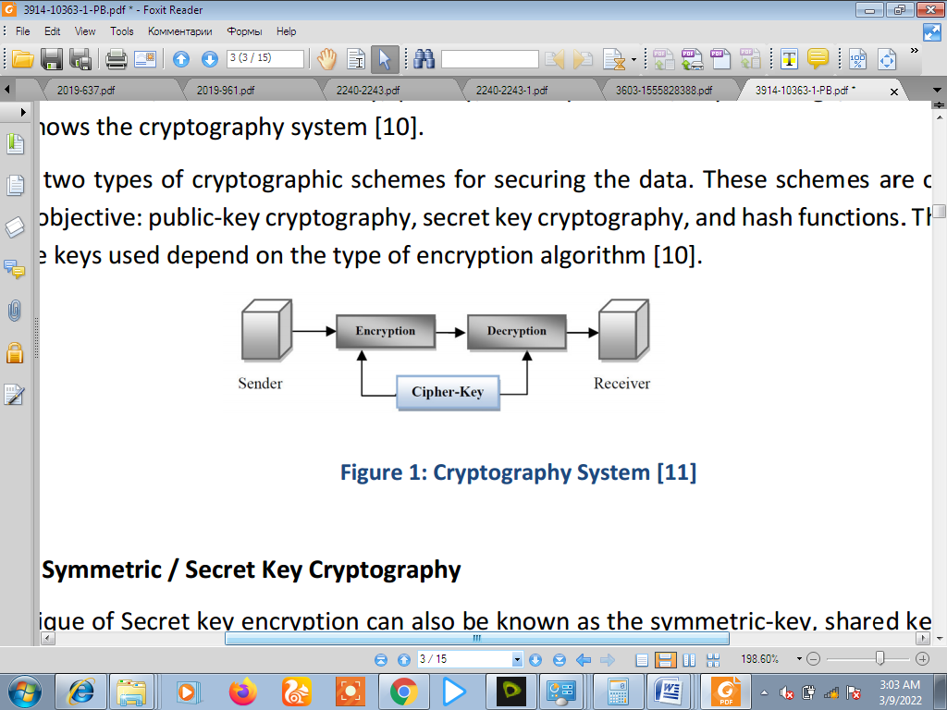
Figure 2.1: Cryptography System (Saini &Verma, 2020)

The three types of algorithms are described:
- Secret Key Cryptography (SKC): Uses a single key for both encryption and decryption.
- Public Key Cryptography (PKC): Uses one key for encryption and another for decryption.
- Hash Functions: Uses a mathematical transformation to irreversibly "encrypt" information.
CRYPTOSYSTEMS CAN BE CLASSIFIED INTO:
- Symmetric (private-key, single-key) cryptosystems – characterized by the fact that it is easy to compute the decryption rule dK from eK, and vice-versa
- Asymmetric (public-key ) cryptosystems – characterized by the fact that it is hard to compute dK from eK. With such cryptosystems, the key K is split into two sub keys, Ke, for encryption, and Kd, for decryption. Moreover, Ke can be made public without endangering security
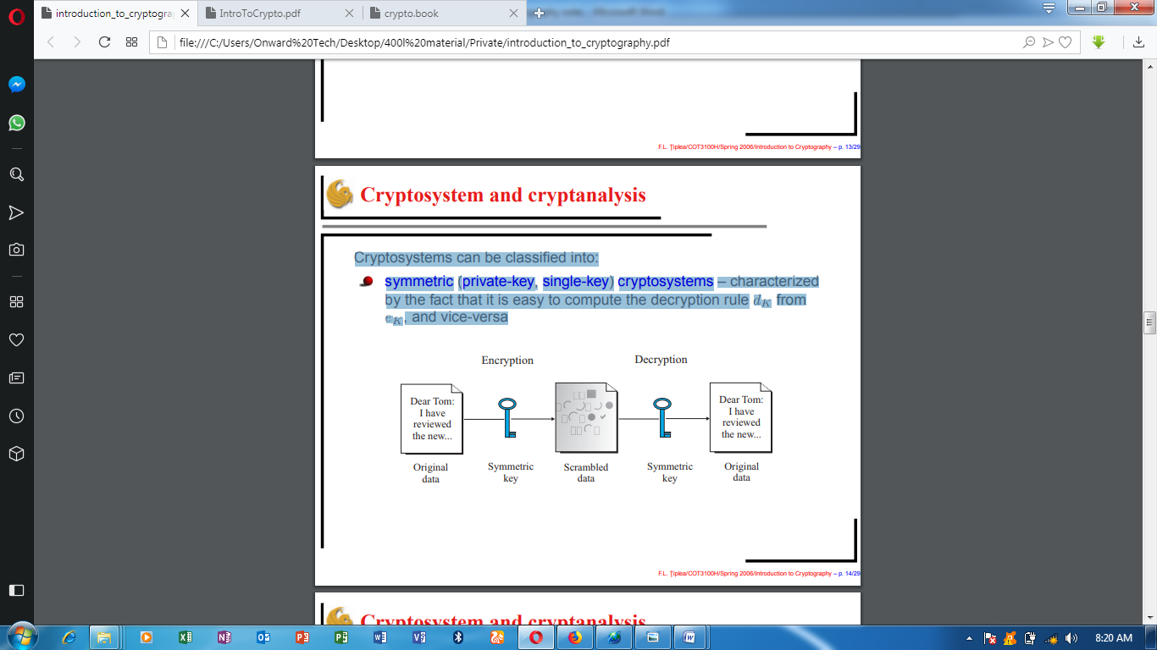
Figure 2.2: Symmetric Diagram (Lee, et al., 2019).

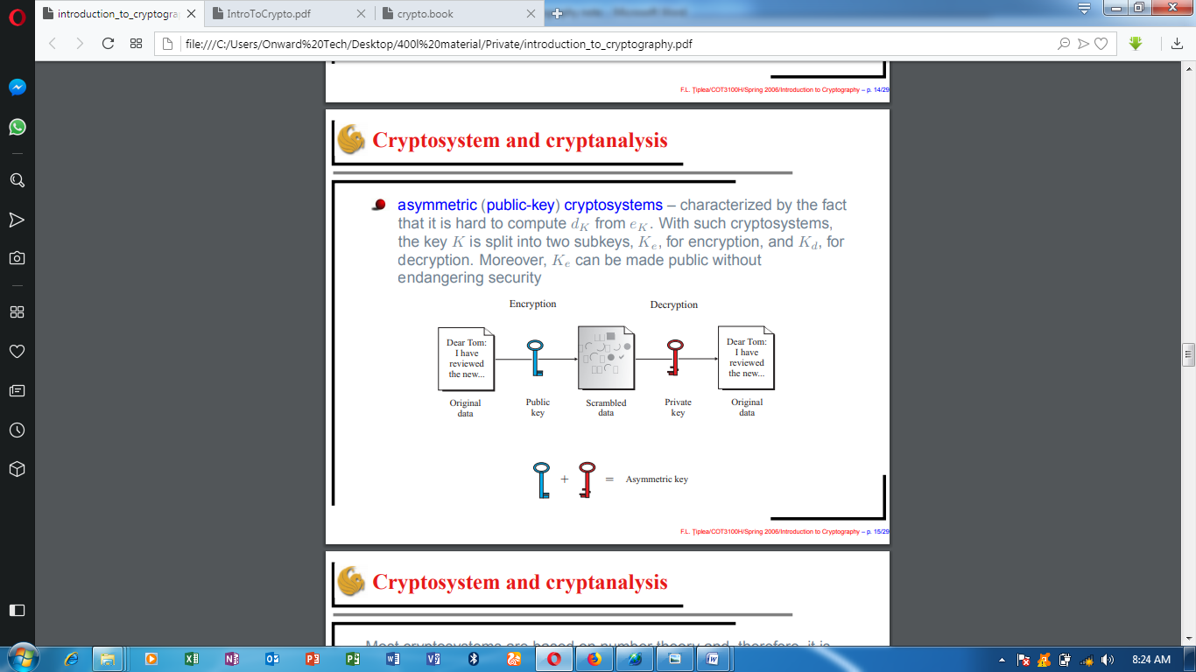
Figure 2.3: Asymmetric Diagram (Lee, et al., 2019).

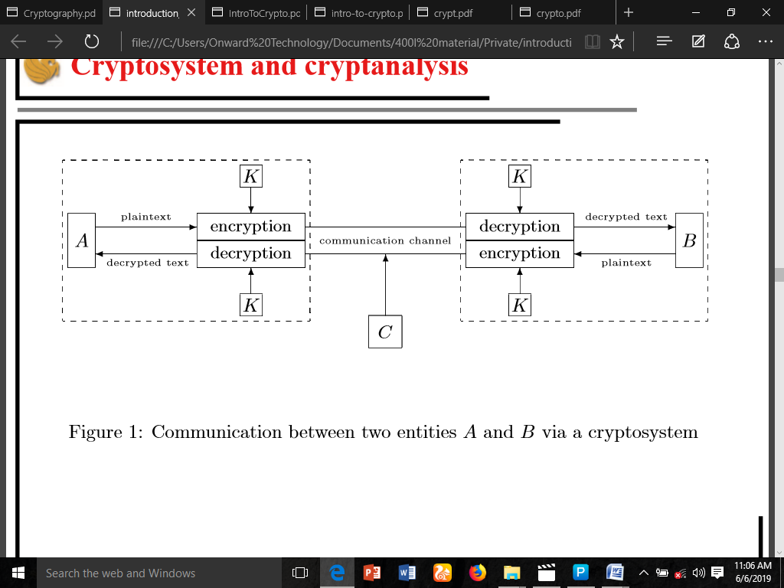

Figure 2.4: Communication between two entities A and B via a cryptosystem

CHAPTER THREE
RESEARCH METHODOLOGY AND ANALYSIS OF THE EXISTING SYSTEM
3.1 RESEARCH METHODOLOGY
No doubt, visual cryptography is among the underlying techniques for guaranteeing security of images that concerns human visual system in digital space. Thus, this study utilised the algorithm medical text encryption. However, instead of generating encryption key from the image as implemented by the researcher, we use key generated by RSA for visual cryptographic.
Text cryptography and image cryptography are among the underlying techniques for guaranteeing security of text/images that concerns human visual system in digital space.
Thus, this study utilized the text cryptography and image cryptography algorithm medical record system.
- Begin
- // encryption steps
- Import M-Record (Pr) = {plain text (Pt), plain image (Pi)}
- Convert {Pt, Pi} to Advance Encryption Standard (AES) equivalent {P’t, P’i}
- Generate encryption key (Ek) and decryption key (Dk) and with AES
- Encrypt P’t with AES as a:= (P’t, Ek)
- Encrypt P’i with visual steganography as v:= (P’i, Ek)
- Generate ciphered record (Cr) with Ea = g(v,a)
- Store Cr in M-Record database
- // decryption steps
- Retrieve Cr
- Decompose Cr to {P’t, P’t} with Da=g⁻¹ (Cr)
- Decrypt P’t with a⁻¹ := (P’I, Dk)
- Decrypt P’t with v⁻¹ := (P’I, Dk)
- Revert (P’t, P’i) to (Pt, Pi)
- Export (Pt, Pi) as plan E- Record record
- End

Figure 3.1: Algorithm for E-health Record Encryption and Decryption

3.3 ANALYSIS OF THE EXISTING SYSTEM
Development of fully functional interoperable EHR system remains a major challenge. Recent research has proposed prototype service-oriented architecture (SOA) models for EHR in various contexts including clinical decision support, collaborative medical (mammogram) image analysis (Estrella et al. 2004), and health clinic setting. These SOA based EHRs are expected to be scalable to enable inter-enterprise environments such as regional health information organizations (RHIO), and alliance of such RHIOs could lead to national and global health information networks.

3.3 PROBLEMS OF THE EXISTING SYSTEM
The problem that affect the efficient use of information exist in addition to the four basic components of information security are as follows:
- Even an authorized user may find it challenging to access strongly encrypted, authenticated, and password-protected information at a time when access is vital for decision-making. An intrusive party may attempt to assault the network or computer system and disable it.
- Cryptography cannot guarantee high availability, one of the core components of information security. Other defense strategies are required to counter dangers like denial of service (DoS) attacks and total information system failure.
- Selective access control, another essential requirement of information security, also cannot be met by using cryptography. For the same, administrative controls and processes must be used.
- The dangers and weaknesses that result from the shoddy systems, methods, and procedures are not protected by cryptography. These require the correct design and construction of a defensive infrastructure to be installed.
3.4 DESCRIPTION OF THE PROPOSED SYSTEM
The system architecture for the proposed E-health record system. The architecture shows the stakeholders, information flow and data storage, as well as the positions of security mechanism to ensure confidentiality and integrity of medical records. Most of all, the stakeholders are patients whose health information needs to be secured and medical team who is the custodian of the records. As indicated in the diagram, all stakeholders require appropriate asymmetric key to encrypt or decrypt desired information. Equally important, all stakeholders must pass authentication challenge by supplying valid username and password before accessing the system.
3.5 ADVANTAGES OF THE PROPOSED SYSTEM
- A reliable method of identification that cannot be stolen or forgotten
- Easy and convenient to use, as there is no need to carry a physical object
- Suitable for people with special needs. One study has shown that illiterate people are content to use biometric identification as they don’t have to reveal the fact that they can’t write
- Confidentiality - An encryption method can protect data and communications against unauthorized access and disclosure.
- Authentication - Information can be safeguarded against spoofing and forgeries using cryptographic techniques like MAC and digital signatures, which are used for authentication.
- Data Integrity - Cryptographic hash functions are essential in giving users confidence in the accuracy of their data.

CHAPTER FOUR
DESIGN AND IMPLEMENTATION OF THE SYSTEM
  - DESIGN OF THE SYSTEM
The proposed system is designed in modules with each modules working together to perform the electronic allocation system in order to enhance the performance of the existing system as earlier discussed in chapter three.
The ability to analyze and give focus to the system is explained in the following formats which are output design, input design, database design and procedure design.
    - OUTPUT DESIGN
Output design for the computerized system to go to the screen and the outputs are designed to present report in a meaningful way. The outputs of the system include import report and lying report.

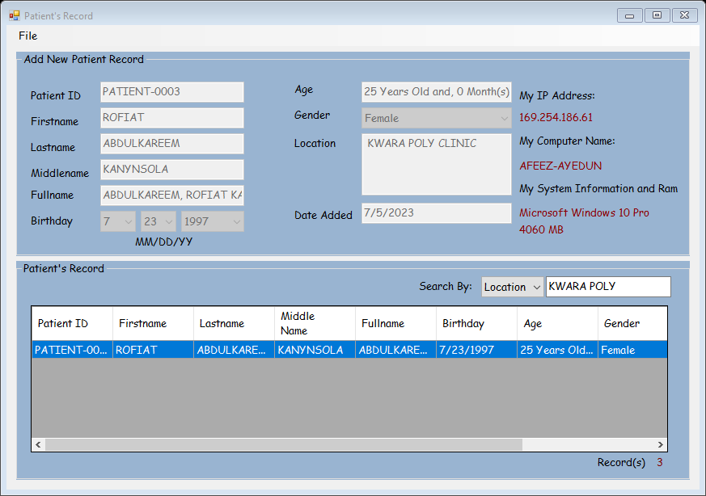
Figure 4.1: Assign Patient - 0003

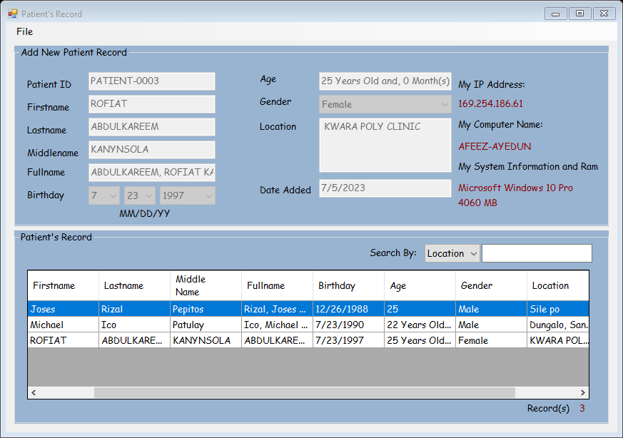
Figure 4.2: Patient Record

This page display the list of all the registered business operator
4.1.2 INPUT DESIGN
This aspect entails the description of the expected data input that will provide our output as described above. This section list out all the input required for the implementation of Career Guidance System. Data entry is done through the keyboard and mouse selection where required. The sample input interfaces are as shown below:
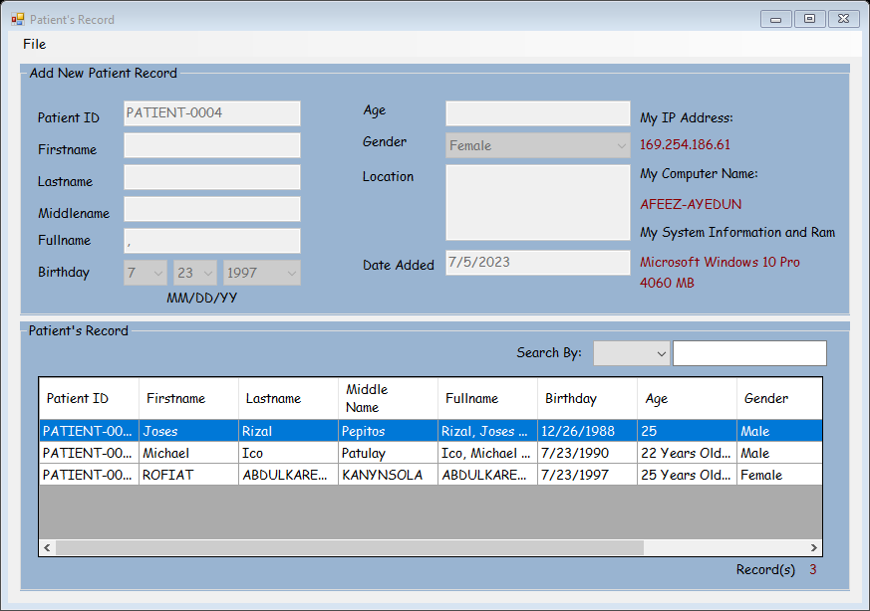
Figure 4.3: Form to Enroll Record
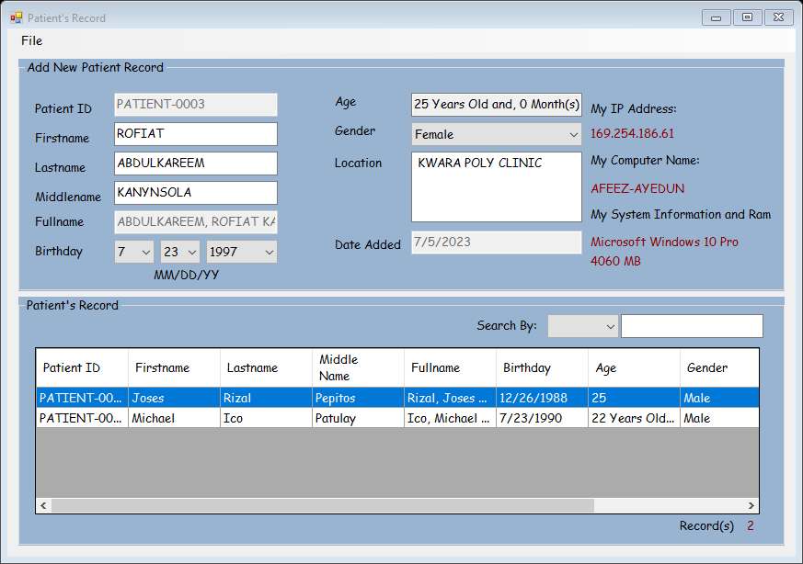
Figure 4.4: The registered patient form

    - DATABASE DESIGN

Table 4.1: Database
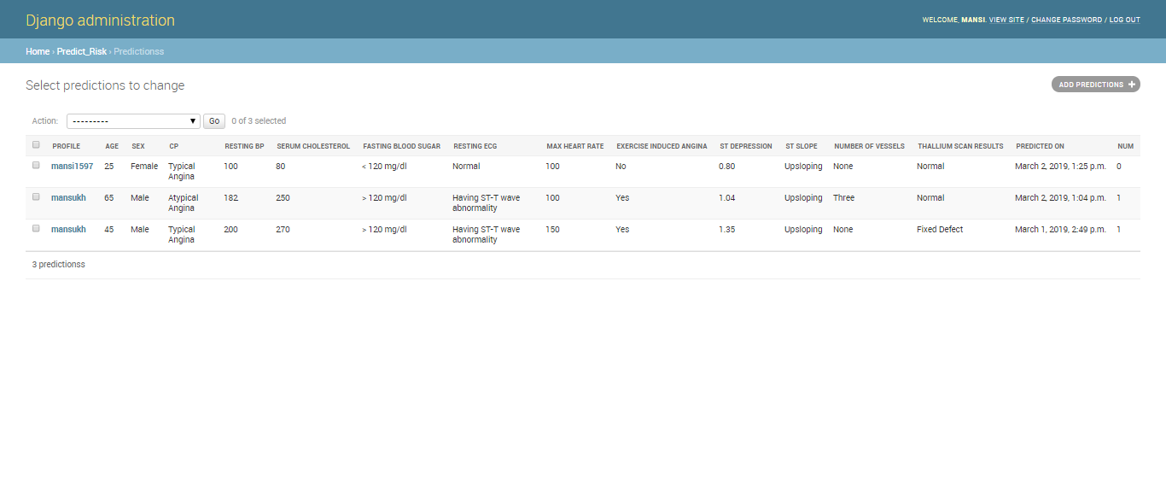

4.1.4 PROCEDURE DESIGN
The administrator can perform the following
- Add new business operator
- Generate shop for the market
- Allocate shop for each operator
4.2 IMPLEMENTATION OF THE SYSTEM
4.2.1 CHOICE OF PROGRAMMING LANGUAGE
In determining a suitable programming language for the design of the online patient management system, the factors to be considered are:-
- The difficulty of the problem
- The technical skills required of the computer program
- The type of processing required
- The availability of sub-programming facilities
- The efficiency of the language translator
- Ease of maintaining and updating the program
- Hardware and software requirement
For the project work, the programming language to be used for the design of the system is PHP and MYSQL for database management system with embedded Structured Query Language (SQL) for database manipulation

4.2.2 HARDWARE SUPPORT
The hardware requirements for this program are:
- PC: The computer should be minimum of Pentium IV with 1000GHs processor speed but preferably Dua Core Processor for greater efficiency
- Memory: This system requires a Higher RAM not less than 512MG, 1GB RAM is recommended.
- Storage: the storage capacity must be 80GB and above.
- VDU: Visual Display Unit required should be a very high resolution not less than 1024 x 768 with 256 colour capability.
- Printer: This system also requires a printer
- Input: The input device required is a mouse, Optical Mouse should be provides for easy use.
4.2.3 SOFTWARE REQUIREMENTS
The software requirements for the operation of this program are as follows:
- Window Operating System
- XAMPP or WampServer (for Apache server on localhost)
- Web Browser e.g Mozila Firefox
- Macromedia dreamweaver
4.2.4 CHANGE OVER TECHNIQUE
The method used in the implementation of the proposed system is parallel, simply because parallel system supports the use of the existing system together with the proposed system and when there system failure information will not be totally lost and will not be back to square one for the users.
4.3 DOCUMENTATION OF THE SYSTEM
4.3.1 PROGRAM DOCUMENTATION
In order for the proposed system to be used on any computer system it takes the following ways
- Boot the system
- Copy the folder to www inside wamp folder of the drive C: after WAMP server is installed onto the system.
- Open any browser on the system (Microsoft internet Explorer, Mozilla Firefox, Netscape Navigator, Opera, Flock, Safari e.t.c)
- Type http://localhost/ patienthealthrecord /index.php on the address bar and press the return key or enter key.

4.3.2 OPERATING THE SYSTEM
This refers to the step by step method of using the proposed system. The proposed system comprises of. The steps to use the proposed system are as follows
- On the address bar of any browser type:
http://localhost/www.patienthealthrecord/index.php
- You are prompted to supply the username and password this verifies that you are a registered voter and has the privileged to vote.

4.3.3 MAINTAINING THE SYSTEM
- Data cable should be plugged properly
- Repair or replacement of all damaged accessories, system cards, peripheral e.t.c.
- prevention from dust
- Prevention of system from heat and moisture
- Prevention from static charges
- Examination of the new system from time to time to ensure it is performing as specified.
- Operators and users to the system must constantly check the output of the system to make sure that it is working accordingly.

CHAPTER FIVE
SUMMARY, CONCLUSION AND RECOMMENDATION
5.1 SUMMARY
Information security for authorized data disclosure, advocates of public health argue that privacy interests should be strongest where they matter most to the individual and communal interests should be maximized where they are likely to achieve the greatest public good. However, every healthcare provider may not deploy state-of-the-art technology, incorporated with most recent algorithms, to disclose data for secondary purposes. Understanding the operational effectiveness of data disclosure technology from the field may help hospital administration in refining disclosure policies, as well choosing appropriate data disclosure technology solutions.

5.2 CONCLUSION
Privacy and security are two important factors that must be considered when developing a patient centric EHR. Existing works have focused largely on security and less on how patient mastermind privacy control with the help of the healthcare providers. Also, outside threats were of more concern, but more often than expected insiders who have legitimate access to EHR are often overlooked. This research implements cryptographic techniques with biometrics despite its key security challenges. This research contributed to the body of knowledge in healthcare and self-care through the development of a cryptography key management scheme for ensuring the privacy of patients attributes in a cryptographic oriented EHR.
The synergistic combination of asymmetric visual cryptography system in the proposed Patient’s Health Record (PER) system has successfully provided a medium through which the privacy of a patient’s electronic health record is maintained. This will no doubt ensure that patient’s Electronic Health Records (PHR’s) are securely stored and that only authorized persons are allowed to view them. It is still important that further studies be carried out to improve on the security of EHR’s possibly by incorporating another security technique in addition to the Visual Cryptography technique. The result of the system evaluation shows significant improvements as the biometrics FAR were greatly reduced which lessens the likelihood of imposters gaining successful access to patients protected health information
5.3 RECOMMENDATION
The use of technology in health applications has great benefits over other means of authentication methods. Password and pin can easily be forgotten and is subject to theft. In developing countries including Nigeria, the use of security as a means of authentication in e-Health sector is still at its low ebb. This article is intended to serve as a security model for protecting the integrity of users of e-Health data.
This study developed the implementation for Patients Health Record (PHR). The system can be used by healthcare providers to keep records and secure patient health record. The system is expected to enhance the effectiveness and the overall efficiency of hospital management. The integration of security is to increase the users’ confidence in the system. The future directions on security in e-Health system comprises of DNA analysis, neural wave analysis, and skin luminescence. More so, the researchers intend to implement a secure mobile biometric system in the future

REFERENCES
Abass N., Thaear S., Khalaf Y., &Putrus S., (2020) NATIONAL IMMUNIZATION PLAN OF IRAQ” University Research Co., LLC.
Abdulazeez A. M., Zeebaree S. R., &Sadeeq M. A., (2020) Design and Implementation of Electronic Student Affairs System,” Acad. J. Nawroz Univ., vol. 7, no. 3, pp. 66–73. doi: 10.25007/ajnu.v7n3a201
Abdulla, A. I., Abdulraheem, A. S., Salih A. A., Sadeeq M. AM, Ahmed A. J., Ferzor B. M., Sardar O. S., & Mohammed S. I.,(2020) “Internet of Things and Smart Home Security,” Technol. Rep. Kansai Univ.,vol. 62, no. 5, pp. 2465–2476.
Abdullah D. & Sallow, A. (2020) “Developing Fault Tolerance Integrity Protocol for Distributed Real Time Systems,” AL-Rafidain J. Comput. Sci. Math.,vol. 10, no. 1, pp. 187–193, 2013,doi: 10.33899/csmj.2013.163435.
Abdullah, D. & Sallow, A., (2020) EOE-DRTSA: End-to-End Distributed Real-time System Scheduling Algorithm,” Int. J. Comput. Sci. Issues, vol. 10, no. 2, p. 8, 2013
AbdulRahman M., Al Dabbagh S., & Al Habeeb Q., (2020) Health education and peer leaders’role in improving low vaccination coverage in Akre district, Kurdistan region, Iraq,” East. Mediterr. Health J., vol. 19, no. 02, pp. 125–129, Feb. 2013,doi: 10.26719/2013.19.2.125.
Abdulrazaq M. &Salih A., (2020) Combination of multi classification algorithms for intrusion detection system,” Int J SciEng Res, vol. 6, no. 1, pp. 1364–1371, 2015.
Abdulrazzaq M. & Saeed J., (2022) A Comparison of Three Classification Algorithms for Handwritten Digit Recognition,” in 2019 International Conference on Advanced Science and Engineering (ICOASE), 2019, pp. 58–63.
Ahmed O. & Sallow, A. (2021) Android Security: A Review,” Acad. J. Nawroz Univ., vol. 6, no. 3, pp. 135–140,doi: 10.25007/ajnu.v6n3a97.
Anderson RM & May RM. (2022) Vaccination and herd immunity to infectious diseases. Nature. 2015;318(6044):323-9.
Bangure D, Chirundu D, Gombe N, Marufu T,Mandozana G,&Tshimanga M. (2022) Effectiveness of short message services reminder on childhood immunization programme in Kadoma, Zimbabwe - a randomized controlled trial, 2013. BMC Public Health. 2015;15:137
Bar-Shalom, Y. & Li, X. R. (2020) Multitarget-Multisensor Tracking: Principles and Techniques. Storrs, CT: YBS, 2015.
Blackman S. S. & R. Popoli,(2021) Design and Analysis of Modern Tracking Systems. Norwood, MA: Artech House, 2019.
Blackman, S. S., Dempster, R. J., Busch, M. T., & R. F. Popoli,(2021) “IMM/MHT solution to radar benchmark tracking problem,” IEEE Trans. Aerosp. Electron. Syst., vol. 35, pp. 730–738, Apr. 2019.
Blair, W. D., Watson, G. A., Kirubarajan, T. & Bar-Shalom, Y. (2021) “Benchmark for radar resource allocation and tracking in the presence of ECM,” IEEE Trans. Aerosp. Electron. Syst., vol. 34, pp. 1015–1022, Oct. 2018.
Brumen, B., Heričko, M., Sevčnikar, A., Završnik, J. and Hölbl, M. (2022) ‘Outsourcing medical data analyses: can technology overcome legal, privacy and confidentiality issues?’, J. Med. Internet Res. Journal of Medical Internet Research, Vol. 15, No. 12, pp.283.
CTI (Center for Technology Innovation at Brookings) (2020) Hackers, Phishers, and Disappearing Thumb Drives: Lessons Learned From Major Health Care Data Breaches.
Das, R. (2020) Bio-Cryptography: Increasing the Protection of Biometric Templates, http://www. biometricnews.net/article3.pdf
Dino H. &Abdulrazzaq M., (2021) “Facial Expression Classification Based on SVM, KNN and MLP Classifiers,” International Conference on Advanced Science and Engineering (ICOASE)..
Expanded Programme on Immunization (EPI) (2020) in the African Region. strategic plan of action 2019-2020. Harare: WHO.

Gatuha G. & Jiang T., (2020) “KenVACS: Improving Vaccination of Children through Cellular Network Technology in Developing Countries,” Interdiscip. J. Inf. Knowl. Manag., vol. 10, pp. 037–046, doi: 10.28945/2208.
Grunwel, D. and Sahama, T. (2020) ‘Delegation of access in an information accountability framework for eHealth’, Proceedings of the Australasian Computer Science Week Multiconference, Canberra, Australia
Haji A, Lowther S, &Ngan’ga Z. (2020) Reducing routine vaccination dropout rates: evaluating two interventions in three Kenyan districts. BMC Public Health.
HIMSS (Healthcare Information and Management Systems Society) (2020) EHR Definition, Attributes and Essential Requirements, http://www.himss.org/content/files/ EHRAttributes.pdf
ICIT (Institute for Critical Infrastructure Technology) (2020) Hacking Healthcare IT in 2016: Lessons the Healthcare Industry Can Learn
IMIA (International Medical Informatics Association) (2020) ‘Recommendations of the international medical informatics association (IMIA) ‘on education in health and medical informatics’, Methods Archive, Vol. 39, No. 3, pp.267–277.
Jain AK, Nandakumar K, Nagar A: (2021)Biometric template security. EURASIP J Adv Signal Process 2018, 1-17.
Jain AK, Ross A: U Uludag, (2020) Biometric template security: Challenges and solutions. Proc of European Signal Processing Conf (EUSIPCO) 2015.
Kashmola M., & Sallow A, (2020) “Information Hiding Techniques Using Network Protocols,” AL-Rafidain J. Comput. Sci. Math.,vol. 8, no. 2, pp. 35–50, 2011, doi: 10.33899/csmj.2011.163650.
Kasidet M., (2020) “SMS-reminder for vaccination in Africa: research from published, unpublished and grey literature” Yale University, New Haven, USA
Katankar V. &Thakare D., (2020) “Short Message Service using SMS Gateway,” vol. 02, no. 04, p. 5, 2020.
Kirubarajan, Y., Bar-Shalom, Blair W. D., & Watson, G. A. (2020) “IMMPDA solution to benchmark for radar resource allocation and tracking in the presence of ECM,” IEEE Trans. Aerosp. Electron. Syst., vol. 34, pp. 1023–1036, Oct. 2018.
Lerro, D. & Bar-Shalom, Y. (2020) “Interacting multiple model tracking with target amplitude feature,” IEEE Trans. Aerosp. Electron. Syst., vol. 29, pp. 494–509, Apr. 2013.
Mahmood M. &Abdulazeez A., (2021)“Different Model for Hand Gesture Recognition with a Novel Line Feature Extraction,” in 2019 International Conference on Advanced Science and Engineering (ICOASE), pp. 52–57.
Mahmood M. R., Abdulazeez A. M., &Orman A. M., (2020)“ A New Hand Gesture Recognition System Using Artificial Neural Network.”
Mercuri, R.T. (2020) ‘The HIPAA-potamus in health care data security’, Communications of the ACM, Vol. 47, No. 7, p.25.
Omotosho, A. and Emuoyibofarhe, J. (2020) ‘A criticism of the current security, privacy and accountability issues in electronic health records’, International Journal of Applied Information Systems, Vol. 7, No. 8, pp.11–18.
Scheirer, W., Bishop, B. and Boult, T. (2020) ‘Beyond PKI: the biocryptographic key infrastructure’, IEEE International Workshop on Information Forensics and Security (WIFS), Seattle, Washington, pp.1–6.
Stavroulakis, P. and Stamp, M. (2020) Handbook of Information and Communication Security, Springer, Heidelberg.
Tiwari, B. and Kumar, A. (2020) ‘Role-based access control through on-demand classification of electronic health record’, Int. J. Electronic Healthcare, Vol. 8, No. 1. pp.9–24.
Uludag U, Pankanti S, Prabhakar S, Jain AK: (2020)Biometric cryptosystems: issues and challenges. Proc IEEE 2014, 92(6):948-960

