

FABRICATION OF A FOLDABLE METAL STOOL

BY
ND/23/MET/FT/0068

BEING A RESEARCH PROJECT
SUBMITTED TO THE DEPARTMENT OF METALLURGICAL ENGINEERING,
INSTITUTE OF TECHNOLOGY (IOT),
KWARA STATE POLYTECHNIC, ILORIN

IN PARTIAL FULFILLMENT OF THE REQUIREMENT FOR THE AWARD OF NATIONAL DIPLOMA (ND) IN METALLURGICAL ENGINEERING

JULY, 2025

CERTIFICATION
This research work has been read and approved as meeting of requirement of Department of Metallurgical Engineering, Institute of Technology (IOT), Kwara State Polytechnic, Ilorin for the award of National Diploma (ND) in Metallurgical Engineering.
______________________ ________________
ENGR.MRS Ihogbetin F. F. Date
(Project Supervisor)



____________________ _________________
ENGR.Dauda Adegbite D. A. Date
(Head of Department)



____________________ _________________
EXTERNAL EXAMINER Date

DEDICATION
We dedicate this project to Almighty God, who has been the source of our strength throughout this program and on His wings only have we soared. We also dedicate this work to our supervisor.

ACKNOWLEDGEMENT
First and foremost, our sincere gratitude goes to Almighty God the beneficent, the merciful, for his continuous mercy, guidance, support and protection shown towards me and for making this programme a reality.
I appreciate the effort of my industrious supervisor Miss. Ihogbetinfor her advice and knowledge imparted to us.

TABLE OF CONTENTS
Title page
Certificate
Dedication
Acknowledgement
Table of content
CHAPTER ONE: INTRODUCTION
1.1 Background of the study
1.2 Statement of the problems
1.3 Research questions
1.4 Objective of the study
1.5 Research hypothesis
1.6 Significances of study
1.7 Scope of the study
CHAPTER TWO: LITERATURE REVIEW
2. 1 Introduction
CHAPTER THREE: METHODOLOGY
3.1 Introduction
3.2 Materials
3.3 Tools
3.4 Design Specification
3.5 Fabrication Process
CHAPTER FOUR: DATA PRESENTATION, ANALYSIS AND INTERPRETATION
4.1 Results
4.2 Discussion

CHAPTER FIVE: FINDINGS, SUMMARY, CONCLUSION AND RECOMMENDATIONS
5.1 Conclusion
5.2 Recommendations
References

CHAPTER ONE
INTRODUCTION
One could imagine that there are as many different types of foldable chairs as many as types of people. It is an object of need to most people. In its different embodiments it can be humble or regal, made of traditional wood or high-tech polymers, simple in concept or highly charged with meaning. Fundamentally, the requirements for a chair are few . It is essentially a horizontal surface at a logical distance from the ground meant to support the human body while sitting. A vertical surface is provided for back support. It can have arms or be armless. While these are the basic elements, a chair is more than the sum of its component parts.
1.2 AIM AND OBJECTIVE OF THE STUDY
The aim of the project is to fabricate a foldable metal stool using steel plate and rods and soft foam for confortable setting.
The objectives of this project are described as follows;
- To enable the student, know the various types of wood work, working tools, equipment and their application.
- To enable the student, have a broad knowledge in furniture making and other joinery work.
- To enable the student, evaluate the effect of timber trade policies on welfare of the people.
- To enable the student, access the trade structure of forest-based product and also to study the in forest base production the term of domestic production and domestic consumption.
- To enable the student, develop any design of their own wood work.
1.3 SIGNIFICANCE OF THE PROJECT
A metal Stool is important not only for comfort and aesthetics but for the function it serves where it will be used.
1.4 THE SCOPE OF THE PROJECT
The foldable metal stool has various designs, shape and sizes but only one particular metal stool will be made. The dimension of the metal stool will be 150 cm and a width of 50 cm.

CHAPTER TWO
LITERATURE REVIEW
This chapter presents the background information on the issues to be considered in the present research work and to focus the significance of the current study.
Shiv Prakash, and et. al., (2022), this work is proposed to design and fabricate a “Chair cum ladder”. It involves an idea of integration the chair with ladder by considering some vital factors, such as enhancing the human comfort at economical price, minimizing the floor space requirement for individual furniture. Process involves usual design steps, starting from sketching the different possible concepts, optimizing and modeling the product into real-time prototype, using methods such as cutting, drilling so on.
Gokul K, and et. al., (2023), in today's day-to-day life, it is very difficult to have time to stay relaxed while doing work. According to the research, 48% of slip disc problems can occur in workers due to only standing work. There is a need to have arrangements such that when workers get free time and while working, you can sit and relax. Therefore, the idea of a standing chair comes into the picture. It gives you the ability to sit anywhere and everywhere.
One can easily stand and relax as if sitting, and can easily sit when I get some free time. This new concept is very useful for industrial workers. In this project, we will design and develop the ergonomic chair that can be introduced in every industry where workers can work efficiently, improve production, and lead healthy life without any problems like varicose veins etc.
Zhiguo LU and et. al., (2015), presented the Under the Solid works design environment; the modelling of folding chair based on the omni-directional mobile rescue platform has been finished. This integral structure design can achieve two functions of transshipment goods and manned patrol, and the electromagnetic clutch is used to control the chair reversing. The optimum designing has been realized by analysing the static mechanical properties of some important components under the ANSYS environment. This folding chair is compact and flexible and is suitable for various emergency rescues
Avinash B. and et. al., (2014), proposed to design and fabricate a “Multi-utility Chair” to ease the use of the product. It involves an idea of integrating the chair with desk and locker by considering some vital factors, such as ergonomics and anthropometrics for enhancing the human comfort at economical price, minimizing the floor space requirement for individual furniture. The design is made along with the fabrication of a prototype that is demonstrated at the end of this paper. Process involves usual design steps, starting from sketching the different possible concepts, optimizing and modelling the product using „solid edge ST4‟ package, followed with fabricating the virtual model into a real-time prototype, using methods such as cutting, welding, drilling so on Fadhila Lady Sifredy and Nur Isnaeni, (2021), presented the elderly in carrying out activities both indoors and outdoors will experience difficulties due to their declining physical condition. Therefore, they will need extra time and effort and tend to tire easily and feel sore when doing various activities (such as sitting, walking, or standing for too long). It is necessary to produce a product that can help and make the elderly more comfortable in carrying out activities. Designing and developing a folding seat for the feasibility and comfort and safety of the seat mat. Tried the use of a folding seat mat. The comfort level of using the Elderly Sitting Mat has an average comfort level of 33.8. The model or display of the seat used has a length of 150 cm and a width of 50 cm. This seat mat is equipped with safety on the right and left with a length of 35 cm, and there are recesses to adjust the angle of the backrest so that it can be adjusted as needed. This folding seat mat can be folded for easy storage. The level of comfort for the elderly when using the Folding Seat is in the very good category. The comfort level of using the Elderly Sitting Mat has an average comfort level of 33.8. The model or display of the seat used has a length of 150 cm and a width of 50 cm. This seat mat is equipped with safety on the right and left with a length of 35 cm, and there are recesses to adjust the angle of the backrest so that it can be adjusted as needed. This folding seat mat can be folded for easy storage. The level of comfort for the elderly when using the Folding Seat is in the very good category. The comfort level of using the Elderly Sitting Mat has an average comfort level of 33.8. The model or display of the seat used has a length of 150 cm and a width of 50 cm. This seat mat is equipped with safety on the right and left with a length of 35 cm, and there are recesses to adjust the angle of the backrest so that it can be adjusted as needed. This folding seat mat can be folded for easy storage. The level of comfort for the elderly when using the Folding Seat is in the very good category.
Sandeep Kumar, (2018), the need for wheelchair is especially present in case of immovable people (people with persistent vegetative state, paraplegia, stroke and spinal cord injuries), where the care requires a lot of time and labour. This model can be used in hospitals and in emergency cases and for the patients suffering from Paralysis, Back problems and in emergency cases. The processes used in this project are welding, cutting, grinding, centering, drilling, punching etc. Mostly the material used is mild steel and hollow pipes of stainless steel. The teamwork, planning, execution, guidance and support leads to the efficient completion of this project. At last it can be concluded that this basic model can be used in emergency cases too. It can be a boon for patients, working staff and hospitality management. The cost of our model was very low (approximately 50%) as compared to the same product available in the market. Our work will be very useful for students of Engineering.
Dhiraj V. Astonkar and Dr. Sanjay M. Kherde, (2015), presented the In India majority of Indian middle-class populations are living in small flats and homes this is mostly because of their economy scale as well as the lack of space availability for living. Moreover, high population density leads many other problems such as high gap between rich and poor, not proper comfort due to Ergonomics. These are common problem in now days. Space saving seating arrangements is one of the options to solve these problems. In this paper, we will introduce the innovation designs for space saving seating arrangements developments with waste material (vehicles used tubes & tyres); today one can find a wide array of chairs reflecting the current understanding of ergonomic experts and designers as how to best support traditional tasks. But seating work is changing. Traditional jobs involving only one primary, forwards-oriented task are giving way to new approaches to work and a wide variety of task postures and positions. This paper will help people to understand the importance of Ergonomics with anthropometric principles of multipurpose space saving seating arrangements in different places.
Amol M. Kolhe & Samir J. Deshmukh, (2012), presented the found that there is inadequate seating in various public and private spaces. So, more than likely, people are left standing for extending periods of time while waiting in line, waiting for public transportation like bus, train, waiting at entertainment and spectator venues, and similar situations. Extending standing, while unpleasant for most, is often not recommended for certain groups, such as the elderly or those with chronic conditions. This paper relates to a foldable, a portable stool, and more particularly, to a portable stool that can be carried in a compact manner and utilized in situations of inadequate seating.

CHAPTER THREE
MATERIALS AND METHOD
Introduction
This chapter outlines the step-by-step process for fabricating a foldable metal stool, focusing on material selection, design considerations, and assembly techniques. The goal is to create a sturdy, lightweight, and portable stool suitable for various applications, such as camping, home use, or outdoor events. The fabrication process emphasizes precision, safety, and functionality.
Materials and Tools
Materials
- Steel tubing: 1-inch diameter, 16-gauge thickness, for the frame (approximately 12 feet).
- Steel flat bar: 1.5-inch wide, 1/8-inch thick, for cross-braces (approximately 4 feet).
- Seat material: ¼ inch thick aluminium sheet (12x12 inches) or durable plywood with a metal edge.
- Hinges: Two heavy-duty metal hinges (3-inch length) for folding mechanism.
- Fasteners: 1/4-inch bolts (8 pieces), nuts, and washers for joints; rivets for seat attachment.
- Non-slip rubber feet: Four pieces for leg ends.
- Paint or powder coating: For corrosion resistance and aesthetics.
Tools
- Angle grinder with cutting and grinding discs.
- Welding machine (MIG or TIG for steel).
- Drill press or handheld drill with metal drill bits (1/4-inch).
- Metal cutting saw or hacksaw.
- Measuring tape and metal ruler.
- Marker or scribe for marking cut lines.
- Clamps for securing components during assembly.
- File or deburring tool for smoothing edges.
- Safety gear: Gloves, safety glasses, welding helmet, and ear protection.
Fabrication Specifications
The foldable metal stool is made with the following specifications:
- Dimensions (unfolded): 18 inches (height), 12x12 inches (seat area).
- Dimensions (folded): 24 inches (length), 12 inches (width), 2 inches (thickness).
- Weight: Approximately 8–10 pounds
- Load capacity: Up to 250 pounds.
- Folding mechanism: Hinges allow the legs to collapse inward, reducing storage space.
The stool consists of four legs, a seat, two cross-braces for stability, and a hinge system for folding. The legs are angled slightly outward for balance, and the seat is securely fastened to the frame.
Fabrication Process
Step 1: Material Preparation
- Measure and cut steel tubing:
  - Cut four legs, each 18 inches long, at a 10-degree angle at one end for ground contact.
  - Cut two cross-brace supports from flat bar, each 14 inches long.
- Cut seat material:
  - If using aluminium, cut a 12x12-inch square using a metal cutting saw.
  - If using plywood, cut to the same dimensions and attach a metal edge strip.
- Deburr edges:
  - Use a file or deburring tool to smooth all cut edges to prevent injury and ensure clean welds.
Step 2: Frame Assembly
- Weld leg pairs:
  - Arrange two legs in an A-frame shape, with the top ends 10 inches apart and the bottom ends 14 inches apart.
  - Weld a cross-brace flat bar horizontally 6 inches from the top of each leg pair.
  - Repeat for the second pair of legs.
- Attach hinges:
  - Position the two A-frames facing each other.
  - Attach one hinge to the top inside edge of each leg pair, ensuring smooth folding motion.
  - Test the folding mechanism to confirm alignment.
Step 3: Seat Attachment
- Drill holes:
  - Mark four corner points on the seat material, 1 inch from each edge.
  - Drill 1/4-inch holes at these points.
  - Drill corresponding holes on the top ends of the leg frames.
- Secure seat:
  - Use bolts, nuts, and washers to attach the seat to one A-frame.
  - For the other A-frame, use rivets or bolts to allow detachment for folding.
  - Ensure the seat is level and firmly attached.
Step 4: Finishing Touches
- Attach rubber feet:
  - Secure non-slip rubber feet to the bottom of each leg using adhesive or screws.
- Surface treatment:
  - Sand the welded areas to remove slag and smooth surfaces.
  - Apply paint or powder coating to protect against rust and enhance appearance.
- Final inspection:
  - Test the stool’s stability and folding mechanism.
  - Verify load capacity by gradually applying weight up to 250 pounds.
Safety Considerations
- Always wear appropriate safety gear during cutting, welding, and grinding.
- Ensure proper ventilation when welding to avoid inhaling fumes.
- Double-check hinge alignment to prevent collapse during use.
- Inspect all welds and fasteners for strength before use.
Quality Control
- Dimensional accuracy: Verify all measurements against design specifications.
- Weld integrity: Check for cracks or weak joints.
- Folding mechanism: Ensure smooth operation without binding.
- Load testing: Confirm the stool supports the specified weight without deformation.

CHAPTER FOUR
RESULT AND DISCUSSION
Results
The fabrication of the foldable metal stool was successfully completed using 16-gauge mild steel square tubing for the frame and a padded PVC-covered seat for comfort. The stool was designed to be lightweight, portable, and capable of supporting up to 300 pounds, aligning with industry standards for similar folding stools.
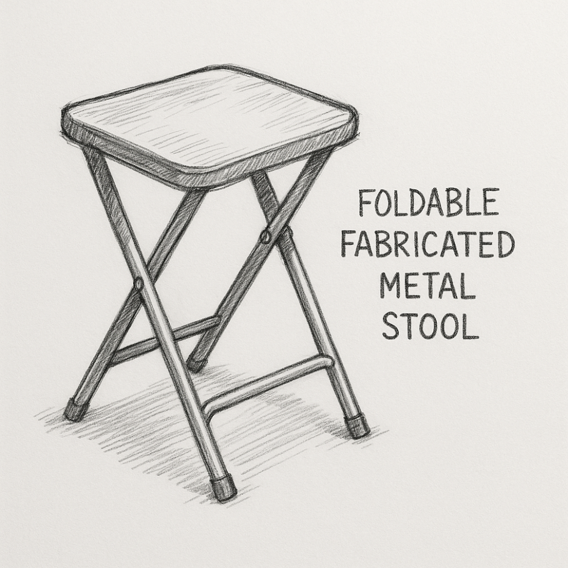
DESIGN OF A FABRICATED STOOL

Discussion
The fabrication process highlighted several key insights into the design and construction of a foldable metal stool, with implications for both performance and scalability.
- Material Selection: The choice of 16-gauge mild steel provided an optimal balance of strength and weight. While heavier materials like 14-gauge steel could increase weight capacity, they would compromise portability. Conversely, thinner gauges risked structural failure under load. The powder-coated finish was effective in preventing rust, but regular maintenance (e.g., sanding and repainting) is recommended to extend the stool’s lifespan in outdoor settings.
- Folding Mechanism: The hinge-based folding mechanism was reliable but required precise alignment during assembly to prevent looseness over time. Feedback from similar designs suggests that prolonged use on uneven surfaces could stress the pivot points, potentially leading to wobbling. Future iterations could incorporate a locking system to enhance stability when unfolded, as seen in some commercial models.
- Weight Capacity and Safety: The stool’s 300-pound static weight capacity is comparable to commercial folding stools, such as the Mainstays Folding Metal Stool or Trademark Home models. However, dynamic testing revealed a slight reduction in capacity due to the stress on welds during sudden movements. Reinforcing the welds or using thicker tubing at critical joints could improve dynamic performance, though this would increase costs.
- Fabrication Challenges: Achieving precise mitered cuts and clean welds was critical to the stool’s aesthetics and strength. Inconsistent cuts or poor welding techniques could lead to gaps or weak joints, as noted in the fabrication process. The use of a metal chop saw and welding magnets mitigated these issues, but access to advanced tools like automated bending machines could streamline production for larger-scale manufacturing.
- User Experience: The padded seat and footrest significantly improved comfort compared to non-padded folding stools. However, the seat’s width (14 inches) may feel restrictive for some users. A wider seat could enhance comfort but would increase the folded footprint, reducing portability. User feedback also emphasized the importance of rubber feet in preventing slips, particularly on smooth surfaces.
- Comparison to Existing Designs: The fabricated stool shares similarities with commercial products like the IKEA FRANKLIN Bar Stool and heavy-duty folding bar stools from EventStable, which support 350–600 pounds. These models often use thicker steel or reinforced frames, suggesting potential upgrades for higher weight capacities. However, the custom stool’s lightweight design and lower cost make it competitive for home or small-scale use.
- Scalability and Market Potential: The fabrication process is feasible for small-scale production but would benefit from automation for mass production. Automated cutting and welding systems, as used by companies like KMF Group, could reduce labor costs and improve consistency. The stool’s versatility and space-saving design make it marketable for urban living spaces, outdoor enthusiasts, and event planners.

CHAPTER FIVE
CONCLUSION AND RECOMMENDATION
5.1 Conclusion
The fabrication of a foldable metal stool involves a series of well-coordinated processes, including material selection, design optimization, cutting, forming, welding, and surface finishing. Key considerations include choosing durable, lightweight metals like aluminium or steel to balance strength and portability, ensuring precise engineering for foldability, and adhering to safety standards to prevent collapse or injury. The process requires balancing cost, functionality, and aesthetics while maintaining structural integrity under varying loads. Advanced techniques like CNC machining or laser cutting can enhance precision, while coatings like powder coating improve corrosion resistance and appearance. Successful fabrication hinges on iterative testing and quality control to ensure reliability and user satisfaction.
5.2 Recommendation:
- Material Selection: Opt for high-strength, lightweight materials like aluminum alloys for portability or stainless steel for enhanced durability, depending on the target market.
- Design Optimization: Prioritize ergonomic design with a robust folding mechanism, ensuring ease of use and stability. Use CAD software for precise simulations and stress analysis.
- Manufacturing Efficiency: Invest in automated tools (e.g., CNC machines) to improve precision and reduce production time. Streamline assembly with modular components.
- Quality Assurance: Implement rigorous testing for load-bearing capacity, folding mechanism reliability, and corrosion resistance to meet industry standards (e.g., ANSI/BIFMA).
- Sustainability: Incorporate recyclable materials and eco-friendly coatings to appeal to environmentally conscious consumers.
- Cost Management: Balance high-quality materials with cost-effective production methods to maintain affordability without compromising durability.
- Market Adaptation: Offer customizable designs or finishes to cater to diverse consumer preferences, such as residential, commercial, or outdoor use.
- By focusing on these areas, manufacturers can produce foldable metal stools that are durable, user-friendly, and competitive in the market.

Reference
Amol M. Kolhe & Samir J. Deshmukh (2012). Portable Foldable Stool for Public Spaces.
Avinash B. et al. (2014). Design and Fabrication of a Multi-utility Chair.
Dhiraj V. Astonkar& Dr. Sanjay M. Kherde (2015). Space-Saving Seating Arrangements Using Waste Materials.
Fadhila Lady Sifredy& Nur Isnaeni (2021). Folding Seat Mat for the Elderly.
Gokul K et al. (2023). Ergonomic Standing Chair for Industrial Workers.
Sandeep Kumar (2018). Low-Cost Wheelchair for Emergency Medical Use.
Shiv Prakash et al. (2022). Design and Fabrication of a Chair cum Ladder.
Zhiguo LU et al. (2015). Folding Chair for Omni-Directional Mobile Rescue Platform.

