CYBER SECURITY IN RISK CLOUD COMPUTING ENVIRONMENT .ANALYZING THREATS AND IMPLEMENTING EFFECTIVE SECURITY SOLUTIONS

BY

SOLIHU AZEEZ AHABIO
ODLND23COM0008

A Project Submitted to the Department of Computer Science, Institute of Information and Communication Technology Kwara State Polytechnic ,Ilorin

In Partial Fulfillment of the Requirements for the Award of National Diploma (ND) in Computer Science

July,2025

CERTIFICATION
This is to certify that this project was carried out by SOLIHU AZEEZ AHABIO Matric Number ODLND23COM0008 as part of the requirements for the award of National Diploma (ND) in Computer Science.

………………………………. ……………………………….
Mr. Muritala K Date
(ProjectSupervisor)

………………………………. ……………………………….
Mr. Oyedepo ,F .S. Date
(HeadofDepartment)

………………………………. ……………………………….
External Examiner Date

DEDICATION
This project is dedicated to the creator of the earth and universe, the Almighty God .It is also dedicated to my parents for their moral and financial support.

ACKNOWLEDGEMENT
All praise is due to the Almighty God the Lord of the universe .I praise Him and thank Him forgiving met he strength hand knowledge to complete my OND programme and also for my continue existence on the earth.
I appreciate the utmost effort of my supervisor, Mr Muritala K. ,whose patience support and encouragement have been the driving force behind the successs of this research work. He gave useful corrections, constructive criticisms, comments, recommendations, advice and always ensures that an excellent research is done. My sincere gratitude goes to the Head of the Department and other members of staff of the Department of Computer Science, Kwara State Polytechnic ,Ilorin ,for their constant cooperation ,constructive criticisms and encouragements throughout the programme.
Special gratitude to my parents who exhibited immeasur able financial ,patience, support, prayers and understanding during the period sin which I was busy tirelessly in my studies .Special thanks go to all my lovely siblings.
My sincere appreciation goes to my friends and class mates.

TABLEOFCONTENTS
Title Page i
Certification ii
Dedication iii
Acknowledgements iv
Abstract v
Table of Contents vi
CHAPTER ONE: GENERAL INTRODUCTION
  - Background to the Study 1
  - Statement of the Problem 3
  - Aim and Objectives of the Study 3
  - Significance of the Study 4
  - Scope of the Study 4
  - Organization of the Report 5
CHAPTER TWO: LITERATURE REVIEW
2.1 Review of Related Works 6
2.2 Review of Related Concepts 10
2.2.1 Overview of Cyber Security 10
2.2.2 Security Protocols 11
2.2.3 Threat Modeling Techniques. 12
2.2.4 Cloud Computing Models (IaaS ,PaaS, SaaS) 12
2.2.5 Cloud Computing and Its Relevance to Cybersecurity 13
CHAPTER THREE: RESEARCH METHODOLOGY AND ANALYSIS OF THE EXISTING SYSTEM
  - Research Methodology 13
  - Analysis of the Existing System 13
  - Problems of the Existing System 14
  - Description of the Proposed System 14
  - Advantages of the proposed system 15
CHAPTER FOUR: DESIGN, IMPLEMENTATION AND DOCUMENTATION OF THE SYSTEM
  - Design of the System 16
    - Output Design 16
    - Input Design 20
4.1.3Procedure Design 22
  - Implementation of the System 22
    - Choice of Programming Language 23
    - Hardware Support 23
    - Software Support 24
  - Documentation of the System 24
    - Program Documentation 25
    - Maintaining the System 25
CHAPTERFIVE:SUMMARY,CONCLUSIONANDRECOMMENDATION
  - Summary 26
  - Conclusion 26
  - Recommendation 27
References
Appendices

Abstract

As the Fourth Industrial Revolution erais now constantly progressing, the emergence of Cloud Computing, the Internet of Things, and Big Data is fast changing the computer domain. Accordingly, the computing tasks and processes are getting bigger and more complicated than ever before .With the increase in the grow thof cloud computing and the changes in technology that have result eda new way for cloud providers tode liver their services to cloud consumers, the cloud consumers should be aware of the risks and vulnerabilities presentin the current cloud computing environment. Cloud computing has revolutioniedd at as to rage and access, enabling businesses to achieves calability and efficiency. However, the inherent risks and vulnerabilities in cloud environments have raised significant cyber security concerns. This project focuses on analyzing threat sin risk -prone cloud computing environments and proposes effective security solutions. By identifying key vulnerabilities and implementing comprehensives afe guards, this research aims to enhance the over all security posture of cloud- based systems.

CHAPTERONE
GENERALINTRODUCTION
  - BACKGROUNDTOTHESTUDY
The advent of cloud computing has transformed the IT landscape ,offering unparalleled benefits such as flexibility ,cost-efficiency ,and scalability .Despite the se advantages, cloud environments are susceptible to arrange of security threats ,including data breaches, insider threats, and denial -of -service attacks. Cloud computing presents serious security risks that require careful attention, despite its many advantages such as scalability, cost -effectiveness, and flexibility (Awodeleatal.,2024).
Bhadra (2020) claimed that the widely accepted definition of cloud computing is one given by NIST (The National Institute of Standards and Technology) .According to its definition, cloud computing is am odel for enabling ubiquitous, convenient, on -demand network access to as hared pool of configurable computing resources (such as, networks, servers, storage, applications and services) that can be rapidly provisioned and released with minimal management effort service provider interaction .National Institute of Standards and Technology (NIST) also enumerates five characteristics such as On -demand self -service ,Broad network access, Resource pooling, Rapid elasticity, and Measured Service.
Cloud computing relie son shared resource sand third -party services, making it a prime target for malicious actors. The dynamic nature of cloud infrastructures, coupled with the in creasing sophistication of cyberthreats, necess it a te songoing research in to effective security measures. While numerous studies have high lighted individual as pects of cloud security, a comprehensive approach that integrates threat analysis and solution implementation remains limited (Kumar,2024).
Cloud computing security is a multi faceted discipline aim edat protecting the vast array of resources and services hosted in cloud environments. One of the core challenge sinc loud security lies in the shared responsibility model, where cloud service providers manage the security of the infrastructure, while customers are responsible for securing their data, applications, and user access .Rob us tau the ntication and authorization mechanisms, coupled with stringent access controls, are crucial to preventing unauthorized access to sensitive information. Multi-fact or authentication (MFA) add san extra layer of protection by requiring users to provide multiple forms of verification before accessing cloud resources ,reducing the risk of unauthorized access even in the even to from promised credentials(Ang'udi,2023).
The shift toward cloud computing has also introduced unique challenges, including maintaining data so vereignty and managing multi-cloud environments .As organizations distribute their resources across various cloud platforms, they face increased complexity in ensuring consistent security measures. This highlights the critical need for in teroper ability and standardization in cloud security practices .Also ,ther apid advancement of technologies such as artificial intelligence, Internet of Things (IoT), and big data analytic samplified the attack surface in cloud ecosystems. These technologies, while beneficial, create new entry points for cybercriminals, under scoring the importance of adaptive security strategies that can evolve along side technological innovations (Drissietal.,2023).
Human factors continue to play as ignifi can trole in cloud security vulnerabilities. Mis configurations, inadequate training, and lack of awareness am on users and administrators are among the leading causes of security incidents. Addressing these challenges requires a holistic approach that combines technical solutions withed ucation and policy enforcement to reduce risks effectively (Hassanetal.,2024).
This project seeks to bridge the gap between cloud computing adoption and robust cyber security measures by exploring the vulnerabilities within cloud ecosystems and proposing effective strategies to mitigate associated risks.
  - STATEMENT OF THE PROBLEM
The rapid adoption of cloud computing has outpaced the development to fade quate security measures, leaving organizations vulnerable to cyberattacks. Key issues include alack of visibility into cloud environments, insufficient access controls, and inadequate incident response mechanism. This project aim to address the critical need using the systematic approach to identifying and mitigating security risks in cloud computing.
  - AIM AND OBJECTIVES OF THE STUDY
The aim of this project is Cyber Security in Risk Cloud Computing Environment .Analyzing threats and Implementing effective security solutions
The objectives are to:
- Identify and classify the common threats in cloud computing environments; require systematic approach to understanding the land scape of risks
- Evaluate the effectiveness of existing cloud security measures;
- Propose are bust frame work form it igating security risks; and
- Establish a proactive incident response plan to quickly detect ,contain and recover from security breaches in the cloud environment.

1.4 SIGNIFICANCE OF THE STUDY
This project is significant for cloud service providers, organizations leveraging cloud technologies, and cybersecurity professionals .It provides action able insights in to threat mitigation, enhance saw are ness of cloud vulnerabilities, and contributes to the development to fore secure cloud environments. This comprehend sive analysis provide critical insights for organizations and security experts empowering them to proactively address recurring threats and minimized is options to daily operations.
1.5 SCOPE OF THE STUDY
The project focuses on analyzing threats and proposing solutions specific to public and hybrid cloud environments. It includes an evaluation of existing security measures, the development of a security framework, and testing of proposed solutions in simulated cloud environments. Thes cope of this project is limited to technical and operational aspects of cybersecurity in cloud systems.
1.6 ORGANIZATION OF THE REPORT
The project write- up is organized in to five distinct chapters. Chapter one covers general introduction, which contains introduction to the project topic, statement of the problem, aim and objectives of the study, significance of the study, scope of the study and organization of the report. Chapter two covers the literature view, which contains review of related past works, over view of cyber security, description cloud computing, threat sand risks mitigation and other related concepts. Chapter three explains the project methodology which includes analysis of existing system, problems of the existing system, the description of the proposed system and advantages of proposed system. Chapter four explains the design, implementation and documentation of the system which contain system designed out put design, input design, procedure design, implementation of the system hard ware and software support and documentation of the new system installation procedure, operating the system and system maintenance. Lastly, chapter five explains the summary of the research, recommendations, and conclusion.

1.7 Definition of Technical Ter msin Computing
Algorithm: A step-by-step procedure or se to frules for solving a problem or performing a task, of ten used in programming and software development.
Cloud Computing: The delivery of computing services (e.g., storage, processing, and software) over the internet, allowing users to access and manage data remotely.
Encryption: The process of converting information in to a code to prevent unauthorized access, commonly used to secure data.
Machine Learning: A branch of artificial intelligence (AI) that enables systems to learn from data, identify patterns ,and make decisions with out explicit programming.
Virtualization: The creation of virtual versions of resources, such as server so storage ,enabling better resource management and isolation.
API (Application Programming Interface): A set of protocol and tools that allow different software applications to communicate with each other, enabling integration and interaction.
Firewall: A security system that monitors and control sin coming and out going network traffic based on prede fined security rules, helping protect networks from unauthorized access.

CHAPTER TWO
LITERATURE REVIEW
2.1 REVIEW OF RELATED LITERATURE
In this section some past journal related to this topic of study are reviewed.
Awodeleetal.,(2024)worke don characterization and risk assessment of cybersecurity threat sin cloud computing, a comparative evaluation of mitigation techniques. This study seeks to categorize and assess the risk levels of cybersecurity threat sin cloud computing environments, providing a comprehensive characterization based one leven major causes, including natural disasters, loss of encryption keys, unauthorized login access, and others. Using fuzzy set theory to analyze uncertainties and model threats, threats wereid entified, prioritized, and categorized according to their impact on cloud infrastructure. A high level of data loss was revealed in five key features, such as encryption key compromise and unauthorized login access, while a lower impact was observed in unknown cloud storage and exposure to sensitive data. Seven threat features, including encryption key loss and operating system failure, were found to significantly contribute to data breaches. In contrast, others like virtual machine sharing and impersonation, exhibited lower risk levels. A comparative analys is of threat mitigation techniques determined Spoofing, Tampering, Repudiation, Information Disclosure, Denial of Service and Elevation of Privilege (STRIDE) as the most effective methodology with a scoreof59, followed by Quality Threat Modeling Methodology (QTMM) (57), Common Vulnerability Scoring System (CVSS) (51), Process for Attack Simulation and Threat Analysis (PASTA) (50), and Persona non- Grata (PnG) (47). Attack Tree and Hierarchical Threat Modeling Methodology (HTMM) eachachieved46, while Link ability, Identifi ablility, Non repudiation, Detectability, Disclosure of Information, Unaware ness and Non compliance (LINDDUN) scored45 .These finding sunder score the value off uzzy se theory in tandem with threat modeling to categoryize and assess cyber security risks in cloud computing. STRIDE is recommended as an effective modeling technique eforcloudenvironments.
Bhadra (2020) proposed a cloud computing threats and risks, uncertainty and uncontrol ability in the risk society. The main objective of this paper is to undertake, from an inter disciplinary cyber -behavioural perspective, a modest attempt to frame acritical discourse mainly of its threats, vulnerabilities and risks that haunt cloud computing services. These cloud computing issues make it impossible to achieveend– to- end security, on the one hand, and, at one and the same time, further strengthen, on the other hand, the process of transforming late modern society in to what is known as risk society.
Kumar (2024) analyzes the security risk sand threat sin cloud computing. The paper provide san in- depth analys is of the various security concerns that cloud computing infrastructures have to address. By examining common threats like data breaches, unauthorized access, unsecured interfaces, and shared technological vulnerabilities, the study aims to illustrate the critical importance of proactive security measures in protecting sensitive data. Through ananalysis of network security strategies, identity and access management, encryption technologies, and incident response planning, this paper offer sin sights in to best practices for managing security risks in the cloud. The paper provides businesses with a road map for enhancing their cloud security.
Ang'udi (2023) conducted research on security challenge sin cloud computing. The paper illuminates the complexities of data and application security in the cloud environment by thoroughly examining the se subjects. The study also look sat actual case studies to show how security breaches in cloud computing affect things and how to fix them. The study intends too for insightful analyse so security challenges with practical implications by examining these cases and providing lessons learned from incidents that have happened in various cloud computings cenarios. Our comprehension of the complexnature of security threats and the tactics used to counter and miti gate the mi improved by looking closely at these cases.This study looks into the potential benefits of cloud security enhancements from emerging technologies like artificial intelligence and machine learning, in addition to identifying existing challenges. There search investigates the potential benefits of these technologies in terms of automated security responses, adaptive access controls, and proactive threat detection. Furthermore, by projecting future trends and challenges in cloud security, this paper offers a forward-looking view of the changing field. Comprehending these possible obstacles is crucial to creating proactive and flexible security approaches that can successfully tackle the ever-changing landscape of cloud computing.
Drissi (2023) conducted a survey on risk assessment or cloud computing. This paper aims to survey existing knowledge regarding risk assessment or cloud computing and analyze existing use cases from cloud computing to identify the level of risk assessment realization in state of art systems and emerging challenges for future research.
Hassan., (2024) developed an enhancing cyber security through cloud computing solutions in the United States. The study investigates how cyber security can be enhanced through cloud computing solutions in the United States. The motive of the study is due to the rampant loss of data, breaches, and unauthorized access of internet criminals in the United States.

2.2 REVIEW OF RELATED CONCEPTS
2.2.1 Over view of Cyber security
Cybersecurity encompasses the practices, technologies, and strategies designed to protect systems, networks, and data from cyberthreats. As digital transformation accelerates, cybersecurity has become a critical concern across industries, aiming to defend against unauthorized access, data breaches, and malicious attacks. The primary oalis to ensure confidentiality, integrity, and availability (CIA) of data and systems, which are the foundation al principles of information security. Cybersecurity measures range from simple password protection to advanced artificial intelligence -powered threat detection systems (Yengetal.,2020).
The field of cybersecurity is broad, in cluding are as such as network security, endpoint security, application security, and data protection. Network security focuse sons a feguarding data as it flows through networks, using technologies like firewall sand intrusion detection systems. End point security protects devices such as laptops and smartphones, while application security ensures that software is developed and deployed securely. Data protection measures include encryption and secure data storage to prevent unauthorized access.
Cybersecurity also involves proactive measures such as threat intelligence and ethical hacking to identify vulnerabilities before they are exploited. Threat in telligence gather sin sights in to potential attackers and their methods, while ethical hackers simulate attacks to assess system weaknesses. The industry is dynamic, requiring constant adaptation to address evolving threats, such as ransomware, phishing attacks ,and advanced persistent threats(APTs).
Finally, human factors play a significant role in cyber security. Despite technological advancements, user error remains a major source of breaches. Awareness training and adherence to best practices, such as using multi-factor authentication and regularly updating software, are essential components of an effective cybersecurity strategy. The future of cyber security will likely see in creased reliance on automation and AI to hand let he complexity of modern threats (Chandgudeet.al,2021).
2.2.2 Security Protocols
Security protocols are standardized procedures and rules designed to protected at a during transmission or interaction with in systems. These protocols are essential for ensuring secure communication, data integrity, and privacy a cross networks. They of ten employ encryption, authentication, and verification mechanisms to prevent unauthorized access and tampering. Commonly used security protocols in clude HTTPS, SSL/ TLS, IPsec, and SS H.
The HTTPS protocol is a secure version of HTTP that encrypts data transmitted between a user's browser and a web server, preventing eaves dropping and data inter ception. It employs SSL/TLS, which uses a symmetric encryption to establish secure connections. SSL (Secure Sockets Layer) and it success or TLS (Transport Layer Security) are widely adopted to safeguard web traffic, email, and other online activities. These protocols also authenticate these rver's identity using digital certificates issued by trusted Certificate Authorities (CAs).
IPsec (Internet Protocol Security) operate sat the network layer to secure data transmitted over IP networks. It is comm only used in Virtual Private Networks (VPNs) to create encrypted tunnels between devices. By ensuring data integrity, authenticity, and confidentiality, IP sec enables secure remote access and safe data transmission over public networks. SSH (Secure Shell), on the other hand, provides secure remotel og in and comm and execution by encrypting the session between the client and server.
Despite their robustness, security protocols are not fool proof and require proper implementation and maintenance. Misconfigurations, out date dversions, and weak cryp to graphical gorithms can render the se protocols vulnerable. There fore, regular audits, updates, and adherence to best practices are crucial to maintaining their effectiveness sins ecuring digital communications (Diaby & Rad,2017).
2.2.3.Threat Modeling Techniques
Threat modeling is a system atic approach to identifying, assessing, and mitigating security risks with in a system or application. I the l p so rganization sunderstand potential attack vectors, prioritize vulnerabilities, and implement appropriate counter measures. This proactive strategy is vitalin ensuring secure system design and development, as I thigh lights potential risks early in the life cycle.
Several techniques are used in threat modeling, including STRIDE, PASTA, and attack trees. STRIDE, developed by Microsoft, categorizes threat sin to six are as: Spoofing, Tampering, Repudiation, Information Disclosure, Denial of Service, and Elevation of Privilege. This method is especially effective for identifying threat sins of ware systems. PASTA (Process for Attack Simulation and Threat Analysis )is a risk- centric approach that aligns business objectives with security goals. It emphasizes understanding the impact of threat son organizational processes.
Attack trees are another popular technique, representing threat shier archically as trees tructures. The root node represents the primary goal of an attacker, while branches detail potential paths to achieve it. This visualization aid sin understanding complex threats and designing counter measures. Additionally, data flow diagrams (DFDs) are of ten used in conjunction with these methods to map how data moves through a system, highlighting are as susceptible to attack.
Effective threat modeling requires collaboration a cross teams, including developers, security experts, and business stakeholders. It is an iterative process, as new threats emerge and systems evolve. By integrating threat modeling in to development processes, organizations can build resilient systems capable of with standing evolving cyber threats (Theodoropoulosetal.,2023).
4.Cloud Computing Models (IaaS, PaaS, SaaS)
Cloud computing offer son- demand access to computing resources, enabling organizations to scale efficiently while reducing infrastructure costs. It is typically categorized in to three primary service models: Infrastructure as a Service (IaaS), Plat form as a Service (PaaS), and Software as a Service (SaaS). Each model provides different levels of control, customization, and responsibility for users.
IaaS delivers virtualized computing resources such as servers, storage, and networking on a pay- as- you- go basis. It provides users with maximum control over the infrastructure while off loading hardware maintenance to the provider. Examples of IaaS include Amazon Web Services (AWS) EC2, Microsoft Azure, and Google Compute Engine. This model is ideal for businesses that require flexibility and scalability but have the expertise to manage their application sand operating systems.
PaaS abstracts the underlying infrastructure, offering a platform for developers to build, deploy, and manage applications without worrying a bout system- level management. It includes tools, runtime environments, and frameworks that accelerate development workflows. Popular PaaS provider sin clude Heroku, Google App Engine, and Microsoft Azure App Service. This model is especially beneficial for developers focusing on application logic rather than in frastructure complexities.
SaaS delivers fully managed software solutions accessible over the internet. Users interact with the software directly with out managing it underlying infrastructure or development. Examples include Google Work space, Sales force, and Microsoft365. SaaS is widely adopted for its simplicity, as users only need a web browser to access powerful applications.
While cloud computing offers numerous advantages, it also introduces unique security challenges, such as data privacy, compliance, and shared responsibility. Understanding these challenges and selecting the appropriate service model can help organizations har ness the benefits Of cloud computing while minimizing risks (Faheemetal.,2017).
2.2.5Cloud Computing and Its Relevance to Cybersecurity
Cloud computing has completely changed how organizations manage and deliver computing services, offering as capable, on- demand model for accessing shared resource so ver the Internet. A tits core, cloud computing allows user stol ever age a pool of computing resources, including servers, storage, networking, and applications, with out up front investment in hard ware or infrastructure. Instead, users can access the se resources on a pay- as- you- go basis, scaling up or down based on demand. Further more, there levance of cloudc omputing to cybersecurity rests in its ability to address critical challenges and enhance security posture in the digital age noted that one of the primary advantages of cloud computing is the robust security measures offered by reputable cloud service providers (CSPs).
Leading CSP sin ves the avily in state- of- the- art security technologies, infrastructure, and expertise to protect their cloud environments from cyber threats. These security measures include encryption, Identity and Access Management (IAM), networks egmentation, intrusion detection and prevention systems (IDPS), and regular security audits and assessments. Additionally, by leveraging the security capabilities of cloud providers, organizations can strengthen their cyber security posture with out the need for significant up front investment in security infrastructure and expertise. This is particularly beneficial for small and medium -sized businesses (SMBs) that may need more resources to implement comprehensive cybersecurity measures on their own (Muneeretal.,2019).
Further more, cloud computing offers in here not scalability and flexibility, enabling organizations to rapidly scale their computing resource sup or down based on demand. The agility allows organizations to quickly respond to changing cybersecurity threats and requirements, such as sudden spikes in traffic or the need to deploy additional security control sin response to emerging threats. Also, cloud computing facilitate scentralized management and control of security policies and configurations a cross distributed environments. Through centralized dash boards and management consoles, organizations can gain visibility in to their cloud infrastructure, monitor real- time security events, and enforce consistent security policies and controls across their entire cloud footprint. Moreover, cloud computing enables organizations to leverage advanced security services and technologies that may be prohibitively expensive or complex to implemention- premises. These include cloud- based security analytics and machine learning algorithms for threat detection and response, automated security or chest ration and remediation tools, and cloud- based backup and disaster recovery solutions (Faheemetal.,2017)

CHAPTER THREE
RESEARCH METHODOLOGY AND ANALYSIS OF THE EXISTING SYSTEM
3.1 RESEARCH METHODOLOGY
A mixed-methods approach is employed, combining qualitative and quantitative methods. Threat analysis is conducted through case studies and incident reports, while proposed solutions are evaluated using simulations in cloud environments. Data collection involves surveys, interviews, and performance metric so fimplemented solutions. Below is the threat classification of cloud in a deployment model scenario.
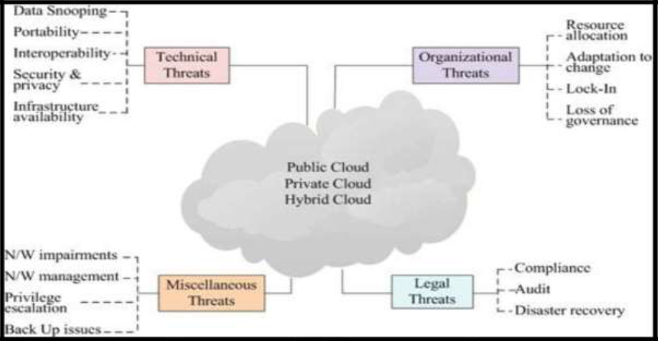
Figure3.1 Threat classification of Cloud: a deployment model scenario (Wikipedia)
3.2 ANALYSIS OF THE EXISTING SYSTEM
Existing cloud security systems of ten rely on reactive measures and lack comprehensive threat intelligence capabilities. Challenges include in consistent access controls, limited visibility in to multi- cloud environments, and inadequate compliance with security standards. The absence of unified security frame works complicates the management of diverse cloud resources, particularly in multi -cloud setups. Organizations frequently rely on the default security measures provided by c loud vendors, which may not be sufficient to address specific threats. This relianceex acerbates risks associated with data breaches and unauthorized access.
A not hercritical issue is the underutilization of advanced tools such as AI- driven analytics and auto mated monitoring systems. While these technologies have shown potential i enhancing security, their adoption remains limited due to cost concerns and alack of expertise. This gap leaves cloud environments vulnerable to sophisticated attacks that exploit weaknesses in traditional security approaches.
3.3 PROBLEMS OF THE EXISTING SYSTEM
The existing system has the following problems:
- In consistent security protocols across cloud providers.
- Vulnerability to emerging threats such as ransom ware and advanced persistent threats (APTs).
- Limited user awareness and training on secure cloud usage.
3.4 DESCRIPTION OF THE PROPOSED SYSTEM
The proposed system integrates advanced threat detection techniques, including AI- driven anomaly detection and real- time monitoring. A zero -trust security model is adopted to enforce strict access controls, complemented by robust encryption mechanisms and automated incident response workflows. This system ensures continuous verification of use rid entities and device compliance, significantly reducing the risk of unauthorized access and data breaches.
Additionally, the system leverages cloud-native security tools to provide seamless integration with existing cloud plat forms. Features such as automated threat intelligence updates and dynamic risk assessment enhance the overall security posture. By addressing the limitation so ftraditional security systems, the proposed system offers as capable and adaptive solution tailored to the complexitie so modern cloud environments. The proposed system integrates advanced threat detection techniques, including AI- driven a normaly detection and real- time monitoring. A zero- trust security model is a do pted to enforce strict access controls, complemented by robust encryption mechanisms and automated incident response workflows.
3.5 ADVANTAGES OF THE PROPOSED SYSTEM
The proposed cyber security in risk cloud computing has the following advantages:
- Enhanced threat detection and prevention capabilities.
- Improved compliance with security standards and regulations.
- Increased user confidence in cloud security.
- Scalable and adaptable security framework.

CHAPTER FOUR
DESIGN IMPLEMENTATION AND DOCUMENTATION OF THE SYSTEM
4.1 DESIGN OF THE SYSTEM
This is the computation of the particulars of a new system and the determination of what the new system would be and the function it is to perform. This may involve changing from one system to another or modifying the existing system operation.
The most challenging phase of the system life cycle is the change from manual operation to a faster and more accurate one; system sign stage covers the technical specifications that will be employed in the implementation of the new system in order to modify the previous system. Some factors are put in consideration. These factors include input design, output design, definitions file and procedure signs and other documentation.
4.1.1 OUT PUT DESIGN
This incorporates the objectives of solving the existing system problems and challenges. This involves the structuring of the desired information and also to enhance efficient and effective Two -Factor Authentication. (2FA). Thing stake in to consideration in determining the output are represented below:

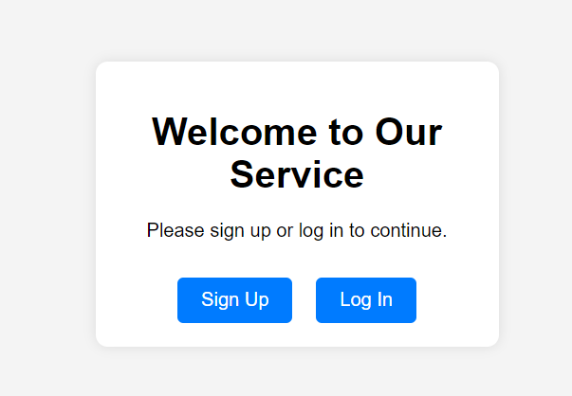
Figure4.1: Sign- in /Sign- up Page
This page allows the user to sign up by creating profile and also allow the user to login -in to their account
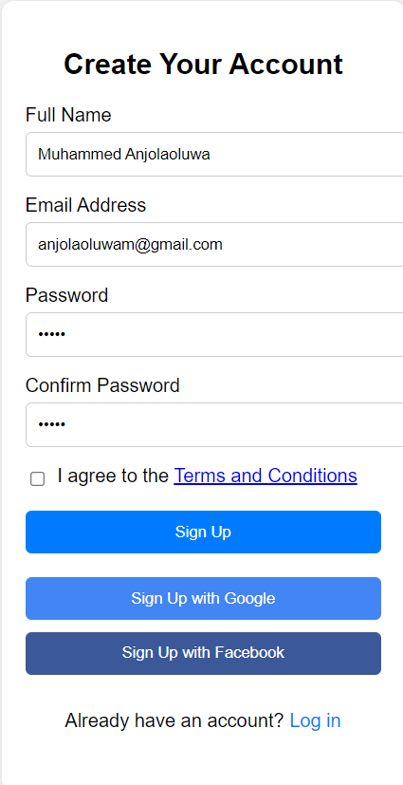
Figure4.2: for sign up Page
This interface allows allow users to register their information
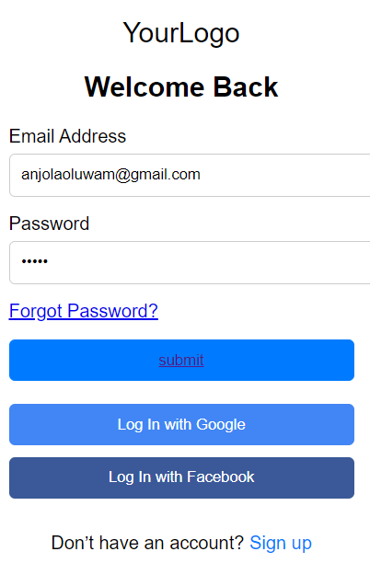
Figure4.3: Login Page.
This is a where user senter their login credentials
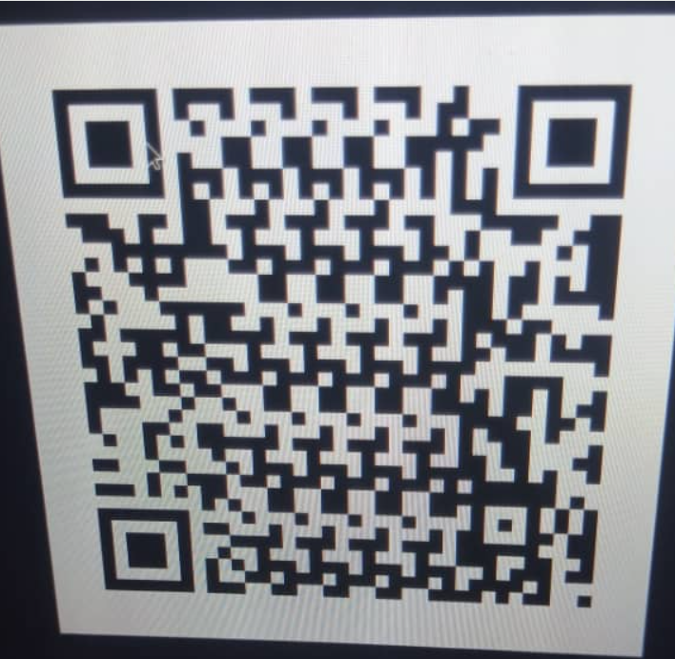
Figure4.4: Barcode authentication
This is a page where users scan the barcode in other to have access to the cloud environment.
4.1.2 INPUT DESIGN
The input to run this software is obtained from Menstrual cycle monitoring system administrator. The administrator is expected to register any User information. He can achieve this by typing via the keyboard. The input required from the Users is their personal data and answer?
To the questions set by the administrator. It can serve as the various input layouts from the various modules first from the collection of data and module then from the assessment module and input from User respectively.
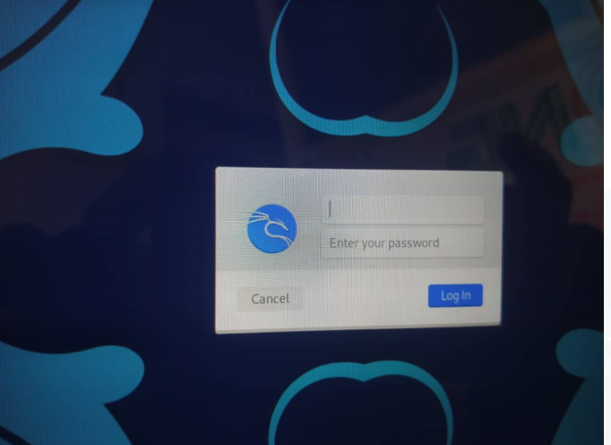
Figure4.5: Login Interface
This interface allows the user to enter /supply his /her log in credentials

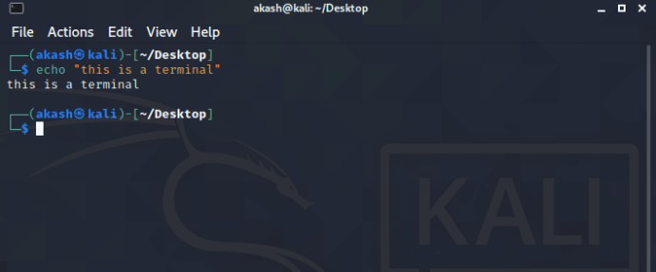
Figure4.6: Linux Terminal interface
This is where you enter your commands for execution.
4.1.3 PROCEDURE DESIGN
These are the steps involved in unifying the whole process to produce the desired output. It involves computer procedures which start from the original input lessons to the out put result file. This allows the processing of User information and result to be possible. Menu is provided to aid User in the processing of the output file.
4.2 IMPLEMENTATION OF THE SYSTEM
Implementing an effective cyber security system in a cloud environment requires as tructured approach. Advanced encryption standards, such as AES -256, should be deployed to secure data. Authentication mechanisms, including multi- factor authentication and single sign- on, enhance identity verification. Network monitoring tools like Intrusion Detection Systems (IDS) and Intrusion Prevention Systems (IPS) should be utilized to detect anomalies in traffic. Configuration management tools, such as AWS Config and Azure Security Center, auto mate compliance with best practices. Regular updates and patches are critical to addressing software vulnerabilities promptly. Employee training is essential to build awareness about security practice sand potential threats. Additionally, are bust incident response plan ensures the organization can effectively handle breaches and minimize their impact.
4.2.1 CHOICE OF PROGRAMMING LANGUAGE
The Application was developed in a. net (dotnet) integrated development environment (.net IDE). The Application IDE is chosen following the fact that extracte din formation needs to be presented in an enhanced pictorial /graphical format and easy communication with the database for program flexibility in windows plat form.
4.2.2 HARDWARERE QUIREMENT
i. 500Hzminimum with CD ROM drive etc.
ii. Harddiskofcapacity10GBMinimum
iii. 126-512megabyte of RAM
iv. An Uninterrupted power supply(UPS)
v. A voltage stabilizer
vi. A power generating set etc.
4.2.3 SOFTWARERE QUIREMENT
i. Windows operating system such as Windows7 etc.
ii. Dream Weaver
iii. Server Query Language (SQL).
4.3 DOCUMENTATION OF THE SYSTEM
4.3.1 PROGRAM DOCUMENTATION
The program is packaged for use in any system irrespective of either it runs visual studio application or not. After developing a programin Visual studio, there is a facility provided in Microsoft Visual Studio suite called “Package and Deployment Wizard” that is used in Visual studio application packaging and deployment.
4.3.2 MAINTAINING OF THE SYSTEM
The system maintenance refers to making modification to an already existing application/ program with out necessarily re-writing everything from start. Program maintenance of a program includes modification of the program to meet -up with certain requirements of the Users. In this course, additional features can be added, errors corrected, ambiguous inter faces rede signed to eliminate confusions and unnecessary features removed.
Maintaining this program can be done in a Visual studio environment. Any future modification can be by re-running the program source code in a visual studio environment making necessary changes and updates and recompile the application in to an grade version of the existing version of the mini word processing application. Further version so this program can be named following their year of release or it can be given a different version number. This research adopt high level programming language (Python).

CHAPTERFIVE
SUMMARY, CONCLUSION AND RECOMMENDATIONS
5.1 SUMMARY
The study explores the pressing issue of cyber security in cloud computing, focusing on the vulnerabilities of public and hybrid cloud environments. It identifies the growing threat land scape, ranging from data breaches to insider threats, and highlights the limitations of existing security measures. Through a detailed analysis, there search sheds light to the necessity of proactive strategies for threat detection and mitigation.
A ninte grated approach is proposed to address these challenges, emphasizing he adoption of advanced threat detection technologies, zero- trust architectures, and automated incident response mechanisms. The finding sunder score the importance of leveraging artificial intelligence and robust encryption to enhance cloud security frameworks. Additionally, the study stresses the value of user education and regular compliance audits.
Ultimately, this project contributes to the development of more secure cloud computing environments by bridging the gap between technological advancements and effective cyber security practices. By implementing the proposed solutions, organizations can reduce risks, comply with security standards, and foster greater trust in cloud technologies.
5.2 CONCLUSION
With the rise of cloud computing, users, practitioners, and providers have become concerned a bout cloud security. Cloud plat forms have become popular as are sult of advancements in machine learning, deep learning techniques and cloud computing power. More and more third -party cloud services are being adopted, such as IaaS, SaaS and PaaS, bringing about security challenge sin cloud computing that require efficient mitigation. According to existing studies, organizations and cloud service providers have established numerous controls to assure data security and protection. However ,such procedure se nail numerous constraints that most cloud service providers are hesitant to impose, since they are likely to reduce the efficiency of cloud access.
5.3 RECOMMENDATIONS
Based on the findings of this research, the researcher recommended that organizations muster main vigilant, adapt their security measures, and foster a culture of security awareness to effectively mitigate risks in the dynamic cloud computing land scape.

REFERENCES
Byali,R.,Jyothi,H.&Shekadar,M.C.(2022).Dual Access Control for Cloud-Based Data Sharing and Storage Security, International Journal of Research Publication and Reviews. Vol.1,Issue:1.Pp.4-5.
Donald,A.C.&Arockiam,T.L.(2019).Securing Data with a uthentication in Mobile Cloud Environment: Methods, ModelsandIssues, International Journal of Computer Applications. Vol.94,Issue:1.Pp.1288-1289.
Fotiou, N., Machas, A.,Polyzos,G.C.&Xylomenos,G.(2019).Access control a saservice for the Cloud, In:Proceedings of the 17thACM Conference on Computer and Communications Security. CCS’10.ACM,NewYork,NY,USA.Pp.735–737.
Gokila,R.,Manimaran,A.&Kumar,K.(2018).Implementation of Two-Factor Authentication Access Controlin Web Based Services with Cloud Computing using C#. Net ,International Journal of Pure and Applied Mathematics. Vol.119,Issue:10.Pp.1881-1908.
Harshavardhan,H.A.(2015).Integrity Auditing for Out sourced Dynamic Cloud Data with Group User Revocation, International Journal of Computer Engineering in Research Trends. Vol.2,Issue:11.Pp.877-881.
Kaur,S.,Kaur,G.&Shabaz,M.(2022).A SecureTwo-Factor Authentication Frame work in Cloud Computing, Journal of Security and Communication Networks.Vol.4.Pp.34-36.
Lal,N.A.,Prasad,S.&Farik,M.(2016).A Review of Authentication Methods, International Journal Of Scientific & Technology Research Vol.5,Issue:11.Pp.2277-8616.
Liao, I.E., Lee, C.C. & Hwang, M.S. (2016). A Password Authentication Scheme Over Insecure Networks. Journal of Computer and System Sciences, 72(4).Pp.727–740.Doi:10.1016/J.Jcss.2005.10.001
Mahmood, G.S., Huang, D.J. & Jaleel, B.A. (2019). A Secure Cloud Computing System by Using Encryption and Access Control Model, Journal of Information Process System. Vol.15,Issue:3.Pp.538-549.
Me gouache, L., Zitouni, A. & Djoudi, M. (2020). Ensuring user Authentication and Data Integrity in Multi Cloud Environment, The 5th IEEE international conferenceon future internet of things and cloud (FiCloud).Pp.56-58.
Mudarri, K. & Al-Rabeei, S. (2019). Security Fundamentals: Access Control Models, International Journal of Interd is ciplinarity in Theory and Practice. Vol.1,Issue:2.Pp.3-5.
Otta,P., Panda, S., Gupta, M. & Hota, C. (2023). A Systematic Survey of Multi-Factor Authentication for Cloud In frastructure, International Journal of Scientific & Technology Research Vol.2,Issue:11.Pp.77-78.

Patel,S.C.,Jaiswal,S.,Singh,R.S.&Chauhan,J.(2018).Access Control Frame work Using Multi-Factor Authentication in Cloud Computing, International Journal of Green Computing. Vol.9,Issue:2.Pp.
Rahman,M.S.,Ahmed,M.K.&Rao,G.S.(2017).Two Step Factor Based Authentication Control to Access Cloud Services, International Journal of Computer Engineering In Research Trends.Vol.4,Issue:10.Pp.431-440.
Shekinah,P.(2015).Decentralized Fine-grained Access Control Scheme for Secure Cloud Storage Data, International Journal of Computer Engineering in Research Trends.Vol.2,Issue:7.Pp.421-424.
Somorovsky,J.,Mayer,A.,Schwenk,J.,Kampmann,M.&Jensen,M.(2019).Security Fundamentals:Access Control Models, In:Proc.of the 21st USENIX Security Symposium. USENIXA ssociation, Berkeley.Vol.12.Pp.21–21.

