DESIGN AND IMPLEMENTATION OF A COMPUTERIZED GRADE EVALUATION SYSTEM USING DECISION TREE ALGORITHM
(CASE STUDY OF UNIVERSITY OF ILORIN)
BY

LAWAL OLUWAFEMI EMMANUEL
ND/23/COM/PT/0182
A Project Submitted to the Department of Computer Science,
Institute of Information and Communication Technology, Kwara State Polytechnic, Ilorin
In Partial Fulfillment of the Requirements for the Award of National Diploma (ND) in Computer Science
June, 2025

CERTIFICATION
This is to certify that this project research was carried out by LAWAL FEMI EMMAMUEL with matriculation number ND/23/COM/PT/0182, has been
read and approve as meeting part of the requirements for the award of National Diploma (ND) in Computer Science.
………………………………. ……………………………….
Dr. (Mrs.) OLUSI Date
Project Supervisor
………………………………. ……………………………….
Mr. Oyedepo, F. S. Date
Head of Department
………………………………. ……………………………….
External Examiner Date

DEDICATION
This project is dedicated to the creator of the earth and universe, the Almighty God. It is also dedicated to my parents for their moral and financial support.
ACKNOWLEDGEMENT
All praise is due to the Almighty God the Lord of the universe. We praise Him and thank Him for giving us the strength and knowledge to complete my ND programme and also for my continue existence on the earth.
We appreciate the utmost effort of our supervisor, Dr. (Mrs.) OLUSI, whose patience support and encouragement have been the driving force behind the success of this research work. She gave useful corrections, constructive criticisms, comments, recommendations, advice and always ensures that an excellent research is done. Our sincere gratitude goes to the Head of the Department Mr. Oyedepo, F. S. and other members of staff of the Department of Computer Science, Kwara State Polytechnic, Ilorin, for their constant cooperation, constructive criticisms and encouragements throughout the programme.
Special gratitude to our parents MR and MRS LAWAL who exhibited immeasurable financial, patience, support, prayers and understanding during the periods in which we were busy tirelessly in our studies. Special thanks go to all our lovely siblings.
Our sincere appreciation goes to our friends and classmate

TABLE OF CONTENTS
Title Page i
Certification ii
Dedication iii
Acknowledgements iv
Abstract v
Table of Contents vi
CHAPTER ONE: GENERAL INTRODUCTION
1.1 Background to the Study 1
1.2 Statement of the Problem 3
1.3 Aim and Objectives of the Study 4
1.4 Significance of the Study 4
1.5 Scope of the Study 5
1.6 Limitation of the Study 5
1.7 Defination of Terms
CHAPTER TWO: LITERATURE REVIEW
2.1 Review of Related Works
CHAPTER THREE: RESEARCH METHODOLOGY AND ANALYSIS OF THE
EXISTING SYSTEM
3.1 Research Methodology 15
3.2 Material Methodology 17
3.3 Design Strategy 17
3.4 Description of the Proposed System 18
3.5 Advantages of the proposed system 19
CHAPTER FOUR: DESIGN, IMPLEMENTATION AND DOCUMENTATION OF THE SYSTEM
4.1.1 Output Design 21
4.1 Design of the system 21
4.1.2 Input Design
4.1.3 Procedure Design 28
4.2 Implementation of the System 29
4.2.1 Hardware Support 30
4.3 Documentation of the System 30
4.3.1 Maintaining the System 31
CHAPTER FIVE: SUMMARY, CONCLUSION AND RECOMMENDATION
5.1 Summary 32
5.2 Conclusion 32
5.3 Recommendation 33
References
Appendices

ABSTRACT
This research work presents a computerized grade evaluation system that is developed to collect, process, and return the exams grades of student of the University of Ibadan. It discusses the design requirements, features, and implementation of the computerized grading system, as well as reactions from course faculty and staff members. The system is developed with numerous advantages over the analog grading methods, including scalability, real-time feedback on the status of grading, the reduced potential for human error in compiling grades, the ability for lecturers to grade remotely and to revise their grades after submission, the ability for course administrators to easily review grading results and remove statistical outliers from the score set, the ability to return both provisional and final grades to the course faculty, staff, and students in a timely manner, and the ability to archive and export grading data for future use. Although the online system is a clear improvement over paperbased grades.
CHAPTER ONE
INTRODUCTION
1.1 BACKGROUND OF THE STUDY
The logistical problems associated with distributing, collecting, grading, and returning assignments and the difficulties in ensuring fairness and consistency in grading tends to increase non-linearly with the number of students enrolled in an academic program.Nowadays, we are living in an information age dependent upon digital Information retrieved from the internet. This Digital information is electronically interpreted,the results of the computer processed information. (Curtis et al., 2008) Different type of jobs relies mostly on the internet to getinformation, using it, managing it, and relaying information to others. Computers enable the efficient processing and storage of information.Computerized-assisted grading system will go a long way in guiding the grading process and compilation of final results among systems of any institution in Nigeria. Ekpenyong report that using computer-assisted grading systems during bulk students grading with large amount of students reduced the grading time by half compared to traditional hand grading without the help of the system (Ekpenyong, 2008). In addition to the “reduced time in grading assignments,” Czaplewski notes that computer-assisted grading system can lead to increased “validity and accuracy of grading – making grading more evenhanded,” increased feedback for students, and increased student satisfaction.This research work presents an online computerized system to assist in grading of students to improve the fairness, consistency, and efficiency of grading.
Many teachers feel that the time they take in recording and computing for the grades of their students is time that could be better spent elsewhere, like preparing lessons, researching or meeting with their students. With the advent of computer technology, more and more schools are taking
advantage of a variety of grading systems available both off-line and online that can help save time on administrative tasks and give teachers more time to attend to other important functions. However, a greater majority, especially small schools, government schools, and schools in remote areas, still utilize the manual method of recording and computing for the grades of the students.
This work provides a brief overview of the course, its deliverables, and the breakdown of the grades. It discusses the design requirements, features, and implementation of the online grading system. Finally, the current limitations and future development directions of the online grading system are discussed.

1.2 STATEMENT OF THE PROBLEM
The general statement of problem is to create a Computerized Grading
Evaluation System for University of Ibadan, to solve the following problems – To design and develop a comprehensive module that will display the student’s grade records easily, To implement grade automation awareness among schools by reducing (if not eliminating) manual tasks of grade keeping and finally To create a system that will automatically compute the student’s grade of university of Ibadan.

1.3 AIMS AND OBJECTIVE OF THE STUDY
The main objective of the study is to develop a Computerized Grading Evaluation System for University of Ibadan. With the following objectives –
- To create design and develop a computerized grade evaluation system for recording of student’s name, grade level and section.
- To create a system that will be secured and maintain the integrity of data, which can be easily retrieved.

1.4 SIGNIFICANCE OF THE STUDY
The computerized grade evaluation system will provide convenience to teachers through the easier and faster way of recording information. Population of students is ever increasing in alleducational institution so great demand in teaching force is also becoming higher. The online Grade evaluation System is very essential and important for school’s operations and goals. The students are graded to measure their performance in their academic courses and knowledge. Teachers spend a lot of time to accurately compute the grades of the students using their calculators, and, in earlier times, teachers manually solve grades using the manual computations means which is always filled of errors.
Acomputerized grade evaluation system for University of Ibadan will provide a marked improvement in the way teachers’ record and compute for the grades of students.
- Faculty Teachers: Teachers’ would be able to record and compute for the grades of their students faster thereby lessening their workload and providing them with added time to attend to other functions. This in turn would improve their efficiency as teachers.
- School Administrators: School Administrators no longer have to recompute the grades of each student to check on their accuracy. Student Reports such as grading results sheets and class records can be submitted on time and seamlessly.
- Students: Students can now look forward to better lessons since their teachers would have added time to prepare for them their lesson plans.

1.5 SCOPE OF THE STUDY
The scope of the research is focused on designing and implementing a computerized grade evaluation system for University of Ibadan.

1.6 LIMITATION OF THE STUDY
The major limitation of this research is related to student results and data which are very sensitive materials which can’t be disclosed to the general public, sourcing and getting student information to be used for this research work was a major limitation.

1.7 DEFINITION OF TERMS
CGPA : Cumulative Grade Point Average (CGPA) is an assessment tool used to evaluate your academic performance.
Evaluation: the making of a judgement about the amount, number, or value of something; assessment.
Database: database, also called electronic database, is any collection of data, or information, that is specially organized for rapid search and retrieval by a computer
Software: An application program is a computer program designed to carry out a specific task other than one relating to the operation of the computer itself.

CHAPTER TWO
LITERATURE REVIEW

THE LITERATURE REVIEW
Evaluation gives an important yard stick to judge the quality of students. It plays a vital role in the educational system. It also offers motivation and a sense of purpose to both teachers and students to achieve set goals. (Mazza et al., 2004) The word examination has come to be associated with stress and anxiety. The practice of teaching and learning which is thought to be meaningful for the student loses its joy because of these negative connotations of examination. The larger context of education is to train futuristic citizens for a meaningful and productive life in a globalised society.
There is a dire need to build up the education system even more so in a pluralistic society which addresses itself to a heterogeneous group. (Stephen, 2002) Evaluation is a means of recognizing the extent to which we have been successful in imparting such an education. Evaluation is an essential part of the educational process as some form of assessment is compulsory to determine the effectiveness of teaching learning processes and their assimilation by learners. External examinations „are largely inappropriate for the „knowledge society of the 21stcentury and its need‟ ‟ for innovative problem solvers , Questions if not framed well, “call for rote‟ memorization and fail to test higher-order skills like reasoning and analysis, lateral thinking, creativity and judgment. External exams make no allowance for different types of learners and learning environments and induce an in-ordinate level of anxiety and stress”. (NCF- Position paper on Examination Reforms) Schools start ranking students, on the basis of their marks, from as early as their preprimary years. Such an impel has several negative effects on learning.
Students, parents and society at large become anxious in the race to attain more and more marks in examinations which leads to an extremely stressful existence. (Tata, 2005) Moreover, while all out efforts are made to improve the reliability of examination, the human error cannot be avoided. This inadequacy can be overcome if the students are placed in ability bands that represent range of scores. This calls for a functional and reliable system of School-Based Evaluation. There was a need to look at the holistic assessment of a learner which also includes co scholastic area of Life Skills, Values and Attitudes, Games and Sports as well as CoCurricular activities. The Continuous and Comprehensive Evaluation scheme seeks at addressing this in a holistic manner. A number of National Committees and Commissions in the past have consistently made recommendations regarding sinking emphasis on external examination and encouraging internal assessment through School-Based Continuous and Comprehensive Evaluation. Therefore, the CCE scheme brings about a paradigm shift from examination to effective pedagogy. The National Policy on Education 1986 (NPE) and Programme of Action 1992 (POA) also envisaged the recasting of the examination system and has, inter alia, suggested that grades be used in place of marks. National Curriculum Framework 2005(NCF) envisaged an evaluation system which would grade the students on their regular activities in the classroom and enable students to understand and focus on their learning gaps and learn through these as part of Formative Assessment. National Curriculum Framework 2005, while proposing Examination Reforms has also stated – “Indeed, Boards should consider, as a long-term measure, making the Class X Examination Optional, thus permitting students continuing in the same school(and who do not need a Board certificate) to take an internal school exam instead “. Hon‘ble Union Minister for Human Resource Development also announced―Push the process of examination reform in accordance with NCF 2005. This will include making the Class X examination optional, thus permitting students continuing in the same school (and who do not need a board certificate) to take an internal school assessment instead.

CHAPTER THREE DATA GATHERING PROCEDURE AND OUTPUT
3.0 Research Methodology
Requirement gathering is usually the first part of any software product. This stage starts when you are thinking about developing software. In this phase, you meet customers or prospective customers, analyzing market requirements and features that are in demand. You also find outif there is a real need in the market for the software product you are trying to develop.
In this stage, marketing and sales people or people who have direct contact with the customers do most of the work. These people talk to these customers and try to understand what they need. A comprehensive understanding of the customers’ needs and writing down features of the proposed software product are the keys to success in this phase. This phase is actually a base for the whole development effort. If the base is not laid correctly, the product will not find a place in the market. If you develop a very good software product which is not required in the market, it does not matter how well you build it. You can find many stories about software products that failed in the market because the customers did not require them
3.1 MATERIALS AND METHODS
The application was developed using the Waterfall software life-cycle model, which is called the traditional model because it was the first widely used software development life cycle. It was put forward about thirty years ago and has since then been successfully used by a wide variety of respected software organizations (Stephen, 1992). It is part of Structured Software Engineering or the Structured Paradigm, which is regarded as the classical approach to software engineering. The Structured Paradigm is the older of the two earliest approaches to formal software engineering. (The other approach is Object-Oriented Software Engineering). The Waterfall model is a document driven model; that is, the previous phase is carefully tested and reviewed before proceeding to the next phase, and each accepted phase is duly signed off (Curtis, 1998). The application was developed in the form of a database capable of running on a network (Onoyom-Ita, 2008). The decision to implement it in the form of a database was informed by the realization that various types of data would need to be held, and a database has advantages over other forms of file systems. Such advantages include data consistency, data integration, data sharing, data independence, data control and minimal data redundancy (Tata, 1995). Network capabilities were included to enable various users of the application to access it from their offices if attached to a network, rather than go to the computer room for every transaction

3.2 Design Strategy
Design strategy Is a discipline which helps firms determine what to make and do, why do it and how to innovate contextually, both immediately and over the long term. This process involves the interplay between design and business strategy, forming a systematic approach integrating holistic-thinking, research methods used to inform business strategy and strategic planning which provides a context for design. While not always required, design strategy often uses social research methods to help ground the results and mitigate the risk of any course of action. The approach has proved useful for companies in a variety of strategic scenarios.
Implementation is the realization of an application, or execution of a plan, idea, model, design, specification, standard, algorithm, or policy. An implementation is a realization of a technical specification or algorithm as a program, software component, or other computer system through programming and deployment. Many implementations may exist for a given specification or standard. For example, web browsers contain implementations of World Wide Web Consortium-recommended specifications, and software development tools contain implementations of programming languages.

Testing: can never completely identify all the defects within software. Instead, it furnishes a criticism or comparison that compares the state and behavior of the product against oracles—principles or mechanisms by which someone might recognize a problem. These oracles may include (but are not limited to) specifications, contracts, comparable products, past versions of the same product, inferences about intended or expected purpose, user or customer expectations, relevant standards, applicable laws, or other criteria.
A primary purpose of testing is to detect software failures so that defects may be discovered and corrected. Testing cannot establish that a product functions properly under all conditions but can only establish that it does not function properly under specific conditions. The scope of software testing often includes examination of code as well as execution of that code in various environments and conditions as well as examining the aspects of code: does it do what it is supposed to do and do what it needs to do. In the current culture of software development, a testing organization may be separate from the development team. There are various roles for testing team members.
Information derived from software testing may be used to correct the process.

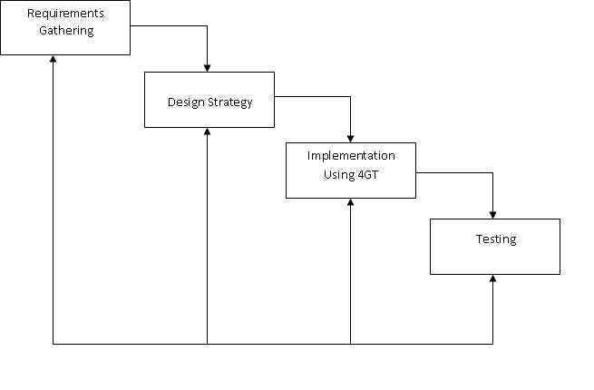

3.4 The Existing System
The current data base used by the University of Ibadan is Microsoft Office Excel 2010. Their method is traditional for recording, computing and updating student files. Everything they do is manually encoded.

3.4.1 Company Background
University of Ibadan is a religious, non-stock, non-profit educational institution founded in August 1964 in Ibadan. It is supervised and operated by One Body Christian Church and Ministries.
University of Ibadan offers pre-elementary, elementary and high school levels to qualify students without discrimination and prejudice as to religious affiliations and family background.
The school’s guiding vision is focused on Ministering to the total person of the students attaining Excellence in Academic and Christian Education and Spiritual Maturity to cope with the Christian mandate of world evangelization. It is their Mission to instill the Authentic Christian identity among students, educate and train them in the ministering of the Lord Jesus Christ, commitment to God and service to our country and fellowmen.
Everyone in the school are all willing to help and pray for the general welfare of each family and the community at large and bring the message of peace and reconciliation among men in all walks of life.
Complementing the school’s desire to teach each student the fear of God and respect for authority and elders are the team-oriented organization of Faculty Teachers, Staff, Administration and Board of Trustees sensitive and responsive to needs and changes relevant to the institutional aims.
At present, the school employs a total of twenty (28) teaching and nonteaching personnel and is catering to an average yearly enrollment of seven hundred (700) students.
As an institution being supervised by One Body Christian Ministries (OBCM), the school maintains very affordable tuition fees that are suitable to average to low income families. Due to their limited funds, the school maximizes its workforce to attend to every student needs that results to overloaded teachers and school personnel.
Although the school has a handful of computers donated to them, they still use the traditional way of maintaining files and records that are all manually done.

3.4.2 Description of the System
The current system being implemented by University of Ibadan is the traditional method of recording, calculating, and maintaining student grades and records. Everything is done manually.
Student information is written on paper forms during enrollment. The registrar prepares a list of official enrolled students and gives copies to the principal and to the teachers. The teachers write down the names of the students in their class records for every subject and section he or she is handling and enters the rating of the students for every grade component. The teachers manually compute the grade of the students using a calculator and submit their class records to the principal for checking.
The principal checks the grades one by one and if errors are found, the class record is returned to the teacher, who re-computes the grade and submit it again to the principal for checking. Correct and verified grades are then given back to the teacher to be submitted to the registrar who prepares the students’ report cards.
This type of system is very tedious and takes along time. Manually calculating, checking and re-computing the grades of students are very difficult and are very prone to human errors. Added to this is the money being spent by the school for paper files and forms, cabinets and other things needed to store student data and records.

3.4.3 Data Flow Diagram OF FICIAL LISTOF REGISTRAR STUD SUBJECT AVERAGE TEACHER SUBJECT GRADE GRADES FOR RECORDING D COMPONENTSEN SUBJECT GRADE
COMPONENTS RATING
E
R
R
O
N
E
O
U
S
S
U
B
J
E
C
T
A
V
E
R
A
G
E
G
R
A
D
E

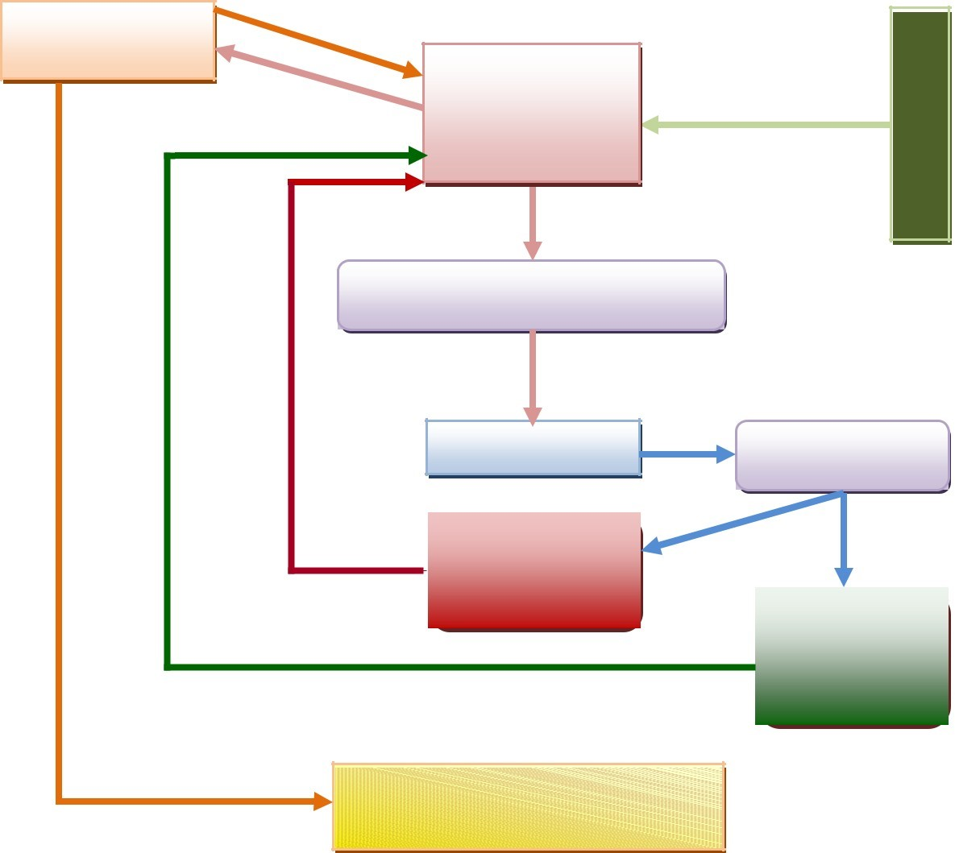
COMPUTE SUBJECT AVERAGE
GRADE
SUBJECT AVERAGE GRADE
FOR CHECKING
PRINCIPAL
CHECKSUBJECT
AVERAGE
GRADE
ERRONEOUS
SUBJECT
AVERAGE GRADE
SUBJECT
AVERAGE
GRADES FOR
RECORDING
STUDENT
PARENTS
REPORT CARD

3.4.4 Data Dictionary
■
Class Record / Grading Sheet – a written document consisting of student names, and their grades for each grade component
■
Grade – numeric equivalent of a student’s performance in subject or grade component.
■ Erroneous Subject Average Grade – Subject Grade Components that contain errors in calculations that are returned to the teacher for re-computation.
■
Official List of Students – List of student names who are officially enrolled in the school for the current schoolyear.
■
Registrar – the person in charge of recording and maintaining student information and grades.
■ Student – a person who is officially enrolled for the current school year
■
Student Report Card – a report given to the parents containing the grades of the student for a given quarter.
■ Subject Average Grade – The grade of the student for the subject as computed by the teacher and that appears on the Student Report Card. It is determined by the sum of all ratings for the different grade components divided by the total number of grade components.
■ Subject Average Grade for Checking – computed grades based on the different grade components to be checked by the Principal for accuracy.
■ Subject Average Grade For Recording – Student grades that have been checked and verified to be correct by the principal that is returned to the teacher for submission to the registrar who then records it on the student’s Report Card and Transcript of Records.
■ Subject Grade Components – Activities undergone by a student in which he or she is rated by the teacher. Grade components are composed of the following:
- Attendance – presence or absence of a student during class periods
- Seatwork/recitation – activities given by the teacher to be performed during class hours. It can be oral (recitation) or written (seatwork).
- Quizzes - short test on topics previously discussed or given as assignments
- Periodical Exam – long test given at the end of every quarter covering topics discussed within the quarter.
■ Subject Grade Components Rating – the mark or rating given by the teacher to the different subject grade components based on the performance of the student in these grade components.
■ Teacher – A school faculty member who is teaching the subject, rates student’s performance on the different subject grade components, and computes for the subject average grade of the student.

3.4.5 Problem Areas
With our research and interview with the staff of the University of Ibadan, We the proponents found out these problems on their manual system. Here are the following:

Redundancy of work and data
There is redundancy of work and data, particularly when it comes to the recording of the names of the students and in the checking of their grades. The student’s list that is given by the Registrar has to be written by the teachers in their class records. This is done by every teacher for every subject the he or she is teaching and for every section he or she ishandling. If a teacher is teaching three subjects with the same section, then he or she has to write the names of the students three times, one for every subject handled. The principal has to manually re-compute the grades of the students just to make sure that these are correct before these can be submitted to the registrar.

Time spent in calculating and checking grades
Grades are recorded and computed manually by teachers. This is a very tedious task and is very time consuming. The principal has to check each grade to make sure that no errors are committed in the computation. If errors are found, it goes back to the teacher concern to make the necessary changes. It then goes back again to the principal for checking.
This cycle continues until all the grades have been verified to be correct.

Accuracy of information
Aside from being time consuming,manual method of recording and computing for the grades of the student is prone to human error. More often than not, teachers rush through deadlines in the submission of grades and because of this, the accuracy of the grades are affected. The principal still has to double check each grade to ensure its accuracy.

3.5 The Proposed System
The ProposedSystem that we developed for University of Ibadan will be efficient in terms of time consuming, space and lessen the costs from their previous data base. Our proposed system has a security feature of which the admin and the teachers are the users by using the log-in form by typing the username and password. In general, our proposed system uses Microsoft
office 2010 for our database and Microsoft ExcelVBA as the programming language for our developed system.

3.5.1 System Overview
The proposed system is developed using VBA Excel. It improves working methods by replacing the activities done manually with the computerbased system. By automating every activity of the manual system being employed by the school, work becomes easier and grades are computed accurately in less time.
The proposed system is simple, interactive and has a very userfriendly interface such that even those with little or no knowledge about working with computers can easily operate it. A welcome screen starts the program and the teachers log-in by entering their username and password.

3.5.2 Process Specification
The proposed system is composed of three main modules, namely the registration module where pertinent student information are entered, the subject module, where the teacher enters the rating of the student for each grade component, and the grade computation module, where the grade of the student is calculated based on the inputted ratings for each grade component.
After the teacher logs-in, the main menu is displayed containing three
(3) options, namely, to enter student information, to enter student grades, or to view student information.
The process begins with the entry of student information (module 1). This is where pertinent student data, such as student name, address, parents name, contact numbers, etc., are entered and stored in a student information database.

Using the data from the student information database, the teacher chooses a subject and enters the rating of the student in each grade component (module 2). The grades are stored in the subject’s database.
The grades stored in the subject’s database are then retrieved and used in computing for the grade of the student (module 3).

3.5.2.1 Data Flow Diagram
PROPOSED SYSTEM BASIC DIAGRAM
INFORMATION
DATA INPUT PROCESS
OUTPUT
Username
Password
Student
Information
Student Grade
Component Rating
Student Grades

Computerized
Grading System
PROPOSED SYSTEM DATA FLOW DIAGRAM
 | Student |  | Component
REGISTRA R | Informatio n | STUDENT | Scores | TEACHER
Component
Grade
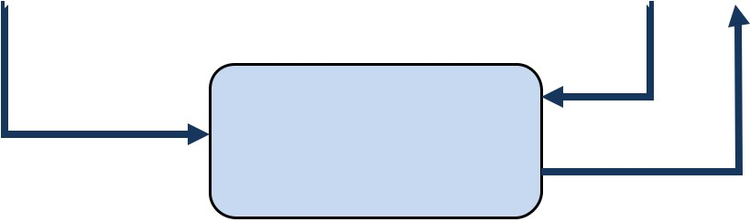
Student
Grading
System
Information
Subject
Grade
3.5.3 Data Dictionary  Component Grade - the mark or rating given by the teacher to the different components scores, based on the performance of the student in these grade components.
■
Component Scores – the scores obtained by the student in a particular subject component.
■
Student Information – pertinent data about the student such as student’s name, address, birth date, parents’ name, etc.
■
Student Information Database – the database where student information data are stored.
■ Subject Database – the database where the component grades and subject grade are stored.
■ Subject Grade - The grade of the student for the subject resulting from the subject grade computation process.
3.5.3 Data Specification

3.5.3.1 Entity Relationship Diagram
The proposed system is composed of 3 entities as shown in the following Entity Relationship Diagram:
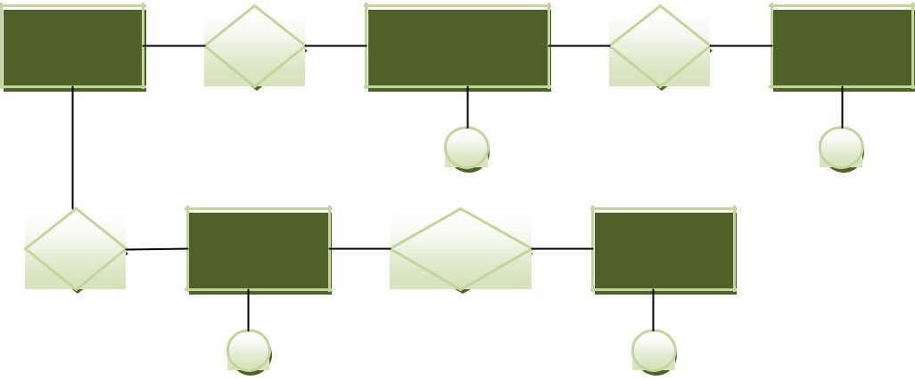
STUDENT
GIV
STUDENT
HAS
SUBJECT
INFORMATION
A
B
HAS
TEACHER
MAKE
Component
Scores

C D
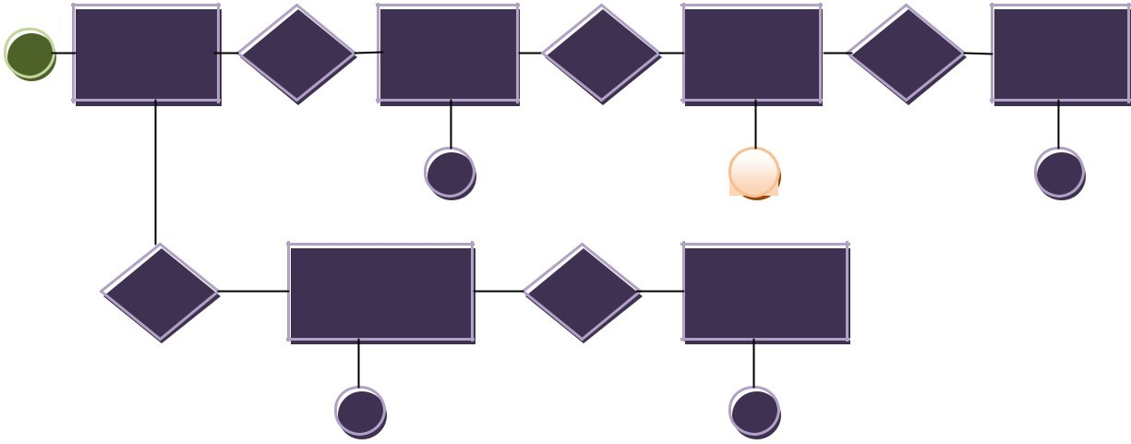COMPONENT SUBJECT
B
SUBJECT
HAS
SUBJECT
HAS
STUDENT
HAS
TEACHER
NAME
F
E
G
HAS
HAS
RATING GRADE

H I
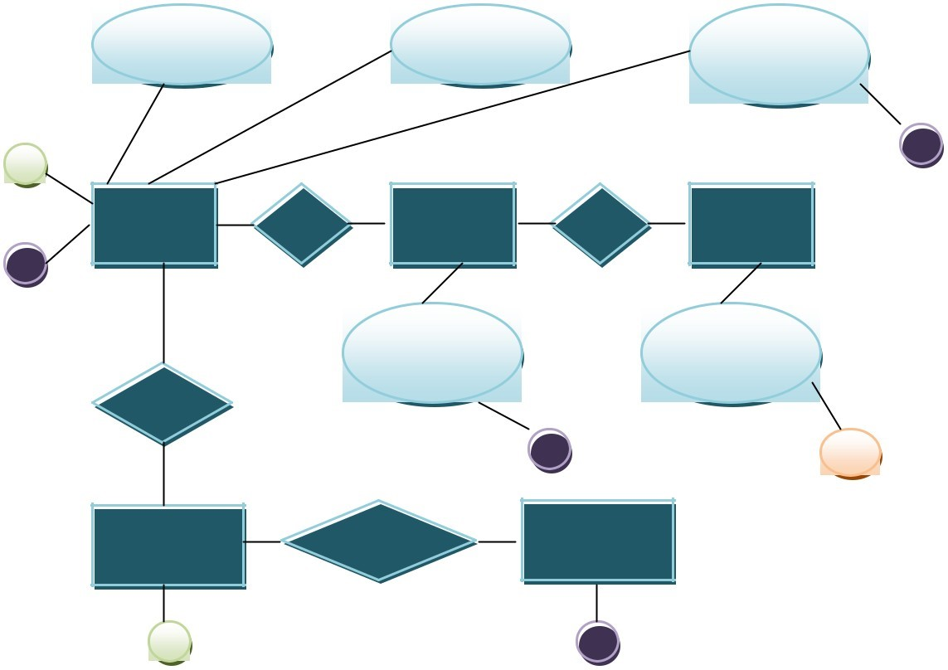
Username
Password
Component
Rating
C
H
TEACHER
HAS
SUBJECT
HAS
STUDENT
G
Subject
Student
Name
Name
RATES
F
E
COMPONENT
SUBJECT
SUBMITS
SCORES GRADE

D I
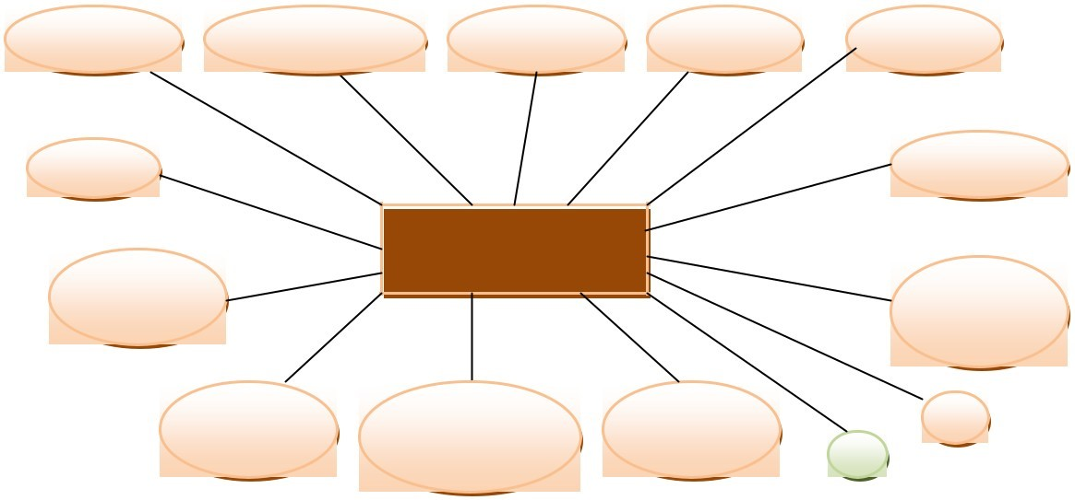STUDENT
First Name
Middle Name
Last Name
Gender
Address
Age
Birth Date
Mother’s INFORMATIO
N
Mobile
Name
Number
Father’s Parent’s Telephone E
Name Marital Status Number A

3.5.3.2 Tables / Files Layout
Table 1: Student Information Table –contains the information aboutthe student that is provided to the school by the student upon enrollment.
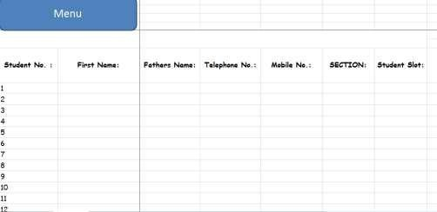

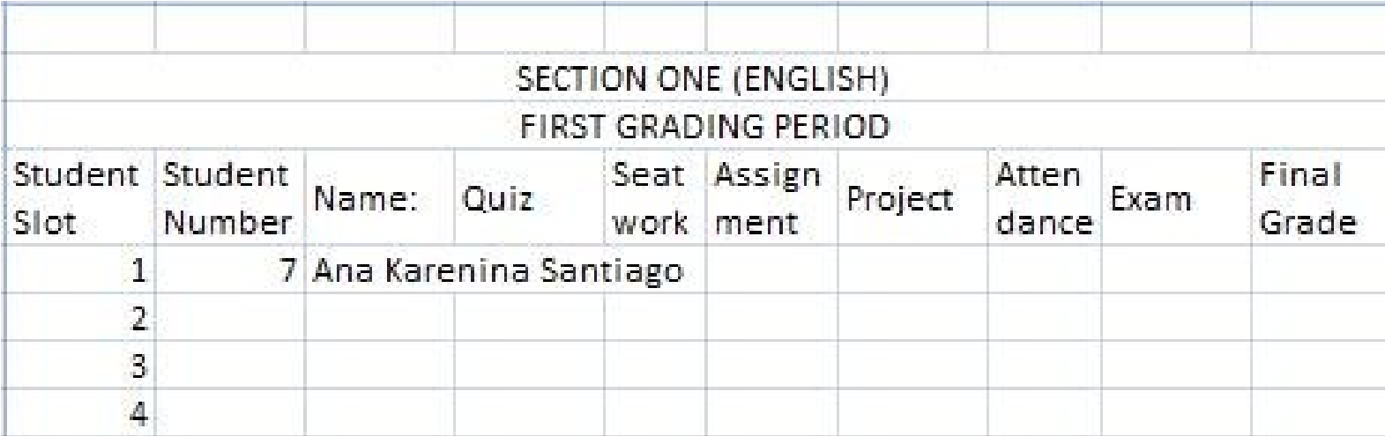
Table 2: Student Record Table Per Section Per Subject – containsthe grades of the student as entered by the subject teacher.

3.5.4 Screen Layout / Specification

Screen 1: Welcome Screen
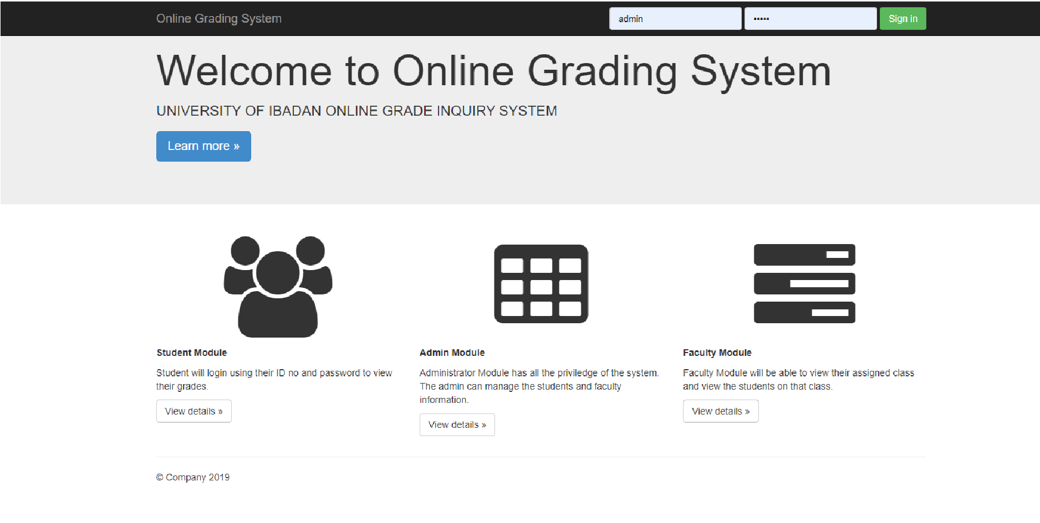
This is the first screen that will be displayed. Pressing the Login button

Screen 2: Admin Screen
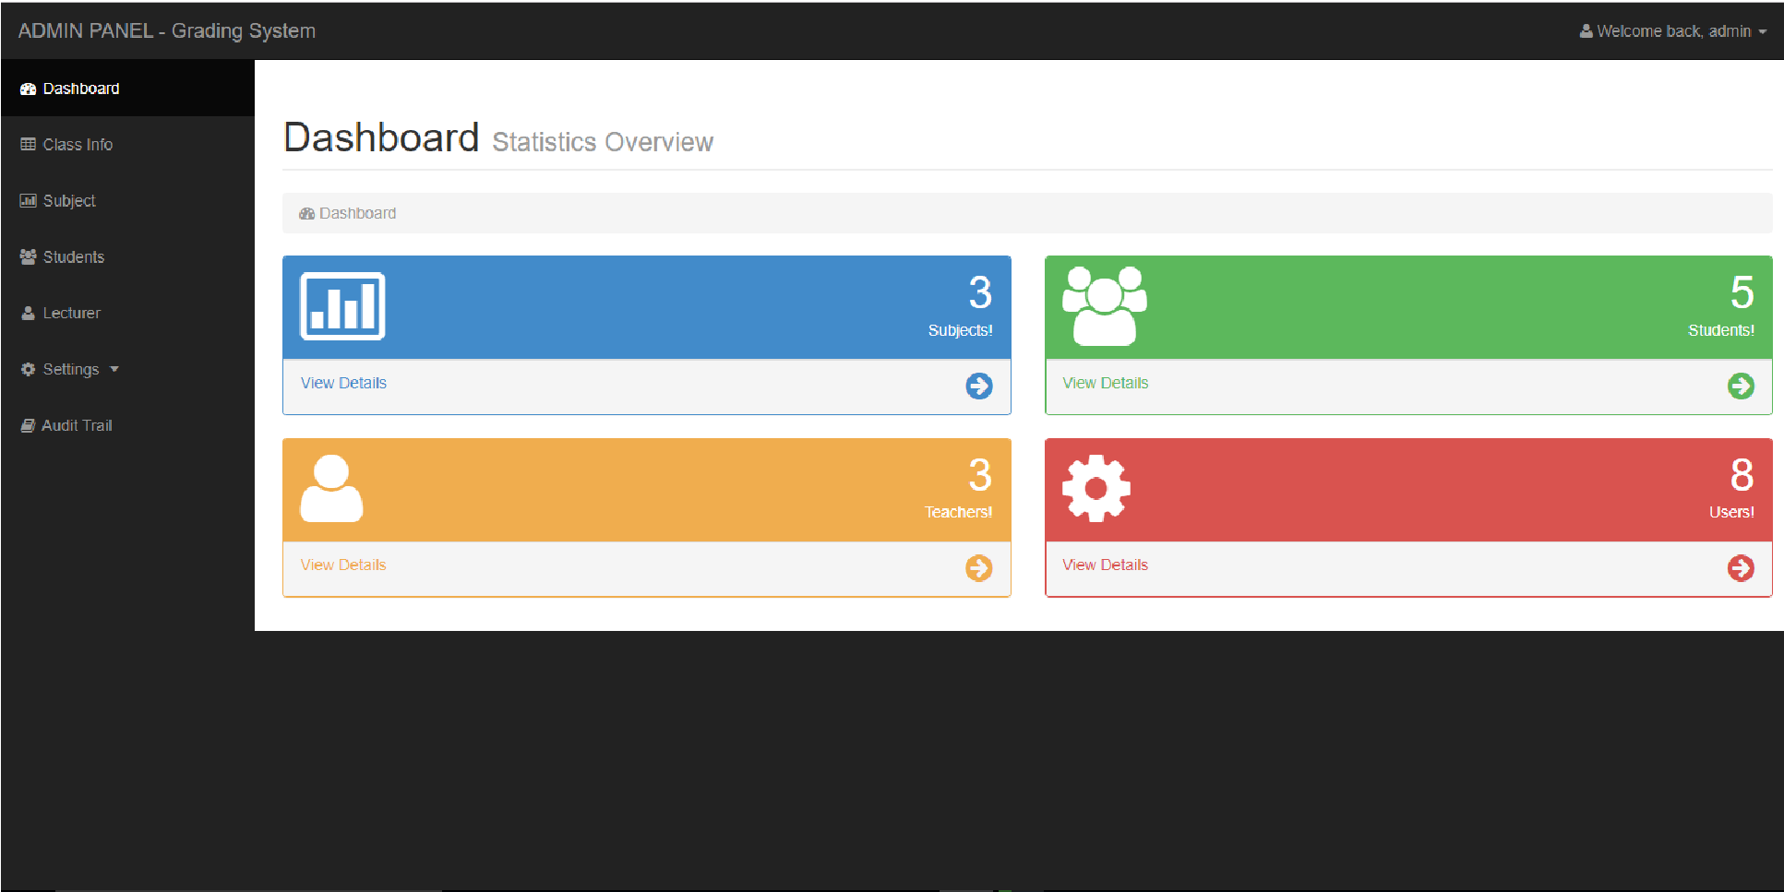
In this section, the admin login to the dashboard to access all the menus listed by the side bar. Admin can also view the reports of students and their activities, teachers and their activities and list of classes created so far.

Screen 3: Teacher Screen
The Teacher Screen displays the options that the teacher can choose from.
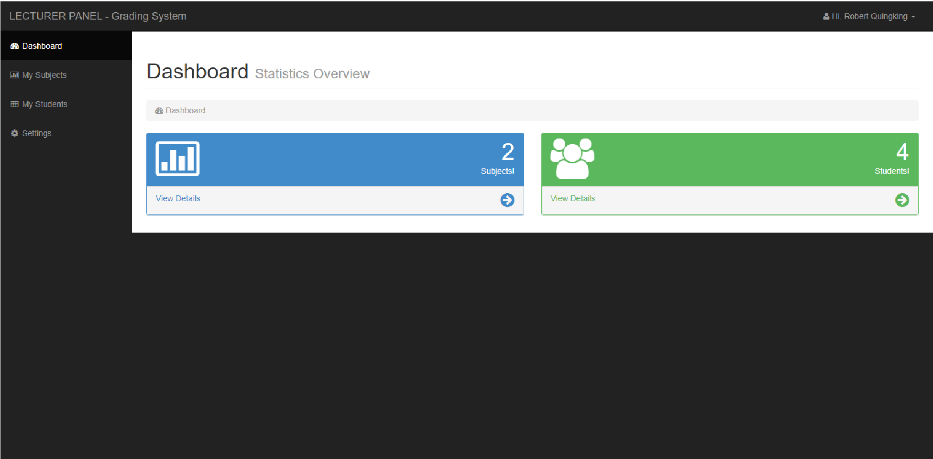

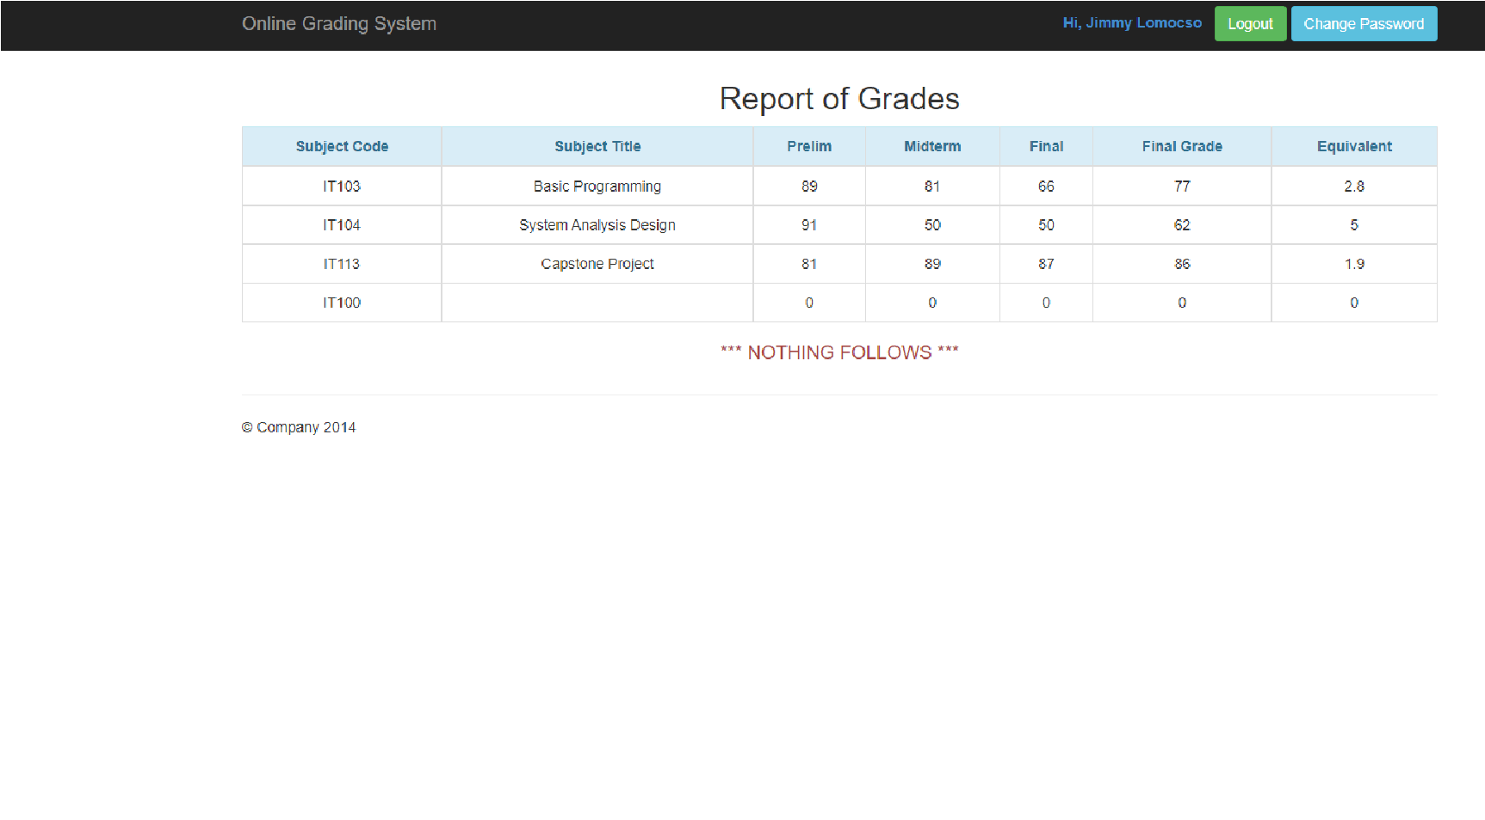
Screen 4 : Student Result Screen
This screen is shown as the student login to view their result. This is where the student will enter pertinent information about the student and assign the student to a particular section.

3.5.6 Program / Module Specification
The following is a general layout of the system :
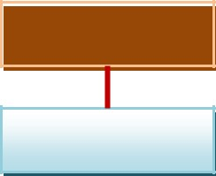
MODULE 5
Welcome Screen
MODULE View Log-In Screen Seat Register Plan MODULE MODULE 6 View Add Section Grade
MODULE 3 MODULE 7 View View
Student Report Info Card
MODULE 4Search Student
SUB  MODULE  1A | SUB  MODULE  1B | S  U  MODULEB  M  O  D | SUB MODULE  5A  Seat Plan  Screen
U
L
E
Student
Registration
Screen
Section
Screen
Information
4
A
SUB
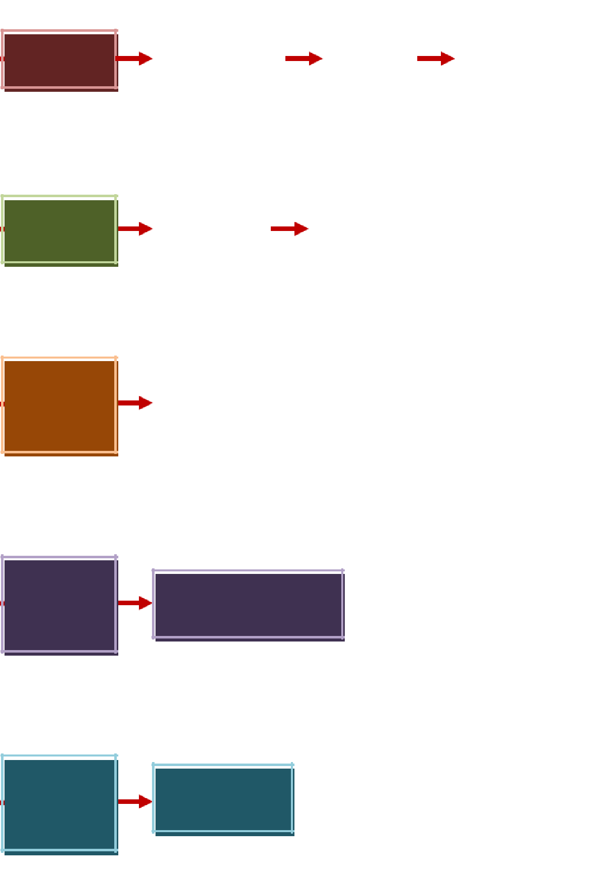
MODULE SUB MODULE
Section
Section Report
Screen
Screen
SUB MODULE
A
3
Student
Registration
Screen
S
S
c
r
e
e
n
S 6A 6B
e
SUB SUB a
  Select Screen
  Subject
  Grade
  Screen
MODULE MODULE r
c
2A 2B h

t u d e
n SUB
t MODULE
7A
Report
Card
Screen

CHAPTER FOUR
IMPLEMENTATION OF THE SYSTEM

4.1 Programming Language
PHP: Hypertext Preprocessor (or simply PHP) is a general-purpose programming language originally designed for web development. It was originally created by Rasmus Lerdorf in 1994; the PHP reference implementation is now produced by The PHP Group. PHP originally stood for Personal Home Page, but it now stands for the recursive initialism PHP: Hypertext Preprocessor.
PHP code may be executed with a command line interface (CLI), embedded into HTML code, or used in combination with various web template systems, web content management systems, and web frameworks. PHP code is usually processed by a PHP interpreter implemented as a module in a web server or as a Common Gateway Interface (CGI) executable. The web server outputs the results of the interpreted and executed PHP code, which may be any type of data, such as generated HTML code or binary image data. PHP can be used for many programming tasks outside of the web context, such as standalone graphical applications and robotic drone control.
The standard PHP interpreter, powered by the Zend Engine, is free software released under the PHP License. PHP has been widely ported and can be deployed on most web servers on almost every operating system and platform, free of charge.
The PHP language evolved without a written formal specification or standard until 2014, with the original implementation acting as the de facto standard which other implementations aimed to follow. Since 2014, work has gone on to create a formal PHP specification.

4.2 Special Purpose Language Tools
Special purpose Language Tools were also used, particularly :
MYSQL database for database connection.
MS Word for the documentation of the system
MS Paint for the developing of the Data Flow Diagram and screen printing and cropping for screenshots used in documentation of the system.
Adobe Photoshop for image editing. This is a graphics editor that is most popularly used because of programs for image manipulation. It is used widely by graphics professionals for all sorts of tasks including website design. Developed by Adobe Systems Inc. Photoshop is considered one of the leaders in photo editing software.

4.3 System Testing Plan
In this part the system is tested. The separate modules are brought together and tested as a complete system. The system is tested to ensure that interfaces between modules work and with the expected volume of data and that the system does what the user requires.

4.3.1 Testing Stages
We employed three testing stages in the development of the system. The first testing stage was during the creation of the program forms and modules. We tested each form and module with random data to know if it is working.
The second testing stage was conducted when the different program modules were put together. Testing begun immediately after joining the first two modules to make sure that data are synchronized, the interfaces between the modules work, and that there are no broken links. This process was repeated until all the modules were put together.
The last stage was testing the entire system using sample data. Here, we asked the help of other students to try our system to check if all unexpected data entries are covered. We also tested the system using other computers and laptops to test the accuracy of the path were data are stored.
4.3.2 Testing Schedules  February 10 – Individual testing of all userforms and modules,
checking for the accuracy of grade computation and if the information entered and produced are added and stored in the database.
- February 13– User form testing and debugging of errors, like no data display.
- February 23– System test. We tested the whole system after errors were corrected.
- March 2 –the system was tested in other computers. No problems were encountered.

4.4 System Implementation Plan
The Computerized Grading System for University of Ibadan is designed to be a stand-alone system. Hence, no networking connectivity is needed and it can be installed and executed in any number of computer units.

4.4.1 Resource Requirements

4.4.1.1 Hardware Requirements
Central Processing Unit
- Pentium, Dual Core, or higher processor. The higher the processor, the faster is the processing time.
- At least 512MB RAM (random access memory).
- Hard Disk
- USB port, CD or DVD Drive for file backup
Input Devices
- Mouse – used for selecting menu options ✓ Keyboard – used for entering information.
Output Devices
- Monitor – a device where information is displayed for the user

4.4.1.2 Software Requirements
Operating System : MS Windows XP or Windows 7
Application Software : MS Office
Programming Language: PHP and MYSQL

4.4.1.3 Human Resource Requirements
The system that we developed is simple and user-friendly such that no special skills or training are needed to operate it.
Basically, the system will need a System Administrator and a user.
The System Administrator (Admin) is the one in-charge of the entire system. This person should be knowledgeable in basic computer operation, like opening and closing programs and file management, The user is any person who knows how to use a computer. For this study, the users are the teachers and the Registrar of University of Ibadan.

4.4.2 Implementation Plan

4.4.2.1 Site Preparation
Prior to the installation of the Computerized Grading System, a site inspection is conducted to determine if the available computer
units of the school meet the hardware and software requirements of the system.
The computer units that will be used are then placed in a designated space within the Registrar’s Office. This is where the teachers will be encoding their grades.

4.4.2.2 Personnel Training
A five-day training program on the operation of the system will be conducted for all users. This training program will be held at University of Ibadan and will be scheduled after the end of the of current school year, when the teachers are no longer busy with their school work.
The training program will include a introduction to the developed system, emphasizing on how the usual activities done in the manual system recording of student information and the computation of grades are automated. Program modules that perform each step of the manual system will be explained, highlighting the results of the processes and their connection to the entire system. Each menu option will be tackled so that the users would know which option to choose for their intended activity.
The main part of the training program will be on running the entire system with sample data so that the users will be confident in using the system. The sample data that will be used are the previous records of the students so that the accuracy of computations can be stressed and the users would have a clear understanding of the entire system.

4.4.2.3 System Conversion
All of the computer units of University of Ibadan are operating in MS Windows XP and MS Windows 7, hence, minimal system conversion is required.
Upon installation of the Computerized Grading System, program modules are checked and the necessary alterations are done to ensure the path where databases will be created and stored is correct. This is done for every installation of the system.

4.4.2.4 Data Conversion
Minimal data conversion is needed because the Computerized Grading System will be implemented during the enrollment period for school year 2014 – 2015. New data from students will be encoded upon their enrollment.

4.4.2.5 Implementation Schedule
The implementation of the Computerized Grading System will be implemented on April 21, 2014, the start of the enrollment period for school year 2014-2015.

4.5 System Maintenance Plan
Inevitably, the system will need maintenance. Maintenance operation takes place after the system has been installed.
Periodic maintenance of the system will be performed to address problems that might arise during post implementation period. Contact numbers will be provided to University of Ibadan that they can use in case of problems arising from the use of the system.
CHAPTER FIVE
SUMMARY, CONCLUSION AND RECOMMENDATIONS

5.1 SUMMARY
Based on the study that the researchers made, several problems can be encountered when using the manual way of recording and computing of grades. One example of that problem are unretrieve files or records of the students.
So, the researchers had determined first the viability of the software by conducting a survey in a form of questionnaires. After analyzing it, the researchers found that majority of the respondents, which are the enrolled students, the faculty and staffs and some people whom answered the said questionnaires is in favor in an automated grading system.
Through descriptive method, which describes data and characteristics about the present condition of the system being studied, we have come up with the idea that applying automation to Grading systems will also make a task easy and accurate

5.2 CONCLUSION
Based on the findings, the researcher came up with a conclusion that a computerized/automated grading system is a must-have in a school. It is a best way of storing and computing grades of students that provides easy way in getting the grades and to make the procedure faster and efficient.
5.3 Recommendation
I hereby recommend this Academic work to be used by staff and management and indeed any other Institution with similar structure and organizational framework for the following reasons:
- The academic work has been able to solve the problem related to easy access of computerized grade evaluation system.
- Grading System is the most commonly used in computing and analyzing the performance, talent and skills of students. It is designed to provide incentive reward for achievement and assist in identifying problems of the student.
- The Computerized Grading System will help both the faculty staffs and the students to have easy access on the records and past records, the easier way. The said system will also lessen the staffs on consuming too much time recording and effort locating records of the students. It will also be connected to the schools’ website (if there is), for the students, so they can check their grades online. The staff in charge will do updating of grades.
- The Computerized Grading System will also be a convenience for the professors as well, because by this, delayed passsing of grade will be prevented and class cards, certificate of grades, and transcript of records will be processed in a speedy way. By this, students would not wait for a long period just to get their papers processed. In case that a student record is lost, we can easily retrieve it with the help of modern technology. There would be no alternation of grades once the records are inputted and finalized, so the records are secure.
APPENDICES:
Appendix A: Front end
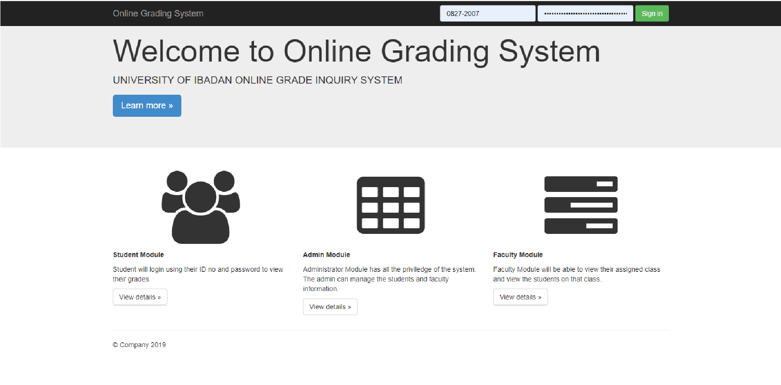
Landing Page
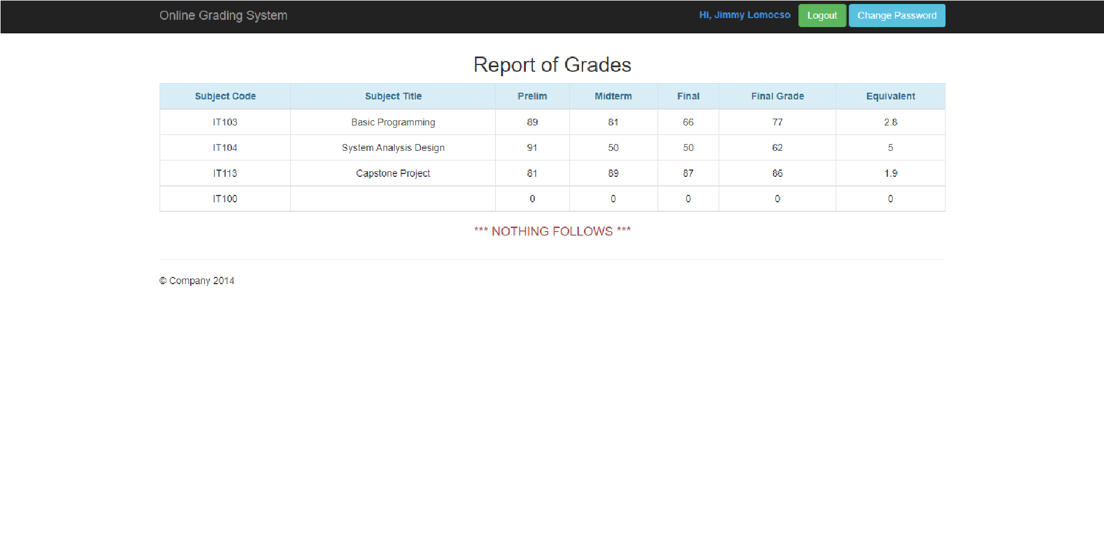
View and Print Student results
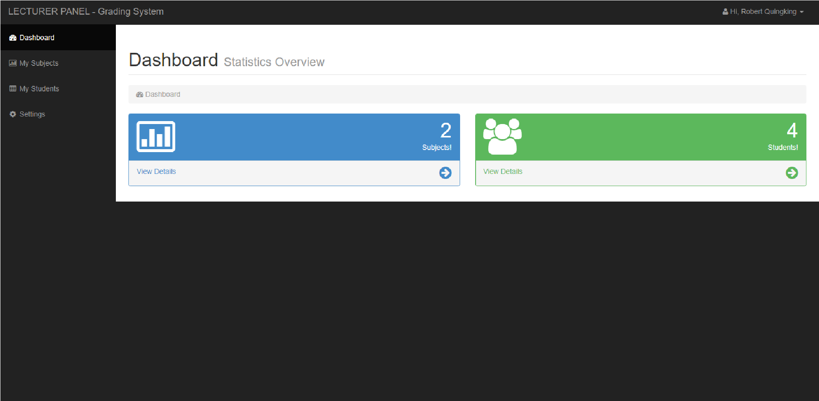
Lecturer Dashboard for inputting student grade
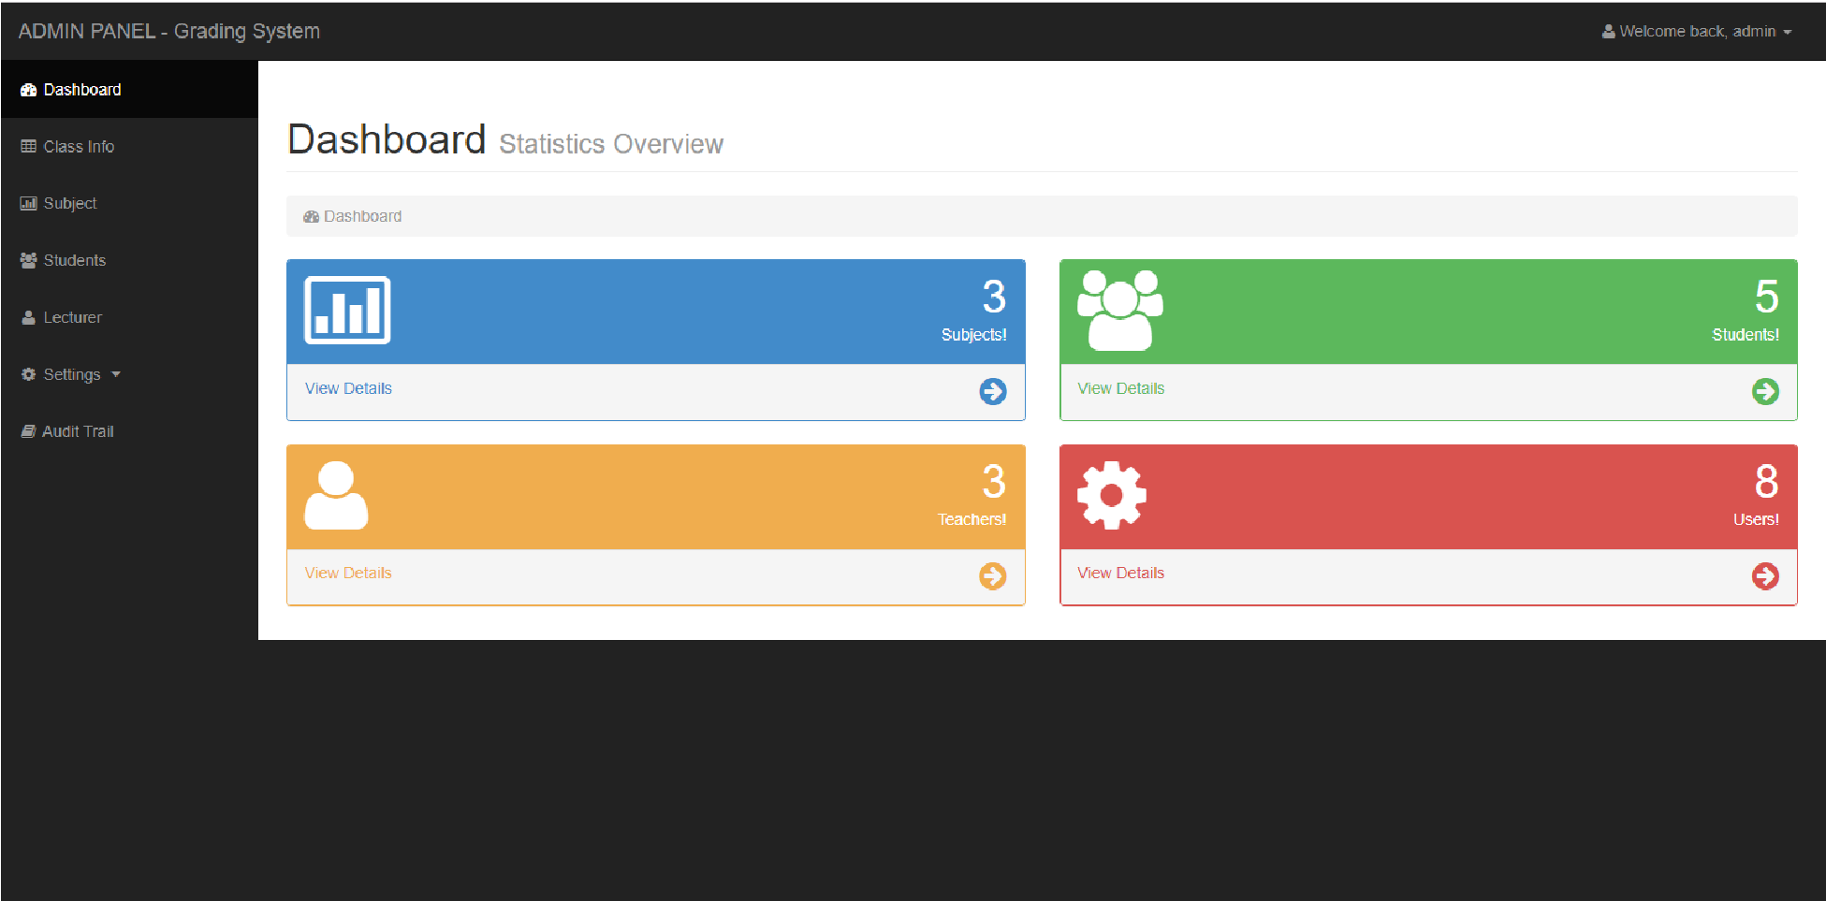
Admin panel.

REFERENCE
Curtis, G. and Longworth, G., 2008. Guide to Software Engineering Paradigm
Ekpenyong, Moses E., 2008. “A Real-Time IKBS for Students Results
Computation”. Journal of Ultra Scientist of Physical Sciences: International Journal of Physical Sciences 20 (3): 627-632
Goodman, D., 2003. JavaScript Bible, Gold Edition, Hungry Minds Inc, New York
Jay, B. and Brad, P., 2007. Introduction to PHPMYSQL. White Scientific Production, Toronto.
Mazza, C. and Depablo, D., 2004. Software Engineering Standards. McGraw-Hill Inc., New York
Onoyom-Ita, E. O., 2008. “A Computer Software for the Processing of Students’ Results in the Physics Department”. A final year project in the Department of Physics, University of Calabar.
Pressmam, E., 2001. Software Engineering Techniques. The Conolis Group, New York.
Stephen, E., 2002. Introduction to Software Engineering. Los Altos, California.
Tata, 1995. Database Management Systems. Tata Consultancy Services, Nariman Point, Bombay, India.
Williams, Brian K. and Sawyer, Stacey C., 2003. Using Information Technology: A
Practical Introduction to Computers & Communications. McGraw-Hill Irwin,
Montreal.

Appendix B:
Source code
Index.php <?php include('config.php'); if(isset($_POST['submit'])){ $user = $_POST['user'];
$pass = $_POST['pass'];
$query = "select * from userdata where username='$user' and password='$pass'";
$r = mysql_query($query); if(mysql_num_rows($r) == 1){
$row = mysql_fetch_assoc($r);
$_SESSION['level'] = $row['level'];
$_SESSION['id'] = $row['username'];
$_SESSION['name'] = $row['fname'].' '.$row['lname'];
header('location:'.$row['level'].'');
}else{ header('location:index.php?login=0');
}
}
if(isset($_SESSION['level'])){ header('location:'.$_SESSION['level'].'');
}
?>
<!DOCTYPE html>
<html lang="en">
<head>
<meta charset="utf-8">
<meta http-equiv="X-UA-Compatible" content="IE=edge">
<meta name="viewport" content="width=device-width, initial-scale=1">
<meta name="description" content="">
<meta name="author" content="">
<link rel="icon" href="favicon.ico">
<title>Online Grading System</title>
<!-- Bootstrap core CSS -->
<link href="css/bootstrap.min.css" rel="stylesheet">
<link rel="stylesheet" href="css/font-awesome.min.css" />
<link rel="stylesheet" href="css/style.css" />
<!-- Custom styles for this template -->
<link href="jumbotron.css" rel="stylesheet">
</head>
<body>
<nav class="navbar navbar-inverse navbar-fixed-top" role="navigation">
<div class="container">
<div class="navbar-header">
<button type="button" class="navbar-toggle collapsed" data-toggle="collapse" datatarget="#navbar" aria-expanded="false" aria-controls="navbar">
<span class="sr-only">Toggle navigation</span>
<span class="icon-bar"></span>
<span class="icon-bar"></span> <span class="icon-bar"></span>
</button>
<a class="navbar-brand" href="index.php">Online Grading System</a>
</div>
<div id="navbar" class="navbar-collapse collapse">
<form class="navbar-form navbar-right" role="form" action="index.php" method="POST">
<div class="form-group">
<?php if(isset($_GET['login'])): ?>
<label class="text-danger">Invalid Username/Password</label>&nbsp;
<?php endif; ?>
</div>
<div class="form-group">
<input type="text" placeholder="ID No." class="form-control" name="user" autocomplete="off">
</div>
<div class="form-group">
<input type="password" placeholder="Password" class="form-control" name="pass">
</div>
<button type="submit" class="btnbtn-success" name="submit">Sign in</button>
</form>
</div><!--/.navbar-collapse -->
</div>
</nav>
<!-- Main jumbotron for a primary marketing message or call to action -->
<div class="jumbotron">
<div class="container">
<h1>Welcome to Online Grading System</h1>
<p>UNIVERSITY OF IBADAN ONLINE GRADE INQUIRY SYSTEM</p>
<p><a class="btnbtn-primary btn-lg" href="#" role="button">Learn more &raquo;</a></p>
</div>
</div>
<div class="container">
<!-- Example row of columns -->
<div class="row">
<div class="col-md-4">
<h2 class="center"><i class="fa fa-users fa-5x"></i></h2>
<p><strong>Student Module</strong></p>
<p>Student will login using their ID no and password to view their grades.</p>
<p><a class="btnbtn-default" href="#" role="button">View details &raquo;</a></p>
</div>
<div class="col-md-4">
<h2 class="center"><i class="fa fa-table fa-5x"></i></h2>
<p><strong>Admin Module</strong></p>
<p>Administrator Module has all the priviledge of the system. The admin can manage the students and faculty information.</p>
<p><a class="btnbtn-default" href="#" role="button">View details &raquo;</a></p>
</div>
<div class="col-md-4">
<h2 class="center"><i class="fa fa-tasks fa-5x"></i></h2>
<p><strong>Faculty Module</strong></p>
<p>Faculty Module will be able to view their assigned class and view the students on that class.</p>
<p><a class="btnbtn-default" href="#" role="button">View details &raquo;</a></p>
</div>
</div>
<hr>
<footer>
<p>&copy; Company 2019</p>
</footer>
</div><!-- /container -->
<!-- Bootstrap core JavaScript
================================================== -->
<!-- Placed at the end of the document so the pages load faster -->
<script src="js/jquery.js"></script>
<script src="js/bootstrap.min.js"></script>
</body> </html>
admin <?php include('include/header.php'); include('include/sidebar.php');
$r1 = mysql_query('select count(*) from student');
$count1 = mysql_fetch_array($r1);
$r2 = mysql_query('select count(*) from subject');
$count2 = mysql_fetch_array($r2);
$r3 = mysql_query('select count(*) from teacher');
$count3 = mysql_fetch_array($r3);
$r4 = mysql_query('select count(*) from userdata');
$count4 = mysql_fetch_array($r4);
?>
<div id="page-wrapper">
<div class="container-fluid">
<!-- Page Heading -->
<div class="row">
<div class="col-lg-12">
<h1 class="page-header">
Dashboard <small>Statistics Overview</small>
</h1>
<ol class="breadcrumb">
<li class="active">
<i class="fa fa-dashboard"></i> Dashboard
</li>
</ol>
</div>
</div>
<!-- /.row -->
<div class="row">
<div class="col-md-6">
<div class="panel panel-primary">
<div class="panel-heading">
<div class="row">
<div class="col-xs-3">
<i class="fa fa-bar-chart-o fa-5x"></i>
</div>
<div class="col-xs-9 text-right">
<div class="huge"><?php echo $count2[0]; ?></div>
<div>Subjects!</div>
</div>
</div>
</div>
<a href="subject.php">
<div class="panel-footer">
<span class="pull-left">View Details</span>
<span class="pull-right"><i class="fa fa-arrow-circle-right fa-2x"></i></span>
<div class="clearfix"></div>
</div>
</a>
</div>
</div>
<div class="col-md-6">
<div class="panel panel-green">
<div class="panel-heading">
<div class="row">
<div class="col-xs-3">
<i class="fa fa-users fa-5x"></i> </div>
<div class="col-xs-9 text-right">
<div class="huge"><?php echo $count1[0]; ?></div>
<div>Students!</div>
</div>
</div>
</div>
<a href="studentlist.php">
<div class="panel-footer">
<span class="pull-left">View Details</span>
<span class="pull-right"><i class="fa fa-arrow-circle-right fa-2x"></i></span>
<div class="clearfix"></div>
</div>
</a>
</div>
</div>
<div class="col-md-6">
<div class="panel panel-yellow">
<div class="panel-heading">
<div class="row">
<div class="col-xs-3">
<i class="fa fa-user fa-5x"></i>
</div>
<div class="col-xs-9 text-right">
<div class="huge"><?php echo $count3[0]; ?></div>
<div>Teachers!</div>
</div>
</div>
</div>
<a href="teacherlist.php">
<div class="panel-footer">
<span class="pull-left">View Details</span>
<span class="pull-right"><i class="fa fa-arrow-circle-right fa-2x"></i></span>
<div class="clearfix"></div>
</div>
</a>
</div>
</div>
<div class="col-md-6">
<div class="panel panel-red">
<div class="panel-heading">
<div class="row">
<div class="col-xs-3">
<i class="fa fa-gear fa-5x"></i>
</div>
<div class="col-xs-9 text-right">
<div class="huge"><?php echo $count4[0]; ?></div>
<div>Users!</div>
</div>
</div>
</div>
<a href="users.php">
<div class="panel-footer">
<span class="pull-left">View Details</span>
<span class="pull-right"><i class="fa fa-arrow-circle-right fa-2x"></i></span>
<div class="clearfix"></div>
</div>
</a>
</div>
</div>
</div>
<!-- /.row -->
</div>
<!-- /.container-fluid -->
</div>
<!-- /#page-wrapper -->
<?php include('include/footer.php');
Student.php
<?php
include('../config.php');
$level = isset($_SESSION['level']) ? $_SESSION['level']: null; if($level == null){ header('location:../index.php'); }else if($level != 'student'){ header('location:../'.$level.'');
}
?>
<!DOCTYPE html>
<html lang="en">
<head>
<meta charset="utf-8">
<meta http-equiv="X-UA-Compatible" content="IE=edge">
<meta name="viewport" content="width=device-width, initial-scale=1">
<meta name="description" content="">
<meta name="author" content="">
<link rel="icon" href="favicon.ico">
<title>Online Grading System</title>
<!-- Bootstrap core CSS -->
<link href="../css/bootstrap.min.css" rel="stylesheet">
<link rel="stylesheet" href="../css/font-awesome.min.css" />
<link rel="stylesheet" href="../css/style.css" />
<link rel="stylesheet" href="mystyle.css" />
</head>
<body>
<nav class="navbar navbar-inverse navbar-fixed-top" role="navigation">
<div class="container">
<div class="navbar-header">
<button type="button" class="navbar-toggle collapsed" data-toggle="collapse" datatarget="#navbar" aria-expanded="false" aria-controls="navbar">
<span class="sr-only">Toggle navigation</span>
<span class="icon-bar"></span>
<span class="icon-bar"></span> <span class="icon-bar"></span>
</button>
<a class="navbar-brand" href="index.php">Online Grading System</a>
</div>
<div id="navbar" class="navbar-collapse collapse">
<div class="navbar-form navbar-right">
<label class="text-primary">
Hi, <?php echo $_SESSION['name']; ?>&nbsp;&nbsp;
</label>
<a href="../logout.php"><button type="button" class="btnbtn-success" name="submit">Logout</button></a>
<button type="button" class="btnbtn-info" data-toggle="modal" datatarget="#changepass">Change Password</button>
</div>
</div><!--/.navbar-collapse -->
</div>
</nav>
<?php
include('grade.php');
$mysubject = $grade->getsubject();
?>
<div class="container" style="margin-top:60px;">
<!-- Example row of columns -->
<div class="row">
<div class="col-lg-12">
<h2 class="text-center">Report of Grades</h2>
<div class="">
<table class="table table-bordered">
<thead>
<tr class="alert alert-info">
<th class="text-center">Subject Code</th>
<th class="text-center">Subject Title</th>
<th class="text-center">Prelim</th>
<th class="text-center">Midterm</th>
<th class="text-center">Final</th>
<th class="text-center">Final Grade</th>
<th class="text-center">Equivalent</th>
<!--<th class="text-center">Units</th>-->
</tr>
</thead>
<tbody>
<?php foreach($mysubject as $row): ?>
<tr>
<td class="text-center"><?php echo $row['subject']; ?></td>
<?php $title = $grade->getsubjectitle($row['subject']);?>
<td class="text-center"><?php echo $title[0]['title']; ?></td>
<?php $mygrade = $grade->getgrade($row['id']); ?>
<td class="text-center"><?php echo $mygrade['prelim']; ?></td>
<td class="text-center"><?php echo $mygrade['midterm']; ?></td>
<td class="text-center"><?php echo $mygrade['final']; ?></td>
<td class="text-center"><?php echo $mygrade['total']; ?></td>
<td class="text-center"><?php echo $mygrade['eqtotal']; ?></td>
<!--<td class="text-center"><?php echo $title[0]['unit']; ?></td>-->
</tr>
<?php endforeach; ?>
</tbody>
</table>
<h4 class="text-center text-danger">*** NOTHING FOLLOWS ***</h4>
</div>
</div>
</div>
<!--
<div class="row">
<?php foreach($mysubject as $row): ?>
<div class="col-lg-4 gradeform">
<div class="form_hover " style="background-color: #428BCA;">
<p style="text-align: center; margin-top: 20px;">
<i class="fa fa-bar-chart-o" style="font-size: 147px;color:#fff;"></i>
</p>
<div class="header">
<div class="blur"></div>
<div class="header-text">
<div class="panel panel-success" style="height: 247px;">
<div class="panel-heading">
<h3 style="color: #428BCA;">Subject: <?php echo $row['subject'];?></h3>
</div>
<div class="panel-body">
<table class="table table-bordered">
<tr class="alert alert-danger">
<th>Prelim</th>
<th>Midterm</th>
<th>Final</th>
<th>FINAL GRADE</th>
</tr>
<?php $mygrade = $grade->getgrade($row['id']); ?>
<tr>
<td><?php echo $mygrade['prelim']; ?></td>
<td><?php echo $mygrade['midterm']; ?></td>
<td><?php echo $mygrade['final']; ?></td>
<td><?php echo $mygrade['total']; ?></td>
</tr>
</table>
<div class="form-group">
<?php $teacher = $grade->getteacher($row['teacher']); ?>
<label>Teacher: <?php echo $teacher;?></label><br />
<label>Semester: <?php echo $row['sem']?> Sem</label><br />
</div>
</div>
</div>
</div>
</div>
</div>
</div>
<?php endforeach; ?>
</div>-->
<!-- add modal for subject -->
<div class="modal fade" id="changepass" tabindex="-1" role="dialog" arialabelledby="mySmallModalLabel" aria-hidden="true">
<div class="modal-dialog modal-sm">
<div class="modal-content">
<div class="modal-header">
<h3>Change Password</h3>
</div>
<div class="modal-body">
<form action="password.php?q=changepassword&username=<?php echo $_SESSION['id'];?>" method="post">
<div class="form-group">
<input type="password" class="form-control" name="current" placeholder="Current Password" />
</div>
<div class="form-group">
<input type="password" class="form-control" name="new" placeholder="New Password" /> </div>
<div class="form-group">
<input type="password" class="form-control" name="confirm" placeholder="Confirm Password" />
</div>
</div>
<div class="modal-footer">
<button type="button" class="btnbtn-default" data-dismiss="modal">Close</button>
<button type="submit" class="btnbtn-primary"><i class="fa fa-plus"></i> Change</button>
</form>
</div>
</div>
</div>
</div>
<hr>
<footer>
<p>&copy; Company 2014</p>
</footer>
</div><!-- /container -->
<!-- Bootstrap core JavaScript
================================================== -->
<!-- Placed at the end of the document so the pages load faster -->
<script src="../js/jquery.js"></script>
<script src="../js/bootstrap.min.js"></script>
</body>
</html>
Teacher.php
<?php
include('include/header.php'); include('include/sidebar.php');
$tmp = $_SESSION['id'];
$q = "select * from teacher where teachid='$tmp'";
$r = mysql_query($q);
$result = mysql_fetch_array($r);
$teachid = $result[0];
$r1 = mysql_query("select count(*) from class where teacher=$teachid"); $count1 = mysql_fetch_array($r1);
$r2 = mysql_query("select * from class where teacher=$teachid");
$students = 0;
while($row = mysql_fetch_array($r2)){
$id = $row['id'];
$r3 = mysql_query("select count(*) from studentsubject where classid=$id");
$count3 = mysql_fetch_array($r3);
$students = $students + $count3[0];
}
?>
<div id="page-wrapper">
<div class="container-fluid">
<!-- Page Heading -->
<div class="row">
<div class="col-lg-12">
<h1 class="page-header">
Dashboard <small>Statistics Overview</small>
</h1>
<ol class="breadcrumb">
<li class="active">
<i class="fa fa-dashboard"></i> Dashboard
</li>
</ol>
</div>
</div>
<!-- /.row -->
<div class="row">
<div class="col-lg-6 col-md-6">
<div class="panel panel-primary">
<div class="panel-heading">
<div class="row">
<div class="col-xs-3">
<i class="fa fa-bar-chart-o fa-5x"></i>
</div>
<div class="col-xs-9 text-right">
<div class="huge"><?php echo $count1[0];?></div>
<div>Subjects!</div>
</div>
</div>
</div>
<a href="subject.php">
<div class="panel-footer">
<span class="pull-left">View Details</span>
<span class="pull-right"><i class="fa fa-arrow-circle-right fa-2x"></i></span>
<div class="clearfix"></div>
</div>
</a>
</div>
</div>
<div class="col-lg-6 col-md-6">
<div class="panel panel-green">
<div class="panel-heading">
<div class="row">
<div class="col-xs-3">
<i class="fa fa-users fa-5x"></i> </div>
<div class="col-xs-9 text-right">
<div class="huge"><?php echo $students; ?></div>
<div>Students!</div>
</div>
</div>
</div>
<a href="student.php">
<div class="panel-footer">
<span class="pull-left">View Details</span>
<span class="pull-right"><i class="fa fa-arrow-circle-right fa-2x"></i></span>
<div class="clearfix"></div>
</div>
</a>
</div>
</div>
</div>
<!-- /.row -->
</div>
<!-- /.container-fluid -->
</div>
<!-- /#page-wrapper -->
<?php include('include/footer.php');

