MODIFICATION AND PERFORMANCE EVALUATION OF HYBRID EGG INCUBATOR

BY

OGUNGBEMIRO ABOSEDE JANET
HND/23/ABE/FT/0104

DEPARTMENT OF AGRICULTURAL AND BIO-ENVIRONMENTAL ENGINEERING INSTITUTE OF TECHNOLOGY, KWARA STATE POLYTECHNIC, ILORIN.
IN PARTITAL FULFILLMENT OF REQUIREMENT FOR THE AWARD OF HIGHER NATIONAL DIPLOMA (HND) IN AGRICULTURAL AND BIO-ENVIRONMENTAL ENGINEERING TECHNOLOGY.

AUGUST, 2025

DECLARATION
I hereby declare that this research project titled: “MODIFICATION AND PERFORMANCE EVALUATION OF HYBRID EGG INCUBATOR” is my own work and has not been submitted by any other person for any degree or qualification at any higher institution. I will also declare that the information provided therein are mine and those that are not mine are properly acknowledged.

___________________ _____________________ Name of Student Date and Signature

CERTIFICATION
I, hereby declare that this research project titled MODIFICATION AND PERFORMANCE EVALUATION OF HYBRID EGG INCUBATOR was carried out by OGUNGBEMIRO ABOSEDE JANET with matric number HND/23/ABE/FT/0104 is my own work and has not been submitted by any other person for any degree or diploma in any higher institution. I also declare that the information provide therein are mine and those that are not mine are properly acknowledged.

_______ __14/_8/2025____________
Engr. (Mrs) Onipede ,E.A Date
(Project Supervisor)
_______________ _____04/08/2025____________
Engr. Oyebanre O.D Date
(Project Co-ordinator)
_____ ___04/08/2025______________
Engr Dauda, K.A Date
(Head of Department)
_____________ ___13/08/2025______________
Dr. Adejumo Akinfoye Daniel Date
(External Examiner)
DEDICATION
I dedicate this project work firstly to Almighty GOD the unborn creator of every creature who has been there for me from my very first beginning till date. Also, to my caring and lovely husband Engr. Olakunle fadario and my family for all they have done for me I pray that you will reap the fruit of your labour by the grace of God.

ACKNOWLEDGEMENT
I give my great thanks to Almighty God, the Lord of the whole universe, the sustainers who guided and provided me all I need to complete my HND (Higher National Diploma) Programme in good health.
My profound gratitude goes to my lovely husband Engr. Olakunle fadario and my family, may Almighty God grant them sound health and bless them.
The next thank goes to my supervisor, a woman of understanding, honour and trust in person of Engr. (Mrs) Onipede,E.A. for being there and lenient with me. I pray Almighty God reward you abundantly (Amen).
My appreciation also goes to the H.O.D of Agricultural and Bio-environmental Engineering Department in person of Engr. Dauda, K.A, and to all my departmental lecturers for the knowledge they have impacted in me throughout my Higher National Diploma Programme, may God reward you abundantly.
Also my gratitude to my friends, who stood by me. I remain disloyal if I drop my pen without appreciating my project partners. Thank you for the sincere love we share during this research work. Also those people I am not opportune to mentioned one after the other, most especially all my course mate I appreciate you all, I will live to always remember your good deeds.
I am using this medium to pray to Almighty God to bestow on me the utmost knowledge and understanding from now till eternity (Amen).

TABLE OF CONTENTS
Title Page
Title Page I
Declaration ii
Certification iii
Dedication iv
Acknowledgement v
Table of Contents vi
List of Table x
List of Figure xi
Abstract xii
CHAPTER ONE
1. Introduction 1
  - Background to the Study 1
  - Problem Statement of the Study 3
1.3 Aims and Objectives of the Study 4
1.4 Justification of the Study 4
1.5 Scope of the Study 4

CHAPTER TWO
2. Literature Review 5
2.1 Poultry Farming in Nigeria 5
2.2 Poultry Incubation Technology 5
2.3 Feature of Hybrid Poultry Eggs Incubator 7
2.4 Incubation Parameters 7
2.5 Condition for Various Eggs Incubation 8
2.6 Reviews on Artificial Incubation 9

CHAPTER THREE
3. Materials and Methods 15
3.1 Materials 15
3.2 Area of Modification 15
3.3 Description of the Hybrid Egg Incubator 16
3.3.1 The Main Cabinet 17
3.3.2 The Auxiliary Unit 18
3.4 Design Consideration 18
3.5 Design Calculation and Analysis 19
3.5.1 Determination of Incubation Chamber 19
3.5.2 Determination of Heat Required for Incubation 21
3.5.3 Heat Loss by Incubator 22
3.5.4 Determination of Humidity 23
3.5.5 Total Power Consumption 24
3.5.6 Power Requirement and Selection of Battery Solar Panel and Inverter 25
3.5.7 Size of Solar Charger 25
3.5.8 Battery Running Time 25
3.6 Materials Selection 26
3.7 Construction and Assembly Procedure 27
3.8 The Operation of Hybrid Egg Incubator 27
3.9 Bill of Engineering Measurement and Evaluation 28
3.10 Performance Evaluation 28
3.10.1 Source of Material 28
3.10.2 Preparation of Sample 29
3.10.3 Output Parameters 29
3.11 Experimental Procedure 30
CHAPTER FOUR
4. Result and Discussion 32
4.1 Result 32
4.2 Discussion 33

CHAPTER FIVE
5. Conclusion and Recommendations 35
5.1 Conclusion 35
5.2 Recommendation 35
References 36 Appendices

LIST OF TABLE
Table 2.1 Condition for Various Egg Incubation 9
Table 3.1 Bill of Engineering and Evaluation 28
Table 4.1 Candling Test on 7th Day on Incubation 32
Table 2.2 Candling Test on The 14th Day of Incubation 32
Table 4.3 Average Records of Temperature and Humidity for 21days of Incubation 33

LIST OF FIGURES
Figure 3.1 Assembly View of Hybrid Eggs Incubator 17
Figure 3.2 Exploded View of Hybrid Eggs Incubator 18

ABSTRACT
A hybrid egg incubator was modified and constructed to solve the problem of power outages that militate against poultry egg incubation. The hybrid egg incubator was constructed from medium density fibreboard (MDF) plywood and lagged with fibre glass to prevent heat loss. The hybrid egg incubator was made of two unit; the main cabinet and auxiliary unit.
The main cabinet contains of egg trays, bulbs, DC fans, water tray and turning mechanism. The auxiliary unit contains of solar PV panel, battery, inverter and charge control. The incubation parameters were measured by control board. The temperature and humidity range within the incubator were 36.1 - 37.5 °C and 50.1 % to 60% respectively, the angle of turn was 45°. The result of performance evaluation showed 91% hatchability, 66% fertility and maturity rate 9%.
The hybrid egg incubator is affordable because it was made from locally available materials and it is therefore recommended for poultry farmers both at rural and urban centers.

CHAPTER ONE
1 INTRODUCTION
1.1 Back ground of the Study
Poultry farming is an essential component of the agricultural sector in Nigeria, contributing significantly to the nation's economy and providing an important source of protein through the production of eggs and poultry meat. According to Akinwumi and Adekunle (2019), poultry production is responsible for approximately 25% of the total livestock output in the country. Small- and medium-scale farmers dominate the sector, with millions of Nigerians directly or indirectly engaged in poultry farming activities.
Despite its economic potential, the Nigerian poultry industry faces several challenges, particularly in the area of egg incubation. Many farmers rely on electrically powered incubators, which are often affected by the country's inconsistent electricity supply. Power outages disrupt the incubation process, leading to reduced hatching rates and increased chick mortality (Bello & Musa, 2020). As a result, there is growing interest in alternative energy solutions, such as solar-powered incubators, which could provide a more reliable and sustainable approach to poultry incubation in Nigeria. The continuous rise and competitive demands for fossil fuel necessitate the need for alternative source of renewable energy. In many parts of the world there is a growing awareness that renewable energy has an important role to play in extending technology to farmers in developing countries to increase their productivity. Solar thermal technology is a technology that is rapidly gaining acceptance as an energy saving measure in agriculture application. It is fast becoming an alternative source of energy because of the high rate depletion of the conventional energy sources. It is preferred to other alternative sources of energy such as wind and shale, because it is abundant, inexhaustible, and non-polluting. It is capable of meeting a significant portion of the world’s future energy needs with minimum of adverse environmental consequence [1-2]. Solar energy has been used for centuries by man for drying animal skins and clothes, preserving meat and fish, drying agriculture crops and evaporating sea water in order to extract salt [3-4]. Several investigators have recently studied various applications of solar drying. Thakur et al. studied the heat transfer and friction factor correlations for packed bed solar air heater for low porosity system. Berinyuy et al and Nasir et al studied a solar tunnel dryer for natural convection drying of vegetables and thermal performance of a parabolic cylindrical trough solar air heater respectively. Bolaji investigated a box-type absorber solar air collector for crop drying. Waewsak et al. studied a mathematical modeling of hot air drying for some agricultural products. However, the application of solar energy in poultry production has not received comparable attention especially in the developing countries. Also, the poultry product requirements of these countries have not been sufficiently met. This calls for more efforts at encouraging the consumption of poultry in the developing countries. This can be achieved through active research in all area of poultry production including the development of efficient and energy saving but cheap equipment for poultry production such as incubators. Incubation is an art of managing fertilized eggs to ensure the satisfactory development of embryo into a normal chick either by natural or artificial method. The egg is an extremely specialized structure which contains sufficient food and water to develop fertilized cell into a chick if subjected to adequate environmental conditions. The environmental factors of major importance for artificial incubator include temperature, relative humidity, air supply and egg turning [10-11]. These four parameters must be properly monitored during incubation. The control of temperature is probably the most critical single factor required for the successful hatching of chicks because developing embryos are extremely sensitive to the temperature of the environment. Overheating speeds up the rate of development and causes abnormal embryo in the early hatches and consequently lowers the percentage hatchability. The relative humidity of air in an incubator for the first 18 days for chicks should be approximately 60% and during the last 3 days, it should be increased to about 70%. High moisture in the incubator prevents normal evaporation and results in low hatchability. Low moisture causes chicks to stick to the shell. Turning eggs during incubation also improves hatchability. It prevents the germ from migrating through the albumen and adhering to the shell. Eggs should be turned 3 - 5 times daily from the 2nd to the 18th day of incubation. Artificial incubation is favored in order to increase the production of chicks and protein intake, particularly in the developing countries. The electrical incubators are the best where the supply of electricity is readily available and cheap. But the supply of electricity is erratic, unreliable and high percentage of the population in the developing world is not on the electricity grid. (UNDP). Alternative, cheap and readily available source of heat should be provided for small scale farmers who are involved in the production of chicks. Therefore, this paper presents the report of the design and construction of a solar poultry egg incubator using materials that are readily available in the local market with the aim to increase the rate of chicks’ production among small scale farmers in the developing countries. The performance of the incubator was also evaluated.
1.2 Problem Statement
the word's growing population and increasing health awareness have lead to a large in demand for poultry products which are received as a healthier alternative to red meat due to their lower cholesterol and trans fats content. This trend is expected to continue, during growing in the poultry industry. the process of hatching eggs by natural method is limited and the artificial incubators that can hatch more eggs at a time are faced with epileptic power supply for an electrical incubator, adverse weather conditions for solar.
1.3 Aim and Objectives
The Study aim to modify and carryout the performance evaluation of existing egg incubator to improve hatchability reduce energy consumption and enhance efficiency and sustainability, while the specific objectives are to;
- identify shortcomings in the existing incubator.
- modify components to improve hatchability.
- asses the temperature and humidity control capacities of incubator under different environmental conditions.
- evaluate the machine performance in terms of hatchability.
1.4 Justification
The Study will contribute to sustainable poultry farming in Nigeria by addressing power failure and weather related challenges reducing energy consumption and operating costs, making incubation practices accessible in rural areas and increases the income of poultry farmers.
1.5 Scope of the Study
The scope of the Study focuses on modifying an existing egg incubator, in term of construction materials, insulation materials, temperature and humidity control, mechanical turning of the eggs procurement of fertile eggs and carryout of performance evaluation in terms of hatchability
CHAPTER TWO
2 Literature Review
2.1 Poultry Farming in Nigeria
Poultry farming is a crucial aspect of agriculture in Nigeria, contributing significantly to the economy and providing essential protein sources through eggs and meat. It is estimated that Nigeria’s poultry sector is one of the largest in Africa, producing over 500,000 metric tons of eggs and 300,000 metric tons of poultry meat annually (Ojo, 2020). The sector plays a vital role in the livelihoods of smallholder farmers, providing employment and contributing to food security. However, challenges such as inadequate technology, poor management practices, and high mortality rates hinder optimal production (Akinola & Essien, 2021).
2.2 Incubation Technology
Incubation technology refers to the methods and devices used to hatch eggs, which is a critical component of poultry production. It ensures a continuous and reliable supply of chicks for the poultry industry. The advancement of incubation technology has allowed farmers to increase the efficiency of egg hatching and reduce losses (Ibrahim, 2021). Incubation methods can be broadly classified into two types: natural incubation and artificial incubation
- Natural Incubation
Natural incubation involves the use of broody hens to incubate eggs. This method has been traditionally practiced by small-scale poultry farmers. The hen provides the necessary warmth, humidity, and ventilation needed for the development of the embryos (Usman, 2019). Although natural incubation is cost-effective and simple, it has limitations such as a low number of eggs that can be incubated at a time and the inconsistency in hatchability rates due to environmental factors and the health of the hen (Adewale & Akintayo, 2020).
- Artificial Incubation
Artificial incubation involves the use of mechanical incubators to mimic the conditions provided by a broody hen. The key advantage of artificial incubation is the ability to hatch a large number of eggs simultaneously and with greater control over the incubation conditions (Oladele, 2018). Modern incubators can regulate temperature, humidity, and ventilation to ensure optimal conditions for embryo development, leading to higher hatchability rates compared to natural methods (Oyetunji et al., 2021). Types artificial incubators includes: kerosene incubator, Charcoal incubator, bio - gas incubator, hybrid incubator and electrical incubator.
- Kerosene incubator is a type of incubator that uses kerosene as it power source
- Charcoal incubator is a type of incubator that uses charcoal as it power source
- Bio – gas incubator is type of incubator that uses bio – gas as it power source
- A hybrid poultry egg incubator is a type of incubator that combines two or more power source or technology to provide a reliable and efficient incubation environment for poultry egg.
- Electric incubator is a type of incubator that uses electricity as its power source.

2.3 Feature of Hybrid Poultry Eggs Incubator
Feature of Hybrid Poultry Eggs Incubator are;
Dual power source: it combines two power source such as electricity and solar power to provide a reliable and consistent incubator environment
Backup power system: Hybrid incubator may include backup power system such as batteries or generator to ensure continuous operation during power outrage or period or low sunlight
Advanced temperature control which can maintain optimal temperature for poultry egg incubator even in extreme weather condition
Humidity control to maintain optimal humidity for poultry egg incubation
Automated egg turning and monitor to ensure proper turning to track incubator parameter such as temperature, humidity and egg turning
2.4 Incubation Parameters
Successful artificial incubation depends on the careful control of certain parameters that influence embryo development. These parameters include temperature, humidity, ventilation, and egg turning.
- Temperature: The optimal temperature for hatching chicken eggs is usually between 37.5°C and 38°C (Meijerhof, 2019). Temperature fluctuations can lead to poor hatchability or embryo mortality.
- Humidity: Humidity levels should be maintained between 50-55% during the incubation period and increased to 65-70% during the last three days to prevent excessive moisture loss from the eggs (French, 2020).
- Ventilation: Adequate oxygen supply and removal of carbon dioxide are crucial for the embryo's survival. Insufficient ventilation can lead to weak chicks or embryo death (Davis & Zhang, 2021).
- Egg Turning: Regular turning of eggs is essential to prevent the embryos from sticking to the eggshell and to ensure proper development. Eggs are typically turned 4-6 times per day during incubation (Tullett, 2019).
- Egg Fertility: Egg fertility is also an important parameter that enhance hatchability hence there is a need for eggs candling to ascertain the fertility of eggs incubated.
2.5 Condition for Various Eggs Incubation
Condition for various egg incubation. The species of the bird, the incubation period, and other parameters for incubation is as shown in table 2.1

TABLE 2.1: Condition for Various Egg Incubation
Species | Incubation Period  (Days) | Temp  F | Humidity  (F) | Do not turn after | Humidity  Last 3days | Open vent more
Chicken  Turkey  Duck  Muscovy duck  Goose  Guinea fowl  Peafowl  Pheasant  Pigeon  Bobwhite  Cotumix  Chukar | 21  28  28  35-37  28-34  28  28-30  23-28  17  23-24  17  23-24 | 100  99  99  100  99  100  99  100  100  100  100  100 | 85-87  84-86  85-86  84-85  86-88  85-87  84-86  86-88  85-87  84-87  85-86  81-83 | 18th day  25th day  25th day  31st day  25th day  25th day  25th day  21st day  15th day  20th day  15th day  20th day | 90  90  90  90  90  90  90  92  90  90  90  90 | 18th day  25th day  25th day  31st day  25th day  24th day  25th day  25th day  14th day  20th day  14th day  20th day

2.6 Review on Artificial Incubation.
Artificial incubation is the process of maintaining and hatching eggs under controlled environmental conditions without the involvement of the parent, commonly used in poultry production and conservation efforts. See: Deeming, D.C. (2002). Avian Incubation: Behaviour, Environment, and Evolution. Oxford University Press. Artificial incubation has evolved significantly over the years, with advancements in both the design of incubators and the understanding of optimal incubation conditions. Early incubators were rudimentary and required manual control of parameters such as temperature and humidity. However, modern incubators are highly automated, incorporating sensors and control systems that maintain precise incubation conditions, leading to higher hatchability rates (Fasanmi et al., 2021).
Several studies have demonstrated the effectiveness of artificial incubation in improving hatchability and chick quality. For instance, Oluwaseun and Akinwale (2022) found that using automated incubators improved hatchability by 15% compared to traditional natural incubation methods. Similarly, Bello et al. (2020) reported that artificial incubation led to more consistent hatching outcomes, reduced the mortality rate of chicks, and enhanced productivity in commercial poultry farms.
Hassan et al., (2021) in characterizing and electric incubator recorded a hatchability percentage of 80.9% and concluded that the major challenge of incubators that can work with electricity are excessive billing rate, erratic power supply as well as complete absence of electricity in remote regions. Equally most of the incubator is developing countries like Nigeria operate at 60% below design capacity grid electric supply.
Olaoye et al., (2013) developed a 120 egg a capacity electric incubator. The system which was coupled with three 100 w electric bulb produced 75.2% fertility in addition to the hatchability rate of 64.8%.
Yadav et al., (2021) Analyzed the developed automatic horizontal egg incubator. A motor clamped mechanism controlled by a micro-controller was used to adjust the egg trays horizontally. The system yielded a hatchability of 72.22%.
Ogunwande et al., (2015) studied a still-air hatchery that has a non-thermostatic control. The system uses electric bulbs as the its source with a resistance varying components as temperature control. With three times daily of the eggs, the system achieved 62% hatchability rate.
Soeb et al., (2021) developed a low-cost incubator that is made up of the embedded controller Incorporated to an egg turning trays with hatchery apartment of 116 egg capacity for Bangladesh market. The manual and automatically evaluations of the developed hatchery showed a 79.3% and 87.1% hatchability rate respectively. The eggs were turned both manually and automatically as the case may be at intervals of 6hours.
Mansaray and Yansaneh (2015) developed a solar egg incubator that achieved temperature range of 36.8-37.9° c. The evaluation of the system yielded a percentage fertility and hatchability rate of 43.3% and 23.1% respectively. The study concluded that the low level of hatchability was as a result of several external influences such as an overcast weather, improper egg storage, time and energy loss, turning of eggs, faulty eggs etc.
Divagar et al., (2022) evaluated and automated solar-driven hybrid egg incubator. The system achieved a hatchability percentage of 81.72%.
Osanyinpeju et al., (2016) walked on the development of solar powered poultry egg incubator. The heat produced by metabolic activities of 150 eggs in the system was 21.9 w. The percentage fertility of 64% in addition to 44% hatchability rate was observed with the system. The low hatchability was attributed to faulty hygrometer used which led to increase in the number of opening made at the last stage.
Niranjan et al., (2021) developed a chicken egg incubator using (IOT) integrated with smartphone effective monitoring and control. The system temperature wear set at the different temperatures of into (H1) 36.5° c, (H2) 37.5° c and (H3) 38° c. The hatchability percentage of the three temperatures were(H1) 81%, (H2) 92% and (H3) 86% respectively.
Ogunwande et al., (2015) developed a biogas powered poultry egg incubator that utilizes biogas as a fuel to provide thermal energy via a heater situated at the base. The system produced temperature range of 36-39.4° c within the incubating compartment. At the end of an evaluation test, a hatchability percent of 59.7% was realized.
Hassan et al., (2021) studied the use of thermal chemical storage media setup as a thermal source of hatching of poultry eggs. In the study, three forms of activated TCMs were utilized as energy containing medium. The media are silica gel, as well as natural zeolites. The TCMs were activated using electricity. Equally, the incubator was partly powered by electricity and partly by the TCMs. The its recapture operation helps to release the stored heat in TCMs. The system's hatchability percentage was 71.4% compared to the solely electric powered conventional incubator with 80.9% hatchability. However, the TCM incubator gave energy savings of 41.8% when compared with the conventional electric type.
Muhammad et al, (2022) Studies a thermoelectric egg incubator coupled to heat storage system. Did Samuel electric component is utilized in the daytime process while a heat storage system made up of a phase change material (PCM) which provides derma energy during off-sunshine (especially nights) periods is complementary heat source. The electric energy that is changed to heat for starting the operation is provided with the arrays of the solar PV. The result of the 300 egg capacity system showed that temperature inside incubator chamber was between 36 iPhone 39° c with 73.3% hatchability.
Olasukanmi et al., (2015) developed a GSM based DC battery powered poultry egg incubator. The system is remotely tracked. The major components of the incubator were the DC motor, humidifier, ventilation fans, in addition to the custom made lower-power DC heater provided for controlling the turning of eggs, humidity, ventilation and temperature, respectively. The hatchery could either be powered using solar PV system, greed power electricity via an inverter or any medium that could charge the DC battery.
Oniya et al., (2013) develop a 160 a capacity low cost semi-in automated incubator powered by a backup inverter. The inverter could either be powered with an AC or DC electric system. The major components of the system were a heat source (100 w bulb), a thermistor, 12 PV battery, 100 w inverter and 0.14 w electric fan. A replicated analysis on the system showed a temperature variation between 36 to 39° c with hatchability 91%.
Uzodinma et al., (2020) carried out a characterization of hybrid solar powered poultry egg incubator. The hybrid incubator is made up of a double glazed flat plate solar collector coupled with paraffin PCM in addition to a PV subsystem. The evaluation of the system reviewed that the incubating temperature was maintained between 36 and 39° c in addition to the mean hatchability rate of 62.37%.
Bukola (2008) modified and carry out performance and evaluation of hybrid poultry solar incubator and stated the environmental factors of major importance for artificial incubator include temperature, relative humidity, air supply and egg turning. overheating speed up the rate of development and called abnormal embryo in the early hatches and consequently lower the percentage hatchability likewise high rate to prevent normal evaporation and results in low hatachability. turing of egg should be done 3- times daily from 2nd to the 18th day of incubation to prevent embryo adhersing to the shell
Okonkwo et al (2024) researched on energy sources for poultry egg incubator efficiency and hatachability. the result showed that sources of energy for incubation are categorized into grid supply electricity solar system, fossil fuel, biogas and thermochemical materials, from reviewed articles 50% identified grid supplied electricity as energy source for poultry egg incubation and hatachabiliy range from 80.9%-98.4% however, due to erratic nature of electricity supply and non availability in rural areas especially in developing nations, the study recommends increase research interest on other every source to improve their hatachability.
Faki etal (2015) reported on incubation condition such as temperature, humidity, ventilation and turning the most important factor significantly affective the hatchability of poultry egg and chick quality.
Despite the benefits, artificial incubation is not without its challenges. The high initial cost of incubators and the need for a reliable power supply are significant barriers to its adoption by smallholder farmers in Nigeria (Okonkwo & Eke, 2021). The development of hybrid incubators that combine solar and electrical energy sources offers a promising solution to this problem, particularly in rural areas with limited access to electricity (Amadi et al., 2022). These hybrid systems provide a sustainable and cost-effective method for improving hatchability and ensuring continuous chick production.

CHAPTER THREE
3. MATERIALS & METHODS
3.1 Materials
The following materials were used in the construction of hybrid egg incubator;
- MDF Plywood (Medium Density Fiber Body)
- Marine Board
- Bolt and Nut.
- Screw
- Ardonic Cabinet Hinge
- Edges Tape
- Door Bolt
- Nails
- Screw Cover
- Plank for the Egg Tray Seat
- Egg
- Hammer
- Glass Fiber
3.2 Area of Modification
The result from the test of previous machine showed that the machine was able to hatch 20 egg out of 45 eggs after operating the machine this gives 44% hatchability rate. The recommendation suggested that the turning mechanism, the temperature and humidity control should be automated for better performance hence the turning mechanism, temperature and humidity control system will be automated and some technical issues like egg fertility will be addressed
3.3 Description of the Hybrid Eggs Incubator
The hybrid eggs Assembly and Exploded views were as shown in figure 3.1 to 3.2 . The hybrid eggs incubator are made up of two components, the main cabinets and the auxiliary unit.
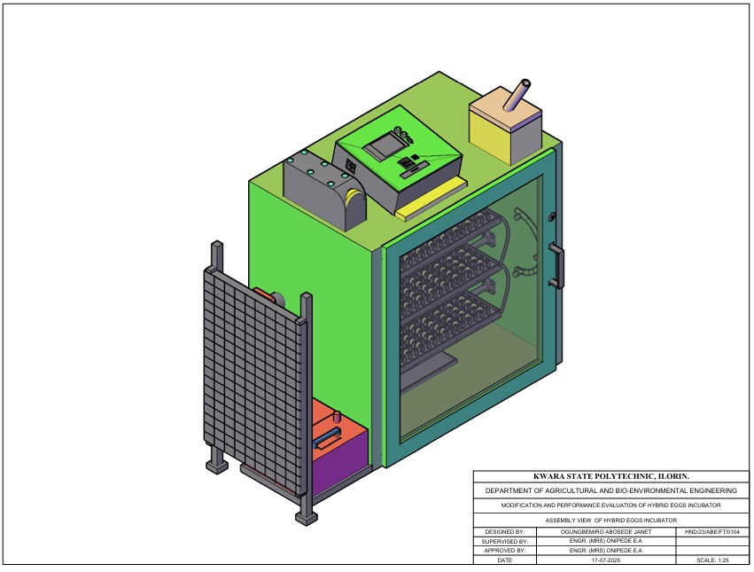
Figure 3.1 Assembly View of Hybrid Eggs Incubator
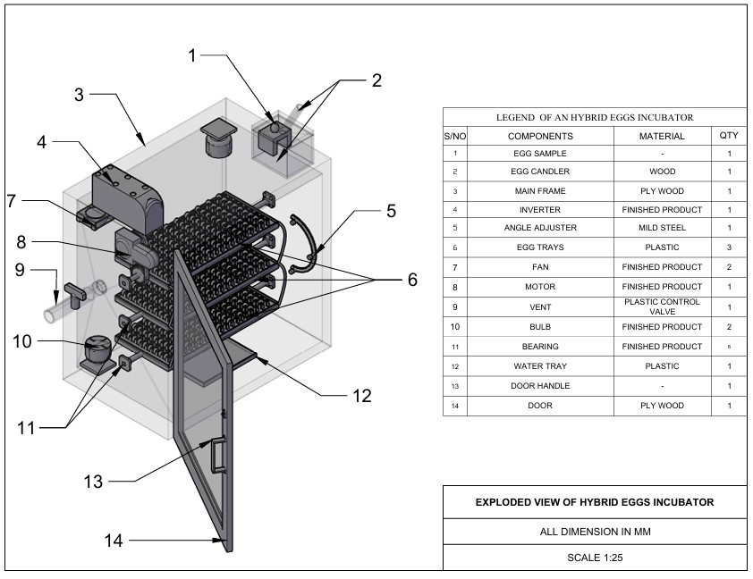
Figure 3.2 Exploded View of Hybrid Eggs Incubator
3.3.1 The Main Cabinet
The main cabinet is the incubating box which consists of the egg trays, fan, bulbs, egg turner, humidity tray, controller and savor motor.
- The incubating box is made from MDF plywood due to it, insulation properties, ease of construction, flexibility and durability. The dimension of the incubating box is 920 mm x 950 mm x 640mm.
- Egg turning trays: The Egg turning trays, is constructed from wood with dimension of 635mm x 335mm x 60 mm to accommodate the egg plastic crates. There are six egg creates, each containing 30 eggs, they were positioned inside incubator and turn 6 hourly.
- Humidity tray Is made up of plastic and placed at the bottom of the incubating box to increase and recover humidity in the incubator during experimental period.
- The fan is incorporated to facilitate the temperature and humidity in the incubator in order to keep them within the requirement of the present values.
- The controller was incorporated to sense the temperature, humidity and the turning mechanism of the incubator for effective incubation.
- The electric bulb 100 w cells as the source of heat to warm the inner unit to temperature range of 36 - 37.5° c.
- The savor motor is used to drive the egg turning tray and tilt it to an angle of 45° either side after a period of 6 hours.
3.3.2 The Auxiliary Unit
The auxiliary unit consists of solar PV panel, solar charge control, battery and inverter. The solar PV panel: Absorb solar energy to charge the battery, the solar charger controls the charging of the battery to prevent overcharging, the inverter converts the direct current from the battery to alternating current to be used by the incubator and at the same time charged the battery when there is electricity.
3.4 Design Consideration
The following factors were considered when designing hybrid eggs incubation
(a) Environmental Control
- Temperature range of 36.5°C-37-5°C within the incubator
- humidity range of 50-60% to prevent water loss and promote healthy development
- ventilation within the incubator is necessary for adequate airflow to maintain oxygen levels and remove carbon dioxide.
(b) Egg Handling
- regular turning (every 1-4 hours) to prevent embryo adhesion to the shell
- egg orientation to ensure eggs are positioned correctly (large end up) to facilitate proper development.
(c) Energy Deficiency and Sustainability.
- incorporating solar energy source to reduce reliance on electrical energy source
- automatic egg turner to reduce labor and ensure consistent turning
- temperature and humidity monitoring to ensure optimal condition
3.5 Design Calculation and Analysis
The design criteria are based on making the equipment more affordable, efficient and durable. the incubator capacity, heating system, turning mechanism, size of battery, power from battery size of solar panel were all designed during the development process.

3.5.1 Determination of Incubation Chamber
The capacity of the incubator is directly proportional to the number of eggs and the number of egg trays. The incubator was design to hatch 180eggs per hatch. The design of incubation chamber was done using equation 3.1and 3.2
c = $\frac{n}{60}$ (3.1)
Where
C = number of trays
n = number of eggs to be hatched
c = $\frac{180}{60}$
c = 3egg trays
the incubation chamber was designed to contain the egg trays; the incubation chamber was rectangular box like structure.
Volume of Incubation Chamber
V = l × b × h (3.2)
Where:
V = volume of incubator (m$^3$) (Abubakar et al 2023)
L = length of incubator (m)
B = breadth of incubator (m)
H = height of incubator (m)

3.5.2 Determination of Heat Required for Incubation
Heat required in the incubator was determined from equation 4
Q = MCΔT (Benjamin and Oye ,2012) (3.3)
Where;
Q = total heat required
C = specific heat capacity
ΔT = change in temperature
M = molar mass
QT = (MaCaΔT) + (MeCeΔT) × Ne + (MpCpΔT) + (MwCwΔT) (3.4) (Abubakar et al 2023)
Where;
MaCaΔT = heat required by air
MeCeΔT = heat required by eggs
Ne = number of eggs
MpCpΔT = heat required by plywood
MwCwΔT = heat required by water.

3.5.3 Heat Loss by Incubator
The heat loss due to conduction can be calculated from the equation 3.5 - 3.9
Q = −KA($\frac{ST}{Sx}$) (3.5)
The flow of air is steady inside the incubator therefore it does not vary with time.
QSx = −KAST (3.6)
Q = − KA$(\frac{Tinc -Ts}{X}$) (3.7)
Where;
Q = heat
K = thermal conductivity coefficient of plywood (0.65) in the design
X = is the thickness of the plywood (15mm)
Heat loss during incubation is given as top and bottom of plywood.
Qptpbpspfpbt =−KA$(\frac{Tinc -Ts}{X}$) × 2 (3.8) (Bala et al, 2020)
Where;
Pt = is the plywood top
Pb = plywood backside
Ps = plywood side
Pf = plywood front
Pbt = plywood bottom.
A = area of incubator chamber
K = thermal conductivity coefficient (0.65 forMDF) plywood (Ajani et al 2020).
The quantity of heat loss is calculated using the following equation
QL = Qptm + Qpss + Qpfb ( 3.9)
The quantity of heat required for the incubation
Q = Ql + Q1 (3.10)
Where:
Q = quantity of heat required for incubation
QL = heat loss by the incubator
Q1 = heat required of the incubator.

3.5.4 Determination of Humidity
The humidity keeps the eggs from losing two much moistures in the process of incubation it is calculated from equation 3.11 – 3.13
H = $\frac{Mv}{v}$ (3.11)
ρ =MvRvT (3.12)
H =$\frac{v}{RvT}$ (3.13)
Where:
H = humidity
ρ = energy density/heat density of water
T = temperature
Mv = molar mall of water
Rv = gas content
V = volume of the incubator’s chamber
3.5.5 Total Power Consumption
The total power consumption of the entire incubator system can be calculated from the following equation.
Total power consumption (PT) =P1+Pfh+Pfv+Pc (3.14) (Abba- ayi et al 2024)
Where;
P1 = power of the incubator chamber
Pfh = power of humidity fan
Pfv = power of ventilation
Pc = power of control board.
3.5.6 Power Requirement and Selection of Battery Solar Panel and Inverter
Total power consumption is added up to 130.435W base on the total power requirement of the incubator. A 200AH lithium phosphate acid battery 12v, a 1KVA inverter and a 300W solar panel will be used to power the entire incubator.
3.5.7 Size of Solar Charger
Size of solar charger was determine using equation 3.15.
SSc = $\frac{wp}{v}×Pf$
Where;
SSc = size of solar charger (AH)
Wp = wattage of solar panel (W)
V = voltage of the battery (V)
Pf = power factor (1.25)
Size of solar charger =21AH but use 25AH
3.5.8 Battery Running Time
The battery running time was calculated using equation 3.16
BR = $\frac{Bc}{L}$ Pf (3.16)
Where;
BR = battery running time (H)
Bc = capacity of battery (AH)
L = load of appliance (w)
Pf = power factor (10)
Battery running time is 16 hours but charging should start after 12 hours.
3.6 Material Selection
The following materials are put into consideration for the selection of materials used for hybrid eggs incubator
- Conservation of heat: MDF plywood was used for construction to conserve heat.
- Availability of material: The material used is easily available for repair and replacement.
- The cost of material: The cost of materials used is not expensive and will eventually leads to low cost of the incubator.
- The durability of the material: The material for construction was the type that will last long and have resistant to insect infestation.
- The easy of construction: The material used for construction is easy to work upon for mass production.
- The weight of material: The material used for construction was light weight for easy transportation.
- Lagging material: Fibre glass was used as a lagging material to further conserve and prevent loss.

3.7 Construction and Assembly Procedure of Hybrid Eggs Incubator
The tool used for the construction include; the hammer, hacksaw, paper tape, nail, bolt and nut. The medium density fibreboard (MDF)plywood of 50mm thickness was cut according to the design specification and joined together by nails and screw to form the incubating box. The three egg trays were in incorporated into the incubating box using bearing at ---- interval between one another to serve as egg crates seat. The savor motor was incorporated to the egg tray to facilitate the turning of the egg trays. The control board that houses temperature, humidity and time of turning was also incorporated.
3.8 The Operation of Hybrid Egg Incubator
The hybrid egg incubator is operated using two sources of energy (electrical and solar energy) that complement one another to prevent power interruption and for efficient incubation. When electricity is available, the incubator is powered directly from the main but in case of power outage the incubator is powered by solar power system. The solar power system consists of solar panel, solar charge control, battery and inverter.
The solar PV absorbs solar energy from the sun and charge the battery via the solar charge control, the DC from the battery is converted to AC by inverter for the use of the incubator thereby preventing power interruption that may be caused by power outage. The switching of power from electricity to solar or vice-versa is made possible through automatic incubator control system.

3.9 Bill of Engineering Measurement and Evaluation
Bill of engineering measurement and evaluation is presented in table
Table3.1 :- Bill of Engineering and Evaluation
S/N | Material | Rate | Quantity | Amount
1  2  3  4  5  6  7  8  9  10  11  12 | MDF Plywood 15mm  Marine Board 15mm  Egg Tray  Egg Crate  Turning Mechanism  Incubator Box Glass  DC Fan  Bearing  Electric Motor (Savor)  Controller Board  Eggs  Miscellenous  TOTAL | 35,000  45,000  20,000  800  50  30  8,000  8,000  45,000  95,000  7,500  15,000 | 1  1  3  6  -  1  2  6  1  1  6  - | 35,000  45,000  60,000  4,800  50,000  30,000  16,000  4,800  40,000  95,000  45,000  15,000  440,600

3.10 Performance Evaluation of Hybrid Eggs
3.10.1 Source of Material Source: The fertile eggs for evaluation were purchase from a poultry farm in Oke Ose, Ilorin East Local Government of Kwara State.
3.10.2 Preparation of Sample: The eggs were cleaned using sand paper, the eggs were of good size and shape. The incubator was fumigated for a day to prevent any contamination in readiness for incubation.
3.10.3 Output Parameter: The output parameters to be measured are;
Percentage Hatchability:
- Percentage hatchability is the number of hatched eggs to the number of fertile eggs loaded into the incubator in percentage.
The equation is stated in 3.17
Ph = $\frac{\text{N}\text{h}}{\text{Nfe}} \text{X }\text{100}$ ……………. 3.17
Where;
Ph = Percentage hatchability (%)
Nh= Number of hatched eggs
Nfe= Number of fertile eggs loaded
- Percentage Fertility:
Percentage fertility is the number of fertile eggs to the number of eggs loaded into the incubator in percentage.
The equation is stated in table 3.18
Pf = $\frac{\text{Nfe}}{\text{Nf}} \text{X}\text{ 100}$ ……………. 3.18
Where;
Pf = Percentage fertility (%)
Nfe = Number of fertile egg
Nf = Number of eggs loaded into the incubator
- Mortality Rate
Mortality rate is the number of death to the number of fertile eggs loaded into the incubator
The equation is stated in 3. 19
MR = $\frac{\text{Nd}}{\text{Nfe}} \text{X }\text{100}$
Where;
MR = Mortailty rate
Nd = Number of death
Nfe = Number of eggs loaded
3.11 Experimental Procedure
The performance evaluation of hybrid eggs incubator was carried out at Kwara State Polytechnic Institute of Skills Acquisition, Mini Campus, Ilorin. The hybrid eggs incubator was fumigated and run empty for one day to ascertain the satisfactory performance of the incubator.
One hundred fowl eggs were purchased from a poultry farm in Oke Ose, Ilorin East Local Government of Kwara State and loaded into the hybrid egg incubator. The temperature, humidity and turning of egg tray were monitored. The temperature and humidity were taken three times a day and the mean value for each day was recorded while the turning of egg trays was on 6 hourly.
The candling of eggs was done on the 7th day of loading and the second candling was done on the 14th day of loading. The turning of egg tray was stopped on the 18th day of loading. The unfertilized and bad eggs removed from the incubator was 34 eggs while the remaining 66 eggs were incubated for the period of 21 days. The hatching of eggs started on the 20th day of incubation. The number of hatched eggs were 58 while the remaining 8 were dead in the shell.

CHAPTER FOUR
4 RESULT AND DISCUSSION
4.1 Result
The result of performance evaluation of hybrid egg incubator is as shown in table 4.1-4.3
Table 4.1 Candling Test On 7th Day On Incubation
S/N | No of Eggs | Development | Observation | Remark
i  ii  iii  iv | 10  11  40  39 | not visible  not visible  visible at one end  visible at the centre | Clear  Larger air space  Liner running across  Visible patches of red strain | Infertile  Infertile  Fertile  Fertile

Table 4.2 Candling Test On The 14th Day of Incubation
S/N | No of Eggs | Development | Observation | Remark
i  ii  iii  iv  v | 13  61  6  5  7 | Not visible  Dark appearance  The whole egg is dark  Dark Appearance  The whole egg is dark | Clear  Clear air space  No air space  Beak is visible  Visible patch of red stain | No development  Development in progress  Development ceased  Almost fertile  Development ceased

Table 4.3 Average Records of Temperature and Humidity for 21days of Incubation
S/N | Temperature(°c) | Humidity(%)
1  2  3  4  5  6  7  8  9  10  11  12  13  14  15  16  17  18  19  20  21 | 37.2  37.4  37.3  37.2  37.3  37.4  37.4  37.5  37.4  37.4  37.4  36.1  37.5  37.5  37.5  37.3  37.3  37.5  37.4  37.3  37.4 | 50.1  52.1  53.1  52.6  57.7  54.9  58.2  58.3  59.8  56.0  56.3  50.4  56.2  56.2  56.1  52.4  55.9  53.4  57.9  60.0  54.1

The output parameter are;
- Percentage hatachability =$\left(\frac{number of eggs hatched}{number of fertile egg }\right)×100$
= $\frac{60}{66}×100=91\%$
- Percentage fertility = $\left(\frac{number of fertile eggs}{number of eggs incubated}\right)×100$
= $\frac{66}{100}×100=66\%$
- Mortality rate =$\left(\frac{number of death embroy}{number of eggs incubated}\right)$
= $\frac{6}{66}×100$ = 9%
4.2 Discussion
The result of incubation from 4.1 showed the temperature range of (36.1° – 37.5°) during the performance evaluation which corroborate the findings of Hard et al (2010), Gbabo et al (2014), Nithin et al (2014), Oniya et al (2010). This showed that the equipment was suitable for incubating fertile eggs. The relative humidity range (50.1 -60%) during performance evaluation was within the range obtained by Oniya et al(2013). The minimum temperature and humidity from the first day to 21st day were 36.1c° and 50% respectively while the maximum temperature was 37.5°c and maximum humidity was 60% for the period of incubation.

CHAPTER FIVE
5 CONCLUSIONS AND RECOMMENDATIONS
5.1 Conclusions
From the study carried out, the following are drawn:
- A hybrid egg incubator that combines electricity with solar energy to complement one another to prevent power interruption of the machine during incubation was modified and constructed.
- The temperature and humidity range within the incubator during performance evaluation were 36.1 – 37.5°c and 50.1 – 60% respectively. The percentage hatachability of the incubation is 91%. The incubator is suitable for the hatching of poultry eggs and is therefore recommended for poultry farmers.
5.2 Recommendations
The following recommendations are made:
- Intensive performance evaluation should be carryout using other species of poultry birds like turkey, duck, guinea fowl.
- Sponsorship should be provided by relevant agencies in order to improve the machine and stop importation of incubators.

Reference
Abba – Ayi, M. A., Usman, A. R., & Shuwa, M. (2024). “Design of a Smart Solar Hybrid Egg Incubator for Engineering, Technology and Environment”, 20(2), 375-384.
Abubakar, M. A., Daheer, A. A., Adache, A. L., & Ferdinand, I. O. (2023). “Development and Testing of an Automated Egg Incubator”. International Journal of Advanced in Engineering and Management (IJAEM), 5(6), 191-202.
Adegoke, C. O., & Bolaji, B. O. (2000). “Performance Evaluation of Solar-Operated Thermosyphon Hot Water System”. International Journal of Engineering and Engineering Technology, 2(1), 35-40.
Adewumi, B. A., & Oduniyi, A. I. (1999). “Design, Fabrication and Testing of a Charcoal Fueled Incubator”. Journal of Applied Sciences, 2(1), 159-175.
Ahmad, A., Saini, J. S., & Varma, H. K. (2003). “Thermohydraulic Performance of Packed Bed Solar Air Heaters”. Energy Conversion and Management.
Ajani, A. S., Olusoji, A. O., Egbeyele, G. B., & Adeniyi, M. O. (2020). “Design and Construction of Automated Eggs Incubator for Small Scale Poultry Farmer”. Internal Journal of Technical Research and Science, 5(8), 1-9.
Akinola, O. A., Akinyemi, A. A., & Bolaji, B. O. (2006). “Evaluation of Traditional and Solar Fish Drying Systems Towards Enhancing Fish Storage and Preservation”. Journal of Fisheries International, 1(2-4), 44-49.
Bala, A. M., Abubakar, M. A., Bello, M. S., & Sakako, T. (2020). “Design, Construction of a Fully Automated Egg Incubator using Electric Battery”. African Scholar Journal of African Sustainability Development, 18(2), 319-332.
Benjamin, N., & Oye, N. D. (2012). “Modification of the Design of Poultry Incubator”. International Journal of Application or Innovation in Engineering, 1, 90-102.
Berinyuy, J. E. (2004). “A Solar Tunnel Dryer for Natural Convection Drying of Vegetables and Other Commodities in Cameroon”. AMA, 35(2), 31-35.
Bolaji, B. O. (2005). “Performance Evaluation of a Box-Type Absorber Solar Air Collector Crop Drying”. Journal of Food Technology, 3(4), 595-600.
Divagar, V., Kannan, N., & Thiruvaran, T. (2022). “Development of an automated solar-driven hybrid egg incubator”. Available: https://nastec.gov.lk
Duffie, J. A., & Beckman, W. A. (1991). “Solar Engineering of Thermal Processes” (2nd ed.). John Wiley and Sons, New York.
Eltawil, M. A., & Samuel, D. V. K. (2007). “Vapour Compression Cooling System Powered by Solar PV Array for Potato Storage”. Agricultural Engineering International: The CIGR Ejournal, 9, 1-23.
Gbabo, A., Liberty, J. T., Gune, O. N., & Owa, G. J. (2014). “Design, Construction and Performance Evaluation of an Electric Powered Egg Incubator”. International Journal of Research in Engineering and Technology, 3, 521-526.
Harb, S. K., Habib, Y. A., Kassem, A. M., & Elraies, A. (2010). “Energy Consumption for Poultry Eggs Incubator to Suit Small Farmer”. Egypt Journal of Agricultural Research, 88(1), 193-210.
Itodo, I. N., Obetta, S. E., & Satimehin, A. A. (2002). “Evaluation of a Solar Crop Dryer for Rural Applications in Nigeria”. Botswana Journal of Technology, 11(2), 58-62.
Mansaray, K. G., & Yansaneh, O. (2015). “Fabrication and performance evaluation of a solar powered chicken egg incubator”. International Journal of Emerging Technologies and Advanced Engineering, 5(6), 31-36.
Niranjan, L., Venkatesan, C., Suhas, A. R., Satheeskumaran, S., & Nawaz, S. A. (2021). “Design and implementation of chicken egg incubator for hatching using IoT”. International Journal of Computational Science and Engineering, 24(4), 363-372. Available: https://doi.org/10.1504/IJCSE.2021.117018
Olasunkanmi, J. N., Akintade, O. O., & Kehinde, L. O. “Development of a GSM based DC Powered Bird Egg Incubator”. International Journal of Engineering.
Ogunwande, G. A., Ajayi, O. A., Ogunjimi, L. A. O., & Osunade, J. A. (2010). “Development of a still-air incubator with nonthermostatic control”. Ife Journal of Technology, 19(2), 59-62.
Okonkwo, W. I., & Chukwuezie, O. C. “Characterization of a photovoltaic powered poultry egg incubator”, in 4th International Conference on Agriculture and Animal Science, Singapore, 2012, pp. 1-6. Available: https://doi.org/10.7763/IPCBEE
Olaoye, I. O., Lawal, B. M., Ibrahim, S. O., & Sanusi, B. A. (2013). “An Electrically Operated Incubator for Household”. Greener Journal of Science and Technological Research, 3(5), 160-165. Available: https://doi.org/10.15580/GJSETR.2013.5.1127
Soeb, M. A., Al Mamun, M. R., Shammi, S., Uddin, M., & Eimon, G. A. (2021). “Design and Fabrication of Low-Cost Incubator to Evaluate Hatching Performance of Egg”. European Journal of Engineering and Technology Research, 6(7), 91-96. Available: http://dx.doi.org/10.24018/ejers.2021.6.7.2662
Thakur, N. S., Saini, J. S., & Solanki, S. C. (2003). “Heat Transfer and Friction Factor Correlations for Packed Bed Solar Air Heater for a Low Porosity System”. Solar Energy, 74, 319-329.
Uzodinma, E. O., Ojike, O., Etoamaihe, U. J., & Okonkwo, W. I. “Performance study of a solar poultry egg incubator with phase change heat storage subsystem”. Case Studies Thermal Engineering, 18, 100593, 2020. Available: https://doi.org/10.1016/j.csite.2020.100593
Waewsak, J., Chindaruksa, S., & Punlek, C. (2006). “A Mathematical Modeling Study of Hot Air Drying for Some Agricultural Products”. Thammasat International Journal of Science and Technology, 11(1), 14-20.
Yadav, B. K., Pokhrel, N., Khatiwada, D., Khanal, M., Bajracharya, T., & Dhakal, R. (2021). “Design, Fabrication, and Performance Analysis of an Automatic Horizontal Egg Incubator”. Journal of the Institute of Engineering, 16(1), 78-85. Available: https://doi.org/10.3126/jie.v1611.36557

Exploded View of Hybrid Eggs Incubator

Assembly View of Hybrid Eggs Incubator

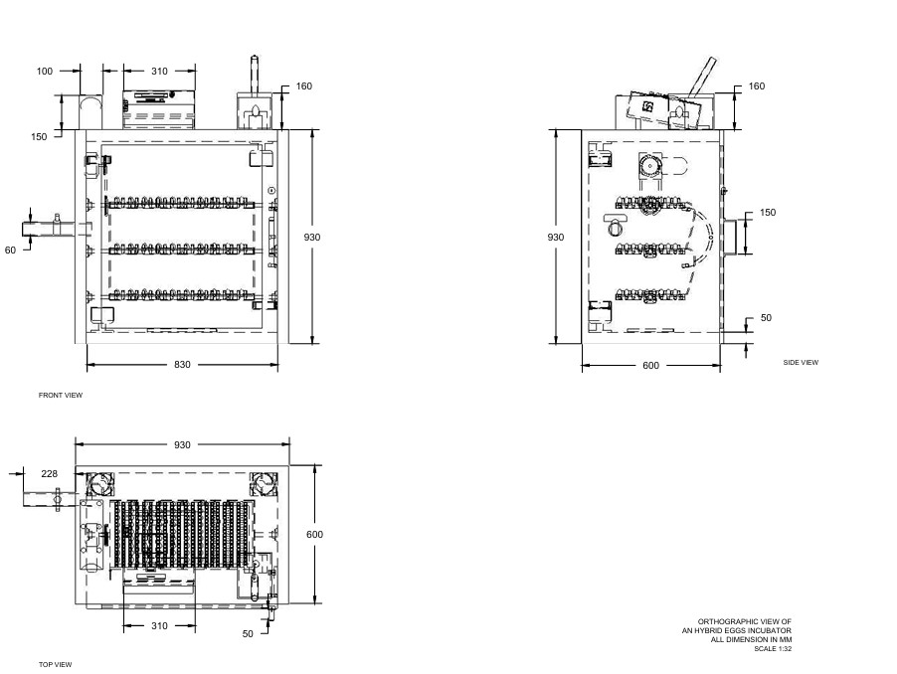
Orthographic View of Incubator

