

PROJECT REPORT TITLE PAGE
PROPOSED RESTAURANT AT ORI ERU, IWO, OSUN STATE, NIGERIA

DESIGNING A CULTURALLY INSPIRED MID-SCALE DINING EXPERIENCE
ADEWALE AYOMIDE ADEBAYO
MATRIC NO: ND/23/ARC/PT/0022
DEPARTMENT OF ARCHITECTURAL TECHNOLOGY
INSTITUTE OF ENVIRONMENTAL STUDIES
KWARA STATE POLYTECHNIC, ILORIN, KWARA STATE

A Project Report Submitted to the Department of Architectural Technology in Partial
Fulfillment of the Requirements for the Award of the
National Diploma (ND) in
Architectural Technology

JULY 2025

DECLARATION
I declare that this project report is a product of my original research work. It has not been presented elsewhere for the award of any diploma, degree, or certificate. All ideas, findings, and contributions from other sources have been duly acknowledged in accordance with academic standards.
Adewale Ayomide Adebayo
Matric No: ND/23/ARC/PT/0022


Signature: _______ Date: ________________

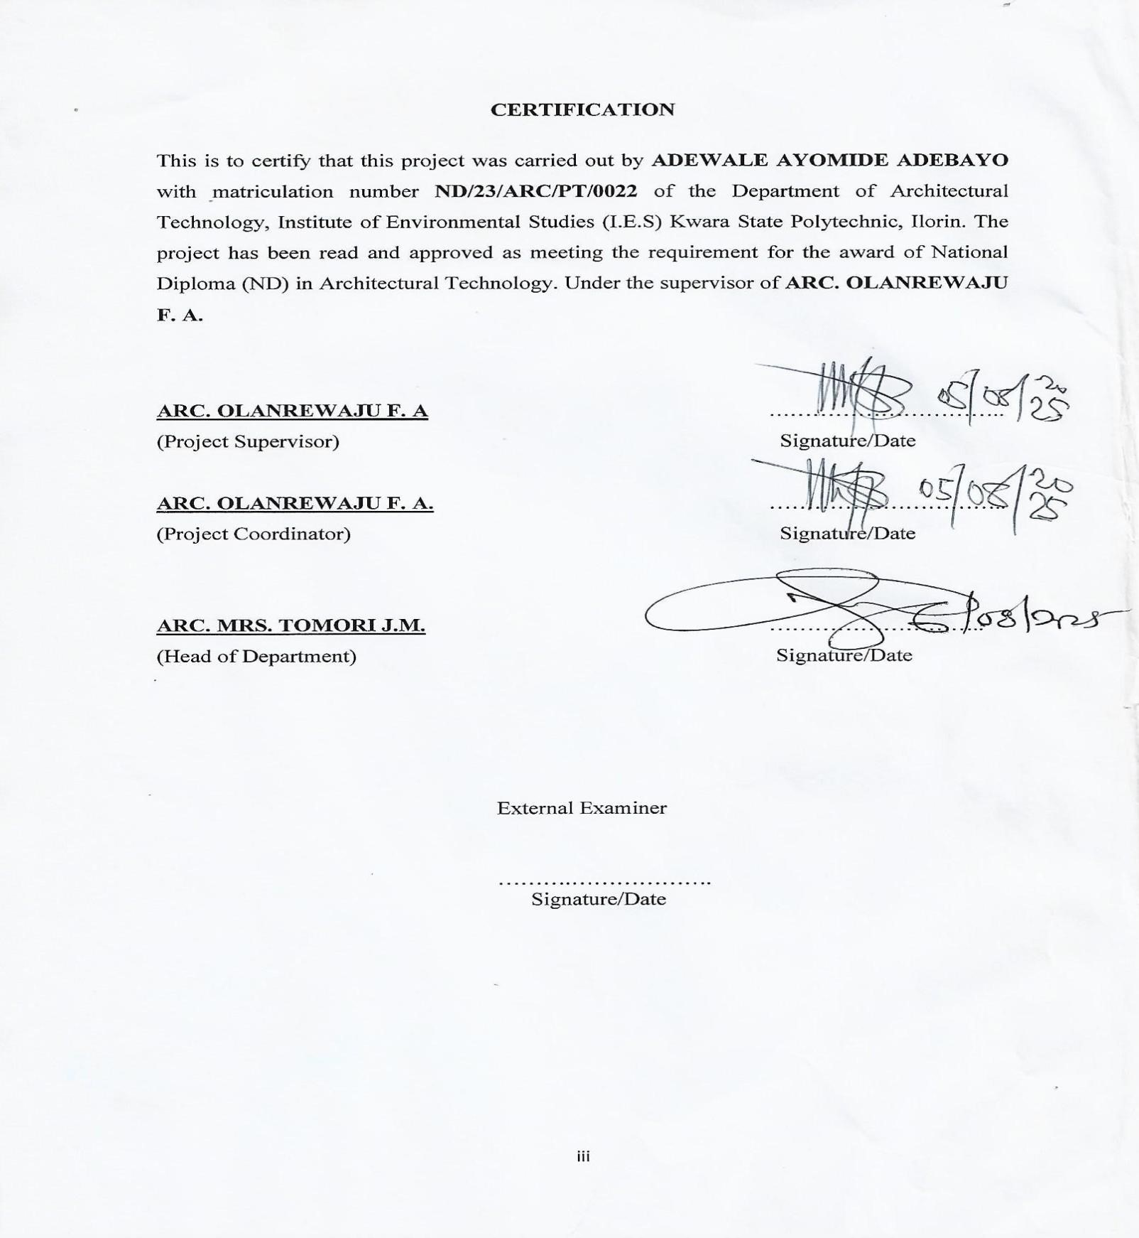

DEDICATION
This project is dedicated to my beloved mom, my siblings, (ADEJUMOKE, MY TWIN SIS OLUWAMOYA ADESHEWA, MY KID SIS TAIWO ADEYEMI & KEHINDE ADEWUNMI) whose unwavering support, prayers, and encouragement gave me the strength to persevere.
And to Almighty God, the source of all wisdom and understanding.

ACKNOWLEDGEMENTS
I give all glory to God Almighty for the grace and strength to complete this academic journey.
My sincere appreciation goes to my supervisor Arch Adeyemi F.O, the HOD ARC J.M TOMORI and other lecturers of the department of Architectural Technology, Kwara State Polytechnic, for their guidance and commitment throughout this project.
I deeply thank my family for their love and support, and my friends and course mates for their encouragement, ideas, and team spirit during the course of this work.

ABSTRACT
This project explores the design and development of a mid-scale culturally expressive restaurant at Ori Eru, Iwo, Osun State. The core objective was to address the functional, spatial, and environmental challenges often observed in existing local dining facilities while providing a space that reflects Yoruba cultural heritage.
A multi-method research approach was adopted, including literature review, environmental analysis, case studies of five restaurant buildings, and conceptual sketch development. The study also involved the formulation of a detailed design brief and schedule of accommodation.
The findings highlighted common problems in local restaurant design such as inadequate zoning, poor ventilation, and lack of cultural integration. Case studies emphasized how strategic planning, proper service separation, and aesthetic enhancements contribute to successful hospitality architecture.
The final proposal is a climate-responsive, accessible, and culturally enriched restaurant design. It balances form and function, modern systems and traditional motifs, and addresses user behavior and environmental sustainability. Recommendations were made for future expansion, cultural collaboration, and continued research in hospitality design.

TABLE OF CONTENTS
Title Page ................................................................. i
Declaration ................................................................. ii
Certification ............................................................... iii
Dedication ................................................................. iv
Acknowledgements ................................................... v
Abstract ................................................................. vi

CHAPTERS
Chapter one: Introduction ..................................... 1
Chapter Two: Literature Review ............................ 10
Chapter Three: Case Studies ................................ 17
Chapter Four: Site Analysis & Project Brief .......... 26
Chapter Five: Design Realization .......................... 34
Conclusion and Recommendations .................. 41
References ............................................................ 44

LIST OF TABLES
Table Number Title Page
Table 4.1Functional and Spatial Criteria28
Table 4.2Environmental and Climatic Data of Iwo25
Table 5.1Equipment and Services for Kitchen and Dining Areas36
Table 5.2Performance and Space Standards40

LIST OF FIGURES
Figure Number Title Page
Figure 1.1Site Location Map of Ori Eru, Iwo4
Figure 3.1Exterior View of The Yellow Chilli Restaurant18
Figure 3.2Interior Layout of Bit More Restaurant21
Figure 4.1Conceptual Site Zoning Diagram29
Figure 5.1Proposed Floor Plan for Ayo Foods & Lounge35
Figure 5.2Cross Section through Dining and Kitchen Zones38

CHAPTER ONE:

INTRODUCTION
1.1 Background of Study
Dining out is increasingly becoming a significant part of urban and semi-urban life in Nigeria. In towns like Iwo, Osun State, restaurants serve not just as eating places, but as centers for social gathering, cultural expression, and recreation. With the growing demand for well-structured, aesthetically pleasing, and comfortable dining environments, there is a need to design restaurants that are both functional and culturally expressive.
As the Nigerian food industry evolves, there's a noticeable shift from informal eateries to modern hospitality spaces that meet environmental and experiential expectations. However, many existing local restaurants suffer from poor spatial organization, inadequate services, and lack of cultural integration. This project aims to bridge that gap through an architectural solution that enhances user experience while reflecting local identity.

1.2 Statement of the Design Problem
Restaurants within Iwo often lack a well-thought-out architectural layout. Common issues include:
Inadequate ventilation and lighting
Poor service circulation between kitchen and dining
Limited comfort for both staff and guests
Lack of staff facilities like changing rooms
Absence of culturally relevant aesthetics
These problems affect not only the functionality of the space but also the commercial success of such establishments. The challenge is to design a restaurant that solves these issues while providing an engaging and comfortable environment.

1.3 Aim and Objectives
Aim:
To design a functional, culturally inspired, and environmentally responsive restaurant at Ori Eru, Iwo, Osun State.

Objectives:
To analyze spatial and functional requirements of a mid-scale restaurant
To incorporate Yoruba cultural elements in the design
To enhance comfort through good ventilation, lighting, and material choices
To provide necessary back-of-house facilities (changing rooms, storage, service bay) To optimize user flow and operational efficiency in the layout

1.4 Justification for the Project
This project is necessary to respond to the changing dining culture in Iwo. As people become more conscious of comfort and experience, there’s a need for purpose-built restaurant facilities. Additionally, showcasing cultural identity through architecture contributes to local pride and tourism.
By designing a climate-responsive, user-centered restaurant that includes both functional and symbolic elements, this project will contribute positively to the community and potentially serve as a benchmark for future hospitality designs.

1.5 Client's Background, Philosophy, and Goal
The client, Mr. Sola Akinwale, is a young entrepreneur passionate about food and Yoruba culture. He envisions Ayo Foods & Lounge as a place where people can enjoy local and continental meals in a space that feels both modern and rooted in tradition. His philosophy emphasizes customer satisfaction, cultural expression, and operational efficiency.

1.6 Scope of the Study
The project will cover the architectural design of:
Main indoor dining area (40–50 seats)
Lobby and reception
Kitchen with dry and cold storage
Staff changing rooms (male and female)
Delivery and service bay
Manager’s office
Public toilets (male and female)
Landscaping and external dining options
It will include conceptual development, spatial planning, and environmental considerations. Detailed structural or MEP design is outside the scope.

1.7 Limitations of the Study
Structural calculations and BOQ costing are not included
Real-life client interviews and surveys are simulated
Design assumes access to utilities (power, water, sanitation 1.8 Research Methodology
Literature Review: Studying past works, architectural theories, and restaurant typologies
Case Studies: Reviewing existing restaurants locally and internationally
Site Analysis: Studying the environmental and contextual characteristics of Ori Eru
Conceptual Design: Developing sketches, space programming, and bubble diagrams
Environmental Integration: Exploring sustainable and climate-responsive strategies

CHAPTER TWO: LITERATURE REVIEW

2.1 Evolution of Restaurant Architecture
The concept of dining establishments dates back to ancient civilizations, where inns and communal eating areas served travelers and merchants. In modern times, restaurant architecture has evolved into a specialized discipline combining hospitality, interior design, and environmental psychology.
Restaurants today are classified based on service styles—fast food, casual dining, fine dining, and hybrid models—each with distinct spatial and functional characteristics.

2.2 Typology and Classification
Restaurants can be classified by:
Cuisine type (local, continental, fusion)
Service method (self-service, table service, buffet)
Target market (family, elite, youth, travelers)
Architectural scale (small kiosks, mid-scale restaurants, franchises)
Each typology demands different layout considerations and technical requirements. These classifications influence design choices such as space allocation, kitchen design, aesthetics, and customer circulation.

2.3 Spatial Relationships and Functional Planning
A well-designed restaurant organizes its spaces for smooth operation. Typical areas include:
Entrance/Lobby – First impression and customer flow control
Dining Area – Flexible seating for groups and individuals
Kitchen – Divided into prep, cooking, washing, cold/dry storage
Staff Rooms – Changing and rest areas
Service Areas – Toilets, delivery bay, manager’s office
Functional planning ensures efficiency, safety, and comfort for both staff and customers. Zoning and circulation pathways must minimize conflict between kitchen staff and patrons.

2.4 Technological and Environmental Design Considerations
Modern restaurants adopt various strategies to optimize performance and sustainability:
Ventilation & Lighting: Natural ventilation and daylighting improve comfort and reduce energy use. Skylights and clerestory windows can enhance ambiance in the dining space.
Materials: Sustainable, durable, and easy-to-maintain materials such as polished concrete, recycled wood or terrazzo are preferred.
Acoustics: Sound control through acoustic panels improves the dining experience.
Fire & Waste Management: Proper zoning ensures safety and hygiene, with fire exits, extinguishers, and waste collection points integrated into design.

2.5 Cultural and Aesthetic Considerations
Restaurant design serves as a canvas for cultural storytelling. Incorporating indigenous motifs, local artwork, and traditional patterns into the architecture creates identity and emotional connection.
In Yoruba architecture, typical features like earthy colors, open courtyards, carved wooden screens, and symmetrical patterns can influence restaurant layout and decor. These elements not only add aesthetic value but also deepen the cultural experience of the space.

2.6 Sub-Topic Review: Cultural Identity in Hospitality Architecture
Globally, hospitality architecture is shifting toward localized experiences. Studies show that culturally themed environments improve customer satisfaction and brand loyalty.
In Nigeria, restaurants like Terra Kulture and The Yellow Chilli integrate cultural design with modern hospitality standards. These examples show how local art, materials, and architectural styles can be incorporated to create a memorable dining environment.
This project seeks to draw from such examples, emphasizing spatial comfort, service efficiency, and cultural symbolism to create a unique restaurant experience in Ori Eru, Iwo.

CHAPTER THREE: CASE STUDIES

3.1 Introduction
Case studies provide real-world insight into how similar restaurant buildings function architecturally. This chapter presents five relevant examples—both local and international—to draw lessons in spatial planning, aesthetics, materials, and operational efficiency. These case studies help inform the design decisions for the proposed restaurant at Ori Eru, Iwo.
3.2 Case Study One: The Yellow Chilli Restaurant – Lagos, Nigeria
Location: Victoria Island & Ikeja, Lagos
Type: Mid-range Nigerian and continental restaurant
Design Features:
Traditional African patterns blended with modern finishes
Indoor and outdoor seating zones
Warm lighting, wall art, and cultural décor elements

Functional Layout:
Reception/Lobby leading to main dining area
Kitchen at rear with cold/dry stores
Separate male/female restrooms

Merits:
Strong cultural identity
Good use of space and customer flow
Comfortable ambiance

Demerits:
Limited parking space
Acoustics can be poor during peak hours

3.3 Case Study Two: Nando’s Restaurant – Johannesburg, South Africa
Type: International Afro-themed fast-casual chain

Design Features:
African art and recycled materials
Colorful murals and open-plan layout
Use of sustainable finishes

Functional Layout:
Entry with order counter and self-service stations
Kitchen and staff areas clearly separated
Flexible seating for various group sizes

Merits:
Strong brand identity through architecture
Efficient service circulation
Use of local materials

Demerits:
Some locations lack adequate ventilation
Layouts may be too standardized across branches
3.4 Case Study Three: Kilimanjaro Restaurant – Ilorin, Nigeria
Type: Fast-casual Nigerian and continental meals
Design Features:
Bold color branding and modular design
Compact, functional interior
Counter-ordering with dine-in space

Functional Layout:
Front counter with food prep behind
Seating area arranged for quick turnover
Rear access for waste and staff

Merits:
Highly efficient floor plan
Clean and functional design

Demerits:
Limited ambiance and cultural elements
Basic material palette
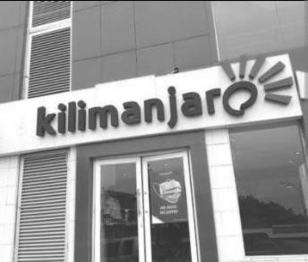
3.5 Case Study Four: Bit More Restaurant – Osogbo, Nigeria
Type: Casual dining with semi-luxury touch
Design Features:
Neutral tones, indirect lighting
Indoor and shaded outdoor spaces
Structured kitchen with walk-in cold room

Functional Layout:
Entry lobby and segmented dining zones
Kitchen separated from public space
Staff rooms and office included

Merits:
High user comfort and clear zoning
Strong aesthetic appeal

Demerits:
Heavy dependence on artificial lighting
Sound reflection in large halls
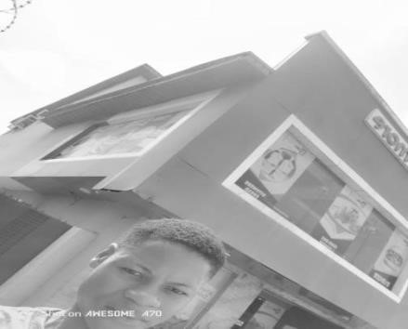
3.6 Case Study Five: Chicken Republic – Ibadan, Nigeria
Type: Quick-service restaurant
Design Features:
Bold red and yellow brand color scheme
Small footprint design for fast construction
Open plan for fast service turnover

Functional Layout:
Order and payment counter at front
Seating for short-term users
Compact kitchen with staff-only access

Merits:
Speed of service and low overhead
Uniform brand recognition

Demerits:
Minimal cultural value
Less comfort for dine-in customers

3.7 Case Study Summary
These five case studies provide comprehensive insight into restaurant design in both local and global contexts:
Yellow Chilli shows how cultural identity improves ambiance
Nando’s balances sustainability and branding
Kilimanjaro and Chicken Republic demonstrate compact, service-driven layouts
Bit More emphasizes comfort and spatial richnes
This project will adopt a hybrid of these lessons to achieve cultural relevance, customer comfort, and operational efficiency.

CHAPTER FOUR:
STUDY AREA / PROJECT SITE (ENVIRONMENTAL AND IMPACT ANALYSIS)
4.1 Introduction of Study Area
The study area, Ori Eru in Iwo, Osun State, Nigeria, is a semi-urban locality experiencing gradual development. Iwo is a major town with cultural significance and expanding urban needs. Ori Eru is located near residential homes, educational institutions, and commercial activities, making it suitable for a hospitality project like a restaurant.

4.2 Site Location and Description
The proposed site is situated along Why Worry Street, Ori Eru, Iwo. It lies on relatively flat terrain, facing a secondary access road with good vehicular and pedestrian traffic. The total area is approximately 1,000 square meters, sufficient for a single-story restaurant with designated parking, service bay, and landscape buffer.

4.3 Site Inventory and Analysis
Topography: Gently sloping, easy to level
Soil Type: Lateritic, good bearing capacity for shallow foundation
Vegetation: Sparse grass cover, few trees
Adjacent Land Use: Residential buildings, a church, and small retail shops
Utilities: Water supply, power lines, and sanitation access are nearby

4.4 Climatic and Geographical Data
Climate Zone: Tropical wet and dry (Aw – Köppen classification)
Temperature: 21°C – 34°C annually
Rainfall: 1,000 – 1,500 mm per year
Prevailing Winds: Southwesterly direction
Sun Path: Morning sun from the east, harsh afternoon sun from the west
4.5 Environmental Conditions and Site Constraints
Advantages:
Quiet environment, ideal for dining
Close to residential communities (target customers)
Good daylight potential and cross-ventilation

Constraints:
Western exposure needs solar protection
Irregular boundaries may affect building shape

4.6 Project Design Goals (Client Brief)
Create a culturally inspired and functional dining space
Serve 40–50 guests at a time with indoor seating
Provide separate male and female staff changing rooms
Include cold and dry storage for kitchen use
Add a delivery bay and back-of-house service path
Incorporate Yoruba motifs and sustainable design elements

4.7 Functional and Spatial Criteria
Space Area (sqm)
Reception12
Dining Area90
Kitchen45
Cold Room10
Dry Store8
Staff Changing Rooms 20
Toilets (M/F)12
Manager’s Office8
Delivery Bay18
Circulation/Service30

4.8 Appraisal of Proposed Scheme The proposed layout supports:
Clear public/private zone separation
Efficient circulation paths for staff and service
Visual openness in the dining space
Secure rear access for supplies and waste management

4.9 Equipment and Performance Requirements Kitchen Equipment: Cooking range, sinks, prep tables, fridges Ventilation: Natural cross-ventilation and ceiling fans
Lighting: Day lighting and energy-efficient LED fixtures
Water Supply: Overhead tank, tap systems in toilets and kitchen
Waste Management: External bin location, service exit
Fire Safety: Fire extinguishers and sand buckets placed strategically

4.10 Functional Relationship and Conceptual Development
Reception leads directly to the main dining area
Dining space opens to external shaded seating zone
Kitchen is located behind the dining area for easy service
Changing rooms and toilets are located in the staff-only section
Delivery access connects to the kitchen and store areas
Concept inspired by Yoruba courtyard style with natural airflow and culturally themed finishes

CHAPTER FIVE:

APPROACH TO THE DESIGN / DESIGN REALIZATION

5.1 Introduction
This chapter outlines the architectural development of the proposed restaurant at Ori Eru, Iwo. It presents the design philosophy, planning process, material choices, environmental considerations, and building services. The approach balances culture, comfort, and sustainability to create a functional dining space.

5.2 Design Concept and Philosophy
The design concept draws inspiration from traditional Yoruba courtyard architecture, emphasizing openness, cultural identity, and comfort. The idea is to create a centralized dining experience enclosed by service zones, incorporating natural light, local motifs, and simple circulation patterns.
Cultural expression is shown through wall patterns, colors, and spatial arrangement.
Comfort is achieved through open ceilings, cross-ventilation, and warm finishes.
Efficiency is embedded in zoning, services layout, and modular design.

5.3 Design Development Stages
Conceptual Sketches: Bubble diagrams and adjacency planning
Zoning: Public vs. private and service separation
Site Integration: Considering wind direction, solar orientation, and access
Spatial Planning: Functional spaces connected by simple paths
Material Expression: Blending local textures with durable construction methods

5.4 Site Planning
Entrance is directly accessible from Why Worry Street
Landscape buffer separates the building from the road
Front area includes signage, parking (for 5–7 cars), and an outdoor seating option
Service access is provided at the back for deliveries and refuse removal
Building footprint maximizes usable land while preserving open space

5.5 Floor Plan Description
Reception & Lobby: Centrally located near the main entrance
Dining Area: Large open space with clerestory windows for natural light
Kitchen: Connected to the dining via service window/pass-through
Cold Room & Dry Store: Located within the kitchen zone
Changing Rooms (M/F): Located beside kitchen for staff privacy
Toilets (M/F): Near the dining area, with accessible entrance
Manager’s Office: Small room near the entrance with security visibility
Delivery Bay: Rear area with access to kitchen and waste zone

5.6 Construction Methodology and Materials
Foundation: Strip foundation using reinforced concrete
Walls: 150mm sandcrete blocks, plastered and painted
Roof: Long-span galvanized aluminum sheets with steel trusses
Floor Finishes: Terrazzo for public areas; ceramic tiles in kitchen and toilets
Windows/Doors: Aluminum framed with mosquito net and security proofing
Ceiling: POP ceilings in dining; PVC in kitchen/toilets for moisture control

5.7 Building Services
Lighting: Natural (windows, skylights) and artificial (LED ceiling lights)
Ventilation: Cross-ventilation with windows on opposing walls; ceiling fans in dining
Water Supply: Overhead tank, plumbing network to kitchen, toilets, and outdoor tap Sanitary Services: Soak-away and septic tank system
Fire Safety: Fire extinguishers, sand buckets, visible exit signage
Waste Disposal: External waste point with access for pickup

5.8 Environmental Design Features
Orientation: Longer sides face north-south to reduce heat gain
Overhangs: Shading devices protect from west sun
Day lighting: Clerestory windows and large side windows reduce electrical load
Rainwater Harvesting: Gutters connected to collection tank for garden use Cooling Strategy: Courtyard cooling with shaded outdoor zones

5.9 Legal and Regulatory Compliance
Setback and boundary regulations in line with Kwara State Building Laws
Design follows fire escape, sanitary, and accessibility codes
Public toilets and accessible ramps included for universal use

5.10 Behavioral and Cultural Considerations
Dining layout allows for family, individual, and group seating
Background music zones and cultural artworks improve ambiance
Cultural wall patterns, materials (e.g., timber paneling), and furniture arrangement reflect Yoruba heritage

5.11 Performance Standards
Ventilation and natural lighting meet comfort thresholds
Fire safety and kitchen hygiene are integrated into spatial planning
Material finishes selected for durability, low maintenance, and aesthetics Dining noise levels managed via acoustic ceiling design

5.12 Summary

The proposed restaurant is not just a place for eating—it is a cultural and social experience. Every design decision reflects an understanding of context, function, and user expectations. The result is a climateconscious, aesthetically rich, and highly functional space for the people of Iwo.

CONCLUSION AND RECOMMENDATIONS
6.1 Conclusion
The proposed restaurant project at Ori Eru, Iwo, Osun State, presents a culturally infused and functionally efficient design tailored for a growing urban environment. This project bridges the gap between traditional identity and modern hospitality needs by incorporating spatial flexibility, environmental responsiveness, and cultural aesthetics into its architecture.
Through systematic research and design processes—ranging from literature review, environmental analysis, and case studies to spatial programming and concept development—the project identifies solutions to key issues in local restaurant architecture. These include poor layout planning, inefficient service flow, underwhelming ambiance, and lack of cultural identity.
The design proposal strategically integrates:
Clear functional zoning
Culturally relevant architectural expression
Comfort-driven dining experience
Environmentally sustainable strategies
By applying the lessons from real-world examples and contextual analysis, the final design promotes not only commercial viability but also social and cultural impact.

6.2 Recommendations
To ensure continued improvement in architectural restaurant design, the following recommendations are made:
- Renewable Energy Integration:
Future designs should incorporate solar power systems and energy-saving devices to reduce operating costs and environmental footprint.
- Cultural Collaboration:
Engaging local artists, craftsmen, and historians can further enrich cultural themes and strengthen community engagement in design processes.

- Behavioral Research:
More detailed study of customer habits and dining behavior across age groups and income levels can help refine spatial layouts and user comfort.

- Flexible Space Planning:
Future restaurants should be adaptable for event hosting, takeout expansion, or seasonal variation in customer volume.
- Design for Expansion:
Provisions should be made for modular growth or vertical additions, especially in developing neighborhoods where commercial demand may rise.
- Material Innovation:
Emphasis should be placed on sustainable, low-maintenance, and cost-effective materials suitable for tropical climates.

This project stands as a model for future hospitality designs that aim to blend culture, comfort, and creativity in a rapidly evolving Nigerian built environment.

REFERENCES
Akinmoladun, O. I., & Oluwoye, J. O. (2019). Space planning and functionality in contemporary Nigerian restaurants. Journal of Architecture and Urbanism, 43(2), 100–112.
Alagbe, O. A. (2011). Introduction to Architectural Design Principles. Ibadan: Concept Press.
Chudley, R., & Greeno, R. (2016). Building Construction Handbook (11th ed.). Oxford: Rutledge.
Davis, H. (2006). The Culture of Building. New York: Oxford University Press.
Kilimanjaro Restaurant. (2023). About us. Retrieved from https://www.kilimanjaro-restaurants.com
Nando’s South Africa. (2023). Restaurant design and sustainability. Retrieved from https://www.nandos.co.za
Olagunju, R. E. (2017). Architectural expression and identity in Nigerian hospitality design. International Journal of African Architecture, 5(1), 34–49.
The Yellow Chilli. (2023). Our story. Retrieved from https://www.yellowchilli.ng
Uduku, O. (2006). Modernist architecture and 'African-ness' in Nigeria. Habitat International, 30(3), 396– 411.
Wikipedia contributors. (2023). Chicken Republic. In Wikipedia, The Free Encyclopedia. Retrieved from https://en.wikipedia.org/wiki/Chicken_Republic orld eather Online. (2023). wo Climate ata. Retrieved from https: www.worldweatheronline.com

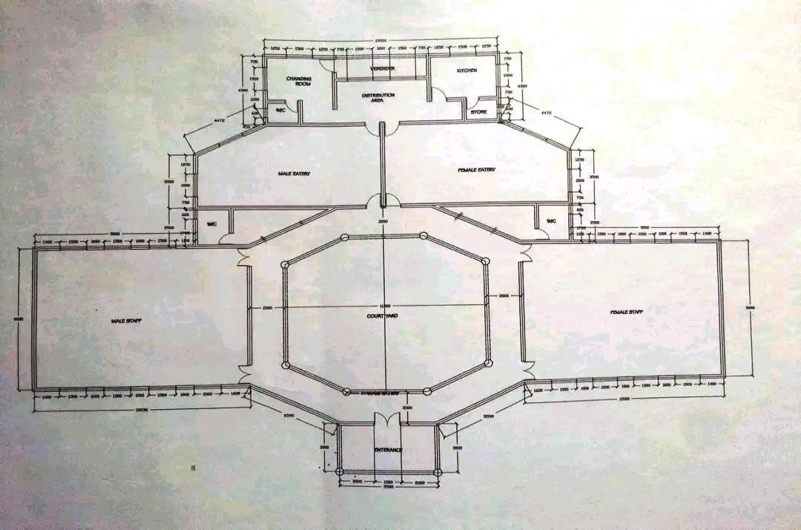
ONLINE CASE STUDIES

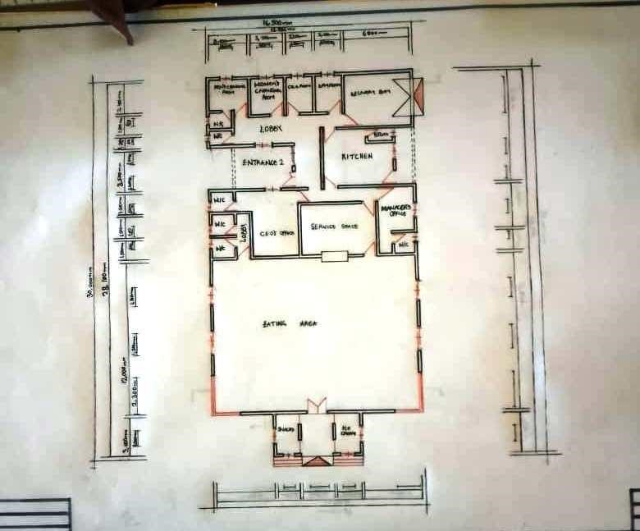
PROJECT FLOOR PLAN
LOCATION PLAN
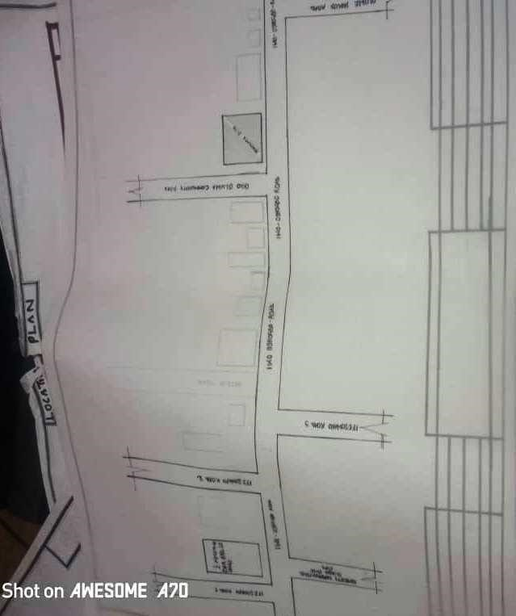
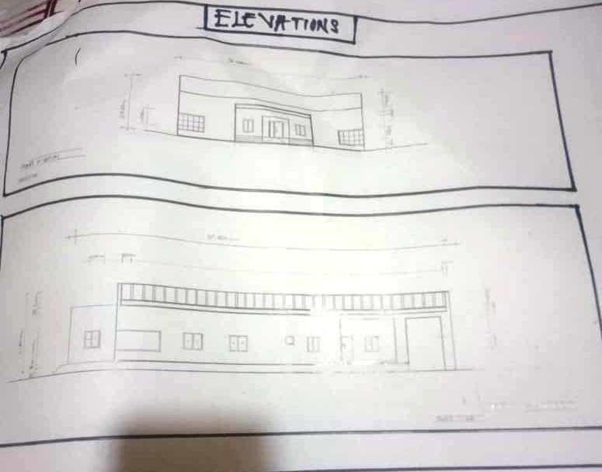
ELEVATIONS

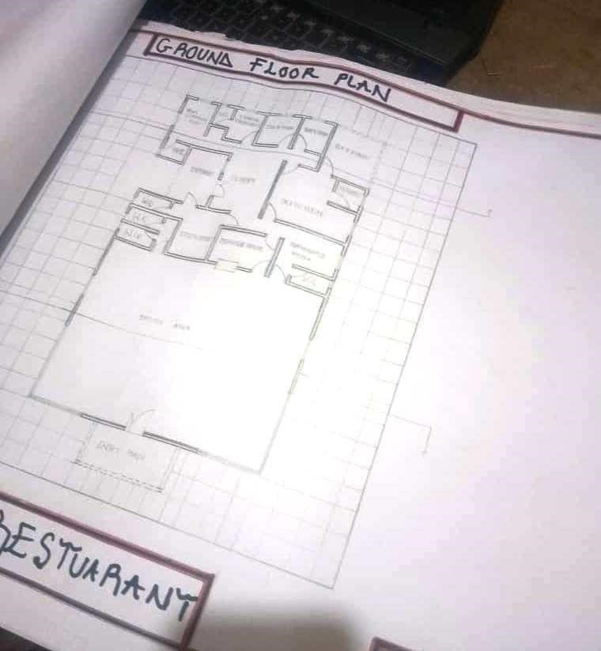
CHICKEN REPUBLIC FLOOR PLAN

