INVESTIGATING THE IMPACT OF GEOMAGNETIC STORM ON
IONOSPHERIC SCINTILLATION

BY
SALAMI ZAINAB AYOMIDE
ND/23/SLT/PT/0117

A PROJECT SUBMITTED TO THE DEPARTMENT OF SCIENCE LABORATORY TECHNOLOGY (PHYSICS & ELECTRONICS UNITS)
INSTITUTE OF APPLIED SCIENCE,

KWARA STATE POLYTECHNIC, ILORIN, NIGERIA

IN PARTIAL FULFILLMENT OF THE REQUIREMENT FOR THE AWARD OF NATIONAL DIPLOMA IN SCIENCE LABORATORY TECHNOLOGY

JULY,2025

CERTIFICATION

This is to certify that the project work was carried out and reported by SALAMI ZAINAB AYOMIDE with matric number ND/23/SLT/PT/0117 in the department of Science Laboratory Technology [SLT] Institute of Applied science [IAS], Physics Option and has been read and approved as meeting the requirement for the award of National Diploma [ND].

______________ ________
Mr. Sanni M.A Date
(Project Supervisor)

______________ ________
Mr. Abdullahi Zubair Lukman Date
(Part-Time Coordinator, SLT)

_______________ ________
External Examiner Date

DEDICATION
This project is dedicated to Almighty GOD, the giver of knowledge and to my parents.
ACKNOWLEDGEMENT

We are highly grateful to ALMIGHTY GOD who in his infinite mercy has showered his blessings and favor upon us throughout the course.

Our special thanks are extended to Mr. Sanni M.A who has worked tirelessly to see the success of this work for his advice and effective supervision. We also wish to appreciate the kindness and support of the head of the Physics/ Electronics Unit, SLT, Mr. Salahu Bashir and all the entire member of the staff of Physics/ Electronics, we will miss you.
These will not be complete if we don’t acknowledge the effort of our dear parents for their Mentorship and support, financially, care, their prayers and moral contribution to the success seeing us through our course of study we say thank you and God bless.

ABSTRACT
During the geomagnetic storms of 1 October 2002 and 22 January 2004, strong ionospheric scintillations on the GPS L1 band were observed at Wuhan station (30.6N, 114.4E; magnetic dip 45.8), located near the northern crest of the Equatorial Ionospheric Anomaly (EIA). The observed intense scintillation events were closely associated with the main phases of the storms and coincided with a marked enhancement of the EIA. Additionally, both large- and small-scale ionospheric irregularities were detected during the post-midnight hours, indicating sustained ionospheric instability.
These findings suggest that storm-time modifications in the eastward equatorial electric field play a significant role in generating and sustaining ionospheric irregularities. The results contribute to a deeper understanding of space weather impacts on low-latitude ionospheric dynamics and emphasize the importance of continuous monitoring for the mitigation of GPS signal degradation during geomagnetic disturbances.
TABLE OF CONTENT
Title page i
Certification ii
Dedication iii
Acknowledgment iv
Abstract v
Table of content vi-vii

CHAPTER ONE
1.1 The heliosphere 1-2
1.2. Internal structure of the sun 3-4
CHAPTER TWO
2.1 Literature review 5-28
2.2. Layers of the ionosphere 29
2.2.1 D Layer 29
2.2.2 E Layer 29-30
2.2.3 F Layer 30-31
2.2.3.1 F1 Layer 31
2.2.3.2 F2 Layer 32
2.3 Geomagnetic storm 33
2.3.1 Categories of geomagnetic storm 34

CHAPTER THREE
3.0. Data and Method of analysis 35-38

CHAPTER FOUR
4.1 Result and discussion 39-43

CHAPTER FIVE
5.1 Conclusion 44
References 45-47

CHAPTER ONE

  - The Heliosphere

At first, nothing well, not quite. The sun, earth, and solar system didn't exist billions of years ago. The galaxy was a vast cloud of gas and dust. The cloud has enough hydrogen atoms for gravity to draw them together about 5 billion years ago. The cloud got denser as it shrank. Before long, the speed of the atoms caused this cloud to glow. When the cloud became sufficiently heated, the hydrogen atoms' protons and electrons flew apart. When two protons collided, they fused, or adhered to one another, to form helium atoms. Fusion is the term for this procedure. Fusion also creates energy in the form of heat and light. This energy made the called to enlarge, while the gravity was pulling to hold the atoms together. Finally, the forces balanced and the sun was formed. With the sun at the center, our solar system formed. Over millions of years, the leftover gas and dust formed the nine planets, and a variety of moons asteroids, comets, and meteors.
The temperature can reach as high as 27 million degrees fahrenheit. The core's gas is about one hundred times denser than most metal. Since the core is this dense, it is hard for rats to leave. When gamma rays are released by fusion, they continue to collided with other atoms. Due to this, it takes the gamma rays almost thirty thousand years to reach the sun's surface. This means that the light that we receive on earth was created thousands years ago.
The Sun is by far the largest object in the solar system. It contains more than 99.8% of the total mass of the solar system (Jupiter contains most of the rest). It is often said that the sun is an "ordinary" star. That's true in the sense that there are many others similar to it. But there are

many smaller stars than larger ones; the sun is in the top 10% by mass. The median size in our galaxy is probably less than half the mass of the sun.
The Sun is personified in many mythologies: the Greeks called it Helios and the Romans called it sol. The Sun is, at present, about 70% hydrogen and 27% helium by mass everything else (" metals") amounts to less than 2%. This changes slowly over time as the sun converts hydrogen to helium in its core. The outer layers of the sun exhibit differential rotation: at the equator the surface rotates once every 25.4 days; near the poles it's as much as 36 days. This odd behavior is due to the fact that the sun is not a solid body like the Earth. Similar effects are seen in the gas planets. The differential rotation extends considerably down into the interior of the sun but the core of the sun rotates as a solid body. Conditions at the sun's core (approximately in the inner 25% of it's radius) are extreme. The temperature is 15.6 million kelvin and the pressure is 250 billion atmosphere. At the center of the core the sun's density is more than 150 times that of water
  - Internal Structure Of the earth

The diagram below depicts the sun's structure, including the inner core, radiative core, convectional shell, photosphere, chromosphere, and corona, which are then detailed.
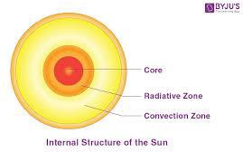

Figure 1.1: The structure of the sun

The surface of the sun, called the photosphere, is at a temperature of about 5800 k. Sunspot are "cool" regions, only 3800 K (they look dark only by comparison with the surrounding regions). Sunspot can be very large, as much as 50,000 km in diameter.s unspot caused by complicated and not very well understood interactions with the sun magnetic field.
A small region known as the chromosphere lies above the photosphere. The highly rarefied region above the chromosphere, called the corona, extend millions of kilometers into space but is visible only during a total solar eclipse (left). Temperatures in the corona are over 1,000,000 K. It just happens that the moon and the sun appear the same size in the sky as viewed from the earth. And the moon orbits the Earth in approximately the same plane as the Earth orbit around the sun sometimes the moon comes directly between the Earth and the sun. This is called solar eclipse ; if the alignment is slightly imperfect then the moon covers only part of the sun's disk and the event is called partial eclipse.
When it lines up perfectly the entire solar disk is blocked and it is called total eclipse of the sun. Partial eclipse are visible over a wide area of the Earth but the region from which a total eclipse is visible, called the path of totality, is very narrow, just a few kilometers ( though it is usually thousands of kilometers long). Eclipse of the sun happen once or twice a year. If you stay home, you are likely to see a partial eclipse several times per decade.
But since the path of totality is so small it is very unlikely that it will cross you home. So people often travel half way around the world just to see total solar eclipse. To stand in the shadow of the moon is an awesome experience. For few precious minutes it gets.

CHAPTER TWO

LITERATURE REVIEW

  - Review of Related Literature

Basu et al. (1981) made significant contributions to understanding the relationship between geomagnetic storms and ionospheric scintillation. Their study, one of the early systematic investigations into storm-time effects on the ionosphere, utilized ground-based radio wave observations to analyze how plasma irregularities evolve under disturbed magnetic conditions. They found that the occurrence of ionospheric scintillation is highly sensitive to magnetic storm phases, particularly the main and recovery phases when energy input from the solar wind is elevated.
The methodology employed by Basu and his colleagues involved monitoring Very High Frequency (VHF) signal fluctuations from satellites over equatorial and low- latitude regions. They recorded the S4 index (amplitude scintillation) and σφ index (phase scintillation) under varying geomagnetic conditions characterized by indices such as Kp and Dst. A major finding was that during intense geomagnetic storms, post-sunset ionospheric irregularities became more pronounced, resulting in stronger scintillation events. Notably, they observed that the amplitude and duration of scintillation were more significant during the solar maximum, a time characterized by heightened solar and geomagnetic activities.
Their results indicated that plasma bubble formation is critically dependent on the strength of the pre-reversal enhancement (PRE) of the eastward electric field at the equator. During geomagnetic storms, electric fields can be disturbed, either strengthening the PRE or reversing it

entirely. When enhanced, the upward plasma drifts promote Rayleigh- Taylor instabilities that culminate in the creation of large-scale plasma depletions, or "bubbles," responsible for the severe scintillation observed.
An important aspect of Basu’s work is the emphasis on storm-time electrodynamics as a primary driver of scintillation variability. They provided a physical model in which increased electric fields from storm-time magnetospheric convection result in a redistribution of plasma in the ionosphere. This dynamic alteration leads to regions with steep plasma density gradients that refract or scatter radio signals.
Critically, their findings have implications for satellite communication and GPS navigation systems, even though GPS technology was in its infancy during their study. Their identification of the causal link between storm- induced electric fields and ionospheric turbulence laid the groundwork for later research and operational monitoring systems in the space weather community.
In connection with the present study, Basu et al. (1981) offer a foundational understanding of how geomagnetic storms modulate the ionospheric environment, making their work a crucial reference point for examining scintillation phenomena during disturbed space weather conditions. Aarons (1991) provided an important extension to the prevailing understanding of ionospheric scintillation by emphasizing the role of pre-storm conditions. His investigations challenged the simplistic view that all geomagnetic storms inherently lead to increased scintillation. Instead, Aarons proposed that the ionosphere’s "memory" its pre-existing state plays a decisive role in determining its response to storm-time forcing.
Through meticulous analysis of scintillation records and geomagnetic indices over multiple solar cycles, Aarons identified that the presence of strong post-sunset plasma drifts and quiet-time

equatorial spread-F (ESF) activity prior to a storm significantly enhances the likelihood of severe scintillation during the storm's main phase. Conversely, if the pre-storm ionosphere is relatively quiet or shows suppressed instability, the subsequent storm may not necessarily lead to the expected amplification of scintillation.
Methodologically, Aarons employed radio beacon satellite data and ground-based observations, linking patterns of nighttime ionospheric instability with preceding magnetospheric and thermospheric conditions. One key insight was that a suppression of the pre-reversal enhancement (PRE) could sometimes occur due to storm-time disturbance dynamo electric fields, which may counteract the normal eastward field at sunset. If the PRE is weakened before or during the storm, plasma bubble formation and associated scintillation can actually decrease, contrary to expectations.
This nuanced view has profound implications. It means that predictive models of ionospheric scintillation must account for pre-existing conditions rather than relying solely on the magnitude of the geomagnetic storm (e.g., Dst or Kp values). Aarons' research thus called for a more holistic approach to space weather modeling, incorporating background ionospheric and thermospheric measurements.
From a physical perspective, Aarons highlighted the complexit y of plasma instability mechanisms under varying electrodynamic inputs. His work illustrates how the ionosphere is not merely passively responding to geomagnetic input but behaves as a dynamic, nonlinear system with feedback processes. This aligns with modern physics' understanding of complex systems and their sensitivity to initial conditions.
For the present study, Aarons (1991) is highly relevant as it stresses the critical importance of initial ionospheric conditions when evaluating the impact of geomagnetic storms on scintillation

phenomena. It provides a caution against oversimplified cause-effect assumptions and encourages deeper investigation into pre-storm ionospheric behavior.

Kintner, Humphreys, and Hinks (2009) shifted the focus of scintillation studies firmly into the practical realm by examining its impact on Global Navigation Satellite Systems (GNSS), particularly the Global Positioning System (GPS). Their study was pivotal in demonstrating the operational vulnerabilities of satellite-based technologies to ionospheric irregularities induced by geomagnetic storms.
Using a combination of field measurements, controlled experiments, and data from GPS networks, Kintner et al. (1998) documented how intense plasma irregularities caused rapid phase and amplitude variations of GPS signals. These variations often resulted in loss of signal lock a situation where GPS receivers temporarily lose track of satellites, causing severe positioning errors.
Their findings showed that scintillation was particularly intense near the magnetic equator and within the South Atlantic Anomaly, regions where the ionosphere is naturally unstable. During geomagnetic storms, the enhanced electric fields drive stronger plasma bubbles, which, in turn, exacerbate signal degradation. Importantly, their study quantified the degree of signal disruption, reporting positioning errors that could exceed 50 meters during severe events, with some outages lasting for several minutes.
From a physics standpoint, Kintner et al. explained that phase scintillation arises from multipath propagation caused by plasma density gradients on scales of hundreds of meters to kilometers. These irregularities cause rapid changes in the path le ngth of the signal, introducing phase errors.

Amplitude scintillation, on the other hand, results from constructive and destructive interference of scattered signals.
Kintner and colleagues also highlighted that GPS systems operating on the L1 frequency (1575.42 MHz) are particularly vulnerable, but even dual- frequency receivers (using both L1 and L2) could suffer under extreme conditions. This finding had significant implications for aviation, military operations, and commercial navigation systems, which heavily rely on precise GPS data. Their work encouraged the development of scintillation monitoring networks and predictive models to warn users of potential disruptions. Moreover, they advocated for the improvement of receiver algorithms to better handle scintillation- induced errors.
Relating to the current project, Kintner et al. (2009) provide crucial evidence that geomagnetic storm- induced ionospheric scintillation is not merely an academic concern but has profound real- world technological consequences, making understanding and forecasting these effects more important than ever.
Kil and Heelis (1998) made substantial contributions to understanding the formation and evolution of plasma bubbles in the ionosphere during geomagnetic disturbances. Their study, relying heavily on data from the DE-2 (Dynamics Explorer 2) satellite mission, focused on the behavior of plasma irregularities in the equatorial ionosphere, particularly how these irregularities respond to storm-time electric field variations.
The authors emphasized that plasma bubbles regions of depleted plasma density — typically form in the evening hours after sunset, a process largely driven by the pre-reversal enhancement (PRE) of the zonal electric field. During geomagnetic storms, this process becomes significantly modified. Kil and Heelis documented that storm- time electric fields, often intensified by

penetration electric fields or disturbance dynamo effects, cause an earlier onset of bubble formation, faster growth rates, and larger spatial extents.
Their methodology involved analyzing in- situ plasma density measurements and electric field observations. They found that during disturbed conditions, the vertical plasma drift speeds increased dramatically, exceeding typical quiet-time values. This rapid uplift of plasma led to enhanced Rayleigh- Taylor instability, which is the primary mechanism responsible for bubble generation. The instability arises when the denser plasma overlying a region of lower density is gravitationally unstable, leading to the formation of "fingers" of depleted plasma that grow into large bubbles.
An important outcome of Kil and Heelis's research was the realization that not only does the strength of the vertical drift matter, but the timing of the disturbance relative to local sunset is critical. If the storm- time penetration electric fields arrive just before or during the local sunset period, they can strongly enhance bubble growth. However, if the disturbance arrives much later at night, it may have little to no effect on new bubble generation, although it can still affect existing structures.
Critically, their findings suggested that the morphology of storm-time plasma bubbles could be drastically different from typical quiet-time conditions. Storm-enhanced bubbles tend to reach higher altitudes, sometimes exceeding 1000 km, and can spread across broader latitudinal ranges. In terms of physics, their work detailed how the electrodynamics of the low- latitude ionosphere are sensitive to external forcing from the magnetosphere, particularly through electric field penetration. This insight into ionosphere-magnetosphere coupling mechanisms has been essential for understanding storm-time effects on ionospheric dynamics.

Relating to the present study, Kil and Heelis (1998) provide a direct link between geomagnetic storm-time electric field modifications and the evolution of ionospheric plasma structures that ultimately cause scintillation, making their work indispensable for any analys is involving the effects of geomagnetic storms on communication and navigation systems.
Fejer et al. (1999) provided a seminal analysis of the role of electric fields during geomagnetic storms and how they impact equatorial ionospheric dynamics. Using a combination of incoherent scatter radar observations, satellite measurements, and theoretical modeling, they dissected the behavior of vertical plasma drifts and ionospheric electric fields under varying geomag netic conditions.
One of the key contributions from Fejer’s group was the distinction between prompt penetration electric fields (PPEFs) and disturbance dynamo electric fields (DDEFs). PPEFs occur rapidly in response to changes in the magnetospheric convection electric field and can cause sudden and strong changes in the equatorial ionosphere, typically enhancing upward plasma drifts during the main phase of a storm. DDEFs, on the other hand, develop more slowly over several hours as thermospheric winds adjust to the storm-induced changes and create secondary electric fields.
Their observations showed that during the main phase of a storm, upward drifts can be significantly enhanced due to PPEFs, promoting the growth of plasma bubbles and intensifying ionospheric irregularities. Conversely, during the recovery phase, DDEFs often introduce westward electric fields at night, which suppresses the normal PRE and inhibits bubble formation. Fejer et al. emphasized the variability and complexity introduced by these storm-time electric fields. They demonstrated that even for storms of similar magnitudes (measured by Dst index), the ionospheric response could vary dramatically depending on the timing, local time, and the interplay between PPEFs and DDEFs.

From a physics perspective, their work illuminated the electrodynamic pathways through which energy input from the solar wind and magnetosphere alters ionospheric behavior. They provided detailed modeling of the temporal evolution of electric fields and plasma drifts, crucial for understanding and forecasting scintillation events.
In relation to the present research, Fejer et al. (1999) underscore the importance of storm- induced electric field dynamics in modulating ionospheric conditions that give rise to scintillation, thereby providing a deeper understanding of the physical mechanisms underlying the phenomenon.
Ledvina, Kintner, and de Paula (2002) tackled a practical aspect of ionospheric scintillation: its impact on satellite-based communication systems. Their study synthesized observational data and modeling efforts to evaluate the extent to which geomagnetic storm- induced scintillation can disrupt radio signals at different frequencies.
A major contribution of their work was the frequency dependence analysis. They demonstrated that lower- frequency signals, particularly those operating in the L-band (1–2 GHz), are more susceptible to scintillation effects. This is because the scale sizes of ionospheric irregularities responsible for scintillation typically fall within the Fresnel zone of these frequencies, leading to significant signal diffraction and interference.
Their research used GPS signal data collected during several strong geomagnetic storms. They recorded instances of rapid amplitude fading, phase slips, and complete loss-of- lock events. Their modeling indicated that the severity of scintillation increases not only with the strength of the storm but also with the local plasma density and irregularity scale sizes.
From a physics standpoint, Ledvina et al. detailed how variations in electron density on spatial scales of hundreds of meters cause scattering of electromagnetic waves. In regions where plasma

density gradients are steep and irregularities are strong, the multiple scattered waves interfere destructively and constructively, leading to rapid fluctuations in received signal strength and phase.
Importantly, their findings emphasized the necessity of building robust communication and navigation systems capable of handling ionospheric scintillation. They suggested design considerations such as dual- frequency operation, improved receiver algorithms, and error- correction techniques.
For the present study, Ledvina et al. (2002) highlight the technological vulnerabilities associated with ionospheric scintillation during geomagnetic storms, reinforcing the practical importance of understanding and mitigating the effects of these space weather phenomena.
A particularly interesting result was that some storms suppressed plasma bubble formation altogether if they led to westward electric fields at sunset a finding consistent with theories on disturbance dynamo effects.
For the current study, Pimenta et al. (2003) provide important observational evidence linking geomagnetic storm dynamics with changes in plasma bubble behavior, highlighting the spatial broadening of scintillation zones during intense storms a crucial consideration for global communication and navigation systems.
Abdu (2005) produced a comprehensive review of the electrodynamic processes affecting the ionosphere during geomagnetic storms, especially in the equatorial and low-latitude regions. His work synthesized observations, theoretical modeling, and previous experimental studies to provide a unified framework for understanding how storm-time processes affect ionospheric stability and plasma irregularity development.

One of Abdu’s major contributions was to elucidate the competition between prompt penetration electric fields (PPEFs) and disturbance dynamo electric fields (DDEFs) in controlling plasma dynamics. He explained that while PPEFs could enhance upward plasma drifts leading to plasma bubble growth, DDEFs typically acted to suppress these processes, especially during the storm’s recovery phase.
Abdu’s analysis highlighted that the timing, duration, and magnitude of these fields determine the ultimate outcome for plasma bubble development. Early evening PPEFs can trigger strong plasma uplift and instability, whereas late- night DDEFs introduce westward drifts that can inhibit spread-F and bubble formation.
Furthermore, Abdu discussed the impact of storm-time thermospheric winds, particularly equatorward surges of neutral winds from high latitudes, which can modify the F-region height and plasma density gradients. Such neutral wind disturbances can either favor or suppress plasma instability, depending on their direction and intensity.
His study emphasized that the ionosphere’s response to storms is highly nonlinear and regionally variable. Local time, longitude, and background thermospheric conditions all influence how the ionosphere reacts to geomagnetic disturbances.
In terms of physics, Abdu provided detailed modeling of electric field generation and ion-neutral coupling processes. He incorporated the magnetosphere- ionosphere-thermosphere system into a coherent model of storm-time ionospheric dynamics.
For this project, Abdu (2005) offers a critical understanding of the electrodynamic controls over ionospheric scintillation during storms, reinforcing the need to consider multiple, often competing, physical processes in analyzing and predicting scintillation effects.

Michael C. Kelley’s influential textbook The Earth's Ionosphere: Plasma Physics and Electrodynamics (2009) offers a broad and deep perspective on ionospheric processes, treating the ionosphere as a natural laboratory for plasma physics.
Within the context of geomagnetic storms and scintillation, Kelley described the ionosphere as a highly dynamic, nonlinear medium whose behavior under disturbed conditions provides rich insights into fundamental plasma instabilities. He discussed in detail the Rayleigh-Taylor instability that underpins equatorial plasma bubble formation, showing how the balance between plasma density gradients, electric fields, and gravitational forces leads to instability growth.
Kelley emphasized the effects of storm-time electric fields — both prompt and dynamo-driven

— on plasma drift velocities. He elaborated on how these fields can either enhance or suppress irregularity growth, depending on the local time of penetration and the background ionospheric conditions.
A major highlight in Kelley’s work is the clear connection between microphysical plasma processes and their macroscopic manifestations — such as large-scale plasma depletions that cause radio signal scintillation. He described how small-scale turbulence within plasma bubbles leads to signal scattering and diffraction effects observed at Earth’s surface.
Kelley also discussed the impact of particle precipitation from the magnetosphere during storms, which can lead to localized increases in ionospheric density and modified electric fields. These secondary processes can further complicate the ionospheric response.
From an engineering perspective, Kelley pointed out the vulnerabilities of radio-based technologies to ionospheric irregularities, reinforcing the need for robust modeling and mitigation strategies.

In relation to this project, Kelley (2009) provides the essential theoretical foundation for understanding ionospheric scintillation from a plasma physics perspective, making his work indispensable for any serious investigation into the effects of geomagnetic storms on radio propagation.
Basu et al. (2010) conducted a detailed study focused on the characteristics of ionospheric scintillation during geomagnetic storm periods. Using data from specialized ground-based networks of GPS receivers and radio beacons, they analyzed the amplitude and phase scintillation indices under various levels of geomagnetic disturbance, offering critical insights into the behavior of irregularities during storms.
A major contribution of their work was the statistical analysis of scintillation intensity across different latitudinal regions, from the magnetic equator to mid- latitudes. They found that scintillation activity tends to peak near the equator and that during geomagnetic storms, these regions of high activity can expand both northward and southward, affecting broader geographical areas than under quiet conditions.
Basu et al. also demonstrated that phase scintillation becomes more severe compared to amplitude scintillation during storm times. Phase scintillation is particularly disruptive for GPS receivers because it can lead to cycle slips and loss-of-lock, thereby degrading positioning accuracy or causing complete system outages.
From a physical perspective, the study attributed these observations to the enhanced generation of small-scale irregularities inside plasma depletions (bubbles) triggered or intensified during storms. Basu et al. emphasized the role of high-altitude plasma bubbles reaching altitudes over 1000 km, where irregularities can align with magnetic field lines and scatter radio waves over large distances.

Importantly, they also observed that the intensity of scintillation is highly time-dependent. Typically, scintillation peaks a few hours after loca l sunset under quiet conditions; however, during storms, the peak can shift or become prolonged, sometimes persisting into the early morning hours.
Basu et al.’s findings hold significant implications for satellite communication and navigation, especially for aviation and maritime sectors that rely heavily on GPS. They stressed the need for developing scintillation warning systems based on real-time ionospheric monitoring.
For the present research, Basu et al. (2010) provide strong empirical support linking storm-time enhancements in plasma irregularities to the severity and distribution of scintillation, making them a critical reference point for understanding the broader impact of geomagnetic disturbances on technological systems.
For the present project, Carter et al. (2013) highlight the potential for forecasting storm-related scintillation events, demonstrating how physical models can be translated into actionable predictive tools for mitigating the effects of space weather disturbances on critical technologies.
Yizengaw et al. (2014) conducted an important regional study on the behavior of the African equatorial ionosphere during geomagnetic storms. Their work filled a major gap in global ionospheric research, as Africa’s equatorial sector had historically been under-observed compared to South America and Southeast Asia.
Using data from the African Meridian B-field Education and Research (AMBER) network and GPS receiver arrays, Yizengaw and colleagues analyzed storm-time variations in plasma density, vertical drift speeds, and scintillation occurrence over African longitudes.
One of their key findings was that the African ionosphere exhibits unique storm- time responses, including stronger vertical drifts and more frequent plasma bubble generation compared to other

equatorial regions under similar geomagnetic conditions. They attributed these differences partly to the geomagnetic declination (difference between magnetic north and geographic north) over Africa, which modifies the electrodynamic environment.
Yizengaw et al. observed that penetration electric fields during storms were often stronger and longer- lasting in the African sector, leading to more pronounced plasma uplift and greater instability. As a result, intense scintillation events were commonly recorded during both the main and recovery phases of geomagnetic storms.
their work demonstrated how regional geomagnetic configurations influence the coupling between storm- time magnetospheric electric fields and ionospheric plasma dynamics. They also discussed the important role of thermospheric wind surges in modulating F-region altitude and instability growth.
A significant implication of their study was the need for region-specific space weather forecasting models. Global models often fail to capture the nuances of African ionospheric behavior, leading to underestimation of scintillation risk in this region.
For this project, Yizengaw et al. (2014) provide essential insights into the regional variability of ionospheric scintillation during storms, highlighting the importance of considering local geophysical factors when assessing storm impacts on communication and navigation systems.

Zakharenkova et al. (2015) explored the response of GPS-derived Total Electron Content (TEC) measurements to geomagnetic storms, providing a valuable perspective on how space weather disturbances influence the ionosphere and, by extension, GPS signal quality. Their work primarily focused on TEC variations during strong storms and the corresponding occurrence of ionospheric irregularities leading to scintillation.

Using a dense network of GPS receivers across Europe and North America, they documented the development of Storm Enhanced Density (SED) structures, which are large-scale enhancements of TEC that typically form on the dayside during storm main phases. These SEDs are critical because their steep plasma density gradients can become sites of irregularity generation, resulting in scintillation when GPS signals traverse these regions.

Zakharenkova et al. found that storm-time SEDs are often associated with polar tongue of ionization features and subauroral polarization streams, both of which lead to complex plasma structuring in the mid- and high- latitude ionosphere. However, their study also showed that at low latitudes, including near the equator, plasma depletions and plasma bubbles dominate the irregularity landscape during storms.
A key aspect of their analysis was the spatial mapping of TEC gradients, which allowed them to identify areas of strong scintillation risk in real time. They demonstrated that sharp TEC gradients correlate well with regions of phase scintillation, suggesting that TEC observations can serve as a proxy for identifying potential navigation disruptions.
From a physical perspective, their findings emphasized the role of storm-driven electric fields and thermospheric disturbances in structuring ionospheric plasma on multiple scales from thousands of kilometers down to a few meters.
By connecting space weather monitoring with practical technological effects, Zakharenkova et al. (2015) offer crucial proof of how large-scale storm- time ionospheric features affect sma ll- scale scintillation events.
Li and colleagues (2017): Observations of Ionospheric Disturbances Using Multiple Instruments A thorough investigation using multi- instrument observations, such as satellites, ionosondes,

magnetometers, and GPS receivers, was conducted by Li et al. (2017) to examine the ionospheric reaction to significant geomagnetic storms. Their multi-pronged strategy allowed for a more thorough knowledge of the localized anomalies that cause scintillation events as well as large- scale ionospheric alterations.
Their research, which concentrated on storm-time behavior at various latitudes, demonstrated that plasma bubbles and spread-F events are the main sources of scintillation at low and equatorial latitudes. In contrast, auroral particle precipitation and medium- scale traveling ionospheric disturbances (MSTIDs) are more important in creating irregularities at mid- latitudes. One of Li et al.'s main conclusions was that the equatorial ionosphere undergoes notable pre- reversal enhancement (PRE) changes during powerful geomagnetic storms. The prevalence of equatorial plasma bubbles varies because storm- time electric fields either amplify or inhibit PRE, the abrupt increase in upward plasma drift close to sunset.
From a modeling perspective, they demonstrated that electrodynamic drivers such as penetration electric fields, disturbance dynamo effects, and thermospheric winds interact in complex ways to shape ionospheric responses. Their study provided clear examples o f how storm-time electric fields could enhance vertical plasma transport, seeding large plasma depletions and promoting instability growth.
Importantly, Li et al. showed that early detection of storm- induced electrodynamic changes — such as measuring enhanced vertical plasma drifts — could provide a short-term warning for scintillation-prone conditions.
Their study has major practical implications for the design of early warning systems for satellite navigation and communications, especially in equatorial and low-latitude regions.

For the present research, Li et al. (2017) offer valuable insights into the multi-scale, multi- process nature of ionospheric scintillation during storms, reinforcing the necessity of integrating multiple observation platforms for a full understanding of storm impacts.
Astafyeva et al. (2018) produced a landmark global-scale study of the ionospheric response to extreme geomagnetic storms, utilizing data from over 6000 GPS stations worldwide. Their work focused on the global morphology of ionospheric disturbances, including TEC anomalies, scintillation signatures, and traveling ionospheric disturbances (TIDs).
One of the most significant findings was that global-scale ionospheric disturbances can emerge within minutes of a geomagnetic shock arrival, highlighting the extremely rapid coupling between the solar wind, magnetosphere, and ionosphere.
Astafyeva et al. observed that low- latitude regions, particularly near the geomagnetic equator, are especially vulnerable to intense plasma irregularity development during the main phase of storms. They linked these irregularities to penetration electric fields that trigger strong vertical drifts, lifting plasma to altitudes where Rayleigh-Taylor instabilities can grow more easily.
Their study also identified that storm-time subauroral polarization streams (SAPS) and polar cap patches at higher latitudes create localized TEC gradients, leading to mid- latitude scintillation events — a phenomenon traditionally thought to be confined to equatorial regions.
Importantly, they emphasized the need for real- time, global ionospheric monitoring using dense GNSS networks. Given the speed at which ionospheric conditions can deteriorate during a storm, predictive capabilities and real-time alerts become critical for aviation, navigation, and communication sectors.

Astafyeva et al. illustrated the importance of coupled system dynamics From a physics standpoint, including solar wind- magnetosphere- ionosphere interactions — in driving global ionospheric disturbances.
For this project, Astafyeva et al. (2018) provide the ultimate global context, showing that geomagnetic storms are not merely regional phenomena, but can produce worldwide impacts on ionospheric stability and scintillation conditions.
A geo - magnetic storm is a temporary disturbance of the earth’s magnetosphere caused by solar wind shock wave and when cloud of magnetic field wind interacts with the earth’s magnetic fields. The increase in the solar wind pressure initially compresses the magnetosphere and the solar wind’s interact with earth’s magnetic field and transferring an increased energy into the magnetosphere. Both interaction cause an increase in movement of plasma through magnetosphere (driven by increase electric field inside magnetosphere)and increase in electric current in the magnetosphere and ionosphere.
During the main phase of a geomagnetic storm, electrical current in the magnetosphere creates a magnetic force, which pushes out the boundary between the magnetosphere and the solar wind. The disturbance in the interplanetary medium that drives the geomagnetic storm maybe due to a solar coronal mass ejection (CME)or a high-speed steam of the solar wind originating from a region of weak magnetic field on the sun surface .the frequency of geomagnetic storm increases and decreases with the sunspot cycle. CME driven storm are more common during the maximum of the solar cycle and co-rotating interaction region (CIR) driven storms are more common during the minimum of the solar cycle. In (1989) a geomagnetic storm energized ground induced current, which distrupted electric power distribution and caused aurorae (Gonzalez et.al,1994).

A geomagnetic storm defined changes in the disturbed storm time (DST) index (David,1972).The DST index estimate the globally averaged changes of the horizontal component of the earth’s magnetic field at the magnetic equator based on measurements from a few magnetometer stations.
A geomagnetic storm has three phases: an initial phase, a main phase and a recovery phase Piddington. (1963). The initial phase is characterised by DST increasing by 20 to -50nT in yens of minutes. The initial phase is also referred to as a storm sudden commencement(SSC).However, not all geomagnetic storms have n initial phase and not all sudden increase in DST, are followed by a geomagnetic storm. The main phase of a geomagnetic storm is defined by DST decreasing to less than -50 nT. The selection of -50nT to define a storm is somewhat arbitrary. The minimum value during a storm will be between-50nT and approximately-600nT. The duration of the main phase is typically between 2 and 8 hours.The recovery phase is the period when the DST changes from its minimum value to its quiet time value. The period of the recovery phase may be as short at 8 hours or as long as 7days.
  - The Ionosphere

The ionosphere is a region of the upper atmosphere that extends between 50 km to 1000 km where there is sufficient ions present to influence the propagation of radio wave (O lawepo, 2021). The layers of the Earth’s atmosphere that contains the high concentration of ion and free electron and is able to reflect radio waves. its lies above the mesosphere and extends from about 80 km to 1000 km above the earth’s surface. The ionosphere is the region in which sufficient ionization exists to influence the propagation of radio waves. The ionosphere which is an electric conductor and a refracting medium for radio wave is produced by a broad spectrum of solar visible and

non-visible radiation which dissociate and ionise the mixture of gasses in the upper atmosphere. Its height range coincides with the atmosphere and the thermosphere. As a result of regular variations of the intensity of solar radiation with the angle of elevation of the sun, the proper ties of the ionosphere, especially the electron density exhibits temporal and spatial variation. The ionosphere shows daily and seasonal variation and is controlled by the solar activity. It depends also on the geographical latitude.
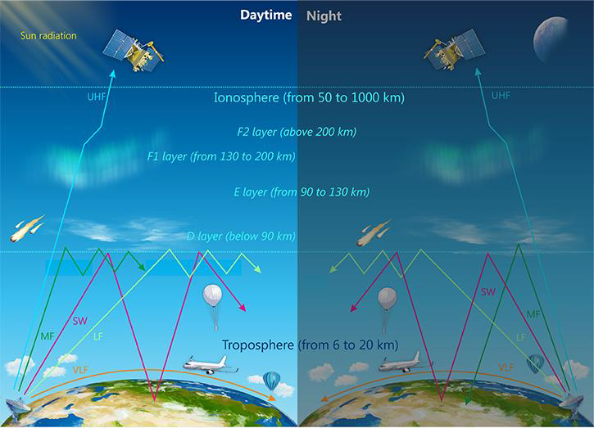

Figure 1.1:Ionosphere

  - LAYERS OF THE IONOSPHERE

    - D - layer

The D layer is the inner most layer 60 km to 90 km above the surface of the earth.its lowest region of the ionosphere, from this region the ionosphere extends in an upward part to the top of the earth atmosphere, implying that the majority of the ionosphere is in the thermosphere. In this layer the primary source of ionization are cosmic rays at this altitude (Davies, 1990;
Komjathy,1997; Moldwin,2008). Thus there is a clear relationship of the D layer’s ele ctron

density with a strong solar cycle variation (Komjathy 1997). In theory the electron density in the D layer above mid- latitude regions increase monotonically with altitude. Since the neutral density in the layer is high, the overall recombination rate is great. As a result, since photoionization only occurs when the sun background radiation is present, the D layer electrons are only present during the day at an altitude of about 60 to 70 km (Komjathy,1997;Moldwin,2008).Also, during night time the chances of electrons attaching to atoms and molecules to form negative ions are rather high, causing the D layers to completely disappear (komjathy,1997). At height near and above 80km, oxygen and nitrogen are mostly present and are ionized by X-radiation of wavelength less than 1 nm (Ratcliffe,1972).
    - E - Layers

The E layer is the middle layer, 90 km to 150 km above the surface of the earth ionization in the layer results from low energy X-rays (1-10 nm) and ultraviolet (UV) solar radiation of molecular oxygen (02), which results in electron density showing distinct solar cycle, sessional and diurnal variation. This layers peak electron density is more than 100 times greater than the peak density in the D layer, since recombination occur less at these high altitude (Moldwin,2008). Similar to D layers, the E layers is also present during day time and decrease during night time to nearly zero electron density (Komjathy,1997). The other sources for ionization in the layers are particle precipitation at high latitude, Effect of neutral atmosphere motion, Autorotate electric fields and meteors entering the upper atmosphere (Moldwin, 2008).
    - F - Layer

The F layer extends from about 150 km to more than 500 km above the surface of the Earth. It’s the layer with the highest electron density, which implies signals penetrating this layers will escape into space. Electron production is dominated by extreme ult raviolet (UV 10 -100 nm) radiation ionizing atomic oxygen. The F layer consist of one layers (F2) at night, during the day, a secondary peak (labeled F1) often forms in the electron density profile. Because the F2 layers remains by day and night, it is responsible for most sky wave propagation of radio waves and long distance high frequency (HF, or short wave) radio communications.

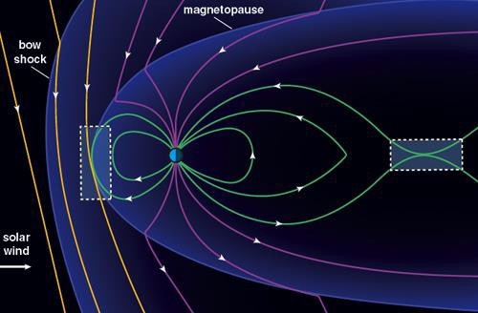

Figure 2.1: Magnetic field lines reconnection

      - F1 Layer

The F1 layer is the lower sector of the F layer and exists from about 150 to 220 km above the surface of the Earth and only during daylight hours. During daytime the presence of the F1 layer

is controlled by zenith angle of the sun. at night time F1 layer disappears to unite with the F2 layer to structure the night time F layer (Opperman etal.,2007).
      - F2 Layer

The F2 layer exists from about 220 to 800 km above the surface of the Earth. The F2 layer is the principal reflecting layer for HF communications during both day and night and contains the maximum electron density in the ionosphere, because of the combined effect of solar EUV radiation and the increase of neutral atmospheric density as the altitude decreases (Kelley, 2009). In terms of the propagation of high frequency (HF) radio waves this layer is considered to be the most critical layer in the ionosphere, the most important parameter is the height maximum of the F2 layer. The height and electron density of this layer is greatly changeable, and large daily, seasonal and sunspot-cycle variations are combined with general unpredictable behavior (Opperman et al.,2007). Unlike the F1 layer which follows the solar zenith angle dependence, the F2 layer is high enough that there is no seasonal effect due to the solar zenith angle.
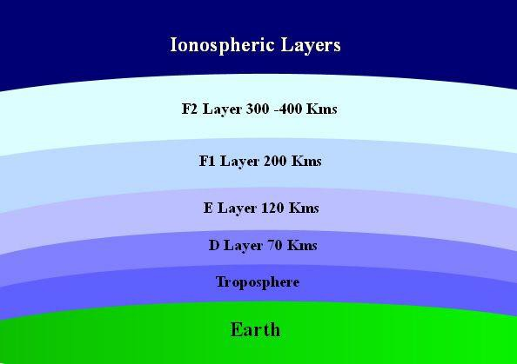

Fig 2.2 ionosphere layers

  - GEOMAGNETIC STORM

A geomagnetic storm (commonly referred to as a solar storm) is a temporary disturbance of the Earth’s magnetosphere caused by a solar wind shock wave and/or cloud of magnetic field that interacts with the Earth’s magnetic field. The increase in the solar wind pressure initially compresses the magnetosphere. The solar winds magnetic field interacts with the Earth’s magnetic field and transfers an increased energy into the magnetosphere. Both interactions cause an increase in plasma movement through the magnetosphere (driven by increased electric fields inside the magnetosphere) and an increase in electric current in the magnetosphere and ionosphere. During the main phase of a geomagnetic storm, electric current in the magnetosphere creates a magnetic force that pushes out the boundary between the magnetosphere and the solar wind.
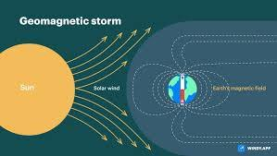

Figure 2.3: Geomagnetic storm

    - CATEGORIES OF GEOMAGNETIC STORM
Geomagnetic storm can be divided into two main categories, storms and sub-storms. Storms, the main contributors to space weather, are initiated when enhanced energy transfer from the

solar wind into the magnetosphere leads into intensification of ring current. The ring current development can be monitored with the Dst. Disturbed storm time (Dst). This is a measure of the deviation of the II (north-south) component of the magnetic field near the Earth’s equator from a long term average (Gonzales et al.,1994) Storm is an interval of time when a sufficiently intense and long- lasting interplanetary convection electric field leads, through a substantial energization process.

CHAPTER THREE

  - DATA AND METHOD OF ANALYSIS

The purpose of this chapter is to discuss data acquisition and methods used for the study. Two storms were selected, geomagnetic storms which occurred on 1 October 2002 and 22 January 2004 at wuhan and in September 2002, a modified GPS receiver for recording the amplitude and of the signal was set up at Wuhan
The strong ionospheric scintillation of the GPS band was observed at Wuhan station (30.6°N, 114.4°E, 45.8°Dip)
3.2 Wuhan location

Global disruptions of the Earth's magnetosphere are known as geomagnetic storms; the same G- scale is applicable everywhere. Thus, the table converts the official UTC peak of each occurrence into Wuhan's local time zone (China Standard Time, UTC + 8), allowing the severe phase to correspond with Wuhan's local conditions (about 30.6° N, 114.3° E). Wuhan's latitude makes it unlikely that auroras will be seen, yet G4 storms can still affect GNSS accuracy, HF communications, and power-grid harmonics
3.1 SCINTILLATION MEASUREMENT

The S4 parameter, which is the square root of the normalized variance of signal intensity over a specified period of time, is used to quantify scintillation.
S4= √({I²} - {I}²)/{I}² 3.1
There are three categories of scintillation: Low scintillation, moderate scintillation and strong scintillation. Strong scintillation generally considered to occur when S4 is greater than ~0.6 and is associated with strong scattering of the signal in the ionosphere. Moderate scintillation falls between 0.4 and 0.6, and low scintillation falls between 0.2 and 0.4. An S4 level below 0.2 is unlikely to have a significant impact on GPS (no scintillation).
  - Ionospheric scintillation monitor (ISM)
A single- or dual- frequency GPS receiver made especially to track the degree of ionospheric scintillation in real time is called an ionospheric Scintillation Monitor (ISM). The ISM samples at a rate of 50 Hz to compute the Scintillation statistics S4, and it has a wide-bandwidth tracking loop to keep lock longer during periods of high ionospheric scintillation. Strong scintillation enhances tracking with wide-bandwidth tracking. Gathering ionospheric Scintillation statistics S4 for every GPS satellite that is visible (up to eleven satellites) and storing these binary data logs on the receiver controller hard drive for posting processing is the main function of the ISM system. The ISM control software can be programmed to collect the data at 0.02 seconds temporal resolution and Carrier divergence is 1Hz can be recorded from the ISM. These data can be used to reconstruct the statistical Scintillation indices, such as S4 recorded in the data log,

from raw data. This allows the user to modify the parameters used in the derivation o f Scintillation indices, such as detruding and filter cut -off parameters.
  - Method of estimating Scintillation (S4)

For the storms used for this study, the S4 index value from a dual frequency GPS receiver at Wuhan (latitude = 30.6°N, longitude = 114.4°E) was utilized. GPS ionospheric scintillation over Wuhan during geomagnetic storms is used to determine Dst values (G. Li et al.). Intense storms with a minimum Dst value of -153nT were observed from September 30 to October 2, 2002, while severe storms with a minimum Dst value of -150nT were observed from January 21 to 23, 2004. These sources address the geophysical effects of geomagnetic storms employed in this work, classification scales, and basic physics.
30 Sep., 2002 | 12 : 00 CST  (~18 : 00  UTC) | G4  (Kp ≈ 8) | 30–02 0ct.,  2002 spring storm | CME strike produced severe conditions; aurora spotted at mid-latitudes. Spaceweather.com
21 Jan 2004 | 09: 57 CST  (24 Jan 06 :  55 UTC) | G4  (Kp ≈ 8) | 21 Jan 2002  CME storm | Severe level observed after paired CMEs; NOAA alert issued. NOAA Space Weather Prediction Center

Figure 3.1: G4-level (severe) geomagnetic-storm events expressed for Wuhan, China (CST = UTC +8

CHAPTER FOUR

  - RESULT
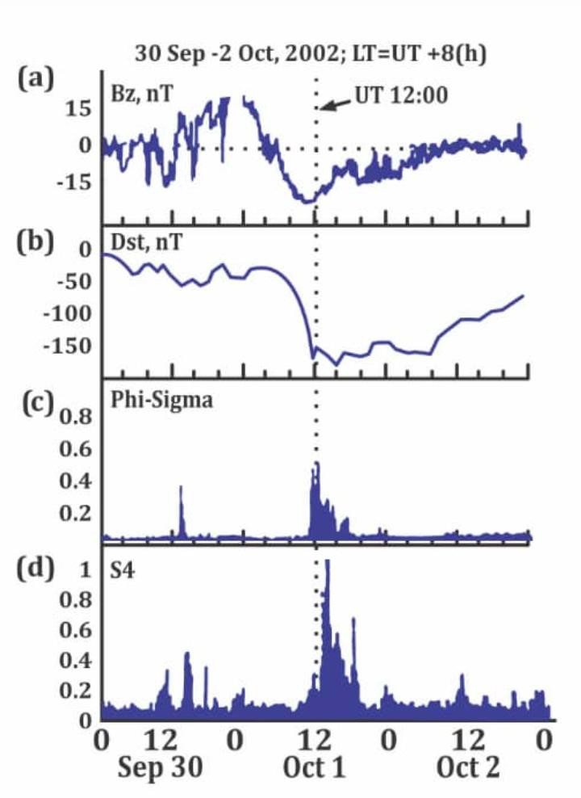

Fig 4.1 shows the S4 index and Bz index panel, Dst inex panel, phi signal for all available satellite for the period of the storm ( 30 September – 2 October 2002)

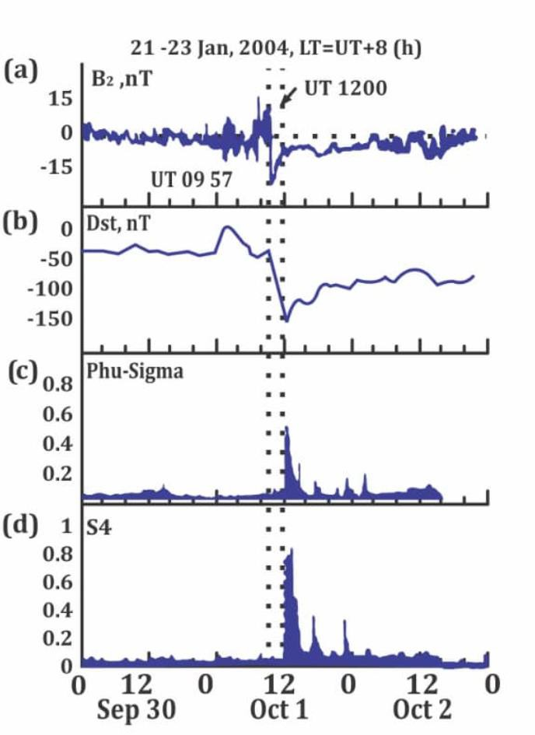

Fig 4.2: shows the S4 index and Bz index panel, Dst inex panel, phi signal for all available satellite for the period of the storm ( 21 -23 January 2004).

Discussion

As shown in Figure 4.1, the geomagnetic storm occurring between 30 September and 2 October 2002 was initiated by a sharp and sustained southward turning of the IMF Bz (below -15 nT) around October 1, 12:00 UT, as shown in panel (a). This was followed by a steep drop in the Dst index to below -150 nT, confirming a major geomagnetic storm (panel b). The ionospheric response is evident in the Phi-Sigma and S4 indices (panels c and d), which showed significant increases during the storm's main phase, with S4 values approaching 0.8, indicating strong ionospheric scintillations. These disturbances suggest heightened ionospheric irregularities, particularly in equatorial regions, consistent with enhanced geomagnetic activity. The event highlights the direct coupling between solar wind variations and ionospheric instability detectable via SID monitors.
As shown in Figure 4.2, during the geomagnetic storm of January 21–23, 2004, a sharp southward turning of the interplanetary magnetic field (IMF Bz) occurred at around 09:57 UT, triggering a major geomagnetic disturbance. This was confirmed by a significant drop in the Dst index to below -150 nT, indicating a strong storm. In response, ionospheric scintillation indices Phi-Sigma and S4 showed marked increases, peaking around the storm’s main phase at 12:00 UT. The elevated S4 values (above 0.6) reflect severe ionospheric irregularities, particularly affecting signal propagation in equatorial regions. Overall, the data clearly demonstrate how solar wind disturbances can induce intense geomagnetic storms and associated ionospheric disruptions, detectable through SID monitoring systems. The results reveal a strong correlation between solar- magnetospheric dynamics and ionospheric disturbances. The observed southward IMF Bz, corresponding Dst depression, and elevated scintillation indices collectively confirm the impact

of solar wind- magnetosphere interactions on ionospheric stability during geomagnetic storms. These disturbances pose significant challenges for space-based navigation and communication technologies, especially in equatorial and low- latitude regions where such scintillation effects are more pronounced.

CHAPTER FIVE

  - CONCLUSION

The geomagnetic storms of 30 September – 2 October 2002 and 21 – 23 January 2004 both exhibited strong southward shifts in the IMF Bz, followed by significant Dst index depressions below -150 nT, indicating major geomagnetic disturbances. In both cases, sharp increases in S4 and scintillation indices were observed, confirming severe ionospheric irregularities during storm main phases. These results collectively demonstrate the direct impact of solar wind-magnetosphere interactions on ionospheric dynamics. The study reinforces the importance of SID monitoring for detecting space weather effects and highlights its relevance in mitigating disruptions to communication and navigation systems, particularly in equatorial and low-latitude regions.

REFERENCES
Aarons, J. (1997). Global morphology of ionospheric scintillations. Radio Science, 32(4), 1567–1574.
Astafyeva, E., Zakharenkova, I., & Förster, M. (2018). Global ionospheric response to extreme space weather events: An overview of GPS observations. Space Science Reviews, 214(1), 1–27.
Basu, S., Basu, S., Groves, K., Yeh, H.C., Su, S.Y., Rich, F.J., Sultan, P.J., & Keskinen, M.J. (2001). Response of the equatorial ionosphere to magnetic storms. Geophysical Research Letters, 28(18), 3577–3580.
Basu, S., Groves, K.M., Quinn, J.M., & Doherty, P. (1999). A comparison of TEC fluctuations and scintillations at Ascension Island. Journal of Atmospheric and Solar-Terrestrial Physics, 61(16), 1219–1226.
Basu, S., Groves, K.M., Basu, S., & Sultan, P.J. (2002). Specification and forecasting of scintillations in communication/navigation links: Current status and future plans. Journal of Atmospheric and Solar-Terrestrial Physics, 64(16), 1745–1754.

Carter, B.A., Yizengaw, E., Retterer, J.M., Groves, K.M., Caton, R.G., & Coster, A.J. (2013). An analysis of equatorial plasma bubble occurrence in the American and African sectors. Journal of Geophysical Research: Space Physics, 118(12), 10418–10426.
Davies, K. (1990). Ionospheric Radio. IEE Electromagnetic Waves Series 31.

Kelley, M.C. (2009). The Earth's Ionosphere: Plasma Physics and Electrodynamics (2nd ed.).

Academic Press.

Pi, X., Mannucci, A.J., Lindqwister, U.J., & Ho, C.M. (1997). Monitoring of global ionospheric irregularities using the worldwide GPS network. Geophysical Research Letters, 24(18), 2283–2286.
Rastogi, R.G., & Klobuchar, J.A. (1990). Ionospheric electron content within the equatorial F2- layer anomaly belt. Journal of Geophysical Research: Space Physics, 95(A11), 19045– 19052.
Woodman, R.F., & La Hoz, C. (1976). Radar observations of F region equatorial irregularities.

Journal of Geophysical Research, 81(31), 5447–5466.

Yeh, K.C., & Liu, C.H. (1982). Radio wave scintillations in the ionosphere. Proceedings of the IEEE, 70(4), 324–360.
Yizengaw, E., Moldwin, M.B., Doherty, P., & Basu, S. (2014). A new longitudinal GPS TEC observation network in Africa. Journal of Geophysical Research: Space Physics, 119(4), 3155–3168.

Kivelson, M. G., & Russell, C. T. (Eds.). (1995). Introduction to Space Physics. Cambridge University Press. Astrophysics Data System

Kamide, Y., & Chian, A. C.-L. (Eds.). (2007). Handbook of the Solar-Terrestrial Environment.

Springer. Amazon

NOAA Space Weather Prediction Center. NOAA Space Weather Scales – Geomagnetic Storms (continually updated web resource). NOAA Space Weather Prediction Center

