EVALUATION OF RUNOFF CORFFICIENT USING A COMTOUR MICRO-CATCHMENT SYSTEM THE ESTABLISHMENT OF CASHEW PLANTATION

BY

AKINLABI EZEKIEL
HND/23/ABE/FT/0072

A PROJECT SUBMITTED TO THE DEPARTMET OF AGRICULTURAL AND BIO-ENVIRONMENTAL ENGINEERING TECHNOLOGY, INSTITUTE OF TECHNOLOGY, KWARA STATE POLYTECHNIC, ILORIN

IN PARTIAL FULFILMENT OF THE REQUIRMENTS FOR THE AWARD OF HIGHER NATIONAL DIPLOMA IN AGRICULTURAL AND BIO-ENVIRONMENTAL ENGINEERING TECHNOLOGY

JULY, 2025


DEDICATION
This project is dedicated to Almighty God the giver of life and my amiable parents.

ACKNOWLEDGEMENT
I give my great thanks to Almighty God, the Lord of the whole universe, the sustainers who guided and provided me all I need to complete my HND (Higher National Diploma) Programme in good health.
​My profound gratitude goes to my beloved parent Mr and Mrs. Akinlabi may Almighty God grant good health and bless them.
​ The next thank goes to my supervisor, a man of understanding honour and trust in person of Engr. Dr. Dauda K.A for being there and lenient with me. I pray may Almighty God reward you abundantly (Amen).
My appreciation also goes to the H.O.D of Agricultural and Bio-environmental Engineering Department in person of Engr. Dr. Dauda K. A and to all my departmental lecturers for the knowledge they have impacted in me throughout my Higher National Diploma Programme may God reward you abundantly.
Also my gratitude to my friends, stood by me. I remain disloyal if I drop my pen without appreciating my project partners. Thank you for the sincerely love we share during this research work. Also those people I am not opportune to mentioned one after the other, most especially all my course mate I appreciate you all, I will live to always remember your good deeds.
Am using this medium to pray Almighty God to bestow on me the utmost knowledge and understanding from now till eternity (Amen).

TABLE OF CONTENTS
Title Page i
Certification ii
Dedication iii
Acknowledgement iv
Table of Content v-vii
Abstract viii
CHAPTER ONE: INTRODUCTION
1.1 Background to the Study 1
1.2 Statement of Problem 1-2
1.3 Aim and Objectives 2
1.4 Significant Importance of the Study 3
1.5 Scope of the Project 3-4
CHAPTER TWO: LITERATURE REVIEW
2.1 Classification of Water Harvesting Techniques 5
2.2 Semi - Circular Bunds 5
2.3 Negarim Micro-Catchments 5-6
2.4 Contour Bunds for Trees 6
2.5 Contour Ridges for Crops 6-7
2.6 Trapezoidal Bunds 7
2.7 Contour Stone Bunds 7
2.8 Permeable Rock Dams 7-8
CHAPTER THREE: MATERIALS AND METHODS
3.1 Location of the Study Area 8
3.2 Selection of Materials 10
3.3 Methodology 10
3.3.1 Determination of Crop Water Requirement 10-12
3.3.2 Statistical Probability Analysis 12-13
3.3.3 Soil Physical and Chemical Analysis 13
3.3.4 Design Model for Catchment – Cultivated Area Ratio (C: CA) 13-14
3.3.5 Design Diagrams and Specifications 14
3.3.6 Field Layout and Constructional Procedure 14
3.3.7 Evaluation of Catchment Runoff Coefficient 17
CHAPTER FOUR: RESULTS AND DISCUSSION
4.1 Crop Water Requirements 18
4.2 Statistical Probability Analysis 18
4.3 Soil Physico-Chemical Analysis 20
4.4 Catchment Runoff Coefficient 21
4.5 Catchment: Cultivated Area Ratio (C: CA) 22
CHAPTER FIVE: CONCLUSIONS AND RECOMMENDATIONS
5.1 Conclusions 24
5.2 Recommendations 25
REFERENCES 26
List of plates
Plate 1: Construction of Infiltration Pit within micro-catchment 15
Plate 2: Planting of Cashew Seedling 16
List of Tables
Table 1: Mean daily percentage (P) of annual day time hours for
different latitudes 11
Table 2: Crop Water Requirement of Citrus 18
Table 3: Statistical Probability Analysis 19
Table 4: Results of Soil Analyses 21
Table 5: Catchment - Cultivated Area Ratio (C: CA) 22
Table 6: Runoff Coefficient (K) from Field Measurements 22

List of Figures
FIGURE 1: Satellite Imagery of the Study Area 9
FIGURE 4.1: Design Diagram of Contour of Micro-Catchment System 27
FIGURE 4.2: A Unit Micro-Catchment 28
FIGURE 4.3: Infiltration Pit 30

ABSTRACT
Contour bunds micro-catchment system is a directly productive form of soil and water conservation which focused on harvesting and conserving rainwater for improved crop productivity. This system has been designed, constructed and runoff coefficient for the study area was evaluated from the field measurements of rainfall and runoff. The results shown that the computed average crop water requirement of Cashew is 3.63 mm/day and on average, an annual rainfall of 1,233.61 mm or higher can be expected at 40% probability of occurrence at 2½ years interval. Physical analysis shows that the soil in the study area is sandy loam. The chemical analysis results also revealed that the salinity, infiltration rate, toxicity and fertility level of the soil in the study area are satisfactory and suitable for citrus production.The average Catchment-Cultivated Area Ratio (C: CA) as estimated throughout the period of record is 1.05 and the mean run-off coefficient for the catchment area is 0.54. Collecting rainwater for agricultural purpose and soil/water conservation has been adopted in numerous projects in Africa and is considered as “state of the art” approaches.Therefore, there is no doubt that implementation of this technique will expand in Africa and the world at large very soon.

CHAPTER ONE
INTRODUCTION
1.1 Background to the Study
The term contour bunds micro-catchments were introduced by Israeli scientists who studied catchments of about one tenth of a hectare during the 1970’s. The basic micro-catchment consists of two parts, the catchment area and infiltration basin. Rainfall runoff is collected from a small catchment area that has been cleared or otherwise lacking vegetation. The concentrated runoff is stored on or in the soil profile of an adjacent infiltration basin for growing crops (Hilary and Gary, 1995).
Contour bunds micro-catchment system is one of the water harvesting schemes for tree production and is simplified form of Negarim micro-catchment system used in agricultureto collect surface runoff, increase water infiltration and prevent soilerosion. Their principle is comparably simple. Small pools aresurrounded by stone walls and/or soil ridges on all sides to collect therainwater and surface runoff. This allows storing rainwater and using it for small-scale tree and bush planting, enabling increased growth ofplants if there is a moisture deficit. The basins may vary strongly in size(ranging between 10 and 100m²) depending on the planted crop.Sometimes, basins are also constructed directly around the plant (Ali et al., 2009).
As its name indicates, the bunds follow the contour, at close spacing, and by provision of small earth ties the system is divided into individual micro-catchments. The construction can be mechanized and the technique is suitable for implementation on a large scale. As with other forms of water harvesting techniques, the yield of runoff is high, and when designed correctly, there is no loss of runoff out of the system. Runoff is collected from within the micro-catchment and stored in the infiltration pit.Contour bunding for tree planting is not yet as common as Negarim micro-catchment system and example of its application come from Baringo district, Kenya (FAO, 1991).
Water harvesting can be considered as a rudimentary form of irrigation. The difference is that with water harvesting the farmer (or more usually, the agro-pastoralist) has no control over timing. This technology is especially relevant to the semi-arid and arid areas where the problems of environmental degradation, drought and population pressures are most evident. It is an important component of the package of remedies for these problem zones, and there is no doubt that implementation of water harvesting techniques will expand (FAO, 1991). Therefore, water harvesting systems are directly productive form of soil and water conservation in which both yields and reliability of production can be significantly improved.
1.2 Statement of Problem
As land pressure rises, more and more marginal areas in the world are being used for agriculture. Much of this land is located in the arid or semi-arid belts where rain falls irregularly and much of the precious water is lost as surface runoff. Recent droughts have highlighted the risks to human beings and livestock, which occur when rains falter or fail. While irrigation may be the most obvious response to drought, it has proved costly and can only benefit a fortunate few. There is now increasing interest in a low cost alternative, generally referred to as ‘water harvesting’ (FAO, 1991).
1.3 Aim and Objectives
The aim of this study is to design and construct a contour bunds micro-catchment system for Cashew production. The following are the specific objectives of this study:
- To compute the crop water requirement for cashew crop.
- To carryout statistical probability analysis and return period.
- To carryout soil physical and chemical analysis.
- To evaluate the runoff coefficient for the study area.
1.4 Significant Importance of the Study
As land pressure rises, more and more marginal areas in the world arebeing used for agriculture. Much of this land is located in the arid orsemi - arid belts where rain falls irregularly and much of the preciouswater is lost as surface runoff. Recent droughts have highlighted therisks to human beings and livestock, which occur when rains falter orfail. While irrigation may be the most obvious response to drought, ithas proved costly and can only benefit a fortunate few. There is nowincreasing interest in a low cost alternative, generally referred to as‘water harvesting’ (FAO, 1991). Improved water harvesting andretention is fundamental for increasing production and addressingincreasing irregularities of rainfall patterns. Expansion of efficient water harvesting management technologies and methods especially, thoserelevant to smallholders is fundamental to reducing the effects of globalclimate change on agricultural production and food security.
1.5 Scope of the Project
The scope of this study includes the following:
- Determination of crop water requirement of citrus as reference crop.
- Carryout physical and chemical analysis of the in-situ soil, for its suitability for Semi-Circular Micro-Catchment System.
- Carryout probability analysis to determine the design rain fall (Rainfall - runoff relationship).
- Estimation of the Design model for catchment: cultivated area ratio.
- Preparation of detail design diagram for Semi-Circular Micro-Catchment System using an appropriate scale.
- Field layout and construction of Semi-Circular Micro-Catchment System.
- Field measurement of runoff and rainfall to determine the actual runoff co-efficient for the project area.

CHAPTER TWO
LITERATURE REVIEW

2.1 Classification of Water Harvesting Techniques
According to Reijet al., 1988; FAO, 1991 classification of water harvesting techniques is as varied as theterminology.
2.2 Semi - Circular Bunds
These are bunds with earth embankments in the shape of a semi-circlewith the tips of the bunds n the contour. Semi-circular bunds are moreefficient in terms of impounded area to bund volume than otherequivalent structures such as trapezoidal bunds. These are primarilyused for range land improvement and fodder production and suitablewhere rainfall is between 200 - 750mm, from arid to semi - arid areas.Soils which are not too shallow or saline are preferable with slopesbelow 2% but with modified bund designs up to 5% and eventopography should be used. Catchment: Cultivated Area (C: CA) ratio of up to 3.1 are generally recommended for water harvesting systemsused for range land / improvement and fodder production.
2.3 Negarim Micro-Catchments
Negarim micro-catchments are diamond -shaped basins surrounding bysmall earth bunds with an infiltration pit in the lowest corner of each.Runoff is collected from within the basin and stored in the infiltrationpit. Micro-catchments are mainly used for growing trees or bushes.This technique is appropriate for small -scale tree planting in any areawhich has a moisture deficit. Besides harvesting water for the trees, it simultaneously conserves soil. The word ‘Negarim’ is derived from the Hebrew word for runoff ‘Negev’. Negarim Micro--catchments are themost well-known form of all water harvesting systems. Israel has themost widespread and best developed Negarim micro-catchments, mostlylocated on research farms in the Negar Desert, where rainfall is as lowas 100 -150mm per annum. However, the technique, and variations ofit, is widely used in other semi - arid and arid areas, in North and sub-Saharan Africa. It is a well- proven technique; it is often one of thefirst to be tested by new projects.
2.4 Contour Bunds for Trees
Contour bunds for trees are a simplified form of micro-catchments.Construction can be mechanized and the technique is therefore suitablefor implementation on a larger scale. As its name indicates, the bundsfollow the contour, at close spacing, and by provision of small earth tiesthe system is divided into individual micro-catchments. Whethermechanized or not, this system is more economical than Negarim micro-catchments,particularly for large scale implementation on even land -since less earth has to be moved. A second advantage of contour bundsis their suitability to the cultivation of crops or fodder between thebunds. As with other forms of micro-catchment water harvestingtechniques, the yield of runoff is high, and when designed correctly,there is no loss of runoff out of the system. Contour bunding for treeplanting is not yet as common as Negarim micro-catchments.
2.5 Contour Ridges for Crops
This is again a micro-catchments technique. Ridges follow the contourat a spacing of usually 1 to 2m. Runoff is collected from theuncultivated strip between ridges and stored in a furrow just above theridges. Crops are planted on both sides of the furrow. The system issimple to construct by hand or by machine. The yield of runoff from thevery short catchment lengths is extremely efficient and when designedand constructed correctly there should be no loss of runoff out of thesystem. It is suitable for rainfall between 350 -750mm and all soils which are suitable for agriculture are okay with slopes from flat up to5%. The topography must be even.
2.6 Trapezoidal Bunds
Trapezoidal bunds are used to enclose larger areas (up to 1ha) and to impound larger quantities of runoff which is harvested from an external or ‘long slope’ catchment. The general layout consisting of a base bund connected to wing walls is a common traditional technique in parts of Africa. The simplicity of design and construction and the minimum maintenance required is the main advantages of this technique. It is suitable for rainfall ranges from 250mm - 500mm and arid to semi -arid areas. It is good for agricultural soils with good constructional properties i.e. significant clay content.
2.7 Contour Stone Bunds
Contour stone bunds are used to slow down and filter runoff, there by increasing infiltration and capturing sediment. The water and sediment harvested lead directly to improved crop performance. This technique is well suited to small scale application on farmer’s fields and given an adequate supply of stones, can be implemented quickly and cheaply. The great advantage of systems based on stone is that there is no needfor spillways, where potentially damaging flows are concentrated. Stone bunding for water harvesting is best developed in Yatenga Province of Burkina Faso
2.8 Permeable Rock Dams
Permeable rock dams are a floodwater farming technique where runoffwaters are spread in valley bottoms for improved crop production. Thestructures are typically long, low dam walls across valleys. It is suitablewhere rainfall ranges between 200 - 750mm, from arid to semi – aridareas. It is good for all agricultural soils and the slopes are best below2% for most effective water spreading. A permeable rock dam is a long,low structure, made from loose stone across a valley floor.The central part of the dam is perpendicular to the watercourse, whilethe extensions of the walls to either side curve back down the valleyapproximately following the contour. The idea is that the runoff which concentrates in the centre of the valley, creating a gully, will be spreadacross the whole valley floor, thus making conditions more favourable for plant growth.
2.9 Water Spreading Bunds
The major characteristic of water spreading bunds is that, as their nameimplies, they are intended to spread water, and not to impound it. Theyare usually used to spread floodwater which has either been divertedfrom a water course or has naturally spilled onto the flood plain. Thebunds, which are usually made of earth, slow down the flow offloodwater and usually made of earth, slow down the flow of floodwater and spread it over land to be cultivated, thus allowing it to infiltrate. Alluvial fans or flood plains with deep fertile soils are appropriate. There are many differentdesigns for water spreading bunds possible, much depends on thequantity of water to be spread, the slope of the land, the type of soil and the labour available.

CHAPTER THREE
MATERIALS AND METHODS
3.1 Location of the Study Area
The study area is located within Agricultural and Bio-Environmental Engineering Demonstration Farm Site, Kwara State Polytechnic, Ilorin, Kwara State, Nigeria. It lies around the latitude of 08⁰ 36' North and longitude 04⁰ 29' East. It is situated on the altitude of approximately 344.13 m and the total area of the field used is (45.45m x 20m) 909m². Figure 1 is a satellite imagery showing the study area.

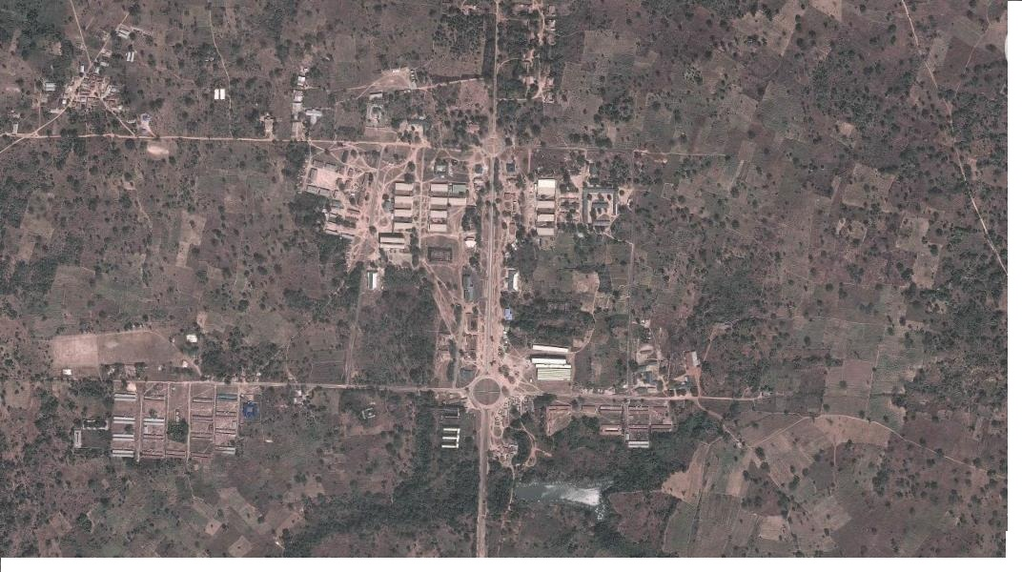Figure1: Satellite Imagery of the Study Area
Source: www.Googlemap.com
3.2 Selection of Materials
The main materials used for the construction of this system are soils and stones. The ability of a soil to form resilient earth bunds was considered very important. The availability of stones for stone pitching within the local area was also considered in the selection of materials for this system and labour requirements are very sensitive to availability of stone. The important parameters which affect plant performance that were considered in the selection of specific type of soil for this system include; soil texture, soil structure, soil depth, soil fertility, soil salinity and sodicity, soil infiltration rate and available water capacity.
3.3 Methodology
3.3.1 Determination of Crop Water Requirement
The procedure used for the determination of crop water requirement of citrus involved the evaluation of reference evapotranspiration and then multiply it by the crop coefficient of citrus. Reference evapotranspiration (ET_{o}) is the rate at which water if available, would be removed from the soil and plant surfaces of a specific crop arbitrary called a reference crop (Jensen et al., 1990). The height of the grass reference should be at least 8cm and not more than 15cm (Doorenbos and Pruitt, 1977).
There are three empirical approaches to estimate ET_{o} and these are; temperature based approach, radiation based approach and combination based approach (Jacob and Satti, 2001). Among these approaches, a temperature based approach was chosen, which Blaney-Criddle equation is the one.
Ten years record (2015-2024) of climatic data (Minimum and Maximum Temperature) from Lower Niger River Basin Development Authority Meteorological Station (LNRBDA, 2021), was used in Blaney-Criddle equation. The Blaney-Criddle equation is of the form (SCS, 1995) in Equation 1. Mean daily percentage (P) of annual day time hours for latitudes is shown in Table 1.
(1)
Where;
ET_{o} = Reference Crop Evapotranspiration, mm/day
T = Mean daily temperature in ⁰C over the month considered
P = Mean daily percentage of total annual daytime hours

Table 1: Mean daily percentage (P) of annual day time hours for different latitudes
Latitude | North | Jan | Feb | Mar | Apr | May | June | July | Aug | Sept | Oct | Nov | Dec
 | South | July | Aug | Sept | Oct | Nov | Dec | Jan | Feb | Mar | Apr | May | June
40⁰  55  50  45  40  35  30  25  20  15  10  5  0 |  | 0.15  0.17  0.19  0.20  0.22  0.23  0.24  0.24  0.25  0.26  0.26  0.27  0.27 | 0.20  0.21  0.23  0.23  0.24  0.25  0.25  0.26  0.26  0.26  0.27  0.27  0.27 | 0.26  0.26  0.27  0.27  0.27  0.27  0.27  0.27  0.27  0.27  0.27  0.27  0.27 | 0.32  0.32  0.31  0.30  0.30  0.29  0.29  0.29  0.28  0.28  0.28  0.28  0.27 | 0.38  0.36  0.34  0.34  0.32  0.31  0.31  0.30  0.29  0.29  0.28  0.28  0.27 | 0.41  0.39  0.36  0.35  0.34  0.32  0.32  0.31  0.30  0.29  0.29  0.28  0.27 | 0.40  0.38  0.35  0.34  0.33  0.32  0.31  0.31  0.30  0.29  0.29  0.28  0.27 | 0.34  0.33  0.32  0.32  0.31  0.30  0.30  0.29  0.29  0.28  0.28  0.28  0.27 | 0.28  0.28  0.28  0.28  0.28  0.28  0.28  0.28  0.28  0.28  0.28  0.28  0.27 | 0.22  0.23  0.24  0.24  0.25  0.25  0.26  0.26  0.26  0.27  0.27  0.27  0.27 | 0.17  0.18  0.20  0.21  0.22  0.23  0.24  0.25  0.25  0.26  0.26  0.27  0.27 | 0.13  0.16  0.18  0.20  0.21  0.22  0.23  0.24  0.25  0.25  0.26  0.27  0.27

Source: FAO (1986).
The Crop evapotranspiration (ET_{c}) is the amount of water needed by a certain crop to grow optimally and it is mainly depended on the climate, crop type and the growth stage of the crop (FAO, 1986). The reference crop is often coupled with crop coefficient (K_{c}) to determine the Crop evapotranspiration (ET_{c}). The equation for the computation of Crop evapotranspiration (ET_{c}) is given in Equation 2:
(2)
Where;
ET_{c} = Crop evapotranspiration, mm/day
ET_{o} = Reference crop evapotranspiration, mm/day
(K_{c}) = Crop coefficient
Source: FAO (1986)

3.3.2 Statistical Probability Analysis
The design rainfall is usually assigned to a certain probability of occurrence or excedance. The design rainfall was determined by means of a statistical probability analysis. Thirty years of annual rainfall totals (from LNRBDA; 1995 – 2024) were used for this analysis. The probability of occurrence P (%) for each of the ranked observations was calculated using Equation 3:
$P \left(\%\right)=\frac{\left(M-o.375\right)}{\left(N+0.25\right)} x100$ (3)
Source: FAO (1991)

Where;
P = probability in (%) of the observation of rank (m)
M = the rank of the observation and
N = total number of observations used.

Ranked observations were plotted against the corresponding probabilities, using normal probability paper and the curve generated was straight line in nature. Finally, the return period (T) was derived using Equation 4, since the excedance probability P(%) was known;
$T=\frac{100 (years)}{P}$ (4)

3.3.3 Soil Physical and Chemical Analysis
Nine soil samples were randomly collected at three points in the study area at depths of 0-20cm, 20-40cm and 40-60cm, respectively, using soil auger and were taken to soil laboratory for both physical and chemical analysis.
Physical analysis carried out is soil texture using sieves of various pores diameters and sizes from 0.0 – 0.2, in order to evaluate the suitability of the in-situ soil. The chemical parameters evaluated are; Electrical conductivity (EC_{w}), Cations and Anions (Ca⁺⁺, Mg⁺⁺, Na⁺, CO₃, HCO₃, Cl⁻, SO₄⁻⁻), Nutrients (Nitrate – Nitrogen NO₃ – N, Ammonium – Nitrogen NH₄⁻ - N, Phosphate – Phosphorus PO₄ – P, Potassium K⁺), Acidity/Basicity (P^{H}), Water saturation percentage (%) and Exchangeable sodium percentage (%).

3.3.4 Design Model for Catchment – Cultivated Area Ratio (C: CA)
The calculation of the catchment: cultivated area ratio was based on theconcept that the design must comply with the rule:
$Water Harvested=Extra Water Required$ (5)
Where,
Water Harvested = Catchment Area x Design Rainfall x RunoffCoefficient x Efficiency Factor and,
Extra Water Required = Cultivated Area x (Crop Water Requirement -Design Rainfall).

By substitution in Equation 5, the ratio between the Catchment and Cultivated area was calculated using Equation 6;
$\frac{Catchment Area }{Cultivated Area}=\frac{Crop Water Requirement-Design Rainfall }{Design Rainfall X Runoff Coefficient X Efficiency Factor}$ (6)
Source: FAO, 1991
3.3.5 Design Diagrams and Specifications
The chosen scale for design drawing was 1cm: 1m. This consists ofoverall field layout, plan view, isometric view of infiltration pit, with sectional view and runoff plot plan as shown in Figure 1, 2, 3 and 4.
3.3.6 Field Layout and Constructional Procedure
The first step is the establishment of the contour line and ground slope of 0.5% which was done using a line level (FAO 1985).The alignment of each bund was marked on the ground before construction at spacing of 10m. Construction was then made using a disc plough mounted on a tractor and the compaction was done with a barrel filled with sand.
Cross-ties of 2m length, 75cm base width and 25cm height were made with hoe, from the excavated material (sand) in the infiltration pit of 80cm x 80cm and 40cm deep in the furrow above the bund. The cross-tie extended upslope from the main bund at an angle of 90⁰ to the main bund. Cashew seedling were then planted in each micro-catchment close to each infiltration pit as shown in Plate 1 and 2.
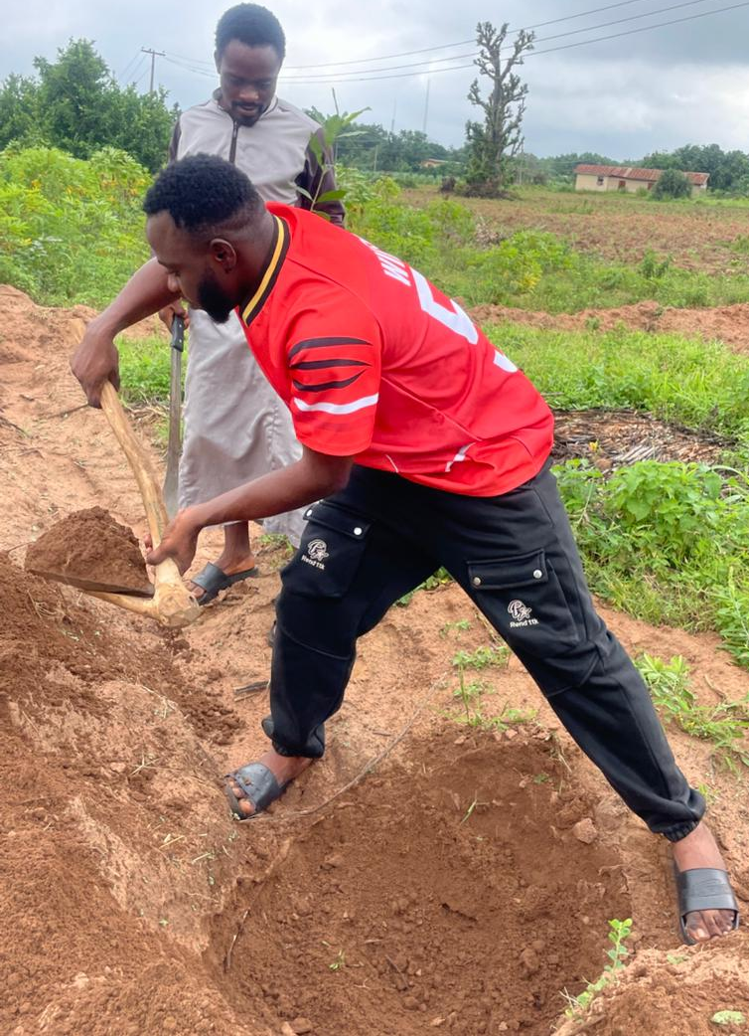
Plate 1: Construction of Infiltration Pit within micro-catchment

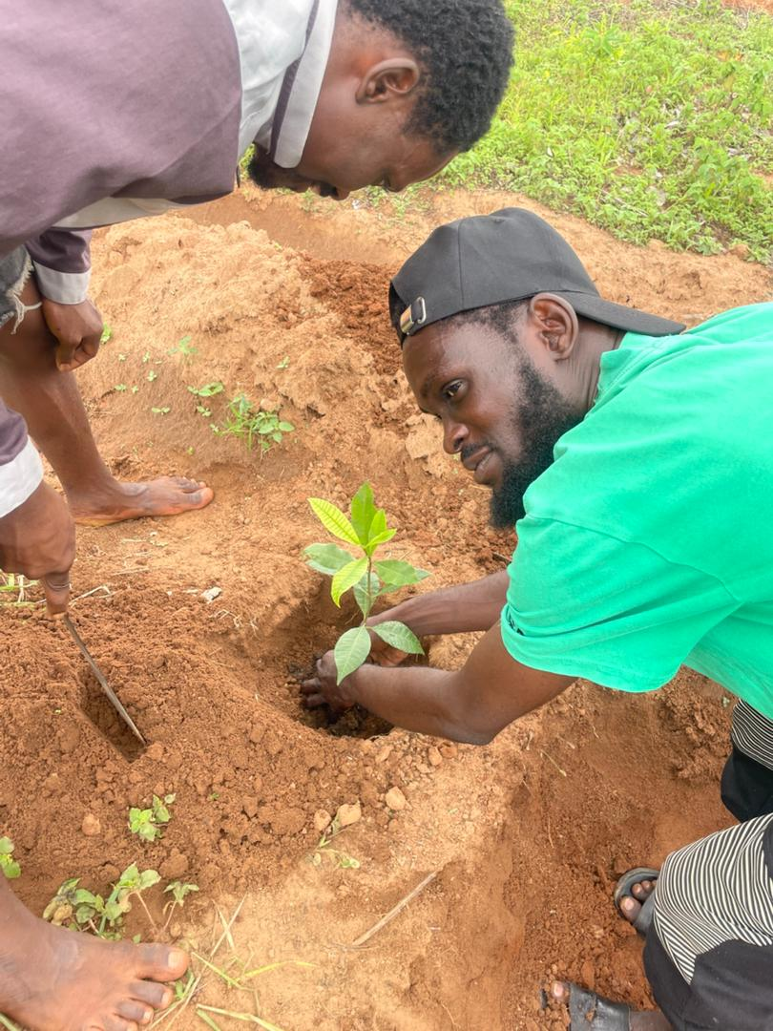Plate 2: Planting of Cashew Seedling
3.3.7 Evaluation of Catchment Runoff Coefficient
An analysis of Rainfall – Runoff relationship and subsequently an evaluation of relevant runoff coefficient (k) for the study area were carried out based on actual simultaneous measurements of both rainfall and runoff.Actual field measurements of rainfall and runoff were obtained using rain gauge and collection tank installed within the system. Catchment runoff coefficient (k) is expressed in Equation 5:
(5)
Source: (FAO 1991)

CHAPTER FOUR
RESULTS AND DISCUSSION
4.1 Crop Water Requirements
Crop water requirement (ET_{c}) estimates for citrus computed were presented in Table 2 and its average value across the period of record is 3.63 mm/day.
Table 2: Crop Water Requirement of Citrus
S/N | Year | ET_{c} (mm/day)
1 | 2015 | 3.43
2 | 2016 | 3.50
3 | 2017 | 3.55
4 | 2018 | 3.85
5 | 2019 | 3.51
6 | 2020 | 3.69
7 | 2021 | 3.13
8 | 2022 | 4.08
9 | 2023 | 3.53
10 | 2024 | 4.15
 | Total | 36.32
 | Mean | 3.63

4.2 Statistical Probability Analysis
The average value of the annual rainfall total and return period are 1,233.61mmand 2.52 years, respectively, from the statistical probability analysis result in Table 3. This implies that on average, an annual rainfall of 1,233.61 mm or higher can be expected at 40% probability of occurrence at 2½ years interval.

Table 3: Statistical Probability Analysis
S/N | Year | Rainfall (mm) | Ranking (M) | Probability (P) (%) | Return Period (T) (Year)
1 | 1995 | 1272.5 | 1750.4 | 57.85 | 1.73
2 | 1996 | 1323.9 | 1515.9 | 50.1 | 2.00
3 | 1997 | 1278.2 | 1503.2 | 49.68 | 2.01
4 | 1998 | 1233.4 | 1495.0 | 49.41 | 2.02
5 | 1999 | 1035.1 | 1474.3 | 48.72 | 2.05
6 | 2000 | 1326.7 | 1454.9 | 48.08 | 2.08
7 | 2001 | 838.6 | 1450.5 | 47.94 | 2.09
8 | 2002 | 1495 | 1396.1 | 46.14 | 2.17
9 | 2003 | 1750.4 | 1393.9 | 46.07 | 2.17
10 | 2004 | 1396.1 | 1353.2 | 44.73 | 2.24
11 | 2005 | 990.2 | 1326.7 | 43.85 | 2.28
12 | 2006 | 1503.2 | 1323.9 | 43.75 | 2.29
13 | 2007 | 980.7 | 1294.9 | 42.79 | 2.34
14 | 2008 | 1294.9 | 1278.2 | 42.24 | 2.37
15 | 2009 | 892.1 | 1272.5 | 42.05 | 2.38
16 | 2010 | 744.2 | 1272.0 | 42.04 | 2.38
17 | 2011 | 1068.8 | 1244.0 | 41.11 | 2.43
18 | 2012 | 1215.9 | 1233.4 | 40.76 | 2.45
19 | 2013 | 1272 | 1222.6 | 40.40 | 2.48
20 | 2014 | 1092 | 1215.9 | 40.18 | 2.49
21 | 2015 | 1353.2 | 1168.0 | 38.60 | 2.59
22 | 2016 | 1474.3 | 1092.0 | 36.09 | 2.77
23 | 2017 | 1515.9 | 1068.8 | 35.32 | 2.83
24 | 2018 | 1393.9 | 1046.6 | 34.59 | 2.89
25 | 2019 | 1046.6 | 1035.1 | 34.21 | 2.92
26 | 2020 | 1450.5 | 990.2 | 32.72 | 3.06
27 | 2021 | 1454.9 | 980.7 | 32.41 | 3.09
28 | 2022 | 1222.6 | 892.1 | 29.48 | 3.39
29 | 2023 | 1244 | 838.6 | 27.71 | 3.61
30 | 2024 | 1168 | 744.2 | 24.59 | 4.07
 | Total |  |  | 1233.61 | 75.67
 | Mean |  |  | 41.12 | 2.52
4.3 Soil Physico-Chemical Analysis
Soil physical and chemical analyses were carried out to evaluate the characteristic properties of the in-situ soil and the results are shown in Table 4. Physical analysis result shown that the soil in the study area is sandy loam, using USDA textural classification triangle chart. Chemical analysis result revealed that the salinity, infiltration rate, toxicity and fertility level of the soil in the study area are found under ‘none’ category, using the ‘Guidelines for the interpretations of water quality for agricultures by FAO (1985). This implies that the level is satisfactory, having little or no negative effect on the yield of the crop.

Table 4: Results of Soil Analyses
S/N | SOIL ACCT. /LAB. NO | 1st | 2nd | 3rd
1  2  3  4  5  6  7  8  9  10  11  12  13  14  15 | Depth of Horizon or Soil layer (cm)  P^{H} in Water (suspension 1:2)  P^{H} in 1m kcl (suspension 1:2)  EC_{w} (Extract 1:2.5)  Exchangeable Cation Ca++(Cmol/kg of soil)  Exchangeable Cation Mg++(Cmol/kg of soil)  Exchangeable Cation Na+(Cmol/kg of soil)  Exchangeable Cation K+(Cmol/kg of soil)  Cation Exchange Capacity (CEC)(Cmol/kg of soil)  Base Saturation (%)  Exchangeable Acidity (Cmol/kg of soil)  Exchangeable Sodium Percentage (ESP) (%)  Total Ammonium Nitrogen (%) (Kieldahi)  Available Phosphorus (Bray 1) ppm  Water Saturation Percentage (%) | 0-20  7.17  6.50  0.18  2.10  0.90  0.09  0.02  2.90  94.0  20.0  3.20  0.07  14.5  40.8 | 20-40  7.10  6.47  0.21  2.23  0.87  0.10  0.05  3.32  82.60  0.13  2.87  0.06  15.2  40.2 | 40-60  6.70  6.62  0.15  2.03  0.76  0.11  0.03  3.27  76.20  0.21  3.06  0.07  14.9  41.3

4.4 Catchment Runoff Coefficient
Rainfall and runoff readings taken after every rainfall event were averaged and used to compute runoff coefficient for the study area. The mean catchment runoff coefficient across the period of observation is 5.94 and presented in Table 6.
Table 6: Runoff Coefficient (K) from Field Measurements
S/N | Rainfall event | Rainfall (mm) | Runoff (mm) | Runoff/Rainfall (K)
1 | 12/05/2025 | 70.0 | 25.0 | 0.36
2 | 18/05/2025 | 350.0 | 150.0 | 0.43
3 | 28/05/2025 | 357.0 | 30.0 | 0.08
4 | 29/05/2025 | 356.0 | 280.0 | 0.79
5 | 30/05/2025 | 365.0 | 210.0 | 0.58
6 | 31/05/2025 | 56.0 | 20.0 | 0.36
7 | 04/06/2025 | 72.0 | 40.0 | 0.56
8 | 07/06/2025 | 357.0 | 270.0 | 0.76
9 | 08/06/2025 | 37.0 | 10.0 | 0.27
10 | 08/06/2025 | 67.0 | 40.0 | 0.60
11 | 09/06/2025 | 346.0 | 170.0 | 0.49
12 | 15/06/2025 | 357.0 | 251.0 | 0.70
13 | 18/06/2025 | 368.0 | 185.0 | 0.50
14 | 29/06/2025 | 368.0 | 265.0 | 0.72
15 | 02/07/2025 | 354.0 | 131.0 | 0.37
16 | 03/07/2025 | 355.0 | 285.0 | 0.80
17 | 13/07/2025 | 45.0 | 26.0 | 0.58
18 | 18/07/2025 | 360.0 | 280.0 | 0.78
19 | 20/07/2025 | 557.0 | 330.0 | 0.59
 | Total |  |  | 10.32
 | Mean |  |  | 0.54
4.5 Catchment: Cultivated Area Ratio (C: CA)
The average Catchment-Cultivated Area Ratio (C: CA) as estimated throughout the period of record is 1.05 as show in Table 5.
Table 5: Catchment - Cultivated Area Ratio (C: CA)
S/N | Year | C:CA
1  2  3  4  5  6  7  8  9  10 | 2012  2013  2014  2015  2016  2017  2018  2019  2020  2021  Total  Mean | 0.84  -0.13  -0.30  1.82  -0.52  0.89  -1.39  1.90  1.398  1.97  10.48  1.05

CHAPTER FIVE
CONCLUSIONS AND RECOMMENDATIONS

5.1 Conclusions
The following conclusions were drawn from the results of this study:
- It was concluded that the average crop water requirement of citrus is 3.63mm/day
- On average an annual rainfall of 1,233.61 mm or higher can be expected a 40% probability of occurrence and at average frequency of occurrence of 2½years interval.
- The soil in the study area is sandy loam and the salinity, infiltration rate, toxicity and fertility level of the soil are found suitable for citrus production.
- The average Catchment-Cultivated Area Ratio (C: CA) as estimated throughout the period of record is 1.05 and the mean run-off coefficient for the catchment area is 0.54.

The Contour bunds micro-catchment system is appropriate for large scale tree planting, especially relevant to semi-arid and arid areas where the problems of environmental degradation, moisture deficit, and drought and population pressures are most evident. It is an important component of the package of remedies for these problem zones and therefore, there is no doubt that implementation of water harvesting techniques will expand in Africa very soon.

5.2 Recommendations
The following recommendations were drawn from the conclusions of the study.
- It is recommended that sediment load should be determined from the runoff tank in subsequent works on this study.
- It is also recommended that the rate of discharge of runoff into the runoff tank through the runoff gutter should be determined, using weir/flume.
- It is recommended that the growth stages of the citrus plated should be observed (Initial, mid, development and end stage).

REFERENCES
Ali, A., Oweis, T., Salkini, A. B., and El-Naggar, S. (2009): Rainwater Cisterns. Traditional Technologies for Dry Areas. Aleppo: International Center for Agricultural Research in the Dry Areas (ICARDA).

Doorenbos, J., Pruitt, W.O., (1977): Crop water requirements. Irrigation and Drainage Paper No 24, (rev.) FAO,Rome,Italy, 144 pp.

Google Map (2022): Imagery showing the Kwara State Polytechnic dam. www.Googlemap.com (Assessed: 12/10/2022).

FAO (1991): Water Harvesting; A Manual for the Design and Construction of Water Harvesting Schemes for Plant Production, Rome, Italy.

FAO, (1986): Irrigation water management. Irrigation Water Needs. Training Manual No. 3, Food and Agriculture Organization of United Nations Rome, Italy.

FAO, (1985): Water quality for Agriculture. Irrigation and Drainage Technical paper 29, Food and Agriculture Organization of United Nations, Rome, Italy.

Hilary, F. R. and Gary, F. (1995): Micro catchment Water Harvesting for Agricultural Production: Part I: Physical and Technical Considerations. Department of civil Engineering, Colorado State University, Colorado 80526.

Jacab, J. M. and Satti, R. S. (2001): Evaluation of Reference Evapotranspiration Methodologies and AFSIRS Crop Water Use Simulation Model (Final Report).

Jensen, M. E., Burman, R. D. and Allen, R. G. (Eds.) (1990): Evapotranspiration and Irrigation Water Requirements. Committee on Irrigation Water Requirements, Irrigation and Drainage Division of ASCE, Manual No. 70.Amer. Soc, of Civil Engr.,New York, 332 p.

LNRBDA (2021): Information Brief on Projects and Activities.Lower Niger RiverBasin
Development Authority. Ilorin,Kwara State, Nigeria.

SCS (1995): Determining Water Requirements in Irrigated areas from Climatologically and Irrigation Data. Soil Conservation Services, United State Department of Agriculture. Technical Paper 96. USA.

0.75
0.75
0.75
0.75
0.75
0.75
45.45
6.7
6.7
6.7
6.7
6.7
6.7
6.7
0.75

4.4
1.
0.6
Runoff Plot
SLOPE

4.4

20.0
0.6

4.4
0.6
4.4
0.8
0.6
0.6
8
0.6
FIGURE 4.1: DESIGN DIAGRAM OF CONTOUR BUNDS MICRO-CATCHMENT SYSTEM
10
9
4
3
7
6
5
2.
2.0
0.8
LEGEND
1 | RUN OFF PLOT | 3 | INFILTRATION PIT | 5 | RUN OFF GUTTER | 7 | DROP STRUCTURE | 9 | EARTH TIE
2 | COLLECTION TANK | 4 | MICROCATCHMENT UNIT | 6 | STONE PITCHING | 8 | CITRUS TREE | 10 | BUND

FIGURE 4.2: A unit Micro-Catchment MICROCATCHMENT UNIT
Slope
X (varies)
X (varies)
B
A
A
B

PLAN

0.25
0.4
Y 0.40
0.40
Y (varies)
Y 0.40
X (varies)
0.25
0.75
0.75
0.25
SECTION A-A, B-B

FIGURE 4.3: INFILTRATION PIT

0.4
0.4
0.4
2
2
0.4

SECTIONAL VIEW
ISOMETRIC VIEW

