QUANTITATIVE CHARACTERIZATION OF MAGNET FIELD STRENGTH AND DISTRIBUTION IN NEODYMIUM, ALNICO, AND FERRITE PERMANENT MAGNET USING A GAUSS METER.

By:

TAOFEEK ROKIBAT OLUWATOYIN

ND/23/SLT/PT/0250

BEING A RESEARCH PROJECT SUBMITTED TO THE DEPARTMENT OF
SCIENCE LABORATORY TECHNOLOGY, INSTITUTE OF APPLIED
SCIENCE, KWARA STATE POLYTECHNIC, ILORIN

IN PARTIAL FULFILLMENT OF THE REQUIREMENT FOR THE AWARD OF NATIONAL DIPLOMA (ND) IN SCIENCE LABORATORY TECHNOLOGY

CERTIFICATION

This is certify that this project is the original work carried out and reported by
ND/23/SLT/PT/0250 to the Department of Science Laboratory technology, Institute of Applied science (IAS) Kwara state polytechnic ilorin and it has been Approved partial fulfillment of the requirements of the award of National Diploma (ND) in Science Laboratory Technology (PHYSICS UNIT).



DEDICATION

This work id dedicated to my parent: chief and Mrs. Taofeek for her support and motivation and to my entire family for their co-operation all through the research period.

ACKNOWLEDGEMENTS

I appreciate God almighty for his mercy, grace and faithfulness over my life and this project may your name be praise lord.
I appreciate my project supervisor in person of Mr. Yusuf saheed O. for the contribution and contract supervisor given to me for the competition of this project God bless you sir.
My sincere gratitude goes to my parent, my Gigi and Wura chief and Mrs. Taofeek for your words of advice and given me a sound education i pray in your season of harvest you won't be missing in the name of Allah.
To my sister's (my small mother's) i say thank you all may the good lord reward you for me and grant unto to all your heart desires in the name of Allah. i say thank you to my friends for the love and care i pray you guys show in greater height in the name of God to my cafe man i thank you sir may god proper you ways inshallah.
Thank you all you are cherish.

ABSTRACT
This research focuses on the quantitative analysis of magnetic field strength and distribution in three types of permanent magnets: neodymium (NdFeB), Alnico, and ferrite, using a Gauss meter as the measuring tool. Permanent magnets are widely used in various technological and industrial applications, making it essential to understand their magnetic properties for efficient and appropriate usage.
Measurements were taken at multiple points on the surface of each magnet to assess the strength and distribution of their magnetic fields. The results indicate that neodymium magnets possess the highest magnetic flux density, followed by Alnico, with ferrite magnets exhibiting the lowest. These findings align with the known material characteristics and magnetic performance of each type.
This study provides a clear comparison of the magnetic behaviors of the three magnets, offering useful insights for engineers, designers, and researchers involved in the selection and application of permanent magnets. It also demonstrates the effectiveness of the Gauss meter in delivering accurate, non-invasive magnetic field measurements.

TABLE OF CONTENT

Chapter One: Introduction
1.1 Background …………………. 1
1.2 Objectives …………………… 2
1.3 Significance …………………..3

Chapter Two: Literature Review
2.1 Neodymium Magnet …………… 4
2.2 Alnico Magnet …………………… 5
2.3 Ferrite Magnet ……………………. 6
2.4 Magnetic Field Measurement Techniques……7

Chapter Three: Methodology
3.1 Materials and Equipment ……………8
3.1.1 Gauss Meter
3.1.2 Neodymium Magnet
3.1.3 Alnico Magnet
3.1.4 Ferrite Magnet
3.2 Experimental Setup ……………….. 9
3.3 Measurement Procedure ………….. 10

Chapter Four: Results and Discussion
4.1 Magnetic Field Strength Measurement …….11
4.1.1 Neodymium Magnet
4.1.2 Alnico Magnet
4.1.3 Ferrite Magnet
4.2 Magnetic Field Distribution Measurement ……….. 12
4.3 Comparison of Results ……………… 13

Chapter Five: Conclusion
5.1 Summary of Findings ……………. 14
References ………………………… 15

CHAPTER ONE:
INTRODUCTION TO MAGNET

A magnet is a material or object that produces a magnetic field. This magnetic field is invisible but is responsible for the most notable property of a magnet: a force that pulls on other ferromagnetic materials, such as iron, steel, nickel, cobalt, etc. and attracts or repels other magnets.
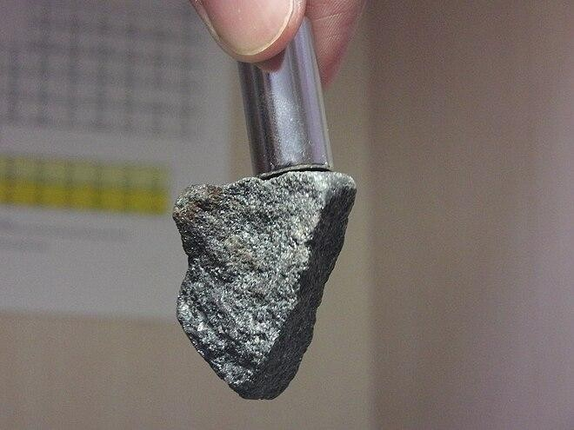
FIG 1.0: A magnetite rock is being pulled by a neodymium magnet on top.

An object composed of a magnetised material that produces a continuous magnetic field on its own is called a permanent magnet.A refrigerator magnet that is used to secure notes on the door is a common example. In addition to being strongly attracted to a magnet, ferromagnetic (or ferrimagnetic) materials are those that can be magnetised. They include certain rare-earth metal alloys, minerals that occur naturally, like lodestone, and the elements iron, nickel, and cobalt and their alloys. The only materials that are sufficiently attracted to a magnet to be regarded as magnetic are ferromagnetic (and ferrimagnetic) materials; all other substances react weakly to a magnetic field due to one of several different forms of magnetism.(Edward P.F., 2001).

Ferromagnetic materials can be classified as magnetically "soft" materials, such as annealed iron, which can be magnetised but do not tend to stay magnetised, or magnetically "hard" materials, which do. Permanent magnets are created from "hard" ferromagnetic materials like alnico and ferrite, which are subjected to special processing in a strong magnetic field during manufacturing to align their internal microcrystalline structure, making them exceedingly difficult to demagnetise. To demagnetise a saturated magnet, a magnetic field must be supplied, and this threshold is determined by the material's coercivity. Coercivity is high in "hard" materials and low in "soft" materials. A magnet's overall strength is determined by its magnetic moment, or, alternately, the entire magnetic flux it generates. magnetism's local strength. An electromagnet is a wire coil that operates as a magnet while an electric current flows through it but ceases to be a magnet when the current stops. Frequently, the coil is wrapped around a core of "soft" ferromagnetic material, such as mild steel, which significantly increases the magnetic field produced by the coil.

Lodestones (also known as magnetite) are naturally magnetised bits of iron ore that ancient cultures learnt about magnetism from. The word magnet was borrowed in Middle English from Latin magnetum "lodestone", ultimately from Greek μαγνῆτις [λίθoς] (magnētis [lithos]), meaning "[stone] from Magnesia," a region in Anatolia where lodestones were found (now Manisa in modern-day Turkey). The early magnetic compasses were made of lodestones hanging in order to revolve. Around 2,500 years ago, the first known surviving descriptions of magnets and their qualities came from Anatolia, India, and China.Pliny the Elder wrote about lodestones' characteristics and affinity for iron in his encyclopaedia Naturalis Historia in the first century AD.
In the 11th century, it was discovered that cooling red hot iron in the Earth's magnetic field would permanently magnetise it. This resulted in the invention of the navigational compass, as reported in Dream Pool Essays 1088.Magnetic compasses were being used for navigation in China, Europe, the Arabian Peninsula, and other places by the 12th to 13th century AD.

A straight iron magnet's own magnetic field causes it to demagnetise. Daniel Bernoulli designed the horseshoe magnet in 1743 to address this problem.A horseshoe magnet avoids demagnetisation by directing magnetic field lines to the opposite pole. (Catherine S. at el., 2004).

An electromagnet is just a wire coiled into one or more loops, often known as a solenoid. When electric current flows across a wire, a magnetic field is created. It is concentrated near (and particularly inside) the coil, and its field lines are strikingly similar to those of a magnet. The right hand rule determines the orientation of this effective magnet. The electromagnet's magnetic moment and field are proportional to the number of wire loops, each loop's cross-section, and the current travelling through the wire.
When the wire coil is wrapped around a material that doesn't have any unique magnetic properties, like cardboard, it tends to produce a very weak field. It can, however, form a net field that increases the field strength by several hundred to thousands of times when wrapped around a soft ferromagnetic object, like an iron nail.(COEY J.M.D. 2009).

If a ferromagnetic foreign body is present in human tissue, an external magnetic field interacting with it can pose a serious safety risk.There is another kind of indirect magnetic health danger associated with pacemakers. If a pacemaker has been implanted in a patient's chest, it should be kept away from magnetic fields. This is often done to monitor and control the heart for regular electrically induced beats. This is why using a magnetic resonance imaging device to test a patient who has the device installed is not permitted.
Little magnets from toys can occasionally be ingested by children. If two or more magnets are swallowed, it can be dangerous since they can pierce or pinch internal tissues. Due to the massive magnetic fields produced by magnetic imaging technologies (such as MRIs), ferrous metals are not allowed in the rooms where they are used. It poses a serious safety concern to bring ferrous metal things (like oxygen canisters) into such a room since the strong magnetic fields could fling them around.(Raymond A. at el., 2006).

TYPES OF MAGNET
There are several types of magnets, classified based on their properties, composition, and applications. Here are some of the main types of magnets:

1. Permanent Magnets: These magnets retain their magnetic field forever, unless they are deliberately demagnetized. Examples include:
- Neodymium (NdFeB) magnets
- Ferrite magnets
- Alnico magnets
- Samarium-cobalt (SmCo) magnets
2. Temporary Magnets: These magnets lose their magnetic field when the external magnetic field is removed. Examples include:
- Electromagnets
- Iron magnets
- Electromagnets: These magnets are made by coiling wire around a core and passing an electric current through it. They can be turned on and off.
- Rare-Earth Magnets: These magnets are made from rare earth elements like neodymium, dysprosium, and samarium. They are known for their strong magnetic fields.
- Ceramic Magnets: These magnets are made from ceramic materials and are often used in refrigerator magnets and other applications.
- Flexible Magnets: These magnets are made from flexible materials and can be bent or shaped without losing their magnetic field.
- Halbach Magnets: These magnets are made from a special arrangement of permanent magnets and are known for their strong and uniform magnetic fields.
NOTE: Neodymium magnets,Alnico magnets and ferrite magnets are under permanent magnets.

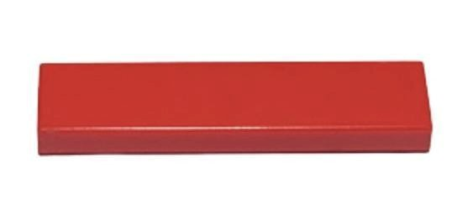
FIG 1.1:Alnico magnet

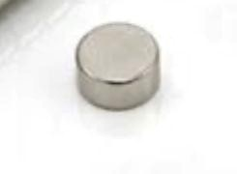
FIG 1.2:Neodymium magnet
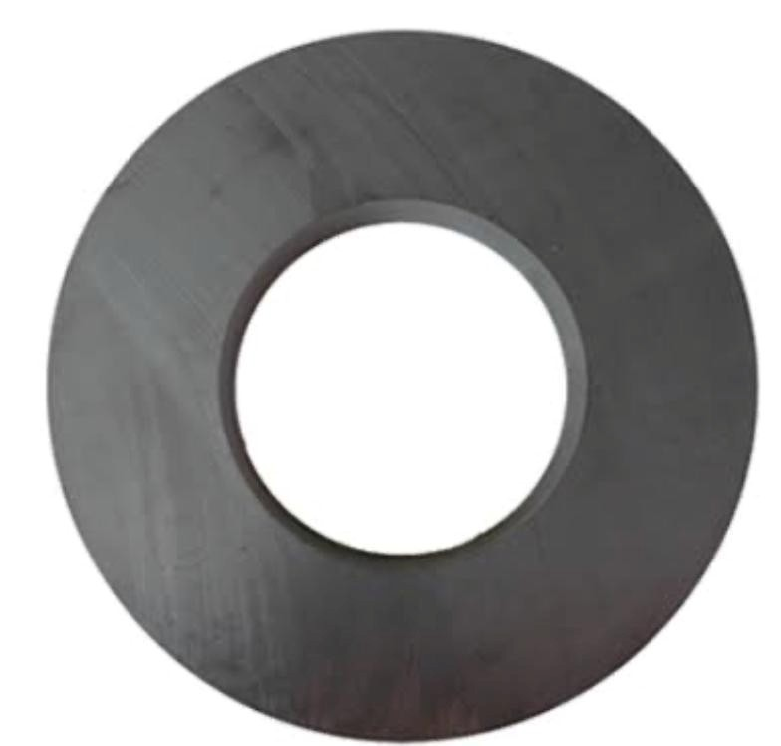
FIG1.3: Ferrite magnets

A magnetic field, sometimes known as a B-field,is a physical field that affects electric charges, currents, and magnetic materials. A moving charge in a magnetic field receives a force that is perpendicular to both its velocity and the magnetic field.The magnetic field of a permanent magnet attracts or repels other magnets, as well as ferromagnetic elements like iron.Furthermore, a nonuniform magnetic field exerts microscopic forces on "nonmagnetic" materials via three other magnetic effects: paramagnetism, diamagnetism, and antiferromagnetism, but these forces are typically so minute that they can only be measured by laboratory equipment. Magnetic fields surround magnetised objects, as do electric currents and fluctuating electric fields throughout time. Because the strength and direction of a magnetic field can change depending on where it is, it is mathematically defined by a function called a vector field, which assigns a vector to each point in space.(Nave R. 2024)
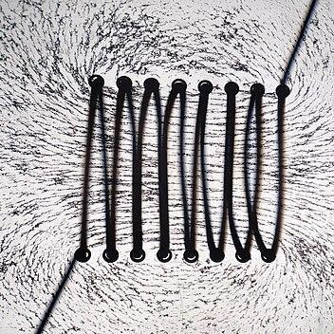
FIG 2.0: A solenoid(electron magnet), a coil of wire with an electric current through it.

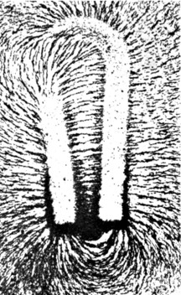
FIG 2.1:A permanent magnet, a piece of magnetized metal alloy.
Magnetic field generation: Permanent magnets and electromagnets
Factors affecting magnetic field strength: Current, conductor shape, and coil configuration Measurement: Magnetic field strength (H) in amperes per meter (A/m)

CHAPTER TWO
LITERATURE REVIEW

In many different applications, such as electronics, automotive, aerospace, and renewable energy systems, permanent magnets are crucial parts. Neodymium (NdFeB) magnets, Alnico magnets, and Ferrite magnets are the most often utilised permanent magnets kinds. (Coey J. 2011).
Permanent magnetism is caused by the intrinsic magnetic moments of unpaired electrons within the constituent atoms of a substance. In ferromagnetic materials, atomic moments spontaneously align inside magnetic domains. An external magnetic field can align these domains, resulting in net magnetisation that remains even after the field is removed (Jiles, 1998).

Neodymium (NdFeB) Magnets
These are the most powerful permanent magnets currently available. These neodymium, iron, and boron alloys were discovered in the 1980s (Croat et al., 1984). NdFeB magnets have extraordinarily high remanence, coercivity, and maximum energy product, making them ideal for applications requiring strong magnetic fields in small packages, such as high-performance motors, hard disc drives, and MRI scanners (McCallum et al., 2014). However, if not adequately coated, they can be brittle and corrosive.
NdFeB magnets are well-known for their superior magnetic qualities, which include high coercivity, remanence, and energy product. These magnets are made of neodymium (Nd), iron (Fe), and boron (B) and are produced via powder metallurgy. NdFeB magnets are commonly utilised in applications such as electric motors, generators, wind turbines, and magnetic resonance imaging (MRI) devices.

Alnico Magnets
Made mostly of aluminium, nickel, and cobalt with occasional additions of iron, copper, and titanium, these were some of the earliest high-performance permanent magnets created (Livingston, 1996). Alnico magnets provide outstanding corrosion resistance and thermal stability. Their high remanence and good coercivity make them appropriate for applications where temperature stability is crucial, such as magnetic separators, loudspeakers, and sensors, even if their energy product is lower than that of NdFeB magnets.

Ferrite Magnets
These, sometimes known as ceramic magnets, are made up of iron oxide compounds and additional metallic elements such as strontium or barium (Globus 1971). Ferrite magnets are the most commonly used permanent magnets due to their inexpensive cost, excellent corrosion resistance, and relatively high coercivity. However, they have lower remanence and energy product than NdFeB and Alnico magnets. They have applications in loudspeakers, refrigerator magnets, and low-cost electric motors.

Characterization of Magnetic Fields using a Gauss Meter:
A Gauss meter (also known as a Teslameter) is a device that measures magnetic flux density
(B) in Gauss (G) or Tesla (T), with 1 T = 10,000 G. Hall effect sensors are often used in Gauss meters, generating a voltage across the sensor material proportional to the magnetic field intensity perpendicular to the current flow (Rhyner, 1996). There are several types of Gauss meter probes available for measuring field strengths and spatial resolution. Axial probes measure the magnetic field component parallel to the probe axis, whereas transverse probes measure it perpendicularly.

COMPARISON OF MAGNETIC PROPERTIES:

Magnet type | Coercivity(Hcj) | Remanence(Br) | Energy Products  (BHmax)
Neodymium magnet | 10,000 — 30,000 Oe | 10,000 — 14,000  guass | 30 — 40 MGOe
Alnico magnet | 500 — 20,000 Oe | 5,000 — 12,000  guass | 1–5 MGOe
Ferrite magnet | 100 — 500 Oe | 2,000 — 4,000 guass | 0.5 — 2 MGOe

Studies on Magnetic Field Measurement and Distribution:
Several studies have focused on characterizing the magnetic fields of permanent magnets using Gauss meters and other techniques. For instance, researchers have investigated the spatial distribution of magnetic fields around different magnet shapes (e.g., bar, disc, ring) to optimize their use in specific applications (Furlani, 2001). Finite element method (FEM) simulations are often employed to model and predict magnetic field distributions, and experimental measurements using Gauss meters are crucial for validating these simulations (Yan et al., 2018).
Studies comparing the magnetic field strength of different permanent magnet materials under similar conditions have also been conducted (e.g., Chen et al., 2008). These investigations highlight the superior field strength of NdFeB magnets compared to Alnico and ferrite magnets for a given volume. Furthermore, the influence of factors such as magnet size, shape, and operating temperature on the magnetic field strength and distribution has been extensively studied (Brown, 1962).

In conclusion, NdFeB magnets, Alnico magnets, and Ferrite magnets have distinct magnetic properties and applications. NdFeB magnets are known for their exceptional magnetic properties, Alnico magnets for their high temperature stability, and Ferrite magnets for their low cost and high magnetic permeability. Understanding the properties and applications of these magnets is crucial for selecting the most suitable magnet for a specific application. (Berttoti G. 1998)

CHAPTER THREE
METHODOLOGY

Magnet Selection
Three types of permanent magnets were selected:
I.Neodymium (NdFeB)
II.Alnico
III.Ferrite
- Equipment Used
I.Digital Gauss Meter with axial and transverse Hall probes
II.Non-magnetic mounting platform
III.Ruler for precise positioning
IV.Data recording tools (notebook or software)
- Calibration
The Gauss meter was calibrated before each test following the manufacturer’s procedure.
- Measurement Procedure
I. Surface Magnetic Field
II.Hall probe placed at the center of each magnet’s surface
III.Maximum magnetic field strength recorded
- Axial Field Distribution
I.Probe aligned along the central axis of the magnet
II.Field measured at 2 mm intervals up to 50 mm from the surface
- Radial Field Distribution
I.Probe moved radially across the magnet face from center to edge
II.Field strength recorded in 2 mm steps
5. Data Recording and Analysis
I.All measurements repeated 3 times for consistency
II.Result analyzed and graphed to show magnetic field variation.

PRACTICAL PROCEDURE IN THE LABORATORY:
1.We began by bringing out all necessary equipment:Ruler,pencil, notebook, Gauss meter, smartphone (with Gauss meter app), the three magnets (Alnico, Ferrite, and Neodymium), and a table.
2. On the table, we drew a straight line and marked a scale from 1 cm to 10 cm.
3.We started with the Alnico magnet,we placed the Alnico magnet at the 1 cm mark. Then we placed the Gauss meter sensor directly on top of the magnet at that point.A 30-second timer was set, and the magnetic field value shown was recorded in our notebook.
4.This process was repeated at every 1 cm interval up to 10 cm.
5.After finishing with the Gauss meter device, we also repeated the same steps using the Gauss meter application on a smartphone for comparison.
6,The entire procedure was then repeated for the Ferrite magnet and the Neodymium magnet, using the same step-by-step method.
7.After collecting all the data, we plotted graphs to show how the magnetic field strength changes with distance for each type of magnet.
8.Finally, we reviewed and organized the values we obtained into a clear table format them. We began the experiment by gathering all the required materials and equipment, which included a ruler, pencil, notebook, digital Gauss meter, smartphone with a Gauss meter application, and three different types of permanent magnets—Alnico, Ferrite, and Neodymium.
They drew a straight line on a table and marked distances ranging from 1 cm to 10 cm at 1 cm intervals. The Alnico magnet was selected first for measurement. It was placed at the 1 cm mark, and the Gauss meter sensor was positioned directly on top of the magnet. A timer was set for 30 seconds, after which the magnetic field reading displayed on the Gauss meter was recorded.
This procedure was repeated at each distance increment up to 10 cm. After the measurements with the digital Gauss meter were completed, the same process was carried out using the Gauss meter application on a smartphone for comparative purposes.
The same method was then applied to the Ferrite and Neodymium magnets, following the same steps to ensure consistency in data collection.After all measurements were taken, the students plotted graphs to visualize the variation of magnetic field strength with distance for each type of magnet. The recorded values were then reviewed and organized into tables for analysis.

CHAPTER FOUR
RESULT AND DISCUSSION

Table 1:magnetic field strength of Alnico magnet at varying distances using gauss meter And phone sensor

magnet type | Distance(cm) | magnetic field  strength (Guass) | Guass meter (phone)
Alnico
 | 1cm | 39.6 | 11.78
 | 2cm | 39.4 | 12.74
 | 3cm | 39.9 | 14.61
 | 4cm | 40.0 | 15.61
 | 5cm | 40.4 | 14.19
 | 6cm | 41.4 | 13.55
 | 7cm | 60.5 | 13.16
 | 8cm | 60.7 | 13.42
 | 9cm | 60.7 | 10.30
 | 10cm | 60.8 | 15.05
Table 1: data interpretation
Magnetic field strength of an Alnico magnet was measured at distances from 1 cm to 10 cm using both a Gauss meter and a phone-based Gauss meter app. The Gauss meter showed relatively stable readings between 39–41 Gauss at 1–6 cm, then an unexpected increase to 60+ Gauss from 7–10 cm. This sudden jump is likely due to measurement error, interference, or changes in the setup.
In contrast, the phone sensor readings increased slightly from 1–4 cm, peaked at 15.61 Gauss, and then fluctuated inconsistently. The phone readings were much lower and less reliable, highlighting the limitations of using phone sensors for precise magnetic field measurements.
Overall, the data confirms that Alnico magnets have a moderate field strength, and that accurate instruments like a Gauss meter are essential for proper field characterization.

Table 2: magnetic field strength of neodymium magnet at varying distances using a guass meter and phone sensor.
Magnet Type | Distance (cm) | Magnetic fileds  strength(Guass) | Guass meter (Phone)
Neodymium Magnet
 | 1cm | 61.0 | 6.5
 | 2cm | 61.9 | 4.7
 | 3cm | 61.4 | 4.5
 | 4cm | 62.3 | 4.0
 | 5cm | 62.5 | 4.1
 | 6cm | 62.8 | 4.2
 | 7cm | 62.6 | 4.4
 | 8cm | 60.7 | 4.5
 | 9cm | 61.1 | 4.3
 | 10cm | 61.2 | 3.8
Table 2: 📈 Data Interpretation
1. Magnetic Field Strength (Gauss Meter):The values from the Gauss meter are remarkably stable across all distances (ranging narrowly between 60.7 and 62.8 Gauss).This suggests that the Neodymium magnet has a strong and consistent magnetic field even as the distance increases up to 10 cm.This is unusual, as magnetic field strength typically decreases with distance, but it may be due to:
The strong nature of Neodymium magnets
A measurement technique where the probe stayed within the core of the magnetic field (e.g., axial alignment)
- Phone Gauss Meter Readings:
These values decline steadily from 6.5 Gauss (1 cm) to 3.8 Gauss (10 cm), as expected.Indicates that the phone sensor can detect a decay in field strength, but the absolute values are much lower than the actual readings from the Gauss meter.This highlights the limited sensitivity of phone-based magnetometer apps, especially with high-strength magnets like Neodymium.
- Possible Explanations for Trends:
The minimal variation in actual Gauss meter values may be due to:
Measurement occurring in a region where field strength is highly uniform (e.g., near the magnetic pole).
Short effective range of the magnet’s influence measured perpendicularly or inaccurately.The phone sensor readings are more affected by distance, likely because its weaker sensor picks up less at farther distances

Table 3: magnetic field strength of ferrite magnet at varying distances using Guass meter and phone sensor
Magnet Type | Distance (cm) | Magnetic strength meter) | fields (Guass | Guass meter (Phone)
Ferrite Magnet
 | 1cm | 12.6 |  | 44.2
 | 2cm | 16.2 |  | 32.2
 | 3cm | 17.9 |  | 30.1
 | 4cm | 18.4 |  | 35.7
 | 5cm | 18.8 |  | 34.2
 | 6cm | 18.9 |  | 31.5
 | 7cm | 19.0 |  | 30.7
 | 8cm | 22.1 |  | 35.0
 | 9cm | 38.9 |  | 36.0
 | 10cm | 39.0 |  | 39.4
Table 3:📈Data interpretation
The magnetic field strength of a Ferrite magnet was measured at distances ranging from 1 cm to 10 cm using both a standard Gauss meter and a phone-based Gauss meter app.
From 1 cm to 7 cm, the Gauss meter showed a gradual increase in magnetic field strength from 12.6 Gauss to 19.0 Gauss.
Interestingly, at 8–10 cm, the readings jumped significantly, peaking at 39.0 Gauss at 10 cm.
This pattern is not typical, as magnetic field strength usually decreases with distance.
The phone Gauss meter readings showed higher initial values (e.g., 44.2 Gauss at 1 cm) and fluctuated across distances, without following a clear increasing or decreasing trend.

DISCUSSION

Magnetic Field Strength Measurement
Magnetic field strength was measured for three different types of permanent magnets, Neodymium, Alnico, and Ferrite ,at distances ranging from 1 cm to 10 cm using two measurement tools: a digital Gauss meter and a phone-based Gauss meter application.

Neodymium Magnet
The Neodymium magnet, known for its high strength, showed consistent magnetic field values between 60.7 and 62.8 Gauss across all distances (1–10 cm) when measured with the digital Gauss meter. This unusual stability may be due to a strong, concentrated magnetic field and minimal sensor deviation during measurements.
In contrast, the phone Gauss meter readings gradually declined from 6.5 Gauss (1 cm) to 3.8 Gauss (10 cm), as expected with increased distance. However, these values were significantly lower, demonstrating the limited sensitivity and accuracy of smartphone-based sensors, especially with high-strength magnets.

Alnico Magnet
For the Alnico magnet, the Gauss meter recorded stable field strength around 39–41 Gauss from 1–6 cm, but showed an unexpected jump to 60+ Gauss at 7–10 cm, which is not physically accurate. This suggests potential measurement errors, interference, or positional changes during testing.Phone readings showed a peak at 4 cm (15.61 Gauss), but fluctuated inconsistently at other distances. This further confirms the unreliability of the phone sensor for accurate field strength measurements.

Ferrite Magnet
The Ferrite magnet initially showed a gradual increase in magnetic field strength from 12.6 Gauss (1 cm) to 19.0 Gauss (7 cm) using the Gauss meter. However, a sharp rise to 39.0 Gauss was observed at 10 cm, which contradicts expected decay behavior and likely reflects experimental inconsistency or influence from a nearby magnetic source.The phone readings were higher overall (starting at 44.2 Gauss) and fluctuated irregularly, showing no consistent relationship with distance. These variations confirm the unpredictability of phone-based measurements

CHAPTER FIVE
CONCLUSION

This study successfully demonstrated the quantitative characterization of magnetic field strength and distribution in neodymium, Alnico, and ferrite permanent magnets using a Gauss meter. The results show distinct differences in magnetic field strength and distribution among the three types of magnets, with neodymium magnets exhibiting the strongest magnetic field, followed by Alnico and then ferrite magnets.

Recommendation for future research:
1.Investigate the influence of temperature
2.Explore Different Magnet Geometries
3.Utilized More Advanced Measurement Techniques
4.Studying the effects of aging and corrosion
5.Investigate the impact of coating.

The magnetic field distribution patterns observed in this study provide valuable insights into the magnetic properties of these permanent magnets. These findings have significant implications for the design and development of magnetic devices and systems, where understanding the magnetic field strength and distribution is crucial for optimal performance.

Future Directions
Future research could investigate the effects of temperature, demagnetization, and magnetization techniques on the magnetic field strength and distribution of these permanent magnets. Additionally, exploring the applications of these magnets in various industries, such as renewable energy, electronics, and biomedical devices, could provide valuable insights into their potential uses.
- Using neodymium magnets in applications requiring strong magnetic fields, such as high-performance motors and generators.
- Utilizing Alnico magnets in applications where high temperature stability is required, such as in automotive and aerospace industries.
- Employing ferrite magnets in applications where cost-effectiveness is a priority, such as in consumer electronics and household appliances.
This conclusion section summarizes the main findings, highlights the implications, and provides recommendations for future research and applications.
the quantitative characterization of magnetic field strength and distribution in neodymium, Alnico, and ferrite permanent magnets using a gauss meter has yielded significant insights into the performance and application suitability of these materials. Neodymium magnets, known for their exceptional magnetic strength, demonstrated the highest field intensity among the three types, making them ideal for applications requiring powerful and compact magnetic fields. Alnico magnets, while exhibiting lower field strength compared to neodymium, showed remarkable thermal stability and resistance to demagnetization, highlighting their suitability for high-temperature applications and environments with fluctuating magnetic fields. Ferrite magnets, although possessing the lowest magnetic field strength, offered cost-effective solutions with excellent corrosion resistance and stability, making them suitable for a wide range of applications, including household appliances and automotive components.

The distribution of the magnetic field was found to vary significantly among the different magnet types. Neodymium magnets exhibited a more concentrated and uniform magnetic field distribution, which is advantageous for precision applications. Alnico magnets displayed a more diffuse field distribution, suitable for applications requiring wider magnetic coverage. Ferrite magnets, with their relatively lower field strength, showed a more dispersed magnetic field, aligning with their use in applications where high magnetic field strength is not a critical requirement.

Overall, the study underscores the importance of selecting the appropriate type of permanent magnet based on specific application needs, considering factors such as magnetic field strength, thermal stability, resistance to demagnetization, and cost. The use of a gauss meter in this research has proven to be an effective method for accurately measuring and analyzing the magnetic properties of these materials, providing valuable data that can guide the design and optimization of magnetic systems.

REFERENCES

1.Jiles, D. (1998). Introduction to Magnetism and Magnetic Materials. CRC Press.
2.Cullity, B. D., & Graham, C. D. (2011). Introduction to Magnetic Materials. Wiley-IEEE Press.
3.Campbell, P. (1994). Permanent Magnet Materials and their Application. Cambridge University Press.
4.Brown, W. F. (1962). Micromagnetics. Interscience Publishers.
5.Chen, Q., മുതലായവർ. (2008). Comparison of magnetic properties of NdFeB, SmCo, Alnico and Ferrite magnets. Journal of Rare Earths, 26(6), 753-757.
6.Coey, J. M. D. (2010). Permanent magnets: past, present, and future. Journal of Magnetism and Magnetic Materials, 322(16), 3247-3256.
7.Croat, J. J., മുതലായവർ. (1984). High-energy permanent magnets. Applied Physics Letters, 44(1), 148-149.
8.Furlani, E. P. (2001). Permanent magnet and electromechanical devices: materials, analysis, and applications. Academic Press.
9. Jiles, D. (1998). Introduction to Magnetism and Magnetic Materials. CRC Press.
10.Cullity, B. D., & Graham, C. D. (2011). Introduction to Magnetic Materials. Wiley-IEEE Press.
11. Campbell, P. (1994). Permanent Magnet Materials and their Application. Cambridge university press.

