EXPERIMENTAL INVESTIGATION OF THE TEMPERATURE DEPENDENCE OF MAGNETIC FIELD STRENGTH IN A NEODYMIUM MAGNET USING A GAUSS METER AND K-TYTPE THERMOCOUPLE

BY

AYANTAYO MARIAM DOLAPO
ND/23/SLT/PT/0343

A PROJECT SUBMITTED TO THE DEPARTMENT OF SCIENCE LABORATORY TECHNOLOGY, INSTITUTE OF APPLIED SCIENCES, KWARA STATE POLYTECHNIC, ILORIN

IN PARTIAL FULFILMENT OF THE REQUIREMENTS OF THE AWARD OF NATIONAL DIPLOMA (ND) IN SCIENCE LABORATORY TECHNOLOGY (SLT)

JULY, 2025



DEDICATION
I dedicate this work to the Lord Almighty, the creator of heaven and the earth, and to my beloved parents, Mr. and Mrs. AYANTAYO, whose love, prayers, sacrifices, and unwavering belief in me have been my greatest source of strength and inspiration.

ACKNOWLEDGEMENT
My immeasurable thanks goes to Almighty Allah the giver of wisdom and understanding for sparing my life since the beginning of my national Diploma programe for making it possible for me to accomplished, despite all the challenges, I always see Allah, as the most beneficent and most merciful in his comfortable of knowledge, at Kwara State Polytechnic, Ilorin.
I also thank my project supervisor MR. YUSUF SAHEED O. for his effort and useful advice tolerant and patient in reading manuscripts and his meticulous reviews and motivated enthusiasm throughout the course of the work.
Also want too thanks all my lectures in department of Business Administration for their assistance that enhance my success in this study may God bless you all.
My unending appreciation also goes to my parent MR. and MRS. AYANTAYO for their contributions to my success, also using this medium to say a very big thank too all May Almighty Allah continue to bless and up lift you, I so much appreciate you all

TABLE OF CONTENT

Chapter One
  - Introduction
  - Important of the Temperature Dependence of Magnetic Field Strength in a Neodymium Magnet Using a Gauss Meter and K-Type Thermocouple.

Chapter Two
Literature Review
  - History Of Magnetic Field Strength in a Neodymium Magnet Using A Guass Meter And K-Type Thermocouple
  - Temperature Measurement in Elecromagnetic Environment
  - Thermocouple Theory and Application
    - Electromagnetic Vulnerabilities
    - Induced Voltage
    - Induction Heating
  - Common Mode Voltage Issues
  - Magnetic Properties

Chapter Three
  - Materials and Methodology
  - Materials Used
  - Methods

Chapter Four
Results and Discussion

Chapter Five
  - Conclusion
  - Recommendation References

CHAPTER ONE

  - INTRODUCTION

The neodymium (Nd) polycrystalline magnet consisting of Nd₂Fe₁₄B (Miyashita S,2018) is an important high-performance permanent magnet. Because of its high coercivity, it is widely used for electric motors, electronic devices, and so forth (Sugimoto S., 2011). Coercivity at finite temperatures is a key factor affecting the performance of permanent magnets. Coercivity essentially depends on the structure of grains and grain boundaries, and the nucleation of reversed magnetization and the depinning mechanisms of magnetic domain walls in the structure play an important role in coercivity (Hirosawa S., 2017). Trials toward achieving higher coercivities at higher temperatures have been actively performed (Akiya T,2014), but the quantitative properties of coercivity at finite temperatures have not been well understood (Hirosawa S,2017).
Temperature effects have been taken into account by using the temperature-renormalized parameters, for example the exchange stiffness constant
(𝑡) and the magnetic anisotropy energy K(𝑇), which are obtained experimentally or by mean-field analyses. Coercivity at finite temperatures is, however, a phenomenon involving the breakdown of a metastable magnetic state. Magnetization reversal occurs with thermal agitation and thus it is a stochastic process (Nishino M,2019).
Permanent magnet synchronous machines are widely used in industry and they are often best solution for some applications such as traction, electric vehicle, robotics or aerospace applications. One of the most common types of rare earth magnet used to build permanent magnets synchronous machine is neodymium-iron-bore (NdFeB). When a magnet is subject to magnetic field variations, eddy currents are induced and its temperature will increase accordingly (H. Toda, 2014). The performance of PM machines is strongly influenced by the magnets’ temperature due to the temperature dependency of its properties.
In a strong magnetic field, the energy spectrum of electrons in a semiconductor becomes quantized, so that the density of states as a function of energy acquires an

oscillating character. This circumstance is the root cause of occurrence of oscillatory magnetic field dependence of a number of equilibrium and nonequilibrium quantities characterizing the state and behavior of the electrons in the crystal in a quantizing magnetic field. Currently, these oscillations are united under the general name of quantum oscillation effects (Fischbacher, 2018).
In this approach, the following difficulties exist, which are general problems in microscopic molecular simulations. First, the relaxation depends on the damping constant α of the LLG equation, which is difficult to know precisely. Moreover, the maximum relaxation time that can be obtained by atomistic calculation is limited. Indeed, the time scale of spin precession in a field of 1 T is of the 10 12 s order, and the maximum time of simulation is up to several nanoseconds. These difficulties have prevented us from estimating the relaxation time quantitatively. However, we have been able to overcome these difficulties and obtained a quantitative estimation of the threshold field for a relaxation time of 1s (Nishino M. 2020). Alternatively, we approached relaxation phenomena from the viewpoint of the free energy barrier at finite temperatures. There have been some works focusing on the free energy barrier using the minimum energy path method (Dittrich R. et. al.,2007), which enabled the energy along a path of evolution of magnetization from the metastable state to the stable state to be obtained, where the energy function contains temperature- dependent parameters.
Magnets work due to an electrical current caused by their electrons. The electrons of a magnet’s atom spin like a top, as they circle around the nucleus, or core of an atom. The movement that they make generates electric currents which causes each electron to act like a magnet (Stanley 2021).
The energy associated with the magnetic influence on flame behavior is generally several orders of magnitude smaller than the kinetic energy of molecules at room temperature. Nevertheless, recent studies have shown that an inhomogeneous magnetic field provides a means to control combustion behavior. Gaseous combustion comprises of not only a chemical reaction but also of physical processes of heat transfer and mass diffusion. These processes can be manipulated using magnetic

forces applied on paramagnetic gas flows to the flame. The motivation for this study is to look at the effects produced by a magnetic field of moderate-strength. The benefits of using permanent magnets include negating the need for external energy sources to produce high magnetic field strengths, as well as relatively less expensive. Magnetic fields are known to affect flame behavior and gas flows because of the paramagnetic and diamagnetic nature of the constituent gases. Paramagnetism is a form of magnetism whereby certain materials are weakly attracted by an externally applied magnetic field, and form internal, induced magnetic fields in the direction of the applied magnetic field. Paramagnetic materials include aluminum, oxygen, titanium, and iron oxide. In contrast with this behavior, diamagnetic materials are repelled by magnetic fields and form induced magnetic fields in the direction opposite to that of the applied magnetic field. Nitrogen, CO₂, and most hydrocarbon fuels are examples of diamagnetic materials and experience a weak repulsion to the applied magnetic field (Gillion, P. et al., 2010).
In diffusion flames, hydrocarbon fuels, nitrogen, carbon dioxide are diamagnetic; oxygen is the principal paramagnetic gas. As the paramagnetic susceptibility of oxygen is orders of magnitude larger, the diamagnetic behavior is considered as negligible. A gas containing more O₂, such as air, tends to move towards the stronger magnetic field and a gas with less O₂ such as fuel or combustion gas tends to move towards the weaker magnetic field. Based on this, it may be possible to utilize a magnetic field to control the flow field of the combustion region to improve combustion characteristics. A key parameter to characterize the laminar diffusion flame behavior is the flame height under the influence of the magnetic field (Legros G. et. Al., 2011). The flame height (Lf) is defined as the vertical distance between the burner surface and the point along the flame axis where the fuel is consumed in stoichiometric proportions. At present, magnetic control of combustion and gas flow with low-cost permanent magnets is a relatively new scope of research and further experimental study is required to establish the mechanism for this interaction (Fujita O. et. Al., 1998)

The purpose of the project is to investigate and understand the influence of temperature on the magnetic properties of magnets. By subjecting magnets to varying temperature conditions, we aim to observe and analyze changes in magnetism, providing insights into how temperature impacts the stability and efficiency of these materials. This research contributes to the broader understanding of magnet behavior and may have practical applications in fields such as materials science, engineering, and magnet technology.

Impact of Temperature Dependence of Magnetic Field strength in a Neodymium Magnet using a Gauss Meter and K-type Thermocouple.
The ac and dc magnetic fields can in principle affect thermometer readings in three ways as follows.
- Electromagnetic effect (EE). Changes in material properties and electromagnetic properties of thermometers and auxiliary instrumentation can occur. The main cause could be magnetization of the metal sensors or housings, sensor permeability, Hall effect of the sensor material or thermoelectric (or thermomagnetic) phenomena (e.g., the Ettingshausen–Nernst effect due to the thermocouple thermal gradient while in a perpendicular magnetic field (Kollie T, 2017).
- Additionally, magneto-resistive effect, induced voltage in wires and cables, non-optimal electrical contacts of sensors and millimetres, type of twisting of thermo-wires and other EMC issues are important to take into account (Stephenson R J et al., 2019)
- Induction Heating (IH). The increase in local temperature, resulting from changes in magnetic fields, i.e. magnetic IH in metallic materials. Thermometers and/or their enclosure/encapsulations could be heated by eddy currents, thus affecting their surroundings.
- Mechanical effects (ME). The magnetic force induced by a magnetic field could change a sensor’s physical position within the temperature media. The sensor can in

principle be displaced inside its enclosure, or the entire (ferromagnetic) enclosure could be displaced spatially. As a result, the sensor is not in the optimal position inside the enclosure, resulting in the potential change of heat transfer and difference in temperature reading.
Magnetic dependence of thermometers is usually small in comparison with the required measuring accuracy. The reading error of thermometers regularly exposed to magnetic fields in many industry and biomedical applications (e.g. cryogenic machining and cutting, cryopreservation of cells and tissue, processes in pharmaceutical industry, magnetic refrigerators, hot permeameters) is around ± 1 ◦C [12–15]. Nevertheless, for precision measurements, the required accuracy can be decreased down to 0.1 ◦C. Additionally, thermometers in everyday use are unlikely to be placed in higher magnetic fields (above 500 mT). Therefore, no magnetic effect can be expected, except in applications where thermometers are indeed exposed to higher magnetic flux densities, e.g. in devices such as hot permeameters, vibrating sample magnetometers, transformers, electric motors, hoods and induction hobs, or simply when magnetization by permanent magnets (like whiteboard magnets) placed in the vicinity of temperature sensors occurs.

CHAPTER TWO LITERATURE REVIEW
  - HISTORY OF MAGNETIC FIELD STRENGTH IN A NEODYMIUM MAGNET USING A GUASS METER AND K-TYPE THERMOCOUPLE
General Motors (GM) and Sumitomo Special Metals independently discovered the Nd₂Fe₁₄B compound almost simultaneously in 1984 (Lucas et. al., 2014). The research was initially driven by the high raw materials cost of samarium-cobalt permanent magnets (SmCo), which had been developed earlier. GM focused on the development of melt-spun nanocrystalline Nd₂Fe₁₄B magnets, while Sumitomo developed full-density sintered Nd₂Fe₁₄B magnets (Chu, 2011).
GM commercialized its inventions of isotropic Neo powder, bonded neo magnets, and the related production processes by founding Magnequench in 1986 (Magnequench has since become part of Neo Materials Technology, Inc., which later merged into Molycorp). The company supplied melt-spun Nd₂Fe₁₄B powder to bonded magnet manufacturers. The Sumitomo facility became part of Hitachi, and has manufactured but also licensed other companies to produce sintered Nd₂Fe₁₄B magnets. Hitachi has held more than 600 patents covering neodymium magnets (Chu, 2011).
Chinese manufacturers have become a dominant force in neodymium magnet production, based on their control of much of the world's rare-earth mines (Peter, 2014).
The United States Department of Energy has identified a need to find substitutes for rare-earth metals in permanent magnet technology and has funded such research. The Advanced Research Projects Agency-Energy has sponsored a Rare Earth Alternatives in Critical Technologies (REACT) program, to develop alternative materials. In 2011, ARPA-E awarded 31.6 million dollars to fund Rare-Earth Substitute projects. Because of its role in permanent magnets used for wind turbines, it has been argued that neodymium will be one of the main objects of geopolitical competition in a world running on renewable energy. This perspective has been criticized for failing to

recognize that most wind turbines do not use permanent magnets and for underestimating the power of economic incentives for expanded production.

Temperature Measurement in Electromagnetic Environments

One of the easiest ways to measure and record temperature is with a thermocouple. Thermocouples perform reliably in most environments, tolerating temperature extremes, vibration and even ionizing radiation. However, they are susceptible to the effects of electromagnetic fields, so should be used with caution, or not at all, in such places.
This White Paper from Omega Engineering discusses the problems with using thermocouples in electromagnetic environments and makes recommendations for alternative types of temperature instrumentation. Individual sections address:
- Thermocouple theory and application

- Electromagnetic vulnerabilities

- Induced voltage

- Induction heating

- Common-mode voltage issues

- Alternative temperature measurement devices

Thermocouple Theory and Application

Thermocouples make use of the Seebeck Effect, discovered by Thomas Johann Seebeck in 1821. This is the phenomenon whereby electrical current flows in a circuit made from dissimilar metals, when their two junctions are at different temperatures.
The metals used in a thermocouple must have thermoelectric properties. This is when the electrons are able to diffuse through the material. At higher temperatures the electrons gain kinetic energy, becoming more mobile and increasing the degree to

which they move, so creating changes in electrical potential. Many nickel-based alloys have such characteristics and are used in most common thermocouple wires. For example, the Type K thermocouple uses junctions of Chromel and Alumel, both of which include significant proportions of nickel. Other material combinations used in thermocouples are based on platinum-rhodium and tungsten-rhenium, which also possess thermoelectric properties.
The current and voltage produced are proportional to the difference in temperature between the two junctions, although the relationship is not exactly linear. The actual voltages are very small. In a Type K thermocouple (widely used owing to its broad temperature range and low cost) the change is 41 mV per degree Celsius. Other thermocouple types produce changes of a similar magnitude. Consequently, thermocouple signals must be amplified for use in measurement systems. Inevitably, any additional voltage in the signals due to external causes gets amplified at the same time.

Electromagnetic Vulnerabilities

High voltages are common in many situations where temperature measurements are needed, and electromagnetic fields are unavoidable. Induction heating is used throughout industry and temperature must be measured to ensure consistent processes. Electrical power lines carry high voltages. Transformers see high loads and can become very hot. Even spark plugs used in internal combustion engines (not only automobile engines but large generator sets) generate transient electromagnetic signals.
Electromagnetic fields affect thermocouple readings in two ways, they may:

      - Induce voltage in the thermocouple wires
      - Cause inductive heating of the thermocouple

Additionally, common-mode voltage relative to earth ground will add voltage to the thermocouple signal. These problems can occur in dc environments but are more severe in the presence of ac.

Induced Voltage

Faraday’s Law describes the phenomenon where moving an electrical conductor through a magnetic field result in the generation of electrical potential. The same effect can create voltage in thermocouple wires, especially if the wires are aligned perpendicular to a changing field. Given that the Seebeck effect produces very small voltages even a small field can alter the temperature reading.

Induction Heating

Subjecting a conductor to an alternating electromagnetic field creates eddies giving rise to heating. Thus with nickel being electrically conductive, an alternating magnetic field which might be found around a large motor or generator, will heat the temperature measurement device itself. This will result in a signal that does not accurately portray the temperature being measured.

Common-mode Voltage Issues

When a thermocouple is used alongside or as part of electrical equipment it is often connected to that supply. Once electrically energized it is possible for a difference between earth ground and equipment ground to affect the thermocouple signal voltage. The solution in such cases is to provide galvanic isolation of the temperature measurement system, or alternatively, to look at other temperature measurement methods.
Alternative Temperature Measurement Devices

Two technologies to explore are Pt100-type resistance temperature devices (RTDs) and the detection of infrared (IR) emission.
RTDs (where the measuring principle is the change in resistance of a length of platinum wire) are renowned for high accuracy and have good immunity to electromagnetic fields. However, they tend to be fragile and are not always suitable for industrial environments.




Fig. 1; Infrared Temperature Sensor/Transmitter

Measurement of IR emission has the advantage of being non-contact and can be performed at distances of several feet or more, depending on the size of the emitter. It takes advantage of Planck’s Law that describes how a body radiates energy in proportion to its temperature. One challenge to be addressed is that different surfaces at the same temperature will radiate at differing rates. Described as a difference in emissivity, this should be taken into account when measuring temperature with any kind of IR detector.
Omega Engineering offers several IR temperature sensors/ transmitters suitable for use in a wide range of industrial situations. The OS137 comes in a NEMA 4 rated 1" diameter stainless-steel housing and can be used at distances up to 48" (Note: the measurement target should fill the field of view of the sensor. If not, the measured temperature will not be accurate).
Three temperature ranges of OS137 are available covering temperatures up to 538°C (1000°F). A laser sighting accessory can be mounted to the front during set-up to ensure accurate alignment with the target. Output type must be specified when ordering: choose from voltage, current or Type K thermocouple outputs. Facility exists for an alarm set point and emissivity is adjustable.
At 3⁄4" diameter the OS136 is a more compact infrared sensor/ transmitter. Performance is similar to the OS137 although the viewing angle is wider (which may require closer placement). Unlike the OS137, emissivity is fixed at 0.95, so corrections must be made for targets that differing.

Comparison of physical properties of sintered neodymium and Sm-Co magnets
Property | Neodymium | Sm-Co
Remanence (T) | 1–1.5 | 0.8–1.16
Coercivity (MA/m) | 0.875–2.79 | 0.493–2.79
Recoil permeability | 1.05 | 1.05–1.1
Temperature coefficient of remanence (%/K) | −(0.12–0.09) | −(0.05–0.03)
Temperature coefficient of coercivity (%/K) | −(0.65–0.40) | −(0.30–0.15)
Curie temperature (°C) | 310–370 | 700–850
Density (g/cm³) | 7.3–7.7 | 8.2–8.5
Thermal expansion coefficient, parallel to magnetization (1/K) | (3–4)×10⁻⁶ | (5–9)×10⁻⁶
Thermal expansion coefficient, perpendicular to magnetization (1/K) | (1–3)×10⁻⁶ | (10–13)×10⁻⁶
Flexural strength (N/mm²) | 200–400 | 150–180
Compressive strength (N/mm²) | 1000–1100 | 800–1000
Tensile strength (N/mm²) | 80–90 | 35–40
Vickers hardness (HV) | 500–650 | 400–650
Electrical resistivity (Ω·cm) | (110–170)×10⁻⁶ | (50–90)×10⁻⁶

Magnetic properties

In its pure form, neodymium has magnetic properties—specifically, it is antiferromagnetic, but only at low temperatures, below 19 K (−254.2 °C; −425.5 °F). However, some compounds of neodymium with transition metals such as iron are ferromagnetic, with Curie temperatures well above room temperature. These are used to make neodymium magnets.
The strength of neodymium magnets is the result of several factors. The most important is that the tetragonal Nd₂Fe₁₄B crystal structure has exceptionally high uniaxial magnetocrystalline anisotropy (H_{A} ≈ 7 T – magnetic field strength H in units of A/m versus magnetic moment in A·m²) (Vikram, 2014) . This means a crystal of the material preferentially magnetizes along a specific crystal axis but is very difficult to magnetize in other directions. Like other magnets, the neodymium magnet alloy is composed of microcrystalline grains which are aligned in a powerful magnetic field during manufacture so their magnetic axes all point in the same direction. The resistance of the crystal lattice to turning its direction of magnetization gives the compound a very high coercivity, or resistance to being demagnetized.
The neodymium atom can have a large magnetic dipole moment because it has 4 unpaired electrons in its electron structure (Boysen, 2011) as opposed to (on average) 3 in iron. In a magnet it is the unpaired electrons, aligned so that their spin is in the same direction, which generate the magnetic field. This gives the Nd₂Fe₁₄B compound a high saturation magnetization (J_{s} ≈ 1.6 T or 16 kG) and a remanent magnetization of typically 1.3 teslas. Therefore, as the maximum energy density is proportional to J ², this magnetic phase has the potential for storing large amounts of magnetic energy (BH_{max} ≈ 512 kJ/m³ or 64 MG·Oe).
s
This magnetic energy value is about 18 times greater than "ordinary" ferrite magnets by volume and 12 times by mass. This magnetic energy property is higher in NdFeB alloys than in samarium cobalt (SmCo) magnets, which were the first type of rare-earth magnet to be commercialized. In practice, the magnetic properties of neodymium magnets depend on the alloy composition, microstructure, and manufacturing technique employed.

The Nd₂Fe₁₄B crystal structure can be described as alternating layers of iron atoms and a neodymium-boron compound. The diamagnetic boron atoms do not contribute directly to the magnetism but improve cohesion by strong covalent bonding. The relatively low rare earth content (12% by volume, 26.7% by mass) and the relative abundance of neodymium and iron compared with samarium and cobalt makes neodymium magnets lower in price than the other major rare-earth magnet family, samarium–cobalt magnets (Plaznik, et. al., 2013).
Although they have higher remanence and much higher coercivity and energy product, neodymium magnets have lower Curie temperature than many other types of magnets. That Nd₂Fe₁₄B maintains magnetic order up to beyond room temperature has been attributed to the Fe present in the material stabilising magnetic order on the Nd sub-lattice.^{[15]} Special neodymium magnet alloys that include terbium and dysprosium have been developed that have higher Curie temperature, allowing them to tolerate higher temperatures than those alloys containing only Nd (Bouaziz, et. al., 2023).

CHAPTER THREE

  - MATERIALS AND METHOD

In order to validate the experiment and ensure accuracy of results, a second experiment was carried out to establish to what extent temperature had on the Gauss probe measurements during the original experiment. The set up shown below was much the same as the experiment, the difference in this set up instead of the probe being mounted in the permanent magnet assembly it is placed next to a small piece of magnetic ore. This purpose of this is to generate a small but measurable magnetic eld (0.0137kG @ 25°C) that can be used as a bias when measuring the change in the probe measurements.

MATERIALS USED
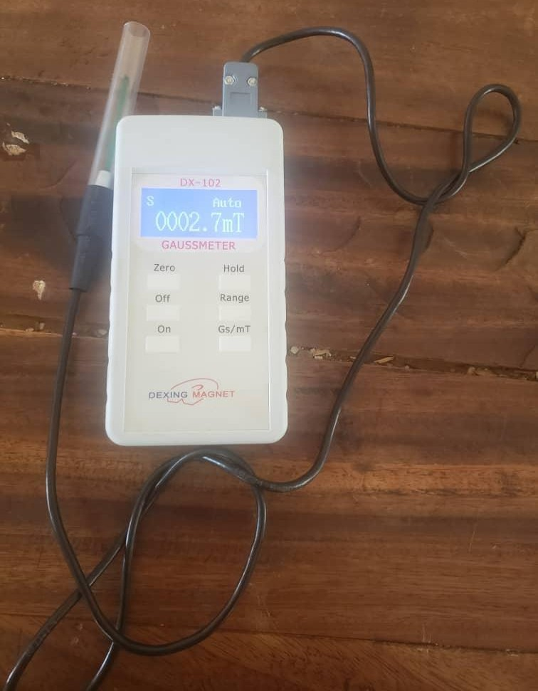

GAUSS METER

A Gauss Meter can measure the direction and the intensity of small (relatively) magnetic fields. For larger magnetic fields, a Tesla Meter, is used, which is similar, but it measures in larger Tesla units. A Gauss Meter comprises a gauss probe/sensor, the meter and a cable connecting both.



NEODYNIUM

Neodymium is a chemical element; it has symbol Nd and atomic number 60. It is the fourth member of the lanthanide series and is considered to be one of the rare-earth metals. It is a hard, slightly malleable, silvery metal that quickly tarnishes in air and moisture.
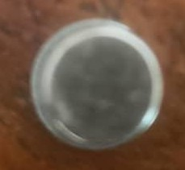

FERRITE
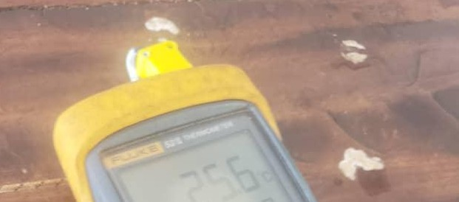
Ferrite refers to a group of magnetic materials, often ceramic-like, used in electronics for their high resistivity and magnetic properties, especially at high frequencies. They are commonly used in components like inductors, transformers, and filters. Additionally, ferrite can also refer to a specific phase of iron with a body-centered cubic crystal structure.

THERMOMETER
A thermometer is an instrument used to measure temperature. It consists of a temperature sensor and a mechanism to convert changes in temperature into a numerical value. Thermometers are essential for various applications, including medicine, science, and manufacturing.


Alnico is a family of ferromagnetic alloys used to create powerful permanent magnets. These alloys, primarily composed of iron, aluminum, nickel, and cobalt (hence the name "al-ni-co"), also include copper and sometimes titanium. Alnico magnets are known for their high coercivity and are used in various applications, including sensors, instruments, and guitar pickups.

METHODS
For magnetic strength and field calculation, we take two magnets and joint them (be careful). After joining two magnets we now put them in cooled temperature. When magnet is being cooled at a temperature of less than zero, the local magnetic moments tries to align, to produce the strongest possible magnetic force in a magnet. This magnet character will be for some fraction of time. Then the magnet will come at the room temperature. After this it again gets its same properties.
As temperature increases, a magnet becomes weaker as more local magnetic moments spin away from the shared alignment; a nonmagnetic field is being created with this elevated temperature. Now, we take the magnet and put it into boil water. The strength of magnet was reused by 50 %. At 100 degree Celsius when magnet is putted for 15-25 minutes. In the meantime, the heater is connected to the boiled water to maintain its temperature. It loses its magnetic property and behaviour. It is being varied with the magnet to magnet.
For normal ferrate magnet, they losses their properties above 200 degree Celsius. But the magnets that I used they losses their properties near 100 degree Celsius.
For electromagnet, after making a set of electromagnets the electricity from battery passed. Now we measure the strength of it. The strength was 10000 gauss or 1 tesla. At room temperature it’s having 1T power, on decreasing the temperature continuously it also decreases the strength of electromagnet. On decreasing the temperature 24 to 0 degree Celsius it decreases the strength about half. After, this putting the dry ice on the electromagnet. The temperature of dry ice was near - 60 degree Celsius. It decreases the strength of electromagnet dramatically, and the value that is measured was near 3000 gauss.
After cooling, start heating the coil. With increase in temperature the electromagnet value increases continuously, but this increase is very less compared to as its power decrease. From room temperature the heating value of electromagnet coil increased to 100 degree Celsius. The strength of the electromagnet increase by 3000. And the value that is measured was 13000 gausses. On further increasing the temperature, the

electromagnet stars increasing its strength slowly. To measure the effect of temperature on electric current I took one meter wire of resistance .02 ohm. The thickness of the wire was 1mm. We connected the wire to the battery and measure its resistance. On decreasing the temperature in refrigerator, its resistance was decreasing. After cooling it to zero degree Celsius the resistance value reached to .014. After this putting the wire in dry ice its resistance again decreases. After this starts heating the wire and measured its resistance. The resistance of the wire was increasing with increase in temperature. At 100 degree Celsius it was having the value of resistance around 0.029.

CHAPTER FOUR RESULTS AND DISCUSSION
The table below are information gotten from the practical carry out with the type magnet carried out with.

Table 1;

Magnet | Temperature | Magnet Field | Phone Magnet
Alnico | 35.0 ^{O} C | 34.8 | 29.5
 | 40^{O} C | 19.3 | 5.7
 | 60^{O} C | 11.5 | 27.9
 | 80^{O} C | 16.3 | 24.5
 | 100^{O} C | 19.1 | 15.8
 | 120^{O} C | 21.5 | 16.7
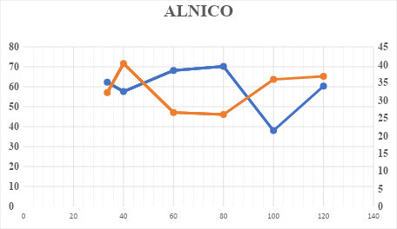
The table above shows the category of where the temperature, magnet field, phone magnet with each value represented in the table above.

Table 2;

Magnet | Temperature | Magnet Field | Phone Magnet
Neodynium | 33.4 ^{O} C | 285.5 | 8.5
 | 40^{O} C | 217.5 | 15.0
 | 60^{O} C | 215.5 | 17.6
 | 80^{O} C | 218.5 | 8.6
 | 100^{O} C | 221.8 | 21.6
 | 120^{O} C | 229.0 | 22.5

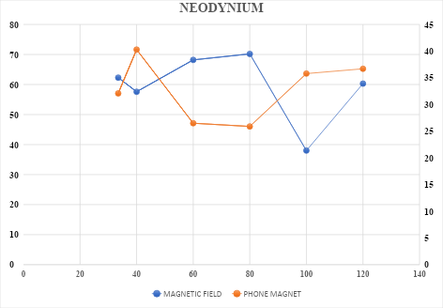

The table above shows the category of where the temperature, magnet field, phone magnet with each value represented in the table above.

Table 3;

Magnet | Temperature | Magnet Field | Phone Magnet

Ferrite | 33.5^{O} C | 62.3 | 32.1
 | 40^{O} C | 57.6 | 40.3
 | 60^{O} C | 68.2 | 26.5
 | 80^{O} C | 70.2 | 25.9
 | 100^{O} C | 38.0 | 35.8
 | 120^{O} C | 60.3 | 36.7

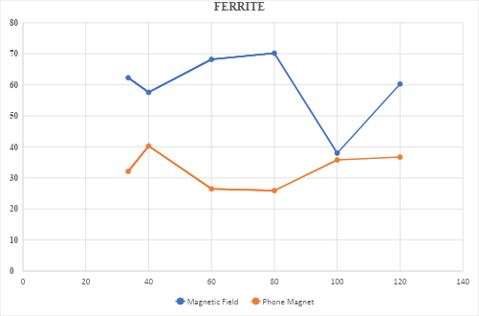
The table above shows the category of where the temperature, magnet field, phone magnet with each value represented in the table above.

CHAPTER FIVE

  - CONCLUSION

In magnets with increase in temperature the very tightly bonded atom starts splitting, and a time comes when they are completely free to move and thus magnetic field is finished because most of them gets excited. On cooling atom get contract and thus their magnetic field increases by some factor. There are some different kinds of magnet whose power slightly decreases on increasing the temperature.
The Gauss meter probe experiment validated the previous experiment and showed that the shift in the measurement of Magnetic Field Strength is not of a significant level and will not be enough cause a systematic error in size above the measurement accuracy of the experiment set up.
From all the experiments that have been performed, one can conclude that for temperature measurements of the highest accuracy the magnetic sensitivity should be estimated.

Recommendation

Special consideration should be given to the influence of small permanent magnets (whiteboard, drawers, cupboards, refrigerators) that could accidentally magnetize thermocouples and/or their enclosures. Similarly, the attachment of thermocouples to metal surfaces using permanent magnets could be a cause of error. Environmental conditions in the laboratory should be checked. Not only temperature, pressure and humidity, but also extraneous electromagnetic fields have to be estimated. Regarding unwanted extraneous magnetic fields, one should take into consideration increasing the distance from the magnetic field source, removing or reducing the power of the magnetic field or introducing high permeability magnetic shielding, e.g. AlNiCo, Mu-metal. Special attention has to be paid to thermocouple-connecting wires; they are to be put in parallel with the magnetic field to exclude induction effects. Because the mechanical vibration of coils and coil holders was induced by the ac magnetic force, all connecting wires (coil power wires, thermometer wires) have to be fastened in such a fashion that the vibrating parts cannot touch physically.

REFERENCES

Akiya T, Liu AJ, Sepehri-Amin H, et al. High- coercivity hot-deformed Nd-Fe-B

permanent mag nets processed by Nd-Cu eutectic diffusion under expansion constraint. Scr Mater. 2014;81: 48–51.
Dittrich R, Schrefl T, Suess D, et al. A path method for finding energy barriers and

minimum energy paths in complex micromagnetic systems. J Magn Magn Mater. 2002;250: 12–19, E W, Ren W, Vanden- Eijnden E. Simplified and improved string method for computing the minimum energy paths in barrier- crossing events J. Chem. Phys. 2007; 126:164103(1-8)
Fischbacher J, Kovacs A, Gusenbauer M, et al. Micromagnetics of rare-earth efficient permanent magnets. J Phys D: Appl Phys. 2018;51(1–17):193002.
H. Toda, Z. Xia, K. Attallah and D. Howe, “IEEE Trans. Magn., vol. no. 4.pp, 2014 – 2016, July.
Hirosawa S, Nishino M, Miyashita S. Perspectives for high-performance permanent

magnets: applications, coercivity, and new materials. Adv Nat Sci Nanosci Nanotechnol. 2017;8:013002(1–12).
Kollie T G, Anderson R L, Horton J L and Roberts M J 2017 Large thermocouple thermometry errors caused by magnetic fields Rev. Sci. Instrum. 48 501–11
Miyashita S, Nishino M, Toga Y, et al. Perspectives of stochastic micromagnetism of

Nd 2 Fe 14 B and computation of thermally activated reversal process. Scr Mater. 2018;154:259–265.
Nishino M, Miyashita S. Nontrivial temperature dependence of ferromagnetic

resonance frequency for spin reorientation transitions. Phys Rev B. 2019;100: 020403 (R) (1–5).

Plaznik U, Tuˇsek J, Kitanovski A and Poredoˇs A 2013 Numerical and experimental

analyses of different magnetic thermodynamic cycles with an active magnetic regenerator Appl. Therm. Eng. 59 52–59
Stephenson R J et al 2019. The Measurement, Instrumentation and Sensors Handbook on CD-ROM (Boca Raton, FL: CRC Press)
Sugimoto S. Current status and recent topics of rare-earth permanent magnets. J Phys D: Appl Phys. 2011;44:064001 (1–11).
Vikram Ramnath. Investigation of the Impact of Low Strength Gradient Magnetic Fields on Jet Diffusion Flames. Theses and Dissertations, NC State University Repository; 2017.

