A PROJECT REPORT
ON
PURE WATER FACTORY FOR BURENA WATER ASA DAM, ILORIN KWARA STATE

PRESENTEDBY

ADELEYE KEHINDE HUSSEIN

ND/21/ARC/PT/048
SUBMITTED TO

THE DEPARTMENT OF ARCHITECTURAL TECHNOLOGY, INSTITUTE OF ENVIRONMENTALSTUDIES (IES), KWARA STATE POLYTECHNIC, ILORIN

INPARTIAL FULFILLMENT OF THE REQUIREMENT FOR THE AWARD OF NATIONAL DIPLOMA (ND) IN ARCHITECTURAL TECHNOLOGY,

JULY,2025

DECLARATION

I declare that this report is a product of my personal research work. It has not been presented for the award of any degree in any Polytechnic . The ideas, observations, comments, suggestions herein represent my own convictions, except quotations, which have been acknowledged in accordance with conventional academic traditions.
Adeleye Kehinde Hussein ND/21/ARC/PT/048

Student name Matric number

Signature & Date.

ii

CERTIFICATION

I certify that this research dissertation entitled Pure water factory by Adeleye Kehinde Hussein, with matric number ND/21/ARC/PT/048 has been duly certified as meeting the requirement for the award of National Diploma ND in Architectural Technology, Institute of Environmental Studies, Kwara State Polytechnic, Ilorin.

ARC. J.M TOMORI

PROJECTSUPERVISOR SIGNATURE & DATE

ARC.OLAREWAJUF.

PROJECT COORDINATOR SIGNATURE & DATE

ARC.J.M TOMORI

HEADOF DEPARTMENT SIGNATURE & DATE

EXTERNAL EXAMINER SIGNATURE & DATE

iii
DEDICATION

This report is dedicated to Almighty Allah for making it possible and also to my Parent and all Architects in the world.

ACKNOWLEDGEMENT

I return all the glory, honor, praise and adoration to the master of the universe that have given me the privilege of seeing the end of this program of him alone be the glory.
My immediate gratitude goes to my supervisor Arc.J.M Tomori who has been supportive responsive throughout this project, may God continue to reward you and your family.
My appreciation goes to my Amiable Head Of Department in person of Arc. J. M Tomori and other academic staffs for their immense contribution toward the success of my program may God bless you all.
My sincere gratitude goes to my Father, Mr Abdulrasheed Adeleye &my Mother Mrs Khadijah Adeleye who brought me to this world, may you eat the fruit of your labour.
However, my gratitude also goes to all my Twins brother Adeleye Taiwo and Jamiu Adeleye for their moral support. May Almighty Allah Be with you
Finally me appriciation goes to my friend in person of Bashit for your assistance during my stay in school.

TABLE OF CONTENTS
Title page……………………………………………………………………………..i
Declaration …………………………………………………………………………..ii
Certification……………………...………………………………………………….iii
Dedication…………………………………………………………………………...iv
Acknowledgement ………………………….……………………………………....v
Table of content ………………………………………………………………..….vi
List of table …………………………………………………………...................vii
List of figure …………………………………………………………………..…viii
List of plate ………………………………………………………………………....ix
List of Appendix …………………………………………………………………..x
CHAPTERONE
- Introduction……………………………………………………………………1
  - Historical background……………………………………………….…………1
  - Statement of the problem………………………………………………………2
  - Aims& objectives……………………………………………………………………….3
  - Justification……………………………..……………………………….……..4
  - Scope of the study ………………………………..…………………….………5
  - Limitation……………………………..………………………………………..6
1.7 Research methodology………………………………………………………..7
CHAPTER TWO
2.0 literature review ……………………………………………………...,,.................8
2.1 Review of literature on the building type: Pure Water Factory / Water Treatment Facility………………………………………………………………8
2.2 Overview of Sachet Water Production in Nigeria…………………………..10
2.3 Water Purification and Production Processes………………………………10
2.4 Regulatory Framework for Sachet Water Production………………….10
2.5 Quality Control and Assurance in Sachet Water Factories…………………11
2.6 Consumer Perception and Satisfaction……………………………………..11
2.7 Empirical Studies on Sachet Water in Ilorin and Kwara State…………….12
2.8 Summary of Gaps in Literature……………………………………………12
CHAPTER THREE
3.1 Cases Studies ………………………………………………………………13
CHAPTER FOUR
4.0 STUDY AREA / PROJECT SITE (Environmental and Impact Analysis).16
4.1 Analysis of the Topographical and Environmental Conditions of the Site………………………………………………………………………………..16
4.2 Project Analysis / Design Criteria…………………………………………………………..18
CHAPTER FIVE
4.0 APPROACH TO THE DESIGN / DESIGN REALISATION……………………………22
5.1 Design Ideas & Concepts at Different Levels (Site / Building)……………………….23
5.2 Technological & Environmental Criteria………………………………………………….24
5.3 . Legal Issues & Planning Regulations………………………………………………………25
5.4 Behavioral Patterns & Considerations……………………………………………………....25
5.5 Conclusion & Recommendations………………………………………………………26
References ………………………………………………………………………………..27
Appendix…………………………………………………………………………………30

List Of Tables
Table 4.1: Spatial Allocation……………………………………………………………………20

List of plates
Plate 3.1 front View of case study ……………………………….………………14
Plate 3.2: back View of case study..…………………………………………….14
Plate 3.3: side View of case study………………,….…………………………….15

List of appendices
Appendix 1: site location ………………………………………………………30
Appendix 2: site plan ………………………….………………………………31
Appendix 3:Roof plan……………………………………………………….. 32
Appendix 4: floor plan ……………………………………………………….32
Appendix 5: section ……………………………………………………………33
Appendix 6: flow chart ….…………………………………………………….34
Appendix 5 elevation …………………………………………………………35

Abstract
The increasing reliance on sachet water, popularly known as "pure water," as a primary source of drinking water in Nigeria has raised significant concerns regarding its quality and safety. This study investigates the production processes, quality control measures, and regulatory compliance of Burema Water, a pure water manufacturing company located in Asa Dam, Ilorin, Kwara State. The research aims to assess the extent to which the company adheres to national health and safety standards, and to evaluate consumer satisfaction with its products.
Using a descriptive case study design, both primary and secondary data were collected through structured interviews with company staff, questionnaires administered to consumers, and direct observation of production activities. Quantitative data were analyzed using descriptive statistics, while qualitative data were interpreted through thematic analysis.
Findings reveal that while Burema Water has implemented basic purification and packaging procedures, there are areas requiring improvement, particularly in documentation, staff training, and regulatory updates. Consumer feedback indicated general satisfaction with the product’s availability and packaging but highlighted concerns about taste and trust in long-term safety.
The study concludes that regular monitoring, improved quality control systems, and enhanced regulatory compliance are essential for ensuring the safety and public confidence in sachet water products. The research provides valuable insights for stakeholders, including water producers, health authorities, and consumers, and contributes to broader efforts aimed at promoting access to safe drinking water in Nigeria.i
TABLEOFCONTENTS
Title page……………………………………………………………………………………..i
Declaration …………………………………………………………………………………..ii
Certification………………………………………………………………………………….iii
Dedication…………………………………………………………………………………...iv
Acknowledgement …………………………………………………………………………....v
Table of content …………………………………………………………………………..….vi
List of table ……………………………………………………………………...................vii
List of figure ……………………………………………………………………………..…viii
List of plate ………………………………………………………………………………....ix
List of Appendix ……………………………………………………………………………..x
CHAPTERONE
- Introduction………………………………………………………………………………1
  - Historical background………………………………………………………….…………1
  - Statement of the problem…………………………………………………………………2
  - Aims& objectives………………………………………………………………………….3
  - Justification………………………………………………………………………….……..4
  - Scope of the study ………………………………………………………………….………5
  - Limitation…………………………………………………………………………………..6
1.7 Research methodology……………………………………………………………………..7
CHAPTER TWO
2.0 literature review ………………………………………………………………...,,.................8
2.1 Review of literature on the building type: Pure Water Factory / Water Treatment Facility…………………………………………………………………………………………8
2.2 Overview of Sachet Water Production in Nigeria…………………………………………..10
2.3 Water Purification and Production Processes………………………………………………..10
ix
2.4 Regulatory Framework for Sachet Water Production…………………………………..10
2.5 Quality Control and Assurance in Sachet Water Factories………………………………….11
2.6 Consumer Perception and Satisfaction………………………………………………………11
2.7 Empirical Studies on Sachet Water in Ilorin and Kwara State……………………………....12
2.8 Summary of Gaps in Literature………………………………………………………………12
CHAPTER THREE
3.1 Cases Studies ………………………………………………………………………………13
CHAPTER FOUR
4.0 STUDY AREA / PROJECT SITE (Environmental and Impact Analysis)……………..16
4.1 Analysis of the Topographical and Environmental Conditions of the Site…………….16
4.2 Project Analysis / Design Criteria…………………………………………………………..18
CHAPTER FIVE
4.0 APPROACH TO THE DESIGN / DESIGN REALISATION……………………………22
5.1 Design Ideas & Concepts at Different Levels (Site / Building)……………………….23
5.2 Technological & Environmental Criteria………………………………………………….24
5.3 . Legal Issues & Planning Regulations………………………………………………………25
5.4 Behavioral Patterns & Considerations……………………………………………………....25
5.5 Conclusion & Recommendations………………………………………………………26
References ………………………………………………………………………………..27
Appendix…………………………………………………………………………………30
x
List Of Table
Table 4.1: Spatial Allocation……………………………………………………………………20

xi
List of plate
Plate 3.1 front View of case study ……………………………….……………………………14
Plate 3.2: back View of case study…………………./////////////////////////……………………………………………………….14
Plate 3.3: side View of case study……………………………………………………………….15

xii
List of appendix
Appendix 1: site location …………………………………………………………………30
Appendix 2: site plan ………………………….…………………………………………31
Appendix 3:Roof plan………………………………………………………………….. 32
Appendix 4: floor plan …………………………………………………………………….32
Appendix 5: section ……….………………………………………………………………33
Appendix 6: flow chart ….………………………………………………………………….34
Appendix 5 elevation ………………………………………………………………………35

Xiii

CHAPTER ONE
1.0 INTRODUCTION
1.1. Background Of Study / Historical Background
Access to clean, safe, and potable water is a basic human necessity and a key indicator of public health and sustainable development. In Nigeria, however, access to pipe-borne water remains limited, particularly in semi-urban and rural areas. As a result, many Nigerians rely on alternative sources of drinking water such as boreholes, wells, and increasingly, sachet water—commonly referred to as "pure water."
The sachet water industry in Nigeria began to emerge in the late 1990s and has since grown rapidly due to its affordability, ease of access, and portability. It involves the filtration and packaging of water into small plastic sachets, typically sealed using heat-sealing machines. This growth was fueled by the inadequacy of government water supply systems and the rising demand for safer and more convenient drinking water options among the population.
However, the industry’s rapid expansion has not been without challenges. Many small- and medium-scale producers operate with minimal oversight, leading to concerns about the quality, hygiene, and safety of the water being produced. There have been cases where poorly treated or contaminated sachet water led to outbreaks of waterborne diseases such as cholera, typhoid, and diarrhea. In response, regulatory agencies such as the National Agency for Food and Drug Administration and Control (NAFDAC) and the Standards Organisation of Nigeria (SON) have introduced guidelines and registration requirements for sachet water producers to ensure public safety.
Burema Water, located in Asa Dam, Ilorin, is one of the companies involved in sachet water production within Kwara State. Asa Dam is an industrial and residential area known for its proximity to water sources, making it a strategic location for water-related businesses. Burema Water has become a recognizable brand in the area, with its products widely distributed across Ilorin and neighboring communities.
Despite its presence in the market, there has been limited academic or public evaluation of Burema Water’s production process, quality control standards, and compliance with regulatory requirements. Understanding how such companies operate is essential to ensuring that they are not only meeting consumer demands but also upholding public health and safety standards.
This study, therefore, explores the operational framework of Burema Water, focusing on its production, purification, and packaging processes, as well as the perceptions of consumers regarding the quality of its products.
1.2 Statement of Design Problem
Access to clean and safe drinking water remains a significant public health concern in many parts of Nigeria, including Ilorin, Kwara State. As a result, many households rely heavily on sachet water—commonly referred to as "pure water"—as their primary source of drinking water. While this product is widely consumed for its affordability and availability, there are growing concerns about the quality, safety, and regulatory compliance of some of the producers in the industry.
In recent years, reports of contaminated sachet water leading to waterborne diseases have raised questions about the effectiveness of quality control measures and the commitment of some manufacturers to health standards. This raises the need for a closer examination of how pure water companies operate, particularly in terms of their production processes, purification methods, hygiene practices, and adherence to regulatory standards.
Burema Water, located in Asa Dam, Ilorin, is one of the notable producers in the region. However, little academic research has been conducted to assess its operational practices, compliance with health and safety guidelines, and consumer satisfaction. Without such studies, it becomes difficult to determine whether companies like Burema Water are truly contributing to public health or inadvertently posing risks to consumers.\
This study, therefore, seeks to investigate the production and quality assurance processes at Burema Water, evaluate their alignment with regulatory standards, and understand consumer perceptions regarding the safety and reliability of the product.
1.3 Aim and Objectives of the Project
Aim:
The aim of this study is to assess the operational practices, production processes, and quality control measures of Burema Water, a pure water manufacturing company located in Asa Dam, Ilorin. The study seeks to evaluate how the company ensures compliance with health and safety standards, the efficiency of its water purification system, and its overall impact on consumer satisfaction and public health within the region.
Objectives
1. To examine the water purification and production processes used by Burema Water in ensuring the safety and quality of its products.

2. To assess the level of compliance of Burema Water with regulatory standards set by health and environmental authorities such as NAFDAC and SON.
3. To evaluate the effectiveness of quality control measures** implemented at different stages of production.
4. To analyze the challenges faced by the company in maintaining consistent product quality and operational efficiency.
5. To assess consumer satisfaction regarding the quality, availability, and packaging of Burema Water products.\
6. To identify possible areas for improvement** in the company’s operations to enhance product quality and public health safety.

1.4 Justification for the Project
Access to clean and safe drinking water is essential for public health and well-being. In Nigeria, the production and consumption of sachet water (commonly known as "pure water") have become increasingly widespread due to its affordability and accessibility, especially in urban and semi-urban areas like Ilorin. However, concerns about the quality and safety of sachet water have raised the need for closer scrutiny of producers and their practices.
This study focuses on Burema Water, a notable pure water manufacturing company in the Asa Dam area of Ilorin, to provide insights into the operational and quality control measures used in its production process. By examining Burema Water as a case study, the research will contribute to a better understanding of how local water factories comply with health and safety standards, and the extent to which they ensure product quality.

The findings of this study will be valuable to regulatory agencies, consumers, and other stakeholders in the water production industry. It will help highlight strengths and areas needing improvement within the industry and may inform policy decisions, improve consumer awareness, and promote best practices in water purification and distribution.
Ultimately, this research will contribute to efforts aimed at safeguarding public health and ensuring that sachet water, as a widely consumed product, meets acceptable standards of quality and safety.
1.5 Scope of Study
This study is limited to the examination of the operations of Burema Water, a pure water production company located in Asa Dam, Ilorin, Kwara State. It focuses specifically on the company’s water purification methods, production processes, quality control measures, and compliance with health and environmental regulations.
The study also covers the evaluation of consumer satisfaction with the company’s products in terms of quality, safety, packaging, and availability. Data will be collected from the company’s management and staff, relevant regulatory bodies (where accessible), and a sample of consumers within the Ilorin metropolis.
The study does **not** include comparisons with other pure water companies outside of Burema Water, nor does it cover the broader water supply chain in Ilorin or Kwara State. However, the findings may serve as a reference point for similar studies or policy recommendations in the water production sector.

1.6 Limitation of Study
Despite efforts to conduct a thorough and objective assessment, this study is subject to certain limitations:
1. Restricted Access to Information: Some internal operational and financial records of Burema Water may be considered confidential by the management, limiting access to comprehensive data.
2. Limited Scope of Generalization: As the study focuses solely on Burema Water in Asa Dam, the findings may not be fully representative of other pure water factories in Ilorin or other regions of Nigeria.
3. Time Constraints: Due to the time-bound nature of the research, the study could not incorporate long-term observations of production patterns or seasonal variations in water quality and consumer demand.
4. Consumer Bias: Responses from consumers regarding product satisfaction may be subjective and influenced by personal preferences, which could affect the accuracy of data collected through surveys or interviews.
5. Regulatory Agency Involvement:** Limited cooperation or delayed responses from regulatory bodies such as NAFDAC or SON may restrict the depth of analysis regarding compliance and monitoring.
6. Resource Limitations: Financial and logistical constraints may have impacted the breadth of data collection, such as the number of consumer surveys or site visits conducted.

1.7 Research Methodology
This section outlines the methods and procedures used in conducting the study on Burema Water, focusing on its production processes, quality control measures, regulatory compliance, and consumer satisfaction.
The study adopts a descriptive case study design, which allows for an in-depth analysis of the operational practices of Burema Water. This design is suitable for examining specific real-life phenomena within their natural setting and is ideal for assessing both qualitative and quantitative aspects of the company’s operations.

CHAPTER TWO
LITERATURE REVIEW
2.1 Review of literature on the building type: Pure Water Factory / Water Treatment Facility
i. Evolution of the building typology
Origins & typology evolution: The pure water factory—essentially a small-scale water treatment and bottling facility—evolved from centralized water works into more hygienic, compact, and community-centered typologies. Many modern designs prioritize public engagement, transparency, and sustainability, transforming industrial infrastructure into cultural and educational spaces. For instance, the **Shenzhen Lotus Water Culture Base in China melds water purification with landscape and public interaction, reimagining industrial utility as social infrastructure.
Small-scale developments: Some projects, like a resort-based water bottling plant in Vietnam, show how traditional building methods (wooden trusses, thatched roofs) paired with modern hygiene standards can create environmentally friendly production spaces that double as educational exhibits. (Salami, A. 2025).
ii. Variants of the building type & classification
Variants: Core types include compact treatment units (often for rural or remote areas), urban decorative/public-purposes treatment plants, and commercial bottling plants. Classification can be based on:
Scale: Small (community/household), medium (township), large (municipal).
Function: Pure water bottling vs. broader wastewater treatment or reuse.
Design intent: Functional (plant-focused), biophilic/public (community-integrated), hybrid.
iii. Functions and spatial relationships
Functional zoning: Essential zones typically include raw water intake/pretreatment, filtration and purification, storage, packaging/bottling, and possibly public/educational areas (as seen in resort examples) .
Flow and spatial logic: Movement of water follows an ordered, hygienic path: intake → treatment → storage → packaging → dispatch. Staffing and logistics require adjacent access to each functional zone, with sightlines for quality control and transparency.
Unique adaptations: Facilities that combine production with public education—such as including displays or viewing areas—provide dual function: operational and pedagogical.
iv. Technological and environmental approaches
Treatment technologies: Common methods include slow and rapid sand filtration, activated carbon, reed bed filtration, biological sand filters, and combinations thereof; selection depends on context, water source, and cost .
Structural considerations: Water treatment facilities require durable, corrosion-resistant materials, and often leverage advanced structural analysis (e.g., finite element modeling), high-performance materials (e.g., fiber-reinforced concrete, corrosion-resistant steel), and sustainability-focused design to ensure longevity and safety .
Eco-technologies: In developing regions, low-cost, nature-based systems like constructed wetlands are viable for decentralized water treatment, offering high effectiveness with minimal energy and infrastructure needs. (Jeminiwa, O. R. 2022).
2.2 Overview of Sachet Water Production in Nigeria
The sachet water industry in Nigeria has grown rapidly since the late 1990s as a response to the failure of public water supply systems (Adeyemi & Adewoye, 2017). Sachet water offers an affordable and accessible alternative for drinking water, especially in urban and semi-urban areas. However, the proliferation of small-scale water producers has brought about concerns over water quality, hygiene standards, and regulatory compliance (Adeleke et al., 2020).
2.3 Water Purification and Production Processes
Pure water factories typically follow basic water purification stages such as sedimentation, filtration (usually through sand and carbon filters), reverse osmosis, and ultraviolet (UV) sterilization. According to Ojo (2019), effective water purification depends on not only the equipment used but also the maintenance culture and the technical expertise of the operators.
At Burema Water in Asa Dam, the purification process includes borehole water extraction, multi-stage filtration, UV treatment, and heat sealing of sachets. While these practices align with standard procedures, it is important to assess whether these methods are consistently applied and properly monitored to ensure water safety.
2.4 Regulatory Framework for Sachet Water Production
Agencies such as the **National Agency for Food and Drug Administration and Control (NAFDAC)** and the **Standards Organisation of Nigeria (SON)** are responsible for licensing and monitoring sachet water producers. These bodies set guidelines for factory setup, water testing, hygiene, and labeling. Despite these efforts, research shows that regulatory enforcement is often weak due to limited manpower and resources (Ibekwe & Ononogbu, 2021).
Burema Water, like other registered producers, is expected to operate under these guidelines. However, periodic inspection, product sampling, and strict enforcement are often lacking in many regions, including Kwara State.
2.5 Quality Control and Assurance in Sachet Water Factories
Quality control is critical in sachet water production to prevent contamination and ensure safety. Good manufacturing practices (GMP) require regular testing of raw water and finished products, proper sanitation of equipment, and training of personnel (Nwachukwu & Uzochukwu, 2018). In many small-to-medium scale factories, such practices are either poorly implemented or entirely absent.
There is limited published data specific to Burema Water, but anecdotal evidence and observations suggest that while the company makes efforts in packaging and branding, quality assurance practices such as microbial testing and record-keeping may not meet optimal standards.
2.6 Consumer Perception and Satisfaction
Consumer trust in sachet water brands is shaped by taste, clarity, packaging, and brand reputation. Studies (e.g., Musa & Yahaya, 2020) show that many consumers lack awareness of the health risks associated with poorly treated water and often rely on visual appearance and pricing when making choices.
In the case of Burema Water, its popularity in Asa Dam and surrounding areas suggests a level of consumer acceptance. However, it remains necessary to evaluate whether this trust is based on actual quality or merely affordability and availability.
2.7 Empirical Studies on Sachet Water in Ilorin and Kwara State
Several studies have examined sachet water quality in Ilorin and its suburbs. A study by Abdulrahman et al. (2020) found that while most sachet water samples met physical and chemical standards, microbial contamination was still a concern, especially for factories operating with poor hygiene. These findings underscore the importance of factory-specific investigations, such as this study on Burema Water.
2.8 Summary of Gaps in Literature
Although existing literature addresses general issues in sachet water production, there is a **noticeable lack of factory-specific studies**, especially on small-to-medium-scale producers like Burema Water. There is also limited data on how consumer satisfaction correlates with actual quality and regulatory compliance. This study seeks to fill these gaps by providing an in-depth analysis of Burema Water's operations, quality control practices, and consumer perception.

CHAPTER THREE
CASES STUDES
The purpose of case study in any architectural research project is to enable the designer to familiarize him/hers with terms, mode of operation, standard required any other factor that may help the designers in achieving his or her desire objectives through the study of the existing similar structure.
CASE STUDY ONE

LOCATION: BUREMA PURE WATER FACTORY IN ASA DAM ILORIN KWARA STATE
Burema Water Location: Osin Olatunji Layout, Off Asa Dam Road, Ilorin, Kwara State — this places it in close proximity to Asa Dam. Business Type: A production company specializing in pure sachet and bottled water hygienically packaged for local distribution. (Musa, R. T, 2013).
Asa Dam serves as a key raw water source for Ilorin’s municipal water supply system. The Asa Dam Water Treatment Plant (also referred to as the Asa water works) processes this raw water using a series of treatment steps—like aeration, lime dosing (pH correction), coagulation, flocculation, sedimentation, filtration, and chlorination—to meet NIS and WHO drinking water standards. After refurbishment, the plant has a capacity of around 2,600 m³/hour.
The Asa Dam water works supply potable water to large parts of the Ilorin metropolitan area, serving hundreds of thousands of residents. (Achuka, J. A., 2021).
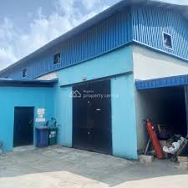
Plate 3.1.2: Front View Showing Of Case Study One Bunera Pure Water Factory in Asa Dam Ilorin Kwara State
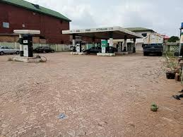
Plate 3.1.3: Back View Showing Of Case Study One Burena Pure Water Factory in Asa Dam Ilorin Kwara State.
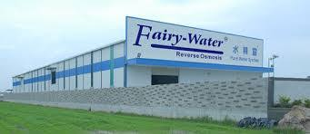
Plate 3.1.1: Side View Showing Of Case Study One Bunera Pure Water Factory in Asa Dam Ilorin Kwara State

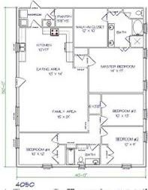
Figure 3.1 Online case study floor plan

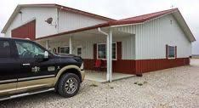
Figure 3.2 font view of online case study
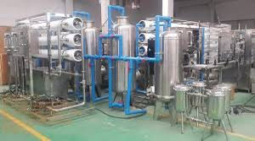
Figure 3.3 Bottle water production of online case study

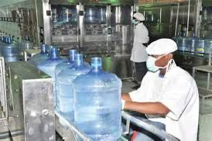
Figure 4. Bottle water production online case study
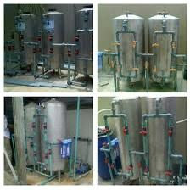
Figure 3. water production online case study

CHAPTER FOUR
4.0 STUDY AREA / PROJECT SITE (Environmental and Impact Analysis)
4.1 Analysis of the Topographical and Environmental Conditions of the Site
i. Introduction: Study Area / Site Selection
The project site is the pure water factory adjacent to Asa Dam, positioned just outside Ilorin, the capital of Kwara State. The Asa River Dam, constructed by Julius Berger Nigeria PLC, comprises a 400 m earth-fill dam, a 150 m concrete gravity dam, and a 160 m lateral earth dam—designed to boost potable water supply by around 50,000 m³/day.
This facility is strategically located for treatment and packaging, leveraging direct access to raw water and proximity to urban demand centers.
ii. Site Location / Description / Criteria
The site falls along the Asa River Basin, located in southwestern Kwara State, spanning approximately 471.95 km² with a perimeter of about **165.98 km.
Elevation in Ilorin averages 257 m to 431 m above sea level, with Sobi Hill rising to around 394 m.
Geological context: The site's foundation comprises basement complex rocks, including gneisses, schists, and granites—typical of southern Nigeria—and sits on loamy, lateritic soilsof medium to low fertility

Topography:
Rolling hills and valleys characterizing distant inflow zones, with lowlands following the riverbed—a key consideration for flood risk during heavy seasonal rains.
iii. Site Analysis / Inventory
Terrain feature: Variable elevations with slopes trending toward the river; the site is near flood-prone plain areas
Soil & foundation: Dominated by **loamy, lateritic soils**, whose permeability and low fertility could influence water treatment construction and structural foundation designs
Hydrology: The Asa River flows south to north through Ilorin, receiving runoff from other tributaries—proper intake engineering is essential to optimize water extraction while mitigating flood risk
Flood dynamics: Rising urban runoff and impervious surfaces have increased frequency and intensity of localized flooding, even with moderate rainfall—critical for site drainage and planning.
iv. Geographical / Climatic Data
Climate classification: Tropical savanna
Temperature: Annual daytime highs range from 32 °C to 38 °C, with March usually the hottest. Nighttime lows fall between 20 °C and 24 °C.
Rainfall: Annual precipitation ranges from **990 mm to 1,318 mm, concentrated in the rainy season from April through October. The dry season spans November to March when rainfall is minimal * Humidity: Relative humidity peaks at 75%–88% during the wet season and drops to 35%–80% in the dry season .
Rainy days: Heaviest precipitation and frequent rainfall occur particularly in July–September**; December is typically dry .
v. Analyses of the Immediate Environmental Conditions

Flood risk: The site’s proximity to the river and basin topography signals susceptibility to seasonal flooding, especially during peak rains—requiring elevated floor levels, stormwater planning, and buffer zones.
Heat & comfort: High ambient temperatures and humidity necessitate shading, natural ventilation, and possibly passive cooling strategies to maintain operational comfort and energy efficiency.
Soil behavior: Lateritic soils may shrink or swell during seasonal moisture shifts, affecting foundation integrity—engineered foundation systems are essential.
Environmental sustainability: Capturing and treating runoff, using water-sensitive landscaping, and integrating nature-based filtration could support resilient site function.

4.2 Project Analysis / Design Criteria
I. Project Goals (Client / Designer Brief)
Provide a reliable pure water bottling facility to serve Ilorin and environs, leveraging..
Ensure hygienic production, scalable capacity, and resilience against local environmental constraints, including flooding and heat.
Prioritize sustainability, operational efficiency, and future expansion potential.
ii. Functional / Spatial Criteria
Zoning must support:
1. Raw water intake and pretreatment
2. Filtration/purification modules
3. Storage (treated water tanks) and packaging
4. Staff facilities, quality control labs
5. Logistics access (entry/exit for distribution)
Flow efficiency: Logical progression from untreated intake to finished goods execution.
iii. Appraisal of Proposed Schemes (Spaces, Sizes, Relationships)
Intake zone: Designed with adjustable intakes to avoid sediment-laden surface inflows during floods.
Treatment hall: Centrally located; space sized for modular unit installation, plus room for upgrade.
Packaging zone: Should abut treated storage tanks, providing direct access for bottling lines.
Flood mitigation buffer zone: Setback from riverbank with elevated platform—serves as floodproofing and emergency overflow.
Service areas: Admin, control, staff access, and waste processing positioned for operational separation from production.
iv. Equipment, Operational & Performance Requirements
Filtration system: Sand filters, activated carbon, or appropriate compact systems, adjusted for turbidity variability.
Storage: Reinforced concrete or stainless steel tanks sized per daily production needs plus buffer.
Power: Reliable energy supply; consider backup generators or solar PV for resilience.
Flood resilience mechanisms: Pumps with float switches, raised service connections, and impervious exterior cavities.
v. Spatial Allocation / Schedule of Accommodation
Zone | Description / Area Allocation
| Raw Water Intake | Intakes with sediment screen
Pretreatment & Filtration | Modular units; adjacent to intake
Treated Water Storage | Elevated tanks near packaging area
Packaging & Bottling | Clean production zone
Quality Control Lab | Abutting production, controlled access
Administration & Staff | Offices, restrooms, safety lockers
Logistics & Service Zone | Loading bay, vehicle access, utilities
Flood Buffer / Landscaping | Setbacks, green area for runoff absorption
vi. Functional Relationship
Sequential flow: Intake → purification → storage → packaging → dispatch.
Supporting services: Quality control lab adjacent to both treatment and packaging for rapid feedback; admin zone separated to minimize contamination.
Access routes: Clear entry for raw material and product dispatch; emergency exits accessible above flood levels.
vii. Conceptual Development
Diagram: A linear plan reflecting operational flow, with treatment core, buffers, and admin periphery.
Elevation desig: Raised production grounds, shaded canopies, vented façades, and green buffers. (Okoh, A. I., 2011).
Sustainability features:
- Rainwater harvesting from roofs for non-potable use.
- Permeable surfaces in landscaping to reduce flood runoff.
- Passive cooling via roof orientation, sun shading, and cross-ventilation.
- Reuse of treated wastewater for maintenance or landscaping.
Spatial Allocation for Burema Pure Water Factory.
1. Land Size and Location:
Total land area: 2,000 square meters
Location: [Insert location – town, city, and address if known]
Accessibility: The site is accessible by tarred road and is located close to residential and commercial areas for ease of distribution.

2. Spatial Breakdown:
Area Description | | Allocated Space (sqm) | Percentage of Total Area | Purpose/Remarks
Administration Block | 150 | 7.5% | Office for management, accounting, and HR
Production Hall | 600 | | 30% | Main area for purification, packaging, and sealing
Raw Water Storage Area | 200 | 10% | Stores untreated water
Finished Product Storage | 250 | 12.5% | Storage for packaged sachets and bottles
Laboratory/Quality Control Unit | 100 | 5% | Testing for water quality and compliance
Loading Bay & Vehicle Parking | 300 | 15% | Delivery truck loading, parking, and turnaround
Staff Changing/Restroom Facilities | 100 | 5% | Locker rooms and sanitation facilities
Generator House & Utilities | 50 | 2.5% | Power backup and control systems
Green Area/Buffer Space | 150 | 7.5% | Landscape, drainage, and future expansion

3. Zoning and Flow Consideration:
Production flow is linear: Raw water → Treatment → Packaging → Storage → Distribution.
Areas are zoned to minimize contamination and optimize efficiency (clean zones separate from raw material zones).
Utilities such as water tanks, waste channels, and power lines are placed strategically to avoid disrupting workflow.
4. Compliance:
Designed to comply with NAFDAC, SON, and Ministry of Health standards.
Sanitation and ventilation are considered in all allocated spaces.

CHAPTER FIVE
APPROACH TO THE DESIGN / DESIGN REALISATION
5.1 Design Ideas & Concepts at Different Levels (Site / Building)
Site-Level Concept:
The pure water factory is envisioned as a responsibly integrated civic infrastructure—much like transforming treatment plants into public assets seen in examples from Shenzhen’s Lotus Water Culture Base and Oak Harbor’s Clean Water Facility.
Key ideas:
Embed production infrastructure into the landscape using green roofs, buffer vegetated zones, and controlled water flow paths, similar to top-left illustration.
Use the site’s topography to optimize gravity-fed flows, minimizing pumping needs and aligning with sustainable design.
Provide setback buffers to manage odor, flood risks, and maintain aesthetic harmony with surroundings.
Building-Level Concept:
The program is structured in a sequential, functional flow reflecting the treatment process—intake → purification → storage → packaging → dispatch—as depicted in the schematic (top-right image).
Emphasis is on operational clarity, hygienic zoning, and ease of expansion. Conceptual renderings (bottom-left) illustrate these ideas through material differentiation, natural lighting strategies, and landscape blending.
5.2 Technological & Environmental Criteria
i. Construction Methodology & Materials / Finishes
Utilize durable, low-maintenance materials resistant to chemical corrosion—e.g., fiber-reinforced concrete, stainless steel, and corrosion-resistant finishes.
Modular structural components enable future expansion and adaptability. Landscape integration—green embankments, vegetative buffers, bioengineered slopes—enhances ecological performance and flood resilience (bottom-right image) .
ii. Services Required
Circulation: Separate service and production access; clear logistics routing for raw materials and dispatch.
Ventilation & Odor Control: Enclosed headworks with scrubbers and ventilation aligned with prevailing winds to minimize community impact.
Lighting: Prioritize daylighting in control zones; ambient exterior lighting directed downward to reduce glare and preserve tranquility.
Plumbing / Electrical: Backup systems (e.g., generators, solar PV) and reliability frameworks essential for continuity.
Acoustics: Sound mitigation for noisy equipment through insulated enclosures and dampening materials.
Waste & Fire Protection: Design chemical storage with containment; integrate fire safety (sprinklers, egress, PPE zones spurred from noise/safety design guidance).
External Works: Permeable paving, landscaped retention zones, and controlled drainage infrastructure.
iii. Environmental Conditions to Be Achieved
Ensure effluent quality meets regulatory thresholds through performance targeting in treatment stages.
Facilitate energy efficiency and resource conservation through passive design (roof shading, cross-ventilation, gravity flow), renewable energy integration (e.g., solar), and smart controls.
iv. Performance Standards
Hydraulic & Structural Integrity: Design for load resilience (dead/live loads, hydrostatic pressure), appropriate duration, and seismic/environmental dynamic forces.
Operational Efficiency: Layout that minimizes transfer distances and streamlines maintenance; modular expansion capability.
5.3 . Legal Issues & Planning Regulations
Follow zoning and water discharge regulations; ensure site location and effluent outfall comply with environmental statutes.
Engage regulatory bodies and stakeholders from early planning stages to incorporate feedback and ensure transparency .
Incorporate design parameters into legal contracts to safeguard architectural intent—similar to the legal embedding seen in the Arklow facility project .

5.4 Behavioral Patterns & Considerations
Design with operational staff ergonomics in mind—clear zones, safe access, minimal cross-contamination risk.
Consider adjacent community engagement (e.g., educational tours, public viewing areas, signage) inspired by integrated civic models.
5.5 Conclusion & Recommendations
Conclusion:
This study on Burema Water, a pure water factory located in Asa Dam, Ilorin, highlights the critical role such enterprises play in providing accessible and affordable drinking water to the local population. The analysis of Burema Water’s production processes, quality control measures, and regulatory compliance reveals that while the company employs standard purification and packaging methods, there remain areas for improvement to fully meet health and safety requirements.
Ensuring consistent adherence to regulatory standards and strengthening quality assurance practices are essential to safeguard consumer health and maintain public trust. Additionally, regular training of staff and periodic monitoring by relevant authorities will enhance the overall effectiveness of production and product safety.
In conclusion, with targeted improvements and sustained commitment to best practices, Burema Water can continue to serve as a reliable source of safe drinking water for Asa Dam and surrounding communities, contributing positively to public health and sustainable water supply in the region.

Recommendations
Analyze long-term performance of green-integrated water facilities under flood and climate variability.
Comparative studies of community-inclusive water infrastructure design—developing best practices.
Lifecycle assessments of sustainable construction materials in water-treatment environments.

REFERNCES
Abdulrahman, I. A., Salihu, M. K., & Idris, B. (2020). *Microbial assessment of sachet water in Ilorin metropolis*. Nigerian Journal of Public Health.
Adedeji, K. B., Ponnle, A. A., Abu-Mahfouz, A. M., & Kurien, A. M. (2022). Towards digitalization of water supply systems for sustainable smart city development—Water 4.0. *Applied Sciences*, 12, 9174.
Adeleke, A. A., et al. (2020). *Regulatory challenges in Nigeria’s sachet water industry*. African Journal of Water Resources.
Adeyemi, O. M., & Adewoye, M. (2017). *Drinking water quality and public health in Nigeria*. Environmental Review Reports.
Adebayo, S. A., & Adediran, G. O. (2005). Effect of waste discharges on the water quality of Asa River in Ilorin, Nigeria. *LAUTECH Publication*, July 2003–June 2004 study.
Ajala, O. N., Olaniyan, J. O., Ahamefule, H. E., & Affinnih, K. (2015).The assessment of water quality for irrigation and sediment along Asa River. Agrosearch*, 15(2).
Ajibade, L. T. (2004). Assessment of water quality along River Asa, Ilorin, Nigeria. *The Environmentalist*, 24, 11–18.
Akintade, O. O., Ogunleye, G. E., Oderinde, R., Ogbesejana, A., & Agbaje, W. B. (2022). Heavy metals pollution assessment of Asa River sediments in Ilorin, Kwara State, Nigeria. *American Journal of Applied and Industrial Chemistry*, 6(1).
“A Rapid Health Impact Assessment of the University of Ilorin Dam.” (2016). Nigerian Journal of Technology*, 36(1), 235–240.
Eletta, O. A., Adekola, F. A., & Aderanti, M. A. (2005). Assessment of Asa River: Impact of waste discharge from soft drink plant into Asa River, Ilorin, Nigeria. *Journal of Applied Sciences and Environmental Management*, 9(1).
Gwari, B. M., Jikantoro, M. U., Birnin Yauri, Y. A., & Jeminiwa, O. R. (2022). Water balance analysis of Asa Lake area and environs, Ilorin, Kwara State. *Asian Journal of Environment & Ecology*, 19(1), 38–44.
Ibekwe, M. U., & Ononogbu, M. C. (2021). *NAFDAC’s role in sachet water monitoring*. Journal of Health Regulation Studies.
Ibrahim, R. B., Toyobo, E. A., Adedotun, S. B., & Yunus, S. (2018). Evaluation of the public pipe-borne water supply in Ilorin West LGA, Kwara State, Nigeria. *Economic and Environmental Studies*, 18(3), 1105–1118.
Kolawole, O. M., Ajayi, K. T., Olayemi, A. B., & Okoh, A. I. (2011). Assessment of water quality in Asa River (Nigeria) and its indigenous *Clarias gariepinus* fish. *International Journal of Environmental Research and Public Health*, 8(11), 4332–4352.
Nwachukwu, O. C., & Uzochukwu, C. C. (2018). *Best practices in sachet water production*. International Journal of Water Quality
Nwankwo, L. I., & Akoshile, C. O. (2005). Monitoring of external background radiation level in Asa Dam industrial area of Ilorin, Kwara State, Nigeria. *Journal of Applied Sciences and Environmental Management*, 9(3), 91–94.
Musa, T. A., & Yahaya, S. I. (2020). *Consumer perception of sachet water in Kwara State*. Journal of Social and Environmental Studies.
Okeola, O., Laaro, Y., Abdulkadir, T., & Salami, A. (2025). Ilorin metropolitan water supply infrastructure (WSI) asset management under limited data. *Water Practice & Technology*, 20(5), 1276–1290.
Orosun, M. M., Usikalu, M. R., Onumejor, C. A., Akinnagbe, D. M., Orosun, O. R., Salawu, N. B., Olasunkanmi, N. K., Akinpelu, A., Adagunodo, T. A., & Achuka, J. A. (2021). Assessment of natural radionuclide contents in water and sediments from Asa‑Dam, Ilorin, Nigeria. In *4th International Conference on Science and Sustainable Development* (pp. —).
Mas’ud, O. T., Olawepo, R. A., & Ajiboye, J. K. (2020). An assessment of socio-economic characteristics of slum residents in Ilorin, Nigeria. *Journal of Applied Sciences and Environmental Management*, 24(9), 1649–1654.
Shiru, M. S., Johnson, L. M., Ujih, O. U., & AbdulAzeez, O. T. (2015). Managing flood in Ilorin, Nigeria: Structural and non-structural measures. *Asian Journal of Applied Sciences*, 3(5), 507–513.
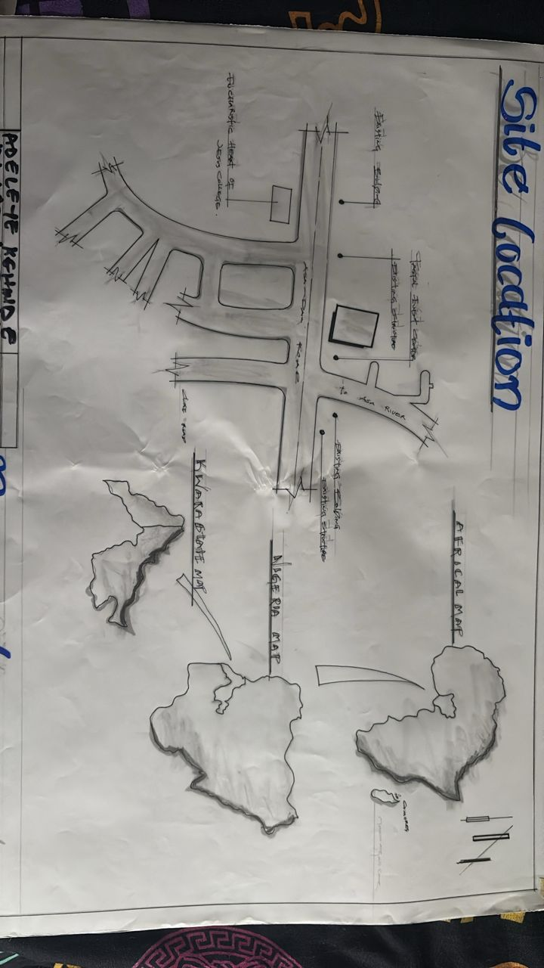
Site location
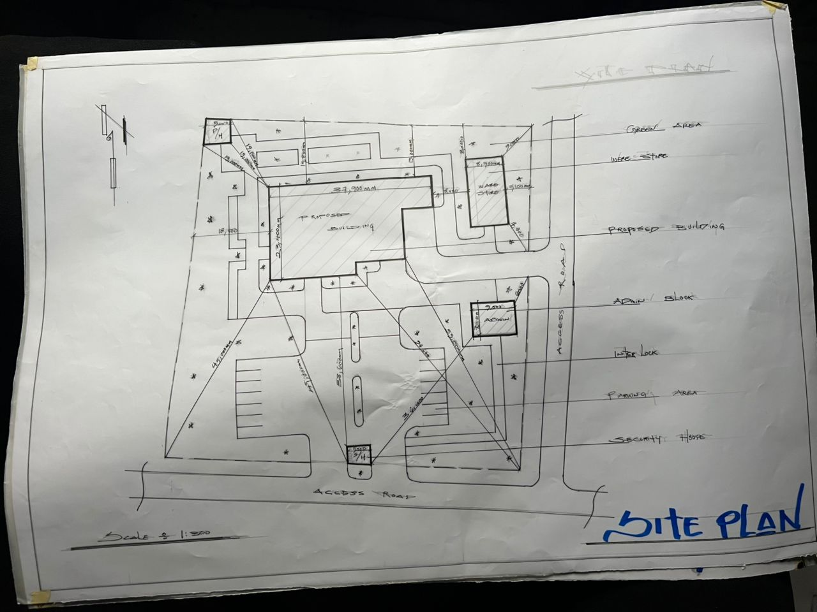
Site plan

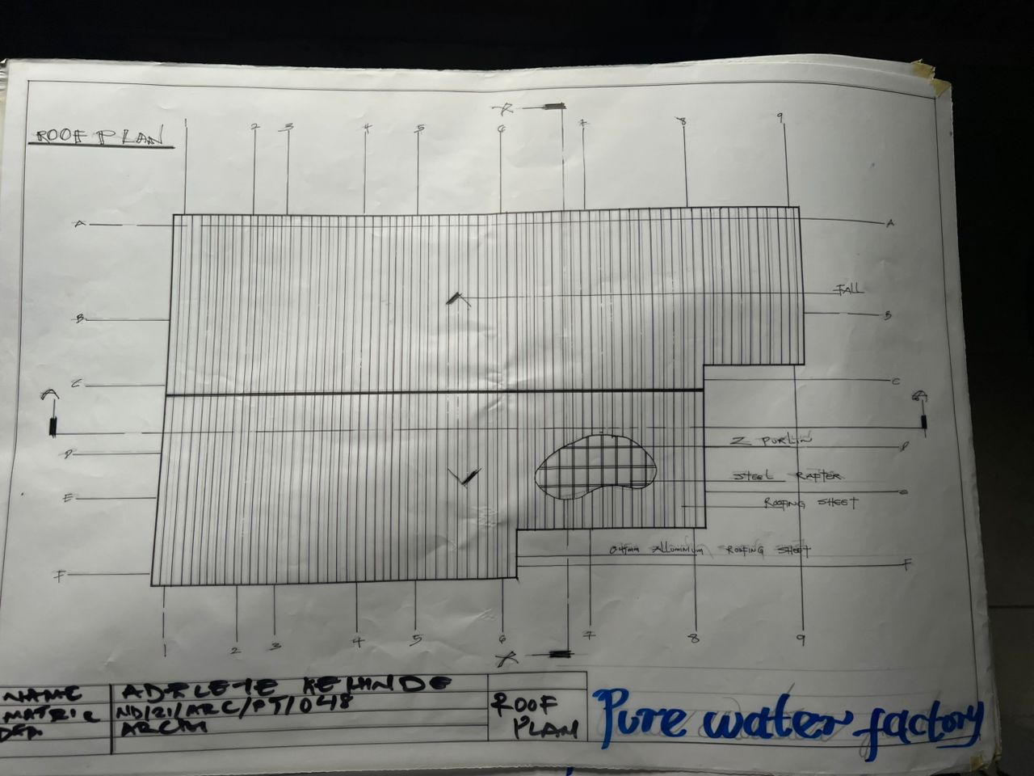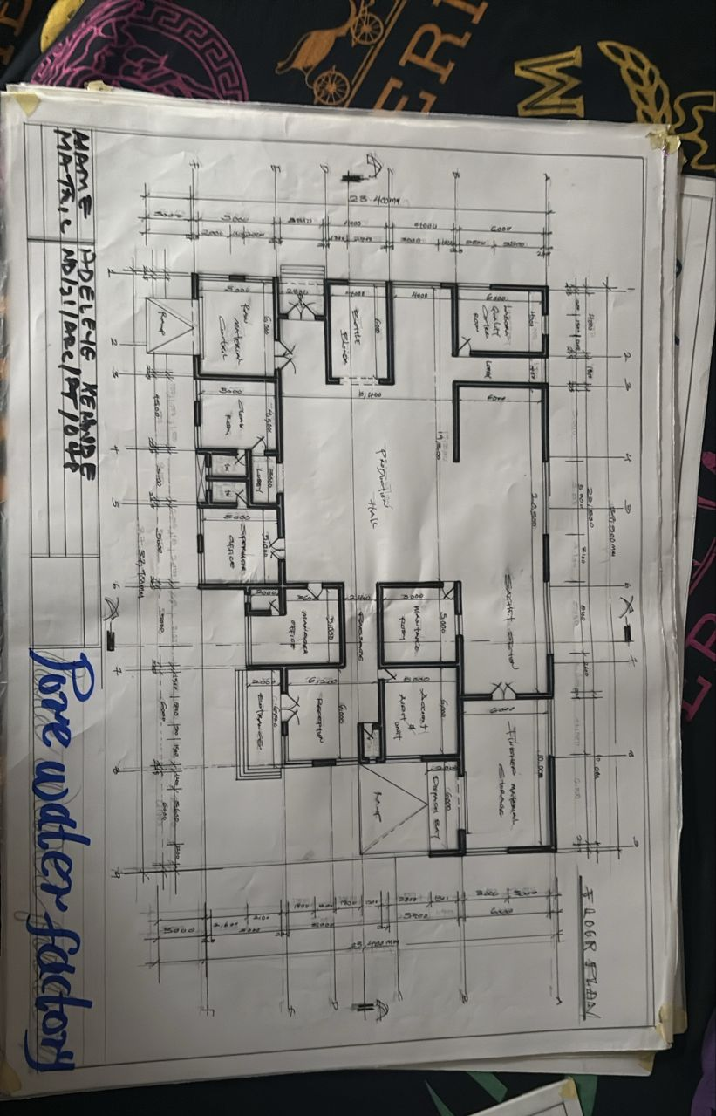
Floor Plan
Roof Plan
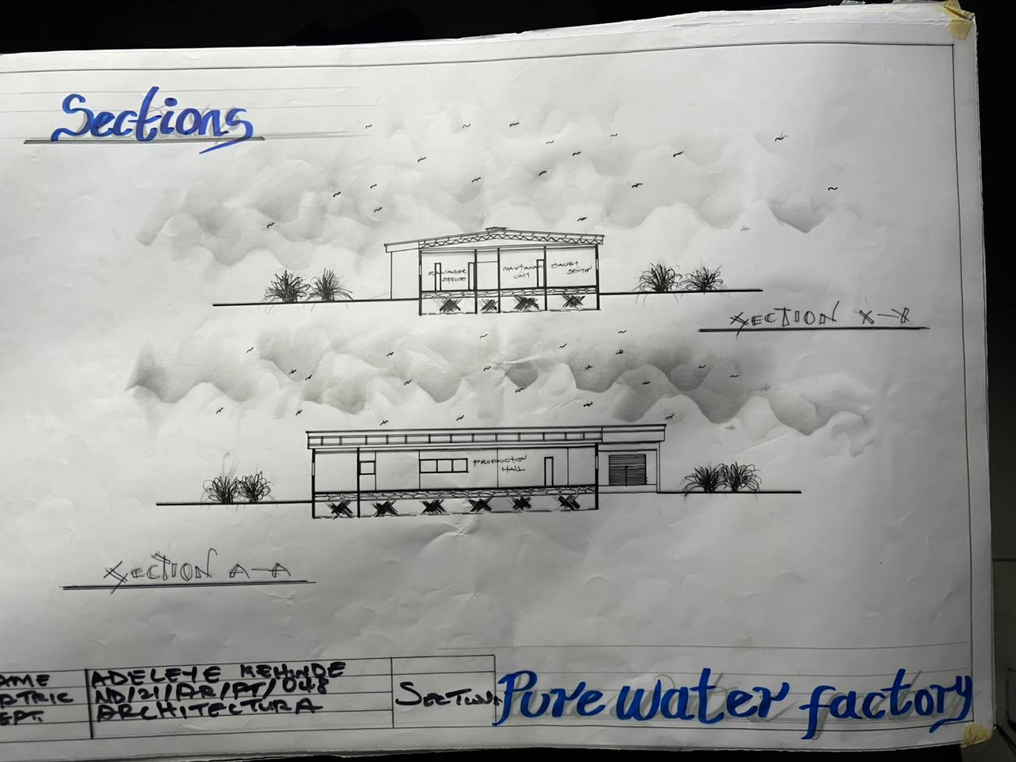
Sections
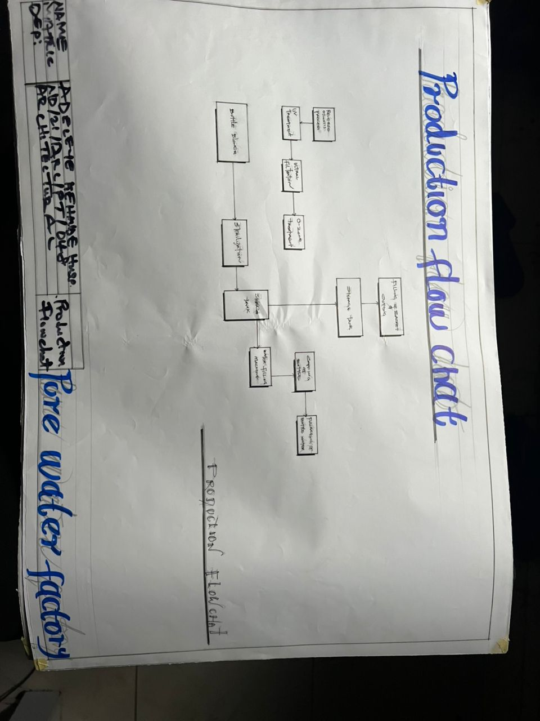
Flow chart

Design Concept

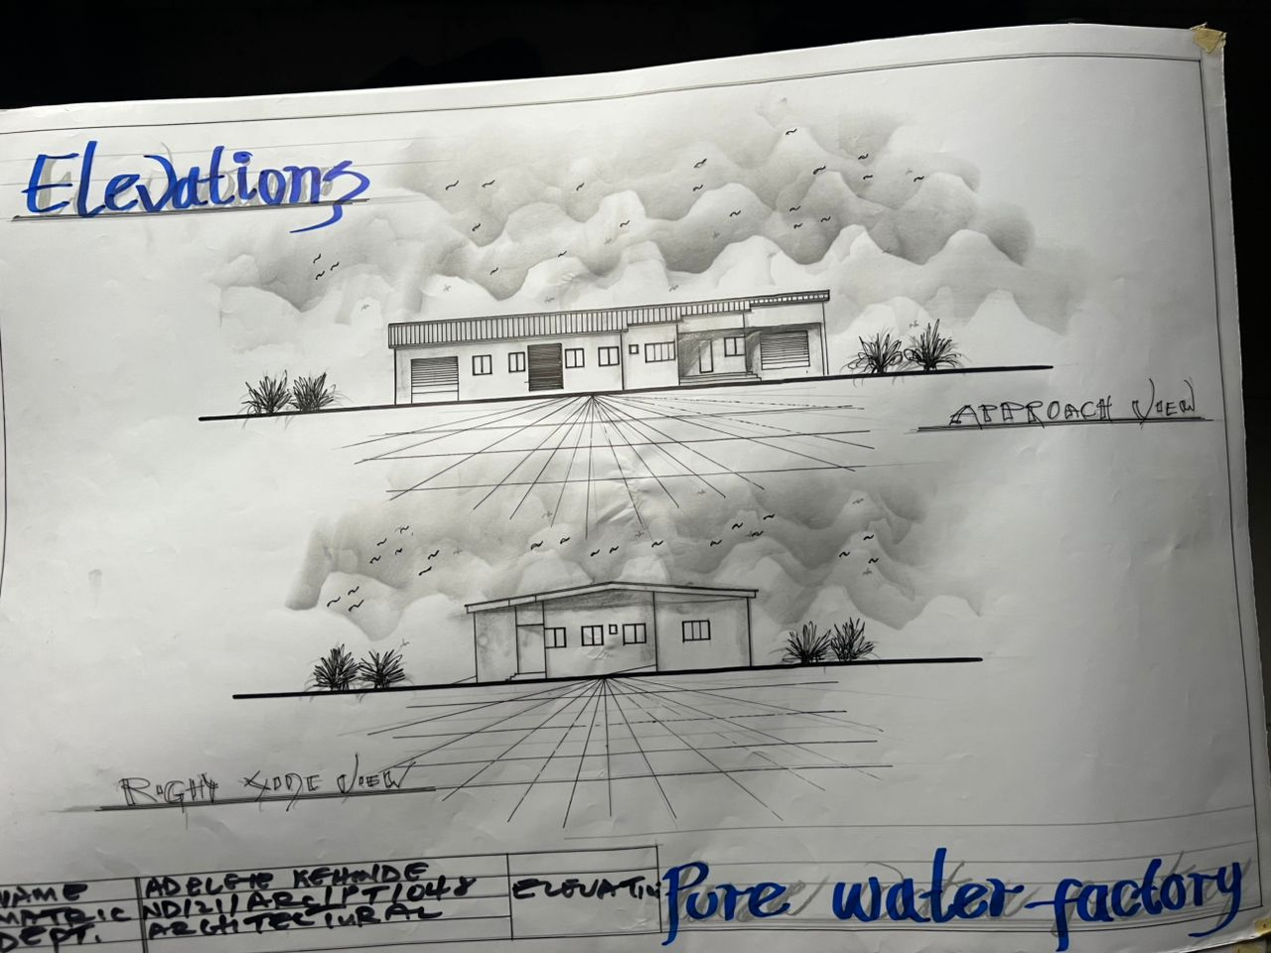
Elevation

Elevations

