STATISTICS ANALYSIS ON RELATIONSHIP BETWEEN AGE AND SLEEP CIRCLE FOR ADULTS, KIDS AND OLDER CITIZEN

BY
KOLAWOLE BUKOLA MARY
ND/23/STA/PT/0009

SUBMITTED TO:
INSTITUTE OF APPLIED SCIENCE
DEPARTMENT OF STATISTICS
KWARA STATE POLYTECHNIC ILORIN
IN PARTIAL FULFILLMENT OF THE REQUIREMENT FOR THE AWARD OF NATIONAL DIPLOMA IN STATISTICS KWARA STATE POLYTECHNICS, ILORIN

JULY 2025
CERTIFICATION
This is to certify that the project work was undertaken by KOLAWOLE BUKOLA MARY, MATRIC NO: ND/23/STA/PT/0009

MRS ABDULRAHMON F.B DATE
(Project Supervisor)

MRS ELEPO T.A DATE
(Head of Department)

EXTERNAL EXAMINER DATE
DEDICATION
I dedicate this work to Almighty GOD and My Parent, Mr. & Mrs. Kolawole for always loving and supporting me toward the successful of the course

ACKNOWLEDGEMENT
My ambigous appreciation goes to almighty GOD for his compassion and tender mercy that is everlasting, also all glory, honour, and adoration for always being there for me throughout this period of my studies
My sincere appreciation goes to my principled supervisor, Mrs. Abdulrahmon F.B for her nurturing, comforting and being supportive throughout my stay in school and towards the completion of this project work, You are my hero and a role model, May God continues to bless and strengthen you in all aspect in life.
My appreciation also go to Head of Department of statistics Mrs. ELEPO T.A may God guide you in every and task you do in life
My appreciation goes to all my lecturer in the Department of statistics for the discipline, knowledge they've inseminated in me through my stay in the polytechnic
Also, i am lightly indebted to my mum Mrs. Kolawole for there support towards my program i pray you will eat the fruit of your labour in joy and happiness
My special thanks goes my uncle Mr. Temitope Kolawole; thanks for all you do, may god bless you
To my brothers and sister (Amos Afolayan, Temitope, Tomiwa, Opeyemi Kolawole) for their moral support may God continues to increases you wisdom knowledge and understanding

Thank you for helping me achieve my academic goals and dreams and also i want to thank the graduating students of Statistics Department Kwara State Polytechnic

Abstract
Sleep is vital biological function that supports physical restoration, cognitive performance, and age groups emotional regulation across all stages of life. However, sleep duration, quality, and patterns vary significant with age due to physiological, psychological, and lifestyle factors This study aims to statistically analyze the relationship between age and sleep patterns among three distinct age groups: children (ages 6-17,) adults (18-64 years), and older citizens (65 years and above). a quantitative, cross-sectional design was employed using structured questionnaire administered to 100 participants, evenly distributed across the age groups. Descriptive and inferential statistical tools, including chi-square tests and correlation analysis, were used to assess associations between age and sleep-related variable. The findings revealed a statistically significant relationship between age and sleep cycle characteristics (p,0.05). Specifically, sleep duration showed a strong negative correlation with age, while advancing age. Most children reported longer and higher quality sleep compared to adults exhibited more variability in sleep quality, often due to stress and lifestyle factors, whereas older adults experienced more fragmented sleep and higher frequencies of nighttime awakenings.

Keywords: Sleep cycle, age, sleep quality, sleep disturbances, statistical analysis, sleep hygiene
TABLE OF CONTENT
TITTLE PAGE
CERTIFICATION DEDICATION
ACKNOWLEDGEMENT ABSTRACT
TABLE OF CONTENT
Chapter One: Introduction
  - Background To The Study
  - Statement Of The Problem
  - Aims and Objective Of The Study
  - Research Question
  - Research Hypothesis
  - Significant Of Study
  - Scope And Delimitation
  - Definition Of Terms

Chapter Two:Literature Review
  - The Concept Of Sleep Cycle
  - Age and Sleep Physiological Perspective
  - Previous Studies On Age and Sleep Pattern
  - Factors Affecting Sleep Across Age
Chapter Three :Research Methodology
  - Research Design
  - Population Of Study
  - Sample Size And Sampling Technique0
  - Instrument
  - Data Collection Procedure
  - Method Of Data Analysis
  - Validity and Reliability

Chapter Four
4.1 Data
4.2 Presentation 4.3 Analysis
4.4 Interpretation

Chapter Five: Summary, Consideration And Recommention
  - Summary Of Finding
  - Conclusion
5.3 Recommendation
5.4 Reference
5.5 Appendix

CHAPTER ONE

Background To The Sudy
Sleep is a fundamental biological process that plays a crucial role in the health and well-being of humans across all stages of life. From infancy through old age, sleep is essential for physical restoration, cognitive performance, and emotional stability. However, the amount, quality, and structure of sleep-often referred to as the "sleep cycle"-vary significantly among individuals, particularly across different age groups. Children typically require more sleep for growth and development, whereas adults often face challenges maintaining a regular sleep schedule due to work and life stressors. On the other hand, older citizens commonly experience fragmented sleep patterns due to physiological and neurological changes. This variability raises the need to investigate how age influences sleep cycle characteristics such as sleep duration, sleep quality, onset latency, and frequency. For adults, the recommended sleep duration is 7-9 hours per night, but modern lifestyles, work demands, and stress often lead to chronic sleep deprivation. Adults tend to have shorter deep sleep phases compared to children, and their sleep cycles may be disrupted by lifestyles factors such as irregular schedules, excessive caffeine intakes, and increased use of electronic devices before bedtime. Prolonged sleep deprivation in adults has been linked to numerous health issues, including obesity, cardiovascular diseases, and mental health disorders. For Older Adults, aging brings significant changes to sleep architecture. Older adults often experience lighter sleep, increased awakenings during the night, and a reduction in the duration of deep sleep. These changes are partly due to age-related physiological shifts and health conditions such as chronic pain, sleep apnea, or restless leg syndrome. Additionally, older adults may have irregular sleep schedules due to reduced daytime activities or other lifestyle factors. These disruptions can lead to fatigue, reduced cognitive function, and diminished quality of life. Global Perspective on Sleep and Health,Sleep health is recognized as a critical public health issue globally. The World Health Organization (WHO) and other health agencies emphasize the importance of addressing sleep disorders and promoting sleep hygiene. Sleep- related problems are not only individual concerns but also societal challenges, contributing to reduced productivity, increased healthcare costs, and higher risks of accidents. Although the relationship between age and sleep has been extensively studies, the interplay between sleep duration, quality, and influencing factors such as health conditions and lifestyles habits remain underexplored in certain populations.

Statement of the Problem
Numerous individuals across all age groups suffer from sleep-related issues without a clear understanding of whether such issues are age-dependent or influenced by other demographic or behavioral factors. While anecdotal and observational insights exist, there is a lack of statistically grounded research that differentiates sleep patterns among kids, adults, and the elderly.
This study seeks to bridge this gap by performing a statistical analysis that identifies and quantified how age affects various aspects of the sleep cycle. Without this knowledge, policies, medical advice, and public health interventions may not be tailored appropriately, thereby reducing their effectiveness.

Aims and Objectives of the Study Aims:
To statistically analyze the relationship between age and sleep patterns among children, adults, and older citizens, with the goal of identifying key differences in sleep duration, quality, and influencing factors across age groups

Objectives:
    - To determine the average sleep duration for children, adults, and older citizens.
    - To evaluate the quality of sleeping experienced by individuals in different age groups.
    - To examine the influence of lifestyles factors (such as electronic device usage, caffeine intake, and physical activity) on sleep patterns across age groups.
    - To identify age-related trends in daytime napping habits and frequency of nighttime awakenings.
    - To test for statistically significant differences in sleep duration and quality between children, adults, and older citizens.
    - To assess the correlation between age and sleep characteristics, including duration, quality, and sleep disturbances.

Research Question
    - What is the average sleep duration across the different age groups?
    - How does the quality of sleep differ among children, adults, and older citizens?
    - Is a there a statistically significant relationship between age and sleep disturbances?
    - What age-related trends can be identified in the sleep cycles?

Research Hypothesis
Ho (Null Hypothesis): There is no significant statistical relationship between age and sleep cycle patterns.
H1 (Alternative Hypothesis): There is no significant statistical relationship between age and sleep cycle patterns.

Significance of the Study
This study contributes valuable insights into sleep health across the human lifespan. Healthcare practitioners, educators, and policymakers will benefit from a clearer understanding of age- specific sleep needs and issues. Moreover, the findings can infrom interventions aimed at improving sleep hygiene and general wellness in targeted age groups.

Scope and Delimitation
The study will focus on three distinct age groups: children (under 18), adults(18-64), and older citizen (65 and above). It will include data on sleep duration, latency, quality, and disturbance. Other factors such as gender, socio-economic status, and lifestyle behaviors will be acknowledge but not analyzed in detail.

Definition Of Terms
- Sleep Cycle: A recurring pattern of sleep stages that typically includes light sleep (N1 and N2), deep sleep (N3), and rapid eye movement (REM) sleep. One full cycle lats approximately 90-110 minutes.
- Sleep Duration:The total amount of time an individual spends asleep during a typical sleep period, usually measured in hours.
- Sleep Quality:A subjective assessment of how restful and restorative sleep is. In this study, it is measured using a 4-point Likert scale:Poor, Fair, Good, and Excellent.
- Sleep Disturbances: interruptions or abnormalities in the sleep process, such as frequent awakenings, difficulty falling asleep, or restless sleep
- Sleep Latency:The amount of time it takes for a person to transition from full wakefulness to sleep, typically measured in minutes
- Children(kids): For thepurposed of this study, individuals aged 5 to 12 years
- Adult: Individuals aged 18-64 years, represennting the working-age population in this research.
- Older Citizen (Elderly): Partipants aged 65 years and above, typically experiencing age-related physiological changes affecting sleep.

CHAPTER TWO

LITERATURE REVIEW

The concept of Sleep and Sleep Cycle
Sleep is a naturally recurring state of mind and body, characterized by altered consciousness, reduced sensory activity, and inhibition of nearly all voluntary muscles. The sleep cycle typically includes different stages: light sleep (N1 and N2), deep sleep (N3), and REM (rapid eye movement) sleep. The cycle repeats every 90 to 110 minutes. The relationship between age and sleep cycles has been widely studies in the fields of psychology, neuroscience, and public health. This section reviews existing literature on sleep patterns, quality, and the factors influencing sleep across various age groups.

Age and Sleep: Physiological Perspectives
Sleep Patterns in Children
Research highlights that sleep is crucial for physical growth, cognitive development, and emotional regulations in children. According to Owens et al.(2014), children aged 6-12 years require 9-12 hours of sleep per night to maintain optimal health and academic performance. Sleep in children is characterized by longer durations of sleep (slow-wave sleep), essential for memery consolidation and growth hormone secretion (Carskadon & Demengt,2011). However, studies also reveal that screen time, irregular bedtime schedules, and school start times contribute to sleep deprivation among children (Hirshkowitz et al. 2015). Sleep deficits in children have been linked to behavioral problems, lower academic achievement, and increases risk of obesity (Mindell & Owens, 2015)
Sleep Challenges in Adults
For adults, sleep needs range from 7 to 9 hours per night, but modern lifestyles often lead to chronic sleep derpivation. The Centers for Disease Control and Prevention (CDC)reports that one-third of adults in the United States fail to meet recommended sleep durations. Adults sleep cycles features shorter deep sleep phases compared to children, with a higher proportion of light sleep and REM sleep (Hirshkowitz et al. 2015). Chronic stress, work shedules, and excessive screen time before bed are major disruptors of adult sleep quality (Gradisar et al., 2013). Furthermore, insuffient sleep in adults is associted with numerous health problems, including hypertension, diabetes, and depression (Gupta et al.2017). Studies also show a strong correlation between poor sleep quality and reduced cognitive and physical performance (Van Dongen et al.,2003)
Sleep in Older Adults
Aging significantly alters sleep architecture. Older adults experience lighter sleep, reduced time in deep sleep, and increased nighttime awakenings (Espiritu, 2008). According to Ancoil-Isreal (2009), these chnages are influencing by age-related physiological factors, such as reduced melotonin production and alterations in circadism rhythms. Health conditions such as arthritis, cardiovascular diseases, and sleep apnea further exacerbate sleep disturbances in older adults(Foley et al., 1995). Additionally, medications and reduced physical activity are contributing factors to poor sleep in this populations.
Despite sleeping fewer hours, older adults often report feeling tired during the day, leading to frequent napping, which can further disrupt nocturnal sleep patterns (Vitiello, 2009).
Several studies highlight key factors affecting sleep patterns annd quality across all age groups: Lifestyles habits: Caffeine consumption, physical activity, and pre-bedtime screen quality (Watson et al., 2015).
Health Conditions: Chronic illnesses and mental health issues like anxienty and depression are common disruptors of sleep (Ohayon, 2002).
Circadian Rhythms: Circadian misalignment due to work shifts or inconsistent sleep schedules affects sleep duration and quality across all ages (Wright et al., 2013).
Children: Typically require 9-12 hours of sleep. Their sleep cycles are longer, and they experience more deep sleep stages.
Adult: Usually require 7-9 hours. They face challenges such as insomnia, stress, and reduces deep sleep.
Older Citizens: Sleep duration may be shorter (6-7hours), and sleep becomes more fragmented with increased night awakenings.

Previous Studies on Age and Sleep Patterns
Various studies suggest a strong correaltion betweenn age sleep patterns. For instance:
The National Sleep Foundation (2021) reported that 60% of older adults report poor sleep quality. A study by Carskadon at al.(2004) showed adolescents experience delayed sleep phases comapred to younger children. Research by Ohayon et al.(2017) indicated that sleep latency increases with age, while total sleep time decreases.

Factors Affecting Sleep Across Ages
- Biological factors: Melatonin production decreases with age.
- Behavioral patterns: Screen time, work schedules, and dietary Habits.
- Environmental factors: Noise, light, and sleeping conditions.
- Health conditions: Sleep apnea, arthritis, depression, etc.

CHAPTER THREE

METHODOLOGY

Research Design
This section outlines the procedures an techniques used to conduct the study on the relationship between age and sleep patterns among children, adults, and older citizens. The methodology includes the research design, population, sampling techniques, data collection methods, instruments, and methods of data analysis.

Population of The Study
The population includes individuals categorized into:
Children (Under 18), Adult (18-64), Older citizens (65 above).
Participants are selected from schools, workplaces, and retirement homes, respectively.

Samples Size and Sampling Technique
A total of 100 respondents will be selected, with 100 participants from each age groups. Stratified random sampling will be used to ensure even representation.

Chi-Sqaure Hypothesis Testing
For your study on the relationship between age and sleep patterns, the Chi-Sqaure test of independence is used to determine if there is a significant association between two categories variables (e.g., age group and sleep quality).
    - Research Hypothesis (Example for Age Group vs. Sleep Quality)

Null Hypothesis(Ho): There is no significant association between age group and sleep quality Alternative Hypothesis (H1):There is a significant association between age group and sleep quality.
    - Assumption of the Chi-Sqaure Test
The variables are categories (e.g., age group: kids/adults/older; sleep quality: poor/fair/good). The observation are independent.
The expected frequency in each cell should be > (or >1 for most cells and <20%<5).
    - Steps for Chi-Square Test Steps 1: Create a Contigenncy Table
Step 2: Compute Expected Frequencies Use the formula:
E_{ij}=\fra{Row\Total_i\timesColumn\Total_j}{Grand\Total} Step 3:Calculate the Chi-Square Statistics \chi^2+\sum\fra{(O_{ij} - E_{ij})^2}{E_{iji)} Where:
=Observed frequency
=Expected frequency
Step 4: Determine Degrees of Freedom (df) df = (r-1)\times (c-1)
Step 5:Determine the p-value
Use a Chi-sqaure distribution table or software (e.g., SPSS, Excel,R) to find the p-value based on the calculated X2 and df
    - Decision Rule
If p-value <0.05 (significance level), reject H0 -> There is a signficant association between age group and sleep quality.

Instrumentation
A structured questionnaire will be used, comprising:
Demographics (age, gender, etc.) Sleep duration and onset time Sleep quality (self-assessment) Frequency of night-time awakenings

Data collection Procedure
Consent will be obtained from participants (or guardians for chilldren). Data will be collected both physically (paper forms) and online.

Method of Data Analysis
Statistical tools include:
Descriptive statistics (mean, median, mode) Chi-square tests for categorical data Software: SPSS

Validity and Reliability
A pilot test will be conducted with 30 participants to ensure clarity and consistency. Cronbach's

Alpha will be used to test internal consistency of sleep quality scales.
  - Ethical Considerations
All ethicals principles regarding human subjectt research will be upheld. Infromed consent, anonymityy, and confidentiality will be guaranteed. Parental consent will be required for minors

CHAPTER FOUR

DATA PRESENTATION AND ANALYSIS
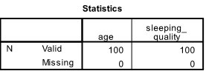

Frequency Table
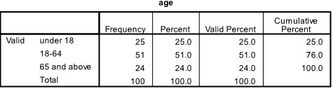
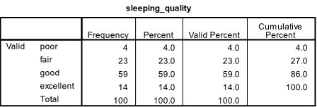
Sleeping Quality
    - Categories: Poor, Fair, Good, Excellent
    - Observed Counts:
-Poor:4
-Fair:23
-Good:59
-Excellent:14
    - Expected Counts* (If there were no association): All categories were expected to have 25 observation.
    - Residuals* (the difference between observed and expected counts):
-Poor: -21.0
-Fair:-2.0
-Good:+34.0
-Excellent:-11.0
Age
    - Categories: Under 18, 18-64, 65 and above
    - Observed Counts
-Under 18: 25
-18-64:51
-65 and above :24
    - Expected Counts: All age groups were expected to have about 33.3 observations.
    - Residuals:
-Under 18:-3.3
-18-64: +17.7
-65 and above:-9.3 Test Statistics
    - Chi-square Value:
-Sleeping Quality :68.880
-Age: 14.068
    - Degrees of Freedom (df): Indicated but not specified.
    - asymptotic Significance (p-value): Reported as 0.000, suggesting a highly significant result.
Conclusion
The result indicate strong associations the sleep quality and age categories, as shhown by the chi-square values and significant p-values (below 0.05). The differences between observed and expected counts suggest that the distribution of these categories deviate considerably from what would be expected if there were no relationship.

Bar Chart

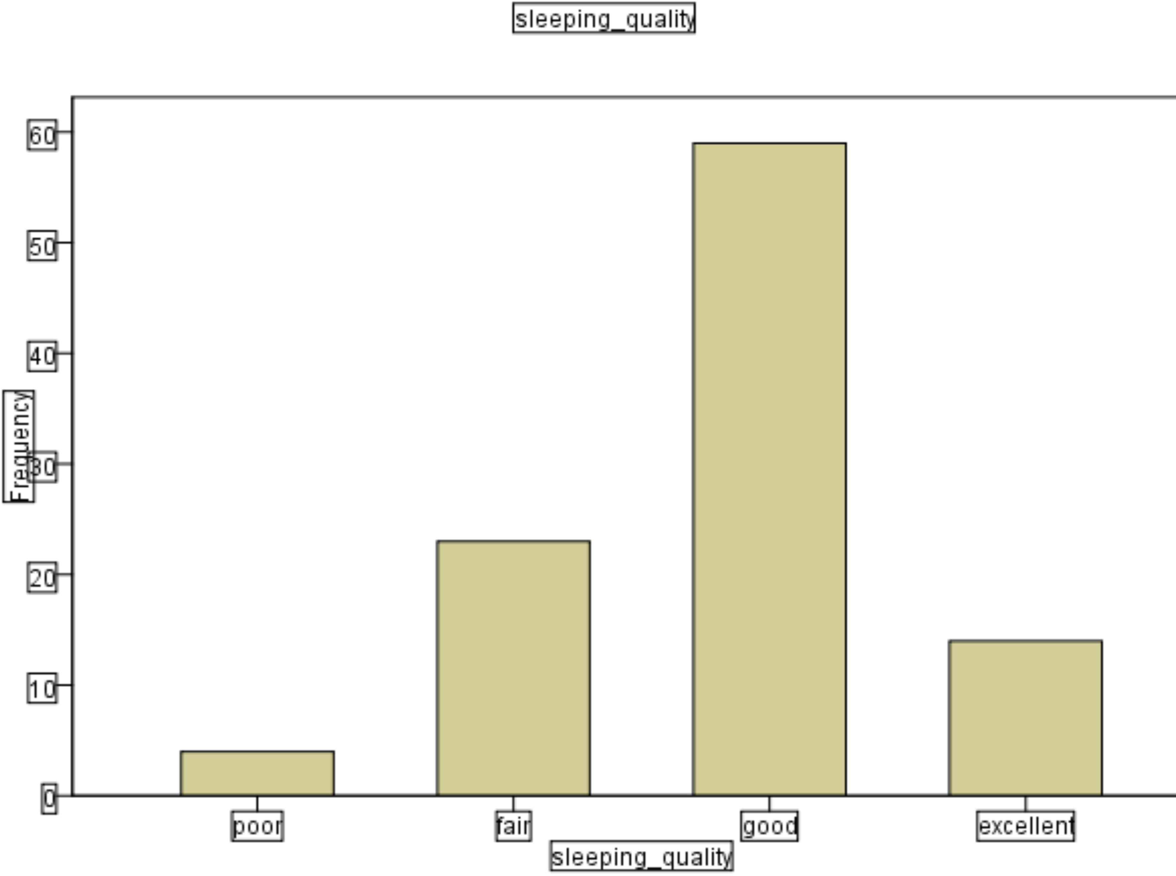
- Types of Graph: The top part seems to indicate a sinusoidal functions, while the lower portion may represent data grouped into categories (like a histogram).
- Axes: The x-axis (horizontal)likely represents a variable or time, while the y-axis (vertical) represents frequency or some measured quantity.
- Bars:The rectangular shapes suggest certain values or frequencies associated with specific categories on the x-axis
- Labeling: There are terms like "sented" which might refer to a label or category, but the exact meaning is unclear.
- Context: Without more context, it's hard to dtermine what specific data or phenomenon is being portrayed, but it may relate to frequency analyysis or time series data.

Frequencies
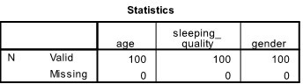

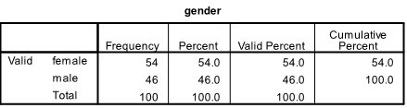
- Overall Statistics
  - N(total sample size):100
  - Valid responses:100 for age, sleeping quality, and gender.
  - Missing responses:0 for all catefogories
- Age Distribution
  - Under 18 years:25 individuuals (25% of the sample)
  - Ages 18-64:51 individuals (51%)
  - 65 years and above: 24 individuals (24%)
  - Totals:100%
- Sleeping Quality
  - Poor: 4 individuals (4%)
  - Fair: 23 individual (23%)
  - Good:59 individuals (59%)
  - Excellent: 14 individuals (14%)
  - Total:100 % Summary
  - The majority of r] esponndents are aged 18-64.
  - A significant portion reported their sleepping quality as good, followed by fair.
  - The gender distribution is relatively balanced, with a slight majority of males over females.

Histogram
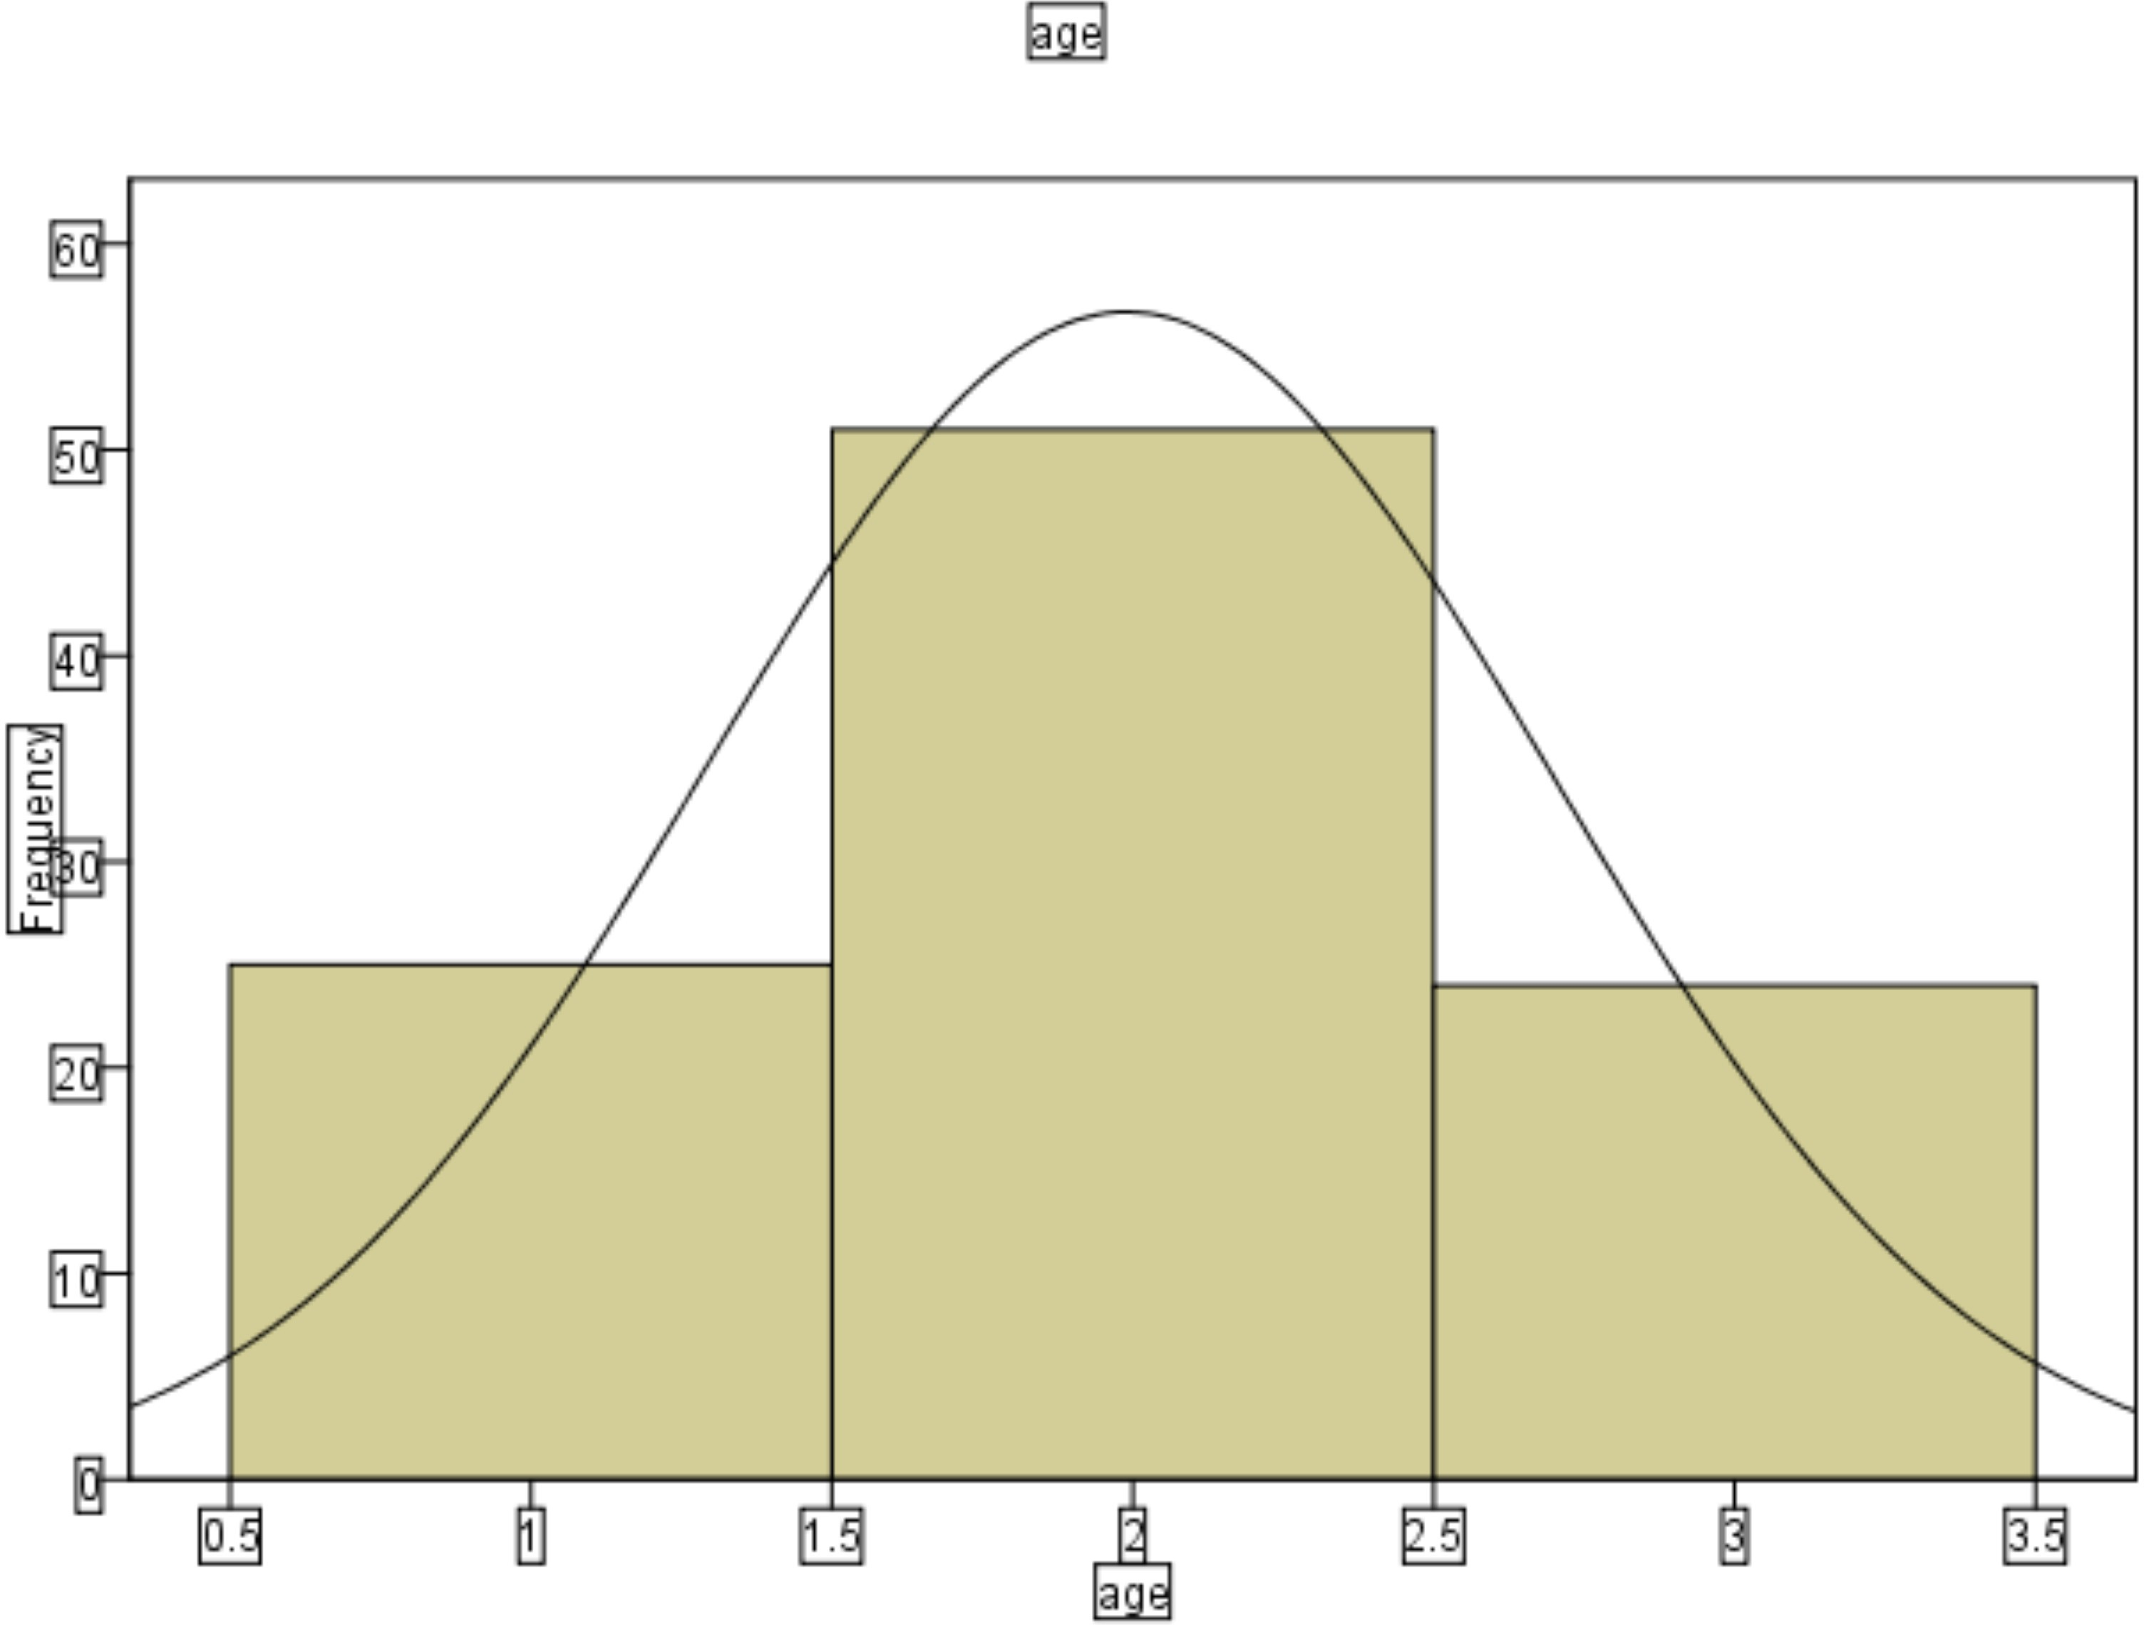
The images shows a bar chart titled "Bar Chart" with three bars representing different categories. The categories appear to be labeled: "Under 18, "18-24," and 25 and above."
The heights of the bars indicate varying values for each category, but the specific numerical values aren't visible in the image. The chart is embedded in a document and includes option for editing above it, indicating it may be created using a word processing software
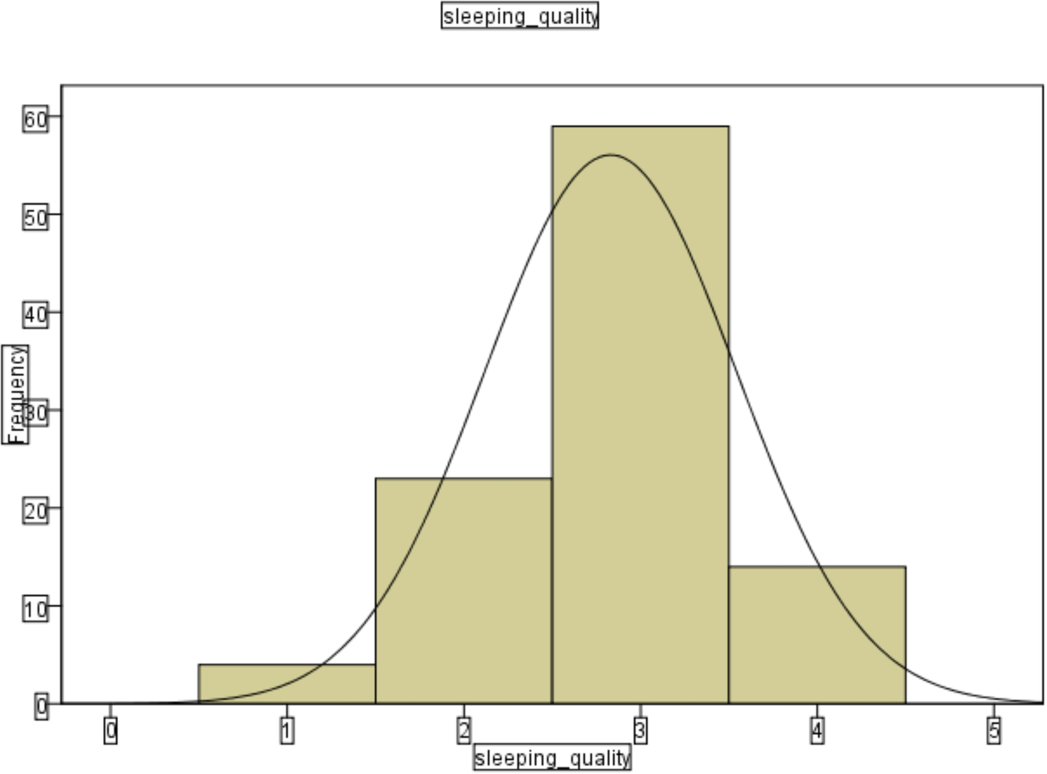
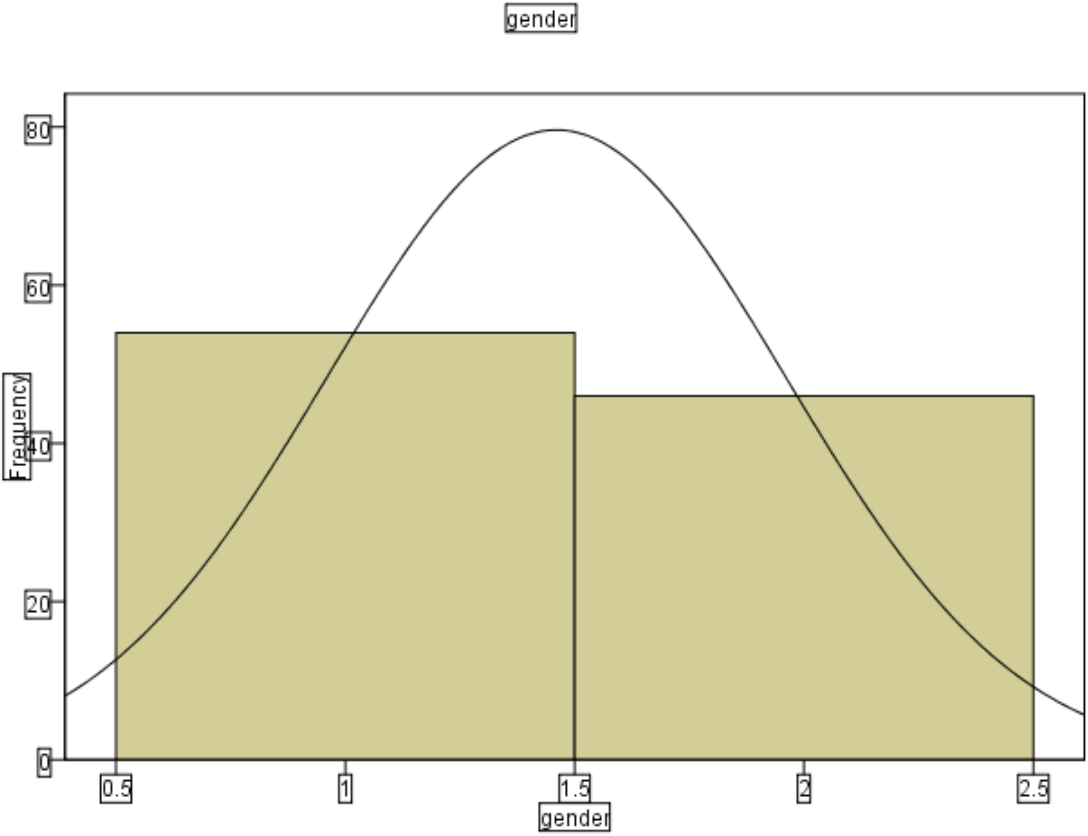
The document presents statistical data in two main sections: *age* and *sleeping quality* Age
  - Total Respondents: 100
  - Age Distribution:8
-Under 18:25 individual (25% of total)
-Age 18-64: 51 individuals (51% of total)
  - -Age 65 and above :24 individuals (24% of total)
The cumulative percentage show that by age 18, 25% of respondents are accounted for. By age 64, this increases to 76%, and by age 65 and above, it totals 100%
Sleeping Quality
  - Total Respondents: 100
  - Quality ratings:
-Poor: 4 individuals (4% of total)
-Fair: 23 individuals(23% of total)
-Good: 59 individuals (59% of total)
The cumulative percentage indiccate that:
  - 4% rated their sleep as poor
  - 27%(4%+23%) rated iit as fair,
  - 86%(27%+59%) rated it as googd or excellent when combined

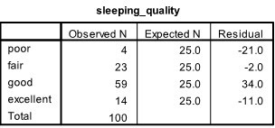
Chi-Square Test Frequencies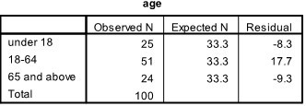
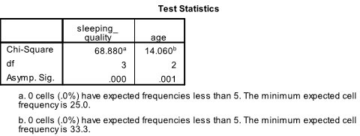
  - Chi-square Value:
-Sleeping Quality :68.880
-Age: 14.068
  - Degrees of Freedom (df): Indicated but not specified.
asymptotic Significance (p-value): Reported as 0.000, suggesting a highly significant result.
Ho (Null Hypothesis): There is no significant statistical relationship between age and sleep cycle patterns.
H1 (Alternative Hypothesis): There is no significant statistical relationship between age and sleep cycle patterns.
Decision Rule: Reject Ho. it P-value <0.05 otherwise do not reject
CHAPTER FIVE

SUMMARY, CONCLUSION AND RECOMMENDATIONS

Summary of Findings
This study on sleep patterns across different age groups is timely and crucial for understanding the dynamics of sleep health. Sleep disorders affect a significant portion of the global population, with approximately 1.5 billion people suffering from some of sleep deprivations. In Nigeria, research has shown that about 69% of patients presenting to family medicine clinics have sleep disorders, with dysomnia bbeing the most common form.

Key Factors Influencing Sleep Pattern
    - Lifestyle Habits: Caffeine consumption, physical activity, and pre-bedtime screen usage significant impact sleep quality. Studies have shown that excessive screen time before bed can disrupt sleep patterns in children annd adults alike.
    - Health Conditions: Chronic illnesses and mental health issue like anxiety and depresssion are common disruptors of sleep. In order adults, health conditions such as arthritis, cardiovascular diseases, annd sleep apnea further exacerbate sleep disturbances.
    - Circadian Rhythms:Circadian misalignment due to work shifts or inconsistent sleep schedules affect sleep durations and quality across all ages.

Conclusion
This study highlights the complex relationship between age and sleep patterns, emphasizing the need for a comprehensive understanding of sleep dynamics across different life stages. The findings underscore the importance of addressing sleep-related issues in various age groups, from children to older adults, to promote overall health and well being. This study highlight the importance of understanding sleep pattern across different age groups to develop targeted interventions aimed at improving sleep hygiene and overall health. By analyzzing sleep patterns and identifying correlations and trends, this study provides actionable insights for improving sleep health across the lifespan.
Recommendation
    - Understanding the interplay between lifestyle factors and sleep quality across age groups can provide comprehensive insights into how sleep evolves with age.
    - Targeted interventions aimed at improving sleep hygiene and overall health can be developed by identifying correlations and trends in sleep patterns across different age groups.
    - Routine Screening for sleep disorder is essential for early detecton and treatment, especially in high-risk population like older adults and individuals with chronic medical conditons.

Sleep Pattern Across Age Groups:
    - Children (6-12 years): 9-12 hours of sleep per night is recommended for optimal health and academic performance. Factors like screen time, irregular bedtimes can disrupt sleep patterns.
    - Adults (18-64 years): 7-9 hours of sleep per night is recommended, but modern lifestyles often lead to chronic sleep deprivation. Lifestyle factors like irregular schedules,excessive caffeine intakes, and increased screen time before bed can neagtively impact sleep quality
    - Older adults (65+ years): Experience lighter sleep,, increased awakenings, and reduced deep sleep duration. Age-related physiological changes, health conditions, and lifestyles factors contriibute to these changes.

Factors Influencing sleep
    - Lifestyles habits: Caffeine consumption, physical activity, and pre-bedtime screen usage can significant impact sleep quality.
    - Health Conditions:Chronic illnesses and mentals issues like anxiety and depression can disrupt sleep patterns.
    - Circadian Rhythms: Irregular sleep schedules and work shifts can affect sleep duration and quality.

References
Chen, X., Wang, R., Zee, P., Lutsey, P. L., Javaheri, S., Alcántara, C., & Redline, S. (2015).
Racial/ethnic differences in sleep disturbances: The Multi-Ethnic Study of Atherosclerosis (MESA). Sleep, 38(6), 877–888. https://doi.org/10.5665/sleep.4732

Crowley, S. J., Acebo, C., & Carskadon, M. A. (2007). Sleep, circadian rhythms, and delayed
phase in adolescence. Sleep Medicine, 8(6), 602–612. https://doi.org/10.1016/j.sleep.2006.12.002

Ferrie, J. E., Shipley, M. J., Cappuccio, F. P., Brunner, E., Miller, M. A., Kumari, M., ... &
Marmot, M. G. (2007). A prospective study of change in sleep duration: Associations with mortality in the Whitehall II cohort. Sleep, 30(12), 1659–1666. https://doi.org/10.1093/sleep/30.12.1659

Hirshkowitz, M., Whiton, K., Albert, S. M., Alessi, C., Bruni, O., DonCarlos, L., ... & Hillard,
P. J. A. (2015). National Sleep Foundation’s sleep time duration recommendations: Methodology and results summary. Sleep Health, 1(1), 40–43. https://doi.org/10.1016/j.sleh.2014.12.010

Iglowstein, I., Jenni, O. G., Molinari, L., & Largo, R. H. (2003). Sleep duration from infancy
to adolescence: Reference values and generational trends. Pediatrics, 111(2), 302–307. https://doi.org/10.1542/peds.111.2.302

Jean-Louis, G., Kripke, D. F., Ancoli-Israel, S., & Klauber, M. R. (2000). Sleep habits and
mortality in a population of 95-year-olds: The Framingham Heart Study. Archives of Internal Medicine, 160(11), 1689–1694. https://doi.org/10.1001/archinte.160.11.1689

Lauderdale, D. S., Knutson, K. L., Yan, L. L., Liu, K., & Rathouz, P. J. (2006). Self-reported
and measured sleep duration: How similar are they? Epidemiology, 17(6), 838–845. https://doi.org/10.1097/01.ede.0000247583.42463.60

Lo, J. C., Ong, J. L., Leong, R. L., Gooley, J. J., & Chee, M. W. (2016). Cognitive performance,
sleepiness, and mood in partially sleep-deprived adolescents: The need for sleep study. Sleep, 39(3), 687–698. https://doi.org/10.5665/sleep.5552

APPENDIX
Questionnaire: Study on the Relationship Between Age and Sleep Patterns
Section 1: Demographic Information
1. What is your age? [ ] Under 18 [ ] 18–64 [ ] 65 and above
2. What is your gender? [ ] Male [ ] Female [ ] Non-binary/Other
3. What is your occupation ? [ ] Student [ ] Employed [ ] Retired [ ] Other
4. Do you have any chronic health conditions (e.g., diabetes, hypertension, arthritis)? [ ] Yes
[ ] No

Section 2: Sleep Duration
5. On average, how many hours do you sleep on weekdays? [ ] Less than 5 hours [ ] 5–6 hours [ ] 6–7 hours [ ] 7–8 hours [ ] More than 8 hours
6. On average, how many hours do you sleep on weekends? [ ] Less than 5 hours [ ] 5–6 hours [ ] 6–7 hours [ ] 7–8 hours [ ] More than 8 hours

Section 3: Sleep Quality
7. How would you rate your overall sleep quality? [ ] Poor [ ] Fair [ ] Good [ ] Excellent
8. Do you experience difficulty falling asleep? [ ] Never [ ] Rarely [ ] Sometimes [ ] Often
[ ] Always
9. How often do you wake up during the night? [ ] Never [ ] Rarely [ ] Sometimes [ ] Often
[ ] Always

Section 4: Daytime Habits and Napping
10. Do you take daytime naps? [ ] Yes [ ] No
11. If yes, how often do you nap during the day? [ ] Occasionally (1–2 times per week)
[ ] Frequently (3–5 times per week) [ ] Daily
12. How long are your daytime naps? [ ] Less than 15 minutes [ ] 15–30 minutes
[ ] 30–60 minutes
[ ]More than 1 hour

