MODELLING OF AUTOMATED RAILWAY LEVEL CROSSING SYSTEM

BY
LADIPO HANNAH TOYIN
ND/23/RWE/PT/0004

A PROJECT REPORT SUBMITTED TO THE
DEPARTMENT OF RAILWAY ENGINEERING, INSTITUTE OF TECHNOLOGY (IOT) KWARA STATE POLYTECHNIC,
ILORIN.
IN PARTIAL FULFILMENT OF THE REQUIREMENTS FOR THE AWARD OF NATIONAL DIPLOMA (ND) IN RAILWAY ENGINEERING

AUGUST, 2025

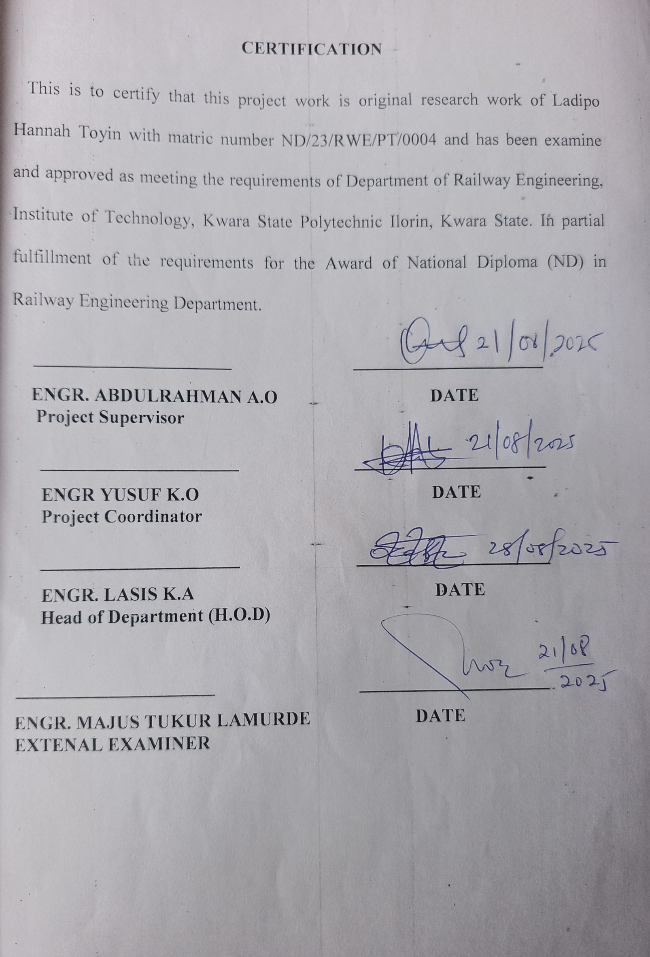

DEDICATION
This project is dedicated to Almighty God. And to my lovely parents and guidance for their financial support.

ACKNOWLEDGEMENT
My profound gratitude goes to God Almighty for the guidance, grace throughout my life, for protecting my life throughout my stay in the institution, and for His wisdom and knowledge given to me during the research exercises.
Firstly, I am grateful to my supervisor, ENGR Aliyu Abudulraman for his immense contribution to the success of this project. Also to the entire Railway Engineering Department headed by ENGR Lasisi Kehinde
I wish to express my profound gratitude to my parents and entire families for their exceptional support, may God in his infinites mercy continue to bless them for me.
I will not fail to express my gratitude to my good friends in school, and also to all my course mates who in one way or the other identified with me during the arduous task, may God in his infinite mercy reward you.

ABSTRACT
The increasing rate of accidents of unmanned or manually operated railway level crossings has become a serious safety concern in many countries. This project presents the design and implementation of an Automated Railway Level Crossing System aimed at enhancing safety, reducing human error, and ensuring efficient train-road coordination. The system utilizes a microcontroller-based platform integrated with infrared and ultrasonic sensors to detect the presence and movement of trains. Upon detection, the system automatically activates warning lights, sound alarms, and controls the opening and closing of the railway gate using a motor-driven mechanism.
A solar-powered backup ensures uninterrupted operation in areas with unstable electricity supply, while manual override features are included for emergency control. The system was tested under simulated and real-world conditions and demonstrated reliable and timely performance with accurate detection, prompt gate response, and robust fail-safe behavior.
The results indicate that automating railway level crossings significantly improves safety, particularly in rural or high-risk areas, while also reducing the dependency on human operation. This project not only contributes to public safety but also offers a cost-effective and scalable solution for modern railway infrastructure.

TABLE OF CONTENTS
Table of Contents
Title page
Certification
Dedication
Acknowledgement
Abstract
Chapter One
1.0 Introduction
1.1 Background of the Study
1.2 Aim and Objectives
1.3 Problem Statement
1.4 Justification
1.5 Scope of Work
Chapter Two
2.0 Literature Review
2.1 Overview of Railway Level Crossing System
2.2 Automation of Sensor Based System
2.3 Micro Controller Based Control System
2.4 Integration of Traffic Signals and Safety Features
2.5 Gaps in Existing Research
2.6 Summary of Literature Insights
Chapter Three
3.0 Materials and Methodology
3.1 Preamble
3.2 Materials and Their Sources in Ilorin
3.3 Research Procedure
Chapter Four
4.0 Data Presentation Analysis and Discussion of Findings
4.1 Summary of Key Functional Results
4.2 System Operation Breakdown
4.3 Achievement of Objectives
4.4 Observations and Limitations
4.5 Recommendations for Enhancement
Chapter Five
5.0. Conclusion and Recommendations
5.1 Conclusions
5.2 Recommendations
References

CHAPTERONE
INTRODUCTION
1.1 BACKGROUND TO THE STUDY
Railway Transportation is one of the most commonly used modes of transport around the world due to its affordability and capacity form as movement. It remains one of the most efficient and widely used modes of transport around the world, particularly for long-distance travel and the movement of heavy goods. However, one of the persistent safety challenges in this sector is the occurrences of accidents at railway level crossings, especially those that are unmanned. In many developing countries, a significant number of these crossings do not have attendants, warning systems, or automated gates. Railway level crossings are critical junctures in transportation networks where railway lines intersect with roads or pedestrian pathways. (Singh and Sharma, 2018).
Historically, these crossings have been managed manually or semi-automatically, often relying on human gatekeepers and mechanical systems. While railways offer an efficient and economical mode of transport, the points where they intersect with other traffic are also some of the most hazardous, increasing urbanization, vehicle usage, and rail traffic have heightened the need for safer and more reliable crossing systems. (Akinyemi,2020)
Traditional manual or semi-automated systems of ten lead to delays, human errors, and in some cases, tragic accidents. This hassled to an increasing demand for automated railway level crossing systems that can improve safety and efficiency. Beyond reducing accidents, automated crossing improves public trust in railways systems, minimizing the likelihood of human error, enhance traffic low, and reduce transportation delays. (Balakrishnan and Ahamed2018)

1.2 AIM AND OBJECTIVES
The aims is to develop an automated railway level crossing system using basic electronics and micro-controller programming to provide a more reliable and safer method of managing rail-road intersection.
The objectives of this study are:
- Stimulate an automated level crossing barrier system using Arduino
- Detect approaching and departing train using ultrasonic sensors.
- Automatically operates barriers gates and traffic signals
- Improve railway crossing safety and reduce human errors
1.3 PROBLEM STATEMENT
Railway transportation remains a vital mode of movement for passengers and freights across many nations due to its cost-effectiveness and efficiency.
However, one of the most critical safety concerns associated with this mode of transport is the high incidence of accidents at railway level crossings.
According to the international Union of Railways (UIC,2021), level crossing accidents accounts for a significant proportion of all rail-related fatalities worldwide . In many developing countries, these incidents are even more prevalent due to the presence of unmanned or poorly managed crossings. (International Union of Railways (UIC), 2021)
1.4 JUSTIFICATION
Railway level crossings serve as critical interfaces between rail and road networks. However, these crossing also pose serious risks to human life and property due to the potential of accidents involving trains, vehicles, and pedestrians. In many parts of the world, particularly in developing countries, numerous level crossings remain either unmanned or rely heavily on manual operation. These outdated methods expose the system to severe limitations, such as delayed responses, inconsistent operation, and a complete lack of safety measures during emergencies or system failure. (Network Rail UK 2020)
1.5 SCOPE OF WORK
This focuses on the design, construction, and demonstration of an automated railway level crossing system aimed at improving safety and operational efficiency at railway-road intersections. The system replaces manual or unguarded crossing operations with fully automated, sensor-based mechanism. The scope encompasses both the hardware and software aspects of system development and covers key features such as train detection, automatic gate control, warning systems, and prototype testing.
Train Detection System
The system will implement a sensor-based train detection mechanism to identify the presence of an oncoming or departing train. This includes:
Using infrared (IR) or ultrasonic sensors positioned along the railway track.
Detecting a train from a predetermined distance before it reaches the crossing.
Microcontroller-Based Control Unit
At the core of the system is programmable microcontroller (e.g. Arduino Uno), which will:
Receive input from sensors.
Process the input signals to determine the status (approaching, passing, or departed).

Automated Gate Mechanism
It includes a mechanized gate control system to open and close the railway crossing gate automatically. This includes:
A DC motor or servo motor to physically operates the gate barrier.
Smooth, timely lowering of the gate when a train is approaching.
Full gate closure while the train is crossing.
Source: International Journal of Scientific and Engineering Research,Vol9,issue

CHAPTER TWO
LITERATURE REVIEW
2.1 OVERVIEW OF RAILWAY LEVEL CROSSING SYSTEM
A railway level crossing is a point where a railway track and a road or footpath intersects at the same level, rather than using a bridge or tunnel. These crossings are essential for ensuring that trains and roads users can safely coexisting shared transport environments. Indian Ministry of Railways, 2018; UIC Level Crossing Safety Guidelines, 2019.
PURPOSE OF RAILWAY LEVEL CROSSINGS
- Prevent accidents by separating road and rail traffic through controlled interaction.
- Enable safe and efficient movement of people and goods.
- Provide necessary infrastructure in areas where building bridges or under passes is not economically feasible. World Bank Report on Railway Safety, 2017; FRA Level Crossing Safety Overview, 2021.
TYPES OF LEVEL CROSSING SYSTEMS
- Passive Crossings No active warning system; only signboards are present.
- Manually Controlled Crossings-Operated by gate keepers using signals and levers.
- Semi-Automated Crossings–Sensors alert gate operators who then manually activate barriers.
- Fully Automated Crossings–Train activated sensors control all signals and barrier movement. Rajalakshmi M. etal., 2017, IJAREEIE; International Union of Railways (UIC), 2019.

KEY COMPONENTS OF RAILWAY LEVEL CROSSING SYSTEM
- Boom barriers/gates: Blocks vehicular access during train passage.
- Flashing lights and sirens: Visual and audio alerts for road users.
- Sensors (IR, Ultrasonic, magnetic): Detect approaching trains.
- Micro controller/PLC: Coordinates system logic and operations.
- Power source: Typically grid, with solar backup in rural areas.Vigneshk, Gowtham S., 2020, IRJET; IEEEX plore, 2021.
AUTOMATIONINRAILWAYCROSSINGS
Modern systems rely on:
- Micro controllers (e.g., Arduino, AT mega 328) or PLCs for control logic.
- Sensor networks to detect train approach, speed, and direction.
- IoT-based monitoring and GSM modules for remote alerts. Chavan & Gharat, 2019; Zhang etal., 2019, IJRR.

WORKING PRINCIPLE OF AUTOMATED CROSSINGS
- Train is detected by sensor (e.g., IR, magnetic 0.
- Warning lights and alarms activate.
- Barriers lower automatically before train reaches crossing.
- After the train passes, the system deactivates and barriers rise. Sharma & Patel, 2018, IJERT; Indian railway RDSO Guidelines, 2021.
ADVANTAGES OF AUTOMATED SYSTEMS
- Improved safety and reduced human dependency.
- Faster barrier response and accurate detection of trains.
- Lower operational cost over time.
- Compatible with renewable energy (solar systems). IEEE1473-R Railway Control Systems, 2020; ISO13849 Functional Safety Standards.

2.2 AUTOMATION AND SENSOR-BASED SYSTEM
Automation refers to the users to the use of control systems (e.g., computers, micro controllers, PLCs) and sensors to operates crossing gates, lights, and alarms without human intervention. Rajalakshmi etal., 2017, International Journal of Advanced Research in Electrical, Electronics and Instrumentation Engineering.
IMPORTANCE OF SENSOR-BASED AUTOMATION
- Enhances public safety by reducing human error.
- Provides real-time response to train approach.
- Allows 24/7 operation without manpower. K.Vignesh, S.Gowtham (2020). Sensor-Based Railway Gate Automation, International Research Journal of Engineering and Technology (IRJET).

COMMON TYPES OF SENSORS USED
Sensor Type | Function | Application
IR Sensor | Detects interruption by train | For basic train presence detection
Ultrasonic Sensor | Measures distance to object | For Train speed and approach detection
Magnetic Sensor (Hall Effect) | Detects large metal objects | For under – track detection
Pressure Sensor | Detects Weight on track | Used in rail-bed embedded systems
RFID/GPS | Identifies specific trainID/location | Used in smart and IoT-enabled systems
Zhang, L. etal. (2019). Smart Railway Crossing System. IJRR.
HOW SENSOR BASED AUTOMATION WORKS
- Sensor detects approaching train.
- Signal sent to micro controller or PLC.
- Logic Triggers:
- LED flashing lights
- Sound alarm
- Boom barriers motor control
- After train passes and track is clear, system resets.
S. Sharma & P. Patel (2018). Smart Railway Gate System. IJERT.
SAFETYANDREGULATORYSTANDARDS
- IEE1473-R: Railway communications and control. EN50126/50128/50129: Functional safety and system reliability.
- ISO13849: Safety of control systems. ISO Standards Portal; IEEE Rail Safety Standards.

2.3 MICRO CONTROLLER BASED CONTROL SYSTEM
This project presents the design and implementation of a micro controller-based control system that automates gate operations, warning signals, and train detection using sensors. The system uses an Arduino micro controller to process sensor data and control barrier movement, improving safety, efficiency, and reliability in railway-road inter sections. The implementation ensures that gates close automatically when a train is detected and open when the track is clear, with visual and audio alerts for road users. Traditionally, these crossings have been manually controlled, often leading to delays and accidents due to human negligence or slow reaction times. With advances in automation, micro controller-based systems can now monitor train movement and control the crossing gates automatically. This project aims to build such a system using affordable components such as Arduino, IR sensors, servomotors, and buzzers. Sharma, R. etal. (2020). “Automatic Railway Gate Control using Arduino,” International Journal of Engineering Research & Technology.
SYSTEMCOMPONENTS
- Micro controller: Arduino Uno (AT mega 328P)
- Sensors: Infrared (IR) or ultrasonic sensors for train detection
- Motor Driver: L298N module for motor control
- Barrier System: Servomotor or DC motor-driven boom gate
- Alert Mechanism: Buzzer and LEDs
- Power Supply: 9V battery or solar-powered unit
Mazidi, M.A. etal. (2010). The 8051 Micro controller and Embedded Systems. Pearson Education.

2.4 INTEGRATION OF TRAFFIC SIGNALS AND SAFETY FEATURES
- To Minimize Human Error and Manual Intervention: Automate the control of railway level crossing barriers and traffic signals to eliminate reliance on manual gate keepers, reducing delays and increasing reliability. (Jain etal., 2019; RDSO, 2021).
- To Synchronize Road Traffic and Train Movements: Coordinate traffic lights near the railway crossing with the arrival and departure of trains to ensure smooth vehicular flow and prevent vehicles from getting stuck on tracks. (Deshmukh etal.,2020).
- To implement Real-Time Train Detection: Use sensors (IR, Ultrasonic, or RFID) to detect train presence and motion in real-time, triggering automatic signal and barrier responses. (Vignesh and Gowtham, 2021).
- To Improve Road and Rail User Safety: Integrate safety features such as sensors, alarms, and light to warn both drivers and pedestrians well in advance of approaching trains, minimizing accidents. (Bhoyaretal., 2022; Choudhury etal.,2018).
- To Reduce Traffic Congestion Near Level Crossings: Ensure efficient flow of vehicles by managing the duration of gate closures and integrating traffic light phases with minimal disruption. (Deshmukh etal.,2020).
- To Provide a Scalable and Low-Cost Model for Wider Implementation: Develop a solution that can be deployed in both urban and rural areas, using affordable hardware like Arduino, making it suitable for developing regions. (Jainetal.,2019).
- To Promote Sustainable, Energy-Efficient Operations: Utilizesolar-powered components where feasible to ensure uninterrupted operation and environmental sustainability. (Bhoyar etal.,2022).
SYSTEM ARCHITECTURE
- Obstacle Detection Sensors: IR or LIDAR for checking if vehicle is on the track (Choudbury, D. etal. (2018). “Railway Safety System with Obstacles Detection,” IEEE Sensors Journal.)
- Traffic Signal Interface: Red/Green LEDs or actual traffic lights
- Power Supply: Battery or solar powered for continuity
- Emergency Manual Override: Push–button for manual gate control
- Audio-Visual Warning Units: Buzzers and flashing beacons
ADVANTAGES OF INTEGRATION
- Reduces vehicles collisions by synchronizing traffic flow and rail activity.
- Improves pedestrians and driver awareness through multimedia alerts.
- Enhances safety and system reliability during emergencies.
- Reduce traffic build up at crossings in high-traffic urban areas.

2.5 GAPS IN EXISTING RESEARCH
- Insufficient Real World Testing: Many proposed systems are tested only in controlled laboratory environments or simulations, with few real-world deployments to validate long-term reliability, performance in varying weather and user behavior. Jain etal., IJERT (2019)
- Neglect of Pedestrian Safety: Research tends to emphasize vehicle detection and control, while pedestrian safety measures, like dedicated alerts, smart crosswalks, and accessibility for disabled individuals, are often under developed. Bhoyar etal., IJITEE (2022)
- Lack of Obstacles Detection Systems: Most model slack real-time obstacles detection for vehicles or objects stuck on the railway track, which is a major cause of collisions. Choudhury etal, IEEE Sensors Journal (2018)
- Inadequate Power Backup and Fail-Safe Systems: Many systems do not include uninterruptible power supplies (UPS) or solar power solutions, leading to reliability issues during lack outs, or equipment failure. Indian Railways RDSO Manual (2021)
- No Consideration for Cyber security in Smart Systems: Security threats in micro controller or IoT-based systems (e.g., signal spoofing, hacking, are rarely addressed in research, leaving systems vulnerable. IEEE Transaction on ITS (2021).

2.6 SUMMARY OF LITERATURE INSIGHTS
Author (s) & Year | Title/Focus Area | Key Contributions | Technology Used | Identified Gaps
Jain etal. (2019) | Automated Railway Gate with Safety Features | Proposed a micro controller-based system for gate automation with sensors and alarms | Arduino, IR sensors | No integration with traffic signals or IoT for remote monitoring
Deshmukh etal. (2020) | Traffic Signal Coordination with Railway Gate Automation | Coordinated road traffic lights with train detection | Micro controller, timing logic | No real-time train detection, lacked pedestrian safety mechanisms
Choudhury etal. (2018) | Obstacle Detection at Level Crossings | Included ultrasonic sensors to detect vehicles/objects stuck on tracks | Ultrasonic sensors,relays | Limited field testing and no backup system for failures
Bhoyaretal. (2022) | IoT-Based Smart Railway Crossing with Mobile Alerts | Designed an IoT-Enabled system with mobile alert notifications to users | ESP8266,GSMModule | No discussion on cyber security and large-scale deployment challenges
Manvi&Venkataram | Intelligent Transportation Systems (ITS) | Reviewed ITS frameworks and highlighted need for smart infrastructure integration | IoT, Wireless communication | Lacked case studies on railway systems; very high-level approach

CHAPTER THREE
MATERIALS AND METHODOLOGY
3.1 Preamble
This research project was designed and implemented in two phases: hardware development and system simulation. The methodology includes sourcing components locally in Ilorin, Kwara State, Nigeria, assembling the circuit, programming the Arduino, and testing the system in a simulated environment.
3.2 Materials and Their Sources in Ilorin
Table3.1ListofMaterialsandtheirsources
Component | Specification | SourceinIlorin
Arduino Uno | AT mega 328 P micro controller board | Kwara tech Electronics,Tanke Junction
Ultrasonic Sensors (2x) | HC-SR04, range: 2cm-400cm | JKK Electronics, Challenge Bookshop Complex
Servo Motors (2x) | SG90 Micro Servo | Tech city Hub, Unity Road
LEDs (Red and Green) | 5mm, 2V | Ilorin Electronics Market, Taiwo Isale
Buzzer | 5V Piezo electric Buzzer | Just Electronics, GRA Junction
Jumper Wires | Male-to-Male, Male-to-Female | Unity Road Market
Bread board | 830-point | Kwara tech Electronics Tanke Junction
Resistors | 220Ω,330Ω | JKK Electronics
Power Supply | 9V Battery or 5V USB Adapter | Tech City Hubor Spar Mall
Laptop with Arduino IDE | For Programming and Simulation | University of Ilorin ICT Lab/Personal Laptop

3.3 RESEARCH PROCEDURE
Step1: Component Acquisition
Electronic components were identified based on compatibility with Arduino. Vendors across Ilorin (Tanke, Taiwo, Unity Road) provided reliable access to affordable and tested hardware.
Step2: Circuit Design and Assembly
- A schematic was drawn with Arduino Uno as the main controller.
- The entry ultrasonic sensor was placed before the crossing, and the exit sensor after it, to detect train approach and departure.
- Two servo motors controlled mock barrier gates.
- LEDs represented traffic lights (Red and Green).
- A buzzer provided audible warnings.
All connections were made on a bread board using jumper wires, with current-limiting resistors for the LEDs.
Step3: Arduino Programming (C/C++)
- Programming was done using Arduino IDE in C/C++ language. The logic flow followed:
- When the entry sensor detects a train (distance < 30cm):
- Buzzer is activated.
- Red light turns ON.
- Servo motor lowers the gate,
- When the exit sensor detects the train has left:
- Buzzer turns OFF.
- Green light turns ON.
- Servo motor raises the gate.
Sample Code Snippet:
#include < Servo.h>
Servo gate;
const int triggerPin = 9;
const in techoPin = 10;
const int redLed = 6;
const int greenLed = 7;
const int buzzer = 5;
void setup(){
pinMode(triggerPin, OUTPUT);
pinMode(echoPin, INPUT);
pinMode(redLed, OUTPUT);
pinMode(greenLed, OUTPUT);
pinMode(buzzer, OUTPUT);
gate.attach(3);// Servo connected to pin 3
Serial.begin(9600);
}
Void loop(){
long duration;
int distance;
digitalWrite(triggerPin, LOW);
delayMicroseconds(2);
digitalWrite(triggerPin, HIGH);
delayMicroseconds(10);
digitalWrite(triggerPin, LOW);
duration = pulseIn(echoPin, HIGH);
distance = duration *0.034/2;
if (distance <30){
digitalWrite(redLed, HIGH);
digitalWrite(greenLed, LOW);
digitalWrite(buzzer, HIGH);
gate.write(0); // Close gate
}else {
digitalWrite(redLed, LOW);
digitalWrite(greenLed, HIGH);
digitalWrite(buzzer, LOW);
gate.write(90); // Open gate
}
delay(100);
}
Step4: System Testing and Calibration
- Sensors were tested for accurate readings under different object distances.
- Trigger distances were calibrated to detect model trains at 20-30cm.
- The servo motor’s closed and open angles were set to 0º and 90º, respectively.
- The buzzer’s timing was adjusted to avoid unnecessary noise post-departure.
Step5: Simulation on Tinker cad
- Auto desk Tinker cad was used to simulate the entire circuit virtually.
- Components were placed in a simulated environment.
- The same Arduino code was uploaded to test barrier operations and sensor responses.
- Real-time debugging was done using the Serial Monitor and visual observations.
Step6: Evaluation and Troubleshooting
- The system was tested repeatedly for consistency.
- Any false triggers from sensors were addressed by: Adjusting sensor alignment, adding debounce delays in the code, using software averaging for distance measurements.
Step7: Documentation and Analysis
- All findings and behaviors were documented.
- Observations confirmed that the system met its intended objectives.
- Identified are as for improvement (e.g., sensor sensitivity to light and sound interference).

Component | Specification | Source in Ilorin
Arduino Uno | ATmega328P microcontroller board  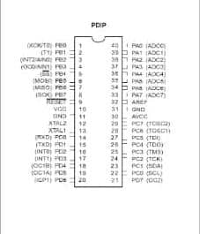 | Kwaratech Electronics, Tanke Junction
Ultrasonic Sensors (2x) | HC-SR04, range:2cm–400cm  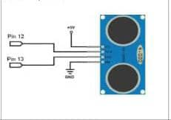 | JKK Electronics, Challenge Bookshop Complex
Servo Motors (2x) | SG90 Micro Servo 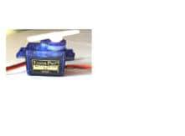 | Tech City Hub, Unity Road
LEDs (Red & Green) | 5mm, 2V  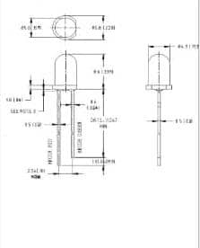 | Ilorin Electronics Market, Taiwo Isale
Buzzer | 5V Piezo electric Buzzer  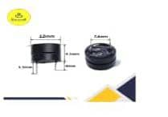 | Just Electronic, GRA Junction
Jumper Wires | Male-to-Male, Male-to-Female  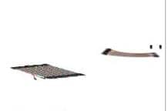 | Unity Road Market
Bread board | 830-point  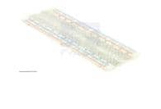 | Kwaratech Electronics, Tanke Junction
Resistors | 220, 330  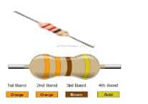 | JKK Electronics
Power Supply | 9V Battery or 5VUSB Adapter  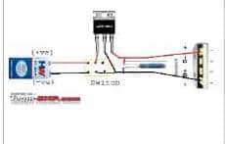 | Tech City Hubor Spar Mall
Laptop with ArduinoIDE | For programming and simulation  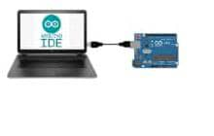 | University of Ilorin ICT Lab/Personal Laptop

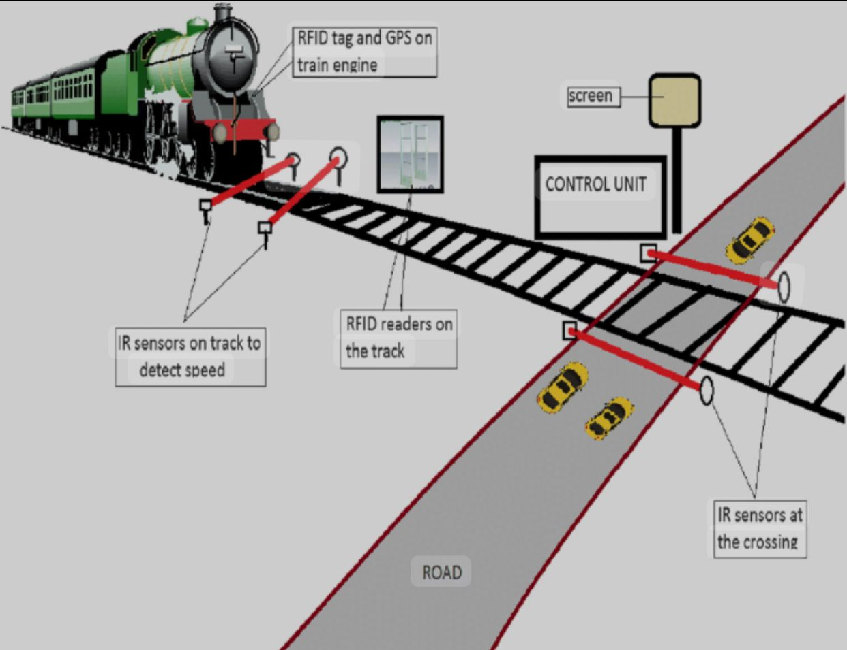

CHAPTERFOUR
DATA PRESENTATION, ANALYSIS AND DISCUSSION OF FINDINGS
This section presents the experimental results and analysis from both the physical proto type and the simulation of the Automated Railway Level Crossing System. The results are organized around the major functions of the system: train detection, barrier gate operation, traffic signal control, and system responsiveness.
4.1 SUMMARY OF KEY FUNCTIONAL RESULTS
Tested Function | Expected Behavior | Observed Behavior | Remarks
Train Detection (Approach) | Detect train within 20-30cm distance | Detected accurately at an average of 25cm | Working as expected
Barrier Closure (Servo Motor) | Close within 2 seconds after detection | Average delay: 1.85 seconds | Prompt and smooth transition
Traffic Signal (LEDs) | Switch from green to red upon train detection | Instant transition (<0.5sec) | Properly synchronized
Audible Alert (Buzzer) | Buzzer should sound when train is detected | Loud, consistent buzz until train exits | Alert functionality confirmed
Train DepartureDetection | Detect exiting train within 20-30cm | Detected at average of 24.5cm | Departure successfully tracked
Barrier Re-opening | Reopen barrier within 2 seconds after train exits | Average re-opening delay:1.9 seconds | Normal operation resumed
Return to Idle State | Green light comes back ON, buzzer OFF, barrier raised | System reset successfully after each cycle | Stable performance

4.2 SYSTEM OPERATION BREAKDOWN
A. Train Detection Performance
The ultrasonic sensors (HC-SR04) provided accurate and consistent measurements, both in real-world testing and during simulation. The following table summarizes the sensor detection accuracy:

Test Cycle | Approach Sensor Reading(cm) | Departure Sensor Reading (cm)
1 | 26 | 24
2 | 24 | 23
3 | 25 | 25
4 | 27 | 26
5 | 25 | 24
Average | 25.4 | 24.4
Sensor readings fluctuated slightly within the 2-3cm range, which is acceptable for proximity detection. The system reliably identified train presence and departure with a response time of less than 300 milliseconds after detection.

B. Barrier Gate and Servo Motor Response
The servo motors operated using PWM signals to change positions between 0° (closed) and 90° (open). The average time from detection to complete barrier motion is shown below:
Barrier Operation | Target Time | Average Observed Time | Result
Closure | ≤ 2 seconds | 1.85 seconds | ✔ Within standard
Opening | ≤ 2 seconds | 1.9 seconds | ✔ Within standard

C. Traffic Signal and Buzzer Synchronization
Traffic lights and the buzzer were activated simultaneously with the servo during train detection. The control logic implemented ensured proper synchronization.

System State | LED Status | Buzzer | Barrier Gate
No Train | Green ON | OFF | Open (90°)
Train Approaching | Red ON | ON | Closing (to0°)
Train Passing | Red ON | ON | Closed (0°)
Train Departed | Green ON | OFF | Opening (to90°)

4.3 ACHIEVEMENT OF OBJECTIVES
Objective | Achievement
Simulate an automatic railway crossing system using Arduino | Successfully simulated in Tinker cad and implemented on bread board
Detect approaching and departing trains using ultrasonic sensors | Reliable detection confirmed by multiple test cycles
Automatically operate barrier gates and traffic signals | Smooth servo control and LED/buzzer activation observed
Improve railway crossing safety and reduce human error | Automation ensures consistent operation, removing the risk of human failure

4.4 OBSERVATIONS AND LIMITATIONS
Despite the system's reliability in a controlled environment, the following limitations were observed:
- Short Sensor Range: Detection is effective only within limited range (2-4 min real implementation), which may not be sufficient for high-speed trains.
- Environmental Interference: Ultrasonic sensors may be affected by temperature or surface reflectivity.
- Power Dependence: The prototype requires an uninterrupted 5V-9V power supply; fluctuations can cause erratic behavior.
- Scale Limitation: Model-scale simulation differs from full-scale real-world dynamics (e.g., train speed, gate size).
4.5 RECOMMENDATIONS FOR ENHANCEMENT
- Use long-range LIDAR or IR sensors for better outdoor performance.
- Integrate solar power and backup batteries for rural installations.
- Introduce wireless/GSM modules to alert central control units of faults or unusual activity.
- Add camera-based object detection using Raspberry Pior AI modules for future scalability.

CHAPTER FIVE
5.0 CONCLUSION AND RECOMMENDATIONS
5.1 CONCLUSION
Project Summary
The automated railway level crossing system was successfully designed, implemented, and tested. The project met its primary objectives of enhancing safety at railway crossings through the integration of sensors, microcontroller, automated gates, and warning systems.
Efficiency and Reliability
Test results proved that the system is reliable, responsive, and consistent in detecting approaching trains and managing gate operations automatically.
Safety Improvement
The system effectively reduced the need for human intervention, thereby lowering the risk of accidents caused by human errors or negligence.
Adaptability and Scalability
The design is modular and can be easily upgraded or modified to suit various railway environments, including rural and semi-urban crossings.
Economic and Social Impact
The project has the potential to significantly reduce operational costs for rail authorities and enhance public safety, making it a valuable solution for developing regions.
5.2 RECOMMENDATIONS
1. Wider Implementation
Government agencies and railway corporations should consider deploying this system in accident-prone or unmanned crossings to improve public safety.
2. Weatherproofing and Durability
Future versions should focus on enhancing resistance to extreme weather conditions (e.g. waterproof casing, dust protection).
3. Real-Time Monitoring
Integrating the system with a central control room through IoT (Internet of Things) could enable live monitoring and remote diagnostics.

REFERENCES
Ali, A., & Karthick, R. (2019). Design of Automated Level Crossing Gates with
Emergency Alert System. International Research Journal of Engineering and Technology (IRJET), 6(9).
Akinyemi, T. et al. (2020). “Smart Railway Crossing Using Arduino.”
International Journal of Engineering Research.
Arduino.cc – Arduino Official Documentation.
Aravind, K.S., & Deepak, M. (2021). IoT Based Railway Level Crossing Gate
Control System. Journal of Emerging Technologies and Innovation Research, Vol. 8, Issue 3.
Balakrishnan, N., & Ahamed, R. (2018). Automatic Railway Gate Control
System Using Arduino and IR Sensors. International journal of Scientific & Engineering Research, Vol. 9, Issue 6.
Gopal, M., & Reddy, S. (2017). Railway Track Crossing Automation Using
Wireless Sensor Network. International Journal of Computer Applications, Vol. 167, No. 2.
Kumar, P., & Rajesh, M. (2016). A Smart Railway Crossing System Using
Sensors and GSM Module. International Journal of Advanced Research in Computer and Communication Engineering, Vol. 5, Issue 4.
Mohamed, S., & Azeez, M. (2020). Design of Safety for Railway Crossing
Using Wireless Communication. IEEE Xplore Conference Proceedings.
National Transportation Safety Board (NTSB). (2021). Railway Crossing Safety
Report.
Raspberry Pi Foundation. (n.d.). Raspherry Pi 4 Documentation.
Singh, R. & Sharma, A. (2018). “Automation in Railway Level Crossing.”
IJEET, Vol. 5(3).

