ON-STREET PARKING AND ITS EFFECT ON FREE FLOW OF TRAFFIC
(A Case Study of Gegele, Ilorin, Kwara State)

PREPARED BY

MUHAMMAD RIDWAN
HND/22/URP/ FT/001

A PROJECT SUBMITTED TO THE

DEPARTMENT OF URBAN AND REGIONAL PLANNING,
INSTITUTE OF ENVIRONMENTAL STUDIES (IES)
KWARA STATE POLYTECHNIC, ILORIN

IN PARTIAL FULFILLMENT OF THE REQUIREMENTS FOR THE AWARD OF HIGHER NATIONAL DIPLOMA (HND) IN
URBAN AND REGIONAL PLANNING

JULY, 2025

CERTIFICATION
This is to certify that this project was carried out by MUHAMMAD RIDWAN with matriculation Number HND/22/URP/FT/001 in the department of Urban and Regional Planning, Institute of Environmental Studies, Kwara State Polytechnic, Ilorin. In partial fulfillment for the award of Higher National Diploma (HND) in Urban and Regional Planning.

__________________ __________________
TPL M.I. YAHAYA DATE
Project Supervisor

_______________________ __________________
TPL M.I. YAHAYA DATE
Project Coordinator

_______________________ ___________________
TPL E.S. ADEKANYE DATE
Head of Department

DEDICATION
This project report is dedicated to Almighty God the Alpha and Omega for sparing my life till this moment. I also give Him glory for His abundant provision and guardian over me during the period of my course of study in Kwara State Polytechnic. May His name be praise forever and ever.

ACKNOWLEDGEMENTS
I give all glory, honor, adoration and praise to Almighty Allah. The God of all creation, the Alpha and Omega, for His mercy, protection, grace upon me throughput the period of this programme, May His name be praised forever and ever Amen.
I will like to acknowledge my able, dynamic indispensable and ever dependable supervisor, in person of TPL M. I. Yahaya for the sacrificial of her time to read through the entire work and offered valuable correction at every stage of this project, may you live long to enjoy the fruit of your labor.
My profound gratitude goes to the capable Head of Department (H.O.D) on person of TPL Adekanye E. S. for his fatherly care and support. Also, TPL Akinbami and all the lecturers of great and noble department for their impact in my life academically.
I want to specially thank my parent Mr. & Mrs. Muhammad for their financial support, ceaseless prayers and advice throughout the period of my programme. May you live to eat the fruit of your labor.
I also want to appreciate my siblings Huzzein, Basirat and Mujidat for all their encouragement, prayer, and contribution in one way or other.

ABSTRACT
This project focus on the impact of on-street parking on the free flow of traffic in urban areas, particularly in central business districts like Gegele and Oja Oba market in Ilorin. The study aims to address the challenges posed by ineffective management of transportation systems, leading to issues such as traffic congestion, pedestrian-vehicle conflicts, and changes in the city's structure. By analyzing the correlation between urban activities and travel generation, the project will shed light on the importance of well-managed parking facilities in enhancing traffic flow and urban mobility. Additionally, the abstract can touch on the significance of convenient and affordable parking in creating a positive environment for users while highlighting the drawbacks of inadequate or excessive parking on traffic congestion, safety, and environmental concerns. The project will delve into the complexities of parking management to propose solutions that balance the need for parking spaces with the goal of ensuring smooth traffic flow and sustainable urban development.
TABLE OF CONTENTS
Title Page i
Certification ii
Dedication iii
Acknowledgements iv
Abstract v
Table of Contents vi
CHAPTER ONE
1.0 Introduction 1
1.1 Statement of Problem 3
1.2 Aim 4
1.3 Objectives of the Study 4
1.4 Scope of the Study 5
1.5 Limitation of the Study 5
1.6 Historical Settings of Ilorin 6
1.7 Geographical Settings 7
1.8 Population Distribution of Ilorin 10
1.9 Research Methodology 15
1.10 Sample Frame 17
1.11 Sample Size 18
CHAPTER TWO
2.0 Literature Review/Conceptual Framework 19
2.1 Introduction 19
2.2 Importance of Parking Space 19
2.3 Parking Management and Design 21
2.4 Improved Enforcements 22
2.5 Definition of Terms 23
CHAPTER THREE
3.0 Research Findings 25
3.2 Socio-Economic Characteristics of the Respondents
in Gegele Market 26
CHAPTER FOUR
4.0 Summary and Findings 41
4.1 Introduction 41
4.2 Summary of Findings 41
4.3 Recommendations 42
4.4 Implementation 44
4.5 Conclusion 45
Bibliography 46
Appendix 48

CHAPTER ONE
1.0 INTRODUCTION
Parking is the most conspicuous urban traffic problem and could be in various forms such as Curb or on street, short term and long term parking, intercity and intercity terminals (Abiodun 1989). Gegele and Oja Oba market Ilorin being among the major Central Business District (CBD)is expected to have workable Networks of roads and transportation system and other facilities for the movement of both goods and services required on various sections of the areas. Examples are walk ways for pedestrians, parking lots and bay for easy traffic flow of the said areas. However, the ineffective management of the transportation system with existing road network brings about the road for a place to preserve the transportation modes that are not in use. There is a very strong correlation between urban activities or land uses and travel or trip generation. The study area is experiencing a lot of issues ranging from on street parking, street trading, lack of pedestrian crossing facilities etc .This problems are reflected in traffic congestion, pedestrian competing with vehicular movement on the urban road leading to its clumsiness and undesirable changes in the structure of the city. (Abiodun, 1989)
Moreover, every vehicle trip requires parking at its destination, so parking facilities integrates components of the roadway system. Parking is one of the first experiences that people have when traveling to a destination.
Convenient and affordable parking are considered as a welcome sign to an environment. Parking that is difficult to find, inadequate, increment or expensive will frustrate users and can contribute to spillover problems in other area. As a result, inadequate parking can create problems to both users and non-users (Victoria transportation planning institute, 2004).
However, excessive parking can also create problems because it encourages driving which increases traffic congestion, crashes and environmental impacts. Parking facilities are expensive to constructs thereby imposing financial cost on developers, builders, users and government. In addition, parking facilities impose environmental costs, contradict [community development objectives for livable and workable communities, and abundant, un-priced parking trends to increase driving and discourage the use of alternative mode.
Gegele and Oja Oba Market as big as they are today, has inadequate and unorganized parking facilities and this made the areas to look unplanned and to be creating havoc to the residents of the vicinity especially Oja Oba. Because, the market is not a seasonal market, it is always on and this thereby creates lots of traffics congestion since majority of vehicles are usually parked on the road side and on any available space.
Inadequate of organized parking spaces for vehicles that patronize the market encourages on/off street parking with numerous negative implication on the road and the market in general. Based on this fact, there is need to provide parking space for the market community.
1.1 STATEMENT OF PROBLEM
Most people have little idea on what it really cost to provide a parking space, because they never provided parking facilities as an individual item (parking space are usually bundled with building or development), and when consumers pay for parking, a portion of costs are often subsidized. This problem is majorly caused by unavailability of land in the study area.
The land which is supposed to be used for parking space in the study area are mostly being used for other land uses e.g. residential and commercial land use etc. For example, when a Developer charges user to recover parking costs, land costs and property charges are often excluded. As a result, consumers tend to underestimate the full cost of providing parking space (Victoria Transport Policy Institute 2003).
Land availability is one of the main problems occurring in Oja Oba market been an ancient market that came up spontaneously without planning this is one of the reason for the need for parking space because since there’s no adequate land in the study area there will be difficulty in the provision of parking space in the market and its environs. Transportation Land Valuation and Victoria Transportation Policy Institute (2000) says that a typical parking space is 2.4 – 3.0 meters wide and 5.5 – 6.0 meters wide, totally 13 – 19 squares meters, but since there’s no enough land or the existing available land has being converted to other uses, it will be difficult to provide the Oja Oba market community with enough/ standard parking facilities.
1.2 AIM
The aim of this project is to investigate the problems of parking in the study area with a view of solving them.
1.3 OBJECTIVES OF THE STUDY
a) To identify the existing land use pattern of the market and its environs.
b) To identify the existing volume of vehicles parked on hourly and daily basis vis a-vis available space.
c) To examine the operational and techniques of the existing car parks in the area.
d) To determine the suitable space for parking in the study area.
e) To make recommendation and suggestion for the improvement of the parking situation of the area.
1.4 SCOPE OF THE STUDY
The study covers parking facilities in Gegele and Oja-oba market and its environs. Also, the study examines the operational and techniques of the existing car parks, determination of the suitable space for parking as well as the operational techniques of existing parking facilities.
Finally, the study examines the activities of the various land uses such as Commercial, residential and so on that can hinder free traffic movement in Gegele and Oja-oba market.
1.5 LIMITATION OF THE STUDY
The major problem that was encountered during the field survey is;
a. Problems of finance on the part of the researcher, the time factor problem due to the limited time and other human resources towards the writing of the project.
b. None existing of up to date map of Gegele and Oja-oba market market and accurate census figure of Gegele and Oja-oba market.
c. Ignorance so some drivers, pedestrians, market sellers both men and women in responding to the interview conducted through the use of a questionnaire.
1.6 HISTORICAL SETTINGS OF ILORIN
Ilorin is an old town, but its history before the nineteenth century is obscure. Ilorin was a miniature Nigeria. The city history was the history of her emirate. It dated back to the early 16th century even before OJO ADEYEMI popularly known as (Ojo Isekuse), who was alleged to have founded Ilorin. It was during Ojo’s time that Ilo-irin grew into conurbation.
Ojo hailed from Oyo-Ile he was a brave hunter who used to sharpening his tool (iron) at a stone in Bamidele’s compound the acting of sharpening i.e. Ilo-irin was constructed into Ilorin. Not quiet long, another brave hunter: “Emila” arrived, both of them lived together. Ojo had an issue and Emila;s son was disrespectful to Ojo. As a result of this act of gross disobedience Ojo grew angry and fled to Shao were he died.
Ilorin, after Ojo sank of obviously, until the arrival of Laderin from Oyo-Ile with his large retinue and launched the city limelight. Afonja the AARE ONAKAKANFO was an Oyo prince from his mothers side.
ALAGBIN fought gallantly in the military instruction that toppled BASHORUN GAA and liberated the OYO Empire from Bashoruns tyranny. This was the height of Ilorin fame when the Yoruba’s generalizing Afonja, Alakija, Loko the brave warrior in the bush and Aare Onakakanfo with his followers arrived Ilorin.
By the tail end of the 18th century, Ilorin became a big settlement when compared with other neighboring villages and around early 19th century, the town got his first king titled Emir of Ilorin.
1.7 GEOGRAPHICAL SETTINGS
Ilorin is located in the Southern part of Kwara State and situated within longitude 4 30 East and latitude 8 30 north. The lowest elevation within Ilorin west is 900ft on both banks of Asa River, North of the water shed between the Atlantic basins of the Niger River, which passes at a distance of 45miles further North of Ilorin Township.
Ilorin is about 160km away from the state capital of OYO state (Ibadan) and about 310km north of the sea coast. Three main rivers flow in the vicinity of Ilorin namely the Oyun river that flows in the north-west direction, at a distance of about 6km east of the town, Asa River crosses Ilorin on the north bound course and the MoroRiver passes about 7km West of the town. The landscape is of gently undulating topography with 50fts rounded hills, while a few fairly deep rivers, valleys and rather high granite inserlbergs, off domeline: shape contrast locally with general moderate morphology.
On the whole, the present topography region is mainly dictated by the unevenly eroded surface of the crystalline rock which underlines the shadow over burden most of the area.
1.7.1 TRANSPORTATION NETWORK
Kwara State is linked with other parts of Nigeria by road, rail, and air transport facilities. The street pattern of the old city of Ilorin is older than Motor car, reflecting the social organization which gave form to the original settlements, when the city was the modest size and pedestrians oriented. The main radial network and newly constructed ring roads in the old city are generally wide enough to accommodate heavier traffic in the future. They have appreciable width of land at both sides of the road as right way. These includes: Muritala Muhammed Road, Taiwo Road, New Yidi Road, Asa-Dam Road, Ahmed Bello Road, Sobi Road, Fate Road and Abdul Azeez Attah Road.
1.7.2 POLITICAL BOUNDARIES
Ilorin, the capital of Kwara State was created by federal military government in 1967. Apart from being the state capital, it was also made the head quarter of Ilorin Emirate or Division comprising of all towns and villages with Ilorin Emirates.
At present, three Local Government Areas were created within Ilorin metropolis including some towns and villages surrounding it mainly Ilorin East, Ilorin West and Ilorin South. Ilorin metropolis share common boundaries with Moro, Asa and Ifelodun Local Government Areas of Kwara State.
1.7.3 TOPOGRAPHY
The main river in Ilorin is Asa River. It occupies a fairly wide valley and flow in the south to north direction. The river divides into two parts. A western part representing the area where Government Reserved Area is located. Towards the north of the western part is an isolated hill called Sobi Hill, its 394m above sea level.
1.7.4 CLIMATE
Ilorin experiences the daily changes in atmospheric condition. The weather is usually humid at the daytime, the relative humidity is about 70% in the morning and it falls between 10-30% in the afternoon.
Ilorin has a tropical wet and dry season. Its mean annual rainfall begins in April and ends in November. The days are very hot during dry season and that is November to march. The hottest month is February to April with temperature at 30⁰C; harmattan dominates the month of December to January.
1.7.5 VEGETATION
Due to nature of Ilorin which is sandy –loamy that favours certain types of trees and grasses, then couple with the climatic condition to which Ilorin falls into, made it experienced or falls into guinea savannah. This is characterized by deciduous trees of mixed trait e.g. sieve cotton, Acacia and Baobao including pride of Barbadous, all of which are found in Ilorin. The map of Nigeria showing Kwara State, Kwara State showing Ilorin and Ilorin showing Gegele respectively.
1.8 POPULATION DISTRIBUTION OF ILORIN
Ilorin Township comprises of part of Ilorin West, East and South local government areas of Kwara State. Ilorin East, West and South local government areas are interwoven in creation and as such different local government maps is difficult to produce.
The three Local Governments Areas comprises 36 wards of which Ilorin township ward form 27 of the wards classified as urban Ilorin. The township comprises of the urban wards of Ilorin East, West and South Local Government area of Kwara State. It has a population of seven hundred and seventy one thousand, nine hundred and thirty four (771,934) (NPC, 2006). This was however projected at a growth rate of 35% to give nine hundred and fourty three thousand, nine hundred and four in 2011. (943,904).
1.8.1 ILORIN LAND USE
According to the ministry of land and urban development Ilorin 2011, the major land uses in Ilorin includes: residential that covers 49,197 hectares, about 58% of the total land uses, commercial 7,634 hectares 9%, road (communication) 12,724 hectares 15%, industrial land use 4,046 hectares 4.77%, public and semi public 10,179 hectares 12% and open spaces 1,043hectares 1.23%.

Fig 1.1: Map of Nigeria, showing Location of Kwara State.
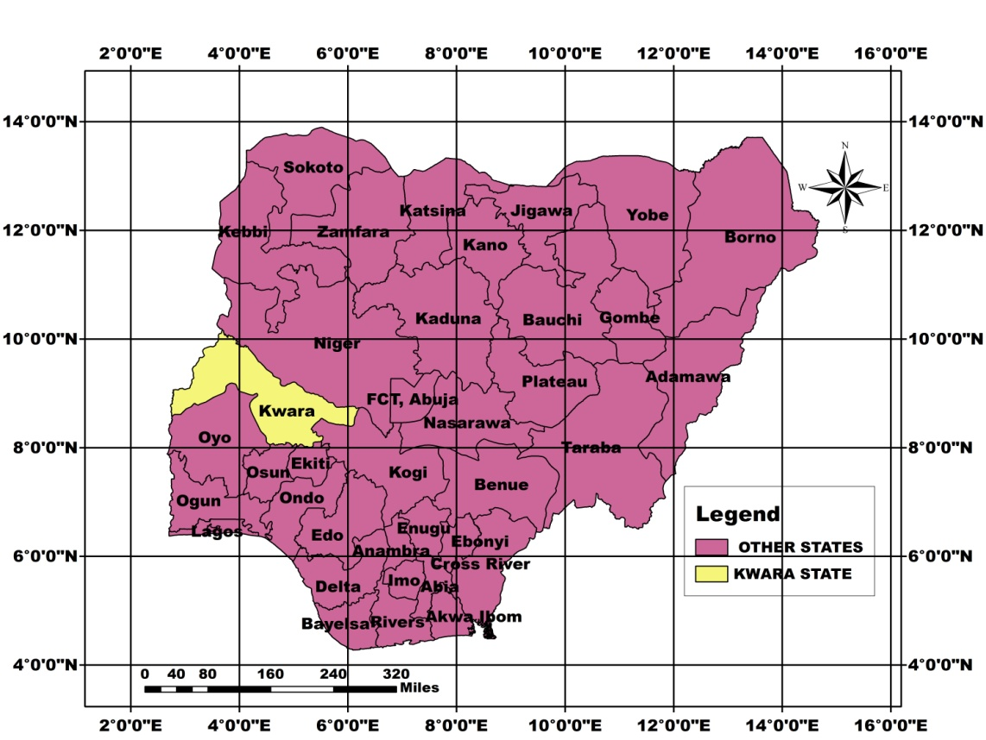

Fig 1.2: Map of Kwara State Showing Location of Ilorin West Local Government Area
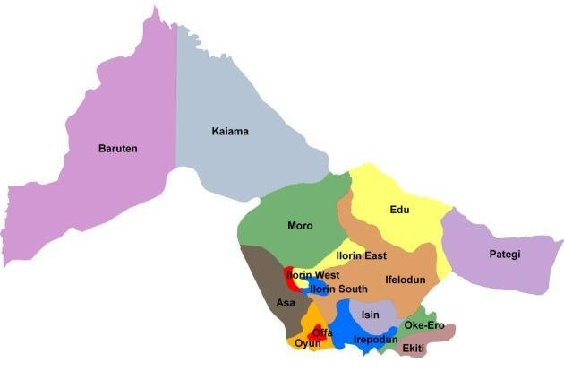

Fig: 1.3 showing of Ilorin West local Government Area

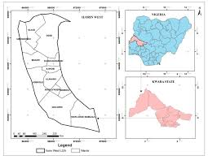
1.9 RESEARCH METHODOLOGY
To achieve all the stated aim and objectives, various approaches were used. Survey was considered with the existing parking situation in Gegele and Oja-oba market through the use of a reconnaissance survey which deals with the visitation of the study area in other to allow the researcher to be familiar with the market and to really understand the parking problems faced by the market people and the residents.
Another survey was carried out through the collection of data’s using the primary source and the rest forms which can be the secondary in nature and this can be derived from studies found useful to the work.
The parking problem was observed in the area, the survey includes parking facilities survey on the vehicles and passengers plying on the road.
Also, information was gathered from the National Union of Road Transport Workers (NURTW) in the study area which happens to be a primary source of data collection. The collection of data through the primary source was by the use of questionnaire, using stratified method in serving the questionnaires.
Some of the information that was collected from the National Union of Road Transport Workers chairman, cars drivers, market sellers and buyers includes:-
(a) Number of available parking facility
(b) Owners of vehicle
(c) Rate of movement within and outside the market.
(d) Parking problem in the study area
(e) Causes of the problems
(f) Solutions to the problems etc.
Data collected are presented in form of tables or tabular form, photographs showing views of vehicles parked on walkways, on the road and on the middle of the road.
The consultation of various text books, encyclopedia, maps and other projects written will also be used as a secondary data. The data collected was analyzed using of simple statistical techniques such as table and percentages. Cartographic presentation like bar charts, pie charts, histograms will also be employed for illustration were necessary, picture will also be drawn from the response which will help to determine the present and future demand for parking space.
In addition, direct observation was employed and all the information needed such as the reason for and the duration of parking activities during parking, payment made will also be gathered through the administration of questionnaires in systematic random sampling form. Inferences was deduced from the direct observation and questionnaire administered.
1.10 SAMPLE FRAME
This contains the total number of vehicular count in the market within 3hrs.
VEHICULAR COUNTS IN THE GEGELEMARKET
TIME | TAXI | BUS | TRUCK | MOTORCYCLE
8-11 | 119 | 94 | 44 | 188
11-1 | 134 | 115 | 35 | 192
1-3 | 126 | 86 | 22 | 174
3-6 | 214 | 105 | 13 | 209
TOTAL | 593 | 400 | 114 | 763

TOTAL NUMBER OF VEHICULAR COUNTS FROM 8am- 6pm
VEHICLES | NO | %
TAXI | 593 | 31.7
BUS | 400 | 21.4
TRUCK | 114 | 6.1
MOTORCYCLE | 763 | 40.8
TOTAL | 1870 | 100

Hence, the total no vehicular counts in Gegele market is 1870 as the sample frame.
1.11 SAMPLE SIZE
The total number of vehicles counted in the course of the research in Gegele market was 1870. The systematic sampling technique was used in selecting 11.5% of the total no of the vehicles counted which was used for administration of questionnaires to gather information.
CHAPTER TWO
2.0 LITERATURE REVIEW/CONCEPTUAL FRAMEWORK
2.1 INTRODUCTION
Achterstraat (2003); sees parking as an act of stopping a vehicle, existing it, and leaving the vehicle unoccupied for more than a brief time. It is against the law virtually to park a vehicle in the middle of a highway or a road. He furthered says that in all countries where motor vehicles are in common use, specialized parking space facilities are routinely constructed in combination with most structures to facilities the coming and going of the structures user.
2.2 IMPORTANCE OF PARKING SPACE
The significance of parking space in commercial land use organization be over emphasized, as a result of this, many people from various fields and sphere of life have commented on the importance, provision, demand, supply etc of parking as it affects our daily activities.
Mdean (1995); “Sees” parking as an integral part of automotive transportation system. It is terminal storage of motor vehicles while drives and occupants of the vehicle are engaged somewhere else” the objective of a good transportation plan is to determine and provide a balance between circulation of motor vehicles and terminal storage.
According to Bob Alexander (2000), the accessible parking space shall be at least 96 inches (8) wide. Parking access aisle (5 wide for a standard car and 8 wide for vans) shall be an accessible route to the building or facility entrance. (Journal index Graphics Home page).
Roberts (1974), he is of the opinion that the demand for parking spaces are directly related to the distribution and intensity of different land uses. The rate at which traffic is generated in an area is determined by what the land is used for, so Margaret Roberts believes that much vehicles would be attracted to public places.
The importance of parking space was also stressed by a Union Nations Town Planning expert, professor Vagale (1973). He viewed it in an encompassing manner that 520 to 760m2 of an administrative floor space in an organization should be provided for parking.
Burke (1980) says that in less developed countries, that overall nationwide proportion of persons to motor vehicle is about 12 to 1 and that each motor vehicle would like a parking space that is an near as possible to his destinations. What is being emphasized here is that the strategic location of parking space must be in great proximity to where the occupants of the vehicle are going to.
According to Radiff (1973), parking may be parallel or angle (right or left). Parallel parking may be allowed for some limited time and at specific locations. Parallel parking covers least space of the road. Angled parking cannot be allowed at road side as they occupy the width of a road and the road itself becomes unsafe, although it is always good in off-street parking, as it beautifies the designing of parking spaces.
Right angled parking is adopted where there are steep grades on the road but their construction costs less while constructing it for off – street parking lots. It should also not be allowed to main roads. Angled and right angled parking can be allowed on residential streets. It is thus cleared from this above submission that each and every parking space located on the streets must be close to the blocks in order to bring about comfort ability.
2.3 PARKING MANAGEMENT AND DESIGN
Parking facility management and design can affect convenience, comfort, security and aesthetic. Design and management standard can address variety of problems and provide a variety of benefits and equally may increase costs.
Below are some specific parking facility management and design improvements.

2.4 IMPROVED ENFORCEMENTS
Effective enforcements is an important aspect of parking management in most communities, where parking is free and abundant, motorist are unaccustomed to regulated or price parking. It is therefore important to have adequate enforcement to keep parkers honest.
2.4.1 AESTHETICS
Parking facility can be designed to be more attractive, with appropriate landscaping, and detailing (smith 1998). Large parking facilities with unadorned cement structures and blank walls are generally considered unattractive.
2.4.2 GROUND FLOOR RETAIL
Urban parking structures can be more attractive and make a positive contribution to the urban environment if they have ground floor retail fronting the sidewalk.
2.4.3 SAFETY AND SECURITY
Design facilities to minimize crash risk to vehicles and pedestrians and to provide personal security with appropriate visibility, lighting, patrols and alarms.(Hamilton 1998).

2.5 DEFINITION OF TERMS
The terms used by different Authors can be defined thus below
CURB PARKING: This is an elongated space constructed along road side to allow traffic vehicle to load off – load goods and passengers with ease and without obstructing traffic flows. (Ojo; 2002)
ON – STREET PARKING: This is the process of parking a vehicle on the heart of the road either for a short or long period of time by vehicle owners.
PARKING DURATION: It is the length of time for which a vehicle is stationed in a particular space area. (Ojo 2002).
PARK AND RIDE: This is the process whereby driver parks his vehicle in the space provided before entering into the market and then takes a ride into the market in order to discourage traffic jam in the area.
PUBLIC PARKING: It is the type of parking that can serve many users and destination.
PARKING DEMAND: It refers to the amount of parking that would be used at a particular time, place and price.
PRICED PARKING: It is the charging of the motorists directly for using the parking facilities.
REGULATE PARKING: This is the regulating of parking time, users, certain vehicles and on –street parking on public parking.
SHARED PARKING: Is the sharing of parking facilities among users.
OFF –STREET PARKING: This is the parking whereby a particular space is provided for vehicles in order to attract them off the road.
ADEQUATE PARKING: It refers to whether there is sufficient parking at a particular time and location.
CHAPTER THREE
3.0 RESEARCH FINDINGS
This chapter was based on the presentation and analysis of the collected data during the field survey. It shows the socio economic characteristics of people, travel patterns such as mode of journey, purpose of journey, parking survey which includes parking problems, causes and solution and costs and benefits of parking is not left out in the research findings.
Others include necessary information and photograph which are considered useful in carrying out this research..
TABLE 3.1: SEX OF RESPONDENTS TABLE
SEX | NUMBER | PERCENTAGES
Male | 97 | 45
Female | 118 | 55
Total | 215 | 100%
Source: Author field survey 2025
3.2 SOCIO-ECONOMIC CHARACTERISTICS OF THE RESPONDENTS IN GEGELE MARKET
The table above show the sex of the respondents in which the female respondents took 55%out of the total no of respondents which is 215. These shows that female are more in the market than men although even if their percentages are not that far too each other
TABLE 3.2: AGE OF RESPONDENTS
AGE (YEARS) | NUMBERS | PERCENTAGES
Under 18 | 28 | 13
20 – 32 | 112 | 52
33 – 46 | 64 | 30
50 above | 11 | 5
Total | 215 | 100
Source: Authors field survey 2025
Age of respondents was analyzed in the table above which shows the numbers and percentage age of respondents that does shop, sell, load goods and off-load goods in the market. From the table, the research shows that age 20-32 (52%) of the respondents are more in the market area.

TABLE 3.3: MODE OF TRANSPORT
VARIABLE | NUMBER | PERCENTAGE
Trekking | 20 | 9
Public bus/taxi | 120 | 56
Private car | 13 | 6
Motorcycle | 62 | 29
Total | 215 | 100
Source: Author field survey 2025
3.3.1 TRAVEL PATTERN
From the table above, shows the mode of movement of the shoppers and sellers in the market, this indicated that the percentage of those taking public bus/taxi is (56%) of 100 out of 215, while those that trek accounts for 9%, private cars 6%, and motorcycle 29%.
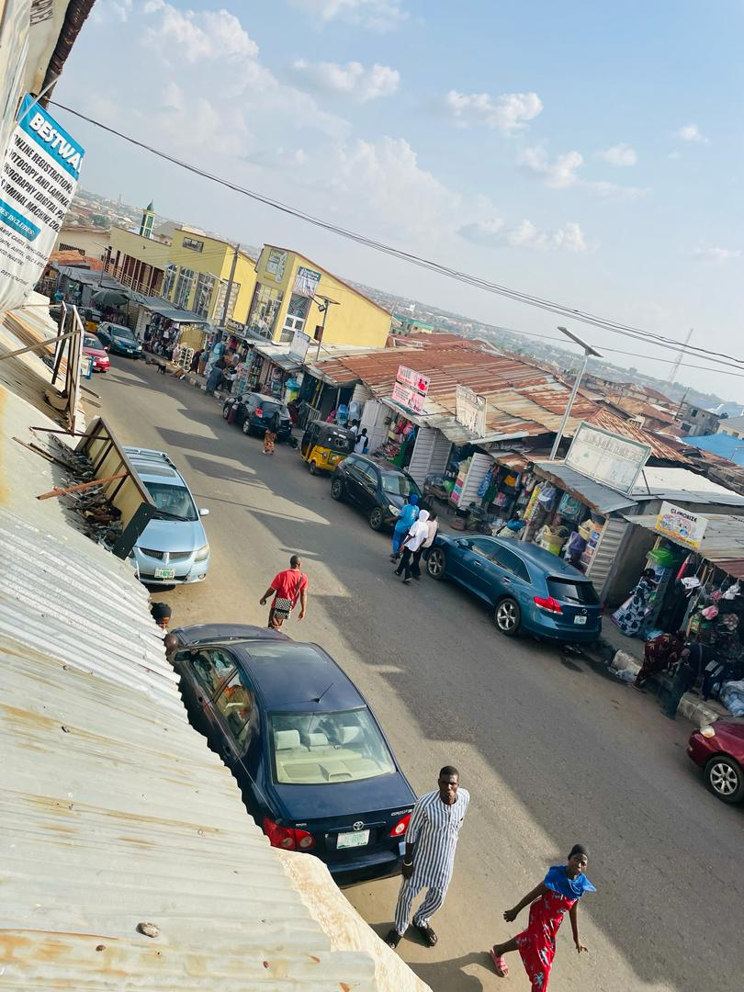
Plate 1: Showing the Parking troubles captured: unveiling the challenges of urban parking management

TABLE 3.4 RATE OF MOVEMENT TABLE
TRIPS | NUMBER | PERCENTAGE
1 trip | 6 | 2
2 Trips | 10 | 5
3 Trips | 40 | 19
4 Trips and above | 160 | 75
Total | 215 | 100
Source: Author field Survey 2025
This table shows the movement of vehicles within and outside the market. Those with 4 trips and above have the highest percentage of 75% of the total respondents.
TABLE 3.5: REASONS FOR PARKING
REASONS | NUMBER | PERCENTAGE
Load and off-load | 132 | 62
Buying | 18 | 8
Selling | 45 | 21
Office purpose | 12 | 6
Other specify | 8 | 3
Total | 215 | 100
Source: Author field survey 2025

3.5.1 PARKING SURVEY
The table above shows the reasons why respondents park their vehicles at any available space in the market. Problems of loading and off-loading of goods takes 62%, point of buying goods accounts for 8%, selling point takes 21%, office purpose takes 12%, and other reasons takes 3%.
TABLE 3.6: OWNER OF VEHICLE TABLE
VARIABLES | NUMBER | PERCENTAGE
GOVERNMENT | 7 | 2
INDIVIDUAL | 196 | 92
UNION | 12 | 6
TOTAL | 215 | 100
Source: Author Field Survey 2025
The option that has the highest percentage in the table above is 92% of 100. This shows that majority of the vehicle parked in the market are owned by individual that have one or another form of business in the market.
TABLE 3.7: NATURE OF PARKING
NATURE | NUMBERS | PERCENTAGE
Bus stop | Nil | 0
Public garage | 53 | 24
Along the road | 162 | 76
Total | 215 | 100
Source: Author Field Survey 2025
The table above shows the nature of parking in the study area. 76% of the respondents park along the road, 24% in the public garage while there is no bus stop. This accounts for the congestion of road within and outside the market..
TABLE 3.8: PARKING PROBLEMS TABLE
PROBLEMS | NUMBER | PERCENTAGE
Inadequate parking | 134 | 63
Inconvenient parking | 81 | 37
Expensive parking | Nil | 0
Total | 215 | 100
Source: Author Field Survey 2025
The table above shows the parking problems in the market area. The vehicular problem in the market is caused by inadequate parking space in the market which accounted for 63% and 37% on inconvenient parking space.
TABLE 3.9: CAUSES OF THE PROBLEM
CAUSES | NUMBERS | PERCENTAGES
Inadequate information | 5 | 2
Inadequate users option | 128 | 60
Inefficient use of parking apace | 9 | 4
Excessive automobile | 73 | 34
Total | 215 | 100
Source: Author Field Survey 2025
The table above show that inadequate user’s option is of higher percentage followed by excessive automobile which covers 60% and 34% of the total sample survey are the major causes of the parking problems.

TABLE 3.10: SOLUTION TO THE PROBLEM
SOLUTION | NUMBERS | PERCENTAGES
Improve parking option | 14 | 7
Reduce automobile dependence | 5 | 2
Increase parking supply | 196 | 92
Total | 215 | 100
Source: Author Field Survey 2025
The table above shows respondents view of solving parking problems in the market. It could be seen from the table that increase in parking lots/spaces could solve the problem which has 92% out of 100
TABLE 3.11: COST OF PROVIDING PARKING FACILITY
COSTS | NUMBERS | PERCENTAGES
Land cost | 108 | 50
Cost of construction | 94 | 44
Cost of maintenance | 13 | 6
Total | 215 | 100
Source: Author Field Survey 2025
The table above shows the component parts cost of providing parking lots. Land cost accounts for 50% of the total cost, construction 44% and maintain ace 6%
TABLE 3.12: REACTION OF THE RESPONDENTS ON THE CHARGES FOR THE INCREASE IN CONSTRUCTION OF PARKING IN THE MARKET
VARIABLE | NUMBERS | PERCENTAGE
Yes | 32 | 14
No | 183 | 86
Total | 215 | 100
Source: Author Field Survey 2025
The table above shows the reactions of the respondents, to the increase/ introduction of levy for the provision of parking facilities within and outside the market. 14% of the respondents support the idea while 86% oppose it.

TABLE 3.13: BENEFITS DERIVED FROM AVAILABLE PARKING
BENEFITS | NUMBERS | PERCENTAGES
Reduced traffic congestion and parking problems. | 183 | 86
Improved walking and cycling condition. | 25 | 2
Other specify | 7 | 2
Total | 215 | 100
Source: Author Field Survey.2025
The table above show the responses on the benefits derived from the available parking space despite its inadequacy. Reduction of traffic congestion 86%, improvement of walking and cycling condition within the market accounts for 2% while other reasons takes 2%.
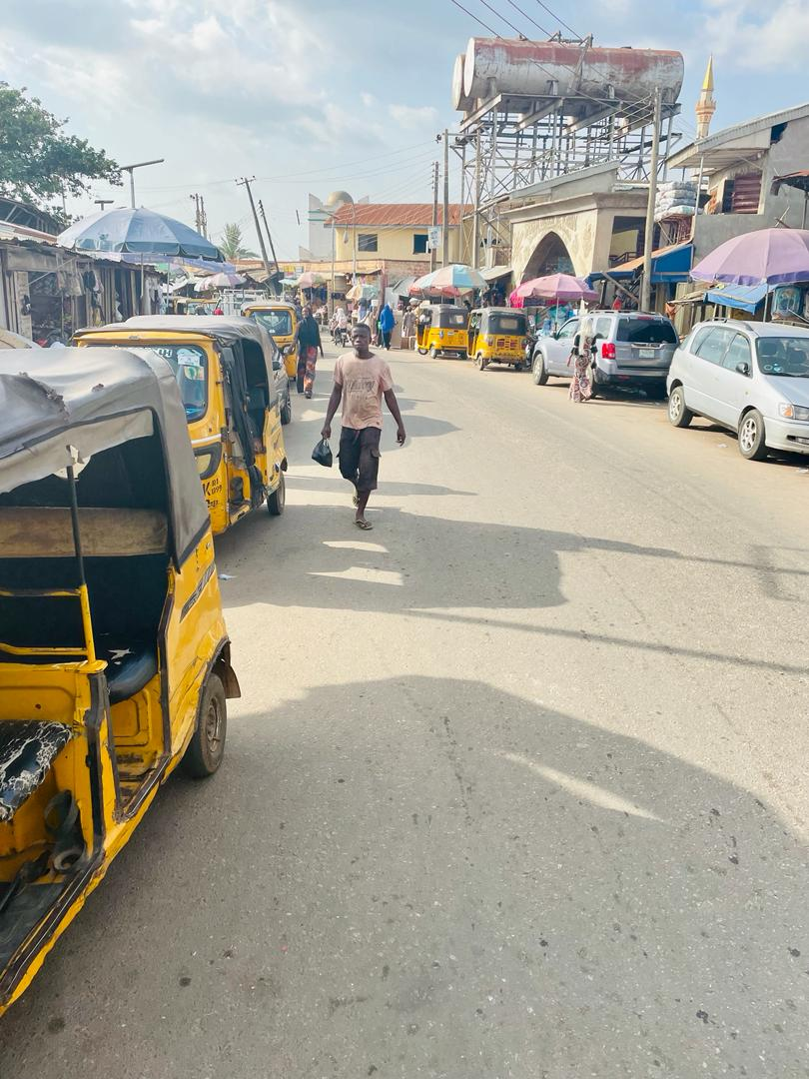
Plate 2: Showing the Street clogged with Parked vehicle, A barrier to smooth traffic follow

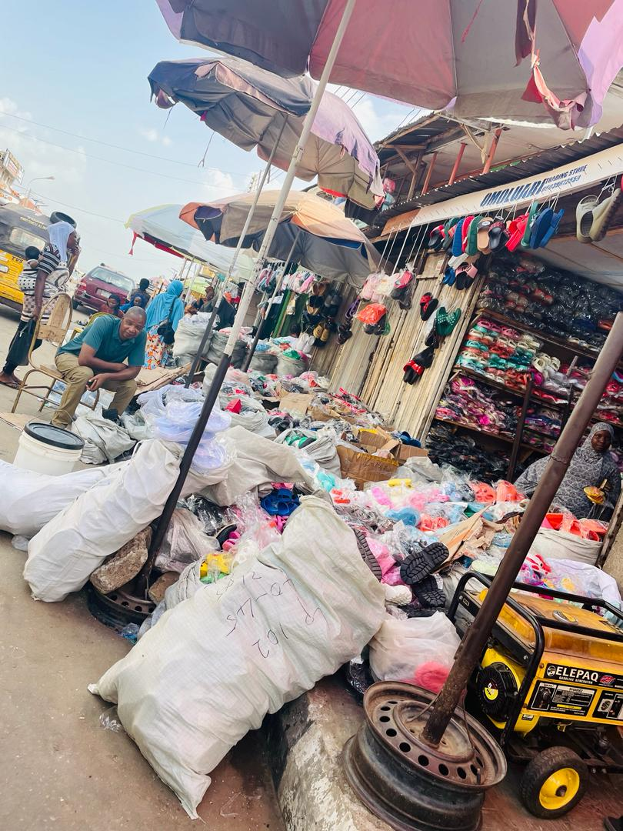
Plate 3: Showing the shop owners putting their goods on the walkways provided for the pedestrians

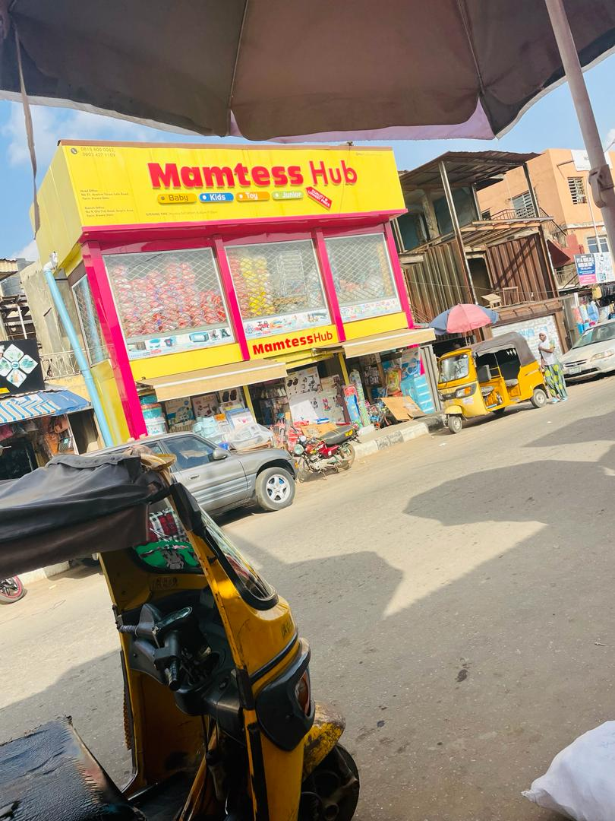
Plate 4: Showing the Navigating through the maze of On street Packaging

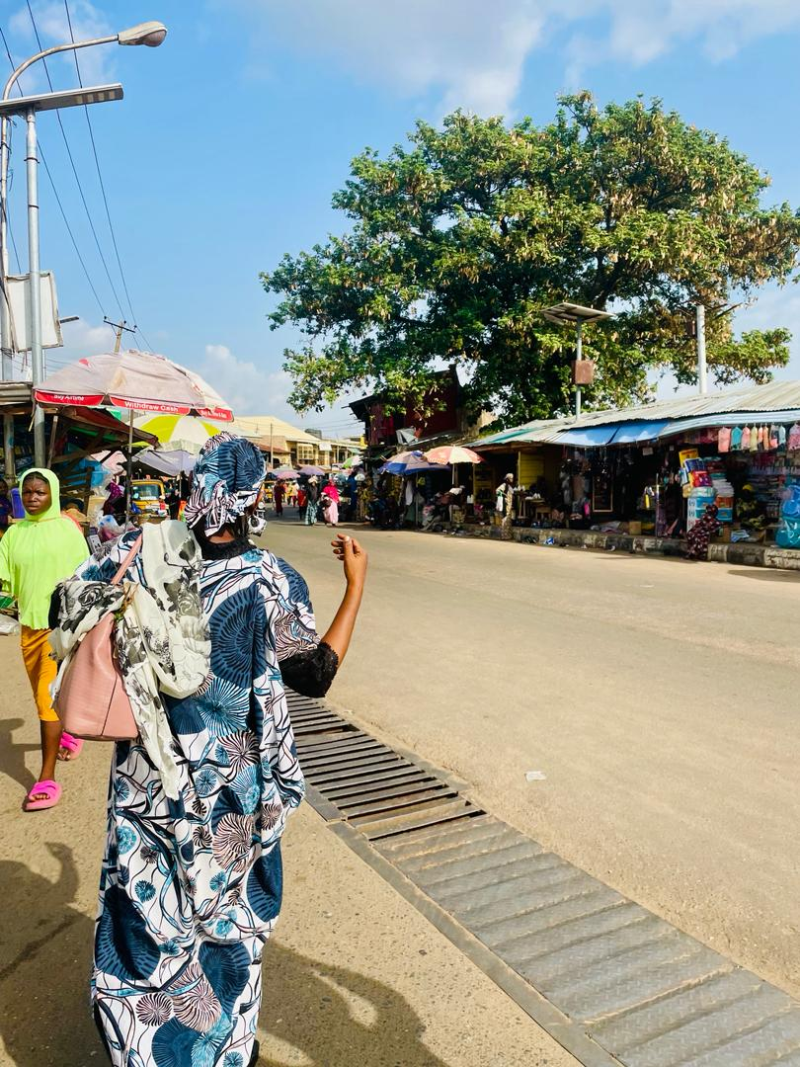
Plate 5: Showing the start point of Gegele Ilorin as Study Area

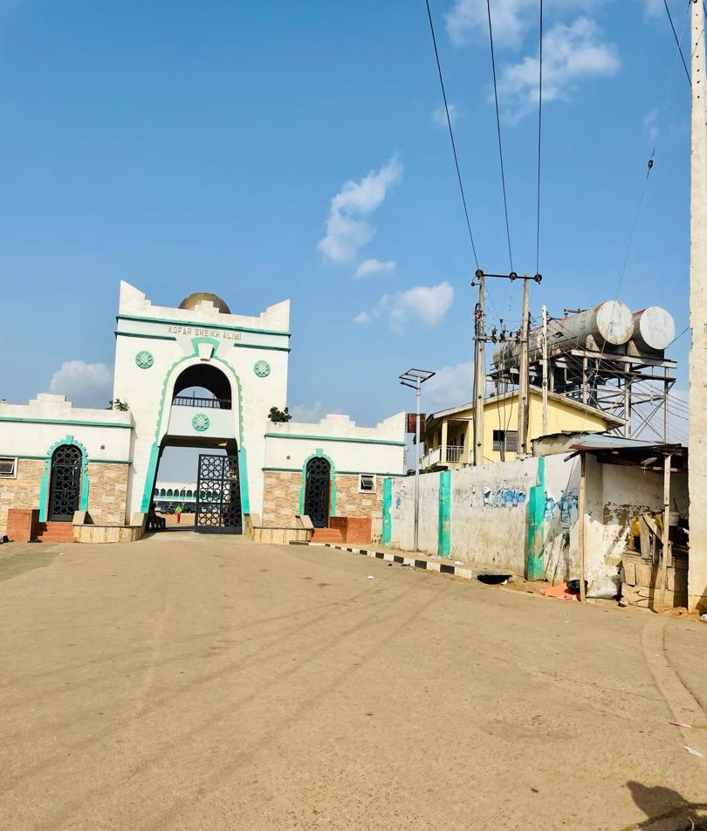
Plate 6: Showing the front of Emri Palace, Ilorin

CHAPTER FOUR
4.0 SUMMARY AND FINDINGS
4.1 INTRODUCTION
This chapter is based on the summary of chapter four which is the data presentation and analysis using tables and photographs as an illustration.
The summary is based on the analysis of the researchers’ findings which has being earlier analyzed with the aid of tables and photographs. The summary will be done by considering each table in conjunction with the photograph depicting each situation of the study area.
4.2 SUMMARY OF FINDINGS
In summary, the research was carried out based on each identified situation of the study area. In the study area, the socio economic characteristics survey of the respondents sex, age determine the proportion of male to female and their age in the study area.
Also, the travel pattern and parking survey such as mode of movement, rate of movement and parking problems, parking capacity, parking situation, available parking and the like were analyzed and found useful for the implementation of the project based on the response of the respondents.
Finally, the effects of parking determined the cost of providing parking facility and the benefits derived in the study area. This was deduced from the analysis and the responses of the respondents during research findings process and all these findings were appropriately used.
4.3 RECOMMENDATIONS
The greatest concern about this terminal project is the effects of parking facility in Gegele market in Ilorin. The cost and primarily the financial expenses associated with developing a TDM program and providing shuttle buses because some potential may be discourage if restriction on cars are considered burdensome or confusing.
The benefits includes reduce traffic congestion and parking problems, road and parking facility cost savings, improved community livability and support for strategic land use objectives, increased transportation choice, improved walking and cycling conditions, increased road safety and a more enjoyable and unique experience for visitors.
In other to achieve the benefits accrued to the provision of parking in a case study, therefore the following programme are recommended.
- TDM strategies
- multi –modal access guide
- parking management programme
TDM STRATEGIES
This strategy includes parking management, parking price, shared parking, commute trip reduction, commuter financial insensitive, transport management association, bicycle parking, smart growth, new urbanism, location efficient development, transit oriented development and access management.
MULTI MODAL ACCESS GUIDE
A multi –modal access guide is a document or sets of documents that provide concise, customized information on how to access a particular destination by various travel modes such as walking, cycling and public transport. Such guide typically includes:
- A map of the area showing the destination, major roads, nearby landmarks, the closest bus stop if any and recommended cycling and walking route.
- Information about transit service frequency, fares, first and last runs and public transportation.
- Information on how long it takes to walk from transits to station, down town area and other refernce location to the site.
- Information on how to reach the destination from major transportation terminals.
- Estimated travel time from nearby cities and towns.
- Availability of motorcycle facilities including secure bike parking, showers and change facilities.
- Automobile parking availability and price.
PARKING MANAGEMENT STRATEGIES AND PROGRAMME
Parking management includes many parking solutions such as shared parking, cash out free parking, favour short time parking, address spillover problems, location and efficient developments, restrict parking and taxi parking which are also supported by TDM strategies.
4.4 IMPLEMENTATION
These aforestated recommendations can be implemented by local government policies and agencies, and by individual businesses, implementation often involves changing current planning, enforcements and design practices with the support of professional organizations, state and federal government financially.

4.5 CONCLUSION
It is highly interesting to conclude here that as far as parking is concern which is the most conspicuous urban traffic problem which could be in various forms such as curb or on street, short term and long term parking or intercity terminals.
However, convenient and affordable parking are considered as a welcome sign to an environment and as we all know that parking that is difficult to find, inadequate, inconvenience or expensive will frustrate users and can contribute to spillover problems in another area.
The fact remains that if there is little or no parking facility in the study area, it can create havoc to the residents of the area and town in general. Therefore, if the suggested recommendation according to the analysis of the research are properly applied by individual, governments and private organization, this will tend to reduce traffic congestion and parking problem, road and parking facilities cost savings, improve walking and cycling condition which in turn improve community livability and support for strategic land use objectives such as preservation of environmental and cultural resources.

BIBLIOGRAPHY
Abiodun J.O. (1989) Urban and Regional Planning Problems in Nigeria; University of Ile-Ife Press Limited Ile-Ife Pg(156-173)
Analytics K.T. (1995), Parking Management Strategies. A handbook for Implementation, Regional Transportation Authority (Chicago)
Bob. A (2000), Journal Index Graphics Home page
Gerald .B. (1980) The strategic location of parking space university press USA
Hamilton Associates (1998), Safety Design Guidelines For Parking Facilities ISBNI-896988-33-5, insurance corporation of British Columbia (Vancouver; 604-661-6969)
Hay, A. (1968), Growth of the Road Havlage Transport services in Nigeria. Grosmenor Press Int. London
Mary, M. (1995) Suburban parking requirements; A Tracit for Automobile use and sprawl, Journal of American Planning Association, Vol. 61, No1, Winter 1995,Pp. 29-42
OSRNSW Treasury (2203), parking space Levy Act 1992
Radiff, E. (1973) Method and system of parking in a Residential streets. Published by W.B. Sander Company London
Reed –E.L (1999) Parking Management, Transportation Tech sheet, Congress for new urbanism
Roti F.R (1974), Parking standard Design Associate West Port Publication U.S.
Smith H. (1969) Composition of parking Provision Published by University press Mayness
Thomas P.S (1988). The Aesthetic of Parking PAS, American Planning Association
Todd L (2000) Transportation Cost and benefit Analysis; Techniques, Estimates and Implications, Victoria Transport Policy Institute
Vagale L.R (1973). The Importance of Parking Space; United NationTown Planning Expert
Vagale L.R (1974) Planning and Designing of parking space: A Guide book for transportation use
VTPI (2003), Parking cost, pricing and Revenue Calculator. Victoria Transport Policy Institute
VTPI (2004), Parking solution: A comprehensive menu of solution to parking problems. Victoria Transport policy institute Canada.
VTPI (2000), Transportation land valuation; Evaluating Policies and practices that affect the Amount of Land Devoted to transportation facilities. Victoria Transport Policy Institute.

APPENDIX
KWARA STATE POLYTECHNIC, ILORIN
INSTITUTE OF ENVIRONMENTAL STUDIES,
URBAN AND REGIONAL PLANING DEPARTMENT,

To Whom It May Concern:
Questionnaire for field survey on the Assessment of the effects of parking facilities in Gegelemarket in Ilorin.
Introduction
Dear respondents,
Please this is purely on academic research. The aim is to assess the effects of parking facility in Gegelemarket Ilorin. Part of the study will require you answering the questions stated in the questionnaires.
Kindly tick the appropriate option.
Thanks
DEMOGRAPHIC AND GENERAL SURVEY
- Sex of the respondent (a) Male (b) Female
- Age of the respondent (a) under 18 years (b) 18 – 29years (c) 30 – 45years (d) over 50years.
- Mode of movement (a) tekking (b) public bux or taxi (c) private car (d) motorcycle.
- Purpose of journey in the study area (a) shopping (b) selling (c) buying (d) office purposes.
- Is parking facility available in the market area? (a) yes (b) no
- If yes, how sufficient is it? (a) sufficient (b) not sufficient
- Nature of parking (a) bustop (b) public garage (c) along the road
- Capacity of the available parking space (a) 50 (b) 70 (c) 100 (d) 120
- Location of the available parking space in the market (a) entrance (b) before entrance (c) after entrance (d) inside the market.
- Reason for parking (a) load and off load (b) shopping (c) for office purpose (d) for other specify.
- Parking duration (a) less than 1hr (b) 3 – 6hrs (c) more than
- Are u being charged for parking in the market (a) yes ( b) no
- If yes to question (12) do you prefer it. (a) yes (b) no.
- If no to question (12) do you want it (a) yes (b) no
- What do you consider as parking problem in the area (a) inadequate parking (b) inconvenient parking (c) expensive parking
- Causes of this problems (a) inadequate information for the users of existing parking capacity (b) inadequate users option (c) excessive automobile users.
- Solution to the problems (a) increase parking supply (b) improved parking option (c) reduce automobile depency.
- What do you think is the cost of providing parking facility in the study area (a) land cost (b) cost of construction (c) cost of maintainance.
- What do u prefer (a) priced parking (b) unpriced parking
- What are benefits derived from the available parking space.(a) reduced traffic congestion and parking problem (b) improve walking and cycling condition (c) other specify.

VEHICLE DRIVERS AND UNION EXECUTIVES
- Sex of the respondent (a) male (b) female
- Age of the respondent (a) 18 – 29years (b) 30 – 45years (c) 50 years and above.
- What union do you belong to (a) national union of road transport workers (b) road transport employee
- What is your position in the union (a) passenger (b) accommodator (c) conductor (d) driver (e) chairman/union executive
- For how long have you been in the union (a) 2 – 5years (b) 6- 10years (c) 10 – 15years (d) 15 – 19years.
- Owner of the vehicle (a) individual (b) government (c) union.
- Rate of movement in day within inter town (a) 0 – 5trips (b) 6-10trips (c) 11-15trips.
- Rate of movement within and outside the town (a) 1trip (b) 2trips (c) 3trips (d) 4 and above.
- Do you consider parking as problem (a) yes (b) no
- If no state the problem you are facing
- If yes to question (9) above, how do you think it could be solved (a) provision of more parking space (b) allow more of on-street parking
- Are you satisfied with the existing parking space (a) yes (b) no
- If no, why?...............................................
- Will you make use parking space if provided (a) yes (b) no
- If money is to be charged for construction will you support in it? (a) yes (b) no.

