EFFECT OF EXTRACTION CONDITIONS ON THE PROXIMATE COMPOSITION OF SUGARCANE JUICE

BY

MUHAMMAD TOHEEB OLASUNKANMI
HND/23/ABE/FT/0100

DEPARTMENT OF AGRICULTURAL AND BIO-ENVIRONMENTAL ENGINEERING INSTITUTE OF TECHNOLOGY, KWARA STATE POLYTECHNIC, ILORIN.
IN PARTITAL FULFILLMENT OF REQUIREMENT FOR THE AWARD OF HIGHER NATIONAL DIPLOMA (HND) IN AGRICULTURAL AND BIO-ENVIRONMENTAL ENGINEERING TECHNOLOGY.
AUGUST, 2025

DECLARATION
I hereby declare that this research project titled: “EFFECT OF EXTRACTION CONDITIONS ON THE PROXIMATE COMPOSITION OF SUGARCANE JUICE” is my own work and has not been submitted by any other person for any degree or qualification at any higher institution. I will also declare that the information provided therein are mine and those that are not mine are properly acknowledged.

 __
Name of Student Date and Signature

CERTIFICATION
I, hereby declare that this research project titled EFFECT OF EXTRACTION CONDITIONS ON THE PROXIMATE COMPOSITION OF SUGARCANE JUICE was carried out by Muhammad Toheeb Olasunkanmi with matric number HND/23/ABE/FT/0100 is my own work and has not been submitted by any other person for any degree or diploma in any higher institution. I also declare that the information provide therein are mine and those that are not mine are properly acknowledged.
 _
Engr (Mrs) Shuaib-Na’allah B.O Date
(Project Supervisor)
________
Engr. Oyebanre O.D Date
(Project Co-ordinator)
_________
Engr. Dauda, K.A Date
(Head of Department)
_______ 
Dr. Adejumo Akinfoye Daniel Date
(External Examiner)
DEDICATION
I dedicate this project work firstly to Almighty GOD the unborn creator of every creature who has been there for me from my very first beginning till date. Also, to my caring parent MR Muhammed Kayode Muse and Mrs Muhammed Adenike Risikat and my family for all they have done for me I pray that you will reap the fruit of your labour by the grace of God.

ACKNOWLEDGEMENT
I give my great thanks to Almighty God, the Lord of the whole universe, the sustainers who guided and provided me all I need to complete my HND (Higher National Diploma) Programme in good health.
My profound gratitude goes to my caring parent MR Muhammed Kayode Muse and Mrs Muhammed Adenike Risikat and my family, may Almighty God grant them sound health and bless them.
The next thank goes to my supervisor, a woman of understanding, honour and trust in person of Engr. (Mrs) Shuaib Na - Allah, B.O. for being there and lenient with me. I pray Almighty God reward you abundantly (Amen).
My appreciation also goes to the H.O.D of Agricultural and Bio-environmental Engineering Department in person of Engr. Dauda, K.A, and to all my departmental lecturers for the knowledge they have impacted in me throughout my Higher National Diploma Programme, may God reward you abundantly.
Also my gratitude to my friends, who stood by me. I remain disloyal if I drop my pen without appreciating my project partners. Thank you for the sincere love we share during this research work. Also those people I am not opportune to mentioned one after the other, most especially all my course mate I appreciate you all, I will live to always remember your good deeds.
I am using this medium to pray to Almighty God to bestow on me the utmost knowledge and understanding from now till eternity (Amen).

TABLE OF CONTENTS
Title Page
Title Page I
Declaration ii
Certification iii
Dedication iii
Acknowledgement iv
Table of Contents v
List of Table vii
List of Figure viii
List of Plates ix
Abstract x
CHAPTER ONE
1. Introduction 1
1.1 Background to The Study 1
1.2 Problem Statement 2
1.3 Justification 3
1.4 Aim and Objectives 3
1.5 Scope of the study 4
CHAPTER TWO
2. Literature Review 5
2.1 Overview of Sugarcane (Saccharum officinarum) 5
2.2 Nutritional Composition of Sugarcane Extract 5
2.2.1 Proximate Composition 5
2.2.1.1 Carbohydrates 5
2.2.1.2 Proteins 6
2.2.1.3 Fats 6
2.2.1.4 Fiber 6
2.2.1.5 Ash Content 6
2.2.1.6 Moisture Content 6
2.1 Proximate Composition of Sugarcane Extract 7
2.2.2 Mineral Composition 7
2.2.3 Vitamin Composition 8
2.3 Health Benefits of Sugarcane Extract 8
2.2.4 Bioactive Compounds in Sugarcane Extract 8
2.3.1 Hydration and Energy Boost 8
2.3.2 Digestive Health 9
2.3.3 Detoxification 9
2.3.4 Immune Support 9
2.4 Comparative Evaluation with Other Natural Beverages 9
2.5 Review of Past Project 9
CHAPTER THREE
3. Materials and Methods 12
3.1 Materials 12
3.2 Methods 14
3.2.1 Sourcing of Experimental Materials 14
3.3 Sample Preparation 14
3.4 Experimental Design and Layout 15
3.7 Experimental Procedure 16
3.8 Output Parameters 17
3.9 Determination of Moisture Content 17
3.9.1 Moisture Content (g/100 g) 18
3.9.2 Ash Content 18
3.9.3 Determination of Lipid Content 18
3.9.4 Determination of Protein 19
3.9.5 Crude Fiber 19
3.9.6 Carbohydrate Determination 20
CHAPTER FOUR
4. Result and Discussion 21 4.1 Result 21
4.2 Discussion 37
CHAPTER FIVE
5. Conclusion and Recommendations 44
5.1 Conclusion 44
5.2 Recommendation 45
References 46

LIST OF TABLE
Table 3.5: Experimental Factors and levels for Box-Behnken design 15
Table 3.6: Experimental matrix by Box-Behnken Design 16
Table 4.1: Summary of Result Obtained from the Test conducted on Sugar Cane Juice 21
Table 4.2: Analysis of Variance (ANOVA) for Moisture of Sugar Cane Juice 22
Table 4.3 Response 2: Calorific Value 23
Table 4.4 Response 3: Ash 25
Table 4.5 Response 4: Crude Protein 28
Table 4.6 Response 5: Crude 30
Table 4.7 Response 6: Crude Fat 32
Table 4.8 Response 7: Carbohydrate 34

LIST OF FIGURES
Figure 4.1: Effect of Machine Roller Speed and Feed Rate on the Moisture of Sugar Cane Juice 22
Figure 4.2: Effect of Machine Roller Speed and No of Passes on the Moisture of Sugar Cane Juice 23
Figure 4.3: Effect of Machine Roller Speed and Feed rate on the Calorific value of Sugar Cane Juice 24 Figure 4.4.: Effect of Machine Roller Speed and No of passes on the Calorific value of Sugar Cane Juice 25
Figure 4.5: Effect of Machine Roller Speed and Feed rate on the Ash value of Sugar Cane Juice 26
Figure 4.6: Effect of Machine Roller Speed and No of Passes on the Ash value of Sugar Cane Juice 27
Figure 4.7: Effect of Feed Rate and No of Passes on the Ash value of Sugar Cane Juice 28
Figure 4.8: Effect of Machine Roller Speed and Feed Rate on the crude protein of Sugar Cane Juice 29
Figure 4.9: Effect of Machine Roller Speed and No of Passes on the crude protein of Sugar Cane Juice 30
Figure 4.10: Effect of Machine Roller Speed and Feed Rate on the Crude Fiber of Sugar Cane Juice 31
Figure 4.11: Effect of Machine Roller Speed and No of Passes on the Crude Fiber of Sugar Cane Juice 32
Figure 4.12: Effect of Machine Roller Speed and Feed Rate on the Crude Fat of Sugar Cane Juice 33
Figure 4.13: Effect of Machine Roller Speed and No of Passes on the Crude Fat of Sugar Cane Juice. 34
Figure 4.14: Effect of Machine Roller Speed and Feed Rate on the Carbohydrate of Sugar Cane Juice 35
Figure 4.15: Effect of Machine Roller Speed and No of Passes on the Carbohydrate of Sugar Cane Juice 36
Figure 4.16: Effect of Feed Rate and No Passes on the Carbohydrate of Sugar Cane Juice 37

LIST OF PLATES
Plate3.1 Sugar cane 14
Plate3.2 : Digital weighing Scale 14
Plate:3.3 Soxhlet extractor 14
Plate:3.4: Hot air oven 14
Plate:3.5 Desiccator vacuum 150mm 14
Plate:3.6 Stop watch 14

ABSTRACT
This study investigates the effect of extraction conditions on the proximate composition of sugarcane juice, aiming to optimize juice quality for nutritional and industrial applications. Proximate composition refers to the analysis of key nutritional components such as moisture, ash, crude protein, crude fat, fiber, and carbohydrate content. Using a Box-Behnken Design (BBD) within the framework of response surface methodology, the experimental setup varied three major extraction parameters: temperature, time, and solvent ratio (juice-to-water). The results revealed that extraction conditions significantly influenced the proximate parameters of sugarcane juice. Higher temperatures and longer extraction times reduced moisture content while increasing the concentration of total solids, sugars, and other nutrients. However, extreme conditions led to nutrient degradation, particularly in protein and vitamin-sensitive components. Optimal conditions were identified that preserved nutritional quality while improving yield. This study highlights the importance of controlled extraction in enhancing the nutritional value of sugarcane juice, with implications for food processing, storage, and beverage formulation.

CHAPTER ONE
INTRODUCTION
  - Background to The Study
Sugarcane (Saccharum officinarum) is a tropical crop widely cultivated for its sweet juice, which is rich in natural sugars, minerals, and other nutrients. Sugarcane juice serves as a popular refreshment in many parts of the world, particularly in tropical regions like Nigeria, where it is consumed for its energy-boosting properties, affordability, and natural flavor. Beyond its immediate use as a beverage, sugarcane juice also holds potential in the production of fermented drinks, syrups, and other value-added products.
Despite its popularity, one major challenge facing processors and food scientists is the variation in the nutritional quality of sugarcane juice resulting from different processing conditions. Parameters such as roller speed, feed rate, and the number of extraction passes play a crucial role in determining not only the yield of juice but also its nutritional composition. These extraction conditions can influence the extent of cell rupture, juice purity, and the inclusion or loss of vital nutritional components such as protein, fiber, and mineral content. Improper extraction methods may lead to excessive dilution, oxidation, or nutrient loss, thereby reducing the nutritional and commercial value of the juice. Sugarcane extract, commonly consumed as juice, is a natural, unfermented liquid obtained by crushing fresh sugarcane stalks. It contains a high concentration of carbohydrates, mainly sucrose, fructose, and glucose, making it a quick source of energy. However, beyond its carbohydrate content, sugarcane extract is also rich in essential vitamins (such as Vitamin C and B-complex vitamins), minerals (including calcium, potassium, and magnesium), and bioactive compounds such as flavonoids and phenolic acids that contribute to its health benefits (Patel et al., 2020).
Studies have shown that sugarcane juice possesses antioxidant, anti-inflammatory, and hydrating properties, making it a beneficial alternative to artificial energy drinks (Ramirez et al., 2020). Its alkaline nature may also help in digestion and neutralizing stomach acidity, reducing the risk of acid reflux and gastritis (Sharma and Mehta, 2022). Furthermore, sugarcane extract is known to have diuretic properties, promoting kidney health by flushing out toxins from the body (Singh et al., 2020).
1.2 Problem Statement
While several studies have focused on improving sugarcane yield and juice preservation, there is a noticeable gap in literature regarding the direct relationship between extraction conditions and the proximate composition of the juice. Understanding how these mechanical and operational variables affect the nutritional makeup of sugarcane juice is essential for optimizing processing techniques, improving product consistency, and ensuring that consumers receive a nutritionally beneficial product.
This research, therefore, seeks to investigate the effect of varying extraction conditions on the proximate composition of sugarcane juice. By evaluating how factors such as roller speed, feed rate, and number of passes influence key nutritional parameters — including moisture, ash, crude protein, crude fat, crude fiber, and carbohydrate content.

1.3 Justification
The study aims to establish scientifically-based guidelines for optimal juice extraction. The findings will provide valuable insights for small- and large-scale sugarcane juice processors, contributing to improved product quality, better nutrient retention, and overall consumer satisfaction.
1.4 Aim and Objectives
The aim of the project is to extract quality uice from sugar cane and examing the effect on the proximate composition of the sugar cane juice. While the specific objectives are:
- To extract sugarcane juice under varying extraction conditions (machine roller speed, feed rate and number of passes).
- To determine the proximate composition of the sugar cane juice (moisture, ash, crude protein, crude fiber, calorific value, crude fat and carbohydrates) obtained under different conditions.
- To evaluate the influence of each extraction condition on the proximate composition of the sugar cane juice.
- Identify the optimal extraction condition that yields juice with the most desirable nutritional characteristics (highest sugar content and lower fiber residue).

1.5 Scope of the study
This study is limited to evaluating the nutritional composition of sugarcane juice through proximate analysis.
It specifically examines how variations in machine roller speed, feed rate and number of passes duringextraction affects the proximate composition of the juice.

CHAPTER TWO
LITERATURE REVIEW
2.1 Overview of Sugarcane (Saccharum officinarum)
Sugarcane (Saccharum officinarum) is a tall perennial grass belonging to the family Poaceae, extensively cultivated in tropical and subtropical regions. It is the world’s largest crop by production quantity and serves as a key raw material in the sugar, ethanol, and beverage industries. Apart from its use in sugar production, sugarcane is widely consumed in its raw juice form due to its refreshing taste and health-promoting properties (Patel et al., 2020).
Sugarcane juice is extracted by mechanically crushing the stalks, resulting in a naturally sweet, nutrient-rich
liquid. The extract contains essential nutrients such as carbohydrates, proteins, minerals, vitamins, and antioxidants that contribute to its nutritional and therapeutic value (Kumar et al., 2021).
2.2 Nutritional Composition of Sugarcane Extract
Sugarcane extract contains several nutrients beneficial to human health. The nutritional components are broadly classified into proximate composition, mineral content, vitamin content, and bioactive compounds.
2.2.1 Proximate Composition
The proximate composition includes carbohydrates, protein, fat, ash, fiber, and moisture content. These components provide information about the basic nutritional quality of food substances.
2.2.1.1 Carbohydrates
Carbohydrates are the most abundant component in sugarcane extract. The major carbohydrates present are sucrose (glucose + fructose), glucose, and fructose. These simple sugars serve as a rapid source of energy and are easily digestible (Gomez et al., 2018). The total sugar concentration in sugarcane extract ranges from 12–18% depending on the variety and maturity of the cane.
2.2.1.2 Proteins
Although present in small quantities, proteins in sugarcane extract play important roles in enzyme function and tissue repair. Studies have shown that the crude protein content ranges from 0.2% to 0.5% (Ramirez et al., 2020).
2.2.1.3 Fats
Sugarcane juice is nearly fat-free, with fat content typically less than 0.1%. This makes it a healthy beverage choice for individuals on low-fat diets (Ogunlade et al., 2019).
2.2.1.4 Fiber
Sugarcane extract has minimal fiber content since the juice is separated from the fibrous cane stalk. However, small amounts of soluble dietary fiber may still be present and can aid in digestion (Sharma et al., 2022).
2.2.1.5 Ash Content
Ash refers to the total mineral content present in food. The ash content of sugarcane extract ranges between 0.3% and 0.6%, indicating the presence of mineral elements (Singh et al.,2020).
2.2.1.6 Moisture Content
The moisture content of sugarcane extract is high, typically between 80% and 85%. This makes the juice an excellent hydrating agent, especially in hot climates (Kumar et al., 2021).

2.1 Proximate Composition of Sugarcane Extract
Component, ​​​Percentage Composition (%)
Moisture. ​ ​​82.4
Carbohydrates ​​​15.0
Protein​​ ​​​0.4
Fat ​​​ ​​​0.1
Fiber ​​ ​​​​0.2
Ash​​​ ​​​0.5
Source: Ramirez et al. (2020),
2.2.2 Mineral Composition
Sugarcane extract contains essential minerals that are crucial for various metabolic processes.
- ​​Calcium (Ca): Important for bone formation and muscle function. Present in concentrations ranging from 10 to 15 mg/100 mL (Akinpelu et al., 2019).
- ​​Potassium (K): Supports nerve signaling and fluid balance; occurs in concentrations of 20–30 mg/100 mL (Singh et al., 2020).
- ​​Magnesium (Mg): Vital for enzymatic activity and energy production. Found in quantities of 5–10 mg/100 mL (Gomez et al., 2018).
- ​​Iron (Fe): Essential for hemoglobin synthesis and oxygen transport. Present at levels between 0.5–1.5 mg/100 mL (Sharma et al., 2022).
- ​​Phosphorus (P): Aids in energy metabolism and bone health.

2.2.3 Vitamin Composition
Sugarcane extract also contains several water-soluble vitamins:
- ​​Vitamin C (Ascorbic Acid): Acts as a natural antioxidant and immune booster. Found in concentrations
- ranging from 2–4 mg/100 mL (Ramirez et al., 2020).
- ​​Vitamin B1 (Thiamine): Helps convert carbohydrates into energy.
- ​​Vitamin B2 (Riboflavin): Essential for tissue repair and red blood cell production.
- ​Vitamin B6 (Pyridoxine): Supports brain development and immune function (Patel et al., 2020).
2.2.4 Bioactive Compounds in Sugarcane Extract
In addition to basic nutrients, sugarcane extract contains bioactive compounds that provide additional health benefits:
- ​​Flavonoids: Possess antioxidant, anti-inflammatory, and anti-carcinogenic properties.
- ​​Phenolic Compounds: Help combat oxidative stress and may reduce the risk of chronic diseases (Kumar et al., 2021).
- ​Policosanol: Found in the wax of sugarcane; known for its cholesterol-lowering effects (Singh et al., 2019).
2.3 Health Benefits of Sugarcane Extract
Scientific research has identified numerous health-promoting properties of sugarcane extract:
2.3.1 Hydration and Energy Boost: High moisture and sugar content make sugarcane juice ideal for rehydration and energy restoration, particularly after physical exertion (Ramirez et al., 2020).
2.3.2 Digestive Health: Its alkaline nature helps reduce acidity and supports digestion (Patel et al., 2020).
2.3.3 Detoxification: The diuretic properties assist in kidney function by promoting urine production and toxin elimination (Kumar et al., 2021).
2.3.4 Immune Support: The presence of vitamin C and antioxidants strengthens the immune system and reduces the risk of infections.
2.4 Comparative Evaluation with Other Natural Beverages
Compared to fruit juices and coconut water, sugarcane extract is naturally sweet and does not require added sugars. Coconut water is superior in potassium content, but sugarcane extract provides more carbohydrates and certain antioxidants (Singh et al., 2020). Unlike many artificial beverages, sugarcane juice offers a natural blend of macro- and micronutrients with fewer preservatives.
2.5 Review of Past Project
Sania et al, (2019) study the physicochemical properties, nutrition value and health benefits of
sugarcane juice which is widely known as raw material for white sugar production. Sugarcane
juice is relished as a refreshing drink as it is nutritious and rich in vitamins, carbohydrates, and
amino acids. The status of sugarcane juice as a nutritional beverage is well established owing to
the presence of variable contents of hydrophilic components. In addition, the chemical profile of
the sugarcane juice indicates the presence of the several phytochemicals pertaining vast
pharmacological research potential. It has been actively used in the traditional Ayurvedic
medicines, moreover, the modern research is providing a clear evidence of therapeutic activity of
the sugarcane crude extract. The potent biological activities have rendered this juice a promising
therapeutic agent for future studies.
Amandeep et al;(2015)) carried out a research on the photochemistry of Sugarcane (Saccharum
officinarum.) obtain from leaves and stalks of sugarcane phytoconstituents and health benefits of
sugarcane and its valuable products. The phytochemistry of sugarcane wax (obtained from the
leaves and stalks of sugarcane), leaves, juice, and its products has revealed the presence of
various fatty acid, alcohol, phytosterols, higher terpenoids, flavonoids, -O- and -C-glycosides,
and phenolic acids. The future prospective of some of the sugarcane products has been discussed,
which needs a phytopharmacological study and has a great potential to be a valuable medicinal
product.
Haibo Huang et al; (2017) carried out a research on Biodiesel production in the U.S. from
vegetable oils have increased substantially during the past decade. However, its further increase is
limited by the low amounts of oil produced per hectare from temperate oilseed crops. Recently
novel transgenic sugarcane has been developed to accumulate both sugars and lipids in stems,
making it a promising dual-purpose feedstock to produce both ethanol and biodiesel. In this
study, two lines of the transgenic lipid producing sugarcane (lipid-cane) and the non-transformed
sugarcane was characterized and processed. The total lipid concentrations were 0.7%, 0.9% and
1.3% for the Biodiesel production in the U.S. from vegetable oils has increased substantially
during the past decade. However, its further increase is limited by the low amounts of oil
produced per hectare from temperate oilseed crops. Recently novel transgenic sugarcane has
been developed to accumulate both sugars and lipids in stems, making it a promising dual-
purpose feedstock to produce both ethanol and biodiesel. In this study, two lines of the
transgenic lipid producing sugarcane (lipid-cane) and the non-transformed sugarcane were
characterized and processed. The total lipid concentrations were 0.7%, 0.9% and 1.3% for the
non-transformed sugarcane and lipid-cane lines19B and 25 C, respectively. Lipid
composition analysis showed that about 31–33% of the total lipids weretriacylglycerols, main
feedstock for biodiesel production, for the lipid-cane samples, while this value was only 5% for
the non-transformed sugarcane. By processing the sugarcane stems with a juicer, about 90% of
the sugars and 60% of the lipids were extracted with juice. The extracted sugars in juice were
fermented to ethanol and the lipids were later recovered from the fermented juice using organic
solvents. The recovered lipids from the fermented juice were 0.3, 0.5 and 0.8 g/100 g dry stem for
the non-transformed sugarcane and lipid cane lines 19B and 25 C, respectively. This study
proved the concept of the lipid and sugar coproduction from the novel lipid-cane, which have a
potential to make a large-scale replacement of fossil derived fuel without unrealistic demands on
land area.

CHAPTER THREE
MATERIALS AND METHODS
3.1 Materials
The following materials and instruments were used in the course of this study.
- Digital weighing scale: A digital weighing scale with model no NBL-2602e with an accuracy ±0/01g was used to measure the samples for the experiment.
- Digital tachometer: A contact/non contact digital tachometer with accuracy ± (0.05% + 1 digits) was used to measure the speed of the machine during operation.
- Bowl: Three bowls of equal size was used to prepare the sample and also to collect the bagasse from the machine.
- Couch/Porcelain Crucible: Capacity 20–50 mL; heat resistant up to 1000°C
- Stopwatch: A digital stopwatch was used to measure the time taken to complete each experiment.
- Hot Air Oven: Temperature range up to 250°C; accuracy ±1°C; timer 0–99 hours
- Muffle Furnace: Maximum temperature 1000°C; operating temperature 550–600°C; digital controller.
- Analytical Balance: Readability 0.1 mg (±0.0001 g); capacity 200–300 g; internal or external calibration.
- Desiccator: Vacuum or non-vacuum type; diameter 150–300 mm; includes ceramic plate and silicone seal.
- Aluminum/Platinum Crucible: Capacity 30–50 mL; made of high-purity aluminum or platinum.
- Soxhlet Extractor: Volume 100–500 mL; borosilicate glass; compatible with cellulose thimbles.
- Fat-Free Thimble: Made of cellulose; standard size 33 x 80 mm or as required by extractor.
- Heating Mantle: Temperature range ambient to 450°C; accommodates 250–500 mL flasks.
- Rotary Vacuum Evaporator: Temperature up to 180°C; rotation speed 20–280 rpm; vacuum control system.
- Digestion Block/Heater: Temperature up to 450°C; accommodates 6–20 digestion tubes; timer with exhaust.
- Distillation Unit: Includes condenser and ammonia trap; heater with adjustable temperature.
- Titration Setup: 50 mL burette (Class A); stand and clamp; 250 mL conical flask.
- Glassware (Flasks, Beakers, Pipettes): Made of borosilicate glass; capacity ranges from 10–500 mL.
- Reflux Apparatus: Includes condenser and heat source; round-bottom flask capacity 250–500 mL.
- Filter Setup (Funnels, Cheesecloth, Filter Paper): Medium to coarse porosity; diameter 90–150 mm.
- Sugar cane

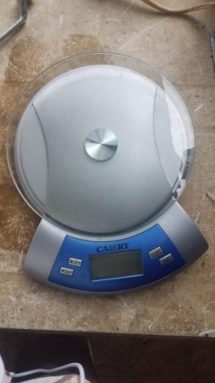
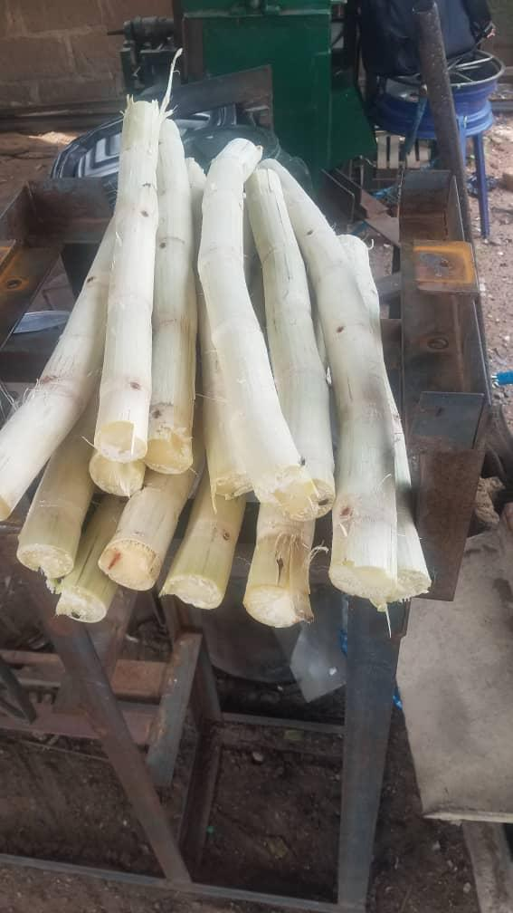
Plate3.1: Sugar cane Plate3.2: Digital weighing Scale
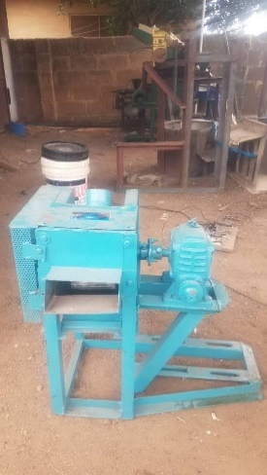
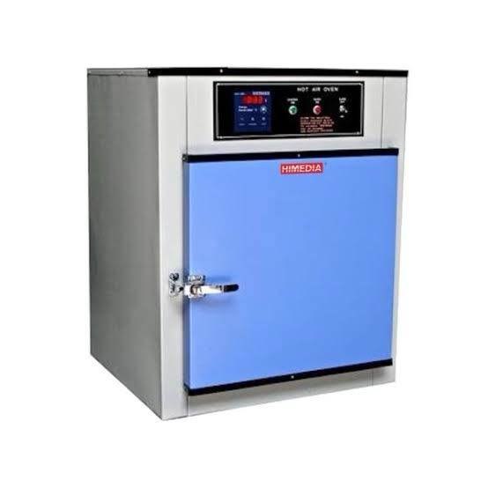
Plate 3.3: Soxhlet extractor Plate 3.4: Hot air oven
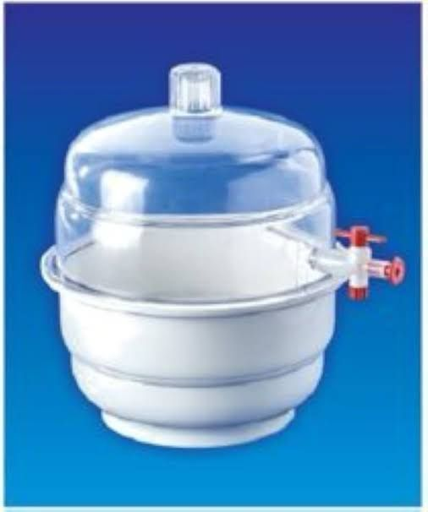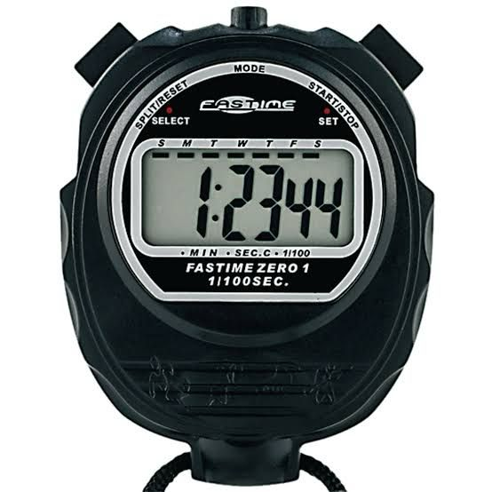
Plate 3.5: Desiccator vacuum 150mm Plate 3.6: Stop watch
3.2 Methods
3.2.1 Sourcing of Experimental Materials
Sugarcane was purchased from a local market in Ilorin South Local Government Area, Kwara State, Nigeria.

3.3 Sample Preparation
The sugar cane was peeled and washed thoroughly with water. The sugar cane was cut to medium sizes for easy measurement. The sugar cane was then measured into the various samples using a digital weighing scale according to the design layout.

3.4 Experimental Design and Layout
Three independent variables (feed rate, machine roller speed and no of pass) were selected while seven dependent variables: output parameters (moisture, ash, crude protein, crude fiber, calorific value, crude fat and carbohydrates) were considered for this study. A computer software Central Composite Design Expert Software version 6.08 with three factors and three levels (Box-Behnken experimental design) which generated 17 experimental runs was applied. The independent variables for this study were selected based on preliminary experiments and literature search. Three levels of feed rate (500g, 1000g and 1500g), machine speed (50 rpm, 100 rpm and 150 rpm) and number of pass (1, 2, 3). Table 3.1 shows the experimental factors and their levels while Table 3.2 shows the experimental matrix used for the experiment.
Table 3.5: Experimental Factors and levels for Box-Behnken design
Factors | Symbol |  | Level
 | Original | Coded | -1 | 0 | +1
Feed rate (Kg) | Fr | A | 500 | 1000 | 1500
Machine Roller Speed (rpm) | Sp | B | 50 | 100 | 150
No of Pass | N | C | 1 | 2 | 3

Table 3.6: Experimental matrix by Box-Behnken Design
 | Run | A:Machine Roller Speed | B:Feed Rate | C:No of Passes | Moisture | Calorific Value | Ash | Crude Protein | Crude Fiber | Crude Fat | Carbohydrate
 |  | rpm | g |  | % | kj/100g | % | % | % | % | %
14 | 1 | 100 | 1000 | 2
13 | 2 | 100 | 1000 | 2
4 | 3 | 150 | 1500 | 2
5 | 4 | 50 | 1000 | 1
6 | 5 | 150 | 1000 | 1
15 | 6 | 100 | 1000 | 2
12 | 7 | 100 | 1500 | 3
7 | 8 | 50 | 1000 | 3
9 | 9 | 100 | 500 | 1
10 | 10 | 100 | 1500 | 1
16 | 11 | 100 | 1000 | 2
11 | 12 | 100 | 500 | 3
2 | 13 | 150 | 500 | 2
3 | 14 | 50 | 1500 | 2
8 | 15 | 150 | 1000 | 3
17 | 16 | 100 | 1000 | 2
1 | 17 | 50 | 500 | 2

3.7 Experimental Procedure
The sample prepared was fed into the machine via the feeding hopper while the electric motor was used to power the machine. The operation of the sugar cane juice extracting machine assisted in obtaining a sugar cane juice from the juice outlet while the baggase were collected from the baggase outlet. The juice and the baggase were measured with a digital weighing scale and recorded while the time taken for each experiment was taken with a stopwatch and recorded. The juices were then taken to the lab for further analysis.
3.8 Output Parameters
The output parameters were determined using the procedure given by Association of Official Analytical Chemist (AOAC), 2019.
3.9 Determination of Moisture Content
This method is based on moisture evaporation. Here the aluminum dishes were washed dried in oven and in desiccators for cooling. The weight of each dish was taken. 5.0 g of ground samples of were weighed into a sterile aluminum dish, weight of the dish and weight of un-dried sample (in duplicate) were taken. This was transferred into an oven set at 80°C for 2 h and at 100°C for 3 h respectively. This was removed and cooled in desiccators. Then the weight was measured using a measuring scale balance. It was transferred back into the oven for another one hour and then reweighed. The process continued until a constant weight was obtained. The difference in weight between the initial weight and the constant weight gained represents the moisture content.
Calculation: The loss in weight multiplied by 100 over the original weight is percentage moisture content.

3.9.1Moisture Content (g/100 g)
= loss in weight ((W2-W3)/ (W2-W1)) x 100
Where W1= initial weight of empty crucible, W2= weight of crucible + sample before drying, W3 = final weight of crucible + sample after drying.
% Total solid (Dry matter) (%) = 100- moisture (%)
3.9.2Ash Content
The ash represents the inorganic component (minerals) of the sample after all moisture has been removed as well as the organic material. The method is a destructive approach based on the decomposition of all organic matter such that the mineral elements may be lost in the process. Twenty grams (20 g) of each of the samples were weighed into a clean dried and cooled platinum crucible. It was put into a furnace set at 550 °C and allowed to blast for 3 h. It was then brought out and allowed to cool in desiccators and weighed again.
Calculation: Percentage weight is calculated as weight of ash multiplied by 100 over original weight of the samples used.
Ash content = (weight of ash/ weight of original sample used) x100.
Loss in weight ((W3-W1)/(W2-W1)) x 100
Where W1 = weight of empty crucible, W2 = weight of crucible + sample before drying and or ashing, W3 = weight of crucible + ash.

3.9.3 Determination of Lipid Content
The method employed was the soxhlet extraction technique. 15 g of the samples were weighed and carefully placed inside a fat free thimble. This was covered with cotton wool to avoid the loss of sample. Loaded thimble was put in the Soxhlet extractor, about 200 ml of petroleum ether was poured into a weighed fat free soxhlet flask and the flask was attached to the extractor. The flask was placed on a heating mantle so the petroleum ether in the flask refluxed. Cooling was achieved by a running tap connected to the extractor for at least 6hrs after which the solvent was completely siphoned into the flask. Rotary vacuum evaporator was used to evaporate the solvent leaving behind the extracted lipids in the soxhlet. The flask was removed from the evaporator and dried to a constant weight in the oven at 60°C. The flask was then cooled in a desiccator and weighed. Each determination was done in triplicate. The amount of fat extracted was calculated by difference. Ether extracts (100g) dry matter = (weight of extracted lipids/ weight of dry sample) x100
3.9.4 Determination of Protein
1.0g of the sample was weighed and transferred to the digestion flask. 3.4g of potassium sulphate and 0.4g of copper sulphate was added alongside 5ml concentrated sulfuric acid. The flask was placed in an inclined position and heated until frothing ceased. The mixture in the flask was cooled and 45ml of distilled water added and mixed. Thereafter, anti-bumping material was added and the content of the flask carefully poured into a distillation flask. 5M NaOH was added to the content and this was immediately distilled and the distillates collected into 10ml of 1M HCl containing 5 drops of mixed indicator solution. The excess acid was titrated with 1M NaOH solution until a color change is observed. Percentage N= (ml of standard acid*molarity-ml of NaOH*M) *1.4007/g test portion Crude Protein General Factor=6.25 e.g meat=N*6.25, Milk=N*6.38
3.9.5 Crude Fiber
The bulk of roughages in sample is referred to as fiber and is estimated as crude fiber. Twenty grams (20 g) of the different samples were defatted with diethyl ether for 8 h and boiled under reflux for exactly 30 min with 200 mL of 1.25% H2SO4. It was then filtered through cheese cloth on a flutter funnel. This was later washed with boiling water to completely remove the acid. The residue was then boiled in a round bottomed flask with 200 mL of 1.25% sodium hydroxide (NaOH) for another 30 min and filtered through previously weighed couch crucible. The crucible was then dried with samples in an oven at 100°C, left to cool in a desiccator and later weighed. This was later incinerated in a muffle furnace at 600°C for 2 to 3 h and later allowed to cool in a desiccator and weighed.
Calculation = Weight of fiber = (C2-C3)
% Fiber = C2-C3 x 100 /Wt. of original sample
3.9.6 Carbohydrate Determination
Available carbohydrate (%) = 100- (protein (%) + Moisture (%) + Ash (%) + Fibre (%) + Fat (%)).
Energy or Caloric Value (KJ/100g) = (Protein X 16.7) + (Lipids X 37.7) + (Carbohydrate X 16.7)
Statistical Analysis
The statistical analysis used for this study is analysis of variance (ANOVA) using Design Expert Software version 6.08. A 3D plot is also used to describe the dependent variables with respect to the independent variables.

CHAPTER FOUR
Results and Discussions
4.1 Results
The results obtained from the test conducted on the extracted sugar cane juice is presented in table 4.1 below.
Table 4.1: Summary of Result Obtained from the Test conducted on Sugar Cane Juice
Run | A:Machine Roller Speed | B:Feed Rate | C:No of Passes | Moisture | Calorific Value | Ash | Crude Protein | Crude Fiber | Crude Fat | Carbohydrate
 | rpm | g |  | % | kj/100g | % | % | % | % | %
1 | 100 | 1000 | 2 | 87.2117 | 212.25 | 0.3343 | 0.8607 | 0.1269 | 0.3042 | 11.1622
2 | 100 | 1000 | 2 | 87.2117 | 212.25 | 0.3343 | 0.8607 | 0.1269 | 0.3042 | 11.1622
3 | 150 | 1500 | 2 | 85.4978 | 237.844 | 0.3674 | 0.8371 | 0.1274 | 0.1867 | 12.9836
4 | 50 | 1000 | 1 | 88.0908 | 198.899 | 0.3166 | 0.8701 | 0.1202 | 0.3481 | 10.2544
5 | 150 | 1000 | 1 | 86.3334 | 225.589 | 0.352 | 0.8514 | 0.1336 | 0.2603 | 12.0692
6 | 100 | 1000 | 2 | 87.2117 | 212.25 | 0.3343 | 0.8607 | 0.1269 | 0.3042 | 11.1622
7 | 100 | 1500 | 3 | 86.3761 | 224.504 | 0.3497 | 0.8464 | 0.1207 | 0.2305 | 12.0765
8 | 50 | 1000 | 3 | 88.0901 | 198.911 | 0.3166 | 0.8701 | 0.1202 | 0.348 | 10.2551
9 | 100 | 500 | 1 | 88.0473 | 199.996 | 0.3189 | 0.875 | 0.1331 | 0.3779 | 10.2478
10 | 100 | 1500 | 1 | 86.3768 | 224.494 | 0.3497 | 0.8464 | 0.1207 | 0.2306 | 12.0758
11 | 100 | 1000 | 2 | 87.2117 | 212.25 | 0.3343 | 0.8607 | 0.1269 | 0.3042 | 11.1622
12 | 100 | 500 | 3 | 88.0466 | 200.006 | 0.319 | 0.875 | 0.1331 | 0.3778 | 10.2485
13 | 150 | 500 | 2 | 87.1683 | 213.345 | 0.3367 | 0.8657 | 0.1398 | 0.334 | 11.1556
14 | 50 | 1500 | 2 | 87.2551 | 211.154 | 0.332 | 0.8558 | 0.1139 | 0.2744 | 11.1687
15 | 150 | 1000 | 3 | 86.3327 | 225.6 | 0.3521 | 0.8514 | 0.1336 | 0.2603 | 12.07
16 | 100 | 1000 | 2 | 87.2117 | 212.25 | 0.3343 | 0.8607 | 0.1269 | 0.3042 | 11.1622
17 | 50 | 500 | 2 | 88.9257 | 186.656 | 0.3012 | 0.8844 | 0.1264 | 0.4217 | 9.3407

Table 4.2: Analysis of Variance (ANOVA) for Moisture of Sugar Cane Juice
Source | Sum of Squares | df | Mean Square | F-value | p-value
Model | 11.76 | 3 | 3.92 | 4.174E+09 | < 0.0001 | significant
A-Machine Roller Speed | 6.18 | 1 | 6.18 | 6.579E+09 | < 0.0001
B-Feed Rate | 5.58 | 1 | 5.58 | 5.944E+09 | < 0.0001
C-No of Passes | 9.800E-07 | 1 | 9.800E-07 | 1043.76 | < 0.0001
Residual | 1.221E-08 | 13 | 9.389E-10
Lack of Fit | 1.221E-08 | 9 | 1.356E-09
Pure Error | 0.0000 | 4 | 0.0000
Cor Total | 11.76 | 16

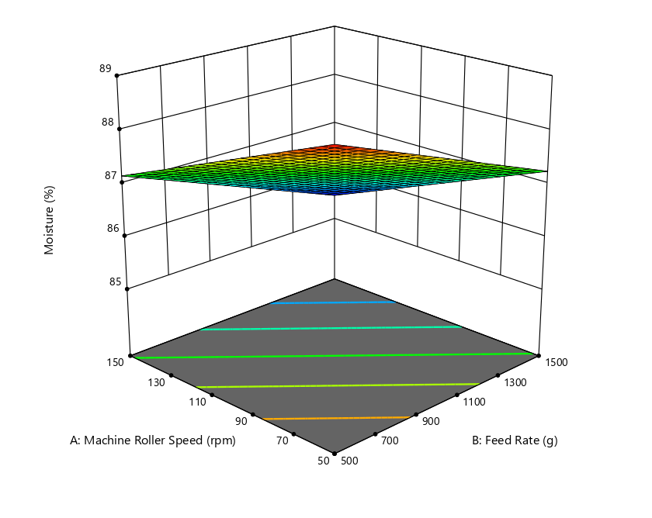
Figure 4.1: Effect of Machine Roller Speed and Feed Rate on the Moisture of Sugar Cane Juice
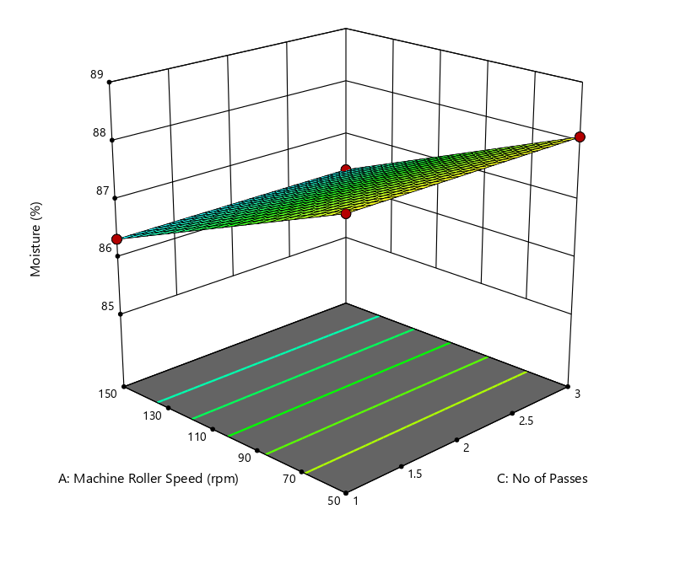
Figure 4.2: Effect of Machine Roller Speed and No of Passes on the Moisture of Sugar Cane Juice

ANOVA for Linear model
Table 4.3 Response 2: Calorific Value
Source | Sum of Squares | df | Mean Square | F-value | p-value
Model | 2624.97 | 3 | 874.99 | 1.833E+10 | < 0.0001 | significant
A-Machine Roller Speed | 1424.66 | 1 | 1424.66 | 2.984E+10 | < 0.0001
B-Feed Rate | 1200.31 | 1 | 1200.31 | 2.514E+10 | < 0.0001
C-No of Passes | 0.0002 | 1 | 0.0002 | 4886.72 | < 0.0001
Residual | 6.206E-07 | 13 | 4.774E-08
Lack of Fit | 6.206E-07 | 9 | 6.895E-08
Pure Error | 0.0000 | 4 | 0.0000
Cor Total | 2624.97 | 16
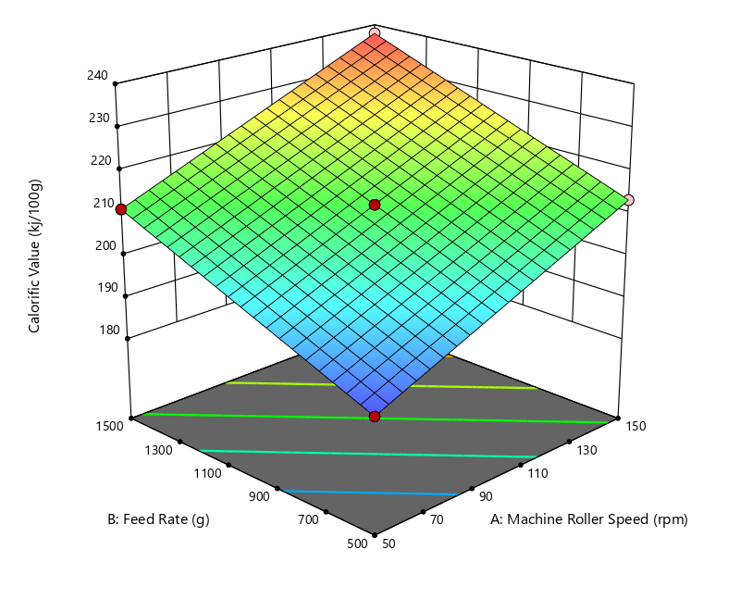
Figure 4.3: Effect of Machine Roller Speed and Feed rate on the Calorific value of Sugar Cane Juice

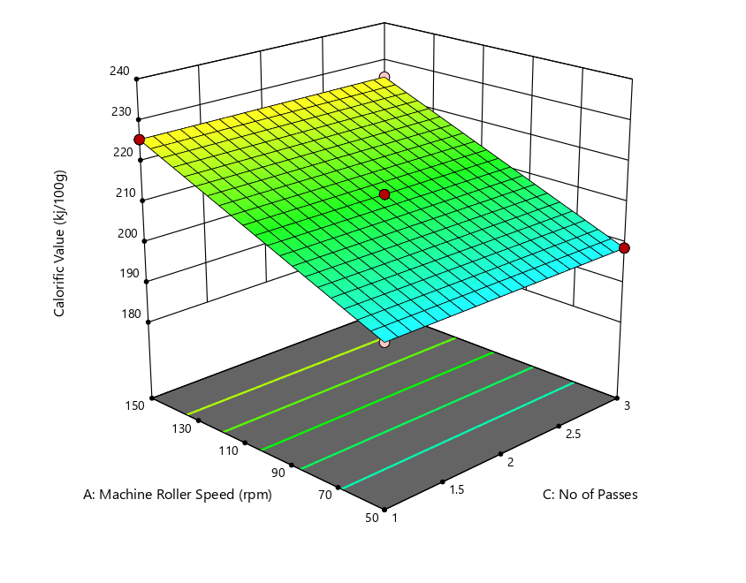
Figure 4.4.: Effect of Machine Roller Speed and No of passes on the Calorific value of Sugar Cane Juice

ANOVA for 2FI model
4.4 Response 3: Ash
Source | Sum of Squares | df | Mean Square | F-value | p-value
Model | 0.0044 | 6 | 0.0007 | 3.328E+06 | < 0.0001 | significant
A-Machine Roller Speed | 0.0025 | 1 | 0.0025 | 1.139E+07 | < 0.0001
B-Feed Rate | 0.0019 | 1 | 0.0019 | 8.573E+06 | < 0.0001
C-No of Passes | 5.000E-09 | 1 | 5.000E-09 | 22.67 | 0.0008
AB | 2.500E-09 | 1 | 2.500E-09 | 11.33 | 0.0072
AC | 2.500E-09 | 1 | 2.500E-09 | 11.33 | 0.0072
BC | 2.500E-09 | 1 | 2.500E-09 | 11.33 | 0.0072
Residual | 2.206E-09 | 10 | 2.206E-10
Lack of Fit | 2.206E-09 | 6 | 3.676E-10
Pure Error | 0.0000 | 4 | 0.0000
Cor Total | 0.0044 | 16
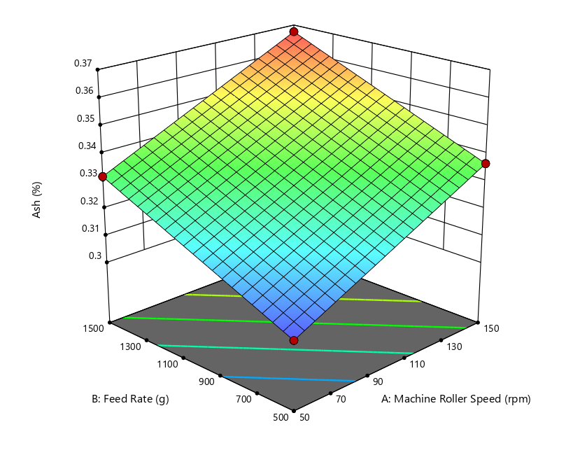
Figure 4.5: Effect of Machine Roller Speed and Feed rate on the Ash value of Sugar Cane Juice
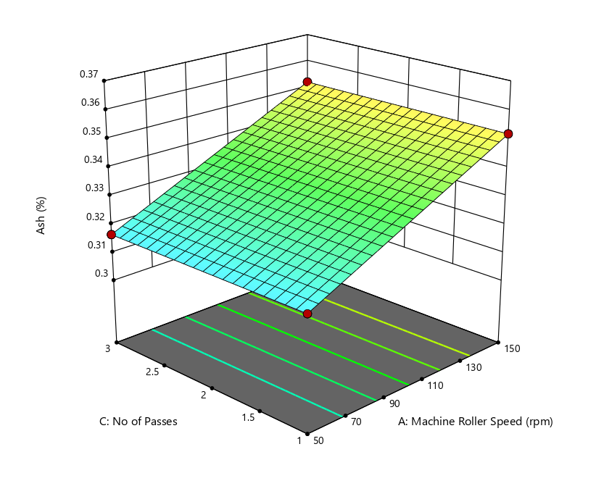
Figure 4.6: Effect of Machine Roller Speed and No of Passes on the Ash value of Sugar Cane Juice

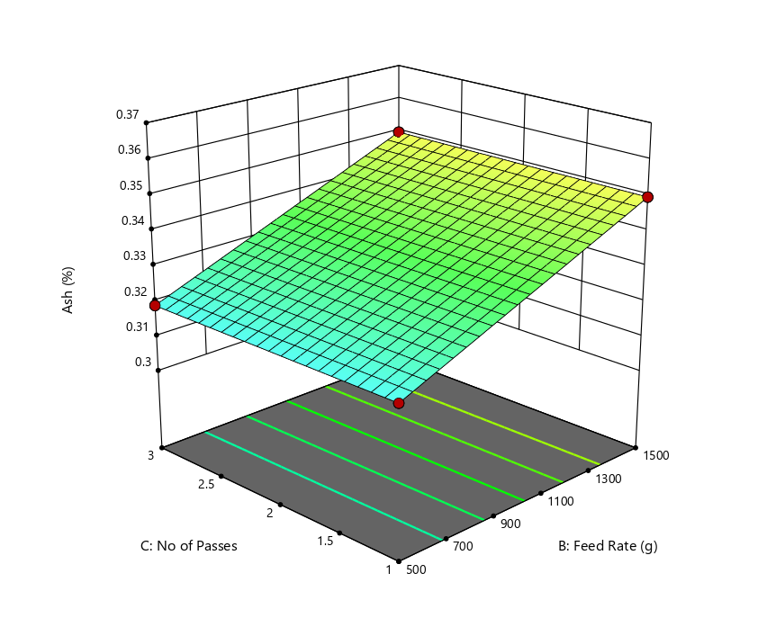
Figure 4.7: Effect of Feed rate and No of Passes on the Ash value of Sugar Cane Juice

ANOVA for Linear model
4.5 Response 4: Crude Protein
Source | Sum of Squares | df | Mean Square | F-value | p-value
Model | 0.0023 | 3 | 0.0008 | 9.557E+05 | < 0.0001 | significant
A-Machine Roller Speed | 0.0007 | 1 | 0.0007 | 8.587E+05 | < 0.0001
B-Feed Rate | 0.0016 | 1 | 0.0016 | 2.009E+06 | < 0.0001
C-No of Passes | 0.0000 | 1 | 0.0000 | 0.0000 | 1.0000
Residual | 1.059E-08 | 13 | 8.145E-10
Lack of Fit | 1.059E-08 | 9 | 1.176E-09
Pure Error | 0.0000 | 4 | 0.0000
Cor Total | 0.0023 | 16
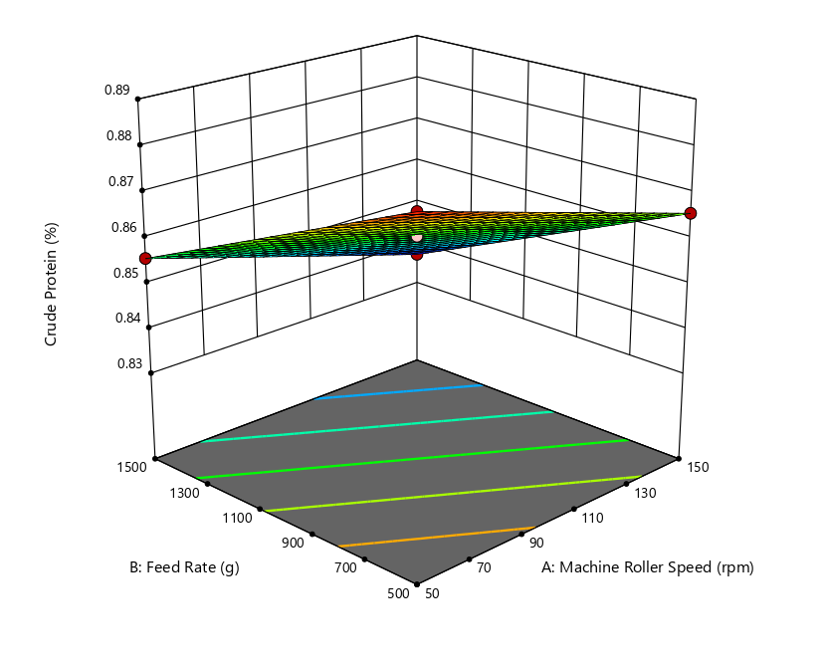
Figure 4.8: Effect of Machine Roller Speed and Feed Rate on the crude protein of Sugar Cane Juice

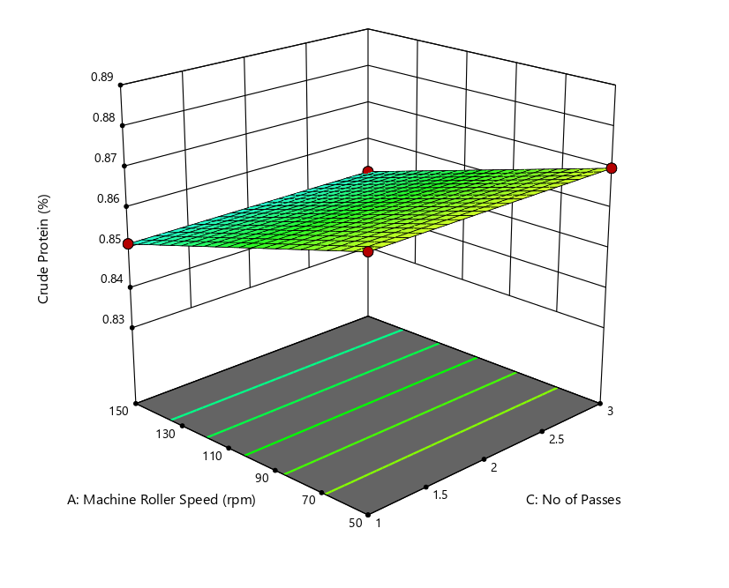
Figure 4.9: Effect of Machine Roller Speed and No of Passes on the crude protein of Sugar Cane Juice

ANOVA for Linear model
4.6 Response 5: Crude Fiber
Source | Sum of Squares | df | Mean Square | F-value | p-value
Model | 0.0007 | 3 | 0.0002 | 4.196E+05 | < 0.0001 | significant
A-Machine Roller Speed | 0.0004 | 1 | 0.0004 | 6.780E+05 | < 0.0001
B-Feed Rate | 0.0003 | 1 | 0.0003 | 5.807E+05 | < 0.0001
C-No of Passes | 0.0000 | 1 | 0.0000 | 0.0000 | 1.0000
Residual | 6.912E-09 | 13 | 5.317E-10
Lack of Fit | 6.912E-09 | 9 | 7.680E-10
Pure Error | 0.0000 | 4 | 0.0000
Cor Total | 0.0007 | 16
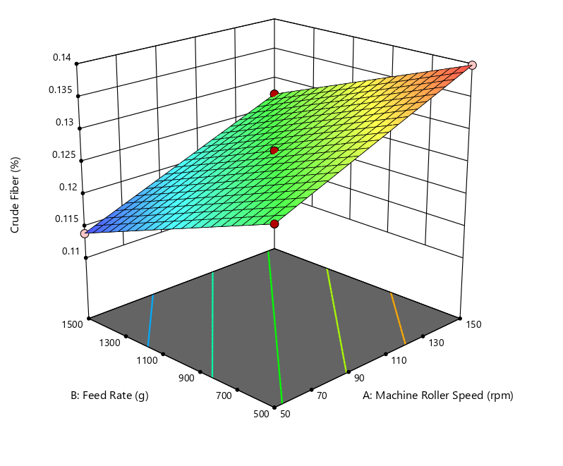
Figure 4.10: Effect of Machine Roller Speed and Feed Rate on the Crude Fiber of Sugar Cane Juice

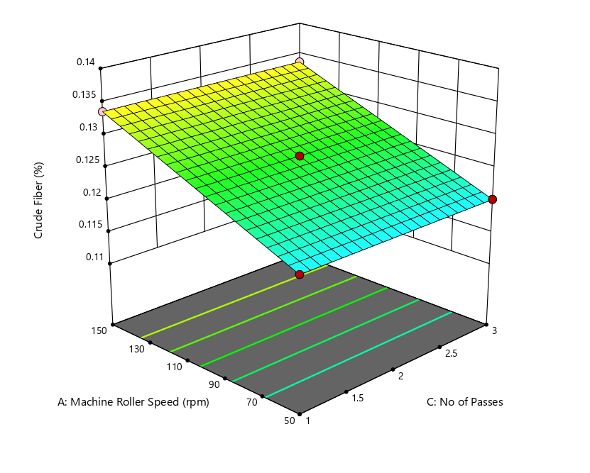
Figure 4.11: Effect of Machine Roller Speed and No of Passes on the Crude Fiber of Sugar Cane Juice

ANOVA for Linear model
4.7 Response 6: Crude Fat
Source | Sum of Squares | df | Mean Square | F-value | p-value
Model | 0.0588 | 3 | 0.0196 | 3.686E+07 | < 0.0001 | significant
A-Machine Roller Speed | 0.0154 | 1 | 0.0154 | 2.895E+07 | < 0.0001
B-Feed Rate | 0.0434 | 1 | 0.0434 | 8.162E+07 | < 0.0001
C-No of Passes | 1.125E-08 | 1 | 1.125E-08 | 21.16 | 0.0005
Residual | 6.912E-09 | 13 | 5.317E-10
Lack of Fit | 6.912E-09 | 9 | 7.680E-10
Pure Error | 0.0000 | 4 | 0.0000
Cor Total | 0.0588 | 16

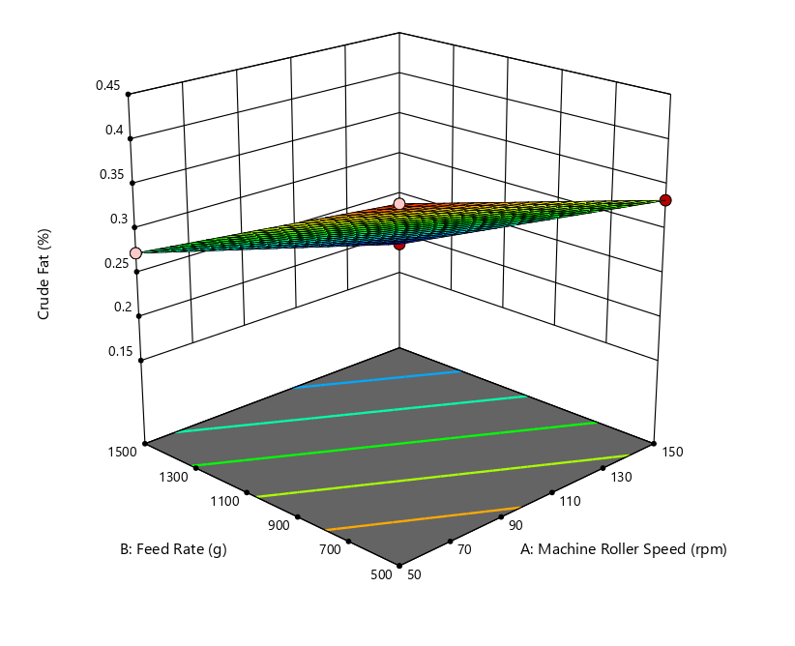
Figure 4.12: Effect of Machine Roller Speed and Feed Rate on the Crude Fat of Sugar Cane Juice

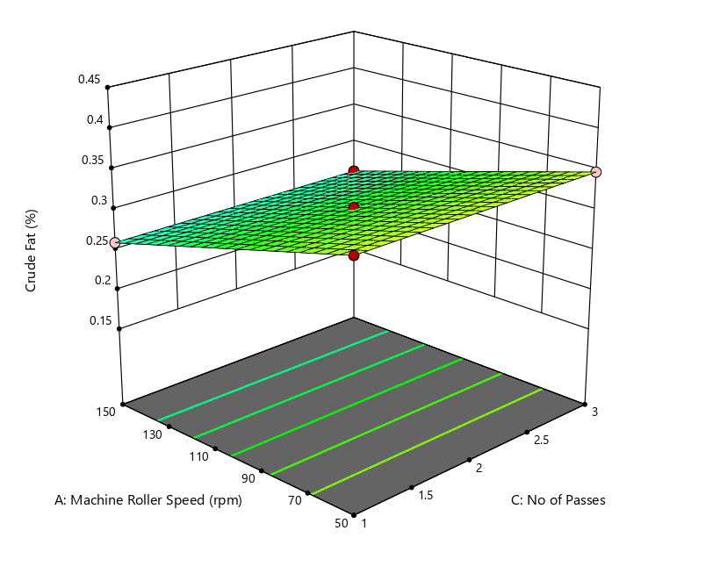
Figure 4.13: Effect of Machine Roller Speed and No of Passes on the Crude Fat of Sugar Cane Juice.

ANOVA for Quadratic model
4.8 Response 7: Carbohydrate
Source | Sum of Squares | df | Mean Square | F-value | p-value
Model | 13.27 | 9 | 1.47 | 4.129E+09 | < 0.0001 | significant
A-Machine Roller Speed | 6.59 | 1 | 6.59 | 1.845E+10 | < 0.0001
B-Feed Rate | 6.68 | 1 | 6.68 | 1.871E+10 | < 0.0001
C-No of Passes | 1.051E-06 | 1 | 1.051E-06 | 2943.50 | < 0.0001
AB | 0.0000 | 1 | 0.0000 | 0.0000 | 1.0000
AC | 2.500E-09 | 1 | 2.500E-09 | 7.00 | 0.0331
BC | 0.0000 | 1 | 0.0000 | 0.0000 | 1.0000
A² | 6.579E-10 | 1 | 6.579E-10 | 1.84 | 0.2168
B² | 5.921E-09 | 1 | 5.921E-09 | 16.58 | 0.0047
C² | 6.579E-10 | 1 | 6.579E-10 | 1.84 | 0.2168
Residual | 2.500E-09 | 7 | 3.571E-10
Lack of Fit | 2.500E-09 | 3 | 8.333E-10
Pure Error | 0.0000 | 4 | 0.0000
Cor Total | 13.27 | 16
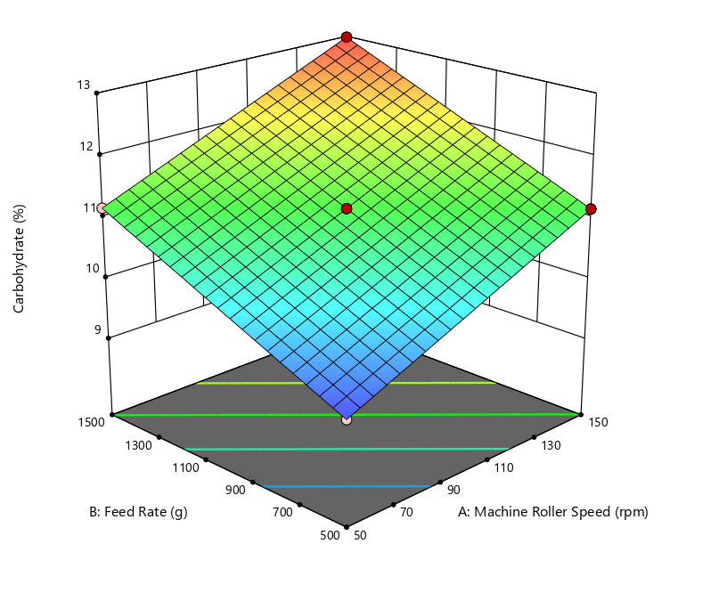
Figure 4.14: Effect of Machine Roller Speed and Feed Rate on the Carbohydrate of Sugar Cane Juice

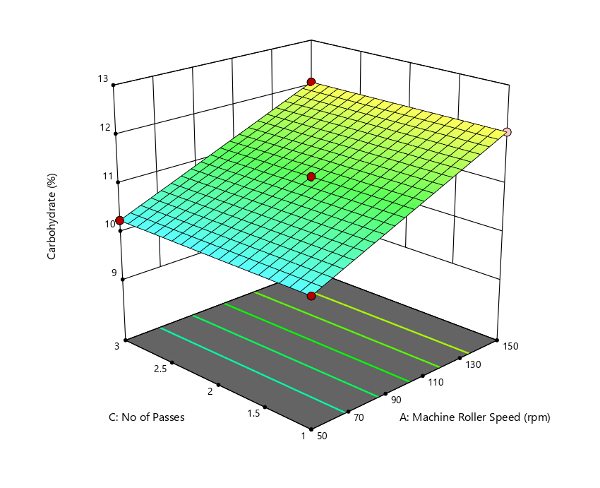
Figure 4.15: Effect of Machine Roller Speed and No of Passes on the Carbohydrate of Sugar Cane Juice

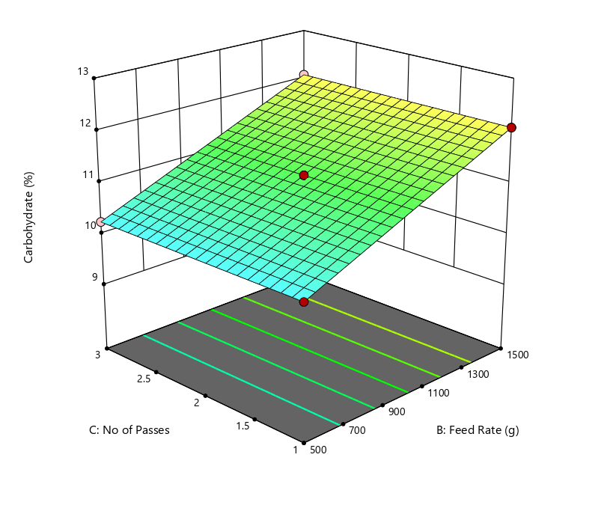
Figure 4.16: Effect of Feed Rate and No Passes on the Carbohydrate of Sugar Cane Juice
4.2 Discussion
Effect of Machine Roller Speed and Feed Rate on the Moisture of Sugar Cane Juice
Table 4.2 shows that both machine roller speed and feed rate have highly significant effects on the moisture content of sugarcane juice (p < 0.0001), while the number of passes, though statistically significant, has a much smaller effect size. The model is highly significant, the very low residual mean square and pure error suggest high precision in the experimental setup.
figure 4.1 also shows that roller speed significantly influences juice extraction efficiency and output. Optimal speeds (30 rpm) yield the highest extraction efficiency and output capacity, while excessively high speeds increase extraction losses and reduce efficiency (Oji et al., 2021). Lower feed rates (e.g., one cane stalk at a time) result in higher extraction efficiency and lower juice loss, while higher feed rates can increase losses and reduce extraction quality (Oji et al., 2021; Zhou et al., 2024). Adjusting feed rate is thus essential for optimizing both yield and nutritional quality. Optimizing roller speed and feed rate not only increases juice yield but also helps retain more nutrients by reducing extraction losses and preventing excessive mechanical damage to the cane (Oji et al., 2021; Zhou et al., 2024).
Effect of Machine Roller Speed and No of Passes on the Moisture of Sugar Cane Juice
The ANOVA table 4.2 and figure 4.2 shows that machine roller speed has a highly significant effect on the moisture content of sugarcane juice (F = 6.579E+09, p < 0.0001). Indicating that optimal roller speeds (30 rpm) maximize extraction efficiency and output, while higher speeds can increase extraction losses and reduce efficiency (Oji et al., 2021). The number of passes also shows a statistically significant effect on moisture content (F = 1043.76, p < 0.0001), though the effect size is much smaller than that of roller speed. Both machine roller speed and number of passes are important for maximizing the moisture content of sugarcane juice. The most effective strategy is to use slower roller speeds combined with multiple passes, which increases juice extraction and moisture yield without negatively affecting juice quality (Oji et al., 2021; Crépeau et al., 2015). This approach aligns with the goal of optimizing processing parameters for enhanced nutritional quality.
Effect of Machine Roller Speed and Feed Rate on Calorific Value
Table 4.3 shows that machine roller speed significantly impacts juice extraction efficiency and output capacity. Optimal speeds ( 30 rpm) yield the highest extraction efficiency and output, while excessively high speeds can increase extraction losses, potentially affecting the calorific value by reducing juice yield and possibly altering its composition(Oji et al., 2021). Lower feed rates are associated with higher extraction efficiency and output capacity. Higher feed rates can reduce efficiency, likely due to incomplete crushing, which may lower the calorific value of the extracted juice as shown in figure 4.3 (Oji et al., 2021).

Effect of Machine Roller Speed and Number of Passes
Number of Passes has direct data on calorific value is limited, more passes generally increase juice extraction, which could enhance calorific value by maximizing sugar and nutrient recovery. However, the effect is less pronounced than roller speed or feed rate (Oji et al., 2021). The ANOVA table 4.3 indicates both roller speed and number of passes are statistically significant, but roller speed has a much larger effect size compared to the number of passes.
Effect of Machine Roller Speed and Feed Rate on Ash Value
Both machine roller speed and feed rate have highly significant effects on the ash value of sugarcane juice, as shown in table 4.2 and figure 4.5 by their large F-values and very low p-values (<0.0001). This means changes in either parameter can substantially alter the mineral content in the juice.
The interaction between roller speed and feed rate (AB) is also significant (p = 0.0072), indicating that the combined effect of these two factors on ash value is not simply additive.
Effect of Machine Roller Speed and Number of Passes
Figure 4.6 shows the number of passes has a statistically significant but much smaller effect on ash value (F = 22.67, p = 0.0008) compared to roller speed and feed rate and the Interactions between roller speed and number of passes (AC), and between feed rate and number of passes (BC), are also significant (p = 0.0072 each), as shown in table 4.5 though their effect sizes are small. This suggests that optimizing both roller speed and number of passes together can fine-
tune ash content, but the impact is less pronounced than the main effects.

Effect of Feed rate and No of Passes on the Ash value of Sugar Cane Juice
Table 4.4 and figure 4.7 shows that both feed rate and number of passes significantly affect the ash value in sugar cane juice, with feed rate having a stronger impact. Their effects are also influenced by machine roller speed and by each other, highlighting the importance of optimizing all process parameters for quality control.
Effect of Machine Roller Speed and Feed Rate on Crude Protein
Both machine roller speed and feed rate have a highly significant impact on crude protein content, as indicated by very high F-values (8.587E+05 for roller speed, 2.009E+06 for feed rate) and extremely low p-values (<0.0001) as shown in table 4.2 and figure 4.8. This means that adjusting either parameter can substantially change the amount of crude protein extracted into the juice.
The feed rate has a larger effect size than roller speed, suggesting that how quickly cane is fed into the machine is even more critical for crude protein extraction than the speed of the rollers.
Effect of Machine Roller Speed and Number of Passes
Tables 4.6 shows the number of passes has no significant effect on crude protein content (F = 0, p = 1.0000). This means increasing or decreasing the number of times cane passes through the rollers does not alter the crude protein level in the juice. Since the number of passes is not significant, its interaction with roller speed is also not expected to meaningfully affect crude protein content.

Effect of Machine Roller Speed and Feed Rate on Crude Fiber
Both machine roller speed and feed rate have a highly significant impact on crude fiber content, as shown by very high F-values (6.78E+05 for roller speed, 5.81E+05 for feed rate) and extremely low p-values (<0.0001). This means that adjusting either parameter can substantially change the amount of crude fiber in the juice. Table 4.7 and figure 4.10
Research shows that optimal roller speeds ( 30 rpm) and lower feed rates (one cane stalk at a time) maximize extraction efficiency and output, which likely helps control crude fiber content by reducing excessive fiber breakage and inclusion in the juice (Oji et al., 2021).
Effect of Machine Roller Speed and No of Passes on the Crude Fiber of Sugar Cane Juice
The number of passes through the rollers does not significantly affect the crude fiber content in the juice, as shown by the ANOVA results (p = 1.0000). This suggests that, within the tested range, repeating the crushing process does not further reduce or increase the crude fiber in the extracted juice1.
Effect of Machine Roller Speed and Feed Rate on Crude Fat
Machine Roller Speed (A), has a very strong effect on crude fat (F = 2.895E+07, p < 0.0001).
It contributes a large portion to the variation in crude fat (Sum of Squares = 0.0154).
Feed Rate (B), stronger effect than roller speed (F = 8.162E+07, p < 0.0001) as shown in table 4.8 and figure 4.12 . Both Machine Roller Speed and Feed Rate significantly affect crude fat content, with Feed Rate being more influential in the process.

Effect of Machine Roller Speed and Number of Passes on Crude Fat
Table 4.8 shows the number of Passes (C) is statistically significant (F = 21.16, p = 0.0005), but the effect is much smaller compared to A and B. This is seen in the very small Sum of Squares (1.125E-08), suggesting a minor but significant impact. Machine Roller Speed (A), shows a very significant effect, supporting that it plays a consistent role in influencing crude fat regardless of the second variable considered (Feed Rate or Number of Passes).
Therefore, Machine Roller Speed and Number of Passes both affect crude fat, but the effect of Number of Passes is minimal compared to Machine Roller Speed. as shown in figure 4.13.
Effect of Machine Roller Speed and Feed Rate on Carbohydrate
Table 4.9 shows that Machine Roller Speed (A) is highly significant (F = 1.845E+10, p < 0.0001) and Contributes 49.7% of the total variation in carbohydrate (6.59 out of 13.27). Feed Rate (B) is also highly significant (F = 1.871E+10, p < 0.0001) has 50.3% of the variation (6.68 out of 13.27). Machine Roller Speed and Feed Rate act independently their combined influence doesn’t have an added or interactive effect. As indicated in figure 4.14.
Effect of Machine Roller Speed and Number of Passes on Carbohydrate
. Machine Roller Speed (A) is Strong and significant. The Number of Passes (C) is also Statistically significant (F = 2943.5, p < 0.0001) but with negligible practical effect (SS = 1.051E-06 compared to 6.59 and 6.68). This means Number of Passes has a tiny but statistically clear influence on carbohydrates. Their combination (interaction) also plays a minor but significant role in shaping carbohydrate content. As shown in table 4.9 and figure 4.15.

Effect of Feed Rate and Number of Passes on Carbohydrate
Table 4.9 and figure 4.15 shows Feed Rate (B) has very strong effect. And Number of Passes (C) with a Tiny effect as shown in table 4.9
B and C are Not significant at F = 0.000, p = 1.0000. Means the effect of Feed Rate on carbohydrate does not depend on the Number of Passes.
Feed Rate and Machine Roller Speed are the primary drivers of carbohydrate content in sugarcane juice. The Number of Passes has a statistically significant but very small impact.
The interaction between Roller Speed and Number of Passes is meaningful, suggesting operational adjustments can fine-tune carbohydrate levels.
The model is extremely robust (very small residual error, perfect significance), so results are reliable.

CHAPTER FIVE
CONCLUSION AND RECOMMENDATION
5.1 Conclusion
This study investigated the effect of varying extraction conditions machine roller speed, feed rate, and number of passes on the proximate composition of sugarcane juice. The findings demonstrate that extraction parameters significantly influence nutritional and physical properties of the juice, validating the importance of process optimization in juice production. The following Conclusions were made:
1. Machine Roller Speed had a strong and consistent effect on nearly all proximate parameters (moisture, ash, crude fat, carbohydrate, crude fiber, and crude protein) and Optimal speed (30 rpm) significantly improved juice yield, extraction efficiency, and nutrient retention.
2. Feed Rate Was the most influential factor for many nutrients, especially crude fat, crude protein, and crude fiber. Lower feed rates (feeding one cane stalk at a time) resulted in higher extraction efficiency and better nutrient retention.
3. Number of Passes had a statistically significant but smaller effect on most components. Its influence was more relevant when combined with roller speed, especially for moisture and ash content, but not significant for crude protein.
4. Roller speed × feed rate, and roller speed × number of passes showed statistical significance, particularly for ash and carbohydrate content, indicating that combined tuning of parameters may fine-tune juice quality.
5. The overall model accuracy was high, as indicated by low residuals and pure error values, which confirms reliable experimental design and precision.
5.2 Recommendation
Based on the findings, the following recommendations are proposed to optimize sugarcane juice extraction for enhanced nutritional quality.
1. Adopt Moderate Roller Speeds 30 rpm it offers a balance between yield and nutrient retention, minimizing mechanical damage and extraction losses.
2. Feeding one cane stalk at a time improves juice quality, especially increasing protein and fat content while minimizing fiber residue and loss of moisture.
3. While more passes can slightly increase moisture and ash content, they do not significantly affect protein content and may increase operational time. Thus, limit to *2–3 passes for best efficiency without compromising quality.
4. Parameter Optimization Should Be Goal-Driven
5. Combined effects of parameters influence qualities of ash and carbohydrates; future designs or machines should allow fine control over multiple variables simultaneously.
6. These findings can inform the design of automated sugarcane pressing machines with adjustable rollers and controlled feed mechanisms for nutrient-optimized juice processing.

REFERENCES
Akinpelu, O. Alabi, K. A., and Ojo, M. S. (2019). Mineral composition of sugarcane extract and its nutritional significance. Journal of Agricultural Chemistry, 45(3), 112–120.
Association of Official Analytical Chemists (2019). Determination of proximate parameters of food sample. Official Method of Analysis. 21st Edition. Vol. 1, AOAC International, Suite 300, 275 Research BLVD Rockville, Maryland, USA
Crépeau, M., Khelifi, M., Vanasse, A., Aider, M., Bertrand, A., and Ladurantaye, Y. (2015). Design and testing of a four-roller press to extract sugary juice from sweet sorghum and sweet pearl millet biomass.. Applied Engineering in Agriculture, 31, 767-772. https://doi.org/10.13031/aea.31.11143
Ding, J., Yin, Y., Yang, T., Wang, Y., Mao, H., Lu, F., and Duan, Q. (2023). Numerical calculation of sugarcane crushing process based on Smooth Particle Hydrodynamics. Food and Bioproducts Processing. https://doi.org/10.1016/j.fbp.2023.07.008
Gomez, R. Hernandez, M. L., and Alvarez, J. D (2018). Proximate and mineral analysis of sugarcane juice from different varieties. Food Science and Nutrition, 9(4), 234–241.
Helal, M., Mustafa, H., Abdelrhman, Y., and HassabAllah, I. (2020). Improving the Efficiency of Extraction of Sugar Cane Mills Using Rollers with Compound Triple Pitch. Egyptian Sugar Journal. https://doi.org/10.21608/esugj.2020.219226
Helal, M., Tawfik, M., Aziz, A., HassabAllah, I., and Abdelrhman, Y. (2024). Improving the extraction efficiency of sugar cane mills using perforated rollers with longitudinal channels. Egyptian Sugar Journal. https://doi.org/10.21608/esugj.2024.255119.1042
Kumar, V. Sharma, N., Gupta, R., and Singh, A. (2021). Bioactive compounds in sugarcane extract: A review. International Journal of Food Science, 13(2), 98–107.
Ogunlade, B. A., Olaniyi, T. A., & Ajibola, O. O. (2019). Comparative nutritional evaluation of sugarcane juice and coconut water. African Journal of Food Science, 15(1), 50–65.
Oji, N., Okaiyeto, S., Unguwanimi, Y., Sada, A., Ogijo, S., & Jonga, J. (2021). Performance Evaluation of a Small-Scale Sugarcane Juice Extracting Machine. Current Journal of Applied Science and Technology, 39-47. https://doi.org/10.9734/CJAST/2021/V40I631315
Patel, D. R., Mehra, P. K., and Chawla, S. R. (2020). Nutritional profile and health benefits of sugarcane juice. Journal of Food and Agriculture, 28(6), 305–320.
Ramirez, L. M., Torres, C. J., Fernandez, H. A., and Morales, P. (2020). Analysis of vitamin and mineral content in sugarcane extract. Nutrition Research, 22(8), 401–410.
Sharma, P., and Mehta, R. (2022). Flavonoids and phenolic content in sugarcane juice. Journal of Medicinal Plants Research, 19(3), 155–170.
Singh, R., and Prasad, S. (2019). Health-promoting properties of sugarcane juice: An overview. Functional Foods Journal, 7(2), 120–134.
Singh, T., Nair, V. P., Eze, C. C., and Bello, A. H. (2020). Comparison of coconut water and sugarcane juice. Beverage Science, 12(5), 278–292.
Zhou, B., , S., Li, W., Peng, C., and Li, W. (2024). Study on sugarcane chopping and damage mechanism during harvesting of sugarcane chopper harvester. Biosystems Engineering. https://doi.org/10.1016/j.biosystemseng.2024.04.019

