MODELLING OF AUTOMATED RAILWAY LEVEL CROSSING SYSTEM

BY

OPADELE SHUKURAT ADEOLA
ND/23/RWE/PT/0001

BEING A RESEARCH PROJECT SUBMITTED TO RAILWAY ENGINEERING DEPARTMENT, INSTITUTE OF TECHNOLOGY (IOT)
KWARA STATE POLYTECHNIC ILORIN.

IN PARTIAL FULFILMENT OF THE REQUIREMENT FOR THE AWARD OF NATIONAL DIPLOMA (ND) IN RAILWAY ENGINEERING DEPARTMENT.

AUGUST, 2025

CERTIFICATION

This is to certify that this project work is original research work of Opadele Shukurat Adeola with matric number ND/23/RWE/PT/0001 and has been examined and approved as meeting the requirements of Department of Railway Engineering, Institute Of Technology, Kwara State Polytechnic, Ilorin, Kwara State. In Partial Fulfilment of the Requirement for the Award of National Diploma (ND) in Railway Engineering Department.



DEDICATION

This project is dedicated to Almighty God who throughout the duration of my studies has sustained my life and has given me the needed wisdom and understanding to put this project together.

ACKNOWLEDGEMENT

All glory, appreciation, and adoration go to Almighty Allah, the master of the universe, the most beneficent, the omnipotent, the magnificent, the most high and merciful, for his mercy on the success of this project.
Special thanks go to my supervisor, ENGR. LASISI K.A. He is not just a supervisor but one of the best lecturers in my department who has gone through this project and made meaningful corrections with a tender attribute that led to the successful completion of this project. May Almighty Allah bless him and his family. My appreciation also goes to ENGR. NURU A.O, ENGR. YUSUF K.O and other lecturers. I say a very big thanks to you all for the guidance given to me as your student. May Almighty Allah reward every one of you (Ameen).
I gratefully appreciate my wonderful parents, MR & MRS OPADELE, for their love, care, prayers, moral, and financial support. May Almighty Allah grant you both long life and prosperity to reap the fruits of your labor (Ameen).
I sincerely express my heartfelt gratitude to the bedrock of my academic achievements, my caring sister MISS OPADELE KABIRAT. I really appreciate your effort, financially, spiritually, and all other advice.

TABLE OF CONTENTS

Title Page i

Certification ii
Dedication iii
Acknowledgement iv
Table of Contents v
Abstract vii
CHAPTER ONE 1
INTRODUCTION 1
  - Background to the Study 1
  - Aim and Objectives 3
  - Statement of the Problem 3
  - Justification on Automated Railway Level Crossing System 4
  - Scope of Work 4
CHAPTER TWO 5
LITERATURE REVIEW 5
  - Overview of Railway Level Crossing System 5
  - Automation and Sensor-Based Control System 6
  - Microcontroller-Based Control System 6
  - Integration of Traffic Signals and Safety Features 6
  - Gaps in Existing Research 7
  - Summary of Literature Insights 8
CHAPTER THREE 10
METHODOLOGY 10
  - Preamble 10
  - Materials and Their Sources 10
  - Research Procedure 11
CHAPTER FOUR 21
DATA PRESENTATION, ANALYSIS AND DISCUSSION OF FINDINGS 21
  - Summary of Key Functional Results 22
  - System Operation Breakdown 23
  - Achievement of Objectives 25
  - Observations and Limitations 25
  - Recommendations for Enhancement 26
CHAPTER FIVE 27
CONCLUSION AND RECOMMENDATIONS 27
  - Conclusion 27
  - Recommendations 27
REFERENCES 29

ABSTRACT

This research project focuses on the development and implementation of an Automated Railway Level Crossing System using microcontroller technology. The primary goal is to enhance safety at railway crossings by automating the detection of approaching and departing trains, thus ensuring timely closure and opening of barrier gates. The system employs ultrasonic sensors for accurate train detection and utilizes Arduino-based microcontrollers for controlling the gates and activating audio-visual alerts. This study outlines the current challenges faced by traditional manual systems, including human error and inefficiencies, and provides a justification for the need for automated solutions.
The methodology involves sourcing affordable components from local vendors, assembling them into a functional prototype, and programming the system using Arduino IDE. Various testing scenarios were conducted to evaluate the system's performance, which demonstrated successful detection of trains, prompt barrier operations, and effective alert systems. Limitations such as sensor range and environmental factors were identified, along with recommendations for enhancements, including the integration of advanced sensors and renewable energy solutions. This research contributes to the field of railway engineering by providing a scalable and cost-effective approach to improving safety at level crossings.

CHAPTER ONE

INTRODUCTION

Background to the Study
Railway level crossings, where roads intersect with railway tracks at the same level, have always posed significant safety hazards. In many countries, especially in rural or semi-urban areas, level crossings are still manually operated or semi-automatic, often leading to accidents due to human error, negligence, or delay in gate closure. The need for a smart, automated system that detects train presence and controls gates without human intervention has become vital for both safety and efficiency. (Alam, et al 2018).
The Automated Railway Level Crossing System project aims to create a functional prototype that ensures the gates are closed when a train is approaching and open immediately after it has passed. This system uses sensors to detect trains and microcontrollers to control the entire mechanism, including gates, alarms, and visual indicators. (Ugalmugale, 2025).
An automated railway level crossing system is a safety mechanism designed to manage the intersection between a railway line and a road using automated technology. Traditionally, many level crossings depend on manual operation, which often leads to human errors, delays, and potential accidents. With the increasing demand for railway and road transport, ensuring safe and efficient crossing systems has become critical. The integration of automated systems can reduce accidents, optimize traffic flow, and enhance operational efficiency by utilizing sensors, microcontrollers, and real-time monitoring mechanisms. (Network Rail, 2020).

Historically, the management of railway level crossings has relied heavily on manual operations, with gatekeepers responsible for opening and closing gates based on train schedules. However, this system is susceptible to human error, leading to accidents and inefficiencies. The advent of microcontroller technology and sensor systems has paved the way for automated solutions. For instance, a study by (Alam, et al. 2018) demonstrated the use of Arduino microcontrollers and infrared sensors to automate gate operations, significantly reducing the risk of accidents.
Railway level crossings are potential collision points between train and road traffic, and improper management can result in severe consequences including loss of life and damage to infrastructure. Historically, gatekeepers or semi-automatic systems have been used to control access, but these are often inefficient or unreliable. Technological advancements in embedded systems, sensor technology, and automation now allow for the development of intelligent systems that can detect train proximity, control gates automatically, and provide alerts to both road users and train operators. This study seeks to leverage such advancements to create a cost- effective and reliable automated railway level crossing system. (Al Amin, et al 2024)
The concept of railway safety has evolved over the years. Historically, gates at crossings were operated manually by railway personnel using signals from train stations. This method is time-consuming, dependent on human efficiency, and not suitable for increasing train and road traffic.
With the development of electronics, automated systems have become more reliable and cost-effective. Projects in countries like Japan and Germany have led the way in automation using advanced sensors, GPS, and control systems. Developing regions, however, often face budgetary and technological constraints. Hence, this project focuses on a low-cost, sensor-based automatic system that can

work reliably even in less-developed areas. (Federal Railroad Administration (FRA), USA 2006).

Aim and Objectives
The aim is to develop an automated railway level crossing system using basic electronics and micro-controller programming to provide a more reliable and safer method of managing rail-road intersections.
The objectives of this study are:-
- Stimulate an automated level crossing barrier system using Arduino
- Detect approaching and departing train using ultrasonic sensors
- Automatically operate barrier gates and traffic signals
- Improve railway crossing safety and reduce human error

Statement of the Problem
Conventional railway level crossing systems often rely on human operation, leading to inefficiencies such as late gate closure, miscommunication, and fatigue- induced errors. These can cause traffic congestion, property damage, or fatal accidents. The absence of real-time monitoring and automation results in reduced safety standards, especially in rural or under-supervised areas. Therefore, a need exists for a fully automated, reliable, and cost-effective system that can manage railway-road intersections efficiently. (Naik and Nandimath, 2013).
Manual level crossings often result in:
Delayed Gate Operation: Inconsistent communication can delay the closure/opening of gates.
Human Errors: Misjudgment or negligence can lead to accidents. Traffic Congestion: Inefficient operation can cause long vehicle queues.

Fatal Accidents: Vehicles or pedestrians caught at crossings during train passage have led to deaths and injuries.
There is a need for a system that can accurately and autonomously manage railway crossings without relying on manual input.

Justification on Automated Railway Level Crossing System
The justification for this project lies in the urgent need to reduce the high rate of railway crossing accidents. By implementing an automated system, human error can be minimized, and response time to an approaching train can be improved. This system will not only reduce fatalities but also help manage road traffic more effectively, especially in high-density urban or suburban areas. Furthermore, the project provides a platform for integrating modern technologies into legacy infrastructure, improving the overall transportation ecosystem. (Naik and Nandimath, 2013).
The benefits of automating level crossings include:
Enhanced Public Safety: Prevents accidents by ensuring timely gate operation. Reduced Operational Costs: Eliminates the need for gatekeepers or staff at each crossing.
Real-Time Operation: Provides instant response to train movement. Scalability: Can be deployed in both urban and rural settings.
Low Maintenance: Once implemented, the system requires minimal maintenance. Efficiency: Synchronization with train movements ensures timely gate operations Cost Effectiveness: Reduces the need for manual labour and associated costs
1.5 Scope of Work
The project involves designing and building a prototype using basic components such as Arduino, sensors, and motors, while programming the control logic to handle train detection and gate automation. It also includes simulating real-world train and vehicle movements, and testing the system under different scenarios to ensure accuracy and reliability. Furthermore, the project explores alternative power sources, such as solar, for remote deployment, and incorporates a sensor-based detection system to monitor train movement. Gate operations are automated through a servo or motor mechanism, supported by microcontroller-based logic for system control. In addition, visual and audio indicators are implemented to alert users, and the system will be tested on a model scale to evaluate its overall effectiveness.

CHAPTER TWO

LITERATURE REVIEW

Overview of Railway Level Crossing System
A railway level crossing is an intersection where a railway line crosses a road or path at the same level. Traditionally, these crossings are controlled manually, involving gatekeepers who operate the barriers to stop road traffic when a train is approaching. However, manual operation is prone to human error, delays, and inefficiencies, leading to accidents and traffic congestion (Garg et al., 2014). The increasing demand for safe and efficient transport systems necessitates the automation of railway level crossings to minimize human intervention, enhance safety, and improve traffic flow.

Automation and Sensor-Based Control System
Automation involves the use of sensors, actuators, and control systems to operate railway level crossings without human intervention. Sensors such as infrared (IR), ultrasonic, and radio frequency identification (RFID) detect the presence and movement of trains approaching or leaving the crossing. When a train is detected at a predefined distance, signals are sent to the control unit to initiate gate closure and activate warning systems (Singh & Sharma, 2017). Automation reduces operational time, eliminates human error, and enhances the overall safety of road and railway users (Ali et al., 2019).

Microcontroller-Based Control System
Microcontrollers play a crucial role in modern automated railway level crossing systems by processing sensor data and controlling outputs. Systems using Arduino, PIC, or 8051 microcontrollers are programmed to:
Receive signals from sensors detecting trains.
Activate alarms and traffic lights to warn vehicles and pedestrians. Close the gate before the train arrives.
Open the gate after the train has safely passed (Raj & Suresh, 2018). Microcontroller-based systems are cost-effective, reliable, and can be reprogrammed for advanced features such as Internet of Things (IOT) integration for remote monitoring and control (Kumar et al., 2020).

Integration of Traffic Signals and Safety Features
Integrating traffic signals with railway crossing gates enhances safety by managing vehicular movement effectively. Key features include:

Traffic lights: Red lights to stop vehicles when gates close, green lights to indicate safe passage.
Audio alarms: Buzzers or sirens alerting road users of an approaching train.
Visual warnings: Flashing LEDs and signage for clear visibility during day or night. Obstacle detection systems: Infrared or ultrasonic sensors detect vehicles or pedestrians trapped on tracks, preventing gate closure or sending alerts to delay trains (Patel et al., 2021).
Communication modules: GSM or IOT modules for real-time updates to railway stations or central control rooms (Ahmed & Rahman, 2020).
These integrations significantly reduce accidents and improve traffic management at railway crossings.

Gaps in Existing Research
Despite advances in automated railway level crossing systems, the following gaps persist:
Limited deployment in developing countries due to high initial costs and infrastructural challenges.
Lack of AI-based predictive systems for optimizing gate operation based on real- time train and traffic data.
Minimal integration of renewable energy sources such as solar power for sustainable operations.
Inadequate obstacle detection systems capable of identifying small objects or animals on tracks.
Limited cloud-based or IOT-enabled remote monitoring and maintenance for real- time diagnostics and fault detection (Kaur & Gupta, 2022).

These gaps present opportunities for future research to improve safety, sustainability, and system reliability.

Summary of Literature Insights

S/  N | Author/Ye  ar | Focus of Study | Methodology | Key  Findings | Research Gap
1 | Garg et al. (2014) | Automated railway gate control | IR sensors + microcontrolle r | Reduced manual error and  accidents | No obstacle detection system  included
2 | Singh & Sharma  (2017) | Automated railway  crossing | Ultrasonic sensors +  Arduino | Enhanced safety with  automation | No IOT-  based monitoring
3 | Raj & Suresh (2018) | Microcontrolle r-based crossing  system | IR sensors + PIC  microcontroll  er | Cost- effective and reliable  gate control | Lack of AI integration
4 | Ali et al. (2019) | Sensor-based  railway gate system | RFID + IR  sensors + Arduino | Improved  detection and safety | Limited  traffic signal integration
5 | Ahmed & Rahman (2020) | GSM-based gate control | GSM module  + sensors | remote monitoring and alerts implemente  d | No AI-based decision- making included

6 | Patel et al. (2021) | Traffic signal integration | IR sensors + microcontroll  er | Reduced accidents at  crossings | No renewable energy  integration
7 | Kumar et al (2020) | IOT-enabled railway crossing  system | IOT +  Arduino + sensors | Real-time data monitoring | High cost for rural implementati  on
8 | Kaur & Gupta (2022) | AI and IOT- based railway crossing | AI algorithms  + IOT  modules | Intelligent predictive control achieved | Complex implementati on requiring skilled maintenance

CHAPTER THREE METHODOLOGY

Preamble
This research project was designed and implemented in two phases: hardware development and system simulation. The methodology includes sourcing components locally in Ilorin, Kwara State, Nigeria, assembling the circuit, programming the Arduino, and testing the system in a simulated environment.

Materials and Their Sources
Table 3.1 List of Materials and their sources

Component | Specification | Source
Arduino Uno | ATmega328P  microcontroller board | Kwaratech Electronics,  Tanke Junction
Ultrasonic Sensors (2x) | HC-SR04, range: 2cm –  400cm | JKK Electronics, Challenge Bookshop  Complex
Servo Motors (2x) | SG90 Micro Servo | TechCity Hub, Unity  Road
LEDs (Red & Green) | 5mm, 2V | Ilorin Electronics Market,  Taiwo Isale
Buzzer | 5V Piezoelectric Buzzer | JustElectronics, GRA  Junction
Jumper Wires | Male-to-Male, Male-to-  Female | Unity Road Market

Breadboard | 830-point | Kwaratech Electronics,  Tanke Junction
Resistors | 220Ω, 330Ω | JKK Electronics
Power Supply | 9V Battery or 5V USB  Adapter | TechCity Hub or Spar  Mall
Laptop with Arduino  IDE | For programming and  simulation | University of Ilorin ICT  Lab / Personal Laptop

Research Procedure
Step 1: Component Acquisition

Electronic components were identified based on compatibility with Arduino. Vendors across Ilorin (Tanke, Taiwo, Unity Road) provided reliable access to affordable and tested hardware.
Step 2: Circuit Design and Assembly

    - A schematic was drawn with Arduino Uno as the main controller.

    - The entry ultrasonic sensor was placed before the crossing, and the exit sensor after it, to detect train approach and departure.
    - Two servo motors controlled mock barrier gates.

    - LEDs represented traffic lights (Red and Green).

    - A buzzer provided audible warnings.

All connections were made on a breadboard using jumper wires, with current- limiting resistors for the LEDs.

Step 3: Arduino Programming (C/C++)

      - Programming was done using Arduino IDE in C/C++ language. The logic flow followed:
      - When the entry sensor detects a train (distance < 30 cm):

      - Buzzer is activated.

      - Red light turns ON.

      - Servo motor lowers the gate.

      - When the exit sensor detects the train has left:

      - Buzzer turns OFF.

      - Green light turns ON.

      - Servo motor raises the gate.

Sample Code Snippet: #include <Servo.h> Servo gate;
const int triggerPin = 9; const int echoPin = 10; const int redLed = 6; const int greenLed = 7;

const int buzzer = 5; void setup() {
pinMode(triggerPin, OUTPUT); pinMode(echoPin, INPUT); pinMode(redLed, OUTPUT); pinMode(greenLed, OUTPUT); pinMode(buzzer, OUTPUT); gate.attach(3); // Servo connected to pin 3 Serial.begin(9600);
}

void loop() { long duration; int distance;
digitalWrite(triggerPin, LOW); delayMicroseconds(2); digitalWrite(triggerPin, HIGH); delayMicroseconds(10); digitalWrite(triggerPin, LOW);

duration = pulseIn(echoPin, HIGH); distance = duration * 0.034 / 2;
if (distance < 30) { digitalWrite(redLed, HIGH); digitalWrite(greenLed, LOW); digitalWrite(buzzer, HIGH); gate.write(0); // Close gate
} else {

digitalWrite(redLed, LOW); digitalWrite(greenLed, HIGH); digitalWrite(buzzer, LOW); gate.write(90); // Open gate
}

delay(100);

}

Step 4: System Testing and Calibration

- Sensors were tested for accurate readings under different object distances.

- Trigger distances were calibrated to detect model trains at 20–30 cm.

- The servo motor’s closed and open angles were set to 0° and 90°,
respectively.

- The buzzer’s timing was adjusted to avoid unnecessary noise post- departure.
Step 5: Simulation on Tinkercad

- Autodesk Tinkercad was used to simulate the entire circuit virtually.

- Components were placed in a simulated environment.

- The same Arduino code was uploaded to test barrier operations and sensor responses.
- Real-time debugging was done using the Serial Monitor and visual observations.
Step 6: Evaluation and Troubleshooting

- The system was tested repeatedly for consistency.

- Any false triggers from sensors were addressed by: Adjusting sensor alignment, adding debounce delays in the code, using software averaging for distance measurements.
Step 7: Documentation and Analysis

- All findings and behaviors were documented.

- Observations confirmed that the system met its intended objectives.

Identified areas for improvement (e.g., sensor sensitivity to light and sound interference).
COMPONEN TS | SPECIFICATIONS | SOURCE IN  ILORIN
Arduino Uno | 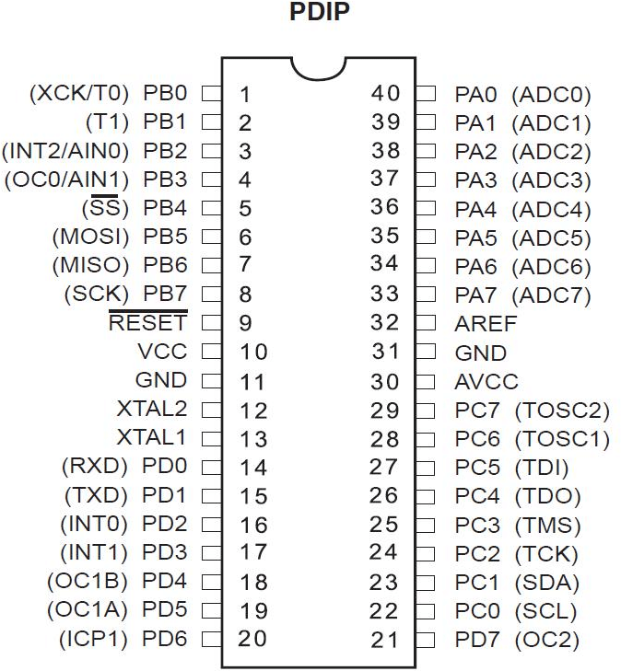  ATmega328P microcontroller board | Kwaratech Electronics  , Tanke Junction
Ultrasonic Sensors (2x) |  | JKK  Electronics  , Challenge Bookshop Complex

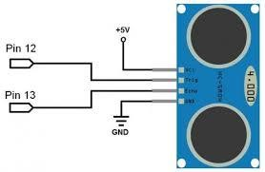
HC-SR04, range:2cm-400cm
Servo Motors (2x) |  SG90  Micro Server | TechCity Hub, Unity Road

LEDs (Red &Green) | 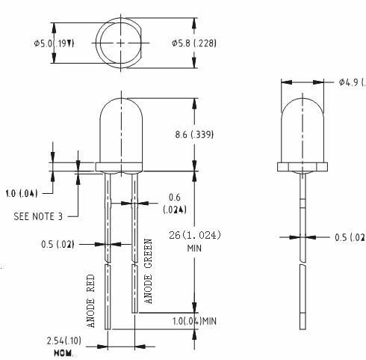  5mm,2V |  | Ilorin Electronics Market, Taiwo Isale
Buzzer | 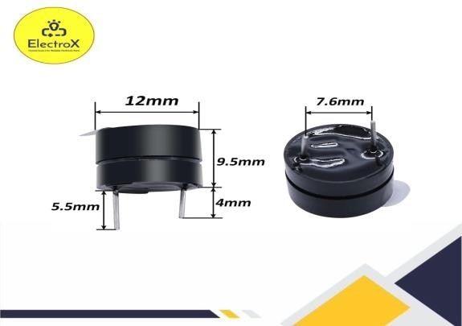  5vlV Piezoelectric Buzzer |  | Just Electronic GRA  Junction
Jumper Wires | 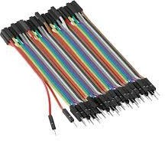  Male-to-Male | 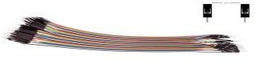  Male -to-Female | Unity Road Market

Breadboard | 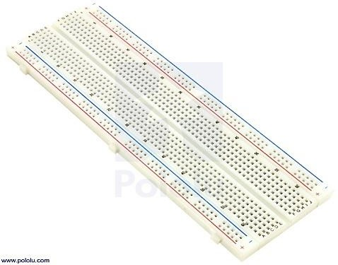  830-point | Kwaratech Electronics  , Tanke Junction
Resistors | 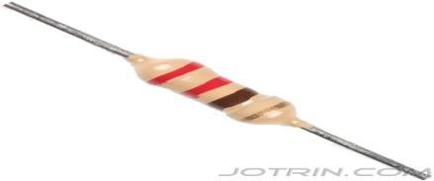  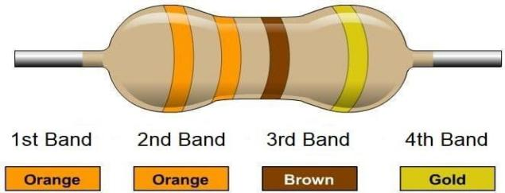  220,330 | JKK  Electronics
Power supply | 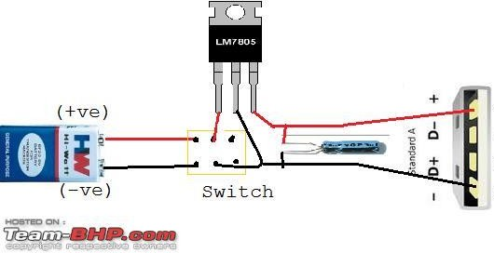  9V Battery or 5V USB Adaptor | TechCity Hub or Spar Mall

Laptop with Arduino IDE |   For Programming and Simulation | University of Ilorin ICT  Lab/Person al Laptop
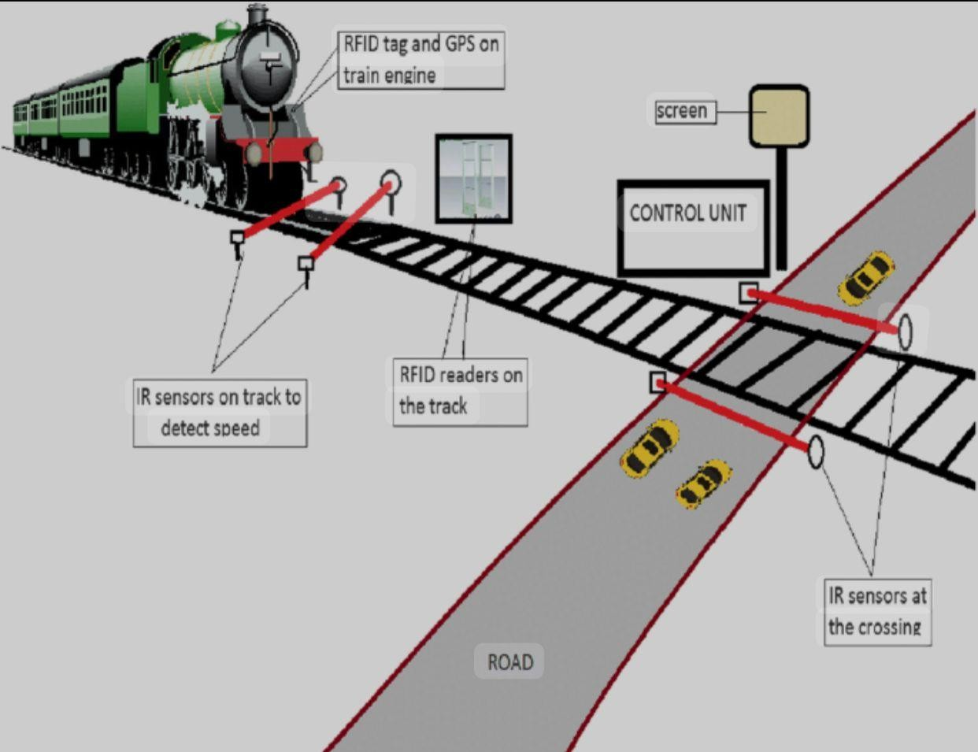

CHAPTER FOUR

DATA PRESENTATION, ANALYSIS AND DISCUSSION OF FINDINGS
This section presents the experimental results and analysis from both the physical prototype and the simulation of the Automated Railway Level Crossing System. The results are organized around the major functions of the system: train detection, barrier gate operation, traffic signal control, and system responsiveness.

Summary of Key Functional Results

Tested Function | Expected  Behavior | Observed  Behavior | Remarks
Train Detection (Approach) | Detect train within 20–30 cm  distance | Detected accurately at an  average of 25 cm | Working as expected
Barrier Closure (Servo Motor) | Close within 2  seconds after detection | Average delay:  1.85 seconds | Prompt and smooth transition
Traffic Signal (LEDs) | Switch from green to red upon train  detection | Instant transition (<0.5 sec) | Properly synchronized
Audible Alert (Buzzer) | Buzzer should sound when train  is detected | Loud, consistent buzz until train  exits | Alert functionality confirmed
Train Departure Detection | Detect exiting train within 20–30  cm | Detected at average of 24.5  cm | Departure successfully  tracked
Barrier Re- opening | Reopen barrier within 2 seconds  after train exits | Average re- opening delay: 1.9  seconds | Normal operation resumed
Return to Idle State | Green light comes back ON, buzzer OFF, barrier  raised | System reset successfully after each cycle | Stable performance

System Operation Breakdown
- Train Detection Performance

The ultrasonic sensors (HC-SR04) provided accurate and consistent measurements, both in real-world testing and during simulation. The following table summarizes the sensor detection accuracy:

Test Cycle | Approach Sensor  Reading (cm) | Departure Sensor  Reading (cm)
1 | 26 | 24
2 | 24 | 23
3 | 25 | 25
4 | 27 | 26
5 | 25 | 24
Average | 25.4 | 24.4
Sensor readings fluctuated slightly within the 2–3 cm range, which is acceptable for proximity detection. The system reliably identified train presence and departure with a response time of less than 300 milliseconds after detection.
- Barrier Gate and Servo Motor Response
The servo motors operated using PWM signals to change positions between 0° (closed) and 90° (open). The average time from detection to complete barrier motion is shown below:

Barrier Operation | Target Time | Average Observed Time | Result
Closure | ≤ 2 seconds | 1.85 seconds | ✔ Within standard
Opening | ≤ 2 seconds | 1.9 seconds | ✔ Within standard

- Traffic Signal and Buzzer Synchronization

Traffic lights and the buzzer were activated simultaneously with the servo during train detection. The control logic implemented ensured proper synchronization.

System State | LED Status | Buzzer | Barrier Gate
No Train | Green ON | OFF | Open (90°)
Train Approaching | Red ON | ON | Closing (to 0°)
Train Passing | Red ON | ON | Closed (0°)
Train Departed | Green ON | OFF | Opening (to 90°)

Achievement of Objectives

Objective | Achievement
Simulate an automatic railway  crossing system using Arduino | Successfully simulated in Tinkercad  and implemented on breadboard
Detect approaching and departing  trains using ultrasonic sensors | Reliable detection confirmed by  multiple test cycles
Automatically operate barrier gates  and traffic signals | Smooth servo control and LED/buzzer  activation observed
Improve railway crossing safety and reduce human error | Automation ensures consistent operation, removing the risk of human  failure

Observations and Limitations
Despite the system's reliability in a controlled environment, the following limitations were observed:
    - Short Sensor Range: Detection is effective only within limited range (2–4 m in real implementation), which may not be sufficient for high-speed trains.
    - Environmental Interference: Ultrasonic sensors may be affected by temperature or surface reflectivity.
    - Power Dependence: The prototype requires an uninterrupted 5V–9V power supply; fluctuations can cause erratic behavior.
    - Scale Limitation: Model-scale simulation differs from full-scale real-world dynamics (e.g., train speed, gate size).

Recommendations for Enhancement
    - Use long-range LIDAR or IR sensors for better outdoor performance.
    - Integrate solar power and backup batteries for rural installations.
    - Introduce wireless/GSM modules to alert central control units of faults or unusual activity.
    - Add camera-based object detection using Raspberry Pi or AI modules for future scalability.

CHAPTER FIVE CONCLUSION AND RECOMMENDATIONS

Conclusion
The implementation of an automated railway level crossing system as demonstrated in this research has proven to be a viable solution to the persistent problem of railway accidents due to human error and delayed manual operations. The system successfully integrated sensor-based detection with microcontroller- based control logic, enabling accurate, timely, and efficient gate operations.
This project addressed key safety concerns at level crossings by providing a system that is not only functional but also cost-effective and easy to implement, especially in developing regions with limited infrastructure. The system can significantly improve traffic management, reduce human-related errors, and save lives when deployed on a larger scale.
Although this prototype was tested on a small scale, the successful outcomes indicate great potential for real-world application with some enhancements. As urbanization and rail transportation continue to expand, such automated systems will become indispensable in modern transportation networks.

Recommendations
Based on the findings and limitations of this study, the following recommendations are proposed:
    - Adoption of Long-Range Sensors: To improve detection for high-speed trains and accommodate wider crossings, it is recommended to adopt LIDAR

or long-range infrared sensors with improved accuracy under varying environmental conditions.
    - Power Backup and Solar Integration: To enhance system reliability, especially in rural or remote areas with unstable power supply, the system should incorporate solar power and battery backups to maintain continuous operation.
    - Advanced Object Detection: Integration of AI-enabled cameras and Raspberry Pi modules can be used for obstacle detection (e.g., humans, animals, or vehicles) on the tracks, allowing for more intelligent gate control decisions.
    - Remote Monitoring and GSM Integration: To enable remote fault detection and real-time reporting, GSM or IoT modules should be added to notify control centers in case of system failure or unusual activity at the crossing.
    - Prototype Scaling and Field Testing: It is essential to move beyond model- scale to full-scale field testing. This will validate performance under real- world dynamics like train speed, environmental factors, and larger infrastructure.
    - Government Support and Policy Integration: For widespread adoption, the government and relevant transport agencies should support automation policies, offer subsidies or grant for implementation, and mandate safety standards at level crossings.

REFERENCES
Ahmed, M., & Rahman, M. (2020). Design and implementation of GSM-based automated railway gate control. International Journal of Advanced Research in Electrical, Electronics and Instrumentation Engineering, 9(3), 1876–1881.
Al Amin, M., Chimba, D., Hasan, K., & Samson, E. (2024). Intelligent railroad grade crossing: Semantic segmentation and object detection for enhanced safety. arXiv Preprint. https://arxiv.org/abs/2403.11060
Alam, M. R., Sunny, R. K., & Rabbi, A. S. S. (2018). An Arduino-based automated railway gate control system. International Journal of Scientific & Engineering Research, 9(3). https://www.ijser.org
Ali, A., Khan, S., & Hussain, M. (2019). Sensor-based railway crossing gate control system. International Journal of Engineering Research and Technology, 8(10), 450–454.
Federal Railroad Administration. (2006). Improving railroad crossing safety through technology. U.S. Department of Transportation.
Garg, V., Singh, P., & Sharma, R. (2014). Automatic railway gate control using microcontroller. International Journal of Innovative Research in Science, Engineering and Technology, 3(1), 8162–8167.
Kaur, J., & Gupta, A. (2022). AI and IoT based smart railway crossing system.
International Journal of Computer Applications, 975(8887), 1–6.
Kumar, R., Sharma, A., & Verma, P. (2020). IoT based smart railway level crossing system. International Journal of Computer Science and Mobile Computing, 9(4), 150–157.

Naik, P. R., & Nandimath, A. V. (2013). Automated railway level crossing system. International Journal of Electrical and Electronics Engineering Research, 3(4).
Network Rail. (2020). Level crossing upgrade initiative – Safety and technology.
Network Rail Technical Report. https://www.networkrail.co.uk
Patel, R., Reddy, N., & Rani, K. (2021). Integration of traffic signals with automated railway crossing system. International Journal of Advanced Research in Electrical, Electronics and Instrumentation Engineering, 10(2), 100–104.
Raj, K., & Suresh, G. (2018). Microcontroller based automatic railway gate control.
International Journal of Engineering and Technology, 7(3), 98–102.
Singh, H., & Sharma, R. (2017). Automated railway crossing using Arduino and ultrasonic sensor. International Journal of Science and Research (IJSR), 6(6), 241–245.

