PROJECT REPORT

ON

PROPOSED EATERY

AT
ILORIN EAST L.G. A, KWARA STATE

By

YUSUF AISHAT AMOKE
ND/23/ARC/PT/0053

SUBMITTED TO THE DEPARTMENT OF ARCHITECTURAL TECHNOLOGY INSTITUTE OF ENVIRONMENTAL STUDIES, (I.E.S) KWARA STATE POLYTECHNIC ILORIN, KWARA STATE.
IN PARTIAL FULFILLMENT OF THE REQUIREMENTS FOR THE AWARD OF NATIONAL DIPLOMA (ND) IN ARCHITECTURAL TECHNOLOGY

JULY, 2025

DECLARATION
“I declare that this project project/dissertation is a product of my personal research work. It has not been presented for the award of any degree in any polytechnic. The ideas, observations, comments, suggestions herein represent my own convictions, except quotations, which have been acknowledged in accordance with conventional academic traditions.”

Name: YUSUF AISHAT AMOKE
Matric no: ND/23/ARC/PT/0053

_______________ ________________

Signature Date

CERTIFICATION
I certify that this Research/Dissertation entitled mass housing was carried out by YUSUF AISHAT AMOKE under my supervision and has been approved as meeting the requirements for the award of ND in Architectural Technology, of Kwara State Polytechnic, Ilorin, Kwara State Nigeria.
_____________________ ____________________
ARC: SHERO MOHAMMED SIGN/ DATE
PROJECT SUPERVISOR

_____________________ ____________________
ARC OLAREWAJU F.A
PROJECT COORDINATOR SIGN/ DATE

_____________________ ____________________
ARC: J.M TOMORI
HEAD OF DEPARTMENT SIGN/ DATE

---------------------------------- ---------------------------
EXTERNAL EXAMINER SIGN/ DATE

ACKNOWLEDGEMENT
All praise and gratitude belong to Almighty Allah (SWT), the Most Gracious and the Most Merciful, for granting me life, strength, sound mind, and the privilege to complete this project successfully. Without His divine mercy and guidance, this journey would not have been possible. I would like to sincerely my Project supervisor ARC MOHAMMED SHERO, for being a constant source of guidance, motivation, and professional inspiration. Your dedication, patience, and willingness to share knowledge has not only impacted the outcome of this work but has also shaped my approach to architecture and design as a whole. Thank you for believing in my potential and pushing me to strive for excellence.
I also appreciate the effort of my Head of Department (HOD) in person of ARC. J.M. Tomori and the whole host of lecturers ARC. Olarewaju F.A, ARC. Chuckwma Nmom and ARC. Familua O.S. I pray almighty Allah will continue to bless you all.
To my beloved family, words cannot fully express my heartfelt gratitude. Your love, prayers, and unwavering support gave me the emotional strength to keep going through difficult moments. Your sacrifices and constant encouragement have been the foundation upon which I stand today. May Allah reward you all beyond measure.
I am also deeply grateful to Mr. and Mrs. YUSUF, for being more than friends—your support and encouragement felt like that of family. Your kind words, advice, and presence have truly been a blessing throughout the course of this work.
To my colleagues, friends, and everyone who contributed in one way or another to the success of this project—thank you. Your encouragement, feedback, and shared experiences have enriched this journey in countless ways.
May Allah continue to bless and uplift everyone who has stood by me through this academic and creative journey.

DEDICATION

This report is dedicated to Almighty Allah the universe, the creator of all creators and the source of mankind who has always been my strength throughout this project and also for his unconditional and infinite mercy showered upon me through my studies.
Also, I dedicated this project to my parent Mr. and Mrs YUSUF for their parental, financial and moral support.
Finally to my brothers and sisters and my colleague and other for their contribution to attain great achievement. I pray Almighty Allah reward everyone abundantly.

TABLE OF CONTENTS
Title page
Declaration……………………………………………….…….....……..ii
Dedication………………………………………………………….....…iii
Certification ………………….………………………………..……...…iv
Acknowledgement………………………………………….….…………v
Table of content…………………………………………….…….……..vi
.
List of table…………………………………………….....….…………..ix
List of figure……………………………………………...….……………x
List of plate………………………………………………....…………….xi
List of appendix……………………………………….…….……………xii
Abstract…………………………………………………........…………..xiii
CHAPTER ONE
1.0 Introduction……………………………………………..…….….…..1
1.1 Background of the Study…………………………………………..2
1.2 Definition of the Study…………………………...………….…….2
1.3 Justification……………………………………………………..…2
1.4 Aim and Objectives of the Project……….…………………….…..2
1.5 Scope of Design…………………………………………...……….3
1.6 Problem Statement…………………………………………,,.……3
1.7 Deduction……………………………………….....…………,,……4
1.8 Limitation …………………………………....……….....….……4
1.9 Methodology…………………………………....…….….…..….…4
CHAPTER TWO:
2.0 Review of Relevant Literature.........................................................5

CHAPTER THREE
3.1 What is Case Studies......................................................................8
3.2 Case Study One…………………………...…………………..…8
3.3 Case Study Two………………………………….….…….….....10
3.4 Case Study Three…………………………..………….….…….12
CHAPTER FOUR
4.0 Background of the Site Location Town........................................15
4.1 Site Location/Description..............................................................16
4.2 Site Location Criteria.....................................................................17
4.3 Geographical/Climate Data…………………...………...…...…..17
4.4 Design Criteria.................................................................................20
4.5 Brief Analysis................................................................................21
4.6 Space Allocation/schedule of accommodation………...…..……22
4.7 Conceptual Development..............................................................23

CHAPTER FIVE
5.0 Appraisal of Proposed Scheme…………………………….…...24
5.1.1 Construction Methodology and Material...……………….…….25
5.1.2 Service, Installation, Acoustic, Waste, Disposal, Lighting, Plumbing and Electrical installation, Acoustic, Waste Disposal, Fire Protection and External Works………………………………………………………………....26
5.2 Recommendation………………………… …………….....……..27
5.3 Conclusion…………………………………………..........…...….28
Reference................................................................................................29
Appendix…………………………………………......…………………..

LIST OF TABLE
TABLE 4.1 SHOWING THE SPACE ALLOCATION….………………22

LIST OF FIGURES
FIG 3.2.1: LOCATION & PLAN FOR CASE STUDY ONE……………….15
FIG 3.2.2: PLATE PICTURE CASE STUDY ONE………………..…….…15
FIG 3.3.1: LOCATION & PLAN FOR CASE STUDY TWO………….……16
FIG 3.3.2: PLATE PICTURE CASE STUDY TWO ……………….......….16
FIG3.4.1: LOCATION & PLAN FOR CASE STUDY THREE………….….18
FIG 3.4.2: PLATE PICTURE CASE STUDY THREE….…….…....….......19
FIG 3.5.1: LOCATION & PLAN FOR CASE STUDY FOUR….…………..20
FIG; 3.5.2: PLATE PICTURE CASE STUDY FOUR……………..….....…20
FIG; 3.6.1: ONLINE CASE STUDY…………………….………....….……20

FIG 4.1 LOCATIONAL PLAN……………………………...............……..24
FIG; 4.2.1. SHOW SITE ANALYSIS……………..……........….……..….26
FIG; 4.2.2 SHOW SITE INVENTORY....................................................…...26
FIG; 4.2.3 SHOW SITE ZONING............................................................…...27

LIST OF PLATES
PLATE 3.2: LOCATION & PLAN FOR CASE STUDY ONE…….....…….15
PLATE 3.2: SHOWING PICTURE CASE STUDY ONE…………..………15
PLATE 3.3: LOCATION & PLAN FOR CASE STUDY TWO…….....……16
PLATE 3.3: SHOWING PICTURE CASE STUDY TWO ……………...….16
PLATE 3.4: LOCATION & PLAN FOR CASE STUDY THREE…....…….18
PLATE 3.4: SHOWING PICTURE CASE STUDY THREE….….........…...19
PLATE 3.5: LOCATION & PLAN FOR CASE STUDY FOUR….......…....20
PLATE; 3.5: SHOWING PICTURE CASE STUDY FOUR………......……20
PLATE 4.1 ONLINE CASE STUDY…………………………...............…..20

LIST OF APPENDICES
APPENDIX 5. FLOW CHAT……………………………….…..……..39
APPENDIX 5. BUBBLE………………………………………..…..….40
APPENDIX 5. SITE PLAN………………..…….…....………………..41
APPENDIX 5. GROUND FLOOR PLAN……………….…...….…….42
APPENDIX 5. ROOF PLAN………………………………….….……43
APPENDIX 5. SECTIONS……………………………….….…......….44

APPENDIX 5. ELEVATIONS……………………………….….…….45
APPENDIX 5. EXTERNAL PERSPECTIVE…………….……….….46

ABSTRACT
This architectural proposal presents the design of a contemporary eatery aimed at providing a functional, comfortable, and aesthetically pleasing dining experience for the general public. With the increasing demand for accessible and well-structured food service spaces, this project seeks to create an environment that not only meets basic catering needs but also enriches social interaction, cultural expression, and customer satisfaction.
The eatery is envisioned as a medium-scale establishment strategically located to serve both local residents and passersby. It integrates modern design elements with local cultural aesthetics to create a unique and welcoming atmosphere. Key considerations in the design include optimal space utilization, efficient kitchen layout, smooth circulation patterns, sanitation compliance, and ease of maintenance. Emphasis is also placed on natural lighting, ventilation, waste management systems, and the incorporation of eco-friendly materials.
Furthermore, the project draws insights from case studies of existing eateries, local demographic analysis, and site-specific evaluations to inform the spatial configuration and functionality of the proposed design. The architectural language employed in this design promotes openness, simplicity, and flexibility, allowing for both indoor and outdoor dining experiences.
This proposal contributes to the growing need for inclusive and community-oriented commercial spaces by fostering a healthy and enjoyable food environment. It aims to enhance not just the act of eating but the overall dining experience, making the eatery a hub for relaxation, connection, and local identity.

CHAPTER ONE

INTRODUCTION

1.1 BACKGROUND OF THE STUDY

An eatery is an establishment where food and beverages are prepared, served, and consumed. It serves as a social space where individuals, families, and groups come together not only to eat but also to relax, socialize, and engage in conversations. In today’s fast-paced world, eateries play a vital role in urban life, providing quick access to meals for people with busy schedules, as well as serving as leisure destinations for social gatherings and celebrations.

The design of an eatery goes beyond mere aesthetics; it encompasses functional planning, comfort, ambiance, hygiene, accessibility, and sustainability. A well-designed eatery creates a welcoming environment that enhances the dining experience while ensuring efficient operations for staff. Good design impacts customer satisfaction, which in turn influences the success of the business. It also ensures that the flow of movement within the eatery is seamless—starting from the entrance, through the dining area, to the service counter, kitchen, and restrooms.

In recent years, there has been a shift towards eateries that are not just places to eat but also reflect cultural values, promote environmental sustainability, and offer aesthetically pleasing interiors. Factors such as lighting, furniture arrangement, ventilation, acoustics, and choice of materials all contribute to how people perceive and enjoy the space. Furthermore, the rise of environmental consciousness has encouraged the incorporation of green design principles in eateries, such as the use of natural lighting, eco-friendly materials, and energy-efficient systems.

In Nigeria, where diverse culinary traditions exist, eateries are becoming increasingly popular, ranging from traditional food joints to modern restaurants and fast food outlets. The demand for well-planned, hygienic, and comfortable dining spaces is on the rise, especially in urban centers where people seek convenience, quality service, and memorable experiences. The need to address this growing demand calls for thoughtful architectural solutions that balance functionality, culture, and sustainability

1.2 HISTORICAL BACKGROUND
The history of eateries dates back thousands of years to ancient civilizations. Early forms of eateries were simple food stalls and inns where travelers could rest and purchase meals. In ancient Rome, for instance, there were establishments known as thermopolia, which served hot food and drinks to the public, resembling today’s fast food culture. Similarly, in ancient China and the Middle East, food markets and roadside food vendors provided essential dining services.

The concept of formal restaurants began to take shape in 18th-century France. The term "restaurant" itself comes from the French word "restaurer," which means "to restore." The first known modern restaurant, offering individual tables and menus, opened in Paris in the 1760s. This development laid the foundation for what we now recognize as the global restaurant industry.

In Nigeria, the history of eateries is closely tied to the local food culture. Traditional eateries, commonly known as bukas, mama put, or canteens, have existed for decades, serving affordable homemade meals to locals. These informal food outlets play a significant role in feeding millions of people daily, especially in urban and semi-urban areas. They offer popular Nigerian dishes such as rice and stew, pounded yam with egusi soup, amala, and other regional specialties.

With globalization and urban development, Nigeria has witnessed the emergence of modern eateries, including fast food chains, fine dining restaurants, and contemporary cafes. These establishments incorporate modern design elements, international cuisines, and standardized services while sometimes retaining elements of local culture and cuisine. This evolution reflects the changing lifestyles, economic growth, and increased appreciation for dining experiences beyond just satisfying hunger.

Today, eateries have become more than places to eat—they are centers of social interaction, business meetings, family bonding, and cultural exchange. As such, their design continues to evolve to meet the demands of modern society while reflecting the rich cultural diversity and hospitality that define the food experience. e concept of eateries can be traced back to ancient civilizations where food was sold in public marketplaces. In medieval times, inns and taverns served food to travelers. The 18th and 19th centuries saw the rise of formal restaurants in Europe, especially in France, following the French Revolution. In Nigeria, local eateries known as bukas or mama put have long served communities, offering traditional meals at affordable prices. However, with globalization, fast food chains and contemporary restaurants have become more prominent, reshaping how food is consumed and how eateries are designed. The evolution from informal food joints to well-designed spaces has led to a greater emphasis on architectural planning, ambiance, and environmental impact.

1.3 STATEMENT OF THE DESIGN PROBLEM
Many existing eateries suffer from poor spatial planning, inadequate seating arrangements, poor ventilation, and uninspiring aesthetics, which negatively impact customer satisfaction and business profitability. Additionally, some eateries fail to consider accessibility, efficient service flow, and comfort for both staff and customers. There is a need for a well-designed eatery that integrates functionality, comfort, aesthetics, and sustainability to create a welcoming environment that enhances the dining experience..

1.4 AIM OF THE PROJECT

The aim is to design and build a standard, comfortable, and well eatery for my client.

1.5 OBJECTIVES OF THE PROJECT
Efficient food preparation and services: design the eatery and facilitate efficient food preparation, storage and service.

Comfortable dining experience: create a comfortable and inviting atmosphere for customers to enjoy their meals

Attractive and retain customers: design the eatery to attract and customers in creasing sales and revenue.

Increase customer customers satisfaction: design the eatery to meet the needs and expectations of customers, increasing customer satisfaction and loyalty

1.6 JUSTIFICATION
A justification for the term “Eatery” is that it describes a local, informal and often self-service food outlet that is widely used in urban environments. Unlike more formal restaurants, eateries tend to be affordable and accessible, making them ideal for casual dining experiences.
(1) Relevance: Justifying the use of “Eatery” aligns with the objective of creating a functional and simple dining environment.

(2) Accessibility: It includes easy layout ideas and materials which are easy to get and affordable to implement.
(3) Simplicity: The term is suitable for understanding and commonly used in casual speech and writing.
(4) Flexibility: The idea for general adaptability refers to multiple food options, such as fast food, African dishes, and snacks.
(5) Cultural relevance: As food culture spreads with pop-up kitchens, quick-to-serve food stands and small bistros, the idea of an eatery remains a vital and adaptable term.

1.7 SCOPE OF THE PROJECT
The project will include:
- Main Building
1. Parking space
2. Pizza area
3. Greenhouse
4. Water tank
5. Security post
6. — (blank)

1.8 RESEARCH METHODOLOGY
- Review of literature on eatery architecture and customer behavior
- Study of eatery corporate requirements and branding guides
- Case studies of existing Eateries buildings
- Site analysis and user interviews
- Use of design software (AutoCAD, Revit, Lumion) for modeling and visualization

CHAPTER TWO

LITERATURE REVIEW
2.1 INTRODUCTION
This chapter reviews existing literature relevant to the design and operation of eateries. It examines the historical development of eateries, design considerations, functional requirements, user experience, and the influence of spatial design on customer satisfaction. The review draws from books, journal articles, case studies, and existing eatery designs to provide a solid foundation for the proposed project.

2.2 CONCEPT AND EVOLUTION OF EATERIES
Eateries, also known as restaurants or food outlets, are commercial establishments where food and beverages are prepared and served to customers. The concept of eateries dates back to ancient times, with early examples found in ancient Rome, China, and the Middle East where inns, taverns, and tea houses provided food and lodging to travelers. In modern times, eateries have evolved into diverse formats including fast food, fine dining, casual dining, cafes, and food courts (Walker, 2017).

2.3 TYPES OF EATERIES
Eateries come in various forms, each with distinct design and service requirements:

- Fast Food Restaurants: Focus on quick service, affordability, and high turnover.
- Casual Dining: Emphasizes comfort, ambiance, and moderately priced meals.
- Fine Dining: Offers upscale service, quality meals, and luxurious ambiance.
- Cafes and Coffee Shops: Provide light meals, beverages, and an informal atmosphere.
- Outdoor and Street Food: Involves minimalistic setups catering to mobility and affordability.

The choice of eatery type influences design decisions, including seating arrangement, kitchen size, lighting, and spatial flow (Pavesic, 2005).

2.4 IMPORTANCE OF INTERIOR DESIGN IN EATERIES
The interior design of an eatery plays a significant role in creating a memorable dining experience. According to Bitner (1992), the physical environment, known as the "servicescape," affects customer behavior, satisfaction, and return intentions. Elements such as color, lighting, furniture, space planning, and decoration contribute to the overall ambiance, influencing how long customers stay and how much they spend.

2.5 FUNCTIONAL PLANNING OF EATERIES
Efficient functional planning ensures smooth operation of an eatery. Key functional zones include:

- Entrance and Reception
- Dining Area
- Kitchen and Food Preparation Area
- Storage Area
- Restrooms

The layout must promote seamless circulation for both customers and staff while complying with safety and hygiene regulations (Hemmington, 2007). Adequate space allocation for each function enhances operational efficiency and customer comfort.

2.6 IMPACT OF SPATIAL DESIGN ON CUSTOMER EXPERIENCE
Research shows that spatial design affects customer emotions, behavior, and perceptions of food quality (Ryu & Jang, 2008). Factors such as:

Lighting: Natural and artificial lighting impact mood and visibility.

Acoustics: Noise levels influence comfort and ambiance.

Seating Arrangement: Impacts privacy, interaction, and capacity.

Color Psychology: Colors evoke emotions; for instance, warm colors stimulate appetite.

A well-designed space encourages positive dining experiences and repeat visits.

2.7 SUSTAINABLE DESIGN IN EATERIES
Sustainability is increasingly important in eatery design. Incorporating eco-friendly materials, energy-efficient lighting, natural ventilation, and waste reduction strategies aligns with global environmental goals and appeals to eco-conscious customers (Edwards, 2014). Sustainable design also reduces operational costs in the long term.

2.8 CASE STUDIES OF NOTABLE EATERIES
Several successful eateries serve as case studies for best design practices:

McDonald’s Restaurants: Known for functional layouts and brand identity through color and furniture design.

Starbucks Coffee Shops: Emphasize comfort, lighting, and social interaction.

Local Nigerian Bukka/Amala Joints: Use local materials, informal layouts, and culturally relevant designs that cater to specific demographics.

Studying these examples offers practical insights into design approaches that enhance functionality and customer appeal.

2.9 SUMMARY OF LITERATURE REVIEW
The reviewed literature highlights the importance of thoughtful design in the success of eateries. Key takeaways include the evolution of eateries, the critical role of interior and functional design, the impact of spatial arrangements on customer satisfaction, and the growing emphasis on sustainability. These insights form the basis for the proposed eatery design, aiming to create an efficient, aesthetically pleasing, and customer-friendly environment..

CHAPTER THREE
3.1 CASE STUDY
Case Studies can be defined as the process of investigation or researching and analyzing an existing project in order to allow creating and improvement in a proposed project.
The need for case studies in this type of project is very important and cannot be over looked due to the following reason:
To have a board knowledge and detailed about the project you embarking on through careful study of the existing one.
To examine, evaluate the existing problem and how it was tackled by the processors in order to avoid such problems in the proposed design or often a better solution for both the future and present design.

3.2 Case Study One
NAME: Chicken republic
LOCATION: At Taiwo, Ilorin kwara State

MERIT
. It has enough space units
. Aesthecally built
. Good circulation
. Adequate space

DEMERITS
. Poor ventilation
. Lightening is not enough
. Poor sustainability

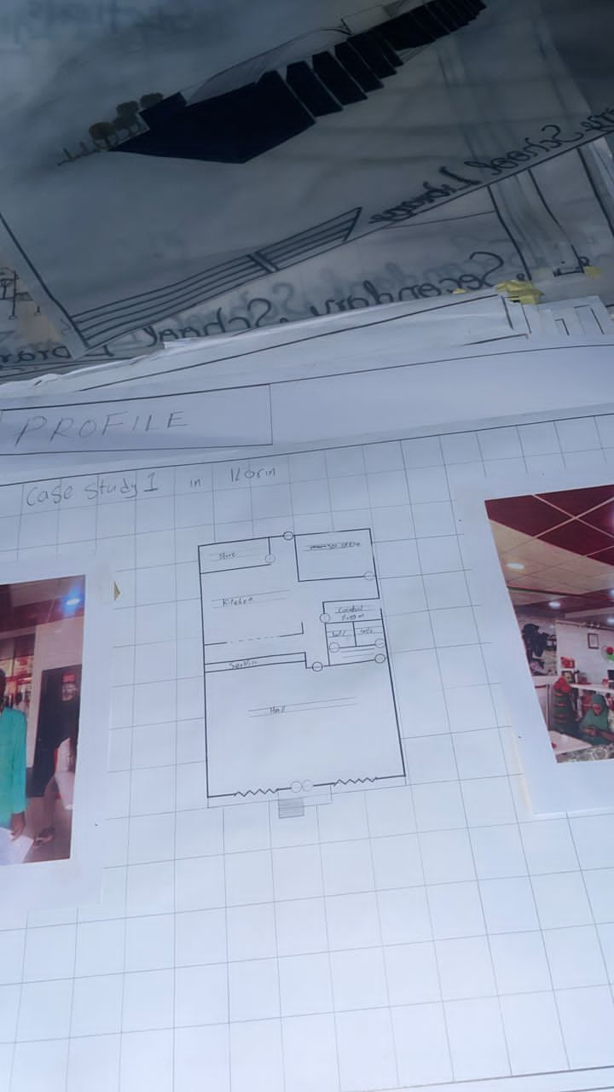

FIG 3.2.1 GROUND FLOOR PLAN

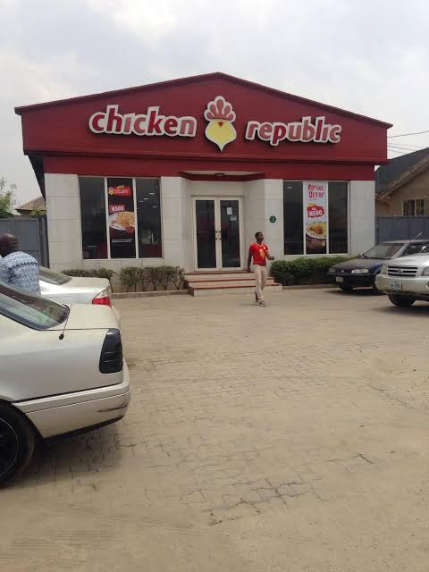

PLATE 3.2.1SHOWING APPROACH VIEW

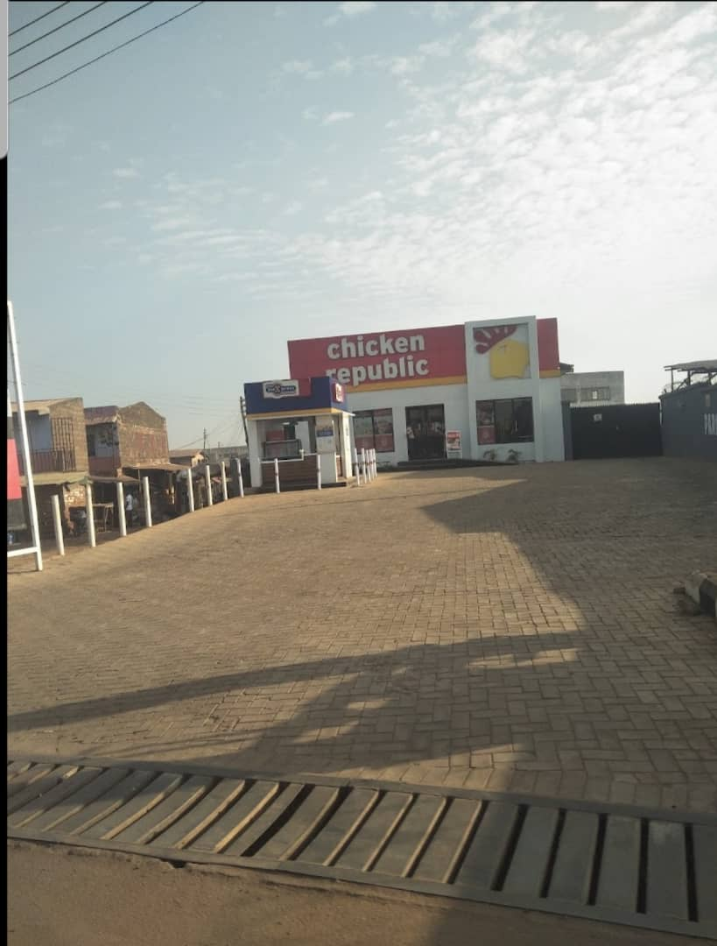

PLATE 3.2.2 SHOWING APPROACH VIEW

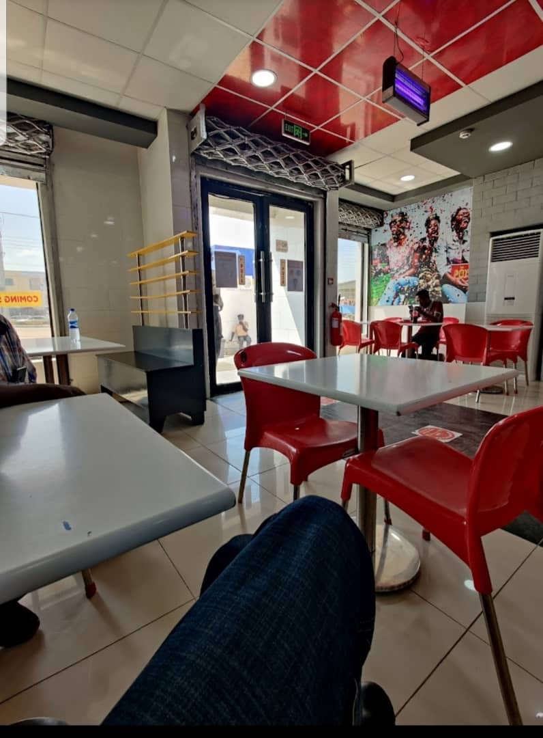

PLATE 3.2.3 SHOWING APPROACH VIEW

3.3 Case Study two
NAME: Captain cook
LOCATION: At offa awodi, Kwara State

MERIT
. it has enough ventilation
. It has enough lightening
. It has enough space
Sustainable

DEMERITS
. No enough toilet
. Aesthetically poor
. Poor functional relationship
. No welcoming entrance

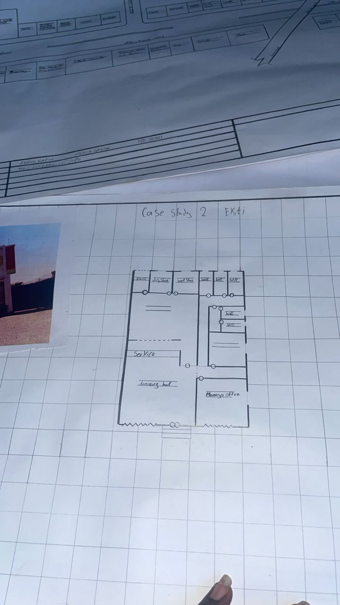

FIG 3.3.1 GROUND FLOOR PLAN

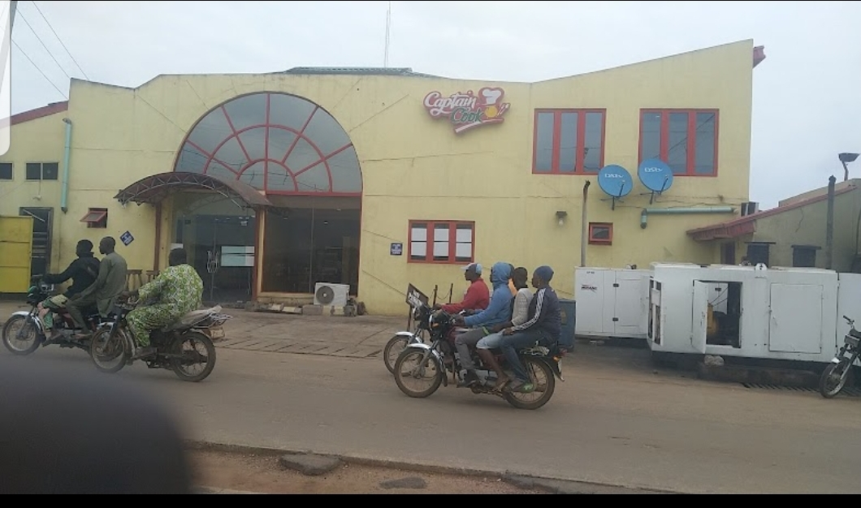

PLATE 3.3.1 SHOWING APPROACH VIEW

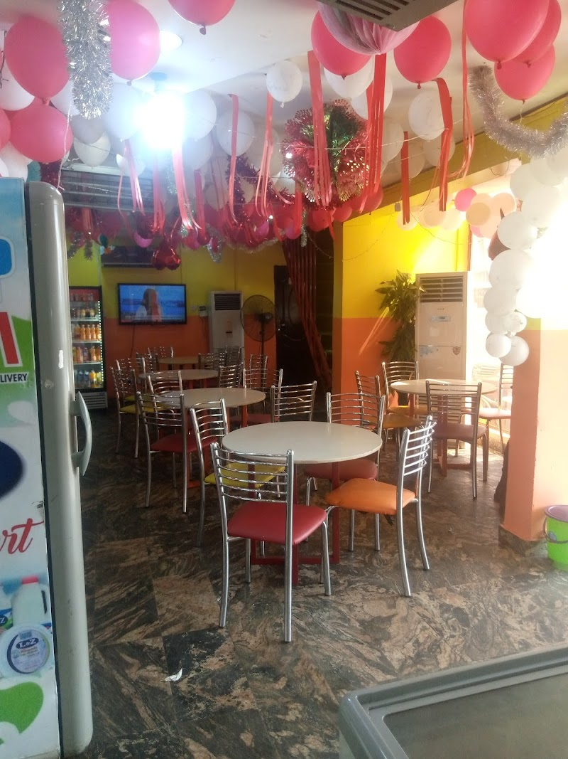

PLATE 3.3.2 SHOWING APPROACH VIEW

3.4 Case Study three
NAME: Chicken Republic
LOCATION: At Iworoko, Ekiti State.

MERIT
. Enough ventilation
. Adequate lightening
. There is proper circulation

DEMERIT
. There is no enough space in the unit
. Aesthecally poor
. Poor sustainability

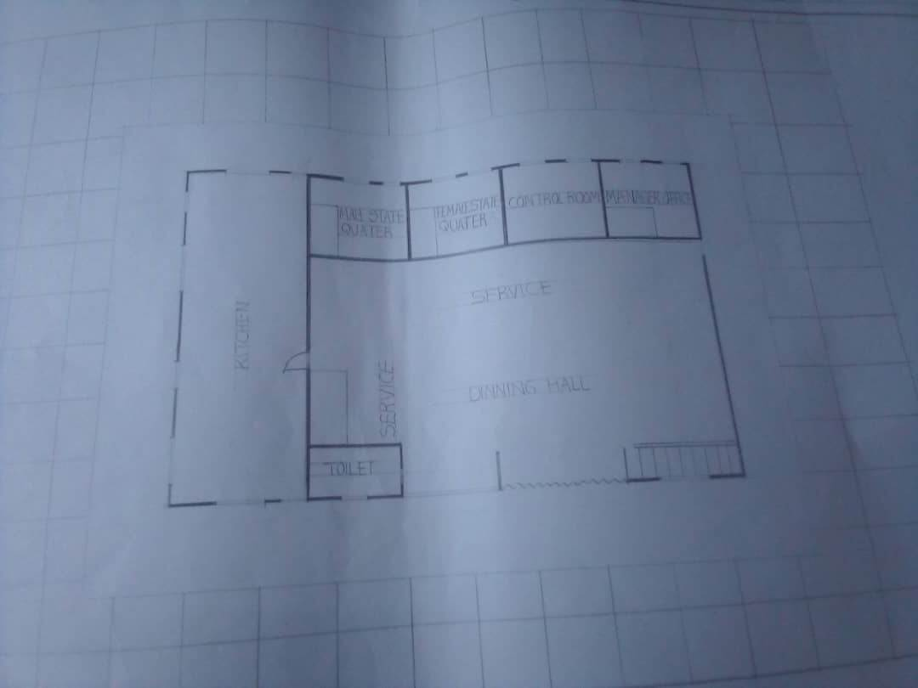

FIG 3.4.1 GROUND FLOOR PLAN

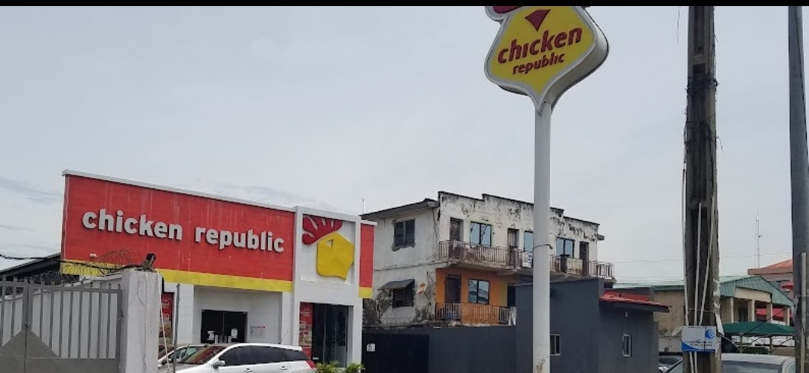

PLATE 3.4.1 SHOWING APPROACH VIEW

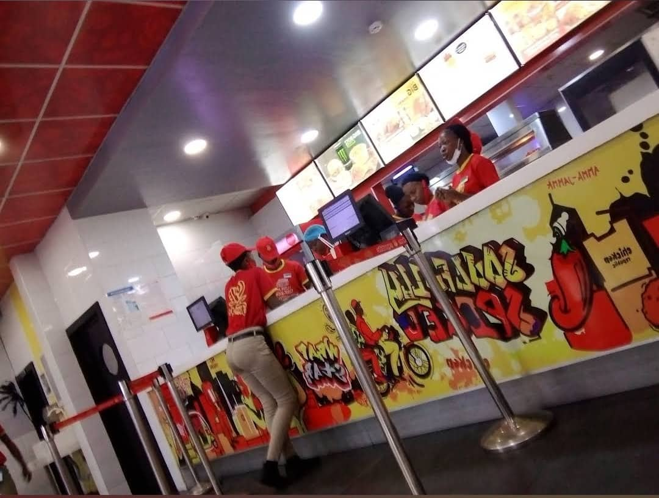

PLATE 3.4.2 SHOWING INTERIOR VIEW

CHAPTER FOUR
4.0 BACKGROUND OF THE SITE LOCATION

Geographic and Demographic Context

ILORIN is the capital city of Kwara State, located in the North-Central geopolitical zone of Nigeria. It lies approximately halfway between Lagos and Abuja and serves as an important commercial and administrative center. The town enjoys a tropical climate characterized by two distinct seasons: the rainy season (April to October) and the dry season (November to March).

Ilorin is home to a diverse population, including Yoruba, Hausa, Fulani, Nupe, and other ethnic groups, creating a rich cultural blend. The city is known for its Islamic heritage, traditional craftsmanship, educational institutions, and emerging hospitality and retail industries. The population density in Ilorin East Local Government Area is relatively high, with a growing number of young people, students, civil servants, and business owners, making it an ideal location for commercial ventures such as eateries.

Historical Background
Ilorin was founded in the late 18th century as a Yoruba city but later became a key part of the Fulani Caliphate in the early 19th century. It has since grown into a major urban center, known for its history as a gateway between the northern and southern regions of Nigeria. Historically, the city has been a melting pot of cultures, religions, and commerce. Its long-standing tradition of craftsmanship—especially pottery, weaving, and blacksmithing—has contributed to its cultural identity.
The town's historical evolution from a trade outpost to a modern city has influenced the development of social and recreational spaces, including food and hospitality businesses, which are essential to the city’s economic and social life.

GOALS OF THE PROPOSAL
The primary goals of the proposed eatery project are to:
Provide a comfortable and modern dining environment that meets the needs of both the local community and visitors.

Promote social interaction and relaxation through thoughtful spatial design and ambiance.
Create employment opportunities for residents of yakuba area and Ilorin East Local Government.
Introduce a unique food experience by offering a variety of cuisines that reflect both local flavors and contemporary tastes.
Encourage sustainable design practices through the use of eco-friendly materials, energy-efficient systems, and waste management.

4.1 SITE LOCATION/DESCRIPTION
The proposed site is situated on yakuba area, within Ilorin East Local Government Area, in Ilorin, the capital city of Kwara State, Nigeria. Yakuba area is a developing urban neighborhood with easy accessibility via major roads and public transportation. The area is primarily residential but is witnessing increasing commercial activity, including small shops, offices, schools, and eateries.
The site enjoys:
Good road access and visibility
Proximity to residential neighborhoods, schools, and religious centers
Availability of basic infrastructure such as electricity, water supply, and drainage
A moderate level of foot and vehicular traffic, providing business visibility without congestion
The location presents an excellent opportunity for the proposed eatery to thrive by serving both the local community and passersby.. 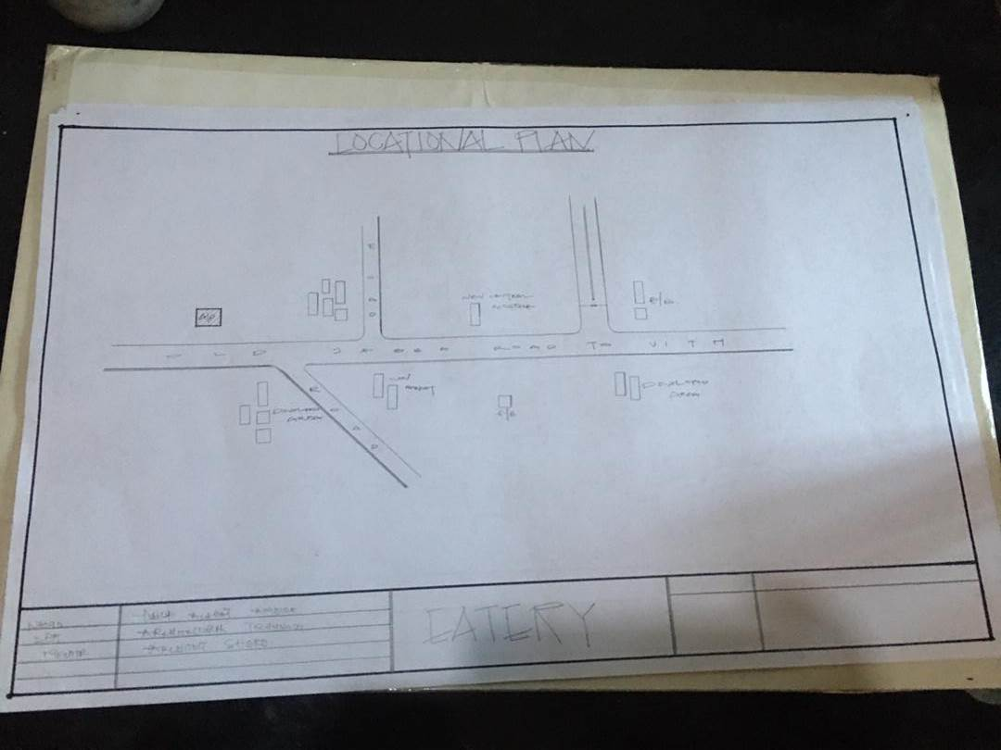
FIG 4.1 LOCATIONAL PLAN
The chosen site meets the following essential criteria:
- Accessibility: Easily accessible from major roads and transport systems.
- Proximity: Near residential areas and existing infrastructure.
- Social Infrastructure: Good access to water supply, electricity, communication, and emergency services.
4.2.1 SITE ANALYSIS/SITE INVENTORY
• Location: yakuba area, Akerebiata Ilorin, Ilorin east local government area kwara State.
• Orientation: The site’s shorter sides face east and south; the longer sides face east and west.
• Environmental Considerations: The site lies in a moderately busy area. Environmental noise is managed through:
- Natural Means: Tree planting and landscape buffers.
- Structural Design: Orientation to reduce exposure to noise and maximize ventilation.
- Mechanical Systems: Acoustic treatments and HVAC systems ensure internal comfort.
• Soil Type: Lateritic soil with good load-bearing capacity, suitable for foundation and structural works.
Ventilation and artificial/structural devices. Natural, by adequate plantation, while opening are employ as artificial devices structure by proper structural orientation.
All the unwanted sound/noise which cannot be controlled structurally are controlled through mechanical means to increase the comfort of human life. The soil type is brownish nature underlined by sedimentary rock with good bearing capacity

.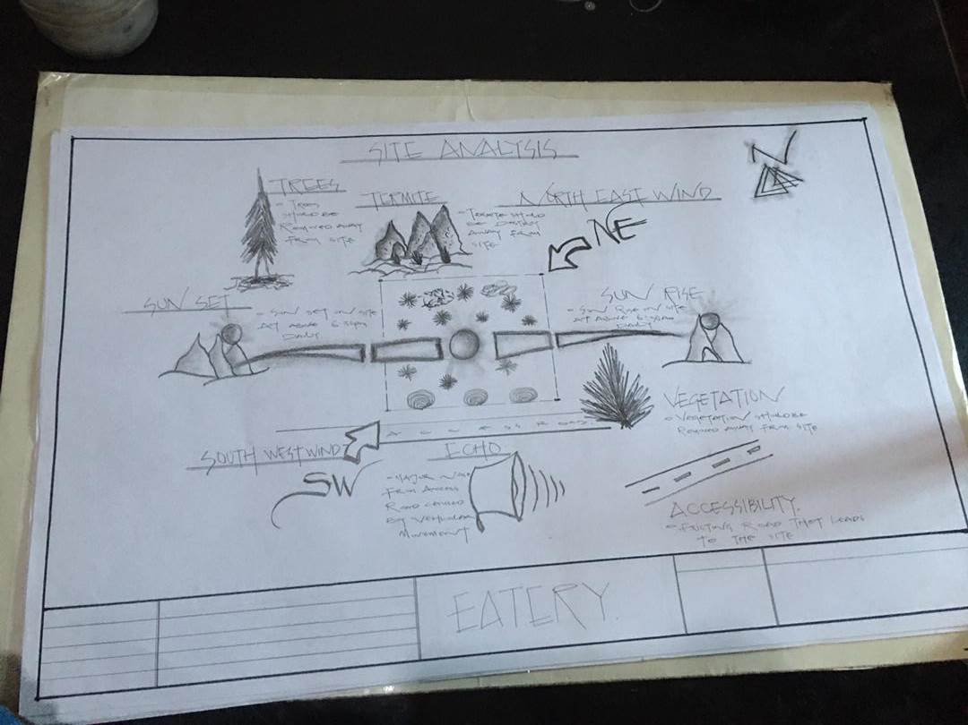
FIG; 4.2.1 SHOWIHG SITE ANALYSIS
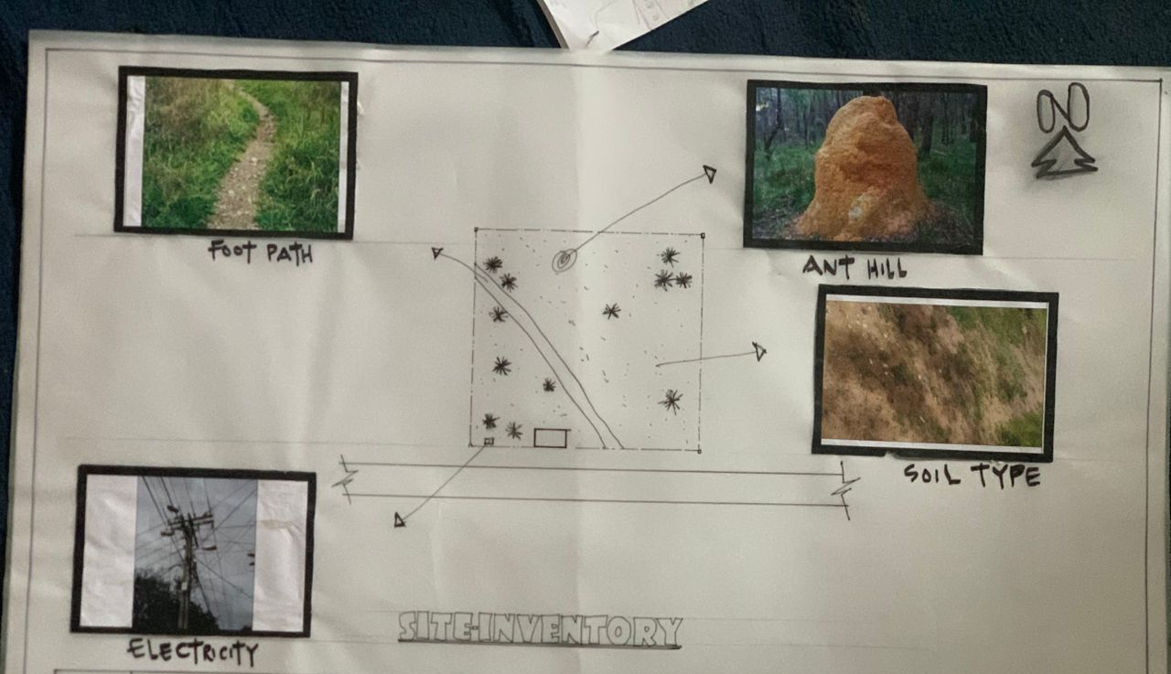

FIG; 4.2.2SHOW SITE INVENTORY
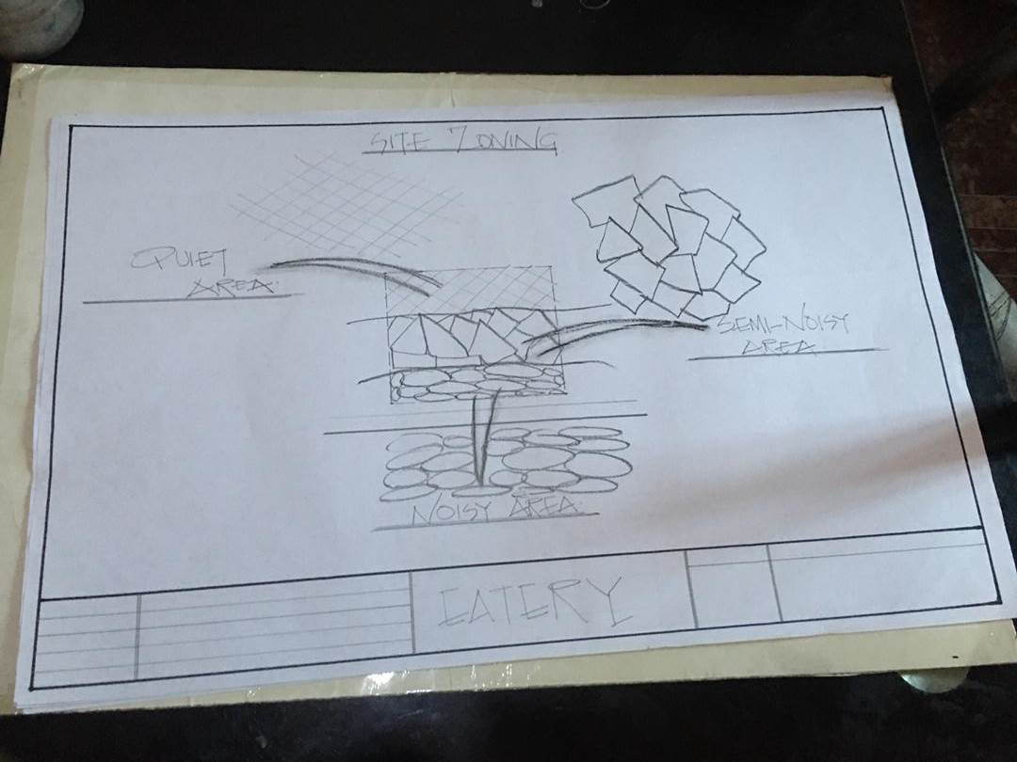

FIG; 4.2.3 SHOW SITE ZOINIG
4.3 GEOGRAPHIC/CLIMATIC DATA
Ede North experiences a tropical wet and dry climate, typical of southwestern Nigeria.
- Average Annual Temperature: ~25.5°C
- Annual Rainfall: Approx. 1400 mm

Climate Characteristics:
- Driest Month: December–January (8–15 mm rainfall)
- Wettest Months: May–October (200 mm+ per month)
- Temperature Range:
  - Warmest Month: March (~28°C)
  - Coolest Month: August (~22°C)
  - Annual Temperature Variation: ~5–6°C

THE CLIMATE GRAPH
The least amount of rainfall occurs in January. Average in this month is 9mm. most of the precipitation here falls in is average 1334mm.
THE TEMPERATURE
The temperature is the highest on average in March, at around 26.5. August is the coldest month, with temperature averaging 22.2°C
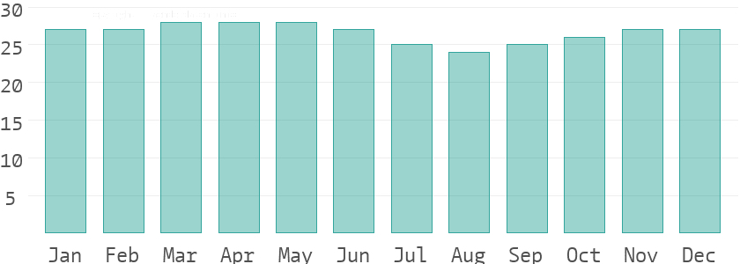
THE CLIMATE TABLE
The variation in the precipitation between the dries and wettest months is 229mm. throughout the year, temperatures vary by 4.3°C.
4.4 DESIGN CRITERIA
Design principles include:
• Functionality: Efficient layout for kitchen, dining, serving, and storage areas to ensure smooth operations and customer flow.
• Accessibility: Must comply with universal design standards — ramps, wide doors, accessible restrooms.
• Ventilation & Lighting: Adequate natural and artificial lighting; proper kitchen ventilation to remove heat, smoke, and odors.
• Hygiene & Safety: Use of non-slip, easy-to-clean materials; clear separation between cooking and dining zones; fire safety measures.
• Aesthetic Appeal: Welcoming interior with comfortable furniture, attractive finishes, and branding that reflects the eatery’s theme.
• Acoustics: Controlled sound levels for comfortable conversation.
• Waste Management: Designated area for waste disposal away from food preparation zones.
• Parking & Circulation: Sufficient parking and clear movement paths for customers and staff.
4.5 BRIEF
- Entrance
- Eating Area
- Serving Area
- Kitchen
- Dry Store
- Cold Store
- Changing Rooms (Male & Female)
- Manager/Director’s Office
- Maintenance Store
- Account Office
- Delivery Bay
- Conveniences / W.C.
- Exit

4.6 SPECIAL ALLOCATION/SCHEDULE OF ACCOMMODATION
Unit | No  required | MN  LENGTH | (MM)  BREADTH | (LXB) AREA (M²)
Entrance | 1 | 6.0 | 2.1 | 12.6
Eating Area | 1 | 16.8 | 13.6 | 228.48
Serving Area | 1 | 8.0 | 7.0 | 35.0
Kitchen | 1 | 5.0 | 7.0 | 35.0
Dry Store | 1 | 3.8 | 2.1 | 7.56
Cold Store | 2 | 6.0 | 5.0 | 60.0
Changing Room | 1 | 3.5 | 4.8 | 16.8
Manager Office | 3 | 4.0 | 3.0 | 36.0
Maintenance Store | 1 | 4.0 | 5.0 | 20.0
W.C | 1 | 7.5 | 3.0 | 22.5
Delivery Bay | 1 | 4.5 | 4.5 | 20.25
Exit | 1 | 3.5 | 4.8 | 16.8
Account Office | 1 | 3.5 | 2.0 | 7.0
TOTAL |  |  | 361.51 m²

4.7 CONCEPTUAL DEVELOPMENT
The conceptual development of an eatery revolves around creating a space that not only serves food but delivers an experience—one that satisfies the taste buds and soothes the soul. The central concept for this eatery is "Flavour Meets Atmosphere", blending modern aesthetics with cultural identity and sensory comfort.

CHAPTER FIVE
5.0 APPRAISAL OF PROPOSED SCHEME
5.1 DESIGN APPRAISAL
In any project design, there are two basics factors that should be taken into consideration. These factors are functionally and aesthetics of the design, although to some designers, aesthetics and functionally of any building are impartibly but in the case of project both aesthetics and functionality of the design were take care of to satisfy the highly demanded functional requirement and to create aesthetically and proportionally balanced design.
The functional efficiency of institute of business and vocational studies depends largely on the closeness of the immediate section that are strongly related in function all these are being taken up as seen on the site and floor respectively.
Construction Methodology
The choice of materials and constructions techniques is influence by a number of factors.
The cost of Materials
The climate condition as it affects material
The topography of the site
Economics: the initial cost and maintenance cost should be reasonable.
The availability of construction materials.
The durability and suitability of materials.
Services
Electricity to trap from the nearest pole of the institute building. The main water pipeline is closely located to the site where drinking water can be tapped telephone line is within the polytechnic which makes connection easy. All of the drains ruins to the surrounding gutter which finally drains to the solid and liquid waste are effectively dispose of by the soak away put and septic tanks.
Circulation
Horizontal circulation based on guided principle of separating human activities from reticular activities. Ventilation.
- Natural Ventilation: these ventilation is experienced in the building through openings. This depends on material wind force and their directions of movement due to the temperature, different between the air and the building.
- Artificial Ventilation: this method of ventilation is often used to improve the colonies of the interior of the units. Such artificial mechanism include fan and air conditioners where necessary.
Lighting
This is a means of providing brightness naturally by sun or moon or artificially by lamps good natural and artificial lighting is important in lecture room and library. It always easy to make mistake and time the eye is in a situation of poor lightening.
Plumbing
Water services are necessary in an installation and both the scope and design of these systems are subjected to statutory and water authority regulation. There is need to install water system to guide against water supply failure. Adequate installation of pipes are recommend.
Electrical Installation
The light fitting should be designed to avoid glare and should be easy to clean and maintain the main sources of electricity supply shall be from the Power Bolding Company of Nigeria but since it is well known that PHCN cannot guarantee uninterrupted services of electricity supply.
Water Disposal
Site slopes is of major factors to be considered in the location and changeling of drains, the use of reinforced concrete drainage covered with precast lead and drainage pipe will be constructed from where waste water will be carried to the drainage zones on the site using surface drainage system.
Fire Protection
Building regulations and construction with local fire authority backed up by insurance policy survey takes care of fire protection.
Noise Control
The is an unpleasant sound often load harsh excessive noise and liberation can cause fatigue, leading to errors and general dissatisfaction in the classrooms, lecture, library, external noise could be easily be controlled with the aid of landscape materials and enough setbacks.
Orientations
The orientation of a building involves the arrangement of the building toward a way from the surreys across or along the trade winds normally determine the thermal comfort in the building.
Sun and Wind Breaking
In the pre-ventilation design gets rid excessive heat moisture and obvious product such as smoke moisture (generator house) and dust the use of terrace couple with spacious and useful often courtyard to avoid all functional part of the building enough natural ventilation.
Materials and Finish
The influencer of building material on construction work in Ibadan and its environment is similar to what prevail in the middle belt of the country.
The materials choice and finishes are influenced by the following:
i. The durability and suitability of materials
ii. Geology and topography of the site
iii. Availability of materials
iv. The climatic condition
v. Prospective of materials
vi. The cost of materials
Roof
Roof should preferably of light weight construction with parapet converging it and the external super should absorb as little solar energy as possible.
Ceilings
Suspended ceiling is used in some lecture room with fang ceiling suitable center to center.
Doors
The door type and size depend on the door location but generally metal door are used for the administrative block, mechanical workshop, aluminum glass door and steel door are used.
Window
The windows uses are glassed pivot aluminum windows.

5.2 Recommendations
Strategic Location and Accessibility: The eatery should be sited along a well-trafficked and easily accessible route to attract both pedestrians and motorists. Adequate parking space should also be considered.
Functional and Flexible Design: The interior layout should allow for efficient service flow between the kitchen, dining, and service areas. Flexible seating arrangements should accommodate both individual and group dining.
Aesthetic Appeal and Comfort: The design should incorporate inviting colors, proper lighting, and comfortable furniture to create a warm and relaxing atmosphere that encourages longer stays and repeat visits.
Incorporation of Local Identity: To stand out, the eatery should reflect local cultural elements in its design, such as traditional patterns, artworks, or locally sourced materials, blended with modern aesthetics.
Sustainability and Energy Efficiency: Sustainable materials, natural ventilation, daylighting, and energy-efficient appliances should be integrated into the design to reduce operating costs and environmental impact.
Hygiene and Safety: The layout must comply with public health and safety standards, ensuring proper waste disposal, good air circulation, and clear emergency exits.
Technology Integration: Modern eateries benefit from technology-enhanced services, such as digital menus, free Wi-Fi, and mobile payment options to improve customer experience.

5.3 Conclusion and Summary
The design of an eatery goes beyond just providing food; it is about creating a space that fosters relaxation, social interaction, and memorable dining experiences. The proposed eatery on Tinu Street, Ilorin is envisioned as a vibrant social space that combines functionality, aesthetics, and sustainability to meet the diverse needs of the local community.

With thoughtful planning, user-focused design, and efficient management, the proposed eatery has the potential to become a popular and profitable establishment that contributes positively to the socio-economic development of Ilorin East Local Government Area.

REFERENCES

Bitner, M. J. (1992). Servicescapes: The Impact of Physical Surroundings on Customers and Employees. Journal of Marketing, 56(2), 57–71. https://doi.org/10.1177/002224299205600205

Edwards, B. (2014). Sustainable Architecture: European Directives and Building Design. Routledge.

Hemmington, N. (2007). From Service to Experience: Understanding and Defining the Hospitality Business. The Service Industries Journal, 27(6), 747–755. https://doi.org/10.1080/02642060701453221

Pavesic, D. V. (2005). Hospitality Facilities Management and Design. Educational Institute of the American Hotel & Lodging Association.

Ryu, K., & Jang, S. (2008). Influence of Restaurants’ Physical Environments on Emotion and Behavioral Intention. Service Industries Journal, 28(8), 1151–1165. https://doi.org/10.1080/02642060802311356

Walker, J. R. (2017). Introduction to Hospitality. 7th Edition. Pearson Education.

Lawson, B. (2001). The Language of Space. Architectural Press.

Zeithaml, V. A., & Bitner, M. J. (2000). Services Marketing: Integrating Customer Focus Across the Firm. McGraw-Hill.

Kwara State Government (2023). Kwara State Demographic and Economic Profile. Retrieved from Kwara State Government official website (if an official source is available for your actual document).

Nigerian Meteorological Agency (NiMet) (2023). Climate Data for Ilorin, Kwara State

APPENDICES

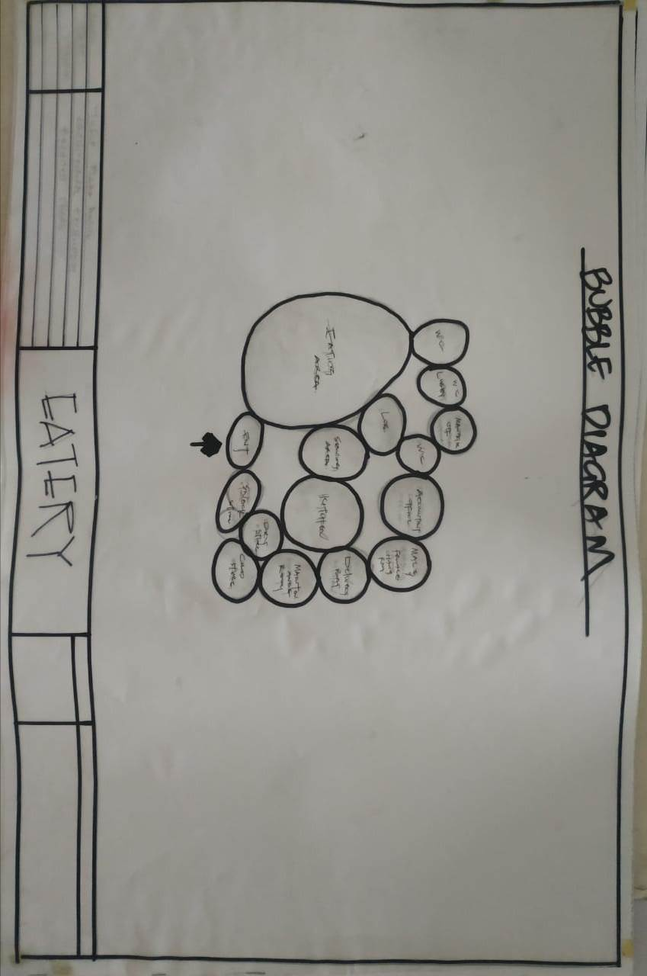

FIG 5.1 BUBBLE PLAN

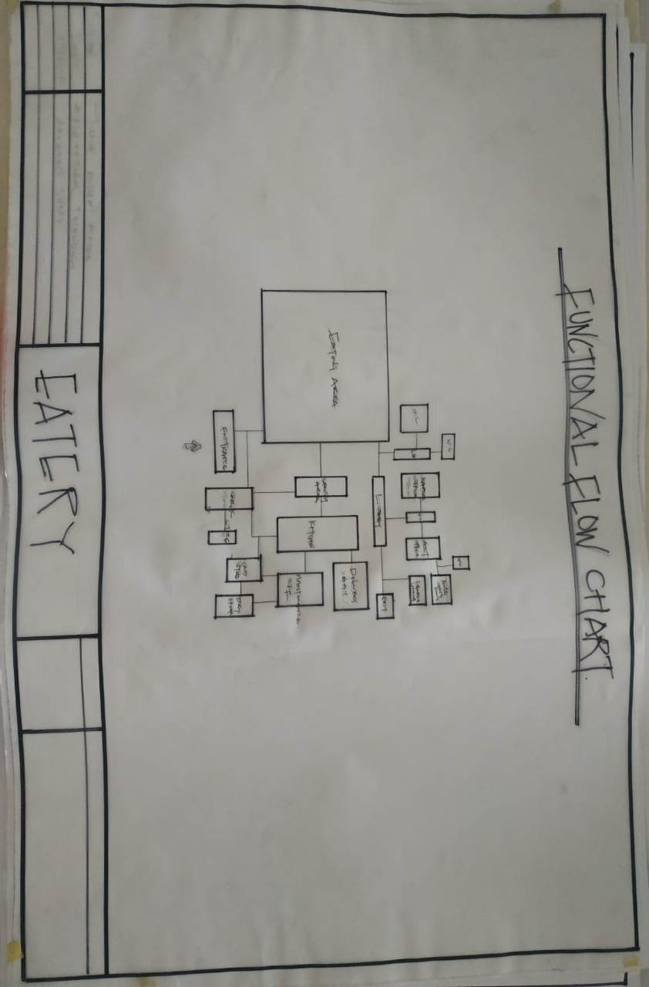

FIG 5.2 FLOW CHART PLAN

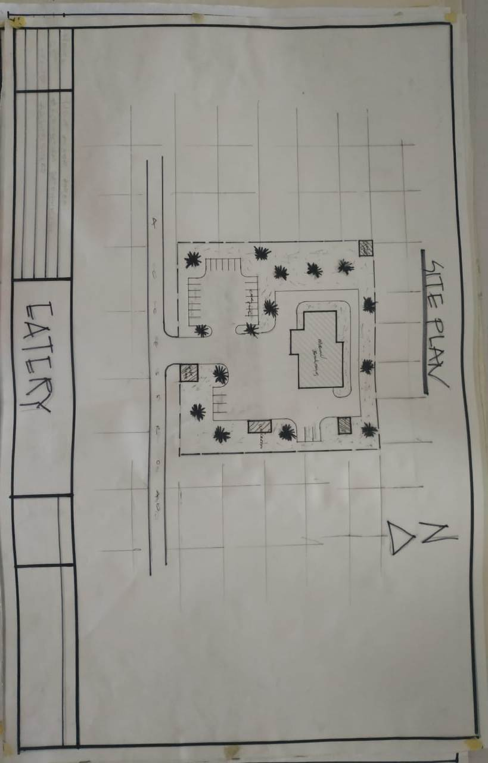

FIG 5.3 SITE PLAN

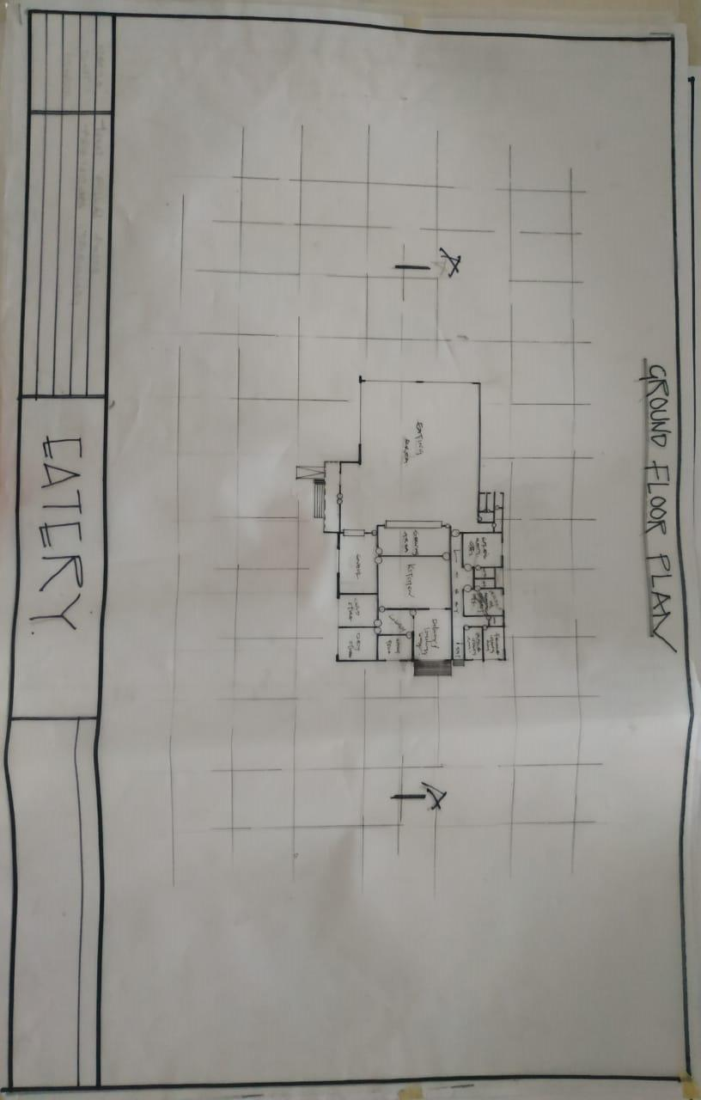

FIG 5.4 GROUND FLOOR PLAN
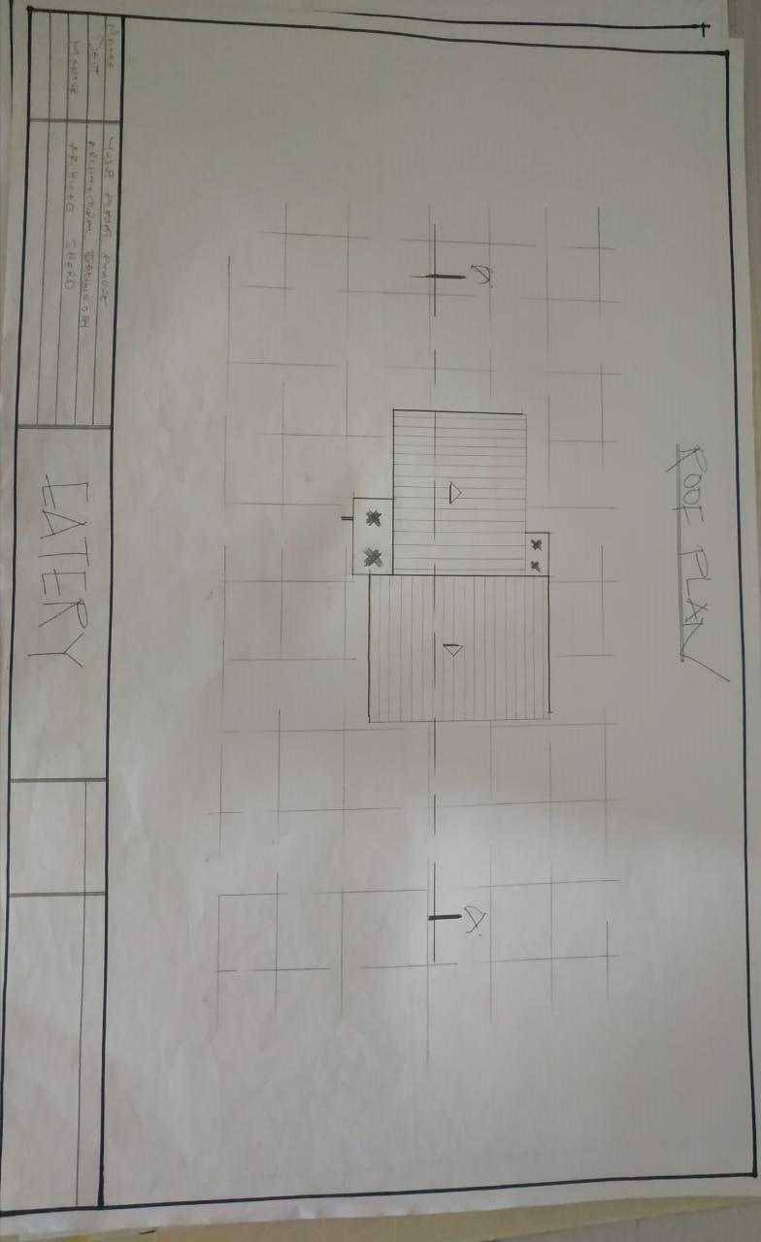

FIG 5.5 ROOF PLAN
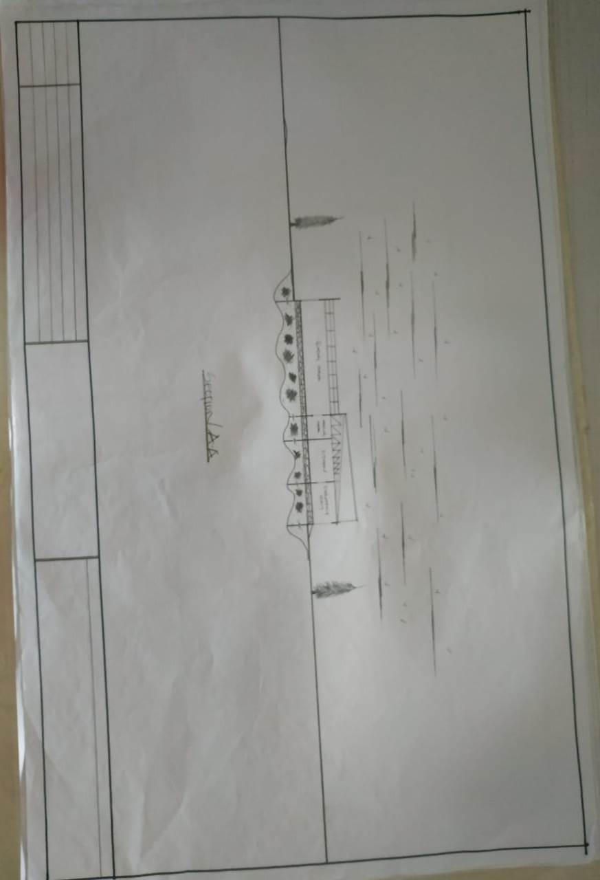

FIG 5.6 SECTION
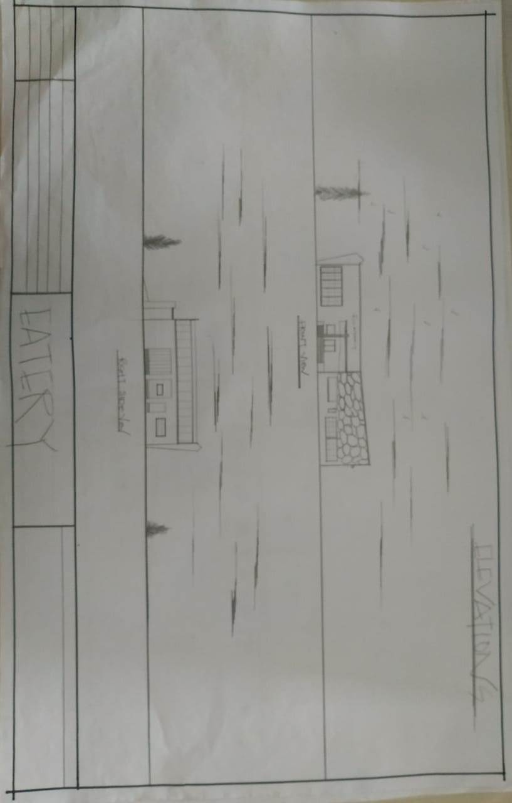

FIG 5.7 ELEVATIONS

