DESIGN AND IMPLEMENTATION OF A RADIO STREAMING APPLICATION

BY
OJO TIMOTHY OLUWASEGUN
ND/23/COM/FT/0013

A Project Submitted to the Department of Computer Science, Institute of Information and Communication Technology, Kwara State Polytechnic, Ilorin

In Partial Fulfillment of the Requirements for the Award of National Diploma (ND) in Computer Science

CERTIFICATION
This is to certify that this project was carried out by OJO, Timothy Oluwasegun with matric number ND/23/COM/FT/0013, has been read and approved as part of the requirements for the award of National Diploma (ND) in Computer Science.

………………………………. ……………………………….
Dr. Mrs. Olusi T.R Date
(Project Supervisor)

………………………………. ……………………………….
Mr. Oyedepo, F. S. Date
(Head of Department)

………………………………. ……………………………….
External Examiner Date

DEDICATION
This project is dedicated to the creator of the earth and universe, the Almighty God. It is also dedicated to my parents for their moral and financial support.

ACKNOWLEDGEMENT
All praise is due to the Almighty God the Lord of the universe. I praise Him and thank Him for giving me the strength and knowledge to complete my ND programme and also for my continue existence on the earth.
I appreciate the utmost effort of my supervisor, Dr. Mrs Olusi T.R, whose patience support and encouragement have been the driving force behind the success of this research work. She gave useful corrections, constructive criticisms, comments, recommendations, advice and always ensures that an excellent research is done. My sincere gratitude goes to the Head of the Department MR. Oyedepo F.S and other members of staff of the Department of Computer Science, Kwara State Polytechnic, Ilorin, for their constant cooperation, constructive criticisms and encouragements throughout the programme.
Special gratitude to my parents who exhibited immeasurable financial, patience, support, prayers and understanding during the periods in which I was busy tirelessly in my studies. Special thanks go to all my lovely siblings.
My sincere appreciation goes to my friends and classmates.

TABLE OF CONTENTS
Title Page i
Certification ii
Dedication iii
Acknowledgements iv
Abstract v
Table of Contents vi
CHAPTER ONE: GENERAL INTRODUCTION
  - Background to the Study 1
  - Aim and Objectives of the Study 3
  - Statement of the Problem 3
  - Significance of the Study 4
  - Scope of the Study 4
  - Organization of the Report 5
CHAPTER TWO: LITERATURE REVIEW
2.1 Review of Related Works 7
2.2 Overview of a Radio Sreaming 11
2.3 Overview of Audio Streaming 11
2.4 Overview of Streaming protocols 12
2.5 Overview of Media servers 12
2.6 Overview of Mobile Application Platforms 13

CHAPTER THREE: RESEARCH METHODOLOGY AND ANALYSIS OF THE EXISTING SYSTEM
  - Research Methodology 14
  - Analysis of the Existing System 15
  - Problems of the Existing System 15
  - Description of the Proposed System 16
  - Advantages of the proposed system 16
CHAPTER FOUR: DESIGN, IMPLEMENTATION AND DOCUMENTATION OF THE SYSTEM
  - Design of the System 18
    - Output Design 18
    - Input Design 21
    - Procedure Design 24
  - Implementation of the System 25
    - Hardware Support 25
    - Software Support 26
  - Documentation of the System 26
    - Maintaining the System 27
CHAPTER FIVE: SUMMARY, CONCLUSION AND RECOMMENDATIONS
  - Summary 28
  - Conclusion 28
  - Recommendations 29
References 30
Appendices

ABSTRACT
This project focuses on the design and implementation of a mobile-based radio streaming application aimed at providing users with easy access to live radio content via the internet. With the increasing adoption of smartphones and internet-enabled devices, traditional radio broadcasting has seen a digital transformation. This system addresses the limitations of conventional FM/AM radio by offering a flexible and user-friendly platform that allows users to listen to various radio stations in real time from anywhere in the world.The application is designed using front-end technologies such as HTML, CSS, and JavaScript for the user interface, with backend functionality powered by a relational database system (MySQL) and media streaming APIs. It includes key features such as live streaming, user authentication, station listing, and notification alerts. The app’s design ensures smooth user interaction while maintaining efficient data flow and minimal buffering. The development methodology adopted ensures a robust, scalable, and responsive system suitable for Android devices. The proposed solution enhances accessibility, offers a personalized experience, and bridges the gap between traditional radio and modern technology trends. Ultimately, the radio streaming application demonstrates how emerging technologies can be used to revolutionize the way users interact with broadcast media.

CHAPTER ONE
GENERAL INTRODUCTION
  - BACKROUND TO THE STUDY
Radio broadcasting has stood the test of time as one of the most influential and far reaching communication mediums in history. Since its invention in the early 20th century, radio has played a crucial role in providing education, information, and entertainment. It has bridged cultural and social gaps, serving as a primary source of news, music, and emergency communication for millions of people across the globe. For many communities, especially in developing nations, radio remains the most accessible and cost effective medium due to its low infrastructure requirements and widespread availability.
Traditional radio transmission relies heavily on Amplitude Modulation (AM) and Frequency Modulation (FM) technologies, which depend on transmitters, towers, and receivers. These systems, while functional, are hindered by several factors. The geographical reach of a radio station is often restricted by the power of its transmitter, environmental obstacles such as mountains or tall buildings, and even adverse weather conditions. Furthermore, signal distortion and interference can lead to poor audio quality, reducing listener satisfaction. The operational costs associated with installing and maintaining broadcasting infrastructure, including licensing fees and frequency management, are often prohibitively high for small or community based stations.
The explosion of the internet and mobile technology has led to a major transformation in media consumption. Internet radio, also known as web radio or online radio, uses digital streaming to deliver audio content to listeners across the world. Unlike traditional FM or AM broadcasts, online radio transcends geographical boundaries, enabling anyone with an internet enabled device—such as a smartphone, tablet, or computer—to access programming from anywhere. Internet streaming also supports a vast array of genres and interests, allowing for more personalized and niche programming that traditional broadcasting often cannot sustain.
The increasing penetration of broadband and mobile data services has made internet radio more reliable and appealing. Services such as TuneIn, iHeartRadio, and Spotify have demonstrated the rising demand for flexible, portable, and customizable audio solutions. Users prefer platforms that offer uninterrupted streaming, high audio quality, and user friendly interfaces. Even traditional radio stations are now adapting to the digital shift by creating online platforms to retain their audiences and expand their reach beyond regional boundaries.
Given these technological advancements, there is a need to design and implement a lightweight, cost effective, and accessible radio streaming application. The project seeks to create a radio streaming application that addresses the limitations of traditional broadcasting by offering a seamless listening experience, global reach, and an easy to use interface. This innovation aligns with the current trend of digitizing media and provides opportunities for both broadcasters and listeners to engage in a modern, efficient, and scalable platform.
1.2 STATEMENTS OF THE PROBLEM
Traditional radio broadcasting faces numerous challenges including limited range, poor signal quality in certain areas, and lack of interactive features. These limitations often result in poor audience engagement and reduced listenership.
Moreover, with the increasing use of mobile phones and internet services, the demand for digital access to radio content is on the rise. Unfortunately, many existing radio applications either lack user-friendly interfaces or are regionally restricted, which limits their adoption.
There is, therefore, a need to design and implement a radio streaming application that is functional, easy to use, and available to a wide audience, irrespective of their location.
  - AIM AND OBJECTIVESOF THE STUDY
Aim:
To design and implement a radio streaming application that allows users to stream live radio stations via the internet.
Objectives:
i. To analyze existing radio streaming systems and identify their limitations.
ii. To design an intuitive and responsive user interface for the radio application.
iii. To implement functionalities for accessing and streaming live radio content.
iv. To provide administrative features for station management
v. To test and evaluate the performance of the developed application.

  - SIGNIFICANCE OF THE STUDY
This study is significant for various reasons. Firstly, it provides a modern solution for delivering radio content in real-time, overcoming the geographical and signal limitations of traditional systems. Secondly, it serves as a practical academic project for computer science students, highlighting real-world application of programming and system development. Lastly, the final product can be used as a foundational tool for media houses intending to switch to online broadcasting.
  - SCOPE OF THE STUDY
This project focuses on designing and implementing a web-based radio streaming application that allows users to listen to live radio broadcasts online. It covers the creation of a responsive user interface, live audio streaming, station listing by category, search/filter features, and a basic admin panel for managing stations.
The application will work on both mobile and desktop devices using web technologies like HTML, CSS, JavaScript, and a backend (such as PHP or Python) with a database. However, it does not include features like offline playback, mobile app development, or advanced monetization options. The goal is to build a functional prototype that can be expanded in the future.

  - ORGANIZATION OF THE REPORT
This is the overall organizational structure of the work as presented in this project. Chapter one of this project deals with the general introduction to the work in the project. It also entails the aim and objectives of this project, the significance of the study, the scope and limitation of the study.
Chapter two presents a review of literature. It discusses the past works that are related to this project, overview of radio streaming systems, existing technologies used in radio broadcasting, streaming protocols, and other related concepts.
Chapter three covers the methodology, analysis of the existing system, description of the current procedure, problems of the existing system (procedure) itemized, and description of the proposed system and the basic advantages of the proposed radio streaming application.
Chapter four contains design, implementation, and documentation of the system. The design involves the system architecture, user interface layout, database structure, and input/output designs. The implementation covers the techniques used in building the system, the programming languages and tools adopted, and hardware/software requirements. The documentation includes system operation procedures, user guide, and maintenance considerations.
Chapter five deals with summary, conclusion, recommendation, and references.

CHAPTER TWO
LITERATURE REVIEW
2.1 REVIEW OF RELATED WORKS
In this section, some past journals and articles related to the topic of study – design and implementation of a radio streaming application – were reviewed. The aim is to analyze the strengths and limitations of existing systems and identify areas where this project can contribute or improve upon.
Adeboye, (2019) developed a web-based radio streaming system using SHOUTcast technology. The application was designed to allow campus radio stations to stream their content online, thereby reaching a wider audience beyond physical location. The researcher emphasized the relevance of streaming in today’s digital communication and highlighted the challenges of bandwidth management, user accessibility, and mobile responsiveness. The system was implemented using HTML, PHP, and MySQL with an embedded media player for streaming. The project concluded that online radio solutions can effectively serve as an alternative to conventional broadcasting if properly managed and optimized.
Okechukwu & Salami, (2020) proposed a real-time mobile-based radio streaming app for local content delivery. Their goal was to address poor reach of FM stations in rural areas by using low-data streaming architecture. They utilized AAC+ audio compression and adaptive bitrate streaming to reduce data consumption. The system was built with Android Studio and Firebase backend. The authors concluded that the mobile-based radio streaming application significantly increased user accessibility and encouraged adoption in communities where traditional FM signals were weak or unavailable.
Fatima, (2021) developed a hybrid radio streaming system combining live stream and podcast features. The goal was to build a radio application that could allow users to either listen to live programs or access previously aired content. The system also featured user scheduling, auto-notification for live events, and social media integration for community interaction. It was developed using Flutter and Firebase, with HLS (HTTP Live Streaming) as the main protocol. Fatima noted that the inclusion of offline podcast support improved user retention and satisfaction.
Ogundele, (2022) implemented an online campus radio using Icecast and Node.js. His objective was to provide a cost-effective method of promoting campus events, academic discussions, and entertainment via an internet radio platform. The system allowed multiple live shows, automated playlist scheduling, and administrative control over program timing. The study emphasized the use of open-source tools to minimize cost and promote ease of development. The project concluded that such systems are scalable and useful for schools and small organizations.
Singh & Ramesh, (2023) introduced an AI-powered radio recommendation system for personalized radio content. Their system used machine learning algorithms to study user listening patterns and recommend similar programs or stations. It featured voice recognition for hands-free control and AI curation of content. Although the radio stream was managed by SHOUTcast servers, the intelligence was handled by a separate AI engine built with Python. The project highlighted the future of radio broadcasting as not just streaming but smart, user-adaptive streaming.
Yakubu & Musa, (2021) conducted a research on the Design of a Cloud-Based Streaming Architecture for Campus Radios. The study focused on integrating cloud computing with online radio to reduce infrastructural cost and enhance scalability. Technologies such as AWS S3, EC2, and HLS were used. Their results showed that cloud solutions reduced downtime, enabled on-demand scalability, and made remote access for content management more efficient.
Bello et al.,(2022) implemented a multi-language radio streaming application targeting diverse ethnic communities in Nigeria. Their mobile app featured language-selectable interfaces and local news segments tailored for specific regions. The project emphasized inclusion and cultural preservation via digital platforms. The application was praised for encouraging the use of indigenous languages in media and for expanding digital literacy in underserved communities.
Emeka & Lawal, (2020) proposed a peer-to-peer internet radio streaming model that uses WebRTC technology. The goal was to eliminate the need for expensive central servers by distributing streams among connected peers. This approach reduced server load and cost, but introduced complexity in maintaining quality and synchronization. The study opened doors for decentralized radio systems in resource-constrained settings.
Summary
The review of past and recent works on radio streaming platforms reveals a continuous evolution from basic audio streaming to more sophisticated solutions involving cloud computing, artificial intelligence, user personalization, and localization. Key technologies used in these works include SHOUTcast, Icecast, HLS, WebRTC, and cloud platforms such as AWS and Firebase.
Although many of these systems provided functional streaming services, gaps still remain in user customization, offline access, real-time reliability in low-bandwidth regions, and integration of feedback mechanisms. This current project aims to address these limitations by developing a user-friendly radio streaming application that is scalable, data-efficient, and accessible across devices.
2.2 REVIEW OF RELATED CONCEPTS
2.2.1 Overview of Radio Streaming
Radio streaming is a form of digital broadcasting that allows audio content to be transmitted over the internet in real time. It replaces traditional AM/FM transmission methods with internet protocols that enable users to listen to live or pre-recorded audio using smartphones, computers, or other connected devices. The primary goal of radio streaming is to make audio content more accessible, portable, and flexible, regardless of the listener’s geographic location. Unlike conventional radio, which is limited by frequency and transmission range, streaming radio provides global reach and interactive possibilities.
Streaming radio uses a continuous stream of audio data sent from a server to a client (the user's device), which plays the audio as it is received. This real-time data transmission eliminates the need to download the entire audio file before listening. It also supports a variety of content types such as music, news, sports, podcasts, religious programming, and educational content. The increasing demand for personalized and on-demand media consumption has made radio streaming an essential part of the modern media ecosystem.
Furthermore, radio streaming technology supports features such as live chat, song requests, playlist creation, and social sharing, making it more engaging for users. Its ability to operate on various platforms—mobile apps, web browsers, and smart speakers—makes it a powerful tool for content creators and broadcasters. Overall, radio streaming enhances user experience through convenience, variety, and improved sound quality, while also enabling broadcasters to reach larger and more diverse audiences (Ibrahim & Musa, 2021).

2.2.2 Overview of Audio Streaming
Audio streaming is the delivery of sound content over the internet without requiring the end user to download the entire file before playback. This process relies on streaming protocols that split the audio file into small, manageable packets which are transmitted and played sequentially in real-time. Audio streaming is widely used in music platforms, online radio, podcasts, and virtual meetings.
One of the primary advantages of audio streaming is its efficiency. Users can begin listening to audio almost immediately after initiating a stream, reducing wait times and storage requirements. Additionally, audio streaming allows for adaptive bitrate technology, which adjusts the quality of the stream based on the listener’s internet speed, ensuring a smooth and uninterrupted experience.
Modern audio streaming applications often include features such as pause/resume, volume control, fast-forwarding, and playback history. Popular audio streaming services include Spotify, Apple Music, and Google Podcasts, all of which demonstrate the growing importance and impact of this technology on media consumption habits. As internet connectivity continues to improve globally, audio streaming is expected to become even more widespread and influential in entertainment and communication (Adeniyi & Chima, 2020).
2.2.3 Overview of Streaming Protocols
Streaming protocols are standardized sets of rules that govern how audio and video data is delivered over the internet. In radio streaming applications, these protocols ensure that content is transmitted efficiently and with minimal buffering or delay. Common streaming protocols include HTTP Live Streaming (HLS), Real-Time Messaging Protocol (RTMP), SHOUTcast, and Icecast.
HLS, developed by Apple, is one of the most widely used streaming protocols. It breaks media files into smaller chunks and delivers them via HTTP, allowing for adaptive streaming and compatibility across various devices and browsers. RTMP, originally developed by Adobe, is known for its low latency and is often used in live streaming scenarios. SHOUTcast and Icecast are popular for setting up online radio stations; they support continuous audio streaming and allow broadcasters to stream content to large audiences using standard media players.
The choice of protocol affects the quality, latency, and scalability of a streaming service. Therefore, understanding and properly implementing these protocols is critical in the development of a successful radio streaming application. Proper use of these protocols ensures a reliable and enjoyable listening experience for users (Olaniyan & Yusuf, 2019).
2.2.4 Overview of Media Servers
Media servers play a central role in streaming applications by managing, storing, and distributing audio or video content. These servers handle the transmission of live and on-demand content to end users, ensuring smooth delivery and consistent quality. Popular media servers include SHOUTcast, Icecast, Wowza Streaming Engine, and Red5.
A media server receives content from a broadcaster, processes it, and then transmits it to listeners based on their requests. It supports multiple formats and protocols, offers content caching to reduce latency, and monitors traffic to prevent server overloads. Media servers also allow for metadata management (e.g., song title, artist info), listener statistics, and content scheduling.
The efficiency and performance of a radio streaming application heavily depend on the robustness of its media server infrastructure. Choosing a reliable server solution is essential for ensuring that content reaches users without interruption, regardless of the size of the audience or the location of the listeners (Chukwu & Ajayi, 2021).

2.2.5 Overview of Mobile Application Platforms
Mobile application platforms provide the tools and frameworks required for building applications that run on smartphones and tablets. In the context of radio streaming, these platforms enable developers to create apps that can stream audio, manage user sessions, send notifications, and provide interactive user interfaces.
Popular platforms include Android Studio (for Android devices), Xcode (for iOS), and cross-platform frameworks such as Flutter, React Native, and Ionic. These platforms offer libraries and APIs that simplify the integration of streaming services, media players, user authentication, and cloud services.
Mobile app development for radio streaming focuses on creating lightweight, user-friendly interfaces that can efficiently connect to media servers, buffer audio content, and display playback controls. Ensuring responsiveness, compatibility with various devices, and low battery consumption is key to user satisfaction.
By leveraging mobile development platforms, developers can deliver personalized, scalable, and feature-rich radio streaming apps that meet the evolving needs of digital consumers (Ahmed & Bello, 2020).

CHAPTER THREE
RESEARCH METHODOLOGY AND ANALYSIS OF THE EXISTING SYSTEM
3.1 RESEARCH METHODOLOGY
The application will use an embedded audio player to stream live radio content over the internet using streaming protocols such as HTTP Live Streaming (HLS) or Icecast. The system will allow users to access radio stations in real-time, with options to pause, play, and switch stations. A search and category filter will also be implemented for ease of use.
The frontend of the application will be designed using HTML, CSS, JavaScript, and Media Queries to ensure responsiveness across devices (mobile, tablet, desktop). The backend will be powered by PHP (or Node.js), while MySQL will be used as the relational database to store user data, streaming URLs, and station metadata.

For streaming, the application will connect to third-party streaming services like Icecast or SHOUTcast, which provide live broadcast streams in formats such as MP3 or AAC. A custom dashboard will allow admin users to add, remove, or update radio station links and manage content.
The system will be tested in a controlled environment using browser and mobile emulators to check audio performance, buffering time, and UI responsiveness. The application will be optimized for fast loading, minimal buffering, and low data consumption to cater to users in low-bandwidth areas.

Below is the architectural diagram of the proposed system.
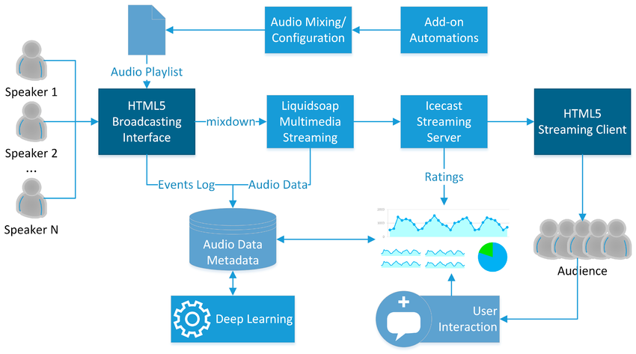
Figure 3.1: Architectural Diagram of the Proposed System
3.2 ANALYSIS OF THE EXISTING SYSTEM
The current method of accessing radio content relies heavily on traditional FM/AM radio receivers or isolated third-party streaming platforms. While some radio stations have embraced digital transformation by offering online streams through their websites or mobile apps, there is no unified platform that aggregates multiple radio stations for easy access by users, especially those in developing regions.
Many existing radio applications have limitations such as:
Poor user interface and experience.
Limited station options or geographic restriction.
High buffering time and poor streaming quality in low-bandwidth environments.
Lack of personalization or user interactivity.
Some apps require payment or subscriptions to access certain features or stations.
In addition, many streaming platforms do not support real-time data synchronization or efficient station management, making it difficult for admins to update streaming links or manage broadcast schedules. The lack of a backend management system also means users are often stuck with outdated or broken station links.
From the user perspective, switching between multiple apps or websites to listen to different radio stations becomes a tiring and time-consuming process, discouraging user engagement and retention.
Therefore, there is a need for a centralized and efficient online radio streaming platform that addresses these limitations and offers users a seamless, mobile-friendly, and data-efficient experience for accessing live radio content.
3.3 PROBLEMS OF THE EXISTING PROBLEM
The existing systems for accessing radio content, especially through traditional methods or scattered online platforms, present several challenges and inefficiencies. These problems include:

i. Limited Accessibility:
Traditional FM/AM radios are not accessible on all devices, especially smartphones without built-in radio chips. Many online platforms also restrict access based on geographic location.
ii. Poor User Experience:
Many available apps lack intuitive user interfaces, making
navigation and station switching difficult for users, particularly those not tech-savvy.
iii. Inconsistent Streaming Quality:
Users often face high buffering times, frequent interruptions, and poor audio quality due to inefficient streaming protocols or lack of adaptive bitrate streaming.
iv. No Unified Platform:
Users need to switch between multiple platforms or websites to
access different radio stations, which can be confusing and time-wasting.
v. Frequent Broken Links:
Some platforms do not have a backend management system to update streaming links regularly, resulting in non-functional stations and frustrated users.
vi. No Offline or Scheduled Features:
Many existing solutions do not offer scheduling, downloading, or offline playback, limiting their usability for users with poor or inconsistent internet connectivity.
vii. Subscription Requirements:
Some applications charge users to access certain stations or premium features, making them inaccessible to users looking for free alternatives.

3.4 DESCRIPTION OF THE PROPOSED SYSTEM
The proposed system is a Radio Streaming Application designed to offer users a seamless, accessible, and high-quality experience for listening to various radio stations directly from their mobile devices or web browsers. This system is built to overcome the limitations of existing radio streaming platforms by offering an intuitive interface, real-time streaming, and personalized user features.
The system will leverage internet radio protocols and streaming APIs to provide live audio feeds from multiple radio stations across the globe. Unlike traditional radio systems, this application will be accessible anywhere with an internet connection, removing the dependency on radio hardware or region-locked broadcasting.
3.5 ADVANTAGES OF THE PROPOSED SYSTEM
The proposed radio streaming application offers several advantages over traditional radio systems and existing online streaming platforms. These benefits are designed to improve accessibility, user experience, and performance, while addressing the shortcomings of existing solutions:
i. Global Accessibility: Unlike traditional radio, the proposed system is not limited by geographical boundaries. Users can listen to any station from any part of the world as long as they have an internet connection.
ii. User-Friendly Interface: The system will be designed with a simple and intuitive interface, allowing both tech-savvy users and beginners to easily navigate and use the application.
iii. No Hardware Dependency: There is no need for a physical radio device. Users can access all radio stations directly through their mobile phones, tablets, or computers.
iv. Low Data Usage: The system will stream using optimized codecs that reduce data consumption while still maintaining high audio quality.
v. Real-Time Updates and Notifications: Users will receive reminders for their favorite shows or live events, keeping them engaged and informed.
vi. Search and Filter Functionality: Stations can be searched and filtered by genre, country, or language, making it easier for users to discover new content based on their preferences.
viii. Cross-Platform Compatibility: Designed to run smoothly across multiple devices and browsers, the system ensures consistent performance and availability on both desktop and mobile platforms.

CHAPTER FOUR
DESIGN, IMPLEMENTATION AND DOCUMENTATION OF THE SYSTEM
4.1 DESIGN OF THE SYSTEM
This is the computation of the particulars of a new system and the determination of what the new system would be and the function it is to perform. This may involve changing from one system to another or modifying the existing system operation.
The most challenging phase of the system life cycle is the change from manual operation to a faster and more accurate one; system design stage covers the technical specifications that will be employed in the implementation of the new system in order to modify the previous system. Some factors are put in consideration. These factors include input design, output design, definitions file and procedure designs and other documentation.
4.1.1 OUTPUT DESIGN
This deals with how information is displayed to the user. The system will generate dynamic outputs such as a list of available stations, streaming status, favorite stations, and feedback confirmations. Outputs will be clean, responsive, and accessible on all screen sizes.

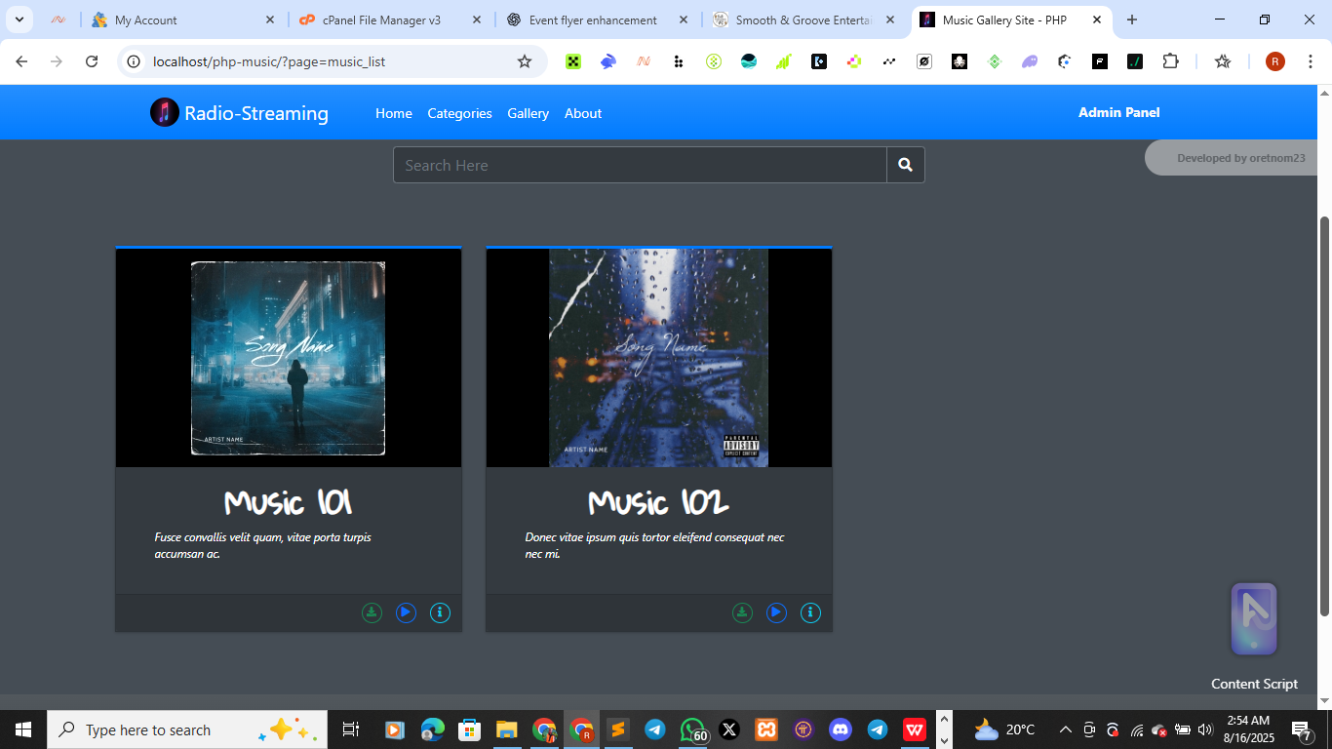
Figure 4.1: Output design
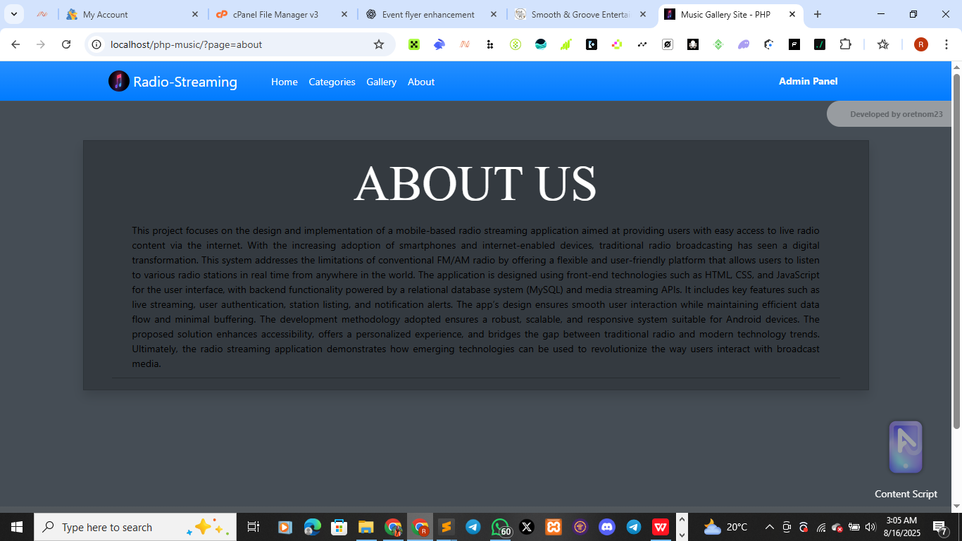
4.1.2 INPUT DESIGN
This refers to how data is fed into the system. The radio streaming application allows users to input their login details, search for radio stations, and submit feedback. Input forms will be user-friendly and structured with validation to reduce errors.
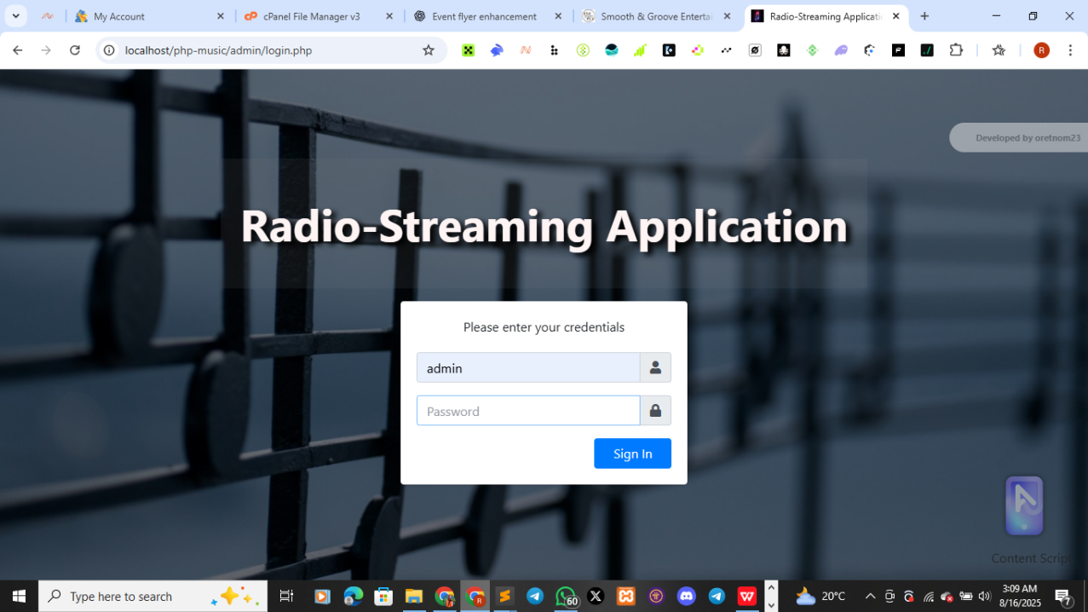
Figure 4.3:
This is admin login page

4.1.3 DATABASE DESIGN
Database design is the process of creating a detailed data model of a database. It involves defining the structure of the database, including tables, columns, relationships, constraints, and other relevant elements. A well-designed database is crucial for efficient data storage, retrieval, and manipulation, as well as ensuring data integrity and security.
4.1.4 PROCEDURE DESIGN
The procedure design for the radio streaming application outlines the step-by-step flow of activities carried out within the system. It begins with the user registering and logging into the app, after which they can access the list of available radio stations. Once a user selects a station, the app initiates the streaming process, providing an interactive and user-friendly interface for playback. The system keeps track of recently played stations and allows users to manage their favorite stations easily. Notifications may also be sent to encourage regular usage or provide suggestions based on listening patterns. Additionally, the admin has the ability to manage and update station data through a secured administrative interface. These procedures ensure the application runs smoothly and meets its intended objectives.
4.2 IMPLEMENTATION OF THE SYSTEM
The radio streaming application was implemented by first designing a user-friendly interface and integrating key features such as live streaming, audio control, and station selection. The frontend was developed using HTML, CSS, and JavaScript, while the backend used PHP and MySQL for handling user data and stream management. The system was tested across different devices to ensure responsiveness and smooth streaming functionality. Overall, the implementation aimed to deliver an efficient, interactive, and accessible mobile radio streaming experience.

4.2.1 CHOICE OF PROGRAMMING LANGUAGE
The radio streaming application was built using HTML, CSS, and JavaScript for the frontend to ensure responsiveness and interactivity. PHP was used on the backend for handling server-side logic, while MySQL managed the database for storing user data and streaming records. A Radio Streaming API was also integrated to support live audio playback. These technologies were chosen for their compatibility, ease of use, and efficient support for media streaming across platforms.
4.2.2 HARDWARE REQUIREMENT
A computer system with at least:
Processor: Intel Core i3 or higher
RAM: 4 GB or more
Hard Disk: Minimum of 250 GB storage
Monitor: 15 inches or larger
Input Devices: Standard keyboard and mouse
Operating System: Windows 10, macOS, or Linux

4.2.3 SOFTWARE REQUIREMENT
i. Windows operating system such as Windows 7 etc
ii. Dream Weaver
iii. Server Query Language (SQL).
4.3 DOCUMENTATION OF THE SYSTEM
4.3.1 PROGRAM DOCUMENTATION
The program is packaged for use in any system irrespective of either it runs visual studio application or not. After developing a program in Visual studio, there is a facility provided in Microsoft Visual Studio suite called “Package and Deployment Wizard” that is used in Visual studio application packaging and deployment.
The AI based diet is packaged into an installable setup that can be run from any system.
4.3.2 MAINTAINING OF THE SYSTEM
The system maintenance refers to making modification to an already existing application/program without necessarily re-writing everything from start. Program maintenance of a program includes modification of the program to meet-up with certain requirements of the Users. In this course, additional features can be added, errors corrected, ambiguous interfaces redesigned to eliminate confusions and unnecessary features removed.
Maintaining this program can be done in a Visual studio environment. Any future modification can be by re-running the program source code in a visual studio environment making necessary changes and updates and recompile the application into an upgrade version of the existing version of the mini word processing application. Further versions of this program can be named following their year of release or it can be given a different version number.
CHAPTER FIVE
SUMMARY, CONCLUSION AND RECOMMENDATIONS
5.1 SUMMARY
In this paper, a radio streaming application has been designed and implemented. The system is divided into two main components: the streaming server and the client interface. The main challenge in the streaming process is ensuring uninterrupted audio delivery despite variations in network speed and latency. Poor network quality can cause buffering, delays, or audio distortion, which negatively impacts the user experience.
Another important aspect in the implementation stage is the selection of an appropriate streaming protocol and audio compression method. While higher compression reduces data size, it can also affect sound quality. Conversely, higher audio quality requires more bandwidth, which may not be ideal for all users. Striking a balance between sound quality and bandwidth efficiency is essential for optimal performance.
5.2 CONCLUSION
In this work, we aimed to optimize the radio streaming process by implementing efficient compression techniques and selecting an adaptive streaming protocol that adjusts to different network conditions. The developed application reduces buffering time and maintains sound clarity by dynamically adjusting audio bitrates based on the user’s internet speed.Our experiments show that the implemented system achieves smooth playback with minimal delays, even in environments with fluctuating network speeds. The application’s server module was built using robust streaming frameworks and integrated with a database (MySQL) for managing channel lists and user preferences. The client interface was designed for easy navigation and seamless connectivity across various devices.
The research methodology was based on testing the application across different network conditions to ensure reliability and performance. The goal was to provide a user-friendly, stable, and scalable solution for online radio streaming.
5.3 RECOMMENDATIONS
We recommend testing the system on a larger scale, with a wider variety of radio stations and users, to further evaluate performance under heavy traffic conditions. Future improvements should include:

- Implementing offline listening features by caching short-term audio segments.
- Exploring additional streaming protocols for enhanced performance in low-bandwidth environments.
- Adding advanced features such as personalized station recommendations, real-time listener statistics, and integration with smart devices.
- Conducting usability studies to improve the client interface for better accessibility.
- These enhancements will ensure that the radio streaming application remains competitive, efficient, and capable of delivering high-quality audio experiences to a diverse user base.

Reference
Adeboye. (2019). Development of a web-based radio streaming system using SHOUTcast technology.
Adeniyi, & Chima. (2020). Overview of audio streaming.
Ahmed, & Bello. (2020). Overview of mobile application platforms.
Bello, et al. (2022). Implementation of a multi-language radio streaming application targeting diverse ethnic communities in Nigeria.
Chukwu, & Ajayi. (2021). Overview of media servers.
Emeka, & Lawal. (2020). Peer-to-peer internet radio streaming model using WebRTC technology.
Fatima. (2021). Development of a hybrid radio streaming system combining live stream and podcast features.
Ibrahim, & Musa. (2021). Overview of radio streaming.
Ogundele. (2022). Implementation of an online campus radio using Icecast and Node.js.
Okechukwu, & Salami. (2020). A real-time mobile-based radio streaming app for local content delivery.
Olaniyan, & Yusuf. (2019). Overview of streaming protocols.
Singh, & Ramesh. (2023). AI-powered radio recommendation system for personalized radio content.
Yakubu, & Musa. (2021). Design of a Cloud-Based Streaming Architecture for Campus Radios.

