DEVELOPMENT OF A PROTOTYPE SOLAR AUTOMATED COCOA SEED
DRYER (Theoboma cacao)
BY;
ADEBAYO LUWASEYI MICHAEL
ND/23/ABE/FT/0024

DEPARTMENT OF AGRICULTURAL AND BIO – ENVIRONMENTAL

ENGINEERING, INSTITUTE OF TECHNOLOGY, KWARA STATE
POLYTECHNIC, ILORIN

INPARITAL FULFILLMENT OF REQUIREMENT FOR THE AWARD OF NATIONAL DIPLOMA (ND) IN AGRICULTURAL AND BIO- ENVIRONMENTAL ENGINEERING TECHNOLOGY.

SUPERVISE BY:
ENG. OYEBANRE.O.D

CERTIFICATION
This is to certify that this project has been read and approved as meeting the requirement of the Department of Agricultural and Bio-Environmental Engineering Technology, Institute of Technology, Kwara State Polytechnic, Ilorin for the award of National Diploma in Agricultural and Bio-Environmental Engineering Technology.
______________________ _________________
ENGR. OYEBANRE O.D DATE Project Supervisor

______________________ _________________
ENGR. OYEBANRE O.D DATE Project Coordinator
______________________ ___________________
ENGR. ABDULQUADRI DAUDA DATE Head of Department
______________________ ___________________
ENGR. DR. MRS. YUSUF R.O DATE
External Examiner

DEDICATION
This project is dedicated to Almighty God God the most Beneficient, the Most merciful.

ACKNOWLEDGEMENT
All adoration and glory are due to the Almighty for His Love, guidance and protection. I thank him for the perfect health, wisdom, knowledge, strength and opportunity to complete this stage of Academic (National Diploma) in peace.
My Profound gratitude goes to my amiable supervisor ENGR. Oyebanre O.D, thanks so much for your support and care throughout the supervision of this research work, also to my good H.O.D Mr. Oyedepo and to all the entire staff of the Institute of Information and Communication Technology.
Finally, I express my gratitude to my parents Mr.& Mrs. Adebayo and my beloved siblings , friends and loved ones who supported us in one way or the other.

TABLE OF CONTENT
Title Page i
Certification ii
Dedication iii
Acknowledgement iv
Table of Contents v
Abstract vii
CHAPTER ONE: INTRODUCTION
1.1 Background to the Study 1
1.2 Problem statement of the Study 2
1.3 Aim and Objectives of the Study 2
1.4 Scope of the Study 2
1.5 Justification of the Study 2
CHAPTER TWO
2.1 Introduction to Automated Solar Cocoa Seed Dryers 3
2.1.1 Importance of Efficient Drying 3
2.1.2 Benefits of Automated Solar Dryers 3
2.1.3 Challenges in Cocoa Drying 3
2.1.4 Future Directions 4
2.2 Design Considerations for Automated Solar Cocoa Seed Dryers 4
2.2.1 Solar Collector Design 4
2.2.2 Drying Chamber Design 4
2.2.3 Automation and Control Systems 5
2.2.4 Energy Storage Options 5
2.3 System Components of Automated Solar Cocoa Seed Dryers 5
2.3.1 Design Considerations 6
2.3.2 Benefits of Automated Solar Cocoa Seed Dryers 7
2.4 Automation and Control Strategies in Solar Dryers 7
2.4.1 Types of Automation and Control Strategies 7
2.4.2 Benefits of Automation and Control Strategies 8
2.4.3 Examples of Automation and Control Systems 8
2.5 Implementation and Testing of Automated Solar Cocoa Seed Dryers 8
2.5.1 Prototype Development 8
2.5.2 Performance Testing 9
2.5.3 Optimization 9
2.5.4 Benefits of Automated Solar Dryers 9
2.5.6 Challenges and Limitations 9

CHAPTER THREE: Materials and Methods
3.1 Design Considerations 10
3.2 Description of the Hybrid Dryer 10
3.2.1 Collector 11
3.2.2 Drying Chamber 11
3.2.3 Trays 12
3.2.4 Fans 13
3.2.5 Frame 13
3.2.6 Monitoring equipment 14
3.2.7 Hinges and lock 15
3.2.8 Solar Battery 15
3.2.9 Solar Panel 15
3.2.10 Charge controller 16
3.3 Hybrid Dryer Parts Design 16
3.4 Moisture Content 19
3.5 The Mass of water evaporated or moisture loss 19
3.6 Average Drying Rate 20
3.7 Principle of Operation of the Hybrid Dryer 21
3.8 Experimental procedure 21
3.9 Material used for construction of Solar Dryer 23
3.10 Tools and Equipment 26
3.11 Design Layout 29

CHAPTER FOUR: Results and Discussion
4.1 Result 32
4.2 Discussion 33

CHAPTER FIVE: Conclusion and Recommendation
5.1 Conclusion 37
5.2 Recommendation 37
References 38

ABSTRACT
This research focused on the development and evaluation of a prototype solar automated cocoa seed dryer designed to enhance the drying process of Theobroma cacao seeds. The study aimed to fabricate a solar-powered drying system integrating key components such as a collector, fan, monitoring equipment, solar panel, drying chamber, frame, and trays, with structural elements welded using an electric arc welding machine for durability and integrity.
Experimental trials were conducted varying sample mass (1000–3000 g) and air flow rate (0.4–0.6 kg/h) to assess the drying rate and drying efficiency of cocoa seeds under controlled solar drying conditions. Results demonstrated significant effects of both mass of sample and air flow rate on drying performance, with drying rates ranging from 0.024 to 0.042 kg/h and drying efficiencies between 78.3% and 96.3%. Statistical analysis using ANOVA highlighted the significance of the model (p < 0.0001) in influencing drying rate and efficiency, with no significant lack of fit, confirming the reliability of the experimental design. The optimized conditions suggested that lower mass and moderate air flow improved drying efficiency, thereby expediting the drying process while preserving seed quality. This prototype offers a sustainable alternative to conventional drying methods by harnessing solar energy, potentially reducing post-harvest losses and enhancing cocoa production efficiency in regions with abundant solar resources.

CHAPTER ONE

1.0 INTRODUCTION

1.1 Background to the study
Traditional drying methods, such as sun drying, have several limitations, including weather dependence, labor intensity, and difficulty in controlling quality (Kalogirou, 2014) .Drying is a critical step in cocoa production, reducing moisture content and preventing mold growth. Proper drying techniques are essential to maintain bean quality and meet international standards. Traditional drying methods, such as sun drying, have several limitations, including weather dependence, labor intensity, and difficulty in controlling quality (Kalogirou, 2014). Cocoa beans are a vital commodity for many countries, particularly in West Africa, where they are a major source of income for farmers. However, the drying process of cocoa beans is a critical step in preserving their quality and preventing spoilage. Traditional drying methods, such as sun drying, are often labor-intensive and weather-dependent, making them less reliable (Hii et al., 2012)
Automated solar dryers offer a promising solution to these challenges by providing a controlled drying environment that can optimize the drying process and improve product quality. However, traditional drying methods often result in inconsistent product quality and can be time-consuming. Automated solar dryers can provide several benefits over traditional drying methods, including improved efficiency, reduced labor requirements, and enhanced product quality (Kumar et al., 2016).
Cocoa beans are a vital agricultural commodity, serving as the raw material for chocolate production. Ensuring the quality and safety of cocoa beans during drying and storage is crucial to meet the demands of both local and international markets (Hii et al., 2012)

Automated solar drying systems offer a potential solution to these challenges. These systems can provide consistent drying conditions, reduce labor requirements, and improve drying efficiency.
By leveraging solar energy, these systems can also reduce energy costs and environmental impact ³.solar drying systems can significantly improve drying efficiency and reduce drying times. For example, a study on the optimization of direct solar drying for cocoa beans using artificial intelligence found that the system can improve efficiency compared to conventional methods ¹.These dryers can also reduce the risk of contamination and spoilage, resulting in higher-quality products.

1.2 Problem statement of the study
Cocoa seed drying, a critical step in cocoa processing, is often hindered by unreliable and inefficient traditional drying methods, resulting in poor quality cocoa beans, reduced yields, and economic losses for small-scale cocoa farmers, thereby necessitating the development of a sustainable and energy-efficient drying solution."

1.3 Aim and objectives of the study
The main aim the project is to design and develop an innovative solar –powered cocoa seed with automated temperature control and battery backup While:

Specific Objective
This study objectives are to evaluate the quality of cocoa beans after continuous drying, investigate the effects of continuous drying on cocoa's physical, chemical, and sensory properties, and identify the optimal continuous drying conditions for maintaining highquality cocoa beans.

1.4 Scope of the study
The scope of this study is to design and develop a solar-powered cocoa seed dryer with temperature control and battery backup, and to evaluate its performance in terms of drying time, energy efficiency, and cocoa seed quality. The study will focus on small scale cocoa farmers and will investigate the economic viability of the solar-powered dryer.

1.5 Justification of the study
The justification for this study is multifaceted, driven by the need to improve cocoa quality, address energy poverty, enhance sustainability, support small-scale farmers, and fill a knowledge gap in the use of solar-powered dryers in cocoa production, ultimately contributing to the development of a reliable and efficient solar-powered cocoa seed dryer with temperature control and battery backup.

2.0 CHAPTER TWO

2.1 Introduction to Automated Solar Cocoa Seed Dryers
Cocoa tree beans (Theobroma cacao L.) are the main raw material for the manufacture of chocolate, cocoa powder, and other cocoa products [Oracz, J.; et al 2020]. Cocoa drying is one of the stages of the post-harvest process; it consists of reducing the water content of the beans from approximately 55% to a range of 6.5 to 7% moisture, which is the desired limit that the beans must contain to avoid the growth of fungi and unpleasant aromas that deteriorate the quality and also to maintain adequate storage conditions, transport, handling, and marketing [Dubón, A.,et al 2016 ]. However, during this process, some structural or chemical changes may occur, which may affect the nutritional or organoleptic properties of the product.
Convective drying is the most commonly used process, and some studies have reported cell destruction that is proportional to the amount of moisture removed. There are other methods such as microwave and freeze-drying, among others, that have been studied, but these methods have presented several disadvantages, such as longer drying time and high energy consumption [Rashid, M.T.;et al 2019]. Some studies have been carried out on different food-type products involving convective drying and parameters such as specific energy consumption (SEC) and energy efficiency [Motevali, A.; et al 2016, Abbaspour-Gilandeh, Y.; et al 2021].

2.1.1 Importance of Efficient Drying
Efficient drying is crucial for maintaining the quality of cocoa beans. Moisture content must be reduced to safe levels to prevent mold growth and spoilage, which can lead to significant economic losses for farmers and processors (Hii et al., 2012) .Traditional drying methods, such as sun drying, are often labor-intensive and weather-dependent, making them less reliable. Automated solar dryers address these challenges by providing a controlled drying environment that can be optimized for specific conditions.

2.1.2 Benefits of Automated Solar Dryers
Automated solar dryers offer several benefits over traditional drying methods. They reduce the dependency on fossil fuels, lower operational costs, and minimize environmental impact (Kalogirou, 2014)]. Additionally, these dryers can improve the quality of the dried product by maintaining consistent temperatures and airflow, which is critical for preserving the flavor and nutritional value of cocoa beans.

2.1.3 Challenges in Cocoa Drying
Despite the benefits, there are challenges associated with drying cocoa beans, including the risk of over-drying or under-drying, which can affect the quality of the final product (Shanmugam & Natarajan, 2007).
Automated solar dryers can mitigate these risks by providing precise control over the drying process, ensuring that the cocoa beans are dried to the optimal moisture level.

2.1.4 Future Directions
The development of automated solar cocoa seed dryers is an area of ongoing research and innovation. Future directions may include the integration of advanced sensors and artificial intelligence to further optimize the drying process and improve energy efficiency (Kumar et al., 2016). Additionally, there is potential for these dryers to be adapted for use with other agricultural products, expanding their applicability and impact.

2.2 Design Considerations for Automated Solar Cocoa Seed Dryers
The design of automated solar cocoa seed dryers involves several critical considerations to ensure efficient and effective drying. These considerations include the type of solar collector, drying chamber design, automation and control systems, and energy storage options.

2.2.1 Solar Collector Design
The solar collector is a crucial component of a solar dryer, responsible for capturing solar radiation and converting it into heat energy. There are several types of solar collectors that can be used in solar dryers, including flat plate collectors, evacuated tube collectors, and concentrating collectors (Kalogirou, 2014). The choice of solar collector depends on the specific requirements of the drying application and the climate conditions.
Flat Plate Collectors: Flat plate collectors are commonly used in solar dryers due to their simplicity and effectiveness (Duffie & Beckman, 2013). They consist of a flat plate absorber that absorbs solar radiation and transfers the heat to a fluid, which is then used to heat the drying air.
Evacuated Tube Collectors: Evacuated tube collectors are more efficient and can operate at higher temperatures, making them suitable for applications that require higher drying temperatures (Kumar et al., 2016).

2.2.2 Drying Chamber Design
The drying chamber is another critical component of a solar dryer, responsible for holding the cocoa beans and allowing them to dry. The design of the drying chamber should ensure uniform airflow and temperature distribution, as well as adequate ventilation to remove moisture (Hii et al., 2012).
Size and Shape: The size and shape of the drying chamber can impact the performance of the solar dryer, with larger chambers accommodating more cocoa beans but requiring more energy to heat.
Materials: The materials used in the construction of the drying chamber should be durable, corrosion-resistant, and able to withstand the operating temperatures (Adebayo & Adeyemi, 2017).

2.2.3 Automation and Control Systems
Automation and control systems are essential components of an automated solar cocoa seed dryer, responsible for monitoring and controlling the drying process. These systems can include sensors to monitor temperature, humidity, and airflow, as well as actuators to control the drying conditions (Kumar et al., 2016).
Sensors and Actuators: The use of sensors and actuators can improve the efficiency and effectiveness of the drying process, reducing labor requirements and improving product quality.

2.2.4 Energy Storage Options
Energy storage options are important considerations in the design of automated solar cocoa seed dryers, as they can provide backup power during periods of low sunlight or at night. Batteries are a common energy storage option, but other options such as thermal energy storage and phase change materials can also be used (Duffie & Beckman, 2013)

2.3 System Components of Automated Solar Cocoa Seed Dryers
Automated solar cocoa seed dryers consist of several key components that work together to dry cocoa beans efficiently. These components include:

- Solar Collector
The solar collector is a critical component of a solar dryer, responsible for capturing solar radiation and converting it into heat energy. There are several types of solar collectors that can be used in solar dryers, including flat plate collectors, evacuated tube collectors, and concentrating collectors (Kalogirou, 2014)
- Drying Chamber
The drying chamber is designed to hold the cocoa beans and allow them to dry. It should be well-insulated to minimize heat losses and ensure uniform airflow. The drying chamber can be designed with multiple trays to increase the drying capacity (Hii et al., 2012).
- Fans and Airflow System
Fans and airflow systems are used to circulate hot air through the drying chamber, ensuring that the cocoa beans dry evenly. DC-powered fans are often used in solar dryers due to their energy efficiency (Kumar et al., 2016).
- Control and Monitoring System
The control and monitoring system is responsible for regulating the drying process and ensuring that the cocoa beans are dried to the optimal moisture level. This system can include sensors to monitor temperature, humidity, and airflow, as well as actuators to control the drying conditions (Shanmugam & Natarajan, 2007).

- Energy Storage System
An energy storage system, such as batteries, can be used to provide backup power during periods of low sunlight or at night. This ensures that the drying process can continue uninterrupted (Duffie & Beckman, 2013)

2.3.1 Design Considerations
When designing an automated solar cocoa seed dryer, several factors should be considered, including:
Climate and Weather Conditions: The design should take into account the local climate and weather conditions, including temperature, humidity, and solar radiation.
Drying Capacity: The drying capacity of the dryer should be sufficient to meet the needs of the user.
Energy Efficiency: The dryer should be designed to maximize energy efficiency and minimize energy losses.

2.3.2 Benefits of Automated Solar Cocoa Seed Dryers
Automated solar cocoa seed dryers offer several benefits, including:
Improved Drying Efficiency: Automated solar dryers can dry cocoa beans more efficiently than traditional drying methods.

Reduced Labor Requirements: Automated solar dryers can reduce labor requirements and improve productivity.
Improved Product Quality: Automated solar dryers can improve the quality of the dried product by maintaining consistent drying conditions.

2.4 Automation and Control Strategies in Solar Dryers
Automation and control strategies play a crucial role in optimizing the performance of solar dryers. By integrating sensors, microcontrollers, and other automation technologies, solar dryers can maintain optimal drying conditions, reduce energy consumption, and improve product quality.

2.4.1 Types of Automation and Control Strategies
There are several types of automation and control strategies that can be used in solar dryers, including:
Temperature Control: Temperature control is critical in solar dryers, as it directly affects the drying rate and product quality. Sensors can be used to monitor temperature levels, and microcontrollers can adjust the heating element or airflow to maintain optimal temperatures (Kalogirou, 2014)
Humidity Control: Humidity control is also important in solar dryers, as high humidity levels can lead to mold growth and spoilage. Sensors can be used to monitor humidity levels, and microcontrollers can adjust the airflow or heating element to maintain optimal humidity levels (Hii et al., 2012)
Airflow Control: Airflow control is essential in solar dryers, as it affects the drying rate and product quality. Sensors can be used to monitor airflow rates, and microcontrollers can adjust the fan speed to maintain optimal airflow rates (Kumar et al., 2016)

2.4.2 Benefits of Automation and Control Strategies
The benefits of automation and control strategies in solar dryers include:
Improved Product Quality: Automation and control strategies can help maintain optimal drying conditions, resulting in higher-quality products.
Increased Efficiency: Automation and control strategies can optimize energy consumption and reduce drying times, resulting in increased efficiency.
Reduced Labor Requirements: Automation and control strategies can reduce the need for manual monitoring and control, resulting in reduced labor requirements.

2.4.3 Examples of Automation and Control Systems
Several automation and control systems have been developed for solar dryers, including:
PID Controllers: PID (Proportional-Integral-Derivative) controllers are widely used in solar dryers to control temperature, humidity, and airflow rates.
Microcontrollers: Microcontrollers, such as Arduino and ATMEGA controllers, can be used to control solar dryers and monitor drying conditions.
IoT-based Systems: IoT-based systems can be used to remotely monitor and control solar dryers, providing real-time data and analytics.

2.5 Implementation and Testing of Automated Solar Cocoa Seed Dryers
The implementation and testing of automated solar cocoa seed dryers involve several critical steps to ensure the dryer operates efficiently and effectively. These steps include constructing a prototype, testing its performance, and optimizing its design based on the results.

2.5.1 Prototype Development
Developing a prototype of an automated solar cocoa seed dryer requires careful consideration of several factors, including the type of solar collector, drying chamber design, and automation and control systems (Kalogirou, 2014). The prototype should be designed to dry cocoa beans efficiently and effectively, while also being durable and easy to maintain.

2.5.2 Performance Testing
Performance testing is a critical step in the implementation of automated solar cocoa seed dryers. The testing should evaluate the dryer's ability to dry cocoa beans efficiently and effectively, while also assessing its durability and reliability (Hii et al., 2012). Key performance indicators may include drying time, energy efficiency, and product quality.

2.5.3 Optimization
Optimization is an essential step in the implementation of automated solar cocoa seed dryers. The dryer's design and operating parameters should be optimized to achieve maximum efficiency and effectiveness (Kumar et al., 2016). This may involve adjusting the solar collector's angle, modifying the drying chamber's design, or fine-tuning the automation and control systems.

2.5.4 Benefits of Automated Solar Dryers
Automated solar dryers offer several benefits over traditional drying methods, including improved efficiency, reduced labor requirements, and enhanced product quality (Shanmugam & Natarajan, 2007). These benefits can lead to increased productivity and profitability for cocoa farmers and processors.

2.5.6 Challenges and Limitations
Despite the benefits of automated solar dryers, there are several challenges and limitations to their implementation, including high upfront costs, technical complexity, and maintenance requirements (Adebayo & Adeyemi, 2017)

CHAPTER THREE
Materials and Methods

3.1 Design Considerations
The Hybrid dryer design was influenced by the following factors:
- The quantity of moisture that needs to be taken out of a specific amount of cocoa bean.
- The period of time during which the drying is needed.
- The number of hours of sunlight per day for determining the total drying time.
- The amount of air required for drying.
- The daily solar radiation to determine the energy received by the dryer per day.

3.2 Description of the Hybrid Dryer
The dryer is composed of a solar collector (triangular prism) and a solar drying chamber constraining rack of drying trays both being integrated. The air allowed in through the air inlet is heated up in the solar collector and channeled through the drying chamber where it is utilized in drying the cocoa bean. The dimensions of the drying chamber so designed were 62cm x 50cm (length x width), the solar collector so designed were 40cm x 50cm x 25cm (height x base x width). The locally available materials that was used for the construction were glass collectors, mild steel sheets, fiberglass, square pipe, angle iron, silicon gum, hinges & locks, and consumables.
3.2.1 Collector
Collector captures solar energy and convert it into heat. The transparent top of the dryer which was made of glass, acts as the collector. It allows sunlight to pass through and heat the air inside the dryer.
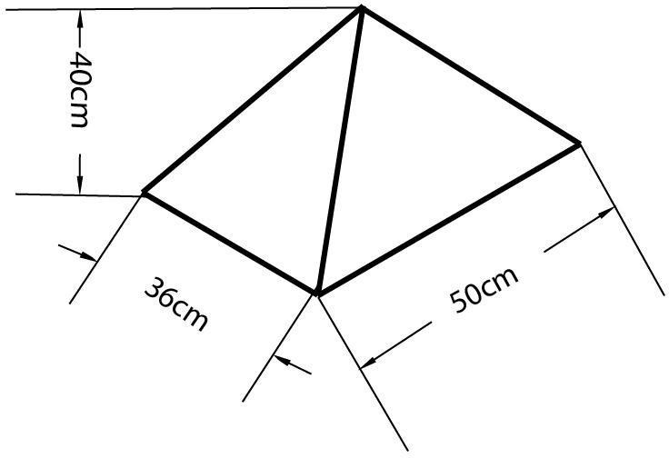

Figure 3.1 Collector
3.2.2 Drying chamber
Drying chamber houses the cocoa bean to be dried. This is the enclosed space where the cocoa bean is placed on trays. It’s designed to retain heat and provide a controlled environment for drying. The dark colour of the interior enhances heat absorption.
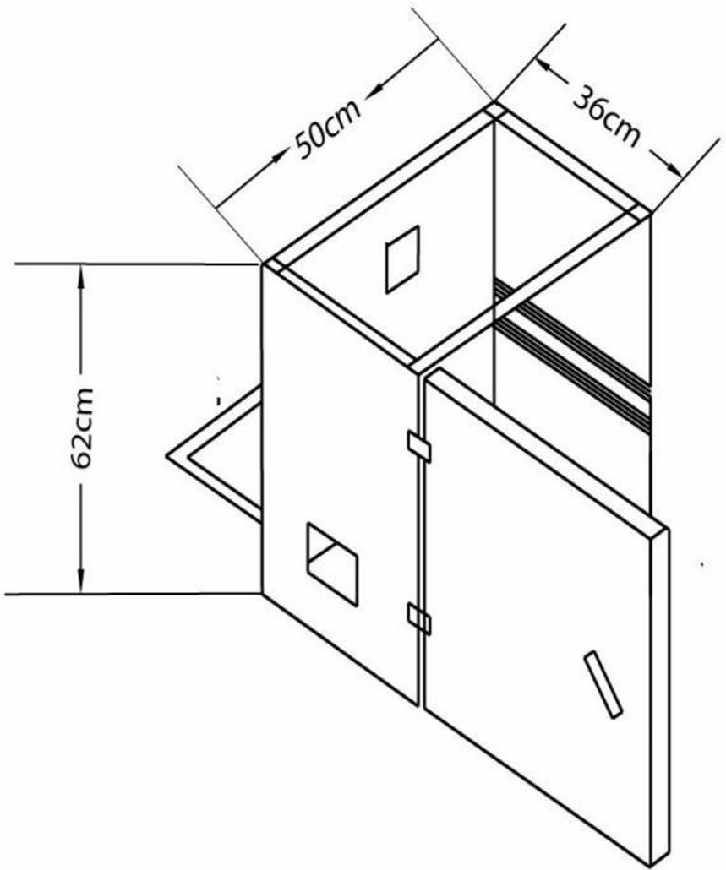

Figure 3.2 Drying chamber

3.2.3 Trays
Trays holds the cocoa bean to be dried. These trays were made of metal mesh to allow for good airflow and even drying. The cocoa bean was spread out on the trays to maximize exposure to the hot air.
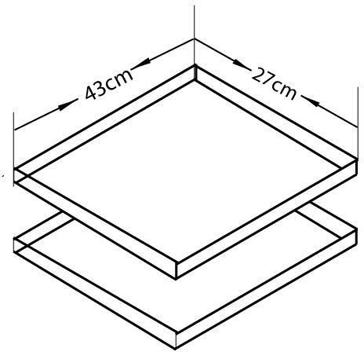

Figure 3.3 Trays

3.2.4 Fans
The fan circulate air within the dryer. The capacity of the fan is 0.44A(amps) and 12V. There was three fans in this design;
Side fans: These two fans draws in fresh, outside air into the dryer, helping to maintain humidity levels and prevent moisture buildup.
Top fan: This fan extracts moisture-laden air from the drying chamber, accelerating the drying process and creating negative pressure to pull in more air.
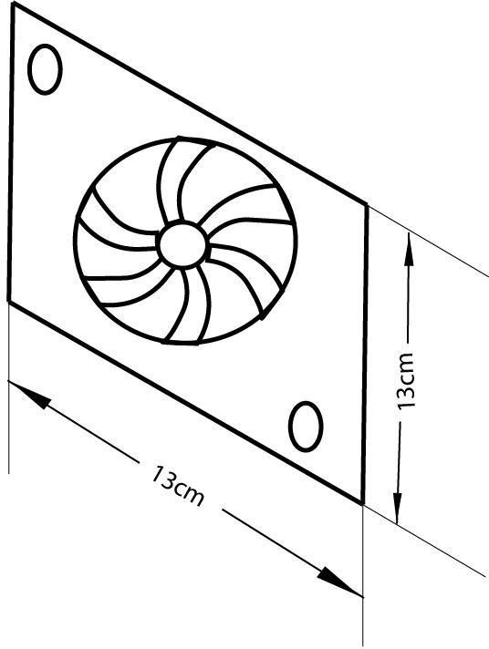

Figure 3.4 Fan

3.2.5 Frame
The frame provides structural support for the dryer. It was made of metal and gives the dryer its shape and stability.
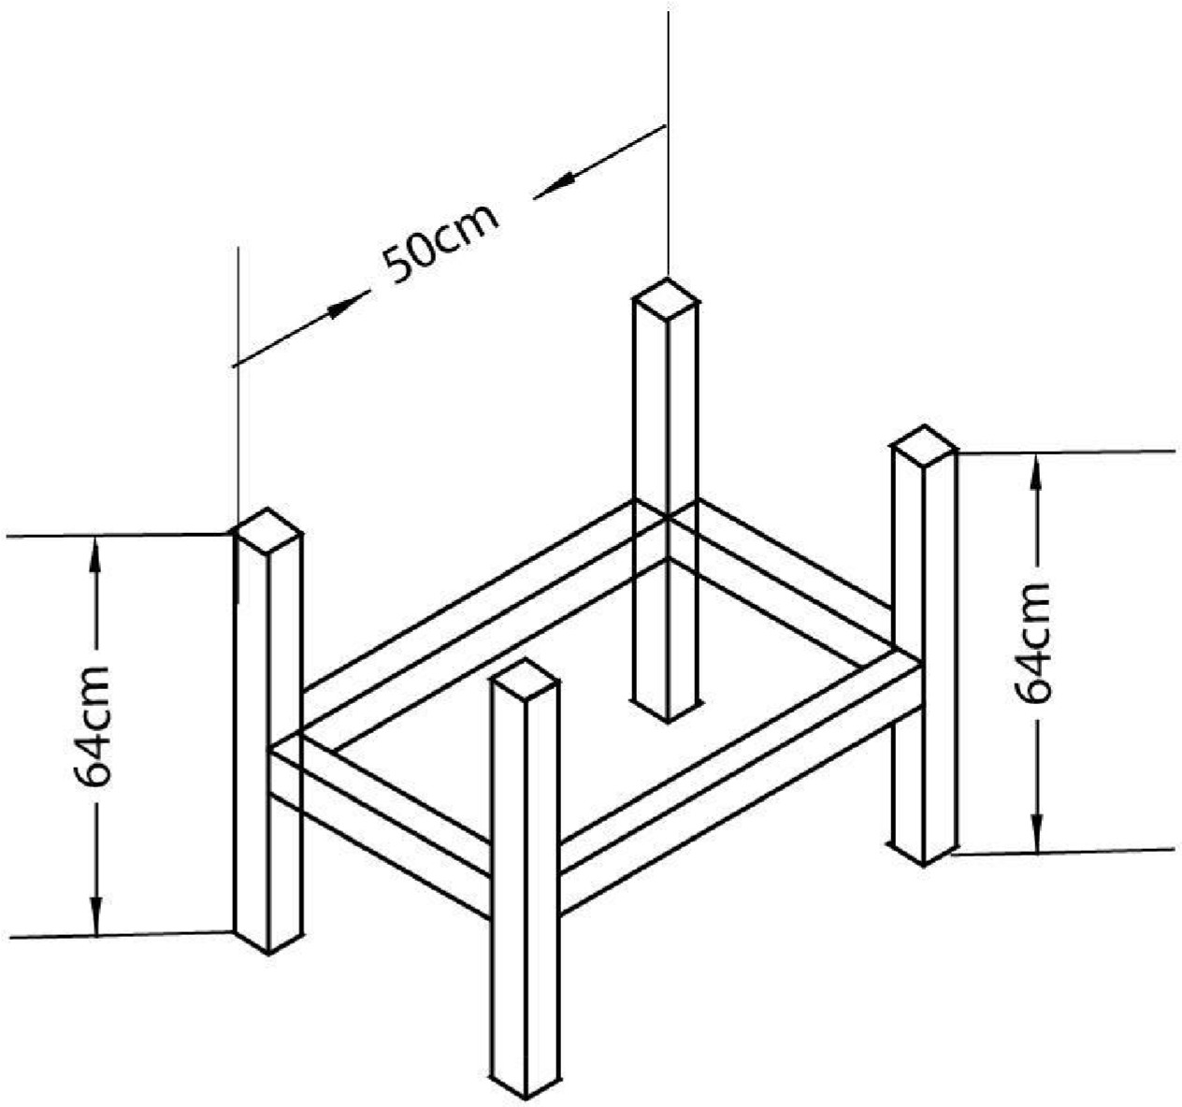

Figure 3.5 Frame

3.2.6 Monitoring equipment
It monitors conditions of the environment. It includes instruments to measure temperature and relative humidity of the environment. The monitoring equipment houses charge controller, solar battery, hygrometer and thermometer.
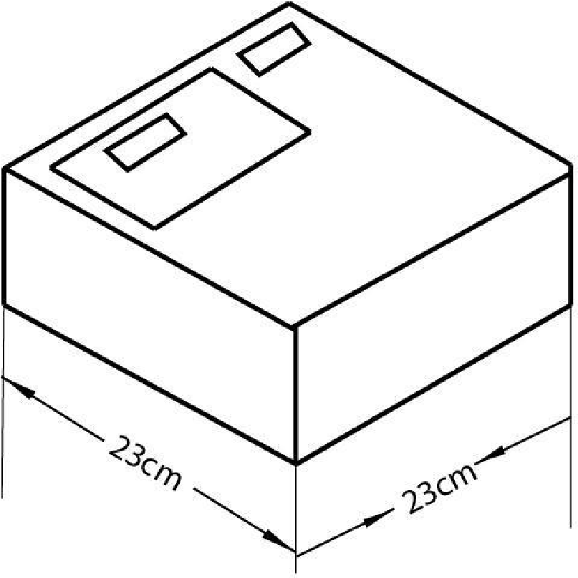

Figure 3.6 Monitoring equipment
3.2.7 Hinges and locks
Hinges are used to attach the door of the hybrid dryer together. It allows the panels to open and close smoothly, making it easy to access the contents of the dryer. Locks were used to secure the door of the hybrid dryer when it is closed. This helps to protect the products inside the dryer from the elements and theft.
3.2.8 Solar battery
A Panasonic 12V 7Ah lead- acid battery was used because of its affordability and reliability. It stores the energy generated by the solar panel for use when there is no sunlight.
3.2.9 Solar panel
It collects energy from the sun in form of sunlight which will help power the monitoring instrument.

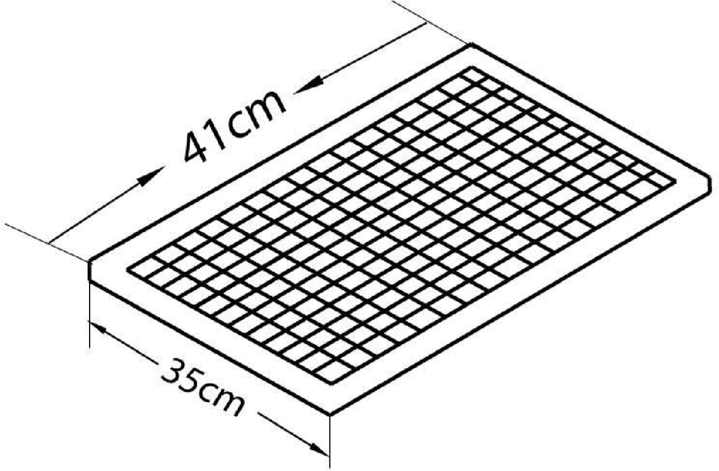

Figure 3.7 Solar panel
3.2.10 Charge controller
The charge controller maintains batteries at their highest state of charge without overcharging them to avoid gassing and battery damage.

3.3. Hybrid Dryer Parts Design

(a) Solar collector area

The solar collector is a triangular prism and it is an isosceles triangle. The solar collector area is given by;
Total surface area = 2 x (area of triangular base) + 3 x (area of rectangular
side)
(3.01) Area of the isosceles triangle base = (√3/4) x
side² (3.02
)
Area of the rectangular sides = length x width
(3.03
)
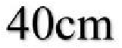

25cm 50cm
Side view of the collector front view of
the collector Where;
Base of the isosceles triangle = 50cm Height of the isosceles triangle = 40cm Width = 25cm
Area of the rectangular sides = 25cm x 40cm = 1000cm²

Area of the isosceles triangle base = (√3/4) x (50cm)²
=1082.53 Total surface area = 2 x (1082.53) + 3 x
(1000) = 5165.06cm²

(b) Absorber Surface Area,

The surface area of the absorber Aab is approximately equal to the area of the collector surface area, Ac; this is related to the length, Lc and width, W of the solar collector as follows:
Aab = Lc x W (3.04)

Lc = height of prism + height of drying chamber

= 40cm + 62cm
=102cm Aab =
102 x 50
= 5100cm²
Aab = Absorber surface area of the collector Lc =Length of the collector
W=Width

(c) The total area of the dryer,

Area of the dryer (rectangle) = L x H (3.05)

= 62 x 50

= 3100cm²

L = length of the dryer H
= Height

3.4 Moisture Content (M.C.):
The moisture content is given as:

Mi -Mf
MC (%)= [ ]x100%; wet basis (3.06)
Mi

Where;

Mi = mass of sample before drying and Mf = mass of sample after drying.

3.5 The mass of water evaporated or moisture loss
Moisture loss is given as;
Mi -Me
mw = mi [ ] (3.07)
100 - Me

Where:

mi= initial mass of the food item (kg);

Me = equilibrium moisture content (% dry basis); Mi= initial moisture content
(% dry basis).
Also this can still be obtained by using equation 3.05

mw = (mi– mf) (3.08)

Where;

mi is the mass of the sample before drying mf is the mass of the sample after drying

3.6 Average drying rate
Mdr, would be determined from the mass of moisture to be removed by the solar heater and drying time by the following equation:

Mw
Mdr =
Td

Where:

Mdr = average drying rate, kg/hour;

Mw = mass of wet products and td = overall drying time
(3.09)

3.7 Principle of Operation of the Hybrid Dryer
Solar energy is captured by the collector in form of sunlight which heats the air inside the dryer. The side fans bring in fresh air while the top fan extracts moist air, creating a continuous airflow. The hot air then circulates around the products, removing moisture and drying it. A humidity sensor and temperature sensor is used to monitor the environment temperature and relative humidity and controls the drying process.

3.8 Experimental procedure
The apparatus used in this experiment were stopwatch, which was used for taking more accurate timing, weighing scale, cocoa bean, grain moisture-meter and the solar dryer. The solar dryer consists of two trays, two fans for blowing air into the dryer, a fan for sucking the air out of the machine.
The machine was firstly test run with small quantity of cocoa before the main drying to know if there was any fault or any adjustment to be made.
The dryer was placed to face the direction of the sun. The three fans were switched on, the speed of the fans blowing air inside the solar dryer was regulated to be at an average. The wet cocoa bean was weighed and the moisture content was known and recorded. The two trays were brought out and the weight of the trays were known and recorded. Tray 1and tray 2 were filled with an equal amount of wet cocoa bean and the weight of the trays filled with wet cocoa bean was recorded, the trays were then placed in the solar dryer. The temperature and relative humidity was recorded as well. The stopwatch was set at an interval of one hour.
After an hour, the trays were brought out to be weighed, and they were placed back after weighing. Then, the temperature and relative humidity was recorded. The stopwatch was set to an interval of an hour again.
This procedure was repeated till the wet cocoa bean was dried to a constant weight three times.

3.9 Material used for construction of solar dryer
- Mild steel sheet
- Square pipe
- Glass collector
- Angle iron
- Fibre glass
- Silicon gum
- Hinges & locks
- Consumables
- 12V 7ah battery
- Dc fan
- 20w solar panel
- Temperature and humidity sensor
- Box

- Wires and clips
- Charge controller
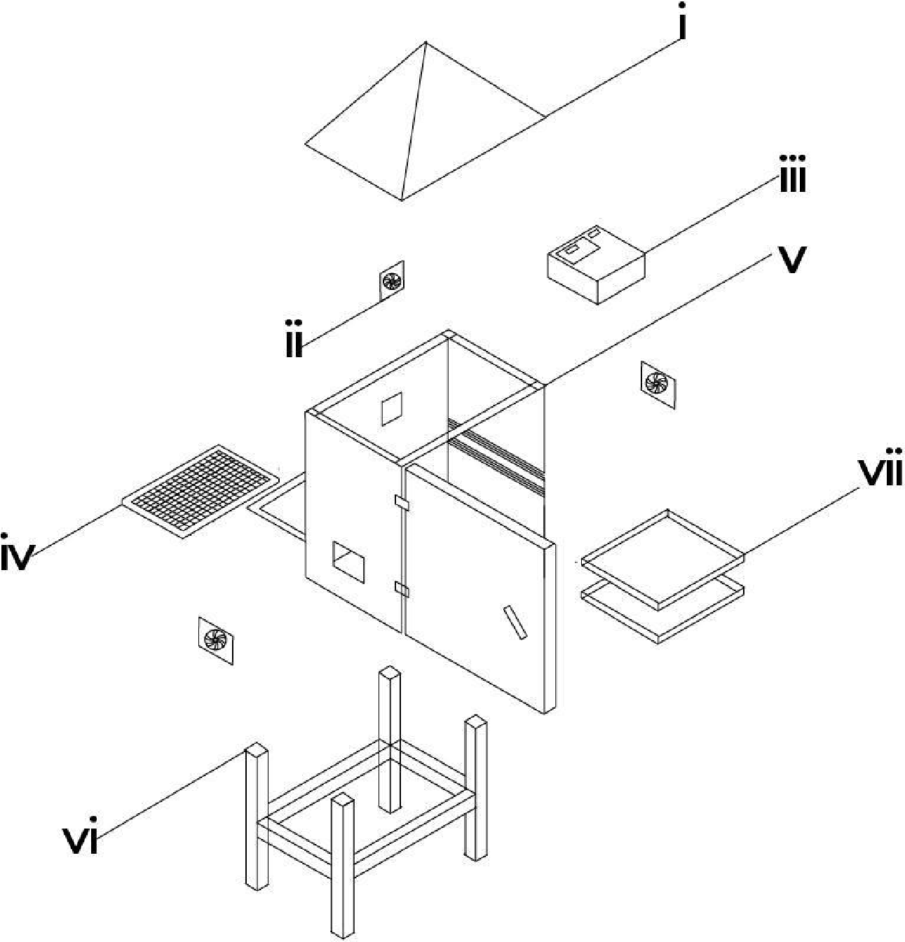

 | MACHINE PARTS’ LIST
S/N | KEYS | PARTS’ NAME
1 | I | COLLECTOR
2 | II | FAN
3 | III | MONITORING EQUIPMENT
4 | IV | SOLAR PANEL
5 | V | DRYING CHAMBER
6 | VI | FRAME
7 | VII | TRAYS

Figure 3.8 Exploded view and labeling of components of the
hybrid dryer.
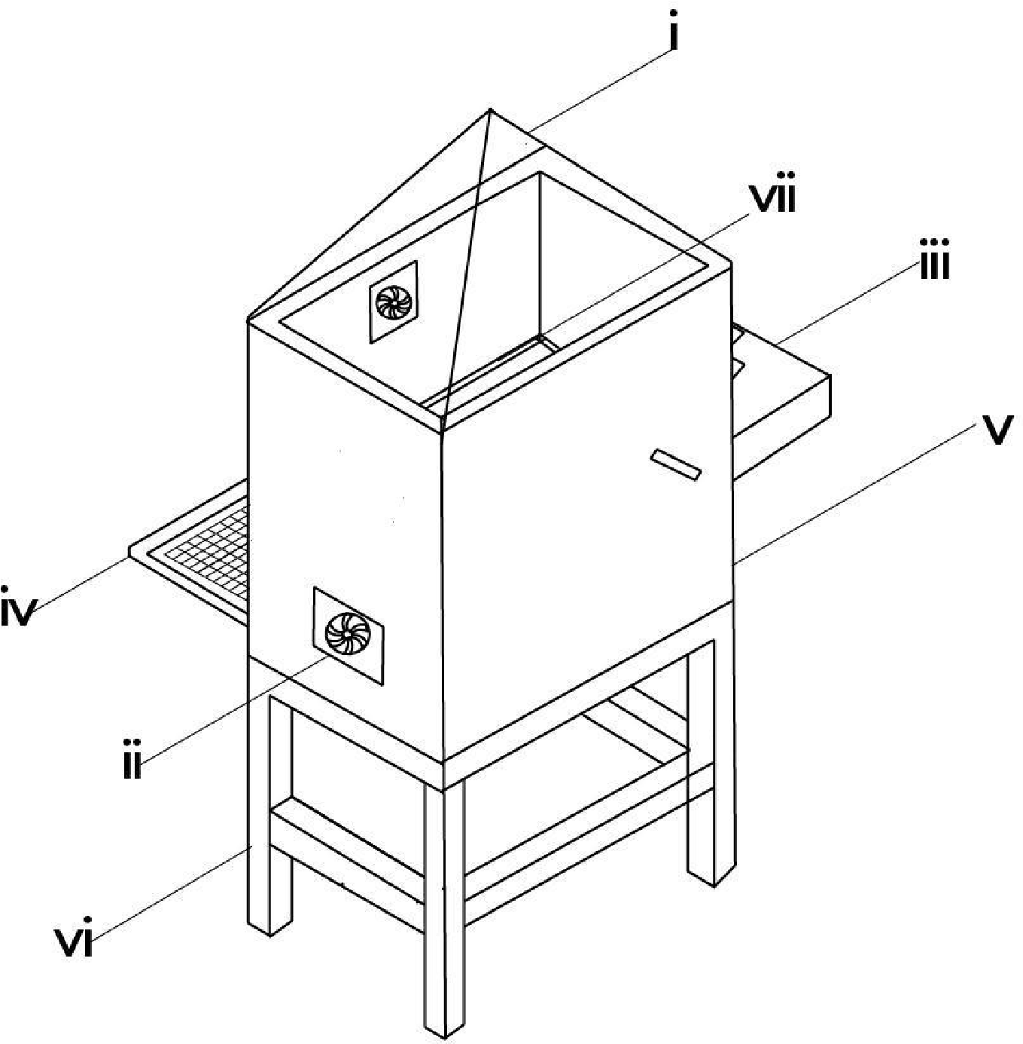

Figure 3.9 Isometric view of hybrid dryer

 | MACHINE PARTS’ LIST
S/N | KEYS | PARTS’ NAME
1 | I | COLLECTOR
2 | II | FAN
3 | III | MONITORING EQUIPMENT
4 | IV | SOLAR PANEL
5 | V | DRYING CHAMBER
6 | VI | FRAME
7 | VII | TRAYS

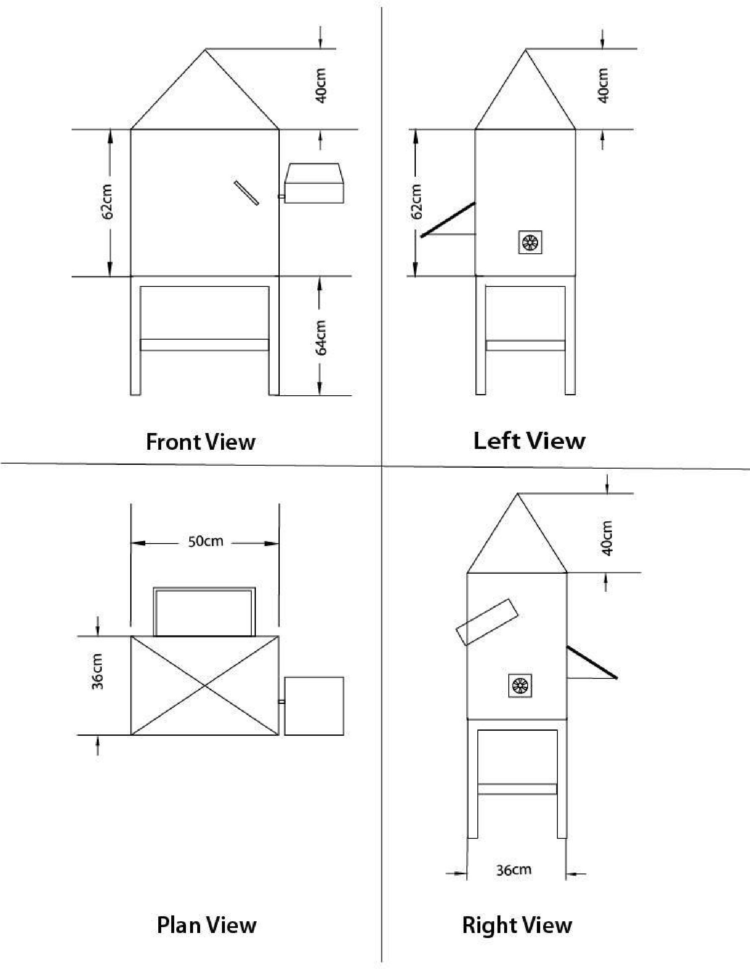

Figure 3.10 Views of The Machine Drawing

3.10 Tools and Equipment
- Electric Arc Welding Machine: it was employed during the fabrication of the drying chamber, supporting frame and tray assembly. It was used to join metal components with high strength and durability ensuring structural integrity of the dryer.
- Grinder/Cutting Machine: It is a power tool with a rotating abrasive disc or blade which was used for cutting and smoothing metal.It is used to cut metal sheets, pipes, or rods to required sizes and for grinding welds to smooth finishes.
- Drilling Machine: It is a machine tool which was used for used to drill holes into materials (metal, wood, etc.). It is used to create holes for bolts, screws, or other fittings in your project components.
- Screwdriver Set: It is a set of hand tools with different tips (flat, Phillips, etc.) which was used for driving screws. It is used for tightening or loosening screws during assembly or adjustments of electrical and mechanical parts.
- Spanner Set: It is a set of tools which was used for for tightening or loosening nuts and bolts. It is essential for assembling and disassembling mechanical parts such as frames, joints, or supports.
- Multimeter (for testing connections): it is an electronic measuring instrument that combines several functions (voltage, current, resistance testing). It was used to check electrical circuits, test battery voltage, or ensure proper connections in the solar-powered system
- Pliers: It is a hand tool with gripping jaws, sometimes with cutting edges.it was used for holding objects firmly, bending wires, or cutting small materials.
- Measuring Tape: It is a flexible ruler used to measure distances or dimensions. It is used to take accurate measurements of components during fabrication or assembly.
- File (for finishing edges):It is a hand tool with a roughened surface used for smoothing or shaping metal.It is used to smoothen sharp edges after cutting or welding metal parts.
- Paintbrush/Spray Gun: it is a tool used to apply paint or protective coatings. It is used for finishing touches to protect metal surfaces from rust and improve aesthetics.
- Soldering Iron (for electronic parts): It is a hand tool that heats up to melt solder (a metal alloy) for joining electronic components. It is used in assembling or repairing the electronic parts of your project like sensors, circuits, or connections.

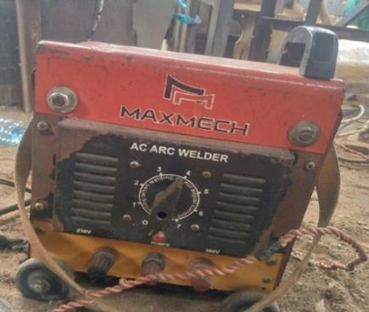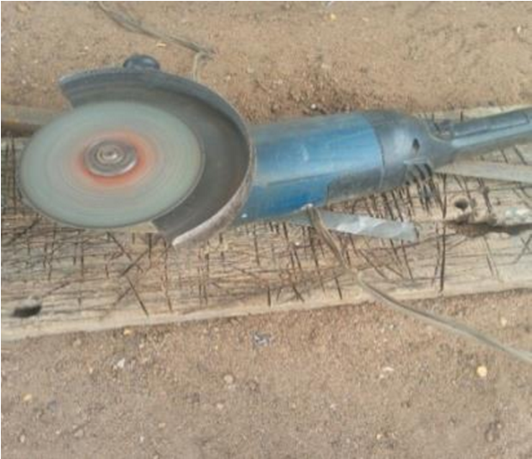
Plate 3.1a:Electric Arc Welding plate 3.1b: Grinding
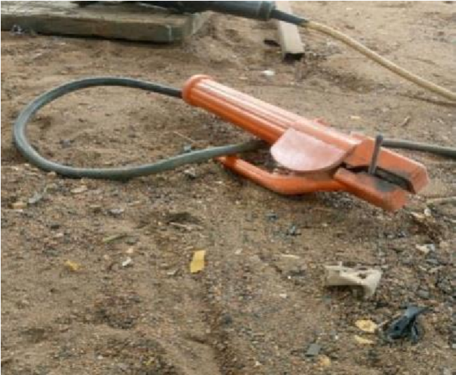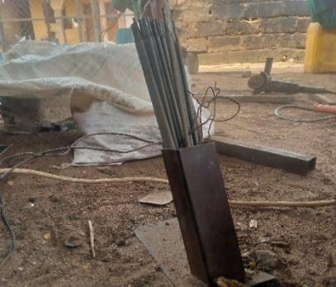

Plate 3.1c: Thong plate 3.1d Electrodes
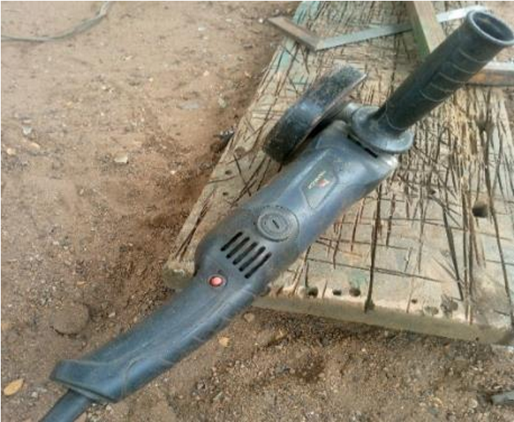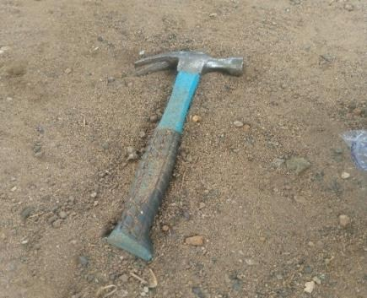

Small Grinder Hammer

3.11 Design Layout
The experimental design for this study was structured using a two factor factorial design to evaluate the effect of the drying parameters on the drying rate and drying efficiency of cocoa seeds. The factors and responses are presented as follows:
- Mass of Sample (g)
- Air flow rate (m³/s)
2. Experimental Responses (Dependent Variables)
Two performance indicators were monitored during the drying process:
- Drying Rate (kg/h): measured as the rate at which moisture was removed from the cocoa seeds.
- Drying efficiency (%): calculated as the ratio of useful energy utilized for moisture removal to the total energy supplied.
3. Experimental Runs
A total of 13 experimental runs were carrid out as presented in Table 3.1. The runs were randomized to minimize the experimental bias and ensure the independence of observations. The experimental matrix includes various combinations of the two factors and their respective levels.

Table 3.1shows the experimental design matrix with the factors and responses for the cocoa seed drying process
Factor 1 Factor 2 Response 1 Response 2
Std Run A:Mass of Sample B:Air Flow Rate Drying Rate Drying Efficiency
g Kg/h %
3 1 1000 0.6
9 2 2000 0.5
12 3 2000 0.5
7 4 2000 0.4
4 5 3000 0.6
2 6 3000 0.4
13 7 2000 0.5
1 8 1000 0.4
11 9 2000 0.5
5 10 1000 0.5
10 11 2000 0.5
6 12 3000 0.5

8 13 2000 0.6 CHAPTER FOUR
Results and Discussion

4.1 Result
The result obtained from the testing of the fabricated hybrid dryer for cocoa bean were presented in table 4.1 below.

Table 4.1: Summary of Result of Cocoa Drying Using the Fabricated Hybrid Solar Dryer

Run Mass of Sample (g) Air Flow Rate (kg/h) Drying Rate (kg/h) Drying Efficiency (%)
- 1000 0.6 0.042 78.3
- 2000 0.5 0.033 87.6
- 2000 0.5 0.033 87.6
- 2000 0.4 0.029 91.2
- 3000 0.6 0.031 89.2
- 3000 0.4 0.024 96.3
- 2000 0.5 0.034 86.1
- 1000 0.4 0.035 85.4
- 2000 0.5 0.031 89.2
- 1000 0.5 0.037 83.9
- 2000 0.5 0.033 87.6
- 3000 0.5 0.027 92.8

Run Mass of Sample (g) Air Flow Rate (kg/h) Drying Rate (kg/h) Drying Efficiency (%)
13 2000 0.6 0.036 84.1

4.2 Discussion
The results obtained from testing the hybrid dryer were presented in table 4.1 above. From the table, it was observed that different mass of sample and airflow rate gave different drying rate and drying efficiency respectively. It was also observed that an increase in mass of sample at the same air flow rate gave a decrease in the drying rate and drying efficiency while an increase in the air flow rate at the same mass of sample gave an increase in drying rate and drying efficiency. This could be attributed to the ease of moisture migration within the sample at higher air flow rate. The analysis of variance (ANOVA) for the drying rate and drying efficiency of cocoa bean is presented in table 4.2 and 4.3 below respectively.

Table 4.2: Analysis of Variance (ANOVA) for the Drying Rate of Cocoa Bean

Source Sum of Squares df Mean Square F-value p-value
Model | 0.0002 2 | 0.0001 184.90 < 0.0001 significant
A-Mass of Sample | 0.0002 1 | 0.0002 258.49 < 0.0001
B-Air Flow Rate | 0.0001 1 | 0.0001 111.32 < 0.0001
Residual | 6.603E-06 10 | 6.603E-07
Lack of Fit | 1.803E-06 6 | 3.004E-07 0.2504 0.9353 not significant
Pure Error | 4.800E-06 4 | 1.200E-06
Cor Total | 0.0003 12

*Significant @P≤0.05
From table 4.2 above, the p value < 0.0001 shows that the model is significant being far below 0.05. this indicates that the selected factors of mass of sample and air flow rates have a great effect on the drying rate of cocoa bean. The graphical representation is shown in figure 4.1 below.

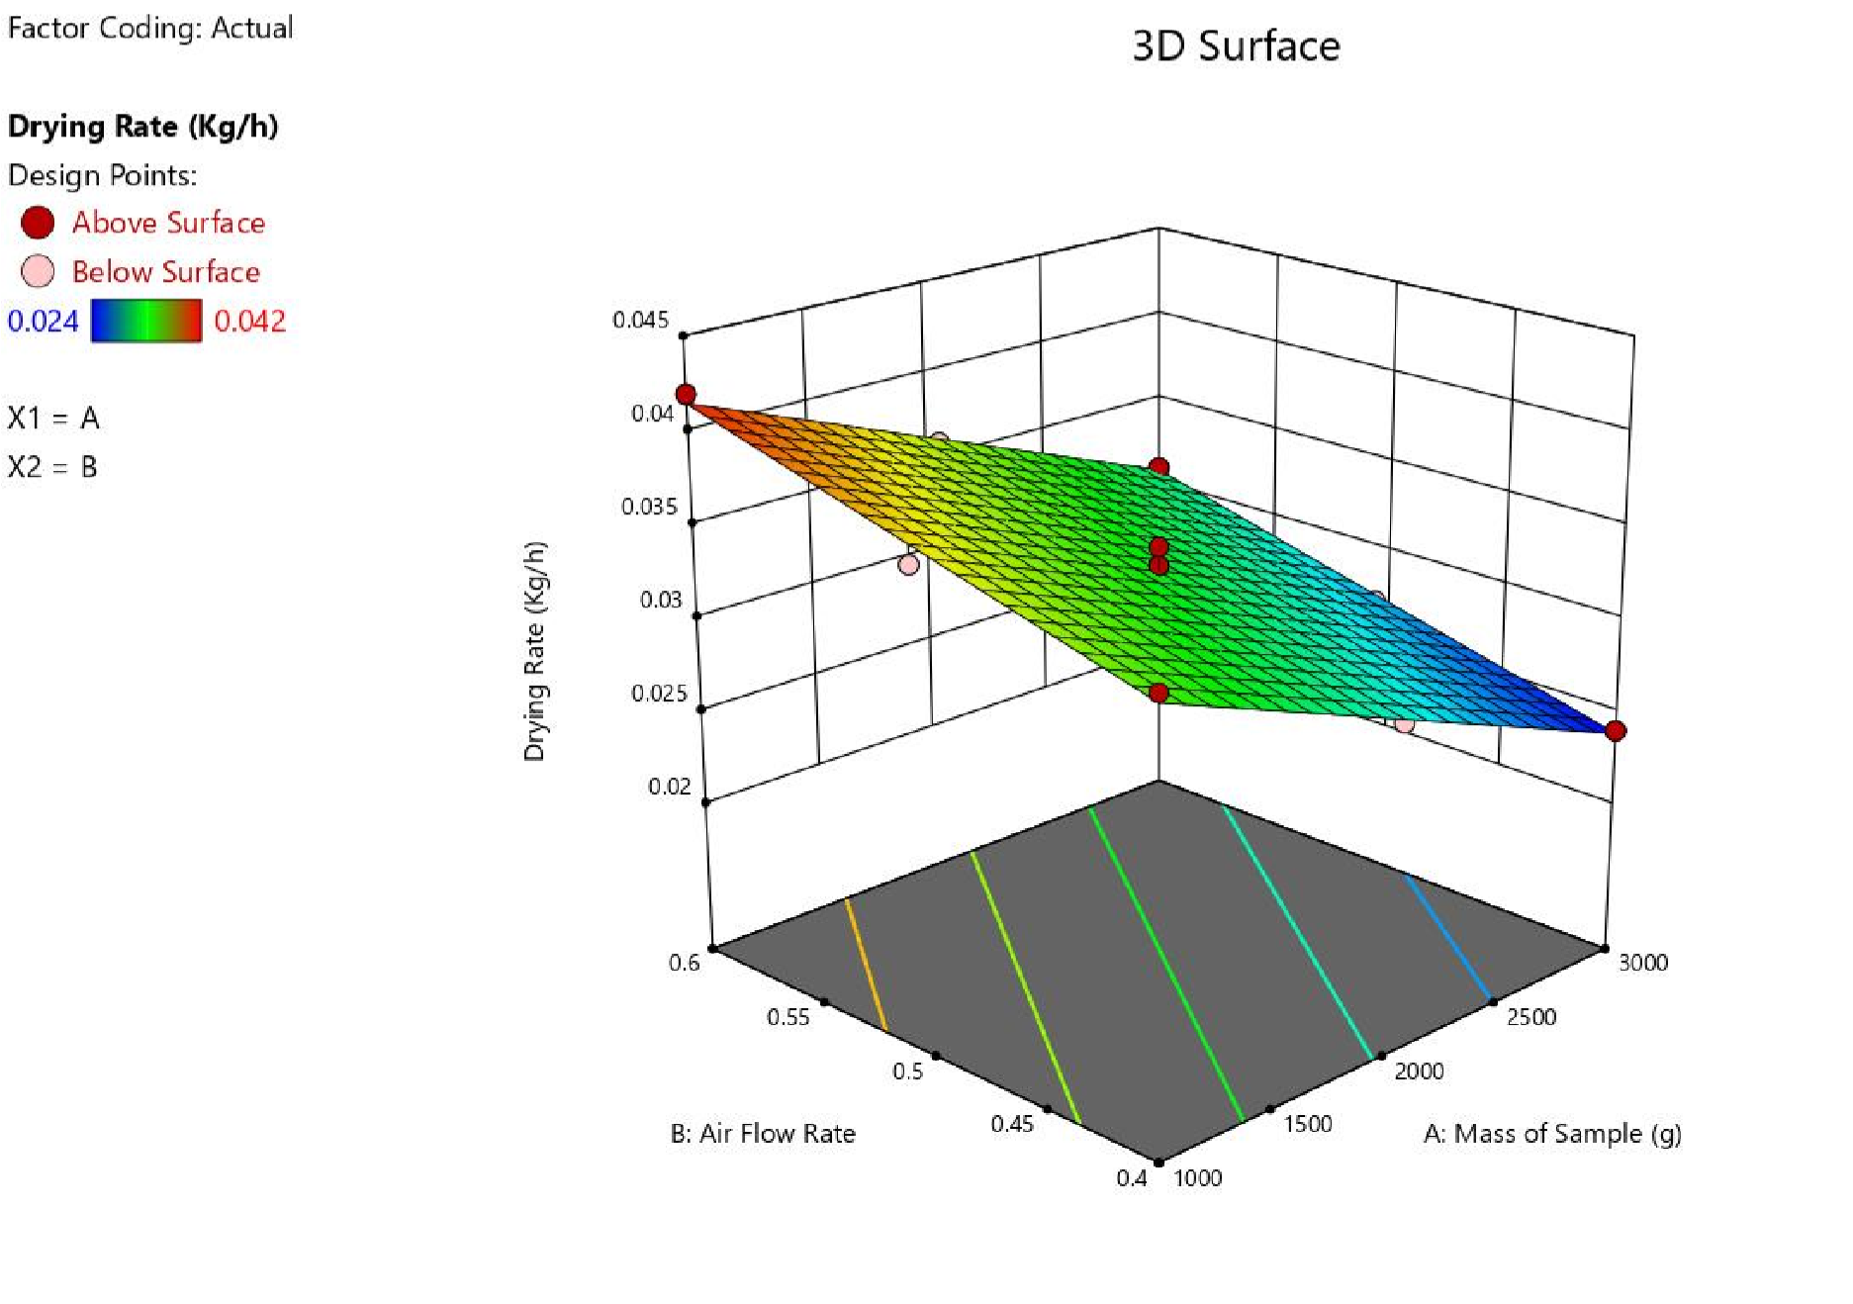

Fig 4.1: Effect of Air Flow Rate and Mass of Sample on the Drying Rate of Cocoa

Table 4.3: Analysis of Variance (ANOVA) for the Drying Efficiency of Cocoa Bean

Source Sum of Squares df Mean Square F-value p-value
Model | 232.70 2 | 116.35 152.81 < 0.0001 Significant
A-Mass of Sample | 157.08 1 | 157.08 206.30 < 0.0001
B-Air Flow Rate | 75.62 1 | 75.62 99.31 < 0.0001
Residual | 7.61 10 | 0.7614
Lack of Fit | 2.81 6 | 0.4677 0.3891 0.8551 not significant
Pure Error | 4.81 4 | 1.20
Cor Total | 240.31 12

*Significant @P≤0.05
From table 4.3 above, the p value < 0.0001 shows that the model is significant being far below 0.05. this indicates that the selected factors of mass of sample and air flow rates have a great effect on the drying efficiency of cocoa bean. The graphical representation is shown in figure 4.2 below.

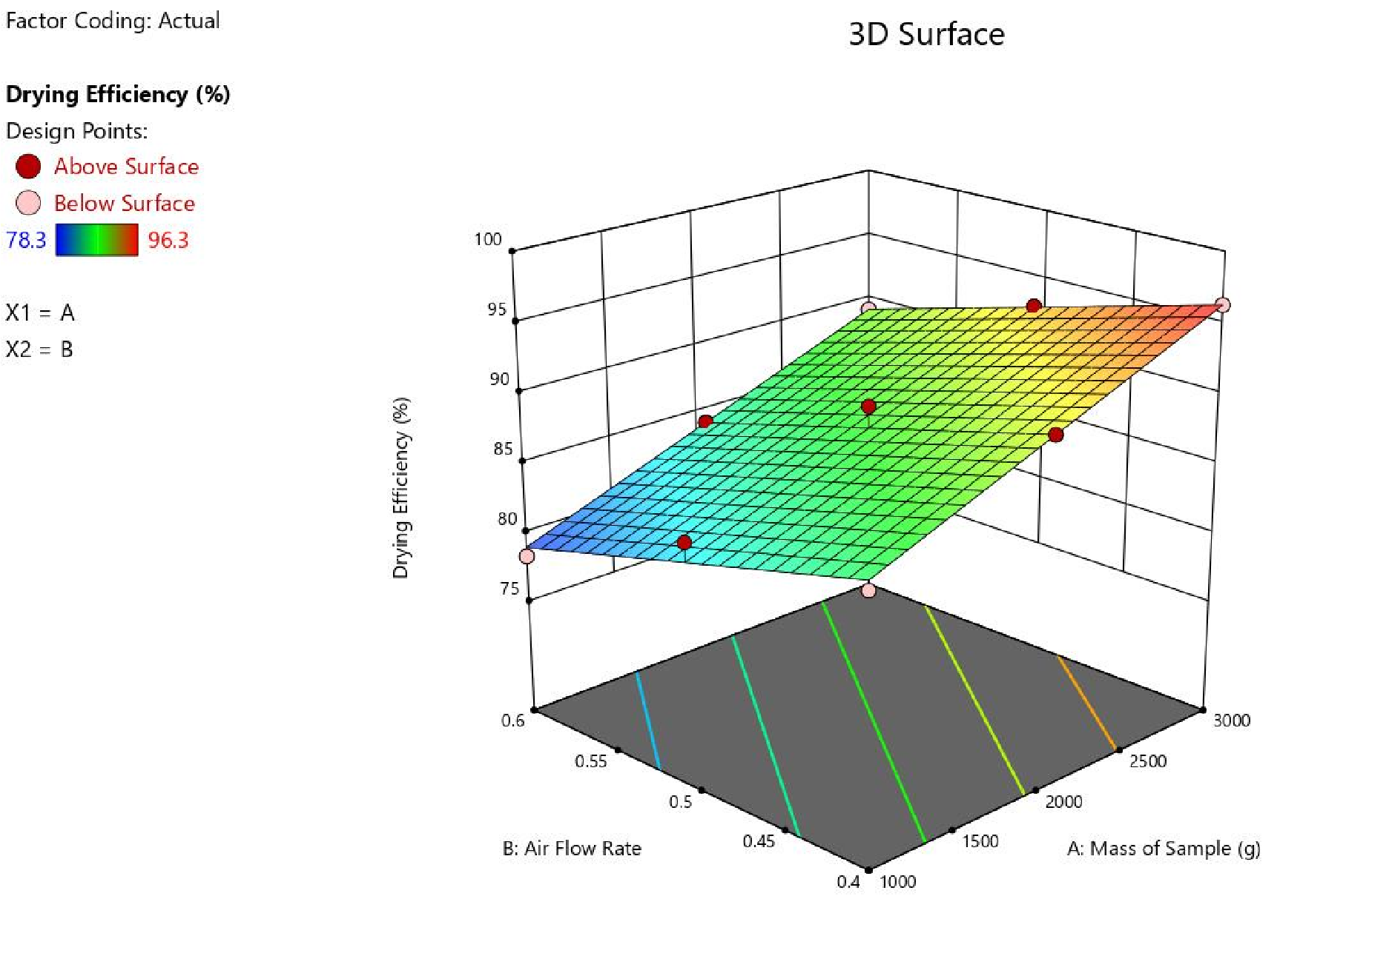

Fig 4.2: Effect of Air Flow Rate and Mass of Sample on the Drying Efficiency of Cocoa Chapter Five
Conclusion and Recommendation

5.1 Conclusion
A hybrid dryer which combines direct solar drying for drying with solar panel powered system for air flow was designed and fabricated in the department of agricultural and bio-environmental engineering technology, institute of technology, kwara state polytechnic, Ilorin. The dryer was able to dry wet cocoa bean effectively.

5.2 Recommendation
The following recommendations were drawn from the study
- It is recommended that a load cell with Personal Computer interface should be incorporated into the drying chamber to know the weight of products in the dryer at every time interval.
- It is recommended that a wheel (Tyre) should be at the stand of the dryer for easy movement.
- The size of the drying chamber should increase for large scale drying, as well as the size of solar panel and capacity of the battery.

References

Akinmoladun, O. P., Adebayo, F., & Akanbi, A. O. (2022). Maintenance practices and durability
of solar dryers in agricultural use. Energy Conservation and Management, 116, 38-47.
Akinola, O. A., Ogunlade, B., & Babarinde, A. A. (2022). Performance analysis of indirect solar
dryers for agricultural products. Renewable Energy, 15(3), 112-121.
Adeoye, O. M., & Olaniyi, T. K. (2020). Improving energy efficiency in hybrid solar drying
systems: A review. Energy Reports, 6, 223–233.
Agunbiade, S., & Adebayo, T. O. (2022). Hybrid solar dryers: Bridging the gap in cocoa drying
processes. African Journal of Agricultural Engineering, 14(3), 156-167.
Ahmed, M. S., Ibrahim, A., & Hassan, Y. T. (2020). Thermal storage in solar drying systems:
Advances and challenges. Renewable Energy Journal, 35(4), 205-214.
Afoakwa, E. O. (2010). Chocolate Science and Technology. Wiley-Blackwell.
Afoakwa, E. O., Paterson, A., Fowler, M., & Ryan, A. (2011). Cocoa drying and its impact on
flavor precursors. Critical Reviews in Food Science and Nutrition, 51(8), 751774.
Ali, A., Tiwari, A., & Rizvi, S. (2021). Reduction of carbon emissions using solar drying
systems in agriculture. Environmental Impact Assessment Review, 85, 106-115.
Ampratwum, D. B., & Dorvlo, A. S. S. (2007). Design and performance of solar dryers for cocoa
beans. Renewable Energy, 32(12), 2063-2076.
Bala, B. K., & Debnath, D. (2012). Solar drying technology and its application in agriculture.
Drying Technology, 30(10), 1123-1132.
Balde, J. (2021). Challenges in adopting solar-powered dryers in developing countries: A review.
Energy for Sustainable Development, 60, 27-37.
Chandra, R., & Arora, A. (2019). Cost-benefit analysis of solar drying in agricultural
applications. Renewable Energy, 142, 248-255.
Chavan, U. D., Patil, J. V., & Kadam, S. S. (2022). Minimizing microbial contamination during
solar drying of agricultural products. Food and Bioprocess Technology, 9(3), 257265.
Dutta, D., & Singh, M. (2020). Weather dependency and hybrid systems in solar drying
technologies. Renewable Energy Technology Reviews, 10(1), 82-90.
Dubón, A., … et al. (2016). [Study on cocoa drying—moisture reduction from 55% to 6.5–7%]. [Journal Name], [Volume]([Issue]), [Page numbers].
Ekechukwu, O. V., & Norton, B. (2001). Review of solar-energy drying systems II: An overview
of solar drying technology. Energy Conversion and Management, 40(6), 615-655.
Energy, Sustainability, and Society (2021). Design, fabrication, and performance evaluation of
solar dryer for agricultural produce. BioMed Central. Available at: Energy, Sustainability, and Society Journal.
Eze, C. C., Okonkwo, I. K., & Ogbu, E. C. (2021). IoT applications in agricultural solar drying
systems: Case studies and future directions. International Journal of Smart Agriculture, 8(1), 45-60.
Fagunwa, F. O., Olatunji, K. T., & Oke, A. R. (2019). Optimization of cocoa drying systems: A
focus on quality retention. Agricultural Science and Technology, 18(3), 225-231.
FAO. (2020). The future of food and agriculture: Trends and challenges. Food and Agriculture
Organization.
ICCO (International Cocoa Organization). (2021). Cocoa Market Report. Available at:
https://www.icco.org.
Koya, O. A., Adebusoye, K. A., & Awogbemi, O. (2014). Development of an intermittent solar
dryer for cocoa beans. Journal of Solar Energy Research, 8(1), 56-67.
Kumar, A., Tiwari, S., & Sharma, R. (2021). Moisture content and quality control in solar drying
of cocoa beans. Journal of Agricultural Engineering Research, 18(2), 45-59.
Leong, H., Lee, J., & Khor, M. (2020). Quality and preservation of cocoa beans in solar drying
systems. Food Processing and Technology, 41(4), 569-574.
Madarang, J. D. (2019). Performance evaluation of a solar-powered cocoa dryer with hybrid
thermal energy storage. Journal of Agricultural Engineering Research, 75(4), 120130.
Mohammed, A., Ibrahim, Y., & Umar, H. (2022). Economic barriers to solar dryer adoption for
smallholder farmers in sub-Saharan Africa. International Journal of Renewable Energy, 51(7), 3452-3460.
Motevali, A., … et al. (2016). [Study on specific energy consumption (SEC) & energy efficiency in convective drying]
Nair, R., Kumar, S., & Singh, D. (2020). Solar dryers: An eco-friendly solution for agricultural
drying. Journal of Cleaner Production, 248, 119-132.
Nair, R. S., Soni, D., & Keshav, P. (2021). Hybrid solar drying systems: A solution to weather
unpredictability in agriculture. Renewable and Sustainable Energy Reviews, 131,
109-118.
Nalubega, J. F. (2015). Design and construction of a cocoa bean solar dryer for smallholder
farmers. Dissertation, Busitema University. Available at: Busitema University Institutional Repository.
Nduka, O. M., Okoli, J. S., & Akpan, A. A. (2021). Impact of solar drying on the quality of
cocoa beans: A comparative study. International Journal of Food Science & Technology, 56(5), 1345-1353.
Obi, C. A., & Ugwuishiwu, B. O. (2023). Quality assessment of solar-dried cocoa beans in
controlled environments. International Journal of Food Science & Technology, 58(4), 678-689.
Olunloyo, V. O., Ajibola, A. O., & Adeyemo, S. O. (2016). Performance evaluation of solar-
powered cocoa dryers. Journal of Agricultural Engineering, 23(2), 45-59.
Patel, S., Vashi, S., & Sheth, N. (2023). Maintenance needs and performance optimization in
solar-powered agricultural dryers. Journal of Renewable and Sustainable Energy, 15(1), 193-205.
Perez, J. M., Morales, J. R., & Muñoz, L. M. (2022). Economic assessment of solar drying
systems in smallholder farms: A case study of cocoa drying. Renewable and Sustainable Energy Reviews, 69, 528-535.
Singh, V., Patel, H., & Mehta, P. (2021). Comparative analysis of thermal storage-assisted solar
dryers for crop drying. Renewable and Sustainable Energy Reviews, 34, 85-97.
Zahouli, I. B., Kouadio, N. J., & Coulibaly, B. (2010). Impact of post-harvest practices on cocoa
bean quality. International Journal of Postharvest Technology, 5(3), 23-31.

