DESIGNANDFABRICATIONOFASOLARPOPCORN MACHINE
BY

AHMED HABEEBULLAHI OLAMILEKAN
ND/23/MET/FT/0002

A PROJECT SUBMITTED TO THE DEPARTMENTOFMETALLURGICALENGINEERING,
INSTITUTE OF TECHNOLOGY, KWARASTATEPOLYTECHNIC,ILORIN

INPARTIALFULFILLMENTOFTHEREQUIREMENTFOR THE AWARD OF ORDINARY NATIONAL DIPLOMA IN METALLURGICAL ENGINEERING,

JULY,2025

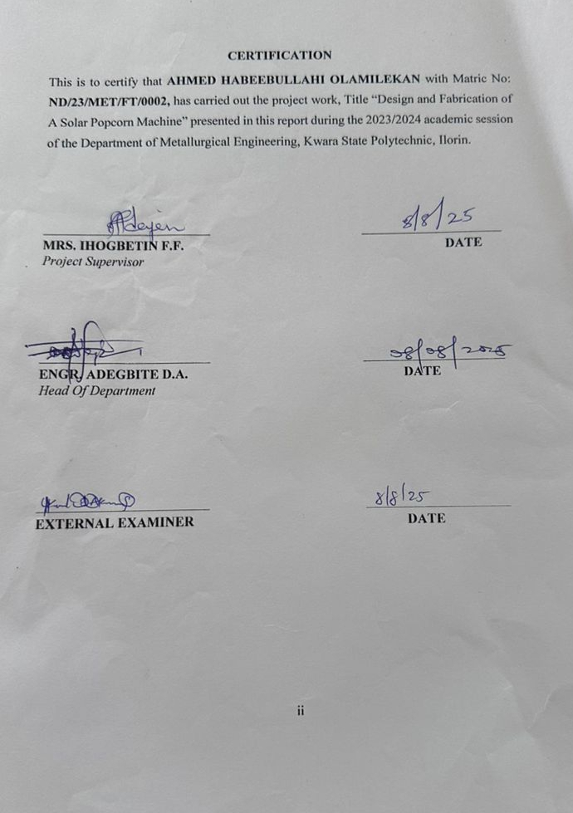
DEDICATION

I dedicate this project to Almighty Allah for guiding me through this successful endeavor. First and foremost, we would like to express my sincere appreciation to God, the Beginning and the End, who has showered me with His boundless mercy. He is the ultimate source of wisdom, knowledge, and understanding.

AKNOWLEDMENTS
I give all praise, honor, and gratitude to Almighty Allah for guiding me through this successful endeavor. First and foremost, we would like to express my sincere appreciation to God, the Beginning and the End, who has showered me with His boundless mercy. He is the ultimate source of wisdom, knowledge, and understanding.
IextendourheartfeltthankstotheHeadofDepartmentalongwithallthefacultymembers in the Department of Metallurgical Engineering for their invaluable support.
A special mention goes to my dedicated supervisor, Mrs. Ihogbetin F.F. whose careful guidance ensured that this project achieved a level of excellence.
To my parents Mr. and Mrs. AHMED, siblings, and friends, I express my profound gratitude for your continuous support and encouragement throughout my academic journey. Thank you for your love and assistance; we hope to reunite in a higher place.

I would like to extend a sincere thank you to everyone involved to make this project work a success. May God continue to bless you all (Amen).

ABSTRACT
The project is the fabrication of solar power popcorn making machine. Which aim is for producing a solar popcorn machine and fabricate device that utilizes solarenergytopopcorn,reducingrelianceonconventionalfuelsandelectricity. The materials used for the fabrication of solar power popcorn making machine are;solarcollector,reflector,poppingchamber,insulation,trackingmechanism and optional components. The solar power popcorn making machine is fabricated with good materials, so it can be used for a very long period of time.

 | TABLEOF CONTENTS
TitlePage |  | i
Approval Page Dedication Acknowledgement Abstract  TableOfContent |  | ii iii iv v vi
CHAPTERONE
  - INTRODUCTION
  - BACKGROUNDANDOVERVIEWOFTHESTUDY
  - PROBLEMSTATEMENT
  - AIM/OBJECTIVEOFTHEPROJECT
  - JUSTIFICATIONOFTHEPROJECT
  - PURPOSEOFTHEPROJECT
  - SIGNIFICANCEOFTHEPROJECT

CHAPTERTWO: LITERATUREREVIEW

  - LITERATUREREVIEW

  - POPPINGHISTORY

  - REVIEWOFPOPPINGMETHODS
  - POPPINGMETHODS
  - HISTORICALREVIEWOFCORN

  - PRINCIPLESOFSOLARPOPCORNMACHINES

  - DESIGNANDFABRICATIONAPPROACH
  - HEATTRANSFER(PRINCIPLEOFHEATTRANSFER)

CHAPTERTHREE
3.0 MATERIALSUSED
3.1. METHODOLOGY

CHAPTERFOUR
4.0DIAGRAMOFASOLARPOWERPOPCORNMAKINGMACHINE

CHAPTERFIVE
5.1 CONCLUSIONS
5.3 REFERENCES

CHAPTER ONE INTRODUCTION
  - BACKGROUNDOFTHESTUDY

Nigeria’seconomyhassufferedaterriblesetbackovertheyearthecommonman finds it difficult to make for his livelihood, some people take pop-corn as one of theirfavoritefoodespeciallybachelorsspinsterswhocantakepop-cornassuper, breakfast and even lunch.
The University and Polytechnics graduate no longer find good employment thereby embarks on self-employment by constructing popcorn machine to meet their needs.
Popcorn is from a special type of maize unlike other types of corn which pops when heated. The popcorn preparation has long been in practice in Nigeria. It usually required a heating source (stove, fire wood as conventionally used), a frying pan with spoon as the stirrer. It was first discovered and used by the early Americans. Popcorn was introduced to the Western world by Christopher Columbus in the 15th century. The kind of popcorn most people pop in their microwave is the Zea mays. Zea mays everta has a certain amount of moisture content,astrongpericarpthatdoesnotallowmoisturetoescapeveryfastasother corn when heated. Consequently, a popcorn machine, which is generically used

for the purpose of making popcorn for human consumption is essential. Most popcorn machines use gas, some use electricity, while some use the solar as sourcesofenergy.Themeritsanddemeritsofthesesourcesareobservableinthe productionrateofthevariousmachines,whichinturndependsontheintensityof heat as well as the power source. The objective of the project, therefore, is to design and fabricate a solar popcorn machine that will enhance popcorn productionusingsolarenergy.Inthiswork,Solarpopcornmachineusesasimple solarthermalapplicationsthatconvertsolarradiationintoheatthatisusedtopop upcorn.Solarpopcornmachineisnowrecognizedasareliablepracticethatsaves substantial amountsof electricity or other conventional fuels, leads to peak load reduction and prevents emission of carbon dioxide.

PROBLEMSTATEMENT

The two conventional method of making popcorn are using electricity or natural gas. The erratic nature of electricity and high cost of gas in developing country such as Nigeria has hindered the production of popcorn – which has made many people don’t show much interest in popcorn making business. It was because of thischallengesthathasmadetechnologytosearchforsolution–byinitiatingsolar energy in popping corn. Solar popcorn machine was invented to solve the problems of power supply and high cost of gas.

AIMANDOBJECTIVESOFTHESTUDY

Themainaimofthisprojectistofabricateasolarpowerpopcornmakingmachine. The objectives of the study
- Togetthedimensionofthemachineto produce.

- Tocutthematerialstomeetthedimension.
- Toweldthemetalsheettogethertoformtheshape required.
- Tofixthesolarpanelandeveryotherpartofthe machine.
- Totestthemachine.

JUSTIFICATION
The design of the improved and more cost effective solar popcorn making machinewillencourageeasieradoptionofsolarpopcornmakingtechnologydue to the user benefits. The machine will cater for substantial household popcorn making energy needs hence reduce on carbon emissions in the atmosphere and high cost of gas. Implementation of the design will reduce on the time spent on moving from one place to another looking for gas. Certainly the project will enable cost savings compared to alternative electric or gas type.

PURPOSEOFTHEPROJECT

A solar popcorn making machine is a device which uses the energy of direct sunlighttopopcorn.Thepurposeofintroducingsolarpopcornmakingmachineis to provide a cheap means of popping corn that does not involve using gas or electricity.

SIGNIFICANCEOFTHEPROJECT

Theadvantagesofbuildingasolarpopcornmakingmachineare:

SaveMoney–approximately50%ofyourelectricitybillandgascouldbesaved. Usingsolarpopcornmakingmachinecoulddrasticallyreducethesizeofinstalled gas cylinder.
Aninvestment–solarpopcornmakingmachinewilladdvaluetoyourproperty.

EnvironmentalFriendly–solarenergyiscleanenergy.No pollution.

Self-sufficiency – with a solar popcorn making machine you are protected from the ever-increasing cost and erratic.

CHAPTERTWO

LITERATUREREVIEW

  - POPPINGHISTORY
People originally popped popcorn by holding a basket over an open flame. This method was less thandesirableas itoften resulted in uneven cooking and burned popcorn. In the 1880s, Charles Cretors adapted a peanut warming machine to better cook popcorn and the modern day popcorn maker was born.
Since then, the design has become increasingly smaller. No longer needed a vendorcart,anyonecancookpopcorninthecomfortoftheirownhomewithone of many popcorn makers on the market today (PBS Food, 2016).

REVIEWOFPOPPINGMETHODS
Part of the "design" of popcorn is the method used to pop it. The dry method consistsofputtingtheunpoppedgrainin abasketor wirecage,agitatingitover a heat source like the campfire or coal stove, allowing the corn to pop, and seasoning it with butter and salt. In the wet-pop method, corn is placed in a container witha solidbottom. Oil is added(either before the cornor pouredon top),andtheoilhelpstodistributetheheatandcausemoreevenandcomplete popping. Commercial popping machines use the wet-pop method, and coconut oilisusedforitsaromaandlightness.Microwavepopcornalsousesthewet-pop method,althoughthemoistureispresentinasolidifiedformofoil,flavoring,and
saltthatmeltswhenthemicrowavingprocessbegins(PBSFood,2016).

POPPINGMETHODS

Part of the "design" of popcorn is the method used to pop it. The dry method consistsofputtingtheunpoppedgrainin abasketor wirecage,agitatingitover a heat source like the campfire or coal stove, allowing the corn to pop, and seasoning it with butter and salt. In the wet-pop method, corn is placed in a container witha solidbottom. Oil is added(either before the cornor pouredon top),andtheoilhelpstodistributetheheatandcausemoreevenandcomplete popping. Commercial popping machines use the wet-pop method, and coconut oilisusedforitsaromaandlightness.Microwavepopcornalsousesthewet-pop method,althoughthemoistureispresentinasolidifiedformofoil,flavoring,and salt that melts when the microwaving process begins (Sobukola, 2013).

HISTORICALREVIEWOFCORN

Cornmay havebegunits long evolutionas a kindof grass. In theAmericas, corn varieties,includingpopcorn,werecultivatedbytheAztecsandMayansinCentral America and Mexico and by the Incas in South America. The Aztecs decorated theirGodsofRainandMaizewithstringsofpopcorn.NorthAmericanIndians
also strung the popped kernels on grass strings and used them for decorations andpersonaladornment.Archaeologistshavefoundpoppedcornindwelling

cavesinNewMexico,andthecornisestimatedtobe5,600yearsold.Scientists' best guesses for the age of popcorn and the place where it originated are 8,000 years and in Mexico. Curiously, popcorn was also common in parts of India, China,andSumatrabeforethediscoveryoftheAmericas,butthepathsand
methodsofitsmigrationareunknown,asisthereasonforitsexistenceinthese areasbutnotothers.Partoftheanswermaybethehardinessofthistypeofcorn overothersorthechangeinclimateconditionsaroundtheworldoverthousands of years (PBS Food, 2016).
Popcorn officially crossed into Western culture at the first Thanksgiving celebration. Popular legend has it that Quadequina, brother of the Indian chief Massosoit, brought a deerskin bag full of popped corn to that harvest celebration. The Indians' methods for popping corn varied from tribe to tribe. They probably discovered how to pop popcorn by accident because the hard kerneldoesn'tgiveanyhintofthepotentialtreatinside.Theearliestpoppersof corn may have thrown it into the fire and eaten the kernels when they popped and flew out of the flames. Our only historical evidence of early but more sophisticated popping methods is from the Incas whose ruins contain specially shapedclaypotswithkernelsofpoppedcornstillinsidethem.TheIncas
apparentlyheatedsandandplaceditinthese pots, thenplacedthe cornon the

sand. The pot was covered, and heat from the sand popped the kernels. The heaviersandstayedatthebottomofthepot,andthepoppedkernelsroseabove it where they could be reached (history.com).
Over 700 types of popcorn were being grown in the Americas by the time Columbus discovered these continents. French explorers in 1612 saw the Iroquoispeoplepoppingcorninclaypots;andtheWinnebagoIndianswholived
neartheGreatLakessimplydrovesticksintothecobsandheldthecobsnearthe fire.PopcornsoupwasafavoritemethodofusingthegrainamongtheIroquois, and the Indians of Central America even made popcorn beer. Early explorers observed ornamental necklaces, bouquets, and headdresses made of popcorn.
In early America, popcorn became a ritual part of many festivities including quiltingbeesandbarnraisings.Incabinsandhomesteads,corncouldbepopped in the fire-place, seasoned with grease or butter, and shared by the family. Popped kernels were used as teeth in Halloween pumpkins and strung in long ropes to festoon Christmas trees. Popcorn was the accompaniment to banjo playing, singing, and the telling of ghost stories and folktales. In the 1700s, the firstpuffedcerealwascreatedbypouringmilkandsugaroverpoppedcorn;this breakfast dish was popular from Boston south to the Carolinas.

Popcorn was grown in family gardens or farms or bought from neighbors who grew more than they needed until about 1890 when it started to become recognized as a legitimate cash crop. The first automatic popcorn popper was a steam-powered machine invented by Charlie Cretors in 1885; before Cretors' invention,streetvendors popped cornin wire baskets over openfires. By about 1890, the glass-sided popcorn machine with its gasoline burner became a popularfeatureofthecircus,carnival,sideshow,localfair,andsmalltownstreets wherepopcornvendorswouldsellbagsofpopcornasduskfell.Thepackagingof popcorn for use at home began in about 1914.
In1893,FredandLouisRueckheimusedtheChicagoWorld'sFairtokickofftheir blend of popcorn, peanuts, and molasses. These German brothers made their name in America by manufacturing Cracker Jack, as this mixture came to be called, in a small kitchen and then at the World's Fair. In order to claim a prize, the consumer could mail in a coupon found in every box of Cracker Jack. After theFairanduntilWorldWarII,prizeswereactuallypackedintheboxes,although this practice stopped during the War because the prizes were made in Japan. After the War, a bonus prize returned to every box (Onwuka, 2005).

When moving pictures became the rage and movie houses opened across the country, the street vendors of popcorn would rent space outside the theaters and sell bags of popcorn to movie ticket buyers. In 1925, Charles T. Manley perfected his electric popcorn machine, and popcorn vendors moved inside the theaterwherethetrappedsoundsandsmellsofpoppingcornoftenmademore moneythanthefeaturefilm.DuringtheGreatDepressioninthe1930s,vendors sold popcorn in five-cent bags, and popcorn became one of few affordable luxuries. Meanwhile, back in the theater, the paper bucket replaced the bag as the container for popcorn because the rustling bags made too much noise. During World War II, popcorn was taken overseas as a treat for American servicemenandwasadoptedbyothercountries.In1945,PercySpencerapplied microwave energy to popcorn and found that it popped; his discovery led to experiments with other foods and development of the microwave oven. Television brought popcorn into the home in the 1950s, when electric popcorn poppers and pre-packed corn for popping were developed and marketed. The 1970s and 1980s witnessed a boom in electric poppers, hot-air poppers, and microwavepopcornasthevideotapeindustrybroughtmoviesandthedesirefor
allthecustomsassociatedwithmovie-goingintothehome(history.com).

PRINCIPALOFSOLARPOPCORNMACHINES.

Solar popcorn machines operate by harnessing solar energy to achieve the high temperatures (180-200°c or 350-400°F) required to pop corn kernels (zea Mays everta). According to studies on solar cooking, such as those documented on Appropedia(2023), the primary mechanism involves concentrating solar radiation using reflective surfaces, typically parabolic or box-type collectors, to focus heat onto a popping chamber.
My projectcircuits (2022) explains that parabolic dish collectors are preferred duetotheirabilitytoachievehighthermalefficiencies(50-60%)byconcentrating sunlight to a focal point, where temperatures can reach up to 550°F. This is critical for popping corn, as kernels require rapid heating to vaporize internal moisture, causing the starch to expand.

2.6.DESIGNANDFABRICATIONAPPROACHES

Solarcollectordesigns:

Theparabolicdishis themostcommon collectorinsolarpopcornmachines due to its high concentration ratio. Adejumo and oluwo(2019) describe a solar popcornmachinefabricatedwitha1.2meteraluminumparabolicdishcoated

with reflective Mylar film, achieving temperatures of 180-220°c under optimal sunlight (800-1000 W/m2). The dish's focal point is positioned to hold a food- grade aluminum pot, which serves as the popping chamber. Appropedia (2023) highlights a similar design using a repurposed satellite dish, reduced materials.
Poppingchamberandheattransfer:

Thepoppingchamberistypicallyalightweight,food-gradealuminumorstainless steel pot placed at the focal point of the collector. My projectcircuits (2022) emphasize the importance of a perforated lid to allow steam escape while retainingpoppedcorn,ensuringsafetyandefficiency.Somedesignsincorporate astirringmechanism-eithermanualormotorized-topreventkernelburningand ensure even heating. Adejumo and oluwo (2019) report that manual stirring is cost-effectivebutlabor-intensive,whileasmallDCmotor(poweredbya10-20W solar panel) improve automation.
Sun-Trackingsystems:

To maintain optimal solar energy capture, many designs incorporate Sun- Trackingsystems. Uniprojects(2023)details a motorizedtracking systemusing a linearactuatorcontrolledbyanArduinomicrocontrollerandlightsensors.This
systemadjuststheparabolicdish'sangletofollowthesun,ensuringconsistent

heat delivery. However, Adejumo and oluwo (2019) note that manual tracting, usingaprotractorandlockingbolts,isaviablelow-costalternative,especiallyfor small-scaleoreducationalprojects.Manualsystemreducecostsbutrequireuser intervention every 15-30 minutes.

HEATTRANSFER(PRINCIPLEOFHEATTRANSFERRE

Therearethreeclassedofheattransfer.

    - Conduction
    - Convention

    - Radiation

- CONDUCTION: This is the transfer of heat from one molecules or matter remaining in a fixed position relation to each other. Conduction of heat throughany bodyin unsteadyifthe temperatureatany pointinthe body varieswithtuneandsteadyofthetemperatureateverypointinthebody remains constant.
KA(t1–t2)

L

Where Q=rateofheattransfer

K=ThermalConductivityofthe body

A=Crosssectionalareaofthebodytakennormaltothe direction of heat flux.
L=Thicknessofthebody.

- CONVENTION: This is the transfer of heat from part of a fluid to another by mixing of warned cooler particles of the fluid. When convention is caused by thermal action only on the molecules it is called Natural Convention.
- RADIATION:Thisinvolvesthetransferofheatfromonebodytoanotheras aresultofbodiesemissionareabsorptionofradiantenergytoagreateror lesserdegreetheeffectonthus matterbeingthesameasitwereheated. Radiant energy travels through space as a velocity of light. It does not require the presence of matter for its transmission. The rate of radiation andabsorptiondependsonthenatureofthesurfacewhileabrightsurface is poor absorber (Sobukola, 2013).

LAWOFRADIATION:

The total energy radiated by a body is proportional to the fourth power of it’s absolute temperature.

FourthPowerLaw:

Q=56.7x 10–12EA (T14–T24)

WhereQ=Qualityofheat. E = Emissivity
A=Surface area

T1andT2=Absolute Temperature.
- LAWBAT’SLAW:Thisstatesthattheenergyradiatedinanydirectionatany angle with the surface is the normal radiation multiplied by the cosine of the angle between the direction and the normal to the surface.
- THE INVERSE SQUARE LAW: It states that the intensity of radiation on a surface is universal proportional to the square of the distance of the surface from the source of radiation.

CHAPTERTHREE

3.0 MATERIALSUSED

S/N | ITEM | MATERIAL | NO. OF MATERIALS
1 | ABSORBER | ALUMINIUM | 1
2 | SCREW LOCK | STEEL | 2
3 | PARABOLIC DISH | ALUMINIUM | 1
4 | RING CONNECTOR | STEEL | 1
5 | SWING ROD | STANLESS STEEL | 1
6 | BOLT LOCK | STEEL | 3
7 | CLAMP | BRASS | 1
8 | SUPER JACK |  | 1
9 | HANDLE | STEEL | 1
10 | SHORT BAR SUPPORT | STEEL | 2
11 | BOLT | STEEL | 16
12 | NUT | STEEL | 16
13 | WHEEL BRACKET | STEEL | 4
14 | WHEEL AXLE | STEEL | 4
15 | WHEEL | RUBBER | 4
16 | NUT | STEEL | 6
17 | BOLT | STEEL | 6
18 | BASE SUPPORT | STEEL | 1
19 | LONG BAR SUPPORT | STEEL | 2
20 | TRUNK | STEEL | 1

  - METHODOLOGY

Measurement:
    - Parabolicdish:approximately1-2metersindiameter
    - Aluminumpot:around 20-30cmindiameterand10-15cminheight
    - Insulationmaterials:dependsonthesizeofthemachine

Assemblyinstructions:
- Assembletheframeusingwoodormetal.
- Attachtheparabolicdishtotheframe,ensuringit'ssecurelyfixed.
- Placethealuminumpotatthefocalpointoftheparabolicdish.
- Addinsulationmaterialsaroundthepottominimizeheatloss.
- Covertheparabolicdishwithreflectivematerialstoenhancesolarradiation collection.

CHAPTERFOUR
4.0 DIAGRAMOFASOLARPOWERPOPCORNMAKINGMACHINE

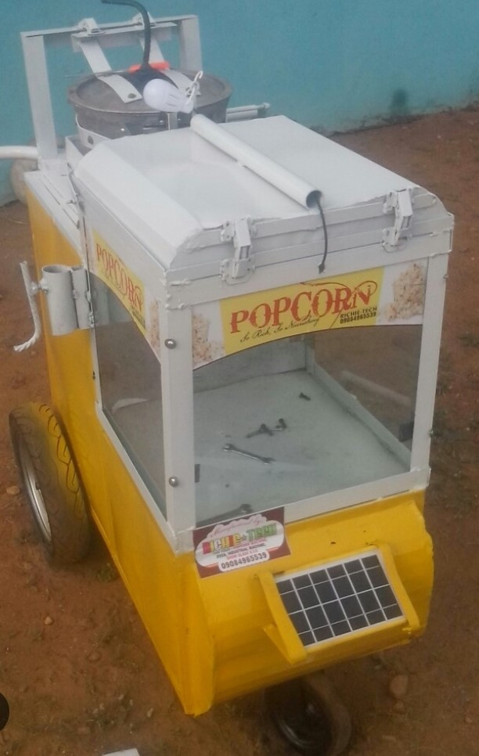

Thesolarpopcornmachineispaintedwithyellowcolourandwelldesign.

CHAPTERFIVE

  - Summary

This project focused on the design and fabrication of a solar-powered popcorn machineaimedatprovidinganeco-friendly,cost-effective,andportablesolution forpopcornproduction,especiallyinruraloroff-gridareas.Themachineutilizes solarenergytogeneratethenecessaryheatforpoppingcorn,eliminatingtheneed for conventional fuel sources such as electricity, charcoal, or gas.
The design incorporated key components such as a solar collector (reflector or panel), a heating chamber, an insulated popping container, and in some models, a battery or energy storage unit. Locally available materials were selected to reduce cost and improve accessibility.

During testing, the machine proved capable of efficiently popping corn under sufficientsunlightconditions.Thesystemoffersseveralbenefits,includingzero carbon emissions, low operational cost, and suitability for outdoor and remote use. However, limitations include dependency on weather conditions and relatively slow operation compared to electric models.

In conclusion, the solar popcorn machine demonstrates a sustainable alternative forsmall-scalesnackproductionandcanbefurtherimprovedthroughadvanced insulation,automaticcontrols,andhybridenergysystems.Itpresentssignificant potential for entrepreneurship and local economic empowerment in developing

regions.

CONCLUSION
The design and fabrication of a solar popcorn machine represent a promising application of solar thermal technology, offering an eco-friendly alternative to conventional popcorn machine. Existing designs leverage parabolic collectors, food-grade popping Chambers, and optional Sun-tracking systems to achieve efficient popping with thermal efficiencies of 50-60%. While challenges like weather dependency and open-source designs enhances accessibility. Future advancementsinthermalstorage,automation,andscalability couldfurtherexpand the adoption of solar popcorn machines, particularly in regions with abundant sunlight and limited access to electricity.

RECOMMENDATIONS
    - Improved Solar Power Storage, It is recommended that future designs incorporate high-capacity lithium-ion batteries or solar power banks to store excess energy. This ensures the machine operates efficiently even during cloudy weather or at night.
    - Use of Advanced Thermal Insulation, Integrating better heat insulation materials (such as ceramic wool or fiberglass insulation) in the popping chamber will help retain heat and improve energy efficiency, resulting in faster popping time and reduced energy loss.

    - Temperature and Timer Control System, Future models should include automatictemperatureregulatorsandtimingsystems.Thesewill: Prevent overheating, Allow uniform popping, Enhance safety, Enable energy conservation, Hybrid System Integration
    - A hybrid energy option combining solar and electrical sources is recommended. This allows the user to switch to grid or generator power when solar energy is insufficient, ensuring continuous operation.
    - Use of Lightweight and Durable Materials, For better portability and reduced manufacturing costs, use materials such as aluminum, stainless steel, or reinforced polymer composites for structural components.
    - User-Friendly Design; The design should be modified to include: Simple interface or control panel, Easy-to-clean compartments, Transparent poppingchambercoversforvisibility,Thisenhancesuserexperience and encourages wider adoption.
    - IncorporationofSafetyFeatures;Installsafetymechanismslike:

Automaticshut-offwhenoverheatingoccurs Insulated outer surfaces to prevent burns Overload protection for electrical circuits
    - EconomicandCommercialFeasibility

It is recommended to conduct a cost-benefit analysis for mass production and commercial distribution, especially in rural or off-grid areas, where solar- powered machines can be a sustainable source of income.
    - Further Research Encourageresearchinto:
Moreefficientsolarthermalcollectors

IntegrationwithInternetofThings(IoT)forremotemonitoring Modular designs for ease of repair and upgrade
    - FieldTestingandCommunityTraining
It is also recommended that prototype models be tested under real-world conditions (e.g., outdoor markets, schools,rural areas), and training programs be offered to teach locals how to operate and maintain the system.

REFERENCES
Adejumo, B. A., & Oluwo,A. A.(2019). Design and fabrication of a solar popcornmachine.JournalofRenewableenergyapplications,12(3),45- 52.

Myprojectcircuits.(2022).Designandfabricationofasolarpopcornmachine.

Retrievedfromhttps://myprojectcircuits.com PBS Food. (2016). The History of popcorn Onwuka, G.I. (2005).( Publisher)
Sobukola,O.P.(2013).(Publisher)
Solarcookerinternational.(2021).Principlesofsolarcooking.Retrievedfrom https://my projectcircuits.com.
Uniprojects.(2023).Designandfabricationofasolarpopcornmachine. Retrieved from https://uniprojects.net.

