ANALYSIS OF CARE SEEKING FOR CHILDREN ILLNESS IN NIGERIA: MULTIVARIATE APPROACH

BY

YUSUF, RAMATALLAHI FUNMILAYO
HND/23/STA/FT/012

A PROJECT SUBMITTED TO THE
DEPARTMENT OF STATISTICS,
INSTITUTE OF APPLIED SCIENCES,
KWARA STATE POLYTECHNIC, ILORIN.

IN PARTIAL FULFILMENT OF THE REQUIREMENT FOR
THE AWARD OF HIGHER NATIONAL DIPLOMA (HND)
IN STATISTICS

JULY, 2025
CERTIFICATION
This is to certify that this project was carried out by Yusuf, Ramatallahi Funmilayo with Matriculation Number HND/23/STA/FT/012.This project has been read and approved as meeting part of the requirement for the award of Higher National Diploma in Statistics.

…………………………. ………………………
Alao N. A. (Ph.D) Date
(Project Supervisor)

…………………………. ……………………..
Ajiboye R.A. Date
(Project Coordinator)

………………………….. ……………………..
Elepo, T. A. (Mrs) Date
(Head of Department)

…………………………… ………………………..
External Examiner Date

DEDICATION
This project is dedicated to the Almighty ALLAH and My beloved parents, Mr And Mrs Yusuf.

ACKNOWLEDGEMENTS
I give thanks to God Most high, for being with me through my academics in Kwara State Polytechnic. I am indebted to my supervisor Dr. Alao N. A., for his suggestions, comments and constant scrutinizing of this work led to several improvements in this work and advancement of knowledge to me.
I am also grateful to Mr. Suleiman S., and my HOD in person of Mrs Elepo, T. A., and the entire lecturers in the Department of Statistics, Kwara State Polytechnic, Ilorin, who mentored and helped me through my studies. May God abundantly reward you all (Amen).
I am also grateful to my parents and my adorable siblings for their unending love and ever supportive actions towards my academics. To my ever dynamic friends, I say a big thank you, for without them learning might have been difficult. I pray God blesses us all. Acknowledgement and thanks are due to numerous authors whose great works we have consulted during the course of this project.

TABLE OF CONTENTS
Title page i
Certification page ii
Dedication iii
Acknowledgements iv
Table of Contents v
List of Tables vi
List of Figures ix
Abstract x
CHAPTER ONE: INTRODUCTION
  - Background to the study 1
1.2 Aim and objectives of the study 3
1.3 Scope and limitation of the study 4
CHAPTER TWO: LITERATURE REVIEW
2.1 Literature Review 5
2.2 Review of the empirical studies 6
CHAPTER THREE: METHODOLOGY
3.1 Source of Data 9
3.2 Statistical Methods 9
3.2.1 Two-way MANOVA 9
3.2.2 Assumption of MANOVA 14
CHAPTER FOUR: DATA PRESENTATION, ANALYSIS AND RESULTS
4.1 Data presentation 16
4.2 Data analysis and results 17
4.2.1 Post Hoc Tests for MANOVA 21
CHAPTER FIVE: SUMMARY, CONCLUSION AND RECOMMENDATIONS
5.1 Summary of findings 24
5.2 Conclusion 25
References 26

LIST OF TABLES
Table 4.1. Dataset on Treatment for ARI symptoms, fever, and diarrhea by Zones 16
Table 4.2. Distribution of Six Geo-political zone 17
Table 4.3. Descriptive Statistics 18
Table 4.4.Multivariate Tests Statistic 20
Table 4.5 MANOVA Table for Tests of Between-Subjects Effects 20
Table 4.6. ARI Post Hoc Tests 21
Table 4.7. FEVER Post Hoc Tests 22
Table 4.8. DIARH Post Hoc Tests 22
Table 4.9 Grand Means for children illness treatment 23

LIST OF FIGURES
Figure 4.1. Pie chart showing the percentage distribution of child illness treatment 18
Figure 4.2. Bar diagram showing the average number of children illness treatment
across the Nigeria regions 19

ABSTRACT
This project focused on number of care seeking for children illness across the six geo political zones in Nigeria using a secondary data obtained from the Nigeria Demographic Health Survey (NDHS) 2023-2024 key indicators. Descriptive statistics and multivariate techniques was employed for the analysis, the results shows that about 48% of children received treatment for fever, 45% of the children were treated for diarrhoea and 7% of the children treated for acute respiratory infection (ARI). Also, the average number of children illness treatment is statistically not the same across the six geo political region in Nigeria. Finally, the overall mean for FEVER (107.838) is the highest follow by DIARH (97.562), then ARI (14.934), respectively. This implies that Nigeria children are mostly affected and treated for FEVER illness.

Keywords: Children, Illness, Nigeria, Geo political zone, MANOVA.

CHAPTER ONE
INTRODUCTION
1.1 Background to the study
Malaria, Pneumonia and Diarrhea are among the leading causes of mortality among the under-fve population across the globe (Sanyang, 2019). In 2018, these three illnesses accounted for almost three out of every ten deaths among under-five in West Africa (Sanyang, 2019). About 70% of deaths due to malaria in 2018 were among children under five while almost 1.7 billion cases of childhood diarrhea and 1,400 cases of pneumonia per 100,000 children occur every year; the trio claims the lives of over 1.5 million children every year (UNICEF, 2021). According to the 2018 Nigeria demographic and health survey (NDHS), the under-five mortality rate in Nigeria is 132 per 1,000 live births; an increase from 128 per 1,000 live births in 2013 (NPC & ICF, 2019).More than 75% of these deaths were as a result of malaria, pneumonia and diarrhea (Adewemimo et al., 2017). Similarly, malnutrition has been associated with increased risk of mortality among children and with an increased risk of death due to diarrhea and pneumonia (Black et al., 2008). Despite their huge burden, these illnesses are preventable through access to lifesaving interventions such as adequate nutrition, vaccination, breastfeeding and are treatable using cost effective essential medicines— pneumonia with effective antibiotics (dispersible amoxicillin tablets), malaria with an artemisinin-based combination therapy (ACT) and diarrhea with oral rehydration salts (ORS) and zinc (Kahabuka et al., 2012; Treleaven et al., 2015). Inadequate access, poor knowledge, and poor care seeking behavior for these life-saving interventions may be responsible for the high burden of these illnesses in developing countries. Several developing countries including Nigeria, have adopted an equity-focused strategy of the World Health Organisations (WHO) referred to as the integrated community case management of childhood illnesses (iCCM). The iCCM strategy is aimed at improving access to lifesaving treatments for children as it can be readily delivered at the community level through community health workers. iCCM complements and extends the reach of public health services by providing timely and effective treatment of malaria, pneumonia and diarrhea to populations with limited access to facility-based health care providers, and especially to children under 5. The strategy has proven to be effective in increasing access to care in hard-to-reach rural communities in different African countries (Oresanya et al., 2019 & Prosnitz et al., 2019). Interventions in African countries have reported its effectiveness in reducing under five mortality by as high as 15% (Oresanya et al., 2019). Through the WHO supported iCCM intervention in Abia and Niger States of Nigeria, community health workers provided lifesaving treatments which contributed to 70% and 80% child lives respectively saved over the course of the intervention in the two states (Oresanya et al., 2019; Isiguzo et al., 2019).
Untreated infections are a major cause of childhood mortality and morbidity in developing countries (Aguilar et al, 1998). While uncomplicated illness can be treated at home, severe illness should be treated by a health professional. Most child deaths occurring in low- and middle-income countries such as Nigeria are attributable to a handful of diseases and are avoidable through existing interventions (WHO, 2004) such as the integrated management of childhood illness (IMCI) strategy developed by the World Health Organization (WHO), the United Nations Children’s Fund and other technical partners (UNICEF, 1999; WHO, 1998 & WHO, 2000). In Nigeria currently 3 out of 20 children die before their fifth birthday, and 70% of these deaths are due to acute respiratory infections (mostly pneumonia), diarrhoea, measles, malaria or malnutrition – and often a combination of these (NPC, 2009 & Policy Project Nigeria, 2002). The WHO has estimated that seeking prompt and appropriate care could reduce child deaths due to acute respiratory infections by 20% (Victora et al., 2000). A high number of children die without ever being taken to a health facility, indicating that the prevalence of appropriate care-seeking is low. Even for those who are taken to a health facility, visits are often not timely enough. Appropriate care-seeking means that the need to take the child for treatment outside the home is recognized, that the care is not delayed, and that the child is taken to an appropriate health facility or provider. Interventions to improve care-seeking behavior include health education of caregivers through training of community health workers (Hill, 2003).
Acute respiratory infection (ARI), fever, and dehydration from diarrhoea are important contributing causes of childhood morbidity and mortality in developing countries (WHO 2003). Prompt medical attention when a child has the symptoms of these illnesses is, therefore, crucial in reducing child deaths. Among children under age 5 who had symptoms of acute respiratory infection (ARI) or had a fever during the 2 weeks preceding the survey, percentage for whom advice or treatment was sought, and among children under age 5 who had diarrhea (DIARH) during the 2 weeks preceding the survey, percentage for whom advice or treatment was sought, percentage given a fluid made from oral rehydration salt (ORS) packets or given prepackaged ORS fluid, percentage given zinc, percentage given ORS and zinc, and percentage given ORS, zinc, and continued feeding, according to background characteristics, Nigeria DHS 2023–24
1.2 Aim and Objective of the study
The aim of this research work is to study the number of child illness treatment in Nigeria based on reports from six geo-political zone using Multivariate approach.
Objectives are
- To the study distribution of child illness treatment in Nigeria as per zone
- To determine if there is significant difference among the treatment of child illness
- To determine if there is significant difference between child illness treatment from the zone
1.3 Scope and limitation of the study
The analysis covers dataset on some selected three child illness which is acute respiratory infection (ARI), fever and diarrhea, respectively and the results are limited to dataset on care seeking for child illness in Nigeria as reported in NDHS 2023-2024 key indicators report only.

CHAPTER TWO
LITERATURE REVIEW
2.1 Literature Review
Patent and proprietary medicine vendors (PPMVs) are gradually becoming an integral part of the Nigerian health system especially for their role in the delivery of primary healthcare services and products. This is due to their presence even in hard-to-reach areas, long opening hours and consistency of service availability unlike government owned health facilities (Oyeyemi et al., 2020). Although, there are concerns about the quality of services being provided by PPMVs (Liu et al., 2016; Beyeler et al., 2015), they still remain a major source of healthcare services in urban and rural settings in Nigeria. According to 2018 NDHS, PPMVs were the most soughtafter source of advice or treatment for fever, diarrhea and acute respiratory infections (ARIs) for under five children compared to other sources including private and public hospitals, community health workers (NPC & ICF, 2019). Also, PPMVs sell and are a major source of orthodox medicines for acute conditions including malaria, diarrhea and pneumonia. Research has shown that several PPMVs in Nigeria have formal and health or medical training which are comparable to community health workers, who have been used to scale up iCCM interventions (Treleaven et al., 2015). Te “Delivering Healthcare to all Children” (Del2All) project is a one-year project of Society for Family Health (SFH) which is targeted at improving PPMVs’ capacity to manage uncomplicated cases of common childhood illnesses (pneumonia, malaria & diarrhea) and to improve community knowledge, care seeking behavior and uptake of services for these illnesses in Ebonyi and Kaduna States. This study was designed as part of the evaluation plan of the project, to explore child health services offering, commodity stocking patterns and case management knowledge for childhood illnesses (Malaria, Pneumonia and Diarrhea among under-five children) among PPMVs in selected local government areas (LGAs) in Ebonyi and Kaduna States. Findings from this study will assist stakeholders in the health sector to better understand the roles PPMVs have in the provision of child health services, identify gaps, and will provide an evidence-base for interventions targeted at improving child health in communities through PPMVs.
According to Nigeria DHS (2024), the overall care seeking for ill children in Nigeria, 2% of children under age 5 showed symptoms of an ARI, 16% had a fever, and 15% experienced diarrhoea in the 2 weeks preceding the survey. Advice or treatment was sought for 60% of children with symptoms of ARI in the 2 weeks before the survey. Also, advice or treatment was sought for 60% of children with a fever in the 2 weeks before the survey while advice or treatment was sought for 60% of children with diarrhoea in the 2 weeks before the survey. Forty-seven percent of children with diarrhoea received oral rehydration salts (ORS), 33% received zinc supplements, 24% received ORS and zinc supplements, and 16% received ORS, zinc supplements, and continued feeding.
2.2 Review of empirical studies
One of the main components of effective health service delivery is the constant availability of essential medical commodities which includes drugs and equipment (WHO, 2004). Poor quality of care and health service delivery are sometimes attributable to shortage of medical commodities. Although, our respondents reported that they do experience stock-out of ACTs, Amoxycilin DT, ORS and Zinc, in most cases, these stock-out last about a week or sometimes, almost a month. The observed relative stock outs of drug supplies for the treatment of childhood illnesses among PPMV outlets in this study compares favorably to most affordable government-owned health facilities as reported in a survey among Nigerian hospitals (Oyekale, 2017). This is because as majority of the PPMVs in this study who experienced stock out in the month preceding the study claimed that the stockout lasted less than a week. Non-availability of medicines in public hospitals among other barriers, affects the ability of patients to seek care and influences choices of place of care with preference for PPMVs among Nigerians (Ushie et al., 2016 & Muhammed et al., 2013). A major challenge in achieving improved outcomes in the management of any illness is the lack of proper clinical management knowledge among service providers. Although, PPMVs do not have a formal training in the management of childhood illnesses, they provide this service. Akuiyibo et al. (2022), studies have shown that community management of pneumonia is difficult when compared to malaria. Similarly, a higher proportion of our respondents had incorrect knowledge of pneumonia management (diagnosis and treatment) compared to other illnesses. Tis is indicative of a huge knowledge gap among PPMVs in pneumonia, malaria and SAM management among under 5 s that can be addressed through exposure to iCCM trainings. We observed a significant relationship between age, level of education, state, health training background and knowledge of common childhood illnesses management. Tis is similar to the findings in study by Treleaven et al. (2015) where education and health training were found to the significantly associated with knowledge of childhood illnesses management. Also, more than half of the management of childhood illness, a significant proportion were not aware of some referral signs such as chest in drawing, unusual sleepiness, swelling on both feet, etc. A study among community health workers in Ghana also reported low number of referrals (Chinbuah et al., 2013). The observed inadequate knowledge of some danger/referral signs among cases with severe/complicated childhood illnesses suggests that a significant proportion of PPMVs might continue to manage such cases even when there are no observable improvements; this poses great risks to the life of such children.
Akuiyibo et al. (2022), results shows that a total of 374 PPMVs were interviewed; the mean age was 33.7±9.8 years. Among the 132 health trained respondents, 59.0% offer treatment services for sick children while 83.5% of the non-health trained respondents offer the same service. At least, 88.0% of the respondents keep stock ACTs, Amoxycilin DT, ORS and Zinc. About 38.5% reported stock-out of ACTs in the month preceding the study, 55.1% reported stock out lasting only 0 to 6 days. Only 83 (22.2%) of respondents knew the correct diagnosis of fast breathing among children aged 2 to less than 12 months old. Education and health training background were associated with a good knowledge of common childhood illnesses management (X²=44.88, p<0.001).
According to Ogundele et al., (2016), care-seeking for children who reported illness was higher in the CIMCI-implementing LGA (90.2%) compared with 74.8% in the non-implementing LGA (p=0.002). Care was sought within the first 48 hours of perceived onset of illness for 83.2% and 57.9% of sick children in the CIMCI-implementing and non-implementing LGAs, respectively. Residing in a CIMCI-implementing area (odds ratio (OR) 2.54, 95% confidence interval (CI) 1.24 - 5.45) and maternal education level (OR 1.50, 95% CI 1.06 - 3.03) were identified as predictors of healthcare-seeking practices among mothers. The study concluded that a high level of care-seeking behavior exists where community-level intervention was operating. Therefore the CIMCI programme should be strengthened further and also scaled up to include non-implementing communities.

CHAPTER THREE
METHODOLOGY
3.1 Sources of data
The data used for this project work is secondary data obtained from the Nigeria Demographic Health Survey (NDHS) 2023-2024 key indicators on care seeking child illness across the geo political region in Nigeria.
3.2 Statistical methods

3.2.1 Two-way MANOVA
Two-way MANOVA can be considered to be an extension of one-way MANOVA to support two factors and their interaction or as an extension to two-way ANOVA to support multiple dependent variables.

Univariate case
Two-way ANOVA investigates the effects of two categorical variables on a continuous outcome (the dependent variable). In two-way ANOVA, we have r random variables (the levels) for Factor A (the row factor) and c random variables for Factor B (the column factor). For each interaction between the factor levels, we have a sample with m elements (we restrict ourselves to the balanced model here). We can represent the sample for the i^{th} level from Factor A and the j^{th} level from Factor B by X_{ij} = {x_{ij1}, …, x_{ijm}}.
Our objective is to test three types of null hypotheses:
H₀: μ_{1.} = μ_{2.} = … = μ_{r.} (Factor A)
H₀: μ_{.1} = μ_{.2} = … = μ_{.c} (Factor B)
H₀: δ_{ij}= 0 for all i, j (Interaction between A and B, where the δ_{ij} are the interaction effects
We define the following where n = mrc.
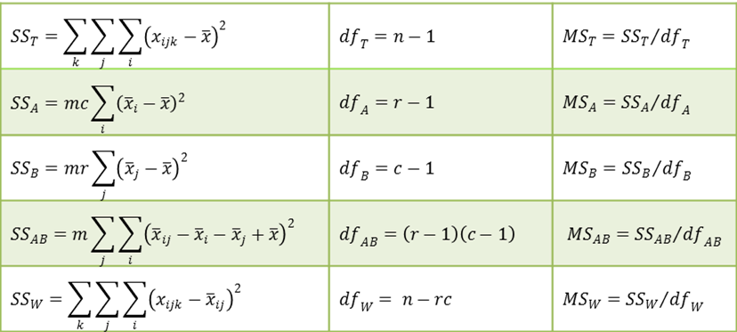
The test statistics F are defined as follows:
For each of the three null hypotheses, we reject the null hypothesis if F > F_{crit}.

Multivariate case
As for one factor MANOVA, two-factor MANOVA is similar to two-factor ANOVA except that in place of simple variables (for each factor) we have random vectors and in place of sample data {x_{ij1}, …, x_{ijm}} for the i^{th} level in Factor A and the j^{th} level in Factor B, we have sample data {X_{ij1}, …, X_{ijm}} where each X_{ijk} is a p × 1 column vector of data elements of the form x_{ijkh}. Here, there are p dependent variables.
The additive model takes the form:
This is exactly as for a two-factor ANOVA model except that x_{ijk} is replaced by X_{ijk} and the other terms are column vectors instead of scalars. With this change, the null hypotheses are as for ANOVA. In place of the ANOVA normality assumption, assume multivariate normality, namely
The df terms are as for ANOVA, as defined above, and the SS terms are defined in terms of the following p × p cross-product matrices.
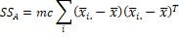
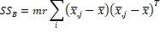
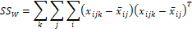
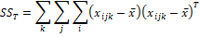
Recall that each of these SS matrices takes the form
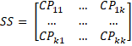
where for SS_{A}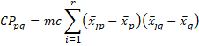
and similarly for the other SS matrices.

Wilk’s Lambda
Each of the three null hypotheses is tested using the appropriate Wilk’s Lambda.
If the Factor H null hypothesis is true (for H = A, B or AB) then
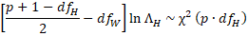
As for one factor MANOVA, a more accurate test is based on the F test, described as follows:
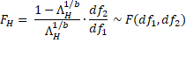
where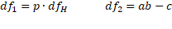
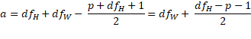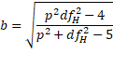
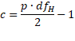If either the numerator or denominator of b equals 0 or results in a negative value inside the square root, then b takes the value of 1.

Hotelling-Lawley Trace
Each of the three null hypotheses is tested using the appropriate Hotelling-Lawley Trace test.
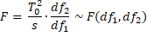
where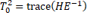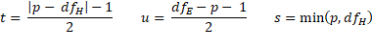

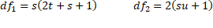

Pillai-Bartlett Trace
Each of the three null hypotheses is tested using the appropriate Pillai-Bartlett Trace test.
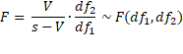
where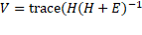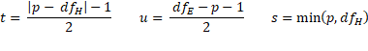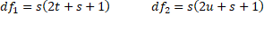
Roy’s Largest Root
Each of the three null hypotheses is tested using the appropriate Roy’s Largest Root test.
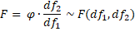
where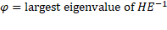
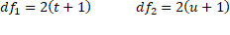
and s, t, u are as for the Pillai-Bartlett Trace test.

3.2.2 Assumption of MANOVA
- One of the assumptions of MANOVA is that the response variables come from group populations that are multivariate normal distributed. This means that each of the dependent variables is normally distributed within group, that any linear combination of the dependent variables is normally distributed, and that all subsets of the variables must be multivariate normal. With respect to Type I error rate, MANOVA tends to be robust to minor violations of the multivariate normality assumption.
- The homogeneity of population covariance matrices (a.k.a. sphericity) is another assumption. This implies that the population variances and covariances of all dependent variables must be equal in all groups formed by the independent variables.
- Small samples can have low power, but if the multivariate normality assumption is met, the MANOVA is generally more powerful than separate univariate tests.

CHAPTER FOUR
DATA ANALYSIS AND RESULTS
4.1 Data presentation
The dataset used for this project are shown in Table 4.1 below showing the distribution of care seeking child illness across the six geo political zones in Nigeria.
Table 4.1. Dataset on Treatment for ARI symptoms, fever, and diarrhea by Zones
ARI | FEVER | DIARH | ZONE
9 | 52 | 44 | North Central
4 | 45 | 16 | North Central
8 | 58 | 43 | North Central
5 | 16 | 17 | North Central
4 | 116 | 120 | North Central
10 | 138 | 68 | North Central
12 | 58 | 49 | North Central
27 | 63 | 101 | North East
22 | 178 | 227 | North East
75 | 104 | 129 | North East
5 | 90 | 58 | North East
1 | 28 | 25 | North East
34 | 243 | 271 | North East
30 | 170 | 228 | North West
94 | 637 | 611 | North West
114 | 691 | 752 | North West
22 | 204 | 245 | North West
22 | 139 | 185 | North West
45 | 62 | 70 | North West
3 | 95 | 55 | North West
0 | 54 | 12 | South East
3 | 49 | 23 | South East
1 | 142 | 78 | South East
1 | 26 | 4 | South East
6 | 97 | 57 | South East
5 | 107 | 28 | South South
10 | 45 | 25 | South South
4 | 43 | 34 | South South
1 | 58 | 29 | South South
5 | 39 | 12 | South South
2 | 60 | 20 | South South
0 | 13 | 5 | South West
1 | 82 | 35 | South West
0 | 81 | 85 | South West
1 | 13 | 16 | South West
3 | 35 | 25 | South West
1 | 32 | 33 | South West
Source: Nigeria Demographic and Health Survey 2023-2024 key indicators reports
4.2 Data analysis and results
Table 4.2. Distribution of Six Geo-political zone
 |  | Value Label | N
ZONE | 1 | North Central | 7
ZONE | 2 | North East | 6
ZONE | 3 | North West | 7
ZONE | 4 | South East | 5
ZONE | 5 | South South | 6
ZONE | 6 | South West | 6

The Table 4.2 showing distribution of information with respect to the category of factors considered for analysis

Table 4.3. Descriptive Statistics

Table 4.3 showing distribution of children illness treatment across the geo political zones in Nigeria. The Table 4.3 is graphically represented in Figure 4.2 below.
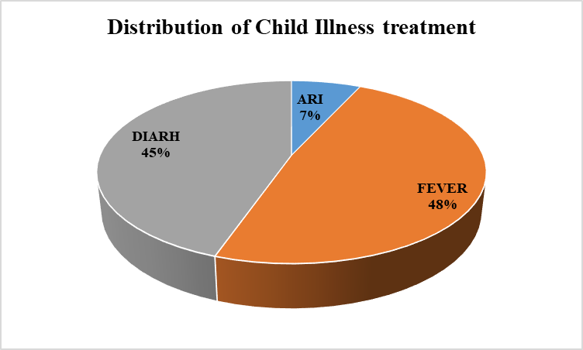
Figure 4.1. Pie chart showing the percentage distribution of child illness treatment

From Figure 4.1, 48% of children received treatment for fever, 45% children were treated for diarrhoea and 7% children treated for acute respiratory infection (ARI).
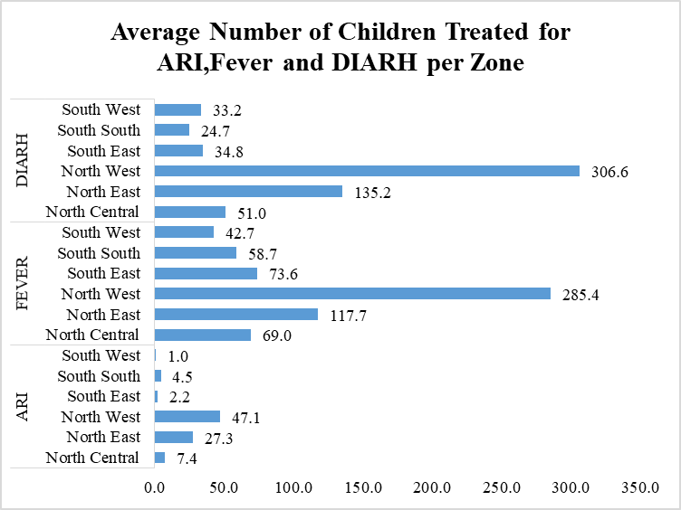
Figure 4.2. Bar diagram showing the average number of children illness treatment across the Nigeria regions

From Figure 4.2, North West (306.6) average for DIARH is the highest, i.e. North West children are mostly affected with DIARH illness. Also, North West average for fever (285.4) and ARI (47.1) which is highest among the zones indicates that the children from the North West zone are mostly affected by FEVER and ARI illness. However, the South South (24.7) zone average is the lowest for DIARH indicating the children from the zone is least affected by DIARH illness. The South West zone FEVER (42.7) and ARI (1.0) average, respectively is the lowest among the zones which implies that the children for South West were least affected by FEVER and ARI illness.

Table 4.4.Multivariate Tests Statistic
Effect |  | Value | F | Hypothesis df | Error df | Sig.
Intercept | Pillai's Trace | 0.518 | 10.395ª | 3 | 29 | 0.000
Intercept | Wilks' Lambda | 0.482 | 10.395ª | 3 | 29 | 0.000
Intercept | Hotelling's Trace | 1.075 | 10.395ª | 3 | 29 | 0.000
Intercept | Roy's Largest Root | 1.075 | 10.395ª | 3 | 29 | 0.000
ZONE | Pillai's Trace | 0.765 | 2.123 | 15 | 93 | 0.015
ZONE | Wilks' Lambda | 0.351 | 2.475 | 15 | 80.458 | 0.005
ZONE | Hotelling's Trace | 1.531 | 2.824 | 15 | 83 | 0.001
ZONE | Roy's Largest Root | 1.303 | 8.077^{b} | 5 | 31 | 0.000

From Table 4.4, all the p-value (0.015, 0.005, 0.001, 0.000) for the multivariate statistics are less than α = 0.05 (level of significance) indicate that the null hypothesis (H₀) is rejected and conclude that the average number of children illness treatment are significantly differs across the zones. That is, the average number of children illness treatment is statistically not the same across the six geo political region in Nigeria.
Table 2. MANOVA Table for Tests of Between-Subjects Effects

From Table 4.5, the p-value ARI (0.002), FEVER (0.011) and DIARH (0.002) are less than α = 0.05 (level of significance) indicate that the H₀ is rejected, and conclude that the average number of children illness treatment are significantly differs across the six geo political zones.
Therefore, a post hoc (multiple comparison) test was conducted to determine the zone with most significant for children illness treatment and the results are shown in Table 4.6 to 4.8, respectively.
4.2.1 Post Hoc Tests for MANOVA
In this section a post hoc test was conducted using Duncan multiple range test (DMRT) and results are shown in the Table 4.6 to Table 4.8 below.

Table 4.6. ARI Post Hoc Tests
ZONE | N | Subset
ZONE | N | 1 | 2
South West | 6 | 1.0000
South East | 5 | 2.2000
South South | 6 | 4.5000
North Central | 7 | 7.4286
North East | 6 | 27.3333 | 27.3333
North West | 7 |  | 47.1429
Sig. |  | .059 | .112

From Table 4.6, children with ARI illness treatment for both the North West (47.1429) and North East (27.3333) geo political zone are more significant when compare with other zones. However, North West with higher marginal mean of 47.1429 is the most significant.

Table 4.7. FEVER Post Hoc Tests
ZONE | N | Subset
ZONE | N | 1 | 2
South West | 6 | 42.6667
South South | 6 | 58.6667
North Central | 7 | 69.0000
South East | 5 | 73.6000
North East | 6 | 1.1767E2
North West | 7 |  | 2.8543E2
Sig. |  | .354 | 1.000

From Table 4.7, children with FEVER illness treatment for the North West (285.43) geo political zone is more significant when compare with other zones.

Table 4.8. DIARH Post Hoc Tests
ZONE | N | Subset
ZONE | N | 1 | 2
South South | 6 | 24.6667
South West | 6 | 33.1667
South East | 5 | 34.8000
North Central | 7 | 51.0000
North East | 6 | 1.3517E2
North West | 7 |  | 3.0657E2
Sig. |  | .184 | 1.000

From Table 4.8 children with DIARH illness treatment for the North West (306.57) geo political zone is more significant when compare with other zones.

Table 4.9 Grand Means for children illness treatment
Dependent Variable | Mean | Std. Error | 95% Confidence Interval
Dependent Variable | Mean | Std. Error | Lower Bound | Upper Bound
ARI | 14.934 | 3.498 | 7.800 | 22.068
FEVER | 107.838 | 20.471 | 66.086 | 149.590
DIARH | 97.562 | 20.950 | 54.834 | 140.290

From Table 4.9, the overall mean for FEVER (107.838) is the highest follow by DIARH (97.562), then ARI (14.934), respectively. This implies that Nigeria children are mostly affected and treated for FEVER illness.

CHAPTER FIVE
SUMMARY AND CONCLUSION
5.1 Summary of the findings
- From Figure 4.1, 48% of children received treatment for fever, 45% children were treated for diarrhoea and 7% children treated for acute respiratory infection (ARI).
- From Figure 4.2, North West (306.6) average for DIARH is the highest, i.e. North West children are mostly affected with DIARH illness. Also, North West average for fever (285.4) and ARI (47.1) which is highest among the zones indicates that the children from the North West zone are mostly affected by FEVER and ARI illness. However, the South South (24.7) zone average is the lowest for DIARH indicating the children from the zone is least affected by DIARH illness. The South West zone FEVER (42.7) and ARI (1.0) average, respectively is the lowest among the zones which implies that the children for South West were least affected by FEVER and ARI illness.
- From Table 4.4, all the p-value (0.015, 0.005, 0.001, 0.000) for the multivariate statistics are less than α = 0.05 (level of significance) indicate that the null hypothesis (H₀) is rejected and conclude that the average number of children illness treatment are significantly differs across the zones. That is, the average number of children illness treatment is statistically not the same across the six geo political region in Nigeria.
- From Table 4.5, the p-value ARI (0.002), FEVER (0.011) and DIARH (0.002) are less than α = 0.05 (level of significance) indicate that the H₀ is rejected, and conclude that the average number of children illness treatment are significantly differs across the six geo political zones.
- Therefore, a post hoc (multiple comparison) test was conducted to determine the zone with most significant for children illness treatment and the results are shown in Table 4.6 to 4.8, respectively.
- The children with ARI illness treatment for both the North West (47.1429) and North East (27.3333) geo political zone are more significant when compare with other zones. The children with FEVER illness treatment for the North West (285.43) geo political zone is more significant when compare with other zones. Also, children with DIARH illness treatment for the North West (306.57) geo political zone is more significant when compare with other zones.
- From Table 4.9, the overall mean for FEVER (107.838) is the highest follow by DIARH (97.562), then ARI (14.934), respectively. This implies that Nigeria children are mostly affected and treated for FEVER illness.

5.2 Conclusion
Based on the analysis, the results shows that about 48% of children received treatment for fever, 45% of the children were treated for diarrhoea and 7% of the children treated for acute respiratory infection (ARI). Also, the average number of children illness treatment is statistically not the same across the six geo political region in Nigeria. Finally, the overall mean for FEVER (107.838) is the highest follow by DIARH (97.562), then ARI (14.934), respectively. This implies that Nigeria children are mostly affected and treated for FEVER illness.

Reference
Adewemimo A, Kalter HD, Perin J, Kof AK, Quinley J, Black RE. (2017). Direct estimates of cause-specifc mortality fractions and rates of under-five deaths in the northern and southern regions of Nigeria by verbal autopsy interview. PLoS One.; 12(5):e0178129.
Aguilar AM, Alvarado R, & Cordero D, et al. (1998) Mortality Survey in Bolivia: The Final Report. Investigating and Identifying the Causes of Death for Children Under Five. Arlington, USA: Basic Support for Institutionalizing Child Survival (BASICS) Project.
Akuiyibo, S. M., Anyanti, J., Amoo, B. A., Aizobu, D., & Idogho. O. (2022). Common childhood illnesses: a cross-sectional study of commodity stocking patterns and management knowledge among patent and proprietary medicine vendors in Nigeria, Archives of Public Health; 80:88
Beyeler N, Liu J, & Sieverding M. (2015). A systematic review of the role of proprietary and patent medicine vendors in healthcare provision in Nigeria. PLoS One.;10(1):e0117165. https://doi.org/10.1371/journal.pone. 0117165 (Published online).
Black RE, Allen LH, & Bhutta ZA, et al. (2008). Maternal and child undernutrition: global and regional exposures and health consequences. Lancet.; 371(9608):243–60.
Chinbuah MA, Abbey M, Kager PA, et al. (2013). Assessment of the adherence of community health workers to dosing and referral guidelines for the management of fever in children under 5 years: a study in Dangme West District Ghana. Int Health.; 5(2):148–56.
Federal Ministry of Health and Social Welfare of Nigeria (FMoHSW), National Population Commission (NPC) [Nigeria], and ICF. (2024). Nigeria Demographic and Health Survey 2023–24: Key Indicators Report. Abuja, Nigeria, and Rockville, Maryland, USA: NPC and ICF.
Hill Z. (2003) Recognized childhood illness and their traditional explanation: Exploring options for care seeking interventions in the context of the IMCI strategy. Trop Med Int Health; 8(7):668-676.
Isiguzo C, Herrera S, & Ufere J, et al. (2019). Improving access to appropriate case management for common childhood illnesses in hard-to-reach areas of Abia State, Nigeria. J Glob Heal Reports.; 3:e2019030.
Kahabuka C, Kvåle G, & Hinderaker SG. (2012). Factors associated with severe disease from malaria, pneumonia and diarrhea among children in rural Tanzania - A hospital-based cross-sectional study. BMC Infect.; 12:219.
Liu J, Prach LM, & Treleaven E, et al. (2016). The role of drug vendors in improving basic health-care services in Nigeria. Bull World Health Organ.; 94(4):267–75.
Muhammed KA, Umeh KN, Nasir SM, & Suleiman IH. (2013). Understanding the barriers to the utilization of primary health care in a low-income setting: Implications for health policy and planning. J Public Health Africa.;4(2):e13.
National Population Commission (2009). Nigeria Demographic and Health Survey 2008. Calverton, USA: ICF Macro.
National Population Commission (NPC) [Nigeria] and ICF (2019). Nigeria Demographic and Health Survey 2018 Key Indicators Report. Abuja, Nigeria, and Rockville, Maryland, USA: NPC and ICF. 2019.
National Population Commission (NPC) [Nigeria], ICF (2019). Nigeria Demographic Health Survey 2018. Maryland: DHS Progr ICF Rockville; Published online.
Ogundele, O. A., Ogundele, T., Olajide, O. S., & Agunbiade, O. I. (2016).Effect of community integrated management of childhood illness on mothers’ healthcare-seeking behavior and home management of childhood illness in Ile-Ife, South-West Nigeria: A household survey, S Afr J Child Health; 10(1):16-19.
Oresanya O, Counihan H, Nndaliman I, et al. (2019). Efect of community-based intervention on improving access to treatment for sick under-fve children in hard-to-reach communities in Niger State,Nigeria. J Glob Health. ; 9(1):010803.
Oyekale AS (2017). Assessment of primary health care facilities’ service readiness in Nigeria. BMC Health Serv Res.; 17(1):172.
Oyeyemi AS, Oladepo O, Adeyemi AO, Titiloye MA, Burnett SM, & Apera I. (2020). The potential role of patent and proprietary medicine vendors’ associations in improving the quality of services in Nigeria’s drug shops. BMC Health Serv Res.; 20(1):567.
Policy Project Nigeria (2002). Child Survival in Nigeria: Situation, Response, and Prospects. http://www.policyproject.com/pubs/countryreports/ nig_csrevised.pdf (accessed 28 January 2016).
Prosnitz D, Herrera S, Coelho H, Davis LM, Zalisk K, Yourkavitch J. (2019). Evidence of impact: ICCM as a strategy to save lives of children under five. J Glob Health.; 9(1):010801.
Sanyang Y. (2019). Prevalence of under-fve years of age mortality by infectious diseases in West African region. Int J Africa Nurs Sci.; 11: 100175.
Treleaven E, Liu J, Prach LM, & Isiguzo C. (2015). Management of paediatric illnesses by patent and proprietary medicine vendors in Nigeria. Malar J.; 14:232.
UNICEF (2021). Childhood diseases. Available from: https://www.unicef.org/ health/childhood-diseases. Accessed 27 Sept 2021.
United Nations Children’s Fund (1999). A Working Paper on Home and Community Health Care to Enhance Child Survival, Growth and Development. New York: UNICEF.
Ushie BA, Ugal DB, & Ingwu JA. (2016). Overdependence on for-profit pharmacies: A descriptive survey of user evaluation of medicines availability in public hospitals in selected Nigerian states. PLoS One.; 11(11):e0165707.
Victora C, Jennifer B, Olivier F, Roeland M. (2000). Reducing deaths from diarrhoea through oral rehydration therapy. Bull WHO; 1(78):10.
World Health Organization (1998). Improving family and community practices. A component of the IMCI strategy. Bull WHO; 73(15):119-128.
World Health Organization (2004). World Health Report. Geneva, Switzerland: World Health Organization.
World Health Organization (WHO). 2003. World Health Report 2003. Geneva: WHO.
World Health Organization/Child and Adolescent Health (2000). Community and Household Moving Forward Programme – Report. Geneva: World Health Organization.

