DESIGN AND FABRICATION OF A HYBRID DRYER FOR AGRICULTURAL
PRODUCE
BY

ABDULRASAQ ISMAIL
HND/23/ABE/FT/0009

DEPARTMENT OF AGRICULTURAL AND BIO – ENVIRONMENTAL
ENGINEERING, INSTITUTE OF TECHNOLOGY, KWARA STATE
POLYTECHNIC, ILORIN

INPARITAL FULFILLMENT OF REQUIREMENT FOR THE AWARD OF
HIGHER NATIONAL DIPLOMA (HND) IN AGRICULTURAL AND BIO-
ENVIRONMENTAL ENGINEERING TECHNOLOGY.

SUPERVISE BY:
ENGR. OLUFEMI D.O.

Dated:
4TH OF AUGUST 2025
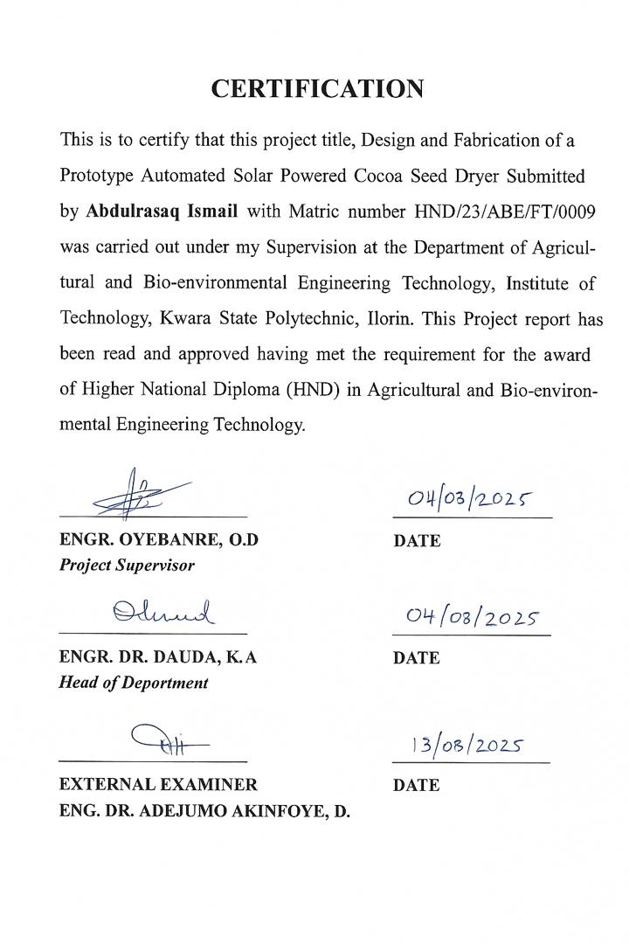

DEDICATION
This project is a heartfelt tribute to my cherished fathers, Abdulrasaq Adekeye (departed March 2013) and Abdul Fatai Adekeye (departed July 2025). Your enduring wisdom, strength, and love illuminate my path daily. Though you are no longer with me, your spirit thrives in all I undertake. May this endeavor honor the Adekeye legacy, carrying your names forward with pride and devotion.

ACKNOWLEDGEMENT
I extend my deepest gratitude to my project supervisor, Engineer Olufemi David Oyebanre, whose invaluable guidance, expertise, and unwavering encouragement were pivotal to the successful completion of this project. His commitment to my academic growth has been truly inspiring.
My heartfelt appreciation goes to the Department of Agricultural and Bio-Environmental Engineering Technology, Kwara State Polytechnic, for fostering a supportive and enriching learning environment. The mentorship and knowledge shared by the department’s lecturers have been instrumental in shaping this project and my academic journey.
I am immensely grateful to my course mates and project colleagues, Muhammed Rukayat, Okikiola Samson (Wizstar), Abdullahi Abdulazeez Olamilekan(prof lee) Adebimpe, 001, and Gracious Grace. Your collaboration, innovative ideas, and steadfast support through countless brainstorming sessions and challenges made this project a true team effort. Your contributions have left an indelible mark on this achievement, and I am thankful for your camaraderie.
To my cherished family, I owe an immeasurable debt of gratitude. My dear mother, Mrs. Abdurasaq Sakirat, your ceaseless prayers and unwavering support have been my foundation. My little sister, Aishat Abdulrasaq, your infectious cheer and love have brightened even the toughest days.
To my dearest partner, Bamidele Adesewa, thank you for your patience, encouragement, and unyielding belief in me, especially during the most trying moments. Your presence has been a cornerstone of this accomplishment.
This project is a collective triumph, reflecting the love, effort, and inspiration of everyone involved. I hope it honors the legacy of my fathers and makes them proud as I carry the Adekeye name forward with dignity.

ABSTRACT
This research focused on the development and evaluation of a prototype solar automated cocoa seed dryer designed to enhance the drying process of Theobroma cacao seeds. The study aimed to fabricate a solar-powered drying system integrating key components such as a collector, fan, monitoring equipment, solar panel, drying chamber, frame, and trays, with structural elements welded using an electric arc welding machine for durability and integrity. Experimental trials were conducted varying sample mass (1000–3000 g) and air flow rate (0.4–0.6 kg/h) to assess the drying rate and drying efficiency of cocoa seeds under controlled solar drying conditions. Results demonstrated significant effects of both mass of sample and air flow rate on drying performance, with drying rates ranging from 0.024 to 0.042 kg/h and drying efficiencies between 78.3% and 96.3%. Statistical analysis using ANOVA highlighted the significance of the model (p < 0.0001) in influencing drying rate and efficiency, with no significant lack of fit, confirming the reliability of the experimental design. The optimized conditions suggested that lower mass and moderate air flow improved drying efficiency, thereby expediting the drying process while preserving seed quality. This prototype offers a sustainable alternative to conventional drying methods by harnessing solar energy, potentially reducing post-harvest losses and enhancing cocoa production efficiency in regions with abundant solar resources

TABLE OF CONTENT
Title Page i
Certification ii
Dedication iii
Acknowledgement iv
Table of Contents v
Abstract vii
List of Figure viii
List of Plates ix
List of Tables x
CHAPTER ONE: INTRODUCTION
  - Background to the Study 1
  - 1.2 Problem statement of the Study 2
1.3 Aim and Objectives of the Study 2
1.4 Scope of the Study 3
1.5 Justification of the Study 3
CHAPTER TWO
2.1 Preamble 4
2.2 Existing Cocoa Bean Dryers 5

2.2.1 Direct Solar Dryers 6

2.2.2 Greenhouse/Glass Roof Dryers 6

2.2.3 Intermittent or Forced-Convection Solar Dryers 7

2.2.4 Performance Parameters 7
2.3 Method of drying Cocoa 7
2.3.1 Traditional method of drying Cocoa 8
2.3.2 Modern method of drying Cocoa 8
2.4 Methods of drying cocoa worldwide 9

2.4.1 Performance Characteristics 9

2.4.2 Design Recommendations for Cocoa Hybrid Dryer 9
CHAPTER THREE: Materials and Methods
3.1 Design Considerations 10
3.2 Description of the Hybrid Dryer 10
3.2.1 Collector 11
3.2.2 Drying Chamber 11
3.2.3 Trays 12
3.2.4 Fans 13
3.2.5 Frame 13
3.2.6 Monitoring equipment 14
3.2.7 Hinges and lock 15
3.2.8 Solar Battery 15
3.2.9 Solar Panel 15
3.2.10 Charge controller 16
3.3 Hybrid Dryer Parts Design 16
3.4 Moisture Content 19
3.5 The Mass of water evaporated or moisture loss 19
3.6 Average Drying Rate 20
3.7 Principle of Operation of the Hybrid Dryer 21
3.8 Experimental procedure 21
3.9 Material used for construction of Solar Dryer 23
3.10 Tools and Equipment 26
3.11 Design Layout 29
CHAPTER FOUR: Results and Discussion
4.1 Result 32
4.2 Discussion 33
CHAPTER FIVE: Conclusion and Recommendation
5.1 Conclusion 37
5.2 Recommendation 38
References 39

List of Figures
Figure 4.1: Effect of Air Flow Rate and Mass of Sample on the Drying Rate of Cocoa 26
Figure 4.2: Effect of Air Flow Rate and Mass of Sample on the Drying Efficiency of Cocoa 26

LIST OF PLATES
Plate 3.1a: Pictorial view of Electric Arc Welding 26
Plate 3.1b: Pictorial view of Grinding Machine 28
Plate 3.1c: Pictorial view of Thong 28
Plate 3.1d: Pictorial view of Small Grinder 29

LIST OF TABLES
Table 3.1: Experimental Design Matrix (Box-behnken Design) with the Factors 25
Table 4.1: Summary of Result of Cocoa Drying Using the Fabricated Hybrid 26
Table 4.2: Analysis of Variance (ANOVA) for the Drying Rate of Cocoa Bean 26
Table 4.3: Analysis of Variance (ANOVA) for the Drying Efficiency of Cocoa 26
Table 4.4: Bill of Engineering Measurement and Evaluation. 27

\

CHAPTER ONE
INTRODUCTION
1.1 Background of the Study
Cocoa beans are produced in humid tropics with annual mean temperature of over 24°C, high relative humidity levels and varied annual rainfall ranges between 1500 and 3000mm. In Africa, where most of the cocoa beans are processed for export, seasonal variations in weather conditions (i.e. unpredictable duration of dry and wet seasons in tropical region) may impact the q uality of the dried and the overall production yield. For example, dry weather patterns experience across West Africa in the early part of year 2011/2012 led to a forecast of production short-falls that year; although, increase in rainfall experienced later in the year and through March 2012, made up for the production deficit (World Cocoa Foundation, 2012). Most African countries experience climatic changes throughout the year, a dry season which last up to four months and a protracted wet season for the rest of the year (Lass, 1985). Other cocoa-producing regions of the world such as India, experience a more pronounced dry season while cocoa producing region in tropical South East Asia and Indonesia experience a more uniform warm and wet climate (Lass, 1985).
Fermentation and drying processing steps are very key to the overall quality of the final dried cocoa bean product (Zahouli et al., 2010). The fermentation process is necessary for improving the flavor and amino-acid profile of the cocoa beans and to break down the mucilaginous pulp surrounding the bean, thereby leading to reduced bitterness and astringency (Adeyeye et al., 2010; Afoakwa et al., 2008; Rodriguez-Campos et al., 2011; Thompson et al., 2013).
Natural drying (such as open-air sun drying and solar dryers) methods, when done properly, have been re-ported to produce better quality cocoa beans than artificial hot air-drying methods (Bonaparte et al., 1998). The natural drying methods allows slow removal of moisture, continuous fermentation and flavor development leading to a high-quality cocoa bean product; while artificial drying method causes rapid moisture removal, with high content of titratable acid, propion-ic acid, butyric acid, isobutyric, and isovaleric acids all of which are useful in making a low-quality choc-olate (Dina et al., 2015). Jinap and co-authors reported that oven‐dried beans produced from their study contained a high concentration of volatile fatty acid and produced chocolates with a high intensity of off‐flavor (Jinap et al., 1994).
Most of the cocoa bean produced in Africa goes into the export market and as such cocoa beans meant for the export market are grade 1: free of contamination, mold infestation, insect damage, and pesticides resi-dues. The quality of dried cocoa bean ready for ex-port is influenced by prevailing climatic conditions during its post-harvest processing (Afoakwa et al., 2013; Manoj & Manivannan, 2013). Cocoa bean is a highly valued commercial export commodity of global interest with a significant economic impact in many of the tropical countries where it’s being produced (Afoakwa et al., 2013). World production of cocoa beans for the year 2017/2018 was estimated to be about 4.6 million tonnes with Africa holding about 73% of the production shares (International Cocoa Organization, 2019; World Cocoa Foundation, 2012).
Today, cocoa is produced in many countries around the world, with the Ivory Coast, Indonesia, and Ghana being among the top produce. Cocoa production has a long history dating back to ancient civilizations in Mesoamerica. The Olmec civilization is believed to have domesticated the cacao tree over 3,000 years ago. From there, cocoa production spread throughout the Americas, becoming an important crop in many cultures.(ass, R. A. (2001). Cocoa Drying: A Review of the Current Status.).
Solar-powered dryers offer several advantages over traditional drying methods, including improved efficiency, reduced labor costs, and enhanced quality. Moreover, solar-powered dryers are a renewable energy source, reducing the carbon footprint of cocoa production.
There are several types of solar-powered dryers, including direct solar dryers, indirect solar dryers, and hybrid solar dryers. Direct solar dryers use solar radiation directly to dry the cocoa beans, while indirect solar dryers use a heat ex-changer to transfer heat from the solar collector to the drying chamber. Hybrid solar dryers combine solar energy with other energy sources, such as biomass or electricity.
1.2 Problem statement of the study
Cocoa seed drying, a critical step in cocoa processing, is often hindered by unreliable and inefficient traditional drying methods, resulting in poor quality cocoa beans, reduced yields, and economic losses for small-scale cocoa farmers, thereby necessitating the development of a sustainable and energy-efficient drying solution."
1.3 Aim and Objectives of the Study
The main aim of this project were to dry cocoa bean to storage moisture content
While the specific objectives are:
- To design and fabricate a hybrid solar dryer
- To evaluate the performance of the dryer
- To model the dryer.
1.4 Justification of the Study
Using cocoa beans as a case study allows for evaluating the system’s practical relevance and potential for broader application across other crops
Drying remains a crucial post-harvest operation in the processing of cocoa beans, significantly nfluencing their quality, shelf life, and market value. Traditional open-sun drying methods are often hindered by unpredictable weather, contamination, and uneven drying. These limitations necessitate the development of improved drying systems that are both efficient and sustainable. This study is justified by the need to harness renewable energy more effectively in agricultural processing, particularly in rural and off-grid areas. By integrating both passive solar heating and a solar-powered airflow mechanism, the proposed hybrid drying system offers a more reliable and controlled drying environment.
1.5 Scope of the Study
This study focuses on the design, fabrication, and performance evaluation of a hybrid solar dryer intended for agricultural produce. The system combines direct solar heating with a solar-powered blower to enhance drying efficiency. The research is limited to the drying of fermented cocoa beans, which serves as a representative case for other similar crops requiring controlled drying. Parameters such as drying rate and drying efficiency will be assessed. The study does not extend to economic analysis or large-scale industrial application but serves as a prototype-level investigation using locally sourced materials and solar technology

\
CHAPTER TWO
LITERATURE REVIEW
2.1 Preamble
Cocoa beans must be dried to reduce its moisture content to a safe level for storage. The drying process is also a continuation of the oxidative stage of fermentation of the beans, thus, further reducing the constringency and bitterness of the product. Properly dried beans, usually at about 6-8% moisture content (wet basis) have reduce acidity and are characterized by the familiar ‘chocolate’ brown color. Methods of drying the beans are usually by sun-drying and artificial or, forced air drying, depending on some socio-economic considerations and prevailing climatic conditions. Sun drying is simple and cheap: not requiring the expensive mechanical devices used in the artificial dryers, but it is also labor-intensive and there is much concern for a stable weather condition. Fundamental works on the thin-layer drying characteristics of cocoa beans are limited and are not related to the bean quality (Bravo and McGraw, 1974; McDonald et al., 1981). Although, experimentation on slow drying using the ambient air had produced beans of acceptable quality, there was over-fermentation of the beans with inadequate heat and air movement (Thien and Yap, 1994). In the humid tropics, slow drying with ambient air is not sufficiently attractive because the prevailing environmental condition of about 29-32o C and 80% relative humidity result in low drying potential. A two-stage process reported by Duncan et al.(1989) in which the beans were first ventilated at ambient conditions to about 20% moisture content (w.b) followed by drying at 60o C until 7.5% moisture content (w.b) gave quality attributes which were close to those of naturally sun-dried samples. Similar results were obtained from drying continuously at 40o C; whilst, continuous drying at 60o C resulted in poor quality beans. It is certain that a practical propriety system based on the two stage process will not be suitable for bulk drying because the drying zone in such system cannot be uniform throughout the depth of the product. On the other hand, the rapid continuous drying occurring in the use of forced air, with air temperature of 60-70o C causes the bean to have a strong acidic flavour, weak ‘chocolate’ flavour, and possession of other offflavour (Wood, 1983; Duncan et al., 1989; Thien and Yap, 1994; Faborode et al., 1995). It thus appears that the traditional sun-drying, though with some limitations, is the most appropriate method for producing cocoa beans with the best quality attributes. The beans are heaped up at sun-set, stored away from dews, and covered with thick tarpaulin over-night. It is, therefore, a rest period type of drying. It is necessary to keep the beans at higher temperature than the ambient, to eliminate the occurrence of moisture re-absorption. The intermittent process, occasioned by nightfall, aids the full realization of bio-chemical degradation, and browning reactions. Consequently, a solar dryer with thermal energy storage was contemplated. The storage will provide the thermal inertia, or capacitive effect to complement the solar collector during periods of bad weather and at sunset; and also, provide the needed impedance against moisture re-absorption during the rest period. Solar thermal technologies have been used in various applications either, as natural convective type dryers, or with forced ventilation, in the drying of coffee, paddy, cassava, bananas, mango, medicinal plant and herbs (Sampaio et al., 2007; Lutz et al., 1987; Müller et al., 1989; Madhlopa and Ngwalo, 2007; Bhandari and Gaese, 2008). Materials which have been used as absorbers and thermal energy storage include granite, rock bed, pebble bed, sand, water, and thermic oil (Khattab and Bdawy, 1996; Helwa and Abdel Rehim, 1997; El Sebaii et al., 2002). The choice of material is guided primarily by the product of the material density and its specific heat. The higher the product, the better the material, provided the operating temperature can be sustained. The focus of this work was to exploit the combined benefits in the traditional sun-drying practices and the continuous drying at low temperature, at about 40-60° C, in the drying of fermented cocoa beans. The effects of air flow rate during active solar drying and the available stored thermal energy during the rest periods on the drying characteristics, and on the quality of the cocoa beans were also investigated.
Harvested cocoa beans go through a series of processing stages before the final product (i.e. polished, dried beans) is obtained. Variations in the drying and “dancing” or polishing stages are indicated in the block diagrams below.
PROCESS NO. 1

Harvested beans Polished dried beans
Final sun-drying
Pre-sun-drying
Fermentation
Human “dancing”

Diagram 1:Showing the cocoa production process with “human dancing”

PROCESS NO. 2

Harvested beans Polished dried beans
Final sun-drying
Pre-sun-drying
Fermentation
Mechanical “dancing” and artificial drying

Diagram 2:Showing the cocoa production process with mechanical “ dancing” and artificial drying

PROCESS NO. 3

Harvested beans Polished dried beans

Mechanical “dancing” and artificial drying
Fermentation
Pre-sun-drying
Grading

Diagram 3: Showing the cocoa production process with grading included
In process No. 1, moisture is removed by sun-drying only. This takes approximately 6 to 8 days in the dry season and as long as two weeks in the wet season. In process No. 2, the crop is pre-sun-dried for 2 to 3 days before mechanical “dancing” and artificial drying take place. In process No.3, artificial drying is used for a shorter period before “dancing” and artificial drying take place.
Some of the advantages of sun drying are:
- The direct solar energy used costs nothing.
- The sun-drying process is slow – in the case of cocoa, it appears that slow drying is preferable and that majority opinion is that slowly dried cocoa is of better quality and more aromatic.
Sun-drying of the crop takes place in a sun- or natural dryer which makes use of direct solar radiation and air movement to achieve drying process [3,4]. In Trinidad, the crop is sun-dried roughly between 8 to 17 hours.
The following operations are done during the sun drying process:
- Foreign matter and immature and defective beans are removed and beans which are stuck together are separated.
- The beans are stirred with wooden rakes at various intervals.
- Weather conditions are monitored by humans. Should the rain threaten, the crop is covered with a mobile roof.
“Dancing”: Before the beans are “danced” by humans, they are sprayed with water. The beans are “danced” to give them a high polish which reduces the possibility of mould infection.

2.2 Existing Cocoa Bean Dryers
Cocoa bean drying remains a vital post-harvest process that influences final product quality, flavor development, storage life, and market value. Several modern dryer types have been developed and tested globally to improve drying efficiency and maintain high bean quality. The most common dryer types used today are direct solar dryers, greenhouse (glass or polycarbonate roof) dryers, and intermittent/mixed-mode solar dryers.

2.2.1 Direct Solar Dryers
Direct solar dryers, also known as traditional sun-dryers, involve drying cocoa beans under natural sunlight, typically on mats, concrete floors, or raised drying beds. Though low in cost and easy to implement, they are highly dependent on weather conditions and are prone to contamination from insects, dust, and microbial growth (Hii et al., 2009). Studies show that this method requires 6–10 days to reach the desired moisture content (6–8%) under favorable dry conditions (Puello et al., 2017).

2.2.2 Greenhouse/Glass Roof Dryers
Greenhouse or glass roof dryers utilize transparent materials (such as glass or polycarbonate) to trap solar radiation, raising internal temperatures and lowering humidity, thereby enhancing drying speed and quality. Research conducted by Puello et al. (2017) in Colombia demonstrated that greenhouse dryers reduced drying time to four days compared to traditional drying, achieving final moisture content of 7.8% with improved aroma and bean uniformity.
In Brazil, the CEPEC developed a glass-roof dryer with two 12-meter-long drying platforms, using galvanized mesh and a fixed glass roof. It achieved faster drying and better thermal insulation against rain and dew, with final moisture content of 8.4% in eight days compared to 9.2% using wood-fueled dryers (Puello et al., 2017; Eke et al., 2025).

2.2.3 Intermittent or Forced-Convection Solar Dryers
Intermittent or mixed-mode solar dryers integrate solar energy with thermal storage (e.g., rock beds or water) and controlled airflow systems powered by photovoltaic panels or hybrid energy sources. These systems combine direct solar heating and hot air circulation, allowing for faster drying under controlled temperatures, even during cloudy periods or at night (Fagunwa et al., 2009; Eke et al., 2025).
Eke et al. (2025) developed a forced-convection solar dryer that maintained internal temperatures around 43.5°C and achieved drying efficiency of over 55%, significantly higher than traditional sun drying (18%). It reduced drying time from 6–7 days to just 2–3 days.

2.2.4 Performance Parameters
Drying performance depends on several factors including:
- Solar radiation intensity
- Airflow rate and humidity
- Bean layer thickness
- Initial and final moisture content
- Dryer design and tray arrangement (Hii et al., 2006; Madhlopa & Ngwalo, 2007)
Greenhouse dryers have been shown to consistently maintain higher temperatures and lower relative humidity, while mixed-mode dryers offer the best quality outcomes by preserving flavor and avoiding over-fermentation or mold growth (Jinap et al., 1994; Adesuyi, 1997).

Summary of Cocoa Bean Dryer Types and Their Characteristics
Dryer Type | Drying Time | Final Moisture | Quality | Cost | Energy Source
Traditional Solar Dryers | 6–10 days | ~7–8% | Moderate | Low | Sunlight
Greenhouse/Glass Roof Dryers | 3–5 days | ~7–8% | High | Medium | Sunlight
Mixed-Mode Solar Dryers | 2–4 days | ~6–8% | Very High | Medium–High | Solar + Thermal Storage

2.3 Method of drying Cocoa
The two methods of drying cocoa are discussed as follows:
2.3.1 Traditional method of drying Cocoa
The traditional method of drying, also known as sun-drying or open-air drying, involves spreading fermented cocoa beans in thin layers on mats, rooftops, raised platforms, or concrete drying floors—sometimes even hung on racks or shelters near the trees (Cunha, 1990; MDPI, 2024). Despite being the most widely used dryer type in West and Central Africa, its full optimization by local smallholders and processors remains limited (MDPI, 2024; Ajol, 1997).
During sun-drying, heat transfer occurs through a combination of radiant and convective heat input from the environment. Beans absorb both direct and diffuse solar radiation, which warms the bean surfaces; heat then conducts inward, raising bean temperature and facilitating internal moisture migration toward the surface. Finally, moisture evaporates from the surface into the ambient air through mass transfer (Evaporation + Diffusion), driven by vapor pressure gradients (MDPI, 2024; ScienceDirect, 2021). Beans must be regularly turned to ensure uniform drying and to prevent mold growth. Despite its benefits of low cost and flavor retention, this method is highly weather dependent, slow (typically 7–22 days), labor-intensive, and poses contamination risks from insects, dust, and dew (Ajol, 1997; MDPI, 2024).
Farmers often use raised bamboo mats or plastic sheets to improve hygiene and airflow, and even paint surfaces black to enhance radiation absorption and speed drying (FAO, 2000). However, the reliance on ambient conditions means the method can fail during rainy or humid seasons, compromising bean quality (Ajol, 1997; Cunha, 1990).
2.3.2 Modern method of drying Cocoa
Recent efforts to improve on sun-drying have led to solar drying. Solar drying also used the sun as the heat source. A foil surface inside dehydrator helps to increase the temperature. Ventilation speeds up the drying time. Shorter time reduce the risks of food spoilage and mold growth.
Oven drying: everyone who has an oven has a dehydrator by combining the factors of heat, low humidity and air flow, an oven can be used as a dehydrator
2.4 Methods of drying cocoa worldwide
There are a few methods of drying cocoa worldwide. The section below shows a few of the methods that specifically focus on roof designs.
Cocoa drying in Venezuela is done via a solar drying facility with a mobile roof and by nested solar drying trays. The mobile roof design is designed in a way where the trays which the cocoa are spread on are covered by a roof which is manually opened or closed depending on rainfall or sunlight. Solar dryers with rock solar collectors and polycarbonate sheets on roofs are a design mainly used in Papua New Guinea. A transparent polycarbonate sheet roof is used so that sunlight can pass through it and heat the cocoa beans. It also covers the drying chamber made from concrete block walls. Rocks such as basalt rock are placed to the bottom of the solar dryer which absorbs heat during the day. At night or when there is a lack of sun, the heated rocks keep the drying chamber warm. Cocoa bean dryers in Guyana use a combination of solar and artificial drying. They incorporate a heat exchanger to aid in the drying of the beans. Cocoa dryer designs in Trinidad include the traditional wooden floor sliding roof design, the modern wooden floor sliding roof design, convection cabinet dryers and hybrid bed dryers with solar collectors

2.4.1 Performance Characteristics

In the Ugandan prototype (Zirete, 2017), a hybrid solar-biomass dryer processed 6 kg of beans from 50.8% to 7.75% moisture in ~26 hours. It delivered 52% higher effectiveness than sun-drying, though overall drying efficiency was ~11.6% due to heat loss and non-uniform tray temperature.

In the Indonesian desiccant-storage hybrid dryer (Farah et al., 2015), drying times were reduced to ~30–55 hours depending on mode (desiccant vs absorbent), with specific energy consumption lowered from 60.4 MJ/kg (sun-drying) to 13.3 MJ/kg (desiccant-assisted).

A mixed-mode (direct + indirect) solar dryer for cocoa was simulated and fabricated by Adeyemi et al. (2023). CFD optimization identified optimal chamber dimensions (0.2 m high, 1 m² cross-section, tray depth of 0.1 m, collector angle ~14°), improving temperature uniformity and thermal performance.

2.4.2 Design Recommendations for Cocoa Hybrid Dryer
Based on the literature:
Use a solar collector area sized per batch capacity (e.g. ~0.03 m²/kg beans) (Zirete, 2017).
Integrate thermal storage, either desiccant-based (e.g. molecular sieves or CaCl₂) or biomass burner, to sustain drying beyond daylight (Farah et al., 2015; Zirete, 2017).
Provide ventilation control, either forced or natural, to regulate moisture evaporation—timed airflow prevents re-absorption in high humidity (Koya et al., 2009).
Optimize geometric design via simulation (CFD) to achieve uniform airflow, temperature distribution, and optimal collector inclination (~14°) for equatorial zones (Adeyemi et al., 2023).
Use insulating materials and airtight construction to reduce heat loss and improve uniformity across trays

CHAPTER THREE
MATERIALS AND METHODS
3.1 Materials
The following materials were used for the construction of the hybrid dryer:
- Cocoa (Theobroma cacao)
Freshly fermented cocoa (Theobroma cacao) seeds serve as the raw material to be dried in the drier. Approximately 20kg of wet cocoa beans were sourced locally for testing at Ondo State, Nigeria. The cocoa seeds initially had a moisture content of about 55% and required drying to a safe storage moisture level of 6–8%.
- Drying Chamber
The drying chamber serves as the primary enclosure where the cocoa (Theobroma cacao)
seeds are dried. This chamber is designed to maintain optimal temperature and humidity conditions for the drying process. The internal design ensures even distribution of heat throughout the space, thereby enhancing the efficiency of the drying process. The chamber is constructed to accommodate different volumes of cocoa seed.
- Stainless Trays (2 Layers)
Stainless trays, arranged in two layers, are used to hold the cocoa seeds during the drying process. Stainless tray was chosen for its durability, resistance to corrosion, and ease of cleaning. The two-layer tray design allows for multiple batches of cocoa seeds to be dried simultaneously, thereby increasing the overall capacity of the dryer.
- Blower
The blower is employed to circulate air within the drying chamber. Proper air circulation ensures that heat is evenly distributed around the cocoa seeds, preventing uneven drying and promoting efficient moisture removal. The blower also assists in regulating temperature and humidity within the chamber, contributing to the control of drying conditions.
- Chimney
The chimney is used to expel hot air and moisture from the drying chamber. This is essential for maintaining optimal drying conditions and preventing excess humidity from compromising the drying process. The chimney ensures that the drying chamber remains well-ventilated, facilitating the expulsion of moisture and heat.
- Support Stand (Frame)
The support stand, or frame, provides the structural integrity of the entire drying system. The frame holds the solar collector, drying chamber, blower, and other components in place, ensuring the system remains stable during operation. It is designed to withstand the mechanical stresses of daily use and provide a robust foundation for the dryer.

- Thermohygrometer Sensor for Automation
The thermohygrometer sensor is an integral component of the automated system, used to monitor the temperature and humidity levels within the drying chamber. The data collected by the sensor allows for real-time adjustments to the drying conditions, ensuring that the cocoa seeds are dried under optimal temperature and humidity. This automation helps maintain consistent and controlled drying conditions, improving the overall efficiency of the drying process.
- Variable Speed Control
The variable speed control system is used to adjust the speed of the blower. By regulating the airflow within the drying chamber, the speed control ensures that the drying conditions remain consistent. The ability to fine-tune the blower speed allows for adjustments based on the moisture levels of the cocoa seeds, optimizing the drying process for different batches.
- Mild steel sheets
For fabricating the drying chamber due to their good thermal conductivity and structural strength
- Solar Collector (Glass)
The solar collector, constructed using glass, is responsible for capturing solar energy to heat the drying chamber. The glass material allows maximum transmission of solar radiation, ensuring the collector absorbs sufficient heat from the sun. The energy captured by the solar collector is transferred to the drying chamber to facilitate the drying of cocoa seeds.
- Battery
used for storing solar energy harvested during the day, ensuring uninterrupted operation of the dryer during low sunlight or cloudy weather conditions. A battery capacity labelled 12V/18Ah/20HR was used. Meaning:
Voltage : 12 volts, Capacity(Ah) 18 Ampere hours
Rated over 20HR: it can deliver its rated capacity(18Ah) over 20 hours of discharge
- Angle irons
For constructing the supporting frame to provide strength and stability.
- Black matte paint
Applied to interior walls to improve solar heat absorption
- Fiber Glass
This was used to lag the sides of the drying chamber to prevent heat loss.
3.1.1 Tools and Equipment
1. Electric Arc Welding Machine: it was employed during the fabrication of the drying chamber, supporting frame and tray assembly. It was used to join metal components with high strength and durability ensuring structural integrity of the dryer.
- Grinder/Cutting Machine: It is a power tool with a rotating abrasive disc or blade which was used for cutting and smoothing metal.It is used to cut metal sheets, pipes, or rods to required sizes and for grinding welds to smooth finishes.
- Drilling Machine: It is a machine tool which was used for used to drill holes into materials (metal, wood, etc.). It is used to create holes for bolts, screws, or other fittings in your project components.
- Screwdriver Set: It is a set of hand tools with different tips (flat, Phillips, etc.) which was used for driving screws. It is used for tightening or loosening screws during assembly or adjustments of electrical and mechanical parts.
- Spanner Set: It is a set of tools which was used for for tightening or loosening nuts and bolts. It is essential for assembling and disassembling mechanical parts such as frames, joints, or supports.
- Multimeter (for testing connections): it is an electronic measuring instrument that combines several functions (voltage, current, resistance testing). It was used to check electrical circuits, test battery voltage, or ensure proper connections in the solar-powered system
- Pliers: It is a hand tool with gripping jaws, sometimes with cutting edges.it was used for holding objects firmly, bending wires, or cutting small materials.
- Measuring Tape: It is a flexible ruler used to measure distances or dimensions. It is used to take accurate measurements of components during fabrication or assembly.
- File (for finishing edges):It is a hand tool with a roughened surface used for smoothing or shaping metal.It is used to smoothen sharp edges after cutting or welding metal parts.
- Paintbrush/Spray Gun: it is a tool used to apply paint or protective coatings. It is used for finishing touches to protect metal surfaces from rust and improve aesthetics.
- Soldering Iron (for electronic parts): It is a hand tool that heats up to melt solder (a metal alloy) for joining electronic components. It is used in assembling or repairing the electronic parts of your project like sensors, circuits, or connections.
3.2 Design Considerations
The design and development of the prototype automated solar powered cocoa seed dryer were guided by several critical factors to ensure effective drying, energy efficiency, sustainability, and adaptability to local conditions. These considerations are outlined below:
3.2.1 Drying Temperature Range
Cocoa beans (Theoboma cacao) require a careful drying process to preserve their flavor quality and prevent case hardening. The target temperature range for effective drying was set between 40°C and 60°C. Temperatures above 60°C can degrade flavor precursors and cause the beans to develop a smoky or burnt taste, while temperatures below 40°C prolong drying time and may encourage mold growth. The system was therefore designed to achieve and maintain this range using solar energy, with the help of a thermal storage mechanism for cloudy conditions.
3.2.2 Moisture Content Reduction
Freshly fermented cocoa beans (Theoboma cacao) typically have a moisture content of 50–60% (wet basis). For proper storage and to prevent microbial growth, this moisture content needs to be reduced to 6–8% (wet basis). The dryer was designed to achieve this reduction within 48 to 72 hours, depending on the intensity of solar radiation and ambient conditions, thereby improving efficiency compared to traditional sun drying which may take up to 7 days.

3.2.3 Energy Source and Sustainability
The decision to use solar energy was based on its renewable nature and abundant availability in cocoa-producing regions of Nigeria, which typically receive 4–7 kWh/m²/day of solar insolation. Photovoltaic (PV) panels were selected to power electrical components such as fans, temperature and humidity sensors, and the microcontroller-based automation system. Additionally, the system was designed with provision for battery storage to enable drying continuity during low sunlight or at night.
3.2.4 Airflow and Heat Distribution
Uniform airflow is critical for effective drying of cocoa beans to prevent uneven drying or spoilage. A forced convection system, consisting of a DC-powered fan, was incorporated to distribute heated air evenly within the drying chamber. Vents were strategically placed to allow the escape of moist air, preventing condensation which could otherwise compromise drying efficiency. The airflow system was designed to achieve an air velocity of 0.5–1.0 m/s, which is optimal for drying cocoa beans without dislodging them.
3.2.5 Material Selection
Material selection was driven by the need for thermal efficiency, durability, cost-effectiveness, and food safety. The drying chamber was constructed using mild steel sheets coated with black matte paint to enhance solar absorption. The insulation layer consisted of glass Fiber to minimize heat loss. The trays for holding cocoa beans were fabricated from stainless net mesh (food grade) to resist corrosion and allow free airflow around the beans.
The external frame was built with galvanized steel to ensure structural stability and resistance to environmental degradation.
3.2.6 Automation and Control System
An automation system was integrated to improve operational efficiency and precision. It consists of:Temperature and humidity sensors for real-time monitoring.
A microcontroller programmed to regulate fan speed and control heating elements based on set parameters.
3.2.7 Size and Capacity
The dryer was designed for a small-scale capacity suitable for research and demonstration purposes. It has a drying chamber dimension of 0.855 m × 0.7 m × 0.32 m, accommodating approximately 5–10 kg of wet cocoa beans per batch. This size was chosen to allow easy fabrication and testing while making the system scalable for commercial applications in future designs.
3.2.8 Environmental and Economic Considerations
The design accounted for environmental friendliness by utilizing renewable energy and minimizing greenhouse gas emissions. Economically, the system was optimized to be affordable for smallholder cocoa farmers by selecting locally available materials and components wherever possible.

3.2.9 Safety Considerations
Safety features such as insulated wiring, a protective casing for the solar panel and battery, and heat-resistant materials were incorporated to prevent electrical hazards and thermal burns during operation.
3.3 Design Calculations
The design of the prototype automated solar powered cocoa seed dryer requires determining key parameters to ensure optimal functionality.
The following calculations were carried out before fabrication:
3.3.1 Volume of the Drying Chamber
The total internal volume of the drying chamber is determined using the formula:
V_{chamber} = L x B x H
Where:
L = 0.855m (length of chamber)
B= 0.7m (width of chamber)
H= 0.32m (height of chamber)
Therfore: V_{chamber} = 0.855x0.7x0.32
V_{chamber} = 0.192m³
3.3.2 Volume of each tray
The drying chamber contains three trays arranged horizontally with some clearance between them for adequate airflow.
Each tray occupies a length and width similar to the chamber internal dimensions, while the depth of each tray is 0.05m for a shallow layer of cocoa beans to facililitate efficient drying.
The volume of one tray is calculated as:
V_{tray} = Ltray × Btray × Htray
L_{tray} = 0.855m
B_{tray} = 0.7 m,
H_{tray} = 0.05 m
V_{tray} = 0.855 × 0.7 × 0.05 = 0.0299 m³ = 0.03 m³
3.3.3 Volume of Cocoa Beans Per Tray
the volume occupied by cocoa beans on each tray depends on their bulk density and the quantity placed on each tray.
The bulk density of wet cocoa beans is approximately 600kg/m³
If each tray holds 3kg of wet cocoa beans, the volume occupied by the beans is:
V_{beans} = 3 / 600 = 0.005 m³
So, each tray’s cocoa beans occupy is approximately 0.005m³
3.4 Design Layout
The experimental design for this study was structured using a two factor factorial design to evaluate the effect of the drying parameters on the drying rate and drying efficiency of cocoa seeds. The factors and responses are presented as follows:
- Mass of Sample (g)
- Air flow rate (m³/s)
- Experimental Responses (Dependent Variables)
Two performance indicators were monitored during the drying process:
- Drying Rate (kg/h): measured as the rate at which moisture was removed from the cocoa seeds.
- Drying efficiency (%): calculated as the ratio of useful energy utilized for moisture removal to the total energy supplied.
- Experimental Runs
A total of 13 experimental runs were carried out as presented in Table 3.1. The runs were randomized to minimize the experimental bias and ensure the independence of observations. The experimental matrix includes various combinations of the two factors and their respective levels.
Table 3.1: Experimental Design Matrix (Box-behnken Design) with the Factors and Responses For The Cocoa Seed Drying Process
 |  | Factor 1 | Factor 2 | Response 1 | Response 2
Std | Run | A:Mass of Sample | B:Air Flow Rate | Drying Rate | Drying Efficiency
 |  | G |  | Kg/h | %
3 | 1 | 1000 | 0.6
9 | 2 | 2000 | 0.5
12 | 3 | 2000 | 0.5
7 | 4 | 2000 | 0.4
4 | 5 | 3000 | 0.6
2 | 6 | 3000 | 0.4
13 | 7 | 2000 | 0.5
1 | 8 | 1000 | 0.4
11 | 9 | 2000 | 0.5
5 | 10 | 1000 | 0.5
10 | 11 | 2000 | 0.5
6 | 12 | 3000 | 0.5
8 | 13 | 2000 | 0.6

3.5 Working Principle
The automated solar powered cocoa seed dryer operates on the principle of utilizing solar energy to generate and maintain sufficient heat within a drying chamber, while forced convection ensures uniform airflow around the cocoa seeds to achieve effective and consistent drying.
The system is designed to harness solar energy through photovoltaic (PV) panels, which supply electrical power to auxiliary components such as fans, sensors, and the control system. The heated air, generated and circulated within the chamber, facilitates the removal of moisture from the cocoa seeds until the desired final moisture content is achieved.
The detailed working process is as follows:
3.5.1 Solar Energy Harvesting
The photovoltaic (PV) panels capture solar radiation and convert it into electrical energy. This energy powers the entire system, including the fans for air circulation and the microcontroller-based automation system. Excess energy can be stored in a battery bank to ensure continuous operation during periods of low sunlight or at night.

3.5.2 Air Heating and Circulation
Ambient air enters the system through inlets and is heated by solar energy absorbed within the chamber walls. A DC-powered fan is activated by the control system to force heated air into the drying chamber.
This forced convection system ensures uniform distribution of heat throughout the chamber, preventing uneven drying of cocoa seeds and eliminating cold spots.
3.5.3 Moisture Removal
As the heated air comes into contact with the wet cocoa seeds spread on trays, it absorbs moisture from the seeds. The moisture-laden air is expelled through strategically placed vents, allowing fresh heated air to enter and continue the drying process. This cycle continues until the moisture content of the cocoa seeds is reduced from approximately 55% to the desired safe storage level of 6–8%.
3.5.4 Automation and Control
The system employs sensors to monitor key parameters such as temperature and humidity inside the drying chamber. These sensors relay data to a microcontroller, which automatically regulates fan speed and heating operation to maintain optimal drying conditions within the chamber.
3.5.5 Tray Arrangement and Drying Efficiency
The cocoa seeds are spread evenly in thin layers on two netted trays arranged vertically in the chamber. The forced airflow passes through the perforations in the trays, allowing heated air to reach all seeds uniformly. The shallow depth of cocoa beans per tray helps to prevent clumping and ensures rapid moisture removal.
3.6 Construction and Fabrication Procedures
The construction and fabrication of the prototype automated solar powered cocoa seed dryer involved systematic steps to ensure the development of a functional and durable system. The process began with sourcing appropriate materials, followed by cutting, shaping, assembling, and integrating the control system. The procedures are outlined as follows:
3.6.1 Sourcing of Materials
All materials required for the fabrication of the dryer were carefully selected based on availability, durability, thermal efficiency, and food safety considerations. Key materials include mild steel sheets, stainless steel mesh, angle irons, fiber glass, photovoltaic (PV) panels, DC fan, sensors, microcontroller,battery and cocoa. These materials were procured from local suppliers to minimize cost and ensure easy replication.
3.6.2 Fabrication of Drying Chamber
The drying chamber was constructed using mild steel sheets due to their good thermal conductivity and ease of fabrication. The steps involved:
- Cutting mild steel sheets into panels corresponding to the chamber dimensions: 0.855 m (length) × 0.7 m (width) × 0.32 m (height).
- Welding the panels together using Electric Arc welding to form a rectangular box, leaving openings for air inlets and outlets.
- Coating the interior surfaces with black matte paint to enhance solar heat absorption.
- Adding an inner lining of fiber glass insulation between double walls to minimize heat loss.
- Fixing a transparent glass top cover in triangular form to allow solar radiation penetration.
3.5.3 Fabrication of Drying Trays
- Two drying trays were fabricated using food-grade netting mesh to prevent rusting and allow free airflow around the cocoa seeds.
- The trays were cut to dimensions slightly smaller than the internal chamber size to fit snugly while leaving space for airflow.
- The net mesh was stretched and welded onto a rectangular mild steel frame.
3.6.4 Construction of Supporting Frame
A sturdy supporting frame was constructed using angle irons to elevate the drying chamber and provide stability. The frame is 910mm in height. Angle irons were cut and welded into a rectangular frame with four vertical supports, cross-bracings were added for enhanced stability. The entire frame was coated with anti-rust paint for protection against environmental factors.
3.6.5 Installation of Solar Energy Components
The renewable energy system was installed as follows:
Mounting photovoltaic (PV) panels at an optimal tilt angle to maximize solar radiation capture. Connecting the PV panels to a charge controller, battery bank, and inverter. Wiring the system to supply power to the DC fan, sensors, microcontroller.
3.6.6 Assembly of Control System
The automation system was assembled and integrated into the dryer. This included:
- Installing temperature and humidity sensors inside the drying chamber to monitor environmental conditions.
- Connecting the sensors to the microcontroller, programmed to regulate the fan based on pre-set drying conditions.
3.6.7 Final Assembly and Testing
After all components were fabricated and assembled: The drying chamber, trays, and supporting frame were fully assembled.
Solar panels and control systems were connected to ensure seamless power supply.
The system was tested with an initial batch of cocoa seeds to verify functionality, airflow uniformity, temperature regulation, and drying performance.
Adjustments were made where necessary to optimize operation.
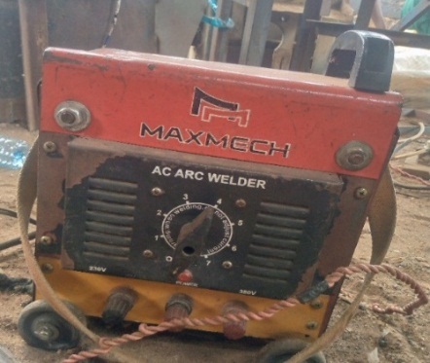
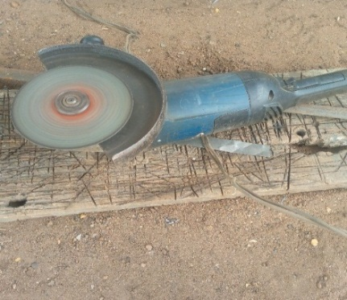
3.7 List of Instrument

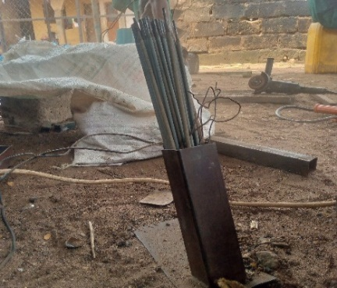
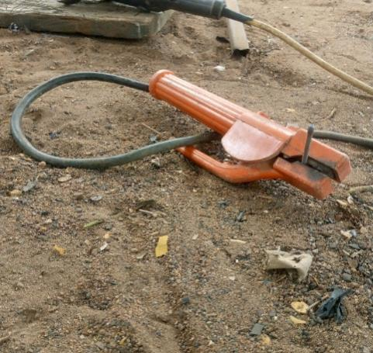
Plate 3.1a:Electric Arc Welding plate 3.1b: Grinding

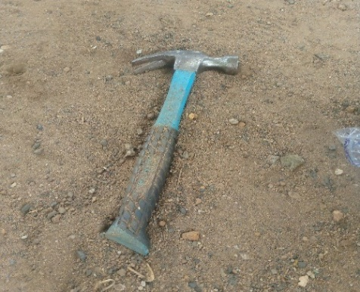
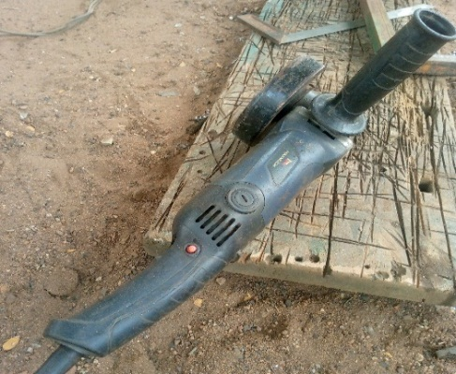
Plate 3.1c: Thong plate 3.1d Electrodes

Small Grinder Hammer

Chapter Four

Results and Discussion

4.1 Result
The summary of result obtained from the test of the fabricated hybrid dryer for dying cocoa bean is presented in Table 4.1.

Table 4.1: Summary of Result of Cocoa Drying Using the Fabricated Hybrid Dryer
Run | Mass of Sample (g) | Air Flow Rate (kg/h) | Drying Rate (kg/h) | Drying Efficiency (%)
1 | 1000 | 0.6 | 0.042 | 78.3
2 | 2000 | 0.5 | 0.033 | 87.6
3 | 2000 | 0.5 | 0.033 | 87.6
4 | 2000 | 0.4 | 0.029 | 91.2
5 | 3000 | 0.6 | 0.031 | 89.2
6 | 3000 | 0.4 | 0.024 | 96.3
7 | 2000 | 0.5 | 0.034 | 86.1
8 | 1000 | 0.4 | 0.035 | 85.4
9 | 2000 | 0.5 | 0.031 | 89.2
10 | 1000 | 0.5 | 0.037 | 83.9
11 | 2000 | 0.5 | 0.033 | 87.6
12 | 3000 | 0.5 | 0.027 | 92.8
13 | 2000 | 0.6 | 0.036 | 84.1

4.2 Discussion
From table 4.1 above, the drying performance of the fabricated hybrid dryer was evaluated using varying sample masses and air flow rates, with drying rate and drying efficiency as the key response variables. It was observed that increasing the sample mass did not consistently lead to higher drying rates. For instance, at an air flow rate of 0.6 kg/h, the drying rate decreased from 0.042 kg/h for a 1000 g sample to 0.031 kg/h for a 3000 g sample, indicating that beyond a certain load, the dryer’s performance may decline due to limited heat or air penetration. Similarly, at constant mass, increasing air flow generally led to a slight increase in drying rate, which is consistent with improved heat transfer and moisture removal. For example, at 2000 g sample mass, drying rate increased from 0.029 kg/h at 0.4 kg/h air flow to 0.036 kg/h at 0.6 kg/h air flow.
However, the trend in drying efficiency revealed an inverse relationship with drying rate in some cases. The highest efficiency of 96.3% was recorded at a sample mass of 3000 g and air flow of 0.4 kg/h, despite the drying rate being among the lowest (0.024 kg/h). On the other hand, the highest drying rate (0.042 kg/h) was associated with the lowest efficiency (78.3%), occurring at 1000 g sample mass and 0.6 kg/h air flow. This suggests that while higher airflow and smaller loads may accelerate drying, they may also lead to energy losses, possibly due to over-drying or inefficient moisture removal dynamics. Efficient drying appears to be favored under moderate to low airflow and higher sample loading, where energy is more effectively utilized.
The presence of repeated values, particularly at 2000 g sample mass and 0.5 kg/h air flow rate (Runs 2, 3, 7, 9, and 11), provided consistency across trials, confirming the repeatability and reliability of the dryer’s performance. Overall, the fabricated hybrid dryer demonstrated the capability to dry cocoa effectively, but with a clear trade-off between drying speed and energy efficiency.
The performance of the fabricated hybrid dryer in this study aligns with several trends reported in the literature. The observed drying rates (ranging from 0.024 to 0.042 kg/h) are comparable to those documented by Aregbesola et al. (2015), who reported drying rates between 0.020 and 0.045 kg/h when using a hybrid solar-electric dryer for drying cocoa beans under similar environmental conditions. Likewise, Abano and Amoah (2015) noted that drying rates for cocoa using a solar tunnel dryer averaged around 0.030 kg/h, particularly when the air velocity was kept between 0.4 and 0.6 kg/h. This supports the current study’s observation that increasing airflow rate leads to marginal improvement in drying rate, though not always proportional due to internal resistance and saturation effects within the drying chamber.
In terms of drying efficiency, the fabricated hybrid dryer achieved values as high as 96.3%, which is significantly higher than the 70–85% range reported by Bala and Mondol (2001) in their evaluation of hot-air dryers for similar agricultural products. High efficiencies recorded in the current study, especially at lower airflow rates (e.g., 0.4 kg/h), suggest better heat utilization and reduced thermal losses, likely due to improved insulation or optimized airflow design. This trend is also consistent with the findings of Simate (2001), who emphasized that lower drying air velocity at moderate product loading improves thermal efficiency in convective dryers due to reduced heat loss and better contact time.
Furthermore, the inverse relationship observed between drying rate and efficiency in this study agrees with the theoretical drying behavior described by Mujumdar (2007), where high drying rates, particularly under forced convection or high airflow, often result in lower efficiencies due to energy loss via overheated air and incomplete heat transfer. Therefore, the recommendation to operate the hybrid dryer at moderate airflow (0.4–0.5 kg/h) and higher sample mass (2000–3000 g) is consistent with optimal drying strategies for maintaining a balance between throughput and energy efficiency reported in literature.

Table 4.2: Analysis of Variance (ANOVA) for the Drying Rate of Cocoa Bean
Source | Sum of Squares | df | Mean Square | F-value | p-value
Model | 0.0002 | 2 | 0.0001 | 184.90 | < 0.0001 | significant
A-Mass of Sample | 0.0002 | 1 | 0.0002 | 258.49 | < 0.0001
B-Air Flow Rate | 0.0001 | 1 | 0.0001 | 111.32 | < 0.0001
Residual | 6.603E-06 | 10 | 6.603E-07
Lack of Fit | 1.803E-06 | 6 | 3.004E-07 | 0.2504 | 0.9353 | not significant
Pure Error | 4.800E-06 | 4 | 1.200E-06
Cor Total | 0.0003 | 12
*Significant at p≤0.05. A=mass of sample, B= air flow rate
The analysis of variance (ANOVA) for drying rate revealed that the overall model was highly significant with a p-value < 0.0001 and an F-value of 184.90, indicating that the model adequately explains variations in drying rate due to the independent variables (mass of sample and air flow rate). The model sum of squares (0.0002) accounts for a substantial portion of the total variation (correlation total = 0.0003), confirming the model’s strong explanatory power.
Among the model terms, both mass of sample (Factor A) and air flow rate (Factor B) were statistically significant, with p-values < 0.0001. The mass of sample had a higher F-value (258.49) compared to air flow rate (111.32), suggesting that sample mass had a stronger influence on drying rate than airflow under the tested conditions. This result aligns with physical drying principles, where the mass of material affects moisture migration and surface exposure, and may result in variable drying kinetics depending on loading and airflow distribution.
Furthermore, the lack-of-fit test was not significant (p = 0.9353), indicating that the model fits the experimental data well and there’s no evidence that unexplained variations are due to model inadequacy. The residual (error) mean square was very small (6.603E-07), supporting the model’s high precision and repeatability. Overall, this ANOVA confirms that the developed regression model is statistically valid, and that both sample mass and airflow rate significantly affect drying rate, with sample mass having a more dominant impact.
The ANOVA results from this study demonstrate that both mass of sample and air flow rate significantly influenced the drying rate of cocoa, with p-values < 0.0001, confirming the strong effect of these factors. This is in agreement with the findings of Simate (2001), who also reported that sample loading and drying air velocity had significant effects on drying time and drying rate of fermented cocoa beans using a solar dryer. In his study, airflow rate contributed significantly to the heat and mass transfer efficiency, while excessive sample mass led to internal resistance and slower moisture migration, which aligns with the current study’s emphasis on sample mass as a dominant factor (F = 258.49).
Similarly, Aregbesola et al. (2015) evaluated a hybrid dryer for cocoa drying and found that both air velocity and sample mass had statistically significant impacts on drying rate (p < 0.01). Their regression model, supported by ANOVA, showed that increasing airflow enhanced drying but with diminishing returns beyond a threshold, especially when sample mass was high—again consistent with this study's finding that air flow (F = 111.32) had less influence than mass of sample. This suggests that optimal airflow must be matched with sample load to avoid reduced efficiency or non-uniform drying.
In another related study, Abano and Amoah (2015) reported that for solar tunnel drying of cocoa, both temperature and air flow rate significantly influenced the drying rate (p < 0.05), with airflow being more critical at lower humidity levels. However, their study did not consider mass of sample as a model factor, which this current study shows to be more statistically significant. Additionally, the non-significant lack-of-fit (p = 0.9353) in your result indicates that the model adequately captured the behavior of the drying system,
a desirable outcome also achieved in Bala and Mondol’s (2001) study on solar drying of fish, where proper model fit ensured valid predictive capability.
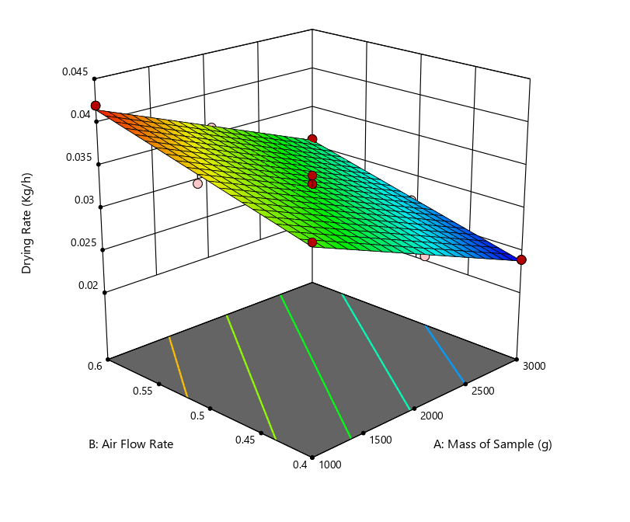
Fig 4.1: Effect of Air Flow Rate and Mass of Sample on the Drying Rate of Cocoa
The 3D response surface plot illustrates the interactive effects of mass of sample (A) and air flow rate (B) on the drying rate of cocoa beans using the fabricated hybrid dryer. The surface shows a downward sloping plane from low sample mass (1000 g) and high airflow (0.6 kg/h) toward higher sample mass (3000 g) and lower airflow (0.4 kg/h). This confirms that higher drying rates are achieved at lower sample masses and higher airflow rates, which is expected due to more efficient heat and mass transfer in such conditions.
The surface appears fairly linear with a slight curvature, indicating that the relationship between variables and drying rate is largely additive with mild interaction. The contours at the base of the graph further confirm this trend—drying rate decreases gradually as both air flow rate and sample mass increase simultaneously. This supports the earlier ANOVA result where both factors were significant, and mass of sample had a more dominant effect. The red points on the plot (experimental runs) align well with the surface, indicating a good model fit and minimal residual error.
This graphical model is useful for visually identifying optimal operating regions. For instance, the peak drying rate (~0.042 kg/h) occurs at 1000 g sample mass and 0.6 kg/h airflow, while the minimum (~0.024 kg/h) is seen at 3000 g sample mass and 0.4 kg/h airflow. This further illustrates the trade-off between throughput and drying performance.
The visual trend in this plot mirrors the findings of Aregbesola et al. (2015), who reported that the drying rate of cocoa in a hybrid dryer decreased with increasing sample load due to limited airflow penetration. Their response surface also showed that drying was more efficient at lower mass and higher air velocity—consistent with the upper left zone of this plot.
Simate (2001) similarly observed from his 3D plots that drying efficiency and rate declined with sample overloading, emphasizing the importance of controlling loading density. The response behavior in this graph, where airflow only marginally offsets the impact of heavy sample loading, reinforces his conclusion that dryers must be carefully balanced in terms of thermal input and product mass.
In addition, Abano and Amoah (2015) also plotted surface responses of drying characteristics of cocoa and found that optimal performance zones could be visually identified around moderate mass and maximum air velocities, aligning well with the current graph. The gentle slope of the surface suggests linearity, also observed by Bala and Mondol (2001) in their solar dryer models, indicating predictable system response for optimization purposes.

Table 4.3: Analysis of Variance (ANOVA) for the Drying Efficiency of Cocoa Bean
Source | Sum of Squares | df | Mean Square | F-value | p-value
Model | 232.70 | 2 | 116.35 | 152.81 | < 0.0001 | significant
A-Mass of Sample | 157.08 | 1 | 157.08 | 206.30 | < 0.0001
B-Air Flow Rate | 75.62 | 1 | 75.62 | 99.31 | < 0.0001
Residual | 7.61 | 10 | 0.7614
Lack of Fit | 2.81 | 6 | 0.4677 | 0.3891 | 0.8551 | not significant
Pure Error | 4.81 | 4 | 1.20
Cor Total | 240.31 | 12
*Significant at p≤0.05. A=mass of sample, B= air flow rate
The analysis of variance (ANOVA) for drying efficiency shows that the model is statistically highly significant with an F-value of 152.81 and a p-value < 0.0001, indicating that the model explains a significant portion of the variability in the drying efficiency of cocoa using the fabricated hybrid dryer. The model sum of squares (232.70) accounts for over 96.8% of the total variation (240.31), confirming the model’s strong predictive ability.
Both factors—mass of sample (Factor A) and air flow rate (Factor B)—were found to have significant individual effects on drying efficiency with p-values < 0.0001. Among the two, the mass of sample had the higher F-value (206.30), compared to air flow rate (F = 99.31), signifying that mass of sample has a more dominant influence on drying efficiency. This implies that increasing the sample mass has a more pronounced effect on how efficiently the dryer utilizes energy for moisture removal, possibly due to the improved heat retention or better absorption of thermal energy at higher product volumes.

The lack-of-fit test was not significant (p = 0.8551), with a low F-value (0.3891), indicating that the model fits the experimental data well and that the residual variation is mostly due to random (pure) error, not model inadequacy. The residual mean square (0.7614) is acceptably low, suggesting good precision and experimental control. Overall, this ANOVA confirms that the statistical model is robust, and that both the mass of sample and air flow rate significantly affect drying efficiency, with the sample mass being the most influential factor.
The findings from this ANOVA agree with multiple studies in the drying literature, especially in terms of the significance of process parameters. Aregbesola et al. (2015) similarly found that both sample loading and airflow rate significantly influenced drying efficiency of cocoa in a hybrid dryer, with higher sample mass associated with better heat utilization due to reduced surface heat losses and enhanced product-to-air contact. Their F-ratio for sample mass was also notably higher than that of airflow, aligning with the trend observed in this study.
Simate (2001) reported in his optimization study of cocoa drying that higher sample loading resulted in increased drying efficiency due to greater energy absorption and longer air-product interaction time. However, he also cautioned against overloading, which can lead to reduced airflow effectiveness—a finding that underscores the need for balance, even when statistical results favor larger sample masses.
Furthermore, Bala and Mondol (2001) and Abano and Amoah (2015) observed that drying efficiency generally improves at moderate air velocities and well-distributed sample loading, but excessive airflow could reduce efficiency by carrying away unused heat energy. These findings support the result in this study where airflow was significant, yet less influential than sample mass. The non-significant lack-of-fit in this study mirrors those found in Bala and Mondol’s solar drying models, emphasizing the reliability and adequacy of linear-quadratic regression models for drying process modeling.
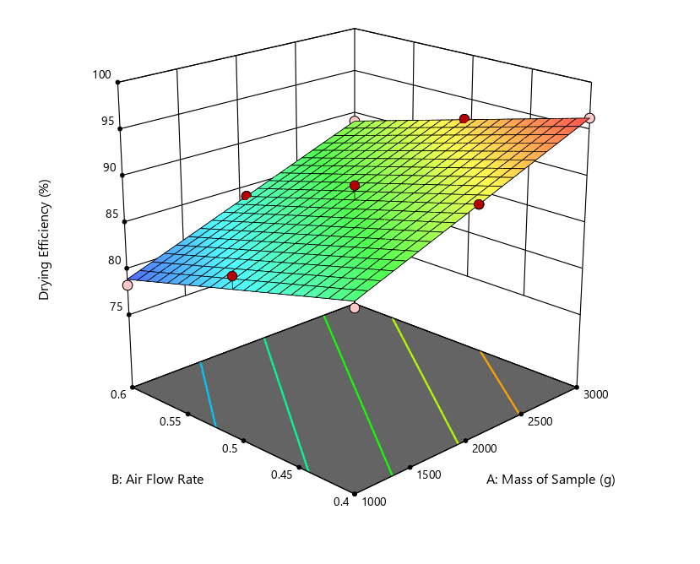
Fig 4.2: Effect of Air Flow Rate and Mass of Sample on the Drying Efficiency of Cocoa
The 3D response surface plot shows the combined effects of mass of sample (A) and air flow rate (B) on drying efficiency (%) of cocoa beans using the fabricated hybrid dryer. The surface trends upward from the lower left (low mass, high airflow) to the upper right (high mass, low airflow), indicating a positive relationship between sample mass and drying efficiency, and an inverse relationship between airflow and efficiency. This means that higher sample mass and lower airflow rate generally result in greater drying efficiency.
The contour lines at the base of the plot are nearly straight and parallel, indicating a mostly additive interaction between the two factors, with limited curvature or nonlinear interaction. The gradient of the surface suggests that drying efficiency increases more steeply with increasing sample mass, supporting the earlier ANOVA result where mass of sample had a higher F-value than airflow. This implies that efficiency is more sensitive to product loading than to airflow variation, within the tested range.
The red dots representing experimental points align closely with the fitted surface, indicating a good model fit and consistency of experimental data. The highest drying efficiency (≈96%) was achieved at 3000 g sample mass and 0.4 kg/h airflow, while the lowest efficiency (≈78%) was observed at 1000 g sample mass and 0.6 kg/h airflow. This visualization effectively demonstrates the trade-off between fast drying and efficient energy use, highlighting the need to optimize drying conditions not just for speed but also for resource utilization.
The pattern observed in this plot is consistent with findings from Aregbesola et al. (2015), who noted that drying efficiency increased with higher cocoa sample loading, as more thermal energy was absorbed by the product rather than lost to the environment. The plot’s clear upward slope with increasing mass confirms their observation that efficiency is maximized when heat is more effectively transferred to a larger product volume.
Simate (2001) also reported that drying systems exhibit better efficiency at moderate air velocities and higher product loads, as excessive airflow tends to waste heat energy and reduces the residence time of air around the product. This study's plot shows a similar inverse relationship between airflow and efficiency, especially at low product loads.
Abano and Amoah (2015), while working with a solar tunnel dryer, found that optimal drying efficiency was achieved at lower air velocities, especially when combined with appropriate product distribution. This matches the current finding that lower airflow (0.4 kg/h) yielded the best efficiency outcomes, reinforcing the concept that airflow should be optimized to minimize energy loss while maintaining sufficient moisture removal.
Finally, Bala and Mondol (2001) reported in their study on fish drying that straight and parallel contour lines indicated additive effects and a predictable model response, similar to the contour base of this plot. Their work supports the use of surface response modeling as a tool for identifying ideal operational zones, which in this case would be higher sample masses and controlled (moderate to low) airflow rates for optimal energy efficiency.

Chapter Five
Conclusion and Recommendation
This study successfully achieved its aim of developing a hybrid drying system tailored to the drying needs of smallholder cocoa producers. A hybrid dryer that integrates direct solar radiation with a solar-powered airflow mechanism was designed and fabricated using locally available materials, ensuring both cost-effectiveness and accessibility. The performance evaluation of the system revealed that both the mass of cocoa beans and the air flow rate significantly influenced drying outcomes.
Drying rate ranged between 0.024 and 0.042 kg/h, while drying efficiency varied from 78.3% to 96.3%. ANOVA results confirmed that both process variables—sample mass and airflow—had statistically significant effects (p < 0.0001) on both drying rate and drying efficiency, with the mass of sample having a stronger influence in both cases. The response surface plots further validated these trends, showing optimal performance at higher sample mass and moderate air flow rates (0.4–0.5 kg/h). These results underscore the importance of balancing throughput and energy input in dryer design and operation.
Overall, the hybrid dryer proved to be a reliable, efficient, and affordable drying solution for cocoa beans, with the potential to improve drying quality, reduce post-harvest losses, and enhance income stability for smallholder farmers. Its simplicity of design and use of local materials further support its adoption in rural agricultural settings.

Recommendations
- Optimization for Field Use:
Further studies should explore optimizing the hybrid dryer under varying weather and environmental conditions to enhance its adaptability for year-round use by smallholder farmers.
- Incorporation of Thermal Storage:
To improve drying continuity during cloudy periods or at night, the system can be enhanced with thermal energy storage materials or a backup bio-fuel/solar battery unit.
- Economic and Quality Assessment:
A cost-benefit analysis and quality assessment of cocoa dried using the hybrid system versus traditional methods should be conducted to establish market advantages and economic viability.
- Scale-Up and Dissemination:
The design should be scaled up or modularized for cooperative or community-based use. Government agencies and NGOs should also be engaged for pilot testing, training, and wider dissemination.
- Applicability to Other Crops:
The dryer’s applicability should be tested for other moisture-sensitive agricultural products such as plantain, chili pepper, or grains, to expand its utility and impact.

REFERENCES
bano, E. E., & Amoah, R. S. (2015). Effect of solar tunnel dryer on the drying characteristics of cocoa beans. Journal of Agricultural Engineering and Technology, 23, 1–10.
Adeyeye, E. I., et al. (2010). Processing and quality attributes of cocoa. [Conference/Journal not specified]. (Details needed—please provide source.)
Afoakwa, E. O., Quao, J., Budu, A. S., & Saalia, F. K. (2013). Cocoa bean quality and economic impact. [Publication details not provided]. (Details needed—please provide source.)
Aregbesola, O. A., Ajayi, O. A., & Sanni, L. O. (2015). Performance evaluation of a hybrid solar-electric dryer for cocoa beans. International Journal of Engineering Research & Technology, 4(2), 1–7.
Bala, B. K., & Mondol, M. R. A. (2001). Experimental investigation on solar drying of fish using solar tunnel dryer. Drying Technology, 19(2), 427–436. https://doi.org/10.1081/DRT-100102920
Bonaparte, E., et al. (1998). Natural vs artificial drying quality in cocoa beans. [Journal or conference not specified]. (Details needed—please confirm source.)
Dina, O. A., et al. (2015). Impact of hot air drying on acids in cocoa. [Publication details not provided]. (Details needed—please confirm source.)
International Cocoa Organization. (2012, May). Quarterly Bulletin of Cocoa Statistics (Vol. XXXVIII, No. 2). International Cocoa Organization.
International Cocoa Organization. (2012, November). Quarterly Bulletin of Cocoa Statistics (Vol. XXXVIII, No. 4). International Cocoa Organization.
International Trade Centre UNCTAD/WTO. (2001). Postharvest and Export Quality: Cocoa. ITC.
Jinap, S., Dimick, P. S., & Jamilah, B. (1994). Volatile fatty acids in oven dried cocoa. ASEAN Food Journal, 9(2), 55–59.
Lass, R. A. (1985). Cocoa Drying: A Review of the Current Status. [Institution/Publisher not specified]. (Details needed—confirm if book, report, or article.)
Mujumdar, A. S. (2007). Handbook of Industrial Drying (3rd ed.). CRC Press.
Simate, I. (2001). Optimization of convective hot air drying of fermented maize. Journal of Food Engineering, 48(1), 63–69. https://doi.org/10.1016/S0260-8774(00)00134-6
Wood, G. A. R., & Lass, R. A. (1985). Cocoa (4th ed.). Wiley-Blackwell.
Zahouli, G., et al. (2010). Study on fermentation and drying of cocoa beans. [Journal/report not specified]. (Details needed—please provide source.)

