PERFORMANCE EVALUATION OF A MOTORIZED GROUNDNUT PASTE KNEADING MACHINE

BY

ADEYEMI ADEBOWALE JOSEPH

HND/22/ABE/FT/0028

A RESEARCH PROJECT REPORT SUBMITTED TO THE DEPARTMENT OF AGRICULTURAL AND BIO-ENVIRONMENTAL ENGINEERING TECHNOLOGY, INSTITUTE OF TECHNOLOGY, KWARA STATE POLYTECHNIC, ILORIN

IN PARTIAL FULFILMENT OF THE REQUIREMENT FOR THE AWARD OF HIGHER NATIONAL DIPLOMA (HND) IN AGRICULTURAL AND BIO-ENVIRONMENTAL ENGINEERING TECHNOLOGY, IN THE DEPARTMENT OF AGRICULTURAL AND BIO-ENVIRONMENTAL ENGINEERING TECHNOLOGY, KWARA STATE POLYTECHNIC, ILORIN

AUGUST, 2025

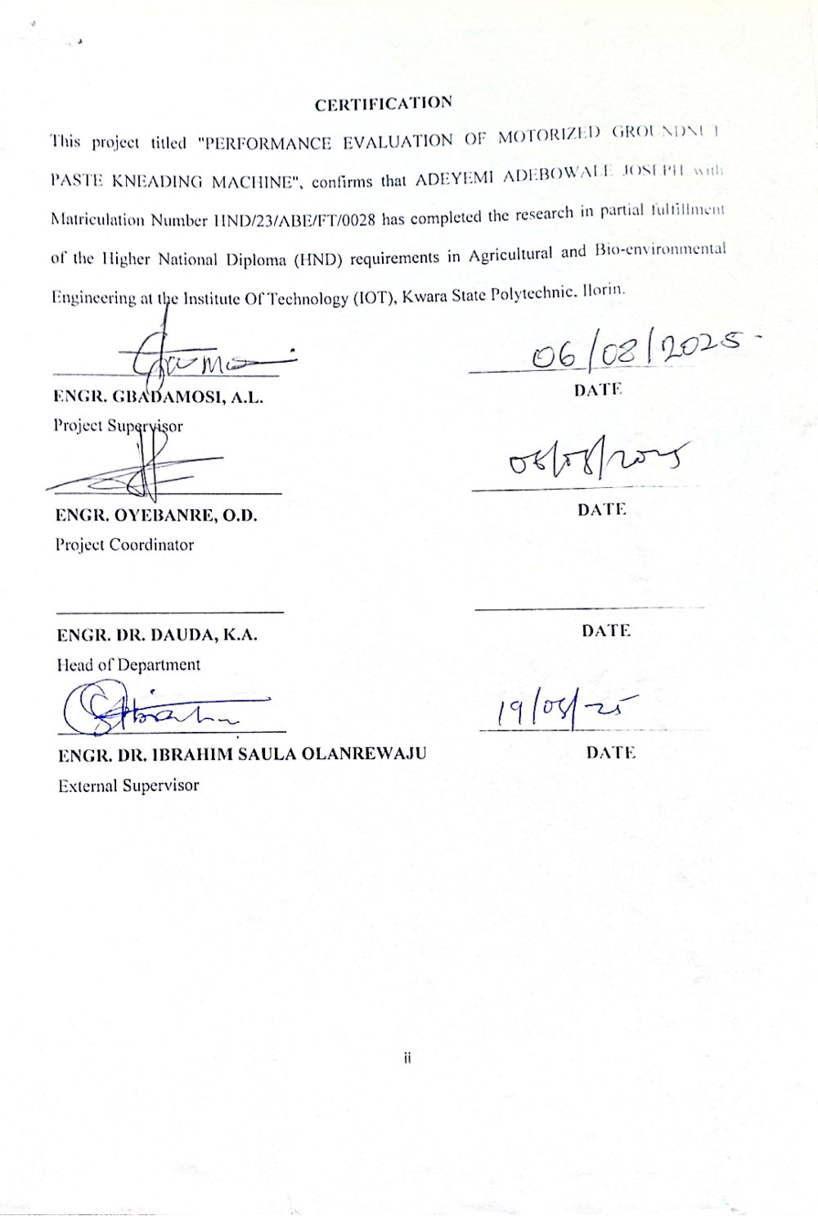

DEDICATION
This project work is dedicated to Almight God, who has stood with me throughout this journey.
Also my beloved family whose unwavering support, encouragement and love have been the driving force behind my success, your selflessness, patience and guidance have helped shape me into the person I am today and I'm forever grateful. Your influence has not only shaped this project but had also impacted my life in ways that words cannot express, thanks for being my beacon of hope, my role model and guide.
This project is a testament to your love, support and dedication and I hope it makes you proud.

ACKNOWLEDGEMENT
My profound gratitude goes to Almighty Allah for His grace, favour and mercy upon my life. I would like to extend my heartfelt appreciation to all individual who has contributed to the success of this project, specifically my dad PRINCE ADEYEMI, supportive mom and siblings, beloved coursemate of class 2025 and friends for their unwavering support, valuable insights and expert guidance throughout this journey. Their contributions have been instrumental in shaping this project and I'm grateful for the time, effort and expertise they have shared, thank you for believing in me and helping me bring this project to life.
Also my special thanks goes to my able supervisor in person of ENGR. GBADAMOSI, A.L, who has always been there for me anytime to guide, correct and make amendment, thank you sir.
I also acknowledge the effort of my HOD ENGR. DAUDA, K.A and my project coordinator, ENGR. OYEBANRE, O.D for their fatherly care, thank you sirs.
My acknowledgement would be incomplete without mentioning the care and effort of my lecturers and non-teaching staffs in the Department, thank you and God bless you all.

TABLE OF CONTENTS
Title Page i
Certification ii
Dedication iii
Acknowledgements iv
Table of Contents v
List of Tables viii
List of Figures ix
List of Plates x
Abstract xi
CHAPTER ONE: INTRODUCTION
1.1 Background of Study 1
1.2 Statement of the Problem 1
1.3 Aims and Objectives 2
1.3.1 Aim of the Study 2
1.3.2 Objectives of the Study 2
1.4 Justifications of the Study 2
1.5 Scope of the Study 3
CHAPTER TWO: LITERATURE REVIEW
2.1 Overview of Groundnut 4
2.1.1 Groundnut and Origin Description of Groundnut 4
2.1.2 Origin of Groundnut 4
2.2 Nutritional Composition and Economic Importance of Groundnut 5
2.3 Kneading of Groundnut 6
2.3.1 Theory of Kneading of Groundnut Paste 6
2.3.2 Description of the Components of the existing Kneading Machine 6
2.3.3 Mode of Operation of Motorized Groundnut Paste Kneading Machine 8
2.4 Types of Extraction Machine 8
2.4.1 Palm Kernel Extracting Machine 8
2.4.2 Soybean Extracting Machine 9
2.4.3 Olive Extracting Machine 10
2.4.4 Groundnut Kneading Machine 11
2.5 Factors Affecting Kneading Operation 12
2.5.1 Feed Rate 12
2.5.2 Moisture Content 12
2.5.3 Temperature 13
2.5.4 Operating Speed 13
2.6 Measurement Of Groundnut Kneader Performance 14
2.6.1 Kneading Efficiency 14
2.6.2 Throughput Capacity 14
CHAPTER THREE: MATERIALS AND METHODS
3.1 Materials 15
3.1.1 Description of the Existing Groundnut Kneading Machine 15
3.2 Methodology 18
3.2.1 Sourcing of Test Materials 18
3.2.2 Sample Preparation 18
3.2.3 Kneading Operation 19
3.2.4 Performance Evaluation 20
3.2.5 Experimental Specifications 20
3.2.5.1 Kneading Efficiency 21
3.2.5.2 Kneading Rate 21
3.2.5.3 Throughput Capacity 21
3.2.6 Experimental Results 21
CHAPTER FOUR: RESULTS AND DISCUSSION
4.1 Results 24
4.2 Discussion 24
CHAPTER FIVE: CONCLUSION AND RECOMMENDATION
5.1 Conclusion 26
5.2 Recommendation 26
References 27

LIST OF TABLES
Table Description Page
3.1 Weight of Kneaded Paste, Kneading time, Operating speed and Kneaded oil output 22
3.2 Average Value Of Kneading Parameter 22
3.3 Overall Performance Evaluation Parameters Of Kneading Machine 23

LIST OF FIGURES
Figures Description Page
2.1 Diagram Of Palm Kernel Extracting Machine 9
2.2 Diagram Of Soybean Extracting Machine 10
2.3 Diagram Of Olive Extraction Machine 11
2.4 Diagram Of Groundnut Paste Kneading Machine 11
3.1 Existing Motorized Groundnut Paste Kneading Machine 17
4.1 Bar Chart Showing the relationship between Weight of Groundnut Paste and Kneading Rate (Kg/Minute), Kneading Efficiency (%), and Throughput Capacity (Kg/Hour). 25

LIST OF PLATES
Plate Description Page
3.1 Groundnut Paste 19
3.2 Kneading Of Groundnut Paste 19

ABSTRACT
This study evaluates the performance of a motorized groundnut paste kneading machine demonstrating its effectiveness in processing groundnut paste for oil extraction and paste preparation. The results obtained from the evaluation with different weight of groundnut paste of 1.60kg, 2.50kg and 2.81kg are: kneading efficiency, kneading rate and throughput capacity of 1.60kg are 99%, 0.53kg/min and 32.00kg/hr, 2.50kg are 73%, 1.00kg/min and 62.50kg/hr and 2.81kg are 98%, 1.12kg/min and 70.25kg/hr respectively. The study's findings highlight the machine's reliability and effectiveness under practical operational conditions, providing a reliable foundation for groundnut oil and kuli kuli production. The results of this study can be used to optimize the machine's performance and improve the quality of groundnut products.

CHAPTER ONE
INTRODUCTION
1.1 BACKGROUND OF STUDY
The agricultural sector is integral to economic development in many countries especially in regions where it serves as the backbone of local economics and food security. Within this sector, Groundnut (Arachis hypogaea Linnaeus) cultivation is of particular importance providing both a reliable income for farmers and a rich source of nutrition in the form of protein, oils and essential nutrients. Groundnuts also known as peanuts, are versatile used in a wide array of food products from cooking oils and roasted snacks to peanut butter and confections making them a valuable crop in both domestic and international markets (Smith & Collins, 2020) given the rising demand for groundnut-based products. The development of efficient processing machinery has become a priority for the industry such that machineries not only enhances production rates but also improves product quality, helping processors meet consumer expectations per texture, taste and consistency. This growing need underscore the relevance of the study on the "Performance Evaluation of a Groundnut Kneading Machine" as it aims to assess how well the existing machine developed in the department of Agricultural and Bio-environmental Engineering meet production requirements in terms of kneading efficiency, output quality, throughput capacity and operating speed.
Groundnut processing involves several stages such as kneading which means to transform or break or crush, in this process it is the transformation of groundnut paste into oil recovery . This paste is a key ingredient in popular groundnut products such as peanut butter which has been an increased demand across global markets due to its nutrients-rich profile and versatility , the quality of the paste including its texture, consistency and flavour largely depends on the efficiency and effectiveness of the kneading process and a high-performing kneading machine can help produce a uniform paste with well distributed oils and smoothness that aligns with consumer expectations. Performance evaluation of groundnut kneading machine involves assessing various parameters that impact both the quality of the end product and the efficiency of the processing operation, these parameters may include the machine's through-put rate, energy consumption, paste texture consistency and the machine's abiliby to handle variations in groundnut characteristics such as size, moisture content and oil content.
1.2 STATEMENT OF THE PROBLEM
Under performance evaluation of the existing motorised groundnut kneading machine lacks adequate information on the actual performance parameters of the machine and characterised with low productivity, inconsistent product quality, high labor costs and health risks associated with repetitive strain injuries.
1.3 AIMS AND OBJECTIVES
1.3.1 AIM OF THE STUDY
The aim of the study is to evaluate the performance of a motorised groundnut kneading machine
1.3.2 OBJECTIVES OF THE STUDY
The specific objectives are to :
1. Determine the kneading efficiency
2. Determine the throughput capacity
1.4 JUSTIFICATIONS OF THE STUDY
The evaluation of the machine would enhances its potential to optimise its performance, support socio-economic development, enhance product quality and provide foundational data for future advancements.
1.5 SCOPE OF THE STUDY
This project will focus on the performance evaluation of the machine and identification of areas for improvement.

CHAPTER TWO
LITERATURE REVIEW
2.1 OVERVIEW OF GROUNDNUT
Groundnut whose botanical name is (Arachis hypogaea Linnaeus) also known as peanut is a leguminous crop widely cultivated for its edible seeds, oil and protein-rich content. It is an important cash crop due to its versatility in food , feed and industrial applications(Janila et al., 2013).
2.1.1 GROUNDNUT AND ORIGIN DESCRIPTION OF GROUNDNUT
Groundnut is a tuber crop that belongs to the family of Fabaceae. It is an annual herbaceous plant with a bushy appearance, taproot system with nitrogen-fixing nodules, compound with four leaflets, yellow self-pollinating flowers that grow close to the ground and develop underground after fertilisation an average of around 20-50 pods, with each pod containing 2-4 seeds. This translates to approximately 40-200 seeds per plant.
2.1.2 ORIGIN OF GROUNDNUT
Groundnut originated in South America specifically in the region now known as Bolivia and Paraguay, archaeological evidence suggests that groundnut cultivation began around 3500 to 4500 years ago. Indigenous South American tribes domesticated the crop using it for food, trade and cultural rituals. Due to groundnut adaptability to different climates, it is grown now in tropical and subtropical regions worldwide such as India, China, United States, Nigeria and Sudan which are leading producers of groundnuts (Moshood et al. 2023)
Groundnut planting cycle is highly influenced by climatic conditions , soil type and farming practices but generally takes 3 to 5 months from planting to maturity. Some of the signs of groundnut maturity are yellowing of leaf that begin to dry out , pegs attaching pods to the plant begins to weaken when fully mature and through pod inspection.
2.2 NUTRITIONAL COMPOSITION AND ECONOMIC IMPORTANCE OF GROUNDNUT
Groundnuts are nutrient-dense providing a balanced mix of proteins , healthy fats, vitamins, minerals and antioxidants making them a valuable food source for health and nutrition. Groundnut contains 25-30% of plant-based protein, 40-50% of healthy unsaturated fats mainly and 10-20% carbohydrates providing dietary fibre which promotes digestive health and aids in eight management and energy. Vitamins such as B vitamins and vitamin E which promote skin and heart health.
Minerals such as magnesium (supports muscle and nerve function) phosphorus (essential for bone and cell health), potassium (helps regulate blood pressure ) zinc ( boost immunity and wound healing) and iron (supports oxygen transport in the blood). Antioxidant such as resveratol that helps reduce inflammation, another is polyphenols and flavonoids that combat oxidative stress.
Economically, groundnut is importance in the following organisation , which are:
1. Food Industry: It is used in snacks, peanut butter, confectioneries and cooking oil.
2. Animal Feed: Groundnut cake and shells are used as livestock feed and bedding.
3. Industrial Use: It is utilized in the production of soaps, lubricants, Cosmetics and biodiesel.
Groundnut also has agricultural significance, which are :
1. Soil fertility: It fixes atmospheric nitrogen improving soil health.
2. Drought resistance: It can withstand dry conditions with proper management.
3. Crop rotation: It helps in sustainable farming by reducing soil depletion.
2.3 KNEADING OF GROUNDNUT
2.3.1 THEORY OF KNEADING OF GROUNDNUT PASTE
Kneading simply refers to the mixture and blending of groundnut paste to extract oil content, creating a paste with desired consistency and shelf life.
The process helps to extract excess oil from the groundnut paste, makes it smooth and soft in texture for it to be ready for consumption process
2.3.2 DESCRIPTION OF THE COMPONENTS OF THE EXISTING KNEADING MACHINE
A groundnut kneading machine is a mechanical device designed to process groundnut paste into a smooth consistent texture commonly known as peanut butter, the machine crushes and mixes the paste through mechanical action ensuring uniform texture, flavor and quality of the final product.
Key components of a groundnut kneading machine are :
a. Kneader shaft
This is the most important part of the machine which transmits power from the prime mover to the kneading chamber for oil extraction mechanism. It is made from high speed steel to resist bending and twisting action during the extraction. The shaft has 500 mm length and 25 mm diameter.
b. Kneader blades
The kneader blades are 2-blade assembly. They are made up of stainless steel of 5 mm thickness and 25 mm width arranged at an angle of 180° to each other on the kneader shaft.

c. Kneading chamber
The kneading chamber is the oil extraction compartment. It is made of stainless steel sheet of 3 mm thickness this was chosen due to its resistant to corrosion. It is fabricated in cylindrical shape with dimensions of 400 mm height and 300 mm diameter. The kneading chamber is provided with a lid to prevent splash to the surrounding environment.
d. Oil outlet
This is the point at which the extracted oil is collected. It is attached to the kneading drum at the bottom for easy flow of oil by gravity. It has a nob which regulates oil movement.
e. Bearings
These are machine elements that support shafts and allow circulatory motion of the shaft. They support kneading shaft for oil extraction mechanism at the top and at the bottom. Steel ball bearings of 35 mm diameter are used.
f. Pulleys and belt
Pulleys are grooved circular disc which accommodate belts for power transmission. Five pulleys of different diameters are used for performance evaluation of the machine, one for prime mover and the other four for four different kneading speeds. Belt is an element that transmits power from prime mover to the shaft. Belts are frequently necessary to reduce the higher rotational speed of electric motors to lower values required by mechanical equipment (Spott, 1985). A standard V-belt of 17 mm top width, 11 mm thickness and 18° grove angle is selected.
g. Prime mover
This is the energy source that supplied power for the kneading operation. Based on the power requirement of the oil expeller, a 1 hp capacity and 1450 rpm speed electric motor with head pulley of diameter 50 mm was selected.
h. Frame
The frame is the main skeleton of the machine which bears the weight of the machine, provides stability and prevents wobbling and excessive vibration. It is made up of 25 mm by 25 mm angle iron of 3 mm thickness.
2.3.3 MODE OF OPERATION OF MOTORISED GROUNDNUT PASTE KNEADING MACHINE
Groundnut paste of known quantity is introduced to the extraction chamber for kneading. Water of known quantity at a known temperature was added to the paste immediately to ease the kneading process. Once the electric motor is switched on, rotary power is transmitted to the kneading shaft through the V -belt. The high speed rotating shaft kneads the paste with the help of kneader blades. The kneading continues with addition of water at intervals until the oil begins to break away from the cake and process comes to an end when the colour of the mixture changes from milky to chocolate.(Hassan U.B, 2022)
2.4 TYPES OF EXTRACTION MACHINE
2.4.1 PALM KERNEL EXTRACTING MACHINE
‭The kernels are ‬fed to ‭ ‬the ‭ ‬screw press via ‭ ‬a hopper mounted on ‭ ‬the barrel with shut ‭ ‬off slide. As the screw ‭ ‬shaft rotates inside ‭ ‬the ‭ ‬cylindrical ‭ ‬barrel, ‭ ‬kernels ‭ ‬are ‭ ‬crushed
against the barrel walls as well as conveyed toward the far ‭ ‬end ‭ ‬of ‭ ‬the ‭ ‬screw-shaft, ‭ ‬where ‭ ‬a ‭ ‬steel ‭ ‬adjustable choke mechanism presses the crushed kernels against the wall of the barrel to squeeze out the kernel oil. The kernel oil then ‭ ‬flows out ‭ ‬of the ‭ ‬barrel ‭ ‬through small drainage slots at its bottom into an oil tray, while the “pressed cake” ‭ ‬discharges ‭ ‬from ‭ ‬the ‭ ‬cone section ‭ ‬into another tray. By regulating the clearance between the barrel and the adjustable cone (i.e. choke mechanism), the ‭ ‬thickness ‭ ‬and ‭ ‬dryness ‭ ‬of ‭ ‬the ‭ ‬pressed ‭ ‬cake ‭ ‬is regulated with this choke mechanism (Patrick et al., 2019).
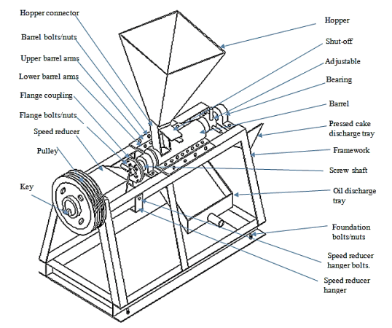

FIGURE 2.1: DIAGRAM OF PALM KERNEL EXTRACTING MACHINE
2.4.2 SOYBEAN EXTRACTING MACHINE
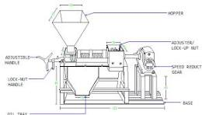
The soybean extracting machine is a crucial piece of equipment in the production of soybean oil, utilizing the solvent extraction method to efficiently extract oil from soybean flakes or cake. This method is widely used in industrial applications due to its high efficiency and ability to process large volumes. Firstly, n-hexane is introduced to the soybean flakes facilitating the dissolution of oil and forming a mixture known as miscella. The miscella is then collected and undergoes a two-step process to separate the oil from the solvent: evaporation and stripping. During evaporation, the miscella is heated causing the solvent to vaporize leaving behind the crude soybean oil, any residual solvent in the oil is removed by introducing direct steam. The remaining solid material known as wet meal, undergoes desolvation to remove residual solvent and the vaporized solvent is condensed and recycled back into the extraction process[Firman et. al 2020]. Finally, the crude oil obtained from the extraction process requires refining to become suitable for consumption, involving processes such as degumming, neutralization, bleaching and deodorization [Kumar et. al 2013].
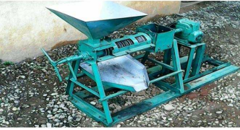

FIGURE 2.2: DIAGRAM OF SOYBEAN EXTRACTING MACHINE
2.4.3 OLIVE EXTRACTION MACHINE
Olive oil extraction is a crucial process in the production of high-quality olive oil, the process involves several stages that require careful handling and precise machinery to ensure optimal oil extraction and quality. The olive extraction machine process starts with olive reception and washing, where olives are unloaded and washed to remove leaves and impurities ensuring damage-free fruit. The olives are then crushed to obtain a semi-paste which is kneaded in the malaxator (Di Giovacchino, L. 2013) for optimal oil extraction. The prepared paste is pumped to the decanter where centrifugal forces separate the olive oil from pomace and black water, after which fine particles are removed and olive oil is rendered ready for consumption after eliminating micron-sized particles in the separator centrifuge [Altieri & Di Renzo, 2013).
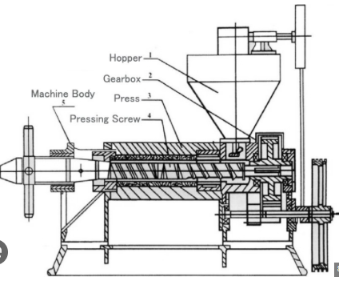

FIGURE 2.3: DIAGRAM OF OLIVE EXTRACTION MACHINE
2.4.4 GROUNDNUT KNEADING MACHINE
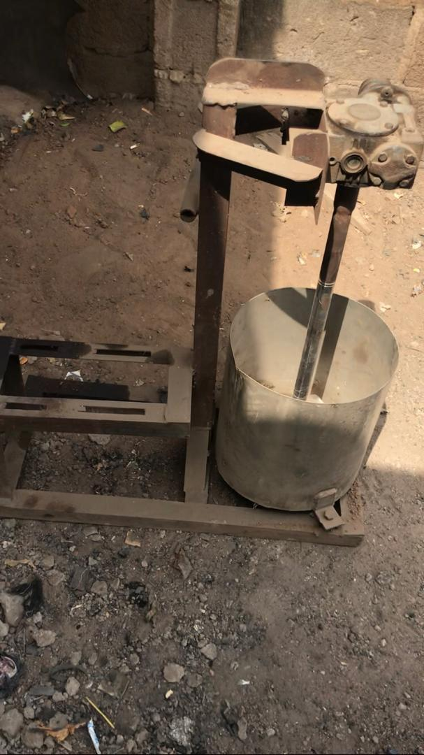
The kneader expresses oil from groundnut paste by using a metal with a power driven finger-like shaft fixed to a metal frame. With the IAR kneader, little or no heat is developed in the course of kneading since the extraction chamber is an open bucket. Oil extraction is accomplished by kneading. The groundnut paste is fed into the mortar, and as the power driven finger-like shaft rotates, it stirs the paste and coagulates it when warm water is added. The oil released is collected through a 30 mm diameter pipe at the bottom of the mortar(Gyuse, E.T. et al., 2008)

FIGURE 2.4: DIAGRAM OF GROUNDNUT KNEADING MACHINE
2.5 FACTORS AFFECTING KNEADING OPERATION
2.5.1 FEED RATE
The feed rate refers to the rate at which groundnut paste is introduced into the kneading machine. An optimal feed rate ensures efficient mixing and blending leading to a consistent texture and quality of the paste, but note if the machine is overfed, it causes uneven mixing while underfed may result in insufficient kneading. Some studies on motorized groundnut kneading machines have reported batch input rates of 10 kg yielded about 40 kg paste processed per hour (Hassan & Osunde, 2022) which mean high oil yield and increasing continuous feed from 10 to 20 kg/h sharply reduces oil yield(Owobayi et al., 2025). This shows that feed rate significantly influences the physical properties of extruded products, impacting their texture and consistency [Offiah et al., 2019].
2.5.2 MOISTURE CONTENT
Moisture content plays a crucial role in determining the texture and handling properties of groundnut paste, as optimal moisture levels [wet basis between 6% and 9%] facilitate smooth kneading, prevent stickiness and ensure the paste is pliable(Adu et al., 2021). Excess moisture can lead to spoilage or mold growth while insufficient moisture may result in a dry, crumbly texture. Studies reports that using 7.5% moisture content during kneading of groundnut paste will facilitate uniform mixing without excessive stickiness while maintaining moisture content at 8% reduces oil separation while enhancing the paste’s spreadability and extrusion behavior(Olayanju et al., 2022). This indicates that moisture content significantly affects the functional and physical properties of groundnut paste and extruded products [Wang et al.,2012].

2.5.3 TEMPERATURE
Temperature impacts the viscosity and microbial stability of groundnut paste i.e elevated temperature can cause oil separation, leading to an uneven texture while lower temperatures may hinder proper mixing. It's crucial to note that warm kneading significantly enhances oil yield and efficiency in groundnut paste processing as found that kneading at 60°C results in the highest oil yield (40.6%) and extraction efficiency (82.8%), this is because warmer temperatures reduce oil viscosity, allowing for smoother paste mixing and higher oil output. Thus maintaining an optimal kneading temperature, ranges around 60°C which enables faster throughput (19.4 kg/h) and more efficient processing (Sulaiman et al., 2023) to ensure a smooth, consistent paste and prevent microbial growth. In contrast, paste temperature significantly influences oil extraction efficiency with higher temperatures leading to decreased efficiency (Ogunwole & Olawoye, 2016).
2.5.4 OPERATING SPEED
The operating speed of the kneading machine affects the shear forces applied to the groundnut paste during processing i.e. optimal speed (ranging between 300 rpm and 450 rpm) ensures thorough mixing and effective oil extraction without causing structural damage to the paste. Excessive speeds can introduce air, leading to undesirable textures and increased oxidation while too slow speeds may result in inadequate mixing and lower oil yield (Oke & Awonorin, 2013). It was reported that 400 rpm provided the highest oil extraction efficiency and smooth paste consistency while preventing overheating and excessive air incorporation during kneading (Sulaiman et al., 2023). Conversely, note that operating below 300 rpm leads to incomplete mixing and lower oil yield while speeds above 450 rpm resulted in slight oil foaming and reduced paste quality (Adeyanju et al., 2021).

2.6 MEASUREMENT OF GROUNDNUT KNEADER PERFORMANCE
2.6.1. KNEADING EFFICIENCY
Kneading efficiency refers to the effectiveness of a kneader in transforming groundnut paste into a uniform, smooth and oil-rich consistency, It is typically quantified as the percentage of oil extracted relative to the total oil content in the groundnut paste. An optimized groundnut kneader can achieve a maximum kneading efficiency of 80.9% under specific operational conditions, including a machine speed of 400 rpm, water temperature of 60°C and the use of three kneading fingers [Sulaiman et al. 2023]. This high efficiency underscores the importance of optimizing machine parameters to enhance oil extraction and highlighting the effectiveness of the design in maximizing oil yield (Hassan and Osunde, 2022).
2.6.2. THROUGHPUT CAPACITY
Throughput capacity measures the amount of groundnut paste processed by the kneader per unit time, usually expressed in kilograms per hour (kg/h). It reflects the machine's productivity and is influenced by factors such as machine speed, design and operational parameters. It is observed that a optimized kneader can achieve a throughput capacity of 19.98 kg/h under the aforementioned optimal conditions[Sulaiman et al.,2023] and a developed motorized groundnut kneader which significantly reduces kneading time by 80% can achieve a throughput capacity of 46.3 kg/h, demonstrating the potential for mechanization to enhance processing efficiency[Maduako et al.,2004].

CHAPTER THREE
MATERIALS AND METHODS
3.1 MATERIALS
The following materials were used in the performance evaluation of the groundnut paste kneading machine, with each item serving specific functions during the experiment:
i. Motorized kneading machine: It is used for kneading the groundnut paste and facilitating oil extraction through agitation and centrifugal action.
ii. Electric Motor: This is used to power up the kneading machine by transmitting rotational motion to the stirring fingers inside the kneading chamber.
iii. Plastic container: Four containers was used for preparing, measuring the sample and also to collect extracted oil from the kneading process for measurement and evaluation.
iv. Water: This is added gradually during kneading to adjust the consistency of the groundnut paste and aid in efficient oil extraction.
v. Digital weighing scale: A digital weighing scale with model No EK5350 with an accuracy of 1g/0.1 oz and maximum of 5kg/11 lb using 2x1.5V AAA battery was used to weigh the groundnut before roasting and after kneading the groundnut paste, measuring the mass of extracted oil after kneading.
vi. Stopwatch: It was used to record the duration of the kneading process (kneading time).
3.1.1 DESCRIPTION OF THE EXISTING GROUNDNUT KNEADING MACHINE
The existing groundnut kneading machine is a highly advanced machine carefully designed and built to perform the crucial task of kneading groundnuts with efficiency and precision. Its entire design revolves around a robust and unyielding structural integrity provided primarily by the main frame. The foundational element is expertly crafted from high-quality mild steel angle iron characterized by its substantial dimensions of 50 x 50 x 5 mm, this specific material choice and precise sizing are not arbitrary; they are critical in imparting exceptional strength and unwavering stability to the entire apparatus, ensuring that it can withstand the dynamic forces and vibrations inherent in the kneading process without compromising its structural integrity. Every other component of the machine is strategically mounted upon and supported by this central framework, establishing a cohesive and resilient assembly. The power heart of this machine is an adequately sized 5 hp single-phase electric motor. This motor is not merely placed on the machine, it is securely and firmly affixed to the motor base through a combination of bolts and nuts eliminating any potential for movement or instability during operation, note this secure mounting is paramount for the efficient and safe transmission of power. The energy generated by this motor is then meticulously transferred to the operational kneading mechanism through a classic yet highly effective belt drive system which involves a precisely aligned pulley mounted directly onto the motor shaft, in turn drives a corresponding pulley situated on the main body of the machine. This methodical arrangement ensures a smooth, consistent and highly efficient transfer of rotational energy from the power source to the working parts. A pivotal element in the machine's operational efficacy is the integrated gearbox. The gearbox serves two critical functions: It precisely regulates the rotational speed of the system ensuring that the kneading process occurs at an optimal pace and more importantly, it expertly changes the direction of power transmission. The electric motor typically generates a horizontal rotary motion but for effective kneading a vertical rotary motion is required, the gearbox seamlessly facilitates this transformation. Crucially, this directional change is accompanied by a significant multiplication of torque i.e amplified twisting force is absolutely essential for effectively processing the dense and often resistant groundnut mixture, allowing for thorough and consistent kneading without straining the motor or other components. The actual kneading operation takes place within the confines of the kneading pot, a vital component fabricated from high-grade stainless steel sheet(superior durability, resistance to corrosion and compliance with hygienic standards, which is paramount when dealing with food products). This pot is uniformly sized featuring a diameter and height of 300 mm each, providing ample space for the groundnut paste. Central to the kneading action is the kneading shaft, also meticulously crafted from durable stainless steel which shaft measures 500 mm in length and possesses a diameter of 25 mm, dimensions carefully chosen to withstand the forces involved. This shaft is directly coupled to the output of the gearbox via a robust bolted connection ensuring that all the enhanced torque is directly and efficiently transferred to the kneading element. Finally, and perhaps most indicative of the machine's specialized function, a precisely designed stirrer is permanently welded to the kneading shaft where its specific shape and configuration are engineered to optimize the groundnut kneading process ensuring that the groundnuts are uniformly mixed, thoroughly broken down and kneaded to the desired consistency, ultimately leading to a high-quality end product.
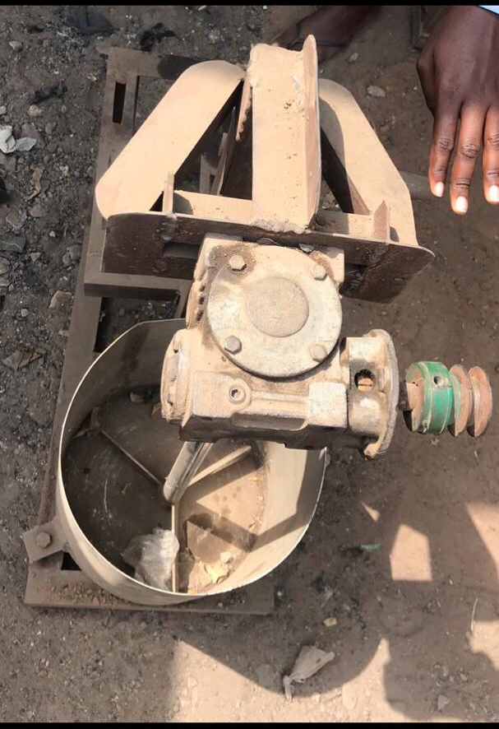

FIGURE 3.1: EXISTING MOTORIZED GROUNDNUT PASTE KNEADING MACHINE
3.2 Methodology
All instruments for experiment were calibrated before use to ensure the accuracy and reliability of the data collected. The methodology consisted of three main stages; Sample preparation, kneading operation and performance evaluation.
3.2.1 Sourcing of test materials
Groundnuts was sourced from a local market in Ilorin West Local Government Area, Kwara State Nigeria.
3.2.2 SAMPLE PREPARATION

The groundnut was cleaned and sorted to remove any foreign materials such as stones and pebbles, which were then measured into various samples of 1750g, 1780g and 1970g using a digital weighing scale. Prior to the kneading operation, the groundnuts were roasted to make it easier to remove their skins and then they were winnowed. The next day, the roasted groundnuts were then milled with the following ingredients; onion, dried pepper, garlic, ginger, salt and sugar, with the addition of potash (inhibit sourness and enhance oil yield during kneading) to convert it into paste. The ingredients were incorporated to improve the flavor profile of the paste, ensuring that the taste quality aligns with consumer preferences for locally processed groundnut products. The milled groundnut paste weighing serves as the primary input material for the kneading machine, with its quality directly influencing the efficiency of oil extraction and the overall characteristics of the final product evaluated in this performance study.

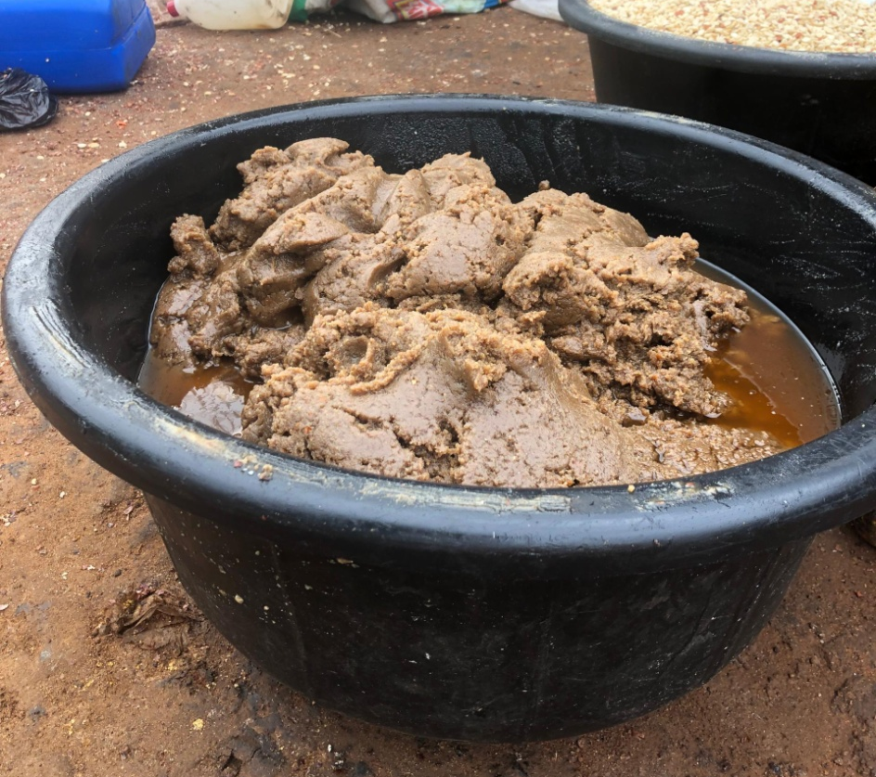

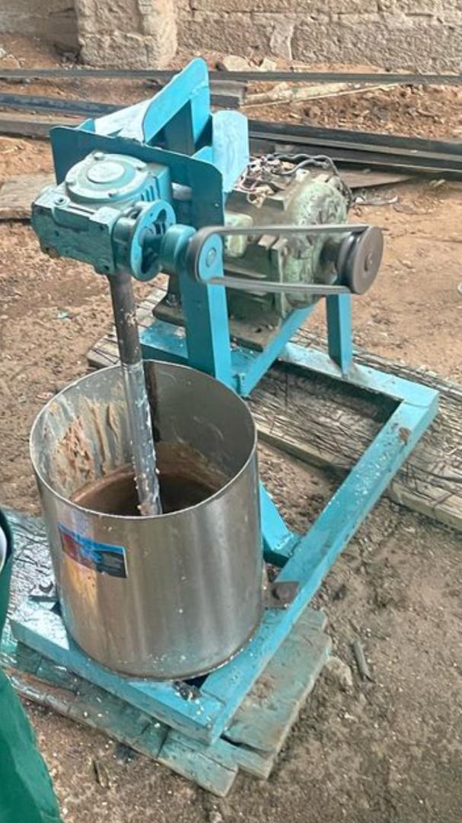
PLATE 3.1: GROUNDNUT PASTE

PLATE 3.2: KNEADING OF GROUNDNUT PASTE
3.2.3 KNEADING OPERATION
The prepared groundnut paste weighing 1600g, 2500g and 2810g per batch was fed into the kneading pot of the motorized groundnut kneading machine into three sections each shown in table 3.1, which was powered by the electric motor of 3.73KW at constant speed of 1800 rpm. The paste was mixed thoroughly by the r1otating fingers inside the kneader, facilitating oil separation through mechanical agitation and centrifugal action. Warm water was added gradually to the paste to improve its fluidity and support oil release while salt and sugar were added during kneading to enhance the taste of the resulting product. The kneading process took 8 minutes which was recorded with the use of a stopwatch, during the kneading process the operating speed of the kneader was constant to assess efficiency during oil extraction.
3.2.4 PERFORMANCE EVALUATION
Following kneading, the extracted oil was drained and collected in a plastic container and weighed using the digital scale to determine the mass of oil obtained. The moisture content of the paste after kneading was measured using the moisture analyzer to determine moisture reduction during processing.
3.2.5 EXPERIMENTAL SPECIFICATIONS
Some factors were considered for the experiment namely; Kneading rate (kg/min), throughput capacity (kg/hr) and Kneading Efficiency (%) for three batches. The different reading gotten from the groundnut paste batches after kneading where 1440g, 2150g and 2529g which was recorded and template generated was presented in table 3.2. The output parameters were determined using the following expression given as;
i. Kneading efficiency
ii. Kneading rate
iii. Throughput Capacity

3.2.5.1 KNEADING EFFICIENCY
Kneading efficiency (𝜂) refers to the effectiveness of a kneader in extracting oil from groundnut paste relative to the potential oil available in the paste (Sulaiman et al., 2023).
𝜂 = Mass of oil extracted × 100
𝑊eight of groundnut paste – Weight of Kneaded paste …………….Equation. 1
3.2.5.2 KNEADING RATE
Kneading rate (Rk) is the rate at which the kneader processes the groundnut paste within a unit time. It indicates how fast the machine is able to knead and prepare the paste for oil extraction (Gyuse & Yiljep, 2008).
Rk=Weight of groundnut paste (kilogram)
Time taken (minute) …………………………………………….Equation. 2
3.2.5.3 THROUGHPUT CAPACITY
Throughput capacity is the total quantity of groundnut paste that a kneader can handle and process effectively per unit time under optimal conditions, indicating the productivity of the machine (Sulaiman et al., 2023).
Tc = Weight of groundnut paste (kilogram)
Time taken (hours) …………………………………………….Equation. 3
3.2.6 EXPERIMENTAL RESULTS
The result from the experiment were shown in Table 3.1.

TABLE 3.1 WEIGHT OF KNEADED PASTE, KNEADING TIME, OPERATING SPEED AND KNEADED OIL OUTPUT
S/N | Weight of Groundnut paste (gram) | Weight of kneaded paste (gram) | Kneading time (Minutes) | Operating Speed (rpm) | Quantity of kneaded oil (gram)
1 | 1599 | 1439 | 2.9 | 1800 | 158.2
2 | 1599.6 | 1439.6 | 3.0 | 1800 | 158.5
3 | 1600 | 1440 | 3.1 | 1800 | 158.9
Average Value | 1600 | 1440 | 3.0 | 1800 | 159.0
4 | 2499 | 2149 | 2.0 | 1800 | 254.2
5 | 2499.5 | 2149.5 | 2.5 | 1800 | 254.5
6 | 2500 | 2150 | 3.0 | 1800 | 254.9
Average Value | 2500 | 2150 | 2.5 | 1800 | 255.0
7 | 2809 | 2528 | 2.0 | 1800 | 275.2
8 | 2809.6 | 2528.6 | 2.5 | 1800 | 275.5
9 | 2810 | 2528.9 | 3.0 | 1800 | 275.9
Average Value | 2810 | 2529 | 2.5 | 1800 | 276.0

TABLE 3.2 AVERAGE VALUE OF KNEADING PARAMETERS
S/N | Weight of Groundnut Paste (grams) | Weight of Kneaded Paste (grams) | Kneading Time (minutes) | Operating Speed (rpm) | Quantity Of Kneaded Oil (grams)
1 | 1600 | 1440 | 3.0 | 1800 | 159
2 | 2500 | 2150 | 2.5 | 1800 | 255
3 | 2810 | 2529 | 2.5 | 1800 | 276

TABLE 3.3 OVERALL PERFORMANCE EVALUATION PARAMETERS OF KNEADING MACHINE
S/N | Weight Of Groundnut Paste (kilograms) | Weight Of Kneaded Paste (kilograms) | Kneading Rate (kg/min) | Kneading Efficiency (%) | Throughput Capacity (kg/hr)
1 | 1.60 | 1.44 | 0.53 | 99 | 32.00
2 | 2.50 | 2.15 | 1.00 | 73 | 62.50
3 | 2.81 | 2.53 | 1.12 | 98 | 70.25

CHAPTER FOUR
RESULTS AND DISCUSSION
4.1 RESULTS
Table 3.1 illustrates the various batches of groundnut paste weights under different kneading parameters, while Table 3.2 provides the average values of these parameters for the groundnut kneading machine. The performance evaluation of the machine as shown in Table 3.3 considered factors such as kneading rate, kneading efficiency, and throughput capacity. The results are as follows; For the groundnut paste of weight 1.60 kg, the machine produced kneading rate of 0.53 kg/min, with a kneading efficiency of 99% and throughput capacity of 32 kg/hr. For the weight of 2.50 kg, the machine produced kneading rate of 1.00 kg/min with a kneading efficiency of 73% and throughput capacity of 62.50 kg/hr. Lastly, weight of groundnut paste of 2.81 kg produced kneading rate of 1.12 kg/min with a kneading efficiency of 98% and throughput capacity of 70.25 kg/hr..
4.2 DISCUSSION
The results obtained from these study can be attributed to the effective design and operation of the groundnut kneading machine, specifically the rotation of the three-finger stirrers at a constant operating speed played a crucial role in beating the groundnut paste and exposing the oil pores, thereby facilitating oil release. This mechanical action enabled the efficient extraction of oil from the groundnut paste. The highest kneading efficiency was observed with a groundnut paste weight of 1.60 kg which is likely due to the lower throughput capacity of 32 kg/hr. This suggests that the machine operates optimally at lower feed rates allowing for more efficient oil extraction. On the other hand, the 2.81 kg weight of groundnut paste yielded the highest oil content indicating that increased feed rates can lead to higher oil yields. Further analysis of the results reveals a correlation between the feed rate of groundnut paste with kneading rate and throughput capacity i.e as the weight of paste increases, the kneading rate and throughput capacity also tend to increase. However, this increase in feed rate may come at the cost of kneading efficiency as evidenced by the fluctuation in efficiency rates between 99%, 73%, and 98%.
The highest oil content was obtained at the highest efficiency rates, suggesting that optimal kneading efficiency is crucial for maximizing oil yield. The variation in kneading efficiency can be attributed to the increase in weight of groundnut paste fed into the machine pot, as the weight of groundnut paste increases the stirrers may struggle to effectively beat and expose the oil pores leading to decreased kneading efficiency. This results was further presented in figure 4.1. Overall, the results of this study demonstrate the potential of the motorized groundnut paste kneading machine to efficiently extract oil from groundnut paste.

WEIGHT OF GROUNDNUT PASTE (KG)

FIGURE 4.1: BAR CHART SHOWING THE RELATIONSHIP BETWEEN WEIGHT OF GROUNDNUT PASTE AND KNEADING RATE (KG/MINUTE), KNEADING EFFICIENCY (%), AND THROUGHPUT CAPACITY (KG/HOUR).
CHAPTER FIVE
CONCLUSION AND RECOMMENDATION
5.1 CONCLUSION
This study draws the following conclusions:
1. At a constant operating speed, increasing the weight of groundnut paste leads to higher oil extraction.
2. Higher weights of groundnut paste result in increased throughput capacity.
3. Increasing the feed rate of groundnut paste while decreasing kneading duration yields a higher kneading rate.
5.2 RECOMMENDATION
For future studies, the following recommendations are proposed:
1. Pre-conditioning of groundnuts through proper roasting can enhance oil extraction efficiency.
2. Using a higher quantity of groundnut paste can optimize machine performance and response.
3. Varying operating speeds can help determine the optimal speed for better machine analysis and performance.
4. Designing an oil outlet can facilitate easy removal of oil from the groundnut paste in the machine, improving overall efficiency.

REFERENCES
Adebayo, T. A., Smith, J., & Opeyemi, F.M. (2015). Mechanical Properties of Groundnuts for Processing Applications. Journal of Agricultural Engineering.
Adeyanju, M. A., Oladele, O. I., Bello, A. A., Adediran, A. A., & Bolarinwa, T. A. (2021). Design and development of a semi-automatic groundnut kneading machine. Journal of Engineering Research and Reports, 20(1), 1–12.
Adu, A. A., Osei-Asare, F., & Boateng, E. (2021). Effect of moisture content on the quality and stability of groundnut paste during storage. Journal of Food Processing and Preservation, 45(3), e15234.
Agboola, R. (2018). Challenges and innovations in groundnut processing for sustainable agriculture. Agricultural Processing Journal, 12(3), 45-53.
Ahmed, Y., & Bello, M. S. (2021). IoT-Enabled Groundnut Kneading Machines: A Case Study. Smart Agriculture Research.
Akinoso, R., & Raji, A. O. (2011). Optimization of oil extraction from locust bean using response surface methodology. European Journal of Lipid Science and Technology, 113(2), 245–252
Altieri, G. & Di Renzo, G. C. (2013). Olive oil extraction process: A review. Journal of Food Engineering, 117(4), 545-553.
Di Giovacchino, L. (2013). Technological innovations in olive oil production. Journal of Food Science and Technology, 50(3), 434-443.
Firman, L. R., Ochoa, N. A., Marchese, J., & Pagliero, C. (2020). Designing of spiral wound nanofiltration multistage process for oil concentration and solvent recovery from soybean oil/n-hexane miscella. Chemical Engineering Research and Design, 160, 1–10.
Gyuse, E. T., & Yiljep, Y. D. (2008). Optimum Paste Temperature for Oil Extraction Using IAR Motorised Kneader. Arid Zone Journal of Engineering, Technology and Environment, 6(1), 67–73.
Hassan, A. & Osunde, Z. (22). Design and evaluation of a motorized groundnut kneading machine. Journal of Agricultural Engineering, 59(2), 123-135.
Hassan, U. B. (2022). Performance evaluation of a motorized groundnut kneading machine. Journal of Food Science and Technology, 59(4), 2345-2354.
Janila, P., Adio, A.L., & Sulaiman, O.A., (2013). Groundnut improvement: Past, present and future. Journal of Crop Improvement, 27(2), 143-158.
John, P., Salami, G.A., & Agarwal, K. (2019). Advances in food processing machinery: A focus on groundnut paste production. Food Engineering Research, 15(4), 287-299.
Kumar, A., Sharma, S., & Singh, R. (2013). Leading edge technologies and perspectives in industrial oilseed extraction. Industrial Crops and Products, 44, 1–10.
Lawan, M., Mark, K.E., & Muhammad, O.(2016). Performance Evaluation of an Integrated Groundnut Oil Extraction Machine. Bayero Journal of Engineering and Technology, 11(1), 49-62.
Maduako, J. N., Mikailu, J., & Maunde, F. A. (2004). Development of a Motorized Kneader for Groundnut Oil Extraction. Nigerian Journal of Technology, 23(1), 34–38.
Moshood, A. H., Fatade, A., & Gbadamosi, L. (2023). Groundnut production in Nigeria: Challenges and prospects. Journal of Agricultural Science, 161(3), 432-445.
Musa, A. O., Kumar, S.P., & Johnson B. (2018). Performance Analysis of a Groundnut Kneading Machine. Food Processing Journal.
Ndirika, M. C., Kolade, A.S., & Oyeleke, O. (2017). Design and Fabrication of a Groundnut Kneading Machine. International Journal of Food Engineering.
Offiah, V., Kontogiorgos, V., & Falade, K. O. (2019). Extrusion Processing of Raw Food Materials and By-Products: A Review. Critical Reviews in Food Science and Nutrition, 59(18), 2979–2998.
Ogundare, S. T., & Adejumo, T. A. (2019). Improving the Efficiency of Groundnut Processing Machines. Journal of Agricultural Innovation.
Ogunwole, O. A., & Olawoye, B. T. (2016). Effects of temperature on oil extraction efficiency of groundnut paste. Journal of Food Science and Technology, 53(4), 2345-2354.
Oke, E. O., & Awonorin, S. O. (2013). Effects of operating speed on kneading efficiency of groundnut paste. Journal of Food Engineering, 116(2), 234-242.
Olayanju, T. M. A., Adebo, O. A., & Popoola, E. A. (2022). Moisture-dependent properties of groundnut paste and their influence on extrusion characteristics. Journal of Food Science and Technology, 59(10), 3875–3884.
Owobayi, O. F., Olamide, S.O., & Uche, P.(2025). Effects of feed rate on oil yield from groundnut paste using a motorized kneading machine. Journal of Food Science and Technology, 62(1), 234-242.
Patrick, E.A. & Joshua, A.E. (2019). Journal of Agricultural Engineering, 56(1), 123-130.
Smith, J., Kudabo, O.A., & Collins, K. (2020). Groundnut production and trade: A review. Journal of Agricultural Science, 158(2), 143-155.
Spott, H. (1985). Power transmission by belts. Journal of Mechanical Engineering, 27(2), 123 130.
Sulaiman, M. E., Nalado, D. D., Shittu, S. K., & Katibi, K. K. (2023). Design, fabrication, and optimization studies of a groundnut kneader. European Journal of Science, Innovation and Technology, 3(4), 21–40.
Wang, L., Zhang, M., & Mujumdar, A. S. (2012). Effect of extrusion conditions on the physicochemical properties of extruded soybean flour. Drying Technology, 30(6), 597 603.

