MODIFICATION AND PERFORMANCE EVALUATION OF HYBRID EGGS INCUBATOR
BY

BABARINDE OLAITAN OLUWAFEMI
HND/23/ABE/FT/0061

DEPARTMENT OF AGRICULTURAL AND BIO-ENVIRONMENTAL ENGINEERING INSTITUTE OF TECHNOLOGY, KWARA STATE POLYTECHNIC, ILORIN.
IN PARTITAL FULFILLMENT OF REQUIREMENT FOR THE AWARD OF HIGHER NATIONAL DIPLOMA (HND) IN AGRICULTURAL AND BIO-ENVIRONMENTAL ENGINEERING TECHNOLOGY.
AUGUST, 2025

DECLARATION
I hereby declare that this research project titled: “MODIFICATION AND PERFORMANCE EVALUATION OF HYBRID EGG INCUBATOR” is my own work and has not been submitted by any other person for any degree or qualification at any higher institution. I will also declare that the information provided therein are mine and those that are not mine are properly acknowledged.

  Name of Student Date and Signature

CERTIFICATION
I, hereby declare that this research project titled MODIFICATION AND PERFORMANCE EVALUATION OF HYBRID EGG INCUBATOR was carried out by Babarinde Olaitan Oluwafemi with matric number HND/23/ABE/FT/0061 is my own work and has not been submitted by any other person for any degree or diploma in any higher institution. I also declare that the information provide therein are mine and those that are not mine are properly acknowledged.

_______ __14/_8/2025____________
Engr. (Mrs) Onipede ,E.A Date
(Project Supervisor)
_______________ _____04/08/2025____________
Engr. Oyebanre O.D Date
(Project Co-ordinator)
_____ ___04/08/2025______________
Engr Dauda, K.A Date
(Head of Department)
_____________ ___13/08/2025______________
Dr. Adejumo Akinfoye Daniel Date
(External Examiner)
DEDICATION
I dedicate this project work firstly to Almighty GOD the unborn creator of every creature who has been there for me from my very first beginning till date. Also, to my caring and lovely parents Mr and Mrs Babarinde for all they have done for me I pray that you will reap the fruit of your labour by the grace of God.

ACKNOWLEDGEMENT
I give my great thanks to Almighty God, the Lord of the whole universe, the sustainers who guided and provided me all I need to complete my HND (Higher National Diploma) Programme in good health.
My profound gratitude goes to my beloved parent Mr and Mrs Babarinde, may Almighty God grant them sound health and bless them.
The next thank goes to my supervisor, a woman of understanding, honour and trust in person of Engr. (Mrs) Onipede,E.A. for being there and lenient with me. I pray Almighty God reward you abundantly (Amen).
My appreciation also goes to the H.O.D of Agricultural and Bio-environmental Engineering Department in person of Engr. Dauda, K.A, and to all my departmental lecturers for the knowledge they have impacted in me throughout my Higher National Diploma Programme, may God reward you abundantly.
Also my gratitude to my friends, who stood by me. I remain disloyal if I drop my pen without appreciating my project partners. Thank you for the sincere love we share during this research work. Also those people I am not opportune to mentioned one after the other, most especially all my course mate I appreciate you all, I will live to always remember your good deeds.
I am using this medium to pray to Almighty God to bestow on me the utmost knowledge and understanding from now till eternity (Amen).

TABLE OF CONTENTS
Title Page
Title Page I
Declaration ii
Certification iii
Dedication iv
Acknowledgement v
Table of Contents vi
List of Table x
List of Figure xi
Abstract xii
CHAPTER ONE
1. Introduction 1
  - Background to the Study 1
  - Problem Statement of the Study 2
1.3 Aims and Objectives of the Study 3
1.4 Justification of the Study 3
1.5 Scope of the Study 4
CHAPTER TWO
2. Literature Review 5
2.1 Poultry Farming in Nigeria 6
2.2 Poultry Incubation Technology 6
2.3 Feature of Hybrid Poultry Eggs Incubator 10
2.4 Incubation Parameters 11
2.5 Condition for Various Eggs Incubation 12
2.6 Reviews on Artificial Incubation 13
CHAPTER THREE
3. Materials and Methods 18
3.1 Materials 18
3.2 Area of Modification 19
3.3 Description of the Hybrid Egg Incubator 20
3.3.1 The Main Cabinet 21
3.3.2 The Auxiliary Unit 21
3.4 Design Consideration 22
3.5 Design Calculation and Analysis 22
3.5.1 Determination of Incubation Chamber 23
3.5.2 Determination of Heat Required for Incubation 24
3.5.3 Heat Loss by Incubator 24
3.5.4 Determination of Humidity 26
3.5.5 Total Power Consumption 27
3.5.6 Power Requirement and Selection of Battery Solar Panel and Inverter 27
3.5.7 Size of Solar Charger 27
3.5.8 Battery Running Time 29
3.6 Materials Selection 28
3.7 Construction and Assembly Procedure 29
3.8 The Operation of Hybrid Egg Incubator 29
3.9 Bill of Engineering Measurement and Evaluation 30
3.10 Performance Evaluation 31
3.10.1 Source of Material 31
3.10.2 Preparation of Sample 31
3.10.3 Output Parameters 31
3.11 Experimental Procedure 32
CHAPTER FOUR
4. Result and Discussion 34
4.1 Result 34
4.2 Discussion 36
CHAPTER FIVE
5. Conclusion and Recommendations 37
5.1 Conclusion 37
5.2 Recommendation 37
References 38 Appendices
LIST OF TABLE
Table 2.1 Condition for Various Egg Incubation 12
Table 3.1 Bill of Engineering and Evaluation 30
Table 4.1 Candling Test on 7th Day on Incubation 34
Table 4.2 Candling Test on the 14th Day of Incubation 34
Table 4.3 Average Records of Temperature and Humidity for 21days of Incubation 35

LIST OF FIGURES
Figure 3.1 Assembly View of Hybrid Eggs Incubator 19
Figure 3.2 Exploded View of Hybrid Eggs Incubator 20

ABSTRACT
A hybrid egg incubator was modified and constructed to solve the problem of power outages that militate against poultry egg incubation. The hybrid egg incubator was constructed from medium density fibreboard (MDF) plywood and lagged with fibre glass to prevent heat loss. The hybrid egg incubator was made of two units; the main cabinet and auxiliary unit.
The main cabinet consists of egg trays, bulbs, DC fans, water tray and turning mechanism. The auxiliary unit consists of solar PV panel, battery, inverter and charge control. The incubation parameters were measured by control board. The temperature and humidity range within the incubator were 36.1 - 37.5 °C and 50.1 % to 60% respectively, the angle of turn was 45°. The result of performance evaluation showed 91% hatchability, 66% fertility and mortality rate 9%.
The hybrid egg incubator is affordable because it was made from locally available materials and it is therefore recommended for poultry farmers both at rural and urban centers.

CHAPTER ONE
1. INTRODUCTION
1.1 Background of the Study
Incubation of egg is a process of transforming embryo in an egg into chick under favorable environmental condition with or without the consent of mother birds. There are two ways hatching of eggs can take place; one is by natural incubation which involves the broody bird sitting on a clutch of eggs while the other way is by artificial incubation which involves the use of incubator. The most important difference between natural and artificial incubation is that the parent provides warmth and stirring of the eggs by contact rather than surrounding the egg with warm air and provision of artificial stirrer. A broody hen can just hatch about 10-12 eggs at once in 21 days, which reduces its productivity as it takes time to incubate and hatch the chicks. More so, some large birds such as condors and albatross, may lay only a single egg every two years. An incubator is a machine for keeping fertilized eggs warm, as the embryo transform into a chick in 21days. Incubator for egg hatching has made a great impact in the agriculture world. It increases the production of chicken, duck, turkey and their eggs to the food industry. The high demand of chicken, fowl, turkey etc in market, hotels, quest houses and hospital has make chick production form developing embryo to become commercialized. Constant power supply is necessary for all incubators especially when the eggs are to be hatched. If there is any breakdown in the power supply, then the eggs lose their hatching value. The solar incubator on the other hand does not face this problem. The solar incubators also have the advantage of been reliable, light in weight and handy for carrying. Silent and power saving incubator is an The solar system has proven too serves as a source of power for the incubator which innovative machine for rural poultry farming. The solar system has proven to serve as a source of power of the incubator which could provide continuous power supply throughout the period of the incubation without failing. The main objective of this study is develop a solar powered poultry egg incubator. Temperature, humidity, ventilation and turning during the incubation period markedly affect the hatchability of fertile eggs and chick quality (Benjamin, 2012). The most vital factor of incubation is the constant temperature required for the embryo the egg will lose too much water to the atmosphere, which can make hatching difficult development over a specific period. The humidity is also critical, and if the air is too dry the egg will lose too much water to the atmosphere, which can make hatching difficult or impossible. The minimum and maximum temperature recommended for the first 18 days were 3/7.70C and 39.30C respectively. The use of solar energy has been gaining significance as a continuous supply of alternative power source, which seems to have an answer to frequent power constraints faced by farmers. Continuous supply of conventional energy in Nigeria is a mirage, due to frequent power outage Kuye el al (2008). The components of solar powered system used in the powering the solar incubator are PV solar module/cells/arrays, Charge controller, Deep cycle Battery, and Solar inverter (Zeman, 2001).
1.2 Problem Statement
The world’s growing population and increasing health awareness have led to a surge in demand for poultry product, which are perceived as a heathier alternative to red meat due to their lower cholesterol and trans fat content. this trend is expected to continue as driving growth in the poultry industry. The process of hatching egg by natural method is limited and the artificial incubators that can hatch more eggs at a time are faced with erratic power supply for an electrical incubator, adverse weather condition for solar incubator, lack of adequate control system of incubation system and besides an inadequate hatcheries contributing to high cost of day old chicks

1.3 Aim and Objectives
The aim of this project is to modify and evaluate the performance evaluation of hybrid eggs incubator that combine solar and electrical power system to enhance hatchability rate and reduce energy consumption while the specific objective are to;
i Identify shortcomings in the existing incubator
ii Modify components to improve hatchability
iii Assess the temperature and humidity control capability of incubator under different environmental conditional
iv Evaluate the machine performance in term of hatchability rate, fertility rate and mortality

1.4 Justification
The study will contribute to sustainable poultry farming in Nigeria by addressing power failure and weather related challenges, reducing energy consumption and operating costs, making incubation practices accessible in rural areas and increase the income of poultry farmers.

1.5 Scope of the Study
The scope of the study focuses on modifying an existing hybrid egg incubator in terms of construction materials, insulation materials, temperature and humidity control, mechanical turning of the egg, procurement of fertile eggs and carry out of performance evaluation in terms of hatchability rate, fertility of eggs and mortality rate

CHAPTER TWO
2. LITERATURE REVIEW
2.1 Poultry Farming in Nigeria
Poultry farming is the art and science of raising domestic birds for the purpose of using their meat and eggs for food. In Nigeria, so many farmers are into poultry production, but the level of technology application remains at the low level which often results in low productivity. Poultry farming simply mean birds that are domesticated and reared at home for provision of food such as egg and meat for human consumption and for the generation of income for the national economy and the producer as well. Other products such as poultry feathers and poultry droppings are also of economic importance to man. Poultry birds also provide income to the farmers. Haruna, Sani, Danwanka, and Adejo (2012). The Nigerian poultry egg industry contributes about 25% to agricultural GDP Since 2010, there has been a purposeful national drive to promote agriculture as a commercial enterprise. The Nigerian poultry egg industry, being a well-organized subsector in the agricultural sector and contributing 25% of the total agricultural contribution to GDP was well positioned to benefit from this and other measures. The poultry egg industry has also witnessed tremendous technical improvement over the last decade and continues to contribute to achieving Nigeria's food sufficiency and economic growth. (Akpan and Udoh, 2018). For S0 many years now, poultry egg production has improved significantly, the growth rates of production have increased but not so remarkable. The output level remains low compared to the input committed in production and the product is grossly inadequate because the supply is lower than demand. High cost of poultry feed increase would rather affect the total profit of the poultry eag farmers because the increase in poultry products prices is not commensurate with feed price increase especially due to the dwindling purchasing power of the populace (Hassan 2016). In Nigeria, the national policy on poultry egg production is aimed at attaining self- sufficiency and become the foremost exporter of poultry egg in Africa. But recently, the performance of poultry industry in Nigeria has fallen below expectation due to high cost of feed arising from fluctuations in feed supplies, rising prices of ingredients, poor feed ingredients qualities, poor storage facilities that lead to deterioration and inefficiency in production and the cost of production becomes too high (Olatunji & lfeanyi-Obi, 2011).
2.2. Poultry Incubation Technology
In the last few years, poultry egg incubation systems have experienced a technological, economic, and social revolution. Remarkable technological and scientific developments allowed the transition from manual incubation to large incubation machines and hatcheries, which incubate a much greater number of eggs using less labor, increasing chick production throughout the year. On the other hand, this incubation revolution generated costs related to the construction of more sophisticated facilities, as well as operational costs, such as energy and water expenses to maintain adequate incubation conditions. It also influenced social relations, creating two classes: producers and consumers. The principles of artificial egg incubation were established centuries ago. At that time, heat, moisture and air renewal of the incubation environment, well as the egg turning, were already taken into consideration. Based in historical records, Paniago (2005) and van den Sluis (2011) mention that, in ancient Egypt, eggs were incubated in mud-brick buildings (an "incubation house") divided in incubation chambers similar to ovens separated by a central hallway and accessible through manholes. In the upper part of the egg chambers, there were shelves for burning, straw, dung, or charcoal to heat the eggs below. Vents in the roof allowed the smoke from the fires to escape and provided some light. In this primitive incubation system, the temperature within the incubation chambers was managed by controlling fire intensity and opening the manholes, vents,
and the hallway. Humidity was controlled by placing moistened jute on eggs, which were manually turned twice per day. An incubator should to be able to regulate factors, such as temperature and humidity, and to allow air renewal and egg turning, providing the perfect environmental conditions for embryonic development, aiming at achieving high hatchability of healthy
chicks, which is directly correlated with the survival and performance of individual chicks in the field. Currently, incubators capable of incubating different numbers of eggs of different species of birds are commercially available, with more or less sophisticated of temperature, humidity, ventilation, and egg turning control systems. Modern state-of-the artcommercial hatcheries are provided with automatic systems controlling all the physical factors of incubation: egg turning; environmental temperature set according to eggshell temperature determined by thermosensors; air
relative humidity and egg water loss determined by egg tray weight using weight sensors; and air quality (02 and CO? levels). However, as already pointed out by Paniago (2005), despite the technological advances of the modern incubation machines, the success of incubation still depends on the quality of labor both inside and outside the hatcheries, which requires training.

- Natural Incubation
Natural incubation is traditional method that involves using a broody hen to sit on the eggs for long plucking feathers from a beast to create a warm nest and becoming aggressive towards other chickens. Natural incubation is the easiest method for hatching small numbers of eggs, and a broody hen can be utilized to incubate and hatch her own or another bird's eggs. A hen has the ability to incubate 12 to 15 chicken eggs or up to 10 duck eggs. A hen can also incubate the eggs of turkeys. A female turkey can lay up to 15 eggs, but only 9 turkey eggs can be incubated by a brooding hen. In natural incubation, a broody hen sits on a clutch of eggs, maintaining optimal temperature and humidity levels essential for embryo. Natural Incubation is Cost- effective, Eliminates the need for artificial incubators, reducing energy and equipment costs. Enhanced Chick Development: Chicks raised by a hen often exhibit better social behaviors and survival skills due to maternal guidance.
- Artificial Incubation
Artificial Incubation is the method of hatching eggs by maintaining the right environmental condition without the parent bird by use of machine called incubator in a commercial poultry farming, an artificial incubation is more efficient than natural incubation during the winter months when domestic hens are less inclined to become broody, more eggs can be hatched at one time for the first 15 days the environment is kept less humid at 45% infertile eggs can be identified and removed at 10-12 days through the process of candling, water should be add to an incubator at 15-17 days and topped up regularly until 20 days have elapsed, once hatched the chicks should remain in the incubator until properly dried out and fluffed up. several source of energy are used by poultry farmer to power artificial incubator and source can be classified based on the type and method of incubation
- Electrical Incubator; Electrical incubators are devices that provide a controlled environment, typically for hatching eggs or growing cultures by regulating temperature, humidity and air circulation most widely used type in commercial and small-scale poultry farming.
- Solar-Powered Incubators; These incubators maintain a controlled environment for purpose like hatching eggs or growing biological culture using energy harnessed from sun, it use solar panels to power heating system, active solar incubator use photovoltaic panels to generate electricity, it's particularly useful in off-grid or rural locations where access to electricity is limited and it is sustainable.
- Kerosene and Charcoal Incubator; These types are traditional and it is used in regions lacking electricity. They use kerosene lamps or charcoal as a heat source. it is Low cost, useful in rural settings. Limitations: Difficult to regulate temperature, higher risk of fire, lower hatch rates Kerosene incubator was developed to substitute the electrically operated type in rural and urban areas where power supply is not steady or where power failure is predominant. It is a simple machine which uses kerosene oil as the energy source to provide the required temperature for hatching. Most of the component parts are made from locally available raw materials which are cheap, durable, simple and efficient. The machine was designed to accommodate 86 eggs. The suitable temperature for the hatching was obtained as 3/0c-390c which lasted for an incubation period of 19 to 22 days. The efficiency of the machine was obtained as 80% which was found satisfactory. lt was concluded that, the machine is an indispensable aspect to agriculturist for reproduction in poultry.
- Hybrid Incubator; Hybrid incubators combine electric and solar power sources to ensure continuous operation. This type is becoming increasingly elegant for rural agricultural applications. They provide more reliability in case of power outages. Advantages: Flexibility, energy backup. Limitations: Complex design, higher maintenance.

2.3 Feature of Hybrid Poultry Eggs Incubator
Feature of Hybrid Poultry Eggs Incubator are;
- Dual power source: it combines two power source such as electricity and solar power to provide a reliable and consistent incubator environment
- Backup power system: Hybrid incubator may include backup power system such as batteries or generator to ensure continuous operation during power outrage or period or low sunlight
- Advanced temperature control which can maintain optimal temperature for poultry egg incubator even in extreme weather condition
- Humidity control to maintain optimal humidity for poultry egg incubation
- Automated egg turning and monitor to ensure proper turning to track incubator parameter such as temperature, humidity and egg turning

2.4 Incubation Parameters
Incubation environment plays a vital role in the artificial incubation process as it is critical for producing quality chicks, it ensure successful artificial incubation the
- incubation environment should meet four essential requirement including temperature relative humidity ventilation and Turning (Ngari et a/ 2022). This review we provide details on them. Temperature: Is the most critical environmental Factor during incubation because developing embryo can only tolerate very small fluctuation in temperature doing the Incubation period and the optimal incubation temperature for chicken eggs is around 37.5°C (99.5°f ) minor division can lead to embryo death or abnormalities. (Oni et a/ 2023).
- Relative Humidity: Determines the rate of moisture loss from eggs doing incubation low relative humidity can cause egg content to dry out too rapidly leading to reduce hatchability rate and producing smaller than normal chicks (poor quality chicken). that will not perform well during brooding period (Adriason ef a/ 2022). For the first 18 days. Most incubator manufacturer recommended relative humidity between 55 and 65%, After transfer to the hatcher the relative humidity requirement increase to about /0% at pipping and hatching, the relative humidity increase (the last day of incubation) to above 75 to 80% (Adriason ef a/ 20272).
- Egg Turning: The position of egg and turning are critical Factor in artificial incubation that affect development and hatchability where eggs are placed in the egg trays the egg orientation and how the egg trays move is crucial to producing high quality chicks (Adriason et a/ 2020) . The practice in commercial hatchery is to set eggs in a large end Up position and rotate them in a large end up position.
- Ventilation: ventilation is critical Factor in artificial incubation since it allows free movement of air through the pores of the shell and shell membranes, which is important for a constant supply of oxygen and the elimination of carbon dioxide and moisture (Bekhet, and Khalifa 2022).Fresh air contains 21% oxygen at sea level, which also the optimum oxygen concentration for developing embryos. For each 1% decline in the oxygen content of air, hatchability will drop by 5%. Poor ventilation (insufficient air exchange) increases the concentration in the incubator (shelter and hatcher), which can be lethal for developing embryos (Jiang and zheng et al 2019)
- Egg Fertility: Egg fertility is also an important parameter that enhance hatchability hence the need for eggs candling to ascertain the fertility of eggs incubated.
2.5 Condition for Various Eggs Incubation
The species of the bird, the incubation period, and other parameters for incubation is as shown in table 2.1
TABLE 2.1: Condition for Various Egg Incubation
Species | Incubation Period  (Days) | Temp  F | Humidity  (F) | Do not turn after | Humidity  Last 3days | Open vent more
Chicken  Turkey  Duck  Muscovy duck  Goose  Guinea fowl  Peafowl  Pheasant  Pigeon  Bobwhite  Cotumix  Chukar | 21  28  28  35-37  28-34  28  28-30  23-28  17  23-24  17  23-24 | 100  99  99  100  99  100  99  100  100  100  100  100 | 85-87  84-86  85-86  84-85  86-88  85-87  84-86  86-88  85-87  84-87  85-86  81-83 | 18th day  25th day  25th day  31st day  25th day  25th day  25th day  21st day  15th day  20th day  15th day  20th day | 90  90  90  90  90  90  90  92  90  90  90  90 | 18th day  25th day  25th day  31st day  25th day  24th day  25th day  25th day  14th day  20th day  14th day  20th day

2.6 Review on Artificial Incubation
Different researchers have made a research on artificial incubation and come out with different result according to:
Osanyinpeju et al., (2016) walked on the development of solar powered poultry ega incubator. The heat produced by metabolic activities of 150 eggs in the system was 21.9 w. The percentage fertility of 64% in addition to 44% hatchability rate was observed with the system. The low hatchability was attributed to faulty hygrometer used which led to increase in the number of opening made at the last stage. Divagar et al., (2022) evaluated and automated solar-driven hybrid egg incubator. The system achieved a hatchability percentage of 81.72".
Faki etal (2015) reported on incubation condition such as temperature, humidity, ventilation and turning the most important factor significantly affective the hatchability of poutry egg and chick
39° c in addition to the mean hatchability rate of 62.37%. quality.
Okonkwo et al (2024) researched on energy sources for poultry egg incubator efficiency and hatachability. the result showed that sources of energy for incubation are categorized into grid supply electricity solar system, fossil fuel, biogas and thermochemical materials, from reviewed articles 50% identified grid supplied electricity as energy source for poultry egg incubation and hatachabiliy range from 80.9%-98.4% however, due to erratic nature of electricity supply and nonavailability in rural areas especially in developing nations, the study recommends increase research interest on other every source to improve their hatachability.
Hassan et al., (2021) in characterizing and electric incubator recorded a hatchability percentage of 80.9% and concluded that the major challenge of incubators that can work with electricity are excessive billing rate, erratic power supply as well as complete absence of electricity in remote regions. Equally most of the incubator is developing countries like Nigeria operate at 60% below design capacity grid electric supply.
Olaoye et al., (2013) developed a 120 egg a capacity electric incubator. The system which was coupled with three 100 w electric bulb produced 75.2% fertility in addition to the hatchability rate of 64.8%.
Yadav et al., (2021) Analyzed the developed automatic horizontal egg incubator. A motor clamped mechanism controlled by a micro-controller was used to adjust the egg trays horizontally. The system yielded a hatchability of 72.22%.
Ogunwande et al., (2015) studied a still-air hatchery that has a non-thermostatic control. The system uses electric bulbs as the its source with a resistance varying components as temperature control. With three times daily of the eggs, the system achieved 62% hatchability rate.
Soeb et al., (2021) developed a low-cost incubator that is made up of the embedded controller Incorporated to an egg turning trays with hatchery apartment of 116 egg capacity for Bangladesh market. The manual and automatically evaluations of the developed hatchery showed a 79.3% and 87.1% hatchability rate respectively. The eggs were turned both manually and automatically as the case may be at intervals of 6hours.
Mansaray and Yansaneh (2015) developed a solar egg incubator that achieved temperature range of 36.8-37.9° c. The evaluation of the system yielded a percentage fertility and hatchability rate of 43.3% and 23.1% respectively. The study concluded that the low level of hatchability was as a result of several external influences such as an overcast weather, improper egg storage, time and energy loss, turning of eggs, faulty eggs etc.
Divagar et al., (2022) evaluated and automated solar-driven hybrid egg incubator. The system achieved a hatchability percentage of 81.72%.
Osanyinpeju et al., (2016) walked on the development of solar powered poultry egg incubator. The heat produced by metabolic activities of 150 eggs in the system was 21.9 w. The percentage fertility of 64% in addition to 44% hatchability rate was observed with the system. The low hatchability was attributed to faulty hygrometer used which led to increase in the number of opening made at the last stage.
Niranjan et al., (2021) developed a chicken egg incubator using (IOT) integrated with smartphone effective monitoring and control. The system temperature wear set at the different temperatures of into (H1) 36.5° c, (H2) 37.5° c and (H3) 38° c. The hatchability percentage of the three temperatures were(H1) 81%, (H2) 92% and (H3) 86% respectively.
Ogunwande et al., (2015) developed a biogas powered poultry egg incubator that utilizes biogas as a fuel to provide thermal energy via a heater situated at the base. The system produced temperature range of 36-39.4° c within the incubating compartment. At the end of an evaluation test, a hatchability percent of 59.7% was realized.
Hassan et al., (2021) studied the use of thermal chemical storage media setup as a thermal source of hatching of poultry eggs. In the study, three forms of activated TCMs were utilized as energy containing medium. The media are silica gel, as well as natural zeolites. The TCMs were activated using electricity. Equally, the incubator was partly powered by electricity and partly by the TCMs. The its recapture operation helps to release the stored heat in TCMs. The system's hatchability percentage was 71.4% compared to the solely electric powered conventional incubator with 80.9% hatchability. However, the TCM incubator gave energy savings of 41.8% when compared with the conventional electric type.
Muhammad et al, (2022) Studies a thermoelectric egg incubator coupled to heat storage system. Did Samuel electric component is utilized in the daytime process while a heat storage system made up of a phase change material (PCM) which provides derma energy during off-sunshine (especially nights) periods is complementary heat source. The electric energy that is changed to heat for starting the operation is provided with the arrays of the solar PV. The result of the 300 egg capacity system showed that temperature inside incubator chamber was between 36 iPhone 39° c with 73.3% hatchability.
Olasukanmi et al., (2015) developed a GSM based DC battery powered poultry egg incubator. The system is remotely tracked. The major components of the incubator were the DC motor, humidifier, ventilation fans, in addition to the custom made lower-power DC heater provided for controlling the turning of eggs, humidity, ventilation and temperature, respectively. The hatchery could either be powered using solar PV system, greed power electricity via an inverter or any medium that could charge the DC battery.
Oniya et al., (2013) develop a 160 a capacity low cost semi-in automated incubator powered by a backup inverter. The inverter could either be powered with an AC or DC electric system. The major components of the system were a heat source (100 w bulb), a thermistor, 12 PV battery, 100 w inverter and 0.14 w electric fan. A replicated analysis on the system showed a temperature variation between 36 to 39° c with hatchability 91%.
Uzodinma et al., (2020) carried out a characterization of hybrid solar powered poultry egg incubator. The hybrid incubator is made up of a double glazed flat plate solar collector coupled with paraffin PCM in addition to a PV subsystem. The evaluation of the system reviewed that the incubating temperature was maintained between 36 and 39° c in addition to the mean hatchability rate of 62.37%.
Bukola (2008) modified and carry out performance and evaluation of hybrid poultry solar incubator and stated the environmental factors of major importance for artificial incubator include temperature, relative humidity, air supply and egg turning. overheating speed up the rate of development and called abnormal embryo in the early hatches and consequently lower the percentage hatchability likewise high rate to prevent normal evaporation and results in low hatachability. Turing of egg should be done 3- times daily from 2nd to the 18th day of incubation to prevent embryo adhersing to the shell

CHAPTER THREE
3. MATERIALS & METHODS
3.1 Materials
The following materials were used in the construction of hybrid egg incubator;
- MDF Plywood (Medium Density Fiber Body)
- Marine Board
- Bolt and Nut.
- Screw
- Ardonic Cabinet Hinge
- Edges Tape
- Door Bolt
- Nails
- Screw Cover
- Plank for the Egg Tray Seat
- Egg
- Hammer
- Glass Fiber
3.2 Area of Modification
The result from the test of previous machine showed that the machine was able to hatch 20 egg out of 45 eggs after operating the machine this gives 44% hatchability rate. The recommendation suggested that the turning mechanism, the temperature and humidity control should be automated for better performance hence the turning mechanism, temperature and humidity control system will be automated and some technical issues like egg fertility will be addressed
3.3 Description of the Hybrid Eggs Incubator
The hybrid eggs Assembly and Exploded views were as shown in figure 3.1 to 3.2 . The hybrid eggs incubator are made up of two components, the main cabinets and the auxiliary unit.
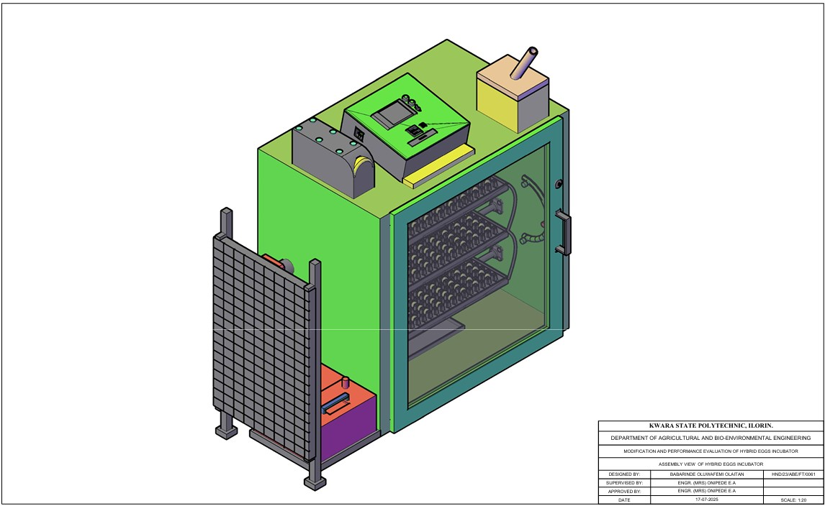
Figure 3.1 Assembly View of Hybrid Eggs Incubator
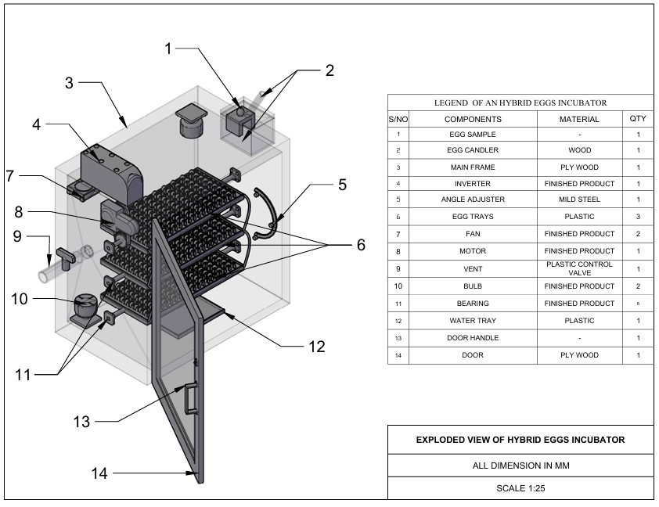
Figure 3.2 Exploded View of Hybrid Eggs Incubator
3.3.1 The Main Cabinet
The main cabinet is the incubating box which consists of the egg trays, fan, bulbs, egg turner, humidity tray, controller and savor motor.
- The incubating box is made from MDF plywood due to it, insulation properties, ease of construction, flexibility and durability. The dimension of the incubating box is 920 mm x 950 mm x 640mm.
- Egg turning trays: The Egg turning trays, is constructed from wood with dimension of 635mm x 335mm x 60 mm to accommodate the egg plastic crates. There are six egg creates, each containing 30 eggs, they were positioned inside incubator and turn 6 hourly.
- Humidity tray Is made up of plastic and placed at the bottom of the incubating box to increase and recover humidity in the incubator during experimental period.
- The fan is incorporated to facilitate the temperature and humidity in the incubator in order to keep them within the requirement of the present values.
- The controller was incorporated to sense the temperature, humidity and the turning mechanism of the incubator for effective incubation.
- The electric bulb 100 w cells as the source of heat to warm the inner unit to temperature range of 36 - 37.5° c.
- The savor motor
- The savor motor is used to drive the egg turning tray and tilt it to an angle of 45° either side after a period of 6 hours.
3.3.2 The Auxiliary Unit
The auxiliary unit consists of solar PV panel, solar charge control, battery and inverter. The solar PV panel: Absorb solar energy to charge the battery, the solar charger controls the charging of the battery to prevent overcharging, the inverter converts the direct current from the battery to alternating current to be used by the incubator and at the same time charged the battery when there is electricity.
3.4 Design Consideration
The following factors were considered when designing hybrid eggs incubation
(a) Environmental Control
- Temperature range of 36.5°C-37-5°C within the incubator
- humidity range of 50-60% to prevent water loss and promote healthy development
- ventilation within the incubator is necessary for adequate airflow to maintain oxygen levels and remove carbon dioxide.
(b) Egg Handling
- regular turning (every 1-4 hours) to prevent embryo adhesion to the shell
- egg orientation to ensure eggs are positioned correctly (large end up) to facilitate proper development.
(c) Energy Deficiency and Sustainability.
- incorporating solar energy source to reduce reliance on electrical energy source
- automatic egg turner to reduce labor and ensure consistent turning
- temperature and humidity monitoring to ensure optimal condition
3.5 Design Calculation and Analysis
The design criteria are based on making the equipment more affordable, efficient and durable. the incubator capacity, heating system, turning mechanism, size of battery, power from battery size of solar panel were all designed during the development process.
3.5.1 Determination of Incubation Chamber
The capacity of the incubator is directly proportional to the number of eggs and the number of egg trays. The incubator was design to hatch 180eggs per hatch. The design of incubation chamber was done using equation 3.1and 3.2
c = $\frac{n}{60}$ (3.1)
Where
C = number of trays
n = number of eggs to be hatched
c = $\frac{180}{60}$
c = 3egg trays
the incubation chamber was designed to contain the egg trays; the incubation chamber was rectangular box like structure.
Volume of Incubation Chamber
V = l × b × h (3.2)
Where:
V = volume of incubator (m$^3$) (Abubakar et al 2023)
L = length of incubator (m)
B = breadth of incubator (m)
H = height of incubator (m)
3.5.2 Determination of Heat Required for Incubation
Heat required in the incubator was determined from equation 4
Q = MCΔT (Benjamin and Oye ,2012) (3.3)
Where;
Q = total heat required
C = specific heat capacity
ΔT = change in temperature
M = molar mass
QT = (MaCaΔT) + (MeCeΔT) × Ne + (MpCpΔT) + (MwCwΔT) (3.4) (Abubakar et al 2023)
Where;
MaCaΔT = heat required by air
MeCeΔT = heat required by eggs
Ne = number of eggs
MpCpΔT = heat required by plywood
MwCwΔT = heat required by water.
3.5.3 Heat Loss by Incubator
The heat loss due to conduction can be calculated from the equation 3.5 - 3.9
Q = −KA($\frac{ST}{Sx}$) (3.5)
The flow of air is steady inside the incubator therefore it does not vary with time.
QSx = −KAST (3.6)
Q = − KA$(\frac{Tinc -Ts}{X}$) (3.7)
Where;
Q = heat
K = thermal conductivity coefficient of plywood (0.65) in the design
X = is the thickness of the plywood (15mm)
Heat loss during incubation is given as top and bottom of plywood.
Qptpbpspfpbt =−KA$(\frac{Tinc -Ts}{X}$) × 2 (3.8) (Bala et al, 2020)
Where;
Pt = is the plywood top
Pb = plywood backside
Ps = plywood side
Pf = plywood front
Pbt = plywood bottom.
A = area of incubator chamber
K = thermal conductivity coefficient (0.65 forMDF) plywood (Ajani et al 2020).
The quantity of heat loss is calculated using the following equation
QL = Qptm + Qpss + Qpfb ( 3.9)
The quantity of heat required for the incubation
Q = Ql + Q1 (3.10)
Where:
Q = quantity of heat required for incubation
QL = heat loss by the incubator
Q1 = heat required of the incubator.
3.5.4 Determination of Humidity
The humidity keeps the eggs from losing two much moistures in the process of incubation it is calculated from equation 3.11 – 3.13
H = $\frac{Mv}{v}$ (3.11)
ρ =MvRvT (3.12)
H =$\frac{v}{RvT}$ (3.13)
Where:
H = humidity
ρ = energy density/heat density of water
T = temperature
Mv = molar mall of water
Rv = gas content
V = volume of the incubator’s chamber

3.5.5 Total Power Consumption
The total power consumption of the entire incubator system can be calculated from the following equation.
Total power consumption (PT) =P1+Pfh+Pfv+Pc (3.14) (Abba- ayi et al 2024)
Where;
P1 = power of the incubator chamber
Pfh = power of humidity fan
Pfv = power of ventilation
Pc = power of control board.
3.5.6 Power Requirement and Selection of Battery Solar Panel and Inverter
Total power consumption is added up to 130.435W base on the total power requirement of the incubator. A 200AH lithium phosphate acid battery 12v, a 1KVA inverter and a 300W solar panel will be used to power the entire incubator.
3.5.7 Size of Solar Charger
Size of solar charger was determine using equation 3.15.
SSc = $\frac{wp}{v}×Pf$
Where;
SSc = size of solar charger (AH)
Wp = wattage of solar panel (W)
V = voltage of the battery (V)
Pf = power factor (1.25)
Size of solar charger =21AH but use 25AH
3.5.8 Battery Running Time
The battery running time was calculated using equation 3.16
BR = $\frac{Bc}{L}$ Pf (3.16)
Where;
BR = battery running time (H)
Bc = capacity of battery (AH)
L = load of appliance (w)
Pf = power factor (10)
Battery running time is 16 hours but charging should start after 12 hours.
3.6 Material Selection
The following materials are put into consideration for the selection of materials used for hybrid eggs incubator
- Conservation of heat: MDF plywood was used for construction to conserve heat.
- Availability of material: The material used is easily available for repair and replacement.
- The cost of material: The cost of materials used is not expensive and will eventually leads to low cost of the incubator.
- The durability of the material: The material for construction was the type that will last long and have resistant to insect infestation.
- The easy of construction: The material used for construction is easy to work upon for mass production.
- The weight of material: The material used for construction was light weight for easy transportation.
- Lagging material: Fibre glass was used as a lagging material to further conserve and prevent loss.
3.7 Construction and Assembly Procedure of Hybrid Eggs Incubator
The tool used for the construction include; the hammer, hacksaw, paper tape, nail, bolt and nut. The medium density fibreboard (MDF)plywood of 50mm thickness was cut according to the design specification and joined together by nails and screw to form the incubating box. The three egg trays were in incorporated into the incubating box using bearing at ---- interval between one another to serve as egg crates seat. The savor motor was incorporated to the egg tray to facilitate the turning of the egg trays. The control board that houses temperature, humidity and time of turning was also incorporated.
3.8 The Operation of Hybrid Egg Incubator
The hybrid egg incubator is operated using two sources of energy (electrical and solar energy) that complement one another to prevent power interruption and for efficient incubation. When electricity is available, the incubator is powered directly from the main but in case of power outage the incubator is powered by solar power system. The solar power system consists of solar panel, solar charge control, battery and inverter.
The solar PV absorbs solar energy from the sun and charge the battery via the solar charge control, the DC from the battery is converted to AC by inverter for the use of the incubator thereby preventing power interruption that may be caused by power outage. The switching of power from electricity to solar or vice-versa is made possible through automatic incubator control system.
3.9 Bill of Engineering Measurement and Evaluation
Bill of engineering measurement and evaluation is presented in table
Table3.1:- Bill Of Engineering and Evaluation
S/N | Material | Rate | Quantity | Amount
1  2  3  4  5  6  7  8  9  10  11  12 | MDF Plywood 15mm  Marine Board 15mm  Egg Tray  Egg Crate  Turning Mechanism  Incubator Box Glass  DC Fan  Bearing  Electric Motor (Savor)  Controller Board  Eggs  Miscellenous  TOTAL | 35,000  45,000  20,000  800  50  30  8,000  8,000  45,000  95,000  7,500  15,000 | 1  1  3  6  -  1  2  6  1  1  6  - | 35,000  45,000  60,000  4,800  50,000  30,000  16,000  4,800  40,000  95,000  45,000  15,000  440,600

3.10 Performance Evaluation of Hybrid Eggs
3.10.1 Source of Material Source: The fertile eggs for evaluation were purchase from a poultry farm in Oke Ose, Ilorin East Local Government of Kwara State.
3.10.2 Preparation of Sample: The eggs were cleaned using sand paper, the eggs were of good size and shape. The incubator was fumigated for a day to prevent any contamination in readiness for incubation.
3.10.3 Output Parameter: The output parameters to be measured are;
Percentage Hatchability:
- Percentage hatchability is the number of hatched eggs to the number of fertile eggs loaded into the incubator in percentage.
The equation is stated in 3.17
Ph = $\frac{\text{N}\text{h}}{\text{Nfe}} \text{X }\text{100}$ ……………. 3.17
Where;
Ph = Percentage hatchability (%)
Nh= Number of hatched eggs
Nfe= Number of fertile eggs loaded
- Percentage Fertility:
Percentage fertility is the number of fertile eggs to the number of eggs loaded into the incubator in percentage.
The equation is stated in table 3.18
Pf = $\frac{\text{Nfe}}{\text{Nf}} \text{X}\text{ 100}$ ……………. 3.18

Where;
Pf = Percentage fertility (%)
Nfe = Number of fertile egg
Nf = Number of eggs loaded into the incubator
- Mortality Rate
Mortality rate is the number of death to the number of fertile eggs loaded into the incubator
The equation is stated in 3. 19
MR = $\frac{\text{Nd}}{\text{Nfe}} \text{X }\text{100}$
Where;
MR = Mortailty rate
Nd = Number of death
Nfe = Number of eggs loaded
3.11 Experimental Procedure
The performance evaluation of hybrid eggs incubator was carried out at Kwara State Polytechnic Institute of Skills Acquisition, Mini Campus, Ilorin. The hybrid eggs incubator was fumigated and run empty for one day to ascertain the satisfactory performance of the incubator.
One hundred fowl eggs were purchased from a poultry farm in Oke Ose, Ilorin East Local Government of Kwara State and loaded into the hybrid egg incubator. The temperature, humidity and turning of egg tray were monitored. The temperature and humidity were taken three times a day and the mean value for each day was recorded while the turning of egg trays was on 6 hourly.
The candling of eggs was done on the 7th day of loading and the second candling was done on the 14th day of loading. The turning of egg tray was stopped on the 18th day of loading. The unfertilized and bad eggs removed from the incubator was 34 eggs while the remaining 66 eggs were incubated for the period of 21 days. The hatching of eggs started on the 20th day of incubation. The number of hatched eggs were 58 while the remaining 8 were dead in the shell.

CHAPTER FOUR
4 RESULT AND DISCUSSION
4.1 Result
The result of performance evaluation of hybrid egg incubator is as shown in table 4.1-4.3
Table 4.1 Candling Test On 7th Day On Incubation
S/N | No of Eggs | Development | Observation | Remark
i  ii  iii  iv | 10  11  40  39 | not visible  not visible  visible at one end  visible at the centre | Clear  Larger air space  Liner running across  Visible patches of red strain | Infertile  Infertile  Fertile  Fertile

Table 4.2 Candling Test On The 14th Day of Incubation
S/N | No of Eggs | Development | Observation | Remark
i  ii  iii  iv  v | 13  61  6  5  7 | Not visible  Dark appearance  The whole egg is dark  Dark Appearance  The whole egg is dark | Clear  Clear air space  No air space  Beak is visible  Visible patch of red stain | No development  Development in progress  Development ceased  Almost fertile  Development ceased

Table 4.3 Average Records of Temperature and Humidity for 21days of Incubation
S/N | Temperature(°c) | Humidity(%)
1  2  3  4  5  6  7  8  9  10  11  12  13  14  15  16  17  18  19  20  21 | 37.2  37.4  37.3  37.2  37.3  37.4  37.4  37.5  37.4  37.4  37.4  36.1  37.5  37.5  37.5  37.3  37.3  37.5  37.4  37.3  37.4 | 50.1  52.1  53.1  52.6  57.7  54.9  58.2  58.3  59.8  56.0  56.3  50.4  56.2  56.2  56.1  52.4  55.9  53.4  57.9  60.0  54.1

The output parameter are;
- Percentage hatachability =$\left(\frac{number of eggs hatched}{number of fertile egg }\right)×100$
= $\frac{60}{66}×100=91\%$
- Percentage fertility = $\left(\frac{number of fertile eggs}{number of eggs incubated}\right)×100$
= $\frac{66}{100}×100=66\%$
- Mortality rate =$\left(\frac{number of death embroy}{number of eggs incubated}\right)$
= $\frac{6}{66}×100$ = 9%
4.2 Discussion
The result of incubation from 4.1 showed the temperature range of (36.1° – 37.5°) during the performance evaluation which corroborate the findings of Hard et al (2010), Gbabo et al (2014), Nithin et al (2014), Oniya et al (2010). This showed that the equipment was suitable for incubating fertile eggs. The relative humidity range (50.1 -60%) during performance evaluation was within the range obtained by Oniya et al(2013). The minimum temperature and humidity from the first day to 21st day were 36.1c° and 50% respectively while the maximum temperature was 37.5°c and maximum humidity was 60% for the period of incubation.

CHAPTER FIVE
5 CONCLUSIONS AND RECOMMENDATIONS
5.1 Conclusions
From the study carried out, the following are drawn:
- A hybrid egg incubator that combines electricity with solar energy to complement one another to prevent power interruption of the machine during incubation was modified and constructed.
- The temperature and humidity range within the incubator during performance evaluation were 36.1 – 37.5°c and 50.1 – 60% respectively. The percentage hatachability of the incubation is 91%. The incubator is suitable for the hatching of poultry eggs and is therefore recommended for poultry farmers.
5.2 Recommendations
The following recommendations are made:
- Intensive performance evaluation should be carryout using other species of poultry birds like turkey, duck, guinea fowl.
- Sponsorship should be provided by relevant agencies in order to improve the machine and stop importation of incubators.

REFERENCES
Abba – Ayi, M.A, Usman, A.R and Shuwa, M (20240): Design of a Smart Solar Hybrid Egg Incubator for of Engineering, technology and environment Vol 20(2) pg 375 – 384.
Abubakar, M.A, Daheer, A.A Adache, A.L Ferdinad, I.O (2023): Development and Testing of an Automated Egg Incubator. International Journal of Advanced in Engineering and Management (IJAEM) 5(6). 191 – 202.
Ajani, A.S, Olusoji, A.O, Egbeyele G.B and Adeniyi M.O (2020): Design and Construction of automated Eggs incubator for small scale poultry farmer. Internal Journal of Technical Research and Science. Volume 5 issue 8 P 1-9.
Bala, A.M, Abubakar, M.A, Bello M.S and Sakako, T (2020): Design, Construction of a Fully Automated Egg Incubator using Electric Battery. Egg Incubator using Electric battery. African Scholar Journal of African Sustainability Development 18(2): 319 – 332.
Benjanim, N and Oye, N.D (2012): Modification of the Design of Poultry Incubator. International Journal of Application or Innovation in Engineering 1: 90 – 102.
Divagar, V., Kannan, N., and Thiruvaran, T. “Development of an automated solar-driven hybrid egg incubator”, 2022. Available: https://nastec.gov.lk
D. O.A, O. J.O and S. H.D, “Proposed Development of a Solar Powered Automated Incubator for Chickens,” International Journal of Engineering and Techniques, vol. 4, no. 1, pp. 517-524, 2018.
Eke, M. O, Ugwuoke, P. E and Okonkwo W. I (2017) Design and construction of a solar powered egg incubator. Nigeria Journal of Technology.
Gbabo, A, Liberty, J.T, Gune, O.N and Owa, G.J (2014): Design, Construction and Performance Evaluation of an Electric power Egg incubator. International Journal of Research in Engineering and Technology 3: 521 – 526.
Harb, S.K, Habib, Y.A, Kasfem, A.M and poultry egg incubator to suit small farmer. Egypt Journal Agricultural Research 88 (1) 193 – 210.
I. Kuye, O. Adekunle, Adetunji, Or Olaleye (2008) Design and construction of solar incubator.
Kingori, A.M. 2011. Review of the Factors that Influence Egg Fertility and Hatchability in Poultry. International Journal of Poultry Science.
Mansaray, K. G., and Yansaneh, O. “Fabrication and performance evaluation of a solar powered chicken egg incubator”, Int. J. Emerg. Technol. Adv. Eng., vol. 5, issue 6, pp. 31-36, 2015.
M. Musa Ademe, Y. Yusuf and N. Tilahunkuda (2022) Influence of type of incubator on hatchability of eggs.
Ngari, A.Z., O.H. Olabimtan, F.A. Samuel, M.A. Amupitan and M.O. Agboni, 2020. Low-cost design of poultry egg incubator with W1209 digital temperature controller. Int. J. Acad. Eng. Res.
Nithin, T.A, Shamea, L.M and Pradeep, K (2014): Design and Implementation of Solar PV Poultry Incubator. International Journal of Engineering and Advance Technology (IJEAT) Vol 3 (3) pg 289 – 291.
Niranjan, L., Venkatesan, C., Suhas, A. R., Satheeskumaran, S., and Nawaz, S. A. “Design and implementation of chicken egg incubator for hatching using IoT”, Int. J. Computational Science and Engineering, vol. 24, issue 4, pp. 363-372, 2021. Available: https://doi.org/10.1504/IJCSE.2021.117018
Oniya, O.O, Akande, F.B, Lawal, A.O and Adeyemo, A.S (2013): Development of a low – cost semi – automated Incubator. Journal of Agricultural Engineering and Technology Vol. 21 Issued P 27 -36.
Ogunwande, G. A., Ajayi, O. A., Ogunjimi, L. A. O. and Osunade, J. A. “Development of a still-air incubator with nonthermostatic control”, Ife Journal of Technology, vol. 19, issue 2, pp. 59-62, 2010.
Olatubosun, F. M, et al (2020) performance evaluation of microcontroller based solar powered incubator. African Journal of Science, Technology Innovation and Dev.
Olasunkanmi, J. N., Akintade, O. O., and Kehinde, L. O. “Development of a GSM based DC Powered Bird Egg Incubator”, International Journal of Engineering.
Okonkwo, W. I., and Chukwuezie, O. C. “Characterization of a photovoltaic powered poultry egg incubator”, in 4th International Conference on Agriculture and Animal Science, Singapore, 2012, pp.1-6. Available: https://doi.org/10.7763/IPCBEE
Osanyinpeju, K., Aderinlewo, A., Adetunji, O., and Ajisegiri, E. “Development of Solar powered poultry egg incubator”, in College of Engineering International Conference, Federal University of Agriculture, Abeokuta, 2016, p. 11.
Onu, P. N, and Madukwe, E. U (2012) Development and performance evaluation of hybrid solar electric incubator. Journal of Agricultural Technology.
Paguntalan, R.B. and V.H. Oquino, 2016. Design and development of a microcontroller based egg incubator for small scale poultry production.
Soeb, M. A., Al Mamun, M. R., Shammi, S., Uddin, M., and Eimon, G. A. “Design and Fabrication of Low-Cost Incubator to Evaluate Hatching Performance of Egg”, European Journal of Engineering and Technology Research, vol. 6, issue 7, pp. 91- 96, 2021. Available: http://dx.doi.org/10.24018/ejers.2021.6.7.2662
Uzodinma, E. O., Ojike, O., Etoamaihe, U, J., and Okonkwo, W. I. “Performance study, of a solar poultry egg incubator with phase change heat storage subsystem”, Case Studies Thermal Engineering, vol. 18, issue 100593, 2020. Available: https://doi.org/10.1016/j.csite.2020.100593
Yadav, B. K., Pokhrel, N., Khatiwada, D., Khanal, M., Bajracharya, T., and Dhakal, R. “Design, Fabrication, and Performance Analysis of an Automatic Horizontal Egg Incubator”, Journal of the Institute of Engineering, vol. 16, issue 1, pp. 78-85, 2021, Available: https://doi.org/10.3126/jie.v1611.36557

Exploded View of Hybrid Eggs Incubator

Assembly View of Hybrid Eggs Incubator
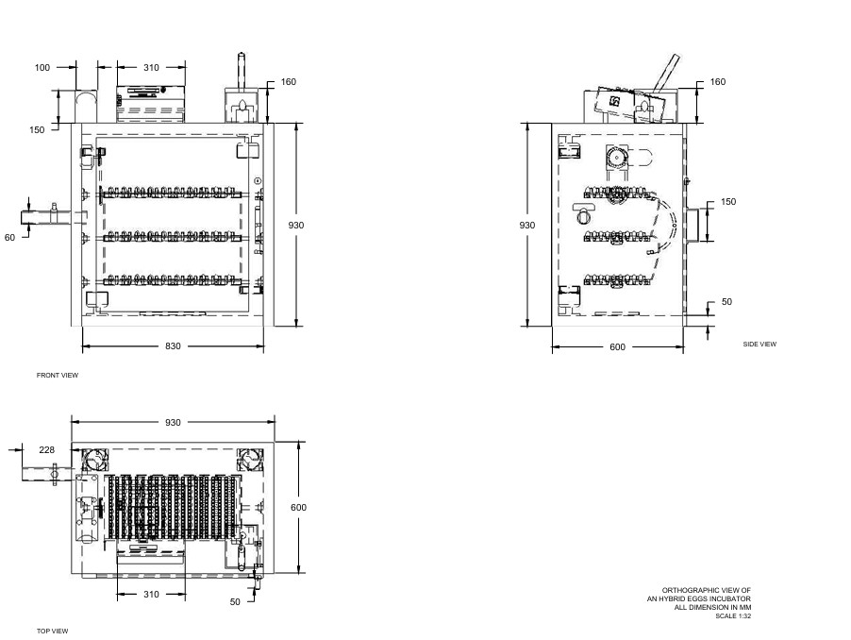
Orthographic View of Incubator

