MODIFICATION AND PERFORMANCE EVALUATION OF HYBRID EGGS INCUBATOR

BY

DAUD SULAIMAN OLUWATOYIN
HND/23/ABE/FT/0024

DEPARTMENT OF AGRICULTURAL AND BIO-ENVIRONMENTAL ENGINEERING INSTITUTE OF TECHNOLOGY, KWARA STATE POLYTECHNIC, ILORIN.
IN PARTITAL FULFILLMENT OF REQUIREMENT FOR THE AWARD OF HIGHER NATIONAL DIPLOMA (HND) IN AGRICULTURAL AND BIO-ENVIRONMENTAL ENGINEERING TECHNOLOGY.
AUGUST, 2025

DECLARATION
I hereby declare that this research project titled: “MODIFICATION AND PERFORMANCE EVALUATION OF HYBRID EGG INCUBATOR” is my own work and has not been submitted by any other person for any degree or qualification at any higher institution. I will also declare that the information provided therein are mine and those that are not mine are properly acknowledged.

__  Name of Student Date and Signature

CERTIFICATION
I, hereby declare that this research project titled MODIFICATION AND PERFORMANCE EVALUATION OF HYBRID EGG INCUBATOR was carried out by DAUD SULAIMAN OLUWATOYIN with matric number HND/23/ABE/FT/0024 is my own work and has not been submitted by any other person for any degree or diploma in any higher institution. I also declare that the information provide therein are mine and those that are not mine are properly acknowledged.

_______ __14/_8/2025____________
Engr. (Mrs) Onipede ,E.A Date
(Project Supervisor)
_______________ _____04/08/2025____________
Engr. Oyebanre O.D Date
(Project Co-ordinator)
_____ ___04/08/2025______________
Engr Dauda, K.A Date
(Head of Department)
_____________ ___13/08/2025______________
Dr. Adejumo Akinfoye Daniel Date
(External Examiner)
DEDICATION
I dedicate this project work firstly to Almighty GOD the unborn creator of every creature who has been there for me from my very first beginning till date. Also, to my caring and to my beloved parent Alhaji Daud Iwalewa and Mrs Daud for all they have done for me I pray that you will reap the fruit of your labour by the grace of God.

ACKNOWLEDGEMENT
I give my great thanks to Almighty God, the Lord of the whole universe, the sustainers who guided and provided me all I need to complete my HND (Higher National Diploma) Programme in good health.
My profound gratitude goes to my beloved parent Alhaji Daud Iwalewa and Mrs Daud, may Almighty God grant them sound health and bless them.
The next thank goes to my supervisor, a woman of understanding, honour and trust in person of Engr. (Mrs) Onipede,E.A. for being there and lenient with me. I pray Almighty God reward you abundantly (Amen).
My appreciation also goes to the H.O.D of Agricultural and Bio-environmental Engineering Department in person of Engr. Dauda, K.A, and to all my departmental lecturers for the knowledge they have impacted in me throughout my Higher National Diploma Programme, may God reward you abundantly.
Also my gratitude to my friends (Timothy Olumide and Muhammed Abdulquyum), who stood by me. I remain disloyal if I drop my pen without appreciating my project partners. Thank you for the sincere love we share during this research work. Also those people I am not opportune to mentioned one after the other, most especially all my course mate I appreciate you all, I will live to always remember your good deeds.
I am using this medium to pray Almighty God to bestow on me the utmost knowledge and understanding from now till eternity (Amen).

TABLE OF CONTENTS
Title Page
Title Page I
Declaration ii
Certification iii
Dedication iv
Acknowledgement v
Table of Contents vi
List of Table x
List of Figure xi
Abstract xii
CHAPTER ONE
1. Introduction 1
1.1 Background to the Study 2
1.2 Problem Statement of the Study 2
1.3 Aims and Objectives of the Study 2
1.4 Justification of the Study 3
1.5 Scope of the Study 3

CHAPTER TWO
2. Literature Review 4
2.1 Poultry Farming in Nigeria 4
2.2 Poultry Incubation Technology 5
2.3 Feature of Hybrid Poultry Eggs Incubator 7
2.4 Incubation Parameters 8
2.5 Condition for Various Eggs Incubation 10
2.6 Reviews on Artificial Incubation 11

CHAPTER THREE
3. Materials and Methods 16
3.1 Materials 16
3.2 Area of Modification 16
3.3 Description of the Hybrid Egg Incubator 17
3.3.1 The Main Cabinet 18
3.3.2 The Auxiliary Unit 19
3.4 Design Consideration 20
3.5 Design Calculation and Analysis 21
3.5.1 Determination of Incubation Chamber 21
3.5.2 Determination of Heat Required for Incubation 22
3.5.3 Heat Loss by Incubator 23
3.5.4 Determination of Humidity 24
3.5.5 Total Power Consumption 25
3.5.6 Power Requirement and Selection of Battery Solar Panel and Inverter 25
3.5.7 Size of Solar Charger 26
3.5.8 Battery Running Time 27
3.6 Materials Selection 27
3.7 Construction and Assembly Procedure 28
3.8 The Operation of Hybrid Egg Incubator 29
3.9 Bill of Engineering Measurement and Evaluation 29
3.10 Performance Evaluation 29
3.10.1 Source of Material 29
3.10.2 Preparation of Sample 30
3.10.3 Output Parameters 30
3.11 Experimental Procedure 31
CHAPTER FOUR
4. Result and Discussion 33
4.1 Result 33
4.2 Discussion 34
CHAPTER FIVE
5. Conclusion and Recommendations 36
5.1 Conclusion 36
5.2 Recommendation 36
References 37 Appendices
LIST OF TABLE
Table 2.1 Condition for Various Egg Incubation 10
Table 3.1 Bill of Engineering and Evaluation 29
Table 4.1 Candling Test on 7th Day on Incubation 33
Table 4.2 Candling Test on The 14th Day of Incubation 33
Table 4.2 Average Records of Temperature and Humidity for 21days of Incubation 34

LIST OF FIGURES
Figure 3.1 Assembly View of Hybrid Eggs Incubator 17
Figure 3.2 Exploded View of Hybrid Eggs Incubator 18

ABSTRACT

A hybrid egg incubator was modified and constructed to solve the problem of power outages that militate against poultry egg incubation. The hybrid egg incubator was constructed from medium density fibreboard (MDF) plywood and lagged with fibre glass to prevent heat loss. The hybrid egg incubator was made of two units; the main cabinet and auxiliary unit.
The main cabinet consists of egg trays, bulbs, DC fans, water tray and turning mechanism. The auxiliary unit consists of solar PV panel, battery, inverter and charge control. The incubation parameters were measured by control board. The temperature and humidity range within the incubator were 36.1 - 37.5 °C and 50.1 % to 60% respectively, the angle of turn was 45°. The result of performance evaluation showed 91% hatchability, 66% fertility and mortality rate 9%.
The hybrid egg incubator is affordable because it was made from locally available materials and it is therefore recommended for poultry farmers both at rural and urban centers.

CHAPTER ONE
INTRODUCTION
1.1 Background of the Study
Incubation is a technology that provides opportunity for farmers to produce chicks from eggs without the consent of the mother hen. It is one of the fastest ways of transforming eggs to chicks. The most important difference between natural and artificial incubation is the fact that the natural parent provides warmth by contact rather than surrounding the egg with warm air. (Benjamin and Oye, 2012).
The world’s population growth is alarming, and so is the need for protein. The growth in protein needs has caused many, such as farmers and scientists, to give more attention to poultry foods and enhance production efficiency. Poultry is one of the ways of getting a good protein source, provided it is affordable and accessible (Kuye and Adekunle, et, al 2008). Agricultural Outlook in 2016 reported that global meat production reached 320.7 million tons and poultry alone reported 12.7 million tons of the total (OECD/FAO at, al, 2015-2024,). The global annual meat consumption per person is increasing and is moving to reach 35.3 kg retail weight equivalent by 2025, and the increase is coming from poultry (OECD/FAO, at, al, 2015-2024,). In most developing countries, small holder farmers and nonfarmers live on poultry farming by keeping some chicken for consumption and sales.
Sustainable poultry farming can be possible in the quest to promote sustainable development goal (SDGs) of ending hunger, achieving food security, improving nutrition, and promoting sustainable agriculture (Sustainable and Goals,2016). Invented egg hatchery is a central solution to the traditional backyard and commercial poultry farming. It can improve poultry output substantially and allow regular income generation, allowing smallholder farmers to transition into viable rural entrepreneurs (Mansaray, at, al, 2015)
1.2 Problem Statement
The world’s growing population and increasing health awareness have led to a surge in demand for poultry product, which are perceived as a heathier alternative to red meat due to their lower cholesterol and trans fat content. this trend is expected to continue as driving growth in the poultry industry. The process of hatching egg by natural method is limited and the artificial incubators that can hatch more eggs at a time are faced with erratic power supply for an electrical incubator, adverse weather condition for solar incubator, lack of adequate control system of incubation system and besides an inadequate hatcheries contributing to high cost of day old chicks
1.3 Aim and Objective
The study aim to modify and carryout the performance evaluation of hybrid egg incubator to improve hatchability, reduce energy consumption and enhance efficiency and sustainability, while the specific objectives are to
- Identify shortcoming in the existing incubator
- Modify component to improve hatchability
- Asses the temperature and humidity control capability of incubator under different environmental condition
- Evaluate the machine performance in terms of hatchability
1.4 Justification of the study
The study will contribute to sustainable poultry farming in Nigeria by addressing power failure and weather related challenges reducing energy consumption and operating costs making incubation practices accessible in rural areas and increase the income of poultry farmers.
1.5 Scope of the Study
The scope of the study focuses on modifying an exciting egg incubator in terms of construction materials, insulation materials, temperature and humidity control, mechanical turning of the egg, procurement of fertile eggs and carryout of performance evaluation in terms of hatchability.

CHAPTER TWO
LITERATURE REVIEW
2.1 Poultry Farming in Nigeria
Poultry business has been the most demanding section of animal rearing as regards farm products in Nigeria which offers great potentials for sustainable development in youth empowerment programmes (Ajani and Mgnbenka, at, al, 2019). Consequently, showed that 0.2% of Nigeria’s aggregate meat demand is met by the poultry industry while the rest is supplied by such segments of the livestock market such as cattle production, rabbitry, and grasscuttery. This revealed a wide deficient gap in comparison to that of European countries which is characterised by large supply infrastructures and abilities (World Economic Forum, 2019).
As at 2018, the annual poultry meat consumption of four important African economies including Nigeria was 176,287,266 meat (Nigeria), 1.1 million meat (Egypt), 10,922,466 meat (Ethiopia), and 1.95 million meat (South Africa)Organisation for Economic Cooperation and Development, (2019) and World Bank,(2020) which is quite moderate in the light of Ritchie and roser (2019) report that Nigeria consumed 192,689 meat, Egypt (1.2 million meat), Ethiopia (73,931 meat) and South Africa (1.76 million meat) during the same period. However, whichever is used, Nigeria still has a long way to go although production and consumption levels have been increasing Prior to the period. This means that opportunities still abound for increased and improved production and consumption of poultry products in the country and the youth have a great part to play in it since they are the largest demographic segment of the country at present and they are agile, strong and more healthy than the now aging current population of poultry farmer in the country. (Ajani and Mgnbenka, at, al, 2019).

2.2 Poultry Incubation Technology
A hatching machine or incubator is a tool that plays a very important role in poultry farming and breeding businesses, both production and hobby poultry, where its various advantages compared to natural hatching make hatching machines increasingly widely used (Musa Adame and Yusuf, at, al, 2022).
Hatching machine technology continues to experience rapid development, even though it was initially made simply, both in terms of materials and working systems, where the hatching machine was originally only a manual machine, then developed into semiautomatic to fully automatic which was able to help speed up poultry breeding more effectively and efficiently (Muttaqin andIhsan2022).
- Natural Incubation
Natural incubation is a process where a hen takes on the role of incubating her eggs. This method has been practiced for centuries and relies on the hen’s instinctual behaviour to provide the necessary conditions for the eggs to hatch successfully.

Advantages of Natural Incubation
Natural incubation offers several benefits that promote healthy chick development and sustainable farming practices. Some key advantages include:
- Instinctual care: The hen’s natural instincts ensure that the eggs receive the best possible care.
- Low cost: No additional equipment is needed, making it a cost-effective method for small-scale farmers.
- Less intervention: The hen takes care of most of the incubation process, requiring minimal human intervention.
Disadvantages of Natural Incubation
Despite it’s natural benefits, relying on hens for incubation also presents several challenges that farmers and breeders must carefully manage. Some of the key disadvantages include:
- Limited capacity: A hen can only incubate a limited number of eggs at a time, usually around 10-12.
- Inconsistent results: Factors such as the hen’s health, environment, and external disturbances can affect the success rate.
- Seasonal limitations: Natural incubation is often limited to certain seasons when hens are more likely to become broody.
- Artificial Incubation
Artificial incubation involves using incubators to create the ideal conditions for hatching eggs. This method is essential in commercial poultry farming, Artificial incubators of several types and capacity are available and they are named according to the source of heat employed in the incubation of eggs. They include: kerosene incubator, Charcoal incubator, bio - gas incubator, hybrid incubator and electrical incubator.
- Kerosene incubator is a type of incubator that uses kerosene as it power source
- Charcoal incubator is a type of incubator that uses charcoal as it power source
- Bio – gas incubator is type of incubator that uses bio – gas as it power source
- A hybrid poultry egg incubator is a type of incubator that combines two or more power source or technology to provide a reliable and efficient incubation environment for poultry egg.
- Electric incubator is a type of incubator that uses electricity as its power source.
.
Advantages of Artificial Incubation
Artificial incubation offers a controlled and efficient method for hatching eggs, but it requires careful management and investment in equipment. These are the key considerations include:
- Large capacity: Incubators can handle a significant number of eggs, making them ideal for commercial operations.
- Consistency: The controlled environment ensures more consistent results compared to natural incubation.
- Year-round availability: Incubators can be used at any time of the year, without relying on the hen’s broody behavior.

Disadvantages of Artificial Incubation
While artificial incubation offers many benefits, it also comes with some potential drawbacks, including:
- Cost: Incubators and their maintenance can be expensive, especially for small-scale farmers.
- Technical knowledge: Successful artificial incubation requires a good understanding of the equipment and the incubation process.
- Power dependency: Incubators rely on a consistent power supply, which can be a challenge in areas with unreliable electricity,

2.3 Feature of Hybrid Poultry Eggs Incubator
Feature of Hybrid Poultry Eggs Incubator are;
- Dual power source: it combines two power source such as electricity and solar power to provide a reliable and consistent incubator environment
- Backup power system: Hybrid incubator may include backup power system such as batteries or generator to ensure continuous operation during power outrage or period or low sunlight
- Advanced temperature control which can maintain optimal temperature for poultry egg incubator even in extreme weather condition
- Humidity control to maintain optimal humidity for poultry egg incubation
- Automated egg turning and monitor to ensure proper turning to track incubator parameter such as temperature, humidity and egg turning
2.4 Incubation Parameter
- Temperature: Temperature is the most critical environmental factor during incubation because the developing embryo can only tolerate very small fluctuations in temperature during the incubation period (Bell and weaver 2022). The recommended temperature ranges for setters and hatchers incubators set temperature are 37.2 to 38.2⁰C during the first 18 days (setter phase). For the last three days (hatcher phase), the temperature is lowered to between 36.0and 36.5⁰C (Paguntalan and Oquino 2016). The optimal temperature range for embryonic development in chickens is between 37.2 and 38.6 ⁰C ( Ozkan and shahat, at, 2019).
- Relative humidity (RH): determines the rate of moisture loss from eggs during incubation. Low relative humidity can cause egg contents to dry out too rapidly, leading to reduced hatchability rates and producing smaller than normal chicks (poor-quality chick) that will not perform well during the brooding period27. For the first 18 days, most incubator manufacturers recommend relative humidity between 55 and 65%. After transfer to the hatcher, the relative humidity requirements increase to about 70%. At pipping and hatching, the relative humidity increases (the last day of incubation) to about 75-80%(Harman and Kırıkçı, at, al, 2022). The relative humidity is an important factor that affects egg development and hatching. The optimal relative humidity range for incubation is between 50 and 60%during the first 18 days and between 65 and 75% during the hatching phase (Gunhan, and Kırıkçı, at, at, 2017). Proper humidity levels are essential for maintaining the correct moisture balance in the egg, which is critical for embryonic development and hatchability (Thimotheo and Almeida, at, al, 2016). The most accurate method of adjusting humidity is to monitor the weight loss of eggs. Hatching eggs weighing 56.7 g with good shell quality should lose 12% of their weight during the first 19 days of incubation (Katekhong, and Charoenrein, at, al, 2016).
- Eggs turning: The position of eggs and turning are critical factors in artificial incubation that affect embryonic development and hatchability. When eggs are placed in the egg trays, the egg orientation and how the egg trays move are crucial to producing high-quality chicks (Akinjute and Logunleko, 2023). When positioned larger end up, more than 90% of the embryos will have their heads near the large end of the egg near the air cell. In contrast, when positioned small end up, 60% of the embryo will develop with their heads near the small end, which can cause problems during hatching (Harman and Kırıkçı, at, al, 2022). The practice in commercial hatcheries is to set eggs in a large end-up position and rotate them back and forth along their long axes for turning, which prevents developing embryos from adhering to the shell membrane and reduces embryo mortality (Markson, and Brundage, at, at, 2019).
- Ventilation: Ventilation is another critical factor in artificial incubation since it allows free movement of Air through the pores of the shell and shell membranes, which is important for a constant supply of Oxygen and the elimination of carbon dioxide and moisture (Bekhet, and Khalifa, 2022). Fresh air contains 21% oxygen at sea level, which is also the optimum oxygen concentration for developing embryos. For each 1% decline in the Oxygen content of the air, hatchability will drop by 5%.Poor ventilation (insufficient air exchange) increases the concentration in the incubator (setter and hatcher), which can be lethal for developing embryos (Jiang and Zheng, at, al, 2019)
2.5 Condition for Various Eggs Incubation
The species of the bird, the incubation period, and other parameters for incubation is as shown in table 2.1
TABLE 2.1: Condition for Various Egg Incubation
Species | Incubation Period  (Days) | Temp  F | Humidity  (F) | Do not turn after | Humidity  Last 3days | Open vent more
Chicken  Turkey  Duck  Muscovy duck  Goose  Guinea fowl  Peafowl  Pheasant  Pigeon  Bobwhite  Cotumix  Chukar | 21  28  28  35-37  28-34  28  28-30  23-28  17  23-24  17  23-24 | 100  99  99  100  99  100  99  100  100  100  100  100 | 85-87  84-86  85-86  84-85  86-88  85-87  84-86  86-88  85-87  84-87  85-86  81-83 | 18th day  25th day  25th day  31st day  25th day  25th day  25th day  21st day  15th day  20th day  15th day  20th day | 90  90  90  90  90  90  90  92  90  90  90  90 | 18th day  25th day  25th day  31st day  25th day  24th day  25th day  25th day  14th day  20th day  14th day  20th day

2.6 Review on Artificial Incubator
Many of researchers have made a research on artificial incubation and come out with some of different results according to (Ajani Adegbenro Sunday et, al, 2014). Demonstrated the design, construction and performance evaluation of automated eggs incubator for poultry farmers. The aim of the research was to produce a low cost user friendly modern incubator to increase the production of day old chicks for small and medium scale poultry farmers. The incubator has the hatching capacity of 100 eggs. Factors that were considered during the performance evaluation of the incubator were humidity, 55% and temperature, 37° C during the first 18 days and were maintained at 37.5 °C till hatching. Turning of eggs was achieved with the use of tilting trays mechanism controlled by a programmed electric motor. The trays were lifted through an angle of 40° either side of horizontal at every hour and lasted for four minutes. 100 fresh, healthy, well developed and matured eggs were used to test the incubator. The result of the test revealed the following average values- fertile eggs 95, infertile eggs 5, hatched eggs 85 and hatchability of 89.47% was achieved.
Hassan et al., (2021) in characterizing and electric incubator recorded a hatchability percentage of 80.9% and concluded that the major challenge of incubators that can work with electricity are excessive billing rate, erratic power supply as well as complete absence of electricity in remote regions. Equally most of the incubator is developing countries like Nigeria operate at 60% below design capacity grid electric supply.
Olaoye et al., (2013) developed a 120 egg a capacity electric incubator. The system which was coupled with three 100 w electric bulb produced 75.2% fertility in addition to the hatchability rate of 64.8%.
Yadav et al., (2021) Analyzed the developed automatic horizontal egg incubator. A motor clamped mechanism controlled by a micro-controller was used to adjust the egg trays horizontally. The system yielded a hatchability of 72.22%.
Ogunwande et al., (2015) studied a still-air hatchery that has a non-thermostatic control. The system uses electric bulbs as the its source with a resistance varying components as temperature control. With three times daily of the eggs, the system achieved 62% hatchability rate.
Soeb et al., (2021) developed a low-cost incubator that is made up of the embedded controller Incorporated to an egg turning trays with hatchery apartment of 116 egg capacity for Bangladesh market. The manual and automatically evaluations of the developed hatchery showed a 79.3% and 87.1% hatchability rate respectively. The eggs were turned both manually and automatically as the case may be at intervals of 6hours.
Mansaray and Yansaneh (2015) developed a solar egg incubator that achieved temperature range of 36.8-37.9° c. The evaluation of the system yielded a percentage fertility and hatchability rate of 43.3% and 23.1% respectively. The study concluded that the low level of hatchability was as a result of several external influences such as an overcast weather, improper egg storage, time and energy loss, turning of eggs, faulty eggs etc.
Divagar et al., (2022) evaluated and automated solar-driven hybrid egg incubator. The system achieved a hatchability percentage of 81.72%.
Osanyinpeju et al.,(2016) walked on the development of solar powered poultry egg incubator. The heat produced by metabolic activities of 150 eggs in the system was 21.9 w. The percentage fertility of 64% in addition to 44% hatchability rate was observed with the system. The low hatchability was attributed to faulty hygrometer used which led to increase in the number of opening made at the last stage.
Niranjan et al., (2021) developed a chicken egg incubator using (IOT) integrated with smartphone effective monitoring and control. The system temperature wear set at the different temperatures of into (H1) 36.5° c, (H2) 37.5° c and (H3) 38° c. The hatchability percentage of the three temperatures were(H1) 81%, (H2) 92% and (H3) 86% respectively.
Ogunwande et al., (2015) developed a biogas powered poultry egg incubator that utilizes biogas as a fuel to provide thermal energy via a heater situated at the base. The system produced temperature range of 36-39.4° c within the incubating compartment. At the end of an evaluation test, a hatchability percent of 59.7% was realized.
Hassan et al., (2021) studied the use of thermal chemical storage media setup as a thermal source of hatching of poultry eggs. In the study, three forms of activated TCMs were utilized as energy containing medium. The media are silica gel, as well as natural zeolites. The TCMs were activated using electricity. Equally, the incubator was partly powered by electricity and partly by the TCMs. The its recapture operation helps to release the stored heat in TCMs. The system's hatchability percentage was 71.4% compared to the solely electric powered conventional incubator with 80.9% hatchability. However, the TCM incubator gave energy savings of 41.8% when compared with the conventional electric type.
Muhammad et al,. (2022) Studies a thermoelectric egg incubator coupled to heat storage system. Did Samuel electric component is utilized in the daytime process while a heat storage system made up of a phase change material (PCM) which provides derma energy during off-sunshine (especially nights) periods is complementary heat source. The electric energy that is changed to heat for starting the operation is provided with the arrays of the solar PV. The result of the 300 egg capacity system showed that temperature inside incubator chamber was between 36 iPhone 39° c with 73.3% hatchability.
Olasukanmi et al., (2015) developed a GSM based DC battery powered poultry egg incubator. The system is remotely tracked. The major components of the incubator were the DC motor, humidifier, ventilation fans, in addition to the custom made lower-power DC heater provided for controlling the turning of eggs, humidity, ventilation and temperature, respectively. The hatchery could either be powered using solar PV system, greed power electricity via an inverter or any medium that could charge the DC battery.
Oniya et al., (2013) develop a 160 a capacity low cost semi-in automated incubator powered by a backup inverter. The inverter could either be powered with an AC or DC electric system. The major components of the system were a heat source (100 w bulb), a thermistor, 12 PV battery, 100 w inverter and 0.14 w electric fan. A replicated analysis on the system showed a temperature variation between 36 to 39° c with hatchability 91%.
Uzodinma et al., (2020) carried out a characterization of hybrid solar powered poultry egg incubator. The hybrid incubator is made up of a double glazed flat plate solar collector coupled with paraffin PCM in addition to a PV subsystem. The evaluation of the system reviewed that the incubating temperature was maintained between 36 and 39° c in addition to the mean hatchability rate of 62.37%.
Bukola (2008) modified and carry out performance and evaluation of hybrid poultry solar incubator and stated the environmental factors of major importance for artificial incubator include temperature, relative humidity, air supply and egg turning. overheating speed up the rate of development and called abnormal embryo in the early hatches and consequently lower the percentage hatchability likewise high rate to prevent normal evaporation and results in low hatachability. turning of egg should be done 3- times daily from 2nd to the 18th day of incubation to prevent embryo adhering to the shell
Okonkwo et al (2024) researched on energy sources for poultry egg incubator efficiency and hatachability. the result showed that sources of energy for incubation are categorized into grid supply electricity solar system, fossil fuel, biogas and thermochemical materials, from reviewed articles 50% identified grid supplied electricity as energy source for poultry egg incubation and hatachabiliy range from 80.9%-98.4% however, due to erratic nature of electricity supply and nonavailability in rural areas especially in developing nations, the study recommends increase research interest on other every source to improve their hatachability.
Faki etal (2015) reported on incubation condition such as temperature, humidity, ventilation and turning the most important factor significantly affective the hatchability of poultry egg and chick quality.

CHAPTER THREE
3. MATERIALS & METHODS
3.1 Materials
The following materials were used in the construction of hybrid egg incubator;
- MDF Plywood (Medium Density Fiber Body)
- Marine Board
- Bolt and Nut.
- Screw
- Ardonic Cabinet Hinge
- Edges Tape
- Door Bolt
- Nails
- Screw Cover
- Plank for the Egg Tray Seat
- Egg
- Hammer
- Glass Fiber
3.2 Area of Modification
The result from the test of previous machine showed that the machine was able to hatch 20 egg out of 45 eggs after operating the machine this gives 44% hatchability rate. The recommendation suggested that the turning mechanism, the temperature and humidity control should be automated for better performance hence the turning mechanism, temperature and humidity control system will be automated and some technical issues like egg fertility will be addressed
3.3 Description of the Hybrid Eggs Incubator
The hybrid eggs Assembly and Exploded views were as shown in figure 3.1 to 3.2 . The hybrid eggs incubator are made up of two components, the main cabinets and the auxiliary unit.

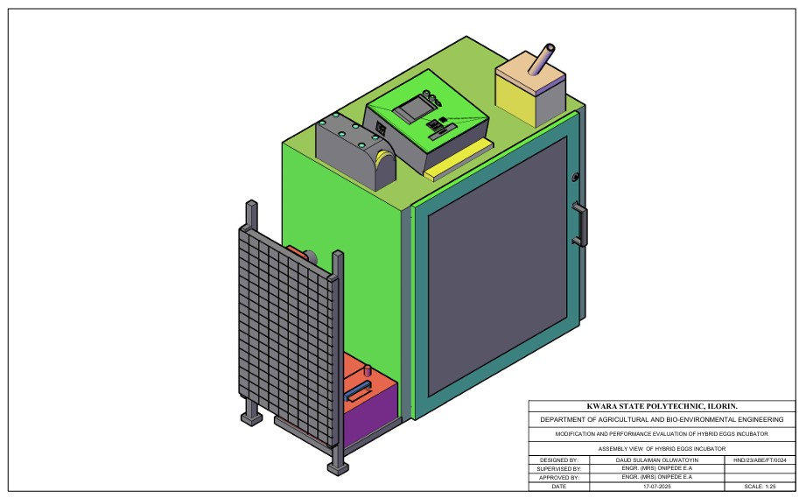
Figure 3.1 Assembly View of Hybrid Eggs Incubator

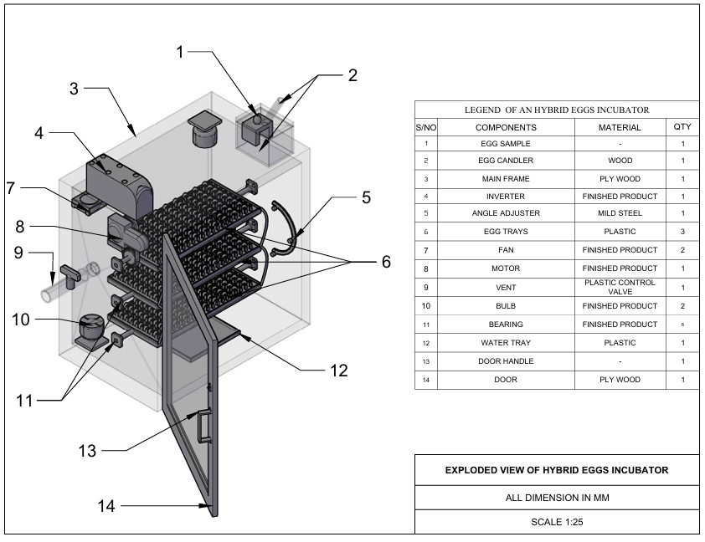
Figure 3.2 Exploded View of Hybrid Eggs Incubator

3.3.1 The Main Cabinet
The main cabinet is the incubating box which consists of the egg trays, fan, bulbs, egg turner, humidity tray, controller and savor motor.
- The incubating box is made from MDF plywood due to it, insulation properties, ease of construction, flexibility and durability. The dimension of the incubating box is 920 mm x 950 mm x 640mm.
- Egg turning trays: The Egg turning trays, is constructed from wood with dimension of 635mm x 335mm x 60 mm to accommodate the egg plastic crates. There are six egg creates, each containing 30 eggs, they were positioned inside incubator and turn 6 hourly.
- Humidity tray Is made up of plastic and placed at the bottom of the incubating box to increase and recover humidity in the incubator during experimental period.
- The fan is incorporated to facilitate the temperature and humidity in the incubator in order to keep them within the requirement of the present values.

- The controller was incorporated to sense the temperature, humidity and the turning mechanism of the incubator for effective incubation.
- The electric bulb 100 w cells as the source of heat to warm the inner unit to temperature range of 36 - 37.5° c.
- The savor motor is used to drive the egg turning tray and tilt it to an angle of 45° either side after a period of 6 hours.
3.3.2 The Auxiliary Unit
The auxiliary unit consists of solar PV panel, solar charge control, battery and inverter. The solar PV panel: Absorb solar energy to charge the battery, the solar charger controls the charging of the battery to prevent overcharging, the inverter converts the direct current from the battery to alternating current to be used by the incubator and at the same time charged the battery when there is electricity.

3.4 Design Consideration
The following factors were considered when designing hybrid eggs incubation
(a) Environmental Control
- Temperature range of 36.5°C-37-5°C within the incubator
- humidity range of 50-60% to prevent water loss and promote healthy development
- ventilation within the incubator is necessary for adequate airflow to maintain oxygen levels and remove carbon dioxide.
(b) Egg Handling
- regular turning (every 1-4 hours) to prevent embryo adhesion to the shell
- egg orientation to ensure eggs are positioned correctly (large end up) to facilitate proper development.
(c) Energy Deficiency and Sustainability.
- incorporating solar energy source to reduce reliance on electrical energy source
- automatic egg turner to reduce labor and ensure consistent turning
- temperature and humidity monitoring to ensure optimal condition.
3.5 Design Calculation and Analysis
The design criteria are based on making the equipment more affordable, efficient and durable. the incubator capacity, heating system, turning mechanism, size of battery, power from battery size of solar panel were all designed during the development process.

3.5.1 Determination of Incubation Chamber
The capacity of the incubator is directly proportional to the number of eggs and the number of egg trays. The incubator was design to hatch 180eggs per hatch. The design of incubation chamber was done using equation 3.1and 3.2
c = $\frac{n}{60}$ (3.1)
Where
C = number of trays
n = number of eggs to be hatched
c = $\frac{180}{60}$
c = 3egg trays
the incubation chamber was designed to contain the egg trays; the incubation chamber was rectangular box like structure.
Volume of Incubation Chamber
V = l × b × h (3.2)
Where:
V = volume of incubator (m$^3$) (Abubakar et al 2023)
L = length of incubator (m)
B = breadth of incubator (m)
H = height of incubator (m)
3.5.2 Determination of Heat Required for Incubation
Heat required in the incubator was determined from equation 4
Q = MCΔT (Benjamin and Oye ,2012) (3.3)
Where;
Q = total heat required
C = specific heat capacity
ΔT = change in temperature
M = molar mass
QT = (MaCaΔT) + (MeCeΔT) × Ne + (MpCpΔT) + (MwCwΔT) (3.4) (Abubakar et al 2023)
Where;
MaCaΔT = heat required by air
MeCeΔT = heat required by eggs
Ne = number of eggs
MpCpΔT = heat required by plywood
MwCwΔT = heat required by water.

3.5.3 Heat Loss by Incubator
The heat loss due to conduction can be calculated from the equation 3.5 - 3.9
Q = −KA($\frac{ST}{Sx}$) (3.5)
The flow of air is steady inside the incubator therefore it does not vary with time.
QSx = −KAST (3.6)
Q = − KA$(\frac{Tinc -Ts}{X}$) (3.7)
Where;
Q = heat
K = thermal conductivity coefficient of plywood (0.65) in the design
X = is the thickness of the plywood (15mm)
Heat loss during incubation is given as top and bottom of plywood.
Qptpbpspfpbt =−KA$(\frac{Tinc -Ts}{X}$) × 2 (3.8) (Bala et al, 2020)
Where;
Pt = is the plywood top
Pb = plywood backside
Ps = plywood side
Pf = plywood front
Pbt = plywood bottom.
A = area of incubator chamber
K = thermal conductivity coefficient (0.65 forMDF) plywood (Ajani et al 2020).
The quantity of heat loss is calculated using the following equation
QL = Qptm + Qpss + Qpfb ( 3.9)
The quantity of heat required for the incubation
Q = Ql + Q1 (3.10)
Where:
Q = quantity of heat required for incubation
QL = heat loss by the incubator
Q1 = heat required of the incubator.
3.5.4 Determination of Humidity
The humidity keeps the eggs from losing two much moistures in the process of incubation it is calculated from equation 3.11 – 3.13
H = $\frac{Mv}{v}$ (3.11)
ρ =MvRvT (3.12)
H =$\frac{v}{RvT}$ (3.13)
Where:
H = humidity
ρ = energy density/heat density of water
T = temperature
Mv = molar mall of water
Rv = gas content
V = volume of the incubator’s chamber
3.5.5 Total Power Consumption
The total power consumption of the entire incubator system can be calculated from the following equation.
Total power consumption (PT) =P1+Pfh+Pfv+Pc (3.14) (Abba- ayi et al 2024)
Where;
P1 = power of the incubator chamber
Pfh = power of humidity fan
Pfv = power of ventilation
Pc = power of control board.
3.5.6 Power Requirement and Selection of Battery Solar Panel and Inverter
Total power consumption is added up to 130.435W base on the total power requirement of the incubator. A 200AH lithium phosphate acid battery 12v, a 1KVA inverter and a 300W solar panel will be used to power the entire incubator.

3.5.7 Size of Solar Charger
Size of solar charger was determine using equation 3.15.
SSc = $\frac{wp}{v}×Pf$
Where;
SSc = size of solar charger (AH)
Wp = wattage of solar panel (W)
V = voltage of the battery (V)
Pf = power factor (1.25)
Size of solar charger =21AH but use 25AH
3.5.8 Battery Running Time
The battery running time was calculated using equation 3.16
BR = $\frac{Bc}{L}$ Pf (3.16)
Where;
BR = battery running time (H)
Bc = capacity of battery (AH)
L = load of appliance (w)
Pf = power factor (10)
Battery running time is 16 hours but charging should start after 12 hours.
3.6 Material Selection
The following materials are put into consideration for the selection of materials used for hybrid eggs incubator
- Conservation of heat: MDF plywood was used for construction to conserve heat.
- Availability of material: The material used is easily available for repair and replacement.
- The cost of material: The cost of materials used is not expensive and will eventually leads to low cost of the incubator.
- The durability of the material: The material for construction was the type that will last long and have resistant to insect infestation.
- The easy of construction: The material used for construction is easy to work upon for mass production.
- The weight of material: The material used for construction was light weight for easy transportation.
- Lagging material: Fibre glass was used as a lagging material to further conserve and prevent loss.
3.7 Construction and Assembly Procedure of Hybrid Eggs Incubator
The tool used for the construction include; the hammer, hacksaw, paper tape, nail, bolt and nut. The medium density fibreboard (MDF)plywood of 50mm thickness was cut according to the design specification and joined together by nails and screw to form the incubating box. The three egg trays were in incorporated into the incubating box using bearing at ---- interval between one another to serve as egg crates seat. The savor motor was incorporated to the egg tray to facilitate the turning of the egg trays. The control board that houses temperature, humidity and time of turning was also incorporated.
3.9 The Operation of Hybrid Egg Incubator
The hybrid egg incubator is operated using two sources of energy (electrical and solar energy) that complement one another to prevent power interruption and for efficient incubation. When electricity is available, the incubator is powered directly from the main but in case of power outage the incubator is powered by solar power system. The solar power system consists of solar panel, solar charge control, battery and inverter.
The solar PV absorbs solar energy from the sun and charge the battery via the solar charge control, the DC from the battery is converted to AC by inverter for the use of the incubator thereby preventing power interruption that may be caused by power outage. The switching of power from electricity to solar or vice-versa is made possible through automatic incubator control system.

3.10 Bill of Engineering Measurement and Evaluation
Bill of engineering measurement and evaluation is presented in table
Table3.1: - Bill of Engineering and Evaluation
S/N | Material | Rate | Quantity | Amount
1  2  3  4  5  6  7  8  9  10  11  12 | MDF Plywood 15mm  Marine Board 15mm  Egg Tray  Egg Crate  Turning Mechanism  Incubator Box Glass  DC Fan  Bearing  Electric Motor (Savor)  Controller Board  Eggs  Miscellenous  TOTAL | 35,000  45,000  20,000  800  50  30  8,000  8,000  45,000  95,000  7,500  15,000 | 1  1  3  6  -  1  2  6  1  1  6  - | 35,000  45,000  60,000  4,800  50,000  30,000  16,000  4,800  40,000  95,000  45,000  15,000  440,600

3.10 Performance Evaluation of Hybrid Eggs
3.10.1 Source of Material Source: The fertile eggs for evaluation were purchase from a poultry farm in Oke Ose, Ilorin East Local Government of Kwara State.
3.10.2 Preparation of Sample: The eggs were cleaned using sand paper, the eggs were of good size and shape. The incubator was fumigated for a day to prevent any contamination in readiness for incubation.
3.10.3 Output Parameter: The output parameters to be measured are;
Percentage Hatchability:
- Percentage hatchability is the number of hatched eggs to the number of fertile eggs loaded into the incubator in percentage.
The equation is stated in 3.17
Ph = $\frac{\text{N}\text{h}}{\text{Nfe}} \text{X }\text{100}$ …………….( 3.17)
Where;
Ph = Percentage hatchability (%)
Nh= Number of hatched eggs
Nfe= Number of fertile eggs loaded
- Percentage Fertility:
Percentage fertility is the number of fertile eggs to the number of eggs loaded into the incubator in percentage.
The equation is stated in table 3.18
Pf = $\frac{\text{Nfe}}{\text{Nf}} \text{X}\text{ 100}$ …………….( 3.18)

Where;
Pf = Percentage fertility (%)
Nfe = Number of fertile egg
Nf = Number of eggs loaded into the incubator
- Mortality Rate
Mortality rate is the number of death to the number of fertile eggs loaded into the incubator
The equation is stated in 3. 19
MR = $\frac{\text{Nd}}{\text{Nfe}} \text{X }\text{100}$
Where;
MR = Mortailty rate
Nd = Number of death
Nfe = Number of eggs loaded
3.11 Experimental Procedure
The performance evaluation of hybrid eggs incubator was carried out at Kwara State Polytechnic Institute of Skills Acquisition, Mini Campus, Ilorin. The hybrid eggs incubator was fumigated and run empty for one day to ascertain the satisfactory performance of the incubator.
One hundred fowl eggs were purchased from a poultry farm in Oke Ose, Ilorin East Local Government of Kwara State and loaded into the hybrid egg incubator. The temperature, humidity and turning of egg tray were monitored. The temperature and humidity were taken three times a day and the mean value for each day was recorded while the turning of egg trays was on 6 hourly.
The candling of eggs was done on the 7th day of loading and the second candling was done on the 14th day of loading. The turning of egg tray was stopped on the 18th day of loading. The unfertilized and bad eggs removed from the incubator was 34 eggs while the remaining 66 eggs were incubated for the period of 21 days. The hatching of eggs started on the 20th day of incubation. The number of hatched eggs were 58 while the remaining 8 were dead in the shell.

CHAPTER FOUR
4 RESULT AND DISCUSSION
4.1 Result
The result of performance evaluation of hybrid egg incubator is as shown in table 4.1-4.3
Table 4.1 Candling Test On 7th Day On Incubation
S/N | No of Eggs | Development | Observation | Remark
i  ii  iii  iv | 10  11  40  39 | not visible  not visible  visible at one end  visible at the centre | Clear  Larger air space  Liner running across  Visible patches of red strain | Infertile  Infertile  Fertile  Fertile

Table 4.2 Candling Test On The 14th Day of Incubation
S/N | No of Eggs | Development | Observation | Remark
i  ii  iii  iv  v | 13  61  6  5  7 | Not visible  Dark appearance  The whole egg is dark  Dark Appearance  The whole egg is dark | Clear  Clear air space  No air space  Beak is visible  Visible patch of red stain | No development  Development in progress  Development ceased  Almost fertile  Development ceased

Table 4.3 Average Records of Temperature and Humidity for 21days of Incubation
S/N | Temperature(°c) | Humidity(%)
1  2  3  4  5  6  7  8  9  10  11  12  13  14  15  16  17  18  19  20  21 | 37.2  37.4  37.3  37.2  37.3  37.4  37.4  37.5  37.4  37.4  37.4  36.1  37.5  37.5  37.5  37.3  37.3  37.5  37.4  37.3  37.4 | 50.1  52.1  53.1  52.6  57.7  54.9  58.2  58.3  59.8  56.0  56.3  50.4  56.2  56.2  56.1  52.4  55.9  53.4  57.9  60.0  54.1

The output parameter are;
- Percentage hatachability =$\left(\frac{number of eggs hatched}{number of fertile egg }\right)×100$
= $\frac{60}{66}×100=91\%$
- Percentage fertility = $\left(\frac{number of fertile eggs}{number of eggs incubated}\right)×100$
= $\frac{66}{100}×100=66\%$
- Mortality rate =$\left(\frac{number of death embroy}{number of eggs incubated}\right)$
= $\frac{6}{66}×100$ = 9%
4.2 Discussion
The result of incubation from 4.1 showed the temperature range of (36.1° – 37.5°) during the performance evaluation which corroborate the findings of Hard et al (2010), Gbabo et al (2014), Nithin et al (2014), Oniya et al (2010). This showed that the equipment was suitable for incubating fertile eggs. The relative humidity range (50.1 -60%) during performance evaluation was within the range obtained by Oniya et al(2013). The minimum temperature and humidity from the first day to 21st day were 36.1c° and 50% respectively while the maximum temperature was 37.5°c and maximum humidity was 60% for the period of incubation.

CHAPTER FIVE
5 CONCLUSIONS AND RECOMMENDATIONS
5.1 Conclusions
From the study carried out, the following are drawn:
- A hybrid egg incubator that combines electricity with solar energy to complement one another to prevent power interruption of the machine during incubation was modified and constructed.
- The temperature and humidity range within the incubator during performance evaluation were 36.1 – 37.5°c and 50.1 – 60% respectively. The percentage hatachability of the incubation is 91%. The incubator is suitable for the hatching of poultry eggs and is therefore recommended for poultry farmers.
5.2 Recommendations
The following recommendations are made:
- Intensive performance evaluation should be carryout using other species of poultry birds like turkey, duck, guinea fowl.
- Sponsorship should be provided by relevant agencies in order to improve the machine and stop importation of incubators.

REFERENCES
Abba – Ayi, M.A., Usman, A.R., & Shuwa, M. (2024). Design of a Smart Solar Hybrid Egg Incubator for Engineering, Technology and Environment, 20(2), 375–384.
Abubakar, M.A., Daheer, A.A., Adache, A.L., & Ferdinand, I.O. (2023). Development and Testing of an Automated Egg Incubator. International Journal of Advanced in Engineering and Management (IJAEM), 5(6), 191–202.
Abioja, M.O., Ojoawo, H.T., Akinjute, O.F., & Logunleko, M.O. (2023). Influence of egg storage length and orientation on hatching traits and spread of hatch in Transylvanian naked chickens.
Ajani, A.S., Olusoji, A.O., Egbeyele, G.B., & Adeniyi, M.O. (2020). Design and Construction of automated Eggs incubator for small scale poultry farmer. International Journal of Technical Research and Science, 5(8), 1–9.
Ajani, E.N., Mgbenka, R.N., & Onah, O. (2019). Empowerment of Youths in Rural Areas through Agricultural Development Programmes.
Bala, A.M., Abubakar, M.A., Bello, M.S., & Sakako, T. (2020). Design, Construction of a Fully Automated Egg Incubator using Electric Battery. African Scholar Journal of African Sustainability Development, 18(2), 319–332.
Benjanim, N., & Oye, N.D. (2012). Modification of the Design of Poultry Incubator. International Journal of Application or Innovation in Engineering, 1, 90–102.
Bekhet, G., & Khalifa, A.Y.Z. (2022). Essential oil sanitizers to sanitize hatching eggs.
Boleli, I.C., Morita, V.S., Matos Jr., J.B., Thimotheo, M., & Almeida, V.R. (2016). Poultry egg incubation: Integrating and optimizing production efficiency.
Çam, M., Kaya, Z.K., Güler, S., Harman, H., & Kırıkçı, K. (2022). Influence of egg storage time, position, and turning on egg weight loss, embryonic mortality, and hatching traits in chukar partridge (Alectoris chukar).
Divagar, V., Kannan, N., & Thiruvaran, T. (2022). Development of an automated solar-driven hybrid egg incubator. Available: https://nastec.gov.lk
Gbabo, A., Liberty, J.T., Gune, O.N., & Owa, G.J. (2014). Design, Construction and Performance Evaluation of an Electric power Egg incubator. International Journal of Research in Engineering and Technology, 3, 521–526.
Günhan, Ş., & Kırıkçı, K. (2017). Effects of different storage time on hatching results and some egg quality characteristics of rock partridge (A. graeca) (management and production).
Harb, S.K., Habib, Y.A., Kasfem, A.M., & Poultry egg incubator to suit small farmers. Egypt Journal Agricultural Research, 88(1), 193–210.
Katekhong, W., & Charoenrein, S. (2016). Changes in physical and gelling properties of freeze-dried egg white as a result of temperature and relative humidity.
K.G. Mansaray, & Yansaneh, O. (2015). Fabrication and performance evaluation of a solar powered chicken egg incubator. International Journal of Emerging Technologies and Advanced Engineering, 5(6), 31–36.
Markson, J., & Brundage, C. (2019). Cooling periods enhance specific pathogen free (SPF) poultry egg hatchability.
M. Musa, Adame, Y., Yusuf, & N. Tilahun Kuda. (2022). Influences of Types of Incubators on Hatchability of Eggs.
Muttaq in, A. Ihsan, & H. Irawan. (2022). Peningkatan Produktivitas Ternak Ayam Melalui Technology Incubator.
Nithin, T.A., Shamea, L.M., & Pradeep, K. (2014). Design and Implementation of Solar PV Poultry Incubator. International Journal of Engineering and Advanced Technology (IJEAT), 3(3), 289–291.
Niranjan, L., Venkatesan, C., Suhas, A.R., Satheeskumaran, S., & Nawaz, S.A. (2021). Design and implementation of chicken egg incubator for hatching using IoT. International Journal of Computational Science and Engineering, 24(4), 363–372. Available: https://doi.org/10.1504/IJCSE.2021.117018
Olasunkanmi, J.N., Akintade, O.O., & Kehinde, L.O. Development of a GSM based DC Powered Bird Egg Incubator. International Journal of Engineering.
Ogunwande, G.A., Ajayi, O.A., Ogunjimi, L.A.O., & Osunade, J.A. (2010). Development of a still-air incubator with non-thermostatic control. Ife Journal of Technology, 19(2), 59–62.
Okonkwo, W.I., & Chukwuezie, O.C. (2012). Characterization of a photovoltaic powered poultry egg incubator. In 4th International Conference on Agriculture and Animal Science, Singapore, pp. 1-6. Available: https://doi.org/10.7763/IPCBEE
Osanyinpeju, K., Aderinlewo, A., Adetunji, O., & Ajisegiri, E. (2016). Development of Solar powered poultry egg incubator. In College of Engineering International Conference, Federal University of Agriculture, Abeokuta, p. 11.
Paguntalan, R.B., & Oquino, V.H. (2016). Design and development of a microcontroller based egg incubator for small scale poultry production.
Soeb, M.A., Al Mamun, M.R., Shammi, S., Uddin, M., & Eimon, G.A. (2021). Design and Fabrication of Low-Cost Incubator to Evaluate Hatching Performance of Egg. European Journal of Engineering and Technology Research, 6(7), 91–96. Available: http://dx.doi.org/10.24018/ejers.2021.6.7.2662
Uzodinma, E.O., Ojike, O., Etoamaihe, U.J., & Okonkwo, W.I. (2020). Performance study of a solar poultry egg incubator with phase change heat storage subsystem. Case Studies Thermal Engineering, 18, 100593. Available: https://doi.org/10.1016/j.csite.2020.100593
World Economic Forum. (2019). Meat: the Future series Options for the Livestock Sector in Developing and Emerging Economies to 2030 and Beyond.
Yadav, B.K., Pokhrel, N., Khatiwada, D., Khanal, M., Bajracharya, T., & Dhakal, R. (2021). Design, Fabrication, and Performance Analysis of an Automatic Horizontal Egg Incubator. Journal of the Institute of Engineering, 16(1), 78–85. Available: https://doi.org/10.3126/jie.v1611.36557

Exploded View of Hybrid Eggs Incubator

Assembly View of Hybrid Eggs Incubator
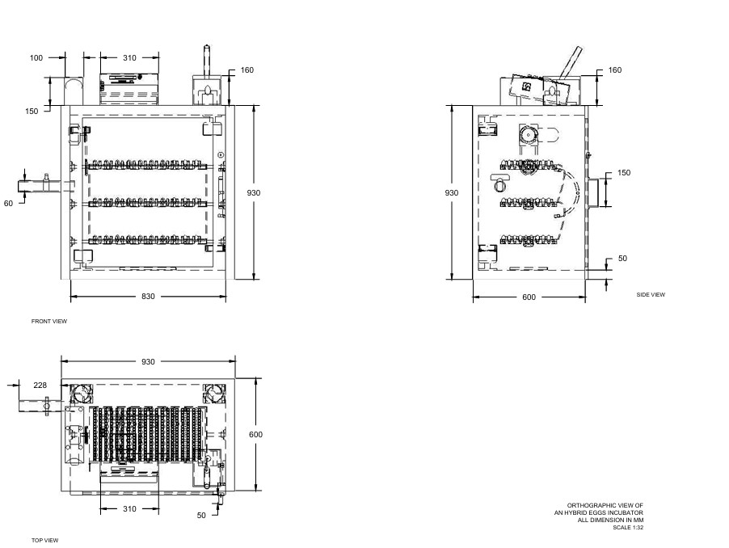

Orthographic View of Incubator

