

PROJECT REPORT ON
METAL COMPLEXES OF IBUPROFEN: SYNTHESIS CHARACTERIZATION AND COORDINATION CHEMISTRY STUDIES
BY
MUSTAPHA KAFILAT AJOKE
ND/23/SLT/PT/0244
SUBMITTED TO
THE DEPARTMENT OF SCIENCE LABORATORY TECHNOLOGY IN PARTIAL FULFILLMENT OF THE REQUIREMENT FOR THE AWARD OF NATIONAL DIPLOMA
SUPERVISED BY
MR ADIO OSENI
2024/2025 SESSION

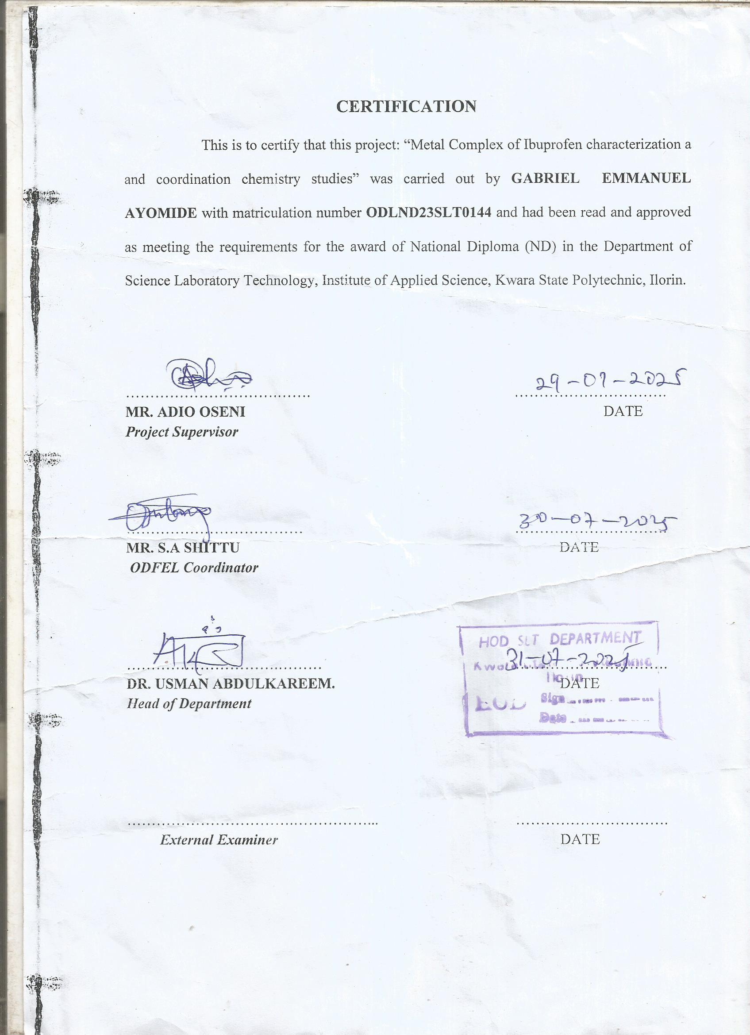
DEDICATION
I dedicate this technical report to the Almighty God, the giver of knowledge, wisdom and who is rich in mercy, and the one who strengthen me throughout my ND, also to my supervisor for the success of the project.

ACKNOWLEDGEMENT
I take this opportunity to express my gratitude and deep regard to the creator of heaven and earth, the alpha and Omega,the one who kept me alive form beginning of the semester to the end may he name be praise.
I also take this opportunity to express a deep sense of gratitude to my mother (Alh and Alha mustapha) and my brother for there support, prayer and been there for me in time of trouble
Also a big thank of gratitude to compliment my mentor the person of (engr adio oseni)bfor his cordial support valuable information and guidance which help me in completing my project through various stage,and also to the HOD and all the staff of SLT department for sharing there experience with me in the course of my study.
Lastly my gratitude to the peace family and all my friend for there support in time of need and for there encouragement thank I love you all.

ABSTRACT
The study is to summarize the main pharmacological effect and therapeutical application and adverse drugs reaction,so Ibuprofen was the first member of propionic acid which is also know as propanoic acid and {is a carboxylic acid with a pungent,sharp oder,and is used as a food preservative and in various industrial application}there have different have different work they do In the body part of it is it reduce hormone that cause pain and swelling in the body,it a nonsteroidal anti-inflammatory drug{NSAID} used to treat mild to moderate pain and help to relieve symptom of arthritis{osteoarthritis, rheumatoid arthritis or juvenile arthritis}, the clinical pharmacology of ibuprofen are it eliminated in 24 hour after the last dose and you can't take more than six(6) dose per day and they are almost insoluble in water also more than 99% of protein bound,it take 20 to 30 minute to work if it taking by mouth and also 1-2 day though skin. the therapeutic application it is widely used as an analysis,mainly used to treatment of mild to moderate pain related to dysmenorrhea,headache,migraine,postoperative dental pain,management of spondyhitis, osteoarthritis, rheumatoid arthritis and soft tissue disorder.

Metal complexes of Ibuprofen: Synthesis Characterization and coordination chemistry studies

LIST OF ABBREVIATONS
Ni Nickel
Zn Zinc
Fe Iron
S Soluble
Ns Not Soluble
Ss Slightly Soluble
Uv Ultraviolet
IR InfraRed
G/mol Gram per mole.

TABLE OF CONTENT
TITLE PAGE i
CERTIFICATION ii
DEDICATION iii
AKNOWLEDGEMENT iv
ABSTRACT v
LIST OF ABBREVIATION vi
TABLE OF CONTENT vii
CHAPTER ONE
1.1 INTRODUCTION 1
1.2 CLINICAL PHARMACOLOGY OF IBUPROFEN 2
1.3 THERAPEUTIC APPLICATION OF IBUPROFEN 3
1.3.1 PATENT DUCTUS ARTEROSUS 4
1.3.2 RHEUMATOID AND OSTERO-ARTHRITIS 4
1.3.3 CYSTIC FIBROSIS 6
1.3.4 ORTHOSTSTIC HYPOTENSION 6
1.3.5 DENTAL PAIN 6
1.3.6 DYSMENORRHEA, FEVER AND HEADACHE 6
1.3.7 PROPHLAXIS OF ALZHEIMER`S DISEASE 8
1.3.8 PARKINSON`S DISEASE 8
1.3.9 BREAST CANCER 8
1.4 ADVERSE REACTIONS 9
1.5 LIGAND AND COMPLEX FORMATION 10
1.6 WHY DRUG-METAL COMPLEX 10
1.7 CHEMISTRY OF TRANSITON METALS USED 11
1.7.1 NICKEL 11
1.7.1.1 COLOUR 12
1.7.1.2 GEOMETRY 12
1.7.1.3 COMPLEXES 12
1.7.2 COPPER 13
1.7.2.1 DEFICIENCY 14
1.7.2.2 TOXICITY 14
1.7.3 IRON 15
1.7.3.1 DEFICIENCY 17
1.8 AIM OF PROJECT 18
CHAPTER TWO
2.1 MATERIALS AND METHODS 19
2.1.1 APPARATUS 19
2.1.2 REAGENTS 20
2.1.3 MATERIALS 21
2.2 EXPERIMENTAL PROCEDURES 22
2.2.1 IBUPROFEN NI(ii) COMPLEX FORMATION 22
2.2.2 IBUPROFEN CU(ii) COMPLEX FORMATION 23
2.2.3 IBUPROFEN FE(ii) COMPLEX FORMATION 23
2.3 CHARACTERIZATION METHODS 24
2.3.1 SOLUBILITY TESTS 24
2.3.2 MELTING POINT DETERMINATION 24
2.3.3 METHOD 25
CHAPTER THREE
3.1 RESULTS AND DISCUSION 26
3.1.1 RESULTS OF SOLUBILITY TEST 26
3.1.2 INTERPRETATION OF SOLUBILITY TEST 16
3.2 RESULTS OF MELTING POINT TEST 27
3.2.1 INTERPRETATION OF MELTING POINT RANGE 27
CHAPTER FOUR
4.1 CONCLUSION 28
CHAPTER FIVE
5.1 SUMMARY
5.1.1 SYNTHESIS AND CHARACTERIZATION 29
5.1.2 COORDINATION CHEMISTRY STUDIES 29
5.1.3 BIOLOGICAL APPLICATIONS 30
5.1.4 POTENTIALTHERAPEUTIC IMPLICATIONS 31
REFERENCES

