A PROJECT REPORT
ON
PROPOSED CULTURAL CENTER
FOR
SANGO, ILORIN, KWARA STATE.

BY
AREMU ABDULWASIU ADEWALE
HND/23/ARC/FT/0061

SUBMITTED TO
DEPARTMENT OF ARCHITECTURAL TECHNOLOGY, INSTITUTE OF ENVIRONMENTAL STUDIES, KWARA STATE POLYTECHNIC, ILORIN.

IN PARTIAL FULFILMENT AS PART OF THE REQUIREMENTS FOR THE AWARD OF HIGHER NATIONAL DIPLOMA (HND) IN ARCHITECTURAL TECHNOLOGY

JULY, 2025
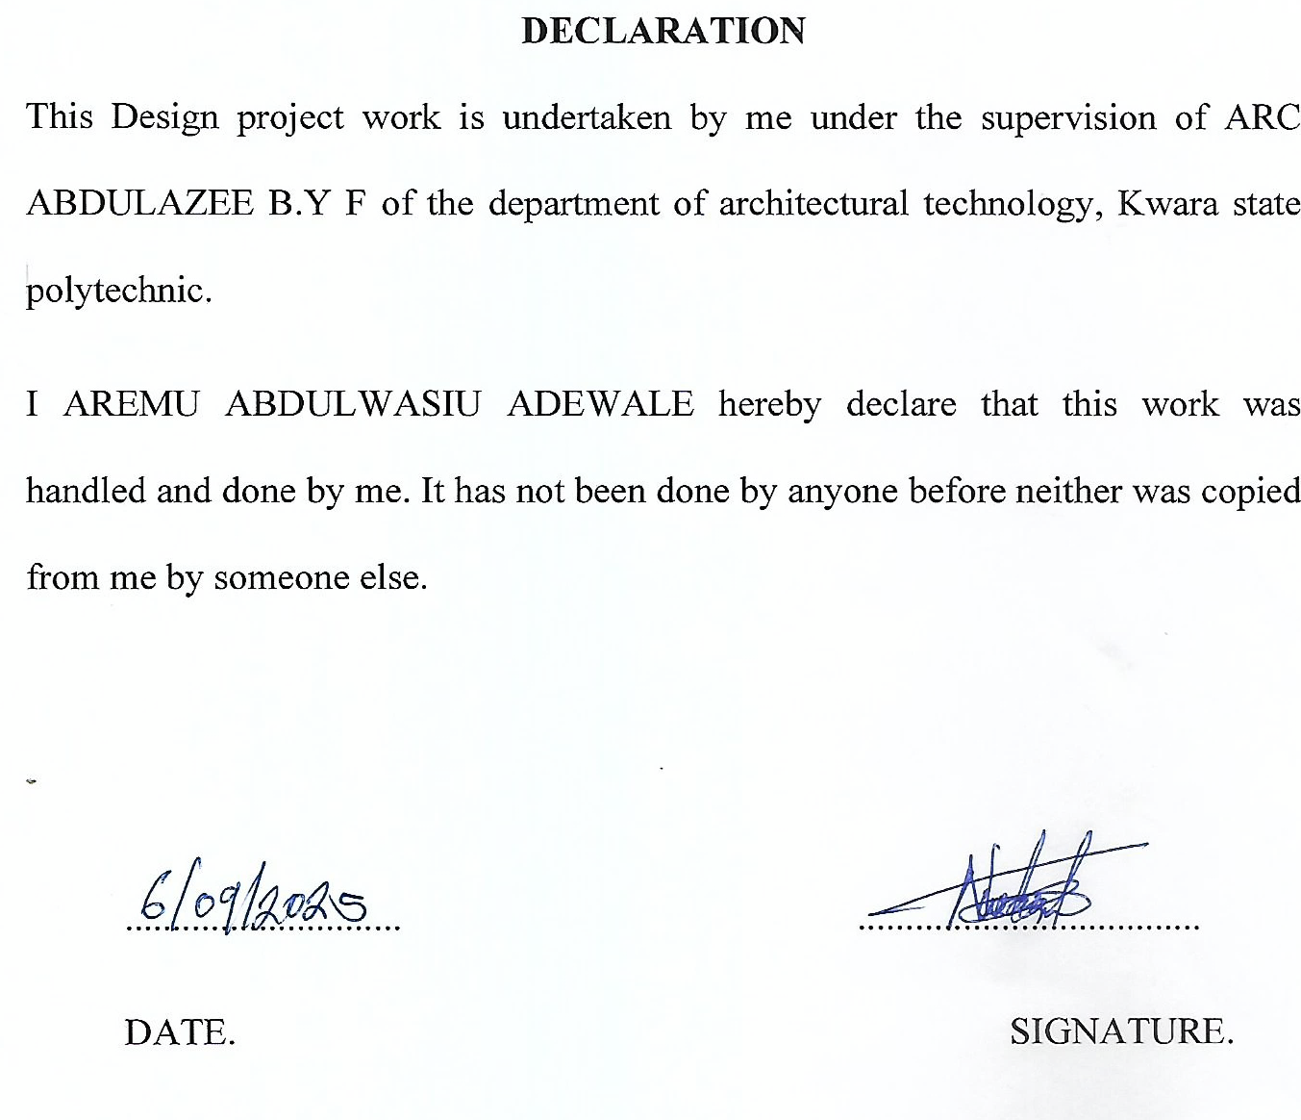

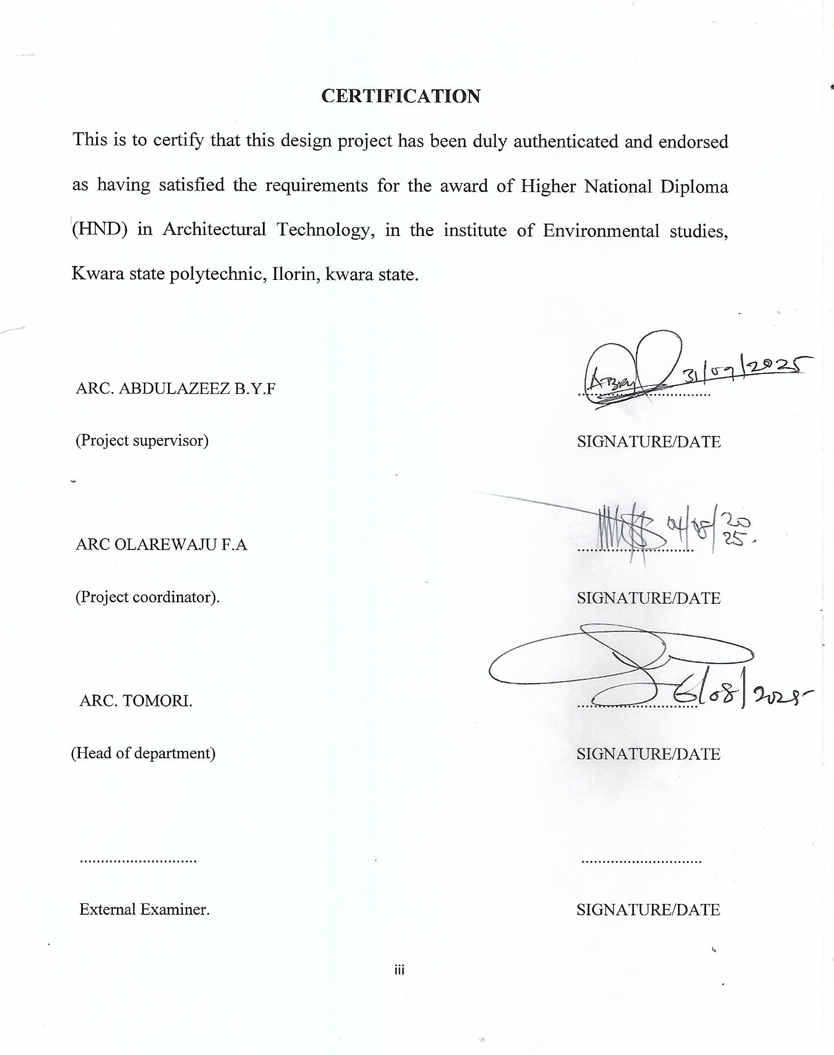

DEDICATION
I am specially dedicating this project to Almighty Allah the giver of Life, knowledge, and source of all inspirations.
I also dedicate this project to my beloved and wonderful parents Mr and Mrs AREMU for their love, care, support and provision during the time of this project.

ABSTRACT
Cultural center are multi- functional institution that provides access to culture, promotes citizens participation and offer lifelong learning opportunities. Cultural centers have their roots in ancient civilizations where public spaces were used for cultural and artistic expression which the historical background highlights the evolution of cultural centers from ancient public spaces to modern multi-disciplinary institution. This work is focusing on Cultural activities. Apart from the fact that this project can't be underestimated the design is also considering some structure as it is of a great significance to cultural heritage. Adequate Car parks are considered for spectators ranging from the V.I.P s to the popular ones, As a cultural center which will accommodate several people, there is a need for proper security measures which was duly approached through the introduction of security post where necessary, Other facilities like gate house, open parade ground, museum, galleries craft village etc, on the site. The research project is limited to cultural center, other factors that restrict over to the project that most of the respond are negative to true information concerning themselves of heavy and levy or counter action against them. The method of research in order to arrive at a functional and appealing design, different types of methods were adopted in carrying out the research work of this project are CASE STUDIES, ONLINE RESEARCH AND ORAL OVERVIEW .

ACKNOWLEDGEMENT
It is a genuine pleasure to express my deep sense of thanks and gratitude to the almighty God for his love and sustenance throughout the course of this study.
I wish to express my profound gratitude to my mentor for his guide, relentless and untiring supervisor, ARC ABDULAZEEZ B.Y.F His dedication and interest above all his overwhelming attitude to help his students had been solely and mainly responsible for the completion of my work. His timely advice, meticulous scrutiny, scholarly advice and scientific approach have helped me to a very great extent to accomplish this great task.
I also want to appreciate my project coordinator Arc. Olarewaju F.A, my HOD Arc.(MRS) J.M Tomori and all my lecturers in the department of architecture Kwara state polytechnic, Ilorin, both academic and none academic.
I owe a deep sense of gratitude to my parents Mr and Mrs AREMU, and my sisters, who gave me all their support financially, physically and also spiritually, wholly to the successful attainment of this worthy and rare degree and have to stopped at nothing to give the best of their support since I was born, I pray for you all will eat the fruit of your labor (Amen).

TABLE OF CONTENT
TITLE PAGE………………………………………………………………………………………i
DECLARATION ii
CERTIFICATION iii
DEDICATION iv
ABSTRACT v
ACKNOWLEDGEMENT vi
TABLE OF CONTENT viii
LIST OF FIGURES xi
LIST OF PLATES xii
CHAPTER ONE 1
1.0 INTRODUCTION 1
1.1 HISTORICAL BACKGROUND/ORIGIN 2
1.2 DEFINITION 4
1.3 AIM AND OBJECTIVES 4
1.4 LIMITATION AND CONSTRAINTS 5
1.5 RESEARCH METHODOLOGY 6
1.6 STATEMENT OF PROBLEMS 6
1.7 SCOPE OF THE DESIGN 7
1.8 JUSTIFICATION 8
CHAPTER TWO 10
2.1 REVIEW OF RELEVANT LITERATURE 10
2.2 IMPORTANCE OF THE PROJECT 11
CHAPTER THREE (3) 35
3.1 SITE LOCATION/DESCRIPTION 35
3.2 SITE LOCATION CRITERIA 35
3.3 SITE ANALYSIS/INVENTORY 36
3.4 GEOGRAPHICAL/CLIMATIC DATA 38
3.5 GEOGRAPHICAL CHARACTERISTICS 39
3.6 CLIMATIC CHARACTERISTICS 40
3.7 CONCLUSION 41
CHAPTER FOUR 42
4.0 DESIGN CRITERIA 42
4.1 BRIEF ON UNITS OF THE PROJECT 42
4.2 FUNCTIONAL AND SPATIAL CRITERIA 44
4.3 SPACE ALLOCATION/SCHEDULE OF ACCOMMODATION OF VARIOUS UNITS. 45
4.5 FUNCTIONAL RELATIONSHIP 50
4.6 CONCEPTUAL DEVELOPMENT (CONCEPT) 51
4.7 EQUIPMENT AND OPERATIONAL AND PERFORMANCE REQUIREMENTS. 51
CHAPTER FIVE (5) 54
5.1 DESIGN APPRAISAL 54
5.2 PLANNING 54
5.3 ASSESSMENT OF PROPOSED DESIGN 54
5.4 CONSTRUCTION METHOD AND MATERIALS 55
5.5 GENERAL REQUIREMENTS 57
5.6 RECOMMENDATIONS 63
5.7 CONCLUSION 63
REFERENCES 64
APPENDIX 66

LIST OF FIGURES
Figure 1: The geographical map
Figure 2: The site location of the proposed site
Figure 3: The site plan of the proposed site
Figure 4: The Floor Plan of the Proposed Project
Figure 5: The Roof Plan
Figure 6: The Approach Elevations
Figure 7: Section
Figure 8: concept derivation

LIST OF PLATES
Plate 1: Showing floor plan of Case study one
Plate 2: The locational plan of case study one
Plate 3: Showing the pictures of case study one
Plate 4: Showing the floor plan of Case study two
Plate 5: The locational plan of case study two
Plate 6: Showing the pictures of case study two
Plate 7: showing the floor plan of Case study three
Plate 8: The locational plan of case study three
Plate 9 showing the pictures of Case study three
Plate 10: showing the pictures of online case study four
Plate 11: Showing the pictures of online case study five

CHAPTER ONE

1.0 INTRODUCTION
The term cultural center refers to both an academic discipline and to its subject matters cultural history, as a discipline in its common definition since 1957 in Denmark often combine the approach of anthropology and history to look at popular Cultural traditions and cultural interpretation of historical experience.
It's examine the records and narrative description of past knowledge custom and arts of a group of people. It's subjects matters encompasses the continuum of events occurring in success leading from the past to the present and even into the future pertaining to culture.
Cultural history records and interprets past events involving human being through the social, cultural and political milieu of relating to arts and manners that a group favor.
Cultural history studies and interprets the human society by denoting the various distinctive ways of living build up by a group of people unclear consideration. Cultural history involves the aggregate of past cultural activities such as class in practices and the interaction with locales.

1.1 HISTORICAL BACKGROUND/ORIGIN
Cultural centers have their roots in ancient civilizations where public spaces were used for cultural and artistic expression.
ANCIENT CIVILIZATION (300BCE-500CE)
Greek agora: public spaces in ancient Greek served as cultural centers, hosting events, performances and intellectual discussion
Roman forum: the Roman forum was a hub for cultural, social and political activities, featuring temples basilica s and public art.
MIDDLE AGES (500- 1500CE)
Monasteries and convents: these institution served as centers for learning, art and culture, preserving ancient texts, and promoting artistic expression.
Gadwalls: gadwalls in medieval Europe hosted cultural events, trade fairs and community gatherings.
RENAISSANCE AND ENLIGHTENMENT (1500-1800CE)
Academies and saloons: institution like the French academy and Italian salons fostered artistic and intellectual exchange, promoting cultural innovations.
Museum and galleries: the establishment of museum and galleries, such as the Louver (1793), marked a new era in cultural preservation and education.
MODERN (1800- 2000CE)
Community centers: the rise of community centers in the late 10th and early 20th centuries provided spaces for cultural activities, education and socialization.
Cultural institution: the establishment of cultural institution like the museum of Modern art (1929) and the LINCOLN CENTRE (1962) further expanded cultural offerings
CONTEMPORARY ERA (2000CE-PRESENT)
Multi-disciplinary cultural center: modern cultural center often incorporate multi-disciplines, such as performances, visual art and educations.
Digital cultural centers: the rise of digital technology has eneble the creation of online cultural centers, expanding access to cultural resources and programming.
The historical background highlights the evolution of cultural centers from ancient public spaces to modern multi-disciplinary institution.

1.2 DEFINITION
Cultural center can be define as a physical or virtual space that promotes and celebrates the Arts, culture and heritage of w community, region or Nation, it's serve as a hub for cultural activities, education and exchange, providing platform for people to engage with and learn about different cultures.

1.3 AIM AND OBJECTIVES
AIM
The Aim of this project is to design a standard, conducive and we'll structured cultural center that will enhance the effectiveness of cultural and art preservation.
OBJECTIVES
- To provide an alternative cultural center/arena to the public as against the traditional museum centers which the society as known for ages
- To provide a Modern cultural center which will serve as a Rendezvous for people who have taste for standard and quality.
- To design a well functional cultural center that can promote and preserve cultural heritage
- To provide functional and decent structure that are complimented with necessary features like model and Hall which will serve as extra income for the center.

1.4 LIMITATION AND CONSTRAINTS
Cultural centers faces a number of limitations and constraints including.
Funding: cultural center does not have enough fund for maintenance, conservation and infrastructure development
Expertise: cultural center are short of skilled professionals in the field of conservation.
Infrastructure: cultural center lacks proper infrastructure such as roads, signage, and visitors facilities.
Urban development: Rapid urbanization and development encroach on cultural center, leading to their destruction or alterations.
Climate changes: climate change increase the risk of flowing, erosion and extreme weather event, which can accelerate the deterioration of the center.

1.5 RESEARCH METHODOLOGY
This is the process that outlines the techniques and procedure used to analyze and identify information about my research topic, it's includes the following aspects:
CASE STUDIES: this is an exercise which involves the study of existing similar structure. From the data taken, deductions for the realization of a better design for the project were derived.
ORAL INTERVIEW: information’s was gathered from some senior officials working in the visited centers, deductions from these sources also influence the end design.
LITERATURE REVIEW: the textbooks like architect Data by Neuter Ernest, the construction of buildings by R. Barry and dictionary of Architecture and Building construction by Nikolas Davies and Erkki Jokiniemi.
INTERNET REVIEW: Foreign case studies were also carried out through the internet

1.6 STATEMENT OF PROBLEMS
Lack of standard cultural centers, most community lack standard cultural center that encapsulate its diverse traditions and practiced. This can lead to fragmented cultural activities and a lack of community Engagement.
Lack of leadership, cultural center experience problems with leadership when civil servants who aren't knowledgeable in the arts and administration are appointed to key position. This can lead to lack of artistic sensitivity and expertise.

1.7 SCOPE OF THE DESIGN
Due to the broadness of the proposed project and time factor, the scope of this project shall be limited to the design of the cultural center.
Design brief
Main hall/Auditorium
Box ticketing
Offices
Museum
Art galleries
Changing room
Rehearsal room
General storage
Costume store
Sound/lighting room
Conference room
Library
Back stage
Workshops/art studio
Conveniences
Gate house
Security hous
Museum
Open parade ground
Car parks
Power supply house/Generator house

1.8 JUSTIFICATION
By justifying the importance of cultural centers, I recognized their vital role in preserving cultural heritage, fostering cultural understanding, supporting artistic innovation and promoting community engagement, economic development and social cohesion.

CHAPTER TWO

2.1 REVIEW OF RELEVANT LITERATURE
Etymology of a cultural center
Cultural centers is a multi-functional institution that provides access to culture, promote citizen participation and offer lifelong learning opportunities. They serve as platforms for people to engage in cultural activities and experience.
Cultural centers promotes socialization within communities, providing space for people to interact and engage with each other, and the Arts, often showcased in cultural center have a positive impact on communities contributing, contributing to their Cultural and social well-being.
Effective design of cultural center is crucial incorporating elements, cultural centers helps prioritize community engagement providing spaces for people to connect and participate in cultural activities.
Theobald (1994) suggested that etymologically the word CULTURE is derived from a Greek work, this changed in modern English to represent (Tradition). It represent the process of typical behavior or quality of a particular or geographical area. It explains the peculiarities, norms and values of an area, as well as how it’s been used to mean many things in the community. Therefore like a cycle a cultural center represent a journey in a round trip. The overall behavior of Geographical surroundings.
The international association of scientific experts in culture define culture in terms of particular or peculiar activities that has been adamant and has become the lifestyle of every individuals in the community.
The cultural center has become an advance evolution starting from the ancient civilizations in (3000 BCE) to the Contemporary Era (2000 CE) where cultural centers are used for multipurpose e.g. displaying cultural events, studying and also Digital cultural learning for students. The study has shown the existence of cultural centers since the late 19th century. Also main aim of every cultural center is to have various people for a particular cultural showcasing the exhibition and gallery to the people with Great standard and functionality under a unique environment.

2.2 IMPORTANCE OF THE PROJECT
- Improves cooperation a d as well as project on image of a county to the outside world.
- It has an educational significance in a narrow sense much cultural activities take the form of educational aim in view.
- Culture in often accompanied by cultural exchanges and by the cultural enrichment of those who travel as well as those at the receiving end.
CASE STUDY ONE (1) @ CALABAR CROSS RIVER STATE
LOCATION
The cultural center is located at Bogoberi, off Mary's slessors avenue (Road) CALABAR, CROSS RIVER STATE NIGERIA
HISTORICAL BACKGROUND
The cultural center CALABAR (CCC), the department of culture and heritage was established under the edit No, 2 of 1976 as the cross river state cultural center board CALABAR.
Presently the department is operated as a development of culture and heritage in the governor's office with a special assistance as the chief executive officer.
Historically, Calabar has been a significant cultural a d trade center, dating back to the 17th century. Today, the cultural center Calabar is a melting pot of cultural exchange, hosting various international events including the Calabar international jazz festival. The center also features incredible cultural artifacts, facilitates for theatre and conference events, and a proposed shopping mall to enhance the cultural and leisure experience.
Tomorrow, the center will continue to play a vital role in promoting the cultural heritage of Calabar supporting the local community and attracting tourist from around the world.
DESCRIPTION
The cultural center in Calabar stands for a significant landmark that encapsulate the rich cultural heritage of the region. This vibrant hub serve as a gathering place for artists, performers and cultural enthusiast, showcasing the diver’s tradition that define the local identity. The center is not only a venue for autistics expression but also a place of learning, where workshops, and seminars provide me insight into traditional crafts, music And dance.
The center is open every day from 9:00am to 9:00pm making it accessible for tourists looking to delve into the local culture at any time during their stay.
CRITISMS
MERITS
- The main hall is very convenient for conference and social gathering.
- The cultural center is well located.
- The structure is well organized.
DEMERITS
- Most units within the building are not functioning.
- It has no space for further development on the site.
- The building lack maintenance.

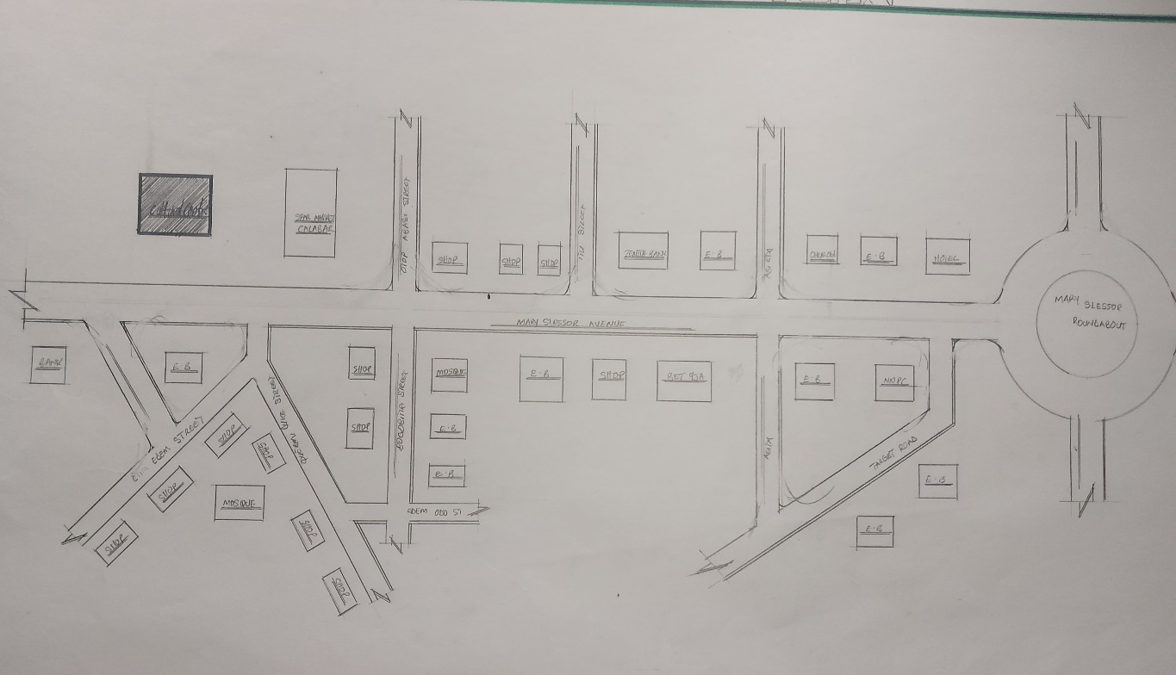
LOCATIONAL PLAN OF CASE STUDY ONE
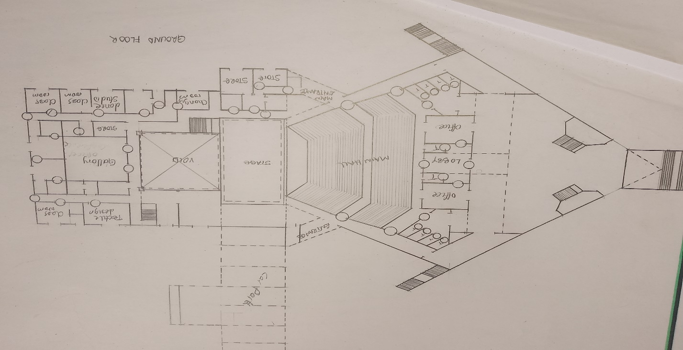
PLAN OF THE CASE STUDY ONE
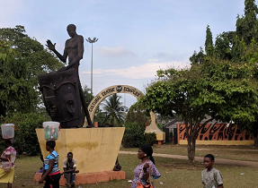

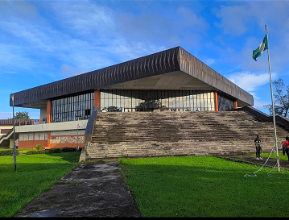
PICTURE OF THE CASE STUDY ONE
CASE STUDY TWO (2) @ ILORIN KWARA STATE
LOCATION
The Kwara state cultural center is situated at Lagos road opposite IGS (Ilorin Grammar School) agunbelewo geri-alimi along airport road Ilorin.
HISTORICAL BACKGROUND
The kwara state, located in the nort central Nigeria, has a rich cultural heritage shaped by its strategic position between the northern and southern parts of the country.
The kwara state cultural center was built in the 90s to provide reservation and recreation center in the capital city ILORIN and situated at agunbelewo geri-alimi along airport road Ilorin. The Kwara state arts and culture emerged as the overall third best participants at the just concluded 16th international Art and Craft (INAC).
DESCRIPTION
Kwara state Arts and culture complex is a unique facility that was designed to enhance traditional and cultural engagements in the state. The complex hosts several events as regards to culture and traditions. It is the duty of the cultural center to promote, preserve, revive, develop an encourage the arts and culture within and outside the state.
CRITISMS
MERITS
- The structure is aesthetically appealing.
- The cultural center is well located at the center of the capital city ILORIN.
- It has adequate land space.
DEMERITS
- No provision for fire outbreak/Resistance in the building.
- The main hall is faulty due to technical issues.
- The gallery is not in proper shape.
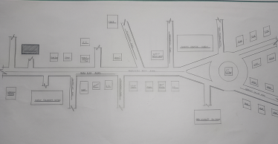
LOCATIONAL PLAN OF CASE STUDY TWO
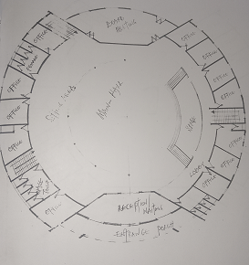
PLAN OF THE CASE STUDY TWO
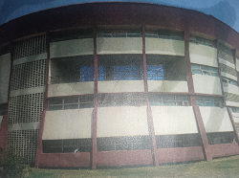
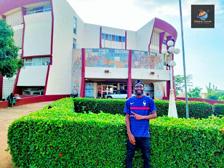
PICTURE OF THE CASE STUDY TWO

CASE STUDY THREE (3) @ IBADAN, OYO STATE
LOCATION
The Oyo State cultural center is located at the top of mokola hill, along mokola Festac, Ibadan Oyo State Nigeria.
HISTORICAL BACKGROUND
The Oyo State cultural center was built in 1977 to complement the FESTAC festival and the plan was to generate state IGS through tourism.
In the 80s and 90s, the cultural center was home to prominent artists, cultural display, stage performances, art exhibitions and other Cultural works, with star performer like Moses olaiya popularly known as Baba sala, the late duro Ladipo, oyin adejobi and ojo Ladipo regularly entertaining and educating people. Jimho aliyu, yemi ekebuibon, lere piamo were also regular faces at the cultural center.
DESCRIPTION
The cultural center, structure was cleverly built into the Hill, so you don't really see much of it from the too but the back. There is the statue of the musician playing tradition instrument beakon's you in, it's like an elite’s museum.
It was designed by the Great ARCHITECT PROFESSOR DEMAS NWOKO, while times May have weathered it's facade, the cultural center remains an iconic attraction, intricated wall carvings adorned statue and unique architecture reflects its ancient beauty, offering a glimpse into the past, the center is also surrounded by other popular landmarks, including the University college hospital (UCH), and the premier hotel of Ibadan.
The Oyo State council for arts and culture as also based at the center and has been involved in various cultural events and activities, including the National festival of Arts and culture (NAFEST).
CRITICISMS
MERITS
- The building has many functional units/spaces.
- The main hall has large capacity accommodations.
- There's enough space for further extension on the site
DEMERITS
- Crafts and painting has detached from the building.
- It's possesses poor landscaping.
- Poor access and circulation.
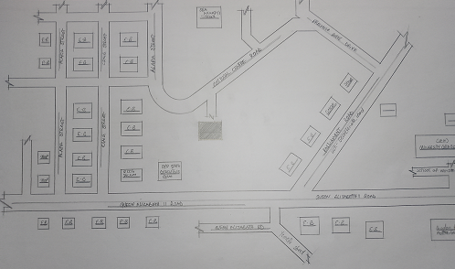
LOCATIONAL PLAN OF CASE STUDY THREE
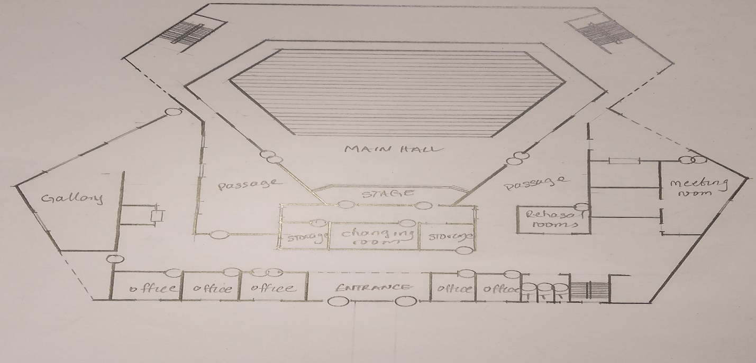
PLAN OF THE CASE STUDY THREE
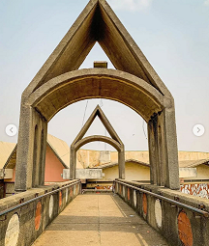

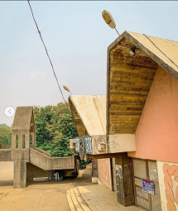
PICTURE OF THE CASE STUDY THREE
CASE STUDY FOUR
CULTURAL HERITAGE CENTER, DODOM ARUSHA, TANZANIA
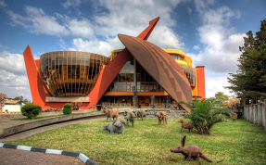

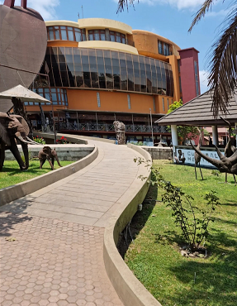

PICTURES OF ONLINE CASE STUDY

CASE STUDY FIVE
HONG KONG CULTURAL CENTER SALISBURY RD, TSIM SHA TSUI. CHINA
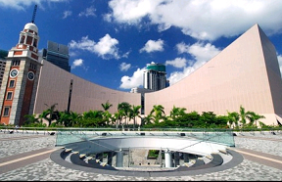

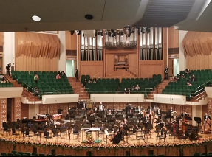
PICTURES OF ONLINE CASE STUDY

CHAPTER THREE (3)
SITE AND ENVIRONMENTAL ANALYSIS
INTRODUCTION TO PROPOSED SITE

3.1 SITE LOCATION/DESCRIPTION
The site selection for the proposed project is situated at SANGO along old jebba road, Ilorin Kwara state.
SANGO is a rural area under the Ilorin south/East local government area of kwara state, it has a latitude of about 515m-572m above the sea level.
It's is underlain by different types of soil in different kinds of location, which some are commonly sandy and clay soil. SANGO consist majorly of three (3) different tribes which are Yoruba's, Hausa and the Fulani's with a major market whis is the SANGO kulende market situated at the area of sango along old jebba road Ilorin Kwara state.

3.2 SITE LOCATION CRITERIA
Site selection is the consideration factors which influence the development of the site and spatial activities, conversely, a site selection criteria is based on screening Factors affecting the site selection includes: comfort, thermal control, (Orientation), Ventilation and sola control etc the activities taking place on the site.

3.3 SITE ANALYSIS/INVENTORY
The proposed site has scattered trees and grasses and also has flat land but has the end of the east sloppy gently. It has an access road directly in its south, a footpath also exist on the site, it's to be blocked by fencing and also termite house to be removed, cashier tress also to be removed/uprooted and filled. Palm tree to be uprooted also in some parts and filled.
Electric pole passes through the site which has a step down transformer on the site and also a telecommunication mast sharing boundaries with the site and the vacant pole behind it.
Soil Condition: the type of soil is sandy and hence aid good vegetation of trees, shrubs and grasses.
Geology: the site soil has a poor location bearing capacity and hence raft foundation will be used for the structure to be erected on the site.
Vegetation: the proposed site is fairly covered with grasses scattered trees and shrubs, this can easily be removed from the site before construction commence.
Topography: the site is of firm ground which is not affected by erosion. The site only required the excavation of the top soil to remove the vegetation soil and shrubs, before the trench excavation of the site.

3.4 GEOGRAPHICAL/CLIMATIC DATA
Ilorin has an area of 1286squara kilometers and a population of 126435 as at the 2006 census (National population commission).
Kwara state has two major season which is the wet and dry season. The wet session extend from April to October while the day season extend from October to March, Each type of season is characterized by a specific type of prevailing wind. The wet season bring with it south easterly wind originating from the equatorial rain belt and blowing from the high pressure zone which occur over the Atlantic. During the period of the dry season it is accompanied by harmattan a dust laden wind blowing from North West.
Latitude: 8:5. North
Longitude: 4.55 East
Temperature: 31.5C
Wind Spread: 21m/s NE
Cloudiness: 1.6%
Relative humidity: 31.5%
Atmospheric pressure: 1007./pa
Average Rainfall: 250mm/annum
By understanding the geographical & Climate of the site, you can make informed decisions about design development, and management of the site.

3.5 GEOGRAPHICAL CHARACTERISTICS
Geographical characteristics of a site refer to it's physical features and attributes, we have key geographical characteristics to consider:
Topography
Elevation: the site's heights above sea level.
Slope: the site slope and gradient.
Aspects: the site Orientation (eg North, south facing).
Landforms and features
Hills, valleys and plans: the site's landforms and their characteristics.
Water bodies: the presence of rivers, lakes, or Ocean
Coastal features: the site coastal characteristics, such as beaches or Cliff.
Social and Geology:
Soil type: the type and quality of soil on the site.
Geological formations: the site's underlying geological formations and rock types.
Natural Hazards
Earthquake Risk: the site earthquake Risk and seismic activity.
Landslide risk: the site's landslide risk and potential for soil instability.
By considering the geological characteristics of the site, informed decisions about development and conservation of the site.

3.6 CLIMATIC CHARACTERISTICS
Climate characteristics is the long-term atmospheric conditions that prevail in a particular region.
Temperature
Average temperature: the average temperature of the region or community
Temperature Range: the difference between the highest and lowest temperature.
Participation
Rainfall Patterns: the amount and distribution of rainfall through the year.
Snowfall: the amount and frequency of snowfall, if applicable.
Humidity and cloud cover
Relative humidity: the amount of moisture in the air.
Cloud cover: the amount of cloud cover and it's impact on temperature.
Wind and Atmospheric circulation
Wind patterns: the prevailing wind direction and speed.
Atmospheric circulation: the movement of air masses and weather patterns.
Seasonal Variation
Seasonal temperature changes: changes in temperature throughout the year
Seasonal precipitation pattern: change in precipitation pattern throughout the year.
Extreme weather events
Droughts: prolonged period of abnormally low rain fall.
Heat weaves: prolonged period of abnormally high temperature.
Storms: severe weather events, such as hurricane tomades.

3.7 CONCLUSION
In conclusion, having duly observed the above analysis (geographical and Climatic characteristics), site analysis and inventory done, the site is found suitable for the proposed project as it's meet up with the site selection criteria.

CHAPTER FOUR

4.0 DESIGN CRITERIA
INTRODUCTION
In the design formulations of any project work, some necessary steps are needed to be put in places in order to achieve the desired results and functionality in the proposed design. Such procedure, formulations and steps are therefore analyzed in this chapter.

4.1 BRIEF ON UNITS OF THE PROJECT
Design brief
Museum.
Administration building.
Cultural/cinema hall.
Entrance to the main hall.
Main hall.
Gallery.
Offices.
Back stage.
Banquet/seminar hall.
Stage/podium.
Convinces.
Visual and performing Arts.
Costume store.
Control room.
General storage.
Sound and lighting room
Design scope
Crafts village.
Gate house.
Mosque.
Car parks.
Parade ground (gbagede).
Achieve library.

4.2 FUNCTIONAL AND SPATIAL CRITERIA
Functional and spatial criteria in a project or design refer to the requirements and Consideration that shape the design of buildings and spaces.
FUNCTIONAL CRITERIA
Purpose and use: the intended use of the building or space, such as residential commercial, or recreational.
Flexibility and adaptability: the design should be flexible and adaptable to changing needs and uses
Efficiency and productivity: the design should facilitates efficient workflows productivity and functionality.
SPATIAL CRITERIA
Space planning: the allocation and Organization of space to meet functional requirements.
Scale and proportion: the relationship between the size and proportion of spaces, furniture and fixtures.
Natural light and ventilation: the incorporation of natural light and ventilation to enhance comfort and well-being.

4.3 SPACE ALLOCATION/SCHEDULE OF ACCOMMODATION OF VARIOUS UNITS.
Space allocation is specifically the process of assigning a specific areas or rooms within the building for particular use of function.
Space allocation, by applying effective space allocation strategies, I can create space that supports projects goals, enhance user experience and optimize resources utilization.
Schedule of accommodations for various units, the functional requirements of space has been determine from the analysis of service in the cultural center such as lobby, showing circulation.
REPRESENTED WITH PHOTOGRAPH
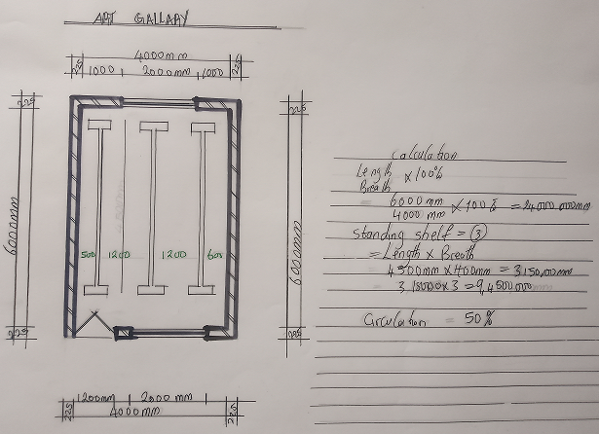

SPACE CALCULATION
This involves measuring and calculation the area and volume of a space or room.
A space/units has been choosen to calculate (the art gallery) calculating room) Space Area.
Firstly measure the length and width of the space either in feets or meters or millimeters.
Calculate the Area: multiplying the length a d the width to get the area in square feet or square meters.
Calculating the volume of a space
Measure the height
Calculate the volume by multiplying the area of the height to get the volume.
Formula Area= length × Breath
Volume= Area × Height.

REPRESENTED WITH PHOTOGRAPH
Space allocation length, breadth dimension (LxB) Area (m²)
S/N | UNITS | LENGTH | BREATH | LXB | AREA
1 | Main entrance | 26,000mm | 7,800 | 202,800,000 | 202,800 m²
2 | Reception | 25,000mm | 7,000 | 175,000,000 | 175,000 m²
3 | Offices | 3,000mm | 2,600 | 10,800,000 | 10,800 m²
4 | Main hall | 34,000mm | 36,400 | 1,237,600,000 | 1,237,600 m²
5 | Stage/Podium | 8,000mm | 26,000 | 208,000,000 | 208,000 m²
6 | Back stage | 5,600mm | 20,900 | 115,920,000 | 115,920 m²
7 | Audio visuals | 3,000mm | 5,000 | 15,000,000 | 15,000 m²
8 | Changing room | 3,000mm | 5,000 | 15,000,000 | 15,000 m²
9 | Rehearsal room | 3,000mm | 5,000 | 15,000,000 | 15,000 m²
10 | General Store | 3,000mm | 5,000 | 15,000,000 | 15,000
11 | Exhibition Display | 10,500mm | 3,000 | 52,000,0000 | 52,000
12 | Stairs | 3,000mm | 5,000 | 15,000,000 | 15,000
13 | Art Galary | 6,000mm | 3,000 | 18,000,000 | 18,000
14 | Maintenance Room | 3,000mm | 5,000 | 15,000,000 | 15,000
15 | Costume store | 3,000mm | 5,000 | 15,000,0000 | 15,000
16 | Seminar room | 3,000mm | 5,000 | 15,000,000 | 15,000
17 | Control Room | 3,000mm | 5,000 | 15,000,000 | 15,000
18 | Workshop/Art Studio | 10,000mm | 3,500 | 34,650,000 | 34,650 m²
19 | Sound/Lighting Room | 5,600mm | 20,700 | 115,920,000 | 115,920 m²
20 | Convenience | 1,200mm | 1,800 | 2,160,000 | 2,160m²

SPACE SCHEDULE
This is a documents that outlines the details of a space or room, including it size, function and occupancy.
Room number
Room and space name
Space size
Function of the space
Furniture s d Equipment
The above listed are what the space schedule entails.
SPACE ANALYSIS
Involve evaluating the physical and functional characteristics of the space to understand how it can be used effectively.
We have to consider this Factors
Space Dimensions: the length & breath and height.
Layout: analyzing the arrangements of furniture, fixtures etc.
Natural light: evaluating the amount of quality natural light entering the space.
Circulation: Assessment of the flow of people through the space.
Functionality: Determining the Space's Purpose and how it will be used.

4.5 FUNCTIONAL RELATIONSHIP
The functional Relationship determined and shows the way different spaces or element within the building interact and relate with each other to enhance specific purpose and functions
While bringing out a functional relationship of the building various consideration must be observed and this includes:
Understanding the needs and behaviors of the proposed building users.
Designing spaces that are functional and efficient.
Creating a logical and efficient flow of people through the building.
Designing spaces that can adapt to changing needs and uses.
Considering the way units relate together, indicating the to and fro movement interaction.
Having put this together, a well functional relation of the building is extracted, making the building more efficient, effective and user-friendly.

4.6 CONCEPTUAL DEVELOPMENT (CONCEPT)
Conceptual Development is the process of generating exploring and refining ideas and concept to meet project requirements and goal.
In regard to this project "CULTURAL CENTER" the proposed concept Design for it is the Benin ivory Mask, to show that the design is related to culture and tradition of Africa.
The "BENIN IVORY MASK" is a miniature sculpture portrait in ivory of IDIA, the first "IYOBA" (Queen mother) of the 62th century Benin Empire, taking the form of a tradition African mask.
After various research, analysis, idea generation and concept refinement the Benin ivory Mask was chosen as the concept for the proposed cultural center project
By investing time and effort into the conceptual Development, I was able to create a design that meet user need a d aesthetically pleasing.

4.7 EQUIPMENT AND OPERATIONAL AND PERFORMANCE REQUIREMENTS.
Equipment requirements: This includes the tools and materials (equipment) required for a cultural center which is the proposed project topic:
Audio - visual system: High-quality sound and projection system for performance, presentation and exhibitions.
Lightning system: Flexibility lighting Design to accommodate various events and performance.
Stage and rigging systems: Safe and versatile stage and rigging systems form performances and events.
Exhibition displays system: Digital cases, panels and other exhibition, furnitures to showcase art, artifacts and exhibits.
Accessibility equipment: Equipment to ensure accessibility for people with disabilities, such as wheelchair, lift and accessible Restrooms.
OPERATIONAL PERFORMANCE REQUIREMENTS
Acoustics: Design for optimal acoustics to ensure high quality sound for performance and events.
Flexibility: Design for flexibility to accommodate various events, performances and exhibition.
Accessibility: Ensure accessibility for all users, including people with disabilities.
Sustainability: incorporate sustainable design principle and materials to minimize environmental impact.
Safety and security: Ensuring the safety and security of users staff, and equipment.
By considering these equipment and Operational performance requirements the proposed cultural center will be functional, sustainable and enjoyable for users.

CHAPTER FIVE
(APPROACH TO DESIGN/ DESIGN REALIZATION)

5.1 DESIGN APPRAISAL
Cultural center being an institution center requires free flow of activities to enhance it fundamentality. So the design concept for the project is achieving a linear circulation of various activities, this achieved with the provision of immediate activities closely to the entrance and segregation of various units.

5.2 PLANNING
This planning is based on zoning the related units according to its scope and limitations in accordance with bubble diagram. This was done by arriving at a functional shape which allows movement with central core
The zone principle (Noisy, semi Noisy and quiet zone) is observed which enhance the placement of each structure, and for easy accessibility the various units, parking space are well planned and placed in order.

5.3 ASSESSMENT OF PROPOSED DESIGN
The site is properly define with a perfect blend of both natural and artificial attraction as well as soft and hard landscaping to give a quality taste of a desire comfort to all guest and workers.
SITE PLAN: The site plan is rectangular in shape with four side and on it is the cinema Hall, an hotel for tourists and visitors, museum/gallery for exhibition also the craft village and the achieve library where book and journal of great writers of the culture will be ketp, visual art and performing arts.
Also on the site is the security house at the gate, the maintenance and the generator house. All link with a walk way and absolutely enough parking lots. Also the open parade (gbagede) for ceremonies is on the site for festival and commercial purpose.

5.4 CONSTRUCTION METHOD AND MATERIALS
In the proposed project the following materials finishes bare Recommended for use,
FLOOR:
In selecting floor finished, many factors are of equal importance in general the following criteria are considered:
Resistance to wear: it should not wear off easily especially in the display hall.
Easy to clean: the cleaning should be easily done.
Durability: ability of the materials to last long.
Non slip Quality: it must not slip under water eg wet areas.
Economical: the initial cost and maintenance should be reasonable.
Resistance to chemical: it must not deteriorate under oil or chemical.
In view of the above reasons, the following Recommendation are specified.
For the main hall, unglazed ceramics tiles floor finishes is recommended for attraction look, easiness I'm cleaning qualities and non-slippery character.
For other units PVCs floor tiles, Rig materials should be used. Wet areas should be gronolithic floor finishes.
WALL:
Most of the units are of framed structure which carries most of the loads. Load bearing masonry walls are used and finished with walk rendering and finally painted according to color specified. In toilets walls, the finishes are with ceramics walls tiles to a height of about 3.0m. Expansion joint also are introduce because of thermal expansion.
CEILING:
The ceiling materials should be attractive and easy to clean, it could be moderate in cost for the above reasons, hence celotex and abestors ceiling board are recommended according to the specific schedule.

5.5 GENERAL REQUIREMENTS
LIGHTNING:
Objectives of lightning in buildings are many which allows people to move easily within the building and can be seen and recognized accurately.
Simple quality of lightning is not enough: direction of flow of light, it appearance and color rendering properties, and the relative contrast and brightness of the object light against their surrounding are also important.
The effects of lightning on the space and it occupants, must be considered, visual comfort must be taken into account, glare produce by the lighting sources, the color and appearance of the source and the effects of day light entering the space with fare through the designer cognizance, the control of most of these factors to produce visually, thermally and economically acceptable lightning in the center.
The decision on the amount of day lighting onto be produced in the offices and other related units spaces such as fundamental influence on the design of the cultural center and it's artificial lighting. Adequate natural lighting can be achieved in the cultural center by providing a very wide overhead window with burglary proof.

ORIENTATION
The orientation of the building in relation to the prevailing winds that affects air infiltration and hence the need for artificial ventilation.
Orientation in relation to the sun path at different seasons will affect solar heat gain to the building and hence the need for heating or cooling. The use of overhead windows to provide small amount of day light without excessive Sola gain through large hall of glazing implemented in the cultural center.
FIRE HAZARD/PROTECTION
Building regulations and consultation with the local fire authority, backed up by fire insurance companies takes care of fire precautions needed in the cultural center. These should be carefully observed and periodically reviewed to ensure that the fullest use can be secured from protection facilities in an emergency.
Fire, not only put persons in danger bit the disruption of materials caused by fire with the damages done to shock machinery and building may cause I'm summon table difficulties leading to the dissolution of the center.
Fire has not been left out in the consideration, this became an important consideration in the cultural center, where most disaster are caused.
Generally, fire extinguisher are recommended to be provided at a appropriate points, fire resistance materials like fire alarms system is to be installed so that everyone could be alerted in case of any fire outbreak. Also a double leave doors are provided in all exits to aid easy escape in the case of fire outbreak.

ELECTRICITY SUPPLY
There is few if any, a building that does not requires electricity power for some purpose. For the service required to make the building works or for the activities of the occupants, the design of a cultural center will have direct effect on the scope of the power supply system, main distribution and it's equipment.
WATER SUPPLY
Water supply us an essential commodity in every establishment (Building) and both the scope and the design of these systems are subject to statutory and water authority regulation.cthese regulation have been developed over the years with three main objective, protection of public health, maintenance of portability of public water is required in the conveniences.
There is the need to install cistern to guide against fire failure supply. Adequate installation of pipes are recommended, installation of water storage system in necessary.
DRAINAGE SYSTEM
The need for special provision for ground water and surface water drainage maybe be affected by impervious surfaces, by the depth of basement proposal, by an interface with existing subsoil drains, grow water flow or surface drainage by the proposed building, and by the method of construction to be used.
Surface and rain water drainage will be affected by the proportion of the site to be covered by various surface, their permeability and the falls which can be built into them, by shape and area of building and it's roots, facade and internal courtyard the layout and the relief of the site for the proposed factory of course influencing the line of sewers in the site overall drainage pattern, the site slopes towards the main sewage line.

SERVICES
Electricity is tapped from the nearest electric pole to the generator room. The main water pipeline is closely located to the site where drinking water can be tapped. Telephone line is very close to the site which make connections easy. All the gutter along the public drainage which follows the natural backup, all the solid and liquid water are effectively disposed off by the use of soak away lit and septic tanks.
RAIN PROTECTION DEVICE
To control the heavy rainfall during the wet season (April to October) the use of simple wall sloppy roofing systems had been adopted. This is to be provided with gutter system which is linked to the ground gutter by the use of PVC drains pipes concrete facial are introduce to control driving rains.
NOISE CONTROL
External nous could be easily controlled with the aid of landscape materials and enough setbacks
The first building is about 40m away from the heavy traffic noise and landscape element such as trees and parking lots are introduced as buffer zone.
The design are zoned in 3 three main categories:
Quiet Zone: craft village, achieve library/gallery.
Semi Noisy zone: open parade (gbagede), hotel and admin block.
Noisy zone: the main hall, gen house.
LANDSCAPING
The idea of landscaping a surrounding evolves from the secondary functions it performs such as giving a good aesthetic look to the building it enhance the psychological feeling of the customers making use of the area, it makes the entire environment healthy, as an adage put it "Cleanliness is next to godliness".
In view of these following had adopted in planing the site and the landscape element are divided in two part:
Soft element
Hare element
SOFT ELEMENT: is a type of landscaping made up of the following:
Trees: trees are planted within the premises to provide natural ventilation. There's which will not be less than 2.5 in height when planted at reasonable position to provide shade.
Grasses: Grasses give food impression of an environment and also protects the land surface from erosion as the site has a relatively flat land for this project recommend Bahamas grass for the lawn areas.
Flowers: a well planned flowers arrangements gives aesthetic balance to the environment, flowers also goes around the walking way and the admin building generally except where it can obstruct vehicle and pedestrian movement.
HARD ELEMENT:
Parking space/lots: travelers, tourists and staff parking lots are located at the front of the approach view of the block with a well-defined space constructed with interlocking tiles. Which form a good site planning.
Walkways: pedestrian walkways are provided around the parking lot and around the building which is well defined with the use of kerbs and edges for easy movement of staff, visitors and spectators.

5.6 RECOMMENDATIONS
As a student, I am recommending this project work to the entire public as a whole, as it's brings development and civilization to it's locality as Researched, it's also pay off in terms of revenue generation for the community and also reduce the rate of unemployment in the state.

5.7 CONCLUSION
Conclusively, this project has seriously broadened my view and observation beyond expectation and by this I have been able to deduce that project work of nsy form must not be taken lightly as it's determine how far one can go to get facts and precise information towards assisting one's self, takin of experience and solving societal problems through academic work.

REFERENCES
Anita Lawrence (1989); Acoustics and Building Environmental Elservier Science Publisher Ltd.
Barry, E (2018) Construction of Building vol. 1-5 Colins, English Language Dictionary.
De-Chiara (1983); Architectural site planing Macmillan press Ltd.
Freezer Rekier (1979); Droughtmanship Architectural Building Graphics, Grand publisher Ltd.
George K. Stedman (1996); Architectural Drafting, Functional Planing and Creative Design Grananda Publisher Ltd.
Macmillan R.(1986); Environmental service Building, the Macmillan press Ltd.
Neufert E. (1980); Architects Data (Third national edition), Granada Ltd, Great Brittain.
Peter A.A (1999) Metric Hand Planning and Design Data (New Edition); Architectural Press, United Kingdom.
R. Chudley and R Greeno (1999). Building construction handbook 6th Edition.
Smith N.A (2002); Lighting for health and safety, A Division of Reed Education and Professional publishing Ltd.

APPENDIX
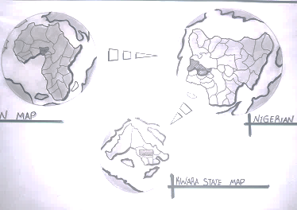
GEOGRAPHICAL MAP
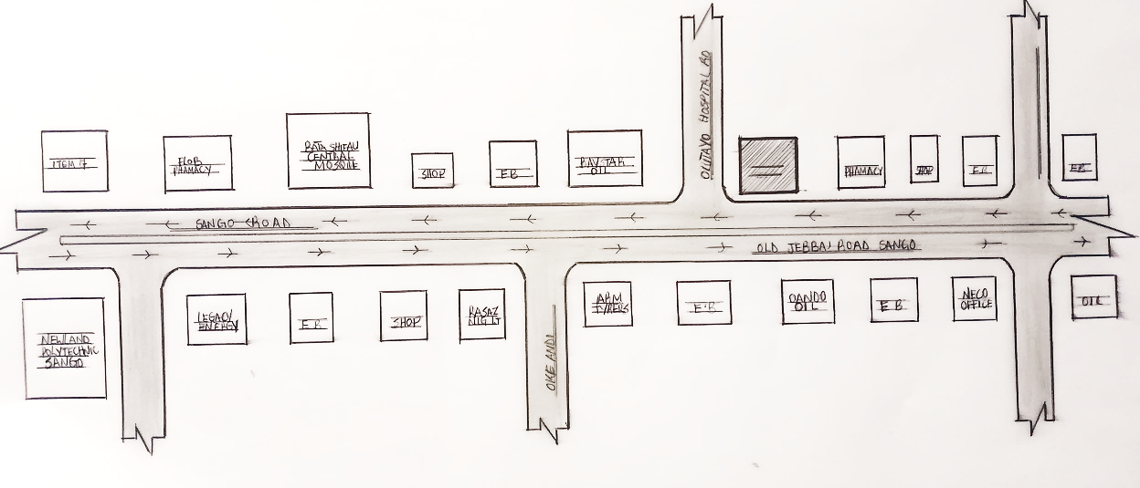
LOCATIONAL PLAN
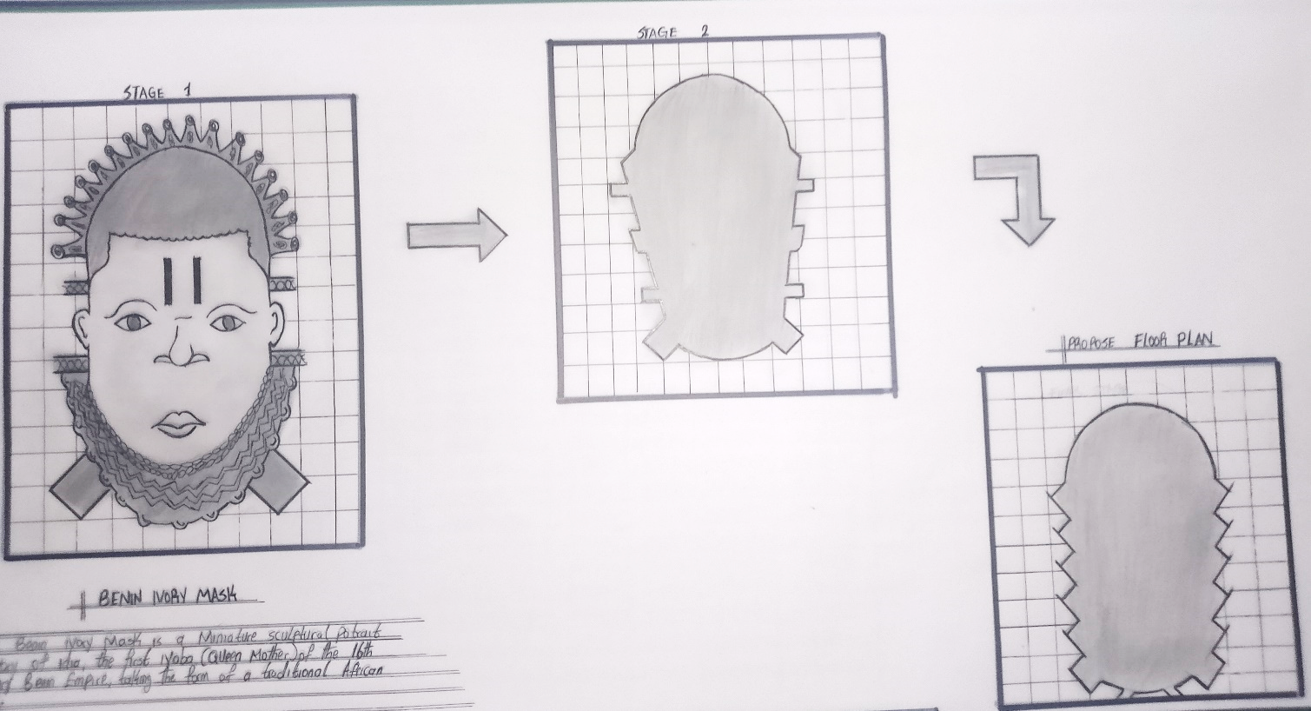
CONCEPT DEPRIVATION

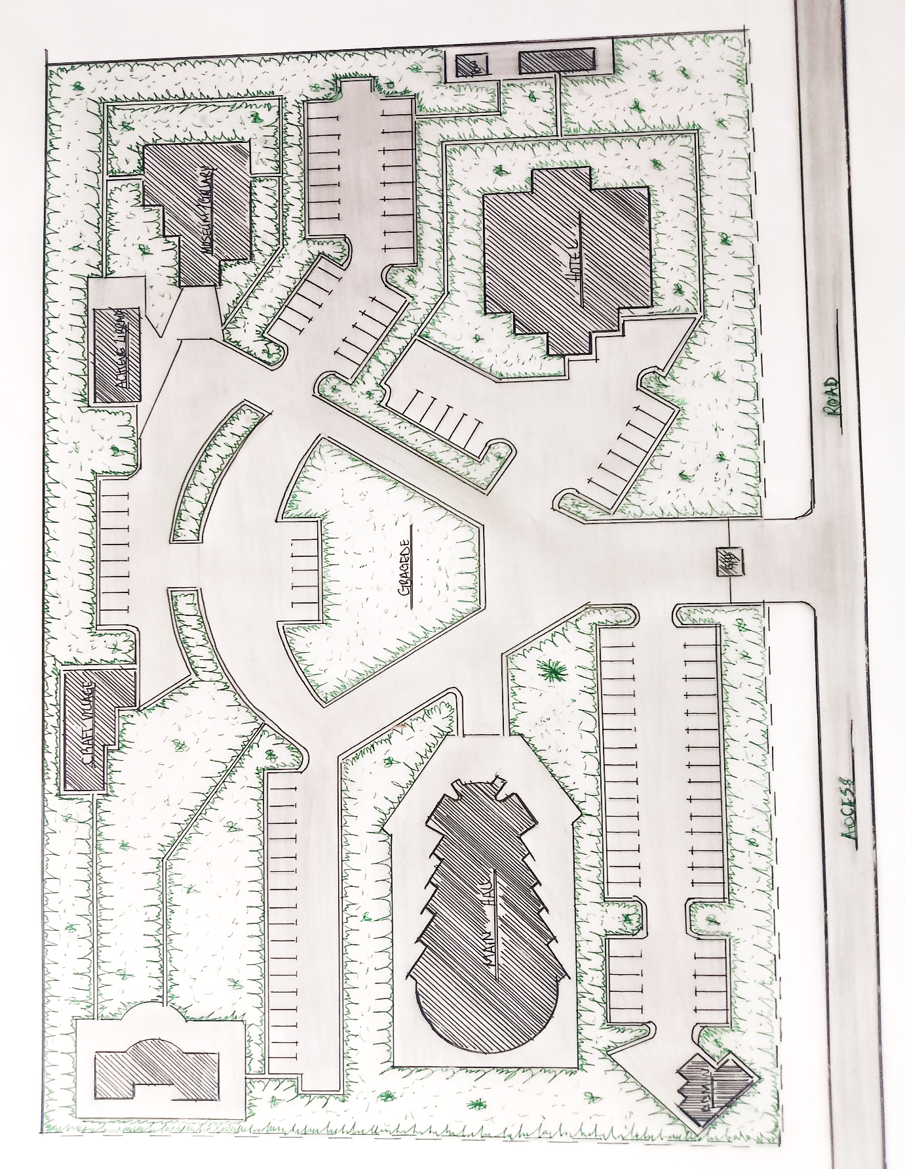
SITE PLAN
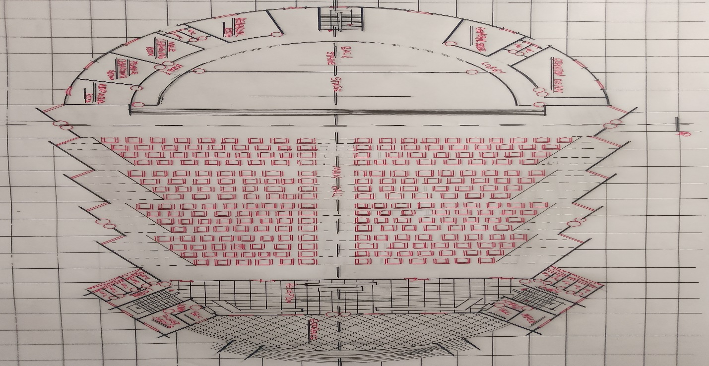
FLOOR PLAN
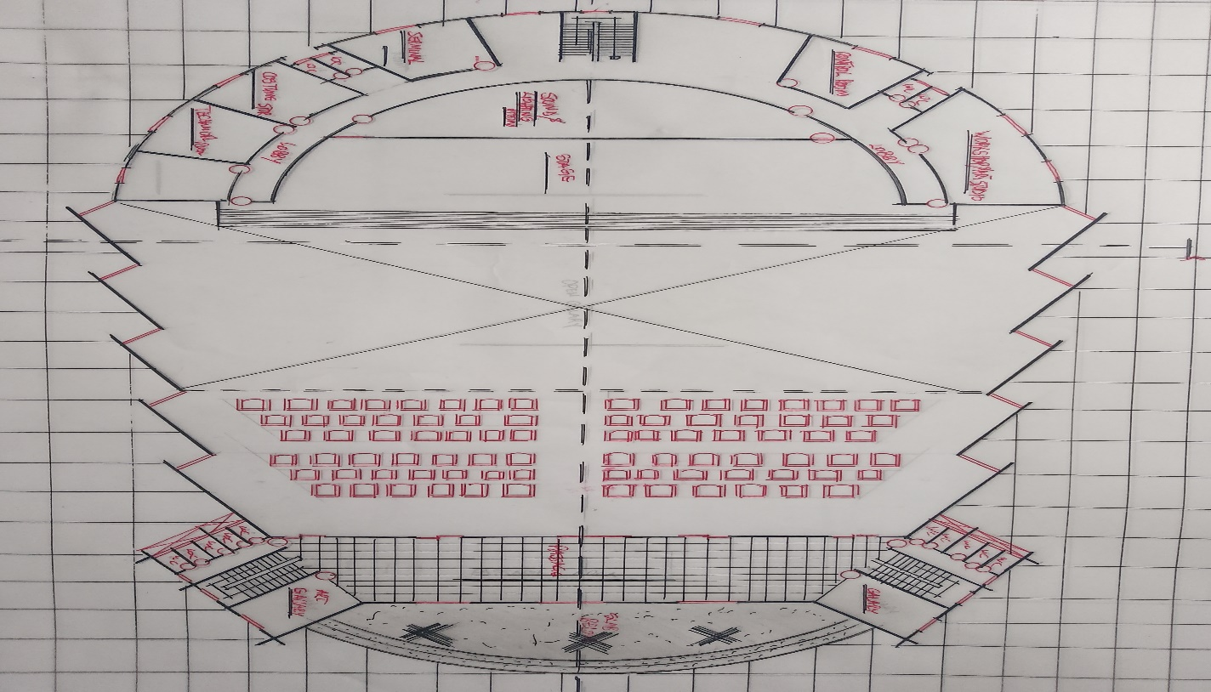
UPPER FLOOR
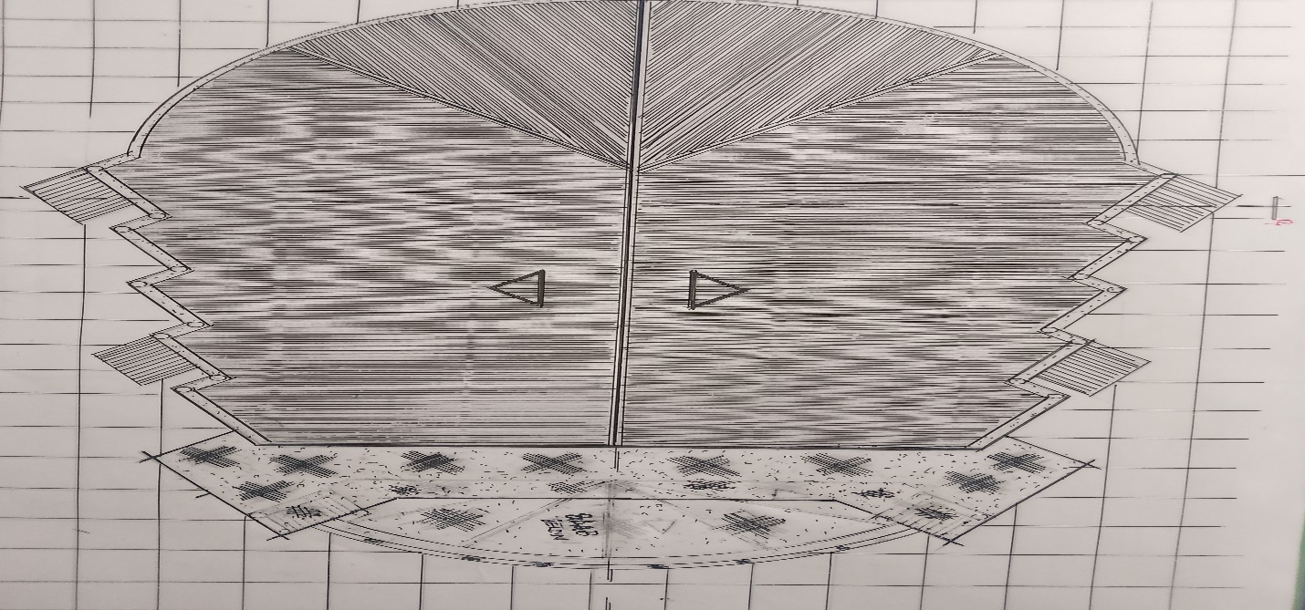
ROOF PLAN

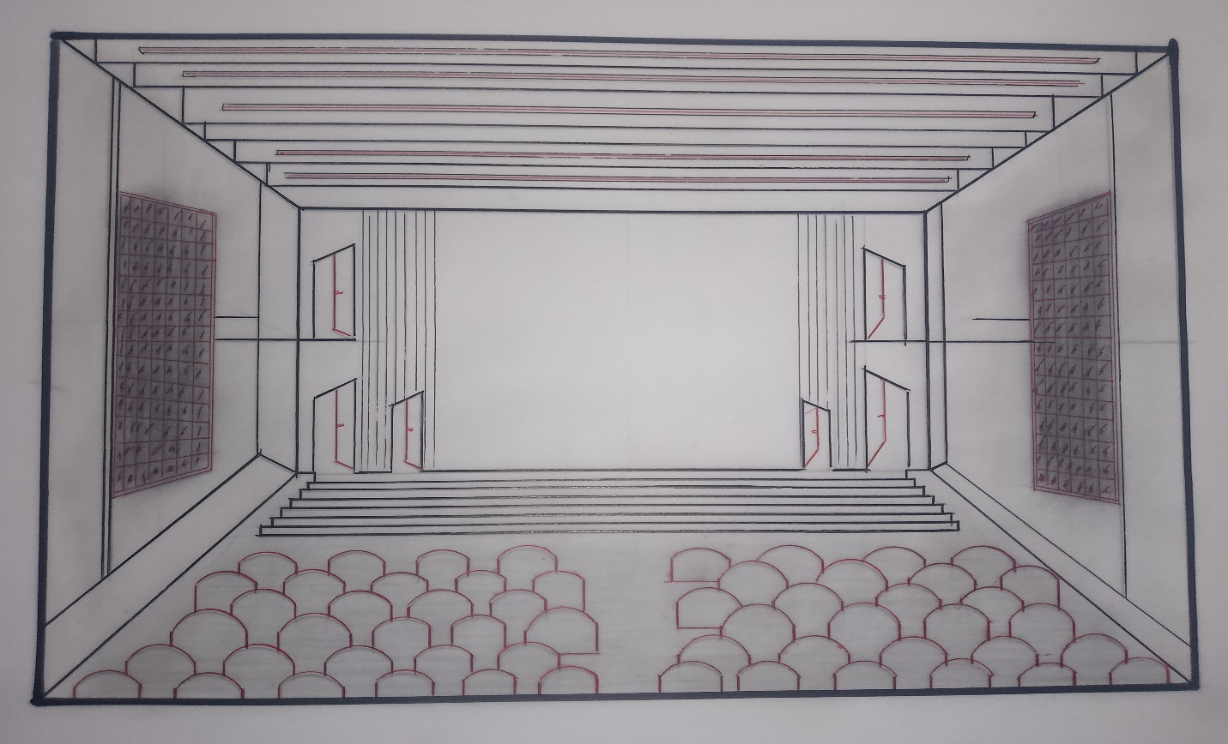
INTERNAL PERSPECTIVE

