DESIGN AND CONSTRUCTION OF 5KVA AUTOMATIC VOLTAGE REGULATOR

BY
ADEBAYO MAYOWA JOSHUA
HND/23/EEE/FT/0027

BEING A RESEARCH PROJECT SUBMITTED TO THE
DEPARTMENT OF ELECTRICAL-ELECTRONICS
ENGINEERING TECHNOLOGY, INSTITUTE OF TECHNOLOGY, KWARA STATE POLYTECHNIC, ILORIN.

IN PARTIAL FULFILLMENT OF THE REQUIREMENTS FOR THE AWARD OF HIGHER NATIONAL DIPLOMA (HND) IN
ELECTRICAL-ELECTRONICS ENGINEERING TECHNOLOGY.

JULY, 2025

CERTIFICATION
I certify that this project was carried out by ADEBAYO MAYOWA JOSHUA with matriculation number
HND/23/EEE/FT/0027 as meeting the requirement for the award of Higher National Diploma in the department of Electrical Electronics Engineering Technology, Kwara State Polytechnic,
Ilorin.

__________________________ _______________
ENGR. ABDULLAHI KUDIRAT Date

Project Supervisor

____________________________ _______________
ENGR. Z.A ABDULKADRI Date

Project Co-ordinator

___________________________ _______________
ENGR. DR A.O LAWAL Date
Head of Department

_________________________ _______________

External Supervisor Date

DEDICATION

I DEDICATE THIS PROJECT TO GOD ALMIGHTY THE SOURCE OF WISDOM, BLESSINGS, STRENGHT AND INSPIRATION, I HUMBLY DEDICATE THIS PROJECT.

ACKNOWLEDGMENTS

I would like to express my deepest gratitude to God Almighty,For His divine guidance, wisdom, and blessings throughout this programme and the project.

my profound gratitude also goes to my supervisor , ENGR K.A ABDULLAHI for her careful guidance and word of encouragement throughout the period of work and my Adviser ENGR S.A DADA for his useful advise and fatherly role throughout.

And also my acknowledgment is not complete without due regards to my Family For their unwavering support, love, and encouragement, and to my bro ENGR SHEUQUADRI For his help, advice, and motivation.

Thank you all for being a source of strength.

ABSTRACT

This project focuses on the design and construction of a 5KVA Automatic Voltage Regulator (AVR) aimed at providing a stable output voltage despite
fluctuations from the power supply. Voltage instability is a common issue in residential, commercial, and industrial environments in Nigeria, often leading to damage or reduced efficiency of electrical appliances. The proposed AVR helps eliminate these problems by automatically correcting under-voltage and over-voltage conditions.
The system consists of major sections including the voltage sensing unit, control circuit using a microcontroller, switching mechanism using relays, and an autotransformer for voltage correction. When the input voltage deviates from the acceptable range, the microcontroller detects the anomaly and activates the appropriate relay to adjust the transformer tapping, ensuring the output remains close to 220V AC.
Construction materials include diodes, capacitors, resistors, relays, autotransformer, voltage regulator ICs (e.g., LM7805), ATmega328 microcontroller, and an LCD for voltage display. Upon testing, the AVR system responded quickly to voltage changes and successfully stabilized the output across different input conditions, proving the functionality of the design.
In conclusion, this project offers a practical solution to voltage instability problems, providing improved safety and performance for sensitive electrical appliances, especially in regions with erratic power supply.

TABLE OF CONTENTS

Title Page i Certification ii
Dedication iii
Acknowledgments iv
Abstract v
Table of Contents v i

CHAPTER ONE: INTRODUCTION
1.1 Background to the study 1
1.2 Statement of the Problem 4
1.3 Objectives of the Study 5
1.4 Research Questions 5
1.5 Research hypothesis 5
1.6 Significance of the study 6
1.7 Scope of the study 6
1.8 Limitation of the study 7
1.9 Operational Definition of Terms 7
CHAPTER TWO: LITERATURE REVIEW
2.1 Conceptual Framework 9
2.2 Theoretical Framework 24
2.3 Empirical Review 27
CHAPTER THREE: RESEARCH METHODOLOGY
3.0 Introduction 28
3.1 Research Design 28
3.2 Population of the study 28
3.3 Sample size and sampling technique 28
3.4 Instrumentation for data collection 29
3.5 Reliability of instrument 30
3.6 Validity of instrument 30
3.7 Method of data collection 30
CHAPTER FOUR: DATA PRESENTATION AND ANALYSIS
4.1 Introduction 31
4.2 Analysis of research Question 37
4.3 Discussion of findings 38

CHAPTER FIVE: SUMMARY, CONCLUSION AND RECOMMENDATIONS
5.1 Summary 41
5.2 Conclusion 42
5.3 Recommendations 42
References 44
Appendix 46

CHAPTER ONE

1.0 INTRODUCTION
In Nigeria and many other parts of the world today, voltage regulation is a critical aspect of electrical power systems. It ensures that the voltage supplied to electrical appliances remains within an acceptable range. The importance of voltage regulation cannot be overstated because voltage fluctuations can damage electrical equipment, leading to inefficiency, malfunction, or even total failure.
Over the years, the demand for reliable and stable voltage has increased, especially with the growing use of sensitive electronic devices in industries such as manufacturing, healthcare, and telecommunications. These devices can easily get damaged by unstable power supply, which makes voltage regulation more important than ever.
An Automatic Voltage Regulator (AVR), commonly known as a stabilizer, is a control device designed to maintain a nearly constant output voltage, even when the input voltage varies. For instance, when the supply voltage drops as low as 90V, the AVR can boost it back up to 230V to protect connected devices from damage caused by under-voltage or over-voltage conditions.

1.1 BACKGROUND OF THE PROJECT
The development of AVRs has advanced over the years with the integration of modern technologies such as microcontrollers, power electronics, and smart control systems. These improvements have made AVRs more efficient, compact, and reliable.
There are several types of AVRs, including electromechanical tap changers and solid-state tap changers. AVRs were not just created through planned innovation but also as a response to frequent electrical problems, especially in regions with unstable power supply. Unlike developed countries like the United States, Germany, and the UK—where voltage variation is minimal— developing countries face voltage instability more often.
According to K.G. Jackson and R. Feinberg, an Automatic Voltage Regulator is a device used in electrical systems to maintain a stable output voltage from a fluctuating power supply. This project focuses on constructing a functional AVR that incorporates several electronic components to ensure stable and reliable voltage delivery.

1.2 AIM AND OBJECTIVES OF THE PROJECT
The main aim of this project is to maintain a stable voltage level to ensure a constant power supply that protects home appliances and electrical systems. The key objectives include:
- To step up or step down voltage when the supply is faulty.
- To prolong the life span of electronic appliances at home and in workplaces.
- To provide filtered, safe current for electronic components.
- To design a system that can automatically adjust and regulate voltage without human input.
- To reduce the risks and damages caused by unstable electricity.

1.3 SIGNIFICANCE OF THE PROJECT
This project is important because it provides a practical solution to the common problem of voltage instability. AVRs are essential in ensuring that electrical and electronic devices function effectively and safely. They:

- Prevent over-voltage and under-voltage from damaging appliances.
- Help maintain constant voltage levels in homes and offices.
- Are widely applicable in power plants, hospitals, and industries.
- Come in various sizes and designs, suitable for different applications.

1.4 SCOPE OF THE PROJECT
This project covers the design and construction of a 5KVA Automatic Voltage Regulator. It involves the use of components such as transformers, relays, voltage sensors, and a microcontroller to ensure stable output voltage. The AVR will be designed to accept a minimum input voltage of 100V and output a stable 220–230V to protect appliances.
The system will be tested under different voltage conditions to ensure it responds correctly and regulates voltage effectively.

1.5 LIMITATIONS OF THE PROJECT
- The AVR is designed to operate within specific voltage and frequency ranges.
- If input voltage goes beyond the set limits, the system may shut down temporarily.
- The system requires some manual restart in certain fault conditions.
- The system is rated at 5KVA and may not handle higher loads.
- It uses convection or fan cooling for temperature regulation.
- Complex overload or short-circuit protection may not be included.

1.6 PURPOSE OF THE PROJECT
The purpose of this project is to provide a stable voltage supply to prevent damage to electrical appliances and to ensure their optimal performance, especially in areas where voltage fluctuation is common.

1.7 PROBLEM STATEMENT
In many homes and workplaces, electronic appliances often get damaged due to poor voltage supply. Devices without built-in transformers, like chargers and some LED lights, are the most affected. This project aims to solve that problem by designing an AVR that adjusts and regulates voltage automatically, protecting appliances from harm.

1.8 APPLICATIONS OF THE PROJECT
AVRs are used in various sectors and devices, such as:
- Homes and offices
- Hospitals and laboratories
- Industrial machines and control systems
- Telecommunication systems
- Elevators, computer servers, and data centers
- Schools, research centers, and construction sites

1.9 DEFINITION OF TERMS
- AVR – Automatic Voltage Regulator
- KVA – Kilo Volt-Amps, a unit of apparent power
- HV – High Voltage, over 650V
- Winding – Copper wire used in transformers
- Surge – A sudden increase in voltage
- Brownout – A drop in voltage that may affect performance
- Blackout – Complete loss of power
- Load – Electrical devices connected to a power supply
- Watts – Measurement of real power
- Standby Power – Power available for backup usage
- Base Load – Constant load required over a period
- Single Phase Power – A type of AC power distribution CHAPTER TWO

LITERATURE REVIEW
This chapter reviews previous studies and information related to voltage regulation and automatic voltage regulators (AVRs). It covers the concept of voltage regulation, how AVRs work, the different types available, and how they are used in practical situations. The aim is to understand what has been done before, identify the strengths and weaknesses of existing systems, and show how this project fits into the broader development of voltage regulation technology.
Voltage regulation is the process of maintaining a constant output voltage level despite variations in the input voltage or load conditions. This is a crucial aspect of electrical and electronic systems, especially in regions where power supply is unstable or experiences frequent fluctuations. The primary objective of voltage regulation is to ensure that sensitive electronic devices and household appliances operate within their rated voltage range to avoid malfunctions or damage.
In electrical systems, voltage regulation can be performed manually or automatically. However, with advancements in technology and the increasing demand for reliable power supply, automatic voltage regulation has become the standard solution. An Automatic Voltage Regulator (AVR) is designed to detect voltage irregularities and adjust the output voltage accordingly without human intervention.
Effective voltage regulation helps in:
Protecting appliances from under-voltage and over-voltage conditions.
Enhancing the lifespan of electrical devices.
Improving system reliability and performance.
Reducing maintenance and replacement costs of appliances.
We need to understand the methods through which voltages can be stabilized by regulating the supply coming from the mains. This stabilization should be automatic, enabling the system to switch ON or OFF to protect household appliances from damage.
In the past, the use of voltage regulators was scarce and not as common as it is today due to a more stable supply distribution system. However, with the world’s population increasing, the demand for electricity has also surged. This high demand leads to overloading of distribution transformers, causing voltage variations. Such variations can damage electrical equipment.
To prevent damage caused by voltage fluctuations, a means was devised by Thomas Alva Edison in 1879 to stabilize voltage by controlling and limiting over-voltage and under-voltage that enters a device. This method ensures a stable electrical output, thus prolonging the lifespan of appliances.
Today, voltage regulators are available in both domestic and industrial forms, varying depending on the size and capacity required for protection.
An Automatic Voltage Regulator (AVR) is designed to maintain a constant output voltage within a specified range, whether in distribution feeders or household equipment, regardless of fluctuations in supply voltage or load current.
Voltage regulators are often built into household appliances to provide a consistent output voltage, protecting the appliance from input variations.
Typically, the voltage regulator is connected to a socket, and its regulated output serves as the input for the household device.
CONTROL CIRCUIT ANALYSIS

2.1.1 RECTIFICATION AND FILTRATION STAGE
The auto-transformer is powered by a 220V supply and tapped at 12V from the center circuit.
RECTIFICATION
Rectification is the process of converting alternating current (AC) to direct current (DC). In this project, a full-wave bridge rectification method was used, which consists of four diodes.
The reduced 12V from the auto-transformer is connected to the full-wave bridge rectifier to convert AC supply to DC voltage through diodes D1-D4.
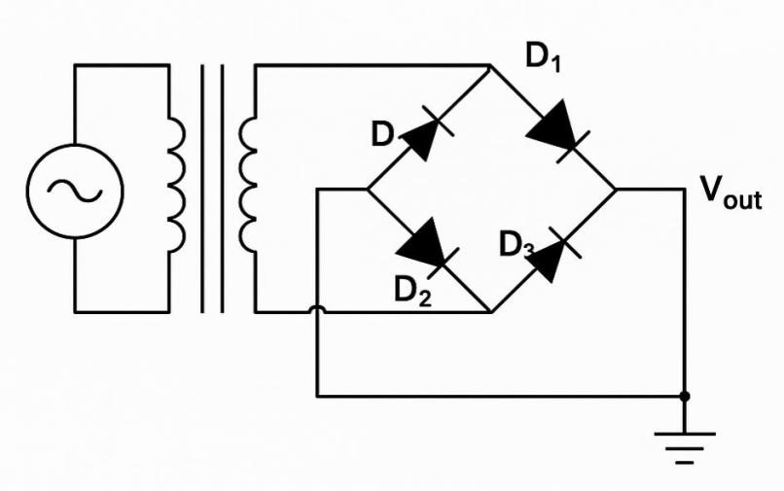
Full Wave Rectification Diagram

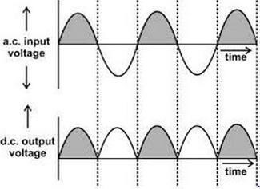

Full Wave Rectification Graph

2.1.2 FILTRATION
Filtration involves removing ripples remaining after rectification. This process is accomplished using an electrolytic capacitor (1000µF, 50V) to smooth the output voltage and prevent damage to electronic components.
The filter capacitor is connected across the output terminals of the rectifier. A voltage regulator (LM 7805) is then used to regulate the rectified 12V to 5V before it is supplied to the microcontroller (ATmega328P).
The operational amplifier in the control circuit works with the non-inverting input so that the comparator output remains high. This output automatically controls the switching stage of the circuit.

2.1.3 SWITCHING STAGE
This is the automation unit, and it is implemented using a transistor (13003) and relays for switching operations. When the comparator output is high, it forward-biases the base of the transistor, turning it ON.
Once the transistor reaches saturation, current flows through its collector, energizing the relay coil. This causes the output terminal of the stabilizer to become active.
The relays operate depending on the voltage value from the main supply, working in conjunction with the comparator stage to maintain a constant output of 220V.
Relay contacts are normally open but close whenever the relay coil is energized, thereby delivering a stable output voltage.
The 13003 transistor can be used in high-voltage applications like inverters, UPS systems, battery chargers, and motor controllers. It is also useful in low-voltage and battery-operated projects. In this AVR project, it amplifies voltage to 12V.

CHAPTER THREE
3.0 METHODOLOGY / MATERIALS USED, FUNCTIONS, AND DESIGN

SPECIFICATIONS

3.1 INTRODUCTION
This chapter discusses the design and implementation of the 5KVA Automatic Voltage Regulator (AVR). It includes the block diagram, system description, components used, circuit diagram, working principle, programming logic, and PCB layout. The AVR is designed to monitor and regulate voltage levels automatically to ensure stable power supply within safe limits.

3.2 BLOCK DIAGRAM OF THE SYSTEM The system consists of the following major
blocks:
- Power supply input (150V – 240V)
- Auto transformer
- Rectifier
- Voltage regulator
- Comparator
- Microcontroller unit
- Relay switching unit
- Amplifier
- Output stage
- Voltage monitoring display
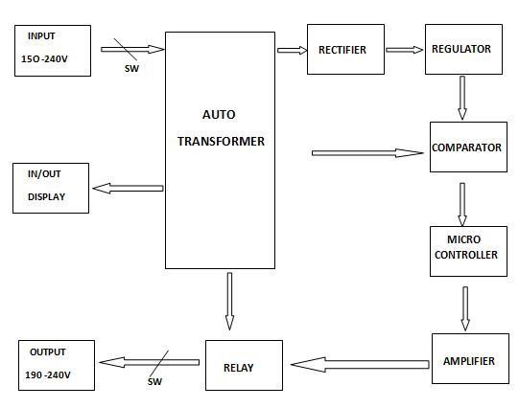

3.3 SYSTEM DESCRIPTION
The AVR system operates by sensing the input voltage using a voltage divider circuit and converting it to a readable DC voltage via a rectifier and voltage regulator. This voltage is fed to a comparator and then into the microcontroller. The microcontroller makes decisions based on programmed thresholds and controls the relay switching to select the appropriate winding on the auto-transformer. An amplifier circuit is used to boost the control signals if necessary. The output voltage is monitored and displayed.

3.1 DESCRIPTION OF COMPONENTS USED AND THERE FUNCTIONS
The electronic components used in the design and connection of the 5KVA Automatic Voltage Regulator include diodes, resistors, transistors, integrated circuits (ICs), a liquid crystal display
(LCD), and power instruments such as auto transformer and essential components like Relay, Rectifier, Voltage Regulator, Comparator, Microcontroller, Amplifier, Voltage Divider, Display.

MAJOR COMPONENTS

3.1.1 Auto Transformer
A An auto-transformer is used in this project to step up or step down the AC voltage depending on the variation in the mains supply. It has multiple taps that allow the system to correct voltage irregularities automatically. The microcontroller, through the relay system, selects appropriate taps to achieve a stable The diagram of Auto transformer is shown below in fig 3.1
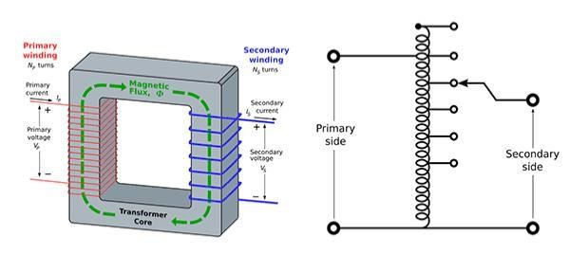

Fig 3.0: Auto Transformer
3.1.2 Rectifier
A rectifier circuit (usually a bridge rectifier) is used to convert AC voltage from the transformer into DC voltage. This DC voltage is essential for powering the microcontroller, voltage comparator, and other control circuitry. The diagram is shown below in fig 3.1.

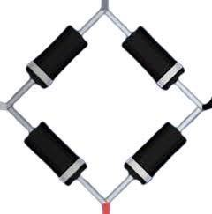
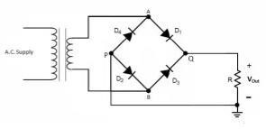
Fig 3.1: Bridge Rectifier
3.1.3 Comparator ( LM324)
The voltage comparator is responsible for monitoring the input voltage and comparing it with a set reference value. If the voltage falls below or exceeds certain thresholds, the comparator outputs a logic signal to alert the microcontroller. This helps the system decide when to adjust the voltage via relay switching. The diagram is shown below in fig 3.2
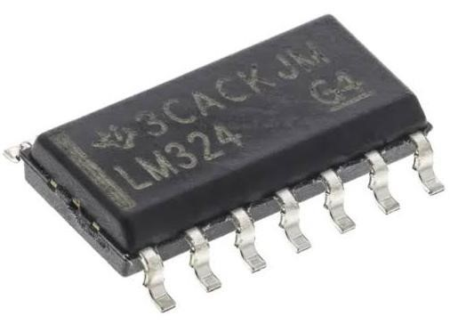
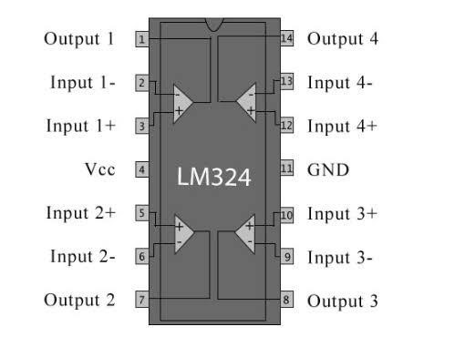
Fig.3.2 Comparator

3.1.4 The ATMEGA328P-PN (Microcontroller)
ATMEGA329P-PN is a versatile 8-bit microcontroller commonly found in Arduino boards. It has a 20MHz clock speed, 32KB flash memory, and features like UART, SPI, timers, ADC, and watchdog. It is used in this project to process and control input voltage readings and relay switching. The diagram is shown below in fig 3.3.
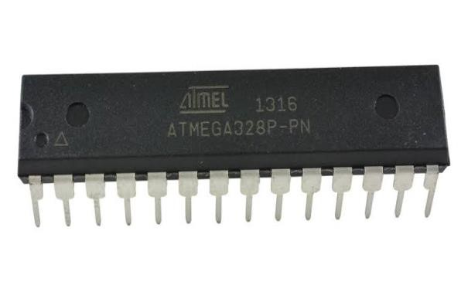

Fig.3.3:ATMEGA328P-PN ( MICROCONTROLLER)

3.1.5 Amplifier
Amplifier are used In cases where the control signal from the microcontroller is not strong enough to drive the relay coil, an amplifier circuit is used. Typically implemented using transistors or operational amplifiers, to strengthens the signal to ensure proper relay actuation.
The circuit diagram is shown below in fig 3.4.
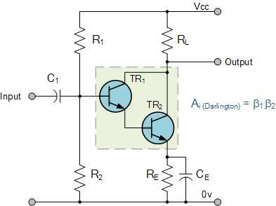

Fig.3.4: circuit diagram of an amplifier

3.1.6 Voltage Divider
The voltage divider circuit scales down the high AC input voltage to a lower, measurable level suitable for the ADC of the microcontroller. This allows the microcontroller to accurately monitor the input voltage without damage. The diagram is shown below in fig 3.5
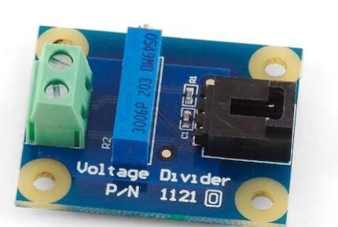
Fig3.5: Voltage divider
3.1.7. Voltage Regulator (LM7805)
The LM7805 is a three-terminal linear voltage regulator IC that outputs a fixed 5V. It is widely used in applications requiring a regulated 5V power supply. In our project The 7805 regulator provides a stable 5V DC supply for the microcontroller and other logic-level components. This regulated voltage is crucial for consistent performance of the control circuit. The diagram is shown below in fig 3.6.
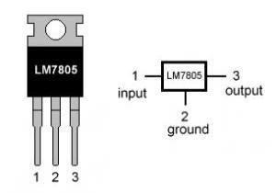
Fig 3.6: Voltage Regulator (LM7805)
3.1.8 Relay
A relay is an electrically operated switch that uses electromagnetic induction. It contains a coil and contacts (normally open or closed). When current flows through the coil, it magnetizes and actuates the contacts, enabling circuit switching in our project relay acts as an electrical switch, controlling current flow. It monitors voltage levels and switches between transformer taps or circuits to adjust output voltage, maintaining stability. Relays ensure the stabilizer provides consistent and reliable output voltage. The diagram of a relay is shown below in fig 3.7
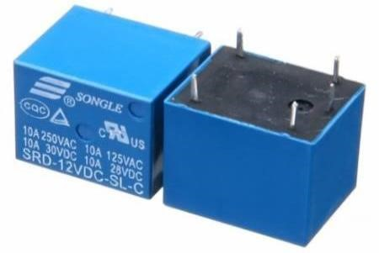
Fig 3.7: Relay
3.1.9 Liquid Crystal Display (LCD)
An LCD is a flat-panel display technology commonly used in electronic devices. In this project, it is used to display input voltage, output voltage, and system status. This provides user-friendly monitoring and troubleshooting during operation. The diagram is shown below in fig 3.8
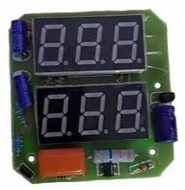
Fig 3.8: Liquid Crystal Display ( LCD)

SUPPORTING DISCRETE COMPONENTS
3.2.0 Capacitor
A capacitor stores electrical charge and energy. It consists of two conductors (capacitor plates) separated by a dielectric material. Capacitors are used in this project to filter out ripples from the rectified DC voltage, providing a steady output current.
Q ∝ V ⇒ Q = CV Where:
C = Capacitance (Farads),
Q = Charge (Coulombs),
V = Voltage (Volts)
The diagram of the capacitor is shown below in fig 3.2
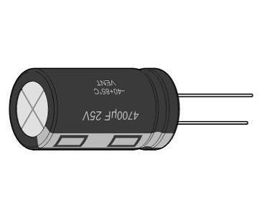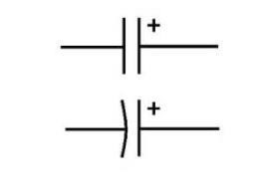
Fig 3.2: capacitor

3.1.3 Resistor
A resistor is a passive two-terminal component that resists the flow of electric current. In this project, resistors are used to limit current, divide voltage, and provide feedback to improve comparator stability. They are available as fixed or variable types. The diagram of resistors are shown below in fig 3.3
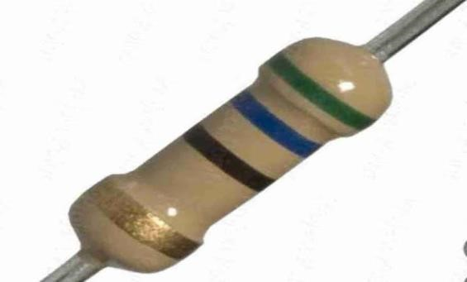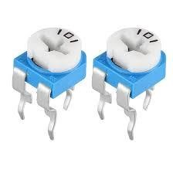
Fig 3.3: a fixed and variable resistor
3.1.4 Diode
A diode is a two-terminal semiconductor device that allows current to flow in only one direction. It is primarily used for rectification, converting AC voltage to DC in either half-wave or fullwave bridge configurations . The diagram of a diode is shown below in fig 3.4
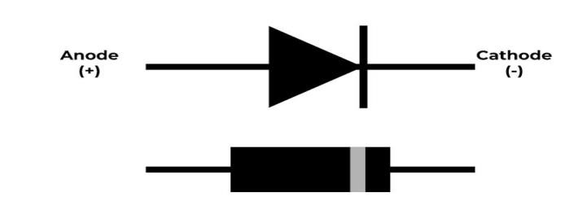

Fig 3.4: Diode
3.1.5 Zener Diode
A Zener diode allows current to flow in the forward and reverse directions. It is heavily doped and conducts in reverse once a specific breakdown voltage is reached. It is commonly used for voltage regulation due to its stable reverse breakdown characteristics. The diagram of a zener diode is shown below in fig 3.5.
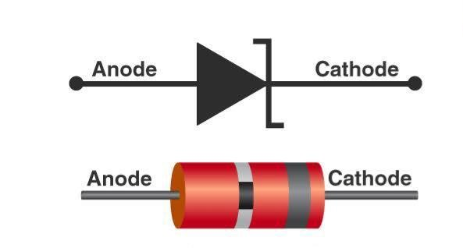
Fig 3.5: zener Diode
3.1.6 Integrated Circuit (IC)
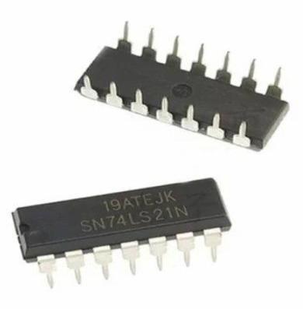
An IC is a compact device consisting of interconnected resistors, transistors, and capacitors embedded into a chip. In this project, it functions as a comparator with high gain, wide bandwidth, and temperature stability.

The diagram is shown below in fig 3.6.
Fig 3.6: Integrated circuit (IC)
3.1.8 Transistor
A transistor is a three-layer semiconductor device with terminals named the base, collector, and emitter. It is used to amplify and switch electronic signals. This project uses NPN transistors for amplifying signals and switching relays. The diagram is shown below in fig 3.8.
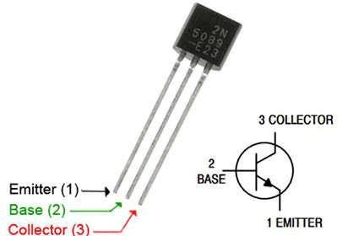

Fig 3.8: NPN Transistor
3.1.9 Light Emitting Diode (LED)
An LED is a P-N junction that emits light when forward biased. During recombination of electrons and holes, energy is released in the form of light. LEDs are used for visual indicators in this project. The diagram is shown below in fig 3.9.
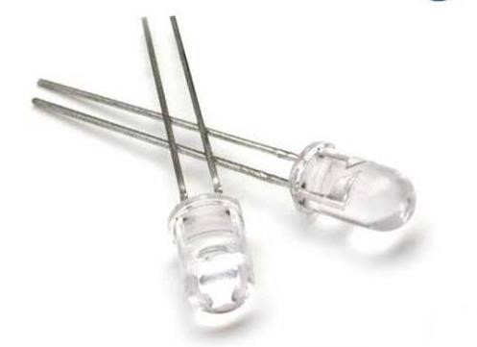

Fig 3.9: Light Emitting Diode ( LED)
3.2.3 Fuse
A fuse is a safety device that protects the circuit from excessive current by melting and breaking the circuit when current exceeds a rated limit. It prevents damage to sensitive components in case of faults like short circuits or overloading. The diagram is shown below in fig 4.3

Fig 4.3:. Fuse

3.2.4 Voltage Sensor Module
This module detects and measures AC voltage and sends the data to the microcontroller for analysis. It plays a key role in monitoring voltage levels and allows the microcontroller to make decisions about relay switching for voltage regulation the diagram is shown below in fig 4.4.
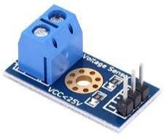
Fig 4.4: Voltage Sensor Module

3,3. CIRCUIT DIAGRAM OF 5KVA AUTOMATIC VOLTAGE REGULATOR

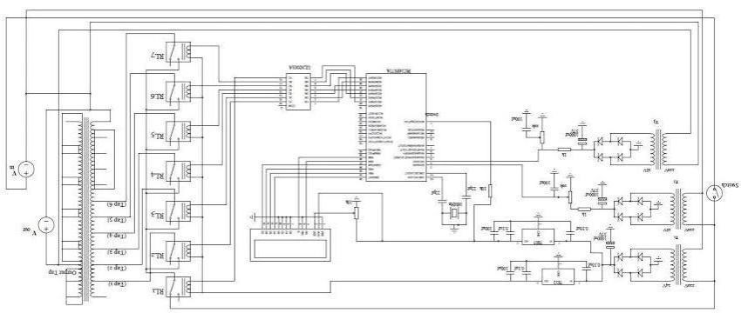

3.6 WORKING PRINCIPLE
When the input voltage is applied, the voltage divider scales it down, and the rectifier converts it to DC. This is regulated and sent to a comparator which checks against a reference voltage. The comparator’s output goes into the microcontroller, which decides whether to switch the relay to increase, decrease or maintain the voltage. The selected tap on the auto transformer then feeds the corrected voltage to the output. The current output is displayed on the screen.

3.7 MICROCONTROLLER PROGRAMMING LOGIC
- Read the scaled input voltage from ADC.
- Compare with defined thresholds (e.g., <180V = low, 180–230V = normal, >230V = high).
- Decide action
If voltage < 180V, activate relay to increase tap.
If voltage > 230V, activate relay to decrease tap.
If voltage in normal range, maintain current tap.
- Update the display with current output voltage.

3.8 Microcontroller Programming Logic Flowchart
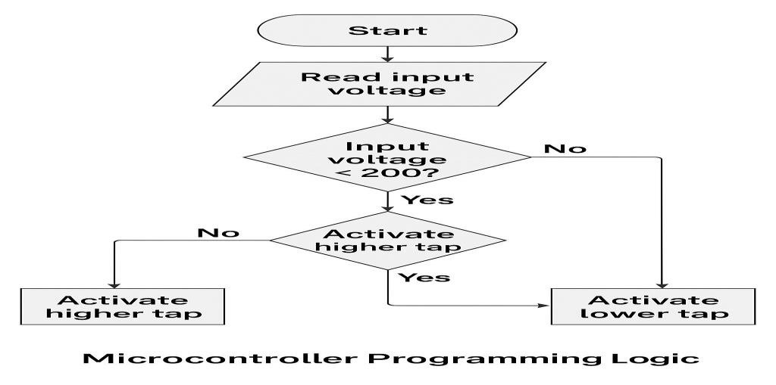

3.3DESIGN SPECIFICATIONS
Typical design specs for our project:
Power Rating: 5KVA
Input Voltage Range: e.g., 140V – 260V AC
Output Voltage: 220V ±5%
Frequency: 50Hz
Correction Time: ≤ 2 seconds
Number of Taps: e.g., 3 or 4 transformer taps
Microcontroller: ATmega328 (or the one you’re using)
Voltage Sensing Accuracy: ±1%
Control Method: Relay-based or triac-based tap switching
Cooling: Natural air cooling or fan assisted
Protection Features: Overvoltage, undervoltage, surge, short circuit, delay timer

3.2 THEORY
This part explains the working principles behind each part of our project
Transformer working principles (auto-transformer)
AC to DC conversion (rectifier theory)
Voltage regulation using feedback and microcontrollers
Relay switching and electromagnetic control
Voltage comparison using op-amps
How microcontrollers sense, process, and control outputs
Use of voltage dividers for ADC input
CHAPTER FOUR

4 .0 SYSTEM IMPLEMENTATION, TESTING AND RESULTS

4.1 INTRODUCTION
This chapter provides a comprehensive explanation of the implementation, testing, and evaluation of the designed 5KVA Automatic Voltage Regulator (AVR). It covers the step-by-step process of constructing the system, loading and testing the microcontroller program, troubleshooting, and validating the results obtained from the project. The performance is evaluated based on voltage correction response, output stability, and general functionality.

4.2 CONSTRUCTION PROCEDURES
The construction process was carried out in the following stages:
1.Breadboard Testing:
All individual components and sub-circuits such as the voltage divider, rectifier, regulator, and display were first assembled and tested on a breadboard. This ensured that each module functioned correctly before final integration.
2.Schematic Design:
A full circuit schematic was designed based on the finalized working concept. The schematic included the transformer, bridge rectifier, filter capacitors, voltage regulator (7805), comparator section using LM324, relay drivers, microcontroller (ATmega328), and output display.
3.PCB Design and Etching:
A Printed Circuit Board (PCB) was designed using Proteus software and the layout was printed on a glossy sheet. The board was etched using ferric chloride solution. After cleaning and drilling, components were soldered onto the board.
4.Enclosure and Wiring:
After the PCB was tested and confirmed working, it was placed in a plastic enclosure. The transformer, power input/output terminals, relays, and the display module were also connected with proper wiring and insulation.

1.4 SOFTWARE IMPLEMENTATION
Program Logic: The microcontroller (ATmega328) was programmed using embedded C through Arduino IDE. The logic was developed based on real-time voltage monitoring and decisionmaking to trigger relays for voltage correction.
The ADC in the microcontroller reads input voltage via a voltage divider.
If the voltage is below a set threshold, the microcontroller switches to a higher tap using a relay.
If the voltage is above a set threshold, the microcontroller switches to a lower tap.
The output voltage is displayed via an LCD or analog voltmeter.
The code was compiled and uploaded to the ATmega328 using an Arduino Uno as ISP.

1.3 TESTING AND TROUBLESHOOTING
After completing construction and programming, the device was tested to ensure it met all functional requirements.
Testing Procedure:
An input voltage between 140V to 260V was applied.
The output was measured using a digital multimeter.
The switching action of relays was observed.
The display output was checked for correctness.
1.4 Troubleshooting:
Cold solder joints were reworked.
Resistor and diode polarities were verified.
Program logic was adjusted for better response.

4.5 RESULTS OBTAINED
Below are the observed results during the testing phase:
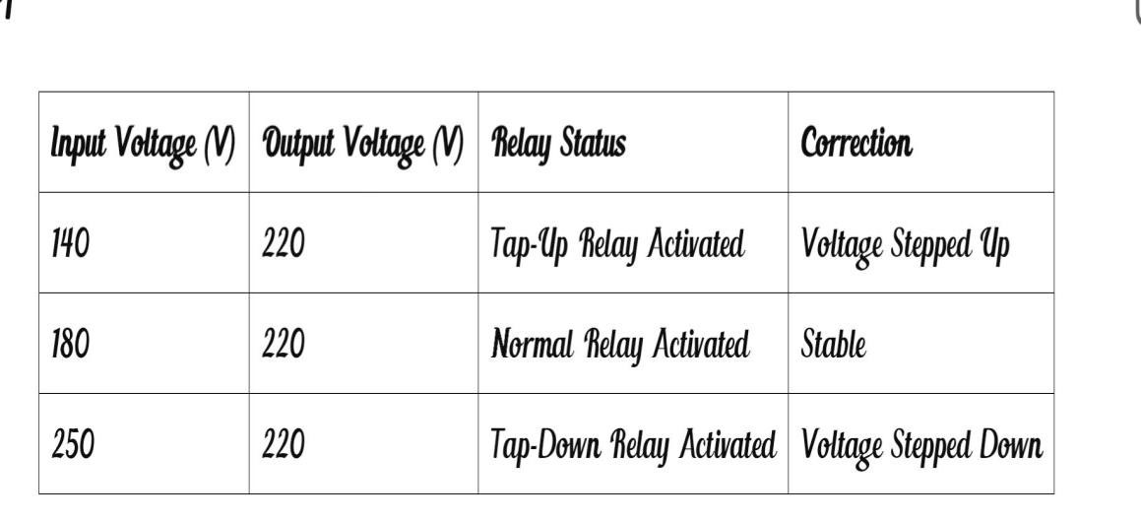
OBSERVATION:
The AVR was able to regulate voltage effectively within the range of 140V to 250V. The output voltage stayed within acceptable limits (±5% of 220V). The relay switching was smooth and the display showed accurate values.

1.3 Bill of Engineering Measurement and Evaluation (BEME)
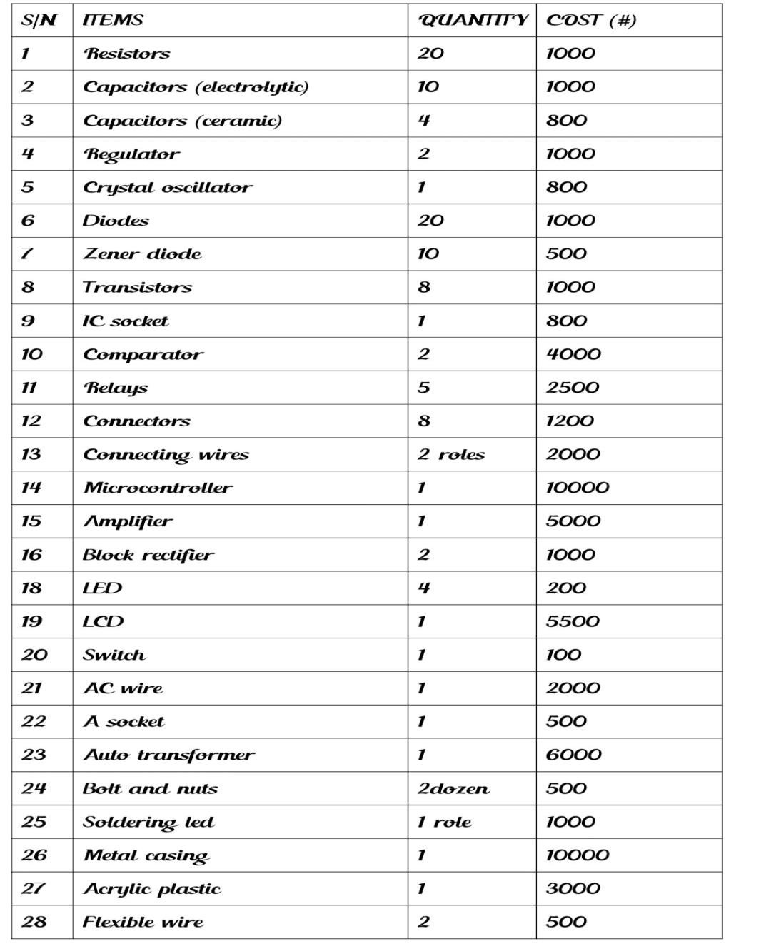
Workmanship #40000

TOTAL #102900

4.7 CHALLENGES ENCOUNTERED
Difficulty sourcing original ATmega328 microcontroller.
Initial code bugs causing relay malfunction.
Heat dissipation in the relay switching section.
Physical space constraint in enclosure mounting.

1.4 SUMMARY
This chapter detailed the practical implementation of the 5KVA Automatic Voltage Regulator, from construction to programming and testing. The system performed effectively during tests, providing consistent voltage regulation and stable output. Despite minor challenges, the project achieved its desired objective.

CHAPTER FIVE

5.0 SUMMARY
This project focused on the design and construction of a 5KVA Automatic Voltage Regulator (AVR) capable of stabilizing voltage supply to electrical appliances. The AVR was designed to monitor and regulate input voltage variations using a microcontrollerbased control system. The system automatically detects under-voltage or over-voltage conditions and adjusts the output by switching between transformer taps via relays to maintain a steady output voltage.
The components used includeincludee a microcontroller (ATmega328), voltage sensors, relays, auto transformer, rectifier, comparator, voltage divider, and display units. These were assembled on a PCB board with proper soldering and housed in a protective casing. The testing phase confirmed that the AVR consistently regulated voltage within safe operating limits.

5.2 CONCLUSION
From the successful design and implementation of the 5KVA Automatic Voltage Regulator, it is evident that the system effectively meets the desired objective of maintaining a stable voltage supply. The AVR automatically compensates for fluctuations in input voltage and protects electrical appliances from damage caused by over-voltage or under-voltage conditions. The use of a microcontroller enhanced the accuracy, response time, and decision-making ability of the system.
The analog or digital display also provides real-time monitoring for users, increasing the system’s usability. The success of this project has proven that incorporating embedded systems into power regulation can enhance performance and reliability in both domestic and industrial environments.

5.3 RECOMMENDATIONS
Based on the design and testing outcomes, the following recommendations are made:
- Use of High-Quality Components: For long-term use and durability, future versions should incorporate higher-grade components to withstand power surges and extreme environmental conditions.
- Enclosure and Cooling: Proper casing and improved ventilation should be prioritized to prevent overheating of sensitive components, especially the transformer and relays.
- Circuit Protection: Adding fuses, surge protectors, and overload protection circuits can further enhance safety.
- Microcontroller Programming: Continuous updates and optimization of the microcontroller code can improve switching speed and voltage sensing accuracy.

5.3 LIMITATIONS
Despite its effectiveness, the project has a few limitations:
The system currently handles only single-phase voltage regulation.
It lacks wireless remote control or data logging features.
Real-time monitoring is limited to local display only.

5.5 SUGGESTIONS FOR FUTURE IMPROVEMENTS
To improve the system’s performance and broaden its application, the following upgrades are suggested:
- Wireless Monitoring and Control: Integrating Wi-Fi or GSM modules for remote voltage monitoring and control using a mobile app or SMS.
- Data Logging and Alerts: Incorporating SD card storage or cloud logging to keep records of voltage conditions over time. Alerts via SMS or app in case of voltage abnormalities.
- Three-Phase Extension: Modify the design to regulate three-phase power supply systems commonly used in industrial applications.
- Auto Bypass Feature: A feature that allows the system to bypass regulation manually or automatically in emergency cases
- Touchscreen Display: Replacing the analog or basic digital display with a touchscreen interface for better user interaction.

REFERENCES
All About Circuits. (2023). Relays and Voltage Control. Retrieved from
https://www.allaboutcircuits.com
ATmega328P Microcontroller Datasheet. (2024). Retrieved from
https://www.microchip.com
Circuit Digest. (2023). Automatic Voltage Regulator Circuit Using Microcontroller. Retrieved from https://circuitdigest.com
ElProCus. (2022). Automatic Voltage Regulator Working Principle. Retrieved from https://www.elprocus.com
EngineersGarage. (2023). Working of Automatic Voltage Regulator using ATmega328.
Retrieved from https://www.engineersgarage.com
Floyd, T. L. (2012). Electronic Devices (9th Edition). Pearson Education.
Horowitz, P., & Hill, W. (2015). The Art of Electronics (3rd ed.). Cambridge University Press.
LM324 Operational Amplifier Datasheet. (2024). Retrieved from https://www.ti.com
Muhammad, A. M. (2011). The 8051 Microcontroller and Embedded Systems: Using Assembly and C (2nd ed.). Pearson Education.
Sedra, A. S., & Smith, K. C. (2015). Microelectronic Circuits (7th Edition). Oxford University Press.
Theraja, B. L., & Theraja, A. K. (2005). A Textbook of Electrical Technology (Vol. II). S. Chand & Company Ltd.
TutorialsPoint. (2023). Voltage Regulators – Electronics Tutorials. Retrieved from https://www.tutorialspoint.com/voltage-regulators7805 Voltage Regulator Datasheet. (2023). Retrieved from https://www.st.com

