
FABRICATION OF WELDING MAGNET

LAWAL RUKAYAT OPEYEMI ND/23/WEC/FT/0012

BEING A RESEARCH PROJECT SUBMITTED TO WELDING AND FABRICATION TECHNOLOGY, INSTITUTE OF TECHNOLOGY, KWARA STATE POLYTECHNIC, ILORIN.

IN PARTIAL FULFILMENT OF THE REQUIREMENT FOR THE AWARD OF NATIONAL DIPLOMA (ND) IN WELDING AND FABRICATION TECHNOLOGY.

Project Supervisor:
ENGINEER AYANTOLA A.A

DATE: 30/06/2025

KWARA STATE POLYTECHNIC, ILORIN
CERTIFICATION
DEPARTMENT OF WELDING AND FABRICATION TECHNOLOGY
This is to undersign certify that this project prepared by;

LAWAL RUKAYAT OPEYEMI ND/23/WEC/FT/0012. Entitled: “Fabrication of Welding Magnet” met the requirements of the Department of Welding and Fabrication Technology, for the award of National Diploma program in Welding and Fabrication Engineering.

………………………..……. ………………………….
ENGR. A. A. AYANTOLA DATE
Project Supervisor

……………………………..… ………………………….
ENGR. M. A. SALAHUDEEN DATE
Head of Department

……………………………..… ………………………….
ENGR. BELLO A. O. DATE
Project Coordinator

…………………………………... …………………….
ENGR.M.O AGAJA DATE
External Supervisor
DEDICATION
This project is dedicated to my beloved parents Mr and Mrs lawal whose unwavering support, sacrifices, and encouragement have been my greatest source of strength and inspiration.
I also dedicate this work to my instructors and mentors, who have guided me with patience and wisdom throughout my academic journey.
To all aspiring fabricators and welders, may this work serve as a stepping stone toward innovation in the field of welding technology.

ACKNOWLEDGMENT
First and foremost, I give thanks to Almighty God for granting me the strength, knowledge, and perseverance to complete this project successfully.
I would like to express my sincere gratitude to my project supervisor, Engineer ayantola abdulwaheed, for their invaluable guidance, constructive feedback, and continuous encouragement throughout the course of this work.
My appreciation also goes to the entire faculty and staff of the Department of welding and fabrication technology, especially the welding and fabrication laboratory team, for providing the tools, materials, and knowledge necessary to carry out this project.
Special thanks to my classmates and friends for their collaboration, support, and motivation. Your shared ideas and help during practical sessions were truly appreciated.
Finally, I extend heartfelt thanks to my family, whose belief in me has been my driving force. This achievement is as much theirs as it is mine.

ABSTRACT
The project titled "Fabrication of Welding Magnet" focuses on the design, construction, and testing of a magnetic tool that aids in holding metal components firmly during welding operations. Welding magnets are essential fixtures in modern fabrication workshops, as they enhance precision, safety, and efficiency by keeping work pieces in fixed positions—especially at specific angles such as 45°, 90°, and 135°. This project explores the principles of magnetism, material selection, and fabrication techniques required to produce a durable and reliable welding magnet. The process involves selecting suitable magnetic materials, designing a functional casing, and assembling the unit to meet desired strength and angle-holding capabilities. Additionally, the study evaluates the performance of the fabricated magnet through strength tests and practical welding scenarios. The overall objective is to provide a low-cost, locally fabricated alternative to imported welding magnets, thereby promoting innovation and practical skills in mechanical and fabrication engineering.

TABLE OF CONTENT
- Title Page
- Certification
- Dedication
- Acknowledgement
- Abstract
Table of content
Chapter One
1.0 Introduction
1.1 History of Welding
1.2 Application of Welding
1.3 Types of Welding Process
1.4 Welding Hand Tools
1.5 Requirements of Welding Tools
1.6 Welding Gig And It's Roles In Welding Alignment
1.7 Squaring Tools In Welding
1.8 Types of Welding
1.9 Impact of Welding Magnet In Welding For Manufacture
1.10 Problems Statement
1.11 Justification For The Project
1.12 Advantage And Disadvantage Of Using Welding Magnet
1.13 Scope of The Project
1.14 Types of squaring hand tools
1.15 Key features and benefit
1.17 Application
1.18 Selection criteria

Chapter Two
2.0 Analysis of types of squaring hand tools in welding
Chapter Three
3.0 Calculations
Chapter Four
4.0 Selection of Materials, Fabrication Details And Testing
4.1 Types of Materials Used For Making Welding Magnets
4.2 Properties of Materials Used For Making Welding Magnets.
4.3 Factor For Selecting Materials For Welding Magnets Fabrication
4.4 Sequence of Fabrication of The Welding Magnet
4.5 Testing of The Fabricated Welding Magnet
4.6 Observations
Chapter Five
5.0 Recommendation And Conclusion
5.1 Recommendation
5.2 Conclusion
5.3 Future work

CHAPTER ONE
1.0 Introduction to Fabrication of Wedding Magnet
Fabrication Wedding magnets are essential tools in welding and metalworking industries. They provide a secure hold on metal work pieces, ensuring accurate alignment and precise welding.
It also involves the design and production of magnetic tools specifically intended to aid in holding, aligning, and positioning metal work pieces during welding operations. These magnets are crafted to provide precision and stability while minimizing human intervention, allowing welders to focus on the welding process itself. The fabrication process combines knowledge of magnetism, material science, and manufacturing techniques to create magnets that are durable, efficient, and safe for use in high-temperature and industrial environments. [MDPI (2021)]

The key materials used in the fabrication of welding magnets are typically ferromagnetic metals like neodymium, iron, or rare earth alloys, chosen for their strong magnetic properties. The magnets are often encased in durable housing, such as steel or plastic, to protect the magnet from damage and to ensure that they can withstand the heat and mechanical stress commonly encountered in welding environments.

The fabrication process involves several stages, including the selection of appropriate magnetic materials, shaping and machining the magnets into useful forms (such as right angles, blocks, or other specialized shapes), and testing them for magnetic strength and durability. In some cases, magnets may be coated with protective layers to prevent corrosion and enhance their lifespan.
Precision is crucial in the fabrication of welding magnets to ensure that the magnets align and hold work pieces correctly. This precision, combined with durability, makes welding magnets a vital tool for improving efficiency, accuracy, and safety in welding applications. As welding technologies and practices evolve, so too does the fabrication of welding magnets, adapting to new materials and requirements in various industries. [Konstatin k., (1932)].

1.1 History of Welding
The history of welding dates back thousands of years, with its roots tracing to ancient civilizations that first used techniques to join metal pieces. Welding, in its various forms, has evolved significantly over time, leading to the advanced methods we use today in a variety of industries.

1.1.1 Early Beginnings (Prehistoric Times to Ancient Civilizations)
The earliest form of welding dates back to around 2000 BC in the Bronze Age, when ancient blacksmiths used rudimentary tools to forge metal. The process primarily involved heating metals until they were malleable and hammering them together to form a joint. This technique was used in the creation of tools, weapons, and jewelry.

1.1.2. The Middle Ages and the Rise of Blacksmith
During the medieval period, blacksmiths were skilled in forging metals. They often joined metal parts by heating them and hammering them to form solid connections, which was essentially a form of "forge welding." This technique remained largely unchanged for centuries and was used in the production of tools, horseshoes, armor, and weapons.
1.1.3. Industrial Revolution (18th and 19th Centuries)
The Industrial Revolution brought about major advancements in metalworking. The introduction of steam-powered machines, increased demand for stronger and more reliable materials, and the mass production of steel led to the need for more advanced welding techniques. Forge welding, still the primary method, was supplemented by new technologies like gas welding.
In the late 19th century, ox-acetylene welding was developed by the French chemist Augusta M. L.(known as "Ox-Fuel welding"), which involved using a flame from a mixture of oxygen and acetylene to melt the metals being welded together. This was the first modern form of welding and allowed for more precision and versatility in metal joining.

1.1.4. 20th Century: The Birth of Modern Welding Techniques
The early 20th century saw the development of arc welding,In 1881, Nikolai Benardos and Stanislaw Olszewski, two Russian scientists, developed the first electric arc welding technique. However, it wasn’t until the early 1900s that Mildred Young (in the U.S.) and High Pen-rose introduced it for industrial use, marking the beginning of what would become one of the most common welding methods.With the advent of electric arc welding, welding became much faster, cleaner, and more efficient. Stick welding (Shielded Metal Arc Welding, or SMAW) was developed and became widely used in construction, shipbuilding, and other industries.
During this period, the development of other key welding processes took place, including TIG welding (Tungsten Inert Gas), MIG welding (Metal Inert Gas), and submerged arc welding, which further revolutionized the welding industry, allowing for greater precision, stronger joints, and better control over the welding environment.

1.1.5. Late 20th and Early 21st Century: Automation and Technological Advances
The late 20th and early 21st centuries saw significant advancements in welding technology, with automation playing an increasingly important role. The introduction of robotic welding systems, particularly in the automotive industry, allowed for high-speed, high-precision welding of metal parts, reducing human error and improving the consistency of welded joints.
Additionally, advanced techniques like laser welding, electron beam welding, and friction welding emerged, providing faster and more efficient methods for joining metals with minimal heat input, reducing distortion, and offering improved mechanical properties.
1.1.6. Modern Welding and Future Trends
Today, welding is an essential skill and technology that spans countless industries, including aerospace, automotive manufacturing, energy production, and construction. With the ongoing development of automation, additive manufacturing, and robotics, the future of welding is likely to involve even more advanced techniques and increased use of artificial intelligence and machine learning to optimize welding processes for quality, speed, and cost-efficiency.
The evolution of welding from ancient forge methods to the sophisticated, automated systems of today reflects the increasing demand for stronger, lighter, and more durable materials and products across a wide range of different industries.
[By Nikolay] B. (1881) and [Konstantin K.] (1932) underwater welding (1932)

1.2 Application of Welding
Welding is a critical process used in various industries to join metal parts and create strong, durable structures.
Here are some of the main applications of welding across different fields:

1.2.1. Construction and Infrastructure
Welding is essential in the construction of buildings, bridges, tunnels, and other infrastructure. Steel beams, columns, and reinforcements are often welded to provide strength and stability. Arc welding, MIG welding, and TIG welding often are commonly used in these applications.

1.2.2. Automotive Industry
In the automotive industry, welding is used for assembling car bodies, frames, exhaust systems, and other components. Robotic MIG welding is particularly common in mass production, offering high precision and efficiency in car manufacturing.
Q(Machinist’s Square)
Use: In metalworking and precision machining.
Features: All-metal construction with very tight tolerances.
Best for: High-precision squareness checks.

1.3 Types of Welding Processes
Welding is a process of joining two or more pieces of metal or thermoplastics by applying heat, pressure, or both, with or without the addition of filler material. The choice of welding process depends on material type, thickness, joint design, production speed, and quality requirements. Below is a detailed discussion of the various types of welding.

1.3.I. Fusion Welding Processes
Fusion welding involves melting the base materials to create a joint. It may or may not require filler metal.

1.3.2. Arc Welding
Arc welding uses an electric arc to produce heat for melting metals.
Shielded Metal Arc Welding (SMAW) / Manual Metal Arc (MMA)
Uses a flux-coated electrode.
Suitable for construction, repairs, pipelines.
Gas Metal Arc Welding (GMAW / MIG)
Uses a continuously fed wire electrode and shielding gas.
High deposition rate.
Used in automotive, fabrication.
Gas Tungsten Arc Welding (GTAW / TIG)
Uses a non-consumable tungsten electrode.
Provides high-quality, precise welds.
eposition rates.

1.4 Welding Hand Tools

Welding is a skilled trade that requires not only knowledge of welding processes but also the proper use of hand tools. Hand tools play an essential role in preparing, executing, and finishing welds safely and accurately. This section discusses various hand tools used in welding, their functions, and their importance.

1.4.I. Measuring and Marking Tools
1.4.1.1. Steel Rule
Used for measuring lengths and marking out metal work pieces.
Usually in millimeters or inches.
1.4.1.2. Combination Square\
Measures angles (45°, 90°).
Checks squareness of edges.
Helps scribe lines parallel to an edge.
1.4.1.3.Tape Measure
For measuring longer lengths quickly and easily.
Essential for layout work.
1.4.1.4. Scriber
A sharp tool used to scratch lines onto metal for precise marking.
1.4.1.5. Center Punch
Makes small indents in metal surfaces to guide drilling.

1.4.2. Cutting and Shaping Tools
1.4.2.1. Chipping Hammer
Removes slag from weld beads, especially in arc welding.
1.4.2.2. Cold Chisel
Cuts sheet metal, removes rivets, or cleans welds.
1.4.2.3. Hacksaw
Cuts small metal pieces manually.
1.4.2.4. Files
Smooth sharp edges.
Shape small features in weld joint.
1.4.2.5. Hand Shears or Tin Snips
Cuts thin sheet metal manually.
1.4.3. Clamping and Holding Tools
1.4.3.1. Vice
Holds workpieces securely for cutting, grinding, or welding.
1.4.3.2. C-Clamps / G-Clamps
Holds metal pieces together during welding to maintain alignment.
1.4.3.3. Magnetic Square
Holds pieces at precise angles (e.g. 45°, 90°) during tack welding.
1.4.3.4. Locking Pliers (Vise-Grips)
Holds parts tightly.
Useful for small assemblies.
1.4.4. Cleaning and Surface Preparation Tools
1.4.4.1. Wire Brush
Cleans metal surfaces of rust, paint, or slag before or after welding.
1.4.4.2. Grinding Wheels
Removes excess weld metal.
Prepares edges for welding.
1.4.4.3. Sandpaper or Emery Cloth
Smooths metal surfaces.
1.4.5. Personal Protection and Safety Tools
1.4.5.1. Welding Helmet
Protects eyes and face from intense light and sparks.
1.4.5.2. Safety Glasses
Worn under helmets or for non-welding tasks.
1.4.5.3. Welding Gloves
Protects hands from heat and sparks.
1.4.5.4. Apron / Jacket
Protects the body from sparks and heat.
1.4.5.5. Ear Plugs or Muffs
Protects hearing from loud grinding or welding noise.
1.4.6. Miscellaneous Tools
1.4.6.1. Electrode Holder
Holds and conducts current to electrodes in arc welding.
1.4.6.2. Ground Clamp
Completes the electrical circuit in arc welding.
1.4.6.3. Soapstone
Used for marking lines on metal which remain visible under heat.
1.4.6.4. Slag Hammer
Specialized hammer for knocking slag off welds.
Importance of Using Proper Hand Tools
Improves accuracy and quality of welds.
Reduces workplace accidents.
Ensures faster and more efficient work.
Promotes safety for welders and others in the workshop.
In summary, welding hand tools are indispensable companions to any welder. They assist in precise measuring, cutting, holding, cleaning, and ensuring safety throughout the welding process.

1.5 Requirements of Welding Tools
Welding tools are essential equipment used to perform welding operations safely, efficiently, and with high quality. However, simply possessing tools is not enough—it is equally important that these tools meet certain requirements to ensure they are suitable for the job, safe to use, and capable of delivering precise results. The following are the key requirements of welding tools:
1.5.I. Durability and Strength
Tools must be made of high-quality, robust materials (e.g. alloy steels) to withstand heat, impact, and wear during welding operations.
Tools should maintain shape and function even under high temperatures.
1.5.2. Heat Resistance
Many welding tools (e.g. electrode holders, clamps, chipping hammers) are exposed to intense heat and sparks.
Tools must be heat-resistant to prevent warping, melting, or loss of strength.
1.5.3. Electrical Insulation
Tools used in electric arc welding (e.g. electrode holders) should have proper insulation to protect the welder from electric shock.
Handles of tools must be non-conductive wherever necessary.
1.5.4. Safety and Ergonomics
Tools should have ergonomic designs for comfortable grip and handling to reduce fatigue during long welding tasks.
Edges and handles should be smooth to prevent injuries.
Tools should be lightweight yet sturdy for ease of use.
1.5.5. Accuracy and Precision
Measuring and marking tools (like rulers, squares, calipers) must be accurate to ensure precise layout and dimensions of welds.
Clamping tools must hold parts securely without shifting.
1.5.6. Easy Maintenance
Tools should be easy to clean and maintain.
Surfaces should resist corrosion and rust.
Components should be replaceable if worn out (e.g. replaceable tips for chipping hammers).
1.5.7. Compatibility with Welding Process
Tools must be suitable for the specific type of welding being performed (e.g. TIG tools differ from MIG tools).
Sizes and capacities of tools should match the thickness and size of work pieces.
1.5.8. Availability and Cost-Effectiveness
Tools should be readily available in the market.
While quality is important, tools should also be reasonably priced to be affordable for workshops and welders.
1.5.9. Compliance with Standards
Tools should comply with relevant safety standards and regulations (e.g. ANSI, OSHA, ISO).
Certified tools ensure better safety and quality assurance.

1.6 Welding Jig and Its Roles in Welding
What is a Welding Jig?
A welding jig is a specialized tool or device used to hold, support, and position metal parts securely in place during the welding process. Jigs ensure that work pieces stay in the correct alignment, orientation, and position so that accurate and consistent welds can be made. Usually made from steel, cast iron, or heat-resistant alloys.
Some jigs are simple frames, while others are complex assemblies built for automated welding systems.
Roles and Functions of Welding Jigs
1.6.1. Ensures Accurate Alignment
Holds work pieces precisely in the required position and angle.
Prevents shifting or misalignment during welding.
1.6.2. Increases Repeatability and Consistency
Allows identical parts to be produced over and over.
Essential in mass production and manufacturing where uniformity is critical.
1.6.3. Saves Time and Labor
Reduces the need for repeated measuring and layout work.
Helps welders complete tasks faster and more efficiently.
1.6.4. Improves Weld Quality
Maintains proper fit-up and gaps between parts.
Reduces defects like distortion, warping, and poor joint penetration.
1.6.5. Enhances Safety
Holds work pieces securely, reducing the risk of movement or dropping hot materials.
Minimizes the need for welders to hold parts manually near hot arcs or flames.
1.7 Squaring Tools in Welding
Meaning of Squaring Tools
Squaring tools are tools used in welding and metal fabrication to check, measure, mark, or ensure right angles (90°) and other specific angles between metal surfaces or parts. They help ensure welded joints and structures are accurate, properly aligned, and structurally sound.
In welding, accurate squareness is essential because:
✅ It guarantees proper fit-up of parts.
✅ It prevents distortion or misalignment after welding.
✅ It ensures the final product meets quality and dimensional standards.
Types of Squaring Tools Used in Welding
Below are common squaring tools used in welding shops:
1.7.1. Try Square
Simple tool with a steel blade fixed at 90° to a handle (stock).
Used to:
Check right angles on edges and corners.
Mark straight lines perpendicular to an edge.\
1.7.2. Combination Square
Multi-purpose tool consisting of:
A steel ruler.
A sliding head adjustable for 90° and 45° angles.
Functions:
Checks right angles and 45° angles.
Measures depths and small distances.
Used for precise layout work.

1.7.3. Engineer’s Square
Precision tool similar to a try square but made entirely from hardened steel.
Used for:
Checking high-accuracy squareness of joints.
Layout work requiring tight tolerances.
1.7.4. Framing Square (Steel Square)
Large, L-shaped tool with a long blade and a shorter tongue.
Used for:
Laying out large sheets or frames.
Checking right angles in structural and fabrication work.
Commonly used in structural welding or large-scale assemblies.
1.7.5. Magnetic Square
Contains strong magnets inside a steel or plastic frame.
Holds metal parts at fixed angles such as:
90° 45° 135°
Benefits:
Frees the welder’s hands while tacking parts together.
Speeds up alignment and setup.
1.7.6. Bevel Gauge or Angle Finder
Measures angles other than 90°.
Used to:
Check bevel angles before welding.
Mark angled cuts or joints.
Important for working with sloped joints or bevel preparations.
1.7.7. Digital Angle Gauge
Electronic device displaying precise angle measurements.
Quality control in precision welding work.

1.8 Types of Squaring Tools
Squaring tools are essential instruments used in welding and fabrication to check, measure, and ensure that materials and welded joints are precisely aligned at right angles or other specific angles. These tools help produce accurate, strong, and professional-quality welds. Below are the common types of squaring tools used in welding workshops:
1.8.1. Try Square
Consists of a steel blade fixed at 90° to a stock (handle).
Used to:
Check right angles on edges or corners.
Mark straight lines perpendicular to an edge.
Common in layout and fitting work for small pieces.
1.8.2. Combination Square
Versatile tool featuring
A steel ruler (scale).
A sliding adjustable head.
Functions:
Checks 90° and 45° angles.
Measures depths and distances.
Used for layout work and precise measurements.
1.8.3. Engineer’s Square
Similar in design to a try square but made entirely from hardened steel for high precision.
Used to:
Verify squareness of parts and weldments.
Check machine setups and fabrication accuracy.
Ideal for precision engineering and fine welding work.
1.8.4. Framing Square (Steel Square / Carpenter’s Square)
Large L-shaped tool with a long blade and a shorter tongue.
Used for:
Laying out large metal sheets, frames, and structural fabrications.
Checking squareness over long distances.
Essential for construction and structural steel work.
1.8.5. Magnetic Square
Contains strong magnets inside a steel or plastic casing.
Holds metal pieces in fixed positions (e.g. 45°, 90°, 135°) while tack welding.
Benefits:
Frees the welder’s hands.
Speeds up alignment for welding tasks.
Popular in fabrication shops for quick setups.
1.8.6. Bevel Gauge / Angle Finder
Measures and checks angles other than 90°.
Used for:
Checking bevels before welding.
Laying out angled cuts or joints.
Crucial when working on sloped or beveled joints.
1.8.7. Digital Angle Gauge
Electronic device that measures angles with high precision.
Displays readings digitally for ease of use.
Helpful for:
Setting exact angles in complex fabrications.
Quality control in precision welding work.
1.8.8. Protractor
Measures angles from 0° to 180° (or sometimes 360°).
Used to:
Mark angles for cutting.
Verify angles after welding or machining.
Importance of Squaring Tools
Ensures accuracy and precision in weld joints.
Prevents misalignment, which could weaken structures.
Helps maintain aesthetic quality in visible weld joint.
Saves time by avoiding mistakes and rework.

1.9 Impact of Welding Magnet in Welding for Manufacture
Welding magnets enhance:
1.9.1. Accuracy
1.9.2. Efficiency
1.9.3. Productivity
1.9.4. Safety

1.10 Problem Statement
Inaccurate alignment and positioning can lead to defects, rework, and decreased productivity.

1.11 Justification for the Project
This project aims to explore the benefits and applications of welding magnets in fabrication, enhancing welding precision and efficiency.

1.12 Advantages and disadvantages of using welding magnets
Increase efficiency
Enhances productivity

Disadvantages:
Limited versatility
Potential for magnetic

1.13 Scope of the Project
This project will;
ⅰ Investigate welding magnet applications
ⅱ Analyze benefits and limitations
ⅲ Explore future developments in welding magnet technology

1.14 Types of squaring hand tools
Here are the types of squaring hand tools in welding and metal working
ⅰ Framing square
ⅱ Try square
ⅲ Speed square
ⅳ Magnetic welding square
ⅴ Pipe filters square

1.15. Key features and benefit
ⅰ Accuracy ensures precise angle and alignment
ⅱ Efficiency streamlines the welding process by reducing errors and minimizing rework
ⅲ Precision enables welders to achieve accurate measurement and layout

1.16 Applications
ⅰ Welding enables accurate alignment and angles in various welding applications
ⅱ fabrications used in fabrication shops for precise measurement and layouts
ⅲ Construction ensures accurate alignments and angles in construction projects

1.17 Selection criteria
When selecting squaring hand tools for welding several important criteria should be considered to ensure accuracy, safety, and efficiency
ⅰ Accuracy and precision
ⅱ Material and durability
ⅲ Types of work pieces
ⅳ Angle requirement
ⅴ Tools size
ⅵ Ease of use
ⅶ Versatility
ⅷ Cost
ⅸ Maintenance

CHAPTER TWO
2.0 Analysis of Types of Squaring Hand Tools in Welding
In welding and metal fabrication, squaring hand tools are essential for ensuring accurate 90-degree angles between metal parts before and during welding. Proper squaring helps maintain structural integrity, alignment, and visual appeal of the final product. Here’s an analysis of the types of squaring hand tools used in welding:
2.0.1. Framing Square (Carpenter’s Square)
Use:Primarily for checking 90-degree angles between two flat surfaces or components.
Material:Usually steel or aluminum.
* Simple to use
* Useful for layout work on flat plates
* Durable and inexpensive
* Not ideal for pipes or rounded surfaces
* Can be inaccurate if dropped or warped

2.0.2. Combination Square
Use: Versatile tool for squaring, measuring angles, and depth.
Features: Ruler with an adjustable head that allows it to act as a square, level, and protractor.
Pros:
* Multipurpose
* Good for small or detailed layout work
Cons:
* Less rugged for heavy fabrication
* Moving parts may loosen over time, affecting accuracy
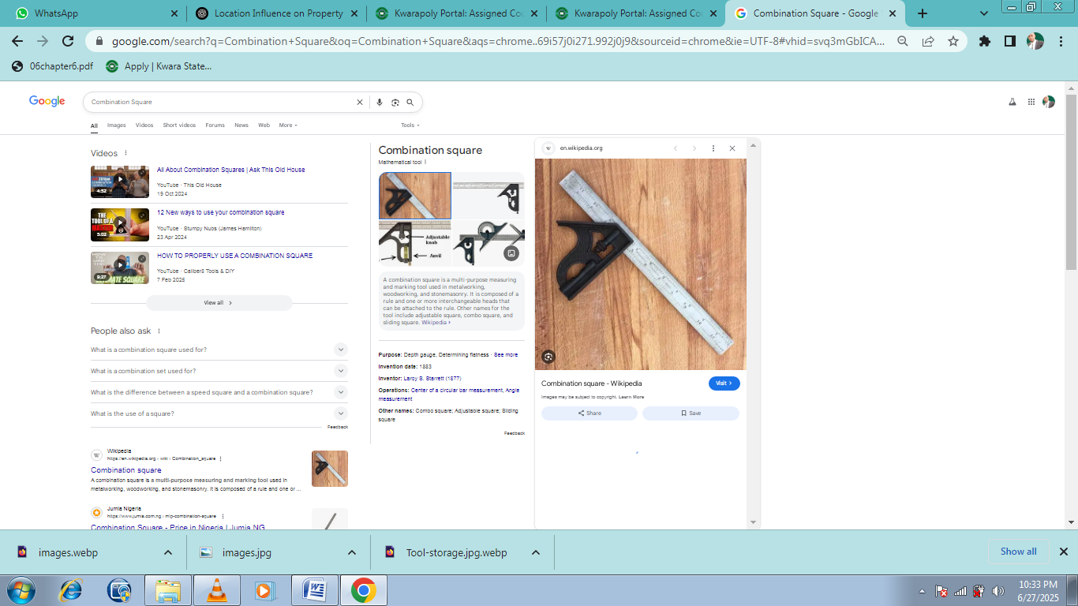
2.0.3. Speed Square (Rafter Square)
Use: Used for quick 90-degree and 45-degree measurements.
Material:Often aluminum or plastic.
Pros:
* Quick reference tool
* Lightweight and portable
Cons:
* Limited to surface use
* Not suitable for pipe or tube fitting

2.0.4. Try Square
Use: Commonly used to mark and verify right angles on flat workpieces.
Pros:
* High precision for layout tasks
* Durable and reliable for checking squareness
Cons:
* Only suitable for small-scale or bench work
* Limited use in pipe fitting or large structures
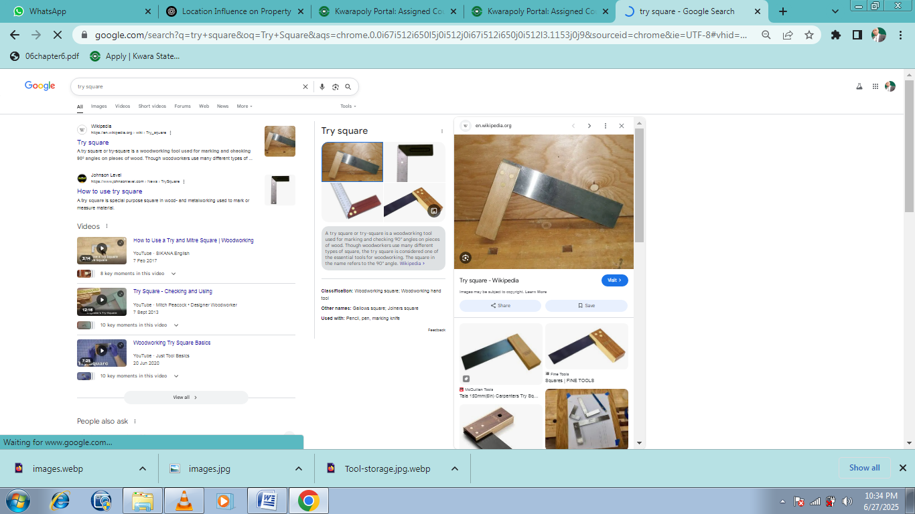
2.0.5. Pipe Fitter’s Square
Use: Designed specifically for pipe fitting to ensure correct angles and alignment between pipes.
Features: Contains scales and charts to calculate offsets, takeoffs, and angles.
Pros:
* Tailored for pipe layout and welding
* Increases productivity and accuracy in pipe welding
Cons:
* Specialized tool, less useful outside pipe work
* Requires experience to use efficiently
2.0.6. Magnetic Square (Welding Magnet)
Use: Holds metal pieces at 45°, 90°, or 135° angles during tack welding.
Pros:
* Frees up hands during welding
* Versatile angles, quick setup
Cons:
* Can lose magnetic strength over time
* Attracts welding debris, requiring frequent cleaning

2.0.7. Engineer's Square
Use: Precision tool for checking right angles, often used in fine fabrication work.
Material: Hardened steel with a fixed blade and stock.
Pros:
* Very accurate
* Suitable for precision inspection
Cons:
* Expensive
* Best for small-scale work
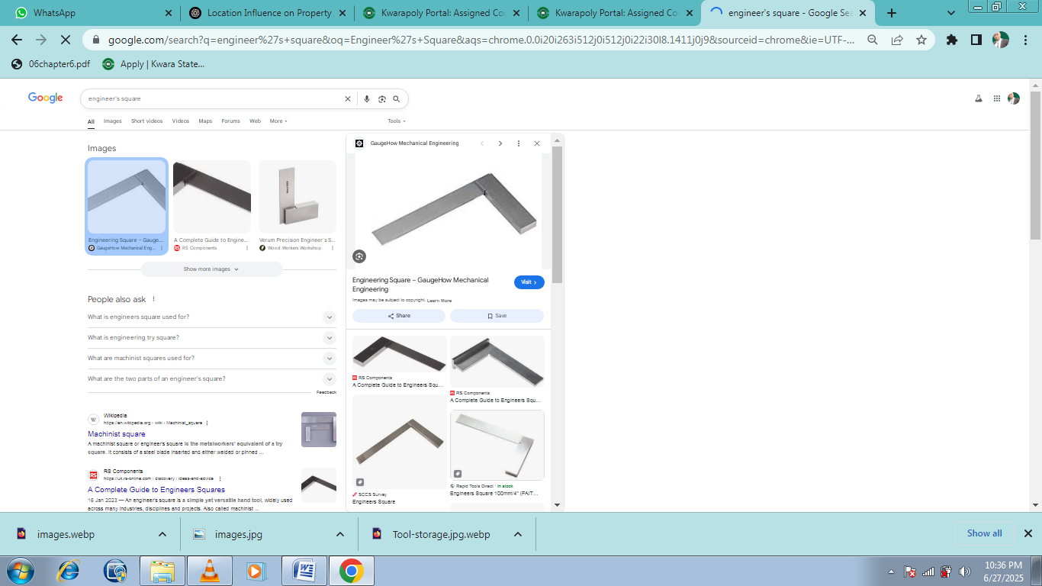
environments.

CHAPTER THREE
3.0 CALCULATION
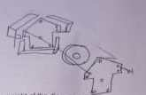
Calculate the mass and the weight of the diagram above
By
- First diagram
30co
45⁰
150cm

- Second diagram

1x3mm
76

150mm

- Third diagram

3m 75

100mm

- Four Diagram

40mm 100

VC
To get mass and weight of the diagram which the formula is

Mass = density x Volume – from Archimedes principle.
fromArchimedes by scienctiss is a newton, GalilesAntoneLaitisier
Weight = Mass x acceleration due to gravity
Getting our mass you have to find the value of the value is
Looking for the volume of what to solve for the triangle represented by
45⁰

Find the opp using Pythagoras theory
0.13
0.11
0.075
45⁰

Vcone = 0.03m
25mm 0.025
150mm
0.1m
75mm
100mm
Vcone = 0.03m
Calculate for the 4thdiagrame
Getting the weight

CHAPTER FOUR
4.0 Selection of Materials, Fabrication Details, and Testing
The fabrication of a welding magnet requires careful consideration of materials, design, and testing. This chapter provides an in-depth look at the selection of materials, fabrication details, and testing procedures for welding magnets.

4.1 Types of Materials Used for Making Welding Magnets
Welding magnets are typically made from materials with high magnetic permeability, strength, and durability. The most common materials used are:
4.1.1. Neodymium Iron Boron (NdFeB): Rare-earth magnets known for their strong magnetic fields and high resistance to demagnetization.
4.1.2. Ferrite Magnets: Ceramic magnets made from iron oxide and other metal oxides, offering good magnetic properties and corrosion resistance.
4.1.3. Samarium Cobalt (SmCo): Rare-earth magnets with high magnetic strength, resistance to demagnetization, and good temperature stability.

4.2 Properties of Materials Used for Making Welding Magnets
The properties of materials used for welding magnets are crucial for their performance. Key properties include:
4.2.1. Magnetic Properties: High magnetic permeability, saturation point, and resistance to demagnetization.
4.2.2. Mechanical Properties: Strength, durability, and resistance to corrosion.
4.2.3. Thermal Properties:Ability to withstand high temperatures without losing magnetic properties.

4.3 Factors for Selecting Materials for Welding Magnets Fabrication when selecting materials for welding magnets.
When selecting materials for fabricating welding magnets, it's essential to consider mechanical, thermal, and magnetic performance to ensure the tool can withstand welding environments.
Here are the key factors to consider:
4.3.1. Magnetic Strength
* Purpose:To securely hold metal components in place during welding.
* Material Consideration:
-Use ferrite (ceramic) magnets for cost-effective, moderate holding power.
-Use neodymium (NdFeB) magnets for strong magnetic force in compact sizes.
4.3.2. Heat Resistance
* Purpose:To withstand high temperatures generated near the weld arc.
* Material Consideration:
-Select magnets with high Current temperatures(above 300°C for ferrite, \~80–150°C for standard neodymium unless heat-stabilized).
-Use heat-resistant casing materials like stainless steel or aluminum.
4.3.3. Corrosion Resistance
* Purpose:To prevent degradation from exposure to moisture, flux, and weld spatter.
* Material Consideration:
-Coated magnets(e.g., epoxy-coated neodymium or plated ferrite).
-Casing materials like powder-coated steel, anodized aluminum, or stainless steel.

4.3.4. Mechanical Strength
* Purpose: To resist chipping or cracking from drops or heavy use.
* Material Consideration:
-Ferrite magnets are brittle but inexpensive.
-Neodymium is stronger magnetically but also fragile—requires protective casings.
-Use impact-resistant housings (metal frames or reinforced plastic enclosures).
4.3.5. Weight and Portability
* Purpose:To allow easy handling and positioning.
* Material Consideration:
-Aluminum casings reduce overall weight.
-Ferrite magnets are heavier than neodymium for the same holding force.
4.3.6. Cost and Availability
* Purpose:To balance performance with budget.
* Material Consideration:
-Ferrite is more economical and widely available.
-Neodymium is more expensive and subject to supply chain fluctuations.
4.3.7. Shape and Fabrication Compatibility
* Purpose: To allow integration into common magnet designs (e.g., V-shaped, arrow, on/off switch types).
* Material Consideration:
-Magnets must be easily machinable or cast into desired shapes.
-Use metals that can be cut, welded, or pressed without losing magnetic integrity.

4.4 Sequence of Fabrication of the Welding Magnet
The fabrication sequence for welding magnets typically involves:
ⅰ Design:Designing the magnet's shape and size.
ⅱ Material Selection: Selecting the appropriate materials.
ⅲ Assembly: Assembling the magnet and other components.
ⅳ Finishing: Applying a protective coating or finish.

4.5 Testing for the fabrication of welding magnet
To ensure a fabricated welding magnet is safe, functional, and reliable for workshop use, several tests should be conducted. These tests evaluate the magnetic holding power,durability, heat resistance, and accuracy of angles Below is a detailed guide on the key testing procedures:
4.5.1. Magnetic Holding Force Test
Purpose:
To verify that the magnet can hold metal parts securely during welding.
Method:
* Attach the magnet to a steel plate.
* Hang weights or apply a pull force perpendicularly until the magnet detaches.
* Compare the force to the design specification (e.g., 50 lbs or 100 N).
Tools required:
* Force gauge or calibrated weights
* Steel test surface (clean and flat)
4.5.2. Angle Accuracy Test
Purpose:
To confirm that the magnet holds metal at the correct angles (typically 45°, 90°, 135°).
Method:
* Use a machinist square, digital angle finder, or protractor to measure the angle between metal surfaces held by the magnet.
* Check for deviations beyond tolerance (e.g., ±1°).
Tools Required:
* Angle gauge or digital protractor
* Test workpieces (e.g., flat bar, angle iron)
4.5.3. Heat Resistance Test
Purpose:
To assess the magnet’s performance near high-temperature welds.
Method:
* Place the magnet near a controlled heat source simulating welding temperatures (e.g., 100–200°C).
* Test if magnetic holding power and casing integrity are retained after exposure.
Tools Required:
* Heat gun, oven, or welding simulation
* Therm couple or infrared thermometer
4.5.4. Durability and Impact Test
Purpose:
To ensure the magnet and casing can withstand rough handling and repeated use.
Method:
* Drop the magnet from a standard height (e.g., 1 meter) onto a steel or concrete surface.
* Inspect for cracks, deformation, or loss of magnetism.
* Repeat as needed (typically 3–5 cycles).
Tools Required:
* Drop test rig (or manual setup)
* Visual inspection tools (magnifier, caliper)
4.5.5. Surface Cleanliness and Contamination Chick
Purpose:
To test the magnet’s ability to remain effective in a real-world shop environment.
Method:
* Apply metal shavings, dust, or welding debris to the magnet surface.
* Assess whether magnetic force is diminished or if cleaning is easy.
Tools Required:
* Metal shavings or dust
* Cleaning cloth or brush
5.4.6. Corrosion Resistance Test (Optional for Long-Term Use)
Purpose:
To ensure the magnet resists rust or surface damage in humid or corrosive environments.
Method:
* Place the magnet in a humidity chamber or conduct a salt spray test.
* Observe for corrosion over 24–72 hours.
Tools Required;
* Salt spray chamber or humidifier setup
Test Report Components:
* Magnet ID and specs
* Test date and environment
* Test procedures used
* Measured values (holding force, angle,
temperature performance)
* Pass/Fail status for each test

4.6 Observations
The fabricated welding magnet showed promising results, but further testing is needed to ensure its reliability and durability.

CHAPTER FIVE
Recommendation and conclusion
5.1 Recommendation
Based on the successful completion and evaluation of the fabrication of a welding magnet, the following recommendations are made to enhance performance, safety, and production quality:
5.1.1. Use High-Quality Magnetic Materials
Recommendation:Utilize neodymium magnets for high holding strength in compact designs or ferrite magnets for cost-effective, heat-resistant solutions.
Reason:Ensures strong, reliable holding force essential for accurate welding setups.
5.1.2. Select Durable, Heat-Resistant Casings
Recommendation: Fabricate the magnet casing using stainless steel or anodized aluminum.
Reason:These materials offer good resistance to heat, corrosion, and physical damage in harsh welding environments.
5.1.3. Incorporate Accurate Angle Guides
Recommendation: Design the magnet to support standard angles like 45°, 90°, and 135°, with clearly marked guides.
Reason: Helps users align materials quickly and accurately during welding tasks.
5.1.4. Include Protective Coatings
Recommendation: Apply epoxy or powder coatings to the magnet and housing.
Reason: Prevents corrosion and simplifies maintenance, extending the tool’s lifespan.

5.1.5. Perform Comprehensive Testing
Recommendation: Establish a routine quality testing protocol for each fabricated unit, including magnetic force, angle precision, and heat resistance.
Reason: Ensures product reliability and builds user trust.
5.1.6. Add User-Friendly Features
Recommendation: Consider features like switchable magnets, handles, or V-grooves for pipe work.
Reason: Improves usability and broadens the range of applications.
5.1.7. Document Design and Test Data
Recommendation: Maintain records of design specifications, materials used, and test results.
Reason: Supports future improvements, quality control, and scaling up production.
By following these recommendations, the fabrication process can produce high-quality welding magnets that are efficient, durable, and suitable for various welding tasks, ultimately contributing to improved workshop productivity and welding accuracy.

5.2 Conclusion
In conclusion, the testing of a fabricated welding magnet is essential to confirm its suitability for welding applications. By assessing magnetic holding strength, angle accuracy, heat resistance, durability, and corrosion resistance, fabricators can ensure the tool meets both performance and safety standards. Proper testing guarantees that the welding magnet will hold materials securely, maintain correct alignment, and withstand the harsh conditions of welding environments. This not only improves the quality of welds but also enhances productivity, precision, and user safety in the workshop.

5.3 Future Work
Building on the successful fabrication and testing of the welding magnet, several areas of future work are recommended to enhance the design, functionality, and applicability of the tool:
5.3.1 Development of Adjustable or Switchable Welding
Objective: Design magnets with an ON/OFF switch mechanism or adjustable angles.
Benefit: Increases versatility, safety, and ease of use by allowing users to engage or disengage the magnet as needed.
5.3.2. Integration of Angle Measurement Displays
Objective: Incorporate digital angle indicators or bubble levels into the magnet body.
Benefit: Allows real-time angle verification, improving accuracy and user confidence during setup.
5.3.3. Use of Advanced Materials
Objective: Explore the use of rare-earth magnets with higher heat resistance or lightweight composite casings.
Benefit: Enhances performance in extreme welding environments while reducing tool weight.
5.3.4. Ergonomic and Safety Improvements
Objective: Design handles or grip features to make placement and removal easier and safer.
Benefit: Minimizes operator fatigue and reduces the risk of injury or dropped tools.

5.3.5. Custom Designs for Specific Applications
Objective: Fabricate specialized magnets for pipe welding, inside corners, or multi-angle joints.
Benefit: Expands the tool's usefulness across different welding scenarios and industries.

5.3.6. Automation Compatibility
Objective: Explore the potential for integrating welding magnets with robotic or automated welding systems.
Benefit: Supports industrial automation and precision fabrication in advanced manufacturing environments.

5.3.7. Long-Term Performance Testing
Objective:Conduct extended use and life cycle testing under various conditions.
Benefit:Gathers data on wear, magnet degradation, and maintenance needs for improved designs.
Pursuing these future developments will lead to more innovative, user-friendly, and industrial-grade welding magnets,helping to meet the evolving demands of modern metal fabrication and manufacturing.

REFERENCE
Alnico & Ferrite material reviews – Up-to-date summaries of permanent magnet materials and processing
American Welding Society (AWS) Handbook – Tools & Fixtures Section.
– Provides in-depth information about welding tools, fixtures, and squaring aids. [Link: www.aws.org]
CWB/Merit-us Gas Partners – Practical guides on magnetic particle testing and weld inspection methods
MDPI (2021) – A survey of NDT methods (ultrasonic, thermography) applied to fusion welding and additive manufacturing .
Madsen, D. A. (2016). Print Reading for Welding and Fabrication. – Includes tool selection, layout, and squaring techniques used in welding.
Modern Welding Technology by Howard B. Cary
– Discusses alignment, jig and fixture setup, and tool accuracy in welding

NdFeB additive methods (arXiv) – Technical insights into advanced splintering, diffusion techniques, and performance boosting .
New land Magnet (2025) – Comprehensive overview of NdFeB testing procedures and equipment
Timings, R. (2008). Fabrication and Welding Engineering.
– Covers workshop tools, including squaring tools and welding alignment procedures. [Link: Science Direct or FlipHTML5]
Wikipedia & ASTM sources – Technical background on magnetic particle inspection, eddy-current testing, electromagnetic and ACFM methods.

