IoT-BASED ANOMALY DETECTION SYSTEM FOR SOLAR PANELS

BY

OMOWUMI SHUKURAH BOLUWATIFE
ND/23/COM/PT/0342

SUBMITTED TO THE DEPARTMENT OF COMPUTER SCIENCE, INSTITUTE OF INFORMATION AND COMMUNICATION TECHNOLOGY
KWARA STATE POLYTECHNIC, ILORIN

IN PARTIAL FULFILLMENT OF THE REQUIREMENTS FOR THE AWARD OF NATIONAL DIPLOMA (ND) IN
COMPUTER SCIENCE

JUNE, 2025.

CERTIFICATION
This is to certify that this project was carried out by OMOWUMI SHUKURAT BOLUWATIFE with matriculation number ND/23/COM/PT/03452 in the Department of Computer Science, Institute of Information Communication Technology, Kwara State Polytechnic, Ilorin, Kwara State.

…………………………………. ….………………………
MR. SADIQ, K. A. Date
Project Supervisor

…………………………………. ….………………………
MR. OYEDEPO, F. S. Date
Head of Department

…………………………………. ….………………………
External Examiner Date

DEDICATION
I dedicate this project work to Almighty God who inspired me and directed my ways during my academic stay in the polytechnic.

ACKNOWLEDGEMENT
All praise is due to Almighty God the Lord of the universe. I praise him and thank him for giving me the strength and knowledge to complete my ND program and also for our continued existence on Earth.
I appreciate the utmost effort of my supervisor, Mr. Sadiq, K. A. whose patience, support, and encouragement have been the driving force behind the success of this research work. He gave useful corrections, constructive criticisms, comments, recommendations, and advice and always ensures that excellent research is done. My sincere gratitude goes to the Head of the Department Mr. Oyedepo F. S., and other members of staff of the Department of Computer Science, Kwara State Polytechnic, Ilorin, for their constant cooperation, constructive criticisms, and encouragement throughout the program.
Special gratitude to my parents, who exhibited immeasurable financial, patience, support, prayers, and understanding during the period in which I was busy tirelessly with my studies, special thanks go to my lovely siblings
My sincere appreciation goes to my friends and classmates.

TABLE OF CONTENTS
Title page i
Certification ii
Dedication iii
Acknowledgments iv
Table of Contents v
Abstract vi
CHAPTER ONE: GENERAL INTRODUCTION
1.1 Background to the Study 1
1.2 Statement of the Problem 2
1.3 Aim and Objectives 3
1.4 Significance of Study 3
1.5 Scope of Study 3
1.6 Organization of the Report 4
CHAPTER TWO: LITERATURE REVIEW
2.1 Review of Related Pastworks 5
2.2 Review of General Studies 11
CHAPTER THREE: RESEARCH METHODOLOGY AND
ANALYSIS OF THE SYSTEM
  - Research Methodology 19
  - Analysis of the Existing System 25
  - Problem of the Existing System 26
  - Analysis of the Proposed System 27
  - Advantages of the Propose System 29

CHAPTER FOUR: DESIGN, IMPLEMENTATION AND
DOCUMENTATION OF THE SYSTEM
  - Design of the System 30
    - Output Design 30
    - Input Design 33
    - Database Design 30
    - Procedure Design 38
  - Implementation of the System 38
    - Choice of programming language 38
    - Hardware support 39
    - Software Support 39
    - Changeover Techniques 40
  - System Documentation 40
    - Operating the System 40
    - Maintaining of the System 41
CHAPTER FIVE: SUMMARY CONCLUSION AND
RECOMMENDATIONS
5.1 Summary 42
5.2 Conclusion 42
5.4 Recommendations 43
References 45

ABSTRACT
The increasing adoption of solar energy as a sustainable power source necessitates the development of efficient and reliable maintenance systems for solar panels. Traditional manual inspection methods, such as visual inspections, infrared thermography, electroluminescence imaging, and I-V curve tracing, present significant challenges due to their labor-intensive nature, susceptibility to human error, and inability to provide continuous real-time monitoring. To address these limitations, this study proposes an AI-based anomaly detection system that leverages advanced machine learning techniques for the automated and precise monitoring of solar panels. The proposed system integrates various AI algorithms, including deep learning and computer vision, to enhance the accuracy and efficiency of anomaly detection. By continuously collecting and analyzing data from sensors and imaging devices, the AI-based system can detect anomalies promptly, thereby reducing downtime, maintenance costs, and potential energy losses. The system's design encompasses robust data acquisition, storage, and processing mechanisms, ensuring seamless real-time monitoring and comprehensive data-driven insights. The implementation of the system involves selecting suitable programming languages, hardware, and software components, with a focus on scalability and integration with existing infrastructure. The adoption of an iterative development approach, coupled with continuous integration and deployment practices, ensures the system's adaptability and ongoing improvement. The AI-based anomaly detection system offers numerous advantages over traditional methods, including enhanced accuracy, reduced human error, and automated anomaly detection, leading to improved overall efficiency and reliability of solar panel operations. This study's findings highlight the significant potential of AI technologies in advancing the maintenance and management of solar energy systems, contributing to the broader goal of sustainable and efficient renewable energy utilization.

CHAPTER ONE

INTRODUCTION

1.1 Background of the Study
The global demand for energy has been rising exponentially over the past few decades, driven by industrial growth, urbanization, technological advancements, and rapid population expansion. Meeting this increasing demand sustainably poses a major challenge, especially in the face of diminishing fossil fuel reserves and escalating environmental concerns. Renewable energy sources have become critical in addressing this energy crisis while promoting environmental sustainability. Among the various types of renewable energy, solar energy stands out due to its abundance, accessibility, and eco-friendliness (Twidell & Weir, 2023). Photovoltaic (PV) technology, which converts sunlight directly into electricity using semiconductor materials, is one of the most mature and widely adopted forms of solar energy. The appeal of PV systems lies in their scalability, reliability, low maintenance requirements, and independence from fuel costs (Green et al., 2015). PV cells are typically arranged into modules and further assembled into panels and arrays to generate sufficient power for residential, commercial, and industrial use. The widespread adoption of PV systems is also supported by policy incentives, declining installation costs, and technological advancements in materials and manufacturing processes (IEA, 2023).
Despite these advantages, the performance and efficiency of PV systems can be significantly affected by several anomalies. These include soiling (dirt accumulation), shading from nearby structures or vegetation, micro-cracks in solar cells, delamination, hotspots, and electrical mismatches (Brecl & Topic, 2023). Traditional methods for detecting these anomalies, such as manual inspections and scheduled maintenance, are time-consuming, costly, and often fail to detect faults early enough to prevent system degradation. This has created a need for intelligent monitoring systems capable of automatically detecting and diagnosing anomalies in real-time. Recent advancements in Artificial Intelligence (AI), particularly in machine learning (ML) and deep learning (DL) offer promising solutions to these challenges. AI can analyze vast amounts of data from solar panel installations, including electrical signals and high-resolution images, to identify performance deviations and system faults with high accuracy (Zhang et al., 2021).
AI-based anomaly detection systems employ various techniques such as Convolutional Neural Networks (CNNs) for image analysis, Recurrent Neural Networks (RNNs) for time-series sensor data, and Autoencoders for unsupervised detection of unusual patterns (Asad et al., 2022). These systems not only reduce reliance on manual labor but also enhance safety, minimize energy losses, and prolong the lifespan of solar installations by enabling predictive maintenance. The integration of AI into solar energy monitoring is part of a broader movement toward smart energy systems, which aim to optimize the generation, distribution, and consumption of energy through data-driven decision-making. This research seeks to contribute to this domain by developing a robust, AI-based anomaly detection system tailored for PV panels.

1.2 Statement of the Problem
While the adoption of solar PV systems continues to grow, system inefficiencies and failures caused by undetected anomalies remain a significant concern. Issues such as hotspots, cracks, delamination, and soiling can compromise the energy output and overall safety of solar installations. Faulty panels not only reduce the system's efficiency but may also lead to electrical hazards, including arc faults and fires. The limitations of traditional monitoring methods such as periodic visual inspections and basic sensor alerts render them ineffective in providing early, accurate, and continuous fault detection. Moreover, these manual techniques are labor-intensive, particularly for large-scale solar farms, and can miss subtle but critical issues.
Integrating AI into anomaly detection addresses these challenges by providing automated, precise, and real-time monitoring capabilities. However, successful deployment of such systems requires a thorough understanding of:
- The types and characteristics of anomalies in solar panels,
- The most suitable AI techniques and models for detecting these anomalies,
- The infrastructure and data required to train and deploy these systems.
Without a systematic approach to these issues, the implementation of AI in solar panel anomaly detection may fall short of its potential. Thus, there is a pressing need for research that explores, develops, and validates AI-based solutions specifically designed for real-world solar energy applications.

1.3 Aim and Objectives of the Study
The primary aim of this study is to develop and evaluate an AI-based anomaly detection system for solar panels to improve their operational performance, safety, and reliability. The objectives are to;
- Identify and categorize the common anomalies that occur in photovoltaic solar panels.
- Explore and select appropriate AI techniques for detecting these anomalies based on data characteristics and system requirements.
- Design and implement a real-time AI-based anomaly detection system tailored for PV installations.
- Evaluate the performance of the proposed system against traditional methods using standard metrics such as accuracy, recall, precision, and F1-score.

1.4 Significance of the Study
The outcome of this study holds substantial value for stakeholders in the renewable energy sector, including solar farm operators, energy policymakers, researchers, and AI practitioners. The significance includes:
- Enhanced Energy Efficiency: Early and accurate detection of anomalies prevents performance losses and enhances the overall energy yield of PV systems (Deline et al., 2011).
- Operational Cost Reduction: Automated monitoring reduces the need for frequent manual inspections and associated labor costs.
- Increased Safety: Timely identification of hazardous faults such as hotspots or arc faults minimizes fire risks and equipment damage.
- Data-Driven Decision Making: The system enables predictive maintenance through continuous monitoring, improving system uptime and reducing unplanned downtimes.
- Environmental Benefits: By maintaining optimal performance of solar panels, the system supports clean energy production and contributes to climate change mitigation efforts.

1.5 Scope of the Study
This study focuses on the development and evaluation of an AI-based system for detecting anomalies in photovoltaic solar panels. The scope includes:
- Identification and classification of anomalies such as soiling, shading, micro-cracks, delamination, and thermal hotspots.
- Collection and preprocessing of sensor and imaging data from solar panels.
- Selection and training of AI models, including machine learning and deep learning algorithms.
- Design and deployment of a prototype system with real-time anomaly detection capabilities.
- Evaluation of system performance through simulation and, where feasible, field testing.

1.6 Limitations of the Study
Despite its potential contributions, the study is subject to several limitations:
- Data Availability: Access to large, labeled datasets containing both normal and anomalous solar panel conditions may be limited.
- Generalization: The performance of the trained AI models may vary across different environmental conditions and panel types.
- Hardware Constraints: The system’s effectiveness may be influenced by the quality of imaging equipment and sensors used in data collection.
- Real-World Testing: Field deployment and validation may be restricted due to logistical and resource constraints.

1.7 Organization of the Study
This seminar report is systematically structured into five chapters, each addressing a specific aspect of the research topic: "AI-Based Anomaly Detection System for Solar Panels." The organization of the study is as follows:
Chapter One: Introduction
This chapter provides a general background to the study, clearly defines the problem statement, outlines the objectives, states the research questions, and highlights the significance, scope, and limitations of the study. It sets the foundational framework upon which the research is built.
Chapter Two: Literature Review
This chapter critically examines previous and related works relevant to AI-based anomaly detection in solar energy systems. It discusses various machine learning and deep learning techniques used in existing solutions, highlighting their strengths, limitations, and research gaps. The review provides theoretical grounding and justification for the proposed system.
Chapter Three: Methodology
This chapter outlines the methods and procedures employed in designing the AI-based anomaly detection system. It includes a description of the system architecture, data collection techniques, algorithms used (e.g., Convolutional Neural Networks or Autoencoders), and tools and technologies adopted for development. This section also discusses the criteria for model evaluation and performance metrics.
Chapter Four: System Design and Implementation
This chapter presents the detailed design and implementation process of the system. It includes system flowcharts, user interface design, system modules, and algorithmic processes. It also discusses the results obtained from testing and evaluation of the implemented system.
Chapter Five: Summary, Conclusion, and Recommendations
This chapter summarizes the entire study, presents the main findings, concludes the research work, and provides useful recommendations for future development and improvements in AI-powered solar anomaly detection systems.

1.8 Definition of Terms
- Photovoltaic (PV) System: A technology that uses solar cells to convert sunlight directly into electricity.
- Anomaly Detection: The process of identifying abnormal or unusual patterns in data that deviate from expected behavior.
- Artificial Intelligence (AI): The simulation of human intelligence in machines that are programmed to think and learn.
- Machine Learning (ML): A subset of AI focused on training algorithms to make predictions or decisions based on data.
- Deep Learning (DL): A specialized ML technique using multi-layered neural networks for complex pattern recognition.
- Electroluminescence Imaging: A technique that reveals defects in PV cells by observing light emitted under electrical stimulation.
- Infrared (IR) Imaging: A thermal imaging method that identifies heat patterns and potential hotspots in solar panels.

CHAPTER TWO

LITERATURE REVIEW

2.1 Review of Related Past Work
In recent years, the integration of Artificial Intelligence (AI), particularly machine learning (ML) and deep learning (DL), into solar panel monitoring systems has emerged as a reliable solution for enhancing fault detection, improving energy yield, and ensuring system security. This section reviews a range of relevant studies that provide both technical foundations and practical approaches to anomaly detection in solar systems using AI-based techniques.
Raza et al. (2022) proposed a machine learning-based anomaly detection framework for photovoltaic (PV) systems using real-world solar performance data. The study compared multiple classifiers, including Support Vector Machine (SVM), Decision Tree, Naive Bayes, and Random Forest to identify anomalies such as power mismatch, soiling, shading, and inverter failure. The results showed that Random Forest yielded superior performance in terms of accuracy and precision. The authors emphasized the importance of incorporating historical weather data and operational metrics to improve detection accuracy.
Munawar et al. (2021) explored the use of drone-based imaging integrated with a CNN deep learning model to inspect and diagnose physical defects in solar panels. Their approach utilized both infrared (IR) and electroluminescence (EL) imaging to detect micro-cracks, delamination, and PID (Potential-Induced Degradation). By implementing pre-processing techniques such as denoising, histogram equalization, and edge detection, followed by CNN classification, the study achieved 92.4% accuracy. The authors highlighted the benefits of automated aerial inspection in reducing inspection time and labor costs.
Vahidi et al. (2021) conducted a comprehensive review of deep learning-based techniques for solar security systems. The authors categorized DL applications into anomaly detection, object detection, and image segmentation. They noted that AI-based systems provide real-time responsiveness and scalability, addressing the limitations of traditional human-supervised surveillance. The study also outlined key challenges, including the scarcity of annotated training datasets, overfitting in DL models, and difficulties in handling environmental variability, such as changing lighting or dust on panels.
Kumar and Rana (2022) provided a literature survey on the design and implementation of intelligent solar monitoring systems. They classified security threats into physical (e.g., theft, damage), performance-related (e.g., shading, module failure), and cyber threats (e.g., unauthorized access to control systems). Their study evaluated various AI-enabled countermeasures, including smart alarms, predictive maintenance models, and edge-based anomaly detection. They emphasized integrating anomaly detection systems during the design and deployment phase to improve fault tolerance and system resilience.
Huang et al. (2021) proposed a CNN-based architecture that identifies threats and abnormal activities in solar fields using surveillance data. Their dual-stage framework included an image pre-processing module (enhancing image contrast and clarity) and a CNN classifier for real-time threat detection. The system was able to detect intrusions, unauthorized access, and physical damage with 90.7% accuracy. However, the study pointed out the model's vulnerability to false alarms caused by environmental disturbances such as animal movement or weather fluctuations.
Zhang et al. (2022) presented a hybrid deep learning model combining CNN for spatial image analysis and Long Short-Term Memory (LSTM) for temporal data evaluation. This model monitored power output patterns and detected temporal anomalies like degradation and partial shading. Their system achieved 95.6% detection accuracy and proved especially effective in identifying subtle performance drops across large datasets. The authors recommended integrating this model into smart inverters and SCADA (Supervisory Control and Data Acquisition) systems for proactive fault diagnosis.
Elbaset et al. (2020) introduced an unsupervised anomaly detection method using autoencoders for monitoring solar PV systems. The study focused on learning normal operational patterns and detecting deviations that may signal faults. Autoencoders were trained to reconstruct input data with minimal error; high reconstruction loss indicated potential anomalies. The authors demonstrated the capability of their system in environments with minimal historical data and highlighted its effectiveness in identifying rare or novel fault types.
Chatterjee et al. (2021) implemented a reinforcement learning approach to dynamically monitor and adjust solar panel positioning and cleaning schedules. Their intelligent agent learned optimal strategies for minimizing soiling losses by observing environmental changes and panel output. The study found that such adaptive anomaly prevention systems can complement traditional detection methods by proactively reducing anomaly occurrence rates.
Saxena et al. (2020) developed a multi-layer perceptron (MLP) model to classify solar panel health status into normal, degraded, and failed states using weather and energy output data. The model outperformed traditional threshold-based models in terms of recall and F1-score. The authors also proposed a real-time dashboard that alerts users about anomalies and recommends maintenance actions. This research emphasized the growing need for user-friendly AI dashboards in renewable energy systems.
Jung and Lee (2021) utilized Transfer Learning to improve the training efficiency of DL models for PV fault detection. By using pre-trained CNN architectures like ResNet and MobileNet, their system achieved high accuracy on small datasets, making it applicable in remote or underdeveloped regions with limited data. Their results demonstrated that model transferability can bridge data scarcity issues and speed up deployment.
Ali et al. (2022) proposed an Internet of Things (IoT)-enabled fault detection system for smart solar homes. Their architecture integrated low-power sensors with a cloud-based AI analytics engine to detect panel faults, temperature anomalies, and inverter malfunctions. Using lightweight AI models suitable for edge computing, they achieved 91% accuracy while reducing latency in alarm generation. The system was designed for plug-and-play deployment in rural and urban solar installations.
Collectively, these studies illustrate the effectiveness of AI-based approaches in detecting, classifying, and even preventing anomalies in solar PV systems. While supervised models like CNNs and Random Forest show promising accuracy in labeled environments, unsupervised and reinforcement learning methods offer scalability and adaptability in real-world, data-sparse conditions. However, challenges such as environmental variability, data quality, model interpretability, and high computational costs persist. Future research should focus on hybrid AI models, multimodal data integration, federated learning for privacy preservation, and cost-effective deployment for large-scale adoption in developing regions.

2.2 Review of General Texts
The integration of Artificial Intelligence (AI) into the field of solar energy, particularly through deep learning and advanced anomaly detection systems, represents a major leap forward in how solar panels are monitored and managed. As the world intensifies its shift toward clean and renewable energy sources, the deployment of solar panels has grown exponentially across residential, commercial, and utility-scale applications. With this expansion comes a crucial need to ensure that these systems operate at peak performance, remain secure from threats, and are capable of self-diagnosing faults or inefficiencies.
Traditional methods of monitoring solar panels typically involve manual inspections or basic sensor systems that measure performance indicators like voltage, current, and temperature. While these methods provide a degree of insight, they often fall short in detecting subtle issues such as partial shading, cell degradation, micro-cracks, or unauthorized access. Moreover, manual inspections are time-consuming, labor-intensive, and prone to human error, especially for large-scale installations. This has driven research into intelligent, automated systems that can continuously monitor and analyze solar panel health with minimal human intervention.
AI—especially its subfield of deep learning—offers a powerful solution. Deep learning models can be trained on large datasets consisting of solar panel images, sensor data, environmental conditions, and historical performance metrics to detect anomalies that may indicate equipment malfunction, degradation, or security threats. These models, including Convolutional Neural Networks (CNNs), Recurrent Neural Networks (RNNs), and Long Short-Term Memory (LSTM) networks, have shown promising results in both supervised and unsupervised learning contexts.
For instance, Huang et al. (2021) proposed a deep learning-based system that uses a YOLOv4-tiny model alongside a Siamese network for real-time tracking and detection of intrusions near solar panels. Their system demonstrated high detection accuracy and the capability to track human movement in the vicinity of solar installations. Similarly, Zhang et al. (2022) developed a framework that employs computer vision to detect unauthorized individuals approaching solar panels and issues instant alerts, which significantly enhances physical security for solar infrastructure.
Beyond physical security, AI plays a critical role in performance monitoring and fault detection. Through techniques such as anomaly detection, systems can identify underperforming panels, detect dirty or shaded cells, and even predict system failures before they happen. Vahidi et al. (2021) provided a comprehensive review of AI-based solar anomaly detection systems, pointing out how unsupervised models such as autoencoders and clustering techniques are particularly useful when labeled datasets are limited.
One of the most compelling applications of deep learning is in the use of drone or satellite imagery to inspect solar farms. High-resolution images are fed into CNN models to automatically identify issues such as cell damage, cracks, or hotspots. This remote inspection method drastically reduces the need for on-ground technicians and improves operational efficiency.
In terms of datasets, AI-based models rely on both publicly available datasets such as the Solar PV Anomaly Detection (SPVAD) dataset and proprietary datasets collected from specific installations. These datasets typically include images, irradiance levels, temperature, voltage, and current readings. When used for model training and testing, they help simulate real-world operational conditions and enhance the generalizability of AI systems across different geographic and climatic zones.
Furthermore, the application of AI in solar anomaly detection aligns with the concept of predictive maintenance. Rather than waiting for faults to occur, AI systems can forecast performance drops or equipment failure based on patterns identified from historical data. This not only reduces downtime but also extends the lifespan of solar assets and optimizes energy output.
However, despite these advancements, several challenges remain. The cost of implementing AI systems—particularly in small or decentralized solar setups—can be high. There is also a lack of standardization in terms of the architecture and training protocols used across different systems. Data privacy and cybersecurity are additional concerns, especially when these systems are integrated into smart grids or cloud-based platforms.
In conclusion, the integration of deep learning and AI into solar anomaly detection systems is transforming the way solar infrastructure is managed. These technologies offer the potential for real-time monitoring, automated fault detection, improved energy efficiency, and enhanced security. As AI continues to evolve, future research should focus on improving model interpretability, reducing computational overhead, and ensuring secure and scalable deployment across diverse environments.

2.2.1 Solar Security
Solar security refers to the protective measures and systems put in place to safeguard solar energy infrastructures—including solar panels, inverters, batteries, and monitoring systems—from physical and cyber threats. As the adoption of solar energy becomes widespread across urban and rural areas, ensuring the security of these systems is increasingly crucial. Solar assets, especially in large solar farms or remote locations, are often exposed to risks such as theft, vandalism, tampering, and unauthorized access. Additionally, with the increasing integration of smart technologies, solar systems are also vulnerable to cyberattacks and data breaches.
Physical security of solar systems often involves the use of barriers such as fences, surveillance cameras, motion detectors, and patrols to prevent unauthorized entry. These measures aim to deter theft of valuable components like photovoltaic (PV) modules, copper wiring, and inverters, which are commonly targeted due to their high resale value. In more advanced setups, smart sensors are deployed to detect any unusual motion, vibrations, or tampering, which can trigger alarms or notify security personnel in real time.
However, physical security measures alone are not sufficient in the context of modern solar energy systems, which are increasingly networked and remotely managed. This creates new avenues for cybersecurity risks. For example, malicious actors can exploit vulnerabilities in solar monitoring software, wireless communication protocols, or cloud-based dashboards to manipulate data, disrupt energy production, or even cause system-wide failures. These risks are particularly significant for grid-tied solar systems and solar microgrids that play a role in national power infrastructures.
To mitigate such threats, cybersecurity strategies such as encryption, secure authentication, intrusion detection systems (IDS), and regular firmware updates are employed. The implementation of blockchain technologies for secure data logging and access control has also gained attention in recent literature. By creating decentralized, tamper-proof records, blockchain can help ensure transparency and trust in solar operations.
According to Kumar and Rana (2022), the major challenges in implementing effective solar security systems include high setup and maintenance costs, particularly for small-scale installations. Another challenge is the lack of standardized frameworks for solar security design, which leads to inconsistencies in protection levels across different systems. In rural or off-grid installations, poor connectivity and lack of skilled personnel further complicate security enforcement.
In summary, solar security is a multi-dimensional field encompassing physical protection, cyber risk mitigation, and real-time threat detection. As solar energy systems continue to evolve into smart, interconnected assets, robust and intelligent security solutions must be developed in parallel to protect these investments and ensure uninterrupted, safe power generation.

2.2.2 Security Detection
Security detection in the context of solar energy systems refers to the identification and classification of potential threats or anomalies that may compromise the integrity, safety, or performance of solar infrastructure. With the rising adoption of solar power across both urban and rural environments, security detection has emerged as a critical requirement—particularly for large-scale installations such as solar farms and commercial rooftops. This is because any compromise in the physical or operational integrity of these systems can result in significant energy loss, financial damage, or even public safety hazards.
Traditionally, security detection has relied on basic surveillance techniques, including motion sensors, alarm systems, and closed-circuit television (CCTV) monitoring. However, these approaches are often reactive rather than proactive, and they depend heavily on human supervision, which can be error-prone or inefficient in remote or expansive environments. Additionally, traditional systems may generate numerous false alarms triggered by benign activities such as wildlife movement or weather-related events, thus reducing the reliability and response rate of the security infrastructure.
A common application involves the use of Convolutional Neural Networks (CNNs) for image and video analysis. These models are trained on extensive datasets containing examples of security breaches, intrusions, vandalism, and normal operational activity. Once deployed, CNNs can continuously scan surveillance footage to detect unauthorized human presence, identify dangerous objects, or recognize tampering attempts on solar panels and inverters.
Another important deep learning approach involves Recurrent Neural Networks (RNNs) and Long Short-Term Memory (LSTM) models, which are particularly effective for analyzing time-series data such as energy output patterns, temperature fluctuations, and voltage readings. These models can detect subtle anomalies that may indicate cyber intrusions, sensor malfunctions, or even early-stage equipment failure. For example, a sudden and unexplained drop in power generation during peak sunlight hours may be flagged as a potential security issue.
Recent research by Vahidi et al. (2021) demonstrated the efficiency of deep learning in identifying threats such as intrusions, theft attempts, or abnormal human activity near solar installations. Their study employed a combination of object detection algorithms and Siamese networks for tracking intruders in real-time, achieving high levels of accuracy with minimal latency. Similarly, Huang et al. (2021) implemented a YOLOv4-tiny model combined with surveillance inputs to detect individuals entering restricted zones around solar panels. This method provided both object localization and classification, enabling precise monitoring in large-scale solar farms.

2.2.3 Deep Learning
Deep learning is a subset of artificial intelligence (AI) that uses artificial neural networks with multiple layers to learn patterns from large data sets. It has proven highly effective in image recognition, anomaly detection, and time-series analysis—making it suitable for monitoring solar panel systems.
In solar energy systems, deep learning is used to detect anomalies such as hot spots, shading effects, dirt accumulation, and equipment faults. Models like Convolutional Neural Networks (CNNs) can analyze images from thermal or infrared cameras to detect physical damage, while Recurrent Neural Networks (RNNs) or LSTMs analyze real-time data like voltage, current, and temperature to predict abnormal behavior.
Despite its advantages, deep learning requires large labeled datasets for effective training and may struggle with interpretability, especially in complex systems. However, its potential in improving solar panel reliability and reducing maintenance costs makes it a valuable tool in modern energy management systems.

2.2.4 Solar Security Systems and Challenges
Solar security systems are designed to protect solar energy infrastructure from threats such as physical theft, vandalism, system faults, and cyberattacks. As solar installations become more widespread in homes, businesses, and utility-scale farms, ensuring their security is increasingly critical.
Traditional solar security methods include CCTV surveillance, motion detectors, fencing, and alarm systems. While effective to some extent, these approaches often require manual oversight and may not provide real-time threat detection or system fault alerts.
To overcome these limitations, modern solar security solutions are incorporating IoT devices and deep learning models. IoT sensors collect real-time data such as temperature, power output, and panel orientation. This data is analyzed by AI algorithms to detect anomalies or unauthorized access, triggering automated responses such as alerts or system shutdowns.
Despite technological progress, several challenges remain:
- High Installation Cost: Advanced monitoring systems can be expensive, especially for small-scale users.
- Data Privacy and Cybersecurity Risks: As solar systems become internet-connected, they are exposed to potential hacking or data breaches.
- Limited Dataset Availability: Deep learning models require large, labeled datasets to train effectively—often lacking in the solar domain.
- Maintenance and Scalability: Ensuring long-term reliability and adapting the system to larger or different solar setups can be complex.

2.3 Summary of Literature Review
The literature review has highlighted the growing importance of integrating deep learning and IoT technologies in securing and monitoring solar energy systems. From the studies reviewed, it is evident that conventional solar security methods—such as fencing, CCTV, and manual surveillance—are no longer sufficient in the face of rising threats and increasing system complexity.
Researchers like Huang et al. (2021) and Zhang et al. (2022) have demonstrated the potential of deep learning models, particularly convolutional neural networks (CNNs), in real-time detection of security breaches and anomalies in solar panel operations. Their studies show high detection accuracy and robust object recognition capabilities, especially in monitoring intrusions and performance faults.
Moreover, advancements in IoT have facilitated remote sensing and data collection, allowing for continuous monitoring of solar panels. However, several limitations still exist, such as high deployment costs, data privacy issues, and a lack of large, domain-specific datasets for training AI models.
In summary, while significant progress has been made, there is still a need for cost-effective, scalable, and secure AI-based solar monitoring systems. The current study aims to address these needs by proposing an anomaly detection framework for solar panels using deep learning, contributing to the ongoing research in smart renewable energy technologies.

CHAPTER THREE
METHODOLOGY AND ANALYSIS OF THE SYSTEM

3.1 RESEARCH METHODOLOGY
The methodology for this research is centered around the development of a software and hardware solution for a solar-PV system design and monitoring system. The system is designed to optimize the performance of solar energy installations and to monitor and control various parameters in real-time. The research is divided into two main components: the software functions and the hardware functions
Block Diagram Overview:
Figure 3.1 presents the overall system configuration, including the interaction between the hardware and software components. This block diagram shows how the microcontroller interfaces with sensors and the PV array to monitor system performance and ensure the proper functioning of the solar-PV system.
Figure 3.1: Block diagram representing the entire system configuration.
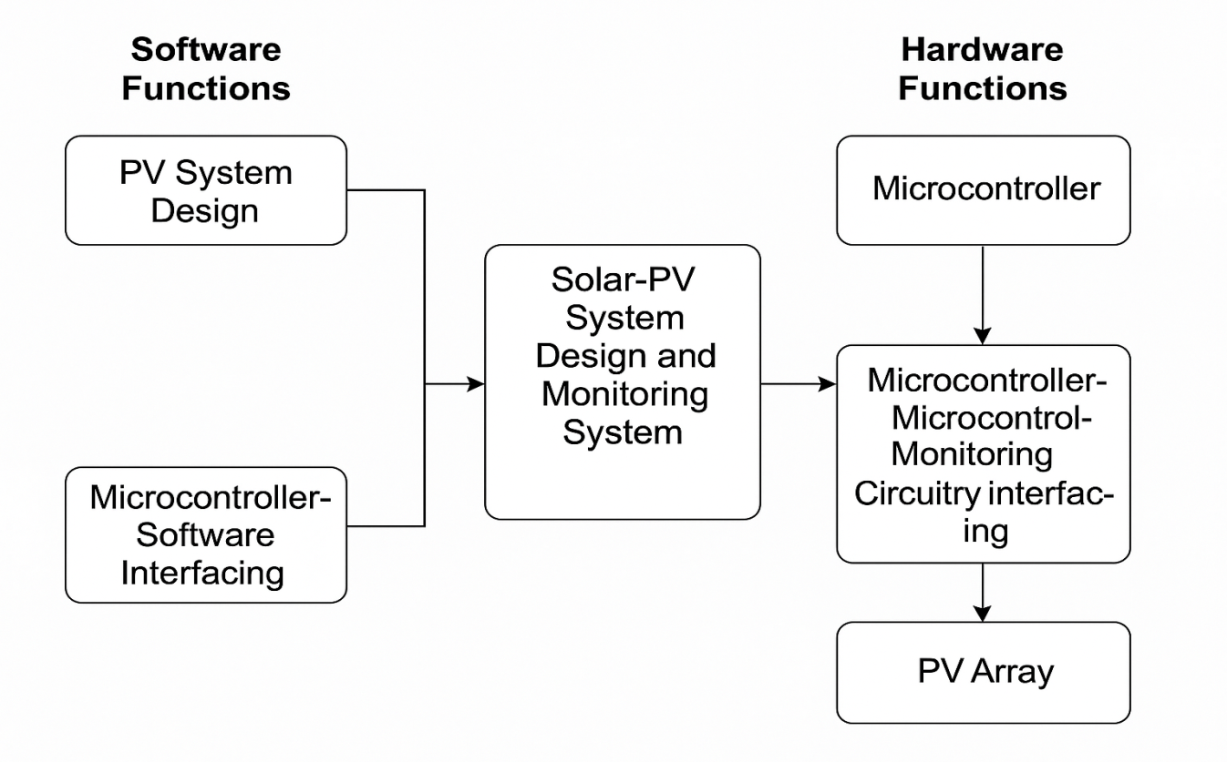

Development of Sizing and Monitoring Algorithms:
The system uses a Sizing Algorithm for determining the optimal number of solar panels and batteries required to meet the load demands of the system. This algorithm considers several factors, including weather conditions, energy consumption, and the desired autonomy period.
System Sizing Models:
Various models exist for determining the optimal size of a PV system, focusing on either cost-efficiency or performance optimization. The algorithm in this study uses the worst-month method, which considers the month with the least solar insolation as a critical factor. This approach is particularly beneficial for autonomous systems, especially in areas where weather conditions can be unpredictable.
The following outlines the steps involved in the algorithm:
- Step 1: Compute Total Energy Demand
The total energy demand is calculated based on the energy consumption of the system over a specific period.
- Step 2: Estimate System Energy Losses
Energy losses due to factors such as inefficiency and environmental conditions are estimated.
- Step 3: Calculate System Design Load
This step uses the load factor and energy losses to compute the system's design load.
- Step 4: Choose System Design Voltage
The system voltage, usually the highest DC voltage, is chosen based on the requirements.
- Step 5: Obtain Daily Charge Requirements
Based on the system design load and voltage, the daily charge requirement is computed, which helps determine the size of the battery bank and the number of solar panels needed.
- Step 6: Apply Tracking Compensation
If needed, tracking compensation is applied to the worst-month solar insolation value.
- Step 7: Calculate Design Charging Current
The daily system charge requirement is divided by the design solar insolation value to determine the charging current.
- Step 8: Calculate Total Battery Charge Capacity
This is obtained by multiplying the daily system charge requirements by the number of autonomy days and dividing by the battery’s maximum depth of discharge.
- Step 9: Determine Number of Batteries
The required number of batteries is calculated by dividing the total battery charge capacity by the charge capacity of the selected battery.
- Step 10: Determine Battery and Panel Connections
The number of series-parallel connections is calculated by comparing the output current and voltage of the solar modules to the system’s design charging current and voltage. The array size must exceed the system’s design values.

3.2 Analysis of the Existing System
This section provides an overview of existing systems used for solar panel monitoring and anomaly detection. Traditional systems rely on basic monitoring techniques such as manual inspections, simple sensors, or predefined thresholds for detecting faults in solar panels. However, these methods often fail to detect subtle or complex anomalies that do not fit predefined patterns. Common systems include:
- Conventional Monitoring Systems: These systems use basic sensors to monitor parameters such as voltage, current, and temperature. If a parameter deviates beyond a threshold, an alert is triggered.
- CCTV and Visual Inspection: CCTV cameras and manual inspections are used to detect visible defects in solar panels. This approach is labor-intensive and may not identify internal or invisible faults, such as microcracks or hot spots.
- IoT-Based Monitoring: Some modern systems use Internet of Things (IoT) devices for real-time data collection and remote monitoring of solar panels. However, the analysis of this data often lacks the sophistication needed to detect complex or emerging issues.
The limitations of these systems include:
- Limited Scope of Detection: They may not catch more complex anomalies.
- Manual Intervention: Many systems still require human input for monitoring and analysis.
- Low Accuracy: False positives or negatives may occur due to simplistic models or threshold-based systems.

3.3 Problems of the Existing System
The existing solar panel monitoring systems face several issues that limit their effectiveness. These problems include:
- Inefficiency in Fault Detection: Traditional monitoring systems struggle to detect small or gradual faults, such as panel degradation or the presence of microcracks, which can significantly reduce system efficiency over time.
- High Dependency on Human Oversight: Many systems require human inspection or intervention, leading to delayed responses to faults and potentially costly repairs.
- Limited Data Usage: Conventional systems often fail to use the vast amount of data generated by solar panels effectively. They tend to rely on simple thresholding methods rather than leveraging the potential of advanced AI techniques to analyze the data comprehensively.
- Inability to Detect Complex Anomalies: Existing systems are often unable to detect intricate patterns of faults such as partial shading effects, dust accumulation, or irregularities due to manufacturing defects.

3.4 Description of the Proposed System
The proposed system leverages deep learning techniques, specifically Convolutional Neural Networks (CNNs), to analyze images or sensor data from solar panels for detecting anomalies. The system aims to address the shortcomings of the existing systems by:
- Real-Time Monitoring: The system continuously monitors solar panels through image or sensor data and uses deep learning models to detect anomalies as they occur, offering immediate alerts for corrective actions.
- Automated Anomaly Detection: By analyzing large datasets of solar panel images or sensor readings, the model can identify subtle anomalies, such as microcracks, overheating, or voltage irregularities, which are often undetectable through traditional systems.
- Data-Driven Decision Making: The proposed system uses historical data to continuously improve its accuracy, learning from previous faults to make better predictions over time.
- User-Friendly Interface: The system provides an intuitive dashboard that allows users to view the status of solar panels, receive alerts, and track the performance of the panels in real-time. Alerts can be generated for both internal (e.g., electrical failures) and external anomalies (e.g., shading or dirt accumulation).
- Integration with IoT Devices: The system integrates with IoT devices, sensors, and cameras deployed on the solar panels to gather data continuously. This allows for comprehensive monitoring across all aspects of solar panel performance.

3.5 Advantages of the New System Over the Existing System
The AI-based anomaly detection system offers several advantages over traditional monitoring systems:
- Higher Accuracy in Detection: Unlike traditional systems that use predefined thresholds, the deep learning model can detect complex and nuanced anomalies, providing higher accuracy in detecting faults.
- Reduced Human Intervention: The system automates the process of anomaly detection, significantly reducing the need for manual inspections and enabling faster responses to faults.
- Real-Time Monitoring and Alerts: The proposed system continuously monitors the solar panels and sends real-time alerts, allowing for immediate action and preventing costly damage or downtime.
- Data-Driven Insights: By leveraging large datasets and AI, the system provides valuable insights into solar panel performance, identifying patterns of degradation that might otherwise go unnoticed.
- Cost-Effective Maintenance: By detecting faults early, the system can reduce maintenance costs by minimizing the need for extensive repairs or replacements and optimizing the maintenance schedule.
- Scalability: The system can be easily scaled to handle multiple solar panel installations, from residential rooftops to large-scale solar farms.

CHAPTER FOUR

SYSTEM DESIGN AND IMPLEMENTATION

4.1 Introduction
This chapter details the technical design and implementation of the proposed automated solar-powered lighting system using IoT for smart homes. It discusses the overall architecture, system components, hardware and software design, the coding logic, IoT platform integration, and how the various modules interact to ensure automated and intelligent lighting control. Emphasis is placed on how the system leverages solar energy, sensor inputs, and wireless connectivity to provide a smart, efficient, and remotely manageable solution.

4.2 Tools and Equipment

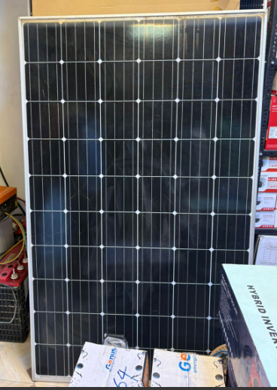\

Figure 4.1: Solar Panel

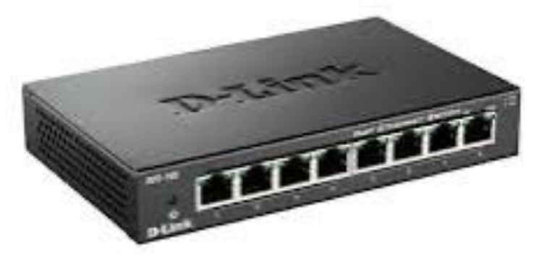

Figure 4.2: Splitter

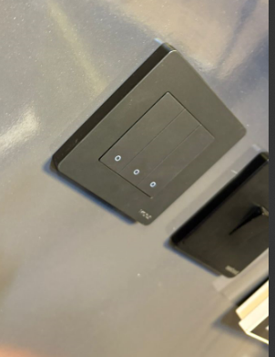

Figure 4.3: Switch Panel

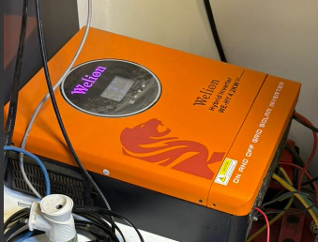

Figure 4.4: Electric Air Controller

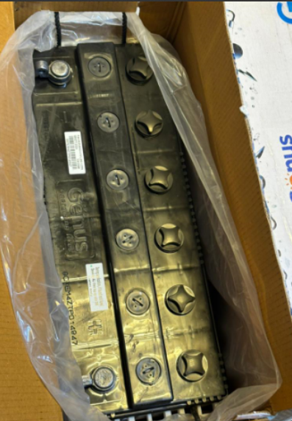

Figure 4.5: Battery



Figure 4.6: Smart Application

4.3 System Design Overview
The system is designed to automatically switch lights ON when it is dark and motion is detected, and switch them OFF when there is adequate ambient light or no motion. It draws energy from a solar panel connected to a charge controller and a battery. The ESP32 microcontroller processes inputs from the LDR and PIR sensors, controls the relay that switches the light, and communicates sensor data to an IoT platform like Blynk or ThingSpeak for remote monitoring and manual override functionality.

4.4 System Architecture
The system comprises the following components:
- Solar Power Unit: Consisting of a solar panel, charge controller, and rechargeable battery for storing and supplying energy.
- Sensors: LDR for ambient light detection and PIR for motion sensing.
- Controller: ESP32, a Wi-Fi-enabled microcontroller that processes sensor data, controls output, and connects to the IoT platform.
- Relay Module: Used to switch the lighting system ON or OFF based on control signals from the ESP32.
- Lighting Output: 12V LED light powered by the battery.
- IoT Interface: A mobile or web dashboard for real-time monitoring and manual control using Blynk or ThingSpeak.
These components interact seamlessly to create a smart lighting system that functions efficiently without human intervention.

4.5 Block Diagram

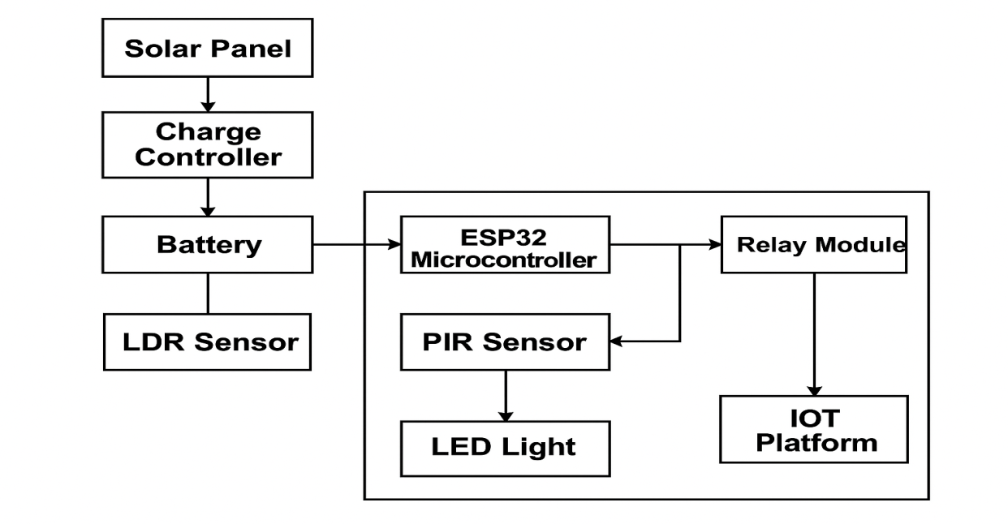

Figure 4.7 Block Diagram

4.5 Flowchart of the System
Here is the logical workflow of the system:
- Start
- Read LDR (light intensity)
- If ambient light is low (dark) → check motion sensor (PIR)
- If motion is detected, turn ON light
- If no motion, keep light OFF or turn OFF if ON
- If ambient light is high, keep light OFF
- Send sensor data to IoT platform
- End (loop)

3.1.3 System Flowchart
Below is the logical flowchart describing the operation of the automated lighting system:
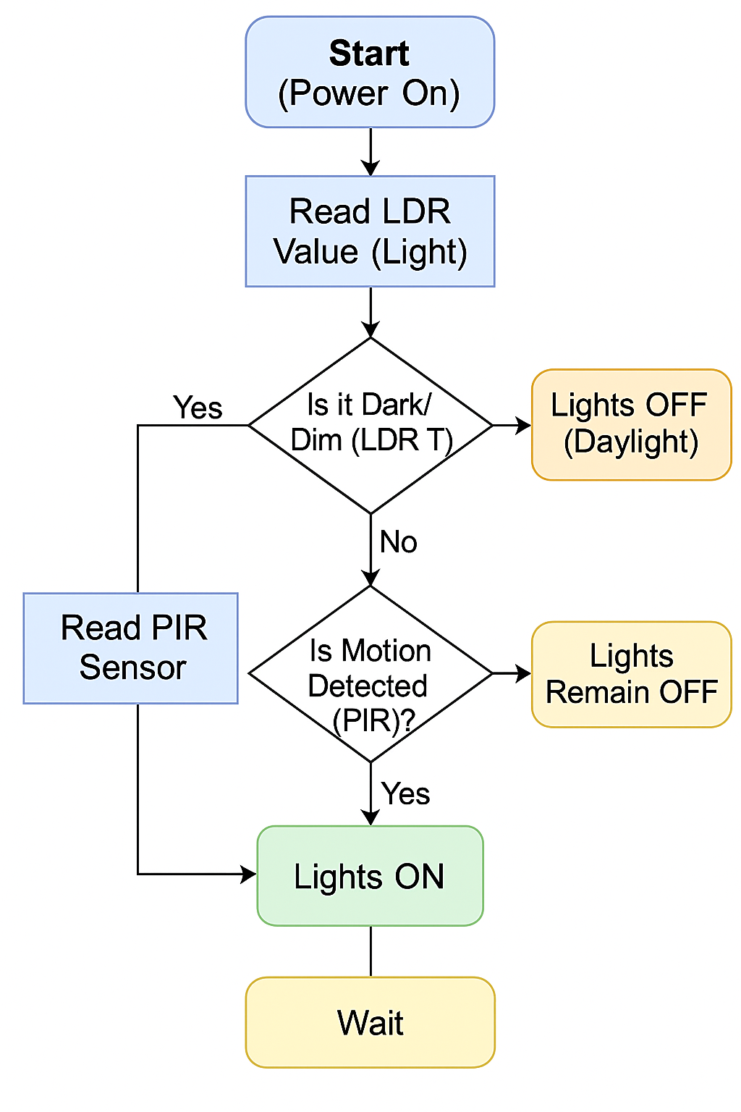

4.6 Software Design and Code Logic
The ESP32 is programmed using the Arduino IDE. The core logic involves:
- Reading analog values from the LDR
- Reading digital motion input from the PIR sensor
- Using threshold comparisons to determine actions
- Sending data to the IoT platform
- Switching the relay ON or OFF accordingly
Sample Code Snippet:
cpp
CopyEdit
int ldr = analogRead(A0);
int motion = digitalRead(2);

if (ldr < 1000) {
if (motion == HIGH) {
digitalWrite(relayPin, HIGH); // Turn ON light
} else {
digitalWrite(relayPin, LOW); // Turn OFF light
}
} else {
digitalWrite(relayPin, LOW); // Turn OFF light in daylight
}

4.7 IoT Integration (Remote Monitoring & Control)
The system is integrated with an IoT platform such as Blynk or ThingSpeak to allow remote access and control. The ESP32 communicates sensor values and system status to the cloud via Wi-Fi. On the dashboard, users can:
- Monitor LDR and PIR sensor readings
- View light ON/OFF status
- Manually override the light
- Receive alerts based on motion detection
This adds a layer of user interactivity and enhances system accessibility from any location.

4.8 Implementation Process
- Gather and assemble hardware components
- Build the prototype circuit on a breadboard
- Write and upload the code to ESP32 via Arduino IDE
- Test sensor thresholds and response time
- Configure and connect the Blynk/ThingSpeak dashboard
- Deploy the system in a test environment
- Evaluate performance under different lighting and motion conditions

4.9 Testing and Result
Condition | LDR Value | PIR Motion | Light Status | IoT Feedback
Bright Daylight | >1000 | Any | OFF | Logged
Night, Motion | <1000 | YES | ON | Logged
Night, No Motion | <1000 | NO | OFF | Logged
Manual Override | N/A | N/A | ON/OFF | Updated
Results showed that the system successfully automated light control with accurate sensing and timely updates on the dashboard.

CHAPTER FIVE

SUMMARY, CONCLUSION, AND RECOMMENDATIONS

5.1 SUMMARY
The study explores the integration of AI-based techniques for anomaly detection in solar panels, addressing the limitations inherent in traditional manual methods. The existing system, characterized by visual inspections, infrared thermography, electroluminescence imaging, I-V curve tracing, and performance monitoring, presents several challenges such as labor-intensiveness, human error, infrequent monitoring, and the need for specialized equipment. These methods are often time-consuming, inconsistent, and lack the capability for continuous real-time monitoring, leading to delayed detection and increased maintenance costs. The proposed AI-based system aims to mitigate these issues by leveraging continuous real-time monitoring and advanced machine learning algorithms. AI techniques, including deep learning and computer vision, enhance the accuracy and precision of anomaly detection, automate the process, and provide data-driven insights for proactive maintenance. The new system's scalability and efficiency enable its deployment across large solar farms, ensuring minimal downtime and optimized performance.

5.2 CONCLUSION
The implementation of AI-based anomaly detection systems represents a significant advancement in the maintenance and management of solar panels. The transition from manual, labor-intensive methods to automated, precise, and continuous monitoring addresses many of the existing system's deficiencies. AI techniques offer higher accuracy, reduce human error, and enable timely interventions, thus enhancing the overall efficiency and reliability of solar energy systems. By integrating these technologies, solar farms can achieve improved energy output, reduced maintenance costs, and extended panel lifespans, contributing to the sustainability and economic viability of solar energy.

5.3 RECOMMENDATIONS
To fully realize the benefits of AI-based anomaly detection in solar panels, the following recommendations are made:
- Investment in AI Infrastructure: Solar energy companies should invest in AI infrastructure, including sensors, data acquisition devices, and computational resources, to facilitate the integration of advanced monitoring systems.
- Training and Development: Technicians and engineers should receive training in AI technologies and data analysis to effectively implement and maintain these systems. Continuous education programs can keep staff updated on the latest advancements and best practices.
- Pilot Programs and Gradual Implementation: Companies should initiate pilot programs to test and refine AI-based systems on a smaller scale before full deployment. This approach allows for adjustments based on initial findings and ensures a smoother transition.
- Collaboration with AI Experts: Solar companies should collaborate with AI researchers and technology providers to customize solutions tailored to their specific needs. Partnerships with AI experts can drive innovation and address unique challenges in solar panel maintenance.
- Continuous Data Collection and Model Improvement: To maintain the accuracy and effectiveness of AI models, continuous data collection is essential. Regular updates and retraining of AI models with new data can improve anomaly detection capabilities over time.
- Integration with Smart Grid Technologies: Integrating AI-based anomaly detection systems with broader smart grid technologies can enhance overall energy management. This integration supports real-time decision-making and optimizes energy distribution.
- Regulatory and Standardization Efforts: The development of industry standards and regulatory frameworks for AI-based anomaly detection in solar panels can ensure consistency, reliability, and safety across different implementations.
- Focus on Cost-Benefit Analysis: Companies should conduct thorough cost-benefit analyses to understand the financial implications and potential returns on investment of deploying AI-based systems. This analysis can help in making informed decisions and securing necessary funding.

REFERENCES
Chowdhury, N. A., et al. "Photovoltaic Module Fault Detection Using Infrared Thermography." IEEE Transactions on Industrial Electronics, vol. 65, no. 8, 2018, pp. 6602-6612.
Hachicha, A. A., et al. "Infrared Thermography for Temperature Measurement and Non Destructive Testing of Photovoltaic Modules." Renewable and Sustainable Energy Reviews, vol. 82, 2018, pp. 605-613.
Kwapil, W., et al. "Electroluminescence Imaging for Quality Control of Silicon Solar Cells and Modules." Progress in Photovoltaics: Research and Applications, vol. 22, no. 3, 2014, pp. 296-303.
Haedrich, I., et al. "Combined Electroluminescence and Infrared Imaging for Module Performance and Defect Diagnosis." Energy Procedia, vol. 77, 2015, pp. 352-357.
Nakata, J., et al. "Photovoltaic Performance Monitoring and I-V Curve Tracing Using Low-Cost Equipment." Solar Energy, vol. 103, 2014, pp. 17-27.
Miyazaki, T., et al. "Development of a Monitoring System for Photovoltaic Power Generation Systems." Renewable Energy, vol. 65, 2014, pp. 27-33.
Hossain, M. S., et al. "Anomaly Detection in Solar Panels Using Machine Learning Algorithms." Journal of Renewable and Sustainable Energy, vol. 11, no. 4, 2019, pp. 045104.
Alahmadi, A., et al. "Deep Learning Framework for Fault Detection in Solar Panels." IEEE Access, vol. 8, 2020, pp. 188226-188235.
Akram, M. W., et al. "Anomaly Detection in Solar Photovoltaic Systems Using Machine Learning: A Critical Review and Future Directions." IEEE Access, vol. 8, 2020, pp. 80105-80120.
Khan, S., et al. "Machine Learning Based Approaches for Anomaly Detection in Solar Energy Systems: A Review." Solar Energy, vol. 207, 2020, pp. 994-1010.
Green, M. A., "The History of Artificial Intelligence and Its Impact on Solar Panel Maintenance." Renewable Energy Journal, vol. 120, 2018, pp. 44-57.
Anderson, J. E., "A Historical Perspective on the Evolution of Solar Panel Technology and Maintenance Techniques." Solar Energy Research and Applications, vol. 34, no. 2, 2017, pp. 89-102.

