DEVELOPMENT OF A WIRELESS SENSOR NETWORK BASED ON INTELLIGENT MULTI-AGENT SECURITY TECHNOLOGY

BY
EHIGUESE SOLOMON
HND/23/COM/FT/422

A PROJECT SUBMITTED TO:
DEPARTMENT OF COMPUTER SCIENCE INSTITUTE OF INFORMATION AND COMMUNICATION TECHNOLOGY (IICT), KWARA STATE POLYTECHNIC, ILORIN.

IN PARTIAL FULFILLMENT OF THE REQUIREMENTS FOR THE AWARD OF HIGHER NATIONAL DIPLOMA (HND) IN COMPUTER SCIENCE

2025

CERTIFICATION
This is to certify that this project was carried out by Ehiguese Solomon with Matriculation Number HND/23/COM/FT/422 in the department of Computer Science, Institute of Information and Communication Technology, Kwara State Polytechnic, Ilorin.

------------------------------------- ----------------------
MR. ISIAKA O.S. Date
(Project Supervisor)

--------------------------------- ----------------------
MR. OYEDEPO F.S. Date
(Head of Department)

----------------------------------- ---------------------
External Supervisor Date

DEDICATION
This project is dedicated to God, the most beneficent, the most merciful and to my Parent.

ACKNOWLEDGEMENT
My sincere appreciation and profound gratitude goes to God Almighty for sparing my life during the course of this project work.
I appreciate my project supervisor, the person of MR. ISIAKA O.S. for the love and support that he showered on me like his child throughout the project exercise. God bless you sir.
I want to use this medium to appreciate the effort of my HOD, MR. OYEDEPO F.S., for his fatherly role and word of encouragement towards this successful of this program.
Lastly, great thanks to my lovely parent and my family at large for supporting us endlessly and keeping us up in prayers.

ACKNOWLEDGEMENT

TABLE OF CONTENTS
PAGE
Title Page i
Certification ii
Dedication iii
Acknowledgement iv
Table of Contents v – vi
Abstract vii
CHAPTER ONE: GENERAL INTRODUCTION
  - Background of the Study 1
  - Statement of the Problem 2
  - Aim and Objectives 2
  - Significance of the Study 3
  - Scope of the Study 3
  - Organization of the Report 4
CHAPTER TWO: LITERATURE REVIEW
2.1 Literature review 5
2.2 Secure multi-agent system 8
2.2.1 Multi-agent platform security 8
2.2.2 Multi-agent platform development 9
2.2.3. Secure Mas network management 9
CHAPTER THREE: METHODOLOGY AND ANALYSIS OF THE EXISTING SYSTEM
3.1 Research Methodology 10
3.2 Analysis of the Existing System 10
3.3 Problems of the Existing System 10
3.4 Description of the Proposed System 11
3.5 Advantages of the Proposed System 11
CHAPTER FOUR: DESIGN AND IMPLEMENTATION OF THE SYSTEM
4.1 Design of the System 12
4.1.1 Output Design 12
4.1.2 Input Design 13
4.1.3 Database Design 14
4.1.4 Procedure Design 15
4.2 Implementation of the System 15
4.2.1 Choice of Programming Language 15
4.2.2 Hardware Requirements 15
4.2.3 Software Requirements 16
4.2.4 Implementation Techniques Used in Details 16
4.3 Documentation of the System 16
4.3.1 Program Documentation 16
4.3.2 Operating the System 16
4.3.3 Maintaining the System 17
CHAPTER FIVE: SUMMARY, CONCLUSION AND RECOMMENDATION
5.1 Summary 18
5.2 Conclusion 18
5.3 Recommendation 19
References 20
Flowcharts 21
Source Code Listing 27

ABSTRACT
A multi-agent system (MAS) is a system made up of multiple intelligent agents that interact with one another. Multi-agent systems can be used to solve problems that would be difficult or impossible to solve with a single agent or monolithic system. A wireless sensor network (WSN) is a wireless network composed of spatially distributed autonomous devices that use sensors to cooperatively monitor physical or environmental conditions, such as temperature, sound, vibration, pressure, motion, or pollutants, at various locations. WSNs are now used in a wide range of industrial and civilian applications, including industrial process monitoring and control, machine health monitoring, environment and habitat monitoring, and healthcare. A multi-agent system (MAS) is a system made up of multiple intelligent agents that interact with one another. Multi-agent systems can be used to solve problems that would be difficult or impossible to solve with a single agent or monolithic system. The proposed application will be created using the.net (dot. Net) integrated development environment (.net IDE). The application IDE was chosen because extracted information must be presented in an enhanced pictorial/graphical format and communicate easily with the database for program flexibility in window platforms and wireless sensor networks.

CHAPTER ONE
GENERAL INTRODUCTION
1.1 BACKGROUND OF THE STUDY
The introduction of Intelligent Multi Agent technologies has altered many human activities, most notably security. Most institutions, such as Polytechnic and University campuses, are in critical positions in terms of capital asset security (i.e. detecting any problem through monitoring: temperature, motion, etc). Intelligent multi-agent technologies are one of the most important tools for accomplishing such tasks. A multi-agent system (MAS) is a system made up of multiple intelligent agents that interact with one another. MAS can be used to solve problems that an individual agent or monolithic system would find difficult or impossible to solve, such as effective and continuous environmental monitoring. A novel multi agent technologies system was proposed in this research work to secure and/or monitor the buildings and rooms in a Polytechnic environment (Raji and Abdulrahman, 2017).
It is assumed that most organizations, such as university campuses, have critical positions and rooms that must be secured. A university campus could be secured by a number of security guards making security checking rounds (on foot or by vehicle) within the university campus. Another option is to use security camera systems. Nonetheless, such systems must be monitored on the fly by a person, and the attacker may be wearing a mask or dressed as a security guard, making it untrustworthy. The goal of this paper is to create an effective and low-cost security system based on a wireless sensor network and multi-agents to protect the buildings and faculties on a university campus (Hare & Lowen, 2000).
A wireless sensor network (WSN) is a wireless network composed of spatially distributed autonomous devices that use sensors to cooperatively monitor physical or environmental conditions, such as temperature, sound, vibration, pressure, motion, or pollutants, at various locations. WSNs are now used in a wide range of industrial and civilian applications, including industrial process monitoring and control, machine health monitoring, environment and habitat monitoring, and healthcare (Faisal, 2010).
A multi-agent system (MAS) is a system made up of multiple intelligent agents that interact with one another. Multi-agent systems can be used to solve problems that would be difficult or impossible to solve with a single agent or monolithic system. Agent systems are systems that are open and extensible, allowing the deployment of autonomous and proactive software components. They have been used in a variety of applications, including context-aware and infomobility services. Any information that can be used to characterize the situation of an entity, where an entity is a person, place, route, train, or any relevant object, is referred to as context (Hare & Lowen, 2000). Context-aware services, then, could be defined as those that provide "up to the minute" information about a given entity. These services include location-based services, travel assistance and planning, and mobility assistance for people with disabilities (Faisal, 2010).
As two major communication technologies, the Internet and wireless, mature at a rapid pace, we must urgently re-establish user confidence in order to harvest new potential applications for large-scale distributed systems. Service agents and distributed multi-agent systems (MAS) have shown promise in assisting with this transition, but a lack of trust caused by severely compromised security issues and concerns about out-of-date solutions is impeding progress. As a result, seek new remedies to ensure that continuity in developing new economies is maintained by developing new solutions to today's techno-economical problems. For this, we begin with trust, a mechanism for measuring trust and improving it for growing markets that provide superior new solutions to today's security issues (Rashvand, 2016).
1.2 STATEMENT OF THE PROBLEM
Existing security solutions are very complex and not cost effective, Security Operatives do not receive timely threat notification in order to respond to the threat as quickly as possible, the attacker may be wearing a mask or dressed as a security guard, making it unreliable, and large environments cannot be monitored and secured solely through human efforts, necessitating the use of intelligent agent technology.
1.3 AIM AND OBJECTIVES
The aim of this study is to develop a wireless sensor network-based intelligent multi-agent security technology. The objectives are as follows:
i. To develop a system that provides adequate monitoring for critical facilities.
ii. To develop a system that allows for rapid threat notification to security personnel so that they can respond to the threat as quickly as possible.
iii. Using intelligent multi-agent technology and wireless sensor networks, to design such technologies with the goal of activating asset security and providing adequate monitoring for critical facilities at the Polytechnic.
1.4 SIGNIFICANCE OF THE STUDY
The significance of this research is that most institutions, such as Polytechnic and University campuses, are in critical positions in terms of capital asset security (i.e. detecting any problem through monitoring: temperature, motion, etc). Intelligent multi-agent technologies are one of the most important tools for accomplishing such tasks. A multi-agent system (MAS) is a system made up of multiple intelligent agents that interact with one another. MAS can be used to solve problems that would be difficult or impossible to solve with a single agent or monolithic system, such as effective and continuous environmental monitoring.
1.5 SCOPE OF THE STUDY
This project work encompasses all aspects of systematic investigation or monitoring of the actions or communications of one or more people in a specific location. Surveillance security systems use surveillance cameras to monitor activities in various areas of the establishment. Cameras can be stationary or rotate in different directions to provide better coverage of activities in a given area. It provides inventory control for today's retail stores, security for corporate and educational campuses, and smart roadway and rapid transit network security and demand monitoring.
1.6 ORGANISATION OF THE REPORT
The first chapter contains the general introduction, which is the chapter that explains what the project is all about. It also includes a statement of the problems, project objectives, the significance of the study, and the scope of this project. The second chapter discusses the literature review, different types of surveillance, and a general text review. The third chapter examines the existing system and project methodology. It also includes data collection methods, an analysis of the existing system and its problems, an analysis of the proposed system's advantages, and design and implementation methodology. The fourth Chapter enumerates the system's design, implementation, and documentation, as well as the output design, input design, database design, and procedure design. The hardware and software that this project supports are also explained. The fifth chapter is the concluding section, which includes a summary of the entire chapter as well as recommendations.

CHAPTER TWO
REVIEW OF RELATED PAST WORK
2.1 LITERATURE REVIEW
Rashvand, Salah, Jose & Harn (2002) identified two interconnected trends for developing new solutions. (1) Secure MAS, in which we seek new solutions for securing general-purpose MAS applications, and (2) Security MAS, as a new overlay security solution in which we propose distributed security models, in order to use the MAS approach for securing distributed systems. Individual agent roles in the use of information in various disciplines also necessitate the use of new security solutions. Data fusion, Ambient Intelligence, Pervasive and Ubiquitous Computing, Cloud and Grid Computing, Services Oriented Computing, and Semantic Web are all examples of emerging technologies.
Faisal et al. (2010) assumed that the majority of organizations have critical positions and rooms that must be secured and/or monitored. A multi-agent system (MAS) is a system made up of multiple intelligent agents that interact with one another. Multi-agent systems can be used to solve problems that would be difficult or impossible to solve with a single agent or monolithic system.
Bendjima & Feham (2012) discovered that, regardless of packet size, our approach consumes less energy than other approaches (whose curves are nearly identical). MAWSNC, on the other hand, consumes less energy than other approaches: nearly 50% for small packets (0.5 Ko), 55% for medium-sized packets (2Ko), and 60% for large packets (4Ko), indicating that the difference in energy consumption worsens as packet size increases.
Raji & Gbolagade (2018) demonstrated that the proposed system's fault tolerance agents function as follows: When a multi agent system (MAS) fails to receive the registration and deregistration messages, an agent detects a failure in that mobile agent.
i. Assuming a mobile agent arrives at a processing node, it registers the message and receives its charge from the previous node's MAS running at a subnetwork's cluster head. The message is then sent to MASi-1 by A.
ii. MASi-1 waits for the message for a specified timeout interval before requesting MASi to determine the status of the mobile agent.
iii. When MASi-1 sends a request, MASi searches the database for registration information.
iv. If the registration information is discovered, MASi retransmits the message registration information to recover the lost message. If the registration information is not found, MASi recovers the mobile agent in the node by requesting the checkpoint from MASi-1.
v. If processing nodei fails to provide the message, MASi requests it from the MAS running at the WSN's base station. MASi retransmits the message registration information after the failure recovery procedure is completed.
vi. The mobile agent completes the task at the processing node and performs a status check at the processing node. The message deregistration is then registered at the processing node.
vii. If the checkpoint fails, the process enlists the assistance of the MAS running at the cluster head of a subnetwork, as well as the assistance of the MAS at the network's base station. If it fails again, the entire task is aborted.
viii. Before migrating from the processing node, the mobile agent performs appropriate fault tolerance to restore the sent message.
For developing a multi-agent application, Raji & Abdulrahman (2018) proposed a three-step methodology. The methodology focuses on logical issues of the problem at hand before moving on to implementation. The stages are as follows:
i. Identifying the Agents: Begin with the list of goals we want the system to achieve, then consider the various entities that will interact with one another to achieve this overall goal. These entities represent the system's agents. After identifying the agents, define each agent's goals and the services they offer. By grouping agents with similar goals and services into a single category, the agents are divided into different categories. These categories aid in the identification of the application's agent classes. Following the identification of the agent classes, identify the application-specific classes that each agent class may use.
ii. Identifying the Conversations: When developing agents, the world is being viewed as composing of intelligent things. At this stage, we begin to model the interaction between these things in the form of conversations. Identify every possible conversation an agent can engage in, and represent those conversations by developing an automata model for each of them. These different automata models identify the different conversation classes in the application.
iii. Identifying the Conversation Rules: Each conversation is represented by an automata model. Alternative actions of an agent produce different states in the conversation (automation), and the current state of a conversation influences how the agent reacts in the next moment. Conversations are rule-based descriptions of what an agent does in specific situations.
According to Muaz & Amir (2011), agent-based computing is a large and widely spread scientific domain. An agent can be anything from a "software agent" or "service/daemon," which may or may not behave intelligently, to an intelligent agent, which is based on artificially intelligent behavior models (Wooldridge 2009; Weiss 1998). An agent could even be a representation of an interacting social component of a large system used in a simulation to investigate emergent global behavior.
Intelligent multi-agent systems, according to Roya, Norwati & Nasir (2009), have enormous potential for use in a variety of applications and research areas. One of the most important issues in applying intelligent multi-agent systems in the real and virtual worlds is developing a framework that supports machine learning models that reflect the entire complexity of the real world. In this paper, we proposed a framework of intelligent agent-based neural network classification model to bridge the gap between two applicable flows of intelligent multi agent technology and real-world learning models.
Bashar, Chee & Ismail (2010) investigate whether these smoothing methods can be used to classify daily activities, how accurate the methods are at classifying activities, how sensitive the classifier's performance is to different smoothing parameter settings, and whether our proposed mechanism improves activity classification accuracy in comparison to other methods. Guy (2000) discovered that the end result is an intrusion detection system capable of detecting the intrusions specified in the original specifications.
2.2 SECURE MULTI-AGENT SYSTEM
Before delving into the security aspects of MAS and their applications, it is worth taking a quick look at some of their fundamental properties. As previously stated, MAS is a loosely coupled distributed autonomous service agent that operates according to a set of rules and is equipped with some common and specific resources to collaborate in order to achieve some specific goals. Each agent acts, has some knowledge, and some resources at its disposal (Fasli, 2007). Three complementary functions of ‘goals’, ‘self-discipline’, and ‘communication’ were maintained independently. The goals characterize the primary purpose of an agent required to perform the MAS service, whereas the self-disciplinary functions ensure the agent's survivability, trust, and dependability. The communication functions are required for the agent to have effective and reliable conversations with the core platform, other agents, or the outside world. This typically includes security, error control, and resource efficiency, for which a cross-layer mechanism may be used to make better use of scarce resources.
2.2.1 MULTI-AGENT PLATFORM SECURITY
It is demonstrated that using a multi-agent style platform simplifies MAS implementation. With today's software techniques, this can be provided via a middleware to facilitate agent deployment, control communication between agents, and maintain the necessary security measures for the agents. Because of their location in the system, agents can easily handle the majority of security functions as well as background processes within the MAS. For instance, depicts a common scenario in which various agents are used to develop a security system within a multi-agent platform.
Assume the security system is set up to handle a distributed intrusion detection system. The processes that run the multi-agent platform (MAP) are spread across multiple machines. Each agent is in charge of analyzing network behavior in relation to its own machine while sharing information on the platform with one another in order to collaborate in detecting potential intrusion activity. Because the information shared among the agents is sensitive, the platform must be capable of dealing with the security aspects of agent-to-agent communication, for which the National Institute of Standards and Technology (NIST) proposes various levels of security solutions.
2.2.2 MULTI-AGENT PLATFORM SECURITY DEVELOPMENTS
Since secure MAS platforms provide improved efficiency and dependability, they can be used to effectively secure complex distributed systems. The most significant trends in the development of new distributed security models are two. The first trend is to strengthen existing MAS platforms' security capabilities, while the second trend is to provide an overlay for existing platforms before developing new brand secure platforms.
2.2.3 SECURE MAS NETWORK MANAGEMENT
Security is now an essential component of network management services, but due to its long history, there is a great deal of variation in network management security. The IEFT3 has published a set of standards and RFCs related to network and information security. However, because these standards are not MAS-based, they cannot offer secure MAS or can do so only at a significant additional cost. Furthermore, the fabric and infrastructure of new network applications are inherently compatible with secure MAS, making them suitable for network management integration with distributed security models (Muaz et al., 2011).

CHAPTER THREE
RESEARCH METHODOLOGY AND ANALYSIS
3.1 RESEARCH METHODOLOGY
A three-step methodology was proposed for developing a multi-agent application. The methodology focuses on the logical issues of the problem at hand before moving on to implementation. The phases are as follows:
Identifying the Agents: The agents are divided into different categories by grouping agents with similar goals and services into a single category. These categories aid in identifying the agent classes in the application. After identifying the agent classes, identify the application-specific classes that each agent class may use.
Identifying the Conversations: Identify and represent every possible conversation that an agent can have by creating an automata model for each of them. These various automata models are used to identify the various conversation classes in the application.
Identifying the Conversation Rules: In order to design a multi-agent system that finds a coherent solution to the overall system problem, it is necessary to analyze the logical consistency of all agent conversations. They should be examined to ensure the system's coherence.
3.2 ANALYSIS OF THE EXISTING SYSTEM
The existing system is being monitored by a security agent, and there are security men (farsar, Civil Devence, and Army) watching over the campus (Kwara State Polytechnic, Ilorin). These security guards only watch over the campus during the day. Once it is 4pm or 6pm, nobody is there to watch over the departments; all lecturers and students leave school, and the area is being monitored by the security guard stationed in the area; he or she watches the area all night.
3.3 PROBLEMS OF THE EXISTING SYSTEM
i. Security personnel do not receive timely threat notifications, limiting their ability to respond to threats as quickly as possible.
ii. The attacker may be disguised as a security guard or wear a mask, making it untrustworthy.
iii. However, large environments cannot be monitored and secured solely through human efforts, necessitating the use of intelligent agent technology.
3.4 DESCRIPTION OF THE PROPOSED SYSTEM
Wireless Sensor Networks (WSNs) are made up of a large number of nodes that are spread out in a hostile environment. These networks are typically deployed in remote locations and are vulnerable to failure due to energy depletion, hardware failure, communication link errors, and malicious attacks if left unattended. As a result, an efficient fault tolerant technique is required to ensure that WSNs continue to operate according to their specifications even when certain faults exist. This study presents fault-tolerant WSNs based on intelligent multi-agent technology, with the primary goal of conceptualizing software architecture and network organization for optimization, monitoring, and performance analysis. This system is designed to control, monitor, and allow the network to operate indefinitely, as well as eliminate any downtime caused by wireless node power loss. The agents' dynamic nature and mobility make them suitable for maintaining these sensors in the WSN. The proposed MAS has five agents: a node monitoring agent, a network monitoring agent, a mobile agent monitoring agent, a fault decision agent, and a fault recovery agent.
3.5 ADVANTAGES OF THE PROPOSED SYSTEM
i. It solves problems that an individual agent or monolithic system would find difficult or impossible to solve, such as effective and continuous environmental monitoring.
ii. It ensures safety while reducing manpower.
iii. Multi-agent systems (MAS) can be used in large-scale WSNs to provide reliable wireless communication while conserving energy.
CHAPTER FOUR
DESIGN, IMPLEMENTATION AND DOCUMENTATION OF THE SYSTEM
4.1 DESIGN OF THE SYSTEM
This is the computation of the specifics of a new system, as well as the determination of what the new system will be and what function it will perform. This may entail switching from one system to another or modifying the current system's operation. The transition from manual to faster and more accurate operation is the most difficult phase of the system life cycle; the system design stage covers the technical specifications that will be used in the implementation of the new system in order to modify the previous system. Some factors are taken into account. Input design, output design, definitions, file and procedure designs, and other documentation are examples of these factors.
4.1.1 OUTPUT DESIGN
This includes the goals of resolving existing system problems and challenges. This entails structuring the desired information as well as improving efficient and effective intelligent multi-agent technologies for activating security through sensor networks. The following factors were considered when determining the output:
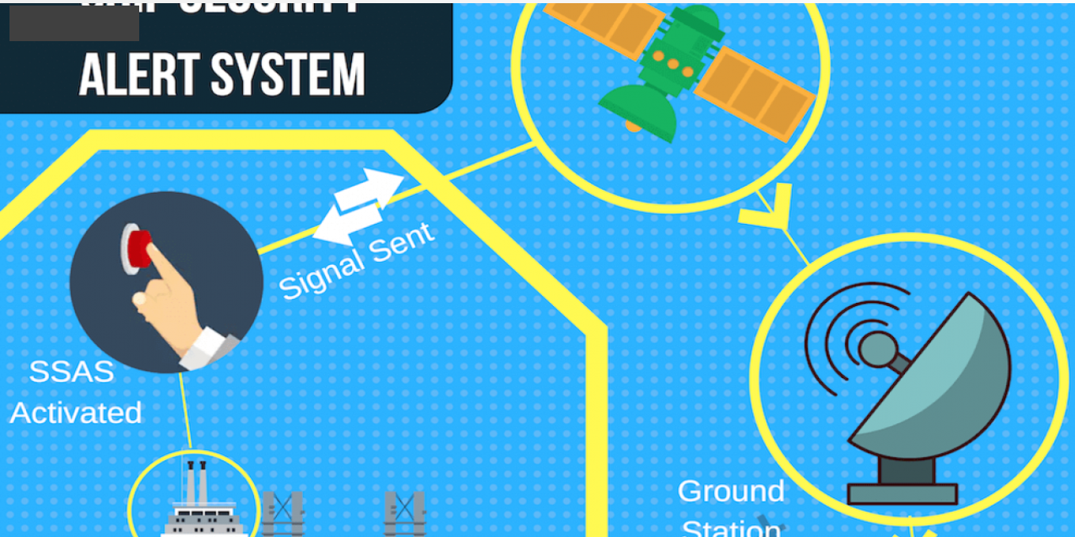
Figure 4.1: Main menu interface

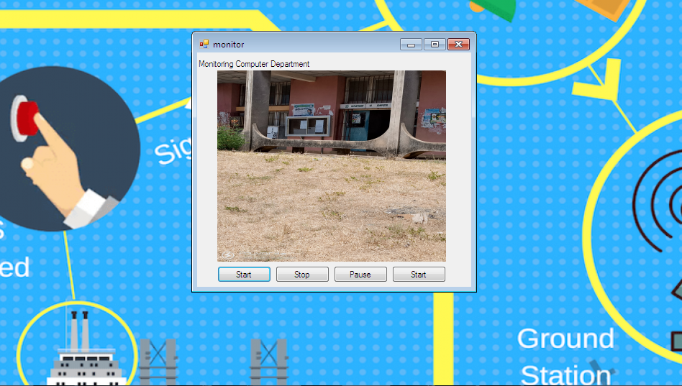
Figure 4.2: Monitoring interface

4.1.2 INPUT DESIGN
Intelligent multi-agent technologies for activating security using sensor network administrators provide the input required to run this software. Any User information must be registered by the administrator. He can accomplish this by typing on the keyboard. Users' personal data and answers are required as input. In response to the administrator's questions. It can serve as the various input layouts from the various modules, starting with the data collection and module, then moving on to the assessment module and user input.
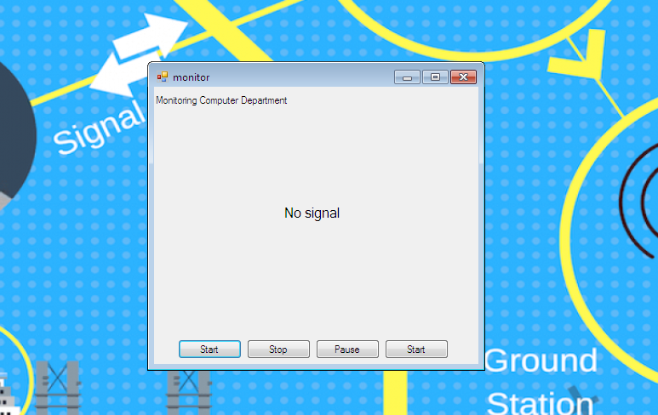
Figure 4.3: Monitoring initialization interface

4.1.3 DATABASE DESIGN
The input file is processed against the output file to generate the required output, and the "various file layout (designs)" have already been provided in the various pages, under the input design and the output design for the various modules, respectively.
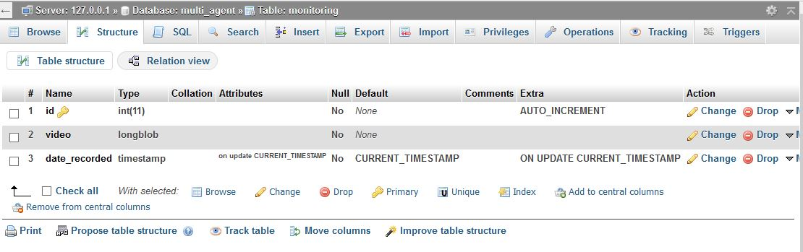
Figure 4.4: Monitoring database interface

4.1.4 PROCEDURE DESIGN
These are the steps involved in bringing the entire process together to produce the desired result. It entails computer procedures that begin with the original input lessons and end with the output result file. This enables the processing of User information and the generation of results. A menu is provided to assist the user in processing the output file.
4.2 IMPLEMENTATION OF THE SYSTEM
This includes selecting the programming language to be used to implement the software, which should be suitable for intelligent multi-agent technologies for activating security via sensor networks. The software is intended for use with intelligent multi-agent technologies to activate security using a sensor network as an assistant. It is also anticipated that it will be used in conjunction with the User. The Intelligent multi-agent technologies for activating security using sensor network administrators will prepare a data base, while the administrators will provide personal information about the user.
4.2.1 CHOICE OF PROGRAMMING LANGUAGE
The application was created using an integrated development environment called.net (dot net) (.net IDE). The Application IDE was chosen because extracted information needs to be presented in an enhanced pictorial/graphical format, as well as easy communication with the database for program flexibility on the Windows platform.
4.2.2 HARDWARE REQUIREMENT
i. 500 Hz minimum with CD ROM drive etc.
ii. Hard disk of capacity 10GB Minimum
iii. 126-512 megabyte of RAM
iv. An Uninterrupted power supply (UPS)
v. A voltage stabilizer
vi. A power generating set etc.

4.2.3 SOFTWARE REQUIREMENT
i. Windows Operating system such as Windows 7 etc
ii. Dream Weaver
iii. Server Query Language (SQL).
4.2.3 IMPLEMENTATION TECHNIQUES USED
The new system will be operational alongside the old one in order to test the new system's dependability and efficiency. This method of changeover is known as a parallel changeover method.
4.3 DOCUMENTATION OF THE SYSTEM
4.3.1 PROGRAM DOCUMENTATION
The program is packaged for use in any system, regardless of whether it supports the Visual Studio application or not. Following the development of a program in Visual Studio, a facility called "Package and Deployment Wizard" is provided in the Microsoft Visual Studio suite and is used in Visual Studio application packaging and deployment. This system is made up of four modules:
i. Splash module: This is the first page that will appear when you run/launch this application, and it provides a brief introduction to the application.
ii. Login module: This is the page where administrators enter or supply their login information for authentication.
iii. Main Menu: This is a page with additional submenus for navigation.
iv. Monitoring Module: This is where intelligent monitoring occurs.
4.3.2 OPERATING THE PROGRAM
Click the start button on the Windows start bar, then move the mouse pointer to all programs, click the Wamp Server to locate the application's folder, and then click it. The user will be taken to the Home page, from which he or she can navigate to other pages one by one.

4.3.3 MAINTAINING THE SYSTEM
System maintenance refers to making changes to an already existing application or program without having to rewrite everything from scratch. Program maintenance entails modifying the program to meet the needs of the users. Additional features can be added, errors corrected, ambiguous interfaces redesigned to eliminate confusions, and unnecessary features removed during this course. This program can be maintained in a Visual Studio environment. Any future changes can be made by re-running the program source code in a visual studio environment, making the necessary changes and updates, and recompiling the application into an upgraded version of the existing mini word processing application.
CHAPTER FIVE
SUMMARY, CONCLUSION AND RECOMMENDATIONS
5.1 SUMMARY
This study generated several key ideas for an intelligent multi-agent technology for a sensor network-based security system. Based on the modeling work presented in the previous chapters, a flexible, basic architecture for a sensor network-based intelligent multi-agent technologies system was designed and implemented to demonstrate the workability of such a system, which could be further extended into a complete, operational intelligent multi-agent technology for activating security system. The use of intelligent multi-agent technology in a sensor network approach to security activation was investigated. Agent-based systems and intelligent agents are two important research topics. Intelligent multi-agent systems have enormous potential for use in a variety of applications. Consider the issue of a lack of a unified framework for combining two relevant flows, intelligent multi-agent systems in the real world and learning systems for the creation of a single intelligent framework in the virtual environment.
5.2 CONCLUSION
In this project, the researcher proposed a novel system that can be used to build an effective and low-cost security system using a wireless sensor network and multiple agents. The intelligent agents are in charge of detecting security breaches and alerting security guards (with the help of sensors). As a result, there is no need for a human to constantly monitor the polytechnic campus's rooms and buildings. Furthermore, the system could be used to secure any organization with critical locations. Although we used laptops in the implementation to simulate sensor functions, real sensors could be seamlessly integrated into the system. In the future, the researcher intends to investigate the use of cameras in conjunction with this system and, as a result, to use image processing techniques to extract security attack features. In this regard, location-based services could be used to track the attacker in the case of personal attacks, as discussed in one of the literature.
5.3 RECOMMENDATIONS
Based on the findings of this study, it is strongly suggested that:
i. The security system should be monitored to ensure the safety of employees and students.
ii. For user compatibility and usage, the system should be generalized and user friendly.
iii. The institution should educate/organize a seminar for their security officers to learn about the utility of this system and to raise awareness among those who are unaware of its implementation.
iv. More research on this topic is needed for more information.

REFERENCES
Faisal A. (2010) A Multi-agent-based system for securing university campus, 1Faculty of IT and Computer Sciences, Yarmouk University, Jordan Faculty of Science and IT, Al-Isra University, Jordan
Hare & Lowen (2000) Computers & Graphics, Special Issue on Pervasive Computing and Ambient Intelligence -Mobility, Ubiquity and Wearables Get Together, Vol. 28, No. 4, Elsevie, pp. 677-689.
Kamaldeen A. (2018) Intelligent Multi-Agent System Based Fault Detection, Monitoring and Recovery in Wireless Sensor Network, International Journal of Information Processing and Communication (IJIPC) Vol. 6 No. 1 , June 2018, pp 17-28
Raji A.K & Gbolagade K (2018) An Enhanced Vitality Efficient and Reliable Wireless Sensor Networks with CRT-Based Packet Breaking Scheme, International Journal of Sensors and Sensor Networks, ISSN: 2329-1796 (Print); ISSN: 2329-1788 (Online)
Raji A.K. & Abdulrahman T.A. (2017) Securing Polytechnic Environment-Agent based with System, Tetfund Sponsored Kwara State Polytechnic Journal of Research and Development Studies Vol. 5. No. 1 June 2017.
Raji A.K. etal (2012). Wireless Internet Access Use by State Polytechnic-Nigeria, Ilorin. International Journal of Advance Technology, Volume3, No4, pp 279-282.
Rashvand H., Salah K, Jose A. & Harn L. (2002) Distributed Security for Multi-Agent Systems Review and Applications
Roya A., Norwati M. & Nasir S (2009) A Framework For Intelligent Multi Agent System Based Neural Network Classification Model, (IJCSIS) International Journal of Computer Science and Information Security, Vol. 5, No. 1

PROGRAM FLOWCHART
Start
Login
Main menu
Monitoring
Help
Report
Stop
LOGIN FLOWCHART
Yes
Yes
MAIN MENU
ENTER USERNAME AND PASSWORD
IS ENTRY CORRECT?
INCORRECT USERNAME OR PASSWORD ENTRY
RETRY?
Stop
Start
Yes
No
No

MAIN MENU FLOWCHART
Start
Is option monitoring?
Is option help?
Stop
Yes
Y
Select option
Monitoring
Help
Is option report?
Report
Yes
Yes
No
No
No

Monitoring flowchart
Start
Is attacker detect?
Even Log
Stop
Yes
Act as needed when and without attack
Attack?
No
Primary data collection
Alert
Act as needed when and without attack

Yes
No

REPORT FLOWCHART

Start

Open database
IS
EOD?
Display Report
Close Database
Return

Read data
No
Yes
HELP FLOWCHART

Start

Open database
Display Help File
Close Database
Return

SOURCE CODE LISTING
using System;
using System.Collections.Generic;
using System.ComponentModel;
using System.Data;
using System.Drawing;
using System.Text;
using System.Windows.Forms;
using Inversion;
using System.IO;
using System.Data.OleDb;
using System.Drawing.Imaging;

using CSharpFilters;

namespace sobel_filtering
{
public partial class Form1 : Form
{
string _dataBasePath = "";
string save_file, extension;
string file_name;
private LogicalOperator processing;
Bitmap b;
string crop_image;
int bLength;
int xp, xq, yp, yq, spq;
int lip_wx, lip_wy;
Bitmap Bit;
Bitmap undo_picture;//for undoing image

public Form1()
{
InitializeComponent();
processing = new LogicalOperator();
}

public Bitmap black_and_white(Image Im)
{
Bitmap b = (Bitmap)Im;
int A, B, C, c;
int limit = 110;

for (int i = 1; i < b.Height; i++) // loop for the image pixels height
{
for (int j = 1; j < b.Width; j++) // loop for the image pixels width
{
Color col;
col = b.GetPixel(j, i);

A = Convert.ToInt32(col.R);
B = Convert.ToInt32(col.G);
C = Convert.ToInt32(col.B);
if (A > limit || B > limit || C > limit)
c = 255;
else
c = 0;

if (c == 0)
b.SetPixel(j, i, Color.Black);
else
b.SetPixel(j, i, Color.White);
}
}
return b;
}

public Bitmap white(Image Im)
{
Bitmap b = (Bitmap)Im;
int A, B, C, c;
int limit = 110;

for (int i = 1; i < b.Height; i++) // loop for the image pixels height
{
for (int j = 1; j < b.Width; j++) // loop for the image pixels width
{
Color col;
col = b.GetPixel(j, i);

c = Convert.ToInt32(col.R) + Convert.ToInt32(col.G) + Convert.ToInt32(col.B);
c /= 3;

if (c > 135)
c = 0;
else
c = 255;

if (c == 0)
b.SetPixel(j, i, Color.Black);
else
b.SetPixel(j, i, Color.White);

}
}
return b;
}

public Image black_white(Image Im)
{
Bitmap b = (Bitmap)Im;
for (int i = 1; i < b.Height; i++) // loop for the image pixels height
{
for (int j = 1; j < b.Width; j++) // loop for the image pixels width
{
Color col;
col = b.GetPixel(j, i);

int c;
c = Convert.ToInt32(col.R) + Convert.ToInt32(col.G) + Convert.ToInt32(col.B);
c /= 3;
if (c > 128)
c = 255;
else
c = 0;

if (c == 0)
b.SetPixel(j, i, Color.Black);
else
b.SetPixel(j, i, Color.GhostWhite);

}
}
return (Image)b;
}

public Image gray(Image Im)
{
Bitmap b = (Bitmap)Im.Clone();
for (int i = 0; i < b.Height; i++) // loop for the image pixels height
{
for (int j = 0; j < b.Width; j++) // loop for the image pixels width
{
Color col;
col = b.GetPixel(j, i);
b.SetPixel(j, i, Color.FromArgb((col.R + col.G + col.B) / 3, (col.R + col.G + col.B) / 3, (col.R + col.G + col.B) / 3));

}
}
return (Image)b;
}

public Image sobel(Image im)
{
int[,] gx = new int[,] { { -1, 0, 1 }, { -2, 0, 2 }, { -1, 0, 1 } }; // The matrix Gx
int[,] gy = new int[,] { { 1, 2, 1 }, { 0, 0, 0 }, { -1, -2, -1 } }; // The matrix Gy
b = (Bitmap)im;
Bitmap b1 = new Bitmap(im);
for (int i = 1; i < b.Height - 1; i++) // loop for the image pixels height
{
for (int j = 1; j < b.Width - 1; j++) // loop for image pixels width
{
float new_x = 0, new_y = 0;
float c;
for (int hw = -1; hw < 2; hw++) //loop for cov matrix
{
for (int wi = -1; wi < 2; wi++)
{
c = (b.GetPixel(j + wi, i + hw).B + b.GetPixel(j + wi, i + hw).R + b.GetPixel(j + wi, i + hw).G) / 3;
new_x += gx[hw + 1, wi + 1] * c;
new_y += gy[hw + 1, wi + 1] * c;
}
}

if (new_x * new_x + new_y * new_y > 128 * 128)
b1.SetPixel(j, i, Color.Black);
else
b1.SetPixel(j, i, Color.White);
}
}
return (Image)b1;
}

public Image prewitt(Image im)
{

int[,] gx = new int[,] { { 1, 1, 1 }, { 0, 0, 0 }, { -1, -1, -1 } }; // The matrix Gx
int[,] gy = new int[,] { { -1, 0, 1 }, { -1, 0, 1 }, { -1, 0, 1 } }; // The matrix Gy
b = (Bitmap)im;
Bitmap b1 = new Bitmap(im);

for (int i = 1; i < b.Height - 1; i++) // loop for the image pixels height
{
for (int j = 1; j < b.Width - 1; j++) // loop for image pixels width
{
float new_x = 0, new_y = 0;
float c;
for (int hw = -1; hw < 2; hw++) //loop for cov matrix
{
for (int wi = -1; wi < 2; wi++)
{
c = (b.GetPixel(j + wi, i + hw).B + b.GetPixel(j + wi, i + hw).R + b.GetPixel(j + wi, i + hw).G) / 3;

new_x += gx[hw + 1, wi + 1] * c;
new_y += gy[hw + 1, wi + 1] * c;
}
}
if (new_x * new_x + new_y * new_y > 128 * 100)
b1.SetPixel(j, i, Color.Black);
else
b1.SetPixel(j, i, Color.White);
}
}
return (Image)b1;
}

public Image laplace(Image im)
{
int[,] gx = new int[,] { { -1, 0, 1 }, { -2, 0, 2 }, { -1, 0, 1 } }; // The matrix Gx
int[,] gy = new int[,] { { 1, 2, 1 }, { 0, 0, 0 }, { -1, -2, -1 } }; // The matrix Gy

//int[,] gx = new int[,] { { 1, 1, 1 }, { 0, 0, 0 }, { -1, -1, -1 } }; // The matrix Gx
//int[,] gy = new int[,] { { -1, 0, 1 }, { -1, 0, 1 }, { -1, 0, 1 } }; // The matrix Gy
b = (Bitmap)im;
Bitmap b1 = new Bitmap(im);
for (int i = 1; i < b.Height - 1; i++) // loop for the image pixels height
{
for (int j = 1; j < b.Width - 1; j++) // loop for image pixels width
{
float new_x = 0, new_y = 0;
float c;
for (int hw = -1; hw < 2; hw++) //loop for cov matrix
{
for (int wi = -1; wi < 2; wi++)
{
c = (b.GetPixel(j + wi, i + hw).B + b.GetPixel(j + wi, i + hw).R + b.GetPixel(j + wi, i + hw).G) / 3;

new_x += gx[hw + 1, wi + 1] * c;
new_y += gy[hw + 1, wi + 1] * c;
}
}
if (new_x * new_x + new_y * new_y > 128 * 45)
b1.SetPixel(j, i, Color.Black);
else
b1.SetPixel(j, i, Color.White);
}
}
return (Image)b1;
}

public Image mirror_image(Image im)
{
Bitmap b = (Bitmap)im.Clone();

Color c1, c2;

for (int i = 0; i < b.Height - 1; i++)
{
for (int j = 0; j < b.Width / 2 - 1; j++)
{
c1 = b.GetPixel(j, i);
c2 = b.GetPixel(b.Width - j - 1, i);

b.SetPixel(j, i, c2);
b.SetPixel(b.Width - j - 1, i, c1);

}
}

return (Image)b;
}

private void button1_Click(object sender, EventArgs e)
{
if (openFileDialog1.ShowDialog() == DialogResult.OK)
{
pictureBox1.Image = Image.FromFile(file_name);
contrast_function();
button_connected.Enabled = true;
button_skincolor.Enabled = true;
button2.Enabled = true;
}

