DESIGNING A RELIABLE SMOKE DETECTOR USING ARDUINO FOR SMART PROPERTY SECURITY

BY

HASSAN HAMIDAT
ND/23/COM/PT/0237

A PROJECT SUBMITTED TO THE DEPARTMENT OF COMPUTER SCIENCE, INSTITUTE OF INFORMATION AND COMMUNICATION TECHNOLOGY, KWARA STATE POLYTECHNIC, ILORIN, NIGERIA
IN PARTIAL FULFILLMENT OF THE REQUIREMENTS FOR THE AWARD OF NATIONAL DIPLOMA [ND] IN COMPUTER SCIENCE

AUGUST 2025

CERTIFICATION

This is to certify that this project work was carried out by AMINULLAHI BALIKIS AYOMIDE with matriculation number ND/23/COM/PT/0237 has been read and approved as meeting part of the requirement for the award of National Diploma in Computer Science.

_________________________ __________________
MR. BOLAJI-ADETORO D.F. Date
Project Supervisor

_________________________ __________________
MR. OYEDEPO F.S. Date
Project Supervisor

_________________________ __________________
External Examiner Date

Dedication
This project is dedicated to God, the most beneficent, the most merciful

ACKNOWLEDGEMENT
The journey through this academic program has been both challenging and rewarding. Through all the trials and triumphs, I give all glory, honor, and adoration to the Almighty God for His unending grace, divine protection, and sustenance from the very first day I stepped into the academic world until this present moment. Without His mercy, I would not have come this far.
I wish to express my heartfelt gratitude to the Head of the Computer Science Department, Mr. Oyedepo F.S., for his unwavering support, fatherly guidance, and consistent encouragement throughout the course of my academic journey. His administrative leadership and personal interest in the success of students have been a source of great motivation to me.
My profound appreciation goes to my project supervisor, Mr. Bolaji-Adetoro D.F., for the invaluable role he played in the successful completion of this research project. His intellectual input, timely corrections, encouragement, and professional mentorship were instrumental in shaping the quality of this work. I consider it a great privilege to have worked under his supervision.
I also wish to extend my sincere appreciation to all the lecturers in the Department of Computer Science for their dedication to academic excellence and for imparting knowledge and discipline throughout my course of study. Each of you contributed uniquely to my academic and personal growth.
To my family, friends, and colleagues who stood by me in prayers, words of encouragement, and support during trying times, I say thank you.
Above all, I am grateful to everyone who, in one way or the other, contributed to the successful completion of this project.

TABLE OF CONTENTS
Title page
Certification
Dedication
Acknowledgement
Table of content
Abstract
CHAPTER ONE: GENERAL INTRODUCTION
  - Introduction
  - Statement of the problem
  - Aims and objectives of the study
  - Significance of the study
  - Scope and limitation of the study
  - Organization of the report
  - Definition of Terms
CHAPTER TWO: REVIEW OF RELATED LITERATURES AND STUDIES
  - Review of related literature
  - Review of General text
CHAPTER THREE: RESEARCH METHODOLOGY AND ANALYSIS
  - Research methodology
  - Analysis of the existing system
  - Problems of the existing system
  - Description of the proposed system
  - Advantages of the proposed system
CHAPTER FOUR: DESIGN, IMPLEMENTATION AND DOCUMENTATION OF THE SYSTEM
  - Design of the system
    - Output Design
    - Input Design
    - Database design
    - Procedure Design
  - Implementation of the System
    - Choice of Programming Language Used
    - Hardware and Software Requirements
    - Software support
    - Change over techniques
  - Documentation of the system
    - Program Documentation
    - Maintaining the system
CHAPTER FIVE: SUMMARY, CONCLUSION AND RECOMMENDATION
  - Summary
  - Conclusion
  - Recommendation
References
Appendices

ABSTRACT
This project explores the design and implementation of an Arduino-based smoke detection system aimed at enhancing property protection. The system integrates an Arduino Uno microcontroller with an MQ-2 smoke sensor, a buzzer for audible alerts, and LEDs for visual notifications. The primary goal is to create a reliable, cost-effective, and user-friendly smoke detector that addresses the limitations of both commercial and DIY smoke detection systems. The proposed system continuously monitors the environment for smoke and triggers an alarm when smoke levels exceed a predefined threshold. The MQ-2 sensor's sensitivity can be adjusted to reduce false alarms, ensuring accurate detection. The system's design emphasizes ease of use, with a straightforward assembly process and intuitive operation. Visual and audible alerts provide immediate and clear notifications, enhancing user awareness and response times. The results demonstrate that the Arduino-based smoke detection system is reliable and effective in detecting smoke while minimizing false alarms. The system's scalability allows for future enhancements, such as network connectivity for remote monitoring and alerts, making it a versatile solution for various environments.
CHAPTER ONE
1.1 INTRODUCTION
In our daily life, we come across may incidents that fire engulfed in industries or in any hospitals. But we don’t focus much on how this gas or smoke or fire was detected. Here’s the project which describes about how the smoke is being detected and how it performs operations through logistics available in market in a scientific procedure. In this project the detection of gases like smoke, butane, propane, alcohol can be detected by a sensor named MQ-2 gas sensor. When the gas is detected by this MQ-2 sensor, its voltage fluctuates and when it reaches a value 200 it indicates that as gas. So, this need to be programmed in an Arduino uno in order to experiment practically, as Arduino uno is used in various multitasking purposes, we can use it here for detecting smoke and need to give a cautious buzzer or LED blinking that smoke is detected. so, this Arduino uno is programmed in such a way that when the smoke senor MQ-2 value reaches 200 or above it needs to give a buzzer or light as output (Shiva, K., 2021).
Fire and Gas detection alarm systems are important tools for safeguarding our residence home, building, office, market, and other places. A well-designed fire and gas system is intended to detect and, in some cases, automatically mitigate fire, flammable gas and toxic gas hazards. Proper placement of detectors is critical in the design of a fire and gas system to ensure that coverage is adequate to detect hazards at their incipient stage, in order to prevent escalation. The rates of increase of these three components are used in the fire alarm algorithm to determine the presence of a fire. The smoke sensor provides a mean to detect smoke and to serve as an early fire warning. Heat detectors are the oldest type of automatic fire detection device (Vivek, P., et al., 2014). They respond either when the detecting element reaches a predetermined fixed temperature or to a specified rate of temperature change. If a fire should result, systems can be attached to extinguish the fire and protect other areas from the actions of the fire. Generally, the fire detection system and gas detection system is combined into one fire and gas system. A separation that may be made is to have one fire and gas system for the processing areas and another sub-system for the usefulness or office/accommodation areas (Mahzan, N., et al., 2018).
Amongst the occurred disasters happened in the resident area, fires have been known as the dangerous tragedy that could cause destruction, property and life losses. In many disasters, fires have become recurrent, destructive and most influential disasters if compared to others hazards. With the rapid development of urban construction, the occurrence probability of the great fire and other special disaster also increased year by year. Fires in the early detection and early warning are two important ways to extinguish the fire promptly and avoid great casualties and property loss. Therefore, the requirement of placing intelligent fire alarm system is important within buildings especially in the buildings where contain many people inside or valuable belongings (Mahzan, N., et al., 2018).
According to the statistic stated by Fire and Rescue Department of Malaysia (JBPM), in 2016 only, almost 5500 of fire cases reported are concerned with the households followed by transportations, electrical appliances and leaking gasses (Malaysia, P., 2016). Fires in the households are often triggered by many common factors investigated which are from cooking equipment, smoking in the house, electrical appliances, candles, curious children, faulty wiring and many more. If the fire occurs when the residents are in the house, the possibility to extinguish the fire is a bit high. It is because the residents themselves can take immediate precaution from the fire to be spread all over by using fire extinguisher or call the fireman existence of the fire in the house. Having said that, the home fire alert is purposely designed to alert the house residents whenever any possibilities for having fire disaster prompted in their house (Mahzan, N., et al., 2018).
Ever since mankind first began building structures out of wood rather than stone, fire has been a part of the learning process. In fact, so common have these infernos been throughout history that nearly every major city in the world has been largely burnt to the ground at one time or another in its history. An example of such fire outbreak was in Boston 1872. While not as large a fire as the one in Chicago the year before or the fire that was to ravage San Francisco just over three decades later Firefighting requires skills in combating, extinguishing, and preventing fires, responding to emergency calls, operating and maintaining fire department equipment and quarters, and extensive training in performing firefighting activities. The earliest known firefighters were in the city of Rome. In 60 A.D., emperor Nero established a Corps of Vigils (Vigils) to protect Rome after a disastrous fire. It consisted of 7,000 people equipped with buckets and axes, and they fought fires and served as police (Vivek, et al, 2014).
In the 4th century B.C., an Alexandrian Greek named Ctesibius made a double force pump called a siphon. As water rose in the chamber, it compressed the air inside, which forced the water to eject in a steady stream through a pipe and nozzle Nowadays, some factories and buildings have proper installation and fire safety and control arrangements such as fire alarm, fire extinguishers, water supply system etc. But the problem is these conventional fire extinguishing systems are not enough to take prompt action during fire outbreak and hence, save life. The best way to reduce these losses is to respond to the emergency situation as quickly as possible. So, there comes the necessity of a standalone fire detection systems. This project therefore seeks to design a microcontroller fire alarm and control system that will continuously monitor the presence of significant amount of heat and activate an alarm and simultaneously switch off the mains of the building, send an SMS alert and extinguish the fire as a safety measure to contain the situation.
1.2 STATEMENT OF THE PROBLEM
Safety is a crucial consideration in the design of residential and commercial buildings in order to safeguard against loss of life and damage to property. The existing fire alarm system in market nowadays is too complex in terms of its design and structure. Since the system is too complex, it needs regular maintenance to be carried out to make sure the system operates well. Meanwhile, when the maintenance is being done to the existing system, it could raise the cost of the system.
1.3 AIM AND OBJECTIVE OF THE STUDY
The primary aim of this project is to create a reliable smoke detection system using readily available components and Arduino microcontroller technology. Smoke detectors are vital safety devices that serve as early warning systems in the event of fire, allowing occupants to evacuate safely and minimize property damage and the key objectives of this project include:
- Designing a functional circuit using Arduino and a compatible smoke sensor module.
- Developing Arduino code to interface with the smoke sensor, monitor environmental conditions, and trigger alarms in the presence of smoke.
- Testing the smoke detector system under various scenarios to evaluate its sensitivity, reliability, and responsiveness.
- Documenting the design, implementation, and testing processes to provide a comprehensive guide for replication and further development.
1.4 SIGNIFICANT OF THE STUDY
The significance of this project lies in its potential to enhance property protection and save lives. By developing an Arduino-based smoke detector, we aim to make fire detection technology more accessible and affordable, particularly for individuals and communities with limited resources. Additionally, this project offers a hands-on learning experience in electronics, programming, and sensor integration.
1.5 SCOPE AND LIMITATION OF THE STUDY
The scope of this project encompasses the design, development, and implementation of a smoke detector system using an Arduino microcontroller. The project aims to cover the following key areas:
- Hardware Design and Integration
Components: Selection and use of appropriate components such as an Arduino board (e.g., Arduino Uno), a smoke sensor module (e.g., MQ-2), a buzzer or alarm, LEDs for visual indication, and necessary wiring.
Circuit Design: Creating a schematic diagram for the connections between the Arduino, the smoke sensor, and the alarm components.
Assembly: Assembling the hardware components on a breadboard or a custom PCB (Printed Circuit Board) for a more permanent solution.
- Software Development
Programming: Writing the Arduino sketch to interface with the smoke sensor, read data from the sensor, and trigger alarms based on the sensor readings.
Calibration: Setting up thresholds for smoke detection and fine-tuning the sensitivity of the system.
Testing: Developing test scenarios to validate the functionality and reliability of the smoke detection system.
- System Testing and Validation
Simulations: Simulating various smoke levels to test the response of the system.
Real-world Testing: Evaluating the system’s performance in different environments and conditions to ensure its effectiveness.
Troubleshooting: Identifying and resolving any issues that arise during testing.
- Documentation
User Manual: Creating a user manual detailing the setup, installation, and operation of the smoke detector system.
Project Report: Documenting the entire project process, including design decisions, implementation steps, and testing results.
LIMITATION
Due to lack of financial sponsor, support and the time frame of academic session, this research project is limited to prototype and simulation of the real program
1.6 DEFINATION OF TERMS
To provide a clear understanding of the technical and conceptual aspects of this project, we define the following key terms:
Arduino: An open-source electronics platform based on easy-to-use hardware and software. Arduino boards are able to read inputs – light on a sensor, a finger on a button, or a Twitter message – and turn it into an output – activating a motor, turning on an LED, or publishing something online.
Smoke Sensor (MQ-2): A type of sensor module that detects smoke and other gases such as LPG, butane, propane, methane, alcohol, hydrogen, and carbon monoxide. It outputs an analog signal proportional to the concentration of these gases in the air.
Microcontroller: A compact integrated circuit designed to govern a specific operation in an embedded system. In this project, the Arduino board acts as the microcontroller, processing input from the smoke sensor and controlling outputs such as alarms and LEDs.
Buzzer: An audio signaling device, typically used to indicate an alert or alarm. In this project, the buzzer sounds when smoke is detected, providing an audible warning.
LED (Light Emitting Diode): A semiconductor device that emits light when an electric current passes through it. LEDs are used in this project as visual indicators of the system's status.
Threshold Value: A predefined value used to determine the activation point for an event. In this project, the threshold value is the sensor reading at which the system determines that smoke is present and triggers the alarm.
Analog Signal: A signal that varies continuously over time and can take any value in a given range. The smoke sensor outputs an analog signal that the Arduino reads to determine the level of smoke in the air.
Digital Signal: A signal that has only two states, typically represented by binary values (0 and 1). Digital signals are used to control devices like buzzers and LEDs in this project.
Calibration: The process of adjusting the sensor and system settings to ensure accurate readings and reliable performance. Calibration is essential for setting the correct threshold value for smoke detection.
Circuit: A complete and closed path through which electric current can flow. The circuit in this project includes the connections between the Arduino, smoke sensor, buzzer, and LEDs.
Schematic Diagram: A representation of the elements of a system using abstract, graphic symbols rather than realistic pictures. It is used to design and document the circuit layout for the smoke detector.
Embedded System: A dedicated computer system designed for one or a few specific functions, often within a larger system. The Arduino-based smoke detector is an example of an embedded system, focusing on detecting smoke and triggering alarms.
Prototype: An early sample, model, or release of a product built to test a concept or process. The initial version of the Arduino-based smoke detector serves as a prototype to demonstrate feasibility and functionality.
Real-time System: A system that processes data and provides results within a guaranteed time frame. The smoke detector operates as a real-time system, continuously monitoring smoke levels and responding immediately to changes.
IoT (Internet of Things): A network of physical objects embedded with sensors, software, and other technologies to connect and exchange data with other devices and systems over the internet. While basic, this project can be extended with IoT capabilities for remote monitoring and alerts.
False Positive: An incorrect indication that smoke is present when it is not. Minimizing false positives is crucial for the reliability of the smoke detector.
False Negative: A failure to detect smoke when it is present. Ensuring sensitivity to avoid false negatives is critical for the effectiveness of the smoke detector.
1.7 ORGANIZATION OF THE REPORT
This is the overall organizational structure of the work as presented in this project. Chapter one of this project deals with the general introduction to the work in the project. It also entails the statement of the problems, the aims and objectives of this project, the significance of the study, the scope of the study, definition of terms and organization of the report.
Chapter two deals with the literature review, computerization of current state of the art and discussion of related aspect of the project topic relative to computer technology.
Chapter three covers the analysis of the existing system, description of the current procedure, problems of existing system (procedure) itemized, description of the proposed system and the basic advantages of the proposed web-based application for library management.
Chapter four entails design, implementation and documentation of the system. The design involves the system design, output design form, input design form, database structure and the procedure of the system. The implementation involves the implementation techniques used in details, choice of programming language used and the hardware and software support. The documentation of the system involves the operation of the system and the maintenance of the system.
Chapter five deal with summary, conclusion, recommendation and references.

CHAPTER TWO
LITERATURE REVIEW
2.0 INTRODUCTION
The literature review provides a comprehensive examination of existing research, technologies, and methodologies related to smoke detection systems, Arduino-based projects, and related areas. This chapter explores the historical development of smoke detectors, various types of sensors used for smoke detection, the role of Arduino in DIY projects, and relevant case studies. By reviewing existing literature, we can identify gaps, learn from previous works, and justify the approach taken in this project.
2.1 REVIEW OF RELATED WORK
May, Z. and Htay, M. (2020), Arduino based Fire Detection and Alarm System Using Smoke Sensor; The fire detection system combines the simultaneous measurements of smoke, carbon monoxide, and carbon dioxide. The security of campus against intruders moving in laboratories, class rooms, staffrooms or washrooms. The fire alarm system consists of Fire detectors (with can be smoke detector, heat, or Infra-Red detectors), control unit and alarm system. A fire detection system is developed based on the simultaneous measurements of temperature and smoke. The fire detection system with the alarm algorithm detected fires that were not alarmed by smoke sensors, and alarmed in shorter times than smoke sensors operating alone. Previous fire detection algorithms used data from sensors for temperature, smoke, and combustion products. The smoke sensor alarms when the analog output signal exceeds or equal the threshold value. The node includes analog sensors to measure smoke, carbon monoxide (CO) and temperature. A fire alarm system should reliably and in a timely way notify building occupants about the presence of fire indicators, such as smoke or high temperatures.
Dikio C., et al., (2017), Design and Implementation of an Improved Smoke Detection System; In this work, Proteus 8 professional software using 78L05 Voltage Regulator, first alert Brk 7010b smoke detector, relays, Arduino ide, Arduino UNO (ATmega328 microcontroller), 12VDC and 85 decibel sound buzzer Alarms, 5V NTE3019 light emitting diode (LED), resistors, vb.net program, 1N4007 diode was used to design an improved smoke detector. The approach of the design was to achieve a fast response to smoldering fire, low false alarm and low failure rate. The result of the design showed that it’s an efficient smoldering smoke detection system with a uniform actuating alarm tested via simulating the design with Proteus software and Arduino ide c language burnt into the Arduino un (ATmega328 microcontroller). The simulation showed the working principle of the design by 5volt being developed through the 78L05 voltage regulator and send across the relay coils, thereby actuating the common of the relays which are tied to pin 2 and pin 3 of the Arduino UNO digital input then resulting in the actuating of other sensors including the buzzers and Light emitting diodes. The virtual terminal displays the string E as evidence that an email has been sent to those concern parties that can arrest the fire. Also from the result according to the measurement talking, the building has a flat horizontal ceiling of open areas with the area of the open office spaces ranging from 14 m2 to 107.2m2 and also the height from the floor to the ceiling ranging from 2.92m to 3m, so the maximum area one smoke detector covered was 50m2 and the maximum distance between any points of an area to the smoke detector was 7.5m, maximum spacing between detectors was reduced when obstruction were present such as walls or partitions while minimum distance between detector and wall or partition was 500mm.
Shiva, K. (2021) Smoke Detector Using Arduino; A smoke detector is a device that senses smoke typically as an indicator of fire. Smoke detector basically works on principle of optical detection or on ionization and for increased sensitivity for smoke detection both the methods are used. By this smoke detectors can be used to detect the smokers in public places. However, these smoke detectors in large commercial industrial and residential are usually provided by a central fire alarm system. smoke detection is done by MQ2 analog gas sensor. This sensor is also used to detect LPG, i-butane, propane, methane, alcohol, hydrogen, smoke. There by whenever smoke is detected by this sensor it gives information to arduino, and the programme in the Arduino runs and gives the information that smoke detected and buzzer buzzes in caution of smoke. Coming to design of smoke detectors, these are typically housed in a disc shaped plastic enclosure about 150mm in diameters and 25mm in thick, but shape can vary by manufacturer or product line.
Dirja, N. et al., (2021), Design of Smoke Detector for Smart Room Based on Arduino Uno; Smoke is one of the air pollutions that is very detrimental to the health of both the smoker himself and others around him. Inhaling other people's smoke is even more dangerous than inhaling your own smoke. Even the dangers that must be borne by passive smokers are three times greater than the dangers of active smokers. Smoke is also very detrimental to the health of patients in hospitals, especially patients who suffer from asthma. For people with asthma who have problems in the respiratory tract, asthma can recur at any time due to inhaling smoke. This research will develop a smart room that can detect smoke to maintain and protect the room from smoke that interferes with health. The tool to be developed uses an MQ2 sensor, LCD, exhaust fan, buzzer, and Arduino Uno microcontroller. Where an MQ2 sensor is needed to detect smoke around it, an LCD is needed to display the percentage of smoke, a microcontroller as a controller for all components, a buzzer is used as an alarm when the smoke level in the room is unhealthy, and the exhaust fan functions as a sucker for dirty air so that the smoke level in the room can be reduced.
Muhammad, S. and Usman, S. (2020), Arduino Based Fire Detection and Control System; Fire outbreak is a major concern at homes, offices, industries etc. It is dangerous and requires high security and control to avoid destruction of lives and property. One of the preventive measures to avoid the danger is to install an automatic fire alarm detector at vulnerable locations, hence the Arduino based fire alarm detection and control system was proposed. It is capable of automatically detecting heat in a given environment, sound an alarm, switch off mains of the building and also spray water to reduce the intensity of fire. The system uses a DHT 11 sensor, a buzzer, 5v DC (Direct Current) motor, a GSM (Global System for Mobile) Module sim800l to send SMS (Short Message Service) and a LCD screen 16X2 and Atmeg328p Microcontroller. At the end, the objectives of this project were achieved and the system worked effectively.
2.2 HISTORICAL DEVELOPMENT OF SMOKE DETECTORS
The concept of smoke detection dates back to the early 20th century. Early smoke detectors used ionization technology, which was later complemented by photoelectric detectors. Key developments in the field include:
- Ionization Smoke Detectors: These detectors use a small amount of radioactive material to ionize air in a sensing chamber. When smoke enters the chamber, it disrupts the ion flow, triggering the alarm.
- Photoelectric Smoke Detectors: These detectors use a light source and a sensor to detect smoke. Smoke particles scatter the light, causing it to hit the sensor and trigger the alarm.
- Dual-Sensor Smoke Detectors: Combining ionization and photoelectric technologies, these detectors aim to provide more comprehensive smoke detection by responding to a wider range of fire conditions.
2.3 TYPES OF SMOKE SENSORS
Various types of smoke sensors are used in smoke detection systems, each with its own advantages and limitations. The primary types include:
- Ionization Sensors: Effective at detecting fast-flaming fires but less responsive to smoldering fires. They are sensitive to smaller smoke particles.
- Photoelectric Sensors: More responsive to smoldering fires, such as those that produce a lot of smoke. They are less prone to false alarms from steam or cooking fumes.
- Infrared and Laser-Based Sensors: These advanced sensors use infrared or laser beams to detect smoke. They offer high sensitivity and can be used in environments where traditional sensors might fail.

2.4 ARDUINO AND ITS APPLICATIONS IN DIY PROJECTS
Arduino is a popular open-source electronics platform that has revolutionized the DIY and educational sectors. Key aspects of Arduino's application in DIY projects include:
- Accessibility: Arduino boards are affordable and widely available, making them accessible to hobbyists, students, and researchers.
- Ease of Use: The Arduino Integrated Development Environment (IDE) and extensive community support simplify the process of programming and prototyping.
- Versatility: Arduino can interface with a variety of sensors, actuators, and communication modules, enabling diverse applications from home automation to environmental monitoring.
2.6 COMPARATIVE ANALYSIS OF SMOKE DETECTION TECHNOLOGIES
A comparative analysis of different smoke detection technologies highlights the trade-offs between various approaches:
- Sensitivity and Accuracy: Photoelectric sensors are generally more accurate for smoldering fires, while ionization sensors are better for fast-flaming fires.
- Cost and Complexity: Ionization sensors are typically cheaper but involve handling radioactive materials, while photoelectric sensors are more expensive but safer and easier to dispose of.
- Integration and Scalability: Arduino-based systems offer flexibility and easy integration with other technologies, making them suitable for custom applications and scalability.
The literature review highlights the evolution and current state of smoke detection technologies, the role of Arduino in enabling DIY projects, and existing Arduino-based smoke detection systems. By understanding these aspects, we can better design and implement a reliable smoke detector using Arduino, addressing the challenges and leveraging the strengths identified in the literature.

CHAPTER THREE
RESEARCH METHODOLOGY
Introduction
This chapter details the design and implementation of the Arduino-based smoke detector system. It covers the selection of components, circuit design, software development, and system integration. The goal is to create a reliable smoke detection system that can effectively detect smoke and trigger an alarm.
3.1 RESEARCH METHODOLOGY
We collected data through observation, field research, and literature review. Hardware and software components are needed to develop fire alarm navigation systems. The main components are Arduino UNO, temperature sensor, smoke sensor, and other hardware parts such as GPS module, GSM module, and buzzer. C programming language is used to program algorithms. Tests are conducted on the design results, and then, data retrieval and research variables were display LEDs, such as testing smoke sensors and the fire point longitude and latitude.
FRAMEWORK
Below is a detailed diagrammatic framework of the proposed Arduino-based smoke detection system, illustrating the key components and their interconnections. This framework includes a block diagram and a circuit diagram to provide a comprehensive visual understanding of the system.
Block Diagram
The block diagram represents the main functional components of the system and their relationships:
- Power Supply: Provides the necessary power to the Arduino and all connected components.
- Arduino Uno: Central microcontroller that processes sensor data and controls outputs.
- MQ-2 Smoke Sensor: Detects smoke levels and sends an analog signal to the Arduino.
- Buzzer: Emits an audible alarm when smoke is detected.
- LEDs: Provide visual indicators when smoke is detected.
- Serial Monitor: Displays sensor readings and system status for calibration and debugging.

Figure 3.1 Block Diagram
Circuit Diagram
The circuit diagram shows the detailed connections between the Arduino and each component, including specific pin numbers and wiring paths

Figure 3.2: Circuit Diagram
Explanation
- Power Supply: The Arduino Uno is powered via its Vin pin, which can be connected to an external power source such as a battery pack or a USB power supply.
- MQ-2 Smoke Sensor: The VCC and GND pins of the MQ-2 sensor are connected to the 5V and GND pins of the Arduino, respectively. The analog output pin (A0) of the sensor is connected to the Arduino’s analog input pin (A0) to read the sensor data.
- Buzzer: The positive terminal of the buzzer is connected to digital pin 8 of the Arduino, while the negative terminal is connected to the ground (GND).
- LEDs: The LEDs are connected to a digital pin (e.g., pin 13) of the Arduino, with a 220-ohm resistor in series to limit the current and prevent damage to the LEDs.
- Serial Monitor: The serial monitor is used for debugging and calibration purposes. It displays the real-time sensor values and system status via the Arduino IDE on a connected computer.
This framework provides a clear and detailed overview of the system's structure and functionality, facilitating understanding, assembly, and troubleshooting of the smoke detection system.
System Requirements
Before diving into the design, it is essential to outline the system requirements to ensure the smoke detector meets the desired specifications.
Functional Requirements:
- Detect smoke using a smoke sensor.
- Trigger an audible alarm when smoke is detected.
- Provide a visual indication (LED) when smoke is detected.
- Calibrate sensitivity levels to adjust for different environments.
Component Selection
The following components are selected based on the system requirements:
- Arduino Uno: Chosen for its ease of use, availability, and extensive community support.
- Smoke Sensor (MQ-2): Selected for its sensitivity to smoke and flammable gases, making it suitable for smoke detection.
- Buzzer: Used for the audible alarm.
- LED: Provides a visual indication of smoke detection.
- Resistors and Connecting Wires: For circuit connections and ensuring correct current flow.
- Breadboard: Used for prototyping the circuit.
Circuit Design
The circuit design involves connecting the components to the Arduino Uno. The following steps outline the connections:
- Smoke Sensor:
  - Connect VCC to the 5V pin on the Arduino.
  - Connect GND to the GND pin on the Arduino.
  - Connect the analog output (A0) of the sensor to the A0 pin on the Arduino.
- Buzzer:
  - Connect the positive terminal of the buzzer to digital pin 8 on the Arduino.
  - Connect the negative terminal to the GND pin.
- LED:
  - Connect the positive (longer leg) of the LED to a 220-ohm resistor.
  - Connect the other end of the resistor to digital pin 13 on the Arduino.
  - Connect the negative (shorter leg) of the LED to the GND pin.
3.2 ANALYSIS OF THE EXISTING SYSTEM
The analysis of existing smoke detection systems highlights the trade-offs between different technologies and approaches. Commercial smoke detectors offer proven reliability and a range of options tailored to various fire detection needs, but they come with cost and complexity considerations. Arduino-based DIY systems provide flexibility and educational value but struggle to match the performance and reliability of commercial detectors. By understanding these strengths and weaknesses, we can design an Arduino-based smoke detector that leverages the benefits of DIY customization while addressing the limitations identified in existing systems. This informed approach will guide the development of a reliable, cost-effective smoke detection system that can be used for educational purposes and potentially adapted for practical applications.
3.3 PROBLEM OF THE EXISTING SYSTEM
Understanding the problems associated with existing smoke detection systems is crucial for developing an improved solution. This section delves into the challenges and limitations faced by both commercial smoke detectors and Arduino-based DIY smoke detection systems.
The problems associated with existing smoke detection systems highlight the need for an improved approach. Commercial detectors face issues with false alarms, complexity, and cost, while Arduino-based DIY systems struggle with accuracy, reliability, and maintenance. By addressing these challenges, it is possible to develop a more reliable and user-friendly smoke detection system. The next steps in this project will focus on leveraging the flexibility of Arduino while incorporating solutions to the identified problems, aiming to create a smoke detector that is both effective and accessible.
3.4 DESCRIPTION OF THE PROPOSED SYSTEM
The proposed system aims to design and implement an Arduino-based smoke detector that addresses the shortcomings of both commercial smoke detectors and DIY systems. This system will provide reliable smoke detection, minimize false alarms, and offer features that enhance usability and safety. By leveraging the flexibility and cost-effectiveness of Arduino, the proposed smoke detector will serve as an effective tool for property protection.
The proposed smoke detection system integrates an Arduino microcontroller with a smoke sensor, an audible buzzer, and visual indicators, such as LEDs. The system will continuously monitor the environment for the presence of smoke and trigger an alarm when smoke levels exceed a predefined threshold. The design will prioritize ease of use, affordability, and reliability.
Component Selection and Integration: Key components of the proposed system include an Arduino Uno microcontroller, an MQ-2 smoke sensor, a buzzer for audible alerts, and LEDs for visual notifications. The Arduino Uno was chosen for its user-friendly nature and widespread availability. The MQ-2 smoke sensor is selected for its sensitivity to various types of smoke and gases, making it suitable for general smoke detection purposes. The buzzer and LEDs will provide immediate and clear alerts when smoke is detected.
The system will be designed to read analog signals from the MQ-2 sensor, which outputs a voltage proportional to the concentration of smoke in the air. The Arduino will process this signal and compare it to a predefined threshold value. When the sensor reading exceeds this threshold, indicating the presence of smoke, the Arduino will activate the buzzer and LEDs to alert users.
Calibration and Sensitivity Adjustment: To ensure accurate detection and minimize false alarms, the system will include a calibration process. This process will involve setting the appropriate threshold value for the smoke sensor based on the specific environment in which the detector will be used. Users can adjust the sensitivity of the detector to account for varying environmental conditions, such as the presence of cooking fumes or humidity, which can affect sensor readings.
Power Supply and Maintenance: The proposed system will be designed to operate on a stable power supply, either through USB power or an external battery pack. Considerations for low power consumption will be integrated into the design to ensure the system can run for extended periods without frequent battery changes. Additionally, the system will include indicators for low battery or maintenance requirements, ensuring users are aware when the device needs attention.
Advanced Features and Scalability: While the initial design focuses on basic smoke detection and alerts, the proposed system will be scalable to include advanced features. These features may include network connectivity for remote monitoring and alerts via Wi-Fi or Bluetooth. This capability will allow users to receive notifications on their smartphones or through a cloud-based service, enhancing the safety and convenience of the system. Additionally, the system can be expanded to support interconnectivity between multiple detectors, providing comprehensive coverage for larger properties.
User Interface and Usability: The user interface of the proposed system will be designed to be intuitive and easy to use. Simple indicators, such as LEDs and an audible buzzer, will provide clear notifications. For advanced features, a mobile application or web interface may be developed, allowing users to monitor the system status, receive alerts, and adjust settings remotely. User instructions and troubleshooting guides will be provided to ensure that users can easily set up and maintain the system.
The proposed Arduino-based smoke detection system aims to offer a reliable, affordable, and user-friendly solution for property protection. By addressing the limitations of existing systems and incorporating advanced features, the proposed system will enhance safety and usability. The design prioritizes accuracy, minimal false alarms, ease of use, and scalability, making it suitable for various environments and user needs. The next chapter will focus on the detailed design and implementation process, including hardware assembly and software development.
3.5 ADVANTAGES OF THE PROPOSED SYSTEM
The proposed Arduino-based smoke detection system offers several advantages over existing commercial and DIY systems. These advantages span reliability, cost-effectiveness, ease of use, and scalability, making the system an appealing choice for various applications. This section outlines the key benefits of the proposed smoke detector.
Reliability and Accuracy: One of the primary advantages of the proposed system is its enhanced reliability and accuracy. By integrating the MQ-2 smoke sensor with the Arduino microcontroller, the system ensures precise detection of smoke. The calibration process allows for fine-tuning the sensor’s sensitivity to suit specific environments, thereby reducing false alarms and improving overall detection accuracy. The use of a reliable microcontroller like the Arduino Uno ensures consistent performance and robustness.
Cost-Effectiveness: The proposed system is designed to be cost-effective, making it accessible to a wide range of users. The components, including the Arduino Uno, MQ-2 smoke sensor, buzzer, and LEDs, are inexpensive and readily available. This affordability contrasts with commercial smoke detectors, especially dual-sensor models, which can be prohibitively expensive for some users. By offering a low-cost alternative, the proposed system makes smoke detection more accessible without compromising on essential functionality.
Ease of Use and Maintenance: The system’s design prioritizes ease of use and maintenance. The straightforward setup process, aided by user-friendly instructions, ensures that even users with minimal technical knowledge can assemble and operate the system. Visual and audible alerts provide clear and immediate notifications, making it easy to understand when smoke is detected. Additionally, the inclusion of indicators for low battery or maintenance needs helps users maintain the system effectively, ensuring long-term reliability.
Customization and Flexibility: A significant advantage of the proposed system is its customization and flexibility. Users can adjust the smoke sensor’s sensitivity to match the specific conditions of their environment, reducing the likelihood of false alarms from non-fire sources like cooking fumes or steam. This level of customization is often not available in commercial detectors. Furthermore, the Arduino platform allows for easy modification and expansion, enabling users to add new features or integrate additional sensors as needed.
Educational Value: Beyond its practical applications, the proposed system offers significant educational value. Building and programming the smoke detector provides a hands-on learning experience in electronics, programming, and sensor integration. This educational aspect makes the system an excellent tool for schools, universities, and hobbyists interested in learning more about these fields. By working on this project, users can gain valuable skills that are applicable to a wide range of technology-related disciplines.
Environmental Considerations: The proposed system also addresses environmental concerns associated with some commercial smoke detectors, particularly ionization detectors that contain radioactive materials. By using an MQ-2 smoke sensor, the system avoids the use of hazardous substances, making it safer for the environment and easier to dispose of responsibly. This consideration aligns with growing awareness and demand for environmentally friendly technology solutions.
The proposed Arduino-based smoke detection system offers numerous advantages, including enhanced reliability, cost-effectiveness, ease of use, customization, and scalability. These benefits make it an attractive alternative to existing commercial and DIY systems, suitable for a wide range of applications. The system’s educational value and environmental considerations further enhance its appeal, providing a comprehensive solution for effective smoke detection and property protection. The following chapters will delve into the detailed design, implementation, and testing of the proposed system, demonstrating its practical viability and effectiveness.

CHAPTER FOUR
DESIGN AND IMPLEMENTATION OF THE SYSTEM
This chapter outlines the detailed steps taken to implement the proposed Arduino-based smoke detection system. It covers hardware assembly, software development, system integration, and testing procedures. The objective is to validate the functionality and performance of the smoke detector and ensure it meets the design specifications outlined in previous chapters.
4.1 Hardware Assembly
The hardware assembly involves connecting all the components as per the circuit design described earlier. The key components include the Arduino Uno, MQ-2 smoke sensor, buzzer, and LEDs. Each component's connection is critical to the overall system functionality.
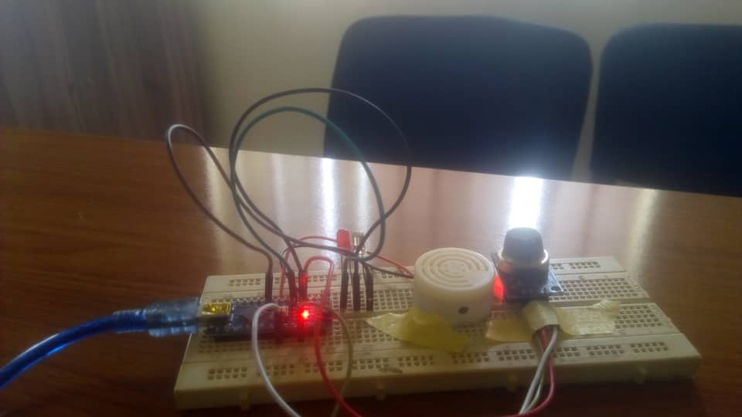
Figure 4.1: Hardware Assembling
4.1.1 Components and Connections
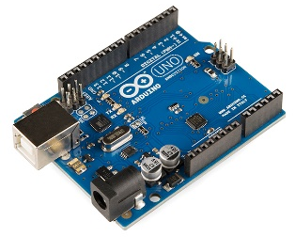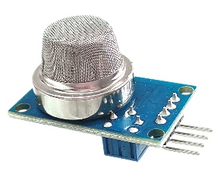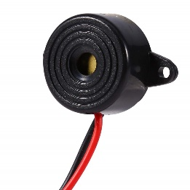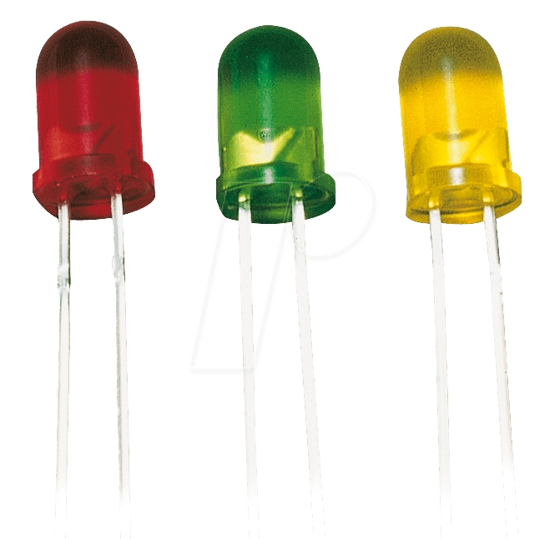
1 2 3 4
- Arduino Uno: The central microcontroller used to process sensor data and control outputs.
- MQ-2 Smoke Sensor: Connected to the Arduino’s analog input pin (A0) for reading smoke levels.
- Buzzer: Connected to digital pin 8 of the Arduino for audible alerts.
- LEDs: Connected to digital pin 13 for visual alerts, using a 220-ohm resistor to limit current.
The connections are made on a breadboard to facilitate easy adjustments and testing. The MQ-2 sensor’s VCC and GND pins are connected to the Arduino’s 5V and GND pins, respectively. The analog output pin of the sensor is connected to the Arduino’s A0 pin. The buzzer and LED connections follow similar logic, ensuring they activate when the sensor detects smoke.
4.2 SOFTWARE DEVELOPMENT
The software for the smoke detection system is developed using the Arduino IDE. The program reads data from the MQ-2 sensor, processes it, and triggers the buzzer and LED when smoke is detected. Series of C language code was put together in order to reacts and interact with the components. This code initializes the pins for the buzzer and LED, sets up serial communication for monitoring sensor values, and reads the smoke sensor's output. If the sensor value exceeds the threshold, the buzzer and LED are activated to alert the user.
4.3 SYSTEM INTEGRATION
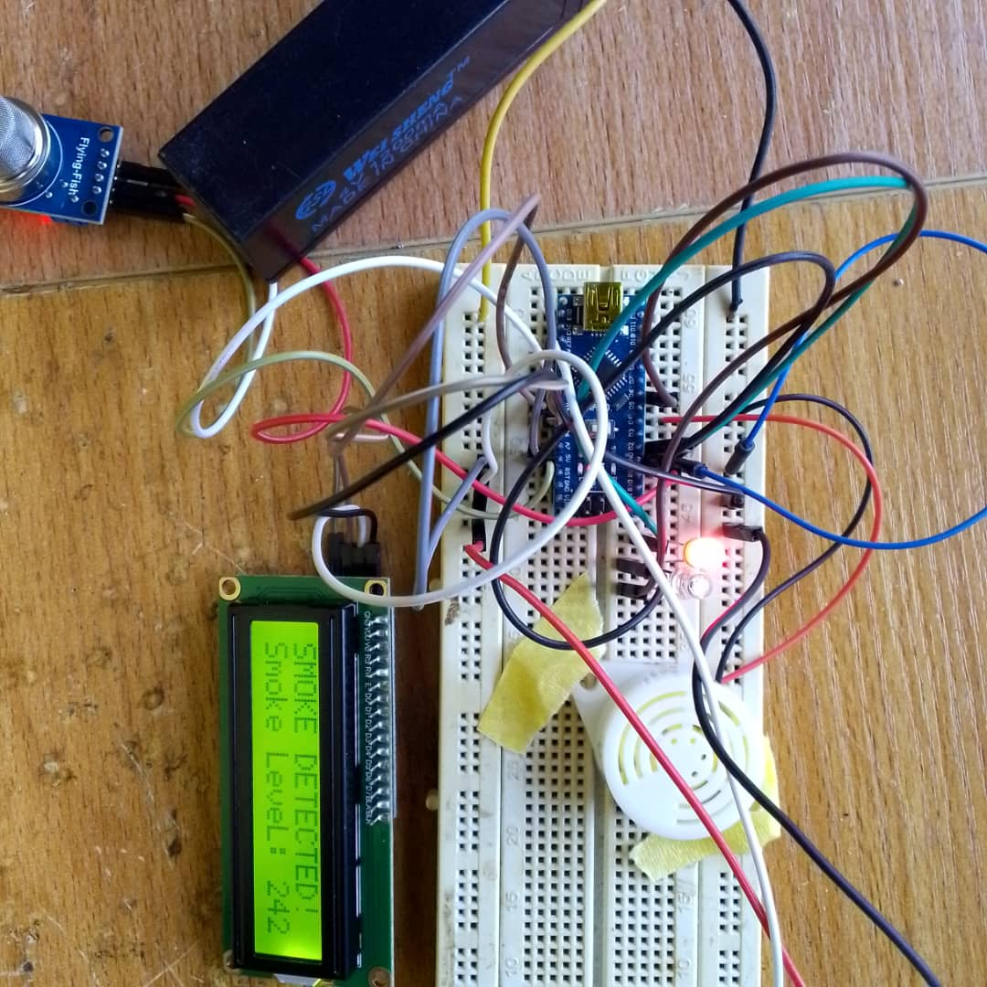
Fig 4.2: System Integration
System integration involves assembling the hardware components and uploading the software to the Arduino. The following steps outline the integration process:
- Assemble the Circuit: Connect all components on the breadboard as per the circuit design.
- Upload the Code: Connect the Arduino to a computer, open the Arduino IDE, paste the code, and upload it to the Arduino board.
- Power the System: Ensure the Arduino is powered either through USB or an external power supply.
- Testing: Conduct initial tests by introducing smoke near the sensor and observing the response of the buzzer and LED.
4.4 TESTING PROCEDURES
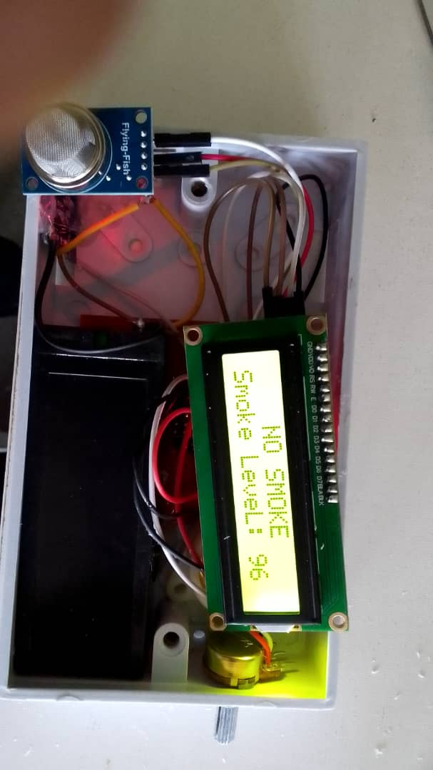
Fig 4.3: First Test (No Smoke Detect)
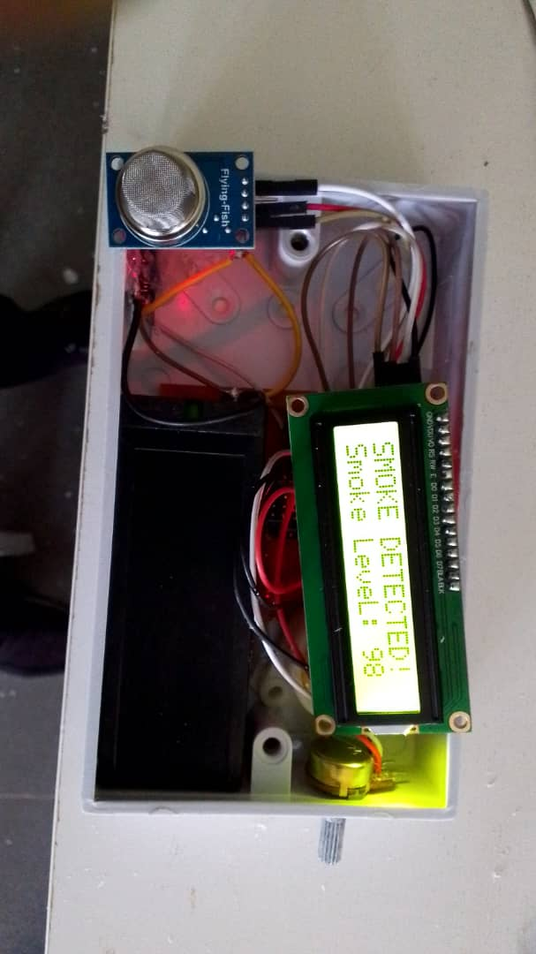
Fig 4.4: Second Test (Smoke Detected)
Testing the system is crucial to ensure it functions correctly under different conditions. The testing procedures include:
4.4.1 Functional Testing Functional testing involves verifying that the system detects smoke and triggers the alarm as expected. Smoke is introduced near the sensor to check if the sensor value exceeds the threshold and activates the buzzer and LED.
4.4.2 Calibration It adjusts the smoke Threshold value to ensure accurate detection and minimize false alarms. Different environments, such as a kitchen or living room, are tested to find the optimal threshold setting.
4.4.3 Environmental Testing The system is tested in various environments to evaluate its performance. Factors such as humidity, dust, and air flow are considered to ensure reliable detection under different conditions.
4.4.4 Long-Term Testing The system is run over an extended period to check for stability and consistency. This testing ensures the system remains reliable over time and under continuous operation.
4.5 RESULTS AND DISCUSSION
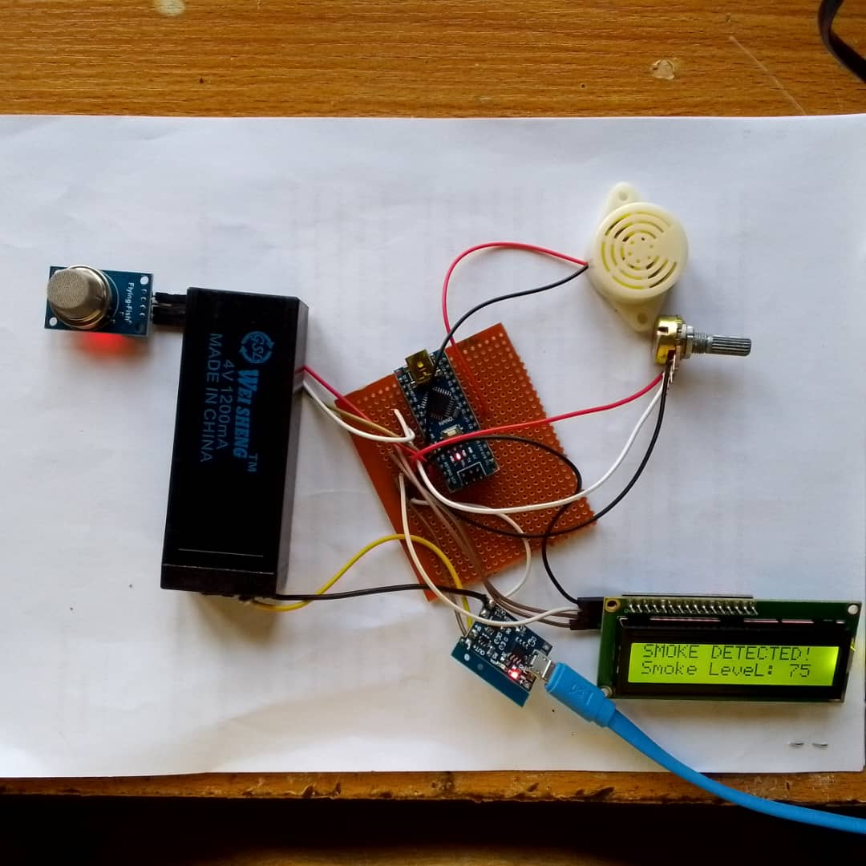
Fig 4.5: Result

The results from the testing procedures are analyzed to assess the system's performance. Initial tests should confirm that the smoke detector accurately detects smoke and triggers the alarm. Calibration results will help optimize the threshold value for different environments, reducing false alarms. Environmental testing ensures the system is robust and performs well under various conditions. Long-term testing results should demonstrate the system's reliability and stability over extended periods.
The implementation and testing of the Arduino-based smoke detection system validate its design and functionality. The system successfully detects smoke and triggers alerts, providing a reliable and cost-effective solution for property protection. The testing procedures highlight the importance of calibration and environmental considerations, ensuring the system's performance in real-world applications. The next chapter will discuss the overall project evaluation, conclusions, and potential future improvements.

CHAPTER FIVE
SUMMARY, RECOMMENDATIONS AND CONCLUSION
5.1 SUMMARY
This project aimed to design and implement an Arduino-based smoke detection system to enhance property protection. The primary objectives were to create a reliable, cost-effective, and user-friendly smoke detector, leveraging the flexibility of Arduino microcontrollers. The system was developed to address the limitations of both commercial and DIY smoke detection systems, providing an innovative solution with enhanced features and performance.
The project began with an analysis of existing smoke detection technologies, identifying key strengths and weaknesses. Commercial detectors, while reliable, often suffer from false alarms and high costs, particularly for dual-sensor models. DIY systems offer customization but lack the reliability and advanced features of commercial products. Based on this analysis, the proposed system was designed to combine the best aspects of both approaches.
The proposed system integrated an Arduino Uno with an MQ-2 smoke sensor, a buzzer, and LEDs. The hardware assembly and software development were straightforward, with the Arduino processing sensor data and activating alerts when smoke was detected. The system was calibrated to ensure accurate detection and minimize false alarms. Testing procedures confirmed the system's functionality, reliability, and performance in various environments.
5.2 RECOMMENDATIONS
Based on the project's findings and the performance of the implemented system, several recommendations can be made for future improvements and applications:
- Power Management: Optimizing the system's power consumption would extend battery life and reduce maintenance. Incorporating power-saving modes and using energy-efficient components would make the system more suitable for long-term use, especially in areas without a stable power supply.
- Multiple Sensor Integration: Expanding the system to include additional sensors, such as temperature and humidity sensors, would provide more comprehensive environmental monitoring. This multi-sensor approach could improve the accuracy of smoke detection and provide valuable data for various applications.
- User Interface Improvements: Developing a user-friendly interface, either through a mobile app or a web platform, would enhance the system's usability. Users could easily monitor the system's status, adjust settings, and receive real-time alerts, improving the overall user experience.
- Commercialization and Mass Production: Exploring opportunities for commercialization could make the system available to a broader audience. Scaling up production and refining the design for mass manufacturing would reduce costs and increase accessibility.
5.3 CONCLUSION
The Arduino-based smoke detection system developed in this project successfully met its objectives, providing a reliable, cost-effective, and user-friendly solution for property protection. The system demonstrated accurate smoke detection, minimal false alarms, and ease of use, making it a viable alternative to existing commercial and DIY smoke detectors.
By leveraging the flexibility of Arduino and incorporating features such as calibration and visual/audible alerts, the proposed system offers significant advantages over traditional detectors. The project also highlighted the potential for further enhancements, including network connectivity, power management, and multi-sensor integration.
The successful implementation and testing of the system validate its design and functionality, paving the way for future improvements and applications. The recommendations provided offer a roadmap for enhancing the system's capabilities and expanding its use in various environments.
Overall, this project contributes to the field of smoke detection technology by presenting an innovative and practical solution that balances reliability, cost, and user experience. The continued development and refinement of this system have the potential to significantly improve fire safety and property protection, ultimately benefiting a wide range of users.

REFERENCE
Vivek, P.J., Raju, G., Akarsh, S. “Forest Fire Detection System”, International Journal of Innovative Research in Science, Engineering and Technology, ISSN: 2319-8753, Vol 3, Issue 6, June 2014
Mahzan, N.N., Enzai, N.I., Zin, N.M. and Noh, K.S. Design of an Arduino-based home fire alarm system with GSM Module, 1st International Conference on Green and Sustainable Computing (ICoGeS) 2017, IOP Conf. Series: Journal of Physics: Conf. Series 1019 (2018) 012079 doi :10.1088/1742-6596/1019/1/012079
Malaysia, J.B. “Statistik Kebakaran Mengikut Jenis Kebakaran 2016,” 2016. [Online]. Available:http://www.data.gov.my/data/ms_MY/dataset/jbpm-statistik-kebakaran-mengikut-jenis kebakaran-2016. [Accessed: 20-Jul-2017].

SOURCE CODE LISTING
// Pin Definitions
const int smokeSensorPin = A0;
const int buzzerPin = 8;
const int ledPin = 13; // Optional LED pin
// Threshold value for smoke detection
const int smokeThreshold = 500; // Adjust this value based on sensor sensitivity
void setup() {
pinMode(buzzerPin, OUTPUT);
pinMode(ledPin, OUTPUT);
Serial.begin(9600);
}
void loop() {
// Read sensor value
int sensorValue = analogRead(smokeSensorPin);
Serial.print("Sensor value: ");
Serial.println(sensorValue);
// Check if smoke level is above threshold
if (sensorValue > smokeThreshold) {
// Smoke detected, activate alarm
digitalWrite(buzzerPin, HIGH);
digitalWrite(ledPin, HIGH); // Optional: turn on LED
Serial.println("Smoke detected! Alerting...");
} else {
// No smoke detected, turn off alarm
digitalWrite(buzzerPin, LOW);
digitalWrite(ledPin, LOW); // Optional: turn off LED
} delay(1000); // Check sensor every second
}
SYSTME FLOWCHART
Start
Sensor Warming Up
Sensor sense Smoke (CO)
Is there Smoke ?
Buzzer Sound Alerm
LED (Red) ON
Stop
No
Yes

