INTERGRATED LITHOLOGICAL AND GRANULOMETRIC ANALYSIS OF SANDSTONES AT LAFIAGI, NORTHERN BIDA BASIN, KWARA STAT NORTH CENTRAL NIGERIA
BY
AYOMIKUN FAVOUR OGUNTOLA
ND/23/MPE/PT/0016

A PROJECT SUBMITTED TO THE DEPARTMENT OF MINERALS AND PETROLEUM RESOURCES ENGINEERINGTECHNOLOGY,
INSTITUTE OF TECHNOLOGY
KWARA STATE POLYTECHNIC, ILORIN

IN PARTIAL FULFILLMENT OF THE REQUIREMENTS FOR THE AWARD OF NATIONAL DIPLOMA (ND) IN
MINERALS AND PETROLEUM RESOURCES ENGINEERING AUGUST, 2025

CERTIFICATION
This is to certify that this research work titled "SEDIMENTOLOGY AND DEPOS ITIONAL ENVIRONMENT OF SANDSTONES EXPOSED AT LAFIAGI, NORTHERN BIDA BASIN, KWARA STATE, NORTH CENTRAL, NIGERIA Was carried out by OGUNTOLA AYOMIKUN FAVOUR with the matriculation number ND/23/M PE/PT/0016 and has been read and approved as meeting part of the requirements of the award of National Diploma (ND) in Mineral and Petroleum Resources Engineering Technology.

___________________________ _________________
MR. RAJI JAMIUDEEN KAYODE DATE
PROJECT SUPERVISOR

_____________________________ _________________
DR. OLATUNJI ADEBISI
HOD DATE DepartmentofMineralandPetroleumResourcesEngineering.

__________________ ________________

Engr. Oluwole C. T

EXTERNAL EXAMINER DATE

DEDICATION
This research work is dedicated to almighty GOD and my beloved parents Mr. and Mrs. OGUNTOLA for their moral, financial, and enthusiastic support and also to my project supervisor MrRajiJamiudeenKayode.

ACKNOWLEDGEMENT
All thanks to almighty GOD for bestowing on me the grace good health indefatigable zeal and knowledge with which I started and complete this journey, I say may all glory praise adoration and thanksgiving be ascribe to almighty GOD.
My gratitude also goes to my parents Mr. and Mrs. OGUNTOLA for their support and guidance may you live long to reap the benefit of your labour (amen)
My appreciation goes to my able supervisor in person of MrJamiudeenKayode for his help and time spent over this project
Also my acknowledgement goes to my H.O.D. Dr. OlatunjiAdebisi who has guided the department efficient and effective.
My gratitude to my lovely siblings
Finally, all thanks to my friends who have in one way or the other contributed to this success of this project, may the lord be with us (AMEN).

TABLE OF CONTENT
Title Page..................................................................................... i
Certification .................................................................................ii
Dedication.....................................................................................iii
Acknowledgement.......................................................................iv-v
Table of Content..........................................................................vi
List of figures...............................................................................vii
List of tables.................................................................................viii
Lists of plates...............................................................................ix
Abstract ........................................................................................x
CHAPTER ONE
1.0 Introduction ....................................................................... 1
1.1 Background Of Study.............................................................2
1.2 Statement Of Problem Of The Research ..............................1-2
1.3 Research Aim And Objectives ................................................2
1.4 Scope And Limitations ............................................................2
1.5 Significance Of The Study.........................................................2
1.6 Location and accesibility of the study area .............................2-4
Chapter Two
2.1 Review of Previous Studies in Bida Basin ..................................5-7
2.2 Geological Setting OfBida Basin .................................................7-8
2.3 Regional Stratigraphic Settings OfBida Basin ............................8-10
2.4 Sedimentary Rock And Its Classification .....................................10-12
2.4.1 Sedimentary Rock Formation ........................................................12
2.4.2 Sedimentary Rock Deformation ....................................................12
2.5 DepostionAndDepostional Environment Of Sandstones .............12-13
2.5.1 Depostional Environments.................................................................13
2.5.2 Types OfDepostional Environments.................................................13-14
2.5.3 Depostional Processes ......................................................................14
2 5.4 Types Of Deposits ...............................................................................14-15
2.6 Sedimentary Structures .......................................................................15
2.6.1. Types of sedimentary structures .........................................................15
2.6.2. Interpretation of Sedimentary Structures ............................................15-16
2.7 Study Of Sedimentary Rocks ................................................................. 16
2.7.1 Purpose Of Field Work ............................................................................16
2.7.2 Tools And Equipments Used..................................................................16-17
2.7.3 Key Field Observations .............................................................................17
2.7.4 Sample Preparation ..................................................................................17
2.7.5 Common Laboratory Tests And Techniques ...........................................17-18
Chapter Three
3.1 Materials And Methods ..............................................................................19
3.2 Sample Collection And Field Study.............................................................19
3.3 Laboratory Analysis .....................................................................................19
3.3.1 Significance ..................................................................................................19
3.3.2 Principle Theory.............................................................................................19-20
3.3.3 Apparatus Used ............................................................................................20
3.3.4 Procedure.....................................................................................................20-21
Chapter Four
4.1 Lithologic Description And Depositional Environment.............................22-25
4.2 Calculation Of Statistical Parameters.........................................................25-28
4.2.1 Analytical Result Of LF1.................................................................................28-31
4.2.2 Analytical Result Of LF2.................................................................................31-33
4.2.3 Analytical Result Of LF3.................................................................................33-35
4.2.4 Analytical Result Of LF4.................................................................................35-37
4.2.5 Analytical Result Of LF5..................................................................................37-40
4.3 Depositional Environment...................................................................... ........40-41
4.4 Provenance, TransportHistory And Textural Maturity................................41-42
4.5 Implication For Petroleum Exploration..........................................................42
Chapter Five
5.1 Conclusion.......................................................................................................43
5.2 Contribution To Knowledge.............................................................................43
5.3 Recommendation references ..........................................................................43-44
References

LIST OF FIGURES
Figure 1.1 The geological map of Nigeria showing the position of Bida basin
Figure2.1 GEOLOGICAL MAP OF BIDA BASIN
Figure.2.2 Regionalstratigraphic successions in the Bida Basin
Figure 2.2.1 STRATIGRAPHIC CHART OF BIDA BASIN
Figure 2.2.2 STRATIGRAPHIC CHART OF ANAMBRA BASIN
Figure 4.1 LITHOLOGICAL DESCRIPTION AND DEPOSITIONAL
FiG. 5 DEPOSITIONAL PROCESSES

LIST OF TABLES
Table 4.1: Grain size Analytical results of LF1
Table 4.2 :Grain size Analytical results of LF2
Table 4.3 : Grain size Analytical results of LF3
Table 4.4: Grain size Analytical results of LF4
Table 4.5: Grain size Analytical results of LF5
Table 4.6: Summary of Values of Statistical Parameters and Interpretation

LIST OF PLATES
Plate 4.1 Massive reddish brown matrix supported conglomerate
Plate 4.2: Massive reddish lithified conglomeratic sandstone
Plate 4.3 : Massive milkish-reddish pebbly sandstone
Plate 4.4 : Project students on the out crop section

ABSTRACT
This study investigates the lithological characteristics and grain size distribution of sedimentary rock samples obtained from the Northern Bida Basin, with a focus on understanding their depositional environments and implications for petroleum exploration. The lithological section reveals a succession dominated by sandstones interbedded with minor shales and siltstones. The sandstones are medium to coarse-grained, moderately to poorly sorted, and angular to sub-angular, indicating deposition under high-energy fluvial or deltaic conditions with minimal reworking.
Grain size analysis shows mean grain sizes ranging from 1.20ϕ to 2.85ϕ, indicating a variation from fine to very fine sands. Sorting values fall within 0.80ϕ to 1.60ϕ, reflecting poor to moderate sorting. Skewness values are predominantly positive (fine-skewed), and kurtosis values range from platykurtic to mesokurtic, suggesting fluctuations in energy conditions during deposition. These textural characteristics support a depositional environment influenced by fluvial-deltaic processes, possibly with episodic marine influence in some locations.
The implications of these results for petroleum exploration are significant. The presence of medium to coarse-grained sandstones with fair sorting suggests good reservoir potential due to relatively high porosity and permeability. However, the occurrence of shales and siltstones as interbeds may act as effective seals or baffles within the reservoir system. The fining-upward sequences and positive skewness further point to a progressive reduction in energy, typical of regressive sequences in marginal marine environments, which can favor hydrocarbon entrapment.
Overall, the integration of lithological and granulometric data indicates that the Northern Bida Basin holds promise as a potential petroleum reservoir, with depositional settings conducive to the development of both reservoir rocks and sealing facies. Continued geochemical and geophysical studies are recommended to confirm hydrocarbon presence and maturity.

CHAPTER ONE INTRODUCTION
BACKGROUNDOFSTUDY
Sedimentaryrocks formthrough the accumulation and compression ofsediments, including mineralparticles, rock fragments, and organic matter. Theyplaya crucialrole in various aspects of Earth's systems. They are the primary source of fossil fuels such as coal, oil, and natural gas (Selley, 1998).These rocksalso host valuable mineraldeposits, including iron, copper,gold, and uranium(Evans, 1993). Additionally, theyserve as aquifers, providing essentialgroundwater for human consumption and agriculture (Freeze & Cherry, 1979). Sedimentary rocks preserve records of past climates (Hay, 1996) and document Earth's history, including ancient environmentsandlife forms(Gradsteinet al., 2012).Sandstonesedimentologyinvolvesstudying theprocessesofweathering,erosion,transportation,deposition,anddiagenesis,whichleadtothe formation of this clastic sedimentary rock composed primarily of sand-sized grains, often quartz and/or feldspar.
Sandstone is a type of sedimentary rock that is composed primarily of sand-sized mineral particles or rock fragments. It is formed through the cementation of sand grains by mineral cements, such as silica, calcium carbonate, or iron oxides(.Springer - Verlag 1987). Sandstone can be classified into severaltypes based on its composition, texture, and cementation (Pettijohn (1997), Potter,&Siever, 1997). Sandstones canbe studied throughbothfieldwork and laboratory analyses. These laboratory analyses include grain size, thin section petrography, X-ray Fluorescence (XRF), X-ray Diffraction (XRD) etc. This study will utilize fieldwork, grain size analysis and thin section petrography to study the sandstone in Bida Formation, Northern Bida Basin exposed along Share - Yikpata, north Central Nigeria. Grain size and thin section are essential tools in studying sedimentaryrocks, particularly sandstone.Grain size analysis provides valuable information on depositional environment, transportation mechanisms and sediment provenance (Krumbien & Sloss, 1963). Thin section petrography involves the microscopic examination of thin sections of rock. This technique provides detailed information on mineral composition, texture and fabric, cementation and diagenesis (Carozzi, 1993).
Together, these methods enhance paleo environmental reconstructions, provenance studies, and reservoir quality assessments, ensuring a more accurate interpretation of sedimentary processes and rock histories.

STATEMENTOF PROBLEM
The Bida Basin in Northern Nigeria is a significant sedimentary basin with extensive deposits of sandstone, but the sedimentological characteristics and depositional environment of these sandstones are not well understood. This knowledge gap hinders the effective exploration andexploitationofhydrocarbonandgroundwaterresourcesintheregion,aswellasthe

assessment of geological hazards. Furthermore, the lack of detailed sedimentological studies in the area limits our understanding of the geological history and evolution of the basin.

RESEARCHAIMANDOBJECTIVES
ThisstudyaimstoinvestigatethedepositionalenvironmentsofsandstoneunitsintheBida formation, Northern Bida-Basin exposed along Lafiagi, Kwara State, Nigeria.
Thespecificobjectivesofthisprojectare:
    - To determine the texturalcharacteristicsofthe sandstone
    - To determinetheprovenanceoftheBidaFormationsandstone
    - TodeterminethematurityoftheBidaformationsandstone
    - Toknowtheirimplicationsonpetroleumexploration

SCOPEANDLIMITATIONS
The scope of this study covers sample collection from Outcrop section ofBida Formation, NorthernBida Basin around Lafiagi and is limited to the dataobtained from fieldwork and grain size analysis.

SIGNIFICANCEOFTHE STUDY
    - To understand the basin's history, potential for hydrocarbon and groundwater resources, and for reconstructing past depositional environments, which are vital for resource exploration and management.
    - Studying the sedimentologyof sandstone in the Bida Basin canprovide insights into the tectonic and paleoenvironmental evolution of the basin. Sandstone units can preserve paleoclimate information, allowing researchers to reconstruct ancient climate conditions.
    - Studying the sedimentology of sandstone in the Bida Basin cancontribute to a broader understanding of sedimentary processes and products. The Bida Basin offers a unique opportunity for comparative studies with other sedimentary basins, both within and outside Nigeria.

LOCATIONANDACCESSIBILITYOFTHESTUDYAREA
Lafiagi is located in the northern part of the Bida Basin, within Edu Local Government Area of Kwara State, north-central Nigeria. The Bida Basin is an elongate, intracratonic, northeast-southwest trendingsedimentarybasin(Akandeetal.,2005).Lafiagilies approximately

between latitudes 8°50′N and 9°00′N and longitudes 5°00′E and 6°00′E (Ojo et al., 2023).The elevation in Lafiagi ranges from about 197 to 222 meters above sea level, based on geological field studies conducted along the Share–Lafiagi–Shonga road axis, where several sedimentary outcrops have been mapped (Ojo et al., 2023).
In terms of accessibility, Lafiagi is easily accessible via a network of tarred and untarred roads. The most prominent route is the Share–Lafiagi–Shonga road, which connects the area to larger towns suchas Tsaragiand Ilorin. These roads have provided exposureto sedimentarysequences, especially the Enagi Formation, which is well-developed in this area (Adamu et al., 2019). Lafiagi, like most of the north-central Nigeria, experiences a tropical savanna climate (Köppen Aw), characterized bytwo distinct seasons:awet seasonfromAprilto October, andadryseason fromNovember to March (NIMET, 2022). The climate is controlled bythe annual movement of the Inter-TropicalConvergence Zone (ITCZ)and the Harmattannortheast tradewinds during the dryseason (Salako et al., 2018). The average annualtemperature in the Lafiagiarea ranges from 25°Cto33°C.ThehottestmonthsareMarchandApril,withtemperaturesoftenexceeding 35°C,whilethecoolestmonthsareJulyandAugust,withnighttimelowssometimesaround 18°C (NIMET, 2022). Annual rainfall in Lafiagi is approximately 1,000 mm, with the peak rainfallmonthsoccurring betweenJulyandSeptember. Rainfallsupportsseasonalagriculturebut also influences sediment deposition in the basin (Adamu et al., 2019).The topography of the Lafiagiregionisgenerallyflat togentlyundulating, withlowrelieffeatures. Theterrainispartof the Bida Basin's downwarped trough, which deepens towards the center of the basin and is defined by NW–SE trending basement structures (Udensi & Osazuwa, 2004). The subsurface depth of the basin in the region is estimated to be up to 7 km, based on gravity and magnetic surveys.
Geologically, the area exposes various lithostratigraphic units including the Bida Sandstone, Sakpe Ironstone, Enagi Formation, and Batati Ironstone, indicating a complex depositional environment ranging from fluvial to tidal and shallow marine systems (Akande et al., 2005; Ojo et al., 2023).

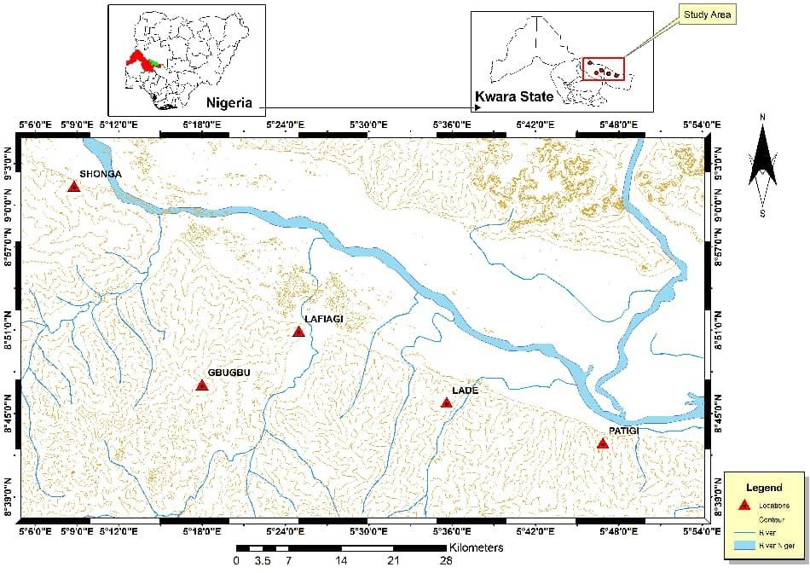
FIGURE1.1:.ThemapofNigeria showingthepositionofthestudy area

CHAPTERTWO
LITERATUREREVIEW

Review ofPrevious StudiesinBidaBasin
The Northern Bida Basin, part of Nigeria’s inland sedimentary basins, has drawn considerable attention from geologists due to its rich sedimentary sequences, structural complexity, and economic potential. Researchers are particularly interested in this regionbecause it offers insight into Cretaceousfluvio-deltaicdepositionalsystems, basinevolution, and provenance history. The basin is also known to contain organic-rich shales, potential reservoir sandstones, and structural features favorable for hydrocarbon generation and accumulation. Additionally, its proximity to the Precambrian Basement Complex makes it a key area for studying basin-margin interactions, sediment supply, and tectono-sedimentary development in Nigeria's inland basins.
According to Obaje et. al(2011) ontheir research on sedimentologyand petroleum geologyat bida basin north central Nigeria . The Bida Basin in North central Nigeria has potential for an active petroleum system, with hydrocarbon seepages reported in several areas. Sedimentological evaluation suggests various depositional facies, including fluvial, marine, and shelf environments.Including source rocks which are gas prone, potentialreservoir unit, seals and traps. And it's prospective areas are around Bida, pategi, muregi, Baro, Agbaja, Agaji and Gandabiyu. The study focuses on the Share-Lafiagi-Shonga areas of the Bida Basin in central Nigeria. The researchers analyzed 15 vertical profiles of Campanian-Maastrichtian sedimentsand identified five distinct depositional facies which are alluvial fan, braided channel, floodplain, tidalchannelandshoreface. ThedepositionalmodelfortheUpperCretaceoussediments in the study area is dominated by alluvial processes, with shallow marine processes and fluvial channels also present.The clay deposits of the floodplain may offer economic resource potential in the area.Olusola & Samuel (2012).
According to Ojo (2012), who analyzed the sedimentology of the Campanian Bida Formation in the northern Bida Basin, centralNigeria. The results indicate,facies which are identified to be conglomerates, sandstone and claystone, The sediments were deposited ina fluvialenvironment, with conglomerates forming from gravity-induced debris flows and sandstones forming in braided fluvial channels, Its grain size analysis i.e the sandstones are texturally immature, suggesting a fluvial origin.The clasts in the conglomerates and conglomeratic sandstones were mainly transported by fluvial processes, with some evidence of recycling from older sediments andthe sandstones are subarkosic, derived from rifted and uplifted continental basement rocksin a warmhumid paleoclimatic setting, the sandstones are composed ofquartz and feldspar, with a subarkosic composition. Roberts et al. (2019) proposed an updated stratigraphy of theBida Basin, detailing basalalluvialfanand braided fluvial.facies(Lokoja/Bida Formations) overlain by shallow marine shoreface sandstones and shales (Patti/Enagi Formations), repres enting a passive margin sequence. PubMed (2021) focused on the Campanian Lokoja Formation, classifyingthesandstonesasarkosictolitharenitic.Thesedimentsweredepositedinhigh-

energy flu vial environments, derived from felsic basement sources, with moderate weatheri ng intensity.
Nton&Adamolekun(2016) studied the Lokoja and PattiFormations inthe southernBida Basin, identifying mineral assemblages, indicating passive continental block provenance under humid weathering conditions.
Ojo (2012)studiedtheCampanianBidaFormationinnorthernBidaBasincomprisespoorly sorted, matrix- and grain-supported conglomerates, massive to cross-bedded sandstones and overlying claystones. Conglomerates indicate debris-flow deposition, while cross-bedded sandstones—showing unidirectional paleoflow to NNE—represent braided fluvial channels. Claystones formed in low-energy non‑marine floodplains. Grain-size statistics (σ=0.65–1.69Φ; skewness=–0.02to+0.96; mean=1.29;skewnessmean=0.11)reveal texturallyimmature, fluvial-origin sandstones.
This investigation of the Maastrichtian Enagi Formation in Share and Shonga areas identifies moderately sorted, grain-supported conglomerates, herringbone cross-stratified sandstones typical of tidal-channel environments, and bioturbated sandstones associated with shoreface settings. The presence of kaolinitic claystones and unidirectional cross-bedded sandstones reflects deposition in braided fluvial channels and floodplains. The overall pattern suggests a transgressive shallow marine systemwith fluvial incision. The economic significance of floodplain clays is also noted (Ojo & Akande, 2012).
XRFgeochemicalanalysisofsandstonesamples fromtheDoko and Jima members indicates high SiO₂ (~71%), moderate Al₂O₃ (~15%), and low CaO (~0.26%), pointing to derivation from felsic-intermediate igneous sources. Weathering indices (CIA ≈ 68.6%; CIW ≈ 71.2%; PIA ≈ 54.7%) suggest moderate chemicalweathering. Tectonic discriminationplots confirmdeposition in a passive continental margin. The provenance is consistent with sediment derivation from cratonic felsic terrains (Odigo & Sambo, 2023).

GEOLOGICALSETTINGOFBIDABASIN
The Bida Basin in Nigeria is believed to have formed through a combination of tectonic and geological processes. The basin is thought to have originated from a rift-related process, associated with the drifting apart of the South American and African plates. This rifting event is linkedtotheevolutionoftheBenueTrough,whichbeganintheearlyJurassictoearly

Cretaceous period. The Bida Basin is part of the tectonic evolution of the Benue Trough, with some researchers suggesting a wrench tectonics model for its evolution. Others propose a pull- apartorigin forthebasin.The basin isunderlain bya basement complexcomposedofmigmatite- gneisses, schists, and older granites. Thiscomplex isthoughtto have played a role inshaping the basin's structure. Studies suggest that the Bida Basin is underlain by an asymmetrical graben rift setting, with subsurface fault trends running in the same direction as fractures. The basin has structural highs and regional lows, accommodating sediment piles up to 4,000 meters thick, researchers have identified three depocenters in the basin, named Batamegi, Gadza, and Okoto subbasins. These depocenters contain pre-Santonian sediments of fanglomerates, central slope channel sands, and distal slope fan deposits.
Overall,theformationoftheBidaBasinisacomplexprocessthatinvolvedtectonic, geological, and sedimentary processes over millions of years.

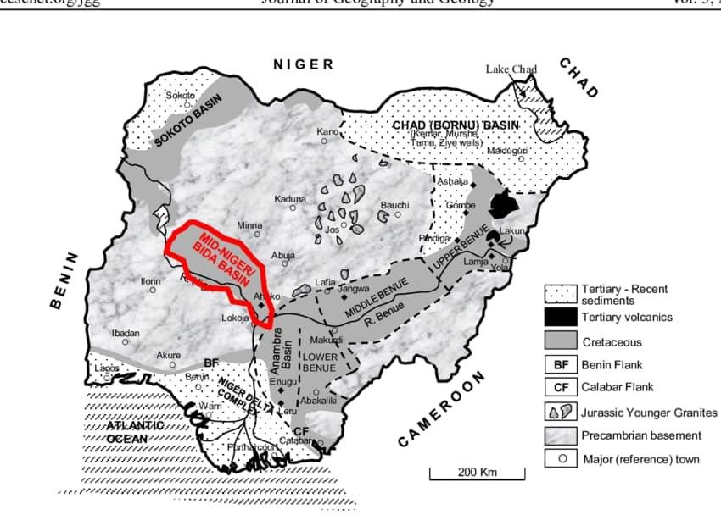

FIG.2.1GEOLOGICALMAPOF BIDA BASIN[Ojo&Akande(2005)]

REGIONALSTRATIGRAPHICSETTINGS OFBIDA BASIN
The Bida Basin in central Nigeria has strong potential for an active petroleum system,with evidence ofhydrocarbonseepages near Pategi/Muregiand Ahoko. Field studies showthe Lokoja Formation was deposited by braided rivers, the Patti Formation by fluvial floodplain to marine environments, andthe Agbaja Formationbymarginalmarine-fluvialchannels. Geochemicaldata suggest the basin’s source rocks are gas-prone, with reservoir potential in the Lokoja and Patti Formations, seals in the Patti and Agbaja shales, and various structural and stratigraphic traps. Areas around Bida, Pategi, Muregi, Baro, Agbaja, Ahoko, Abaji, and Gada Biyu are especially promising for hydrocarbon exploration. (Obaje et al. 2011).
According to Ojo and Akande (2005), the Bida Basin in central Nigeria is divided into northern and southernparts, but the Share-Lafiagi-Shonga area isunder-studied. Fifteensediment profiles from this area reveal five depositional facies: alluvial fan, braided channel, floodplain, tidal channel, and shore face. The sediments show a transition from gravity-driven alluvial fans to fluvial and tidal environments, with economic clay deposits present on floodplains. The Bida Basin, located in central Nigeria, is divided into two main sectors: the Northern and Southern Bida Basin, each with distinct stratigraphic sequences influenced by varying depositional environments and tectonic settings (Obaje, 2009; Ojo & Akande, 2012).
In the Northern Bida Basin, the stratigraphy is dominated by the Bida Formation and the overlying EnagiFormation, both ofCampanian–Maastrichtian age. The Bida Formation consists of coarse-grained sandstones, conglomerates, and claystones, interpreted as deposits frombraided fluvial systems and alluvial fans (Ojo, 2012). Above it, the Enagi Formation comprises bioturbated sandstones, kaolinitic clays, and tidal structures, indicating a transgressive phase dominated by fluvial and tidal influences (Ojo & Akande, 2012).
Conversely, the Southern Bida Basin displays a more complex stratigraphy with three main formations: the Lokoja, Patti, and Aganebode Formations. The Lokoja Formation, the basalunit, includes conglomerates and arkosic sandstones deposited in alluvial fan and proximal fluvial settings (Obaje, 2009). The overlying Patti Formation is characterized by carbonaceous shales, siltstones, and plant fossils, reflecting delta plain to swampy lagoonal environments. The Aganebode Formation, rich in marine fossils and calcareous beds, represents shallow marine deposition during a major marine transgression (Adeleye, 1975; Obaje, 2009).
While bothsectors share a LateCretaceous age,the NorthernBasin is more fluvio-tidal, whereas the Southern Basin shows a progression from fluvial to fully marine conditions.

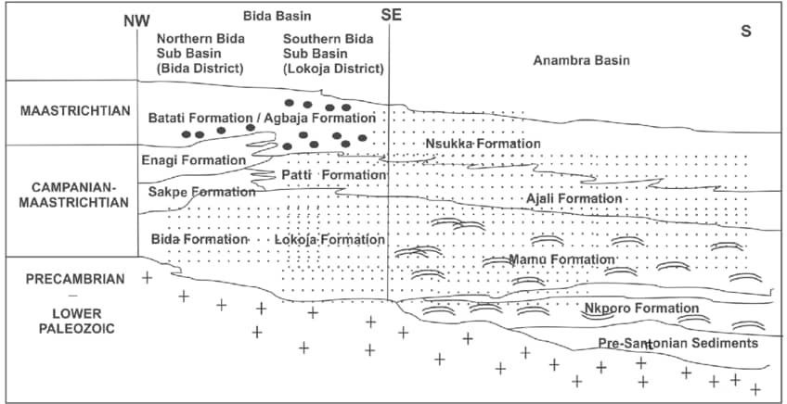
FiG. 2.2Regional stratigraphic successions in the Bida Basin and their lateral equivalents in the Anambra Basin (After Ojo & Akande 2009).

SEDIMENTARYROCKSANDITSCLASSIFICATION
Sedimentary rocks are formed through the accumulation and compression of sediments.Sedimentary rocks can be classified based on their texture,composition, and origin. The most common classification system is the Folk classification, which divides sedimentary rocks into three main categories: clastic, chemical, and organic (Folk, 1968)

ClasticSedimentaryRocks
Clastic sedimentary rocks are formed from the accumulation and cementation of clastic sediments, which are pre-existing rocks that have been broken down into smaller fragments(Blatt & Tracy, 1996). These fragments can range in size from clay to boulders and are transported bywater, wind, or ice before being deposited in a new location.

TypesofClasticSedimentaryRocks

Conglomerates:Coarse-grainedrockscomposedofroundedgravelandpebblescementedtogether (Boggs, 2009).
Sandstones:Medium-grainedrockscomposedofsand-sizedgrains,oftenquartzorfeldspar (Tucker, 2001).
Siltstones:Fine-grainedrockscomposedofsilt-sizedgrains. Shales: Fine-grained rocks composed of clay minerals.

ChemicalSedimentaryRocks
Chemical sedimentary rocks are formed through the precipitation of minerals from a solution, often through chemical reactions or changes in temperature and pressure (Blatt &Tracy, 1996). These rocks can be composed of a wide range of minerals, including calcite, dolomite, gypsum, and halite.

TypesofChemicalSedimentary Rocks
Limestones : Composed primarilyofcalcite (CaCO3), often formed throughthe accumulationof shell fragments or chemical precipitation (Tucker, 2001).
Dolostones:Composedprimarilyofdolomite(CaMg(CO3)2),oftenformedthroughthe alteration of limestones (Boggs, 2009).
Evaporites : Composed of minerals such as gypsum (CaSO4·2H2O) and halite (NaCl), formed through the evaporation of seawater or other saline solutions (Kendall, 2010).
Cherts:Composedprimarilyofmicrocrystallinequartz(SiO2),oftenformedthroughthereplacement of other minerals or rocks (Tucker, 2001).

OrganicSedimentaryRocks
Organic sedimentaryrocks form fromthe accumulation and compression oforganic matter, such as plant and animal remains. These rocks contain large organic molecules with carbon- hydrogen bonds, like those found in living organisms

TypesoforganicSedimentaryrocks
Coal :Formsin swampy lands adjacenttoriversandwithindeltas,whereclimates arehumid and tropical.
Coquina : A type of limestone composed of shell fragments and other organic material. BioclasticLimestone:Atypeoflimestoneformed fromtheremainsofmarineorganisms.

SkeletalLimestone: Atypeoflimestoneformedfromtheskeletalremainsofmarine organisms.

SedimentaryRockFormation
Weathering:Theprocessbywhichrocksarebrokendownintosmallerparticlesthrough exposure to wind, water, and ice (Tucker, 2001).
Erosion:Theprocessbywhichsedimentistransportedawayfromitssourcethroughnatural forces such as wind, water, and glaciers (Pettijohn et al., 1987).
Deposition: The process by which sedimentis deposited in a new location,such as a river delta or ocean basin (Folk, 1968).

SedimentaryRockDeformation
- Folding :The process by which sedimentary rocks are bent or folded through tectonic forces (Tucker, 2001).
- Faulting:Theprocessby whichsedimentary rocksarebroken orfractured through tectonic forces (Pettijohn et al., 1987).
- Diagenesis:Theprocessbywhichsedimentaryrocksarealteredthroughchemicalandphysical changes after deposition (Folk, 1968).

DEPOSITIONANDDEPOSTIONALENVIRONMENTOFSEDIMENTARYROCKS
Sedimentary rocks are formed through the deposition of sediments, which are fragments of pre-existing rocks or organic matter. Deposition occurs when the energy of the transporting medium, such as water or wind, decreases, allowing the sediments to settle and accumulate (Boggs, 2009). Sediment can be transported as pebbles, sand and mud, or as salts dissolved in water. Salts may later be deposited byorganic activity(e.g. as sea shells) or byevaporation.

DepositionalEnvironments
Depositional environment is the accumulation of chemical, biological, and physicalproperties and processes associated with the deposition of sediments that lead to a distinctive suite of sedimentary rocks. Sedimentary environments are interpreted by geologists based on clues within such as rock types, sedimentary structures, trace fossils, and fossils. We can then compare these clues to modern environments to reconstruct ancient environments. We can break up the numerous depositional environments found on earth into common environments we find on land (continental environments), in the ocean (marine environments), and at the interface between the two (transitional environments).

Typesofdepositionalenvironments Continental Environments
There are many different environments on the continents, but again we are limited to those that are dominated by the deposition rather than the erosion ofsediments. Erosion occurs in high altitude areas and although continents are overall topographically elevated compared to the oceans, there are several different areas on the continent where we get distinctive depositional properties. Continental depositional environments are dominated by clastic sedimentary rocks, largely because of their proximity to the source of the sediments eg Rivers (streams and ponds), Lakes, Swamps, Desserts Glacial environment.

Marinedepositionalenvironments
Marine environments differ in multiple ways, but the controlling factors in the rocks that are produced is related to the proximity and supply ofcontinentalsediment, the water depth, and the community of organisms that live in the area. The further an environment is from the shore the lessclastic sediment willbepresent andtheareawillhaveahigherconcentrationof thechemical and biological sedimentary rocks that are formed within the ocean. In addition, some organisms in the right environmental conditions can produce huge amounts of skeletal material.examplesare shallow marine, tropical shallow marine water area, deep marine depositional environments

TransitionalEnvironments
The interface between the continents and oceans are complicated areasthat can be influenced by rivers, ocean currents, winds, waves, and tides. In addition, the sediments that are present in these areas are a mixture of materials derived from the continents (clastic and organic) and those from the ocean (chemical and biochemical Finally, with the abundant currents (both air and water), sediments influenced by the elements, and abundant life in these areas, which results in abundant sedimentarystructures and trace fossils. However, we candistinguishtransitionalareas that are dominated by different forces such as tides, ocean currents, and rivers.

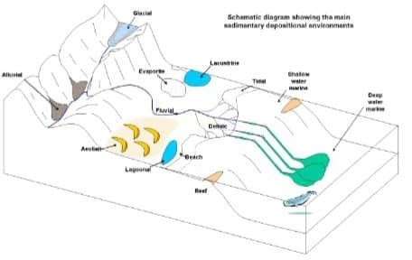

FIGURE2.3:DEPOSITION PROCESSES

DepositionalProcesses
Sediment transport: Movement of sediment by water, wind, or ice (Bridge, 2003). Deposition:Settlementofsediment particlesfromafluid(waterorair)(Tucker,2001). Accumulation: Buildup of sediment over time (Pye, 1987).

4Typesof Deposits
Clasticdeposits:Composedofclasticsediments(e.g.,sand,silt,clay)(Folk,1968).
Chemical deposits: Formed through chemical precipitation (e.g., limestone, evaporites) (Tucker, 2001).
Organicdeposits:Composedoforganicmatter(e.g.,coal,oilshale) (Tucker,2001).

SEDIMENTARYSTRUCTURES
Sedimentary structures are features that form during the deposition or diagenesis of sediments. They provide valuable information about the conditions under which the sediments were deposited and can be used to interpret the geological history of an area.

Types of Sedimentary Structures ClassificationofSedimentaryStructures
Sedimentarystructurescanbeclassifiedintoseveralcategories,including:
Primary structures also known as mechanical structures. They are formed due to mechanical action of waves. Primary sedimentary structures include bedding and stratification, cross- bedding, graded bedding, ripple marks, mud cracks, rain drop imprints, sole structure formed during the initial deposition of sediment (Tucker, 2001).
Secondarystructures are features that form in a sedimentary rock after the initial deposition. These structures are modified or formed by various processes, including diagenesis, chemical reactions, or even the activity of organisms after the sediment was laid down. Examples include concretions, bioturbation (animal burrows), and fluid escape structures. Formed after the initial depositionofsediment,(Folk, 1968). Secondarystructurescanprovide valuable insightsintothe post-depositional history of a sedimentary rock, including changes in mineralogy, diagenetic processes, and the effects of biological activity.
Biogenic structures in rocks are traces or evidence of past life's interactions with sediment and substrates, such as tracks, trails, burrows, and borings. These structures, also known as ichnofossils or trace fossils, provide insights into the behavior oforganisms and the environment they inhabited. They are categorized into bioturbation, biostratification, biodeposition, and bioerosion structures, each reflecting different aspects of organism-sediment interactions. They are Formed through the activities of organisms (Bromley, 1996).

InterpretationofSedimentaryStructures
Sedimentary structures can provide valuable information about the conditions under which sediments were deposited, including:
Water depth: The presence of certain sedimentary structures, such as ripple marks or cross- bedding, can indicate the water depth at the time of deposition (Tucker, 2001).
Current direction: The orientation of sedimentary structures, such as cross-bedding or ripple marks, can indicate the direction of current flow (Pettijohn et al., 1987).
Sediment supply: The presence of certain sedimentary structures, such as dunes or sand waves, can indicate a high sediment supply (Pye, 1987).

STUDYOFSEDIMENTARYROCKS
Sedimentary rocks are formed through the deposition and lithification of sediments. To understand their origin, history, and potentialresources(suchas hydrocarbons, groundwater,and minerals), geologists engage in two core activities:

FIELDWORK
Whererocksareobserved,recorded,andsampledintheir naturalenvironment.

LaboratoryStudy
Where samples are analyzed under controlled conditions to determine their physical and chemical characteristics.

PurposeofFieldWork
Fieldwork helps geologists to Map sedimentary rock units, Identify depositional environments, Recognize structural and sedimentary features, Collect samples for furtheranalysis and Determine spatial relationships between rock layers.

ToolsandEquipmentUsed
Geologicalhammer –forbreakingrocks.
Compass-clinometer–tomeasurebeddingorientation(strike&dip). Measuring tape or Jacob’s staff – for stratigraphic thickness.
Handlens–toobservegrainsizeandtexture.
GPS device – to record sample location coordinates. Fieldnotebook–todocumentobservationsandsketches.
Topographic/geologicalmaps–fornavigationandcorrelation. Sample bags and markers – for labeling collected specimens.

Key Field Observations
Lithology Stratigraphy
Sedimentary Structures Fossils and Bioturbation OrientationMeasurements Sample Collection

After field collection, rocks are examined in the lab for textural, mineralogical, chemical, and structural details.

SamplePreparation
Handspecimenanalysis–macroscopicdescriptionandphotography. Thin section preparation – for petrographic microscope.
Sieve/pipette separation – for grain size analysis. Powdering/crushing–forgeochemicalandmineralogicalanalysis.

CommonLaboratoryTestsandTechniques
      - Petrographic Analysis: Use of a polarizing microscope on thin sections. It is used to determine Grain size and shape,Sorting and roundness,Type of matrix and cement, Porosity and diagenetic features, Helps classify rocks (e.g., quartz arenite, arkose,wacke).
      - Grain Size Analysis /Sieve Analysis (for coarse grains) Used in Measuring grain size distribution using stacked sieves. Sedimentation Methods (for fine grains like clay/silt) and Pipette or hydrometer method.

Parameterscalculated
Meangrainsize–averagegraindiameter. Sorting – uniformity of grain sizes.
Skewness–symmetryofsize distribution.
Kurtosis–peakednessofthecurve(Folk&Ward,1957).
A comprehensive understanding ofsedimentary rocks requires both direct field observationsand laboratory analyses. Fieldwork helps collect real-world data and context, while laboratory work refines interpretations using scientific tools and techniques. This combination is critical in geology for resource exploration, environmental assessment, and academic research.

CHAPTER THREE METHODSOFSTUDY

MATERIALSAND METHODS
Thisstudyinvolvesbothfield work andlaboratoryanalysis.

SAMPLECOLLECTIONANDFIELDSTUDY
Field study entailed carrying out a geological mapping of the rock types in the study areaLafiagi, NorthernBida Basin. The mapping exercise wasbasicallyaimed at identifying the rocks and establishing stratigraphic succession of the rocks on the basis of their field relationships. It also involved collectionofspot rock samples for laboratorystudies. Field observations including grain texture, colour, grains orientation, mineralogical composition, measurements ofcoordinates and elevation with GPS, taking photographs of important sedimentarystructures and logging of exposed vertical sections were done.
Five (5) samples of sandstones were collected from the road cut exposures with the aid of geological hammer. The samples were properly kept in the sample bags and labelled accurately with masking tape and permanent marker for easy identification. They were labelled as follows: LF1, LF2, LF3, LF4, LF5 and LF6 respectively. The samples were then taken to the laboratory for further analysis.

LABORATORY ANALYSIS

The grain size analysis was aimed at determining grain size distribution of the sediments. The experiment was performed in the Sedimentological Laboratory, Geology Department, Kwara State University, Malete.

SIGNIFICANCE
Particlesize isanimportanttexturalparameterofclasticrocksbecause it supplies informationon the conditions oftransportation, sorting, and depositionofthe sediment and provides some clues to the history of events that occurred at the depositional site prior to final induration. It can also be used to determine the paleocurrent, textural maturity and the energy of deposition.

PRINCIPLE/THEORY
The size ofparticulate materials that make up sediments and sedimentaryrocks are measured by weighing the proportions that accumulate in a series of wire mesh screen sieves, by visually counting grains with a petrographic microscope, or by determining the rate at which particles of varying diameter accumulate in a water-filled glass cylinder (known as a settling tube).
The millimetre and phi unit grade scales are the standard ones used for sediments and sedimentary rocks. In the millimetre scale, each size grade differs from its predecessor by the constant ratio of 1:2; each size class has a specific class name used to refer to the particles included within it. Grain-size diameters in millimetres are converted to phi units using the conversion formula:
phi (ϕ) = - log2D, where ϕ is size expressed in phi units and D is the grain size in millimetres.Phi values for grains coarser than one milli-metre are negative, while those for grains finer than one milli-metre are positive.

APPARATUSUSED
Set of sievesElectricalsieveshaker
Tripodweighingbalance Drying oven
Cleaningbrush Spatula

PROCEDURE:

The samples were air-dried to remove any moisture present in them. Further,the lumpyportions were disintegrated with fingers. The disaggregated samples were thoroughly mixed and a representative fraction of the sample was obtained by quartering.
100 grams ofeach samples was carefully weighed on a tripod weighing balance and then poured into a set of British Standard sieve arranged in descending order of mesh diameter from top to bottom with receiving pan at the base. The sieve was arranged in the order of decreasingdiameterinmmi.e.4.00,2.36,1.70,1.60,1.00,0.50,0.35,0.25,0.112,,0.090,0.063and
<0.063 mm. Thesievewascovered and the set ofsievewas shakenthoroughlywiththe aid ofan automated electronic sieve-shaker for five minutes. At the end of each shaking, materialsretained ineachsieve were removed carefullynot to spillaway, pouredona cleansheet ofpaper and reweighed.
Recording of weight of each retained fractions was made against each sieve size and later converted to percentage weight and cumulative weight percent respectively. A graph of cumulative weight retained percent is then plotted against sieve diameter in phi unit onthe probability graph papers.
phi(ϕ)=-log2D=-(log10D)
(log102)
Whereϕ issizeexpressed inphiunitsandD isthegrainsizeinmillimeters
%retained=
Cumulativeweightpassed%=100%-Cumulativeweightretained%
From the cumulative curve, the phi values of the needed percentile such as ϕ5, ϕ16, ϕ25, ϕ50, ϕ75, ϕ84, and ϕ95 were deduced and used in calculating the graphic mean, graphic standard deviation, skewness and kurtosis. These parameters will be used to reconstruct paleoenvironment of deposition.

CHAPTER FOUR RESULTSANDDISCUSSIONS

LITHOLOGICALDESCRIPTIONANDDEPOSITIONALENVIRONMENTS
This lithological log from Lafiaji, Northern Bida Basin, Kwara State reflects a sequence of sandstone units with varying grain sizes, structures, and bioturbation levels. The vertical profile and sedimentary structures suggest a range of continental to marginal marine depositional environments, transitioning from fluvial to tidal or shallow marine settings.
LF 1 (0.0–0.6 m) Massive, pinkish, clay-supported medium-grained sandstone. Likely fluvial channel deposit or distal alluvial fan. The massive bedding and clay support imply deposition by a high-energy, unidirectional current with rapid sedimentation, typical of braided streams or distributary channels. (Nichols, 2009; Miall, 2006)
LF 2 (0.6 –1.3 m), Massive, pinkish, clay-supported medium-coarse grained sandstone. Similar to LF1 but with coarser grains indicating higher energy. This could suggest proximal fluvial channel or braided river settings. (Reading, 1996; Miall, 2006)
LF3 (1.3–2.2m), Reddishto brownish, thin-laminated, clay-supported pebblysandstone. The lamination and presence of pebbles suggest a transitional fluvial environment, possibly crevasse splays or floodplain channels, occasionally influenced by flash floods.(Nichols, 2009; Miall, 2014)
LF 4 (2.2–2.8 m), Massive, pinkish-reddish, clay-supported fine-grained sandstone. Likely a distal floodplain or deltaic front deposit, where finer sediments settle in lower energy settings. The reddish coloration may indicate subaerial exposure or oxidation. (Reading, 1996).
LF 5 (2.8–4.0 m), Reddish-brownish, bioturbated. The presence of bioturbation indicates colonizationbyorganisms,suggestingashallowmarine,tidalflat,orestuarineenvironment. The

reddish-browncolormayindicateintermittentsubaerialexposureoroxidizingconditions. (Pemberton & Wightman, 1992; Buatois & Mángano, 2011)
LF 6 (4.0–5.0 m), Massive, brownish very fine-grained sandstone. This could represent a tidal mudflat, estuarine, or lagoonalsetting. The fine grain size and massive nature suggest low- energy deposition possibly influenced by tidal currents. (Dalrymple et al., 1992; Buatois & Mángano, 2007).
Surface soil horizon, Modern soil formation processes; not representative of ancient depositional environments.

SummaryofDepositionalSettings
LF1–2FluvialchannelsMassivebedding,medium-coarsegrains LF 3 Crevasse splay/floodplain Laminations, pebblytexture LF 4 Distalfloodplain/delta front Fine grains, massive bedding LF 5 Tidal flat/estuarine Bioturbation, reddish color
LF6 Lagoonal/tidalmudflat Veryfinegrains,massivebedding.
The lithostratigraphic succession in the Lafiaji section of the Northern Bida Basin reflects a progradational sequence transitioning from fluvial systems at the base (LF1–3) to marginal marine settings at the top (LF4–6). This suggests a relative sea-level rise or regional subsidence that allowed marine conditions to encroach upon fluvial landscapes.

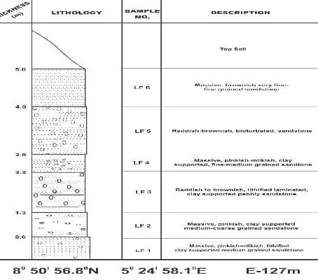

FIGURE4.1:LITHOLOGICALSECTIONOFBIDASANDSTONEEXPOSEDAT LAFIAGI

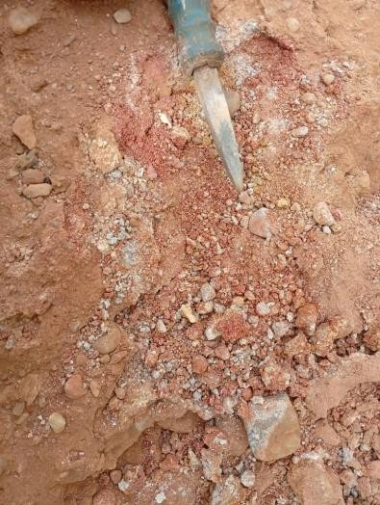
Plate4.1Massivereddish brown reddish lithified
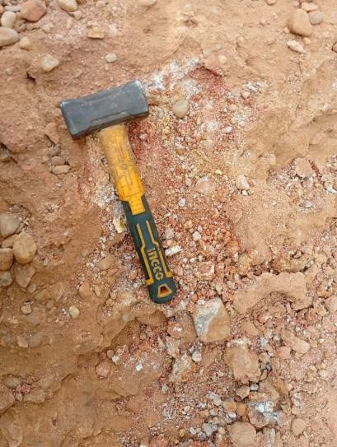Plate4.2Massivereddishbrownmatrixsupported
conglomerate

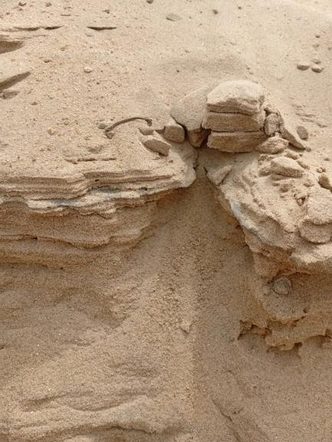
Plate4.3Massivemilkish-reddishpebblysandstone

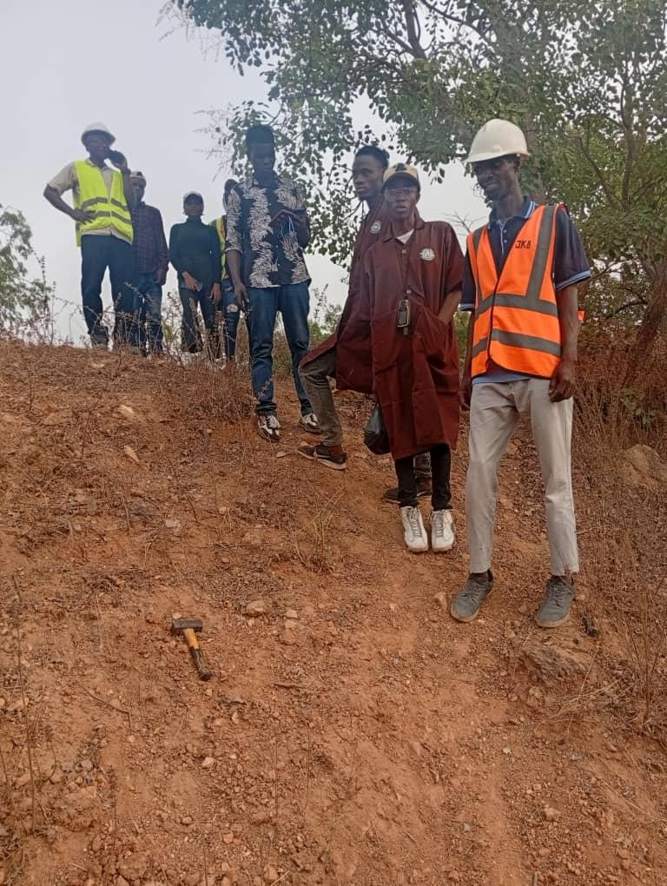Plate4.4Projectstudentsontheoutcrop section of Bida sandstone Formation

CALCULATIONOFSTATISTICALPARAMETERS

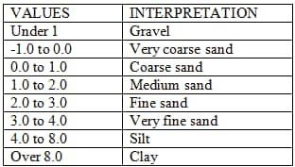
The following statistical parameters were calculated in order to reconstruct the paleoenvironment ofdeposition. These includes graphic mean, standard deviation, skewness and kurtosis.Graphic (Geometric) Mean: is the measure of an estimate of the arithmetic average particle size. It can be calculated using the equation below:

ϕ16+ ϕ50+ ϕ84 Folk and Ward (1957) gave the following scale of interpretation for the graphic mean
3

Fromthis,wecandeducetheenergyofdepositionandenvironmentofdeposition.Coarse particles usually associated with high energy environment such as continent.
Inclusive Graphic Standard Deviation: is the degree of sorting. It measures the spread of the distribution of the grain size about the mean. It can be calculated by:
ϕ84-ϕ16+ϕ95-ϕ5

4 6.6

FolkandWard(1957)presentedaverbalclassificationscaleforsorting.

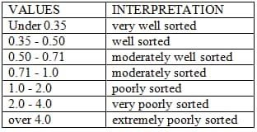Fromthisthetexturalmaturityandthedistanceoftransportation
can be deduced. Poorlysorted particles are texturally immature and are close to the source, thus, they have low porosity and permeability and cannot serve as a good reservoir rock
Inclusive Graphic Skewness (Sk): measures the symmetryofthe distributionofgrains and it is best seen from smoothed frequency. It is given by:
ϕ16+ ϕ84- 2ϕ50+ϕ5+ ϕ95- 2ϕ502(ϕ84- ϕ16) 2(ϕ95-ϕ5)
The table for the description of skewness is given below:

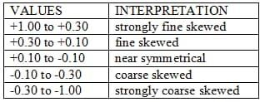Symmetricalcurveshaveskewness=0.00; thosewithexcessfinematerial(atail totheright)havepositiveskewnessandthosewithexcess
coarse material (a tail to the left) have negative skewness. The more the skewness value departs from 0.00, the greater the degree of asymmetry. Therefore, positive skewness is an indication of low energy environment e.g. fluvial environment, lagoon, lake bottoms, flood plain while negative skewness is an indication of high energy environment e.g. sand dunes, river beds, streams and beaches.

Graphic Kurtosis (KG): measures the degree of peakedness of departure from the normal frequency or cumulative frequency. It expresses the ratio of strong of the extreme tails of the distribution compared to the sorting in the central portion. It is given by :
ϕ95 - ϕ52.44(ϕ75-ϕ25)
If the central portion is better sorted than the tail, the curve is said to be excessive peaked or leptokurtic. However, mesokurtic curves have about equal sorting in the tail and central region. That is, mesokurtic curves have a normal bell shaped curve. A verbal classification for kurtosis suggested by Fork and Ward (1957) is as follows:
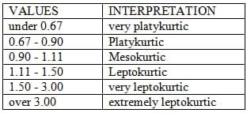

ANALYTICALRESULTSOFLF1
SampleLF1Table4.1:GrainsizeAnalyticalresultsofLF1

S/NO | SIEVE  SIZE, d | ɸ = - | Weight | % Individual | % Cumulative

 | (mm) | log2d | retained (g) | weightretained | weightretained
1 | 4.00 | -2 | 14.5 | 14.52 | 14.52
2 | 2.36 | -1.24 | 3.0 | 3.01 | 17.53
3 | 1.70 | -0.77 | 6.3 | 6.31 | 23.84
4 | 1.60 | -0.68 | 15.8 | 15.83 | 39.67
5 | 1.00 | 0 | 5.0 | 5.01 | 44.68
6 | 0.50 | 1.00 | 31.7 | 31.76 | 76.44
7 | 0.35 | 1.51 | 2.0 | 2.00 | 78.44
8 | 0.25 | 2.0 | 13.4 | 13.42 | 91.86
9 | 0.112 | 3.2 | 2.2 | 2.20 | 94.06
10 | 0.09 | 3.5 | 3.3 | 3.31 | 97.37
11 | 0.063 | 3.99 | 2.0 | 2.00 | 99.37
12 | <0.063 | >3.99 | 0.6 | 0.60 | 99.97
Total |  |  | 99.8
Fromthetable4.1above,thegraphofphivalues isplottedagainst %cumulativeweight retained value. The following parameters were obtained from the graph and were used

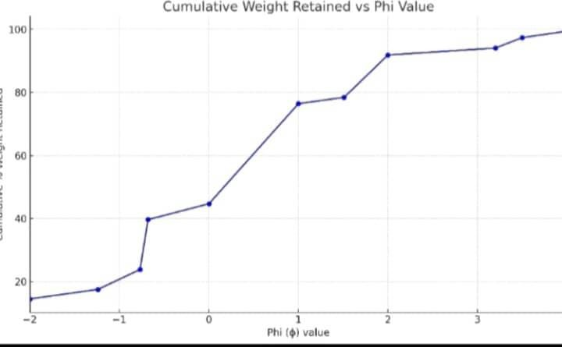
tocalculatethestatisticalparametersasfollow.

Figure4.1:GraphofPhiagainst%CumulativeWeightforsampleLF1

ɸ5=-1.9,ɸ16=-1.5,ɸ25= -1.0,ɸ50=1.0,ɸ75= 2.0,ɸ84= 2.3,ɸ95= 3.8
Graphicmean=ϕ16+ϕ50+ϕ84 =-1.5+1.0+2.3 =0.60(coarsedsand)
3 3

Inclusivegraphicstandard deviation=ɸ84-ɸ16+ɸ95-ɸ5

4 6.6

= 2.3–(-1.5)+(-1.5) – 3.8 –(–1.9) =1.81(Poorlysorted)

4 6.6

Inclusivegraphic skewness = (ɸ84+ɸ16-2ɸ50) (ɸ95 +ɸ5-2ɸ50)

2(ɸ84-ɸ16) + 2(ɸ95-ɸ5)
= [2.3+(-1.5)–2(1.0)]+[(3.8)+(-1.9)–2(1.0)]
=-–0.17(coarse skewed) |  | 2(2.3–(-1.5)) | 2(3.8–(-1.9))
Graphickurtosis= (ɸ95-ɸ5) |  | =(3.8 –(- 1.9) | =0.78(platykurtic)
2.44(ɸ75-ɸ25) |  | 2.44(2.0 –(-1.0))

ANALYTICALRESULTSOFLF2

Table4.2: Grain sizeAnalyticalresultsofLF2

S/NO | SIEVESIZE, d  (mm) | ɸ = - log2d | Weight retained(g) | % Individual weightretained | % Cumulative weight retained
1 | 4.00 | -2 | 14.6 | 14.64 | 14.64
2 | 2.36 | -1.24 | 2.2 | 2.21 | 16.85
3 | 1.70 | -0.77 | 2.5 | 2.51 | 19.36
4 | 1.60 | -0.68 | 4.0 | 4.01 | 23.37
5 | 1.00 | 0 | 8.0 | 8.02 | 31.39
6 | 0.50 | 1.00 | 40.4 | 40.52 | 71.91
7 | 0.35 | 1.51 | 6.2 | 6.22 | 78.13
8 | 0.25 | 2.0 | 15.6 | 15.64 | 93.77
9 | 0.112 | 3.2 | 1.7 | 1.71 | 95.48
10 | 0.09 | 3.5 | 2.0 | 2.01 | 97.49
11 | 0.063 | 3.99 | 2.1 | 2.11 | 99.60
12 | <0.063 | >3.99 | 0.4 | 0.40 | 100
Total |  |  | 99.7
Fromthetable4.2above, thegraphofphivalues isplottedagainst % cumulativeweight retained value. The following parameters were obtained from the graph and were used to calculate the statistical parameters as follow.

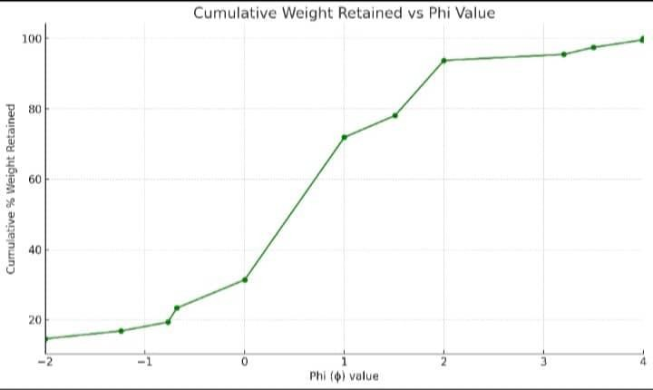

Figure 4.2: GraphofPhi against % Cumulative Weight for sample LF2 ɸ5=-1.85,ɸ16=-1.3, ɸ25=-0.7,ɸ50=0.9, ɸ75=1.7, ɸ84=2.1,ɸ95=3.6
Graphicmean=ϕ16+ϕ50+ϕ84 =-1.3+0.9+2.1 =0.57(mediumsand)

3 3

Inclusivegraphic standarddeviation= ɸ84-ɸ16+ɸ95-ɸ5

4 6.6

=2.1–(-1.3) + 3.6–(-1.85) =1.68(VeryPoorly

sorted)

4 6.6

Inclusivegraphic skewness = (ɸ84+ɸ16-2ɸ50) +(ɸ95+ɸ5-2ɸ50)

2(ɸ84-ɸ16) 2(ɸ95-ɸ5)

=[2.1)+(-1.5)–2(0.9)]+ [(3.6)+(-1.85)–2(0.9)]

2(2.1–(-1.3)) 2(3.6–(-1.85))
=-–0.15(coarse skewed)
Graphic kurtosis = (ɸ95 - ɸ5) =(3.6– (- 1.85) =0.93(mesokurtic) 2.44(ɸ75- ɸ25) 2.44(1.7 – (-0.7))

ANALYTICALRESULTSOFLF3

Table4.3: Grain sizeAnalyticalresultsofLF3

S/NO | SIEVESIZE, d  (mm) | ɸ = - log2d | Weight retained(g) | % Individual weightretained | % Cumulative weight retained
1 | 4.00 | -2 | 54.2 | 54.36 | 54.36
2 | 2.36 | -1.24 | 4.0 | 4.01 | 58.38
3 | 1.70 | -0.77 | 2.0 | 2.01 | 60.38
4 | 1.60 | -0.68 | 2.3 | 2.31 | 62.69
5 | 1.00 | 0 | 3.0 | 3.01 | 65.70
6 | 0.50 | 1.00 | 2.4 | 2.41 | 68.10
7 | 0.35 | 1.51 | 0.2 | 0.20 | 68.30
8 | 0.25 | 2.0 | 5.1 | 5.12 | 73.42
9 | 0.112 | 3.2 | 14.4 | 14.44 | 87.86
10 | 0.09 | 3.5 | 10.0 | 10.03 | 97.89
11 | 0.063 | 3.99 | 1.7 | 1.71 | 96.60
12 | <0.063 | >3.99 | 0.4 | 0.40 | 100.00
Total |  |  | 99.7
Fromthetable4.3above,thegraphofphivalues isplotted against%cumulativeweightretainedvalue.Thefollowing parameters were obtained from the graph and were used
tocalculatethestatisticalparametersasfollow.

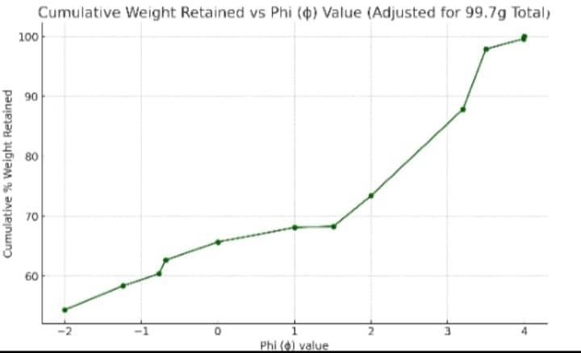

Figure4.3:GraphofPhiagainst %Cumulative Weight forsampleLF3 ɸ5=1.75,ɸ16= –1.1,ɸ25=-06,ɸ50= 1.3,ɸ75=3.0,ɸ84= 3.3,ɸ95=3.9
Graphicmean=ϕ16+ϕ50+ϕ84 =-1.1+1.3+3.3 =1.17(mediumsand)

3 3

Inclusivegraphicstandard deviation=ɸ84-ɸ16+ɸ95-ɸ5

4 6.6

=3.3–(-1.1) + 3.9–1.75. =1.96(Poorlysorted)

4 6.6

Inclusivegraphic skewness = (ɸ84+ɸ16-2ɸ50) + (ɸ95+ɸ5- 2ɸ50)

2(ɸ84-ɸ16)  = [3.3)+(-1.1)– 2(1.3)] | + | 2(ɸ95-ɸ5)  [(3.9)+(-1.75) –2(1.3)]
2(3.3–(-1.1))  =0.03(Stronglyfine skewed) |  | 2(3.9– 1.75))

Graphickurtosis= (ɸ95-ɸ5) = 3.6–1.75. = 0.64(veryplatykurtic)

) 2.44(ɸ75-ɸ25) 2.44(1.7–(-0.7))

ANALYTICALRESULTSOFLF4

Table4.4: GrainsizeAnalyticalresultsofLF4

S/NO | SIEVESIZE, d  (mm) | ɸ = - log2d | Weight retained(g) | % Individual weight retained | % Cumulative weight retained
1 | 4.00 | -2 | 14.0 | 14.03 | 14.03
2 | 2.36 | -1.24 | 4.5 | 4.51 | 18.54
3 | 1.70 | -0.77 | 2.0 | 2.00 | 20.54
4 | 1.60 | -0.68 | 2.0 | 2.00 | 22.55
5 | 1.00 | 0 | 12.2 | 12.22 | 34.77
6 | 0.50 | 1.00 | 25.5 | 25.55 | 60.32
7 | 0.35 | 1.51 | 10.0 | 10.02 | 70.34
8 | 0.25 | 2.0 | 23.4 | 23.45 | 93.79
9 | 0.112 | 3.2 | 2.5 | 2.51 | 96.29
10 | 0.09 | 3.5 | 1.2 | 1.20 | 97.49
11 | 0.063 | 3.99 | 2.1 | 2.10 | 99.60
12 | <0.063 | >3.99 | 0.4 | 0.40 | 100.00
Total |  |  | 99.8

Fromthetable4.4above, thegraphofphivalues isplottedagainst % cumulativeweight retained value. The following parameters were obtained from the graph and were used to calculate the statistical parameters as follow.
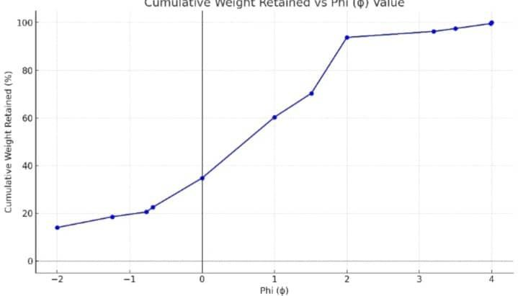
Figure4.4:GraphofPhiagainst %Cumulative Weight forsampleLF4 ɸ5=–1.6,ɸ16=–1.1,ɸ25= 0.2,ɸ50=1.0,ɸ75=1.8,ɸ84=2.0,ɸ95=3.0
Graphicmean=ϕ16+ϕ50+ϕ84 = -1.1+1.0+2.0 =0.63(coarse sand)

3 3

Inclusivegraphicstandarddeviation=ɸ84-ɸ16+ɸ95-ɸ5

4 6.6

=2.0–(-1.1) + 3.0–(–1.6) =1.47(Poorly

sorted)

4 6.6

Inclusivegraphic skewness = (ɸ84+ɸ16-2ɸ50) (ɸ95+ɸ5-2ɸ50)
2(ɸ84-ɸ16) | + | 2(ɸ95- ɸ5)
= [2.0+(-1.1)– 2(1.0)] | + | [(3.0+ (-1.6)–2(1.6)]
2(2.0–(-1.1))  =–0.81(coarseskewed) |  | 2(3.0–(–1.6))
Graphic kurtosis = (ɸ95 - ɸ5) = 3.0 – (–1.6) =1.18(Leptokurtic) 2.44(ɸ75- ɸ25) 2.44(1.8 – 0.2)

ANALYTICALRESULTSOFLF5

Table4.5: GrainsizeAnalyticalresultsofLF5

S/NO | SIEVESIZE, d  (mm) | ɸ = - log2d | Weight retained(g) | % Individual weightretained | % Cumulative weight retained
1 | 4.00 | -2 | 30.2 | 30.23 | 30.23
2 | 2.36 | -1.24 | 1.0 | 1.00 | 31.23
3 | 1.70 | -0.77 | 1.5 | 1.50 | 32.73
4 | 1.60 | -0.68 | 0.4 | 0.40 | 33.13
5 | 1.00 | 0 | 1.7 | 1.70 | 34.83
6 | 0.50 | 1.00 | 2.5 | 2.50 | 37.34
7 | 0.35 | 1.51 | 0.4 | 0.40 | 37.74
8 | 0.25 | 2.0 | 15.0 | 15.02 | 52.75
9 | 0.112 | 3.2 | 21.4 | 21.42 | 74.17
10 | 0.09 | 3.5 | 22.3 | 22.32 | 96.50
11 | 0.063 | 3.99 | 2.8 | 2.80 | 99.30
12 | <0.063 | >3.99 | 0.7 | 0.70 | 100.00
Total |  |  | 99.9

Fromthetable4.5above, thegraphofphivalues isplottedagainst % cumulativeweight retained value. The following parameters were obtained from the graph and were used to calculate the statistical parameters as follow.

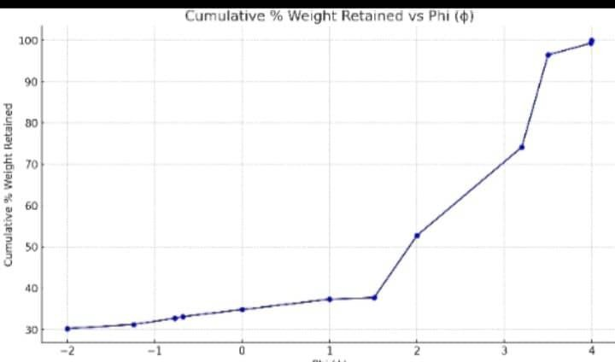

Figure4.5:GraphofPhiagainst%CumulativeWeightforsampleLF5

ɸ5=–1.6,ɸ16=–1.2,ɸ25= –0.8,ɸ50=1.2,ɸ75=3.3,ɸ84=3.7,ɸ95=4.0
Graphicmean=ϕ16+ϕ50+ϕ84 = -1.2+1.2+3.7 =1.23(mediumsand)

3 3

Inclusivegraphicstandarddeviation=ɸ84-ɸ16+ɸ95-ɸ5

4 6.6

=3.7–(-1.2) + 4.0–(–1.6) =2.08(veryPoorly
sorted)

4 6.6

Inclusivegraphic skewness = (ɸ84+ɸ16-2ɸ50) + (ɸ95+ɸ5- 2ɸ50)

2(ɸ84-ɸ16) 2(ɸ95-ɸ5)
=[3.7+(-1.2) –2(1.2)] + [(4.0+(-1.6)–2(1.2)]

2(3.7–(-1.2)) 2(4.0–(–1.6))
=–0.112(stronglycoarseskewed)
Graphic kurtosis = (ɸ95 - ɸ5) = 4.0 –(–1.6) =0.56(veryplatykurtic) 2.44(ɸ75- ɸ25) 2.44(3.3 – 0.8)

Table4.6: SummaryofValuesofStatisticalParametersandInterpretation

Sample Number | StatisticalParametersand Interpretation
Sample Number | Mean | Standard Deviation |  | Skewness |  | Kurtosis
LF1 | 0.60  (Coarsesand) | 1.81  (Poorlysorted) |  | -0.17  ( coarseskewed) |  | 0.78  (Platykurtic)
LF2 | 0.57  (Mediumsand) | 1.68  (Very sorted) | Poorly | –0.15  (Coarseskewed) |  | 0.93  (Mesokurtic)
LF3 | 1.17  (Mediumsand) | 1.96  (Poorlysorted) |  | 0.03  (Strongly skewed) | Fine | 0.64  (Veryplatykurtic)
LF4 | 0.63  (Coarsesand) | 1.49  (Poorlysorted) |  | -0.81  (Coarseskewed) |  | 1.18  (Leptokurtic)
LF5 | 1.23  (Mediumsand) | 2.08  (Very sorted) | poorly | –0.112  (Strongly skewed) | coarse | 0.56  (Veryplatykurtic)
AVERAGE | 0.84  (Coarsesand) | 1.80  (Poorlysorted) |  | –0.44  (Strongly skewed) | coarse | 0.82  (Platykurtic)

DEPOSTIONALENVIRONMENTS

The meangrainsize values range from –3.07 Φto 0.24Φ, withanoveralltrend toward coarseto verycoarsegrains,indicatinghigh-energydepositionalsettings(FolkandWard,1957;Tucker,

2003). Particularly, Tables 1, 2, and 5 (Mz ≈ 0.08–0.24 Φ): Represent coarse sand, suggesting fluvial channel or delta-front environments.Tables 3 and 4 (Mz = –3.07 Φ and –2.52 Φ): Represent very coarse sediments, consistent with proximal high-energy fluvial environmentssuch as alluvial fans, braided rivers, or channel lag deposits (Blatt et al., 1980). The sorting values (σI), ranging from 1.79 Φ to 7.77 Φ, indicate that all samples are poorly to very poorly sorted. According to Folk (1980), such sorting is characteristic of rapid deposition in fluvial systems where energy varies frequently. Skewness (SkI) values are all negative (–0.85 to –0.11), indicating a coarse-skewed trend, where coarser grains dominate. Coarse skewness typically indicates bedload-dominated transport, common in rivers or high-energy subaqueous channels (Ojo, 2012). Kurtosis (KG) values range from0.62 to 1.87, showing variability fromplatykurtic to mesokurtic. Platykurtic curves reflect a wider range of particle sizes—supporting the interpretation of fluctuating energy environments, such as fluvial floodplains or debris-laden channels.
Collectively, thesedimentologicalparametersstronglysuggest thattheBidaSandstonewas depositedincontinentalfluvialenvironments, possiblyacombinationof:Braidedrivers, Alluvial fans,Deltaicchannels,Floodplain facies.Theprevalenceofcoarse-grained material,poorsorting, and coarse-skewed distributions aligns with high-energy depositional regimes, with rapid shifts in flow velocity and sediment input.
The variation across the samples supports complex fluvial systems influenced by tectonics, local relief, and episodic flooding.These environments range from proximal coarse deposits (Tables 3 &4) to slightly more distal, moderate-energy fluvialdeposits (Tables 1, 2, and 5). The Bida Formation likely reflects a braided fluvial system with variable sediment supply, occasionally interfacing with deltaic systems or floodplain deposits.
This analysis shows how grain size statistics can serve as a powerful tool to interpret ancient depositional systems, especially when Outcrop data is limited. Paleontological evidence is lacking, Sedimentary structures are poorly preserved.The Bida Sandstone, in this case, is a prime example of how quantitative grain size parameters, when analyzed carefully, can reconstruct past environments and inform basin evolution models.

PROVENANCE,TRANSPORTATIONHISTORYANDTEXTURALMATURITY

The provenance of sedimentaryparticles refers to their source area and origin, typicallyrevealed through grain size, shape, and mineral composition. The analyzed samples from the Bida Sandstone exhibit mean grain sizes ranging from –3.07 Φ to 0.24 Φ, indicating dominance of coarseto verycoarse grains, particularly in samples fromTables 3 and 4 (–3.07 Φ and –2.52 Φ). These extremely coarse sediments suggest proximal sources, most likely derived from nearby basement complex rocks or older sedimentary successions (Tucker, 2003).
The angular to sub-angular nature inferred from coarse skewness and poor sorting further indicates short-distance transport, supporting derivation from local high-relief upland areas, possibly within the adjacent Nigerian Basement Complex. According to Ojo (2012), fluvial systemswithintheBidaBasinwere fed bylocalterrigenousclasticserodedfromthesurrounding highlands.
The combination of very coarse grain sizes, poor sorting, negative skewness, and platykurtic to mesokurtic distributions reflects a sedimentary suite derived from proximal sources, transported by high-energy fluvial systems, and deposited under limited reworking conditions. The sandstonesarethus immatureto submature intexture, indicatinga first-cyclesedimentaryhistory in a continental fluvial depositional setting.

IMPLICATIONFORPETROLEUMEXPLORATION

ReservoirPotential
Coarse grain sizes (–3.07 to 0.24 Φ) suggest high porosity and permeability, favorable for reservoir quality. Fluvial and alluvial fan deposits often form lens-shaped sandstone bodies, suitable for stratigraphic or structural traps.

Sorting and Skewness
Poorto verypoorsorting indicatesheterogeneousreservoirswithvariablepermeability. Coarse skewness (dominance of larger grains) implies bedload transport, supporting preserved primary porosity.

DepositionalEnvironment
Environments like braided rivers and alluvial fans indicate proximal, high-energy settings, ideal for coarse clastic reservoirs.
Fine-grainedsourcerocks(e.g.,shales) mayexist inadjacent or underlyingunits, not withinthe coarse beds.

ExplorationStrategy

Focusonidentifyingchannelsandbodiesandpinch-outs.
Evaluate reservoir heterogeneityusing seismic, core, and well log data. Locate possible seal and source rocks in finer-grained facies nearby.

Conclusion

CHAPTER FIVE CONCLUSIONANDRECOMMENDATIONS

Altogether, the sedimentological parameters suggest that the Bida Sandstone was deposited in a continental depositional setting, likely a fluvial system, with sediments derived from proximal basement rocks. The sandstones are texturally immature to submature, with limited reworking duringtransport, implyingshort-distancetransport fromsourceto siteofdeposition.Theseresults are inagreement withearlier interpretations(e.g.,Ojo, 2012),strengthening the understanding of the sediment dynamics and environmental setting of the northern Bida Basin.
The lithological log from Lafiaji in the Northern Bida Basin reveals a vertically stacked sequence of sandstone units reflecting a progressive shift from high-energy fluvial to lower- energy marginal marine depositional environments. The basal layers (LF1–LF3) consist of clay- supported, medium to coarse-grained, and pebbly sandstones indicative of fluvial channels, braided river systems, and crevasse splay settings, deposited under unidirectional, high-energy flow regimes. Upward, the sequence transitions into finer-grained, massive to bioturbated sandstones (LF4–LF6), reflecting lower-energy environments such as distal floodplains, delta fronts, tidal flats, or shallow marine settings, with increasing evidence of biogenic activity and possible tidal influence. This vertical succession suggests a gradual environmental shift from continental fluvial systems to marginal marine or estuarine conditions, likely driven by relative sea-level rise or deltaic progradation.

ContributiontoKnowledge
This study provides a granulometric framework for understanding the sedimentological properties of the Bida Sandstone in the Northern Bida Basin. By integrating Folk and Ward statistical parameters,the study has Supplemented existing sedimentological data on the provenance, transportation history, and textural maturity of the formation, Strengthened the evidence for a fluvial depositional model for the Bida Sandstone. Demonstrated the utility of grain size analysis in reconstructing paleoenvironments of inland basins.
Thus, the research has contributed to ongoing efforts to better understand the stratigraphy, sedimentary dynamics, and depositional framework of the inland basins of Nigeria.

Recommendations
Inorder to refine the paleoenvironmentaland stratigraphic understanding ofthe Bida Formation, the following recommendations are proposed:
    - Heavy Mineraland Petrographic Analysis: To better constrainprovenance, mineralogical composition, and weathering intensity, heavy mineral assemblage and petrographic studies should be conducted on the sandstones.

    - Biostratigraphic and Palynological Studies: Incorporating biostratigraphic (microfossil) and palynological data would enhance the chronostratigraphic resolution and allow for correlation with other basins.
    - Geochemical and Isotopic Analysis: Geochemical signatures (e.g., trace elements, REE patterns) can provide deeper insight into tectonic setting, weathering regime, and paleoclimate during deposition.
    - Facies and Sequence Stratigraphy: A facies-based approach, integrated with sequence stratigraphic principles, would help delineate lithofacies associations and identify potential reservoir horizons.
    - GIS and Remote Sensing Mapping: Application of remote sensing and GIS techniques could provide spatial coverage of sandstone units and enhance basin-wide stratigraphic models.
    - Comparative Basin Analysis: Comparative studies with other inland basins (e.g., Sokoto Basin, Benue Trough) would help place the Bida Basin within a broader regional depositional and tectonic context.

REFERENCES
Barnes,R.S.K.(1998).The diversityofanimalcommunitiesincoastalwetlands.Estuarine, Coastal and Shelf Science, 46(3), 257–274.

Bennett,M.R.,&Glasser,N.F.(2009).Glacialgeology:Icesheetsandlandforms. Wiley- Blackwell.

Berner,R.A.(1980).Earlydiagenesis:Atheoreticalapproach.PrincetonUniversityPress.

Blatt,H.,Middleton,G.,&Murray,R.(1980).OriginofSedimentaryRocks.2nded.Prentice- Hall, Englewood Cliffs, NJ.

Bridges,E.M.(1990).Soildegradationandconservation.JournalofSoilScience,41(3),251– 264.

Buatois,L.A.,&Mángano,M.G.(2007).Sedimentaryfaciesandichnologyoftidalflats: perspectives from the rock record. Earth-Science Reviews, 81(3–4), 173–192.

Dalrymple,R.W.,Zaitlin,B.A.,&Boyd,R.(1992). Estuarine faciesmodels:conceptualbasisand stratigraphic implications. Journal of Sedimentary Research, 62(6), 1130–1146.

Dewey,J.F.(1977).Suturezonecomplexities:A review.Tectonophysics,40(1–2),53–86.

Evans,A.M.(1993).Oregeologyandindustrialminerals:Anintroduction.BlackwellScience.

Folk,R.L.(1968).Petrologyofsedimentaryrocks.Hemphill'sBookStore.

Folk,R.L.,&Ward,W.C.(1957).BrazosRiverbar:astudyinthe significance of grainsize parameters. Journal of Sedimentary Petrology, 27(1), 3–26.

Freeze,R.A.,&Cherry,J.A.(1979).Groundwater.Prentice-Hall.

Gradstein,F.M.,Ogg,J.G.,Schmitz,M.D.,&Ogg,G.M.(2012).Thegeologictimescale 2012. Elsevier.

Hay,W.W.(1996).Tectonicsandclimate.GeologischeRundschau,85(2),211–224.

McBride,E.F.(1985).Diageneticprocessesthataffectsandstones.JournalofSedimentary Petrology, 55(3), 333–342.

Miall,A.D.(2006).Thegeologyoffluvialdeposits: Sedimentaryfacies,basinanalysis,and petroleum geology. Springer.

Miall,A.D.(2014).Fluvialdepositionalsystems. Springer.

Nichols,G.(2009).Sedimentologyandstratigraphy(2nded.).Wiley-Blackwell.

Ojo,O.J.(2012).PetrographicandsedimentologicalcharacteristicsofBidaSandstones,Nigeria: implicationsforprovenanceanddepositionalenvironments.NigerianJournalofEarthSciences, 8(2), 47–58.

Pemberton, S. G., & Wightman, D. M. (1992). Ichnological characteristics of brackish water deposits.InApplicationsofIchnologytoPetroleumExploration(SEPMShortCourse,No.4).

Pettijohn,F.J.(1975).Sedimentary rocks(3rded.).Harper&Row.

Pettijohn,F.J.,Potter,P.E.,&Siever,R.(1987).Sandandsandstone.Springer-Verlag.

Reading,H.G.(1996).Sedimentaryenvironments:Processes,faciesandstratigraphy(3rded.). Blackwell.

Selley,R.C.(1998). Elementsofpetroleumgeology.AcademicPress.

Taylor,K.G.,&Macquaker,J.H.S.(2011).The sedimentologyanddiagenesisofsandstones. Sedimentology, 58(2), 257–276.

Tucker,M.E.(2001).Sedimentarypetrology:Anintroductiontotheoriginofsedimentary rocks. Blackwell Science.

Tucker,M.E.(2003).Sedimentaryrocksinthefield:Apracticalguide(3rded.).Wiley-Blackwell.

