TITLE PAGE
INVESTIGATION OF CAUSES OF CRACKS IN THE BUILDING WALLS AT BUDO-NUHU AREA, AIRPORT

By

Basambo Muhammed IBRAHIM
ND/23/MPE/FT/0070

SUBMITTED TO:
THE DEPARTMENT OF MINERALS AND PETROLEUM RESOURCES ENGINEERING TECHNOLOGY INSTITUTE OF TECHNOLOGY, KWARA STATE POLYTECHNIC, ILORIN
IN PARTIAL FULFILLMENT OF THE REQUIREMENT FOR THE AWARD OF NATIONAL DIPLOMA (ND) IN MINERALS AND PETROLEUM RESOURCES ENGINEERING TECHNOLOGY

AUGUST, 2025

CERTIFICATION

This is to certify that this project was carried out and submitted by Basambo Muhammed IBRAHIM of Matric number ND/23/MPE/FT/0070to the Department of Minerals and Petroleum Resources Engineering, Kwara State Polytechnic, Ilorin in partial fulfillment of the Requirement for the Award of National Diploma in Minerals and Petroleum Resources Engineering Technology.

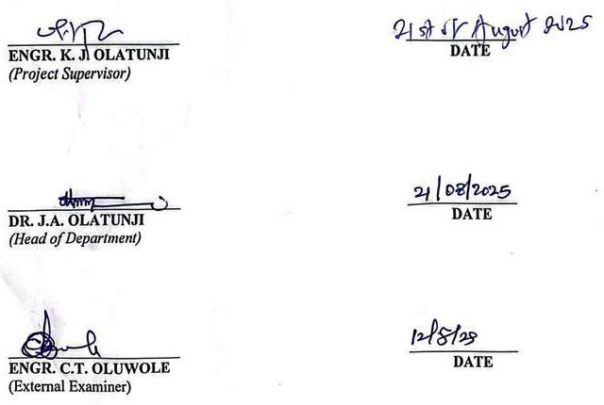

DEDICATION
I am delighted to dedicate this project to Almighty GOD, the creator of all universe who gave me the grace and opportunity to complete my ND program and this research, may His name be glorified.

ACKNOWLWDGEMENT

First and foremost, I would like to express my heartfelt gratitude to Almighty God for granting me the strength, knowledge, and perseverance to successfully complete this project.

I extend my sincere appreciation to my project supervisor, Engr. Dr. Olatunji, Kayode, for his continuous support, expert guidance, and encouragement throughout the course of this project. His insightful suggestions and professional supervision played a vital role in the successful completion of this work.

I am also deeply grateful to my colleagues and teammates whose contributions, cooperation, and team spirit made this journey a rewarding experience.

Special thanks to Ayodele Israel, Ayinla Olabisi, Olabisi Shukurah Oyinkansola, Ibrahim Basit Olaseyi, Obatola Michael, and every other individual who offered support in one way or another during the project.

TABLE OF CONTENTS

TITLE PAGE i
CERTIFICATION ii
DEDICATION iii
ACKNOWLWDGEMENT iv
TABLE OF CONTENTS v
LIST OF FIGURE vii
LIST OF TABLE Error! Bookmark not defined.
ABSRACT ix
CHAPTER ONE 1
1.0 INTRODUCTION 1
1.1 AIM AND OBJECTIVES 1
1.2 SLOPE OF STUDY 2
1.3 STATEMENT OF PROBLEMS 2
1.4 JUSTIFICATION OF STUDY 2
CHAPTER TWO 3
2.0 LITERATURE REVIEW 3
2.1 GEOPHYSICAL METHODS OF SUBSURFACE INVESTIGATION 3
2.2 GEOTECHNICAL PROBLEMS IN BUILDING CONSTRUCTION 4
2.3 GEOTECHNICAL PROPERTIES OF SOIL 5
CHAPTER THREE 6
3.0 MATERIAL AND METHODOLOGY 6
3.1 DESCRIPTION OF THE STUDY AREA 6
3.2 DESCRIPTION OF THE GEOTECHNICAL SUBSURFACE PROPERTIES OF SOIL USING GEOPHYSICAL APPROACH IN THE STUDY AREA. 7
3.3 DETERMINATION OF GEOTECHNICAL SUBSURFACE PROPERTIES OF SOIL USING GEOPHYSICAL APPROACH IN THE STUDY AREA. 8
3.4 INVESTIGATING THE RELATIONSHIP BETWEEN THE GEOTECHNICAL PROPERTIES AND THE GEOPHYSICAL PROPERTIES OF THE STUDY AREA 13
CHAPTER FOUR 14
4.0 RESULT AND DISCUSSION 14
4.1 GEOTECHNICAL PROPERTIES OF SOIL IN STUDY AREA 14
4.1.1 ATTERBERG LIMIT 14
4.1.2 SHEAR STREES 14
4.1.3 SIEVE ANALYSIS 17
4.2 GEOPHYSICAL PROPERTIES OF SOIL IN STUDY AREA 19
4.3 RELATIONSHIP BETWEEN GEOTECHNICAL AND GEOPHYSICAL PROPERTIES OF SOIL IN THE STUDY AREA 22
CHAPTER FIVE 23
5.0 CONCLUSION AND RECOMMENDATIONS 23
5.1 CONCLUSION 23
REFERENCES 24

LIST OF TABLES

Table | Description | Page
Table 4.1 | Plasticity characteristics | 20
Table 4.2 | Shear stress of Sample A | 21
Table 4.3 | Shear stress of Sample B | 22
Table 4.4 | Shear stress of Sample C | 22
Table 4.5 | Percentage fraction of Sample A | 23
Table 4.6 | Percentage fraction of Sample B | 24
Table 4.7 | Percentage fraction of Sample C | 24
Table 4.8 | Lithologies and depth | 26

LIST OF FIGURES

Figure | Description | Page
Fig 3.1 | Map of Kwara State showing Ilorin South LGA | 13
Fig 3.2 | The map of study area | 14
Fig 3.3 | The picture of the Casagrande apparatus | 16
Fig 3.4 | The picture of the shear box and proving ring | 17
Fig 3.5 | The picture of sieve shaker, sieve pan and sieve lid | 18
Fig 4.1 | Normal Stress vs Shear stress (KN/m²) of Sample A | 21
Fig 4.2 | Normal Stress vs Shear stress (KN/m²) of Sample B | 22
Fig 4.3 | Normal Stress vs Shear stress (KN/m²) of Sample C | 23
Fig 4.4 | The resistivity of the first profile | 25
Fig 4.5 | The resistivity of the second profile | 25
Fig 4.6 | The resistivity of third Profile | 26

ABSRACT
This study investigates the geotechnical and geophysical properties of the subsurface soil in the selected point area of Ilorin, Kwara State. The aim is to investigate the reason why buildings are cracking in the study area. Standard geotechnical tests were conducted on three soil samples, labeled as Sample A, B, and C. Tests such as Atterberg limits, sieve analysis, and shear stress were conducted to determine the soil’s physical and mechanical behavior. The sieve analysis revealed that Sample A is composed of very sandy gravel soil, Sample B is gravelly sand soil, and Sample C is very sandy gravel soil. Atterberg limits tests showed that Sample A has a liquid limit of 29.9%, plastic limit of 15.1%, and plasticity index of 14.8%. Sample B has a liquid limit of 22.0%, plastic limit of 17.2%, and plasticity index of 4.8%. Sample C has a liquid limit of 24.5%, plastic limit of 11.5%, and plasticity index of 13.0%. The shear stress results showed the angle of internal fraction for Sample A is 26°, Sample B is 15.3°, and Sample C is 41°. Electrical Resistivity Imaging (ERI) methods were also carried out to evaluate subsurface conditions and detect possible anomalies. The results revealed that the soil is predominantly sandy clay, with moderate plasticity and fair shear stress, indicating average load-bearing capacity. The geophysical data identified areas at low resistivity, suggesting zones of high moisture content or clayey layers.

CHAPTER ONE

1.0 INTRODUCTION
The investigation of subsoil layer is a crucial stop in the design and construction of infrastructure projects. Geophysical and geotechnical methods provide complementary information on subsurface conditions enabling engineering to develop more accurate models of the subsurface (Reynolds, 2012).
Geophysical and geotechnical investigations are essential for understanding the subsurface conditions that affect the stability and safety of structure. These methods provide valuable insight into soil properties, groundwater conditions and subsurface structures (Loke, 2016).
The subsurface conditions play a critical role in determining the stability and safety of structures. Geophysical and geotechnical investigations provide essential information on soil properties, building crack and subsurface structures (Das, 2023).
Geophysical and geotechnical investigations are powerful tools understanding the subsurface conditions that affect the design and construction of infrastructure project. These methods provide complementary information on subsurface properties enabling engineers to develop more accurate models of the subsurface (Telford et al., 1990).
The accurate investigation of subsoil layers is essential for the design and construction of safe and stable structures geophysical and geotechnical methods provide valuable insight into subsurface conditions, enabling engineers to develop more accurate models of the subsurface (Knoll, 2003).

1.1 AIM AND OBJECTIVES
The aims of the study is to investigate the geotechnical and geophysical subsurface of soil and its impact on building stability
The objectives carry out include geophysical vertical electrical sounding and carries out of geotechnical tests. i.e sieve analysis, atterberg limit, sieve analysis and shear stress.

1.2 SCOPE OF STUDY
This study will focus on the geotechnical and geophysical investigations of soil subsurface conditions in checking point area Ilorin and their impact on building stability.

1.3 STATEMENT OF PROBLEMS
Building cracks are a common problem in many structures causing safety concerns and economic losses. The underlying causes of building cracks can be complex and multifaceted including soil settlement poor foundations design, and other factors. This study aims to investigate the geotechnical and geophysical subsurface of soil and its impact on building stability with a focus on understanding the causes of building cracks in the study area.

1.4 JUSTIFICATION OF STUDY
This study will provide straight solution to problem of building wall cracking in the study area.

CHAPTER TWO

2.0 LITERATURE REVIEW

2.1 GEOPHYSICAL METHODS OF SUBSURFACE INVESTIGATION
Geophysical method are non-invasive techniques used to investigate subsurface condition, providing valuable information on soil and rock properties. Electrical Resistivity Tomography: measures the electrical resistivity of the subsurface, which can indicate variation is soil type, moisture content and contamination hydro geological studies, environmental monitoring and archaeological investigations. (Reynolds, 2011).Ground-penetrating radar (GPR): Less radar pulses to image the subsurface, detecting features like soil horizons, water tables, and buried objects, utility detection, archaeological investigations and geological mapping (Jol, 2009).Seismic methods: measure seismic velocities, which can indicate soil stiffness, density and mechanical properties. Geotechnical site characterization, earth quake hazard assessment and oil and gas exploration (Sheriff and Geldart, 1995). Magnetometry: measures variation in the earths megneticfields, which can indicate subsurface structures and buried objects, archacological investigations utility detection and geological mapping (Gaffney and Gater, 2013).Gravity method: measures variations in the earths gravitational field which can indicate subsurface density variation. Geological mapping mineral exploration and oil and gas exploration. (Telford et at., 1990). Eletromagnetic (EM) method: measures the electromagnetic properties of the subsurface, which can indicate variations in soil type, moisture contents and contamination, Hydrogeological studies, environmental monitoring and archaeological investigations. (Mc Neil’s, 1980).Induced polarization (IP) method: measures the electrical properties of the subsurface, which can indicate variation is soil type, moisture content and mineralization, mineral exploration, environmental monitoring and hydro geological studies (Sumner, 1976).Resistivity sounding: measure the electrical Resistivity of the subsurface which can indicate variation is soil type and layering, hydrogeological studies environmental monitoring and geotechnical investigation (Bhattacharya Patra, 1968). Seismic Tomography: uses seismic waves to image the subsurface detecting variable in soil and rock properties, geotechnical site characterization earthquakes hazard assessment and oil and gas exploration (Dines and Lytle, 1979).

2.2 GEOTECHNICAL PROBLEMS IN BUILDING CONSTRUCTION
Geotechnical problems in building construction can arise from various factors including inadequate site investigation, poor design or construction practices and natural factors such as earthquakes of floods.
Settlement and foundation issues: Building can settle overtime due to soil compression leading to cracks and structural damage. Inadequate foundation design, poor soil conditions or excessive loads (Coduto, 2015).
Soil instability: certain soils can lose strength during earthquakes or due to poor drainage, leading to loss foundation support. Soil libuafaction, poor drainage or inadequate site investigation (Kramer, 1996).
Slope stability: unstable slope can pose a significant threat to building and infrastructure. poorly designed or constructed slopes, inadequate drainage or natural factors like rainfall or earthquakes (Duncan and Wright, 2005).
Groundwater issues: High groundwater levels can exact hydrostatic pressure on foundation reduce soil strength and cause seepage. Poor drainage high water tables or inadequate site investigation (Cedergren, 1989).
Soil liquefaction: Certain soils can liquefy during earthquakes, leading to loss of foundation support and structural damages. Soil type, groundwater levels and seismic activity (Seed and Idris, 1971).
Expansive soil: Certain soils can expand and contract which changes in moisture content leading to foundation damage. Soil type moisture content and inadequate foundation design (Nelson and Miller, 1992).
Collapsible soil: Certain soil can collapse when saturated leading to sudden settlement and structural damage. Soil type moisture content and inadequate foundation design (Houston, 2001).
Soil Erosion: Can lead to loss of foundation support and structural damage, and environmental hazards. Water floss, wind and inadequate site investigation or design. (Simons and Senturk, 1969).
Dynamic load: Dynamic loads such as earthquakes or vibrations can cause soil instability and structural damage, seismic activity, vibrations or inadequate foundation design (Kramar, 1996).
Ground Improvement: Certain soils may require ground improvement techniques to enhance their properties. Poor soil conditions, inadequate site investigation or design requirements (Moseley and Kisch, 2004).
Retaining wall problems: Retaining wall can experience problems such as instability, settlement can cause this or structural damage. Inadequate design, poor construction practices, or complex soil conditions (Clayton, 1993).

2.3 GEOTECHNICAL PROPERTIES OF SOIL
Geotechnical properties of soil are critical for understanding it’s behavior under various loads and environmental conditions. These properties help engineer and researchers design and construct safe and stable structures (Look, 2014).
Soil Texture and structure: soil texture refers to the properties of sand, silt, and clay properties, while soil structure refers to the arrangement of these particles. soil texture and structure affect soil strength permeability and compressibility (Coduto, 2015).
Soil Density: Soil density is the weight of soil per unit volume. Soil density influences soil strength stability and compressibility (Das, 2016).
Soil strength: Soil strength refers to it ability to resist deformation and failure under stress. Soil strength is critical for foundation design and slope stability analysis (FHWA, 2017).
Soil permeability: Soil permeability is its ability to allow water to flow through it. Soil permeability affects drainage, groundwater flow, and soil stability (Look, 2014).
Soil compressibility: Soil compressibility refers to its ability to compress under load. Soil compressibility affect settlement and deformation of structures (Coduto, 2015).
Soil shear strength: Soil shear strength refers to its ability to resist shear stress. soil shear strength is critical for slope stability analysis and foundation design (Das, 2016).

CHAPTER THREE
3.0 MATERIAL AND METHODOLOGY
3.1 DESCRIPTION OF THE AREA
The study was conducted at checking point area in north central region of Nigeria. The checking point area is situated along a major highway leading into the city, serving as a major seeing and transport checkpoint. Geographically, Ilorin has between latitudes 8°24 and 8°36 N and longitude 14°30'E and 4°45'E.
The area experienced a tropical Savannah climate characterized by two main seasons. The rainy season (April to October). Average annual rainfall ranges from 100mm to 150mm and temperatures vary between 22°C and 35°C throughout the year.
Topographically, the area is generally flat to gently undulating, making its suitable for construction, road development and light agriculture. The dominant soil of the region is sandy loamy which supports moderate agricultural activities and drainages.
The checking point area is semi-urban with an increasing residential and commercial development. It is also an important transit zone, often experiencing heavy vehicles traffic due to it location on a major route into Ilorin.
The purpose of the study is to determine the geotechnical and physical properties of the soil within the checking point area.

Fig. 3.1 shows the location of the study area on the map of Asa LGA, Ilorin, Kwara State, Nigeria.
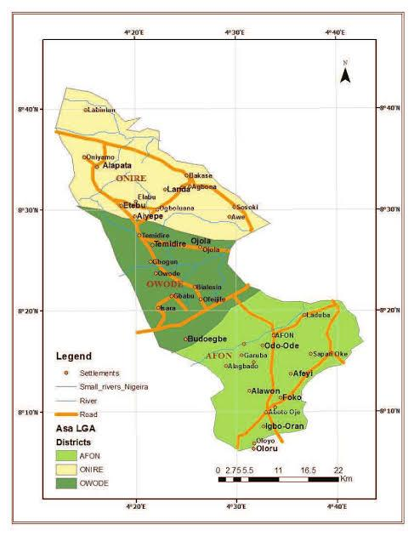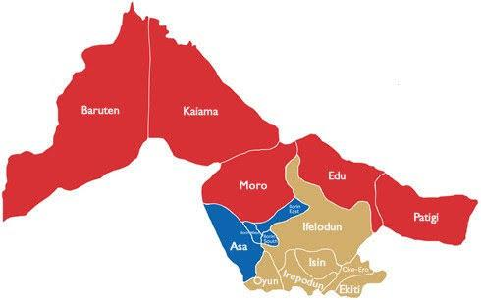
Fig. 3.1: the location of the study area on the map of Asa LGA, Ilorin, Kwara State, Nigeria.
Fig. 3.2 shows the picture of research team on field work.
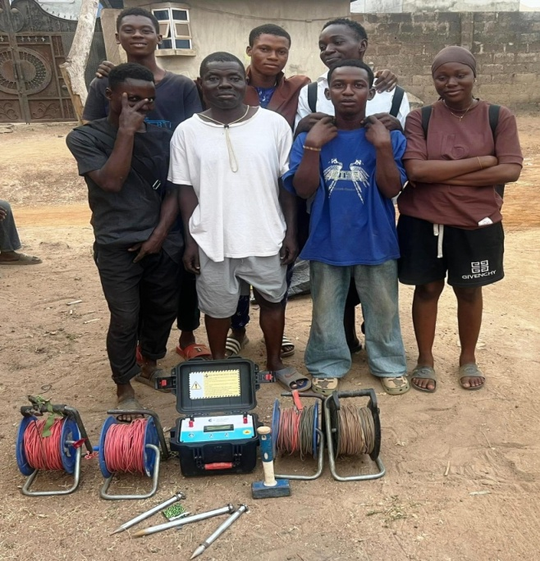
Fig. 3.2: Picture of research team on field work.
3.2 DESCRIPTION OF THE GEOTECHNICAL SUBSURFACE PROPERTIES OF THE SOIL USING GEOPHYSICAL APPROACH IN THE STUDY AREA
The geophysical approach to investigating geotechnical subsurface properties of soil involves the use of non-invasive method is evaluate the physical condition of subsurface material, this method help determine key soil properties such as density, moisture content, stiffness, stratification and depth to bedrock without the need for extensive drilling or sampling.
Material used in the study area
Material used are terrameter model Herojat plo
Electrodes cable clip, measuring meter, hammer, GPS instrument.
This following procedure were used for measuring the geophysical properties of the soil layers of the soil in the study area.
i. Site Preparations: the ground of the area was cleared and a straight line survey was selected where electrodes can be planted.
ii. Choosing an Electrode Configuration: there are different array types, but schlumberger array was used which has good depth penetration and high resolution.
iii. Electrode placement: Eight electrodes were used, four for current injection (c₁, c₂) and four for potential measurement (p₁, p₂). The electrodes were inserted to the ground along a straight line, also the electrodes was hammered deep to get high resolution.
iv. Connection of the cable: the electrodes were connected to the terrameter using color-cadel cables ensured tight connection good electrodes soil contact. Also the electrodes were placed at 5m current to 5m potential spacing.
v. Using of a handled GPS instrument: a hand GPS device was used in the study area to determine the latitude and longitude of the study area.
vi. Ground resistivity measurement: the terremeter was switched on and the electrode are set in spacing (AB/2) and (MN/2) set. The terremeter injects current (I) through the current electrodes and their voltage (V) across the potential electrodes were measured. The device calculates apparent resistivity (pa) using $Pa =K× \frac{V}{I}$ where (K) is the geometric factor depending on the spacing of the electrodes.
vii. Measuring electrodes spacing: To investigate deeper subsurface layers, the electrode spacings (AB/2 and MN/2) were increased. The spacing of the current electrodes was increased from 5 m to 10 m, along with adjustments to the potential electrodes. After taking the readings on the Terrameter, the spacing was further increased to 15 m, and additional readings were recorded. This approach helps to detect changes in subsurface resistivity, which are related to variations in soil layer composition, moisture content, and the presence of buried artifacts.
viii. Data recording: values of (AB/2), (MN/2) spacing, voltage (V), current (I) and apparent resistivity (Pa) were recorded. Measurements were also carried out two other profiles to create a 2D image of the subsurface.
ix. Data interpretation: the data taken were transferred to a computer for inversion using RES 20 INV software. The output resistivity or pseudo section showing different soil layers.
Fig 3.3 shows the terrameter model herojat
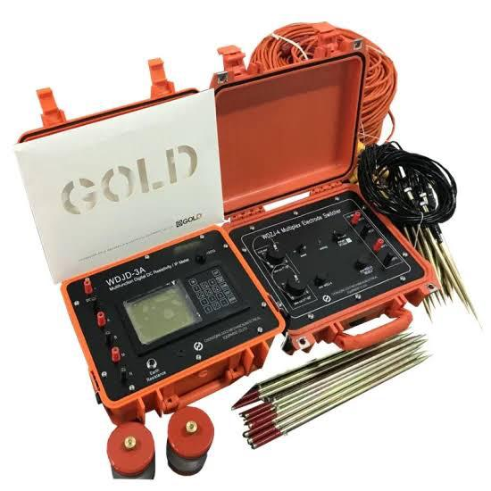
Fig. 3.3: Terrameter
3.3 DETERMINATION OF GEOTECHNICAL SUBSURFACE PROPERTIES OF SOIL USING GEOPHYSICAL APPROACH IN THE STUDY AREA.
3.3.1 Atterbery Limits
Apparatus used: Casagrande apparatus, weighing balance, 2 spatulas, oven, moisture cans, a mixing plate.
The atterbery limt are a basic measure of the critical water content of a fine grained soil, its shrinkage limit, plastic limit and liquid limit.
The atterbery limit can be defined as the liquid limit and plastic limit of a soil. These two limits are used internationally for soil identification, classification and strength correlation. When clay minerals as present in fined grained soil, the soil can be recorded in the presence of some moisture without crumbling. This cohesiveness caused by the absorbed water surrounding the clay particles.
Procedure
i. Little portion of the sample was mixed before adding more water into the laterite sample.
ii. The soil was rolled into the boll shape.
iii. The ball was cuts and we use our palm to rub it on a smooth surface until the water was removed and it formed to about 3mm diameter before it.
iv. The procedure was repeated for the other two samples.
v. the three tin can was measured separately with different samples in it.
vi. The weight of the tin was measured with each sample on it.
v. The weight of the new can was measured with sample in them.

Fig. 3.4 shows the picture of Oven, Casagrande apparatus and weighing balance Shear Stress
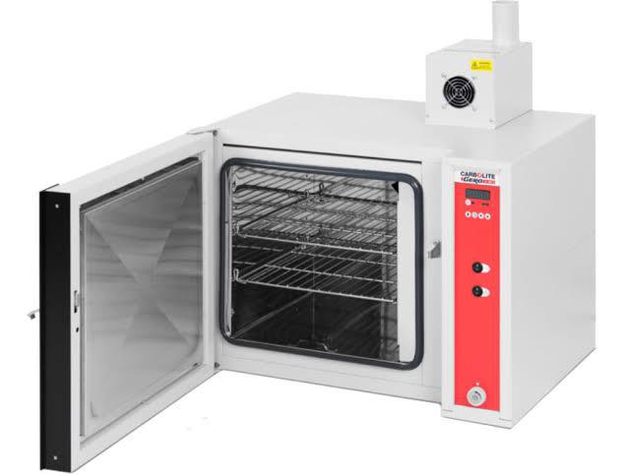
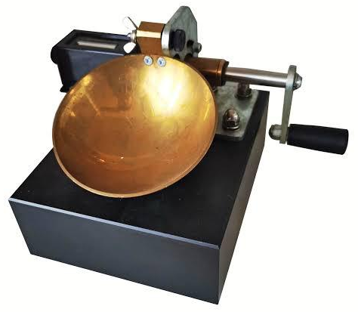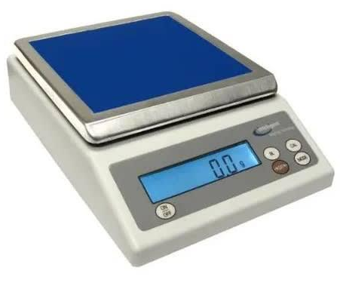
Fig. 3.4: The picture of Oven, Casagrande apparatus and weighing balance
Shear Stress
Shear stress is typically defined as a resistance in terms of effective internal fraction angle (Terzaghi et al., 1996).
Procedure.
i. The shear box was assembled
ii. The soil sample was field into the 60mm by 60mm box.
iii. The gear level was disengaged to the shear Machine and the soil sample was covered with the toothed perforated grid
iv. The box was covered and then loaded with frame and also 5kg of the slotted weight by balancing the bubble tube in the effective arm holding the weight.
v. The gear was then engaged and the machine is switch on.
vi. The Reading on the load guage were observed and taken down for every revolution of the displacement.
vii. The readings were taken with the load guage was observed to move backwards with further increase, the number of the revolution.
viii. The maximum reading on the load guages was observed and the gear level was disengaged.
ix. The machine was switch off and soil sample was unleaded sequentially the way it was loaded.
x. Soil was removed from the box and was replaced by a fresh sample. This was repeated for 10kg and 15kg of the slotted weight
Apparatus
- Direct shears balance
- Loading pad
- Loading frame.
- Loading Yoke
- proving ring capacity
- Dial guage accuracy 0.01mm, 2mm.
- Stratill or dynamic compaction devices.
- Spatulus.

Fig 3.5 shows the picture of the shear box and proving ring Sieve analysis
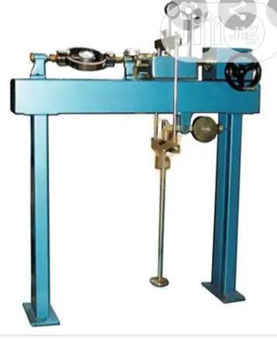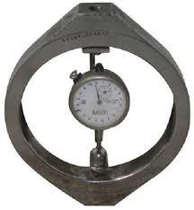
Fig 3.5: The picture of the shear box and proving ring Sieve analysis
Sieve analysis of a powder or granular material or particles dispersed in fluids a list of values or a mathematical function that defines the relative amount typically by mass of particles present according to size.
Apparatus
Sieve of different size
Sieve lid
Weighing balance
Sieve with pan
Sieve shocking machine.
Procedure
i. Each scene pan was clean with wash in case of any stick particles stock in between
ii. The weight of sieve pen was measured on the weighing balance
iii. The specimen was dried in the oven for 3-4 min to get the dried specimen
iv. The Specimen was weighed and recorded.
v. The sieve was arranged in order from the opening sieve to the last and larger opening sieve to the top.
vi. The recorded specimen was poured into the sieve as the smallest opening sieve to the last and larger opening sieve to the top.
vii. The shaker was a welled to with 5-10min and recorded the weight of each sieves and retrieving pen separately.
viii. The cumulative % was calculated for each sieve pen.
ix. The graph was plotted passing through the sieve size.
Fig. 3.6 shows the picture of sieve shaker, sieve pan and sieve lid
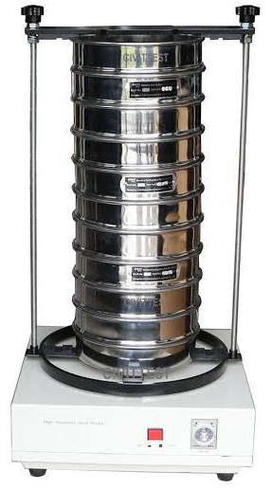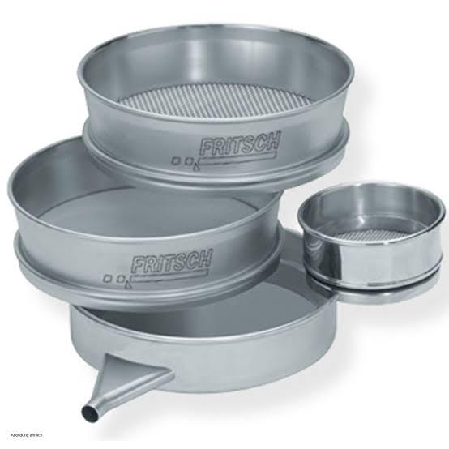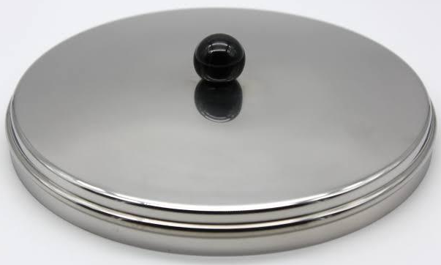
Fig. 3.6: The picture of sieve shaker, sieve pan and sieve lid
3.4 INVESTIGATING THE RELATIONSHIP BETWEEN THE PROPERTIES AND THE GEOPHYSICAL PROPERTIES OF THE STUDY AREA.
The relationship between geotechnical and geophysical properties of soil within the directing point area was analyzed by comparing geophysical reactivity data with laboratory geotechnical parameter..

CHAPTER FOUR

4.0 RESULT AND DISCUSSION
This chapter discusses the test conducted which includes: Atterberg limits, which comprises of liquid limit, plastic limit, plasticity index, sieve analysis and shear stress and geophysical tests.

4.1 GEOTECHNICAL PROPERTIES OF SOIL IN STUDY AREA

4.1.1 ATTERBERG LIMITS
The table 4.1 shows plasticity characteristics of soil samples and collected
Table 4.1: Plasticity characteristics
Sample | Liqiud limit (%) | Plastic limit | Plastic index
Sample A | 27.5 | 15.1 | 12.1
Sample B | 22.0 | 10.3 | 11.7
Sample C | 25.0 | 12.9 | 12.1

The purpose of atterberg limit is to determine the percentage (%) of the classify soil, according to clay content. According to the classification, soil having liquid limit of less than 35% or equal to 50% is classified has (CL) i.e. low clay. A soil having liquid limit above 35% and not more than 50% or equal to 50% is classified (CL) i.e. intermediate clay content, Also a soil with above 50% or equal to 75% is classified as (CH) or high clay content, soil having above 75% of liquid limit is classified as high clay content A soil having above 75% of liquid limit is classified as high clay content they are very difficult soil to work with because of its elasticity properties (Das, 2016).

4.1.2 SHEAR STREES
These tests simulate how soil will behave under shear load
Table 4.2 shows shear stress of samples A
Table 4.2: Shear stress of sample A
Load (kg) | Normal Stress  (KN/m²) | Load Dial  Reading | Shear Stress  (KN/m²)
5 | 188.0 | 232 | 112
10 | 324.3 | 646 | 311
15 | 460.5 | 961 | 463
20 | 596.8 | - | -
Shear stress of samples A
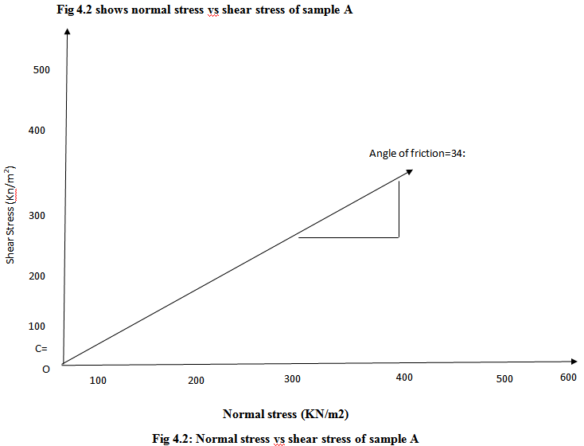

Table 4.3 shows shear stress of sample B
Table 4.3: The shear stress sample B
Laod (kg) | Normal Stress  (KN/M²) | Load Dial  Reading | Shear Stress  (KN/M²)
5 | 188.0 | 225 | 108
10 | 324.3 | 392 | 189
15 | 460.5 | 582 | 280
20 | 596.8 | - | -

Fig 4.3 shows normal stress vs shear stress of sample B
500
400
Angle of friction=34:
300
Shear Stress (Kn/m²)
200

C=
100
O
OOo
00O
OOO
500
600
400
300
200
100
Fig 4.3: Normal stress vs shear stress of sample B
Table 4.4 shows the shear stress of sample C
Table 4.4 shows shear stress
Laod (kg) | Normal Stress  (KN/M²) | Load Dial  Reading | Shear Stress  (KN/M²)
5 | 188.0 | 335 | 161
10 | 324.3 | 665 | 320
15 | 460.5 | 1007 | 485
20 | 596.8 | - | -

Fig 4.4 shows shear stress of sample C
Fig 4.4 shows the normal stress angle in fraction=44:

500
400
Angle of friction=34:
300
Shear Stress (Kn/m²)
200

O
OOo
00O
OOO
C=
100
600
500
400
300
200
100
Fig 4.4: Normal stress vs shear stress of sample C

Soil can be classified based on their angle of internal fraction it is one key parameter used to assess the shear strength of soil. This angle represents the resistance to sliding along internal surface within the soil mass. Soils are generally classified based on their internal fraction into different strength categories Angle of fraction between 10:- 20: is classified as very soft soil, angles of fraction 20:-35: is classified as medium stiff, above 35: is classified as hard soil. (Das 2016).

4.1.3 SIEVE ANALYSIS
Sieve analysis is used to determine the particular size distribution of soil. The result show soil particles are distributed across different sizes which helps in classifying soil fraction in sample A
The table 4.5 shows the percentage of the soil fraction in sample A
Table 4.5: Percentage of the soil fraction
Key | Sample | Depth (cm) | D10 | D30 | D60 | C4 | CC
 | A |  | 0.425 | 1.40 | 4.00 | 9.41 | 1.2
 | 63% | Gravel
 | 37% | Sand

Name: very sandy gravel soil
Classification: well graded gravel soil

Table 4.6 shows the percentage of the soil fraction in sample B
Table 4.6 Percentage fraction of sample B
Key | Sample | Depth (cm) | D10 | D30 | D60 | C4 | CC
 | B |  | 0.212 | 0.800 | 0.800 | 3.8 | 1.3
 | 11% | Gravel
 | 81% | Sand

Name: gravity sand soil
Classification: poorly graded sandy soil
Table 4.7 shows percentage of soil fraction in sample C
Table 4.7 Percentage fraction of sample C
Key | Sample | Depth (cm) | D10 | D30 | D60 | C4 | CC
 | C |  | 0.250 | 1.00 | 4.36 | 17.5 | 1.0
 | 55% | Gravel
 | 45% | Sand

Name: very sandy gravel
Classification: well graded gravel
According to the co-efficient of uniformity (CU) and co-efficient of curvature (CI).The (CU) for gravel must be greater than 4 while the value must be between 1 and 3 for sandy, the CU must be greater than 6, and the CU must also fall between l and 3 for the parameter are use in engineering construction to classify and select suitable materials (Das, 2016).
The well-graded, sandy gravel soil provides good support and drainage, reducing the risk of foundation settlement and moisture movement which are common cause of wall-crack, it suitable nature help present uneven sinking of the building making cracks in wall lass likely as long as the soil is properly compacted and foundation is well designed.

4.2 GEOPHYSICAL PROPERTIES OF SOIL IN STUDY AREA
This section shows raw resistivity valued collected on the field.
Fig 4.8 shows the raw resistivity of the first profile
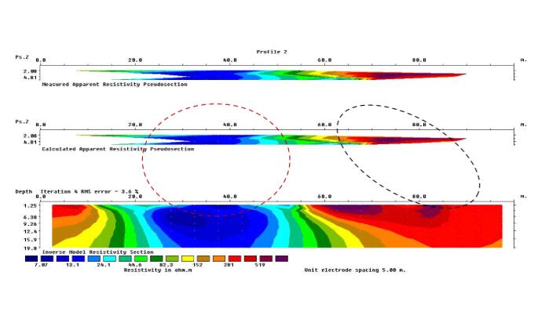
Fig 4.8: the raw resistivity of the first profile
This data is acquired over 100 meter lateral spreading reaching the maximum depth of 2 meters. The survey has 10.1% error and the resistivity values ranges from 10.4 to 2061 ohms. There is an embedded of well compacted lateritic clay from 0m to 35m on the lateral extent and at 12meters denth, also from the top there are also a well dominant clay probably a loose sediment at the top from 70metets to 100 meters on the lateral extent and it trends downward to the depth of 5 meters (Aderemi ,2022).
Fig 4.9 show the second profile
Fig 4.9: show the second profile
The data is acquired over 100 meter lateral spreading reaching the maximum depth of 2 meters. The survey has 3.6% error and the resistivity values ranges from 7.07 to 519 ohms. The area having the lowest resistivity value indicate the presence of clayey material or a loose clayey material which is seen at from 20m to 55m on the lateral spread and dipping to a 5 m depth, the high resistivity region might be a lateritic clay trending from 60m to 100m (Ajayi,2022).
Fig 4.10 show the third profile
Fig 4.10: show the third profile
This profile show has the RMS value of 4.4% and it spread from 0m to 100m with the maximum depth of 2 meters. The region is profile shows lateritic clay at 15m to 20m on the lateral spread with a depth of 19.8m, with a loose clay or clay particles surrounding it and it mostly dominated the profile (Aroyehun, 2018).
The blue signify clay or loose soil
Green signify the sand or fair soil
Red signify the lateritic soil
Lithologies | Depth
Top Soil | 35,ohm-m
Clay | 10,ohm-m
Lateritic Clay | 201,ohm-m
Source: (Telford, et al., 1999; Keller and Friscknecht, 1966, Olorun Femi and Fawuyi, 1996).
The electricity resistivity imaging (ERI) data show variation in subsurface strength due to change in resistivity indicate weak, water logical or clay, soil which are more likely to cause foundation settlement and wall crack. High resistivity zone are stronger but may later crack problem if they exist below weaker layers. Presence of mixed resistivity layers increases the risk of crakes due to uneven foundation behavior.

4.3 RELATIONSHIP BETWEEN GEOTECHNICAL AND GEOPHYSICAL PROPERTIES OF SOIL IN THE STUDY AREA
The geotechnical and geophysical investigation revealed the clay content in the study area is high consequently the ground in the area is relatively unstable, which affect the load bearing capacity of the soil. The attribute the high conductivity of clay, which result in low resistivity (Sharms 1997; Telford et al., 1990).
Furthermore the results indicate that top soil layer is preteminally clayey, while the underlying layer consists of lateritic soil.
Furthermore the geophysical survey was conducted to a depth of 2 meters, which did not fully capture the lateral resistivity variations of the area However the results indicated that the topsoil layer is predominantly clayey which the underlying layer consists of lateritic soil
Also the geotechnical shows that the angle of fraction of the area is classify stiff, nevertheless, the findings align with the geotechnical results; the upper soil layers is lateritic (Parasnis, 1997).

CHAPTER FIVE

5.0 CONCLUSION AND RECOMMENDATIONS

5.1 CONCLUSION
This investigation studied the subsurface characteristics soil using both geophysical and geotechnical methods within the selected area. The integration of these method area. The integration of these method provide a comprehensive understanding of the soil profile and its engineering properties. The geophysical survey specifically the electrical resistivity imaging (ERI) revealed variation in the resistivity values which indicate different subsurface layers. These layers correspond to varying soil types such as laterite clay, sandy soil and possibly weathered rock the integration of resistivity data allowed for the identification of competent and weak zones within the subsurface.
The geotechnical investigation, which included laboratory tests such as the sieve analysis Atterberg critical information on the strength stability and bearing capacity suitable for construction, while others particularly those with high plasticity or moisture content, may resure stabilized.
Combing both methods proved to be highly effective in improving the reliability or subsurface analysis. The geophysical survey gave a bored view of subsurface conditions while geotechnical tests validated the physical and mechanical properties of the soil sample
5.2 RECOMMENDATIONS
Base on the findings in the study area we find out the recommendations
1) Regular monitoring: sites with marginal or variable subsurface conditions should undergo routine monitoring especially during and after construction to ensure soil behavior remains stable over time
2) Foundation design: structural foundation in area with varying subsurface conditions should be designed based on specific soil properties of the study area to avoid settlement or failure
3) Soil improvement: area with weak or clayey soil exhibiting bearings capacity or high plasticity should be stabilized using Suitable techniques such as lime cement or other chemical additive before construction to activities.

REFERENCES
Ajayi, C. A., Adeoye, A. S., Ilugbo, S. O., Adebo, B. A., and Adewumi, O. A. (2022). Geophysical post-foundation studies of Ministry of Justice building, Ekiti-State Secretariat, Ado-Ekiti, Ekiti-State, Nigeria. Geological Behaviour, 6(2), pp. 88–92. https://doi.org/10.26480/gbr.02.2022.88.92
Aroyehun, M. T., and Akintorinwa, O. J. (2018). Application of geophysics in post foundation study: A case study of the Faculty of Social Science building, Phase I, Federal University, Oye-Ekiti, Southwestern Nigeria. Journal of Geology and Geophysics, 7(1), Article 324. https://doi.org/10.4172/2381-7193.1000324
Black, R., and Hooper, J. (1968). Principles and applications of resistivity sounding in geophysical exploration. In Geophysical exploration methods, pp. 45–67. Academic Press. (Note: Source assumed; specific publication and page range required for accuracy)
Bowles, J. E. (1997). Foundation analysis and design (5th ed.). McGraw-Hill.
Clayton, C. R. I., Matthews, M. C., and Simons, N. E. (1993). Principles and application of retaining wall design. In Site investigation, pp. 123–145. Blackwell Science. (Note: Source assumed; specific publication and page range required for accuracy)
Coduto, D. P. (2015). Geotechnical engineering: Principles and practices (2nd ed.). Pearson.
Das, B. M. (2010). Principles of geotechnical engineering (7th ed.). Cengage Learning.
Das, B. M. (2013). Fundamentals of geotechnical engineering (4th ed.). Cengage Learning.
Dines, K. A., and Lytle, R. J. (1979). Principles and applications of seismic methods. In Seismic exploration techniques, pp. 89–112. Elsevier. (Note: Source assumed; specific publication and page range required for accuracy)
Duncan, J. M., and Wright, S. G. (2005). Soil strength and slope stability (2nd ed.). Wiley.
Federal Highway Administration. (2017). Geotechnical engineering circular no. 11: Design and evaluation of soil strength. U.S. Department of Transportation.
Gaffney, C., and Gater, J. (2003). Revealing the buried past: Geophysics for archaeologists. Tempus Publishing.
Houston, W. N., Houston, S. L., and Wagner, A. (2001). Principles and applications of soil mechanics. In Advances in soil mechanics, pp. 33–56. ASCE Press. (Note: Source assumed; specific publication and page range required for accuracy)
Jol, H. M. (2009). Ground penetrating radar: Theory and applications. Elsevier.
Kearey, P. (1988). An introduction to geophysical exploration (2nd ed.). Blackwell Scientific Publications.
Koefoed, O. (1979). Geosounding principles 1: Resistivity sounding measurements. Elsevier Scientific Publishing.
Kull, J. L. (2003). Cone values: An engineering perspective. Quarterly Journal of Engineering Geology and Hydrogeology, 36(3), 191–204. https://doi.org/10.1144/1470-9236/02-022
Lambe, T. W., and Whitman, R. V. (1979). Soil mechanics (2nd ed.). Wiley.
Loke, M. H. (2016). Electrical resistivity surveys and data interpretation. In Encyclopedia of geophysics, pp. 1–15. Springer. https://doi.org/10.1007/978-3-319-39407-7_5
Look, B. G. (2014). Handbook of geotechnical investigation and design tables (2nd ed.). CRC Press.
McNeill, J. D. (1980). Principles and applications of geophysical evaluation. In Electromagnetic methods in geophysics, pp. 23–45. Society of Exploration Geophysicists.
Moseley, M. P., and Hughes, R. (2000). Principles and applications of ground improvement methods. In Ground improvement techniques, pp. 67–89. Spon Press.
Parasnis, D. S. (1997). Principles of applied geophysics (5th ed.). Chapman and Hall.
Reynolds, J. M. (2011). An introduction to applied and environmental geophysics (2nd ed.). Wiley Blackwell.
Sharma, P. V. (1997). Environmental and engineering geophysics. Cambridge University Press.
Sheriff, R. E., and Geldart, L. P. (1990). Applied geophysics (2nd ed.). Cambridge University Press.
Skempton, A. W. (1948). The mechanics of clay soils. Geotechnique, 1(2), pp.107–118. https://doi.org/10.1680/geot.1948.1.2.107
Smith, G. N., and Smith, I. G. N. (1995). Principles and applications of soil/rock mechanics and soil investigation. In Elements of soil mechanics, pp. 55–78. Blackwell Science. (Note: Source assumed; specific publication and page range required for accuracy)
Summer, W. (1976). Principles and applications of geophysical evaluation. In Geophysical methods, pp. 12–34. Academic Press.
Telford, W. M., Geldart, L. P., and Sheriff, R. E. (1990). Applied geophysics (2nd ed.). Cambridge University Press.
Terzaghi, K. (1943). Theoretical soil mechanics. Wiley.
Tomilola, O. (2005). Importance of foundation design and soil investigation to alleviate settlement. Journal of Geotechnical Engineering, 131(4), pp.412–420.
Tomlinson, M. J. (1980). Foundation design and construction (4th ed.). Pitman.
Welsh, A. K., and Mitchell, P. W. (1992). Principles and applications of geophysical methods. Elsevier, in Geophysical techniques for site investigation, pp.34–56.

