DESIGN AND IMPLEMENTATION OF AN ONLINE RADIO STREAMER APPLICATION

BY:

Kolawole Omoniyi Abiodun
ND/23/COM/PT/0058

A PROJECT SUBMITTED TO THE DEPARTMENT OF COMPUTER SCIENCE, INSTITUTE OF INFORMATION AND COMMUNICATION TECHNOLOGY, KWARA STATE POLYTECHNIC, ILORIN, NIGERIA

IN PARTIAL FULFILLMENT OF THE REQUIREMENTS FOR THE AWARD OF NATIONAL DIPLOMA [ND] IN COMPUTER SCIENCE
JUNE, 2025

CERTIFICATION
This is to certify that this project research was carried out by Kolawole Omoniyi Abiodun with matriculation number ND/23/COM/PT/0058, has been read and approved as meeting part of the requirements for the award of Higher National Diploma (HND) in Computer Science.

_______________________ __________________
MRS AJADI Date
Project Supervisor

_______________________ __________________
MR. OYEDEPO F.S Date
Head of Department

_________________________ __________________
External Examiner Date

DEDICATION
This project is dedicated to the creator of the earth and universe, the Almighty God. It is also dedicated to my parents for their moral and financial support.

ACKNOWLEDGEMENT
First and foremost praises and thanks to God, for his infinite mercy and showers of blessings on me throughout my undergraduate level.
I express my deep and sincere gratitude to my project supervisor Mrs Ajadi, for giving me the valuable guidance throughout this project work. His dynamism, vision, sincerity and motivation have deeply inspired me; it is a great privileged and honour to work under his guidance. Special thanks to the Head of Department Mr. Oyedepo F.S, and other members of staff in the Department of Computer Science for their support always.
To my family and friends, words can’t express my appreciation because your contribution can never be measured, your constant and unrelenting prayers made this work to the desired destination. I say God bless you all (Ameen).

TABLE OF CONTENTS
i Title page
ii. Certification
iii Dedication
iv Acknowledgement
v Abstract
Table of content
CHAPTER ONE: GENERAL INTRODUCTION
  - Introduction
  - Statement of the problem
  - Aims and objectives of the study
  - Significance of the study
  - Scope of the study
  - Organization of the report
CHAPTER TWO: LITERATURE REVIEW
2.1 Review of Related Works
2.2 Online radio streamer
2.3 Streaming algorithm
CHAPTER THREE: RESEARCH METHODOLOGY AND ANALYSIS
  - Research methodology
  - Analysis of the existing system
  - Problems of the existing system
  - Description of the proposed system
  - Advantages of the proposed system

CHAPTER FOUR: DESIGN, IMPLEMENTATION AND DOCUMENTATION OF THE SYSTEM
  - Design of the system
    - Output Design
    - Input Design
    - Database design
    - Procedure Design
  - Implementation of the System
    - Hardware Support
    - Software support
    - Implementation techniques
  - system of Documentation
    - Program Documentation
    - Operating the system
CHAPTER FIVE: SUMMARY, CONCLUSION AND RECOMMENDATION
  - Summary of findings
  - Conclusion
  - Recommendations for further investigation
References
System Flowchart / Program Flowchart
Source Code
ABSTRACT
Many users like to listen to radio program on a transistor radio, but the mobile gadget has many limitations. Currently, radio streaming systems are going through transition where more and more traditional analog solutions and systems are being replaced by newly available digital systems. The reason is that traditional systems are not easily expandable and have low voice interference with little or no signal processing. However, Internet Protocol (IP)-based digital systems having high speed dedicated processors not only offer fast processing but also provide ease in implementing advance features such as voice detection and cyber security. Radio streamer (e-radio, internet radio or online radio) is the digital distribution of radio content, such as radio programs, as streaming voice delivered over the Internet. Streaming radio online stands in contrast to dedicated terrestrial radio delivered by over-the-air aerial systems, traditional radio systems. In order to rationally use the network resources, and make the transmission of streaming media more fluent, this research proposes a design scheme of the streaming radio transmission system, and describes the design of the general structure. In this study, a concept of a radio station URL service is proposed. The aim is to create a solution where the qualities in traditional radio systems are preserved in an online environment. The decisions that were taken when shaping this project are based on a literature study and expert interviews. The proposed methodology was to design the application using Visual C# - Winforms. Visual C# is a high level programming language that was developed and implemented on the .Net framework (software framework developed by Microsoft that runs primarily on Microsoft windows) and MySQL as the database.

CHAPTER ONE
GENERAL INTRODUCTION
  - INTRODUCTION
We are in a digital age where the technological change hugely impacts all forms of media. Radio is not an exception and is today facing a rapid transition toward Internet-based services. Radio was once as simple as TV - scheduled broadcasts received by the public with a device capable of changing the channel and adjusting the volume. Not only has technology brought new innovative features, but it has also challenged the notion of what the entire radio media really is (Jackie, 2011).
According to Waterman (2013) radio streamer or online radio is the “digital distribution of radio content such as radio programs, news and so on, as streaming voice delivered over the Internet. Streaming radio stands in contrast to dedicated terrestrial radio delivered by radio stations over-the-air aerial systems, FM and/or AM frequency transmission”.
Currently, radio streaming systems are going through transition where more and more traditional analog solutions and systems are being replaced by newly available digital systems. The reason is that traditional systems are not easily expandable and have low voice transmission with little or no signal processing. However, Internet Protocol (IP)-based digital systems having high speed dedicated processors not only offer fast processing but also provide ease in implementing advance features such as voice detection, object tracking and cyber security (Wang, 2002).
Dave (2017) asserted that radio streamer is a software or system that collects (accepts) as input, a radio station streaming URL, checks the authenticity of the URL and then connect to it through the internet; and this is done with the aid of the computer. It offers a more computerized approach to the way and manner we appreciate the use of technology by listening to radio online in our day to day activities thereby reducing the massive limitation that is associated with the limited system of listening through a radio player or a mobile phone.
It serves as an alternative medium to amplitude modulation (AM) / frequency modulation (FM) when broadcasting a station. Some radio stations (within and outside the nation) broadcast online live on the internet and because of the limitation of the FM Radio in accessing frequencies at a very far distance, the software ensures that there is a globalize access to such information when needed (Franc, 2005). Some radio stations (within and outside the nation) broadcast online live on the internet and because of the limitation of the FM Radio in accessing frequencies at a very far distance, the software ensures that there is a globalize access to such information when needed.
Recently, radio streaming has been extensively used for information broadcasting. Availability of improved and enhanced transmission facilities (i.e. high speed LAN, wireless Ethernet) make it further possible to use radio streaming in fast real time applications. Before developing the software, the perspective of a situation where radio listeners i.e. the users buys a FM/AM radio device and start listening to his/her desired local station. This device must have been preconfigured to have access to these local stations. But before the user will be able to listen to his/her desired station, it is assumed that the radio device must have met certain necessities. New services that attempt to define what radio should be are frequently being released on the market: new devices, new applications and new models of content delivery. Although the options are many, it is difficult to recognize a solution that covers both the need for usability and a comprehensive access to content.
Before the advent of computer technology (internet to be precise), the traditional means that has been the way people listen to radio has a lot of limitations in terms of assessing or listening to radio across the nation or even beyond the vicinities of a local station area. It was because of this reason that radio stations started broadcasting their programs online. The invention and application of computer and internet now brought succour to the way and manner radio stations broadcast their programs (Anjola, 2013).
The rapid development and popularity of Internet provides the strong market momentum for the development of the streaming media business, the streaming media business is becoming increasingly popular. Streaming media technology is widely used in multimedia news publishing, live broadcast online, advertising online, e-commerce, video on demand, remote education, telemedicine, Internet radio, real-time video conference and other aspects of the Internet Information Services. The application of the streaming media technology will bring great changes on the network information exchange and have a profound impact on the people's work and life (Liu, 2010).
The streaming media technology is not a single technology, it is the organic combination of network technology and video / audio technology. The implementation of streaming media technology on the network, needs to solve the problems on the streaming media production, publishing, transmission and playing, and so on. The transmission platform which the streaming media is dependent on is IP network, because the connectionless packet forwarding mechanism of IP network is designed for the sudden data transmission, it does not apply to the transmission of continuous media stream (Deering, 2010).
  - STATEMENT OF THE PROBLEM
Listening to radio programs traditionally in our midst especially among the youths usually undergo tedious and delayed process, and even when the stations are ready, users encounter many ups and downs on trying to access the frequency of the broadcasting station. Some of the problems posed by this system include: Limited access to radio stations, unable to access radio stations outside the nation or outside certain vicinity, time wasted in getting the frequency of radio stations. All these shortcomings led to the implementation of this research.
1.3 AIM AND OBJECTIVES OF THE STUDY
The aim of this research work is to design and implement an Online Radio Streamer Application that would upon successful completion be able to achieve the following objectives:
i. Provide ease of access to online radio broadcast.
ii. To design an easy documentation of the uniform resource locator (URLs) of different radio stations.
iii. Allow users to listen to live radio stations from around the world, categorized by genre, language, or location.
iv. Ensure high-quality, uninterrupted audio streaming with adaptive bitrate support.
1.4 SIGNIFICANCE OF THE STUDY
The significance of this study is based on the fact that online radio streamer application offers a more computerized approach to the way and manner we appreciate the use of technology by listening to radio online in our day to day activities thereby reducing the massive limitation that is associated with the limited system of listening through a radio player or a mobile phone. The system ensure unlimited access to radio broadcast within and outside Nigeria, it increase the level of accuracy and create an online radio streamer application that handles and manages radio stations broadcast URLs.
1.5 SCOPE OF THE STUDY
This project will produce an online radio streamer that would handle and allow users to listen to live radio broadcast over the internet and have the URL stored in the application database for easy access and reference sake. It considered the different URL of the broadcast station as the input, connects through this URL and then transfers the live broadcast back to the application on the system.
This system is ideal for its purpose and may be used for other similar usage like listening to local music on the system.
1.6 ORGANIZATION OF THE REPORT
The project write-up is organized into five chapters. Chapter one is an introduction to the project which describe what the project entails. It discusses the problems in the existing system. Also described in chapter one are the aim, the objectives, the significance and the limitation of the study. Chapter two is the literature review of the project which contains diverse research and scholarly articles written of this project while chapter three describes the method of data collection, system analysis and design and improvement on the proposed system. Chapter four describes the implementation and result of the project and lastly, chapter five gives the summary, conclusion and recommendation.

CHAPTER TWO
LITERATURE REVIEW
2.1 REVIEW OF RELATED WORKS
Xiaoyu and Rui (2011) proposed a design scheme of the streaming media transmission system, and described the design of the general structure, the buffer and the scheduling algorithm, last, described the RTP transmission of the streaming media and the implementation of the buffer in detail. The new designed streaming media transmission system can improve the transmission efficiency, and reduce the waste of the network resources. In the proposed system, streaming media transmission system, when the node broadcast a program, it first connect the node of which tracker can get available services at random, when the streaming media system begins to play, or reconnect the node for failure, there is a buffer delay, and the effective organizational strategy of data transmission ensure that the buffer delay is small as much as possible.
Ever since the first terrestrial radio broadcast in December of 1906, new technologies have continually emerged that have tried and tested the durability of radio. Radio experienced a period of extreme growth and prosperity in the 1930s and 1940s, with 95% of homes equipped with a radio by 1950. As the world’s most widely available and most listened to form of mass media out there, the notion that it may be fading is a difficult concept to realize. However, radio itself is not really in the decline – it is simply just evolving with new changes in technology. The new millennium brought on the emergence of satellite radio in 2001, which relays digital signal through the use of satellites that can transmit to a much wider geographical area than terrestrial radio, which transmits sound over the air via electromagnetic waves. But even more advanced than satellite is the notion of Internet Radio – being able to stream radio over the web from virtually anywhere in the world, from a multitude of internet-connected devices (Dominick et. al, 2012).
Dominick et. al., (2008) in their work, asserted that there are a wide variety of Internet Radio stations available with different features that users can choose from. One of the most popular Internet radio stations is called Pandora, which uses a technology, it calls the Music Genome Project, a music information system that classifies songs based on a multitude of distinct characteristics to deliver music based on individuals’ tastes and interests (Pandora Media, Inc.). Another station is called Live 365, which allows users to create their own Internet radio station to reach a global audience. The site has thousands of stations created by the public that cover over 260 genres of music (Live365). A different type of program is Blog Talk Radio, which lets anybody with a telephone and computer host a live Internet talk show and it integrates with social networks to go even deeper into the web radio experience (Blog Talk Radio). There is also Last.fm, a service that lets listeners subscribe to stations and then access them from any Internet-connected device (Last.fm). Aside from these programs, there are countless other stations with similar features such as Slacker, SHOUTcast, Jango, AOL, Radio Tower, Last.fm, Reciva, NPR, Sangean, CBS Radio, and Absolute Radio – the list goes on and on.
The rapid development and popularity of Internet provides the strong market momentum for the development of the streaming media business, the streaming media business is becoming increasingly popular. Streaming media technology is widely used in multimedia news publishing, live broadcast online, advertising online, e-commerce, video on demand, remote education, telemedicine, Internet radio, real-time video conference and other aspects of the Internet Information Services (Xinyan Zhang, et al, 2010).
The application of the streaming media technology will bring great changes on the network information exchange and have a profound impact on the people's work and life. The streaming media technology is not a single technology; it is the organic combination of network technology and video / audio technology. The implementation of streaming media technology on the network needs to solve the problems on the streaming media production, publishing, transmission and playing, and so on. The transmission platform which the streaming media is dependent on is IP network, because the connectionless packet forwarding mechanism of IP network is designed for the sudden data transmission, it does not apply to the transmission of continuous media stream. In order to transmit the effective and high quality video streams in Internet, we need to solve many problems; this paper mainly solves the problem of the streaming media transmission (Xiaoyu et al, 2012).
The Internet Radio model is very effective for many reasons. First of all, there are no boundaries as to how far it can transmit audio because it isn’t running through the airwaves – terrestrial radio can only travel about 30-40 miles and satellite can travel over 20,000 miles, but the distance of the Internet is unlimited. There are also much fewer, if any, interruptions to programming by DJs or commercial advertising. The majority of Internet Radio sites make money by sporadic 15-30 second commercials after a few songs have been played, and much of the advertising is displayed via banner ads and mobile ads that don’t take away from listening time. Terrestrial radio often has several minutes of commercials in between songs. Internet Radio is also free, pending the availability of an Internet connection – no costly subscription fees like those necessary for satellite. Additionally, Internet Radio provides the highest possible sound quality, and there is not the hassle of dealing with radio static or frequency loss. Finally, and perhaps most importantly, Internet Radio can travel wherever there is an Internet connection. Users can listen from home, in the car through a mobile device, or on a computer from anywhere in the world – the programming is not limited to a specific geographical area (Cridland, James 2010).
Radio users can also purchase Wi-Fi Internet radio players that stream music through aggregators of Internet radio sites. Many of these have a social networking aspect as well that lets users share recommendations and see what their friends are listening to at the same time. These devices are turning radio into more of a social experience (Hardware Zone). Another up and coming technology is in-dashboard car radio systems now available by most automobile manufacturers that use Smartphone and Bluetooth connections to stream online radio. Many of these are partnered with brands such as Pandora and are hands-free and voice controlled to allow for a safe and enjoyable driving and listening experience (Kerry). According to an Arbiton in-car study done in 2009, 38% of drivers are interested in listening to Internet radio in the car (RAB).
One of the reasons that Internet radio is so successful is because it is controlled by the listener, meaning that users of these sites get to decide exactly what they want to listen to. However, this is not as easy as it appears and it can fact be very costly. The Digital Millenium Copyright Act of 1998 has played a major role in regulating Internet Radio and making sure that proper royalties are paid off. While terrestrial radio stations only have to pay publishing royalties to songwriters when a song is played, Internet radio stations must pay both publishing royalties as well as performance royalties to the artist performing the song (Radio City FM). Pandora states on its website that they monitor every single song that is played so that they can pay these royalties to their respective artists and songwriters (Pandora Media, Inc.). In addition, Internet radio stations also must pay a flat fee to run the station, as well as fees to host the website and domain name (Jackie, 2011). As for the future of Internet radio, it has yet to make enough of an impact on the industry to replace existing forms of radio, but it is certainly making its way up.
2.2 STREAMING ALGORITHM
Streaming algorithms are algorithms for processing data streams in which the input is presented as a sequence of items and can be examined in only a few passes (typically just one). In most models, these algorithms have access to limited memory (generally logarithmic in the size of and/or the maximum value in the stream). They may also have limited processing time per item. These constraints may mean that an algorithm produces an approximate answer based on a summary or "sketch" of the data stream.
The rapid development and popularity of Internet provides the strong market momentum for the development of the streaming media business, the streaming media business is becoming increasingly popular. Streaming media technology is widely used in multimedia news publishing, live broadcast online, advertising online, e-commerce, video on demand, remote education, telemedicine, Internet radio, real-time video conference and other aspects of the Internet Information Services. The application of the streaming media
technology will bring great changes on the network information exchange and have a profound impact on the people's work and life. The streaming media technology is not a single technology, it is the organic combination of network
technology and video / audio technology. The implementation of streaming media technology on the network, needs to solve the problems on the streaming media production, publishing, transmission and playing, and so on. The transmission platform which the streaming media is dependent on is IP network, because the connectionless packet forwarding mechanism of IP network is designed for the sudden data transmission, it does not apply to the transmission of continuous media stream. In order to transmit the effective and high quality video streams in Internet, we need to solve many problems; this research mainly solves the problem of the streaming media transmission.
The design of the streaming media transmission system
The rapid development and popularity of Internet provides the strong market momentum for the development of the streaming media business, the streaming media business is becoming increasingly popular. Streaming media technology is widely used in multimedia news publishing, live broadcast online, advertising
online, e-commerce, video on demand, remote education, telemedicine, Internet radio, real-time video conference and other aspects of the Internet Information Services. The application of the streaming media technology will bring great changes on the network information exchange and have a profound impact on the people's work and life.
2.3 ONLINE RADIO STREAMER
Internet radio (also known as web radio, net radio, streaming radio and e-radio) is an audio service transmitted via the Internet. Music streaming on the Internet is usually referred to as webcasting since it is not transmitted broadly through wireless means. The project “Internet radio” is one of the latest android applications, which is gaining popularity along with the AM/FM kind of radios in India. A lot of audio material is available these days on the net ranging from music to education. It is made for android mobile and it is portable so we can use it for any android device. It contains hundreds of Internet radio stations with all sorts of sounds and news. Maybe your favorite station is among them. It is based on one single basic functionality playing a given set of Internet radio channels. Just start up the player and it immediately starts playing audio. There is no need to define play lists or find and type in URL's. We are fetching data from radio times. And after fetching, storing the data in to databases, so that we increase the performance. There are many functionalities, like we can display the categories like news, oldies etc. and after clicking on the category stations of that category are listed. And after clicking on the station name the radio is start playing. We can also play the previous played item and we can switch to next one. We can add any station to our favorite list with the option add to favorite and can play that station anytime from the favorite list that will display the contents of favorite database. We can control the volume, means able to increase or decrease the volume. One search function is there so we can search any station that we want to play. Setting is also there to create the database again and again. It increases the performance. We are deleting the old database and creating new one (Maitreyee, 2011).

CHAPTER THREE
RESEARCH METHODOLOGY AND ANALYSIS
3.1 RESEARCH METHODOLOGY
Methodology and analysis of the existing system, problem of the existing system are discussed, description of proposed system and advantage of the proposed system also discussed.
Streaming radio is a constant process of receiving content via a delivery network form a provider to an end user. You can obtain audio visuals even without the whole file on your system, since it gets streamed bit by bit to the client. Its an alternative to downloading, where you can only watch the content once it has been fully obtained as a whole file in the client system. It reduces setup time and client storage requirement, and is view-able in real time.
Steps:
- On the device
- Connect to internet
- Input uniform resource locator (URL)
- Select stream
- Listen to program

3.2 ANALYSIS OF THE EXISTING SYSTEM
The existing system is the use of a radio player or a mobile to listen to the radio program or station by the tuning of the radio to the desired station or by inputting the radio frequency on the radio or mobile phone. The existing or traditional way of listening to radio programs in our midst especially among the youths usually undergo tedious and delayed process, and even when the stations are ready, users encounter many ups and downs on trying to access the URL of the broadcasting station.

3.3 PROBLEMS OF THE EXISTING PROBLEM
The problem of the existing system include but not limited to the following:
i It has limited access to radio stations; because it cannot stream to other stations except radio stations
ii. It provides access of listening to radio broadcast. This allow people to listening to an radio programs via this application.
iii. It Allow users to listen to live radio broadcast over the internet and have the uniform resource locator (URL) stored in the application database for easy access and reference sake.
To solve these problems, the proposed methodology was to design the application using Visual C# - Winforms. Visual C# is a high level programming language that was developed and implemented on the .Net framework (software framework developed by Microsoft that runs primarily on Microsoft windows). It is an Object Oriented Programming (OOP) computer language. It comes in two main editions either as a commercial software e.g. Microsoft Visual Studio or as a freeware in the form of Visual C# Express edition.
3.4 DESCRIPTION OF THE PROPOSED SYSTEM
The proposed system is a software or system that accepts a radio station streaming URL as input, checks the authenticity of the URL and then connect to it through the internet and this is done with the aid of the computer. It offers a more computerized approach to the way and manner we appreciate the use of technology by listening to radio online in our day to day activities thereby reducing the massive limitation that is associated with the limited system of listening through a radio player or a mobile phone. It serves as an alternative medium to AM/FM when broadcasting a station and ensures that there is a globalize access to such information when needed. Online radio streamer application provides the highest possible sound quality, and there is not the hassle of dealing with radio static or frequency loss, it can travel wherever there is an Internet connection and users can listen from home, in the car through a mobile device, or on a computer from anywhere in the world it is not limited to a specific geographical area
3.5 ADVANTAGES OF THE PROPOSED SYSTEM
The Internet Radio model has no boundaries as to how far it can transmit audio because it isn’t running through the airwaves, terrestrial radio can only travel about 30-40 miles and satellite can travel over 20,000 miles, but the distance of the Internet is unlimited. The Internet Radio model is very effective for many reasons and some of its advantages are;
i. It allows the user to listen to music on the Internet in real time.
ii. It offers all kinds of music genres; there’s something for every generation, fewer advertisements compared to a regular radio station.
iii. It provides access to web-based stations by the range of the broadcaster’s transmitter as with traditional radio stations. As long as you have your computer or your smart phone, you can listen to your favorite music anytime.
iv. Better sound quality- Radio interference is a common problem during storms and bad weather. Internet radio is not affected by competing signals in the airwaves.
v. It can be adjusted and improved to make it more attractive to listeners. Traditional radio stations can never know exactly how large their audience is; the best they can do is to take polls and then extrapolate on the data.

CHAPTER FOUR
4.0 DESIGN, IMPLEMENTATION AND DOCUMENTATION OF THE SYSTEM
4.1 DESIGN OF THE SYSTEM
This is the computation of the particulars of a new system and the determination of what the new system would be and the function it is to perform. This may involve changing from one system to another or modifying the existing system operation.
The most challenging phase of the system life cycle is the change from manual operation to a faster and more accurate one; system design stage covers the technical specifications that will be employed in the implementation of the new system in order to modify the previous system. Some factors are put in consideration. These factors include input design, output design, definitions file and procedure designs and other documentation.
4.1.1 INPUT DESIGN
The input to run this software is obtained from Radio streamer administrator. The administrator is expected to register any User information. He can achieve this by typing via the keyboard. The input required from the Users is their personal data and answer?
To the questions set by the administrator. It can serve as the various input layouts from the various modules first from the collection of data and module then from the assessment module and input from User respectively.
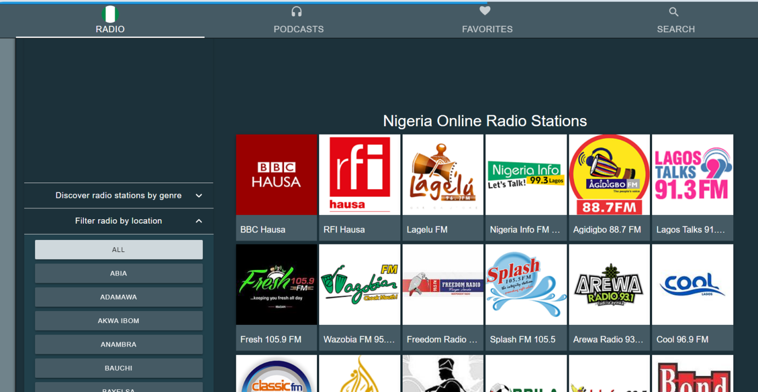
Figure 4.1: Stations
This interface contains different stations
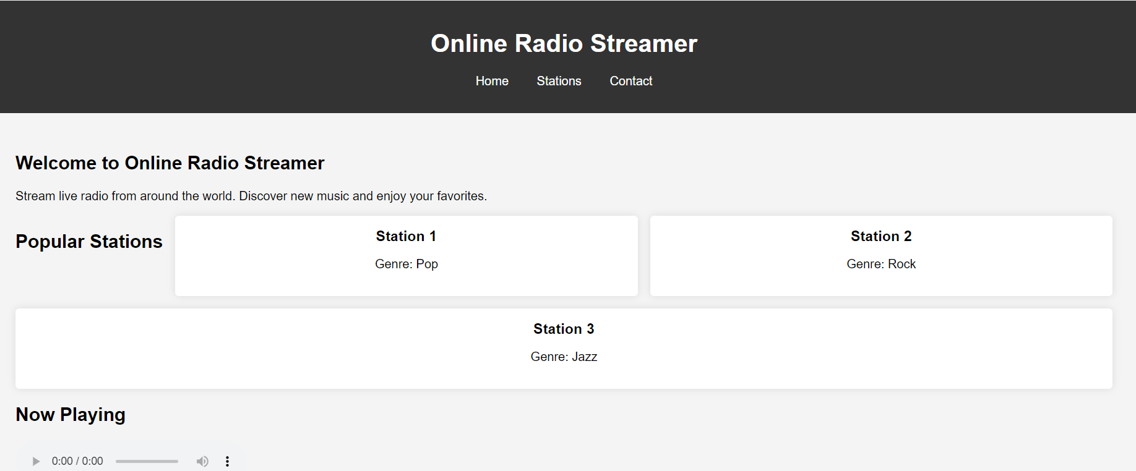
Figure 4.2 home page
This page allows users to navigate from one page to another
4.1.2 OUTPUT DESIGN
This incorporates the objectives of solving the existing system problems and challenges. This involves the structuring of the desired information and also to enhance efficient and effective Radio streamer. Things taken into consideration in determining the output are represented below:

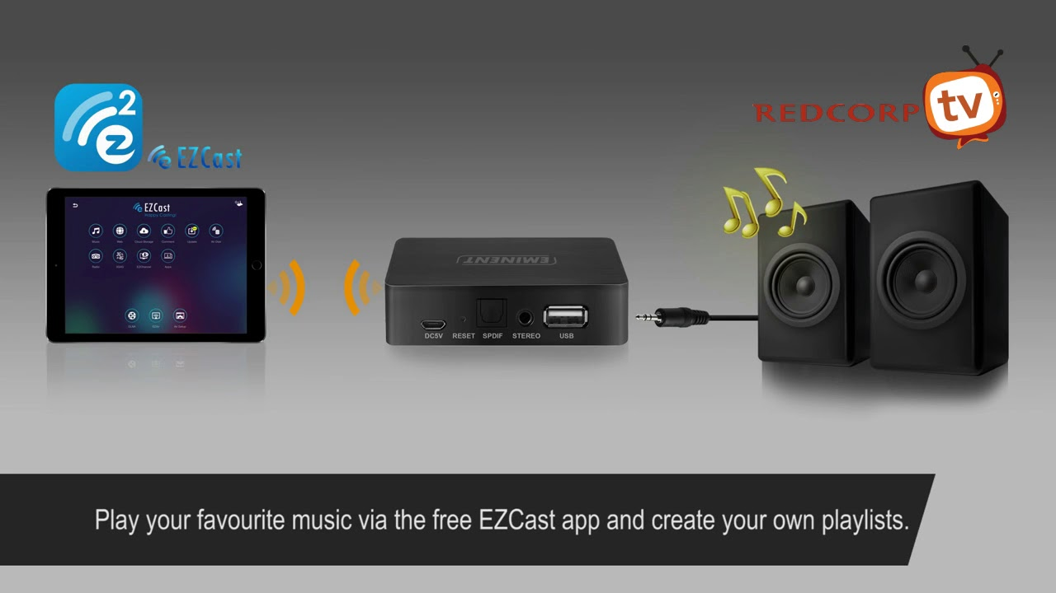
Figure 4.3: Home Page
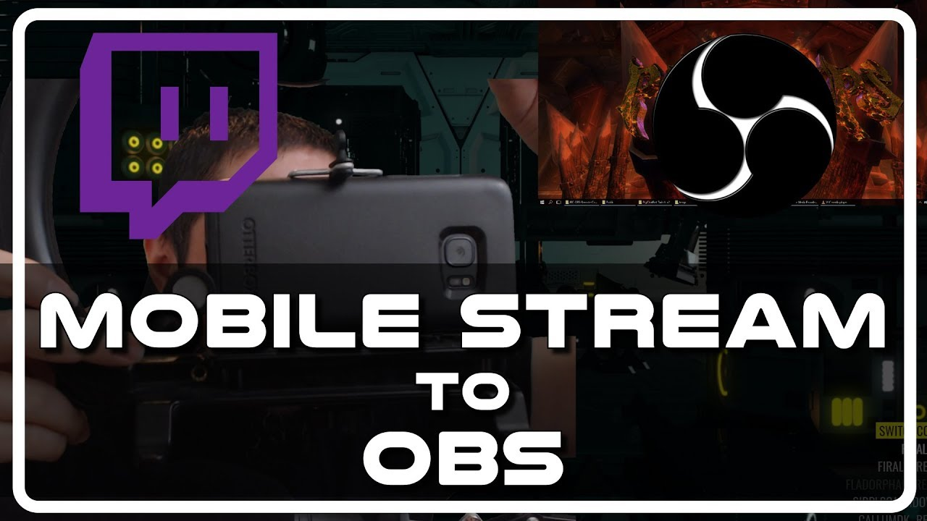
Figure 4.4: Streaming Interface of OBS
4.1.3 PROCEDURE DESIGN
These are the steps involved in unifying the whole process to produce the desired output. It involves computer procedures which start from the original input lessons to the output result file. This allows the processing of User information and result to be possible. Menu is provided to aid User in the processing of the output file.
4.2 IMPLEMENTATION OF THE SYSTEM
This entails the choice of the programming language employed to implement the software which should-be suitable for Radio streamer. The software is designed for the use of Radio streamer which should serve as an assistant. It is also expected to be used in conjunction with the User. The Radio streamer admin will prepare data base while the admin will provide personal data about the User.

4.2.1 CHOICE OF PROGRAMMING LANGUAGE
The Application was developed in a .net (dot net) integrated development environment (.net IDE). The Application IDE is chosen following the fact that extracted information needs to be presented in an enhanced pictorial/graphical format and easy communication with the database for program flexibility in windows platform.
4.2.2 HARDWARE REQUIREMENT
i. 500 Hz minimum with CD ROM drive etc.
ii. Hard disk of capacity 10GB Minimum
iii. 126-512 megabyte of RAM
iv. An Uninterrupted power supply (UPS)
v. A voltage stabilizer
vi. A power generating set etc.
4.2.3 SOFTWARE REQUIREMENT
i. Windows operating system such as Windows 7 etc
ii. Visual studio
iii. Server Query Language (SQL).
4.3 DOCUMENTATION OF THE SYSTEM
4.3.1 PROGRAM DOCUMENTATION
The program is packaged for use in any system irrespective of either it runs visual studio application or not. After developing a program in Visual studio, there is a facility provided in Microsoft Visual Studio suite called “Package and Deployment Wizard” that is used in Visual studio application packaging and deployment.
The Radio streamer is packaged into an installable setup that can be run from any system.
4.3.2 MAINTAINING THE SYSTEM
The system maintenance refers to making modification to an already existing application/program without necessarily re-writing everything from start. Program maintenance of a program includes modification of the program to meet-up with certain requirements of the Users. In this course, additional features can be added, errors corrected, ambiguous interfaces redesigned to eliminate confusions and unnecessary features removed.
Maintaining this program can be done in a Visual studio environment. Any future modification can be by re-running the program source code in a visual studio environment making necessary changes and updates and recompile the application into an upgrade version of the existing version of the mini word processing application. Further versions of this program can be named following their year of release or it can be given a different version number.

CHAPTER FIVE
SUMMARY, CONCLUSION AND RECOMMENDATIONS
  - SUMMARY
The application of the online radio streaming technology will bring great changes on the network information exchange and have a profound impact on the people's work and life. The streaming media technology is not a single technology; it is the organic combination of network technology and video / audio technology. The implementation of online radio streaming technology on the network, needs to solve the problems on the streaming media production, publishing, transmission and playing, and so on.
This research is based on the fact that online radio streamer application offers a more computerized approach to the way and manner we appreciate the use of technology by listening to radio online in our day to day activities thereby reducing the massive limitation that is associated with the limited system of listening through a radio player or a mobile phone. The system ensure unlimited access to radio broadcast within and outside Nigeria, it increase the level of accuracy and create an online radio streamer application that handles and manages radio stations broadcast URLs.
This research is based on the fact that online radio streamer application offers a more computerized approach to the way and manner we appreciate the use of technology by listening to radio online in our day to day activities thereby reducing the massive limitation that is associated with the limited system of listening through a radio player or a mobile phone. The system ensure unlimited access to radio broadcast within and outside Nigeria, it increase the level of accuracy and create an online radio streamer application that handles and manages radio stations broadcast URLs.
5.2 CONCLUSION
It is concluded that the advent of computer technology (internet to be precise) brings about a drastic development on the traditional means that has been the way people listen to radio which has a lot of limitations in terms of assessing or listening to radio across the nation or even beyond the vicinities of a local station area. It was because of this reason that radio stations started broadcasting their programs online. The invention and application of computer and internet now brought succour to the way and manner radio stations broadcast their programs.
It produce an online radio streamer that would handle and allow users to listen to live radio broadcast over the internet and have the URL stored in the application database for easy access and reference sake. It considered the different URL of the broadcast station as the input, connects through this URL and then transfer the live broadcast back to the application on the system.
This system is ideal for its purpose and may be used for other similar usage like listening to local music on the system.
The software accepts a radio station streaming URL as input, checks the authenticity of the URL and then connect to it through the internet and this is done with the aid of the computer. It offers a more computerized approach to the way and manner we appreciate the use of technology by listening to radio online in our day to day activities thereby reducing the massive limitation that is associated with the limited system of listening through a radio player or a mobile phone. It serves as an alternative medium to AM/FM when broadcasting a station and ensures that there is a globalize access to such information when needed. Online radio streamer application provides the highest possible sound quality, and there is not the hassle of dealing with radio static or frequency loss, it can travel wherever there is an Internet connection and users can listen from home, in the car through a mobile device, or on a computer from anywhere in the world.
5.3 RECOMMENDATIONS
Based on the findings of the study, the researcher recommends the following;
i. Adoption of the system: This system should be adopted to enhance uninterrupted radio program and to enable access to a desired radio station anywhere and everywhere in the world.
ii. User Training: Every staffs or administrator who works on the system of the radio broadcasting station should be properly trained on the implementation of the software to enhance effective running of the programme/software.
iii. More research should be conducted on the usefulness and effectiveness of online radio streamer application system.
iv. It is strongly recommended that this work should be used for academic purpose

REFERENCES
Apostolopoulos, J. G., Tan, W.-, & Wee, S. J. (2002). Video Streaming: Concepts, Algorithms, and Systems.

EN Dictionaries. (2020). (version 1.1.2). [mobile application software]. Retrieved from https://play.google.com

Fraz, M., Malkani, Y. A., & Elahi, M. A. (2009). Design and implementation of real time video streaming and ROI transmission system using RTP on an embedded digital signal processing ( DSP ) platform Design and Implementation of Real Time Video Streaming and ROI Transmission System using RTP on an Embedded Digital Signal Processing ( DSP ) Platform. (June 2014). https://doi.org/10.1109/IC4.2009.4909244

Gestner, B., & Persson, B. (2002). RNC3810 — Ericsson ’ s first WCDMA radio network controller. 62–67.
Jackie F. (2011): What Kind of Impact is the Internet Having on The Radio Industry? IACSIT Press, Singaport10.7763/IPCSIT.2012.V51.82 .
Maitreyee Initia(s) (2011): Internet Radio For Android Device at Pathpartner, Bangalore, Department Of Computer Applications Cochin University Of Science And Technology Kochi – 682022
Deering S. (2010): Host Extensions for IP Multicasting[S].RFC 1112, IETF, pp. 112–116,Apr, 2010.

Xinyan Z., Liu JC., Bo Li., and Tak-Shing P. Y. (2010): Cool Streaming/ DOnet:A data- driven overlay network for efficient live media streaming.In Proceedings of IEEE INFOCOM, pp.68–73, Mar, 2010.
Xiaoyu Ma. and Rui Jin (2011): Design and implementation of a streaming media transmission system 2011 International Conference on Computer Science and Information Technology (ICCSIT 2011) IPCSIT vol. 51.

Streaming
START
Connect to Station
Input station URL
IS
Station Found?
Display streaming Video
STOP
Y
N

SOURCE CODE
using System;
using System.Collections.Generic;
using System.ComponentModel;
using System.Data;
using System.Drawing;
using System.Linq;
using System.Text;
using System.Windows.Forms;
using MySql.Data.MySqlClient;

namespace Streamer
{
public partial class Form1 : Form
{
public Form1()
{
InitializeComponent();
}

private void button1_Click(object sender, EventArgs e)
{

// url https://onlineradiobox.com/ng/?cs=ng.freshfm&played=1

//string str, ur;
// textBox1.Text = "https://tunein.com/radio/1027-NAIJA-FM-s134094/";

// https://www.youtube.com/watch?v=gxKQRixQlGg
//System.Diagnostics.Process.Start(textBox1.Text);
string webpage = textBox1.Text.Trim();
webBrowser1.ScriptErrorsSuppressed = true;
webBrowser1.Navigate(webpage);

// https://tunein.com/radio/1027-NAIJA-FM-s134094/

}

private void treeView1_AfterSelect(object sender, TreeViewEventArgs e)
{
//treeView1.Nodes.Add('node');
}

private void button2_Click(object sender, EventArgs e)
{
webBrowser1.GoHome();
}

private void button4_Click(object sender, EventArgs e)
{
webBrowser1.Refresh();
}

private void button3_Click(object sender, EventArgs e)
{
if (webBrowser1.CanGoBack)
{
webBrowser1.GoBack();
}
}

private void button6_Click(object sender, EventArgs e)
{
webBrowser1.Stop();
}

private void button5_Click(object sender, EventArgs e)
{
if (webBrowser1.CanGoForward)
{
webBrowser1.GoForward();
}
}

private void webBrowser1_DocumentCompleted(object sender, WebBrowserDocumentCompletedEventArgs e)
{
textBox1.Text = webBrowser1.Url.AbsoluteUri;
}

private void button7_Click(object sender, EventArgs e)
{

}

private void Form1_Load(object sender, EventArgs e)
{
textBox1.Text = "https://www.youtube.com/";
button7.Visible = false;
try
{

// Bind combobox

MySqlConnection con = new MySqlConnection(connect.connectstring);
con.Open();
string strCmd = "select video_ from video";

MySqlCommand mycd = con.CreateCommand();

MySqlDataAdapter da = new MySqlDataAdapter(strCmd, con);
DataTable dt = new DataTable();
da.Fill(dt);
comboBox1.DataSource = dt;

comboBox1.DisplayMember = "video_";
comboBox1.ValueMember = "video_";
comboBox1.Enabled = true;
mycd.ExecuteNonQuery();
con.Close();

}

catch (ArgumentException) { }
catch (FormatException) { }
catch (InvalidOperationException) { }
catch (MySqlException) { }
catch (NullReferenceException) { }
}

private void comboBox1_SelectedIndexChanged(object sender, EventArgs e)
{
comboBox1.Text = textBox1.Text;
}

private void button7_Click_1(object sender, EventArgs e)
{

textBox1.Text = comboBox1.SelectedValue.ToString();
button1.Visible = button1.Visible = true; ;

}

private void textBox1_TextChanged(object sender, EventArgs e)
{

}

private void button8_Click(object sender, EventArgs e)
{
Form1 f1 = new Form1();
f1.Show();
}
}
}

