A PROPOSED PROJECT REPORT
ON
VOCATIONAL CENTER
FOR
OGUN STATE.
BY
HUNNU PHILIP SUNDAY
HND/23/ARC/FT/0022
SUBMITTED TO:

THE DEPARTMENT OF ARCHITECTURAL TECHNOLOGY
INSTITUTE OF ENVIRONMENTAL STUDIES (I.E.S)
KWARA STATE POLYTECHNIC, ILORIN.

IN PARTIAL FULFILMENT OF THE REQUIREMENTS FOR THE AWARD OF HIGHER NATIONAL DEPLOMA (HND) IN ARCHITECTURAL TECHNOLOGY

JULY, 2025.

DECLARATION
I, HUNNU PHILIP SUNDAY, under the supervision of ARC. OLANREWAJU FELIX ADEYEMI of the department of Architectural Technology, Kwara State Polytechnic, Ilorin, declared that this project has been completed by me and it is record of my research work. All citations and sources of informations are clearly acknowledged by means of reference.



_______________________ ____________________
SIGNATURE DATE

CERTIFICATION
This project on the Propose Vocational Centre located at Ogun State by HUNNU PHILIP SUNDAY has been duly certified as meeting the requirement of the award of Higher National Diploma (HND) in Architectural Technology, Institute of Environmental Studies, Kwara State Polytechnic, under the supervision of Arc. Olarewaju F. A.

ARC. OLAREWAJU F.A
(Project supervisor) SIGNATURE/DATE

ARC. OLAREWAJU F.A
(Project coordinator) SIGNATURE/DATE



ARC. MRS. J.M TOMORI
(Head of Department) SIGNATURE/DATE

EXTERNAL SUPERVISOR SIGNATURE/DATE

DEDICATION
This project is primarily dedicated to Almighty Allah, the Giver of Knowledge, Wisdom, and Understanding, for His Grace and Strength Throughout the Course of My Higher National Diploma, and for Counting Me Worthy of His Mercy,

ACKNOWLEDGEMENT
Many thanks and praise to almighty God for his mercy and blessings. I glorify his name for guiding and protecting me from the beginning of this HND program to this end.
My profound gratitude goes to my supervisor ARC. OLANREWAJU FELIX ADEYEMI for his love and care throughout the write-up of my project and my stay in school. Also to all the lecturers in my department, I pray may almighty God continue to be with each and everyone of you in JESUS NAME.
I also say a big thank you to my colleagues in the department of Architectural Technology and Management and some other numerous people to mention. I pray God almighty continue to bless, guide and protect us all.
My appreciation goes to my late father MR. HUNNU JAMES my beloved mother MRS. HUNNU MARIA who brought me to this world. I am pained for the death of my late father because you are no more. The space you left is still uncovered. May your soul continue to rest in peace (Amen).
I sincerely appreciate and thank everyone mentioned and those I cannot remember to mention. I am grateful to you all. God almighty will continue to be with you and your entire family. May God blessings, mercy, protection and guidance never cease in your life (Amen).

ABSTRACT
A vocational school for all student experiences of special needs support in vocational education. The aim of this center is to make visible and heard students in special educational needs (SEN) own perspectives on and experiences of various forms of support in vocational education and training (VET) research has shown that students studying in vocational programmes were in high need of accommodation and require increased attention, especially in activities and subjects with academic focus. Students are rarely informative even when they are the subject being studied . However when asked various experience of inclusion and exclusion emerges from their narratives. Recent research reviews focusing on special education show that more inclusive assessment practices are needed as well as more research in the area of special needs education (SNE) in vocational education.
Overall the results show that the informants in the interview study express satisfaction with the vocational programme they have chosen as it gave possibilities to inclusive support in the practical activities, whereas activities related to more academic achievement required special support and individual accommodation such as special support classes (SS). A common reason for this exclusive support was failed grades in academic core subjects such as mathematic, Swedish or English. The student’s experience of being in need of special support are ambivalent. They blame themselves of being disable while grateful for the support they get even when excluded.

TABLE OF CONTENT
Title Page……………………………………………………………………………. i
Declaration…………………………………………………………………………. ii
Certification ………………………………………………………………………...iii
Dedication …………………………………………………………………………...iv
Acknowledgment ……………………………………………………………………v
Table of content ……………………………………………………………………...vi
List of plates……………………………………………………………………...…vii
List of Tables………………………………………………………….……………viii
Abstract ……………………………………………………………………………. ix
CHAPTER ONE:
1.0 General Introduction …………………………………………………..………………….…….1
1.1. Historical background of the project…………………………………………………………..……2
1.2 Definition…………………………………….……………………...2
1.3 Statement of design problem ………………………………………………………….……….3
1.4 Aim and Objectives of the study………………………………………………………….…….4
1.5 Project justification …………………………………………………………….………………5
1.6 Clients background……………………………………………………………………...……….5
1.7 Scope of the study …………………………………………………………………….………...6
1.8 Limitation of design………………………………………………………………….…………9
1.9 Research Methodology ……………………………………………………………………….10
CHAPTER TWO:
2.0 Review of relevant Literature…………………………………………………. ….…………...11
CHAPTER THREE
3.0 Case studies………………………………………………………………………….………….14
3.2 Case study one……………………………………………………………...…………………...15
3.3 Case study two…………………………………………………………….……………………18
3.4 Case study three………………………………………………………………………………...22
3.5 Case study four………………………………………………………………………………….26
3.6 Case study five (online case study) ……………………………………………...……………...29
3.7 Deduction from Case study ……………………………………………………...……………...29
CHAPTER FOUR
4.0 Project location……………………………………………………………………….………...31
4.1 Historical background of selected location state ……………………………………...………...31
4.2 Historical background of Selected location LGA……………………………………………….32
4.3 Physical feature of the location ……………………………………………………...…………33
4.4 Population ………………………………………………………………………...…………….33
4.5 Social service …………………………………………………………………….….…………33
4.5.1 Road ……………………………………………………………………….……………...33
4.5.2 Health service …………………………………………………………………….………33
4.5.3 Water and electricity ……………………………………………………………………...34
4.6 General climatic condition …………………………………………………………….……….34
4.7 Site analysis ……………………………………………………………………………………35
4.7.1 Site selection/justification …………………………………….…………………………...35
CHAPTER FIVE
5.0 Design report…………………………………………………………………………………42
5.1 Design brief ………………………………………………………………………………...42
5.2 Design analysis ……………………………………………………………………………42
5.3 Design appraisal ……………………………………………………………………………45
5.4 Design characteristics ………………………………………………………………………...45
5.5 Building structure …………………………………………………………………………….47
5.6 Service ………………………………………………………………………………………...48
5.7 General requirement ………………………………………………………………………….48
5.7.1 Lighting ………………………………………………………………………………….48
5.7.2 Orientation ……………………………………………………………………………….49
5.7.3 Rain protection devices ………………………………………………………………….50
5.7.4 Noise control device ……………………………………………………………………...50
5.8 Material and finishes ……………………………………………………………………………51
CHAPTER SIX
6.0 Summary and conclusion ……………………………………………………………………54
6.1 Summary ……………………………………………………………………………………...54
6.2 Conclusion ……………………………………………………………………………………54
References …………………………………………………………………………………………56
Appendix

LIST OF PLATES
Plate 2.1: Approach And Side View Of Case Study One………………….…….15
Plate 2.2: Approach View Of Case Study Two…………………………….……17
Plate 2.3:Garri Frying And Cassava Drying Area Of Case Two…………….…..18
Plate 2.4: Approach View Of Case Study Three…………………………………20
Plate 2.5: Approach And Side View If Case Study Three………………………..21
Plate 2.6: Location Plan Of Case Study Four ( Online )………………………….23
Plate 2.7: Aerial And Approach View Of Case Study Four ( Online)……..…….24
Plate 2.8: Location Plan Of Case Study Five ( Online )…………………..……..26
Plate 2.9: Aerial And Approach View Of Case Study Five ( Online)……….…..27

LIST OF FIGURES
Figure 3.1: Showing Location Plan And Floor Plan of Case Study One……………….…14
Figure 3.2: Showing Floor Plan Of Case Study Two………….…………………….……17
Figure 3.3: Showing Floor Plan Of Case Study Three……………………………..……..20

LIST OF APPENDIX
Appendix 1: Profile and location map …………………………………. 48
Appendix 2: Locational plan and site inventory……………………….. 49
Appendix 3: Site analysis and site plan……………………………..….. 50
Appendix 4: Bubble diagram and Functional relationship……………. 51
Appendix 5: Floor plan and Roof plan…………………………….…… 52
Appendix 6: Section and elevations ……………………….…………… 53
Appendix 7: Staff area floor and Admin floor plan…………………… 54
Appendix 8: Production Flowchart ……………………………………. 55
Appendix 9: Details …………..………………………………………… 56

CHAPTER ONE
INTRODUCTION
Vocational education has been in existence in Nigeria right from the pre-colonial era when early men moved from place to place gathering fruits and rearing domesticated animals to secure their means of living. Then they took up vocational like black smithing, farming and hunting. Fafuwa (1982) asserts that the blacksmith then manufactured his own tools like cutlass for farming and arrow for hunting. These are passed from father to children through apprenticeship (Fafunwa, 1974).
During the colonial era, vocational and technical education married was de-emphasized and
literary education gained prominence organized vocational and technical education
in Nigeria railway, marrie traced to the establishment of course in various government
department of formal vocational technical education is linked with the introduction of
western education by the white missionaries at Hope Waddell Institute, Calabar in 1895 and
the establishment of blaize memorial industrial school, founded co-jointly by Nigeria and
West India (Fafunwa 1974).

In Nigeria, the white paper on education and defines it as that National Policy on
Education NPE (FME, 1981) uses the term technical to embrace vocational applied
skills as well as basic scientific knowledge's for the purpose of this discussion, on the
terms vocational and technical education will be used interchangeably because they
considered to be sine qua non.

HISTORICAL BACKGROUND OF THE STUDY
Throughout history, vocational education has given students hand on experience to
prepare them for employment. Some might say it all began in 62BC with the Neo-baby
Lonian empire and his knack for apprenticeship run education. Regardless of its true
origin, today's vocational education it well-developed schooling system which balances
class time and work experience.
Vocational schools, also known as trade school, career colleges and technical colleges, train
students for skills based careers. Those interested in careers such as event planning,
accounting, graphic design, plumbing or law enforcement can study at a vocational technical
school. The most notable development to U.S vocational education came in the early 28th
century, before the great depression, society was industrializing. Agriculture was less
lucrative and children from rural areas were showing up to attends schools that were already
overcrowded. These schools were even less prepared for the influx of immigrants that were
arriving in the United State at the same time.
According to American Radio works, on paper the creation of these vocational education programme solved major problems (like overcrowded classroom and the demand for a skilled workforce) but in reality it was still problematic notably, the students who were assigned to vocational education programs were often immigrant or poor children from rural areas.

DEFINITION OF VOCATIONAL CENTRE
Definition of Term Vocational center means a facility for the institution of specific skills, which meet the state and/or federal requirement to be accredited as such. Vocational center means a facility for the institution of specific skills, which may include green technology education and training and meets the state and federal requirements to be accredited as such

INADEQUATE FUNDING OF TECHNICAL AND VOCATIONAL EDUCATION
The persistent underfunding of technical and vocational education in Nigeria has led to the production of poorly trained graduates. The lack of adequate financial resources makes it difficult to build and maintain functional workshops and laboratories, or to procure modern equipment essential for practical learning. Furthermore, funding constraints have resulted in inadequate staffing, as skilled professionals are often not employed. Those who are employed tend to leave the teaching profession due to poor remuneration, opting instead for better-paying jobs in the private sector or abroad.
INADEQUATE FACILITIES
Many vocational education departments across Nigerian universities lack properly equipped laboratories and workshops. In cases where such facilities exist, they are often outdated or non-functional, having been installed at the inception of the departments. These obsolete tools and machines are no longer suitable for training students in line with current industrial standards, further contributing to the decline in the quality of vocational education..
AIM AND OBJECTIVES
The aim of this project is to design a well functioning and aesthetically balance vocational training center which will enable any gender to have knowledge about work of their interest so as to increase their scope of knowledge.

OBJECTIVES
The objective of the study are as follows:
- To improve the economic growth of the society.
- To provide comfortable environment for learning.
- To reduce unemployment.
JUSTIFICATION
Ogun State has a large youth population and growing industries but faces high unemployment and a lack of skilled workers. A vocational centre will equip people with practical skills, reduce joblessness, support local businesses, and boost the state's economy. It will also help preserve traditional crafts and promote self-reliance..
CLIENTS BACKGROUND
Ogun State, located in the South-Western region of Nigeria, is one of the country’s most industrially developed states and a key hub for education, agriculture, and manufacturing. It is predominantly Yoruba-speaking and culturally rich, with strong historical ties to the ancient Oyo Empire. Ogun shares boundaries with Lagos State, Oyo State, Osun State, and the Republic of Benin, making it a strategically positioned state for economic and vocational growth.
Historically, the people of Ogun State have been known for their enterprise and craftsmanship, excelling in traditional trades such as textile weaving, blacksmithing, carpentry, and pottery. Over time, these skills have evolved into modern vocational sectors including tailoring, welding, mechanics, electrical installation, and agro-processing.
The state is home to many notable institutions and industries, including the Olabisi Onabanjo University, Moshood Abiola Polytechnic, and several tertiary and technical colleges. This academic environment, coupled with the presence of industrial estates like those in Ota, Abeokuta, and Sagamu, creates a strong demand for skilled labor and technical expertise.
Culturally, Ogun State celebrates a wide range of traditional festivals and maintains a respected chieftaincy and community leadership structure. It has produced many prominent figures in governance, business, and the arts.
In recent years, Ogun State has invested in infrastructure, education, and youth empowerment, creating a growing need for well-structured vocational training centers. These centers are essential to equip the youth with relevant skills, reduce unemployment, and support the state’s economic diversification.
PHILOSOPHICAL REVIEW ON CLIENT
The client’s philosophy in commissioning the design and development of a vocational centre in Ogun State is rooted in the conviction that education and hands-on skill acquisition are essential drivers of economic growth and social transformation. The client strongly believes that equipping individuals with practical, market-relevant skills is key to reducing unemployment, fostering entrepreneurship, and uplifting underserved communities.
Whether represented by a governmental agency, a non-governmental organization, or a community-based initiative, the client envisions a vocational centre that serves as a bridge between formal education and real-world application, addressing the skill gap that limits many young Nigerians from meaningful employment or self-employment.
The philosophy guiding this project emphasizes inclusive development, with a strong focus on empowering youths, women, artisans, school dropouts, and economically marginalized groups. The client aims to create an environment where learners can thrive—developing skills in trades such as agro-processing, construction, ICT, fashion design, and technical maintenance—thereby becoming self-reliant and productive contributors to the local and state economy.
Ultimately, the client believes that infrastructure, when combined with purpose-driven training, becomes a powerful catalyst for sustainable community development and long-term economic resilience in Ogun State.
SCOPE OF THE STUDY
- Administrative block
- Security house
- Workshop building
- Staff quarters
- Mini clinic
- Cafeteria
- Generator house
- Sport activities arenas
BRIEF DEVELOPMENT OF THE PROJECT
ADMINISTRATIVE BLOCK
- Entrance
- Reception
- Stair hall
- Admission office
- Secretary office
- Accountant office
- Conveniences
- Show room
- Control room
FIRST FLOOR
- Dean office
- Secretary to dean office
- Registrar’s office
- Conference hall
- Stair hall
- Conveniences
WORKSHOP BLOCK 1
- Reception
- General store
- Conveniences
- Fashion designing
- Instructor office
- Store
- Photography Studio
- Instructor office
- Store
- Hairstyling Workspace
- Instructor office
- Store
- Catering
- Instructor office
- Store
- Clothing and Textile workspace
- Instructor office
- Store
- Arts and crafts studio
- Instructor office
- Store
- Printing Press Workshop
- Instructor’s Office
- Store
- Computer Studies
- Instructor’s Office
- Store
WORKSHOP BLOCK 2
- Entrance
- Reception
- Conveniences
- Plumbing workshop
- Instructor office
- Store
- Carpentry workshop
- Instructor office
- Store
- Automobile workshop
- Instructor office
- Store
- Aluminum Workshop
- Instructor’s Office
- Store
LIMITATION OF THE STUDY
Limitation of the Study This project has potential limitation like completion. This is one of the major limitations of the study because since it take two years or less to complete many vocational programs, the schools can graduate a lot of student in short span. This can saturate the job market with people who all have the same skills and training if the school does not provide or require internships or hand on experience, this can be another obstacle for graduate..

RESEARCH METHODOLOGY
Various avenues were explored as regard the method of research in order to arrive at a functional and appealing design concept. The following research methods were employed.
Literature review: reference to tolerance for ideas of various writer were consulted in order to attain useful and important past thesis work on similar project.
Oral interview: practicing architects, engineers, allied professional as well as students of various schools were interviewed and better deduction from their information sources also influence the end design.
Personal observation: personal initiations coupled with inquisitive measure, interviewed and visitation was made in order to actually visualize the daily activities that take place within the required motive.
Case study: This involves the thorough synthesis and analysis of similar existing structure building based on the data collected and better seduction was made for realization of the design best.

CHAPTER TWO
2.0 REVIEW OF RELEVANT LITERATURE
(a) Review of Literature on Vocational Centre Building Type
Vocational education and training (VET) has been widely recognized as a strategic tool for national development. According to Adeyemi and Ojo (2016), vocational education plays a crucial role in enhancing economic growth, reducing unemployment, and promoting skill acquisition in Nigeria. Their study stresses the need for vocational education to be more embedded within the formal education system, alongside adequate investment in modern training facilities and infrastructure.
Similarly, another national-level study highlights the role of VET in addressing youth unemployment and poverty. The authors advocate for the establishment of more vocational centres across Nigeria and call for increased funding, curriculum modernization, and teacher training to enhance the quality of instruction and practical training. These studies underscore the importance of designing and building vocational centres that are well-equipped, accessible, and responsive to current labor market demands.
(b) Review of Literature on the Sub-Topic of the Thesis – Vocational Centres in Ogun State
Focusing specifically on Ogun State, the National Bureau of Statistics (2017) reports the existence of 16 vocational centres distributed across various local government areas. These centres offer training in diverse fields such as agriculture, fashion design, mechanical repairs, information communication technology (ICT), and electrical works. However, the same report highlights a significant gap in terms of infrastructural adequacy, equipment availability, and program alignment with market demands.
The current literature reveals limited documentation and analysis specifically tailored to vocational centres in Ogun State, yet it consistently points to a need for increased government and private sector investment. The goal is to transform these centres into viable platforms for practical skill development, economic empowerment, and community transformation.

Complexity and Issues in Vocational Education and Training (VET)
As Grubb (2006) discusses, the nature of vocational education and training systems varies significantly across nations, particularly in terms of definitions, delivery methods, and societal perceptions. In the Nigerian context, this variability is evident in the inconsistent structure and quality of vocational programs across states, including Ogun. Some of the major issues include:
- Imbalanced Curriculum: There is often an overemphasis on theory at the expense of practical skills, limiting graduates’ readiness for employment.
- Fragmented Training Models: Training may be delivered in school-based settings or through apprenticeships, without a standard model for integration.
- Imprecise Education-Training Boundaries: The division between vocational education (long-term, broad-based) and job training (short-term, skill-specific) is often unclear, creating confusion in curriculum planning and implementation.
- Mismatch with Market Demands: Program content often does not align with current industry needs, resulting in graduates who are not job-ready.
Planning and Designing Vocational Centre Facilities
The planning and design of vocational centre facilities require a specialized approach that addresses both academic and technical needs. According to Cutshall (2003), unlike general academic schools, vocational centres must accommodate hands-on training that simulates real-world work environments. These include workshops, studios, laboratories, and specialized training rooms.
JISC (2006) further emphasizes that the infrastructure must be adaptable to different trades and skills, with adequate room sizes, ventilation, durable surfaces, power supply, and safety systems. Equipment must reflect current industry standards, and spaces must support flexible teaching methods—such as group projects, individual practice, and demonstration-based instruction.
For a vocational centre in Ogun State, this means:
- Designing skill-specific workshops (e.g., tailoring, welding, ICT labs).
- Ensuring flexible spaces that can be updated with evolving technologies.
- Integrating sustainability features such as natural lighting and efficient power systems, especially considering inconsistent electricity supply.
- Incorporating community-friendly spaces for outreach training and entrepreneurial incubation.

CHAPTER THREE
CASE STUDIES .
CASE STUDY ONE
ALHAJI SHAKIRU AKANNI SERIKI SKILL AND VOCATIONAL CENTRE.
LOCATION: OSHINOWO STREET, EPE, LAGOS STATE.
BRIEF INTRODUCTION
Lagos State officially began building and recognizing vocational centres in areas like Epe in the late 1980s and early 1990s. These were often linked to initiatives like the Government Technical College in Odomola (later in Epe), created under the Seriki‑led technical education review committee in 1984–85 .
While specific founding dates for the Alhaji Shakiru Akanni Seriki Centre are not publicly documented, it likely emerged within the broader expansion of vocational education in Epe during that period or later under state empowerment programs.
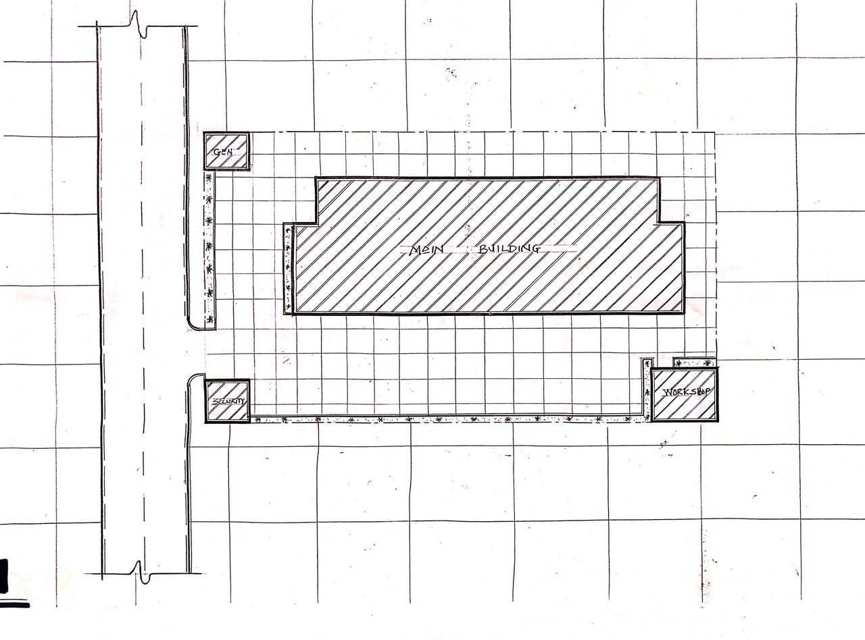
FIG 3.1:- SITE PLAN
SOURCE:- Researcher Field Work, 2024
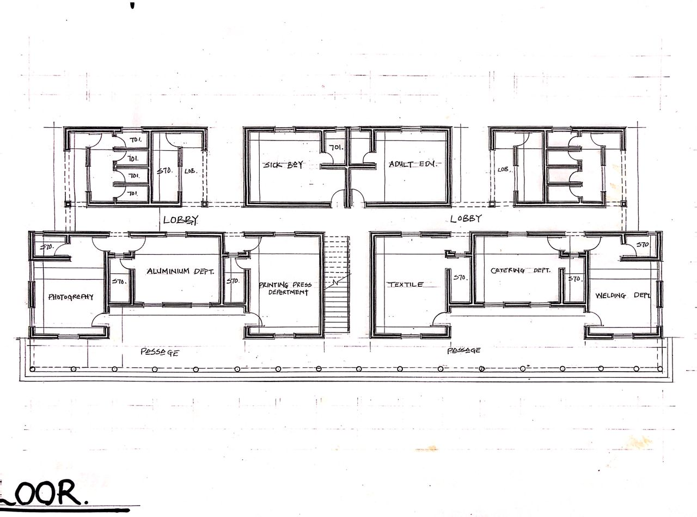
FIG 3.2:- GROUND FLOOR PLAN
SOURCE:- Researcher Field Work, 2024
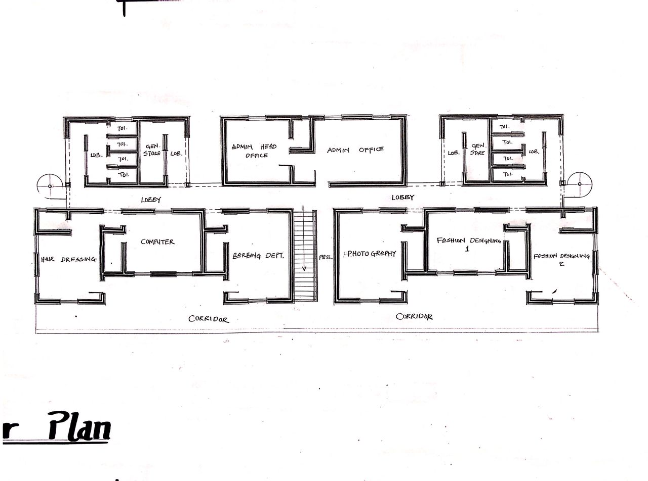
FIG 3.3:- FIRST FLOOR PLAN
SOURCE:- Researcher Field Work, 2024
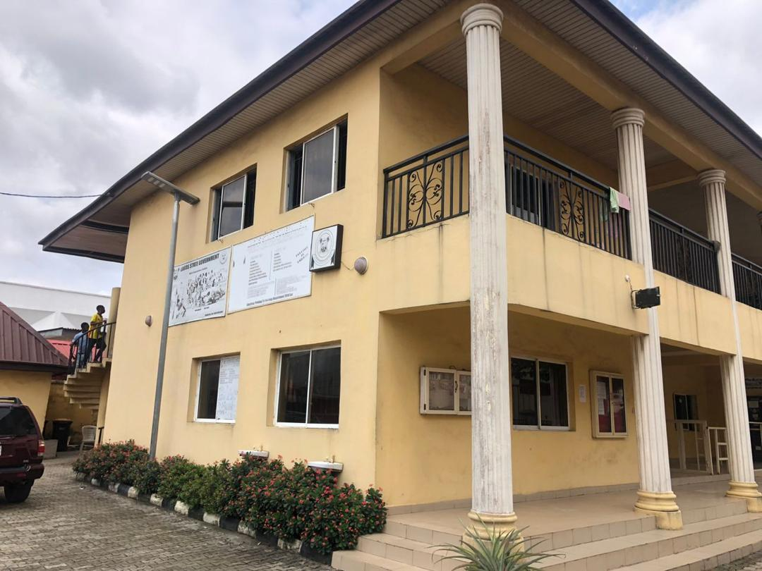
PLATE 3.1:- SIDE VIEW
SOURCE:- Researcher Field Work, 2024

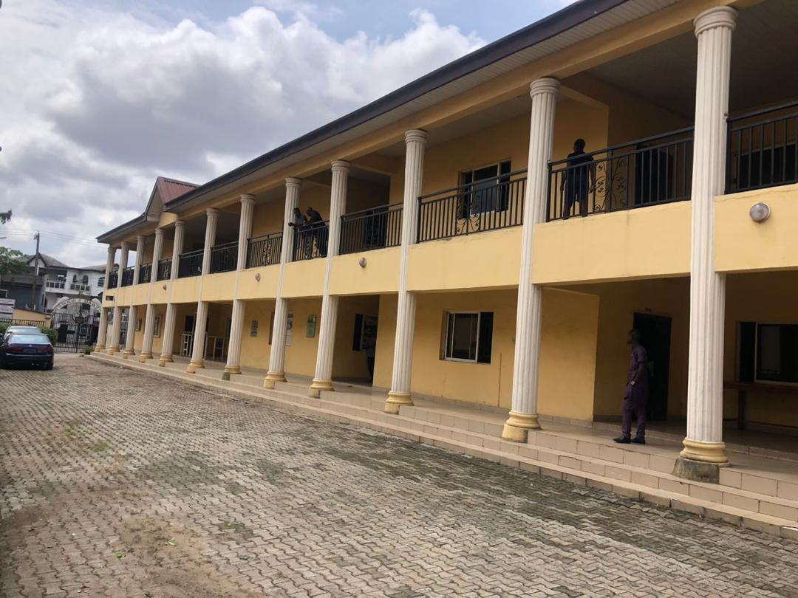
PLATE 3.2:- SIDE VIEW
SOURCE:- Researcher Field Work, 2024

MERITS
- Adequate ventilation
- The department are well linked together
- Good security arrangement
- It has nice area

DEMERITS
- Parking space not divine
- No landscape
- Drainage system not provided

CASE STUDY TWO
INSTITUTE OF VOCATIONAL STUDIES CENTRE LOCATED AT AJASE IPO, KWARA STATE, NIGERIA.
The institute was commissioned by the vice president of the federal republic of Nigeria, Professor Yemi Osinbajo on November 21st 2017 and they commenced training programs on April 30, 2018.
COURSES OFFERED
- Aluminum workshop
- Event decoration
- Clothing and textile
- Computer studies (Graphic Design)
- Electrical & electronic workshop
- Welding & Steel Works
- Aluminum
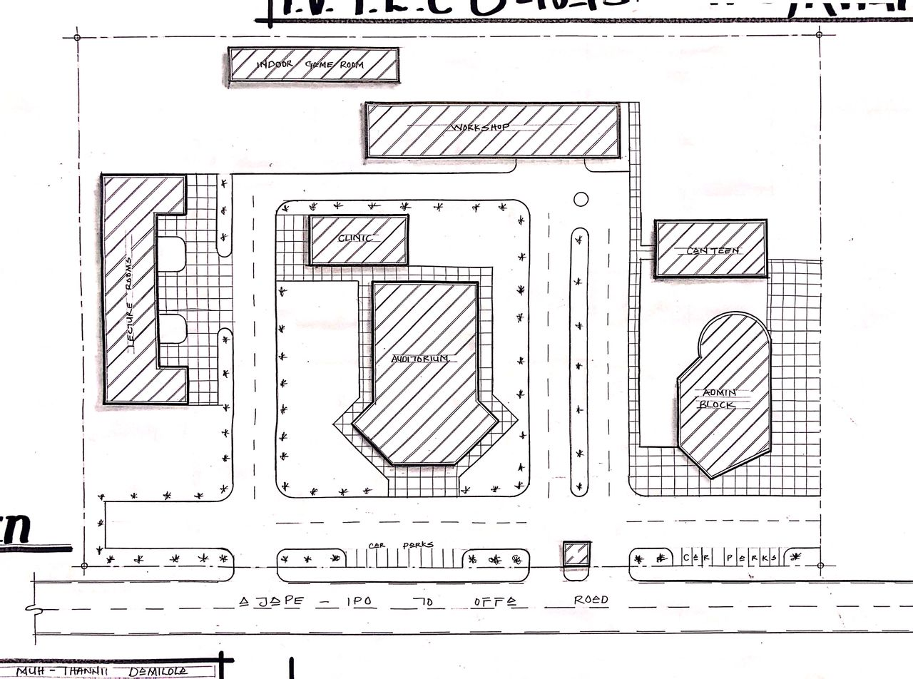
FIG 3.4:- SITE PLAN
SOURCE:- Researcher Field Work, 2024

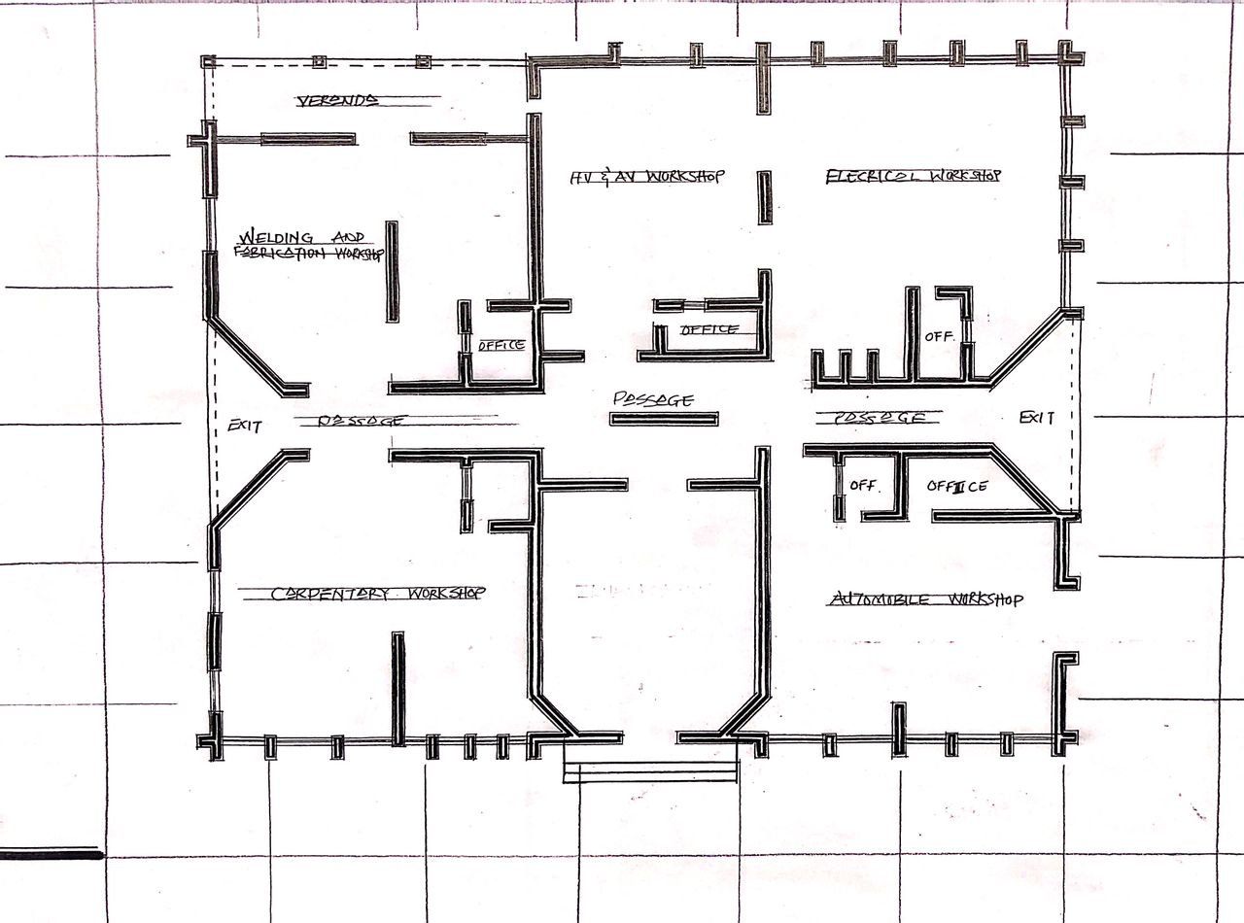
FIG 3.5:- FLOOR PLAN
SOURCE:- Researcher Field Work, 2024

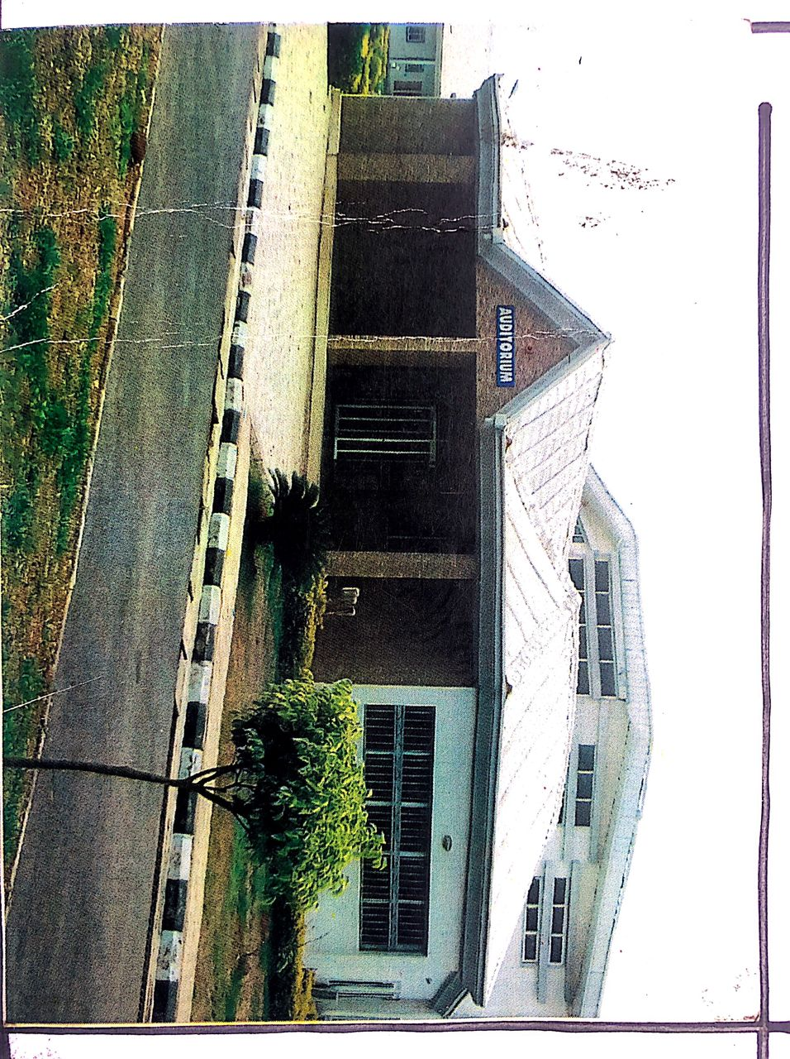
PLATE 3.3:- INSTITUTE’S AUDITORIUM
SOURCE:- Researcher Field Work, 2024

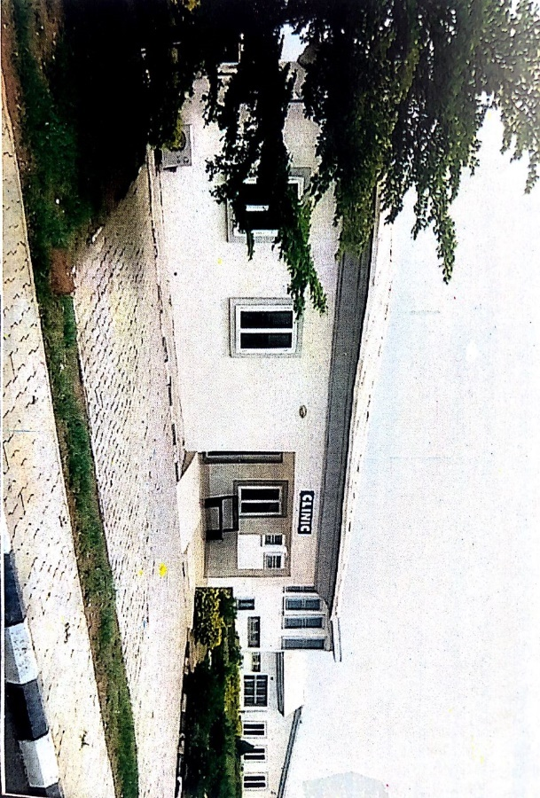
PLATE 3.4:- INSITUTE’S CLINIC
SOURCE:- Researcher Field Work, 2024

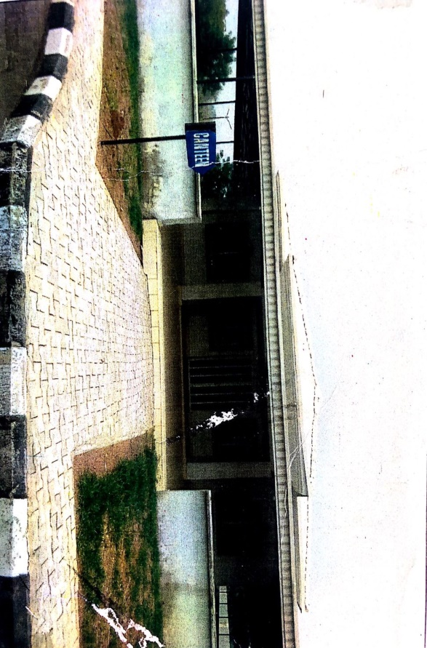

3.5:- INSITUTE’S CANTEEN
SOURCE:- Researcher Field Work, 2024

3.2.1 MERITS
- The Facility is Well Landscaped
- Easily accessible
- Adequate conveniences
- It was centrally located
3.2.2 DEMERITS
- Inadequate parking space
- The building is a mix-use building
- Poor ventilation for the classrooms
3.3 CASE STUDY THREE
INDUSTRIAL DEVELOPMENT CENTER (I.D.C) AT OSHOGBO, OSUN STATE, NIGERIA.
BRIEF INTRODUCTION
I.D.C AT OSHOGBO, OSUN STATE, was established in 1993 by the federal Government of Nigeria as part of the National Industrial Development Center (NIDC) programs. It was focused on promoting industrialization and entrepreneurship in the region and it has provided training, consultancy and infrastructural support for small and medium scale enterprises (SMEs),Today, it continues to play a vital role in skill development and vocational training, business incubation and entrepreneurship support.
COURSES OFFERED
- Tailoring
- Electrical and Electronic
- Event decoration
- Hat and bead making
- Toiletry
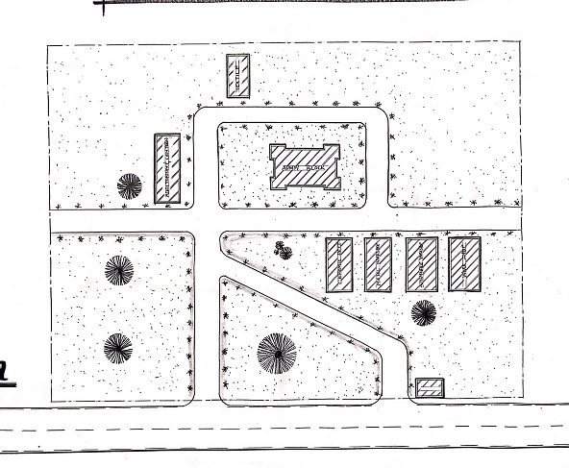
FIG 3.6:- SITE PLAN
SOURCE:- Researcher Field Work, 2024

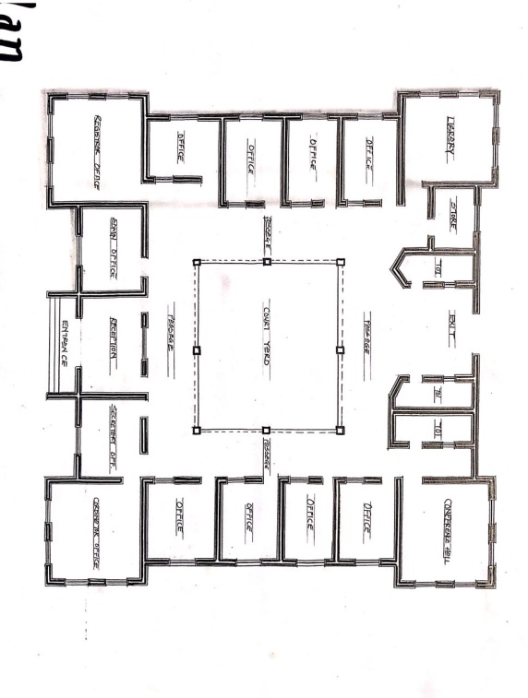

FIG 3.7:- FLOOR PLAN
SOURCE:- Researcher Field Work, 2024

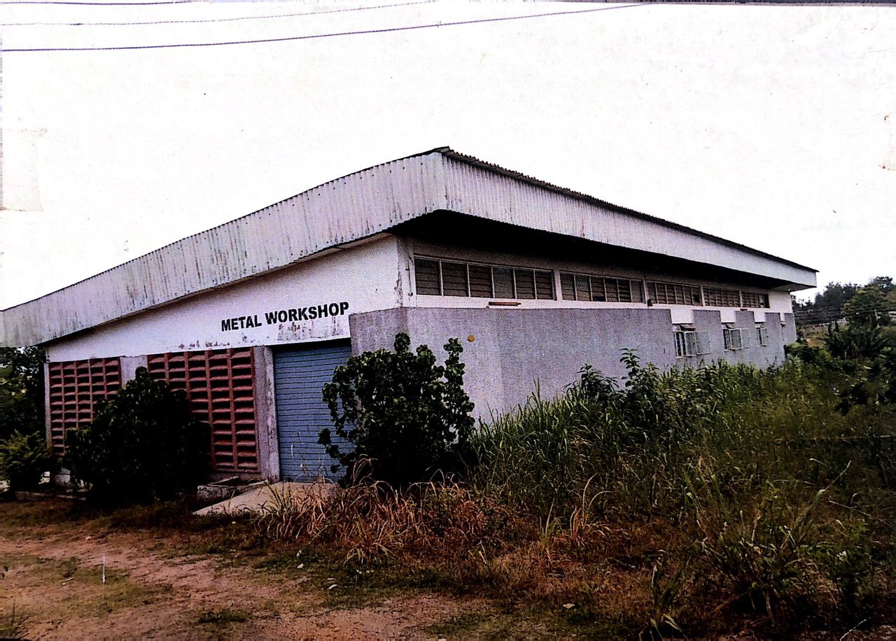
PLATE 3.6:- METAL WORKS BUILDING
SOURCE:- Researcher Field Work, 2024
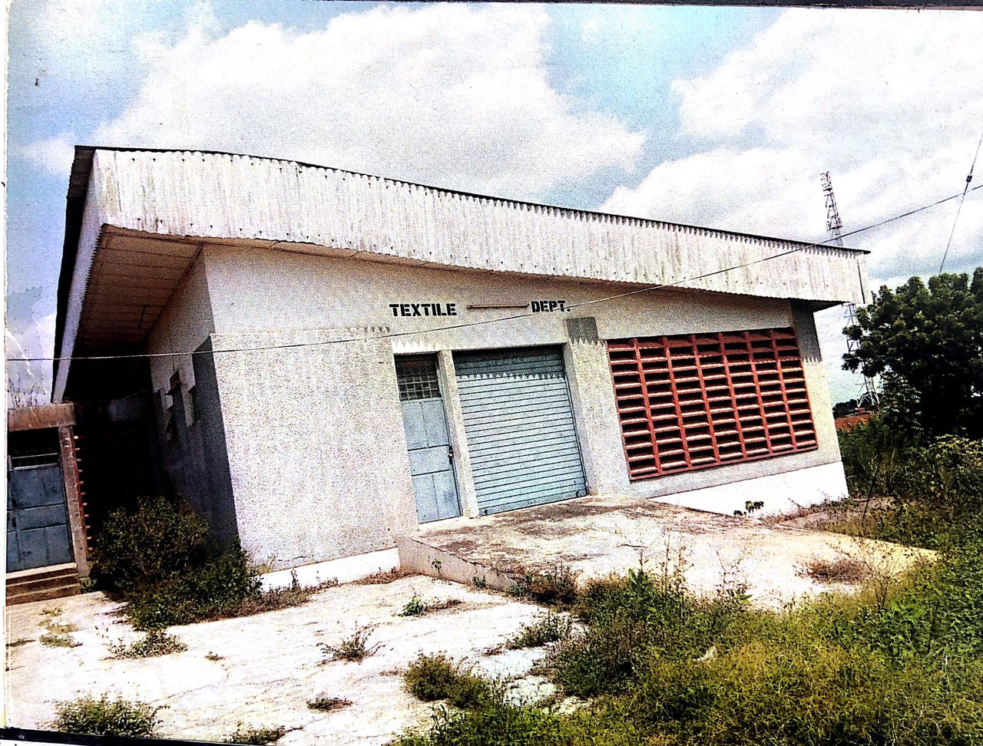
PLATE 3.7:- CLOTHING & TEXTILE BUILDING
SOURCE:- Researcher Field Work, 2024
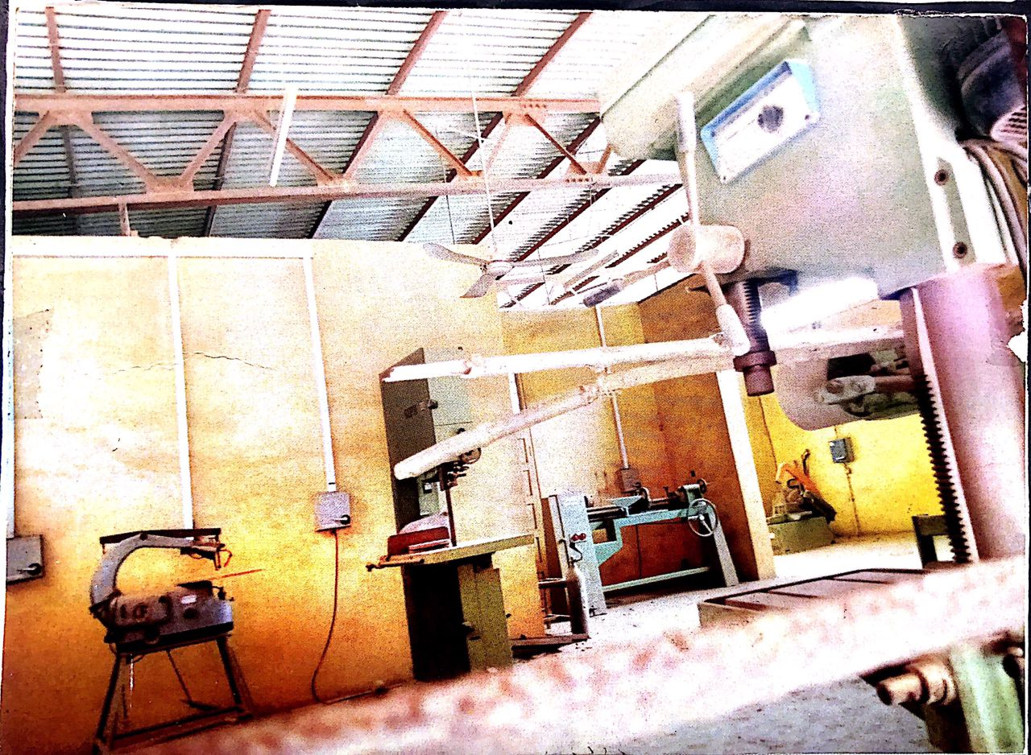

PLATE 3.8:- METAL WORKSHOP
SOURCE:- Researcher Field Work, 2024

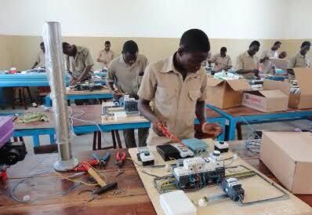
PLATE 3.9:- ELECTRIC AND ELECTRICAL WORKS
SOURCE:- Researcher Field Work, 2024

3.3.1 MERITS
- Easily accessible from the gate
- Good security
- Adequate ventilation
- Lecture rooms are properly linked.
3.3.2 DEMERITs
- Poor landscaping of the site
- Poor drainage system
3.4 CASE STUDY FOUR [ONLINE CASE STUDY
TOULON VOCATIONAL CENTER LOCATED IN TORONTO, CANADA
BRIEF INTRODUCTION
Toulon Vocational center is a standard vocational center located in Toronto, Canada where serval courses are been offered to student interested in learning vocational studies, being an entrepreneur or being self-employed personnel.
These are the courses been offered in the centre below:
- Electrical and Electronics Engineering work
- Automobile Work
- Carpentry work
- A.C workshop
- Welding and fabrication work.
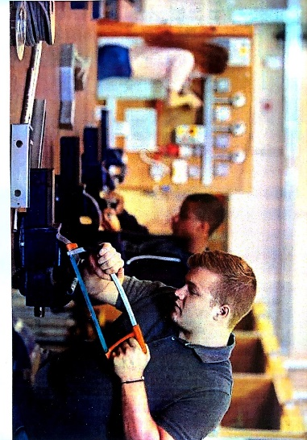
PLATE 3.10:- METAL WORKSHOP
SOURCE:- Researcher Field Work, 2024

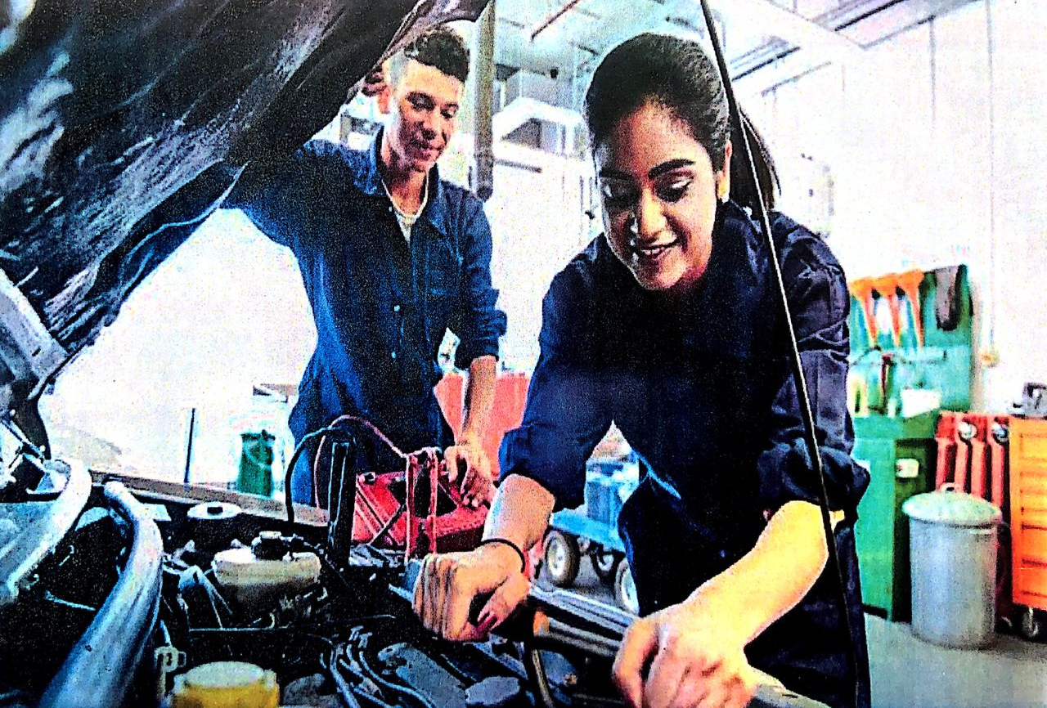
PLATE 3.11:- AUTOMOBILE WORKSHOP
SOURCE:- Researcher Field Work, 2024

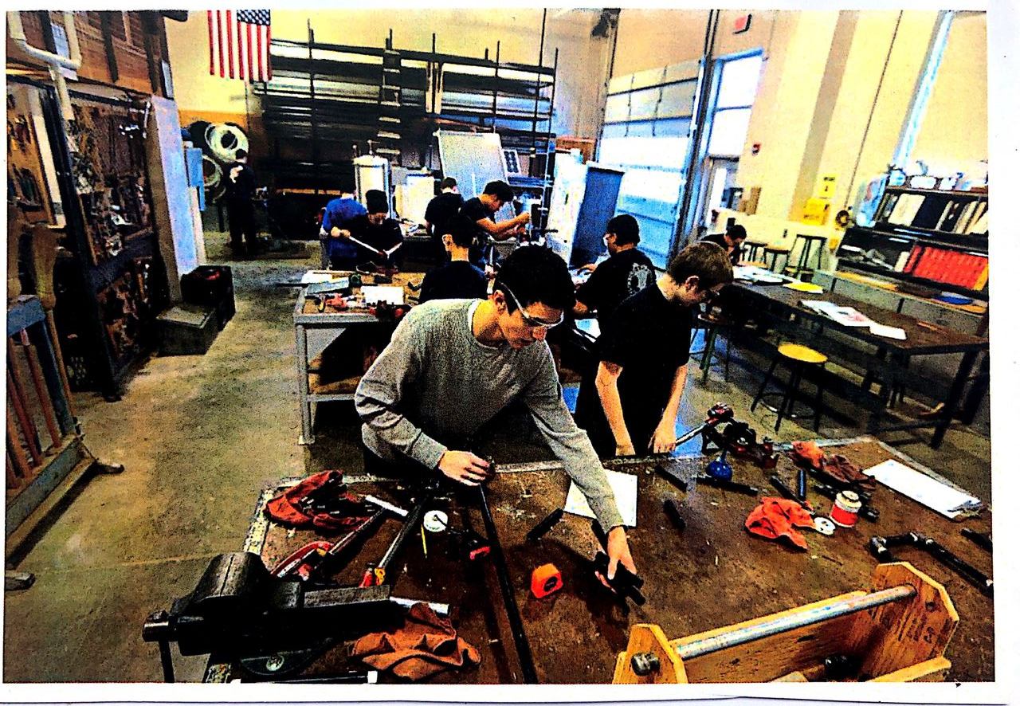
PLATE 3.12:- CARPENTRY AND WOOD WORKSHOP
SOURCE:- Researcher Field Work, 2024

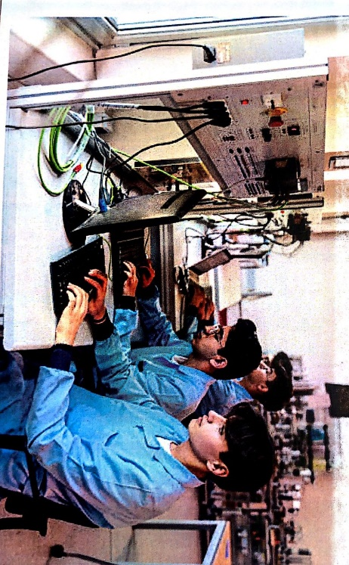
PLATE 3.13:- COMPUTER STUDIES
SOURCE:- Researcher Field Work, 2024

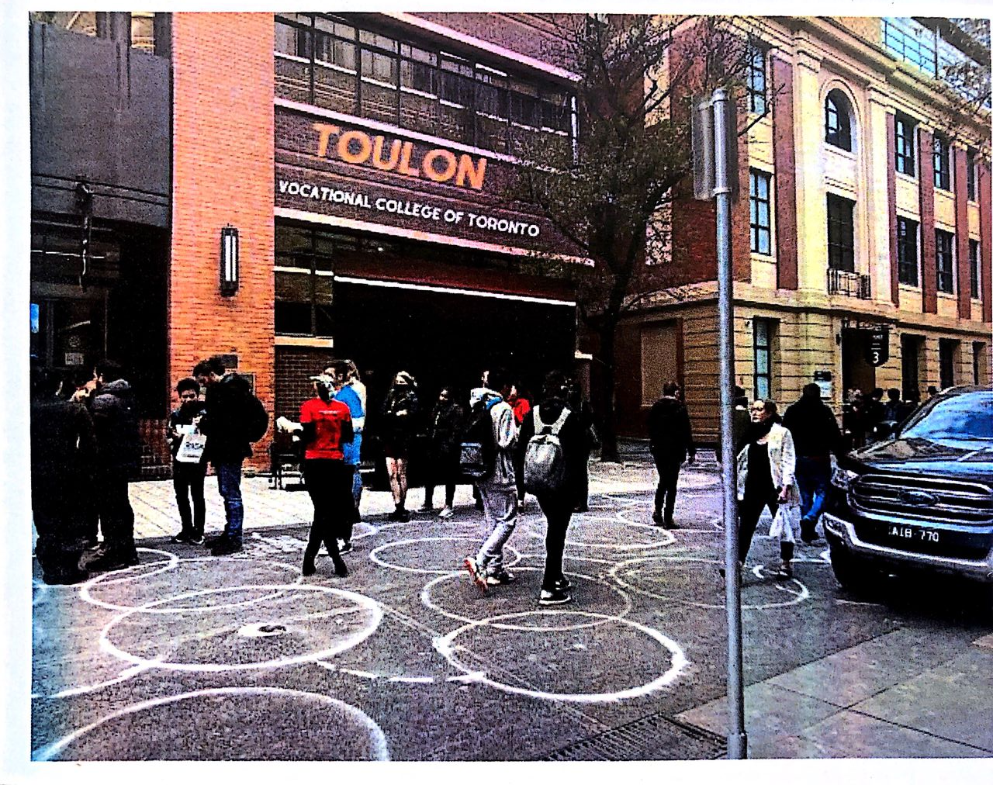
PLATE 3.14:- EXTERNAL VIEW
SOURCE:- Researcher Field Work, 2024
3.4.1 MERITS
- It facility is easy to access and located in a developed area
- It is purposely built for its purpose
- Cross Ventilated and Natural lightning
- Aesthetically pleasing to the eye
3.4.2 DEMERIT
- No provision for enough parking lots
- The facility is directly positioned along the road

3.5 CASE STUDY FIVE [ONLINE CASE STUDY 2]
P.A.C.C ADULT EDUCATION CENTER AND VOCATIONAL TRAINNG AT QUEBEC, CANADA.
BRIEF INTRODUCTION:
Adult education in PACC is teacher-directed and is taught by a seasoned group of dedicated professionals who know that each who walks through there door is capable of achieving success. For this reason, they have put in place for students to study their various courses their chosen fields in the school/center
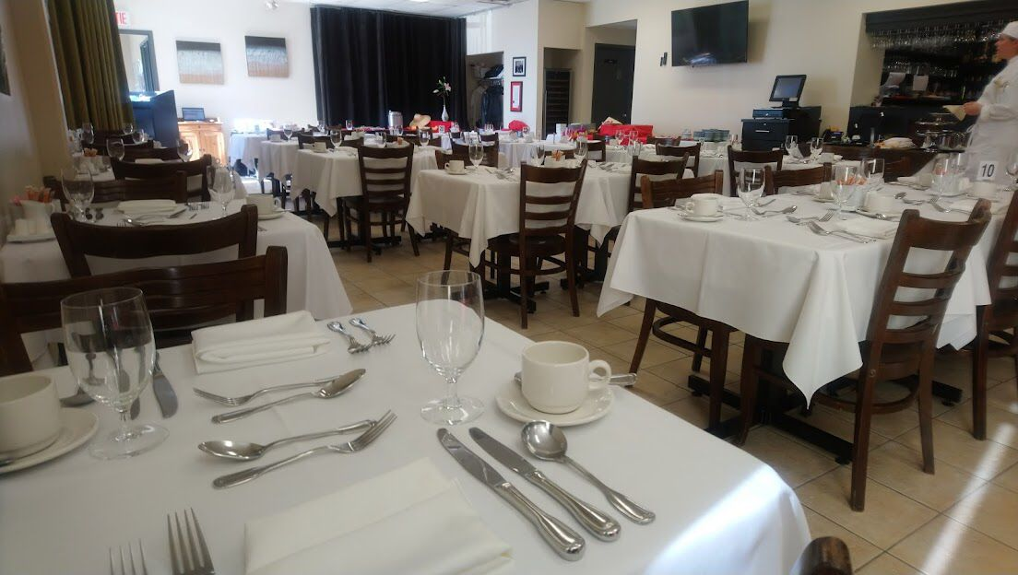
PLATE 3.15:- CATERING DEPARTMENT
SOURCE:- Researcher Field Work, 2024

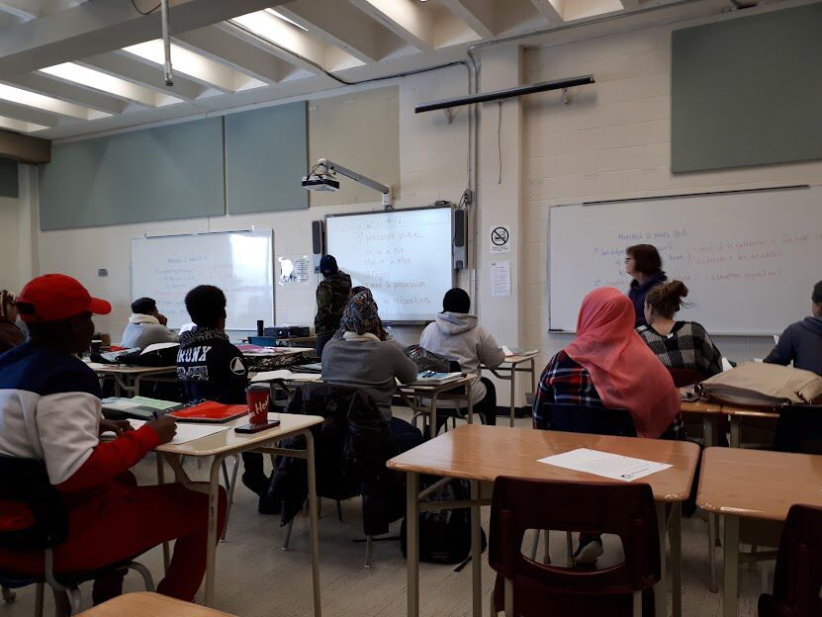
PLATE 3.16:- COMPUTER ROOM
SOURCE:- Researcher Field Work, 2024
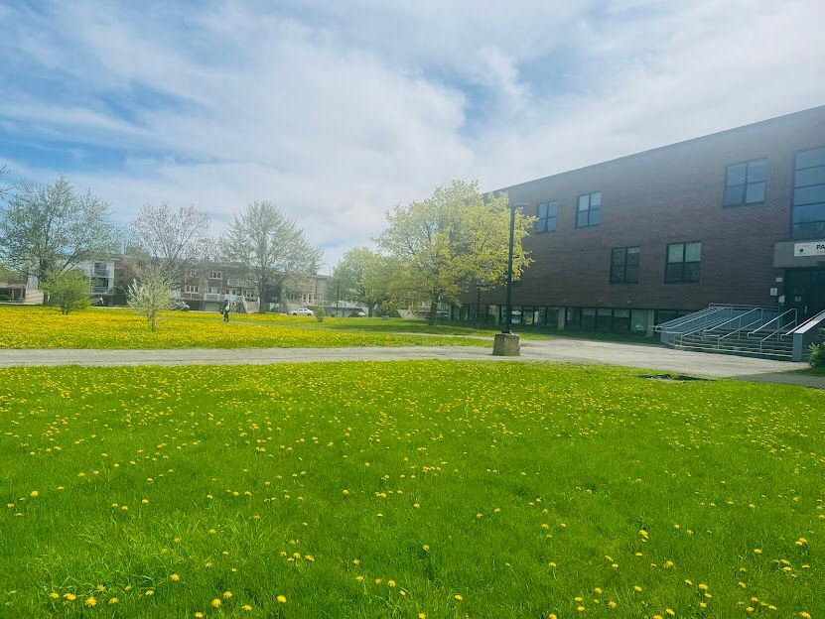
PLATE 3.17:- EXTERNAL VIEWS
SOURCE:- Researcher Field Work, 2024

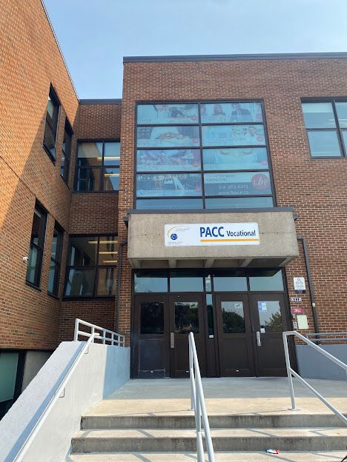
PLATE 3.18:- EXTERNAL VIEW
SOURCE:- Researcher Field Work, 2024
3.5.1 MERITS
- Easily accessible
- Adequate ventilation
- Lecture room are properly linked
- Built for its purpose.
3.5.2 DEMERIT
- No provision for enough parking lots
- The facility’s landscape is not properly done

3.6 DEDUCTION FROM CASE STUDIES:
These are the common similar knowledge or information derived from the aforementioned case studies. Some of which are:

- Choice of location should be in a developing or already developed area for easy access to the trainings offered.
- Segregation of each department form one another
- Well designed and well positioned landscapes
- Separation of noisy departments from departments with less noise
- Provision of required ventilation and fenestration into each units to serve the spaces well

CHAPTER FOUR
4.0 ANALYSIS OF THE ENVIRONMENTAL AND TOPOGRAPHICAL CONDITIONS OF THE SITE
4.1 INTRODUCTION TO STUDY AREA
4.2 HISTORICAL BACKGROUND OF OKE-OYI
Ogun State, created in 1976, has its capital in Abeokuta and consists predominantly of Yoruba-speaking people, especially the Egba, Egbado, Awori, and Ijebu subgroups.

Pre-Colonial Era:
The region was home to organized Yoruba kingdoms such as the Egba and Ijebu, with strong traditional institutions and thriving local economies. Agriculture, blacksmithing, and trading were central to the pre-colonial economy.

Colonial Era (1900 – 1960):
British colonial administration introduced formal education, missionary activities, and basic infrastructure. Towns like Abeokuta, Ijebu-Ode, and Ota played critical roles in the colonial economy.

Post-Colonial Era (1960 – Present):
The state has witnessed rapid development, especially in areas closer to Lagos like Ota and Ifo. Ogun has become an industrial and educational hub, home to several tertiary institutions, including Covenant University, Babcock University, and FUNAAB.

PHYSICAL FEATURE OF THE LOCATION
The selected site in Ogun State features gently undulating terrain with moderate slopes and fertile soil, suitable for construction and agriculture. The location’s accessibility and proximity to Lagos and Abeokuta make it ideal for a VTE center, drawing students from both urban and rural settlements.

POPULATION OF OGUN STATE (AND STUDY AREA)
Ogun State had an estimated population of over 6 million as of 2022. The project site is located in one of the fast-growing LGAs like Ifo or Ado-Odo/Ota, which are densely populated due to urban spillover from Lagos. The local population includes artisans, traders, students, factory workers, and civil servants — making it a prime area for vocational training services.

SOCIAL SERVICES
- Healthcare:
- Presence of government general hospitals and multiple private clinics.
- Access to Primary Healthcare Centres (PHCs) within the community.

- Education:
- Numerous public primary and secondary schools.
- Proximity to tertiary institutions like Covenant University, Federal Polytechnic Ilaro, and Tai Solarin University of Education.

- Transportation:
- Efficient road networks link the site to Lagos, Abeokuta, and neighboring towns via major expressways (e.g., Lagos-Abeokuta Expressway).

- Housing and Utilities:
- Growing number of modern housing estates.
- Power supplied by the Ibadan and Ikeja Electricity Distribution Companies (IBEDC and IKEDC).

- Water Supply:
- Boreholes, public taps, and wells are the main sources of water supply in the area.

ROAD

The site is connected via well-paved township roads and major highways, including the Lagos–Abeokuta Expressway, Sagamu–Ijebu Ode Road, or Ijebu Igbo–Ibadan Road, depending on the specific location in Ogun.

HEALTH SERVICES

Accessible healthcare facilities include:

- Local Primary Health Centres

- General hospitals in major towns (e.g., Ifo General Hospital, Ota General Hospital)

- Private clinics and maternity centers

WATER AND ELECTRICITY

Electricity is supplied by IBEDC or IKEDC with growing coverage of mini-grid and solar systems. Water is obtained through motorized boreholes, community wells, and rainwater harvesting.

GENERAL CLIMATIC CONDITION

Ogun State has a tropical climate with wet and dry seasons typical of South-West Nigeria.

1. Wet Season (March – October):

Rainfall: 1,200 – 1,800 mm annually

Humidity: 70–90%

Temperatures: 24°C – 31°C

2. Dry Season (November – February):

Temperatures: 22°C – 35°C

Lower humidity: 40–60%

Harmattan winds affect the area during December–February

Other Features:

Sunshine: Approx. 2,500 hours/year

Average annual temperature: ~27°C

Elevation: 100–350 meters above sea level, depending on the town

Relative Humidity:

Annual average: ~75%

Highest: June–September

Lowest: January–February

Wind:

Generally mild winds, with occasional dry winds during harmattan.

Temperature:

Daytime: 29–34°C

Nighttime: 19–24°C

Coolest: December – January

Hottest: March – April

VEGETATION

The vegetation consists of tropical rainforest in the south and derived savannah in central and northern parts of the state. The proposed site features mixed vegetation, including shrubs, tall grasses, and scattered trees. Existing vegetation will be partially cleared for construction, while some trees will be retained for shading and landscaping.

SITE ANALYSIS

Site Selection / Justification
The selected site is located in a well-positioned area along a township road within easy reach of major roads and expressways. Its proximity to Lagos and Abeokuta makes it suitable for a VTE center, providing easy access for trainees, staff, and materials. The flat terrain, availability of utilities, and social infrastructure further justify its suitability.

Factors influencing site selection include:

          - Accessibility: Proximity to major roads and transport routes

    - Location: Semi-urban setting close to Ilorin, ideal for a vocational center

    - Infrastructure: Existing public utilities like roads, electricity, and water

    - Topography: Gently sloping land suitable for construction

    - Soil Structure: Laterite-rich soil with good bearing capacity

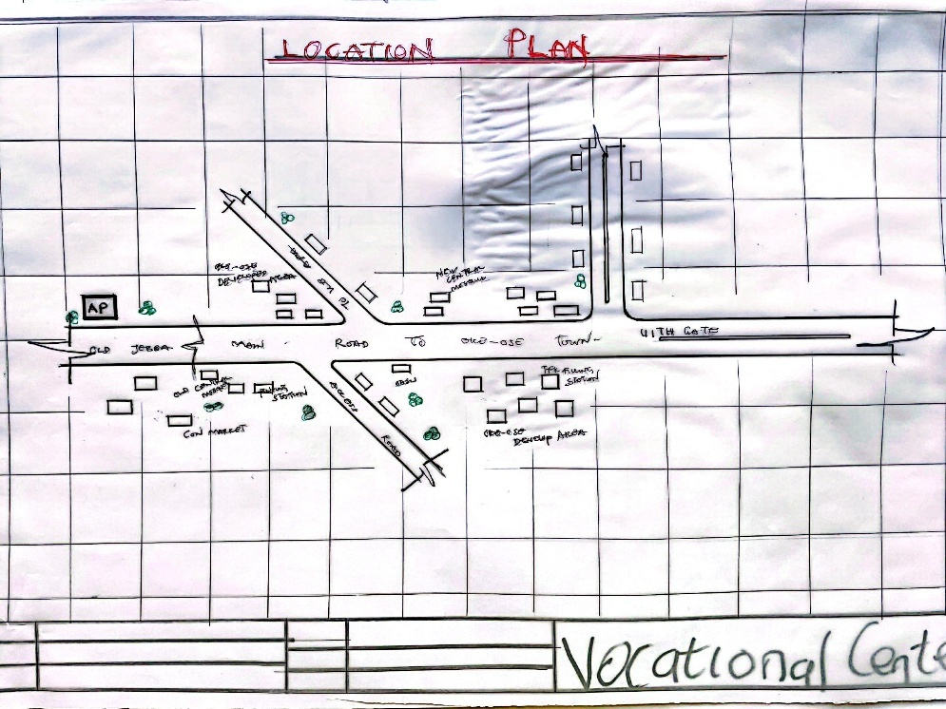

FIG 4.1:- LOCATION PLAN
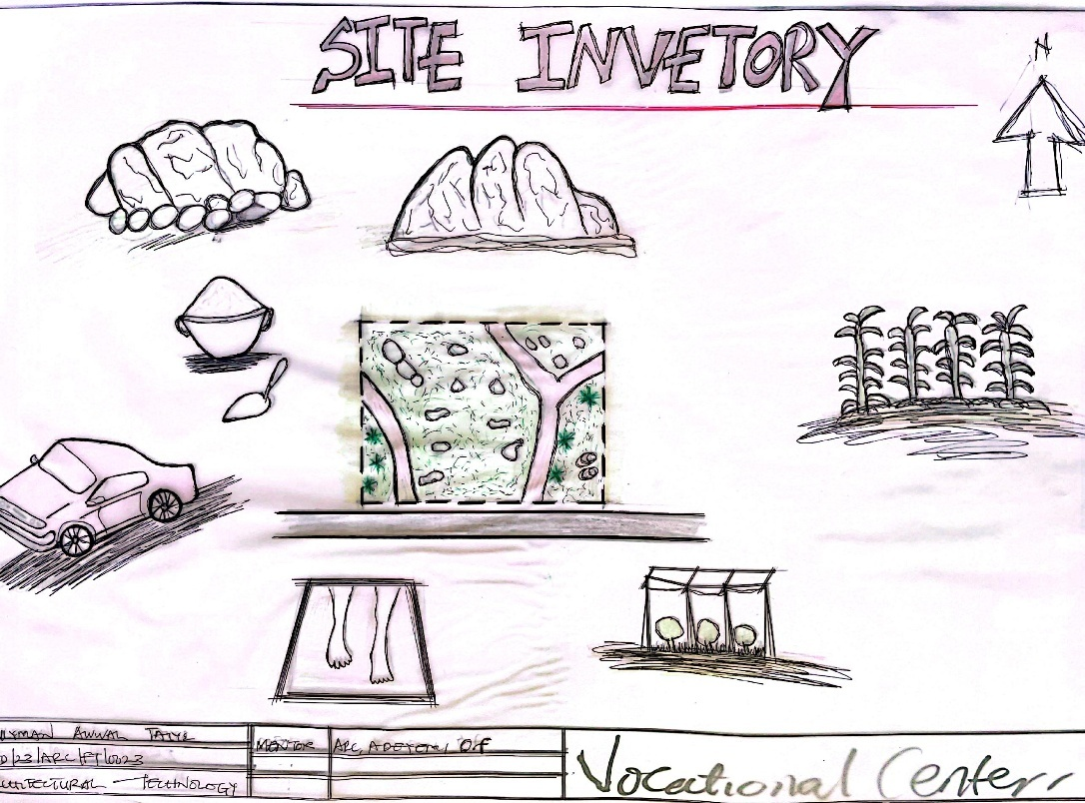

FIG 4.2:- SITE INVENTORY

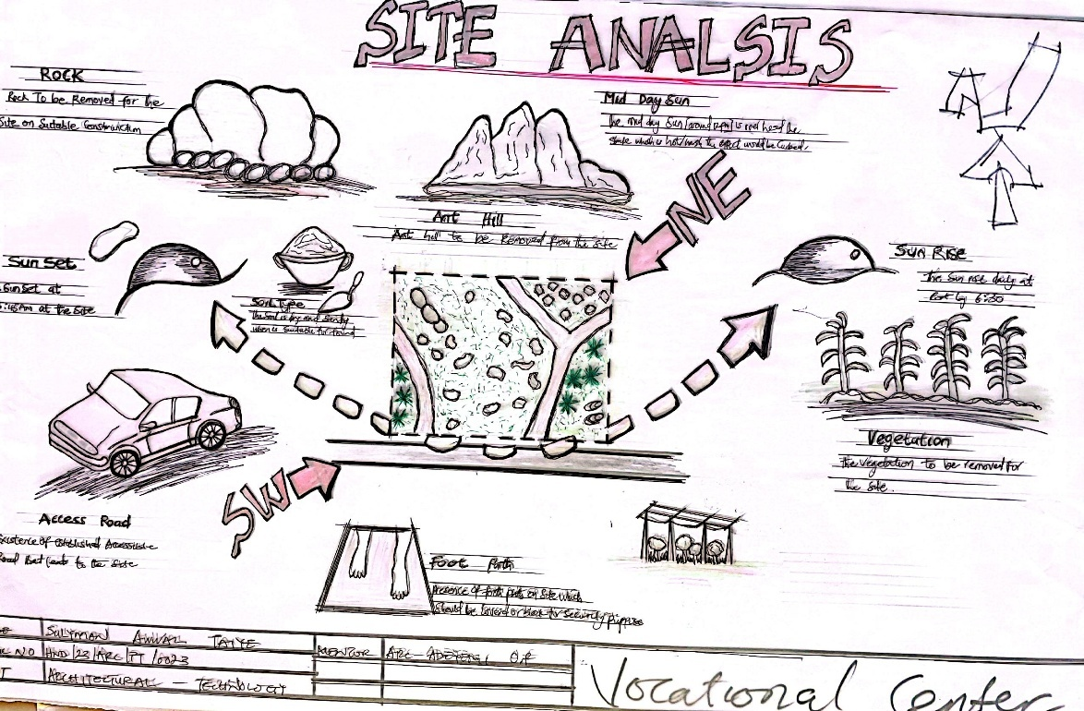

FIG 4.3:- SITE ANALYSIS

DESIGN CONCEPT/PLANNING PRINCIPLE
DESIGN PLANNING
Firstly, the process of analysis in the design into the necessary units required for the design is based on the data collected through research methodologies.
Secondly, the grouping of the various unit together according to their relationship with one another also based on the data and information gathered.
The concept of the design was arrived at from the functional relationship and bubble diagrams prepared out of the design brief which is based on the activities performed within the institute/school. The relationship of these various activities with one another within different units that makes up the design and also based on the zoning in accordance with the level of noise produce by each unit.
PLANNING PRINCIPLE
The planning principle is one of the most important aspect of any design. The planning of various units taking into consideration the activities performed in each unit, how they are related to one another and the users of the various units in the design.
In respect to the design above factors, the building is divided into two blocks. The first block is the administrative building; while the second block is the workshop building which is well positioned on the site taking cognizance and into consideration the works going on in the workshops and possible noises that might be produce.
In respect to the sit zoning, the safe zoning is divided into three parts. The first division as semi quite area while third division C is quite and noisy area.

CHAPTER FIVE
5.0 DESIGN REPORT
5.1 DESIGN BRIEF
After research and planning, the next step in the series of the project programme is design itself. To achieve functional and well aesthetic design the1¢ must be a brief to work on. This brief depends generally on the scope of individual design. The brief of this project is therefore based on the various activities that take place in the institute of vocational studies.
To have enough brief for the proposed institute case studies were carried out ‘on the existing schools both in the Nigeria universities and polytechnics. The studies also give me the opportunity to know the nature of the courses offered in the schools and how related to each other.
The institute of vocational studies train six different department, they are computer studio, tie and dye, electrical engineering, plumbing, fashion, design and carpentry.
5.2 DESIGN ANALYSIS
This is the process of itemizing units within the components of the entire design with a view to establish a solid understanding and appreciation of the space relationships.
SNO | WORKSHOP BLOCKS UNIT | DIMENSIONS | M²
1 | ENTRANCE | 6.3 X 3.9 | 24.6m²
2 | RECEPTION | 6.3 X 3.6 | 22.7m²
3 | Hairstyling Workspace | 12.0 X9.0 | 108m²
4 | Instructor Office | 3.6 X3.0 | 11.7m²
5 | Store | 3.6 X 2.4 | 9.4m²
6 | Fashion Designing | 12.0 X9.0 | 108m²
7 | Instructor Office | 3.6 X 3.0 | 11.7m²
8 | Store | 3.6 X 2.4 | 9.4m²
9 | Aluminum Workshop | 12.0 X 9.0 | 108m²
10 | Instructor Office | 3.0 X 3.0 | 9m²
11 | Store | 3.0 X 2.7 | 8.1m²
12 | Electrical and electronic workshop | 12.0 X 9.0 | 108m²
13 | Instructor Office | 3.0 X 3.0 | 9m²
14 | Store | 3.0 X 2.7 | 8.1m²
15 | Welding and Fabrication Workshop | 9.0 X 8.0 (X2) | 147.6m²
16 | Instructor Office | 3.3 X 3.6 | 11.9m²
17 | Store | 3.0 X3.6 | 10.8m²
18 | Art & Craft Studio | 13.2 X7.4 | 97.68m²
19 | Instructor Office | 3.0 X 3.6 | 11.9m²
20 | Store | 3.0 X 3.6 | 10.8m²
21 | Conveniences | 2.1 X 1.2 (X4) | 12.9m²
 | TOTAL |  | 839.58m²
S/N | UNITS | DIMENSION | M2²
1 | Entrance | 3.3 X 2.4 | 7.9m²
2 | Wood Workshop | 12.0 X 8.2 | 98.4m²
3 | Instructor Office | 3.0 X3.0 | 9m²
4 | Store | 3.0 X 3.0 | 9m²
5 | Plumbing Workshop | 12.0 X 8.2 | 98.4m²
6 | Instructor Office | 3.0 X 3.0 | 9m²
7 | Store | 3.0 X 3.0 | 9m²
8 | Automobile Workshop | 11.6 X 10.6(X2) | 245.92²
9 | Instructor office | 3.0 X 3.0 | 9m²
10 | Store | 3.0 X3.0 | 9m²
11 | Conveniences | 1.8 X 1.5 (X2) | 5.4m²
 | TOTAL |  | 510.02

5.3 DESIGN APPRAISAL
In any project design, there are two basic factors that should be taken into consideration. These factors are functionality and aesthetics and functionality of any building are incompatible but in the case of this project, both aesthetic and functionality of the design were taken care of to satisfy the highly demanded functional requirement and to create aesthetically and proportionally balanced design.
The functional efficiency of institute of Vocational studies depends largely on the enclosures of the immediate section that are strongly related in function all these are being taken up as seen on the site and floor plans respectively.

5.4 DESIGN CHARACTERISTICS
The idea of planning a good surrounding involves from the primary function. It gives a good aesthetic view to the structure; it enhances the psychological feeling of the public, making use of the area: it makes the entire environment healthy, as an adage says "cleanliness is next to godliness". A clean and well-planned site is a healthy environment in view of these following had been adopted in planning the site.
1.LANDFORM: As earlier discussed under the topography the land is gentle slope hence it will affect good planning.
2.TREES: Trees are planted within the institute building to effect natural Ventilation. Trees which will not be more than 2.5m high when grown are to be planted at reasonable spacing to provide shade for the car park. Shrubs and trees such as Amelina, Aborea, Flamboyant, Alternance etc. with good foliage are to be planted along with the fence and some strategic places within the site to provide shade and serve as sun's and wig breakers. ‘The trees also reduce the atmospheric temperature and release of oxygen during photosynthesis makes the atmosphere cold.
3.GRASSES: Grasses give good impression of an environment and also protect. the land surface from erosion for this project, Bahama grass is recommended for all the lawn area. Some courtyard that are busy are covered with lawns, fines grasses like Kikuyu grass planted in the courtyard and some parts are paved for relaxation purpose.
4.FLOWER BEDS: A well planned flower arrangement gives aesthetic to environment. Flower is grown along the walkways around the main building generally except where it can obstruct vehicular pedestrian movement. Flower such as slender, Bryphallion roses, lady on boat, ice plant etc. are planted.
5.HEDGES: Hedges are also planted along some part of the walkway. In the courtyard while shrubs are also used along vehicular ways. The following shrubs are used for the hedge. Dodoneaviscosal (Josorevet). The vital (bush mil) casavatinalequstifolic (Whistling pic). Shrub such as spotted croton. Euphobiasplender (desert rose) are planted for their beautiful leaves and good scents also for ornamentation.
6.PARKING SPACE: Parking lots are located in front of administrative offices to service the administrative. Loading send concrete block should be Portland cement delivered in good condition to the construction site all the instruction given in civil engineering drawing will be thoroughly and strictly adhered to in order to avoid failure. The walkways should be constructed of concrete roof laid to fall with 2 layer of bitumen fact. The roof member should be firmly secured. The mortar bed should at least 25mm thick bond of block should be stretcher bond.
5.5 BUILDING STRUCTURE
The whole institute building has administrative building complex and workshop building which makes the environment more comfortable for both the student and the staff in that environment. The story building supported by beans and column at appropriate intervals. Most modern school buildings are usually constructed by introducing grid into the design. This make for easy and accurate consideration of frame structure used in school buildings. ‘There are two types of grid system:
- Modular grid
- Structure grid
For this project, structure grid system was employed in filled sand Crete blocks were used for all the retaining walls of the institute. The roofing system used for the lecture theatre is steel truss roofing.
Some part concrete roof where also used along with timber the prevalent damage usually caused by termites is prevented by the application termitarium treatment like Gamalin 20 solignum etc.
5.6 SERVICE
Electricity is tapped from the nearest pole of the institute building. The main water pipeline is closely located to the site where drinking water can be tapped telephone line is within the polytechnic which makes connection easy.
The entire roof drains runs to the surrounding gutter which finally drains to the main gutter along the public drainage all the solid and liquid wastes are effectively disposed of by the soak away pits and septic tanks, a central AC system shall be fixed where appropriate.
5.7 GENERAL REQUIREMENT
5.7.1 LIGHTING
This is a means of providing brightness naturally by sun or moon or artificially by lamps. Good natural and artificial lighting is important in the lecture rooms, students and library. It is always easy to make mistake and the eye in a situation poor lightning floor. For the purpose of this project, effort is made as much as possible to light up the entire building naturally before the use of artificial lighting.
In this project, to obtain maximum lighting more openings are provided for the lecture rooms, studios, seminar hall and library. Artificial source of light will still be provided for in case where there is call for the use of it at night or in a situation where the weather condition warrants it.
5.7.2 ORIENTATION
The orientation of a building involves the arrangement of the building forward or away from the sunrays, across or along the trade winds normally determines the thermal comfort in the building. In view of these, the building is oriented in the safe plan in such a way that be short facts is facing the east with no opening at all and the fact away from the sunrays and forward the north east trade wind and south west monsoon wind to produce thermal comfort since the facet towards the sun always tap temperature the sun and the long facet away from the sun but long the trade winds will always tap the advantage of other winds while the harsh effect of the north east trade wind will be reduced by planting trees along the side facing it. This will enhance Permeable screening order words serving as wind breaker.
5.7.3 RAIN PROTECTION DEVICES
The rainfall of a place generally determines the living condition and all comfort associated with that environment hence provision should be made for fast dispersal of the rain as well as associated condition with rainfall. This calls for the need to study the nature of rainfall of the area. To control the heavy rainfall during the wet season (April-October). The use of simply sloppy system roofing has been adapted.
Damp proof draught proof materials are used by various joint of the roof to withstand the passage of rain water.
25mm thickness is used for rendering so that water absorbed from the external wall will not reflect on the internal side of the wall.
5.7.4 NOISE CONTROL DEVICE
This is an unpleasant sound of ten lauded harsh. Excessive noise and vibration can cause fatigue, leading to errors and general dissatisfaction in the classrooms, studio, seminar hall. External noise could be easily controlled with the aid of landscape materials and rough setbacks.
The workshop departments is separated from the administrative building with the use of comfier in the workshop building and landscape clement such as tree, shrubs, are introduced as buffer zones that is noisy semi-noisy and quiet zone.
Acoustic ceiling tiles offer much help reducing overall noise level thus it is recommended for the school offices, lecture rooms, departmental studios, library and other units where conversation are confidential in nature e.g. the board room.
5.8 MATERIAL AND FINISHES
The influence of building material on construction works in Abeokuta and its environs is similar to what prevail in the middle belt of the country. In the south the rainfall encourages the use of parapet wall to reduce falling out of the roof by heavy wind (either North-East or South-West trade wind). Concrete/Sand Crete blocks in regular molds are often used for wall construction with a standard of 100mm, 150mm and thickness.
The material choice and finishes are influence by a number of factors such as follows:
- The durability and suitability of materials
- Geology and topography of the site
- Availability of material
- The climate conditions
- Properties of materials
- The coast of the materials
ROOF
In areas experiencing tropical climate condition such as Lagos where there is rainfall, roof should preferably not be of light weight construction. A corrugated iron sheet with parapet covering it and the external surface should absorb as little solar energy as possible. For these reasons, long span galvanized aluminum roofing sheets is recommended for all parts of the complex in addition to the reinforced concrete roof gutter and concrete roof slab. Steel is recommended as roofing strimhire of the lecture theater and other unit's timber are to be used.
CEILING
Suspended ceiling is used in some lecture roof with metal hangers with fanny ceiling at suitable center to center. The ceiling material is prepared to be attractive and easily cleaned. It should be of moderate cost for the above reasons the recommendation furnishing of all the offices is Celotex expect the lecture theatre that acoustic material is used to reduce the effect of the noise.
WALL
The structural walls of the building are to be constructed with 225mm engine molded sand/cement hollow blocks. The column and beans are properly reinforcing with wall the wall whole applicable column and beans are furnished with 25mm gauged smooth. Also, most if the unit are of framed structured which carried most of the loads. Load bearing masonry wall are also used and furnished with 25mm thick wall rendering and finally painted according to color specification schedule in the toilet/lavatories, the wall is to be furnished with ceramic tile to height of about 2100mm.
DOORS
The door type and size depend on the door location, but generally range from paneled door to panel folding doors of sizes from 750mm for toilets to 2700mm for the lecture theatre, library and main entrances to departments. Some doors are purposely made swinging doors for durability, fire resistance and noise control.
WINDOWS
The windows that are to be used range from pivoted windows, projected and Naco louvers blade with metal and aluminum frame.
COVERED WALKWAYS
The roofing to all covered walkways with the institute should be made of reinforced concrete slab finish laid to fall two layers of bitumen felt, the walking paying should be made of present concrete slab finished roughly to prevent slippery when wet.

SUMMARY AND CONCLUSION
SUMMARY
Throughout the design process (from inception to the final detailed drawing). Consideration has been given to a simple hut functional design, which take care of all problem in the existing institute of business and vocational studies. However, this project is part of the pace to a conventional institute of business and vocational studies in any higher institution of learning.
Since design generally are affected by various factors ranging from finance, nature of site, material choice and availability as well as various other factors, the design could vary but the approach and concept are basically within a range everywhere.
6.2 CONCLUSION
In conclusion, the deduction and experience learnt and gained from the essential research which was carried out on the school of business and vocational studies in some Nigerian Polytechnic and Universities have extremely exposed me and of course the reader of the project report to what is obtainable in school of business and vocational studies in Nigeria.
Institution design, especially as I have realized from the research has follow functions that follow one another. It also enables me to know what is needed in school design, with particular reference of business discipline. In my design, I have made sure that all the functional aspect of the project was located at a particular point.
Finally, this project fulfills my ambition to contribute my own quota to the enhancement of educational development of the school generally in Nigeria.

REFERENCES
Abia Govt and Youth Empowerment (2013): Available online at www.vanguardngr.com/2013/05/abiagovt-andyouthempowerment accessed on 22nd june, 2013.
Adegbite, S.A Ilori, M.O, Irefin, I.A, Abereijo, I.O and Aderemi, H.O.S (2006): Evaluation of the Impact of Entrepreneurial Characteristics on the Performance of Small Scale Manufacturing Industries in Nigeria Journal of Asia Entrepreneurship and Sustainability, Vol 3(1) pp 1-15.
Andow, A.A (2011): Impact of Entreneurial Skill Development Programmes on Women Entrepreneurs in Kaduna State. Unpublished Doctoral Dissertation, Department of Economics and Management Science Kaduna, Nigeria Defence Academy.
Awogbonle A.C and Iwuamadi, K.C (2010):Youths Unempolyment: Entrepreneurship Development Programme as Intervation Mechanism.
African Journal of Business Management Vol 4(6) pp 831-835. www.academicjournals.org/ajom. Fatunla, G.T.(1989): lntrepreneurship Development Programme in Nigeria. International Small Business Journal Vol 7(3) pp47-58.
Ige, C. (2007):Promoting Entrepreneurship for Economic Development of Nigeria. Text of the 2007 C B N annual Lecture Presented at Bankers House, Lagos.
Meredith,G.G, Nelson, R.E and Neck, P.A (1996):The Practice of Entrepreneurship, Lagos: University of Lagos Press. 2006 population and Housing Census, Priority Table, Vol 111, April, Abuja.
Oghojafor, B.E.A, Kuye, OJ. Sulaimon, A.A.J and Okonji, P.S.(2010):"Empowering Nigeria Youths for National Economic Development": the Role of Entrepreneurship Education Lecture Series, Department of Business Administration Lagos: University of Lagos press.
Omoruyi, F.E.O, and Osunde, A.U (2004):Evaluting the Effectiveness of the National Youths Empowerment and Vocational Skills acquisition programme in Midwestern Nigeria. www.iz.dvv.de/index..

APPENDIX
