MODIFICATION AND PERFORMANCE EVALUATION OF HYBRID EGGS INCUBATOR
BY

ABDULAZEEZ ABDULLAHI OLANREWAJU
HND/23/ABE/FT/0048

DEPARTMENT OF AGRICULTURAL AND BIO-ENVIRONMENTAL ENGINEERING INSTITUTE OF TECHNOLOGY, KWARA STATE POLYTECHNIC, ILORIN.
IN PARTITAL FULFILLMENT OF REQUIREMENT FOR THE AWARD OF HIGHER NATIONAL DIPLOMA (HND) IN AGRICULTURAL AND BIO-ENVIRONMENTAL ENGINEERING TECHNOLOGY.

AUGUST, 2025
DECLARATION
I hereby declare that this research project titled: “MODIFICATION AND PERFORMANCE EVALUATION OF HYBRID EGGS INCUBATOR” is my own work and has not been submitted by any other person for any degree or qualification at any higher institution. I will also declare that the information provided therein are mine and those that are not mine are properly acknowledged.

___ _ Name of Student Date and Signature

CERTIFICATION
I, hereby declare that this research project titled MODIFICATION AND PERFORMANCE EVALUATION OF HYBRID EGG INCUBATOR was carried out by Abdulazeez Abdullahi Olanrewaju with matric number HND/23/ABE/FT/0048 is my own work and has not been submitted by any other person for any degree or diploma in any higher institution. I also declare that the information provide therein are mine and those that are not mine are properly acknowledged.

_______ __14/_8/2025____________
Engr. (Mrs) Onipede ,E.A Date
(Project Supervisor)
_______________ _____04/08/2025____________
Engr. Oyebanre O.D Date
(Project Co-ordinator)
_____ ___04/08/2025______________
Engr Dauda, K.A Date
(Head of Department)
_____________ ___13/08/2025______________
Dr. Adejumo Akinfoye Daniel Date
(External Examiner)
DEDICATION
I dedicate this project work firstly to Almighty GOD the unborn creator of every creature who has been there for me from my very first beginning till date. Also, to my caring and lovely mother Mrs Abdulazeez B. and Mrs Rasheedat Gbagba (TGM) for all they have done for me I pray that you will reap the fruit of your labour by the grace of God.

ACKNOWLEDGEMENT
I give my great thanks to Almighty God, the Lord of the whole universe, the sustainers who guided and provided me all I need to complete my HND (Higher National Diploma) Programme in good health.
My profound gratitude goes to my caring and lovely mother Mrs Abdulazeez B. and Mrs Rasheedat Gbagba (TGM), may Almighty God grant health and bless them.
The next thank goes to my supervisor, a woman of understanding honour and trust in person of Engr. (Mrs) Onipede,E.A. for being there and lenient with me. I pray may Almighty God reward you abundantly (Amen).
My appreciation also goes to the H.O.D of Agricultural and Bio-environmental Engineering Department in person of Engr. Dauda, K.A, and to all my departmental lecturers for the knowledge they have impacted in me throughout my Higher National Diploma Programme may God reward you abundantly.
Also my gratitude to my friends, who stood by me. I remain disloyal if I drop my pen without appreciating my project partners. Thank you for the sincerely love we share during this research work. Also those people I am not opportune to mentioned one after the other, most especially all my course mate I appreciate you all, I will live to always remember your good deeds.
I am using this medium to pray Almighty God to bestow on me the utmost knowledge and understanding from now till eternity (Amen).

TABLE OF CONTENTS
Title Page
Title Page I
Declaration ii
Certification iii
Dedication iv
Acknowledgement v
Table of Contents vi
List of Table x
List of Figure xi
Abstract xii
CHAPTER ONE
1. Introduction 1
  - Background to the Study 1
  - Problem Statement of the Study 2
1.3 Aims and Objectives of the Study 2
1.4 Justification of the Study 3
1.5 Scope of the Study 3
CHAPTER TWO
2. Literature Review 4
2.1 Poultry Farming in Nigeria 4
2.2 Poultry Incubation Technology 4
2.3 Feature of Hybrid Poultry Eggs Incubator 5
2.4 Incubation Parameters 6
2.5 Condition for Various Eggs Incubation 6
2.6 Reviews on Artificial Incubation 7
CHAPTER THREE
3. Materials and Methods 14
3.1 Materials 14
3.2 Area of Modification 14
3.3 Description of the Hybrid Egg Incubator 15
3.3.1 The Main Cabinet 16
3.3.2 The Auxiliary Unit 17
3.4 Design Consideration 17
3.5 Design Calculation and Analysis 18
3.5.1 Determination of Incubation Chamber 18
3.5.2 Determination of Heat Required for Incubation 19
3.5.3 Heat Loss by Incubator 20
3.5.4 Determination of Humidity 22
3.5.5 Total Power Consumption 23
3.5.6 Power Requirement and Selection of Battery Solar Panel and Inverter 23
3.5.7 Size of Solar Charger 23
3.5.8 Battery Running Time 24
3.6 Materials Selection 24
3.7 Construction and Assembly Procedure 25
3.8 The Operation of Hybrid Egg incubator 25
3.9 Bill of Engineering Measurement and Evaluation 26
3.10 Performance Evaluation 27
3.10.1 Source of Material 27
3.10.2 Preparation of Sample 27
3.10.3 Output Parameters 27
3.11 Experimental Procedure 28
CHAPTER FOUR
4. Result and Discussion 30
4.1 Result 30
4.2 Discussion 31
CHAPTER FIVE
5. Conclusion and Recommendations 32
5.1 Conclusion 32
5.2 Recommendation 33
References 35 Appendices

LIST OF TABLE
Table 2.1 Condition for Various Egg Incubation 7
Table 3.1 Bill of Engineering and Evaluation 26
Table 4.1 Candling Test On 7th Day On Incubation 30
Table 4.2 Candling Test on The 14th Day of Incubation 30
Table 4.3 Average Records of Temperature and Humidity for 21days of Incubation 31

LIST OF FIGURES
Figure 3.1 Assembly View of Hybrid Eggs Incubator 15
Figure 3.2 Exploded View of Hybrid Eggs Incubator 16

ABSTRACT
A hybrid egg incubator was modified and constructed to solve the problem of power outages that militate against poultry egg incubation. The hybrid egg incubator was constructed from medium density fibreboard (MDF) plywood and lagged with fibre glass to prevent heat loss. The hybrid egg incubator was made of two unit; the main cabinet and auxiliary unit.
The main cabinet contains of egg trays, bulbs, DC fans, water tray and turning mechanism. The auxiliary unit contains of solar PV panel, battery, inverter and charge control. The incubation parameters were measured by control board. The temperature and humidity range within the incubator were 36.1 - 37.5 °C and 50.1 % to 60% respectively, the angle of turn was 45°. The result of performance evaluation showed 91% hatchability, 66% fertility and maturity rate 9%.
The hybrid egg incubator is affordable because it was made from locally available materials and it is therefore recommended for poultry farmers both at rural and urban centers.

CHAPTER ONE
1. INTRODUCTION
1.1 Background of the Study
Poultry production remains a cornerstone of Nigeria’s agrarian economy, contributing significantly to protein supply, employment, and rural livelihoods. According to Ajayi and Koledoye (2020), traditional natural incubation methods, including brooders like hens or hot sand, dominate small-scale hatchery practices, though they often yield low efficiency and inconsistent outcomes. This inconsistency underscores a pressing need for reliable and scalable artificial incubation systems to boost hatchability and productivity. Modern artificial incubators controlled via electric heating, thermostats, ventilation, and mechanical turning mechanisms have achieved improved hatchability rates of 58–84%, depending on design and management. However, these systems often rely solely on grid electricity—an unreliable resource in many parts of Nigeria. Frequent outages disrupt the incubation process and can compromise hatchability and chick quality. To mitigate this instability, hybrid incubators that integrate renewable energy sources—such as solar panels, batteries, thermoelectric modules, and phase-change materials—have emerged worldwide. For instance: A thermoelectric-plus-PCM system operated on solar PV achieved stable incubation temperatures (36–39 °C) and humidity levels (56–80%) over 21 days. A smart solar hybrid incubator designed in Nigeria successfully powered egg incubation during grid failures, maintaining 37.5 °C and 45% humidity for up to 1,056 eggs through solar panels and battery backup systems. In Ethiopia, a solar system with thermal storage maintained incubator temperature and humidity within optimal ranges, though hatchability (27%) was impacted, indicating the need for localized adaptation. These innovations suggest hybrid incubators can improve energy efficiency, reduce reliance on unstable power, and enhance hatchability. Yet, most studies have focused on design and theoretical performance; few provide complete evaluations in Nigerian conditions. Additionally, performance metrics such as energy consumption, temperature stability during outages, embryonic mortality, and overall economic viability remain underreported.
1.2 Problem Statement
The world’s growing population and increasing health awareness have led to a surge in demand for poultry product, which are perceived as a heathier alternative to red meat due to their lower cholesterol and trans fat content. this trend is expected to continue as driving growth in the poultry industry. The process of hatching egg by natural method is limited and the artificial incubators that can hatch more eggs at a time are faced with erratic power supply for an electrical incubator, adverse weather condition for solar incubator, lack of adequate control system of incubation system and besides an inadequate hatcheries contributing to high cost of day old chicks
1.3 Aim and Objectives
The aim of this project is to modify and evaluate the performance evaluation of hybrid eggs incubator that combine solar and electrical power system to enhance hatchability rate and reduce energy consumption while the specific objective are to;
i Identify shortcomings in the existing incubator
ii Modify components to improve hatchability
iii Assess the temperature and humidity control capability of incubator under different environmental conditional
iv Evaluate the machine performance in term of hatchability rate, fertility rate and mortality
1.4 Justification
The study will contribute to sustainable poultry farming in Nigeria by addressing power failure and weather related challenges, reducing energy consumption and separating costs, making incubation practices accessible in rural areas and increase the income of poultry farmers.
1.5 Scope of the Study
The scope of the study focuses on modifying an existing hybrid egg incubator in terms of construction materials, insulation materials, temperature and humidity control, mechanical turning of the egg, procurement of fertile eggs and carry out of performance evaluation in terms of hatchability.

CHAPTER TWO
2. LITERATURE REVIEW
2.1 Poultry Farming in Nigeria
Poultry farming forms a critical component of Nigeria’s agricultural framework, offering vital protein, income, and employment to both urban and rural communities. According to the National Bureau of Statistics (2021), poultry production accounts for a substantial share of agricultural GDP, with millions participating in smallholder farming. Despite its socioeconomic importance, the sector faces significant constraints—outbreaks of disease, inadequate infrastructure, volatile input costs, and limited adoption of modern tech impede its full potential.
2.2 Poultry Incubation Technology
Artificial incubation is vital for enhancing hatchability and mass chick production.
a) Natural Incubation
Historically, Nigerian farmers rely on hens for natural incubation. While low-cost and simple, this method is plagued by inconsistent results and vulnerability to environmental factors. A 2020 study in Kwara State shows that natural incubation remains predominant but yields unreliable hatch rates due to lack of control.
b) Artificial Incubation
Artificial incubators—ranging from simple electric units to advanced automated systems—provide controlled conditions and enable simultaneous hatching at scale. Research by Adegbulugbe et al. (2013) shows incubators maintaining 37 °C and 55%–70% humidity achieved hatchability rates of 84%. Another Nigerian study emphasized controlling temperature (37.5°C) and humidity (45%) in a 540-egg unit yielded stable performance. However, most depend solely on grid power, posing risks in areas with unreliable electricity. Several designs—kerosene, charcoal, solar, and electric incubators—are used, but sustainment of optimal temp-humidity remains a challenge under local conditions. Hybrid incubators that combine multiple power sources show promise but require empirical validation under Nigerian climates. . They include: kerosene incubator, Charcoal incubator, bio - gas incubator, hybrid incubator and electrical incubator.
- Kerosene incubator is a type of incubator that uses kerosene as it power source
- Charcoal incubator is a type of incubator that uses charcoal as it power source
- Bio – gas incubator is type of incubator that uses bio – gas as it power source
- A hybrid poultry egg incubator is a type of incubator that combines two or more power source or technology to provide a reliable and efficient incubation environment for poultry egg.
- Electric incubator is a type of incubator that uses electricity as its power source.
2.3 Feature of Hybrid Poultry Eggs Incubator
Feature of Hybrid Poultry Eggs Incubator are;
- Dual power source: it combines two power source such as electricity and solar power to provide a reliable and consistent incubator environment.
- Backup power system: Hybrid incubator may include backup power system such as batteries or generator to ensure continuous operation during power outrage or period or low sunlight.
- Advanced temperature control which can maintain optimal temperature for poultry egg incubator even in extreme weather condition.
- Humidity control to maintain optimal humidity for poultry egg incubation
- Automated egg turning and monitor to ensure proper turning to track incubator parameter such as temperature, humidity and egg turning
2.4 Incubation Parameters
Successful artificial incubation depends on four key parameters:
- Temperature: Optimal range is 37.5–38.0 °C. Even slight deviations affect hatchability and chick quality.
- Humidity: Ideal relative humidity is 50%–60% during most incubation, rising to 65%–75% during lockdown.
- Ventilation: Ensures supply of fresh oxygen and removal of CO₂—crucial for embryo respiration. Poor ventilation leads to stunted growth and respiratory issues.
- Egg Turning: Regular turning prevents the embryo from adhering to the shell and ensures even temperature distribution. Studies link this to increased hatchability and chick vigor.
- Egg Fertility: Egg fertility is also an important parameter that enhance hatchability hence there is a need for eggs candling to ascertain the fertility of eggs incubated.
2.5 Condition for Various Eggs Incubation
Condition for various egg incubation. The species of the bird, the incubation period, and other parameters for incubation is as shown in table 2.1

TABLE 2.1: Condition for Various Egg Incubation
Species | Incubation Period  (Days) | Temp  F | Humidity  (F) | Do not turn after | Humidity  Last 3days | Open vent more
Chicken  Turkey  Duck  Muscovy duck  Goose  Guinea fowl  Peafowl  Pheasant  Pigeon  Bobwhite  Cotumix  Chukar | 21  28  28  35-37  28-34  28  28-30  23-28  17  23-24  17  23-24 | 100  99  99  100  99  100  99  100  100  100  100  100 | 85-87  84-86  85-86  84-85  86-88  85-87  84-86  86-88  85-87  84-87  85-86  81-83 | 18th day  25th day  25th day  31st day  25th day  25th day  25th day  21st day  15th day  20th day  15th day  20th day | 90  90  90  90  90  90  90  92  90  90  90  90 | 18th day  25th day  25th day  31st day  25th day  24th day  25th day  25th day  14th day  20th day  14th day  20th day

2.6 Reviews on Artificial Incubation
Numerous research efforts have evaluated the effectiveness of artificial incubation technologies and their impact on hatchability rates. Djo et al. (2021) emphasized the advantages of temperature-controlled artificial incubators over traditional brooding methods. Their findings showed that modern incubators improve hatchability, reduce embryonic mortality, and enhance energy efficiency by automating heat and humidity regulation.
In Nigeria, Ejiofor et al. (2020) assessed the performance of locally produced incubators. Although they were more affordable and accessible to smallholder farmers, they often lacked precision in temperature control and failed to maintain required humidity levels, resulting in inconsistent hatch rates. These shortcomings stress the importance of further development in incubator engineering to meet local climatic and power reliability challenges.
Similarly, Adame and Ameh (2023) reviewed advances in poultry incubation and hatchery management practices. Their findings pointed to persistent issues such as poor chick quality, low hatchability rates, and inadequate monitoring of incubation parameters in both rural and urban setups. The review concluded that while natural incubation methods are economical and easy to implement, they lack efficiency and scale. Artificial incubation, on the other hand, though requiring greater investment and maintenance, provides a controlled environment that supports high-yield hatching and better chick survival rates.
Hassan et al., (2021) in characterizing and electric incubator recorded a hatchability percentage of 80.9% and concluded that the major challenge of incubators that can work with electricity are excessive billing rate, erratic power supply as well as complete absence of electricity in remote regions. Equally most of the incubator is developing countries like Nigeria operate at 60% below design capacity grid electric supply.
Olaoye et al., (2013) developed a 120 egg a capacity electric incubator. The system which was coupled with three 100 w electric bulb produced 75.2% fertility in addition to the hatchability rate of 64.8%.
Yadav et al., (2021) Analyzed the developed automatic horizontal egg incubator. A motor clamped mechanism controlled by a micro-controller was used to adjust the egg trays horizontally. The system yielded a hatchability of 72.22%.
Ogunwande et al., (2015) studied a still-air hatchery that has a non-thermostatic control. The system uses electric bulbs as the its source with a resistance varying components as temperature control. With three times daily of the eggs, the system achieved 62% hatchability rate.
Soeb et al., (2021) developed a low-cost incubator that is made up of the embedded controller Incorporated to an egg turning trays with hatchery apartment of 116 egg capacity for Bangladesh market. The manual and automatically evaluations of the developed hatchery showed a 79.3% and 87.1% hatchability rate respectively. The eggs were turned both manually and automatically as the case may be at intervals of 6hours.
Mansaray and Yansaneh (2015) developed a solar egg incubator that achieved temperature range of 36.8-37.9° c. The evaluation of the system yielded a percentage fertility and hatchability rate of 43.3% and 23.1% respectively. The study concluded that the low level of hatchability was as a result of several external influences such as an overcast weather, improper egg storage, time and energy loss, turning of eggs, faulty eggs etc.
Divagar et al., (2022) evaluated and automated solar-driven hybrid egg incubator. The system achieved a hatchability percentage of 81.72%.
Osanyinpeju et al.,(2016) walked on the development of solar powered poultry egg incubator. The heat produced by metabolic activities of 150 eggs in the system was 21.9 w. The percentage fertility of 64% in addition to 44% hatchability rate was observed with the system. The low hatchability was attributed to faulty hygrometer used which led to increase in the number of opening made at the last stage.
Niranjan et al., (2021) developed a chicken egg incubator using (IOT) integrated with smartphone effective monitoring and control. The system temperature wear set at the different temperatures of into (H1) 36.5° c, (H2) 37.5° c and (H3) 38° c. The hatchability percentage of the three temperatures were(H1) 81%, (H2) 92% and (H3) 86% respectively.
Ogunwande et al., (2015) developed a biogas powered poultry egg incubator that utilizes biogas as a fuel to provide thermal energy via a heater situated at the base. The system produced temperature range of 36-39.4° c within the incubating compartment. At the end of an evaluation test, a hatchability percent of 59.7% was realized.
Hassan et al., (2021) studied the use of thermal chemical storage media setup as a thermal source of hatching of poultry eggs. In the study, three forms of activated TCMs were utilized as energy containing medium. The media are silica gel, as well as natural zeolites. The TCMs were activated using electricity. Equally, the incubator was partly powered by electricity and partly by the TCMs. The its recapture operation helps to release the stored heat in TCMs. The system's hatchability percentage was 71.4% compared to the solely electric powered conventional incubator with 80.9% hatchability. However, the TCM incubator gave energy savings of 41.8% when compared with the conventional electric type.
Muhammad et al,. (2022) Studies a thermoelectric egg incubator coupled to heat storage system. Did Samuel electric component is utilized in the daytime process while a heat storage system made up of a phase change material (PCM) which provides derma energy during off-sunshine (especially nights) periods is complementary heat source. The electric energy that is changed to heat for starting the operation is provided with the arrays of the solar PV. The result of the 300 egg capacity system showed that temperature inside incubator chamber was between 36 iPhone 39° c with 73.3% hatchability.
Olasukanmi et al., (2015) developed a GSM based DC battery powered poultry egg incubator. The system is remotely tracked. The major components of the incubator were the DC motor, humidifier, ventilation fans, in addition to the custom made lower-power DC heater provided for controlling the turning of eggs, humidity, ventilation and temperature, respectively. The hatchery could either be powered using solar PV system, greed power electricity via an inverter or any medium that could charge the DC battery.
Oniya et al., (2013) develop a 160 a capacity low cost semi-in automated incubator powered by a backup inverter. The inverter could either be powered with an AC or DC electric system. The major components of the system were a heat source (100 w bulb), a thermistor, 12 PV battery, 100 w inverter and 0.14 w electric fan. A replicated analysis on the system showed a temperature variation between 36 to 39° c with hatchability 91%.
Uzodinma et al., (2020) carried out a characterization of hybrid solar powered poultry egg incubator. The hybrid incubator is made up of a double glazed flat plate solar collector coupled with paraffin PCM in addition to a PV subsystem. The evaluation of the system reviewed that the incubating temperature was maintained between 36 and 39° c in addition to the mean hatchability rate of 62.37%.
Bukola (2008) modified and carry out performance and evaluation of hybrid poultry solar incubator and stated the environmental factors of major importance for artificial incubator include temperature, relative humidity, air supply and egg turning. overheating speed up the rate of development and called abnormal embryo in the early hatches and consequently lower the percentage hatchability likewise high rate to prevent normal evaporation and results in low hatachability. turning of egg should be done 3- times daily from 2nd to the 18th day of incubation to prevent embryo adhersing to the shell
Okonkwo et al (2024) researched on energy sources for poultry egg incubator efficiency and hatachability. the result showed that sources of energy for incubation are categorized into grid supply electricity solar system, fossil fuel, biogas and thermochemical materials, from reviewed articles 50% identified grid supplied electricity as energy source for poultry egg incubation and hatachabiliy range from 80.9%-98.4% however, due to erratic nature of electricity supply and nonavailability in rural areas especially in developing nations, the study recommends increase research interest on other every source to improve their hatachability.
Faki etal (2015) reported on incubation condition such as temperature, humidity, ventilation and turning the most important factor significantly affective the hatchability of poutry egg and chick quality.
Furthermore, the study by Alabi et al. (2019) reported that most locally fabricated incubators in Nigeria struggle to sustain the optimal incubation temperature of 37–39 °C and humidity range of 50–70%, mainly due to erratic power supply. Hybrid systems combining solar energy, batteries, and automated controls were recommended to bridge this gap. However, most of these hybrid incubators remain underutilized due to lack of awareness, funding, or technical know-how among rural farmers.
In summary, while artificial incubation technologies present immense potential for improving poultry productivity, several challenges persist. These include poor temperature stability, inadequate ventilation systems, and limited access to quality incubators. There remains a crucial need for localized modification and performance evaluation of hybrid egg incubators to ensure optimal hatchability and sustained productivity under Nigerian conditions.

CHAPTER THREE
3. MATERIALS & METHODS
3.1 Materials
The following materials were used in the construction of hybrid egg incubator;
- MDF Plywood (Medium Density Fiber Body)
- Marine Board
- Bolt and Nut.
- Screw
- Ardonic Cabinet Hinge
- Edges Tape
- Door Bolt
- Nails
- Screw Cover
- Plank for the Egg Tray Seat
- Egg
- Hammer
- Glass Fiber
3.2 Area of Modification
The result from the test of previous machine showed that the machine was able to hatch 20 egg out of 45 eggs after operating the machine this gives 44% hatchability rate. The recommendation suggested that the turning mechanism, the temperature and humidity control should be automated for better performance hence the turning mechanism, temperature and humidity control system will be automated and some technical issues like egg fertility will be addressed
3.3 Description of the Hybrid Eggs Incubator
The hybrid eggs Assembly and Exploded views were as shown in figure 3.1 to 3.2 . The hybrid eggs incubator are made up of two components, the main cabinets and the auxiliary unit.
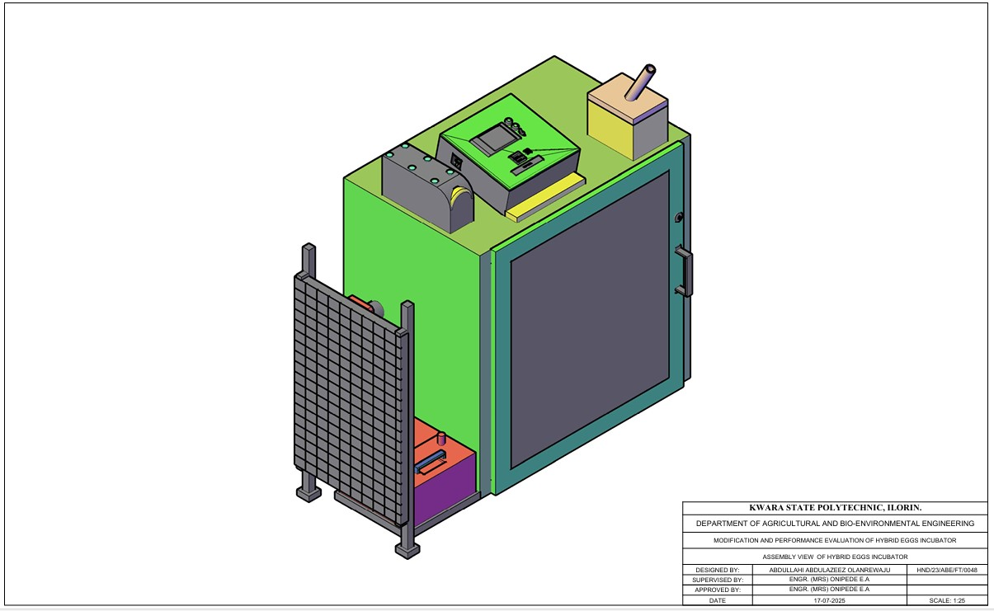
Figure 3.1 Assembly View of Hybrid Eggs Incubator

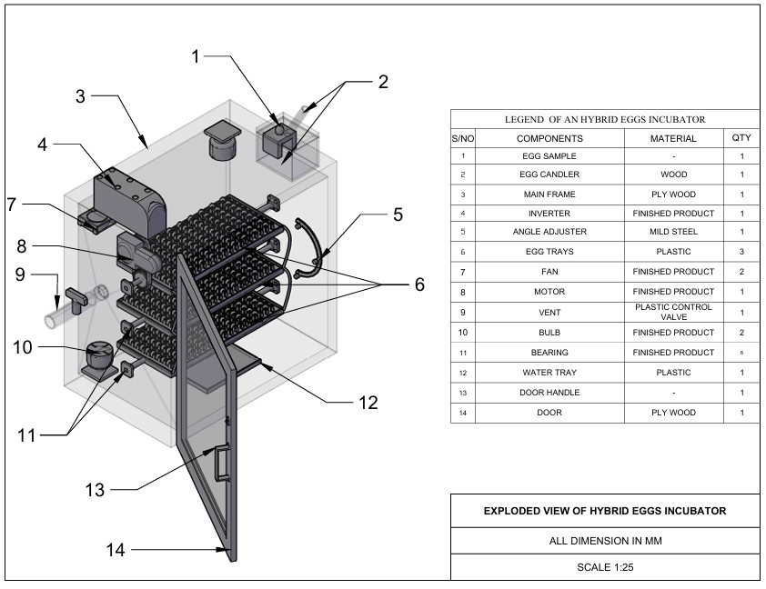
Figure 3.2 Exploded View of Hybrid Eggs Incubator
3.3.1 The Main Cabinet
The main cabinet is the incubating box which consists of the egg trays, fan, bulbs, egg turner, humidity tray, controller and savor motor.
- The incubating box is made from MDF plywood due to it, insulation properties, ease of construction, flexibility and durability. The dimension of the incubating box is 920 mm x 950 mm x 640mm.
- Egg turning trays: The Egg turning trays, is constructed from wood with dimension of 635mm x 335mm x 60 mm to accommodate the egg plastic crates. There are six egg creates, each containing 30 eggs, they were positioned inside incubator and turn 6 hourly.
- Humidity tray Is made up of plastic and placed at the bottom of the incubating box to increase and recover humidity in the incubator during experimental period.
- The fan is incorporated to facilitate the temperature and humidity in the incubator in order to keep them within the requirement of the present values.
- The controller was incorporated to sense the temperature, humidity and the turning mechanism of the incubator for effective incubation.
- The electric bulb 100 w cells as the source of heat to warm the inner unit to temperature range of 36 - 37.5° c.
- The savor motor is used to drive the egg turning tray and tilt it to an angle of 45° either side after a period of 6 hours.
3.3.2 The Auxiliary Unit
The auxiliary unit consists of solar PV panel, solar charge control, battery and inverter. The solar PV panel: Absorb solar energy to charge the battery, the solar charger controls the charging of the battery to prevent overcharging, the inverter converts the direct current from the battery to alternating current to be used by the incubator and at the same time charged the battery when there is electricity.
3.4 Design Consideration
The following factors were considered when designing hybrid eggs incubation
(a) Environmental Control
- Temperature range of 36.5°C-37-5°C within the incubator
- humidity range of 50-60% to prevent water loss and promote healthy development
- ventilation within the incubator is necessary for adequate airflow to maintain oxygen levels and remove carbon dioxide.
(b) Egg Handling
- regular turning (every 1-4 hours) to prevent embryo adhesion to the shell
- egg orientation to ensure eggs are positioned correctly (large end up) to facilitate proper development.
(c) Energy Deficiency and Sustainability.
- incorporating solar energy source to reduce reliance on electrical energy source
- automatic egg turner to reduce labor and ensure consistent turning
- temperature and humidity monitoring to ensure optimal condition
3.5 Design Calculation and Analysis
The design criteria are based on making the equipment more affordable, efficient and durable. the incubator capacity, heating system, turning mechanism, size of battery, power from battery size of solar panel were all designed during the development process.
3.5.1 Determination of Incubation Chamber
The capacity of the incubator is directly proportional to the number of eggs and the number of egg trays. The incubator was design to hatch 180eggs per hatch. The design of incubation chamber was done using equation 3.1and 3.2
c = $\frac{n}{60}$ (3.1)
Where
C = number of trays
n = number of eggs to be hatched
c = $\frac{180}{60}$
c = 3egg trays
the incubation chamber was designed to contain the egg trays; the incubation chamber was rectangular box like structure.
Volume of Incubation Chamber
V = l × b × h (3.2)
Where:
V = volume of incubator (m$^3$) (Abubakar et al 2023)
L = length of incubator (m)
B = breadth of incubator (m)
H = height of incubator (m)
3.5.2 Determination of Heat Required for Incubation
Heat required in the incubator was determined from equation 4
Q = MCΔT (Benjamin and Oye ,2012) (3.3)

Where;
Q = total heat required
C = specific heat capacity
ΔT = change in temperature
M = molar mass
QT = (MaCaΔT) + (MeCeΔT) × Ne + (MpCpΔT) + (MwCwΔT) (3.4) (Abubakar et al 2023)
Where;
MaCaΔT = heat required by air
MeCeΔT = heat required by eggs
Ne = number of eggs
MpCpΔT = heat required by plywood
MwCwΔT = heat required by water.
3.5.3 Heat Loss by Incubator
The heat loss due to conduction can be calculated from the equation 3.5 - 3.9
Q = −KA($\frac{ST}{Sx}$) (3.5)
The flow of air is steady inside the incubator therefore it does not vary with time.
QSx = −KAST (3.6)
Q = − KA$(\frac{Tinc -Ts}{X}$) (3.7)
Where;
Q = heat
K = thermal conductivity coefficient of plywood (0.65) in the design
X = is the thickness of the plywood (15mm)
Heat loss during incubation is given as top and bottom of plywood.
Qptpbpspfpbt =−KA$(\frac{Tinc -Ts}{X}$) × 2 (3.8) (Bala et al, 2020)
Where;
Pt = is the plywood top
Pb = plywood backside
Ps = plywood side
Pf = plywood front
Pbt = plywood bottom.
A = area of incubator chamber
K = thermal conductivity coefficient (0.65 forMDF) plywood (Ajani et al 2020).
The quantity of heat loss is calculated using the following equation
QL = Qptm + Qpss + Qpfb ( 3.9)
The quantity of heat required for the incubation
Q = Ql + Q1 (3.10)
Where:
Q = quantity of heat required for incubation
QL = heat loss by the incubator
Q1 = heat required of the incubator.
3.5.4 Determination of Humidity
The humidity keeps the eggs from losing two much moistures in the process of incubation it is calculated from equation 3.11 – 3.13
H = $\frac{Mv}{v}$ (3.11)
ρ =MvRvT (3.12)
H =$\frac{v}{RvT}$ (3.13)
Where:
H = humidity
ρ = energy density/heat density of water
T = temperature
Mv = molar mall of water
Rv = gas content
V = volume of the incubator’s chamber
3.5.5 Total Power Consumption
The total power consumption of the entire incubator system can be calculated from the following equation.
Total power consumption (PT) =P1+Pfh+Pfv+Pc (3.14) (Abba- ayi et al 2024)
Where;
P1 = power of the incubator chamber
Pfh = power of humidity fan
Pfv = power of ventilation
Pc = power of control board.
3.5.6 Power Requirement and Selection of Battery Solar Panel and Inverter
Total power consumption is added up to 130.435W base on the total power requirement of the incubator. A 200AH lithium phosphate acid battery 12v, a 1KVA inverter and a 300W solar panel will be used to power the entire incubator.
3.5.7 Size of Solar Charger
Size of solar charger was determine using equation 3.15.
SSc = $\frac{wp}{v}×Pf$
Where;
SSc = size of solar charger (AH)
Wp = wattage of solar panel (W)
V = voltage of the battery (V)
Pf = power factor (1.25)
Size of solar charger =21AH but use 25AH
3.5.8 Battery Running Time
The battery running time was calculated using equation 3.16
BR = $\frac{Bc}{L}$ Pf (3.16)
Where;
BR = battery running time (H)
Bc = capacity of battery (AH)
L = load of appliance (w)
Pf = power factor (10)
Battery running time is 16 hours but charging should start after 12 hours.
3.6 Material Selection
The following materials are put into consideration for the selection of materials used for hybrid eggs incubator
- Conservation of heat: MDF plywood was used for construction to conserve heat.
- Availability of material: The material used is easily available for repair and replacement.
- The cost of material: The cost of materials used is not expensive and will eventually leads to low cost of the incubator.
- The durability of the material: The material for construction was the type that will last long and have resistant to insect infestation.
- The easy of construction: The material used for construction is easy to work upon for mass production.
- The weight of material: The material used for construction was light weight for easy transportation.
- Lagging material: Fibre glass was used as a lagging material to further conserve and prevent loss.
3.7 Construction and Assembly Procedure of Hybrid Eggs Incubator
The tool used for the construction include; the hammer, hacksaw, paper tape, nail, bolt and nut. The medium density fibreboard (MDF)plywood of 50mm thickness was cut according to the design specification and joined together by nails and screw to form the incubating box. The three egg trays were in incorporated into the incubating box using bearing at ---- interval between one another to serve as egg crates seat. The savor motor was incorporated to the egg tray to facilitate the turning of the egg trays. The control board that houses temperature, humidity and time of turning was also incorporated.
3.8 The Operation of Hybrid Egg Incubator
The hybrid egg incubator is operated using two sources of energy (electrical and solar energy) that complement one another to prevent power interruption and for efficient incubation. When electricity is available, the incubator is powered directly from the main but in case of power outage the incubator is powered by solar power system. The solar power system consists of solar panel, solar charge control, battery and inverter.
The solar PV absorbs solar energy from the sun and charge the battery via the solar charge control, the DC from the battery is converted to AC by inverter for the use of the incubator thereby preventing power interruption that may be caused by power outage. The switching of power from electricity to solar or vice-versa is made possible through automatic incubator control system.
3.9 Bill of Engineering Measurement and Evaluation
Bill of engineering measurement and evaluation is presented in table
Table 3.1: - Bill of Engineering and Evaluation
S/N | Material | Rate | Quantity | Amount
1  2  3  4  5  6  7  8  9  10  11  12 | MDF Plywood 15mm  Marine Board 15mm  Egg Tray  Egg Crate  Turning Mechanism  Incubator Box Glass  DC Fan  Bearing  Electric Motor (Savor)  Controller Board  Eggs  Miscellenous  TOTAL | 35,000  45,000  20,000  800  50  30  8,000  8,000  45,000  95,000  7,500  15,000 | 1  1  3  6  -  1  2  6  1  1  6  - | 35,000  45,000  60,000  4,800  50,000  30,000  16,000  4,800  40,000  95,000  45,000  15,000  440,600

3.10 Performance Evaluation of Hybrid Eggs
3.10.1 Source of Material Source: The fertile eggs for evaluation were purchase from a poultry farm in Oke Ose, Ilorin East Local Government of Kwara State.
3.10.2 Preparation of Sample: The eggs were cleaned using sand paper, the eggs were of good size and shape. The incubator was fumigated for a day to prevent any contamination in readiness for incubation.
3.10.3 Output Parameter: The output parameters to be measured are;
Percentage Hatchability:
- Percentage hatchability is the number of hatched eggs to the number of fertile eggs loaded into the incubator in percentage.
The equation is stated in 3.17
Ph = $\frac{\text{N}\text{h}}{\text{Nfe}} \text{X }\text{100}$ …………….( 3.17)
Where;
Ph = Percentage hatchability (%)
Nh= Number of hatched eggs
Nfe= Number of fertile eggs loaded
- Percentage Fertility:
Percentage fertility is the number of fertile eggs to the number of eggs loaded into the incubator in percentage.
The equation is stated in table 3.18
Pf = $\frac{\text{Nfe}}{\text{Nf}} \text{X}\text{ 100}$ ……………. (3.18)
Where;
Pf = Percentage fertility (%)
Nfe = Number of fertile egg
Nf = Number of eggs loaded into the incubator
- Mortality Rate
Mortality rate is the number of death to the number of fertile eggs loaded into the incubator
The equation is stated in 3. 19
MR = $\frac{\text{Nd}}{\text{Nfe}} \text{X }\text{100}$
Where;
MR = Mortailty rate
Nd = Number of death
Nfe = Number of eggs loaded
3.11 Experimental Procedure
The performance evaluation of hybrid eggs incubator was carried out at Kwara State Polytechnic Institute of Skills Acquisition, Mini Campus, Ilorin. The hybrid eggs incubator was fumigated and run empty for one day to ascertain the satisfactory performance of the incubator.
One hundred fowl eggs were purchased from a poultry farm in Oke Ose, Ilorin East Local Government of Kwara State and loaded into the hybrid egg incubator. The temperature, humidity and turning of egg tray were monitored. The temperature and humidity were taken three times a day and the mean value for each day was recorded while the turning of egg trays was on 6 hourly.
The candling of eggs was done on the 7th day of loading and the second candling was done on the 14th day of loading. The turning of egg tray was stopped on the 18th day of loading. The unfertilized and bad eggs removed from the incubator was 34 eggs while the remaining 66 eggs were incubated for the period of 21 days. The hatching of eggs started on the 20th day of incubation. The number of hatched eggs were 58 while the remaining 8 were dead in the shell.

CHAPTER FOUR
4 RESULT AND DISCUSSION
4.1 Result
The result of performance evaluation of hybrid egg incubator is as shown in table 4.1-4.3
Table 4.1 Candling Test On 7th Day On Incubation
S/N | No of Eggs | Development | Observation | Remark
i  ii  iii  iv | 10  11  40  39 | not visible  not visible  visible at one end  visible at the centre | Clear  Larger air space  Liner running across  Visible patches of red strain | Infertile  Infertile  Fertile  Fertile

Table 4.2 Candling Test On The 14th Day of Incubation
S/N | No of Eggs | Development | Observation | Remark
i  ii  iii  iv  v | 13  61  6  5  7 | Not visible  Dark appearance  The whole egg is dark  Dark Appearance  The whole egg is dark | Clear  Clear air space  No air space  Beak is visible  Visible patch of red stain | No development  Development in progress  Development ceased  Almost fertile  Development ceased

Table 4.3 Average Records of Temperature and Humidity for 21days of Incubation
S/N | Temperature(°c) | Humidity(%)
1  2  3  4  5  6  7  8  9  10  11  12  13  14  15  16  17  18  19  20  21 | 37.2  37.4  37.3  37.2  37.3  37.4  37.4  37.5  37.4  37.4  37.4  36.1  37.5  37.5  37.5  37.3  37.3  37.5  37.4  37.3  37.4 | 50.1  52.1  53.1  52.6  57.7  54.9  58.2  58.3  59.8  56.0  56.3  50.4  56.2  56.2  56.1  52.4  55.9  53.4  57.9  60.0  54.1

The output parameter are;
- Percentage hatachability =$\left(\frac{number of eggs hatched}{number of fertile egg }\right)×100$
= $\frac{60}{66}×100=91\%$
- Percentage fertility = $\left(\frac{number of fertile eggs}{number of eggs incubated}\right)×100$
= $\frac{66}{100}×100=66\%$
- Mortality rate =$\left(\frac{number of death embroy}{number of eggs incubated}\right)$
= $\frac{6}{66}×100$ = 9%
4.2 Discussion
The result of incubation from 4.1 showed the temperature range of (36.1° – 37.5°) during the performance evaluation which corroborate the findings of Hard et al (2010), Gbabo et al (2014), Nithin et al (2014), Oniya et al (2010). This showed that the equipment was suitable for incubating fertile eggs. The relative humidity range (50.1 -60%) during performance evaluation was within the range obtained by Oniya et al(2013). The minimum temperature and humidity from the first day to 21st day were 36.1c° and 50% respectively while the maximum temperature was 37.5°c and maximum humidity was 60% for the period of incubation.

CHAPTER FIVE
5 CONCLUSIONS AND RECOMMENDATIONS
5.1 Conclusions
From the study carried out, the following are drawn:
- A hybrid egg incubator that combines electricity with solar energy to complement one another to prevent power interruption of the machine during incubation was modified and constructed.
- The temperature and humidity range within the incubator during performance evaluation were 36.1 – 37.5°c and 50.1 – 60% respectively. The percentage hatachability of the incubation is 91%. The incubator is suitable for the hatching of poultry eggs and is therefore recommended for poultry farmers.
5.2 Recommendations
The following recommendations are made:
- Intensive performance evaluation should be carryout using other species of poultry birds like turkey, duck, guinea fowl.
- Sponsorship should be provided by relevant agencies in order to improve the machine and stop importation of incubators.

REFERENCES
Abba-Aji, A. A., Mohammed, B. A., & Musa, I. A. (2024). Design and field evaluation of a solar-powered hybrid egg incubator in Northern Nigeria. AZOJETE – Arid Zone Journal of Engineering, Technology and Environment, 20(2), 225–236.
Abba – Ayi, M.A., Usman, A.R., & Shuwa, M. (2024). Design of a Smart Solar Hybrid Egg Incubator for Engineering, Technology and Environment, 20(2), 375–384.
Abubakar, M. A., Daheer, A. A., Adache, A. L., & Ferdinand, I. O. (2023). Development and Testing of an Automated Egg Incubator. International Journal of Advanced in Engineering and Management (IJAEM), 5(6), 191–202.
Adebayo, T. A., Ibrahim, A., & Sanni, A. O. (2020). Assessment of traditional and artificial incubation methods in poultry production in Nigeria. African Journal of Sustainable Agricultural Development, 1(2), 45–52.
Adegbulugbe, T. A., Ogunlade, C. A., & Fapohunda, J. A. (2013). Development and evaluation of a solar-powered egg incubator. Journal of Engineering and Applied Sciences, 8(2), 87–94.
Adame, O. A., & Ameh, J. M. (2023). Comparative review of artificial and natural egg incubation techniques in Nigerian poultry systems. Nigerian Journal of Agricultural Engineering and Technology, 30(1), 23–35.
Ajayi, B. O., & Koledoye, G. F. (2020). Challenges of poultry farming and power supply in Nigeria: A review. Journal of Agriculture and Food Sciences, 18(4), 41–49.
Ajani, A. S., Olusoji, A. O., Egbeyele, G. B., & Adeniyi, M. O. (2020). Design and Construction of automated Eggs incubator for small scale poultry farmer. International Journal of Technical Research and Science, 5(8), 1–9.
Alabi, A. O., Oladipo, O. T., & Ogundipe, K. (2019). Performance evaluation of a locally fabricated egg incubator. Nigerian Journal of Engineering Research and Development, 15(2), 59–66.
Bala, A. M., Abubakar, M. A., Bello, M. S., & Sakako, T. (2020). Design and Construction of a Fully Automated Egg Incubator using Electric Battery. African Scholar Journal of African Sustainability Development, 18(2), 319–332.
Benjanim, N., & Oye, N. D. (2012). Modification of the Design of Poultry Incubator. International Journal of Application or Innovation in Engineering, 1, 90–102.
Burgess, L., Hernandez, R., & Malik, A. (2018). Optimal humidity ranges for artificial incubation of chicken eggs. Poultry Science Journal, 97(11), 3922–3927.
Djo, B., Ambo, D. G., & Tebi, G. F. (2021). Effectiveness of hybrid incubation methods on hatchability performance in West Africa. African Journal of Agricultural Technology, 8(1), 33–42.
Divagar, V., Kannan, N., & Thiruvaran, T. (2022). Development of an automated solar-driven hybrid egg incubator. Available: https://nastec.gov.lk
Ejiofor, S. C., Nwachukwu, C. M., & Madu, U. (2020). Performance analysis of locally fabricated egg incubators in Nigeria. International Journal of Sustainable Agricultural Research, 6(3), 109–117.
Gbabo, A., Liberty, J. T., Gune, O. N., & Owa, G. J. (2014). Design, Construction and Performance Evaluation of an Electric power Egg incubator. International Journal of Research in Engineering and Technology, 3, 521–526.
Gonzalez, J. M., Perez, H. R., & Smith, T. R. (2020). Critical incubation parameters for hatchery success: Temperature, humidity, and ventilation. World’s Poultry Science Journal, 76(4), 567–579.
Harb, S. K., Habib, Y. A., Kasfem, A. M., & Poultry egg incubator to suit small farmers. Egypt Journal Agricultural Research, 88(1), 193–210.
Mansaray, K. G., & Yansaneh, O. (2015). Fabrication and performance evaluation of a solar powered chicken egg incubator. International Journal of Emerging Technologies and Advanced Engineering, 5(6), 31–36.
Nithin, T. A., Shamea, L. M., & Pradeep, K. (2014). Design and Implementation of Solar PV Poultry Incubator. International Journal of Engineering and Advanced Technology (IJEAT), 3(3), 289–291.
Niranjan, L., Venkatesan, C., Suhas, A. R., Satheeskumaran, S., & Nawaz, S. A. (2021). Design and implementation of chicken egg incubator for hatching using IoT. International Journal of Computational Science and Engineering, 24(4), 363–372. Available: https://doi.org/10.1504/IJCSE.2021.117018
Olasunkanmi, J. N., Akintade, O. O., & Kehinde, L. O. Development of a GSM based DC Powered Bird Egg Incubator. International Journal of Engineering.
Ogunjimi, L. A. O., Akinyemi, M. O., & Ojo, A. A. (2020). Design and construction of a hybrid-powered egg incubator. Nigerian Journal of Renewable Energy, 27(1), 55–64.
Ogunwande, G. A., Ajayi, O. A., Ogunjimi, L. A. O., & Osunade, J. A. (2010). Development of a still-air incubator with non-thermostatic control. Ife Journal of Technology, 19(2), 59–62.
Okonkwo, W. I., & Chukwuezie, O. C. (2012). Characterization of a photovoltaic powered poultry egg incubator. In 4th International Conference on Agriculture and Animal Science, Singapore, pp. 1-6. Available: https://doi.org/10.7763/IPCBEE
Oniya, O. O., Akande, F. B., Lawal, A. O., & Adeyemo, A. S. (2013). Development of a low-cost semi-automated incubator. Journal of Agricultural Engineering and Technology, 21, 27–36.
Osanyinpeju, K., Aderinlewo, A., Adetunji, O., & Ajisegiri, E. (2016). Development of Solar powered poultry egg incubator. In College of Engineering International Conference, Federal University of Agriculture, Abeokuta, p. 11.
Philip, A. (2009). Principles of poultry incubation and brooding. Lagos: Agricultural Science Press.
Soeb, M. A., Al Mamun, M. R., Shammi, S., Uddin, M., & Eimon, G. A. (2021). Design and Fabrication of Low-Cost Incubator to Evaluate Hatching Performance of Egg. European Journal of Engineering and Technology Research, 6(7), 91–96. Available: http://dx.doi.org/10.24018/ejers.2021.6.7.2662
Uzodinma, E. O., Ojike, O., Etoamaihe, U. J., & Okonkwo, W. I. (2020). Performance study of a solar poultry egg incubator with phase change heat storage subsystem. Case Studies Thermal Engineering, 18, 100593. Available: https://doi.org/10.1016/j.csite.2020.100593
Yadav, B. K., Pokhrel, N., Khatiwada, D., Khanal, M., Bajracharya, T., & Dhakal, R. (2021). Design, Fabrication, and Performance Analysis of an Automatic Horizontal Egg Incubator. Journal of the Institute of Engineering, 16(1), 78–85. Available: https://doi.org/10.3126/jie.v1611.36557

Exploded View of Hybrid Eggs Incubator

Assembly View of Hybrid Eggs Incubator
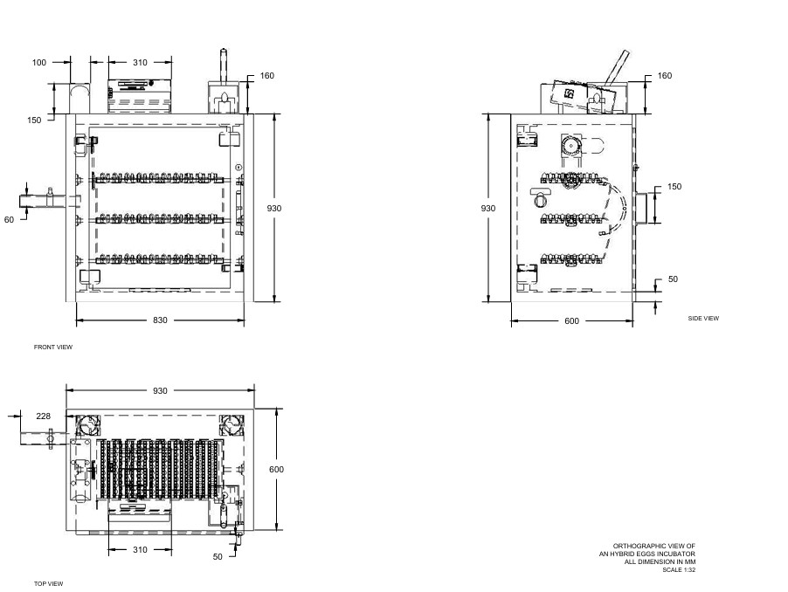
Orthographic View of Incubator

