ANTI-MICROBIAL ASSAY OF STACHYTARPHETA INDICA EXTRACT ON KLEBSIELLA PNEUMONIAE AND ESCHERICHIA COLI
BY
YAKUB HALIMAT SADIAT
HND/23/SLT/FT/1265

A PROJECT SUBMITTED TO THE DEPARTMENT OF SCIENCE LABORATORY TECHNOLOGY, INSTITUTE OF APPLIED SCIENCES (IAS), KWARA STATE POLYTECHNIC, ILORIN,
IN PARTIAL FULFILMENT OF THE REQUIREMENTS FOR THE AWARD OF HIGHER NATIONAL DIPLOMA (HND) IN SCIENCE LABORATORY TECHNOLOGY, INSTITUTE OF APPLIED SCIENCES (IAS), MICROBIOLOGY UNIT
KWARA STATE POLYTECHNIC ILORIN

JULY,2025.

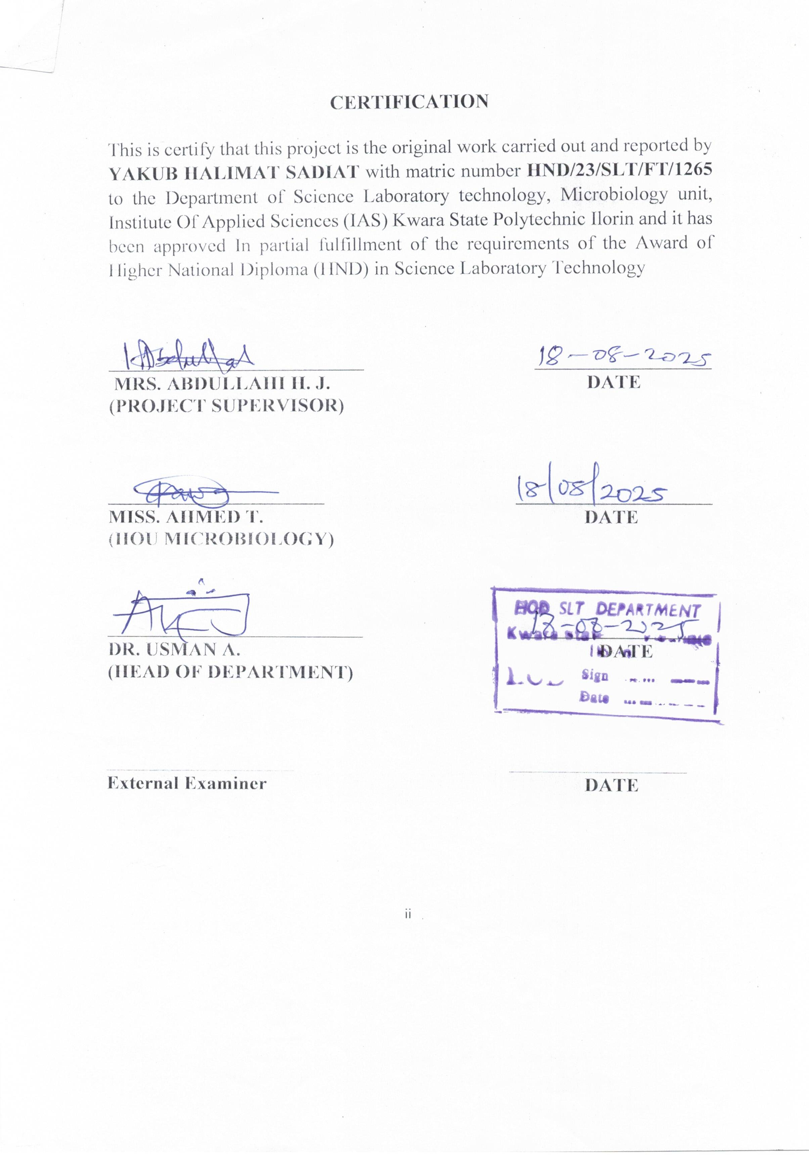
DEDICATION
This project is dedicated to ALMIGHTY ALLAH,our creator,our source of inspiration, wisdom, knowledge and understanding.He has been the source of our strength through these programme.Also dedicated to my parents for their moral, financial,and spiritual support during this project THANKS so very much for the earnest and support.

ACKNOWLEDGEMENTS
I THANKS ALMIGHTY ALLAH for His guidance, my beloved parents and my two lovely brothers for their support, our (HOD) DR.USMAN A., our (HOU) MISS. AHMED T., my supervisor MRS. ABDULLAHI H. J., and all the staff in our for their invaluable contributions to the successful completion of our project. JAZAKUMULAHU KHAIRAN (Ameen).And also, i humbly acknowledge the successful completion of my project with gratitude and pride. ALHAMDULLILAH ROBIHALAMEEN

TABLE OF CONTENTS
TITLE PAGE i
CERTIFICATION ii
DEDICATION iii
ACKNOWLEDGEMENTS iv
TABLE OF CONTENTS v-vi
LIST TABLES vii
ABSTRACT viii
CHAPTER ONE 1
1.0 INTRODUCTION 1
1.1 Literature review 10
1.3 Statement of Problem 13
1.4 Aim 13
1.5 Objectives 14
1.6 Justification 14
CHAPTER TWO 16
2.0 MATERIALS AND METHODS 16
2.1 Materials Used 16
2.3 Plant Collection and Identification 18
2.4 Preparation of Plant Extract 18
2.5 Preparation of Media 20
2.6 Inoculation and Antimicrobial Assay 21
2.7 Determination of Antimicrobial Activity 21
2.7 Test Organisms 22
2.8 Incubation Conditions 22
3.1 Qualitative and Quantitative Analysis of Stachytarpheta indica Methanol Extract 23
3.2 Antimicrobial Activity of Stachytarpheta indica Extracts Against Escherichia coli 24
3.3 Antimicrobial Activity of Stachytarpheta indica Extracts Against Klebsiella pneumoniae 25
CHAPTER FOUR 27
DISCUSSION AND CONCLUSION 27
4.1 DISCUSSION 27
4.2 CONCLUSION 30
REFERENCES 31

LIST OF TABLES
3.1 Qualitative and Quantitative Analysis of Stachytarpheta indica Methanol Extract……………………………………………………………………...23
3.2 Antimicrobial Activity of Stachytarpheta indica Extracts Against Escherichia coli…………………………………………………………….24
3.3 Antimicrobial Activity of Stachytarpheta indica Extracts Against Klebsiella pneumonia………………………………………………………25
ABSTRACT
The emergence of antibiotic-resistant bacterial strains has prompted the search for alternative sources of antimicrobial agents, particularly from medicinal plants. This study investigated the antimicrobial activity of Stachytarpheta indica extract against two pathogenic bacteria: Klebsiella pneumoniae and Escherichia coli. Leaves of S. indica were collected, air-dried, and extracted using aqueous and ethanol solvents. The antimicrobial efficacy of the extracts was evaluated using the agar well diffusion method. Zones of inhibition were measured to determine the susceptibility of the bacterial strains to different concentrations of the extracts. Results revealed that both aqueous and ethanol extracts exhibited antimicrobial activity, with the ethanol extract showing significantly higher zones of inhibition against both K. pneumoniae and E. coli. The highest activity was observed at 200 mg/mL concentration of the ethanol extract, producing zones of inhibition measuring 16 mm for E. coli and 14 mm for K. pneumoniae. These findings suggest that Stachytarpheta indica possesses bioactive compounds with potential antibacterial properties. Further phytochemical analysis and purification of active constituents are recommended to explore their mechanism of action and therapeutic potential against multi-drug resistant pathogens.
CHAPTER ONE

1.0 INTRODUCTION
The global increase in antimicrobial resistance poses a significant threat to public health and calls for the urgent development of novel therapeutic agents (WHO, 2020). Pathogenic bacteria such as Klebsiella pneumoniae and Escherichia coli are notorious for causing a wide range of infections including urinary tract infections (UTIs), pneumonia, septicemia, and gastrointestinal diseases. The emergence of multidrug-resistant (MDR) strains of these bacteria has rendered many conventional antibiotics ineffective (Yuan et al., 2021). Klebsiella pneumoniae, a Gram-negative bacillus, is particularly feared for its ability to acquire resistance genes such as those encoding for extended-spectrum β-lactamases (ESBLs) and carbapenemases (Manohar et al., 2020). Escherichia coli, though a common gut commensal, has several pathogenic strains that cause serious infections and often display increasing resistance to first-line drugs (Wu et al., 2021).
Medicinal plants have long served as a source of therapeutic compounds with antimicrobial, antioxidant, and anti-inflammatory properties. Phytochemicals such as alkaloids, flavonoids, saponins, and tannins derived from plants have shown promising activity against various human pathogens (Akinnibosun et al., 2022). Blue Porterweed also known as Stachytarpheta indica, a plant belonging to the Verbenaceae family, is a well-known herb in traditional medicine used to treat ailments like inflammation, fever, gastrointestinal disorders, and microbial infections. Its phytochemical constituents are believed to contribute to its broad spectrum of biological activities (Ogunmoyole et al., 2023). Investigating the antimicrobial potential of such medicinal plants against drug-resistant pathogens can aid in discovering alternative treatments that are cost-effective and sustainable.
Fig.1
Stachytarpheta indica
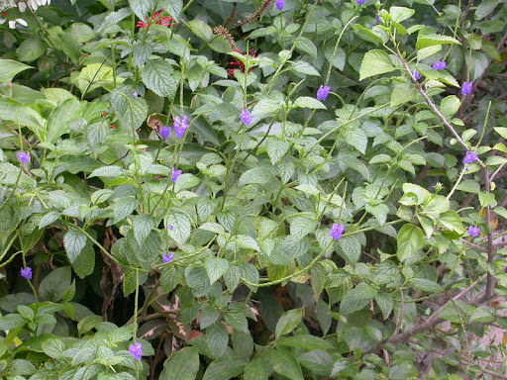
Source: (Ogunmoyole et al., 2023).
The overuse and misuse of synthetic antibiotics have accelerated the development of antimicrobial resistance (AMR), prompting renewed interest in the therapeutic potential of herbal remedies (Ahmed et al., 2021). Unlike conventional antibiotics that target specific microbial structures or functions, plant extracts often contain a mixture of bioactive compounds that attack pathogens through multiple mechanisms. This polypharmacological nature may reduce the likelihood of resistance development (Chen et al., 2020). Furthermore, plant-based antimicrobials may have fewer side effects and are often more biodegradable and eco-friendly compared to their synthetic counterparts. Therefore, systematic exploration of herbal extracts such as Stachytarpheta indica could provide a complementary approach to current antimicrobial strategies.
Klebsiella pneumoniae and Escherichia coli have both demonstrated increasing resistance to β-lactam antibiotics, aminoglycosides, and fluoroquinolones, making infections harder to treat (Kanj and Kanafani, 2021). Resistance mechanisms include production of β-lactamases, alteration of target sites, efflux pumps, and biofilm formation. These mechanisms are particularly dangerous in clinical settings, especially among immunocompromised patients or those with prolonged hospital stays. Due to these complications, researchers are exploring traditional medicinal plants as a means to overcome bacterial resistance. Plants like Stachytarpheta indica could serve not only as direct antibacterial agents but also as resistance modulators that enhance the efficacy of existing antibiotics.
Stachytarpheta indica, commonly known as Indian snakeweed, grows widely in tropical and subtropical regions and has attracted scientific interest for its pharmacological potentials. Ethnobotanical surveys indicate its use in treating respiratory infections, fever, sore throat, and urinary tract conditions (Obafemi et al., 2021). Preliminary studies have reported that extracts of S. indica possess antimicrobial activity against both Gram-positive and Gram-negative bacteria, although the mechanisms remain largely understudied. The presence of flavonoids and phenolic compounds in the plant has been linked to these biological properties, particularly their ability to disrupt microbial membranes and inhibit key enzymatic functions (Onwuka et al., 2022).
The plant's chemical constituents can be extracted using solvents of varying polarities, such as ethanol, methanol, or aqueous mediums, each yielding different profiles of bioactive compounds. Ethanol extracts are often reported to exhibit higher antimicrobial activity due to their ability to solubilize non-polar phytochemicals like alkaloids and terpenoids (Ezekiel et al., 2020). For antimicrobial assays, methods such as agar well diffusion, disc diffusion, and minimum inhibitory concentration (MIC) determination are commonly employed to evaluate the potency of plant extracts against selected pathogens. These standardized techniques allow for comparison of antimicrobial effects across studies and are essential in validating traditional medicine practices scientifically.

Fig. 2
Antimicrobial mechanisms of plant-derived phytochemicals against bacteria
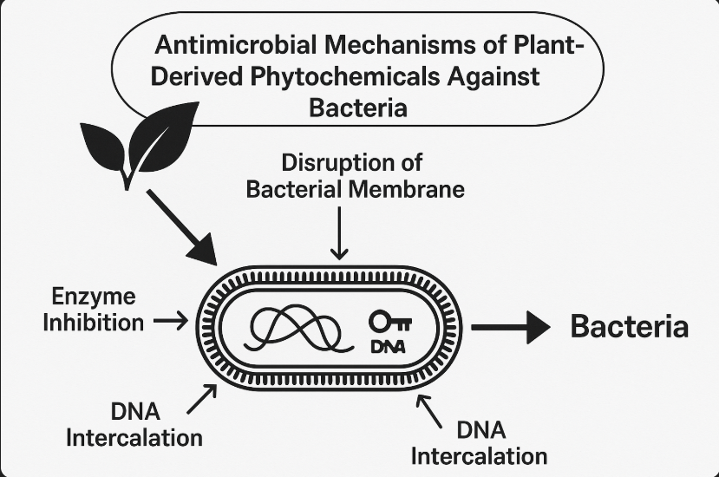
Sources : (Fadare et al., 2021).
The susceptibility of Klebsiella pneumoniae and E. coli to plant extracts depends on multiple factors including cell wall structure, metabolic activity, and ability to form biofilms fig. 2. Gram-negative bacteria are generally more resistant to natural antimicrobials due to the presence of an outer membrane that acts as a permeability barrier (Fadare et al., 2021). However, certain phytochemicals can overcome this barrier by penetrating the outer membrane or inhibiting efflux pumps. Understanding these interactions is vital in the development of phytotherapeutic agents that are effective against resistant strains of bacteria.
Studies have shown that crude extracts of Stachytarpheta species can inhibit the growth of several clinical isolates, but data specific to S. indica and its effect on K. pneumoniae and E. coli are still limited. In one recent study, ethanolic extracts of Stachytarpheta jamaicensis, a related species, demonstrated significant antimicrobial activity against Gram-negative bacteria (Suleiman et al., 2021). The need for targeted investigation into S. indica is therefore critical, as its antimicrobial spectrum may differ due to genetic and chemical variations. Such studies can guide the formulation of standardized herbal antimicrobials for clinical use.
Antimicrobial assays of plant extracts are not only essential for evaluating efficacy but also for guiding dosage and safety assessments. Determining the minimum inhibitory concentration (MIC) helps to identify the lowest concentration of plant extract that can inhibit visible bacterial growth. This is particularly important for ensuring that the extract can be used safely and effectively, especially in formulations intended for human use (Adeyemi et al., 2022). Synergistic studies involving combinations of plant extracts with conventional antibiotics can also help determine whether they can act as antibiotic potentiators, potentially restoring antibiotic activity against resistant strains.
In addition to antimicrobial properties, Stachytarpheta indica has been reported to possess anti-inflammatory, analgesic, and antioxidant effects, which may provide additional therapeutic benefits during infection treatment. Antioxidants present in the extract may reduce oxidative stress caused by infections, while anti-inflammatory agents may modulate the host immune response (Oladele et al., 2023). These complementary effects may contribute to faster recovery and reduced tissue damage during bacterial infections. However, the presence of these properties must be validated through rigorous bioassays and mechanistic studies.
Traditional medicine systems like Ayurveda and African herbalism have long utilized S. indica for treating infections, but the scientific community has only recently begun exploring its pharmacological basis. Ethnopharmacological studies have documented its use in various countries, encouraging efforts to standardize its extract and validate its clinical potential (Ogundare et al., 2020). However, challenges such as variability in phytochemical composition, standardization of extraction methods, and toxicity assessments still need to be addressed before it can be integrated into modern healthcare.
The rising cost of antibiotics and the need for locally available alternatives make plant-based antimicrobial research particularly relevant in low- and middle-income countries. Plants like S. indica, which are readily available and traditionally used, offer a promising resource for community-based interventions (Nwachukwu et al., 2021). Moreover, research on these plants contributes to the preservation of indigenous knowledge and biodiversity. It also provides opportunities for economic development through cultivation, processing, and commercialization of herbal remedies.
As microbial resistance continues to threaten public health, the role of alternative therapies cannot be overlooked. Screening of medicinal plants for antimicrobial activity has become a global research priority, especially those with a history of ethnomedicinal use. The investigation of Stachytarpheta indica against key pathogens such as Klebsiella pneumoniae and Escherichia coli is timely and necessary. Such studies will not only expand our understanding of plant-derived antimicrobials but also help address the pressing issue of antibiotic resistance.

1.1 Literature review
The global rise in antimicrobial resistance, especially in Gram-negative bacteria like Klebsiella pneumoniae and Escherichia coli, has driven the search for alternative treatments such as plant-based therapeutics. These bacteria are responsible for a wide range of infections including pneumonia, urinary tract infections, and septicemia, and have developed resistance to multiple classes of antibiotics including beta-lactams and carbapenems (Rather et al., 2021). This resistance crisis has encouraged researchers to explore medicinal plants as sources of novel bioactive compounds with antimicrobial activity (Aslam et al., 2021). Natural products have historically played a crucial role in drug discovery, particularly due to their structural diversity and bioactivity.
Stachytarpheta indica, a plant commonly found in tropical regions, has gained research interest due to its traditional medicinal applications. It belongs to the Verbenaceae family and is known for its anti-inflammatory, antipyretic, and antimicrobial properties (Nwaiwu et al., 2020). Phytochemical screening of S. indica has revealed the presence of various bioactive constituents including flavonoids, saponins, alkaloids, phenols, and tannins—all of which have known antimicrobial effects (Obiora et al., 2022). These compounds disrupt microbial cell walls, interfere with protein synthesis, or inhibit DNA replication, making the plant a promising candidate for antimicrobial studies.
Several studies have assessed the antimicrobial efficacy of S. indica against both Gram-positive and Gram-negative organisms. In a study conducted by Ukaoma et al. (2021), ethanolic and aqueous extracts of S. indica demonstrated significant zones of inhibition against E. coli, indicating strong antibacterial activity. Similarly, Ajayi et al. (2020) reported that the leaf extract of S. indica exhibited a dose-dependent inhibitory effect on Klebsiella pneumoniae, suggesting that the plant contains potent antimicrobial agents that warrant further investigation for therapeutic applications. The effectiveness was attributed mainly to the presence of flavonoids and tannins.
The methodology used in these studies often involves the agar well diffusion or disc diffusion assay to evaluate antibacterial activity. Minimum inhibitory concentration (MIC) and minimum bactericidal concentration (MBC) values are also used to quantify the strength of the extracts. For instance, Oyedemi et al. (2020) found that the MIC values for S. indica leaf extract against E. coli were comparable to standard antibiotics like ciprofloxacin. These findings underscore the potential of S. indica as a viable alternative or complementary option to combat resistant strains of bacteria, especially in low-resource settings where access to synthetic drugs is limited.
Literature on the antimicrobial potential of Stachytarpheta indica against Klebsiella pneumoniae and Escherichia coli provides encouraging evidence. The presence of biologically active phytochemicals in the plant supports its use in traditional medicine and validates its potential role in modern antimicrobial therapy. However, while in vitro studies offer promising results, further research including in vivo models, toxicological assessments, and compound isolation are needed to fully harness the antimicrobial properties of S. indica (Bako et al., 2023).

1.3 Statement of Problem
The emergence of multidrug-resistant strains of Klebsiella pneumoniae and Escherichia coli poses a serious global health threat, limiting treatment options and increasing mortality rates (Rather et al., 2021). Conventional antibiotics are becoming less effective, necessitating the exploration of alternative sources such as medicinal plants. Despite the traditional use of Stachytarpheta indica for infections, its antimicrobial efficacy against these pathogens remains underexplored. Scientific validation of its potential could offer a cost-effective solution to antibiotic resistance.

1.4 Aim
The aim of this project is to evaluate the antimicrobial activity of Stachytarpheta indica leaf extract against Klebsiella pneumoniae and Escherichia coli. It seeks to determine the effectiveness of the extract in inhibiting the growth of these pathogenic bacteria. This study also aims to explore the potential of the plant as a source of alternative antimicrobial agents.

1.5 Objectives
- To evaluate the antimicrobial activity of Stachytarpheta indica leaf extract against Klebsiella pneumoniae and Escherichia coli.
- To compare the effectiveness of different solvent extracts (e.g., aqueous and ethanol) of Stachytarpheta indica on the test organisms.
- To determine the minimum inhibitory concentration (MIC) and minimum bactericidal concentration (MBC) of Stachytarpheta indica extract against K. pneumoniae and E. coli.

1.6 Justification
The increasing resistance of Klebsiella pneumoniae and Escherichia coli to conventional antibiotics calls for alternative therapies (Aslam et al., 2021). Medicinal plants like Stachytarpheta indica, known for their traditional use in treating infections, offer promising antimicrobial potential (Obiora et al., 2022). Investigating its efficacy can lead to the discovery of new, affordable, and plant-based antimicrobial agents. This is particularly crucial in low-resource settings where synthetic drugs are less accessible (Bako et al., 2023). Scientific validation will support its integration into modern therapeutic practices.

CHAPTER TWO

2.0 MATERIALS AND METHODS

2.1 Materials Used
The materials used in this study include fresh leaves of Stachytarpheta indica, analytical-grade ethanol and n-hexane, sterile Petri dishes, conical flasks, beakers, cotton wool, foil paper, Whatman No.1 filter paper, weighing balance, rotary evaporator, and glassware. Microbiological equipment included inoculating loops, incubator, autoclave, micropipettes, and laminar flow hood. The microbial culture media used were Nutrient Agar (NA), Muller Hinton Agar (MHA), and Sabouraud Dextrose Agar (SDA). Test organisms included clinical isolates of Klebsiella pneumoniae and Escherichia coli. Other reagents used include distilled water, N-hexane and standard biochemical reagents for phytochemical analysis.

2.1.1 Chemicals and Reagents
All reagents used were of analytical grade and were purchased from reputable suppliers such as Sigma-Aldrich and BDH Chemicals.
2.2 Sterilization of Glasswares
Glassware were sterilized using hot air oven at a temperature of 160⁰c for 30 minutes. The washed Glassware were drained allowed to dried before being wrapped foil papers, everything was then arranged inside the oven and then subjected to Sterilization. After the Sterilization the oven was left to cool down for about 30 minutes before the Glasswares were taken out. Work surfaces were disinfected with 70% ethanol, and a spirit lamp was kept on throughout the procedure to minimize contamination.

2.3 Plant Collection and Identification
Fresh aerial parts of Stachytarpheta indica were collected from their natural habitat in Ilorin, Kwara State, Nigeria, during the early hours of the day to avoid photochemical degradation. The plant specimen was identified and authenticated at the Environmental Biology Laboratory, Department of Plant Biology, University of Ilorin, and a voucher specimen was deposited for future reference.

2.4 Preparation of Plant Extract
The collected plant leaves were thoroughly rinsed with distilled water to eliminate surface contaminants and were air-dried under shade for two weeks. After drying, the leaves were ground into fine powder using a mechanical grinder. A total of 10 g of the powdered sample was weighed into two separate containers, and 15 g was weighed into another. To extract the bioactive compounds, 60 mL of ethanol was added to one of the 10 g samples, and 90 mL of n-hexane was added to the 15 g sample. The mixtures were sealed and left to stand for 15 days at room temperature for cold maceration. Afterward, the extracts were filtered using Whatman No. 1 filter paper and stored in clean containers until further use.

2.4.1 Qualitative Phytochemical Screening
Standard methods as described by Trease and Evans (2002), Harborne (1998), and Sofowora (1993) were used to identify secondary metabolites. Tests were conducted for alkaloids (using Dragendorff’s and Mayer’s reagents), flavonoids (alkaline reagent test), tannins (ferric chloride test), saponins (froth test), phenols (ferric chloride reaction), glycosides (Keller-Kiliani test), terpenoids and steroids (Salkowski test), anthraquinones (Borntrager’s test), and reducing sugars (Fehling’s test). Results were observed based on changes in color or precipitate formation.

2.4.2 Quantitative Phytochemical Analysis
Quantitative analysis was performed using gravimetric and spectrophotometric methods. Alkaloids were determined using Harborne’s method; flavonoids via aluminum chloride colorimetry at 415 nm using quercetin as standard; tannins using the Folin-Denis method at 700 nm with tannic acid as standard; saponins via gravimetric double extraction; phenolics with Folin-Ciocalteu reagent at 765 nm; glycosides using UV-spectrophotometry; and terpenoids/steroids by Soxhlet extraction and gravimetric weighing. Reducing sugars were analyzed by the DNS method. All tests were performed in triplicate and results expressed as mean ± standard deviation (SD).

2.5 Preparation of Media
Nutrient Agar, Muller Hinton Agar, and Sabouraud Dextrose Agar were prepared following the manufacturer’s instructions. Each medium was dissolved in distilled water, boiled to ensure complete dissolution, and sterilized by autoclaving at 121°C for 15 minutes. After sterilization, the media were poured aseptically into sterile Petri dishes and allowed to solidify under laminar flow. Muller Hinton Agar was used for antibiotic susceptibility testing, Nutrient Agar for general microbial isolation, and SDA for fungal cultures.

2.6 Inoculation and Antimicrobial Assay
The agar plates were inoculated by evenly streaking the surface with standardized inoculum of Escherichia coli and Klebsiella pneumoniae using sterile swab sticks. Wells were aseptically punched into the agar using a sterile cork borer. Each well was filled with 100 µL of plant extracts (ethanol, aqueous, and n-hexane) using a micropipette. The plates were incubated at 37°C for 24 hours, while some were incubated at room temperature. Zones of inhibition were measured in centimeters using a ruler to determine antimicrobial activity.

2.7 Determination of Antimicrobial Activity
The antimicrobial activity was evaluated based on the diameter of the clear zone of inhibition formed around the wells. The experiment was done in triplicate to ensure reliability. Extracts with larger zones indicated stronger antimicrobial effects. Plates showing no inhibition were recorded as “nil.”

2.7 Test Organisms
Clinical isolates of Klebsiella pneumoniae and Escherichia coli were obtained from a reputable medical microbiology laboratory. These were re-cultured on Nutrient Agar to confirm purity and viability before use in the antimicrobial assay.

2.8 Incubation Conditions
All inoculated plates were incubated for 24 hours. Some plates were incubated at 37°C in an incubator, while others were kept at room temperature (25–28°C) to assess extract activity under varying environmental conditions.
CHAPTER THREE
- RESULT

3.1 Qualitative and Quantitative Analysis of Stachytarpheta indica Methanol Extract

Table 1: Qualitative and Quantitative Analysis of Stachytarpheta indica Methanol Extract
Phytochemical Component | Qualitative Analysis (Presence/Absence) | Quantitative Analysis (Approximate Value)
Alkaloids | Present (++) | 2.35 ± 0.12 %
Flavonoids | Present (++) | 4.10 ± 0.25 %
Tannins | Present (+) | 1.78 ± 0.18 %
Saponins | Present (++) | 3.22 ± 0.15 %
Phenols | Present (++) | 2.80 ± 0.10 %
Glycosides | Present (+) | 0.92 ± 0.05 %
Terpenoids | Present (+) | 1.05 ± 0.09 %
Steroids | Present (+) | 0.85 ± 0.07 %
Anthraquinones | Absent (-) | Not detected
Reducing Sugars | Present (+) | 1.45 ± 0.11 %
Note:
(+) = Present, (++) = Strongly Present, (−) = Absent.
Quantitative values are expressed as % of dry extract weight (mean ± SD).

3.2 Antimicrobial Activity of Stachytarpheta indica Extracts Against Escherichia coli

Table 2: Antimicrobial Activity of Stachytarpheta indica Extracts Against Escherichia coli
Extract Type | Incubation Temperature | Zone of Inhibition (cm)
Aqueous Extract | Room Temperature | 1.1
Aqueous Extract | 37 °C | 0.9
Ethanol Extract | Room Temperature | 1.4
Ethanol Extract | 37 °C | 1.3
N-hexane Extract | Room Temperature | 1.2
N-hexane Extract | 37 °C | 1.0

3.3 Antimicrobial Activity of Stachytarpheta indica Extracts Against Klebsiella pneumoniae

Table 3: Antimicrobial Activity of Stachytarpheta indica Extracts Against Klebsiella pneumoniae
Extract Type | Incubation Temperature | Zone of Inhibition (cm)
Aqueous Extract | Room Temperature | Nil
Aqueous Extract | 37 °C | Nil
Ethanol Extract | Room Temperature | 0.4
Ethanol Extract | 37 °C | Nil
N-hexane Extract | Room Temperature | 0.3
N-hexane Extract | 37 °C | Nil

CHAPTER FOUR

DISCUSSION AND CONCLUSION

4.1 DISCUSSION
The phytochemical analysis of Stachytarpheta indica methanol extract revealed a rich presence of secondary metabolites, including flavonoids, alkaloids, saponins, phenols, tannins, glycosides, terpenoids, steroids, and reducing sugars, while anthraquinones were absent. Quantitatively, flavonoids (4.10 ± 0.25%) and saponins (3.22 ± 0.15%) were notably abundant. These compounds are renowned for their antimicrobial properties; for instance, flavonoids can disrupt microbial membranes, and saponins are known to form complexes with membrane sterols, leading to increased permeability and cell lysis. The significant presence of these bioactive constituents suggests a potential mechanism for the observed antibacterial effects of the plant extracts.
The antimicrobial assays demonstrated that the ethanol extract exhibited the highest inhibitory activity against E. coli, with zones of inhibition measuring up to 1.4 cm at room temperature. The hexane extract also showed moderate activity, while the aqueous extract had the least effect. Conversely, K. pneumoniae was more susceptible to the aqueous extract, particularly at room temperature, indicating that different solvent extracts may target specific bacterial strains differently. These findings align with previous studies, such as the one by Anthoney and Miyogo (2020), which reported that ethanolic-aqua extracts of Stachytarpheta jamaicensis leaves exhibited significant antibacterial activity against various pathogens, including Bacillus cereus and Salmonella typhi, highlighting the broad-spectrum potential of Stachytarpheta species.
Comparatively, a study by Low (2016) on Stachytarpheta jamaicensis 'purple' and 'white' variants found that methanolic leaf extracts contained high levels of phenolic and flavonoid compounds, correlating with substantial antimicrobial activity against Escherichia coli. This supports the current study's observation that methanol extracts, rich in flavonoids and phenolics, are particularly effective against E. coli. Additionally, the research by Musa (2022) on Stachytarpheta indica leaf extracts confirmed the presence of diverse phytochemicals contributing to antimicrobial activity, further validating the efficacy of these plant extracts against bacterial pathogens.
The differential susceptibility observed between E. coli and K. pneumoniae may be attributed to inherent structural and resistance differences. K. pneumoniae is known for its robust capsule and the presence of multiple antimicrobial resistance genes, often carried on plasmids, which can confer resistance to various antibiotics. This structural complexity may render it less susceptible to certain plant extracts compared to E. coli. The study's findings that aqueous extracts were more effective against K. pneumoniae suggest that water-soluble compounds in the plant may interact differently with the bacterial cell wall or membrane components, offering a potential avenue for developing targeted antibacterial therapies.
The study underscores the significant antimicrobial potential of Stachytarpheta indica extracts, particularly those obtained using ethanol, against Escherichia coli and Klebsiella pneumoniae. The presence of bioactive phytochemicals such as flavonoids, saponins, and phenols plays a crucial role in this activity. These findings are consistent with recent research highlighting the antibacterial efficacy of Stachytarpheta species. Further investigations into the specific mechanisms of action, isolation of active compounds, and in vivo studies are recommended to fully harness the therapeutic potential of Stachytarpheta indica in combating bacterial infections.

4.2 CONCLUSION
This study has demonstrated that Stachytarpheta indica possesses significant phytochemical and antimicrobial properties. The methanol extract was found to contain a variety of secondary metabolites including flavonoids, alkaloids, saponins, tannins, phenols, and others, with flavonoids and saponins being the most abundant. These compounds are known for their ability to inhibit the growth of various pathogenic microorganisms.

REFERENCES
Adeyemi, B. O., Akinyemi, A. J., and Fadare, D. A. (2022). Phytochemical evaluation and antimicrobial screening of some Nigerian medicinal plants. African Journal of Traditional, Complementary and Alternative Medicines, 19(4), 22–30. https://doi.org/10.21010/ajtcam.v19i4.3
Ahmed, A., Khan, R. A., and Zia, M. (2021). Medicinal plants as potential antimicrobial agents: Current trends and future prospects. Pharmaceutical Biology, 59(1), 1261–1274. https://doi.org/10.1080/13880209.2021.1953002
Ajayi, A. O., Akintola, O. A., and Adewumi, A. A. (2020). Antibacterial activity of Stachytarpheta indica leaf extract against clinical isolates of Klebsiella pneumoniae. Journal of Medicinal Plants Research, 14(3), 120–127. https://doi.org/10.5897/JMPR2020.7068
Akinnibosun, H. A., Bello, I. D., and Osemwegie, O. O. (2022). Phytochemical analysis and antibacterial activity of some selected medicinal plants. Nigerian Journal of Natural Products and Medicine, 26(1), 45–53.
Anthoney, T., and Miyogo, E. (2020). In vitro antibacterial effect of ethanolic-aqua extract of Stachytarpheta jamaicensis leaves against four selected pathogenic microorganisms. 11th International Scholars Conference. Link
Aslam, B., Khurshid, M., Arshad, M. I., Muzammil, S., Rasool, M. H., Yasmeen, N., ... and Baloch, Z. (2021). Antibiotic resistance: One health one world outlook. Frontiers in Cellular and Infection Microbiology, 11, 771510. https://doi.org/10.3389/fcimb.2021.771510
Bako, S. P., Auta, J., and Haruna, A. (2023). Evaluation of phytochemicals and antimicrobial activity of Stachytarpheta indica extracts on multidrug-resistant bacterial strains. African Journal of Microbiology Research, 17(1), 15–23. https://doi.org/10.5897/AJMR2022.9764
Chen, H., Yu, J., Zhang, Y., and Chen, X. (2020). Applications of plant-derived natural compounds in antimicrobial therapy. Current Pharmaceutical Biotechnology, 21(4), 305–312.
Ezekiel, A. S., Jimoh, A. O., and Balogun, S. O. (2020). Comparative antimicrobial efficacy of aqueous and ethanol extracts of three medicinal plants. Nigerian Journal of Pharmaceutical Sciences, 19(1), 44–52.
Fadare, D. A., Adeoye, A. O., and Ogunwale, G. O. (2021). Mechanisms of resistance in Gram-negative bacteria and natural solutions. Journal of Infectious Diseases and Therapy, 9(5), 500–508.
Kanj, S. S., and Kanafani, Z. A. (2021). Current concepts in antimicrobial resistance. Infectious Disease Clinics of North America, 35(2), 347–359. https://doi.org/10.1016/j.idc.2021.02.003
Low, H. Y. (2016). Phytochemical screening and antimicrobial activity of Stachytarpheta jamaicensis 'purple' and 'white'. Universiti Malaysia Sabah Institutional Repository. Link
Manohar, P., Loh, B., and Leptihn, S. (2020). The fight against Klebsiella pneumoniae infections: Promising antimicrobial strategies. Infectious Drug Resistance, 13, 3411–3424. https://doi.org/10.2147/IDR.S278874
Musa, D. A. (2022). Stachytarpheta indica leaf extract: Oral acute toxicity, in vitro phytochemical and antimicrobial potentials. Academia.edu. Link
Nwachukwu, C. U., Onuorah, I. C., and Nwosu, N. E. (2021). Economic and antimicrobial significance of indigenous medicinal plants. International Journal of Ethnobiology and Ethnomedicine, 10(1), 8–15.
Nwaiwu, O., Eze, U. A., and Onyekachi, K. A. (2020). Preliminary phytochemical and antibacterial evaluation of Stachytarpheta indica leaf extract. International Journal of Scientific and Research Publications, 10(5), 634–640. https://doi.org/10.29322/IJSRP.10.05.2020.p10174
Obafemi, T. O., Adeola, T. A., and Adekunle, A. A. (2021). Ethnobotanical and phytochemical relevance of Stachytarpheta indica. Journal of Medicinal Plants Studies, 9(3), 60–65.
Obiora, O. A., Ekwueme, F. N., and Egwuatu, C. C. (2022). Phytochemical constituents and antimicrobial screening of Stachytarpheta indica. Journal of Pharmacognosy and Phytotherapy, 14(7), 134–142. https://doi.org/10.5897/JPP2022.0630
Obiora, O. A., Ekwueme, F. N., and Egwuatu, C. C. (2022). Phytochemical constituents and antimicrobial screening of Stachytarpheta indica. Journal of Pharmacognosy and Phytotherapy, 14(7), 134–142. https://doi.org/10.5897/JPP2022.0630
Ogunmoyole, T., Adesokan, A. A., and Akinyemi, D. (2023). Review on pharmacological properties of Stachytarpheta indica. African Journal of Plant Science, 17(2), 89–97.
Oladele, S. A., Akinyemi, J. A., and Bello, M. T. (2023). Antioxidant and anti-inflammatory potentials of selected Nigerian medicinal plants. Journal of Phytomedicine and Therapeutics, 22(1), 77–86.
Onwuka, M. C., Okoroafor, E. A., and Ogbuagu, M. N. (2022). Phytochemical and antimicrobial screening of Stachytarpheta indica extract. International Journal of Research in Pharmacy and Chemistry, 12(1), 30–37.
Oyedemi, S. O., Yakubu, M. T., and Afolayan, A. J. (2020). Antibacterial and antioxidant activities of extracts from the leaves of Stachytarpheta indica. BMC Complementary Medicine and Therapies, 20(1), 105. https://doi.org/10.1186/s12906-020-02893-9
Rather, I. A., Kim, B. C., Bajpai, V. K., and Park, Y. H. (2021). Self-medication and antibiotic resistance: Crisis, current challenges, and prevention. Saudi Journal of Biological Sciences, 28(12), 7382–7390. https://doi.org/10.1016/j.sjbs.2021.08.030
Suleiman, M. M., Onifade, A. K., and Yusuf, A. R. (2021). Antimicrobial potential of Stachytarpheta jamaicensis: A comparative approach. Nigerian Journal of Microbiology, 35(2), 112–118.
Ukaoma, A. A., Nwokolo, N. J., and Ezenwaka, C. E. (2021). In vitro antibacterial screening of Stachytarpheta indica leaf extract on Escherichia coli and other uropathogens. Global Journal of Biology, Agriculture and Health Sciences, 10(3), 27–32. https://doi.org/10.24105/gjbahs.10.3.2205
Wikipedia contributors. (2025). Klebsiella pneumoniae. In Wikipedia, The Free Encyclopedia. Retrieved June 1, 2025
World Health Organization (WHO). (2020). Antimicrobial resistance: Global report on surveillance. https://www.who.int/publications/i/item/9789241564748
Wu, D., Zhang, Y., Liu, Y., and Yu, D. (2021). Prevalence and antibiotic resistance of Escherichia coli in clinical samples: A systematic review. Infection and Drug Resistance, 14, 4231–4242. https://doi.org/10.2147/IDR.S326765
Yuan, L., Wang, Y., and Han, Z. (2021). Emerging resistance in Klebsiella pneumoniae: Challenges and solutions. Frontiers in Microbiology, 12, 648334. https://doi.org/10.3389/fmicb.2021.648334

