TITLE PAGE
INVESTIGATION OF CAUSES OF CRACKS IN THE BUILDING WALLS AT BUDO-NUHU AREA, AIRPORT

By

AYINLA RIDWAN OLABISI
ND/23/MPE/FT/0080

SUBMITTED TO:
THE DEPARTMENT OF MINERALS AND PETROLEUM RESOURCES ENGINEERING TECHNOLOGY INSTITUTE OF TECHNOLOGY, KWARA STATE POLYTECHNIC, ILORIN
IN PARTIAL FULFILLMENT OF THE REQUIREMENT FOR THE AWARD OF NATIONAL DIPLOMA (ND) IN MINERALS AND PETROLEUM RESOURCES ENGINEERING TECHNOLOGY

AUGUST, 2025

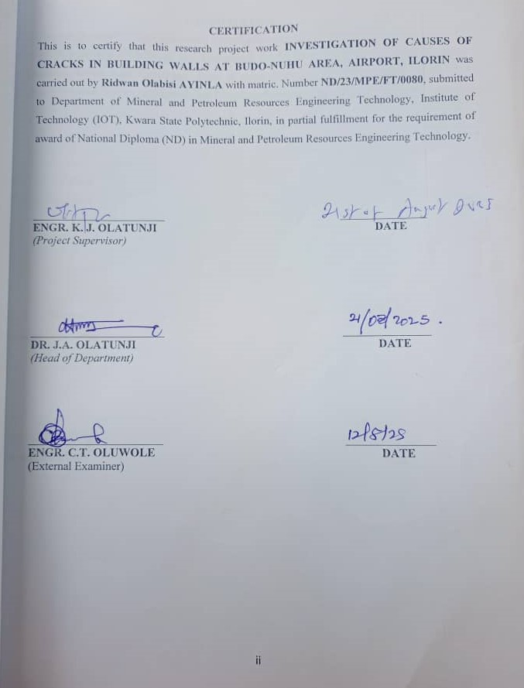
CERTIFICATION
This is to certify that this project was carried out and submitted by Ayinla Ridwan Olabisi of Matric number ND/23/MPE/FT/0080 to the Department of Minerals and Petroleum Resources Engineering, Kwara State Polytechnic, Ilorin in partial fulfilment of the Requirement for the Award of National Diploma in Minerals and Petroleum Resources Engineering Technology.

…………………………….. ………………………
Eng. J.K. Olatunji Date
Project Supervisor

………………………………. ……………………….
Dr. J. A. Olatunji Date
Head of Department

….………………………………. ………………………
Engr. OLUWOLE C.T
External Examiner Date

DEDICATION

This work is dedicated to my beloved parents, who laid the foundation of my education with their sacrifice.

ACKNOWLEDGEMENT
I would like to express my sincere gratitude to my supervisor, Engr Dr. Olatunji K.J, for his invaluable guidance, encouragement, and support throughout the course of this research project. His expertise and insight greatly contributed to the successful completion of this work.
I also extend my appreciation to my colleagues Ayodele Isreal, Ibrahim Basambo, Olagoke Shukurah Oyinkansola, Ibrahim Basit Oluwaseyi and Obatola Michael for their collaboration, assistance, and teamwork during the fieldwork and analysis stages of this project.
Finally, I am grateful to God Almighty for the strength, wisdom, and perseverance to complete this work. My heartfelt thanks also goes to my family for their unwavering support and prayers

TABLE OF CONTENTS
Contents
TITLE PAGE i
CERTIFICATION ii
DEDICATION iii
ACKNOWLWDGEMENT iv
TABLE OF CONTENTS v
LIST OF FIGURE vii
LIST OF TABLE viii
ABSRACT ix
CHAPTER ONE 1
INTRODUCTION 1
1.0 BACKGROUND TO THE STUDY 1
1.1 AIM AND OBJECTIVES 1
1.2 SCOPE OF THE STUDY 1
1.3 PROBLEM STATEMENT 2
1.4 JUSTIFICATION OF STUDY 2
CHAPTER TWO 3
LITERATURE REVIEW 3
2.1 GEOTECHNICAL PROPERTIES OF SOIL 3
2.2 GEOPHYSICAL METHODS OF SUBSURFACE INVESTIGATION 4
2.3 GEOTECHNICAL PROBLEMS IN BUILDING CONSTRUCTION 6
CHAPTER THREE 7
3.0 MATERIAL AND METHODOLOGY 7
3.1 DESCRIPTION OF THE STUDY AREA 7
3.2 DESCRIPTION OF THE GEOTECHNICAL SUBSURFACE PROPERTIES OF SOIL USING GEOPHYSICAL APPROACH IN THE STUDY AREA. 8
3.3 DETERMINATION OF GEOTECHNICAL SUBSURFACE PROPERTIES OF SOIL USING GEOPHYSICAL APPROACH IN THE STUDY AREA. 10
3.4 INVESTIGATING THE RELATIONSHIP BETWEEN THE GEOTECHNICAL PROPERTIES AND THE GEOPHYSICAL PROPERTIES OF THE STUDY AREA 14
CHAPTER FOUR 15
4.0 RESULTS AND DISCUSSION 15
4.1 GEOTECHNICAL PROPERTIES OF SOIL WITH STUDY AREA 15
4.1.1 ATTERBERG LIMIT 15
4.1.2 SHEAR STRESS 16
4.1.3 SIEVE ANALYSIS 18
4.5: Percentage of the soil fraction 19
4.2 GEOPHYSICAL PROPERTIES OF SOIL IN STUDY AREA 20
4.3 RELATIONSHIP BETWEEN GEOTECHNICAL AND GEOPHYSICAL PROPERTIES OF SOIL IN THE STUDY AREA 22
CHAPTER FIVE 23
CONCLUSION AND RECOMMENDATION 23
5.1 CONCLUSION 23
5.2 RECOMMENDATIONS 23
REFERENCES 24

LIST OF FIGURE
Figure 3.1: Map of Kware state showing Ilorin South LGA. 7
Figure 3.2: The picture of research team on field work. 8
Figure 3.3: The picture of the Terameter. 10
Figure 3.4: The picture of Oven,casagrante apparatus and weighing balance. 11
Figure 3.5: The picture of proving ring and shear box. 13
Figure 3.6: The picture sieve lid, sieve shaker and sieve pan. 14
Figure 4.1: Normal stress vs Shear stress (KN/m²) sample A 16
Figure 4.2: Normal stress vs Shear stress (KN/m²) sample B 17
Figure 4.3: Normal stress vs Shear stress (KN/m²) sample C 18
Figure 4.4: The resistivity of first profile. 20
Figure 4.5: The resistivity second profile. 21
Figure 4.6: The resistivity third Profile. 21

LIST OF TABLE
Table 4.1: Plasticity Characterritics 15
Table 4.2: Shear stress of Sample A 16
Table 4.3; Shear stress sample 17
Table 4.4: Shear Stress of Sample C 18
Table 4.5: Percentage fraction of Sample A 19
Table 4.6: Percentage fraction of Sample B 19
Table 4.7: Percentage fraction of sample C 19
Table 4.8 Lithologies and depth 22

ABSRACT
This research explores the geotechnical and geophysical characteristics of the subsurface soils in the Cherring Point area of Ilorin, Kwara State. The purpose of the investigation is to determine the causes of structural cracks observed in buildings within the study location. Standard geotechnical tests were conducted on three soil samples, labeled A, B, and C. These tests included Atterberg limits, particle size distribution, and direct shear tests, aimed at assessing the physical and mechanical behavior of the soil. Sieve analysis indicated that Sample A consists mainly of very sandy gravel, Sample B contains gravelly sand, and Sample C is largely sandy gravel. Atterberg limit results revealed that Sample A has a liquid limit of 27.5%, plastic limit of 15.1%, and a plasticity index of 12.4%. Sample B exhibited a liquid limit of 32.0%, plastic limit of 14.9%, and plasticity index of 17.1%, while Sample C showed a liquid limit of 24.5%, plastic limit of 11.6%, and a plasticity index of 10.9%. Direct shear test results showed that the angle of internal friction for Sample A is 26°, Sample B is 13.1°, and Sample C has a friction angle of 14°.Electrical Resistivity Imaging (ERI) was employed to investigate subsurface conditions and detect potential anomalies. Findings revealed that the soil in the area is primarily sandy clay, with moderate plasticity and fair shear strength, indicating an average load-bearing capacity. The geophysical results also identified zones of low resistivity, which may correspond to areas with high moisture content or clay-rich layers.the combination of both methods provide a comprehensive understanding the subsurface condition this study emphasizes The importance of integrated soil investigation in minimizing construction failure and enhancing environmental planning

CHAPTER ONE

INTRODUCTION

1.0 BACKGROUND TO THE STUDY
The subsoil layer a critical component of the earth crust playing a vital role in supporting infrastructure building and other structure. The subsoil layers is a complex system consisting of various soil and rock types each with its unique properties and behaviors. Understanding the properties and behavior of the subsoil layer is essential for ensuring the stability and safety of structure built on it (Smith, 2020).
Geophysical and geotechnical evaluation are two complement approaches uses to investigate the subsoil layers. Geophysical evaluation involves the use of non-invasive techniques to image the subsurface and identify potential hazard, such as cavities fractures and soil instability. Geotechnical evaluation on the other hand, involve the collection of soil and rock sample for laboratory testing and analysis (Smith, 2020).

1.1 AIM AND OBJECTIVES
This study is to investigate the effectiveness of geophysical and geotechnical evaluation in characterize the properties and behavior of subsoil layers.
i. To carry out geophysical fieldwork on the site.
ii. To collect soil samples and carry out laboratory tests on them.
iii. To model the subsurface layer and identify the source of wall cracks from obtaining data.

1.2 SCOPE OF THE STUDY
This study focuses on the geophysical and geotechnical evaluation of the subsoil layers in a specific region. The scope of the study includes vertical electrical sounding sieve analysis atterberg limits and shear strength.

1.3 PROBLEM STATEMENT
Building cracks are a widespread problem in the study area, posing significant risk, of damage water infiltration and safety hazards primarily caused by inadequate subsurface studies soil evaluation and characteristics of ground conditions.

1.4 JUSTIFICATION OF STUDY
The study is justified as it will contribute to the advancement of knowledge on the geotechnical and geophysical properties of the soil contributing to utilization of effective methods for subsurface investigations and soil characterization.

CHAPTER TWO

LITERATURE REVIEW

2.1 GEOTECHNICAL PROPERTIES OF SOIL
Soil is a complete heterogeneous material that exhibits unique properties, making it challenging to product its behavior under different conditions (Das, 2010).
Soil classification
Soil classifications is a critical step in geotechnical engineering.it involving categorizing soil into different type based on it physical and mechanical properties the unified soil classification system (u.s.c.s) (Lambe and Whitemen 1979).
Is a widely used classification system (Lambe and Whiteman, 1979).
- Physical properties: soil physical properties significantly impact its behavior, some key physical properties include:
- Moisture content: The amount of water present in the soil. Moisture content affects soil strength, stiffness and permeability (Das, 2010).
- Density: The mass of soil per unit volume. Density affects soil strength, stiffness and settlement (Tergaghi, 1925).
- Specific Gravity: The ratio of the density of soil to the density of water. Specific gravity affect soil permeability and settlement (Lambe and Whiteman, 1979).
- Porosity: The percentage of words in the soil. Porosity affects soils permeability settlements and strength (Das, 2010).
- Mechanical properties: Soil mechanical properties are essential for understanding its behavior under different loads. Some key mechanical properties include:
- Unconfined compressive strength (USC): The maximum compression stress that soil can withstand without confinement UCS affects soils permeability settlements, stability, settlements and bearing capacity (Das, 2010).
- Triaxial compressive strength: The maximum compressive stress that soil can withstand under confinement triaxial compressive strength affect soils, stability, settlement and bearing capacity (Terzaghi, 1925).
- Shear strength: The maximum shear stress that soil can withstand, shear strength affected soil, stability, settlement and bearing capacity (Lambe and Whitman, 1979).
- Young’s modulus: A measure of soils stiffness young’s affects soils settlement stability and bearing capacity (Das, 2010).
- Poissons ratio: A measure of soils lateral strain response to axial loading poissons ratio affects soil, settlement, stability and bearing capacity (Terzaghi, 1925).
Hydraulic properties:
Soil hydraulic properties are critical for understanding its behavior under different water conditions some key hydraulic properties include:
Hydraulic conductivity:
A measure of soils ability to transmit water hydraulic conductivity affects soil settlement stability and environment impacts (Terzaghi, 1925)

2.2 GEOPHYSICAL METHODS OF SUBSURFACE INVESTIGATION
Geophysical methods offer non-invasive and cost effective solutions for subsurface investigations. These method help identify subsurface structures cavities and soil properties (Reynolds, 2011).There are several types of geophysical methods including:
- Seismic method: This seismic method is based on their principle that seismic wave. Generated by a controlled source travel through the earth subsurface and are reflected or reflect by subsurface structure by measuring the time it takes for these waves to travel from the source to a receiver and analyzing the characteristics of the water geophysical can interested the subsurface structure (Reynolds, 2011).
There are several types of seismic methods including:
- Reflection seismology: This method involves generating seismic waves that reflect off subsurface structure and return to the surface where they are recorded by receivers (Telford et,al. 1990).
- Refraction seismology: This method involves generating seismic waves travel through the subsurface and are reflected or bent by subsurface structure (Kearney, et al. 2002).
- Surface wave seismology: This method involves generating seismic waves that travel along the surface of the earth and are used to investigate shallow subsurface structure.(Socco, et al. 2010).
- Electrical Resistivity:
Tomography (ERT): This method involves measuring electrical resistivty of the subsurface by injecting an electrical current into the ground and measuring the resulting voltage (Griffiths and long, 1981).
There are several method of electrical resistuvity.
- Vertical electrical soundings (VES): This method involves injecting an electric current into the ground through a pair of electrodes and measuring the resulting voltage drop at different depths (Keller and Frischkneht, 1966).
- Electrical Resistivity: Tomography (ERT): This method involves injecting an electric current into the ground through a series of electrodes and masuring resulting voltage drop at multiple location (Daily and Owen, 1991).
- Electrical Resistivity imaging (ERI): This method involves injecting an electric current into the ground through a series of electrodes and measuring the resulting voltage drop at multiple locations, creating a detailed image of the subsurface (Griffiths and Barker, 1993).
- Ground penetrating Radar (GPR):
This method involves transmission electromagnetic waves into the subsurface and measuring the reflected. Signals (Annan, 2005).
There are several methods of GPR including:
- Reflection GPR: This method involves transmitting radar pulse into the ground and measuring the reflection that bounce back from subsurface features (Daniel, 2004).
- Transmission GPR:*This method involves transmitting radar pulses through the ground and measuring the signal that is transmitted through the subsurface (Reynolds, 2011).
- Tomographic GPR: This method involves collecting, data from multiple angles and location to create a detailed image of the subsurface (Grasmueck, 1996).

- Gravity methods:
These methods involves measuring the gravitational field of the subsurface, which can indicate the presence of subsurface structure or anomalies (Reynolds, 2011).

2.3 GEOTECHNICAL PROBLEMS IN BUILDING CONSTRUCTION
Geotechnical problem are a major concern in building construction as they can leads to structural damage, costly repairs and even collapse. These problem arise when the soil or rock beneath a building is unable to support the weight of the building or when that soils or rock is unstable (Das, 2010).
There are several types of geotechnical problem that can occur in buildings constructions including:
- Settlement and instability: settlement occur when the soil beneath a building compresses or settles, causing the building to sink or tilt. Instability occurs when the soil or rock beneath a building is unable to support the weight of the building is unable to support the weight of the building (Das, 2010).
- Landslides and Rockfalls: Landslide and rock falls occur when soil or rock on a slope become unstable and slides or falls (Hungr et al 2014).
- Soil Liquefaction: Soil liquefaction occurs when water saturated soil is subjected to shaking or vibration causing the soil particle to lose contact with each other and become liquid (Kramer, 1996).
- Soil erosion: soil erosion occur when soil is worn away by wind or water causing the soil to become unstable (Das, 2010).
- Foundation failure: Fundation failure occurs when the foundation of a building it unable to support the weight of the building (Terzaghi, 1925).
Causes of geotechnical problems
- Poor Design: poor design can lead to a building that is unable to withstand the laod imposed on it (Terzaghi, 1925).
- Inadequate construction: inadequate construction can lead to a building that is unable to withstand the loads imposed on it. (Das, 2010).

CHAPTER THREE

3.0 MATERIAL AND METHODOLOGY

3.1 DESCRIPTION OF THE STUDY AREA
The study was conducted at checking point area in Ilorin the capital of kware state located in the north-central region of Nigeria. The checking point area is situated along a major highway leading into the city serving as a major security and transport checkpoint. Geographically Ilorin lies between latitude 8:24N and 8:36N and longitude 4:30’E and 4;45’E.
The area experiences a tropical savanna climate characterized by two main seasons: the rainy season (April to October) average annual rain ranges from 1,100 to 1,500 and temperatures vary between 22:c and 35c throughout the year.
Topographically the area is generally flat to gently underrating making it suitable for construction road development and light agriculture the dominant soil type in the region is sandy loamy, which support moderate agricultural activities and drainages.
The checking point area is semi-urban, with increasing residential and commercial development. it is also an important transit zone often experiencing heavy vehicle traffic due to its location on a major route into Ilorin.
The purpose of this study is to determine the Geotechnical and Geophysical properties of the soil within the checking point area.
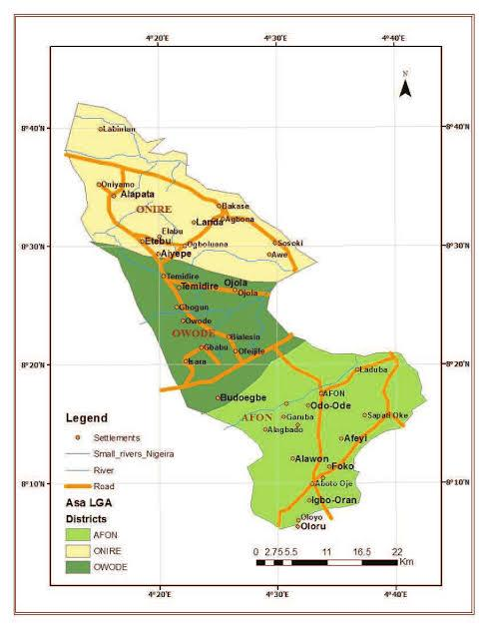
Fig 3.1: shows the location of the study area on the map of Asa LGA, Ilorin, Kware state, Nigeria.
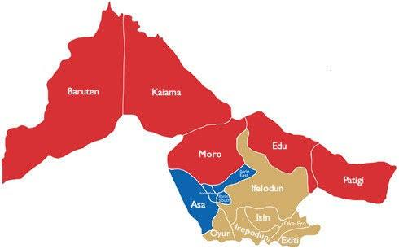

Fig 3.1: The location of the study area on the map of Asa LGA, Ilorin, Kware state, Nigeria
Fig 3.2: shows the picture of research team on field work
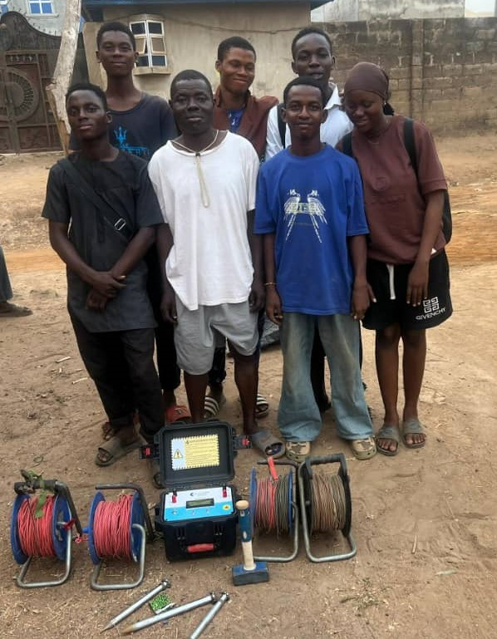

Fig 3.2: The picture of research team on field work

3.2 DESCRIPTION OF THE GEOTECHNICAL SUBSURFACE PROPERTIES OF SOIL USING GEOPHYSICAL APPROACH IN THE STUDY AREA.
The geophysical approach to investigating geotechnical subsurface properties of soil involves the use of non-invasive methods to evaluate the physical conditions of subsurface materials. These method help determine key soil properties such as density moisture content stiffness, stratification and depth to bedrock without the need for extensive drilling or sampling.
Method used in the study area
Material used are Terameter model herojat PLO electrodes, cable, clip, measuring meter, hammer, GPS, intromal extrex. This following procedure were used to measure the geophysical properties of the soil layer of the soil in the study area
- Site preparation: The ground of the area was cleared and a straight line survey was selected where electrodes can be planted.
- Choosing an electrode configuration: They are different array types but schlumberger array was used (which has a good depth penetration and high resolution.
- Electrode placement: Eight electrode were used four for current injection (C1,C2) and four for potential measurement (P1,P2) the electrodes were inserted into the ground along a straight line . Also the electrodes was hammered deep to get high resolution.
- Connection of the cables: The electrodes were connected to the terameter using color-coded cables, ensure tight connection good electrodes sold contact, also the electrodes were placed at 5m current to 5m potential spacing.
- Using of a hand held GPS instrument: A hand GPS device was used in the study area to determine the latitude and longitude of the study area.
- Ground resistivity measurement: The terameter was switched on and the electrodes are set in spacing of (AB/2 and MN/2) set. The terameter injects current (I) through the current electrodes and the voltage (V) across the potential electrodes were measured. The device calculates apparent resistivity (pa) using: I<=k>$\frac{V}{I}$.Where (K) is the geometric factor depending on the spacing of the electrodes.
- Increasing electrode spacing: To probe deep AB/2 and MN/2 were increased the spacing of the current electrodes was increased from 5m to 10m same with the potential electrodes after taking the readings on the terameter it was increased again to 15m and the readings were taken .This helps to detect changes in subsurface resistivity which relate to soil layers, compaction, moisture, content voids or hard strata.
- Data recording: valves of AB/2, mn/2 voltage (v) current (c) and apparent, resistivity (pa) were recorded. The measurement were recorded along two other different profiles for 2 Dimensions imaging.
- Data interpretation: The data taken were transferred to a computer for inversion using res2dinv software. The output is resistivity or pseudo-section showing different soil layers.

Fig 3.3: show the terameter model herojat

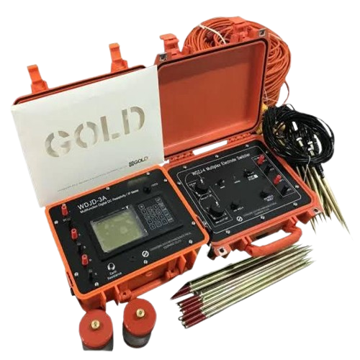

Fig 3.3: The Terameter

3.3 DETERMINATION OF GEOTECHNICAL SUBSURFACE PROPERTIES OF SOIL USING GEOPHYSICAL APPROACH IN THE STUDY AREA.
3.3.1 Atterberg limits
Apparatus used: Casagrande Apparatus, weighting, balance, 2spatuius, ovens, moisture cans, A mixing plate.
The Atterberg limit are a basic measure of the critical water content of a fine -grained soil it’s shrinkage limit ,plastic limits, and liquid limits.
The Atterberg limit can be defined as the liquid limit and plastic limits of soil .these two limits are used internationally for soil identification, classification and strength correlations. when clay minerals are present is fined -grained soil, the soil can be remolded in the presence of some moisture without crumbling the cohesiveness is caused by the absorbed water surrounding the clay particles.
PROCEDURE
- A little portion of the sample, before adding more water into the laterite sample
- The soil was rolled into a ball shape.
- The ball was cut and used our palms on a smooth surface to rub the ball between the palm and the smooth surface until the water was removed and it formed to about 3mm dis meter before it started to break.
- The procedure was repeated for two - others sample
- Measured three tin cans and placed the clay mold on each sample of the different tin cans.
- Measured three the weight of the tin can with the sample on it
- Measured the new weight of the tin cans with the sample in them.
Fig 3.4 shows the pictures of Oven, casagrante apparatus and weighing balance shear stress.
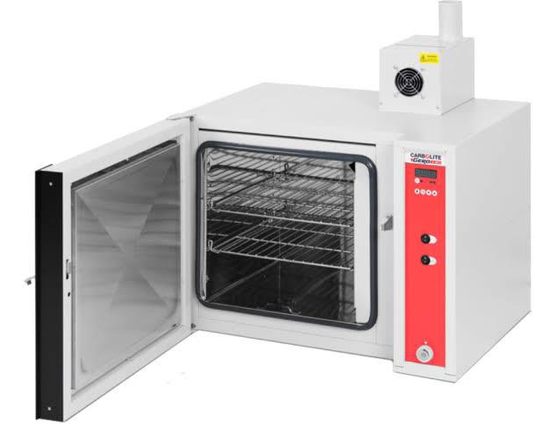

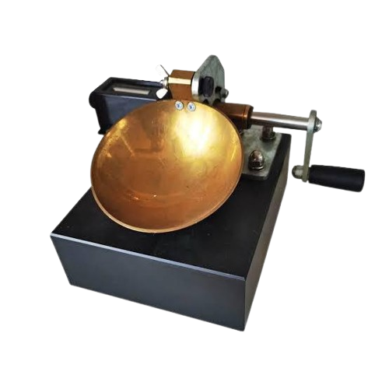
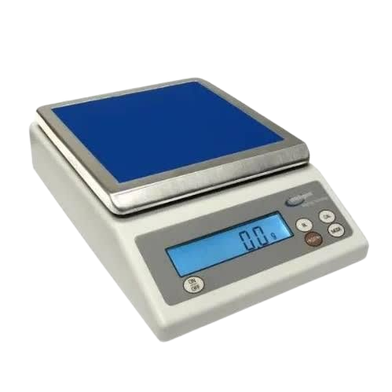

Fig 3.4: The pictures of Oven, casagrante apparatus and weighing balance.
Shear stress
The shear stress is typically defined as the resistance in terms of the effective internal friction angle and effective cohesion.
PROCEDURE
- The shear box was assemble.
- The soil sample was link into 60mm by 60mm.
- The gear level was disengage of the shear machine and the soil sample was covered with the toothed perforated grid.
- The box was then covered and then loaded with frame and also 5kg of the slotted weight by balancing the weight.
- The gear was then engaged and the machine is switched on.
- The reading on the load gauge were observed and taken down for every revolution of the displacement gauge
- The reading were taken until the load gauge was observed to move backwards with further increase in the number of revolutions
- The maximum reading on the load gauge was observed and the gear level was disengage.
- The machine was switch off and soil samples was unloaded sequentially the day it was loaded
- The soil was removed from the box and was replaced by a fresh sample this was repeated for 10kg and 15kg of the slotted weight
APPARATUS
Direct shear machine
Loading pad
Loading frame
Loading yoke
Proving ring capacity KN
Dial gauge accuracy 0.01mm, 2Nos
Static or dynamic compaction device spatula
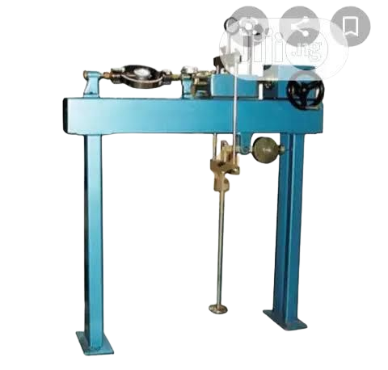
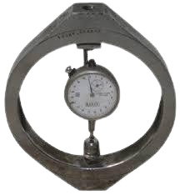
Fig 3.5: show the picture proving ring and shear box.

- Proving Ring (b) Shear Box
Fig 3.5:The picture proving ring and shear box.
Sieve analysis
Sieve analysis of a pounder or granular material or particle dispersed in fluid is a list of valves or a mathematical function that defines the relative Amount, typically by mass of particles present according to size.
APPARATUS
Sieve of different size
Sieve lid
Weighing balance
Sieve with pan
Sieve shaking machine
PROCEDURE
- The sieve was cleaned with brush in case of any particles stuck in between.
- The weight of each sieve and receiving pan was recorded.
- The specimen was dried in the oven for 3-4 minutes to get the dried specimen.
- The specimen was weight and recorded its weight.
- Arranged the sieve in order as the smaller opening sieve to the last and larger opening sieve to the top.
- Poured the recorded specimen on the top sieve and then placed the complete sieve stack on the sieve shakers.
- Allowed the shaker to work 5-10minutes.
- Remove the sieve stack from the shaker and recorded the weight of each sieve and removing pan separately.
- Calculated the cumulative %passing sieve size

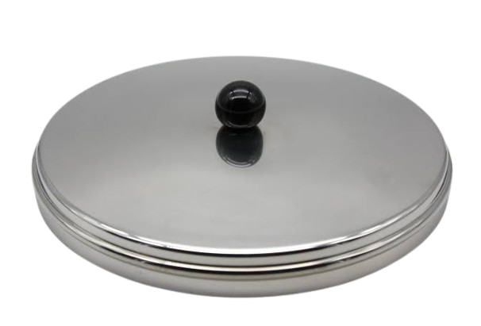
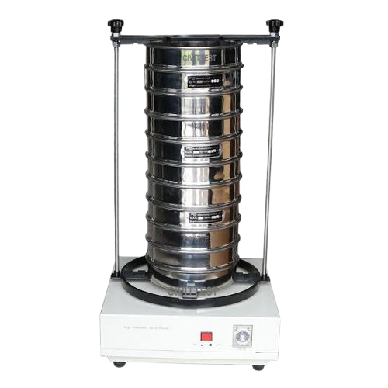
Fig 3.6: show the picture of sieve shaker, sieve pan and sieve lid.
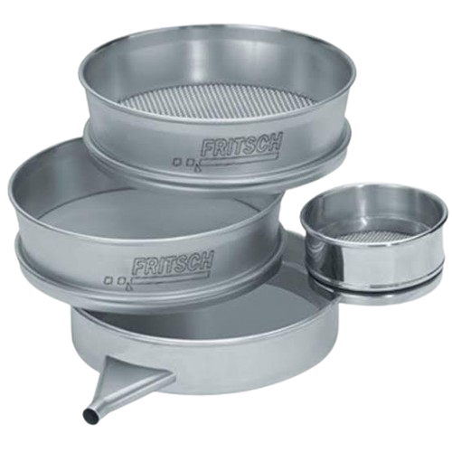

Fig 3.6: Tthe picture of sieve shaker, sieve pan and sieve lid.

3.4 INVESTIGATING THE RELATIONSHIP BETWEEN THE GEOTECHNICAL PROPERTIES AND THE GEOPHYSICAL PROPERTIES OF THE STUDY AREA
The relationship between the geotechnical and geophysical properties of soil within the checking point area was analyzed by comparing geophysical resistivity data with laboratory geotechnical parameters.

CHAPTER FOUR

4.0 RESULTS AND DISCUSSION
This chapter presents and interprets the results of the Laboratory tests conducted, these include the atterberg limit which comprise the liquid limit, plastic limit and plasticity index, along with the siene analysis and Shear Strength test, with geophysical study.

4.1 GEOTECHNICAL PROPERTIES OF SOIL WITH STUDY AREA

4.1.1 ATTERBERG LIMIT
Table 4.1 shows the plasticity characteristic of Soil Samples collected
Table 4.1: The plasticity characteristic of Soil Samples collected
Sample | Liquid Limit (%) | Plastic Limit (%) | Plasticity Index (%)
A | 27.5 | 15.1 | 12.4
B | 22.0 | 10.3 | 11.7
C | 25.0 | 12.9 | 12.1

Purpose of Atterberg Limit
The Atterberg, limit are used to determine the percentage of Clay or plasticity in a soil samples based on the value, soil can be categorized by their consistency and plasticity
- A soil with a liquid limit less than 35% is considered to have low plasticity (CL), which indicates moderate low clay content
- A Liquid limit above 80% signifies high plasticity (CH) Suggested high Clay content and more challenging work ability due to its elasticity and moisture sensitivity
- A soil with a Liquid limit between 35% and 50% is of intermediate plasticity.
According to (Das, 2010), Soil with high plasticity are generally more difficult to handle and compact because of their elastic behaviour and tendency to swell or shrink with moisture charge (Das, 2010).

4.1.2 SHEAR STRESS
These tests stimulates how soil will behave under shear loads.
Table 4.2 shows stress of sample A
Table 4.2: Shear stress of Sample A
Load (kg) | Normal Stress (KN/m²) | Load Dial Reading | Shear (Kn/M²)
5 | 188.0 | 232 | 112
10 | 324.3 | 646 | 311
15 | 460.5 | 961 | 463
20 | 598.8

Shear stress of sample A
Fig 4.1 shows Normal stress of sample A
400 Angle of friction
= 34⁰
300
Shear stress (KN/M²)

200

100
0
- 200 300 400 500
Normal Strees (KN/M²)
Fig 4.1: Normal Stress vs Shear Stress of the Sample A

Table 4.3 shows Shear Stress of Sample B
Table 4.3: shows Shear Stress of Sample B
Load (kg) | Normal Stress (KN/m²) | Load Dial Reading | Shear (Kn/M²)
5 | 188.0 | 225 | 082
10 | 324.3 | 392 | 189
15 | 460.5 | 582 | 280
20 | 598.8
Normal Stress (KN/M²)
500 Angle of internal friction
= 31⁰
400

300
Shear stress (KN/M²)

200

100
0 100 200 300 400 500 600
Normal Stress (KN/m²)
Fig 4.2: Shear stress of sample B

Table 4.4Shear Stress of Sample C
Table 4.4: shows the shear stress of sample C

Load (kg) | Normal Stress (KN/m²) | Shear (Kn/M²)
5 | 188.0 | 161
10 | 324.3 | 320
15 | 460.5 | 485

500

400

300

200

100
0
Fig 4.3 shows Normal Stress of sample C
Soil can be classified base on their angle of Internal fraction which is a key parameter used to evaluate the Shear Strength of the soil. This angle indicate the soils resistance to sliding along surface with the soil mass Based on the Internal resistance. Soil are Categorized into different Strength Classes. An angle of friction between 10⁰ and 20⁰ is considered very Soft soil, between 20⁰ and 30⁰ is Classified as Stiff Soil, any angle above 35° is considered hard soil (Das, 2016)

4.1.3 SIEVE ANALYSIS
Sieve analysis determines particle size distribution helping engineer, Classify soil type and assess their suitability for foundation and construction work (Head, 2006)
The table 4.5 Shows the percentage of the soil fraction in Sample A

4.5: Percentage of the soil friction
Key | Sample  A | Depth (m) | D10  0.425 | DB0  1.40 | D60  4.00 | C4  9.41 | CC  1
Key | 63% | Gravel
Key | 37% | Sand
Name: Very Sandy Gravel Soil
Classification: Well graded gravel soil
Table 4.6 shows the percentage of the soil Fraction in Sample B
Table 4.6: Percentage of the soil Friction.
Key | Sample  B | Depth (m) | D10  0.212 | D30  0.800 | D60  0.800 | C4  3.8 | CC  1.5
Key | 11% | Gravel
Key | 81% | Sand
Name: Gravity Sand Soil
Classification: Poorly Graded Sandy Soil
Table 4.7 shows the percentage of the soil fraction in sample C
Table 4.7: Percentage of the soil Fraction
Key | Sample  C | Depth (m) | D10  0.425 | D30  1.40 | D60  4.00 | C4  9.41 | CC  1
Key | 55% | Gravel
 | 45% | Sand

Name: Very Sandy Gravel
Classification: Well Graded Gravel
According to the co-efficient of uniformity ((v) and co-efficient of curvature (cc)), the Cu for gravel must be greater than 6, and the cc must also use in engineering construction to classify and select suitable materials (Das, 2016). The well-graded, sandy gravel soils provides good support and drainage, reducing the risk of foundation settlement and moisture movement which are common causes of wall cracks. Its stable nature helps prevent uneven sinking of the building making cracks in walls less likely as long as the soil is properly compacted and the foundation is well-designed. ( Das, 2016).

4.2 GEOPHYSICAL PROPERTIES OF SOIL IN STUDY AREA
This section shows the Raw-Resistivity Values collected on the field.
Fig 4.4 shows the Raw-Resistivity of first profile.
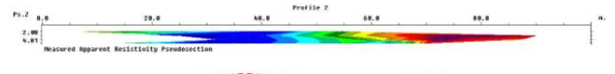
Fig 4.4: The Raw-Resistivity of first profile.
The geophysical data were acquired along a 100meter lateral spread, reaching a maximum investigation depth of 4.91 meters. The survey yielded an estimated range from 10.4 meters to 206.00 meters. A well compacted lateritic clay layer was identified, extending from 0 to 35 meters laterally and appearing prominently at a depth of approximately 12 meters. Additionally, a dominant clay layer, likely representing loose surface sediments, was observed from 70 to 100 meter along the lateral profile. This layer trends downward and extend to a depth of approximately5 meter. These subsurface characteristic indicate significant lateral and vertical variation in soil composition, which essential for geotechnical and geophysical interpretation (Telford, 1990).
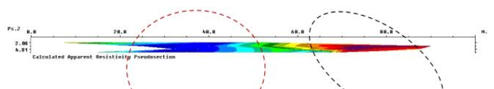
Fig 4.5 shows the second profile

Fig 4.5: The second profile
The geophysical data were acquired across a 100 meter lateral spread, reaching a maximum depth of 4.81 meter. The survey recorded a low percentage error of 3.6% indicating reliable data quality, the resistivity value obtained range from 7.07 to 5.9 ohm-meters. Zones exhibiting lowest resistivity values, particularly between 20 to 55 meter along the lateral extent and dipping to a depth of approximately 5 meters are indicative of clayey or loosely compacted clayey material. Such low resistivity reading are commonly associated with fine-grained, water retaining soil like clay (Reynolds, 2011).
Fig 4.6: show the third profile
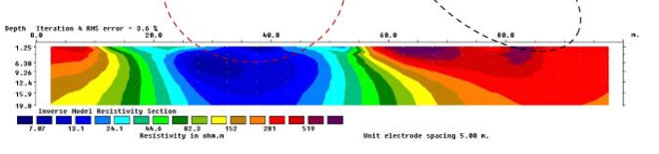

Fig 4.6: The third profile
The geophysical profile exhibit a root mean square (RMS) error of 44% and indicating acceptable data reliable. 0m to 100m with the maximum depth of 19.8meter the region is a profile show lateritic clay a 15m to 20m on the laterial spread with a depth of 12m, with a loose clay or clay particles surrounding it and it mostly dominated the profile (Ajaji, 2022).
The Blue Signify Clay or Loose Soil
The Green Signify the Sand or Fairy Soil
Red Signify the Lateritic Soil
Table 4.8 Shows Lithologies of Depth
Table 4.8: Lithologies and Depth
LITHOLOGIES | DEPTH
Top Soil | 35, 0hm.m
Clay | 10, 0hm.m
Lateritic Clay | 201, 0hm.m

Source: (Telford, et, al, 1990, Keller and Frisch Knecht, 1996, and Olorunfemi and Fawuyi, 1993)
The Electrical Resistivity imaging (ERI) data shown variation in subsurface strength due to changes in resistivity. Zones with low resistivity indicates weak, clayey or water logged soils are more likely to cause foundation settlement and wall cracks. High resistivity zones are stronger but can be problematic if found beneath weaker layers, mixed resistivity layers increase the risk

RELATIONSHIP BETWEEN GEOTECHNICAL AND GEOPHYSICAL PROPERTIES OF SOIL IN THE STUDY AREA
The geotechnical and geophysical investigation conducted in the study area revealed that the topsoil is predominantly composed of clay. The high clay content significantly reduces soil stability, thereby lowering its load-bearing capacity. This reduction in strength is largely due to the presence of water and fine-grained particles, which promote high plasticity, shrink–swell behavior, and poor drainage. Such characteristics are reflected in the low resistivity values obtained from the electrical resistivity survey, indicating saturated and fine-textured materials (Olorunfemi and Fasuyi, 1993; Ajayi et al., 2020). In this condition, the subsoil becomes highly susceptible to settlement, differential movement, and the development of structural cracks, especially when moisture content fluctuates seasonally. Without proper foundation design or soil improvement measures, these weaknesses and can lead to long-term structural instability within the study area (Adeyemo et al., 2015; Bello and Akinlabi; 2017).

CHAPTER FIVE

CONCLUSION AND RECOMMENDATION

5.1 CONCLUSION
The integrated geotechnical and geophysical investigation of the sub soil in Bud-Nuhu, Ilorin, Kwara state reveals a soil profile dominated by laterite clay, salty sand and loose clawed material with varying degrees of plastic strength, and resistivity. The atterberg limit results indicate that sample A and B fall within the range of medium plasticity, while sample C show low plasticity implying a higher tendency for shrink swell behavior in some layer
Sieve analysis reveals a poorly graded soil with a significant percentage of fines, which may limit its bearing capacity, the direct shear test results suggest that sample B has the highest shear strength, making it more suitable for load-bearing applications compared to the others. Geophysical resistivity profiles reveal zone of low resistivity consistent with clayey and saturated layers which may pose a risk to structural stability due to potential compressibility and low permeability, higher resistivity zones likely indicate well compacted laterite layers suitable for shallow foundations construction.

5.2 RECOMMENDATIONS
- Use shallow foundation in area with strong laterite soil, use deep foundation where soil are weak or clayey.
- Improve weak soils with stabilizer like lime or cement.
- Install proper drainage to prevent water build up and soil weakening.
- Avoid building or saturated or highly plastic clay unless treated or stabilized

REFERENCES
Adeyemo, I. A., Olorunfemi, M. O., and Bayowa, O. G. (2015). Geoelectric investigation of foundation conditions at a site in southwestern Nigeria. International Journal of Applied Science and Engineering Research.
Ajayi, C. A., Adeoye, A. S., Ilugbo, S. O., Adebo, B. A., and Adewunmi, O. A. (2022). Geophysical post foundation studies of Ministry of Justice building, Ekiti State Secretariat, Ado-Ekiti, Ekiti State, Nigeria. Geological Behavior.
Bello, R. A., and Akinlabi, O. D. (2017). Geotechnical and geophysical assessment of subsoil competence for building foundation in basement complex terrain of Nigeria. Nigerian Journal of Environmental Sciences and Technology.
Bishop, A. W., and Henkel, D. J. (1962). The measurements of soil properties in the triaxial test.
Das, B. M. (2010). Principles of geotechnical engineering (7th ed.). Cengage Learning.
Das, B. M. (2016). Principles of geotechnical engineering (9th ed.). Boston, MA: Cengage Learning.
Daily, W., and Wen, E. (1991). Cross-borehole resistivity tomography. Geophysics, 56(8), 1228–1235.
Daniels, D. J. (2004). Ground penetrating radar. Institution of Electrical Engineers.
Grasmueck, M. (1996). 3D ground penetrating radar imaging. Journal of Applied Geophysics, 36(1), 15–26.
Griffiths, D. H., and Barker, R. D. (1993). Electrical resistivity tomography. Quarterly Journal of Engineering Geology, 26(2), 131–140.
Griffiths, D. H., and King, R. F. (1981). Applied geophysics for geologists and engineers. Pergamon Press.
Hunger, O., Leroueil, S., and Picarelli, L. (2014). The Varnes classification of landslide types, an update. Landslides, 11(1), 167–194.
Kearey, P., Brooks, M., and Hill, I. (2002). An introduction to geophysical exploration. Blackwell Science.
Keller, G. V., and Frischknecht, F. C. (1966). Electrical methods in geophysical prospecting. Pergamon Press.
Kramer, S. L. (1996). Geotechnical earthquake engineering. Prentice Hall.
Lambe, T. W., and Whitman, R. V. (1979). Soil mechanics (SI version). Wiley.
Mader, H. M. (1996). 3D ground penetrating radar imaging. Journal of Applied Geophysics, 36(1), 15–26.
Olorunfemi, M. O., and Fasuyi, S. A. (1993). Aquifer types and geoelectric/hydrogeologic characteristics of the central basement terrain of Nigeria (around Ilesa). Journal of African Earth Sciences.
Reynolds, J. M. (2011). An introduction to applied and environmental geophysics (2nd ed.). Wiley-Blackwell.
Sheriff, R. E., and Geldart, L. P. (1995). Applied geophysics. Cambridge University Press.
Smith, J. (2020). Introduction to geophysical and geotechnical evaluation of subsoil layers. Journal of Geotechnical Exploration, 19(10), 1092–1094.
Socco, L. V., Boiero, D., and Strobbia, C. (2010). Surface-wave analysis for building near-surface velocity models: Basic issues, biased approaches, and new perspectives. Geophysics, 75(5), A83–A102.
Terzaghi, K. (1925). Erdbaumechanik auf boden physikalischer grundlage. Franz Deuticke.

