DESIGN AND IMPLEMENTATION OF EXAMINATION SITTING ARRANGEMENT USING ANT BEE COLONY ALGORITHM

BY
GBADEGESIN JOSHUA
ND/23/COM/PT/0179

A PROJECT SUBMITTED TO:
DEPARTMENT OF COMPUTER SCIENCE,
INSTITUTE OF INFORMATION AND COMMUNICATION TECHNOLOGY (IICT),

KWARA STATE POLYTECHNIC, ILORIN.
IN PARTIAL FULFILLMENT OF THE REQUIREMENTS FOR THE AWARD OF NATIONAL DIPLOMA (ND) IN COMPUTER SCIENCE.

JUNE, 2025
CERTIFICATION
This is to certify that this project research was carried out by GBADEGESIN JOSHUA with Matriculation Number: ND/23/COM/PT/0179, has been read and approved as meeting part of the requirement for the award of National Diploma (ND) in computer science

__________________________ __________________
MR. OLAJIDE, A.T. DATE
PROJECT SUPERVISOR

__________________________ ___________________
MR. OYEDEPO F.S DATE
HEAD OF DEPARTMENT

__________________________ ___________________
EXTERNAL EXAMINER DATE

DEDICATION
This project work is sincerely dedicated to Almighty God for his mercy upon my live, divine protection, for his wisdom, knowledge and understanding given to me to put this project work together and throughout the course our study in this great polytechnics. May his name be praise forever and ever (amen).Also to my lovely, caring and darling parents for their moral and financial support. God bless you.

ACKNOWLEDGEMENT
All praise and thanks to my inestimable Almighty God the most beneficial, merciful, nourished and the sustainer for his guidance over my lives throughout this research work and my programme in this great institution.
I also appreciate the effort of my amiable supervisor Mr OLAJIDE A.T for his supervision and corrections made during the project work. May almighty God bless you and your home (amen).
Special thanks to Hod of the department Mr Oyedepo F.S, MR. ISIAKA O.S, Mrs olusi R.T, Dr Agboola O.M ,Mrs Dada M.O, (Dr.Raji A.K) and other members of the staff of the Department of Computer science for their support always.
Finally, i express my profound gratitude to all lecturers in computer science department in Kwara State Polytechnics, Ilorin. God bless you all (amen). More grease to your elbow.

TABLE OF CONTENTS
TITLE PAGE
CERTIFICATION PAGE
DEDICATION PAGE
ACKNOWLEDGEMENT
ABSTRACT
CHAPTER ONE: GENERAL INTRODUCTION
  - BACKGROUND OF THE STUDY
  - STATEMENT OF THE PROBLEM
  - AIM AND OBJECTIVES
  - SIGNIFICANCE OF THE STUDY
  - SCOPE OF THE STUDY
  - ORGANIZATION OF THE REPORT
CHAPTER TWO: LITERATURE REVIEW
2.1 REVIEW OF RELATED WORKS
2.2 REVIEW OF GENERAL TEXT
CHAPTER THREE: METHODOLOGY AND ANALYSIS OF THE SYSTEM
3.1 RESEARCH METHODOLOGY
3.2 ANALYSIS OF EXISTING SYSTEM
3.3 PROBLEMS OF EXISTING SYSTEM
3.4 DESCRIPTION OF PROPOSED SYSTEM
3.5 ADVANTAGES OF PROPOSED SYSTEM
CHAPTER FOUR: DESIGN AND IMPLEMENTATION OF THE SYSTEM
4.1 DESIGN OF THE SYSTEM
4.1.1 OUTPUT DESIGN
4.1.2 INPUT DESIGN
4.1.3 DATABASE DESIGN
4.1.4 PROCEDURE DESIGN
4.2 SYSTEM IMPLEMENTATION
4.2.1 CHOICE OF PROGRAMMING LANGUAGE
4.2.2 HARDWARE SUPPORT
4.2.3 SOFTWARE SUPPORT
4.2.4 CHANGEOVER TECHNIQUES
4.3 SYSTEM DOCUMENTATION
4.3.1 PROGRAM DOCUMENTATION
4.3.2 SYSTEM MAINTENANCE
CHAPTER FIVE: SUMMARY, CONCLUSION AND RECOMMENDATIONS
5.1 SUMMARY FINDINGS
5.2 CONCLUSION
5.3 RECOMMENDATIONS
REFERENCE
APPENDICES

ABSTRACT
Examination as we know is one of the best methods of evaluating knowledge and grade student’s ability understanding of what he/she was taught in the classroom. Its purpose is to assess how much each student has learned compared to fellow students in the same course or learning situation. Malpractices, low capacity examination venues, inadequate invigilators, inadequate examination materials, omission of student’s results and human error(s) during the marking / grading process will be automatically eliminated following the adoption of this system. In furtherance, during manual computation of results, errors may arise due to “omission” or “commission”. There are also cases of missing examination scripts during marking. There is also a problem of time wasting, among others. Challenges encountered in traditional examinational mode which includes examination. It was expected that the system would proffer solutions to challenges such as examination malpractices, low capacity examination venues, inadequate invigilators and inadequate examination materials.
KEYWORD: Examination, Arrangement, System, Invigilator

CHAPTER ONE
GENERAL INTRODUCTION
1.1 BACKGROUND TO THE STUDY
Sitting Arrangement of students during examinations is distributed. Students face difficulties as they have to scrounge for their examination hall numbers and sitting arrangement while they are wits end. An innovation which could aid the students in finding their exam halls and sits would be welcoming and very rewarding. This project computerization of sitting arrangement in examination hall system, presents a modernized method of examination hall management. It is possible for a student to identify the particular exam hall from any other hall, when they enter their matric number into the system. This programe helps them to identify the floor or get directions to their respective halls without delays (Burda, 2016).
The IICT Institute Examination Rules and Regulations have been formulated with a view to putting into place a credible and efficient system for the conduct of examinations. These rules and regulations, covering the different aspects of the examination process, are to ensure the smooth and orderly conduct of the examinations as well as to safeguard the security and integrity of all IICT examinations. All staff are required to familiarize themselves with these rules and regulations to enable them to carry out their duties and responsibilities as examiners and invigilators effectively. These rules and regulations may be amended by the Senate as deemed necessary from time to time.
Examinations shall be held at examination halls as specified in the Examination Time Table, prepared by the Examinations Division and displayed on Faculty/Centre and Examinations Division notice boards. Examinations division is responsible for the handling bookings of exam hall. Handling of keys arrangement of chairs and maintenance of exam hall are the responsibility for the maintenance division. The number of Invigilators for each examination hall is to be determined by the Examinations Division. Examination Assistants may be appointed by the Examinations Officer to assist the Invigilators and their main duties are to help distribute examination books and papers and specific authorized materials, as directed by the Invigilator at the start of the examination and to collect the unused answer books and specific authorized materials at the end of the examination. All examination desks shall be numbered. Candidates are required to sit at the desks allocated to them by the Examinations Division, unless otherwise the case.
This is a system used by Education Institutions or other organization which are willing to arrange student into an examination hall. We have three roles in the system administration, a director and a student. An administrator logs into this system and register a director who belong to that institution.
Students register in this system and get allocated into their specific examination hall. A student showed register in order to allocate their examination hall. (Like semester marks, technologies about his team members experience) and also provide information about his team members this is saved in a database after the registration (Dykman, 2019).
1.2 STATEMENT OF THE PROBLEM.
The methods of operation for student allocation and management are done manually with series of problem that occur during the allocation. As a result of this the proposed system (student sitting examination allocation and management) was introduced to handle the problems for easy and efficient performance of allocating hall to students in an institution. The problems of hall allocation includes but not limited to the following:
- Manual way of coordinating student examination hall.
- Stress encountered in manual way of arranging student in hall.
1.3 AIM AND OBJECTVES OF THE STUDY
The aim of this project is to design computerization system for the examination hall allocation for student and this is expected to facilitate the examination hall allocation process and the sitting arrangement of the student by greatly reducing if not completely eliminating time wastage.
The objectives of this project are:
- To keep record of the examination hall venue.
- To enable easy arrangement of student in the examination hall.
- To implement the arrangement using Greedy Algorithm.
- To use PHP as the programming language to use.
- To use MYSQL as the database storage for the student and hall information.
1.4 SIGNIFICANCE OF THE STUDY
This manual method of examination hall allocation has gone very expensive and time wastage in the delivery of services to student time environment condition and especially inconveniency to student.
Due to the problem arising from the existing method at kwara state polytechnic, Institute of Information and Communication Technology (IICT), the research is now aimed at eradicating the problem and to design a new system by using computer to allocate student to the examination hall.
1.5 SCOPE OF THE STUDY
The scope of this project will cover the design of computerized method of allocating all fully registered student into the examination hall for three department in the institute of information and communication technology, kwara state polytechnic, Ilorin. These three department are Computer Science, Office Technology Management, Mass Communication.
Hence a student without matric- number will not be allocated to any of the examination hall
1.6 ORGANIZATION OF THE STUDY
For ease study and proper understanding of this project write-up, It is planned and organized into five chapters. The description of what each chapter contains is explained below:
CHAPTER ONE: This contains an Introduction to the whole write-up, the problem of the study, aims and objectives of the study, the significant of the study, the scope and limitation of the study, and organization of the report.
CHAPTER TWO: It contains the literature review of the study, organization of the board of director, computerization of the current state of the art.
CHAPTER THREE: Presents data collection method employed, analysis of data and existing system, advantages of the proposed system, design and implementation, programming language used with reasons, hardware and software support.
CHAPTER FOUR: contains system design implementation and documentation, design of the system, output design, input design, file system, procedural design, and documentation of the new system.
CHAPTER FIVE: contains the summary, experienced gained, recommendation and conclusion.
1.7 DEFINITION OF TECHNICAL TERMS
- Allocation: The action or process of allocating or sharing out something.
- Examination: This is an educational assessment intended to measure a test-taker's knowledge, skill, aptitude, physical fitness, or classification in many other topics.
- Algorithm: An algorithm is a finite sequence of well-defined, computer-implementable instructions, typically to solve a class of problems or to perform a computation.
- Hall: This is a relatively large space enclosed by a roof and walls.

CHAPTER TWO
LITERATURE REVIEW
2.1 REVIEW OF PAST WORK
Examination hall allocation may be decided by using computer programs applied to a specific domain to automatically and dynamically distribute hall to students. It may be considered as a specialized case of automatic scheduling or allocation. This is done over an electronic device like computer linked to the departmental project database.
It is very glaring that this method if well executed will provide a better means of eliminating other problems like plagiarism which is very common among the students. For a better execution, the design should be a plan with two parts: Firstly, there is the basic allocation decision rule and secondly there is contingency mechanism. The basic allocation decision rule is the general automatic and dynamic allocation of different hall to registered students which is a one-time access. The contingency mechanism entails a priority ranking of items excluded from the plan, this is done when a particular hall is over-allocated to students.
Sitting arrangement advocates the implementation of a systemic approach to education in which interrelated problems are addressed at multiple levels to ensure the success of all students. A critical component in this systemic approach is the effective use of financial resources. As education systems are redesigned to create high performance in all schools, finance systems must also be redesigned for greater efficiency and effectiveness (Odden& Busch, 2018). Recent trends support this need for considering financial structures in school reform.
The funding of education has experienced tremendous growth in the past 40 years. However, increased student performance has not accompanied the influx of money into the educational system (Hanushek, 1994; Odden& Busch, 2018).
Although the disparities are declining, current finance structures are still plagued by funding inequities across states, districts, and schools (Hussar &Sonnenberg, 2000; Parrish &Hikido, 2018; U.S General Accounting Office, 2017).
Efforts to reduce class size, appropriately fund programs for disadvantaged students, and update teacher compensation systems require additional funding. The funding necessary for these expenses is most likely to come through new approaches to allocation. Decision makers have an enormous challenge to spend the funds they do have more efficiently (Hanushek, 1994; Odden& Archibald, 2001; Picus, 2001; Picus&Fazal, 1995).
Research efforts in recent decades have helped broaden our understanding of the role of school resources and how their distribution and use can be improved. This study draws from existing knowledge in three areas: resource allocation inputs, the linkage between financial resources and student performance, and effective spending practices.

This finding is inconsistent with the majority of research at the secondary education level. In a review of educational studies, Fisher concluded that improved building conditions lead to improved student performance. The author identified individual factors, such as air quality, lighting, and temperature, which have been linked to student behavior and outcomes. Design issues such as exams hall arrangement and circulation have also been found to affect student performance. Tanner noted that hall spaces arranged to promote freedom of movement were related to higher test scores. Another study by (Uline, C.L., 2010) examined the effect of facility conditions on the overall learning climate for a large, metropolitan institution. The findings showed that physical conditions of the school played a role in shaping student behavior and performance.
2.2 REVIEW OF GENERAL TEXT
Examination is a basic requirement of an educational system at any level. The examination questions are usually receiving the major focus in any examination.
However, a lot of tasks are required in order to organize an examination from the institution such as assigning each subject to a room, assigning a set of proctors to each examination room, and assigning a sitting layout for each examination hall. These tasks usually involve a lot of data from many sources. For example, the registration information provides the list of subjects, the list of students in each subject, the list of instructors in each subject, and the examination schedule (i.e., date and time). Furthermore, each proctor may not be available during the examination period. In addition, the available halls to be assigned as examination halls are limited. Thus, the examination schedule of each subject and the list of examination proctors for each subject must consider such constraints. This leads to an idea of developing an application to create a suitable examination hall schedule.
2.2.1 SITTING ARRANGEMENT
This is a system used by Educational Institutions or other organizations which are willing to allocate students to the examination hall. Hall allocation is used to assign students to the available examination hall in the department in various Institutions because it is part of resource management or project management scheduling. More so hall allocation is the scheduling of students sittingin an Institutions with respect to the available number of sit in a particular hall, this allows students to have prior access to their allocated hall for examination. The methods of operation for hall allocation are done manually resulting to series of problems during allocation. Hall allocation for examination is part of departmental strategic planning which can be tailored towards successful elimination of various problems usually associated with assigning sits as well as available hall to the students. This manual method is somehow tedious, time consuming and stressful for the Exam coordinator to assign student or group of students to a particular Examination hall.
However, what is usually not fully appreciated by many institutions, examination bodies as well as the public is the fact that conducting examinations is largely a management task. If things go right or wrong during the examinations, it is because those who are in charge, (examination managers), have either done the right thing or have left the right thing undone. Even the most fraudulent students will not have his way if all examination managers performed their-duties as expected, whereas such students will exploit any loophole. Thus, School Plant Planning and Development as well as Personnel Management play important role in conducting hitch-free exams.
In view of the significance of examinations to the progress of students, the institution, the nation and the world in general, the need for their effective management cannot be over-emphasized.
2.2.2 GREEDY ALGORITHM
A greedy algorithm is an algorithmic strategy that makes the best optimal choice at each small stage with the goal of this eventually leading to a globally optimum solution. This means that the algorithm picks the best solution at the moment without regard for consequences. It picks the best immediate output, but does not consider the big picture, hence it is considered greedy.

2.2.3 TECHOPEDIA EXPLAINS GREEDY ALGORITHM
A greedy algorithm works by choosing the best possible answer in each step and then moving on to the next step until it reaches the end, without regard for the overall solution. It only hopes that the path it takes is the globally optimum one, but as proven time and again, this method does not often come up with a globally optimum solution. In fact, it is entirely possible that the most optimal short-term solutions lead to the worst possible global outcome.
Think of it as taking a lot of shortcuts in a manufacturing business: in the short term large amounts are saved in manufacturing cost, but this eventually leads to downfall since quality is compromised, resulting in product returns and low sales as customers become acquainted with the “cheap” product. But this is not always the case, there are a lot of applications where the greedy algorithm works best to find or approximate the globally optimum solution such as in constructing a Huffman tree or a decision learning tree.
For example: Take the path with the largest sum overall. A greedy algorithm would take the blue path, as a result of shortsightedness, rather than the orange path, which yields the largest sum.
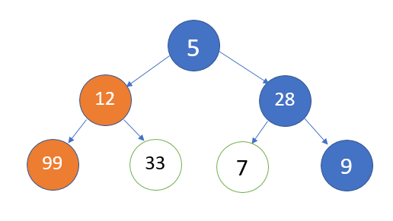COMPONENTS:
- A candidate set of data that needs a solution
- A selection function that chooses the best contributor to the final solution
- A feasibility function that aids the selection function by determining if a candidate can be a contributor to the solution
- An objective function that assigns a value to a partial solution
- A solution function that indicates that the optimum solution has been discovered

CHAPTER THREE
METHODOLOGY AND ANALYSIS OF THE EXISTING SYSTEM
3.1 RESEARCH METHODOLOGY
The study of examination seating arrangement is a pre-requisite for increases institution output was carried out using recursive algorithm. Recursion is a method where the solution to a problem depends on solutions to smaller instances of the same problem (as opposed to iteration). This approach can be applied to many types of problems.
METHODS OF DATA ANALYSIS
A recursive function definition has one or more base cases, meaning input(s) for which the function produces a result trivially (without recurring).
A recursion is a special class of object that can be defined by two properties:
- Base case
- Special rule to determine all other cases
After the collection of data, the researcher started collating for analysis. Analysis of data was based on recursive algorithm
Formula used;
k! = 1 and, for all n > k, n! = n (n − 1)!
In this formula, ‘k’ stands for the total number of students occupying a seat while ‘n’ stands for the total number of students occupying each role. In this case ‘k’ is the base case while ‘n’ is the special rule that determines all other cases.

3.2 ANALYSIS OF THE EXISTING SYSTEM
The existing system is a manual process of seat arrangement which offers the Examination officers to arrange the exams individually for the students of the same course. But it is very hard for a course teacher to manage quality examination while conducting exams this way. For maintaining central examination some institutions offer one room for one exam to get rid of this hassle of preparing a seating plan. As a result the quality of examination as well as education becomes questionable for lots of the educational institutions.
Therefore, automated examination sitting arrangement was introduced to eliminate all the setbacks that arise as a result of the manual method and the new method aims at enhancing efficiency and effectiveness in sitting arrangement.
3.3 PROBLEM OF THE EXISTING SYSTEM
Usually Exam seats are allocated manually based on some basic rules. Most of the cases, it demands high cost and time to provide the optimum solution while there are a large number of students and they are from multiple disciplines or subjects. Some of the cases there are possibilities of having some empty seats, overlapping students with different subjects in the same column and also having no distance between the students with getting same question set. As a result it becomes very tough for invigilators to control the exam hall and also to ensure a proper exam environment. With the increasing number of students and subjects, it becomes more difficult to arrange the proper seat plan for the students. Most of the institutions do this process manually. Although there have many related works of exam arrangement, institutions face difficulties to do those works. Most difficulties arise from the exam timetabling and room assignment problem.
3.4 DESCRIPTION OF THE PROPOSED SYSTEM
This research provides an effective measure to dynamically place students in an examination hall just by providing the number of rooms available. This offers a solution for preventing some exam hall cheating by arranging seats for large students and it also finds out the best combination of rooms to be assigned for the exam to organize perfect seating based on the room orientation and size, number of students, differentiation of subjects.
3.5 ADVANTAGES OF THE PROPOSED SYSTEM
A lot of benefits are derived from the proposed system, they include:-
- It is an organized system which enables us to automatically allocate students to their desired location
- Institutions who use this software can save an ample amount of time during the examination
- it is very fast, reliable and robust
- It can be used to design timetables for large number of students

CHAPTER FOUR

DESIGN AND IMPLEMENTATION OF THE SYSTEM

4.1 DESIGN OF THE SYSTEM
This is the process of designing the input, output and the processing steps to meet the user’s requirement identified in the system analysis. It starts with logical design, which produces a specification of major features of the system. These include the data, input, output, processing storage and other control requirements.
4.1.1 OUTPUT DESIGN
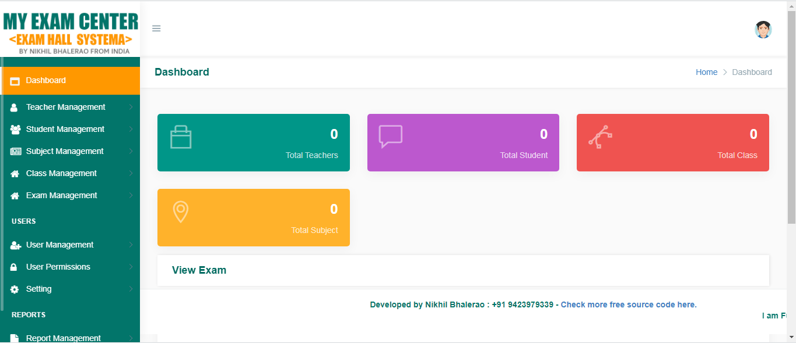
Figure 4.1: Admin Homepage: This is the homepage for admin portal
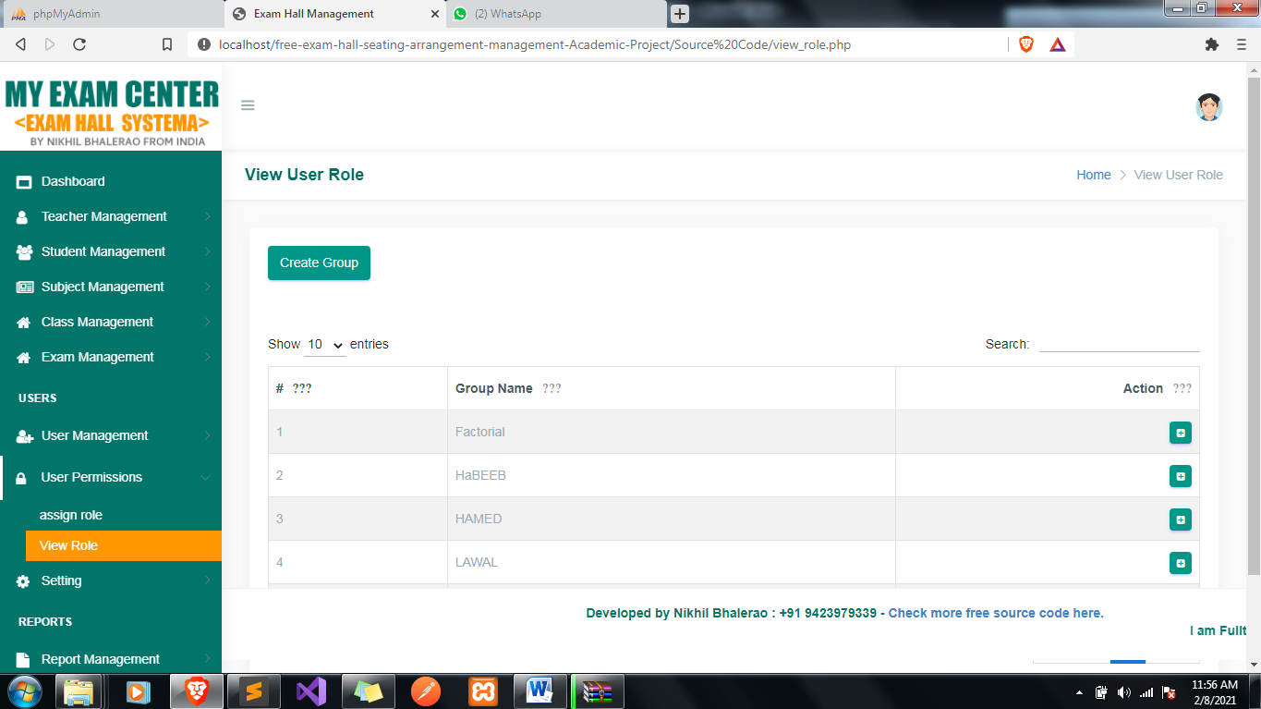
Figure 4.2: View User role: This is where list of user and their role can be view.
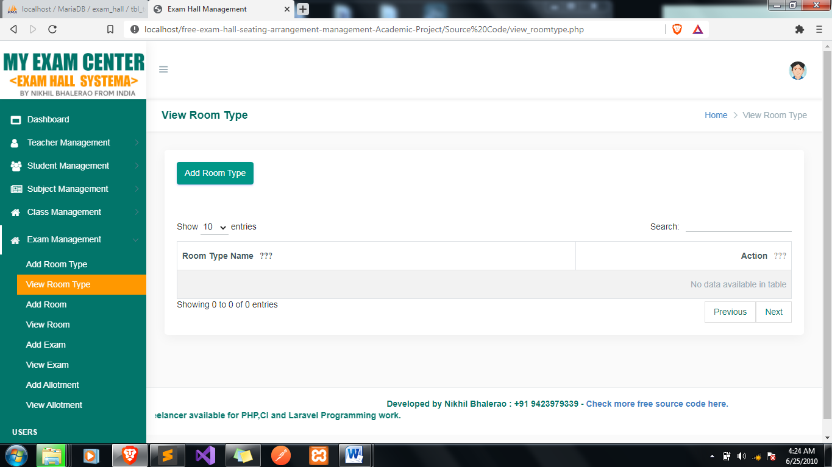
Figure 4.3: View room type: This is page view different room type available.
Figure 4.3: Requests: This is request page where admin approve blood donated by the donor.
4.1.2 INPUT DESIGN
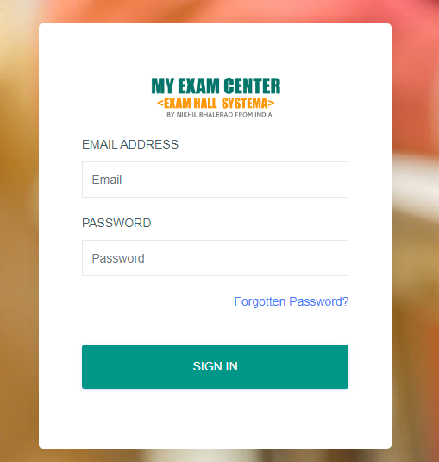
Figure 4.4: Login page: A login page is a web page or an entry page to a websitethat requires user identification and authentication, regularly performed by entering a username and password combination. Loginsmay provide access to an entire site or part of a website.

4.1.3 DATABASE DESIGN
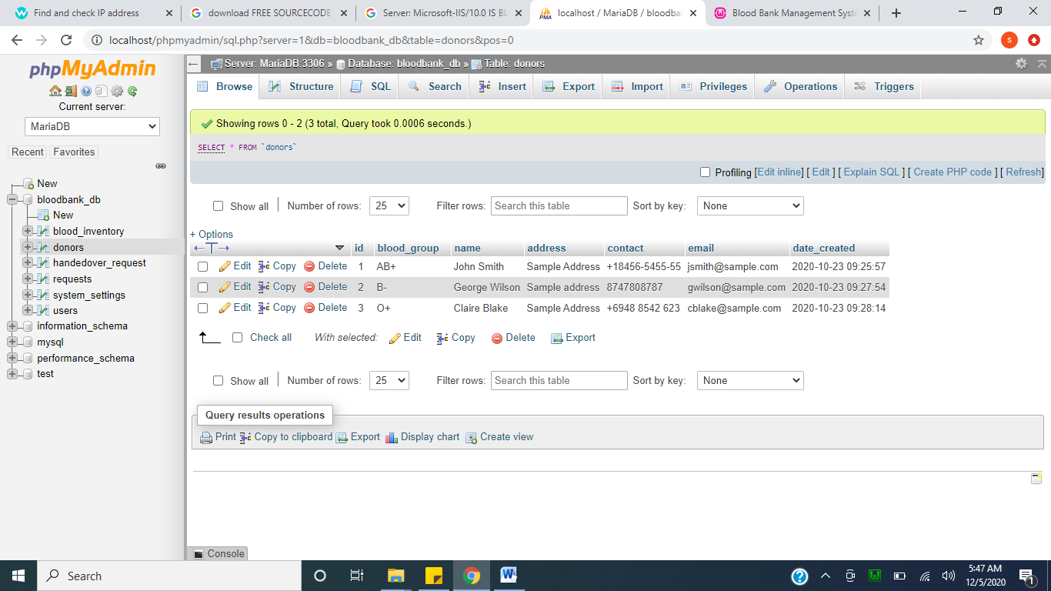
Figure 4.7: Exam Database: This handles all table which includes all the entire document.
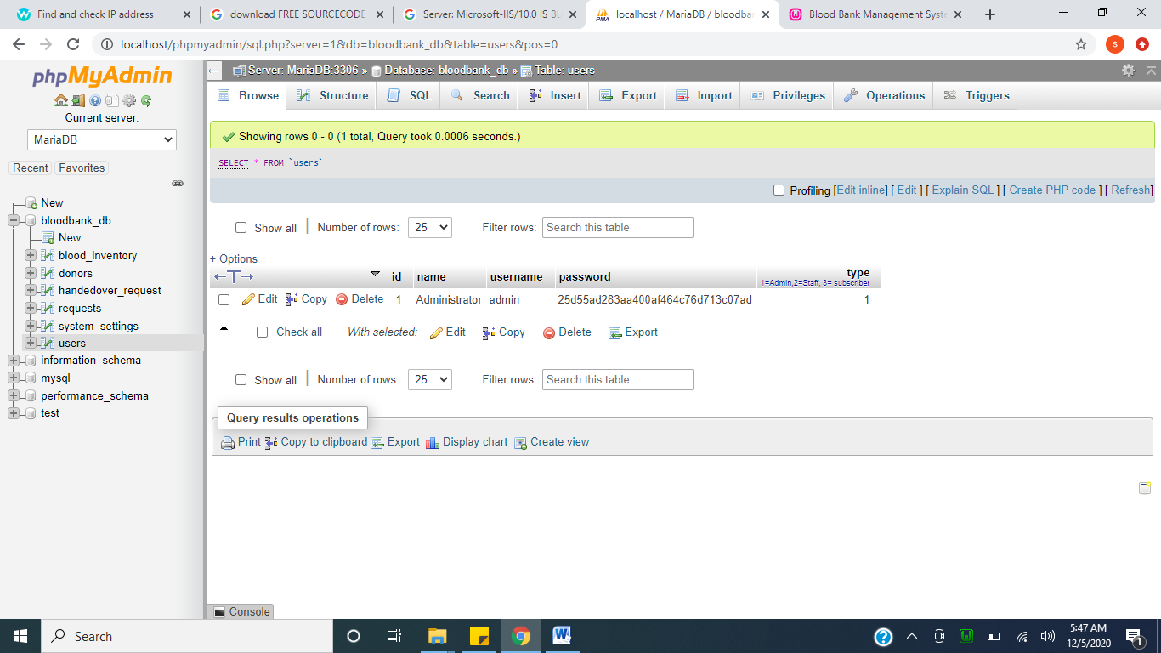
Figure 4.8: Admin login Table: This hold admin and user data who register on the platform.
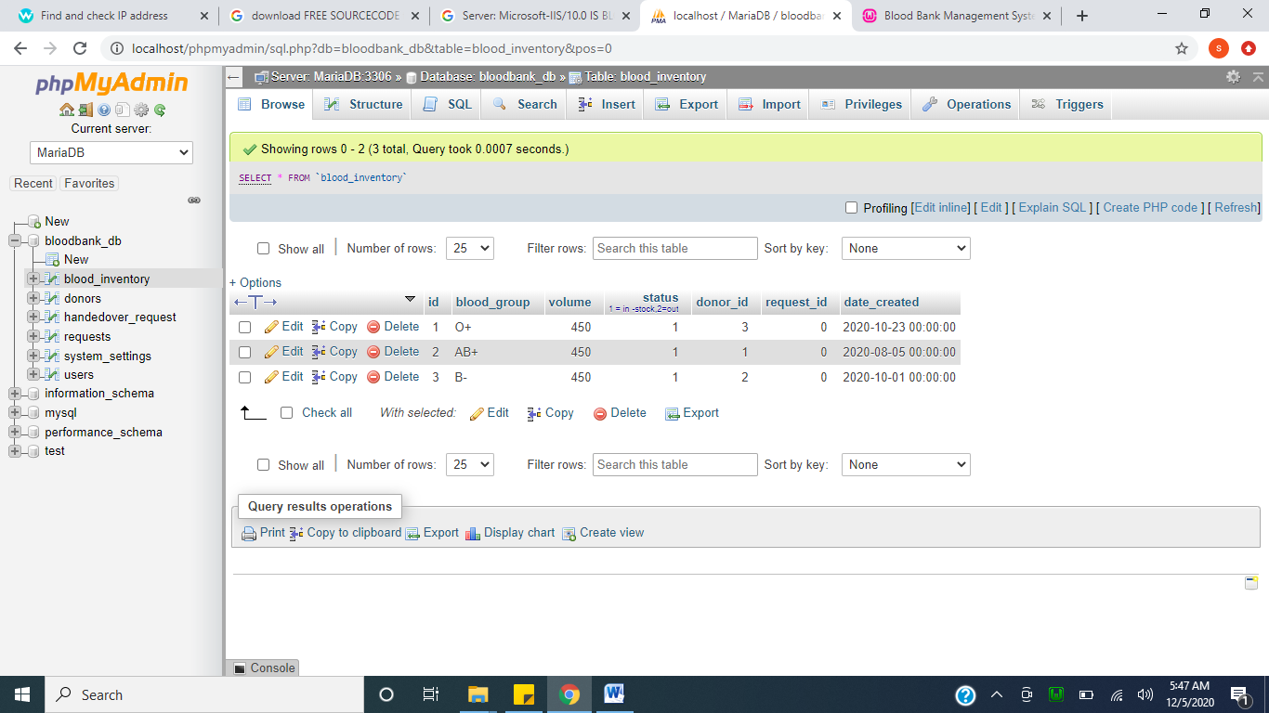
Figure 4.9: Class Table: This hold all class type in the school.
4.1.4 PROCEDURE DESIGN
This refers to the ways in which the proposed system will be used and the steps are as follows:
- Click start on the computer desktop
- Select all programs
- Select any browser e.g Morzilla Firefox , internet Explorer , Google Chrome e.t.c
- Type the url (Uniform Resource Locator) of the system into the address bar (http://localhost/examhall /index.php)

4.2 SYSTEM IMPLEMENTATION
The design system depends on the capabilities and power of the computer on which the application system is installed. However, selecting a choice of application support (Hardware and Software) depends much on:
- How readily the user is to interfere with the computer
- Cost and benefits
- Managements support for changes
Hence, choosing the appropriate hardware and software will enhance the performance of the system.
A most important requirement on which the running of the program basically depends on is the provision of internet facility. So any system that must run this program must be internet ready.
4.2.1 CHOICE OF PROGRAMMING LANGUAGE
The programming language used in the proposed system is php. PHP meaning (PHP Hypertext Preprocessor) is a server-side programming language. It is an open source server-side scripting language that has taken web-based development to a new level of sophistication. The PHP scripting engine is well optimized for the response times needed on web applications, it can even be part of the web server itself improving the throughput even more.
If it were only a matter of improving the speed of the scripts, then PHP will be one of many solutions. But there is more to the PHP equation than that. There is the simplicity and robustness of the language and the scripting engine. There is the connectivity to an ever increasing number of database servers, the shorter development cycles and the ease (encouraged by the syntaxes and constructs) of creating modular and reusable components.
4.2.2 HARDWARE SUPPORT
The hardware that is required in the successful completion of this project includes monitor, CPU, keyboard, mouse, printer and an uninterrupted power supply (UPS) and an internet access.
- An appropriate hard disk storage of at least 120 GB (for the dynamically expandable database)
- A minimum of 1.0 GHz processor
- Random access memory (RAM) of at least 1 GB
- An effective display unit (VGA monitor)
- A suitable printer
- Standard input devices such as keyboard, mouse, etc.
- CD-ROM drive or DVD-ROM drive (since the installation would be made through this medium)
- An uninterrupted power supply (UPS) unit (to prevent abrupt interruption due to power failure)
- A network modem (for internet connection).
4.2.3 SOFTWARE SUPPORT
The software required are basically any web browser (internet explorer, Firefox and the likes), WampServer and a network service, be it wired or wireless.
- A network operating system windows NT from Microsoft, Novell Netware.
- A DBM either PhpMyAdmin
- MySQL as the query language to query the database.
- Wambserver

4.2.4 IMPLEMENTATION TECHNIQUES
The system will be implemented using the parallel approach. This approach is considered because it ensures that the new system is tested along side with the old system to ensure the effectiveness and efficiency of the system.

4.3 SYSTEM DOCUMENTATION
It has to do with the installation and usage of the new system.
After the program has been well tested with input that the output has already been known, the next is to install the software in to the computer system for use.
The process of installing are been stated below
- Insert the CD into the system through the CD-ROM after the computer is switch on
- Locate the CD drive directory in my computer and click it to open
- After open, locate setup.exe, and then click to install the program by following the necessary step in installing the program.
- Ensure full installing of the software for effective operation of the system.
After the program has been fully install. The next thing is to locate the package install to put it into operation, to locate the package for expiration purpose the following step are to be taking
v. Click on start menu from task bar. Then select all program
From the display sub option, select by locating the software installed named http://localhost/examhall /index.phppersonality check to load the software.
4.3.1 PROGRAM DOCUMENTATION
- HOME PAGE
- LIST OF DONOR
- BLOOD INVENROTY
- NEW DONOR

4.3.2 OPERATING THE SYSTEM
- Click on the start button
- Click on control panel
- Click add/remove program
After the configuration, the folder called examhall will be created in the local disk.
4.3.3 MAINTAINING OF THE SYSTEM
- Keeping the system free from virus so as not to corrupt the program installed on the system.
- Having an updated anti-virus.

CHAPTER FIVE
SUMMARY, CONCLUSION AND RECOMMENDATIONS
5.1 SUMMARY
Every institution has examinations held at particular intervals. Placing the students for appearing in the exams is an important of the procedure. If we manually allocate each student to a specified seat, it is a mammoth task. Institutions have various databases and software designed to perform this task.
The paper is attributed to design an Examination Seating Arrangement Tool which automatically places students in their respective seats according to their allotted roll numbers. The students are seated serially roll number wise in numeric order. Each student has a specific seat as allotted by the server and no two students from the same course structure can be seated next to each other. This project focuses on improving the efficiency of the seat allotment system and the tedious task of manually allocating seats to each individual.
5.2 CONCLUSION
The manual method of examination seating arrangement is not only tedious and time consuming but prone to errors as well. This research solves one of the big issues of centralized examination system by offering a series of algorithms. This will reduce a huge number of workload that have to be given by the exam officer before exam to prepare an exam seating arrangement plan. Also this will reduce the risk of mismanagement during exam like not having seats for all students, overlapping of multiple students in the same seat, not having proper distance between students with same question sets, etc. The examination seating arrangement tool depends upon the number of vacant rooms and seating capacity of each room. The rooms are considered as a multi-dimensional array with specified number of rows and columns. The students are placed in each seat one behind the other according to last digits of their enrollment number. This software can be greatly used in every institution for any kind of exam or sometimes even event managements. It decreases our time and makes the procedure very systematic. The software can be extended to various other ways to seat people in a hall for any event or function. The examination seating arrangement tool encompasses a wide variety of uses in our daily lives and has made examination planning very efficient. This software enables the user to be accurate, fast and produce reliable results. It manages the system very efficiently and secures our work.
5.3 RECOMMENDATION
The researcher recommends the following about the system:-
User Training
After the successful system implementation, training of the user (administrator) is one of the most important subtasks of the developer. For this purpose user manuals will be prepared and handled over to the user to operate the developed system. Thus the user is trained to operate the developed system. Both the hardware and software securities are made to run the developed systems successfully in future. In order to put new application system into use, the following activities were taken care of:
- Preparation of user and system documentation
- Conducting user training with demo and hands on
- Test run for some period to ensure smooth switching into the system

a) More research on this system is required to fully identify and eliminate some of the weaknesses.
b) There is need for the system upgrade as user’s requirements increase. User requirements differ with time, therefore, it is of great help for the system to be flexible enough.
c) Other researchers can use this project report as a basis during future study of examination seating arrangement and probably implement it in other institutions.
d) The system can support any network basis architecture, which is for both the client server and peer to peer architecture.

REFERENCES

Anuja Chowdhary, Priyanka Kakde, Shruti Dhoke (2014): “Time table Generation Syst EM,” IJCSMC, VOL. 3, ISSUE. 2, ISSN 2320–088X

Dammak, A. Elloumi, and H. Kamoun. (2006): "Classroom assignment for exam timetabling," Advances in Engineering Software, pp. 659 -666.

Dinesh Ramdas, Damse Pritam, S. Kharat, Shruti Doshi, (2009): “On line Examination Form Sub mission and Report Generation” in CCSW, pp. 103 – 114.
E.K.Burke, B.McCollum, and P.McMullan (2006): “Examination Timetabling: A New Formulation,” International Conference on the Practice and Theory of Automated Timetabling (PATAT 2006), Brno, Czech Republic, ISBN 80-210-3726-1.

Luke We lling, Laura Thompson (2011) “php and mysql web development.

M. Ayob and A. Malik, (2011): “A New Model for an Examination-Room Assignment Problem,” IJCSNS International Journal of Computer Science and Network Security, VOL.11 No.10.

Prof.Santa Kumar Chaki at ell (2016): “Algorithm For Efficient Seating Plan For Centralized Exam System” International Conference on Computational Techniques in Information and Communication Technologies (ICCTICT)

S.Vasupongayya, W.Noodam, and P.Kongyong (2013): “Developing Examination Management System: Senior Capstone Project, a Case Study,” World Academy of Science, Engering and Technology, Vol:7.
T. Prabnarong and S. Vasupongayya (2011): "Examination management system: room assignment and seating layout," Proceeding of the Office of Academic Resources International Conference, Phuket, Thailand

ADD STUDENT
ADD ADMIN
Yes
Start
Open database
Input Student details
Save to database
Any more record ?
No
Close database
Return
Yes
Any more record ?
Start
Open database
Input Admin details
Save to database
No
Close database
Return

LOGIN
Start
Open database
Input login details
Is username & password correct
Display login error
Close database
Return
Main menu
Yes
No
Process details

RECORD
Yes
Start
Open database
Does record exist ?
Close database
Return
Load from Database
Displayall record from database

No

SYSTEM FLOWCHART

Start
Login
Student login
Admin login
Take attendance
Record
Stop

SOURCE CODE
INDEX
<!DOCTYPE html>
<html lang = "eng">
<head>
<meta charset = "utf-8" />
<title>Attendance Record System</title>
<meta name = "viewport" content = "width=device-width, initial-scale=1" />
<link rel = "stylesheet" type = "text/css" href = "css/bootstrap.css"/>
</head>
<body class = "alert-info">
<nav class = "navbarnavbar-inverse navbar-fixed-top">
<div class = "container-fluid">
<div class = "navbar-header">
<imgsrc = "admin/images/logo.png" width = "200px" height = "50px"/>
<p class = "navbar-text pull-right"> Attendance Record System</p>
</div>
</div>
</nav>
<div class = "container-fluid">
<br />
<br />
<br />
<br />
<br />
<br />
<br />
<div class = "col-lg-3"></div>
<div class = "col-lg-6 well">
<h2>Attendance Login</h2>
<br />
<div id = "result"></div>
<br />
<br />
<form enctype = "multipart/form-data">
<div class = "form-group">
<label>Student ID:</label>
<input type = "text" id = "student" class = "form-control" required = "required"/>
<br />
<br />
<div id = "error"></div>
<br />
<button type = "button" id = "login" class = "btnbtn-primary btn-block"><span class = "glyphiconglyphicon-login"></span>Login</button>
</div>
</form>
</div>
</div>
</body>
<script src = "js/jquery.js"></script>
<script src = "js/bootstrap.js"></script>
<script src = "js/login.js"></script>
</html>
ADMIN
<!DOCTYPE html>
<?php
require_once 'validator.php';
require_once 'account.php';
?>
<html lang = "eng">
<head>
<title>Attendance Record System</title>
<meta charset = "utf-8" />
<meta name = "viewport" content = "width=device-width, initial-scale=1" />
<link rel = "stylesheet" href = "css/bootstrap.css" />
<link rel = "stylesheet" href = "css/jquery.dataTables.css" />
</head>
<body>
<nav class = "navbarnavbar-inverse navbar-fixed-top">
<div class = "container-fluid">
<div class = "navbar-header">
<imgsrc = "images/logo.png" width = "200px" height = "50px"/>
<p class = "navbar-text pull-right">Attendance System</p>
</div>
<ul class = "navnavbar-navnavbar-right">
<li class = "dropdown">
<a href = "#" class = "dropdown-toggle" data-toggle = "dropdown"><i class = "glyphiconglyphicon-user"></i><?php echo htmlentities($admin_name)?><b class = "caret"></b></a>
<ul class = "dropdown-menu">
<li><a href = "logout.php"><i class = "glyphiconglyphicon-off"></i> Logout</a></li>
</ul>
</li>
</ul>
</div>
</nav>
<div class = "container-fluid" style = "margin-top:70px;">
<ul class = "navnav-pills">
<li><a href = "home.php"><span class = "glyphiconglyphicon-home"></span> Home</a></li>
<li class = "dropdown active">
<a class = "dropdown-toggle" data-toggle = "dropdown" href = "#"><span class = "glyphiconglyphicon-cog"></span> Accounts <span class = "caret"></span></a>
<ul class = "dropdown-menu">
<li><a href = "admin.php"><span class = "glyphiconglyphicon-user"></span> Admin</a></li>
<li><a href = "student.php"><span class = "glyphiconglyphicon-user"></span> Student</a></li>
</ul>
</li>
<li><a href = "record.php"><span class = "glyphiconglyphicon-book"></span> Record</a></li>
</ul>
<br />
<div class = "modal fade" id = "myModal" tabindex = "-1" role = "dialog" aria-labelledby = "myModallabel">
<div class = "modal-dialog" role = "document">
<div class = "modal-content panel-primary">
<div class = "modal-header panel-heading">
<button type = "button" class = "close" data-dismiss = "modal" aria-label = "Close"><span aria-hidden = "true">&times;</span></button>
<h4 class = "modal-title" id = "myModallabel">Add new Admin</h4>
</div>
<form method = "POST" action = "save_admin_query.php" enctype = "multipart/form-data">
<div class = "modal-body">
<div class = "form-group">
<label>Username:</label>
<input type = "text" required = "required" name = "username" class = "form-control" />
</div>
<div class = "form-group">
<label>Password:</label>
<input type = "password" maxlength = "12" required = "required" name = "password" class = "form-control" />
</div>
<div class = "form-group">
<label>Firstname:</label>
<input type = "text" name = "firstname" required = "required" class = "form-control" />
</div>
<div class = "form-group">
<label>Middlename:</label>
<input type = "text" name = "middlename" placeholder = "(Optional)" class = "form-control" />
</div>
<div class = "form-group">
<label>Lastname:</label>
<input type = "text" name = "lastname" required = "required" class = "form-control" />
</div>
</div>
<div class = "modal-footer">
<button class = "btnbtn-primary" name = "save"><span class = "glyphiconglyphicon-save"></span> Save</button>
</div>
</form>
</div>
</div>
</div>
<div class = "modal fade" id = "delete" tabindex = "-1" role = "dialog" aria-labelledby = "myModallabel">
<div class = "modal-dialog" role = "document">
<div class = "modal-content ">
<div class = "modal-body">
<center><label class = "text-danger">Are you sure you want to delete this record?</label></center>
<br />
<center><a class = "btnbtn-danger remove_id" ><span class = "glyphiconglyphicon-trash"></span> Yes</a><button type = "button" class = "btnbtn-warning" data-dismiss = "modal" aria-label = "No"><span class = "glyphiconglyphicon-remove"></span> No</button></center>
</div>
</div>
</div>
</div>
<div class = "modal fade" id = "edit_admin" tabindex = "-1" role = "dialog" aria-labelledby = "myModallabel">
<div class = "modal-dialog" role = "document">
<div class = "modal-content panel-warning">
<div class = "modal-header panel-heading">
<button type = "button" class = "close" data-dismiss = "modal" aria-label = "Close"><span aria-hidden = "true">&times;</span></button>
<h4 class = "modal-title" id = "myModallabel">Edit Admin</h4>
</div>
<div id = "edit_query"></div>
</div>
</div>
</div>
<div class = "alert alert-info">Accounts / Admin</div>
<div class = "well col-lg-12">
<button type = "button" class = "btnbtn-success" data-target = "#myModal" data-toggle = "modal"><span class = "glyphiconglyphicon-plus"></span> Add new</button>
<br />
<br />
<table id = "table" class = "table table-bordered">
<thead>
<tr class = "alert-info">
<th>Username</th>
<th>Password</th>
<th>Firstname</th>
<th>Middlename</th>
<th>Lastname</th>
<th>Action</th>
</tr>
</thead>
<tbody>
<?php
$q_admin = $conn->query("SELECT * FROM `admin`") or die(mysqli_error());
while($f_admin = $q_admin->fetch_array()){
?>
<tr>
<td><?php echo $f_admin['username']?></td>
<td><?php echo md5($f_admin['password'])?></td>
<td><?php echo $f_admin['firstname']?></td>
<td><?php echo $f_admin['middlename']?></td>
<td><?php echo htmlentities($f_admin['lastname'])?></td>
<td><a class = "btnbtn-danger radmin_id" name = "<?php echo $f_admin['admin_id']?>" href = "#" data-toggle = "modal" data-target = "#delete"><span class = "glyphiconglyphicon-remove"></span></a><a class = "btnbtn-warning eadmin_id" name = "<?php echo $f_admin['admin_id']?>" href = "#" data-toggle = "modal" data-target = "#edit_admin"><span class = "glyphiconglyphicon-edit"></span></a></td>
</tr>
<?php
}
?>
</tbody>
</table>
<br />
<br />
<br />
</div>
</div>
<div class = "navbarnavbar-fixed-bottom alert-warning">
<div class = "container-fluid">
<label class = "pull-left">&copy; Student Attendance System 2019</label>
<label class = "pull-right">Developer: Group: 108</a></label>
</div>
</div>
</body>
<script src = "js/jquery.js"></script>
<script src = "js/bootstrap.js"></script>
<script src = "js/jquery.dataTables.js"></script>
<script type = "text/javascript">
$(document).ready(function(){
$('#table').DataTable();
});
</script>
<script type = "text/javascript">
$(document).ready(function(){
$('.radmin_id').click(function(){
$admin_id = $(this).attr('name');
$('.remove_id').click(function(){
window.location = 'delete_admin.php?admin_id=' + $admin_id;
});
});
$('.eadmin_id').click(function(){
$admin_id = $(this).attr('name');
$('#edit_query').load('load_edit.php?admin_id=' + $admin_id);
});
});
</script>
</html>
LOAD EDIT
<?php
require_once 'connect.php';
$q_edit_admin = $conn->query("SELECT * FROM `admin` WHERE `admin_id` = '$_REQUEST[admin_id]'") or die(mysqli_error());
$f_edit_admin = $q_edit_admin->fetch_array();
?>
<form method = "POST" action = "edit_query.php?admin_id=<?php echo $f_edit_admin['admin_id']?>" enctype = "multipart/form-data">
<div class = "modal-body">
<div class = "form-group">
<label>Username:</label>
<input type = "text" required = "required" value = "<?php echo $f_edit_admin['username']?>" name = "username" class = "form-control" />
</div>
<div class = "form-group">
<label>Password:</label>
<input type = "password" required = "required" maxlength = "12" value = "<?php echo $f_edit_admin['password']?>" name = "password" class = "form-control" />
</div>
<div class = "form-group">
<label>Firstname:</label>
<input type = "text" name = "firstname" value = "<?php echo $f_edit_admin['firstname']?>" required = "required" class = "form-control" />
</div>
<div class = "form-group">
<label>Middlename:</label>
<input type = "text" name = "middlename" value = "<?php echo $f_edit_admin['middlename']?>" placeholder = "(Optional)" class = "form-control" />
</div>
<div class = "form-group">
<label>Lastname:</label>
<input type = "text" name = "lastname" value = "<?php echo htmlentities($f_edit_admin['lastname'])?>" required = "required" class = "form-control" />
</div>
</div>
<div class = "modal-footer">

COMPUTER OUTPUT
Figure 4.1: Admin Homepage: This is the homepage for admin portal
Figure 4.2: View User role: This is where list of user and their role can be view.
Figure 4.3: View room type: This is page view different room type available.
Figure 4.3: Requests: This is request page where admin approve blood donated by the donor.
Figure 4.4: Login page: A login page is a web page or an entry page to a websitethat requires user identification and authentication, regularly performed by entering a username and password combination. Loginsmay provide access to an entire site or part of a website.

