KWARA STATE POLYTECHNIC, ILORIN
DEVELOPMENT OF A MANUALLY CASSAVA UPROOTING MACHINE

BY

OLALERE SODIQ OLADOSUN
ND/23/MEC/PT/0094

A PROJECT SUBMITTED TO DEPARTMENT OF MECHANICAL ENGINEERING
IN PARTIAL FULFILMENT OF THE REQUIREMENT FOR THE AWARD OF NATIONAL DIPLOMA (ND) IN MECHANICAL ENGINEERING, INSTITUTE OF TECHNOLOGY, KWARA STATE POLYTECHNIC ILORIN, NIGERIA.

AUGUST, 2025

CERTIFICATION
The undersigned certified that this project report prepared by OLALERE SODIQ OLADOSUN with the matric number ND/23/MEC/PT/0094. Titled: “Development of a manually cassava uprooting machine” meets the requirement of Department of Mechanical Engineering for the award of National Diploma in Mechanical Engineering.

________________________ ________________
Engr. Jimoh AbdulRaheem Date
Project Supervisor

________________________ ________________
Engr. Issa Abdulganiyu Date
Project coordianator

________________________ ________________
Engr. Ayantola A.A Date
Head of Department

________________________ ________________
Engr. Durojaye J.A Date
External Examinal

DEDICATION
This project is dedicated to Almighty God who has leaded us throughout our National Diploma (ND) program.

ACKNOWLEDGEMENT
All praise and adoration to Almighty God for His infinite mercy on us.
We acknowledge the effort of our supervisor Engr. Jimoh AbdulRaheem for giving us the opportunity to work on this project under his supervision, support, guidance and encouragement from initial stage to the end has enable us to understand the concept of this project work.
Not forgetting our HOD Engr. Ayantola A.A for the moral knowledge he gave us and all our departmental lecturers, workshop technicians, technologists and non-teaching staffs for their support.

ABSTRACT
Cassava is a major source of food and raw material for domestic and industrial uses in Nigeria. Consequently, the technologies involved in its cultivation from planting to harvesting require proper development. This paper reports the development of a labour-saving technology for harvesting cassava using standard procedures for designing soil engaging implements. Locally available materials were also used in the fabrication of the harvester. Results of trial tests indicate a digging efficiency of 58.9%, fuel consumption of 16 l/ha, field capacity of 0.11 ha/hr, field efficiency of 67.9% and root damage of 43.03%. The total cost of fabricating the machine was 184,000 naira only. Further tests under various soil and operational conditions for improvement and optimization were recommended for the purpose of patenting for commercialization.
KEYWORDS: Cassava, uprooting, Fabrication, Digging, Efficiency, Roots.

TABLE OF CONTENTS
Title Page i
Certification ii
Dedication iii
Acknowledgement iv
Abstract v
Table of Content vi
CHAPTER ONE
1.0 Introduction 1
CHAPTER TWO
2.0 Literature Review 2
CHAPTER THREE
3.0 Material and methods 3
3.1 Design calculation 4
3.2 Fabrication of the Machine 7
3.3 Testing of the Uproot 7
CHAPTER FOUR
4.0 Result and Discussion 8
4.1 Maintenance and Precaution 8
CHAPTER FIVE
5.0 Conclusion 10
References

CHAPTER ONE

1.0 INTRODUCTION
Cassava is a basic food crop grown in several developing countries (Shackelford et al., 2018). Today, it is one of the world's most important food crops in tropical countries and ranks as the 6th most important food crop in the world.
Harvesting is the most challenging process in the production of cassava (Reinhardt Howeler et al., 2018). This is because cassava is a highly perishable crop and it starts to deteriorate after one to three days of harvest (Raju Saravanan et al., 2016). Therefore, harvesting cassava at the right time and in the right way is critical. Too early harvesting results in low yield and poor food quality; on the other hand, the central part becomes woody and inedible when the roots are left in the soil for too long (Amponsah, 2017). Cassava is ready for harvest as soon as storage roots are sufficiently large to satisfy the consumer's needs, from 6 to 7 months after planting, especially for most new cultivars of cassava. Mature roots cluster around the base of the plant and extend on all sides, approximately 60 cm. The crop is grown for these roots which contain 15–40% starch. Under the most favourable conditions, fresh root yields can exceed 90t/ha, while average root yields are 10t/ha, mostly from subsistence farming systems. Traditionally, cassava is harvested by hand, raising the lower part of the stem and extracting the roots from the ground, and then removing them by hand from the base of the plant. Until harvesting, the top portions of the stems with the leaves are usually removed. It is possible to use levers and ropes to help harvest. It is also possible to use a mechanical harvester. Mechanical harvesters will grab the stem and raise the roots from the ground.

CHAPTER TWO
Developing labour-saving technologies for harvesting cassava has become the world's most important obstacle in the transformation of cassava (FAO & IFAD 2005). Earlier attempts at mechanized harvesting were affected by constraints such as soil characteristics, tuber nature and size, cluster depth and width, and tuber bonding with soil, resulting in high tuber damage. Amponsah et al. (2010) state that, farm size and root tuber breakage level are critical factors considered in the selection and adoption of any method of harvesting cassava. Farmers around the globe have essentially three ways to harvest cassava: manual, semi-manual and mechanized.
Manual harvesting is the traditional method of harvesting cassava using bare hands with or without the use of native tools such as hoe, cutlass, mattock, earth chisel, etc. Manual harvesting takes about 22–62-man days per hectare (Nweke et al., 2011). The distinct unit operations for the harvesting of cassava include loosening the roots and pulling up the crops, removing the soil and separating the roots, collecting the roots and loading them for transport. Existing manual harvesting techniques contribute to drudgery and wasting, and they consume a lot of time as well as farm labour, which is scarce and expensive.
Additional benefits of using harvesters include a reduction in the total cost of production, an increase in labour productivity and a significant reduction in harvest losses and root damage. Several attempts have been made in developing cassava harvesters; it was discovered that those that were developed were with one defect or the other. This has necessitated the development of a new cassava harvester of better quality.

CHAPTER THREE
3.0 MATERIALS AND METHODS
Design Features
The developed cassava harvester for harvesting cassava consists of the following components:
Frame: The frame is the skeletal structure that holds the whole parts of the implement together, and to which the point of attachment to the tractor three-point linkage is welded. The design factors considered in the determination of the material required for the frame are weight and strength.
Leg: The leg is the part of the cassava harvester that joins the frame to the shoe of the implement. The material selected for this part requires high strength and durability to withstand shock and vibrations during operation.
Shoe: This is the part of the cassava harvester that enters into the soil and lifts the cassava out of the soil; it has a sharp/pointed edge that enters into the soil.
Bolt and Nut: All the parts of the cassava harvester are coupled together by the means of bolt and nut at the respective joints.
Spikes: The spikes, which are welded to a flat bar, are attached to the shoe of the implement to shake off the soil from the cassava tuber as the implement lifts the cassava from the soil.
Point of Attachment (3-Point Linkage): The point of attachment is the point at which the implement is coupled/hitched to the tractor through the three-point linkages which are coupled with the procedure LEFT - RIGHT - TOP.

3.1 DESIGN CALCULATIONS
The design calculations were done using standard procedure reported by Godwin and Spoor (1978), Agbetoye et al. (2000) and Crossly (1983).
Determination of Soil Force
The average depth of the mature cassava tuber will help to determine the length of the digging shovel. Soil force required to uproot a mature cassava tuber is calculated using
𝑝 = 𝛾𝑍2𝑁𝛾 + 𝐶𝑍𝑁𝑐𝑎 + 𝑞𝑍𝑁𝑄
where Z = working depth of digging shovel q = surcharge
𝛾 = bulk unit weight of the soil C = cohesion
𝑁𝛾, 𝑁𝑐𝑎, 𝑁𝑄 are dimensionless Reece factors δ = angle of soil/metal friction

Selection of Rake Angle
The effective rake angle of complex shaped tines is the chord joining the working tip with the point where the line meets the soil surface.
α

Determination of Draft Per Unit Width (KN/m)
Draft per unit width (KN/m) is obtained by using the equation:
𝐷 = 𝑃 𝑠𝑖𝑛 (𝛼 + 𝛿) + 𝐶𝑎𝐶𝑜𝑠𝛼
where 𝛿 = angle of soil/metal frictions
𝛼 = rake angle

𝐶 = 𝐶∝𝑍
𝑆𝑖𝑛 ∝𝑎
(Z = working depth of digging shovel
Determination of Vertical Force Per Unit Width (KN/m)
This was obtained using the formula below:
𝑉 = 𝑃𝑐𝑜𝑠 (𝛼 + 𝛿) + 𝐶𝑎 𝑆𝑖𝑛𝛼

Determination of Power Requirement Per Unit Width
This was obtained using the formula below:
𝑃𝑜 = D.V
where D = draft force in KN/m
V = tractor forward speed

Determination of Vertical Force Per Unit Width (KN/m)
This was obtained using the formula below:
𝑉 = 𝑃𝑐𝑜𝑠 (𝛼 + 𝛿) + 𝐶𝑎 𝑆𝑖𝑛𝛼

Determination of Power Requirement Per Unit Width
This was obtained using the formula below:
𝑃𝑜 = D.V
where D = draft force in KN/m
V = tractor forward speed (m/s)

Determination of Tensile Stress of the Bolt
Tensile stress of the bolt is obtained using the equation:
P= ^{𝜋𝑑𝑐}2 × 𝛿𝑡 (Crossley, 1983)
4
where 𝑑𝑐 = diameter of the thread
𝛿𝑡 = permissible tensile stress for bolt materials
Determination of Shear Stress
Shear stress of the bolt is obtained using the equation (Crossley, 1983) given as:
ɤ = ^{𝜋𝑑}2×τ
𝑠 4
where d = major diameter of the bolt, τ = number of bolts
Determination of Weight of Digging Material
Volume of soil with digger = 𝐴 × 𝐻
where A = cross sectional area of digger H = Height of soil level on digger M = 𝜌𝑠𝑜𝑖𝑙× 𝑉𝑠𝑜𝑖𝑙
Weight of the digger (w) = m × g
g = 9.81
Determination of Rupture Distance Ratio
F
Z
This is obtained using the formula below: M= ^{𝐹}𝑍
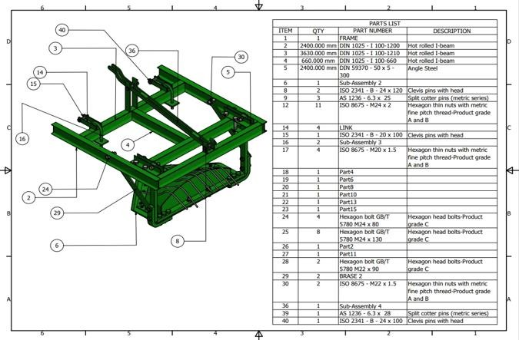

Figure 1: Fabricated cassava harvester showing component parts

Fabrication of the Machine
Fabrication of the cassava harvester involves cutting, bending, grinding, joining and drilling of metals of various sizes and shapes as shown in Figure 1.
Testing of the Cassava Uproot
Trial tests were conducted to examine the effectiveness of the implement in harvesting cassava ercompared to that of the digging shovel; the ability to penetrate into the soil and dig up cassava tuber without considerable damage is an important factor in evaluating its performance.
A well mechanized farm was used for the harvesting operation. The implement was coupled to the tractor appropriately through the three-point linkage, starting from the left link to the right link and to the top link, and was conveyed to the farm. The cassava stem of each row was cut and cleared to ease the operation of the implement, then the tractor mounted with implement was positioned at the start of the first row. The implement was lowered into the soil and was driven through the row at a required speed to the top end of the row. The implement was raised up at the top end and a U-turn movement was made to position the implement at the tip end of the other row. The implement was lowered once again and then driven through the row to harvest the cassava.

CHAPTER FOUR

4.0 RESULTS AND DISCUSSION

Results
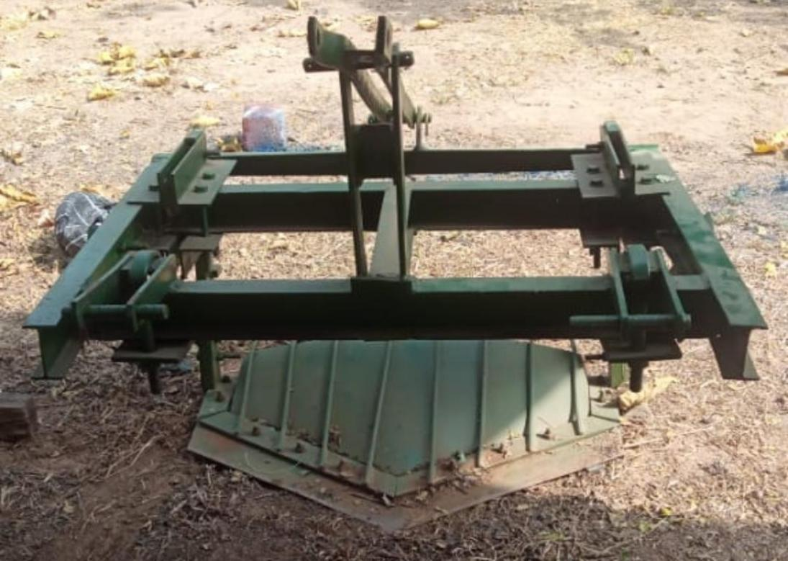

Test Results of the Machine
The results obtained from the field test of the cassava harvester were used to determine the following parameters:
Digging Efficiency
After the harvesting of the cassava tubers, dug tubers were weighed. The area was then inspected for undogged tubers which were manually dug out from the soil. The undugged tubers were also weighed.
Dug tubers = 24.10 kg, total root yield = 40.9 kg
Digging Efficiency = 𝑑𝑢𝑔 𝑡𝑢𝑏𝑒𝑟𝑠/𝑡𝑜𝑡𝑎𝑙 𝑟𝑜𝑜𝑡 𝑦𝑖𝑒𝑙𝑑× 100% = 24.10 × 100% = 58.9% 40.9
The digging efficiency obtained is lower when compared with that of other cassava harvesters, which may be partly due to the fact that the testing was conducted during the dry season and the field was not prepared specifically for the testing.

Theoretical Field Capacity
TFC = 𝑤𝑖𝑑𝑡ℎ(𝑐𝑚)× 𝑠𝑝𝑒𝑒𝑑( 𝑠 ) × 36
10000

Width = 200 cm, speed of harvesting operation = 0.225 m/s
TFC = ²⁰⁰ × ^{0.225} × ³⁶ = 0.162 ha/hr
10000

Effective Field Capacity (C)
Area covered = 20 × 1.6 ×1= 32 𝑚²
Time of operation = 105 sec = 0.029 hr

C= 𝐴 × 3600
10000 × 𝑡

(ha/hr) = ³² × ³⁶⁰⁰
10000 × 105
= 0.11 ha/hr

CHPTER FIVE
The field capacity obtained is higher than that of the cassava digger produced by Thangdee and Wongpichet (2012), which was 0.05 ha/hr, and higher than that of the tractor-operated cassava digger produced by Jesudas et al. (2014), which was 0.07 ha/h

REFERENCES
Agbetoye, L. A. S., Dyson, J. and Kilgour, J. (2000): Prediction of the Lifting Forces for Cassava Harvesting. Jornal. agric. Engineering Research. 75: 39-48.
Amponsah, S.K, Addo A. and Gangadharan (2017). Review of various harvesting options for Cassava. IntechOpen.com
Amponsah, S.K, Sheriff, J.T. and Byju, G. (2010): Comparative evaluation of manual cassava harvesting techniques in Kerala India. Agric. Eng. Int. CTCRI.; pp.16:41-52.
FAO and IFAD (2005): Proceeding of the validation form on the Global Cassava Development Strategy, Volume 2. A review of cassava in Africa with country case studies on Nigeria, Ghana, the United Republic of Tanzania, Uganda and Benin.
Godwin RJ Spoor G. (1978). An experimental investigation into the deep loosening of soil by rigid tines. Journal of Agricultural Engineering Res., 23 (3) (1978) pp. 243-258.
Hall, A.S., Holowenko, A.R., Laughing H.G (1982): Machine design. Mc Grawhill, Singapore3rd edition pp.45.
National Center for Agricultural Mechanization NCAM, (2013): Review of Various Harvesting Options for Cassava. http://dx.doi.org/10.5772/intechopen.71350 Review of Various Harvesting Options for Cassava http://dx.doi.org/10.5772/intechopen.71350 pp: 303.
Nweke, F.I.; Dixon, A.G.O.; Asiedu, A. and Folayan, S.A. (2011): Cassava varietal needs of farmers and the potential for production growth in Africa. Pp: 32, 89-90.
Raju Saravanan, Vinisa Ravi, R. Stephen, S. Tajuddin & J. George (2016): Post-harvest physiological deterioration of cassava – A review. Researchgate.net
Reinhaerdt Howeler, Peter Cain, Larry Trumbore and Sapto Utomo Hidajat (2018): The Challenge of large-Scale cassava production. Researchgate.net

