A PROJECT REPORT
ON
RESTUARANT
FOR
LUKMAN MUSTAPHA OLAYIWOLA
AT
KWARA STATE POST OFFICE ILORIN, KWARA STATE.
BY
TEMIM IBRAHIM ALABI
ND/23/ARC/PT/0020
BEING A PROJECT SUBMITTED TO:
THE DEPARTMENT OF ARCHITECTURAL TECHNOLOGY
INSTITUTE OF ENVIRONMENTAL STUDIES
KWARA STATE POLYTECHNIC, ILORIN
IN PARTIAL FULFILMENTS OF THE REQUIREMENTS FOR AWARD OF
NATIONAL DIPLOMA (ND) IN ARCHITECTURAL TECHNOLOGY
JULY, 2025

DECLARATION
I declare that this design project is a project of my personal efforts. It has not been
presented for the award of any ND in any Ilorin post office. The ideas, observations,
comments, suggestions here in represent my own convictions, except quotations, which
have been acknowledged in accordance with conventional academic traditions.
TEMIM IBRAHIM ALABI.
-----
----------------------------
ND/23/ARC/PT/0020
SIGNATURE/DATE
ii

I certify that this design project entitled RESTAURANT was carried out by me
TEMIM IBRAHIM ALABI under the supervision of ARC. OLAREWAJU F.A and has
been approved as meeting the requirements for the award of National Diploma (ND) in
Architectural Technology Institute of environmental studies Kwara State Ilorin.
--------------------------------
SIGNATURE AND DATE
---------------------------------
SIGNATURE AND DATE
---------------------------------
SIGNATURE AND DATE
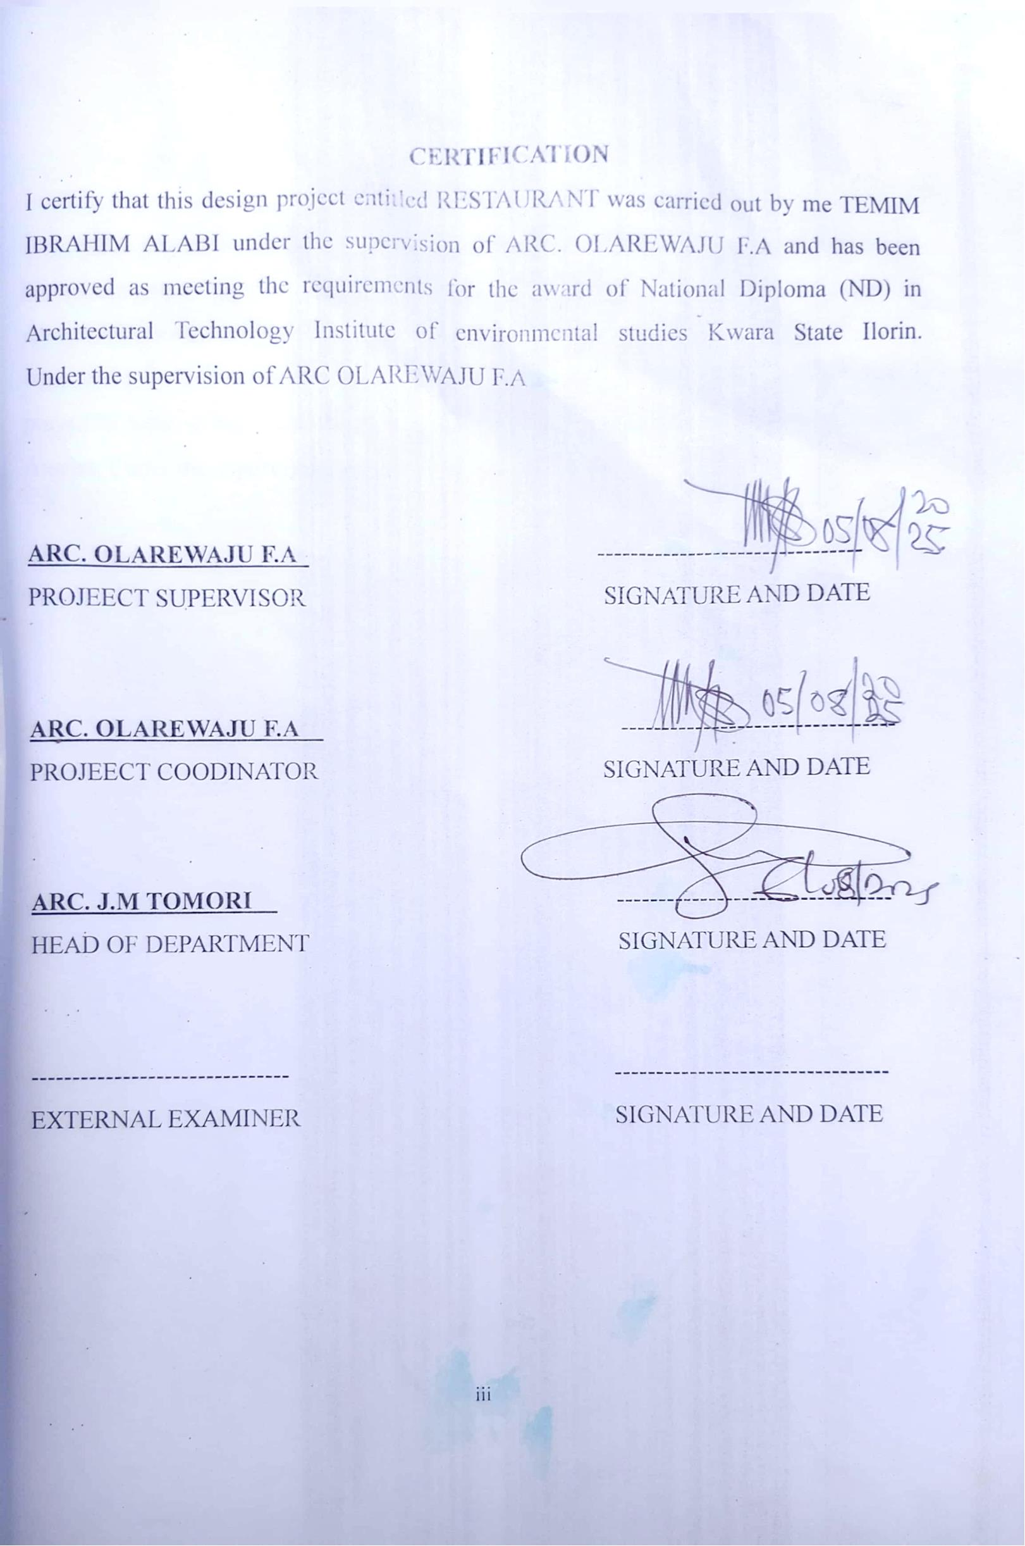

DEDICATION
This project is dedicated to Almighty Allah, the master of the universe who out of
his infinity mercy that prevailed over judgment has guided me throughout the period of
my academic career to him all honors. Glory Adoration
Also to my loving caring parents for their love and support right from birth, till
date, I prayed to Allah in his sufficient mercy grant all them their heart desired Ameen-
thuma- Ameen
iv

ACKNOWLEDGEMENT
Firstly, my gratitude goes to Almighty Allah for granting me good health throughout the
duration of my course and the grace to complete another phase of my academic pursuit.
My appreciation also goes to my mentor in person of ARC. OLAREWAJU F.A for the
patience and assistance of fared during the writing of this project. And also to all the
entire lecture and the management of Architectural department starting from director of I.E.S (ARC B.F.Y ABDULAZEEZ, H.O.D ARC J.M TOMORI, ARC CHUCKUWMA, ARC FAMILIUM S.O, ARC BOLAKALE

I also acknowledged to my loving mother and also to the most supporting person
have ever seen my lovely father for their financially and sponsored on me throughout
my programme.

My indebted gratitude goes to my brother and sister for their financial and moral
support during the course and my loving one may Allah reward you richly.
Finally, my appreciation also goes to my friend and my course mate in mention
like, olamilekan, sulaiman, Ibrahim for their support from the beginning of this program
till end.
v

TABLE OF CONTENT
Declaration ...ii
Certification .....iii
Dedication .iv
Acknowledgement . v
Table of content vi
List of tables .. .viii
List of figures .. ix
List of plates .x
List of appendices xi
Abstract xii
CHAPTER ONE
1.0
introduction of the study 1
1.1 project definition 3
1.2
1.3
1.4
1.5
historical background .. . .3
Aim and Objectives of the project ....4
Justification for the Project ...4
Scope of the Study 4
Limitation of the Study .5
Research Methodology .5
1.6
1.7
CHAPTER TWO
2.0
2.1
Review of Literature of the project... .. . .6
Review of relevant literature on building .. ...6
2.2 Review of literature on sub-topic of the thesis . 7
CHAPTER THREE
3.0
3.1
3.2
Case Studies .. 9
Case Study one .. . ...9
Case Study two ........12
vi

3.3
Case Study three . .. ..….15
3.4 Case study four online case study .........18
3.3
3.5
3.6
Case
Study
five
online
case
study .. .19
Findings and Discussions ... ...19
Deductions for studies .…..19
CHAPTER FOUR
4.0
4.1
4.2
4.3
Analysis of Topographical and Environmental Conditions of the site .…20
Introduction of the Study area ... 20
Site Location and description ...22
Site Analysis/Inventory .. ..23
4.4 Geographical / climatic data . 25
4.5
4.6
4.7
Design Criteria .26
Brief Analysis/Project goals . . . ..26
Spatial Allocation .....27
4.8 Functional relationship . . . ..28
4.9 Conceptual Development . .…...28
CHAPTER FIVE
5.0
5.1
5.2
5.3
5.4
5.5
5.6
Approach to the Design …. .. .29
Technological and Environmental Criteria .…......29
Essential Service Required …. ....30
Environmental Conditions to Be Achieved …. .. .32
Performance Standard ..…...32
Legal Issue & Planning Regulation .. ..33
behavioral pattern and Considerations....................................................... ...33
5.7 Summery .. .34
5.8
Conclusions and Recommendations … .34
Reference … ..36
Appendices ..... ..38
vii

LIST OF TABLES
Table 4.5.1: Showing the Geographical and Climate Data of Ilorin .25
Table 4.5. 2: Showing the Average Temperature of Ilorin 26
Table 4.10.1: Space Allocation for the design .. 27
viii

LIST OF FIGURES
Fig3.1.1: showing the location plan of case study one . 9
fig3.1.2: showing the floor plan of case study one . . .9
fig3.2.1: showing the location plan of case study two ... ..12
fig3.2.2: showing the floor plan of case study two . ..…. ..12
fig3.3.1: showing the location plan of case study three .. .. ...15
fig3.3.2: showing the floor plan of case study three ............................15
Fig5.1: showing The site inventory .. …...............23
Fig5.2: showing The site analysis .. ... ..….. .........24
ix

LIST OF PLATES
Plate3.1.1: showing approach view of case study one----------------------------------------11
Plate3.1.2: showing side view of case study one ---------------------------------------------11
Plate3.1.3: showing the inner view of case study one ---------------------------------------12
Plate3.2.1: showing approach view of case study two --------------------------------------14
Plate3.2.2: showing left view of case study two ---------------------------------------------14
Plate3.2.3: showing inner view of case study two -------------------------------------------15
Plate3.3.1: showing approach view of case study three-------------------------------------17
Plate3.3.2: showing side view of case study three-------------------------------------------17
Plate3.3.2: showing inner view of case study three------------------------------------------18
Plate3.4.1: showing internal view of case study four (online case study) --------------18
Plate3.5.1: showing internal view of case study five (online case study) --------------------
19
x

LIST OF APPENDICES
Appendix 5.3; showing the site plan . .. 38
Appendix 5.4; showing the floor plan ..........................................................39
Appendix 5.5; showing the roof plan ..40
Appendix 5.6; showing the sections ..41
Appendix 5 8; showing the elevations . 42
Appendix 5.12; showing the external perspective.….....43
Appendix 5.13; showing the internal perspective .… . .. ..43
xi

ABSTRACT
Restaurants play a significant role in our lifestyles, and dining out is a favorite social
activity. Everyone needs to eatso, to enjoy good food and perhaps wine in the company
of friends and in pleasant surroundings is one of lifes pleasures. Eating out has become
a way of life for families. Today, more meals than ever are being eaten away from home.
The methodology used for this project was based on the survey of existing similar project
undertaken as case studies and review of literature on the subject matter via internet.
Deduction from the findings indicate that the restaurant should be well equipped with
adequate spaces, ray of sunlight, material to be used and maintenance of plant, the
project include the proposal power house, Gate House, Relaxation Area and Car Park.
xii

CHAPTER ONE
1.0 INTRODUCTION
1.1 BACKGROUND OF THE STUDY
Restaurant is a place where the diners could buy food and drink with a high-service.
There are lots of restaurants around Bali, either they belong to hotels or stand alone.
According to White M (2019), restaurant is a place that could be visited by everyone
which provides and sells food and beverage commercially to personal, couple or group.
Restaurants offer service of Food and Beverage desires to satisfy the guest. The food and
beverage service department is the department that has a contribution for the positive
feed-back given by the guests in the restaurant. The waiter/waitresses are the sections in
food and beverage service who are responsible to give best service to the guest. By giving
the best service, guests would feel satisfied and mostly they would give good reviews to
the restaurant. As waiters, they have to know the job description before assisting the
guests in every section and know the conversation or the language used for assisting
guests. Jejaton restaurant is a restaurant in Fairfield by Marriot Kuta Sunset Road. Jejaton
restaurant provides Indonesian traditional food. It makes this restaurant different than
others. Not only is the food, the equipment used for food are also made from traditional
things, such as: plate from wood, straw from bamboo and etc. The guests who are coming
to have meal in this restaurant are not only the in-house guest (guest who are staying in
the hotel). There are lots of guests come from outside. Many of them said that this
restaurant is like a beauty in simplicity.
Based on the review, this shows the logical progression from dream to reality, from
concept to finding a market gap to managing and operating a restaurant. Along the way,
it gives a comprehensive picture of the restaurant business. Going into the restaurant
business is not for the faint of heart. People contemplating opening a restaurant come
from diverse backgrounds and bring with them a wealth of experience. However, there
is no substitute for experience in the restaurant businessespecially in the segment in
which you are planning to operate.
1

Eating out has a long history. Taverns existed as early as 1700 b.c.e. The record of a
public dining place in Ancient Egypt in 512 b.c.e. shows a limited menuonly one dish
was served, consisting of cereal, wild fowl, and onion. Be that as it may, the ancient
Egyptians had a fair selection of foods to choose from: peas, lentils, watermelons,
artichokes, lettuce, endive, radishes, onions, garlic, leeks, fats (both vegetable and
animal), beef, honey, dates, and dairy products, including milk, cheese, and butter.
The ancient Romans were great eaters out. Evidence can be seen even today in
Herculaneum, a Roman town near Naples that in 70 a.d. was buried under some 65 feet
of mud and lava by the eruption of Mt. Vesuvius. Along its streets were a number of
snack bars vending bread, cheese, wine, nuts, dates, figs, and hot foods. The counters
were faced with marble fragments. Wine jugs were imbedded in them, kept fresh by the
cold stone. Mulled and spiced wines were served, often sweetened with honey. A number
of snack bars were identical or nearly so giving the impression that they were part of a
group under single ownership.
Bakeries were nearby, where grain was milled in the courtyard, the mill turned by blind-
Folded asses. Some bakeries specialized in cakes. One of them had 25 bronze baking
pans of various sizes, from about 4 inches to about 1.5 feet in diameter.
After the fall of Rome, eating out usually took place in an inn or tavern, but by 12:00 a.m.
There were cooking houses in London, Paris, and elsewhere in Europe, where cooked
food could be purchased but seating wasnt available. Medieval travelers dined at inns,
taverns, hostelries, and monasteries.
1.2PROJECT DEFINITION
RESTAURANT
According to White M (2019), restaurant is a place that could be visited by everyone
which provides and sells food and beverage commercially to personal, couple or group.
Restaurant is a place where the diners could buy food and drink with a high-service.
2

1.3 JUSTIFICATION
To design a well functional and spacious restaurant located at Department of
Agriculture Ilorin Kwara State and to design, fabricate and install a well functioned new
restaurant suitable for use as a place of income and also to develop a project demonstrate
excellent practice in suitable environmental design at Department of Agriculture Ilorin
Kwara State.
The structure will demonstrate the best of aesthetic contemporary and environmental
design practice.
1.4
AIM AND OBJECTIVEs
AIM
The aim of the design project is to design a functional, aesthetically balanced restaurant
that aid the economic situation and reconnect people with their food and high light the
value of locally grown produce and healthy eating and lifestyles for kwara state ilorin
post officeIlorin
OBJECTIVES
(i) Identify various causes of fire incidences in the restaurant
(ii) Identify and evaluate construction techniques that would help in functionality
(iii)
To create a restaurant that relate to and complement each other through site
design, for example, through shared use of public spaces and landscape
connections.
(iv)
To create a restaurant that respond to their context and complement each
other in their building design and street orientation.
(v) To facilitate linkages among uses on and off site through use of pedestrian,
bicycle and circulation connections, shared access and parking.
(vi)
Design a spacious restaurant that can accommodate people and their
circulations.
3

1.5
SCOPE OF PROJECT
The design project will provide facilities that are necessary in the restaurant with more emphasis
on passive means of fire safety. The outdoor spaces as much as the indoor spaces will receive
attention. It will accommodate only female students. Facilities to be provided in the hostel would
include;
Main building.
1.6
LIMITATION OF DESIGN
The project is limited on main restaurant in Kwara State post office Ilorin. And also
limited to planting eight different crops in it due to sufficient area of land provided.
1.7 RESEARCH METHODOLOGY
Various method of research has been regards the architectural design of restaurant.
This involves series of research in order to achieve a balance structure in design of
RESTAURANCE.
1. Case studies
2. Oral interview
3. Literature review
4. Site visitation
CASE STUDY: As the name implies involves a study of an existing structure that are
similar to the proposed project.
ORAL INTERVIEW: Individual interview was carried out randomly with member of
the housing.
LITERATURE REVIEW: Relevant textbooks, lecture notes, magazines, journals and
pdf notes.
SITE VISITATION: In the research all the mentioned above would not have meaning if
the site were not visited so the site visitation confirmed all that is necessary to be adopted
in the design.
4

CHAPTER TWO
2.0
REVIEW OF RELEVANT LITERATURE
Restaurant is an establishment that prepares and serves food and drinks to customers.
Meals are generally served and eaten on the premises, but many restaurants also offer
take-out and food delivery services. Restaurants vary greatly in appearance and offerings,
including a wide variety of cuisines and service models ranging from inexpensive fast-
food restaurants and cafeterias to mid-priced family restaurants, to high-priced luxury
establishments.
In the United States, it was not until the late 18th century that establishments that
provided meals without also providing lodging began to appear in major metropolitan
areas in the form of coffee and oyster houses. The actual term "restaurant" did not enter
into the common parlance until the following century. Prior to being referred to as
"restaurants" these eating establishments assumed regional names such as "eating house"
in New York City, "restorator" in Boston, or "victualling house" in other areas.
Restaurants were typically located in populous urban areas during the 19th century and
grew both in number and sophistication in the mid-century due to a more affluent middle
class and to urbanization. The highest concentration of these restaurants were in the
West, followed by industrial cities on the Eastern Seaboard.
When Prohibition went into effect in 1920, restaurants offering fine dining had a hard
time making ends meet because they had depended on profits from selling wine and
alcoholic beverages. Replacing them were establishments offering simpler, more casual
experiences such as cafeterias, roadside restaurants, and diners. When Prohibition ended
in the 1930s, luxury restaurants slowly started to appear again as the economy recovered
from the Great Depression.
The Civil Rights Act of 1964 outlawed segregation based on race, color, religion, or
national origin in all public accommodations engaged in interstate commerce, including
restaurants. Katzenbach v. McClung, 379 U.S. 294 (1964), was a decision of the US
Supreme Court which held that Congress acted within its power under the Commerce
5

Clause of the United States Constitution in forbidding racial discrimination in restaurants
as this was a burden to interstate commerce.
In the 1970s, there was one restaurant for every 7,500 persons. In 2016, there were
1,000,000 restaurants; one for every 310 people. The average person eats out five to six
times weekly. 3.3% of the nation's workforce is composed of restaurant workers.
According to a Gallup Poll in 2016, nearly 61% of Americans across the country eat out
at a restaurant once a week or more, and this percent is only predicted to increase in
future years. Before the COVID-19 pandemic, The National Restaurant Association
estimated restaurant sales of $899 billion in 2020. The association now projects that the
pandemic will decrease that to $675 billion, a decline of $274 billion over their previous
estimate.
2.1
REVIEW OF RELEVANT LITERATURE ON BUILDING.
FRENCH CULINARY HISTORY
The first restaurant ever was called a public dining room and established in France.
Through-out history, France has played a key role in the development of restaurants. The
first restaurant that actually consisted of patrons sitting at a table and being served
individual portions, which they selected from menus, was founded in 1782 by a vendor
named Beau Villiers. It was called the Grand Tavern de Londres. However, this was not
the beginning of the restaurant concept. The first restaurant proprietor is believed to have
been A. Boulanger, a soup vendor, who opened his business in Paris in 1765.7 He sold
soups at his all-night tavern on the Rue Bailee. He called these soups restaurants
(restoratives), which is the origin of the word restaurant. Boulanger believed that soup
was the cure to all sorts of illnesses. However, he was not content to let his culinary
repertoire rest with only a soup kitchen. By law at the time, only hotels could serve food
(soup did not fit into this category). In 1767, he challenged the traitors (hotel
restauranteurs) monopoly and prepared a soup that consisted of sheeps feet with a white
sauce. The traitors guild filed a lawsuit against Boulanger, and the case went to the
French Parliament. Boulanger won the suit and soon opened his restaurant, Le Champ
dOiseau.
6

In 1782, the Grand Tavern de Londres, a true restaurant, opened on the Rue de Richelieu;
three years later, Aux Trois Frères Provençaux opened near the Palais-Royal. The French
Revolution in 1794 literally caused heads to rollso much so that the chefs to the former
nobility suddenly had no work. Some stayed in France to open restaurants and some went
to other parts of Europe; many crossed the Atlantic to America, especially to New
Orleans.
AMERICA RESTAURANT REVIEW
The beginning of the American restaurant industry dates back to 1634, when Samuel
Coles opened an establishment named Coles Ordinary in Boston. It was a tavernthe first
tavern of record in the American colonies. It was quite successful, lasting well over 125
years. Prior to the American Revolution, establishments selling food, beverages, and a
place to sleep were called ordinaries, taverns, or inns. Rum and beer flowed freely. A
favorite drink, called flip, was made from rum, beer, beaten eggs, and spices. The
bartender plunged a hot iron with a ball on the end into the drink. Flips were considered
both food and a drink. If customers had one too many flips, the ordinaries provided a
place to sleep.
In America, the innkeeper, unlike in Europe, was often the most respected member of the
community and was certainly one of its substantial citizens. The innkeeper usually held
some local elected office and sometimes rose much higher than that. John Adams, the
second president of the United States, owned and managed his own tavern between 1783
and 1789.9 the oldest continually operating tavern in America is the Frances Tavern in
New York City, dating from about 1762. It served as the Revolutionary headquarters of
General George Washington and was the place where he made his farewell address. It is
still operating today.
The restaurant, as we know it today, is said to have been a byproduct of the French
Revolution. The term restaurant came to the United States in 1794 through a French
refugee from the guillotine, Jean-Baptiste Gilbert Paypalt. Paypalt set up what was likely
the first French restaurant in this country, Juliens Restauranteur, in Boston. There he
served truffles, cheese fondues, and soups. The French influence on American cooking
7

began early; both Washington and Jefferson were fond of French cuisine, and several
French eating establishments were opened in Boston by Huguenots who fled France in
the eighteenth century to escape religious persecution.
2.2 REVIEW OF LITERATURE ON SUB-TOPIC OF THE THESIS
2.2.1 COMMON TYPES OF STRUCTURES
THE COFFEEHOUSE
The coffeehouse which appeared in Oxford in1650 and seven years later in London, was
a forerunner of the restaurant today. Coffee at the time was considered a cure-all. As one
advertisement in 1657 had it: ... Coffee closes the orifices of the stomach, fortifies the
heat within, and helped digesting ... is good against eyesores, coughs, or colds...  Lloyds
of London, the international insurance company, was founded in Lloyds Coffee House.
By the eighteenth century, there were about 3,000 coffeehouses in London.
Coffeehouses were also popular in Colonial America. Boston had many of them, as did
Virginia and New York. Both the words cafe, meaning a small restaurant and bar, and
cafeteria come from the single word cafe, French for coffee.
In the eighteenth century, with the exception of inns which were primarily for travelers,
food away from home could be purchased in places where alcoholic beverages were sold.
Such places were equipped to serve simple, inexpensive dishes either cooked on the
premises or ordered from a nearby inn or food shop. Tavern-restaurants existed in much
of Europe including France and Germany with
8

CHAPTER THREE
3.0CASDE STUDY SELECTED
1. CASE STUDY ONE; LOCATION: AT ADO EKITI STATE
2. CASE STUDY TWO; LOCATION: AT, CHICKEN REPUBLIC TAIWO ROAD
ILORIN, KWARA STATE.
3. CASE STUDY THREE; LOCATION: AT, CAPTAIN COOK, OFFA, KWARA
STATE
4. CASE STUDY FOUR (ONLINE CASE STUDY) AT CHINEASE
5. CASE STUDY FIVE (ONLINE CASE STUDY) AT SPAIN
3.1 CASE STUDY ONE
LOCATION: AT, ADO EKITI, EKITI STATE
MERIT
• Well and simple structure
• Easy to locate and accessible
• Provision of hard landscaping
DEMERIT
 Lack of natural ventilation
 Deficiency in soft landscaping
 Insufficient dining space / eating area
9

Plate 3.1.2: Picture Showing the Site Plan of case study one
10
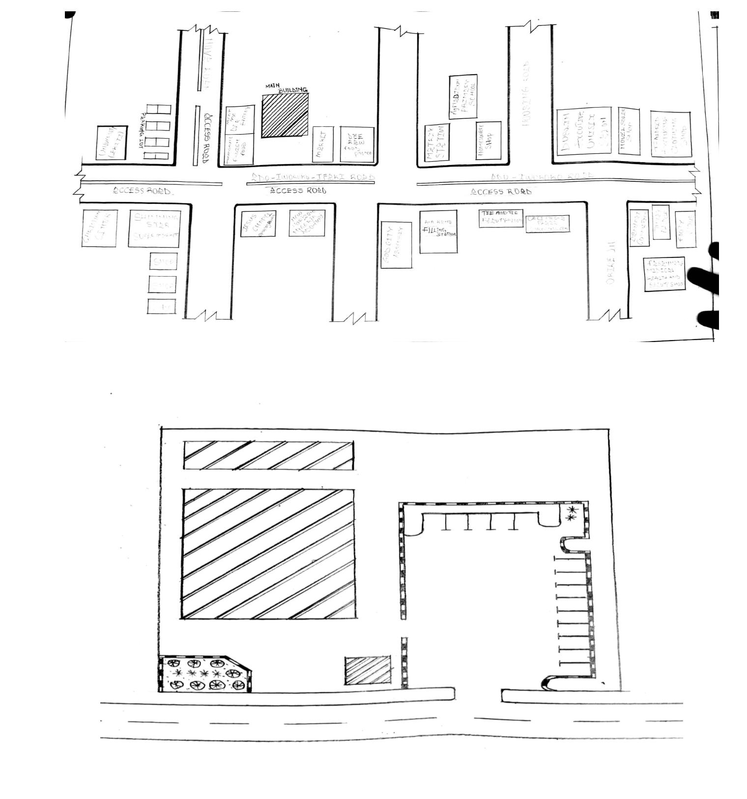

Plate 3.1.3: Picture Showing the Floor Plan of case study one
Plate 3.1.1: Showing the approach view of case study one
11
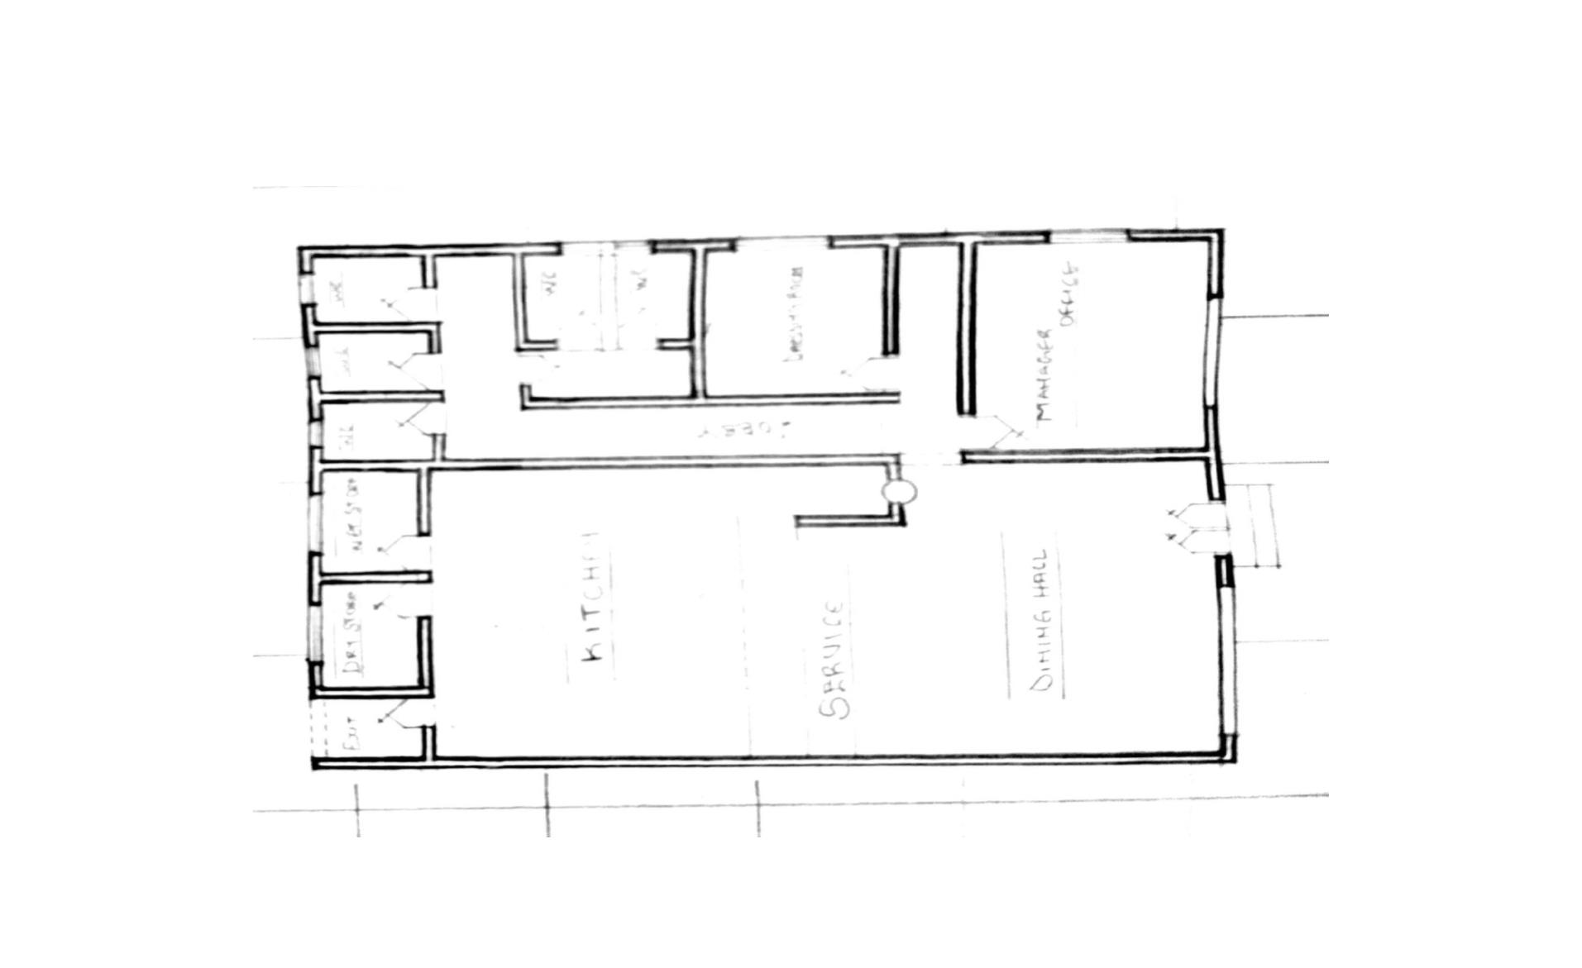
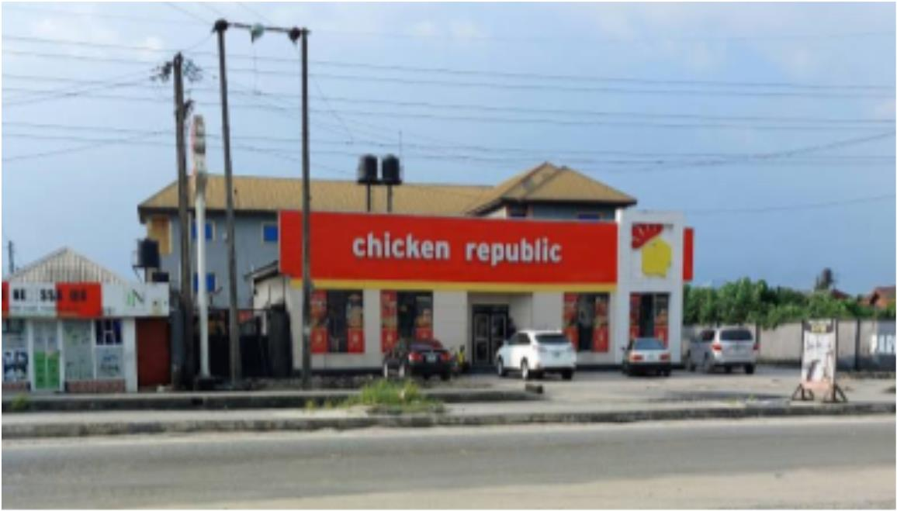

Plate 3.1.2: Showing the left view of case study one
3.2.1 CASE STUDY TWO
LOCATION: AT, CHICKEN REPUBLIC TAIWO ROAD ILORIN, KWARA
STATE.
MERIT
 Structural balance and design
 It's well ventilated
 Provision of hard soft and hard landscaping
DEMERIT
 Limited seating space
 Insufficient dining area
 limited availability of parking space
12
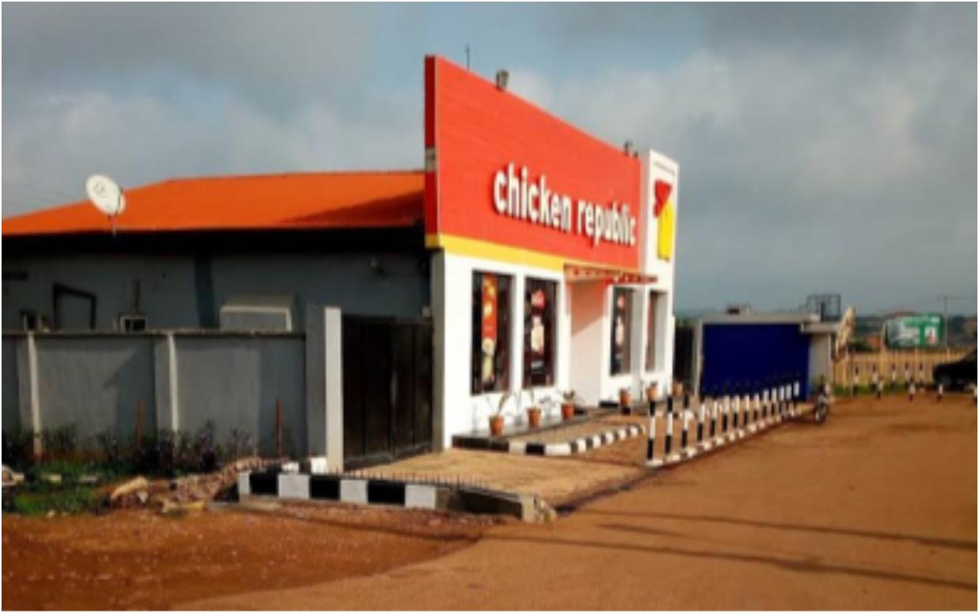

Figure 3.2.1: Picture Showing the Location Plan of case study two
Figure 3.2.2: Showing the Site Plan of case study two
13
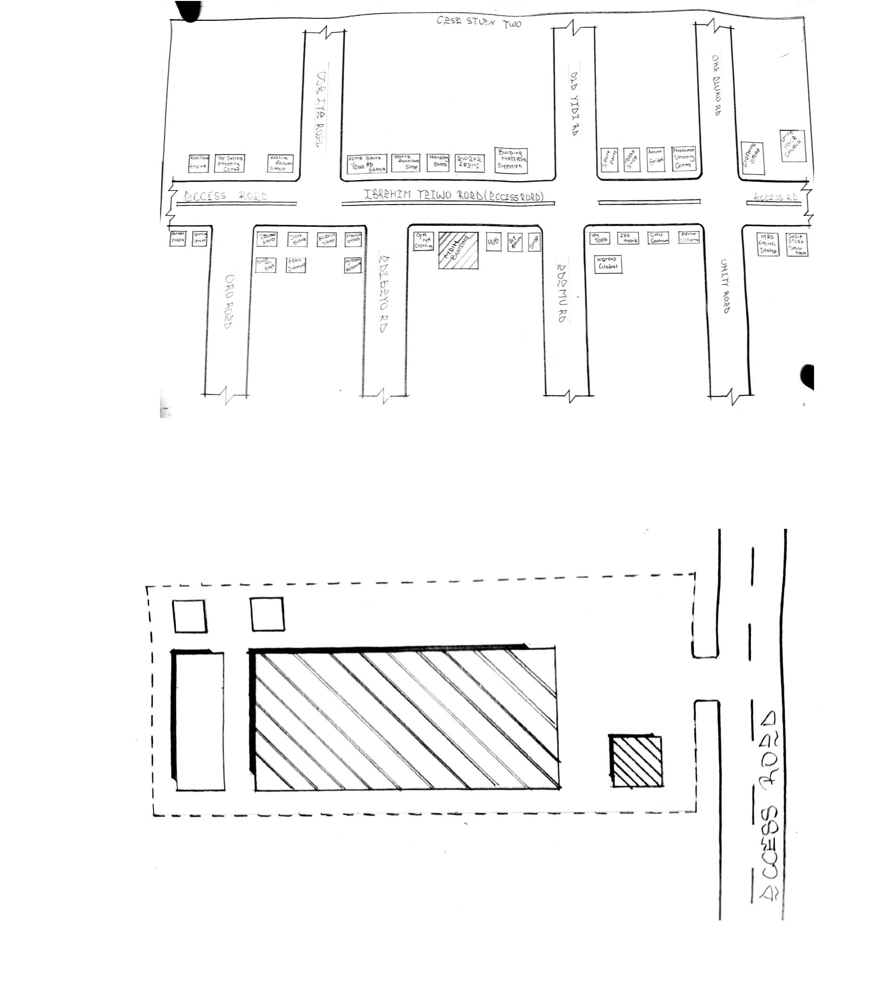

Figure 3.2.3: Showing the Floor Plan of case study two
Plate 3.2.1: Showing the approach view of case study two
14
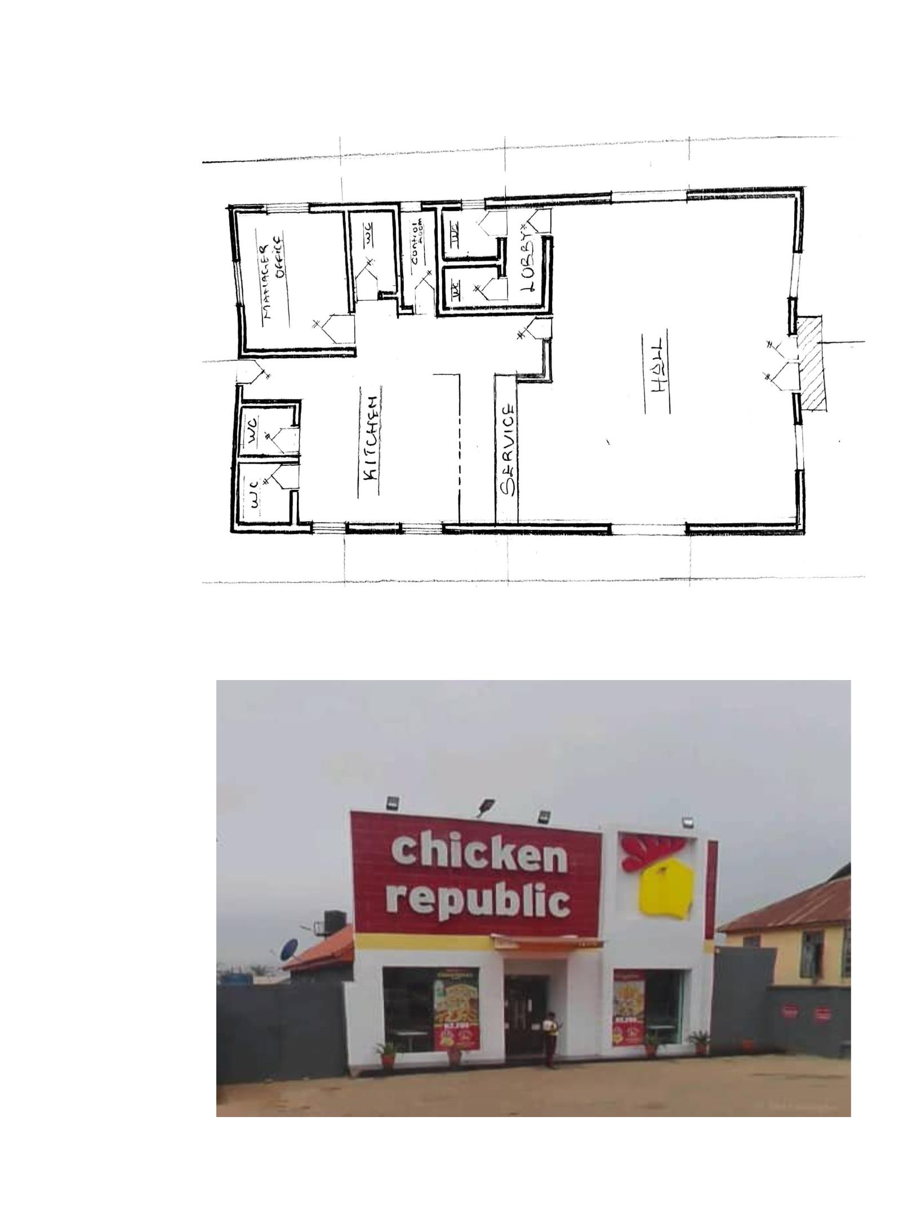

Plate 3.2.2: Showing the left view of case study two
Plate 3.2.3: Showing the interior view of case study two
15
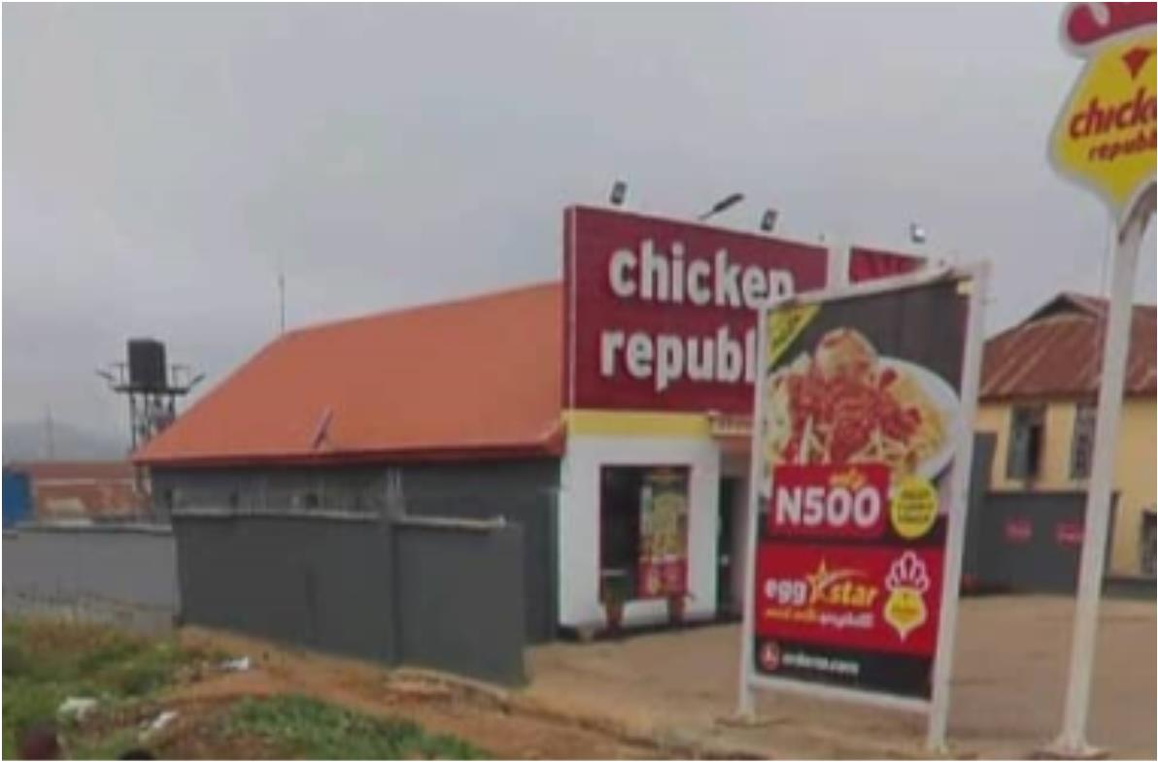
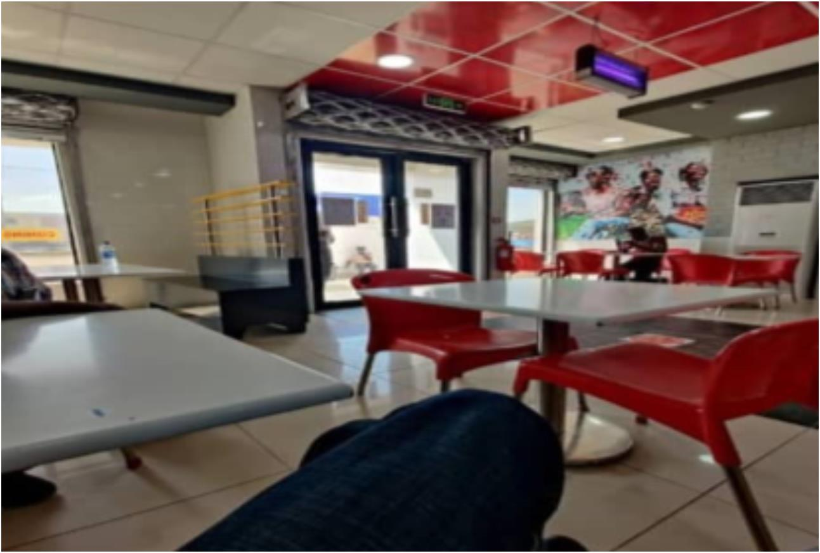

3.3 CASE STUDY THREE
LOCATION: AT, CAPTAIN COOK OFFA, KWARA STATE
MERIT
 Availability of artificial ventilation
 Simplicity design
 Easy to locate and accessible
DEMERIT
 shortage of parking space
 Inadequate natural ventilation
 Insufficient seating capacity
Figure 3.3.1: Showing the location plan of case study three
16
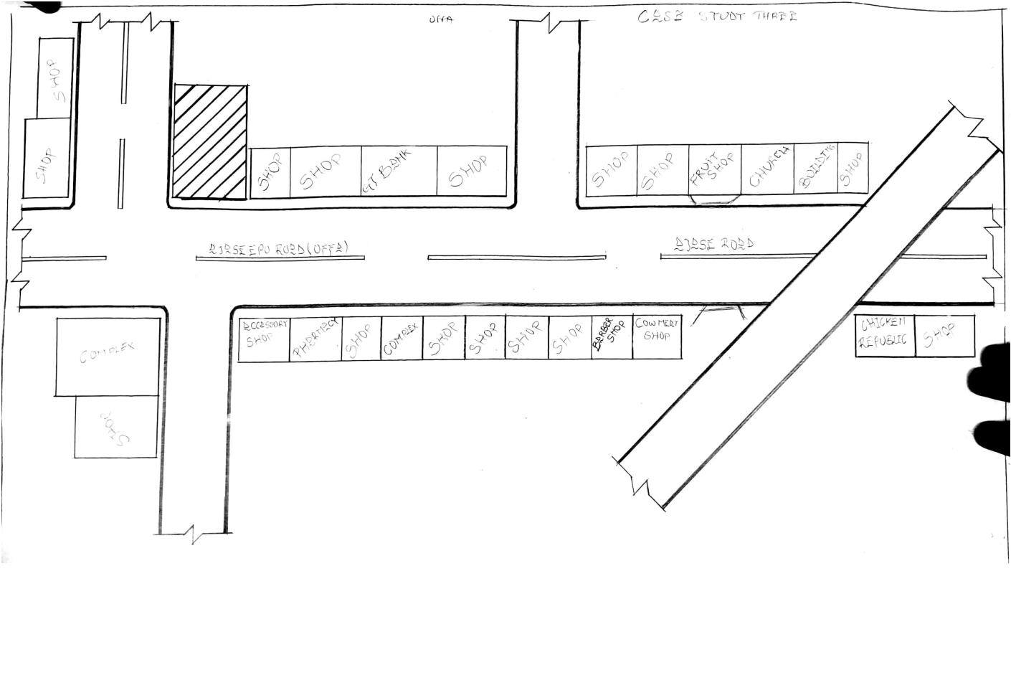

Figure 3.3.2: Showing the Site plan of case study three
17
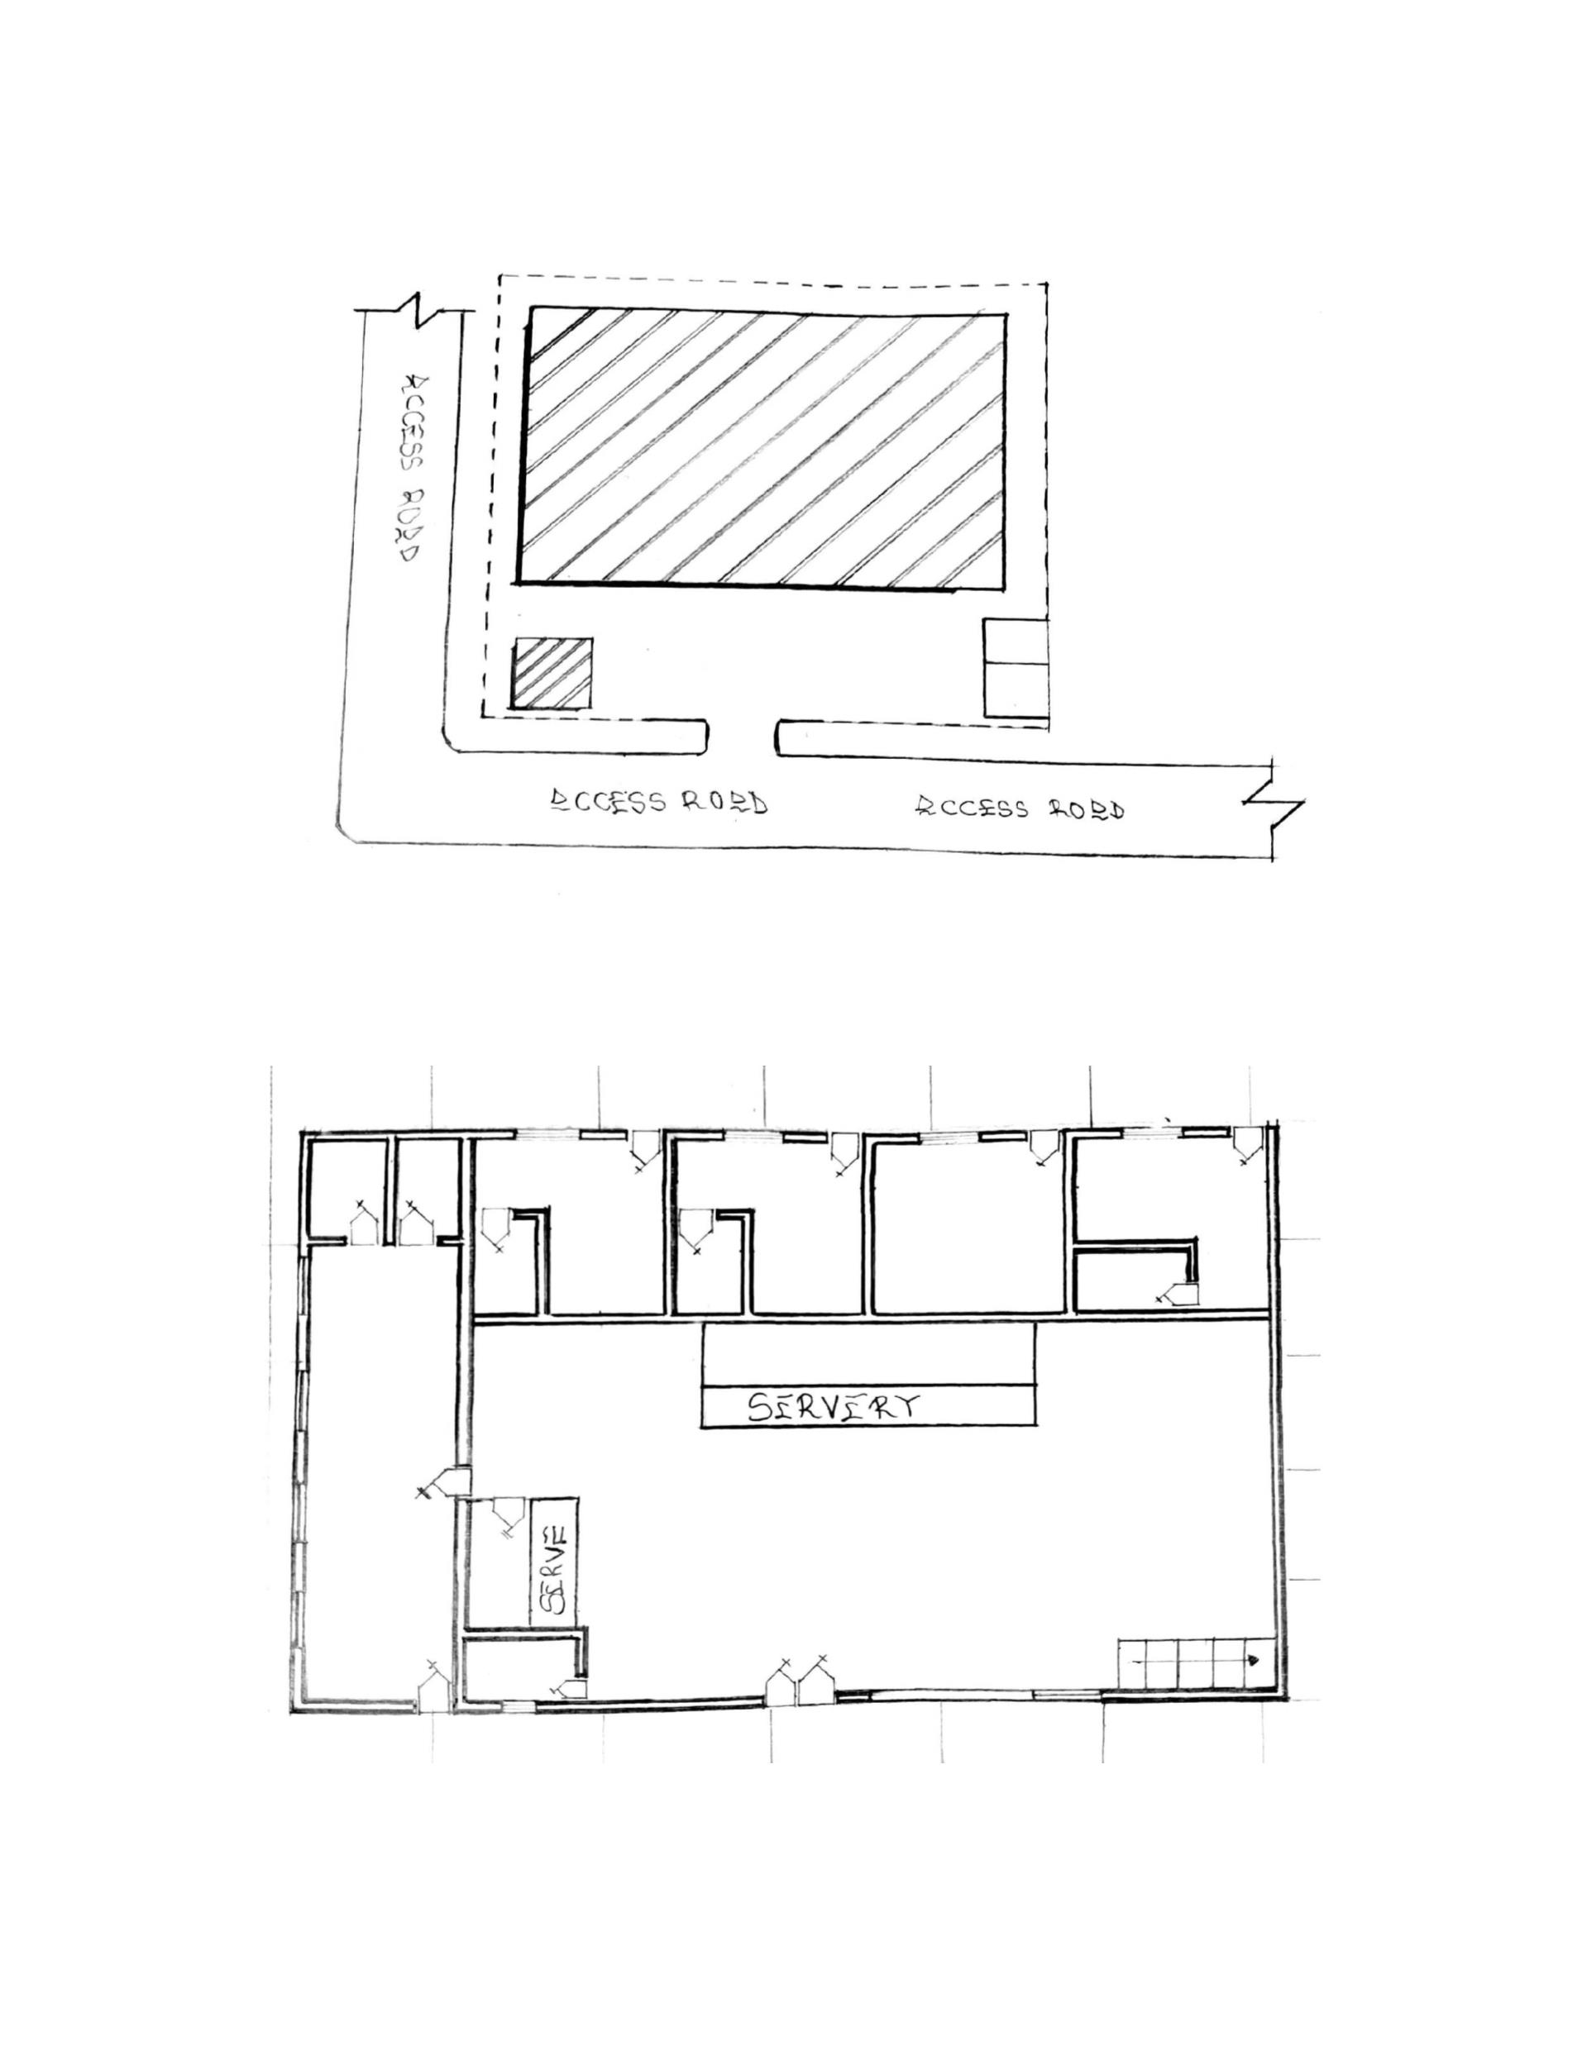

Plate 3.3.1: Showing the approach view of case study three
Plate 3.3.2: Showing the side view of case study three
18
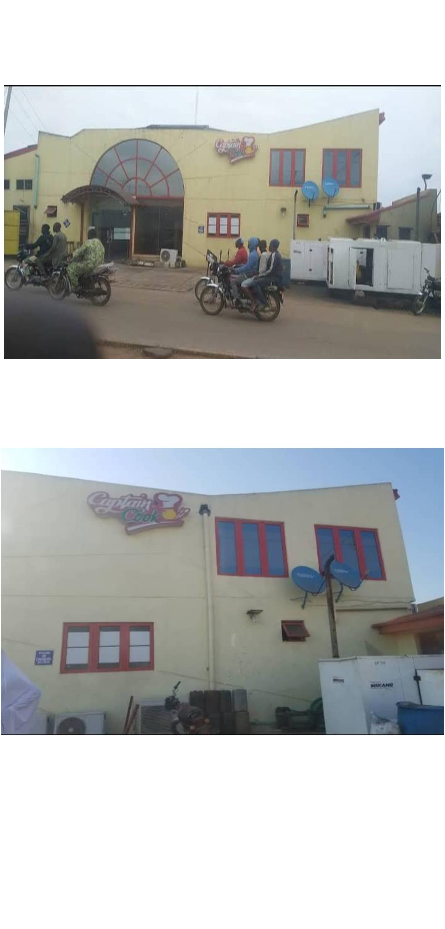

Plate 3.3.3: Showing the interior of case study three
3.4 CASE STUDY FOUR (ONLINE CASE STUDY)
LOCATION; CHINESE RESTAURANCE
Plate 3.4.1: Showing the Internal view of case study
3.5 CASE STUDY FIVE (ONLINE CASE STUDY)
LOCATION; SPAIN
19
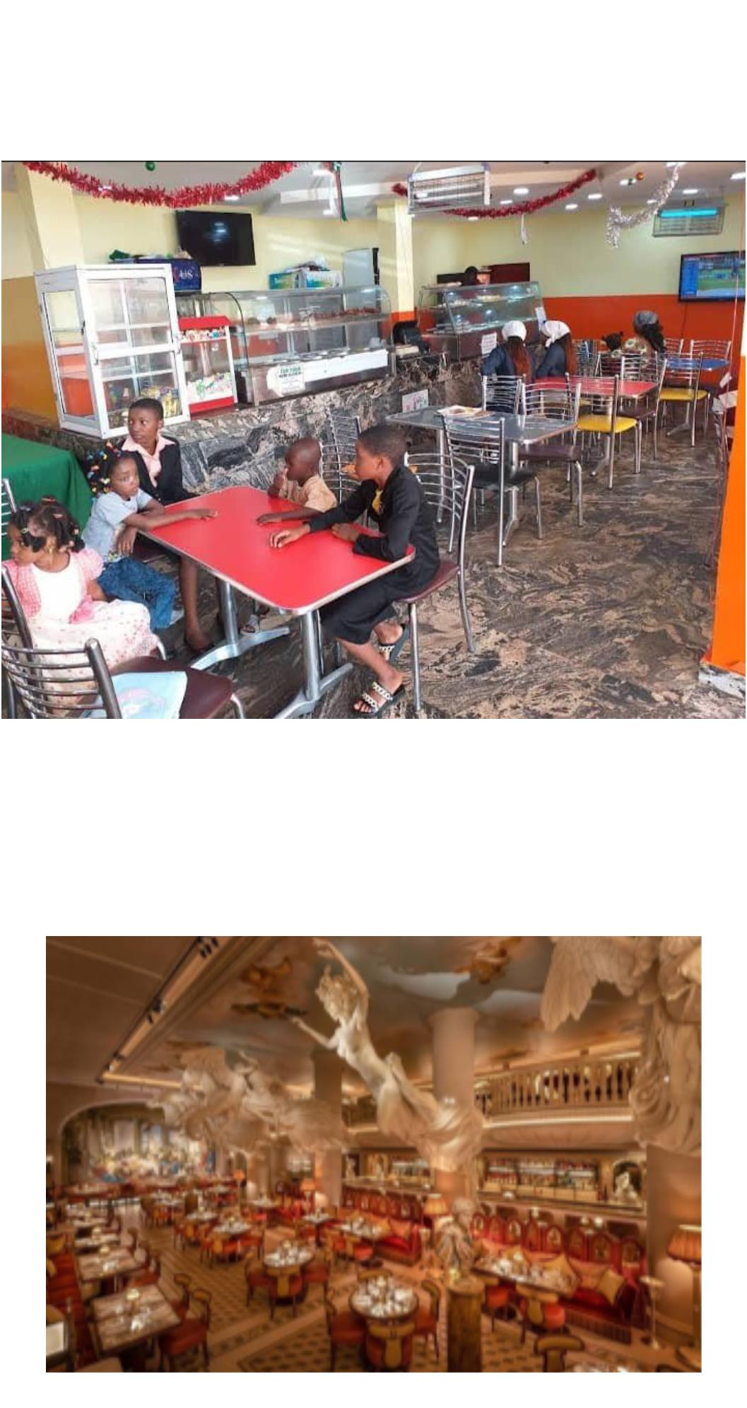

Plate 3.5.1: Showing the internal view of case study
3.5 FINDINGS AND DISCUSSIONS
From the research carried out I have found out that expansion area on the site
should be provided and there should be provisions of social amenities to help the people
achieve optimum comport as well as a suitable drainage system.
3.6 DEDUCTION FOR STUDY
From the case studies carried out, I observe that;
 The restaurant were not properly designed and also the provision for the
customer are not taking care of.
 That there is need for proper landscape to provide a good view on the clinic
and to control climatic condition prevailing on the site.
 That it is of necessity to provide adequate social amenities to improve the
physical and social life of people. Security is not an alternative, it is of great
importance to people in the eating area, hence the design should place high
rate on security.
20
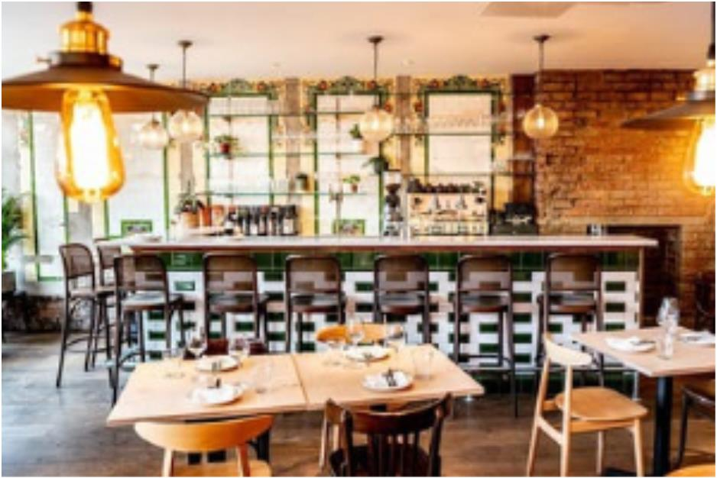

CHAPTER FOUR
4.0 ANALYSIS OF TOPOGRAPHICAL AND ENVIRONMENTAL
CONDITIONS OF THE SITE
VEGETATION, TOPOGRAPHY

VEGETATION
The site is covered with shrubs, thick grass and vegetable leaves and trees. All the
vegetables and shrubs are to be removed. At the time of conducting of site investigated
on the proposed project site, the site displays a relatively thick vegetation cover that is;
there are grasses, shrubs as well as big trees. There are portions with simple vegetation
cover due to human activities (Clearing and farming) that is taking place on the site.
 TOPOGRAPHY
It has a gentle slope. It does not undulate. The topography of the proposed
development site is relatively low that the top soil and the sub-soil is firm and buildable.
The site is therefore free from any natural or physical constraints and rock outcrops.
4.1INTRODUCTION OF STUDY AREA
4.1.1 HISTORY OF KWARA STATE
Kwara State was created on 27th May 1967, when the Federal Military Government of
General Yakubu Gowon broke the four regions that then constituted the Federation of
Nigeria into 12 States. At its creation, the State was made up of the former Ilorin and
Kabba Provinces of the Northern region and was initially named the West Central State
but later changed to Kwara a local name for the River Niger
Kwara State has since 1976 reduce considerably in size as a result of further State
creation exercises in Nigeria. On 13th February 1976, the Idah/Dekina part of the state
was called out and merged with a part of the Benue/Plateau State to form Benue State.
On 27th August 1991, five Local Government Area namely Oyi, Yagba, Okene, Okechi,
and Kogi State were also exercised to form part of the new Kogi State, while a sixth,
Borgu local Government area was merged with Niger state.
There are sixteen local government areas in the state they includes;
21

Asa ,Baruten,Edu, Ekiti, felodun, Ilorin East, Ilorin West, Ilorin South, Offa, Moro,
Kiama, Oke-Ero, Irepodun, Edu
 HISTORY OF PROJECT TOWN (ILORIN)
The Ilorin of the 1930s and 1940s was a society that was struggling to preserve its
cultural and evolve cultural commonality in its encounter with the British Colonial
enterprise, which despite its comfort with the Emirate system, was posing new modern
challenges. This culture of Ilorin which the peoples of the city had come to cherish, was
itself a mesh of cultures: Yoruba, fulanis, Hausa, Nupe, Kemberi and others. The
historical encounters between the Fulani Jihadists led by Alimi and the Yoruba worriers
led by Afonja, had about a century earlier led the defeat of the latter.
However, what emerged in Ilorin was a traditional leadership system which meshed the
Hausa-Fulani emirate system with Yoruba title holding.
 ILORIN LOCATION
Ilorin is a city with a large population in Kwara state, Nigeria, which is located in the
continent of African.
Cities, Towns and places near Ilorin include Yemoja, Akamo and Ogidi, the closest major
cities include Oshogbo, Ede, Oyo and Ijebu-Ode.
ILORIN DATA
Latitude
8.4965/82929.9616
4.544642/43240.7106
Kwara
Longitude
State/region
Country
Nigeria
Continent
Population size
Africa
Large
22

4.2 SITE LOCATION AND DESCRIPTION
The proposed site for RESTAURANCE is located at kwara state ilorin post office, Ilorin,
Kwara State.
 SITE LOCATION CRITERIA
The guiding rules which determine the choice of site depends on the following factors.
 Topography and soil type on the soil
 Accessibility of site to users
 Nearness to users and surrounding environment
 Wind direction
All these factors listed above have been considered and found to be satisfactory which
determine the choice of site.
 CONSIDERATION FOR SITE SELECTION
1. Therapeutic Possibilities: The site provide therapy in the form of social
interaction and physical activities
2. Accessibility: The site can be directly accessed and has no problem being
located. It is located at Ilorin post Kwara State.
3. Infrastructural Facilities: Infrastructural facilities such as electricity, water,
drainage and good road network are all present advantages on site for
utilization.
4. Vegetation: The vegetation is characterized by trees and shrubs. The
topography is relatively flat with gentle slope.
5. Soil Textures: The soil is a sandy soil, the soil is a virgin in the sense that there
is no existing building on it.
6. Land Scape: Trees and shrubs are to be scattered over the site which are to be
incorporated has landscaped features on site among other landscaped element.
23

4.3 SITE INVENTORY/SITE ANALYSIS
4.3.1 SITE INVENTORY
The presence features on the site are well analyzed and some measures are put in place to
control and at the same time aid the design. It is the preliminary survey of the site.
4.3.2 SITE ANALYSIS
This is done on the basic purpose for which the site is to serve. Certain steps are
considered to obtain vital information of the site. This information is then analyzed after
site survey in details. For design purpose, the information includes soil condition,
geology, topography, vegetation etc. it also involves carrying out a preliminaries survey
of the site.
a.
soil condition: the type of soil on the site is loamy and hence aids good vegetation
of flowers and grasses. Etc.
b.
Geology: this soil has a poor load bearing capacity and hence the type of
foundation to be use is to be based on geo-physics result of the site soil nature.
c. Vegetation: the site is covered with shrubs, palms, trees. Most of the shrubs should be
retain in the site for landscaping.
d.
Topography: this is the layout of the site. The site is relatively flat at the east
while the west part is a little sloppy towards the northern part. This will aids effective
landscape planning.
The sunrise and sunset will be considered for building orientation and lightening.
Also the northeast trade wind and the southwest trade wind will give due consideration
for effective ventilation and solar radiation control for total comfort of occupant.
4.4
GEOGRAPHICAL / CLIMATE DATA OF ILORIN.
This city has a tropical climate. The summers here have good deal of rainfall,
while the winters have very little. According to Koppen and Geiger, this climate is
classified as AW. In Ilorin, the average annual temperature is 26.50c. The rainfall here
averages 1217mm.
24

Table 4.5.1: Showing the Geographical and Climate Data of Ilorin
Table 4.5. 2: Showing the Average Temperature of Ilorin
The temperatures are highest on average in March, at around 29.00c. August is the
coldest month, with temperatures averaging 24.5 c.
0
4.5
DESIGN CRITERIA
There are three methods of designing of any project which are:
Function before form method
Form before function method
Combination of shapes
Designing projects, the function, before form methods used in line with this method, the
following are the design criteria for this project:
Functional: In term of functional requirement the following design criteria must be
considered.
Sustainability, Site and location, Flexibility, Circulation, Accessibility, Organization,
Maintenance, Environment and services
25
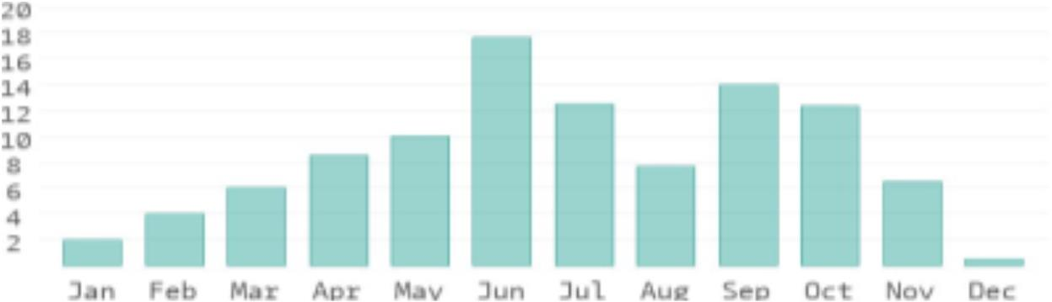
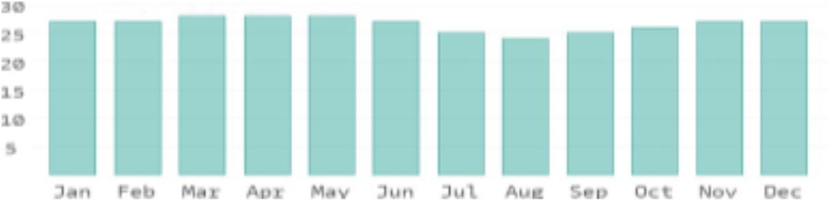

4.5.1
SITE PLANNING
The site is planned in order to give it a defined shape and also to reflect the activities
taking place. The location of building and facilities within the site follows this main
principle.
a.
The zoning principle (noisy, semi-noisy, quiet zone) is respected which enhance
placement of each structure in respect to the level of egress and ingress.
b.
c.
Structures are placed in accordance to usage.
For easy accessibility to restaurants, parking space for cart cars are planned within
and around each structure.
4.6 DESIGN BRIEF
4.6.1 SCOPES AND BRIEFS
SCOPES
1. Main restaurant
2. Power house
3. Mosque
4. Security post
5. pedestrians
6. Parking space
BRIEFS
1. Entrance
2. Eating Area
3. Chef Offices
4. kitchen
5. Cold store
6. Dry store
7. Changing room
8. servery
9. exit
10. Rest room
26

4.7
SCHEDULE OF SPATIAL ALLOCATION
ADMIN. BLOCK.
Units
Qty
1
Length(m) Breath(m) LxBxQty
Area (sqm)
Entrance
5.0M
6.6m
7.2m
8.6m
4.9m
4.9m
10.0m
4.2M
5.2m
4.2m
5.6m
4.0m
4.0m
16.0m
5.0X4.2X1 21.0
Eating area
Chef Offices
Kitchen
1
6.6x5.2x1
7.2x4.2x4
8.6x5.6x1
4.9x4.0x1
4.9x4.0x1
10.0x16.0
34.32
30.24
44.72
19.6
4
1
Cold store
Dry store
Server
1
1
19.6
1
480.0
Exit
1
2
7
10.0m
2.8m
1.2m
9.7m
16.0m
2.1m
10.0x9.7x1 97.0
2.8x16.0x2 44.0
Changing rooms
Toilet ( rest room)
1.2x2.1x7
176.4
Table 4.7.1: Showing the Space Allocation of the Admin Block
4.8 FUNCTIONAL RELATIONSHIPS
The functional relationship chart represents graphically the connections existing between
the various spaces provided. It also emphasizes and educates on the strength and weakness of
these connections. For instance, in this study it is important for the main Auditorium to have
close proximity to the back stage and simultaneously to the changing room. Achieving these
connections entails the functional relationships.
4.9
CONCEPTUAL DEVELOPMENT
The design concept of restaurant should reflect the identity and should articulate the
attributes of restaurant activities, the natural landscape is an increasingly scarce and
valuable resources and the proposed restaurant is helping to protect it.
The design is flexible and the elements used are bold massive and of flowing
expression in order to attract new market in agricultural system.
A design solution based on reliability, stability, strength, safety and aesthetic is
aimed at giving the restaurant an identity and expression.
27



CHAPTER FIVE
APPROACHES TO THE DESIGN
In approaching this design project, many factors, strategies and research works
5.0
were taken into consideration. Some of the factors which include functionality, durability,
cost of materials. The research work put into consideration are study of neighborhood
Value, statistic, household value, patient and social lives of the workers and the patient in
the center. The proposed restaurant design consists of battered design which consists of
farm stead and huts which does not have the capacity to withstand heavy rainfall and high
rate temperature. Hence the climatic data and neighborhood activities were vehemently
considered. These factors and deductions were highly adhered to in this project to achieve
a functional, aesthetically balanced, durable and proportional balanced design.
5.1
TECHNOLOGY AND ENVIRONMENTAL CRITERIAL
CONSTRUCTION METHODOLOGY
The method of construction involved in the erecting the building structure is in
accordance to the Architectural detail required in executing the buildings and process of
construction that is critical to structural component as affected by the site conditions and
type of materials to be used.
After the preparation of the site plan, many design details are developed to show
the specific methods of construction. It is to serve two important purpose; firstly they
stipulate the aesthetics and structural element of the plan and secondly they provide the
basis for costing the project.
The section is not intended to present aesthetic or design solution alone but also
indicate how similar technological difficulties are handled. In the method of construction,
the factors are considered:
 Climatic condition
 Fire protection
 Durability and easy maintenance
 Easy accessibility
28

 Economy/Aesthetics
 Available of materials
 Cost of material
 Construction techniques
 Condition of the sub-soil present on the sit
The various building component taken into consideration are:
5.1.1 CONSTRUCTION METHOD AND MATERIAL
Wooden domes have a hole drilled in the width of a strut. A stainless steel band locks
the strut's hole to a steel pipe. With this method, the struts may be cut to the exact length
needed. Triangles of exterior plywood are then nailed to the struts. The dome is wrapped
from the bottom to the top with several stapled layers of tar paper, in order to shed water,
and finished with shingles. This type of dome is often called a hub-and-strut dome
because of the use of steel hubs to tie the struts together.
Panelized domes are constructed of separately framed timbers covered in plywood.
The three members comprising the triangular frame are often cut at compound angles in
order to provide for a flat fitting of the various triangles. Holes are drilled through the
members at precise locations and steel bolts then connect the triangles to form the dome.
These members are often 2x4's or 2x6's, which allow for more insulation to fit within the
triangle. The panelized technique allows the builder to attach the plywood skin to the
triangles while safely working on the ground or in a comfortable shop out of the weather.
This method does not require expensive steel hubs.
5.2
ESSENTIAL SERVICE REQUIRED
SERVICES AND CIRCULATION

The highest point of view part put into consideration in this project is strictly circulated.
The design will encourage flexibility of space for free and easy circulation interpretation
of space within and outside the building and the use of level change to accentuate the
characters of individual spaces within the building.
29


VENTILATION
Ventilation is one of the most important components in a successful restaurant, especially
in hot and humid tropical climate condition. If there is no proper ventilation, restaurants
and their growing plants can become prone to problems. The main purposes of ventilation
are to regulate the temperature, humidity and vapor pressure deficit to the optimal level,
and to ensure movement of air and thus prevent build-up of plant pathogens (such as
Botrytis cinerea) that prefer still air conditions. Ventilation also ensures a supply of fresh
air for photosynthesis and plant respiration, and may enable important pollinators to
access the restaurant crop.
Ventilation can be achieved via use of vents often controlled automatically via a
computer - and recirculation fans.
iii. LIGHTNING
Adequate natural lightning with the use of openings is expected within the units of the
building in the day and artificial lightning is needed in the building in other to provides
light to some spaces where natural lightning are not provided.
iv. PLUMBING
Complex of water supply is obtained from the main water supply system, all the
restaurants are connected to the main water supply system.
v. ELETRICAL INSTALLATION
Electrical connection is from close services (IBDC) with three phases connections to
avoid power failure in case the automatic generator has been provided with switches on.
vi. ACOUSTICS
Acoustics design controls intrusive noise by the choice of materials, dimension and
shape of building. High level of noise can cause damage to the ear and so careful
selection of doors, windows seals and on mongering will play and effective role in
providing acoustic for the building. Also suspended ceiling and parquet will be
extensively used.
30

In the proposed design there will be provision for fire alarms and detectors. Also fire
extinguisher such as hose reels, sprinklers and drenches are provided at strategic position
for easy access.
vii. WASTE DISPOSAL
All waste water appliances should be easily drained into soak away and soil
appliance should be drained separately.
Large refuse container is to be placed along one side of the building and be easily
accessed by the collection vehicle to lift and dump out the refuse in the container.
viii. FIRE PROTECTION AND CONTROL
Modern building require not only means of escape, access for fire brigade and
structure protection but also first aid equipment i.e hydrant plant, fire extinguisher to
combat any fire outbreak before the intervention of fire brigade.
In the proposed design there will be provision for fire alarms and detectors. Also fires
extinguish such as hose reels, sprinklers and drenches are provided at strategic position
for easy access.
ix. EXTERNAL WORK
For external works, the following specifications are applicable:
 The floor surface to be of interlocking materials and asphalt to allow effective
drainage.
 The drainage to be conveyed away through suitable sealed gully fitted with
strong grating. It should be drained into existing gutter.
 The enclosure to be secured against unauthorized entry.
Tarred and grasses surface should be separated with kerbs.
5.3 ENVIROMENTAL CONIDITIONS TO BE ACHIEVED
.
The plantation of trees to regulate the temperature
.
The orientation of the building structure to achieve maximum comfort
thereby controlling solar radiation.
31

5.4 PERFORMANCE STANDARDS
The performance standard of the building construction is to be a highly luxurious because
of the targeted users and the occupants of the town which have a high taste of social lives.
5.5 LEGAL ISSUES AND PLANNING REGULATIONS
The proposed building must pass through various processes in order to be approved of the
planning regulations of the local government authorities and the board of chiefs because
of it being a public building. The process for approval in the local planning authority is to
provide the following
The c of o of the land
The original land purchase documents
The survey plan
The structural drawings
The architectural drawings
The mechanical and electrical drawings
5.6 BEHAVIORAL PATTERNS AND CONSIDERATIONS
The considerations is the designing the RESTAURANCE to bring comfort to the targeted
users by providing adequate security, creating open spaces to be used for learning Arabic
recitation of the Muslim residents and provision of recreational facilities.
5.6.1 GENERAL MAINTENANCE
Maintenance cannot be isolated from the initial planning and design of any
architecturally edified most especially a project of this caliber which involves
accommodation.
Timely maintenance of the structure and facilities to put them in proper condition
to enhance balanced living and to avoid building deterioration. It is the work done to
restore a building to an acceptable standard. The maintenance will be dully attended to
with regular cleaning, repainting, and constant checking of access roads, planting of trees
5.7 SUMMARY
32

This proposed project is designed to produce an adequate, functional balanced
structure with good orientation for the proposed restaurant structure.
The research methodology employed was a case studies carried in the following area.
1. restaurant at Ado ekiti, Chicken Republic Ilorin, kwara state, captain cook ilorin
kwara State and the Online case studies.
Oral interview were also conducted in these structure, these were done to visualize
the building that were located on ground and to access the merit and demerit of unit
provided for the building or structure of a restaurant.
5.8 CONCLUSIONS AND RECOMMENDATIONS
5.8.1 CONCLUSION
This study has shown that there is a high level of awareness and utilization of the
restaurant services at post office Ilorin kwara state. The level of utilization was however
very much higher among the people in the vicinity.
The level of utilization of the restaurant among the residents is not affected by their levels
of service. The results also show that many respondents are not satisfied with the services
obtained at the area due to the poorly-maintained facilities, inadequacies in restaurant
equipment.
5.8.2 RECOMMENDATIONS
From the findings of this study, the following recommendations were made:
1. Policy makers' and all stakeholders' attention ought to be drawn to improving the status
and performance of the restaurant of the location at ilorin post office by properly
maintaining these facilities and providing basic utilities such as water supply and
electricity.
2. The image of restaurant should be improved by educating members of the area on the
purpose for establishing restaurant within the location as the first point of call in
providing skill growth.
3. Adequate prevention and regulation should be made available at the restaurant.
33

4. Incentives should be made available for restaurant personnel to encourage them to
work in urban areas.
5. Adequate facilities and equipment should be made available at the restaurant in to
make the jobs of the workers easier and more effective.
The experience gained and deduction gathered from the research has exposed my
knowledge to civic designs. These research were used to develop the design of the
proposed of restaurant
Conclusively, this particular project enable me to know what is adequate needed and
requirement for restaurants design with reference to architectural design protocols, it also
fulfill my ambition to contribute and encourage my quota to the enhancement of
architectural technology study in Kwara state Ilorin.
REFERENCE/BIBLIOGRAPHY
Afzali, S (2021) Development and implementation of optimal supplemental lighting
control strategies in restaurants (Doctoral dissertation, University of Georgia).Google
Scholar
Afzali, S, Mosharafian, S, van Iersel, MW and Mohammadpour Velni, J (2021a)
Development and implementation of an IoT-Enabled optimal and predictive lighting
control strategy in restaurants. Plants 10(12), 2652.CrossRefGoogle ScholarPubMed
Ahamed, MS, Guo, H and Tanino, K (2020) Modeling heating demands in a Chinese-
style solar restaurant using the transient building energy simulation model TRNSYS.
Journal of Building Engineering 29, 101114.CrossRefGoogle Scholar
Aissa, M and Boutelhig, A (2021) CFD comparative study between different forms of
solar restaurants and orientation effect. Journal Homepage 39(2), 433440.
http://iieta.org/journals/ijht Google Scholar
Al-Helal, I, Picuno, P, Alsadon, AA, Ibrahim, A, Shady, M and Abdel-Ghany, AM
(2022) Effect of shape, orientation and aging of a plastic restaurant cover on the
34

degradation rate of the optical properties in arid climates. Applied Sciences 12(5),
2709.CrossRefGoogle Scholar
Alharbi, A, Campen, J, Sharaf, M, de Zwart, F, Voogt, W, Scheffers, K, Tsafaras, I,
Abdelaziz, ME, Babiker, O, Gruda, N and Qaryouti, M (2021) Effect of clear and defuse
glass covering materials on fruit yield and energy efficiency of restaurant cucumber
grown in hot climate. Acta Scientiarum Polonorum, Hortorum Cultus 20(3),
3744.CrossRefGoogle Scholar
Aroca-Delgado, R, Pérez-Alonso, J, Callejón-Ferre, ÁJ and Díaz-Pérez, M (2019)
Morphology, yield and quality of restaurant tomato cultivation with flexible photovoltaic
rooftop panels (Almería-Spain). Scientia Horticulturae 257, 108768.CrossRefGoogle
Scholar
Azaizia, Z, Koolz, S, Hamdi, I, Elkhal, W and Guizani, AA (2020) Experimental study of
a new mixed mode solar restaurant drying system with and without thermal energy
storage for pepper. Renewable Energy 145, 19721984.CrossRefGoogle Scholar
Bazgaou, A, Fatnassi, H, Bouharroud, R, Elame, F, Ezzaeri, K, Gourdo, L, Wifaya, A,
Demrati, H, Tiskatine, R, Bekkaoui, A and Aharoune, A (2020) Performance assessment
of combining rock-bed thermal energy storage and water filled passive solar sleeves for
heating Canarian restaurant. Solar Energy 198, 824.CrossRefGoogle Scholar
Benavides, PT, Lee, U and Zare-Mehrjerdi, O (2020) Life cycle restaurant gas emissions
and energy use of polylactic acid, bio-derived polyethylene, and fossil-derived
polyethylene. Journal of Cleaner Production 277, 124010.CrossRefGoogle Scholar
Briga-Sá, A, Paiva, A, Lanzinha, JC, Boaventura-Cunha, J and Fernandes, L (2021)
Influence of air vents management on trombe wall temperature fluctuations: an
experimental analysis under real climate conditions. Energies 14(16),
5043.CrossRefGoogle Scholar
Evans, D, Parkes, D, Dooner, M, Williamson, P, Williams, J, Busby, J, He, W, Wang, J
and Garvey, S (2021) Salt cavern exergy storage capacity potential of UK massively
bedded halites, using Compressed Air Energy Storage (CAES). Applied Sciences 11(11),
4728.CrossRefGoogle Scholar
Fernández, EF, Villar-Fernández, A, Montes-Romero, J, Ruiz-Torres, L, Rodrigo, PM,
Manzaneda, AJ and Almonacid, F (2022) Global energy assessment of the potential of
photovoltaics for restaurant farming. Applied Energy 309, 118474.CrossRefGoogle
Scholar
Anita Lawrence(1989)acoustics and built environment Elsevier
De-chira (1983) architecture site planning, Macmillan press ltd.
publisher
ltd.
35

Frezer rekeir (1979) draughtmanship architectural building graphics.
publisher
Granada
George k. steman (1996) architectural drafting function planning
design, Granada publisher.
and creative
Microsoft Encarta 2008. 1993-2997 microsoft corporations.
Neufert E. (1980) architectural data. (third national English
Granada.
edition).
edition,
Peter A. (1999) metric handbook planning and design data new
architectural press. United kingdom.
Smith N.A (2002) lighting for health and safety. A division of reed
and professional publishing ltd.
educational
36

