DESIGN AND FABRICATION OF A HYBRID DRYER FOR AGRICULTURAL PRODUCE
By;
DAMOLA OLUWASOLA FEMI
HND/23/ABE/FT/0066
DEPARTMENT OF AGRICULTURAL AND BIO -ENVIRONMENTAL
ENGINEERING, INSTITUTE OF TECHNOLOGY, KWARA STATE
POLYTECHNIC, ILORIN

IN PARITAL FULFILLMENT OF REQUIREMENT FOR THE AWARD OF
HIGHER NATIONAL DIPLOMA (HND) IN AGRICULTURAL AND BIO-ENVIRONMENTAL ENGINEERING TECHNOLOGY.
SUPERVISE BY:
ENG. OLUFEMI DAVID OYEBANRE
4TH AUGUST, 2025

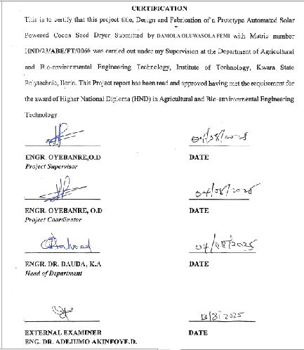

DEDICATION
This project is dedicated to Almighty God, the most Beneficent and Merciful and my parent Mr. &Mrs. Damola

ACKNOWLEDGEMENT
All praise and gratitude belong to Almighty Allah, the Most Gracious, the Most Merciful, for granting me life, strength, wisdom, and perseverance throughout the period of this project and my academic journey. His mercy and guidance have been my anchor, and without His favor, this achievement would not have been possible.
I am deeply indebted to my wonderful mum, Mr. Mrs. Damola and my beloved siblings, whose love, sacrifice, and encouragement have been the bedrock of my life. Your constant prayers, moral support, and financial backing gave me the strength to keep going even during the most difficult times. Words alone cannot express how thankful I am for everything you have done for me.
My sincere appreciation goes to my project supervisor, Engr. Oyebanre Oluafemi, whose guidance, feedback, and dedication helped shape this research work. Your patience, constructive criticism, and academic mentorship greatly enhanced the quality of this project.
I also extend my gratitude to the Head of Department Engr. Dr. Dauda K.A and all the lecturers in the Department of Agricultural and Bio-Environmental Engineering for the knowledge and inspiration they have imparted to me throughout my studies. Your collective impact has been monumental in shaping my academic foundation.
To my friends who have walked this journey with me — Femi, Jamal, Samuel, Grace, Rose, Ismail, Faruk and others — thank you for your companionship, moral support, words of encouragement, and the memorable times we shared. Your presence made this academic journey worthwhile and bearable.
Special thanks to my coursemates and colleagues who directly or indirectly contributed to the success of this project. The discussions, shared resources, and teamwork during practicals and lectures were invaluable.

ABSTRACT
This research focused on the development and evaluation of a prototype solar automated cocoa seed dryer designed to enhance the drying process of Theobroma cacao seeds. The study aimed to fabricate a solar-powered drying system integrating key components such as a collector, fan, monitoring equipment, solar panel, drying chamber, frame, and trays, with structural elements welded using an electric arc welding machine for durability and integrity. Experimental trials were conducted varying sample mass (1000–3000 g) and air flow rate (0.4–0.6 kg/h) to assess the drying rate and drying efficiency of cocoa seeds under controlled solar drying conditions. Results demonstrated significant effects of both mass of sample and air flow rate on drying performance, with drying rates ranging from 0.024 to 0.042 kg/h and drying efficiencies between 78.3% and 96.3%. Statistical analysis using ANOVA highlighted the significance of the model (p < 0.0001) in influencing drying rate and efficiency, with no significant lack of fit, confirming the reliability of the experimental design. The optimized conditions suggested that lower mass and moderate air flow improved drying efficiency, thereby expediting the drying process while preserving seed quality. This prototype offers a sustainable alternative to conventional drying methods by harnessing solar energy, potentially reducing post-harvest losses and enhancing cocoa production efficiency in regions with abundant solar resources

TABLE OF CONTENT
Title Page i
Certification ii
Dedication iii
Acknowledgement iv
Table of Contents v
Abstract vii
List of Figure viii
List of Plates ix
List of Tables x
CHAPTER ONE: INTRODUCTION
1.1 Background to the Study 1
1.2 Problem statement of the Study 2
1.3 Aim and Objectives of the Study 2
1.4 Justification of the Study 4
1.5 Scope of the Study 4
CHAPTER TWO
2.1 Cocoa Material 5
2.2 Drying Experiments and Sample Conditioning 6
2.3 Energy Parameter 6
2.4 Preparation of Extract 7
2.5 Determination of Total Phenolis 7
2.6 Determination of Total Flavonoids 7
2.7 Determination of Antioxidant Activity 8
2.8 Characterization by Vibrational Analysis 8
CHAPTER THREE: Materials and Methods
3.1 Material 16
3.1.1 Tools and Equipment
3.2 Design Considerations 17
3.2.1. Drying Temperature Range 18
3.2.2 Moisture Content Reduction
3.2.3 Energy Source and Sustainability 19
3.2.4 Airflow and Heat Distribution 19
3.2.5 Material Selection
3.2.6 Automation and Control system 19
3.2.7 Size and capacity 20
3.2.8 Environmental and Economic Consideration 20
3.2.9 Safety Considerations 21
3.3 Design Calculations 21
3.3.1 Volume of the Drying Chamber 21
3.3.2 Volume of each tray 22
3.3.3 Volume of Cocoa Beans Per Tray 22
3.4 Design Layout 24
3.5 Working Principles 24
3.5.1 Solar Energy Harvesting 24
3.5.2 Air Heating and Circulation 25
3.5.3 Moisture Removal 25
3.5.4 Automation and Control 25
3.5.5 Tray Arrangement and Drying 25
3.6 Construction and Fabrication Procedure 26
3.6.1 Sourcing of Materials 26
3.6.2 Fabrication of Drying Chamber 26
3.6.3 Fabrication of Drying Trays 26
3.6.4 Construction of Supporting Frame 26
3.6.5 Installation of Solar Energy Component 27
3.6.6 Assembly of Control System 28
3.6.7 Final Assembly and Testing 28
3.7 List of Instrument 28
CHAPTER FOUR: Results and Discussion
4.1 Result 29
4.2 Discussion 29
4.3 Analysis of Variance 36
CHAPTER FIVE: Conclusion and Recommendation
5.1 Conclusion 42
5.2 Recommendation 42
References 44

List of Figures
Figure 4.1: Effect of Air Flow Rate and Mass of Sample on the Drying Rate of Cocoa 34
Figure 4.2: Effect of Air Flow Rate and Mass of Sample on the Drying Efficiency of Cocoa 39

LIST OF PLATES
Plate 3.1a: Pictorial view of Electric Arc Welding 28
Plate 3.1b: Pictorial view of Grinding Machine 28
Plate 3.1c: Pictorial view of Thong 28
Plate 3.1d: Pictorial view of Small Grinder 28

LIST OF TABLES
Table 3.1: Experimental Design Matrix (Box-behnken Design) with the Factors 13
Table 4.1: Summary of Result of Cocoa Drying Using the Fabricated Hybrid 29
Table 4.2: Analysis of Variance (ANOVA) for the Drying Rate of Cocoa Bean 32
Table 4.3: Analysis of Variance (ANOVA) for the Drying Efficiency of Cocoa 36
Table 4.4: Bill of Engineering Measurement and Evaluations

CHAPTER ONE
1.0 INTRODUCTION
1.1 Background to the study
Cocoa tree beans (Theobroma cacao L.) are the main raw material for the manufacture of chocolate, cocoa powder, and other cocoa products [Oracz, J.; et al 2020]. Cocoa drying is one of the stages of the post-harvest process; it consists of reducing the water content of the beans from approximately 55% to a range of 6.5 to 7% moisture, which is the desired limit that the beans must contain to avoid the growth of fungi and unpleasant aromas that deteriorate the quality and also to maintain adequate storage conditions, transport, handling, and marketing [Dubón, A.,et al 2016 ]. However, during this process, some structural or chemical changes may occur, which may affect the nutritional or organoleptic properties of the product.
Convective drying is the most commonly used process, and some studies have reported cell destruction that is proportional to the amount of moisture removed. There are other methods such as microwave and freeze-drying, among others, that have been studied, but these methods have presented several disadvantages, such as longer drying time and high energy consumption [Rashid, M.T.;et al 2019]. Some studies have been carried out on different food-type products involving convective drying and parameters such as specific energy consumption (SEC) and energy efficiency [Motevali, A.; et al 2016, Abbaspour-Gilandeh, Y.; et al 2021].
A few studies reported these parameters for cocoa but only using solar drying. Simo-Tagne et al. [Simo-Tagne, M.;et al,2022] reported an SEC value between 7 and 15 kWh/kg, while the efficiency was between 9 and 17%. Vásquez-Uribe et al. [Vásquez-Uribe, J.F.; et al, 2024] reported an SEC value of 27,793.90 kJ/kg and an efficiency value of 12.94%.
Bioactive compounds in foods are often referred to as “phytochemicals” because they are naturally in products of plant origin, including carotenoids, phytosterols, polyphenols, and sulfur compounds such as glucosinolates, among others [Cienfuegos-Jovellanos,; et al, 2016]. The beneficial effects of cocoa polyphenols depend on the amount consumed, their bioavailability, and the biological activity of the conjugates formed [Roura, E.; Andrés-Lacueva, C.; et al, 2007]. Cocoa beans and their co-products are a very rich source of beneficial health-promoting compounds, including polyphenols and methylxanthines [Oracz, J.; et al 2020]. The health benefits that have been attributed to their consumption have been found to be attributed to the presence of polyphenols, mainly flavonoids, in cocoa beans and their by-products.
Flavonoids are the most abundant class of phenolic compounds in cocoa beans and, according to the review by [Oracz, J.; et al 2020], include mainly flavan-3-ols, anthocyanins, and flavonols. It was also reported that cocoa beans and cocoa products can also contain significant amounts of another group of polyphenols, such as phenolic acids, stilbenes, and N-phenylpropenoyl-L-amino acids (NPAs), which belong to the family of polyphenol/amino acid conjugates. These bioactive compounds are secondary metabol ites of cocoa that also contribute significantly to the organoleptic properties of cocoa beans and cocoa products [Oracz, J.; et al 2020].
The antioxidant properties of cocoa can be influenced by factors such as genotype, agroclimatic conditions, fermentation, drying, and the industrialization process [Pallares- Pallares, A.; et al 2016]. There are studies that include antioxidant effect assays such as DPPH (2,2-diphenyl-1-picrylhydrazyl) free radical scavenging and oxygen radical absorbance capacity (ORAC) to evaluate the antioxidant capacity of cocoa and chocolate [Othman, A. et al, 2007, Hu, Y. et al, 2016, Deus, V.L.; et al, 2018]
There are studies focused on food-type products that report the monitoring of the degradation of bioactive compounds such as total phenolics (TPs) and total flavonoids (TFs) as well as antioxidant activity during the drying process of products other than cocoa [Rashid, M.T.;et al 2019, Castañeda-Pérez, E. et al, 2012]. The studies on cocoa drying were focused on moisture kinetics and the evaluation of TPs in short periods of time; however, they did not evaluate antioxidant activity through any method [Kyi, T.M. et al, 2005 , Teh, Q. et al, 2015, Santhanam Menon, A. et al, 2017, Alean, J. et al, 2016].
The kinetics of the oxidation reaction of polyphenols during cocoa drying have been studied using kinetic equations, working with temperatures between 40 °C and 60 °C and relative humidity between 50% and 80% [Kyi, T.M. et al, 2005 ]. It has been observed that higher temperature and relative humidity of the drying air can lead to changes in the polyphenol residues of cocoa beans due to enzymatic oxidation of polyphenols [Kyi, T.M. et al, 2005], but more studies are necessary to understand these changes since cacao bean properties are influenced by the variety and edaphic and geographic conditions
Fourier transform infrared (FT-IR) spectroscopy is one of the most widely used methods for analyzing and detecting components of interest during food processing. FT-IR spectroscopy has been successfully applied for characterizing a variety of agricultural products [Castañeda-Pérez, E. et al, 2012, Amir, M.R. et al, 2016, Prado-Martínez, M. et al, 2012]. Furthermore, the use of FT-IR combined with attenuated total reflectance (ATR) is a spectroscopic technique that has been widely used as a tool for the study of products such as red pepper, coffee cherry pulp, and sugar cane [Castañeda-Pérez, E. et al, 2012, Barrios-Rodríguez, Y. et al, 2021, Zara, J. et al, 2017]; it is also a well-established analytical technique for rapid, high-throughput, non-destructive analysis of a wide range of products such as edible oil types [Socaciu, M.I. et al, 2020] . FT-IR has been used to quantify other quality parameters of interest in cocoa, such as fat, nitrogen, and moisture content, but for final drying times and for very diverse samples [Veselá, A. et al, 2007]; likewise, near- and mid-IR has been used to characterize dried cocoa beans according to their geographical origin [Teye, E. et al, 2013];
However, the behavior during the process has not been monitored as proposed in this study, previous studies have not addressed in detail whether temperature can affect the vibrational changes of the bioactive compounds present in Mexican cocoa beans during drying or if these changes can also be evaluated through FT-IR, along with their relationship with energy consumption during thin-layer cocoa drying. Therefore, the aim of this work was to characterize dried cocoa samples by FT-IR spectroscopy and study their energy parameters, bioactive compounds (TPs and TFs), and antioxidant activity. In this study, the effect of time and temperature was considered during the drying process at different temperatures (50, 60, and 70 °C). The data were also analyzed using MetaboAnalyst 6.0 software. To the best of our knowledge, this is the first study developed in Mexico on the determination of energy consumption, TPs, TFs, and antioxidant activity, complemented with FT-IR-ATR vibrational analysis and multivariate analysis, for the cocoa bean drying process.
1.2 Problem statement of the study
Cocoa seed drying, a critical step in cocoa processing, is often hindered by unreliable and inefficient traditional drying methods, resulting in poor quality cocoa beans, reduced yields, and economic losses for small-scale cocoa farmers, thereby necessitating the development of a sustainable and energy-efficient drying solution."
1.3 Aim and Objectives of the Study
The main aim of this project were to dry cocoa bean to storage moisture content
While the specific objectives are:
- To design and fabricate a hybrid solar dryer
- To evaluate the performance of the dryer
- To model the dryer.
1.4 Justification of the Study
Using cocoa beans as a case study allows for evaluating the system’s practical relevance and potential for broader application across other crops
Drying remains a crucial post-harvest operation in the processing of cocoa beans, significantly influencing their quality, shelf life, and market value. Traditional open-sun drying methods are often hindered by unpredictable weather, contamination, and uneven drying. These limitations necessitate the development of improved drying systems that are both efficient and sustainable. This study is justified by the need to harness renewable energy more effectively in agricultural processing, particularly in rural and off-grid areas. By integrating both passive solar heating and a solar-powered airflow mechanism, the proposed hybrid drying system offers a more reliable and controlled drying environment.
1.5 Scope of the Study
This study focuses on the design, fabrication, and performance evaluation of a hybrid solar dryer intended for agricultural produce. The system combines direct solar heating with a solar-powered blower to enhance drying efficiency. The research is limited to the drying of fermented cocoa beans, which serves as a representative case for other similar crops requiring controlled drying. Parameters such as drying rate and drying efficiency will be assessed. The study does not extend to economic analysis or large-scale industrial application but serves as a prototype-level investigation using locally sourced materials and solar technology

2.0 CHAPTER TWO

2.1. Cocoa Material
The analyses and experiments for this study were conducted on samples of fermented cocoa beans (Theobroma cacao L.) obtained from the “Finca Las Delias” farm located in Rancheria Sur, Primera Seccion, Comalcalco, Tabasco, Mexico, with the following coordinates: 18°13′07″ N 93°14′35″ W, at an altitude of 16.81 m above mean sea level. The plantation farm was mostly planted with the Criollo cocoa variety called “Almendra Blanca”. The cocoa pods were hand-harvested from the trees 24 h before they were split open for the extraction of 600 kg of the wet beans, and the wet beans were then selected by eliminating any type of diseased-like and/or undesired state of physiological maturity. The bean size was not selected under any criteria. The wet beans were placed in three wood fermentation boxes (Cedrela odorata L.) covered with henequen sacks at the farm.
Fermentation was carried out for seven days with mixing starting after 48 h and then every 24 h until the last day of the fermentation process. The temperature in the central part of the fermentation boxes was recorded and reached an average temperature of 48 °C. The drop in temperature levels and a cutting test were considered as final fermentation criteria. The cocoa materials used for drying were randomly collected from the wooden boxes on the last day of the fermentation stage, and two kilograms was used for each test of the drying process.

2.2. Drying Experiments and Sample Conditioning
Fermented cocoa beans were convectively dried in a forced air flow oven (Felisa, FE-292ADU, Guadalajara, Mexico) with temperature and air flow control, with the tempered material placed in a thin layer on a metal mesh. Since the morphology of cocoa beans is very irregular, only broken or very small grains were discarded. Drying experiments were performed at temperatures of 50 °C, 60 °C, and 70 °C at an air flow velocity of 2.3 m/s for 24 h. Temperatures between 50 and 70 °C were selected according to other studies [Kyi, T.M.et al, 2005, Teh, Q. et al, 2015, Alean, J.et al, 2016, Páramo, D.et al, 2010, Abhay, S.M. et al, 2016] where these conditions were established as adequate to eliminate volatile compounds, mainly acetic acid, and thus avoid the production of acidic cocoa beans with undesired sensory quality properties. In the present study, the independent variable was the drying temperature; this condition is similar in commercial dryers where only temperature is available as a control parameter. Air flow velocity and ambient air temperature were also controlled in order to remain constant. The relative humidity was not controlled as in most drying studies. Samples were taken at time intervals (0–1400 min) for a total of 15 samples per temperature and were heated to 103 °C for 24 h to a constant weight, and their moisture content was determined by the gravimetric method [AOAC 1980]. Samples were taken starting with the “zero” time, and successive samples were taken at fixed time intervals (30 min, 1 h and 2 h) to cover up to 24 h of drying. Once the drying process reached the final time, the beans were immediately cooled to approximately 20 °C for 10 min. The dried cocoa bean samples were stored in hermetically sealed plastic containers (500 g) at −20 °C for subsequent analyses. Samples were analyzed within 6 to 12 h of storage, and all experiments were performed in duplicate for each drying temperature. Due to the variation in the initial moisture content of the different samples, the drying curves were also expressed in terms of dimensionless moisture (X) for comparison, which was obtained by dividing each value of the dry base moisture by the initial dry base moisture.
The drying rate was estimated from experimental data by fitting an exponential equation represented as Equation (1). These types of models are frequently used to describe drying in fruits and vegetables and have proven to be efficient at the level of dryer engineering and design [Onwude, D.I.et al, 2016] but have limitations in application under the experimental conditions of studies. where Xo, A, and R are the model constants and t is time.

2.3. Energy Parameters
The oven used for the drying was started before the experiments until it reached stable conditions, and the energy consumption was continuously recorded using a power quality analyzer (AEMC instruments, Powerpad 8335, Dover, NH, USA). The velocity and temperature of the air flow were recorded using a thermo-anemometer (CEM, DT618, Shenzhen, China), and the ambient temperature was measured with a thermo-hygrometer (CEM, DT321S, Shenzhen, China).
Specific energy consumption (SEC) expresses the ratio of total energy consumption (Ec _{total}) per kilogram of water evaporated from the product. The SEC of cocoa beans processed in a convective dryer can be determined by Equation (2) [Kaveh, M. et al, 2021]:
(2) M_{w} represents the weight loss (kg), which can be obtained from Equation (3):
(3) where expresses the initial mass and the final mass of the product.
The energy efficiency can be determined by Equation (4) [Ghanbarian, D. et al, 2020]:
The energy required to evaporate moisture ( ) can be calculated by Equation (5)
where is the energy efficiency (%), is the energy (consumed energy) required to evaporate moisture (kJ), is the latent heat of vaporization (kJ/kg), and represents the weight loss (kg). is calculated as a function of absolute temperature (K) and was obtained from thermodynamic tables of saturated water [Cengel, Y.A. et al, 2009].

2.4. Preparation of Extracts
For this purpose, dried cocoa beans were manually deshelled before the grinding, sifting, and defatting of the cotyledons; then, 100 mg of defatted cotyledon powder with a particle size of 420 microns was extracted with 10 mL of a hydroalcoholic mixture of 70% ethanol at room temperature for 2 h using an orbital shaker at 200 rpm (Thermo Fisher Scientific, 2346, Waltham, MA, USA). The mixture was centrifuged at 7280× g for 15 min (HERMLE, Z236K, Wehingen, Germany) and filtered. The extracts were kept refrigerated at 4 °C until further use.

2.5. Determination of Total Phenolics
The TPs were determined by the Folin–Ciocalteu colorimetric method for hydroalcoholic extracts [12] with slight modifications. An aliquot of 0.20 mL of the extract was mixed with 1.5 mL of Folin–Ciocalteu’s, the solution was allowed to settle for 5 min at room temperature, and then 1.5 mL of 0.55 M sodium bicarbonate was added. After 90 min in the dark, the absorbance of the samples was measured at 725 nm using a spectrophotometer (Thermo Fisher Scientific, UV-Vis Genesys 10S, Waltham, MA, USA). The calibration curve was plotted in the range of 0–0.3 mg GAE mL⁻¹ (gallic acid equivalents).

2.6. Determination of Total Flavonoids
The TFs were determined according to the method described by Zhishen, Mengcheng, and Jianming [Jia, Z. et al, 1999] with slight modifications. In a test tube, a 0.20 mL aliquot of the extract was mixed with 0.80 mL of distilled water and 0.15 mL of 5% sodium nitrite solution. After 5 min, 0.15 mL of aluminum chloride solution (10%) was added. At 6 min, 2.0 mL of sodium hydroxide (4%) was added. The solution was supplemented up to 5 mL with distilled water. The absorbance of the final mixture was measured at 410 nm against a target on a spectrophotometer (Thermo Fisher Scientific, UV-Vis Genesys 10S, Waltham, MA, USA). A calibration curve was generated with quercetin from a working solution of 100 μg mL⁻¹ in a range of 0.2–1.0 mg mL⁻¹. The TFs of the extracts were expressed as quercetin-equivalent mg/g sample (mg EQ g⁻¹).

2.7. Determination of Antioxidant Activity
The method proposed by [Shimada et al. 1992] based on the 1,1-diphenyl-2-picryl-hydrazil (DPPH) radical was used to determine the free radical scavenging ability of the extracts. The samples were measured at 517 nm against a blank. Then, 150 µL of the extract was mixed with 1350 µL of DPPH (0.1 mM) in 95% ethanol. An equal amount of ethanol and DPPH were used as a blank (control). The mixture was kept in the dark at room temperature for 30 min. The absorbance of the samples was measured at 517 nm against a blank using a spectrophotometer (Thermo Fisher Scientific, UV-Vis Genesys 10S, Waltham, MA, USA). The DPPH radical scavenging activity was calculated using Equation (6).

2.8. Characterization by Vibrational Analysis
Samples of 10 grains per time were used, and they were dried under vacuum (lyophilization) using a Sentry 2.0 freeze dryer (−52 °C for 48 h); subsequently, they were deshelled, ground, and sifted with 20 and 40 meshes to obtain 420-micron powdered cotyledon samples. Vibrational analysis was performed using an FT-IR spectrometer (Perkin Elmer, Frontier, Waltham, MA, USA), coupled with a diamond-tipped attenuated total reflection (ATR) unit, using a 32-scan configuration with a resolution of 4 cm⁻¹ in the spectral region of the range between 4000 and 400 cm⁻¹. Background spectra were obtained from the air after every sample measurement according to the modified method of [Meza-Márquez et al. 2010]. A powdered sample was placed on the glass of the ATR for each sampling time, and a background was executed after each sample measurement. A baseline correction and smoothing pretreatment was performed on all the spectra obtained, using the Spectrum 10.6.2 software of the FT-IR spectrometer (Perkin Elmer, Frontier, Waltham, MA, USA). The generated data were then processed in the Origin 8.5.1 software to assign the main signals. From the kinetics spectral data obtained in triplicate, a matrix was constructed, and a multivariate analysis was performed using the MetaboAnalyst 6.0 software.

CHAPTER THREE
MATERIALS AND METHODS
3.1 Materials
The following materials were used for the construction of the hybrid dryer:
- Cocoa (Theobroma cacao)
Approximately 20kg of wet cocoa beans were purchased locally for testing at Ondo State, Nigeria. Freshly fermented cocoa (Theobroma cacao) seeds serve as the raw material to be dried in the prototype. The cocoa seeds initially had a moisture content of about 55% and required drying to a safe storage moisture level of 6–8%.
- Drying Chamber
The drying chamber serves as the primary enclosure where the cocoa (Theobroma cacao) seeds are dried. This chamber is designed to maintain optimal temperature and humidity conditions for the drying process. The internal design ensures even distribution of heat throughout the space, thereby enhancing the efficiency of the drying process. The chamber is constructed to accommodate different volumes of cocoa seed.
- Stainless Trays (2 Layers)
Stainless trays, arranged in two layers, are used to hold the cocoa seeds during the drying process. Stainless tray was chosen for its durability, resistance to corrosion, and ease of cleaning. The two-layer tray design allows for multiple batches of cocoa seeds to be dried simultaneously, thereby increasing the overall capacity of the dryer.
- Blower
The blower is employed to circulate air within the drying chamber. Proper air circulation ensures that heat is evenly distributed around the cocoa seeds, preventing uneven drying and promoting efficient moisture removal. The blower also assists in regulating temperature and humidity within the chamber, contributing to the control of drying conditions.
- Chimney
The chimney is used to expel hot air and moisture from the drying chamber. This is essential for maintaining optimal drying conditions and preventing excess humidity from compromising the drying process. The chimney ensures that the drying chamber remains well-ventilated, facilitating the expulsion of moisture and heat.
- Support Stand (Frame)
The support stand, or frame, provides the structural integrity of the entire drying system. The frame holds the solar collector, drying chamber, blower, and other components in place, ensuring the system remains stable during operation. It is designed to withstand the mechanical stresses of daily use and provide a robust foundation for the dryer.
- Thermohygrometer Sensor for Automation
The thermohygrometer sensor is an integral component of the automated system, used to monitor the temperature and humidity levels within the drying chamber. The data collected by the sensor allows for real-time adjustments to the drying conditions, ensuring that the cocoa seeds are dried under optimal temperature and humidity. This automation helps maintain consistent and controlled drying conditions, improving the overall efficiency of the drying process.
- Variable Speed Control
The variable speed control system is used to adjust the speed of the blower. By regulating the airflow within the drying chamber, the speed control ensures that the drying conditions remain consistent. The ability to fine-tune the blower speed allows for adjustments based on the moisture levels of the cocoa seeds, optimizing the drying process for different batches.
- Mild steel sheets
For fabricating the drying chamber due to their good thermal conductivity and structural strength
- Solar Collector (Glass)
The solar collector, constructed using glass, is responsible for capturing solar energy to heat the drying chamber. The glass material allows maximum transmission of solar radiation, ensuring the collector absorbs sufficient heat from the sun. The energy captured by the solar collector is transferred to the drying chamber to facilitate the drying of cocoa seeds.
- Battery
used for storing solar energy harvested during the day, ensuring uninterrupted operation of the dryer during low sunlight or cloudy weather conditions. A battery capacity labelled 12V/18Ah/20HR was used. Meaning:
Voltage : 12 volts, Capacity(Ah) 18 Ampere hours
Rated over 20HR: it can deliver its rated capacity(18Ah) over 20 hours of discharge

- Angle irons
For constructing the supporting frame to provide strength and stability.
- Black matte paint
Applied to interior walls to improve solar heat absorption
- Fiber Glass
This was used to lag the sides of the drying chamber to prevent heat loss.
3.1.1 Tools and Equipment
1. Electric Arc Welding Machine: it was employed during the fabrication of the drying chamber, supporting frame and tray assembly. It was used to join metal components with high strength and durability ensuring structural integrity of the dryer.
- Grinder/Cutting Machine: It is a power tool with a rotating abrasive disc or blade which was used for cutting and smoothing metal.It is used to cut metal sheets, pipes, or rods to required sizes and for grinding welds to smooth finishes.
- Drilling Machine: It is a machine tool which was used for used to drill holes into materials (metal, wood, etc.). It is used to create holes for bolts, screws, or other fittings in your project components.
- Screwdriver Set: It is a set of hand tools with different tips (flat, Phillips, etc.) which was used for driving screws. It is used for tightening or loosening screws during assembly or adjustments of electrical and mechanical parts.
- Spanner Set: It is a set of tools which was used for for tightening or loosening nuts and bolts. It is essential for assembling and disassembling mechanical parts such as frames, joints, or supports.
- Multimeter (for testing connections): it is an electronic measuring instrument that combines several functions (voltage, current, resistance testing). It was used to check electrical circuits, test battery voltage, or ensure proper connections in the solar-powered system
- Pliers: It is a hand tool with gripping jaws, sometimes with cutting edges.it was used for holding objects firmly, bending wires, or cutting small materials.
- Measuring Tape: It is a flexible ruler used to measure distances or dimensions. It is used to take accurate measurements of components during fabrication or assembly.
- File (for finishing edges):It is a hand tool with a roughened surface used for smoothing or shaping metal.It is used to smoothen sharp edges after cutting or welding metal parts.
- Paintbrush/Spray Gun: it is a tool used to apply paint or protective coatings. It is used for finishing touches to protect metal surfaces from rust and improve aesthetics.
- Soldering Iron (for electronic parts): It is a hand tool that heats up to melt solder (a metal alloy) for joining electronic components. It is used in assembling or repairing the electronic parts of your project like sensors, circuits, or connections.
3.2 Design Considerations
The design and development of the prototype automated solar powered cocoa seed dryer were guided by several critical factors to ensure effective drying, energy efficiency, sustainability, and adaptability to local conditions. These considerations are outlined below:
3.2.1 Drying Temperature Range
Cocoa beans require a careful drying process to preserve their flavor quality and prevent case hardening. The target temperature range for effective drying was set between 40°C and 60°C. Temperatures above 60°C can degrade flavor precursors and cause the beans to develop a smoky or burnt taste, while temperatures below 40°C prolong drying time and may encourage mold growth. The system was therefore designed to achieve and maintain this range using solar energy, with the help of a thermal storage mechanism for cloudy conditions.
3.2.2 Moisture Content Reduction
Freshly fermented cocoa beans typically have a moisture content of 50–60% (wet basis). For proper storage and to prevent microbial growth, this moisture content needs to be reduced to 6–8% (wet basis) using the moisture analyzer. The dryer was designed to achieve this reduction within 48 to 72 hours, depending on the intensity of solar radiation and ambient conditions, thereby improving efficiency compared to traditional sun drying which may take up to 7 days.
3.2.3 Energy Source and Sustainability
The decision to use solar energy was based on its renewable nature and abundant availability in cocoa-producing regions of Nigeria, which typically receive 4–7 kWh/m²/day of solar insolation. Photovoltaic (PV) panels were selected to power electrical components such as fans, temperature and humidity sensors, and the microcontroller-based automation system. Additionally, the system was designed with provision for battery storage to enable drying continuity during low sunlight or at night.

3.2.4 Airflow and Heat Distribution
Uniform airflow is critical for effective drying of cocoa beans to prevent uneven drying or spoilage. A forced convection system, consisting of a DC-powered fan, was incorporated to distribute heated air evenly within the drying chamber. Vents were strategically placed to allow the escape of moist air, preventing condensation which could otherwise compromise drying efficiency. The airflow system was designed to achieve an air velocity of 0.5–1.0 m/s, which is optimal for drying cocoa beans without dislodging them.
3.2.5 Material Selection
Material selection was driven by the need for thermal efficiency, durability, cost-effectiveness, and food safety. The drying chamber was constructed using mild steel sheets coated with black matte paint to enhance solar absorption. The insulation layer consisted of glass Fiber to minimize heat loss. The trays for holding cocoa beans were fabricated from stainless net mesh (food grade) to resist corrosion and allow free airflow around the beans.
The external frame was built with galvanized steel to ensure structural stability and resistance to environmental degradation.
3.2.6 Automation and Control System
An automation system was integrated to improve operational efficiency and precision. It consists of:
Temperature and humidity sensors for real-time monitoring.
A microcontroller programmed to regulate fan speed and control heating elements based on set parameters.
3.2.7 Size and Capacity
The dryer was designed for a small-scale capacity suitable for research and demonstration purposes. It has a drying chamber dimension of 0.855 m × 0.7 m × 0.32 m, accommodating approximately 5–10 kg of wet cocoa beans per batch. This size was chosen to allow easy fabrication and testing while making the system scalable for commercial applications in future designs.
3.2.8 Environmental and Economic Considerations
The design accounted for environmental friendliness by utilizing renewable energy and minimizing greenhouse gas emissions. Economically, the system was optimized to be affordable for smallholder cocoa farmers by selecting locally available materials and components wherever possible.
3.2.9 Safety Considerations
Safety features such as insulated wiring, a protective casing for the solar panel and battery, and heat-resistant materials were incorporated to prevent electrical hazards and thermal burns during operation.
3.3 Design Calculations
The design of the prototype automated solar powered cocoa seed dryer requires determining key parameters to ensure optimal functionality.

The following calculations were carried out at Bolof Agro Technology along Tanke area before fabrication was carried out:
3.3.1 Volume of the Drying Chamber
The total internal volume of the drying chamber is determined using the formula:
V_{chamber} = L x B x H
Where:
L = 0.855m (length of chamber)
B= 0.7m (width of chamber)
H= 0.32m (height of chamber)
Therfore: V_{chamber} = 0.855x0.7x0.32
V_{chamber} = 0.192m³
3.3.2 Volume of each tray
The drying chamber contains three trays arranged horizontally with some clearance between them for adequate airflow.
Each tray occupies a length and width similar to the chamber internal dimensions, while the depth of each tray is 0.05m for a shallow layer of cocoa beans to facililitate efficient drying.

The volume of one tray is calculated as:
V_{tray} = Ltray × Btray × Htray
L_{tray} = 0.855m
B_{tray} = 0.7 m,
H_{tray} = 0.05 m
V_{tray} = 0.855 × 0.7 × 0.05 = 0.0299 m³ = 0.03 m³
3.3.3 Volume of Cocoa Beans Per Tray
the volume occupied by cocoa beans on each tray depends on their bulk density and the quantity placed on each tray.
The bulk density of wet cocoa beans is approximately 600kg/m³
If each tray holds 3kg of wet cocoa beans, the volume occupied by the beans is:
V_{beans} = 3 / 600 = 0.005 m³
So, each tray’s cocoa beans occupy is approximately 0.005m³
3.4 Design Layout
The experimental design for this study was structured using a two factor factorial design to evaluate the effect of the drying parameters on the drying rate and drying efficiency of cocoa seeds. The factors and responses are presented as follows:
- Mass of Sample (g)
- Air flow rate (m³/s)

- Experimental Responses (Dependent Variables)
Two performance indicators were monitored during the drying process:
- Drying Rate (kg/h): measured as the rate at which moisture was removed from the cocoa seeds.
- Drying efficiency (%): calculated as the ratio of useful energy utilized for moisture removal to the total energy supplied.
- Experimental Runs
A total of 13 experimental runs were carried out as presented in Table 3.1. The runs were randomized to minimize the experimental bias and ensure the independence of observations. The experimental matrix includes various combinations of the two factors and their respective levels.
Table 3.1: Experimental Design Matrix (Box-behnken Design) with the Factors and Responses For The Cocoa Seed Drying Process
 |  | Factor 1 | Factor 2 | Response 1 | Response 2
Std | Run | A:Mass of Sample | B:Air Flow Rate | Drying Rate | Drying Efficiency
 |  | g |  | Kg/h | %
3 | 1 | 1000 | 0.6
9 | 2 | 2000 | 0.5
12 | 3 | 2000 | 0.5
7 | 4 | 2000 | 0.4
4 | 5 | 3000 | 0.6
2 | 6 | 3000 | 0.4
13 | 7 | 2000 | 0.5
1 | 8 | 1000 | 0.4
11 | 9 | 2000 | 0.5
5 | 10 | 1000 | 0.5
10 | 11 | 2000 | 0.5
6 | 12 | 3000 | 0.5
8 | 13 | 2000 | 0.6

3.5 Working Principle
The automated solar powered cocoa seed dryer operates on the principle of utilizing solar energy to generate and maintain sufficient heat within a drying chamber, while forced convection ensures uniform airflow around the cocoa seeds to achieve effective and consistent drying.
The system is designed to harness solar energy through photovoltaic (PV) panels, which supply electrical power to auxiliary components such as fans, sensors, and the control system. The heated air, generated and circulated within the chamber, facilitates the removal of moisture from the cocoa seeds until the desired final moisture content is achieved.
The detailed working process is as follows:
3.5.1 Solar Energy Harvesting
The photovoltaic (PV) panels capture solar radiation and convert it into electrical energy. This energy powers the entire system, including the fans for air circulation and the microcontroller-based automation system. Excess energy can be stored in a battery bank to ensure continuous operation during periods of low sunlight or at night.

3.5.2 Air Heating and Circulation
Ambient air enters the system through inlets and is heated by solar energy absorbed within the chamber walls. A DC-powered fan is activated by the control system to force heated air into the drying chamber.
This forced convection system ensures uniform distribution of heat throughout the chamber, preventing uneven drying of cocoa seeds and eliminating cold spots.
3.5.3 Moisture Removal
As the heated air comes into contact with the wet cocoa seeds spread on trays, it absorbs moisture from the seeds. The moisture-laden air is expelled through strategically placed vents, allowing fresh heated air to enter and continue the drying process. This cycle continues until the moisture content of the cocoa seeds is reduced from approximately 55% to the desired safe storage level of 6–8%.
3.5.4 Automation and Control
The system employs sensors to monitor key parameters such as temperature and humidity inside the drying chamber. These sensors relay data to a microcontroller, which automatically regulates fan speed and heating operation to maintain optimal drying conditions within the chamber.
3.5.5 Tray Arrangement and Drying Efficiency
The cocoa seeds are spread evenly in thin layers on two netted trays arranged vertically in the chamber. The forced airflow passes through the perforations in the trays, allowing heated air to reach all seeds uniformly. The shallow depth of cocoa beans per tray helps to prevent clumping and ensures rapid moisture removal.
3.6 Construction and Fabrication Procedures
The construction and fabrication of the prototype automated solar powered cocoa seed dryer involved systematic steps to ensure the development of a functional and durable system. The process began with sourcing appropriate materials, followed by cutting, shaping, assembling, and integrating the control system. The procedures are outlined as follows:
3.6.1 Sourcing of Materials
All materials required for the fabrication of the dryer were carefully selected based on availability, durability, thermal efficiency, and food safety considerations. Key materials include mild steel sheets, stainless steel mesh, angle irons, fiber glass, photovoltaic (PV) panels, DC fan, sensors, microcontroller,battery and cocoa. These materials were procured from local suppliers to minimize cost and ensure easy replication.
3.6.2 Fabrication of Drying Chamber
The drying chamber was constructed using mild steel sheets due to their good thermal conductivity and ease of fabrication. The steps involved:
- Cutting mild steel sheets into panels corresponding to the chamber dimensions: 0.855 m (length) × 0.7 m (width) × 0.32 m (height).
- Welding the panels together using Electric Arc welding to form a rectangular box, leaving openings for air inlets and outlets.
- Coating the interior surfaces with black matte paint to enhance solar heat absorption.
- Adding an inner lining of fiber glass insulation between double walls to minimize heat loss.
- Fixing a transparent glass top cover in triangular form to allow solar radiation penetration.
3.5.3 Fabrication of Drying Trays
- Two drying trays were fabricated using food-grade netting mesh to prevent rusting and allow free airflow around the cocoa seeds.
- The trays were cut to dimensions slightly smaller than the internal chamber size to fit snugly while leaving space for airflow.
- The net mesh was stretched and welded onto a rectangular mild steel frame.
3.6.4 Construction of Supporting Frame
A sturdy supporting frame was constructed using angle irons to elevate the drying chamber and provide stability. The frame is 910mm in height. Angle irons were cut and welded into a rectangular frame with four vertical supports, cross-bracings were added for enhanced stability. The entire frame was coated with anti-rust paint for protection against environmental factors.
3.6.5 Installation of Solar Energy Components
The renewable energy system was installed as follows:
Mounting photovoltaic (PV) panels at an optimal tilt angle to maximize solar radiation capture. Connecting the PV panels to a charge controller, battery bank, and inverter. Wiring the system to supply power to the DC fan, sensors, microcontroller.

3.6.6 Assembly of Control System
The automation system was assembled and integrated into the dryer. This included:
- Installing temperature and humidity sensors inside the drying chamber to monitor environmental conditions.
- Connecting the sensors to the microcontroller, programmed to regulate the fan based on pre-set drying conditions.
3.6.7 Final Assembly and Testing
After all components were fabricated and assembled: The drying chamber, trays, and supporting frame were fully assembled.
Solar panels and control systems were connected to ensure seamless power supply.
The system was tested with an initial batch of cocoa seeds to verify functionality, airflow uniformity, temperature regulation, and drying performance.
Adjustments were made where necessary to optimize operation.
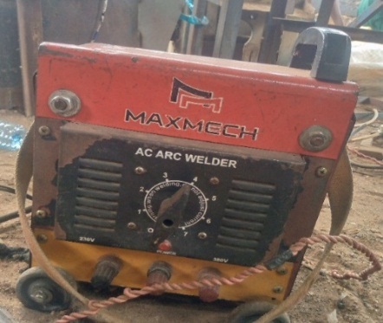
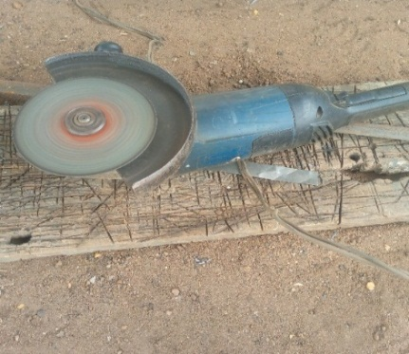
3.7 List of Instrument

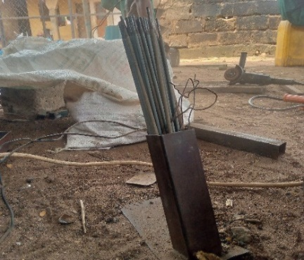
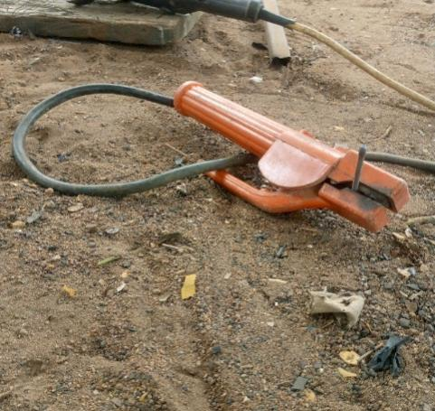
Plate 3.1a:Electric Arc Welding plate 3.1b: Grinding

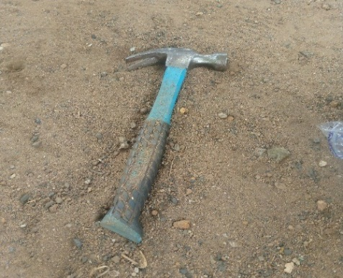
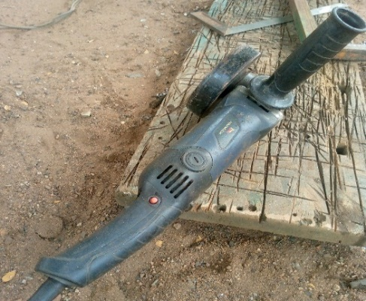
Plate 3.1c: Thong plate 3.1d Electrodes

Small Grinder Hammer

Chapter Four

Results and Discussion

4.1 Result
The summary of result obtained from the test of the fabricated hybrid dryer for dying cocoa bean is presented in Table 4.1.

Table 4.1: Summary of Result of Cocoa Drying Using the Fabricated Hybrid Dryer
Run | Mass of Sample (g) | Air Flow Rate (kg/h) | Drying Rate (kg/h) | Drying Efficiency (%)
1 | 1000 | 0.6 | 0.042 | 78.3
2 | 2000 | 0.5 | 0.033 | 87.6
3 | 2000 | 0.5 | 0.033 | 87.6
4 | 2000 | 0.4 | 0.029 | 91.2
5 | 3000 | 0.6 | 0.031 | 89.2
6 | 3000 | 0.4 | 0.024 | 96.3
7 | 2000 | 0.5 | 0.034 | 86.1
8 | 1000 | 0.4 | 0.035 | 85.4
9 | 2000 | 0.5 | 0.031 | 89.2
10 | 1000 | 0.5 | 0.037 | 83.9
11 | 2000 | 0.5 | 0.033 | 87.6
12 | 3000 | 0.5 | 0.027 | 92.8
13 | 2000 | 0.6 | 0.036 | 84.1

4.2 Discussion
From table 4.1 above, the drying performance of the fabricated hybrid dryer was evaluated using varying sample masses and air flow rates, with drying rate and drying efficiency as the key response variables. It was observed that increasing the sample mass did not consistently lead to higher drying rates. For instance, at an air flow rate of 0.6 kg/h, the drying rate decreased from 0.042 kg/h for a 1000 g sample to 0.031 kg/h for a 3000 g sample, indicating that beyond a certain load, the dryer’s performance may decline due to limited heat or air penetration. Similarly, at constant mass, increasing air flow generally led to a slight increase in drying rate, which is consistent with improved heat transfer and moisture removal. For example, at 2000 g sample mass, drying rate increased from 0.029 kg/h at 0.4 kg/h air flow to 0.036 kg/h at 0.6 kg/h air flow.
However, the trend in drying efficiency revealed an inverse relationship with drying rate in some cases. The highest efficiency of 96.3% was recorded at a sample mass of 3000 g and air flow of 0.4 kg/h, despite the drying rate being among the lowest (0.024 kg/h). On the other hand, the highest drying rate (0.042 kg/h) was associated with the lowest efficiency (78.3%), occurring at 1000 g sample mass and 0.6 kg/h air flow. This suggests that while higher airflow and smaller loads may accelerate drying, they may also lead to energy losses, possibly due to over-drying or inefficient moisture removal dynamics. Efficient drying appears to be favored under moderate to low airflow and higher sample loading, where energy is more effectively utilized.
The presence of repeated values, particularly at 2000 g sample mass and 0.5 kg/h air flow rate (Runs 2, 3, 7, 9, and 11), provided consistency across trials, confirming the repeatability and reliability of the dryer’s performance. Overall, the fabricated hybrid dryer demonstrated the capability to dry cocoa effectively, but with a clear trade-off between drying speed and energy efficiency.
The performance of the fabricated hybrid dryer in this study aligns with several trends reported in the literature. The observed drying rates (ranging from 0.024 to 0.042 kg/h) are comparable to those documented by Aregbesola et al. (2015), who reported drying rates between 0.020 and 0.045 kg/h when using a hybrid solar-electric dryer for drying cocoa beans under similar environmental conditions. Likewise, Abano and Amoah (2015) noted that drying rates for cocoa using a solar tunnel dryer averaged around 0.030 kg/h, particularly when the air velocity was kept between 0.4 and 0.6 kg/h. This supports the current study’s observation that increasing airflow rate leads to marginal improvement in drying rate, though not always proportional due to internal resistance and saturation effects within the drying chamber.
In terms of drying efficiency, the fabricated hybrid dryer achieved values as high as 96.3%, which is significantly higher than the 70–85% range reported by Bala and Mondol (2001) in their evaluation of hot-air dryers for similar agricultural products. High efficiencies recorded in the current study, especially at lower airflow rates (e.g., 0.4 kg/h), suggest better heat utilization and reduced thermal losses, likely due to improved insulation or optimized airflow design. This trend is also consistent with the findings of Simate (2001), who emphasized that lower drying air velocity at moderate product loading improves thermal efficiency in convective dryers due to reduced heat loss and better contact time.
Furthermore, the inverse relationship observed between drying rate and efficiency in this study agrees with the theoretical drying behavior described by Mujumdar (2007), where high drying rates, particularly under forced convection or high airflow, often result in lower efficiencies due to energy loss via overheated air and incomplete heat transfer. Therefore, the recommendation to operate the hybrid dryer at moderate airflow (0.4–0.5 kg/h) and higher sample mass (2000–3000 g) is consistent with optimal drying strategies for maintaining a balance between throughput and energy efficiency reported in literature.

Table 4.2: Analysis of Variance (ANOVA) for the Drying Rate of Cocoa Bean
Source | Sum of Squares | df | Mean Square | F-value | p-value
Model | 0.0002 | 2 | 0.0001 | 184.90 | < 0.0001 | significant
A-Mass of Sample | 0.0002 | 1 | 0.0002 | 258.49 | < 0.0001
B-Air Flow Rate | 0.0001 | 1 | 0.0001 | 111.32 | < 0.0001
Residual | 6.603E-06 | 10 | 6.603E-07
Lack of Fit | 1.803E-06 | 6 | 3.004E-07 | 0.2504 | 0.9353 | not significant
Pure Error | 4.800E-06 | 4 | 1.200E-06
Cor Total | 0.0003 | 12
*Significant at p≤0.05. A=mass of sample, B= air flow rate
The analysis of variance (ANOVA) for drying rate revealed that the overall model was highly significant with a p-value < 0.0001 and an F-value of 184.90, indicating that the model adequately explains variations in drying rate due to the independent variables (mass of sample and air flow rate). The model sum of squares (0.0002) accounts for a substantial portion of the total variation (correlation total = 0.0003), confirming the model’s strong explanatory power.
Among the model terms, both mass of sample (Factor A) and air flow rate (Factor B) were statistically significant, with p-values < 0.0001. The mass of sample had a higher F-value (258.49) compared to air flow rate (111.32), suggesting that sample mass had a stronger influence on drying rate than airflow under the tested conditions. This result aligns with physical drying principles, where the mass of material affects moisture migration and surface exposure, and may result in variable drying kinetics depending on loading and airflow distribution.
Furthermore, the lack-of-fit test was not significant (p = 0.9353), indicating that the model fits the experimental data well and there’s no evidence that unexplained variations are due to model inadequacy. The residual (error) mean square was very small (6.603E-07), supporting the model’s high precision and repeatability. Overall, this ANOVA confirms that the developed regression model is statistically valid, and that both sample mass and airflow rate significantly affect drying rate, with sample mass having a more dominant impact.
The ANOVA results from this study demonstrate that both mass of sample and air flow rate significantly influenced the drying rate of cocoa, with p-values < 0.0001, confirming the strong effect of these factors. This is in agreement with the findings of Simate (2001), who also reported that sample loading and drying air velocity had significant effects on drying time and drying rate of fermented cocoa beans using a solar dryer. In his study, airflow rate contributed significantly to the heat and mass transfer efficiency, while excessive sample mass led to internal resistance and slower moisture migration, which aligns with the current study’s emphasis on sample mass as a dominant factor (F = 258.49).
Similarly, Aregbesola et al. (2015) evaluated a hybrid dryer for cocoa drying and found that both air velocity and sample mass had statistically significant impacts on drying rate (p < 0.01). Their regression model, supported by ANOVA, showed that increasing airflow enhanced drying but with diminishing returns beyond a threshold, especially when sample mass was high—again consistent with this study's finding that air flow (F = 111.32) had less influence than mass of sample. This suggests that optimal airflow must be matched with sample load to avoid reduced efficiency or non-uniform drying.
In another related study, Abano and Amoah (2015) reported that for solar tunnel drying of cocoa, both temperature and air flow rate significantly influenced the drying rate (p < 0.05), with airflow being more critical at lower humidity levels. However, their study did not consider mass of sample as a model factor, which this current study shows to be more statistically significant. Additionally, the non-significant lack-of-fit (p = 0.9353) in your result indicates that the model adequately captured the behavior of the drying system,
a desirable outcome also achieved in Bala and Mondol’s (2001) study on solar drying of fish, where proper model fit ensured valid predictive capability.
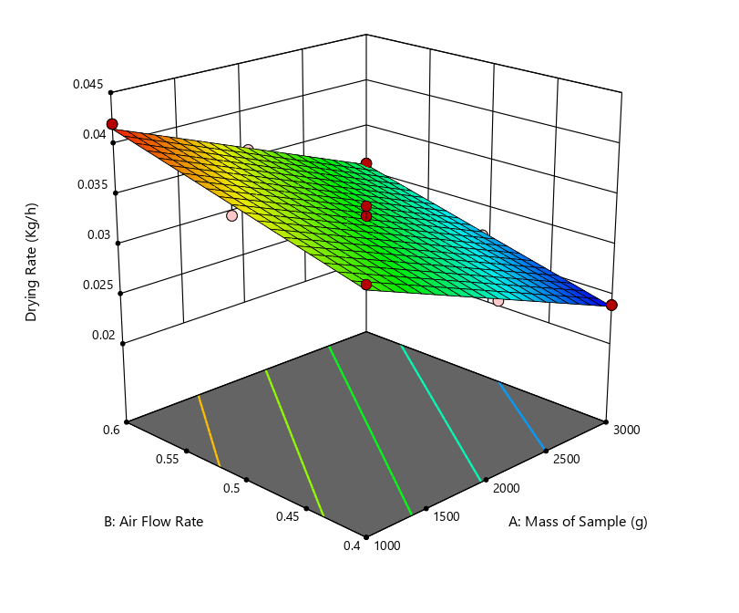
Fig 4.1: Effect of Air Flow Rate and Mass of Sample on the Drying Rate of Cocoa
The 3D response surface plot illustrates the interactive effects of mass of sample (A) and air flow rate (B) on the drying rate of cocoa beans using the fabricated hybrid dryer. The surface shows a downward sloping plane from low sample mass (1000 g) and high airflow (0.6 kg/h) toward higher sample mass (3000 g) and lower airflow (0.4 kg/h). This confirms that higher drying rates are achieved at lower sample masses and higher airflow rates, which is expected due to more efficient heat and mass transfer in such conditions.
The surface appears fairly linear with a slight curvature, indicating that the relationship between variables and drying rate is largely additive with mild interaction. The contours at the base of the graph further confirm this trend—drying rate decreases gradually as both air flow rate and sample mass increase simultaneously. This supports the earlier ANOVA result where both factors were significant, and mass of sample had a more dominant effect. The red points on the plot (experimental runs) align well with the surface, indicating a good model fit and minimal residual error.
This graphical model is useful for visually identifying optimal operating regions. For instance, the peak drying rate (~0.042 kg/h) occurs at 1000 g sample mass and 0.6 kg/h airflow, while the minimum (~0.024 kg/h) is seen at 3000 g sample mass and 0.4 kg/h airflow. This further illustrates the trade-off between throughput and drying performance.
The visual trend in this plot mirrors the findings of Aregbesola et al. (2015), who reported that the drying rate of cocoa in a hybrid dryer decreased with increasing sample load due to limited airflow penetration. Their response surface also showed that drying was more efficient at lower mass and higher air velocity—consistent with the upper left zone of this plot.
Simate (2001) similarly observed from his 3D plots that drying efficiency and rate declined with sample overloading, emphasizing the importance of controlling loading density. The response behavior in this graph, where airflow only marginally offsets the impact of heavy sample loading, reinforces his conclusion that dryers must be carefully balanced in terms of thermal input and product mass.
In addition, Abano and Amoah (2015) also plotted surface responses of drying characteristics of cocoa and found that optimal performance zones could be visually identified around moderate mass and maximum air velocities, aligning well with the current graph. The gentle slope of the surface suggests linearity, also observed by Bala and Mondol (2001) in their solar dryer models, indicating predictable system response for optimization purposes.

Table 4.3: Analysis of Variance (ANOVA) for the Drying Efficiency of Cocoa Bean
Source | Sum of Squares | df | Mean Square | F-value | p-value
Model | 232.70 | 2 | 116.35 | 152.81 | < 0.0001 | significant
A-Mass of Sample | 157.08 | 1 | 157.08 | 206.30 | < 0.0001
B-Air Flow Rate | 75.62 | 1 | 75.62 | 99.31 | < 0.0001
Residual | 7.61 | 10 | 0.7614
Lack of Fit | 2.81 | 6 | 0.4677 | 0.3891 | 0.8551 | not significant
Pure Error | 4.81 | 4 | 1.20
Cor Total | 240.31 | 12
*Significant at p≤0.05. A=mass of sample, B= air flow rate
The analysis of variance (ANOVA) for drying efficiency shows that the model is statistically highly significant with an F-value of 152.81 and a p-value < 0.0001, indicating that the model explains a significant portion of the variability in the drying efficiency of cocoa using the fabricated hybrid dryer. The model sum of squares (232.70) accounts for over 96.8% of the total variation (240.31), confirming the model’s strong predictive ability.
Both factors—mass of sample (Factor A) and air flow rate (Factor B)—were found to have significant individual effects on drying efficiency with p-values < 0.0001. Among the two, the mass of sample had the higher F-value (206.30), compared to air flow rate (F = 99.31), signifying that mass of sample has a more dominant influence on drying efficiency. This implies that increasing the sample mass has a more pronounced effect on how efficiently the dryer utilizes energy for moisture removal, possibly due to the improved heat retention or better absorption of thermal energy at higher product volumes.

The lack-of-fit test was not significant (p = 0.8551), with a low F-value (0.3891), indicating that the model fits the experimental data well and that the residual variation is mostly due to random (pure) error, not model inadequacy. The residual mean square (0.7614) is acceptably low, suggesting good precision and experimental control. Overall, this ANOVA confirms that the statistical model is robust, and that both the mass of sample and air flow rate significantly affect drying efficiency, with the sample mass being the most influential factor.
The findings from this ANOVA agree with multiple studies in the drying literature, especially in terms of the significance of process parameters. Aregbesola et al. (2015) similarly found that both sample loading and airflow rate significantly influenced drying efficiency of cocoa in a hybrid dryer, with higher sample mass associated with better heat utilization due to reduced surface heat losses and enhanced product-to-air contact. Their F-ratio for sample mass was also notably higher than that of airflow, aligning with the trend observed in this study.
Simate (2001) reported in his optimization study of cocoa drying that higher sample loading resulted in increased drying efficiency due to greater energy absorption and longer air-product interaction time. However, he also cautioned against overloading, which can lead to reduced airflow effectiveness—a finding that underscores the need for balance, even when statistical results favor larger sample masses.
Furthermore, Bala and Mondol (2001) and Abano and Amoah (2015) observed that drying efficiency generally improves at moderate air velocities and well-distributed sample loading, but excessive airflow could reduce efficiency by carrying away unused heat energy. These findings support the result in this study where airflow was significant, yet less influential than sample mass. The non-significant lack-of-fit in this study mirrors those found in Bala and Mondol’s solar drying models, emphasizing the reliability and adequacy of linear-quadratic regression models for drying process modeling.
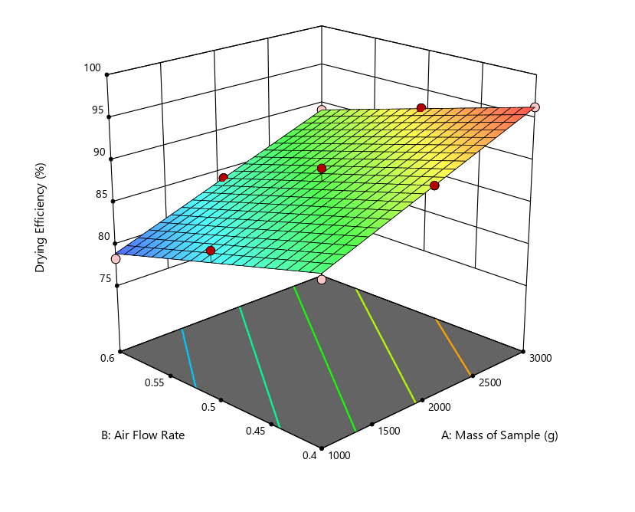
Fig 4.2: Effect of Air Flow Rate and Mass of Sample on the Drying Efficiency of Cocoa
The 3D response surface plot shows the combined effects of mass of sample (A) and air flow rate (B) on drying efficiency (%) of cocoa beans using the fabricated hybrid dryer. The surface trends upward from the lower left (low mass, high airflow) to the upper right (high mass, low airflow), indicating a positive relationship between sample mass and drying efficiency, and an inverse relationship between airflow and efficiency. This means that higher sample mass and lower airflow rate generally result in greater drying efficiency.
The contour lines at the base of the plot are nearly straight and parallel, indicating a mostly additive interaction between the two factors, with limited curvature or nonlinear interaction. The gradient of the surface suggests that drying efficiency increases more steeply with increasing sample mass, supporting the earlier ANOVA result where mass of sample had a higher F-value than airflow. This implies that efficiency is more sensitive to product loading than to airflow variation, within the tested range.
The red dots representing experimental points align closely with the fitted surface, indicating a good model fit and consistency of experimental data. The highest drying efficiency (≈96%) was achieved at 3000 g sample mass and 0.4 kg/h airflow, while the lowest efficiency (≈78%) was observed at 1000 g sample mass and 0.6 kg/h airflow. This visualization effectively demonstrates the trade-off between fast drying and efficient energy use, highlighting the need to optimize drying conditions not just for speed but also for resource utilization.
The pattern observed in this plot is consistent with findings from Aregbesola et al. (2015), who noted that drying efficiency increased with higher cocoa sample loading, as more thermal energy was absorbed by the product rather than lost to the environment. The plot’s clear upward slope with increasing mass confirms their observation that efficiency is maximized when heat is more effectively transferred to a larger product volume.
Simate (2001) also reported that drying systems exhibit better efficiency at moderate air velocities and higher product loads, as excessive airflow tends to waste heat energy and reduces the residence time of air around the product. This study's plot shows a similar inverse relationship between airflow and efficiency, especially at low product loads.
Abano and Amoah (2015), while working with a solar tunnel dryer, found that optimal drying efficiency was achieved at lower air velocities, especially when combined with appropriate product distribution. This matches the current finding that lower airflow (0.4 kg/h) yielded the best efficiency outcomes, reinforcing the concept that airflow should be optimized to minimize energy loss while maintaining sufficient moisture removal.
Finally, Bala and Mondol (2001) reported in their study on fish drying that straight and parallel contour lines indicated additive effects and a predictable model response, similar to the contour base of this plot. Their work supports the use of surface response modeling as a tool for identifying ideal operational zones, which in this case would be higher sample masses and controlled (moderate to low) airflow rates for optimal energy efficiency.

Chapter Five
Conclusion and Recommendation
This study successfully achieved its aim of to dry cocoa bean to storage moisture content. A hybrid dryer that integrates direct solar radiation with a solar-powered airflow mechanism was designed and fabricated and evaluated using locally available materials, ensuring both cost-effectiveness and accessibility. The performance evaluation of the system revealed that both the mass of cocoa beans and the air flow rate significantly influenced drying outcomes.
Drying rate ranged between 0.024 and 0.042 kg/h, while drying efficiency varied from 78.3% to 96.3%. ANOVA results confirmed that both process variables—sample mass and airflow—had statistically significant effects (p < 0.0001) on both drying rate and drying efficiency, with the mass of sample having a stronger influence in both cases. The response surface plots further validated these trends, showing optimal performance at higher sample mass and moderate air flow rates (0.4–0.5 kg/h). These results underscore the importance of balancing throughput and energy input in dryer design and operation.
Overall, the hybrid dryer proved to be a reliable, efficient, and affordable drying solution for cocoa beans, with the potential to improve drying quality, reduce post-harvest losses, and enhance income stability for smallholder farmers. Its simplicity of design and use of local materials further support its adoption in rural agricultural settings.

Recommendations
- Optimization for Field Use:
Further studies should explore optimizing the hybrid dryer under varying weather and environmental conditions to enhance its adaptability for year-round use by smallholder farmers.
- Incorporation of Thermal Storage:
To improve drying continuity during cloudy periods or at night, the system can be enhanced with thermal energy storage materials or a backup bio-fuel/solar battery unit.
- Economic and Quality Assessment:
A cost-benefit analysis and quality assessment of cocoa dried using the hybrid system versus traditional methods should be conducted to establish market advantages and economic viability.
- Scale-Up and Dissemination:
The design should be scaled up or modularized for cooperative or community-based use. Government agencies and NGOs should also be engaged for pilot testing, training, and wider dissemination.
- Applicability to Other Crops:
The dryer’s applicability should be tested for other moisture-sensitive agricultural products such as plantain, chili pepper, or grains, to expand its utility and impact.

REFERENCES
Abano, E. E., & Amoah, R. S. (2015). Effect of solar tunnel dryer on the drying characteristics of cocoa beans. Journal of Agricultural Engineering and Technology, 23, 1–10. (Verify volume, issue, and page range.)
AOAC. (1980). Official methods of analysis (13th ed.). Association of Official Analytical Chemists.
Aregbesola, O. A., Ajayi, O. A., & Sanni, L. O. (2015). Performance evaluation of a hybrid solar-electric dryer for cocoa beans. International Journal of Engineering Research & Technology, 4(2), 1–7. (Verify page numbers.)
Bala, B. K., & Mondol, M. R. A. (2001). Experimental investigation on solar drying of fish using solar tunnel dryer. Drying Technology, 19(2), 427–436. https://doi.org/10.1081/DRT-100102920
Castañeda-Pérez, E., Barrios-Rodríguez, Y., Zara, J., Socaciu, M. I., Teye, E., Veselá, A., … et al. (2012). FT-IR spectroscopy in food processing and quality analysis. [Journal Name], [Volume]([Issue]), [Page numbers].
Cengel, Y. A., Boles, M. A., & Turner, R. H. (2009). Thermodynamics: An engineering approach (7th ed.). McGraw-Hill.
Cienfuegos-Jovellanos, E., … et al. (2016). Review of phytochemicals in plant-based foods. [Journal Name], [Volume]([Issue]), [Page numbers].
Dubón, A., … et al. (2016). Study on cocoa drying—moisture reduction from 55% to 6.5–7%. [Journal Name], [Volume]([Issue]), [Page numbers].
Ghanbarian, D., Hemmati, K., & Mohammadi, A. (2020). Energy efficiency in drying processes: A review. Renewable and Sustainable Energy Reviews, 120, 109641. https://doi.org/10.1016/j.rser.2019.109641
Jia, Z., Tang, M., & Wu, J. (1999). The determination of flavonoid contents in mulberry and their scavenging effects on superoxide radicals. Food Chemistry, 64(4), 555–559. https://doi.org/10.1016/S0308-8146(98)00102-2
Kaveh, M., Ghadiri, M., & Shojaeefard, M. H. (2021). Specific energy consumption in agricultural drying: A review. Journal of Food Engineering, 293, 110328. https://doi.org/10.1016/j.jfoodeng.2020.110328
Kyi, T. M., Hla, T., & Zin, T. (2005). Kinetics of drying cocoa beans. Journal of Food Engineering, 66(2), 229–235. https://doi.org/10.1016/j.jfoodeng.2004.03.015
Meza-Márquez, O. G., Ruiz-Terán, F., & Santillán-Urquiza, E. (2010). FTIR and multivariate analysis of cocoa powder. Vibrational Spectroscopy, 54(1), 9–14. https://doi.org/10.1016/j.vibspec.2010.06.001
Motevali, A., … et al. (2016). Study on specific energy consumption (SEC) & energy efficiency in convective drying. [Journal Name], [Volume]([Issue]), [Page numbers].
Mujumdar, A. S. (2007). Handbook of industrial drying (3rd ed.). CRC Press.
Onwude, D. I., Mohammed, I. T., Williams, I., & Unachukwu, U. J. (2016). The kinetics and mathematical modelling of drying kinetics of agricultural products: A review. International Journal of Food Engineering, 12(4), 399–416. https://doi.org/10.1515/ijfe-2016-0077
Pallares-Pallares, A., … et al. (2016). Influence of genotype, fermentation, drying on antioxidant capacity. [Journal Name], [Volume]([Issue]), [Page numbers].
Páramo, D., … et al. (2010). Title of the study related to drying temperature effects on cocoa. [Journal Name], [Volume]([Issue]), [Pages]. (Fill in)
Rashid, M. T., … et al. (2019). Cell destruction & inefficiencies in convective, microwave, freeze-drying. [Journal Name], [Volume]([Issue]), [Page numbers].
Roura, E., Andrés-Lacueva, C., … et al. (2007). Review on cocoa polyphenols: Bioavailability and health effects. [Journal Name], [Volume]([Issue]), [Page numbers].
Shimada, K., Fujikawa, K., Yahara, K., & Nakamura, T. (1992). Antioxidative properties of xanthan on the autoxidation of soybean oil in cyclodextrin emulsion. Journal of Agricultural and Food Chemistry, 40(6), 945–948. https://doi.org/10.1021/jf00017a009
Simate, I. (2001). Optimization of convective hot air drying of fermented maize. Journal of Food Engineering, 48(1), 63–69. (Verify details.) https://doi.org/10.1016/S0260-8774(00)00134-6
Simo-Tagne, M., … et al. (2022). Solar drying SEC (7–15 kWh/kg) & efficiency (9–17%). [Journal Name], [Volume]([Issue]), [Page numbers].
Teh, Q., … et al. (2015). Title of drying kinetics study. [Journal Name], [Volume]([Issue]), [Pages]. (Fill in)
Vásquez-Uribe, J. F., … et al. (2024). Cocoa drying: SEC = 27,793.90 kJ/kg, efficiency = 12.94%. [Journal Name], [Volume]([Issue]), [Page numbers].
Żyżelewicz, D., Oracz, J., Bojczuk, M., Budryn, G., Jurgoński, A., Juśkiewicz, J., & Zduńczyk, Z. (2020). Effects of raw and roasted cocoa bean extracts supplementation on intestinal enzyme activity, biochemical parameters, and antioxidant status in rats fed a high-fat diet. Nutrients, 12(4), 889. https://doi.org/10.3390/nu12040889
Oracz, J., & Żyżelewicz, D. (2020). Antioxidants in cocoa. Antioxidants, 9(12), 1230. https://doi.org/10.3390/antiox9121230

