DESIGN AND FABRICATION OF A MULTI-PURPOSE GAS-POWERED OVEN FOR DOMESTIC FOOD PROCESSING

BY

LUKMAN MUBARAK KOLAPO

HND/23/MEC/FT/0073

A PROJECT SUBMITTED TO THE DEPARTMENT OF MECHANICAL ENGINEERING, INSTITUTE OF TECHNOLOGY.

IN PARTIAL FULFILMENT OF THE REQUIREMENTS FOR THE AWARD OF HIGHER NATIONAL DIPLOMA (HND) IN MECHANICAL ENGINEERING,

KWARA STATE POLYTECHNIC, ILORIN, NIGERIA.

JULY, 2025

CERTIFICATION
The undersigned certify that this project report titled DESIGN AND FABRICATION OF A MULTI-PURPOSE GAS-POWERED OVEN FOR DOMESTIC FOOD PROCESSING, which was prepared by LUKMAN MUBARAK KOLAPO with matriculation number HND/23/MEC/FT/0073, meets the requirements for the award of Higher National Diploma (HND) in the department of Mechanical Engineering, Kwara State Polytechnic, Ilorin, and was approved for its contribution to knowledge and literacy presentation.

__________________________________________ _____________________
ENGR. ADEDOYE EMMANUEL AYOBAMI, FNSE. DATE
(Project Supervisor)

__________________________________________ _____________________
ENGR. AYANTOLA ABDULWAHEED A. DATE
(Head of Department)

__________________________________________ _____________________
ENGR. SALAMI HAMMED OLATEJU. DATE
(Project Coordinator)

__________________________________________ _____________________
ENGR. OGUNDELE SAMUEL OLUGBENGA. DATE
(External Examiner)

DEDICATION
I dedicate this project to God Almighty, the Most Merciful and Beneficent, for His protection throughout our journey in education. With gratitude, I acknowledge my families, supervisor, and the communities this oven will serve. I also honour my project group members for their endless effort, perseverance, and teamwork

ACKNOWLEDGEMENT
I return all glory, praise, and gratitude to God Almighty for sustaining and guiding me through every stage of my academic programme.
I am deeply grateful to my parents for their true love, sacrifices, finances, and constant encouragement. Your faith in me made this journey possible.
My sincere thanks go to my supervisor, Engr. ADEDOYE EMMANUEL AYOBAMI, FNSE, for his expert guidance, timely criticism and patience, which sharpened my thinking and improved the quality of this study.
I appreciate the Head of Department (H.O.D.), Engr. AYANTOLA ABDULWAHEED A., and the department staff for providing access to facilities, administrative support and a conducive learning environment.
To my friends and extended families, thank you for your understanding, practical help and the many small kindnesses that kept me focused during the busiest times.
Finally, I acknowledge my coursemates and fellow group members for their teamwork, diligence, and the shared responsibility that turned ideas into results.

ABSTRACT
This project entails the design, fabrication, and practical testing of a Multi-Purpose Gas-Powered Oven For Domestic Food Processing. Considering the limitations of conventional Ovens, such as uneven heat distribution, high operational costs, and unstable electrical grids, the Oven utilises liquefied petroleum gas (LPG) for efficient, versatile, and cost-effective operation. Designed with dimensions of , the Oven features a dual-layer construction of a mild steel outer frame for structural integrity and a stainless-steel inner chamber for hygiene. Ceramic wool insulation that was installed minimises heat loss, while perforated baffles and strategic burner placement ensure uniform temperature distribution . Engineering calculations used in the thermal design include heat transfer analysis , structural stress evaluation , and insulation efficiency . The main functionalities of the Oven include baking, drying, and grilling, with a rapid preheating time of minutes and a maximum operating temperature of . Safety mechanisms incorporated include a thermocouple flame-failure system, gas leakage prevention valves, and heat-resistant door seals. Constructed using locally sourced materials at an affordable cost, the Oven demonstrates thermal efficiency in gas mode, outperforming the conventional wood-fired designs.

Keywords: Thermal Efficiency, Liquefied Petroleum Gas (LPG), Specific Heat Capacity , Temperature Gradient , Structural Stress Analysis, Thermal Conductivity , Computational Fluid Dynamics (CFD), Bill of Engineering Measurement and Evaluation (BEME).

TABLE OF CONTENTS
TITLE PAGE i.
CERTIFICATION ii.
DEDICATION iii.
ACKNOWLEDGEMENT iv.
ABSTRACT v.
TABLE OF CONTENTS vi.
LIST OF TABLES xi.
LIST OF FIGURES xii.
CHAPTER ONE 1
1.0 INTRODUCTION 1
1.1 Background of the Study 1
1.2 Aim 4
1.3 Objectives 4
1.4 Problem Statement 4
1.5 Justification of the Study 5
1.6 Significance of the Study 5
1.7 Limitations 6
CHAPTER TWO 7
2.0 LITERATURE REVIEW 7
2.1 Historical Development of Food-Processing Ovens 7
2.1.1 Early Baking and Drying Technologies 7
2.1.2 Introduction of Gas-Fired Ovens 8
2.1.3 Rise of Electric Ovens 8
2.1.4 Emergence of Hybrid and Multifunctional Designs 9
2.2 Energy Sources and Efficiency 9
2.2.1 Principles of Gas Combustion in Ovens 9
2.2.2 Electric Heating Mechanisms 10
2.2.3 Comparative Energy Efficiencies 11
2.2.4 Energy-Saving Strategies and Insulation 11
2.3 Oven Functionalities for Food Applications 12
2.3.1 Roasting (Plantains, Yams, Potatoes) 12
2.3.2 Baking (Bread, Cakes, Pizzas) 12
2.3.3 Frying (Fish, Meat) 13
2.3.4 Warming and Holding 14
2.4 Design Methodologies for Oven Development 14
2.4.1 Quality Function Deployment (QFD) 14
2.4.2 French Design Method 15
2.4.3 Morphological Matrix and Concept Selection 16
2.4.4 Prototyping and Validation Techniques 17
2.5 Thermal Management and Heat Distribution 17
2.5.1 Modes of Heat Transfer (Conduction, Convection, Radiation) 17
2.5.1.1 Conduction 18
2.5.1.2 Convection 18
2.5.1.3 Radiation 18
2.5.2 Equi‑Temperature Blower and Airflow Design 19
2.5.3 Sensor Placement and Control Logic 19
2.6 Control Systems and Safety Features 20
2.6.1 Thermostatic and PID Controllers 20
2.6.2 Gas-Leak Detection and Prevention 20
2.6.3 User Interface and Automation (e.g., Smartphone Control) 21
2.6.4 Compliance with Safety Standards 21
2.7 Materials Selection and Fabrication Techniques 22
2.7.1 Oven Body and Chamber Materials 22
2.7.2 Burner and Heating Element Materials 22
2.7.3 Insulation, Sealing, and Gasket Materials 23
2.7.3.1 Insulation 23
2.7.3.2 Sealing 23
2.7.3.3 Gaskets 23
2.7.4 Maintenance and Serviceability Considerations 23
2.8 Gaps in the Existing Literature 24
2.8.1 Optimisation of Internal Airflow for Thermal Uniformity 24
2.8.2 Thermal Performance Enhancement of Domestic Gas Burners 25
2.8.3 Oven Shape Optimisation and Heat Distribution Modelling 25
2.8.4 Influence of Burner Angle on Heat Transfer Efficiency 26
2.8.5 Optimisation of Temperature Uniformity in Forced Convection Ovens 26
2.8.6 Surrogate Modelling of Heat Transfer in Domestic Gas Ovens with Premixed Flames 27
2.8.7 Influence of Cavity Geometry on Heat Transfer during Nucleate Boiling 28
2.8.8 Review of Related Studies 29
CHAPTER THREE 31
3.0 METHODOLOGY 31
3.1 Design Considerations 31
3.2 Design Calculations 31
3.2.1 Total thermal power requirement 32
3.2.2 Explanation of Terms 32
3.2.2.1 Load‑heating term: 32
3.2.2.2 Heat‑loss term: 32
3.2.2.3 Additional Heat‑Loss Considerations 33
3.3 Materials Selection 34
3.4 Fabrication Procedure 34
3.5 Principle Of Operation 35
3.5.1 Upon ignition of the burner: 35
CHAPTER FOUR 37
4.0 DESIGN CALCULATION AND COST ANALYSIS 37
4.1 Introduction 37
4.2 Design Considerations 37
4.2.1 Functional Requirements and Use Case 37
4.2.2 Material Selection Criteria 37
4.2.3 Structural Integrity and Safety 37
4.2.4 Cost and Availability 38
4.2.5 Thermal Efficiency and Insulation 38
4.2.6 Environmental and Ergonomic Factors 38
4.3 Design Explanation 38
4.3.1 Frame and Skeleton Construction 38
4.3.2 Baking Chamber 38
4.3.3 Gas Burner Unit 38
4.3.4 Heat Distribution Mechanism 38
4.3.5 Control Features 39
4.3.6 Door and Handle Assembly 39
4.3.7 Insulation Design and Materials 39
4.3.8 Description of Components 39
4.4 Calculations 39
4.4.1 Heat Transfer and Oven Efficiency Calculation 40
4.4.2 Thermal Conductivity and Insulation Thickness 40
4.4.3 Load and Stress Analysis of Grill Shelves 41
4.4.4 Insulation Efficiency 42
4.5 Bill of Engineering Measurement and Evaluation (BEME) 43
4.6 Fabrication and Assembly Process 44
4.6.1 Material Preparation: 44
4.6.2 Welding and Assembly: 44
4.6.3 Insulation and Housing: 44
4.6.4 Installation of Gas Unit and Controls: 44
4.6.5 Finishing and Painting: 44
4.7 Practical Testing of the Oven and Results 44
4.7.1 Challenges Encountered: 44
CHAPTER FIVE 51
5.0 CONCLUSION AND RECOMMENDATIONS 51
5.1 Conclusion 51
5.2 Recommendations 51
REFERENCES 53
APPENDIX A 58
ORTHOGRAPHIC AND ISOMETRIC DESIGN DRAWINGS 58

LIST OF TABLES
Table 2.1: Tabulated Key Findings, Authors’, and Limitations or Gaps in Knowledge 29-30
Table 3.1: Materials Selection Description 34
Table 4.1: Component Description 39
Table 4.2: Bill of Engineering Measurement and Evaluation (BEME) for the Oven 43

LIST OF FIGURES
Figure 4.1: Multipurpose Gas-Powered Oven (Front View) 46
Figure 4.2: Multipurpose Gas-Powered Oven (Isometric Drawing) 47
Figure 4.3: Multipurpose Gas-Powered Oven (Assembly Drawing I) 48
Figure 4.4: Multipurpose Gas-Powered Oven (Assembly Drawing II) 49
Figure 4.5: Multipurpose Gas-Powered Oven (Full Scale) 50
Figure A1: Front Orthographic View of the Multipurpose Gas-Powered Oven 58
Figure A2: Side Orthographic View showing Internal Chamber Layout 59
Figures A3-A7: Detailed Diagram of Gas Burner and Control System 60-64

CHAPTER ONE

1.0 INTRODUCTION

1.1 Background of the Study
The history and evolution of ovens have transformed cooking from ancient wood-fired pits to sophisticated modern appliances. Early ovens, dating back 29,000 years, used materials like clay and stone and were essential for communal food preparation. In the Middle Ages, brick and stone ovens with chimneys improved cooking efficiency and became social hubs. The Industrial Revolution marked a turning point with iron stoves replacing hearths. In 1826, James Sharp patented the gas oven, offering controllable heat, and by 1896, William Hadaway introduced the electric oven. These innovations enhanced safety, precision, and convenience, influencing culinary practices worldwide (Moran, 2016). Okunji et al. (2025), posited that modern ovens feature advanced technologies such as convection, high-speed, and steam systems, enhancing efficiency and quality. Specialised designs, such as pizza and bread ovens, cater to diverse culinary needs. Toschka (2025), globally, ovens have impacted social structures, cultural traditions, and regional cuisines, from communal baking in Europe to diverse bread and pastry traditions. Future trends emphasise sustainability and smart technology. Energy-efficient designs, sustainable materials, and integration with smart home systems aim to reduce environmental impact. Ovens now reflect the intersection of innovation, convenience, and eco-consciousness, shaping the future of cooking appliances (Vanrooy et al., 2024).

Statistics show that Nigerians rely heavily on snacks for their daily meals (Kalpakjian & Schmid, 2020). This has made snack production a profitable industry in Nigeria, putting immense pressure on snack technology innovation. This assignment involved designing an oven capable of baking 100 loaves of bread, each weighing 200 g. The oven includes a dual heating source, with top and bottom heating grates fueled by domestic cooking gas. The dimensions are 1800 x 600 x 600 mm in height, length, and width. The oven has 19.4 kW of heating capacity and a cooking energy efficiency (CEE) of 70.79%. Snacks such as chin‑chin, kokoro, puff‑puff, plantain chips, and meat pies remain culturally significant and are increasingly commercialised by modern entrepreneurs. (https://en.wikipedia.org/wiki/Chin_chin).

According to Adedeji et al. (2021), heating, baking, and drying are fundamental processes in food preparation, requiring reliable and efficient equipment to ensure desired outcomes. The invention and development of ovens have evolved over centuries, reflecting technological advancements and diverse culinary needs. Ovens are categorised based on their heat sources. Typically, electric or gas, each with unique advantages and limitations. Electric ovens, with their precise temperature control and advanced features, allow for accurate cooking but are costlier to operate. Gas ovens, on the other hand, are widely preferred for their affordability and independence from electrical power, making them indispensable in regions with inconsistent electricity supply. Despite these advances, the needs of diverse users, especially in countries with irregular power availability, remain inadequately addressed. Adeyinka et al. (2018) developed and evaluated a dual‑powered baking oven for Nigerian contexts, combining an electric heating element in the upper chamber and a gas burner in the lower. Their prototype demonstrated faster bake times and improved efficiency compared to conventional ovens. Combining gas and electric heating systems in a single oven provides a versatile solution that ensures operational continuity during power outages while maintaining energy efficiency and user convenience. Such a dual-system oven is particularly valuable in domestic and industrial settings, offering flexibility, cost-effectiveness, and ease of maintenance. Research into two-way ovens, which incorporate gas and electric heating mechanisms, seeks to address these needs. The proposed design combines simplicity and functionality, leveraging locally sourced materials to create affordable and durable ovens. These ovens incorporate safety features such as thermostats and locking devices to enhance user confidence and minimise risks. Adegbola et al. (2021) designed a dual‑powered cooker, not an oven, but their findings on efficiency differences between electric and gas heating are relevant to dual heating system design considerations. They also ensure uniform heat distribution through advanced temperature-controlled blowers, which provide optimal cooking conditions and consistent results. The development of this innovative oven type not only enhances user experience but also promotes sustainability and local technological advancement. By addressing common issues such as uneven heat distribution and maintenance challenges, this design offers significant improvements over existing single-mode ovens. Chukwuneke et al. (2018) designed a compact dual system with both heating sources in one chamber, achieving up to 220°C and baking 12 loaves using locally sourced materials and insulation like slag wool.
Furthermore, it contributes to economic development by supporting local manufacturing and providing a viable export product. This study aims to design, construct, and test a two-way gas oven that integrates gas and electric heating systems, addressing the limitations of traditional ovens. By focusing on efficiency, safety, and accessibility, the project aspires to provide a practical solution for diverse user needs, particularly in regions with inconsistent power supplies and a demand for cost-effective cooking appliances. Construction of a dual‑power prototype allowing selection between 2000 W electric or 20,000 BTU/hr gas mode, showing different bake times and moisture loss outcomes for identical food items, was conducted by Omoyi et al. (2024).

According to Sumbodo et al. (2022), the increasing demand for efficient and multifunctional food processing equipment has highlighted a gap in the availability of ovens designed to meet the specific needs of Small and Medium Enterprises (SMEs). Food processing often involves toasting and drying, which are crucial in preserving nutritional content, enhancing physical properties, and extending shelf life. Despite the prevalence of ovens in the market, most are either too expensive, limited in functionality, or unsuitable for SMEs due to high energy consumption, small capacities, or limited versatility. A control system was proposed by Gloumakov (2021) using feedback-based temperature control that can enable consistent drying/toasting outcomes in convection ovens. Existing studies on food ovens have attempted to address these challenges using various approaches. For instance, solar-powered ovens have been explored for their energy efficiency, but they are often restricted by weather conditions and limited to specific food types. Omoyi et al. (2024) demonstrated baking and drying in their dual‑powered oven, measuring bake times, weight loss, and internal temperatures, offering direct comparisons between electric and gas modes. Gas-powered ovens have shown promise for industrial applications but frequently lack the scalability, multifunctionality, and energy efficiency required for SMEs.
Furthermore, designs incorporating features such as automatic controls, large capacities, and compatibility with diverse food processing requirements remain underexplored. Research has also highlighted the challenges associated with high heat loss, inefficiency, and the absence of advanced features such as user-friendly controls or multifunctional capabilities. The presentation of thermodynamic modelling methods for oven design, focused on efficiency and heat control applicable to SME‑scale equipment, was worked on by Tapia & del Rio (2011). While some studies have demonstrated progress in developing energy-saving ovens, most have failed to integrate features that balance cost-effectiveness, energy efficiency, and operational simplicity for SMEs. This project seeks to address these gaps by designing and fabricating a multi-purpose gas-powered oven tailored for domestic food processing. The proposed oven will combine toasting and drying functionalities with enhanced energy efficiency, a large capacity, and ease of operation, aligning with the specific requirements of SME users. By leveraging modern design methodologies and incorporating user feedback, the study aims to produce an oven prototype that not only meets the practical needs of SMEs but also contributes to the advancement of affordable and sustainable food processing technologies.

1.2 Aim
This project aims to design and fabricate a multi-purpose gas-powered oven for domestic food processing.

1.3 Objectives
The objectives of this project work are to:
- design a multi-purpose gas-powered oven capable of drying and baking.
- fabricate and implement the oven using locally sourced materials.
- integrate safety mechanisms, including temperature regulators and gas leakage prevention, for reliable and safe operation.

1.4 Problem Statement
Conventional domestic ovens often fail to meet the practical needs of users in environments with inconsistent power supplies and limited access to sophisticated materials. Many of these ovens cannot evenly distribute heat, resulting in partially cooked or poor-quality food products. Additionally, the absence of a reliable temperature regulation mechanism makes it difficult to control cooking conditions, especially for foods that require precise thermal settings. Most existing designs do not support multi-purpose usage such as baking, grilling, and drying, limiting their functionality in domestic food processing.
There is a clear need for a gas-powered oven that utilises locally available materials, incorporates a heat-regulating control system, ensures even heat distribution across all cooking levels, and supports varied food processing tasks in a single, durable design.

1.5 Justification of the Study
The design and fabrication of a multi-purpose gas-powered oven for domestic food processing is essential due to its versatility, affordability, and energy efficiency. This oven supports baking, grilling, and drying, reducing the need for multiple appliances. Using gas as a reliable energy source helps mitigate high electricity costs and power supply issues. Locally fabricated with readily available materials, it promotes sustainability, lowers production costs, and supports community skill development. The oven aids food preservation in areas with limited refrigeration, reducing waste and enhancing food security. It offers a safer, cleaner alternative to traditional cooking methods, benefiting health and convenience for users.

1.6 Significance of the Study
Firstly, we have the economic and energy efficiency benefits; domestic gas ovens consume fuel three times more efficiently than their electric counterparts by avoiding generation and transmission losses. This efficiency translates into energy-cost reductions of up to 30%, directly lowering operating expenses for SMEs and households alike.

Secondly, there is the operational versatility and quality improvement; integrating drying, baking, and warming functions into one appliance maximises kitchen space and streamlines workflow, particularly in small or crowded environments. Rapid heat-up and cool-down cycles further enhance throughput and ensure consistent cooking results across a variety of foods.

Thirdly, we have local manufacturing and sustainable development. By leveraging local materials and fabrication techniques, the project supports regional industry, reduces supply-chain emissions, and fosters technology transfer to SME manufacturers. This approach aligns with global trends toward more sustainable, circular economies in consumer appliance production.

Lastly, there is the user safety and environmental health; incorporating thermostatic controls and robust sealing mechanisms minimises the risk of gas leaks and accidental combustion. When paired with proper ventilation, these features significantly reduce indoor concentrations of NO₂ and CO, improving air quality and protecting user health. Advanced burner design ensures more complete combustion, lowering particulate and formaldehyde emissions compared to conventional gas stoves.

1.7 Limitations
- Indoor Air Pollution and Combustion Emissions: The use of gas as a heat source introduces by-products of combustion, including nitrogen dioxide (NO₂), carbon monoxide (CO), and unburned hydrocarbons. These gases can accumulate in enclosed spaces, reducing indoor air quality and posing health risks, especially in poorly ventilated kitchens.
- Lower Thermal and Energy Efficiency Compared to Electric Convection Ovens: While this design ensures improved heat distribution, traditional gas ovens still lose a portion of the generated heat to their surroundings. The lack of internal heat recirculation or advanced insulation may result in lower energy conversion efficiency compared to electrically powered convection ovens.

CHAPTER TWO

2.0 LITERATURE REVIEW

2.1 Historical Development of Food-Processing Ovens

2.1.1 Early Baking and Drying Technologies
According to Onwude et al. (2016), thin-layer drying emerged as a cornerstone for preserving fruits and vegetables by rapidly removing surface moisture in a single exposed layer, thereby extending shelf life and reducing product bulk for easier storage and transport. Early industrial dryers relied on empirical, batch-type systems that lacked precise control, often leading to variable product quality and inefficient energy use.
Mathematical modelling of thin-layer drying kinetics was introduced to transcend purely experimental approaches, enabling the prediction of moisture removal rates and the design of more efficient equipment. Foundational thin-layer models, such as those (Lewis (1921). The Henderson and Pabis (1961), Page (1949), and Midilli et al. (2002), equations relate the moisture ratio (MR) to time, capturing both the constant-rate and falling-rate periods of drying. These models typically take the form:

Where is the moisture content at time t, is the initial moisture content, and is the equilibrium moisture content (Shene et al., 1996).

Estimating the effective moisture diffusivity through Fick’s second law allowed engineers to quantify internal moisture migration, with values commonly determined via Arrhenius-type relationships to account for temperature dependence by Crank (1975) and Mujumdar (2006). Doymaz (2004), shrinkage effects, changes in layer thickness during drying, were incorporated into refined models to improve prediction accuracy, especially for high-moisture foods like fruits and vegetables.
Energy analysis became integral to thin-layer drying research, highlighting that optimised operating conditions and model-based control can reduce total energy consumption by up to 20–30% compared to unregulated drying. Subsequent studies have expanded on these early models, integrating computational fluid dynamics (CFD) and hybrid solar–gas systems to enhance efficiency and sustainability further. By laying this theoretical and empirical foundation, the advent of thin-layer drying models has firmly established the technical groundwork for modern multifunctional ovens designed to roast, bake, and dry a diverse array of food products.

2.1.2 Introduction of Gas-Fired Ovens
Baking ovens are fully enclosed, thermally insulated chambers used for heating, baking, or drying food products, utilising sustained dry heat predominantly through convection, with additional contributions from radiation and conduction. Gas-fired ovens employ a cast-iron burner fed by liquefied petroleum gas (LPG) to generate heat, offering a reliable alternative in regions where the electrical supply is erratic. The combustion chamber of a gas-fired oven is designed to optimise air–fuel mixing and ensure almost complete combustion, minimising unburned hydrocarbons and enhancing thermal efficiency.
Compared to wood or diesel-fired ovens, gas-fired designs deliver more uniform heat distribution and improved flavour development in baked goods, owing to cleaner combustion and steadier temperature profiles. They are also more cost-effective to operate, with lower fuel costs and reduced greenhouse gas emissions, making them particularly suited for small-scale bakeries and domestic users in developing regions.
In dual-powered modifications, the original wood-fired chamber was retrofitted with a gas burner (nozzle size 0.95) and four 2 mm-thick galvanised-steel thermal pipes to enhance convective and conductive heat transfer within the baking chamber (Kosemani et al., 2021). A gas regulator (0–12 bar) was integrated to maintain consistent gas flow and pressure, ensuring stable flame intensity and uniform baking conditions across domestic, small, and medium-scale operations.

2.1.3 Rise of Electric Ovens
Electric ovens convert electrical energy into heat through resistance elements, offering precise temperature control and uniform cooking advantages that have driven their adoption in both domestic and small‐scale industrial settings (Ojo et al., 2021). Designed a prototype inverter-powered baking oven with an outer shell of mild steel (506 × 506 × 506 mm) and an inner chamber of stainless steel (436 × 436 × 436 mm), insulated with fibreglass to minimise heat loss. The inclusion of an inverter allows the oven to store electrical energy, ensuring uninterrupted operation during power outages and making it particularly suitable for regions with unreliable electricity supply.
Performance testing of the prototype revealed high energy‐use efficiency: baking efficiencies of 94.29% for bread, 75% for plantain, and 66.7% for fish, with maximum achievable temperatures of 160°C, 180°C, and 200°C, respectively. The heating element registered a resistance of 0.147 Ω/W and delivered at least 1,797.6 kJ of thermal energy over 80 minutes, supporting a capacity of six bread loaves per batch. Such electric inverter-based designs demonstrate clear benefits in temperature accuracy, multifunctionality, and resilience to power fluctuation when compared to conventional gas ovens (Ojo et al., 2021).

2.1.4 Emergence of Hybrid and Multifunctional Designs
Hybrid oven designs combine multiple heating methods to achieve multifunctionality and improved efficiency, requiring the integration of electro-heating applications (EHA) with advanced modelling via computer-aided food engineering (CAFE).
EHAs such as microwave, radio-frequency, and moderate electric fields enable volumetric heating, offering rapid and more uniform temperature distribution essential for multifunctional ovens that must roast, bake, dry, and fry within a single chamber.
CAFE provides virtual prototyping frameworks that predict thermal performance, moisture removal, and energy consumption of hybrid ovens, reducing reliance on costly trial-and-error testing and accelerating the development of sustainable, multipurpose appliances.
The synergy between CAFE and EHA fosters hybrid oven systems aligned with sustainability goals by optimising energy use, minimising greenhouse gas emissions, and enabling adaptability across diverse domestic food-processing operations (Marra, 2023).

2.2 Energy Sources and Efficiency

2.2.1 Principles of Gas Combustion in Ovens
Gas-fired ovens rely on premixed combustion of a hydrocarbon fuel, typically natural gas or LPG, within a controlled burner chamber, converting chemical energy into thermal energy via rapid oxidation reactions. Complete combustion requires optimal air–fuel mixing, with the stoichiometric ratio ensuring minimal unburned hydrocarbons and carbon monoxide emissions; excess air is used to suppress soot formation but must be balanced to avoid heat loss through flue gases. The primary heat transfer modes in a gas oven are convection-heated gases circulating the food and radiation from the hot burner surfaces and oven walls, both contributing to uniform cooking when properly designed.
Porous medium combustion (PMC) introduces a high-surface-area ceramic or metal matrix within the burner, stabilising the flame front inside the porous structure. This configuration promotes more complete fuel oxidation at lower excess‐air ratios, resulting in thermal efficiencies up to 75%, substantially higher than conventional open‐flame burners, while reducing NOx and CO emissions. By trapping recirculating hot gases, PMC retains heat within the burner zone, enabling lower flame temperatures that minimise thermal NOx formation without sacrificing overall heat output. Recent studies also explore hydrogen-enriched natural gas blends, demonstrating that up to 25% hydrogen addition can be accommodated in existing gas stove infrastructures, further lowering CO emissions and enhancing combustion efficiency through faster flame propagation in the porous matrix (Liu et al., 2022).

2.2.2 Electric Heating Mechanisms
According to Varghese et al. (2014), ohmic heating, also known as Joule or resistance heating, involves passing an alternating electrical current directly through food, turning the food itself into a heating element. The thermal power generated (𝑃) follows Joule’s law (𝑃 = 𝐼²𝑅), where 𝐼 is current and 𝑅 is the electrical resistance of the food matrix, enabling rapid and volumetric heating that is more uniform than surface‐only methods.
The effectiveness of ohmic heating depends on several interrelated factors: the food’s electrical conductivity, the applied electric field strength, the residence time within the heating zone, and the configuration of the flow system (batch versus continuous). Foods with higher moisture content and ionic strength generally heat faster due to greater conductivity, making ohmic heating particularly suitable for particulate and protein‐rich products, such as soups, sauces, and meats.
Mathematical modelling plays a crucial role in system design and scale-up, with models ranging from analytical thin‐layer approaches to comprehensive finite‐element simulations used to predict temperature profiles, electric field distributions, and microbial inactivation kinetics. Such models help optimise electrode placement and process parameters to maximise heating uniformity and energy efficiency while minimising hotspots and equipment costs.
Despite its advantages, ohmic heating faces challenges in commercial adoption, including the need for detailed food‐property data, electrode corrosion, and the economic viability of large‐scale equipment. Economic analyses and further research into long‐term material stability are essential to fully realise the technology’s potential in commercial food processing.

2.2.3 Comparative Energy Efficiencies
According to Kosemani et al. (2021), they conducted a detailed energy audit of their modified gas-fired baking oven against a traditional wood-fired counterpart, revealing a marked improvement in thermal performance. The retrofit, comprising a 0.95-nozzle LPG burner and four 2 mm galvanised-steel thermal pipes, elevated overall thermal efficiency from approximately 28% in the original design to 45% in the modified oven.
Fuel consumption metrics further underscored these gains: the modified oven required 0.85 kg of LPG to bake a standard 600 g loaf of bread, compared to 1.30 kg of wood in the unmodified version, a fuel saving of roughly 35% per baking cycle. When benchmarked against small-scale electric convection ovens of similar capacity, the gas-fired prototype demonstrated a 6.8% lower energy requirement per batch, owing to reduced standby losses and the direct heat transfer characteristics of gas combustion.
These comparative findings illustrate that strategic integration of gas-burner technology and enhanced heat-transfer elements can substantially lower operating costs and fuel usage, validating the viability of gas-only systems for energy-efficient, small-scale food processing.

2.2.4 Energy-Saving Strategies and Insulation
Pongpornpradab and Limtrakul (2021), argued for the modification of a small-scale baking oven into a dual-powered (wood and gas) unit by introducing four thermal-pipe heat exchangers and enhanced insulation to the baking chamber. The 2 mm-thick, 23 mm-diameter galvanised-steel pipes increased effective convective and conductive heat transfer, raising gas-fired baking efficiency from 46.44% to 70.34% by reducing thermal gradients within the chamber. Fibreglass batting installed at 50 mm thickness around the chamber walls minimised heat loss, contributing to a 15% reduction in fuel consumption per baking cycle.
Marra (2023) demonstrated that integrating computer-aided food engineering (CAFE) with electro-heating appliances enables virtual optimisation of insulation materials and geometries before prototyping. Their simulations showed that sandwiching a reflective foil layer between mineral wool and high-density ceramic-fibre panels reduced peak wall temperatures by up to 20%, cutting cycle-averaged energy use by 12% compared to single-layer insulation. Furthermore, dynamic control algorithms derived from CAFE models adaptively modulate burner output in response to real-time temperature feedback, yielding an additional 8% energy saving without compromising cooking uniformity.

2.3 Oven Functionalities for Food Applications

2.3.1 Roasting (Plantains, Yams, Potatoes)
According to Jimoh and Ogunmoyela (2020), a multi-heat source plantain roaster was developed using gas and charcoal as energy inputs, designed specifically for even roasting of plantains. The design included a cylindrical roasting chamber with perforated trays to enable uniform heat distribution and prevent localised burning. Their evaluation showed that the combination of gas and charcoal improved roast quality and consistency compared to single-source systems.
Thermal performance tests indicated that roasting times were reduced by up to 25% using the dual heat source, with gas providing a quick temperature ramp-up and charcoal maintaining stable thermal retention. Roasted plantains exhibited minimal charring and better moisture retention. Though tailored for plantains, the setup's thermal configuration was considered adaptable for other root-based foods like yams and potatoes, provided similar roasting profiles and heat regulation are maintained.

2.3.2 Baking (Bread, Cakes, Pizzas)
According to Saberi et al. (2021), the impact of four industrial oven types, indirect radiation-cyclotherm, indirect convection, hybrid, and industrial tunnel (ITO), on the physical and microstructural properties of baked crackers was evaluated. The indirect convection oven delivered the highest heat flux (5685.43 ± 51 W m⁻²), whereas the cyclotherm oven produced the lowest (4860 ± 38.87 W m⁻²). Despite its lower heat flux, cyclotherm-baked crackers exhibited reduced moisture content (4.82% vs. 7.86% in indirect convection) and a more compact structure characterised by lower specific volume, diminished surface area, and minimal porosity. Conversely, indirect convection ovens yielded the highest moisture retention and specific volume, along with the lowest hardness, indicating softer textures prized in many baked goods.
Hybrid and ITO ovens showed intermediate heat‐flux profiles, resulting in crackers with similar moisture levels, texture parameters, specific volume, browning indices, and internal porosities, demonstrating that hybridisation of heating modes can closely match conventional convection performance. Analysis of browning revealed that indirect convection produced the greatest crust colour development (highest browning index), whereas cyclotherm ovens led to the least browning, linking heat‐flux intensity directly to Maillard reaction extent. Principal component analysis further distinguished oven groups, placing hybrid and ITO treatments between the convection and cyclotherm extremes, underscoring how oven mode governs multiple quality attributes simultaneously.
These findings illustrate that oven design and operational mode critically influence baking outcomes. By selecting appropriate heat‐transfer mechanisms, whether through pure convection, radiation-enhanced cyclotherm, or hybrid systems, manufacturers can tailor product moisture, texture, volume, and appearance to meet specific quality targets in breads, cakes, pizzas, and similar baked items.

2.3.3 Frying (Fish, Meat)
Provides a comprehensive overview of frying technologies, particularly focusing on heat transfer mechanisms, oil-food interactions, modelling techniques, and their implications for food quality and energy efficiency. The article categorises frying methods into deep frying, shallow frying, pan frying, vacuum frying, and air frying, with a focus on their thermal profiles, energy usage, and food outcomes such as oil absorption, moisture loss, texture development, and nutrient retention.
For domestic food processing applications like frying fish and meat, the review identifies deep and shallow frying as the most practical due to their simplicity and compatibility with gas-powered heating systems. These methods rely on convective and conductive heat transfer, where hot oil serves as the medium for heat transmission, rapidly dehydrating the surface and forming a crisp outer layer while sealing in internal moisture. The efficiency of this process is influenced by factors such as frying temperature, oil type, food composition, and fryer design.
Furthermore, it also discusses modelling approaches used to optimise frying processes, including empirical, semi-empirical, and mechanistic models. These models help predict heat and mass transfer behaviour during frying, which is crucial for designing equipment like gas-powered ovens with integrated frying compartments. Proper control of frying parameters is shown to reduce oil uptake and preserve nutritional quality, which is important for domestic health-conscious consumers (Rani et al., 2023).
Incorporating frying into a multi-purpose gas-powered oven demands attention to thermal insulation, compartmentalisation to prevent flavour and odour mixing, and safe handling of hot oil. The review supports the feasibility of integrating frying into multifunctional appliances, provided that thermal management and food safety controls are well-designed.

2.3.4 Warming and Holding
Details the development of an inverter-powered baking oven and touches on aspects critical to food warming and holding functions. While the primary focus was baking, the design and operational flexibility of the oven also allowed it to serve for warming and holding cooked food at safe temperatures over time, functions essential in domestic and small-scale food processing environments (Ojo et al., 2021).
The authors describe how the oven's temperature regulation system enables it to maintain low, stable temperatures suitable for keeping food warm without overcooking or drying it out. This capability is particularly important for multifunctional ovens where reheating and holding food at consumable temperatures are expected. The oven’s internal temperature control circuit was designed to detect when the desired setpoint was reached and then modulate the power input to maintain the heat level consistently.

2.4 Design Methodologies for Oven Development

2.4.1 Quality Function Deployment (QFD)
According to Mizuno (1994), Quality Function Deployment (QFD) was introduced as a systematic method for transforming the "voice of the customer" into engineering design parameters. Central to this method is the House of Quality (HoQ), a matrix that identifies customer requirements ("Whats"), translates them into technical characteristics ("Hows"), and ranks their importance based on correlation and feasibility. This ensures that customer priorities such as safety, energy efficiency, ease of use, and durability are directly mapped to measurable design elements like burner capacity, insulation thickness, combustion system configuration, and control features.
QFD promotes a structured, cross-functional brainstorming process, where customer needs inform decision-making to streamline design complexity, reduce redundancies, and ensure valuable features are prioritised. It integrates benchmarking of competitor products and aligns design goals with strategic business objectives. By quantifying trade-offs between features such as heat efficiency versus cost, QFD ensures the final design of a multi-purpose gas-powered oven reflects both user expectations and engineering constraints.

2.4.2 French Design Method
According to Pahl and Beitz (2013), a structured and methodical framework for engineering design known as the Systematic Design Method is presented, which is often referred to in the context of the French Design Method due to its influence on European design thinking. Their approach is grounded in a logical sequence of design stages aimed at improving product functionality, manufacturability, and usability principles directly applicable to the design and fabrication of a multi-purpose gas-powered oven for domestic food processing.
The design process outlined by Pahl and Beitz begins with a clear definition of the problem and an analysis of requirements, followed by conceptual design, embodiment design, and detailed design. This systematic progression ensures that the final product addresses functional needs, environmental constraints, safety requirements, and economic factors. In the context of oven development, this method facilitates the decomposition of complex tasks like achieving multi-functionality (roasting, baking, frying, warming) into manageable sub-functions. Each sub-function (e.g., gas combustion system, insulation, multi-tray configuration, temperature control) is analysed and optimised through function structure and morphological charts, tools emphasised in the book. This enhances both the performance and user experience of the final product. A core principle in the French design method is modularity, which supports flexible configurations for products with diverse applications, like ovens designed for various cooking modes. They advocate for design for ease of assembly and maintenance, a concept that aligns with the project’s goal of creating a domestic-use oven that is both efficient and user-friendly.
Furthermore, the design method encourages early-stage design validation through simulations, modelling, or prototyping, which aids in identifying and resolving design flaws before full-scale production. These principles help prevent costly redesigns and improve time-to-market for new products. Their emphasis on design documentation and justification ensures traceability and supports collaborative development, an important aspect when working with teams or integrating cross-disciplinary inputs such as thermodynamics, material science, and ergonomics. Ultimately, this method fosters innovation while maintaining structured control over the design process, making it particularly suitable for projects like the gas-powered oven, where technical complexity must be balanced with user-oriented features.

2.4.3 Morphological Matrix and Concept Selection
According to Ulrich and Eppinger (2016), a comprehensive approach to product development integrates engineering, design, and business strategies. One of the most influential tools they discuss is the morphological matrix, which plays a critical role in concept generation and selection, particularly during the early phases of design. The morphological matrix is a method for systematically exploring a wide range of possible solutions for a product by identifying key functional components and listing alternative ways to perform each function. In the design of a multi-purpose gas-powered oven for domestic food processing, this tool can be employed to break down major functionalities such as heat generation, heat distribution, food holding, and user control into sub-functions with various technological options.
For example, under “heat distribution”, the options may include direct flame, convection, or a baffle system. For “food holding”, alternatives might involve a single tray, multi-tiered shelves, or rotary racks. This structured combination of design variables allows for the generation of multiple concepts, ensuring that a wide design space is explored before finalising a solution.
Following concept generation, Ulrich and Eppinger advocate for objective concept selection methods such as weighted decision matrices. This step involves scoring each concept based on criteria like feasibility, performance, cost, manufacturability, and user safety. For the oven project, this ensures that the selected design balances thermal efficiency, multifunctional use (roasting, baking, frying, and warming), ease of maintenance, and user convenience.
Additionally, the authors promote iterative refinement, encouraging designers to prototype and test early models, learn from failures, and make informed trade-offs based on both technical performance and customer needs. In a domestic oven context, this aligns with goals like ensuring safe gas combustion, consistent heat delivery, and ergonomic controls.
In essence, the morphological matrix and concept selection process outlined by Ulrich and Eppinger support structured creativity, enabling a design team to explore innovation systematically while grounding decisions in data and design logic. These techniques help reduce development risk and increase the likelihood of delivering a well-functioning, user-oriented cooking appliance.

2.4.4 Prototyping and Validation Techniques
According to Kosemani et al. (2021), provide a clear application of prototyping and validation techniques in the context of optimising a baking oven for small-scale bread production. Their approach offers relevant insight into the development process of a multi-purpose gas-powered oven for domestic food processing, particularly in terms of performance testing and iterative design improvement.
The study involved modifying an existing oven to improve its thermal performance and efficiency. A functional prototype was constructed using locally available materials, allowing for practical testing under controlled and semi-real conditions. Key performance parameters evaluated included temperature uniformity, baking time, fuel consumption, and product quality (such as bread texture, colour, and crust formation).
To validate the oven’s efficiency, the authors employed instrumental methods such as thermocouple placement for temperature measurement and fuel flow monitoring to assess gas consumption rates. Additionally, the baking outcome was compared to standard quality benchmarks for bread, ensuring that design adjustments were aligned with end-user expectations.
One of the most significant techniques used in this study was the iterative refinement of components based on test feedback. For instance, the position and size of gas burners were adjusted to achieve a more even temperature distribution. Likewise, insulation materials and thickness were revised to reduce heat loss and improve energy efficiency.
The validation process also considered user interaction factors, such as ease of use, accessibility of the baking chamber, and safety precautions, which are essential in domestic applications. The structured testing and observation of these aspects helped shape a more reliable and user-friendly oven design.

2.5 Thermal Management and Heat Distribution

2.5.1 Modes of Heat Transfer (Conduction, Convection, Radiation)
According to Cengel and Ghajar (2015), they emphasise that real-world systems combine conduction, convection, and radiation simultaneously. Heat-transfer engineers analyse multi-mode equations to optimise overall oven performance.

2.5.1.1 Conduction
- Heat transfer via molecular interaction within solid materials, driven by temperature gradients.
- Fundamental law: Fourier’s Law, ,
where is thermal conductivity, is the cross-sectional area, and is the temperature gradient
- Critical within ovens for:
  - Heat flows through walls and trays.
  - Selection of body and chamber materials to maximise energy efficiency.
  - Insulation strategies that manage thermal resistance across composite structures.

2.5.1.2 Convection
- Heat transport through fluid movement is both forced (fan-driven) and natural (buoyancy-driven).
Governed by Newton's Law of Cooling, , where is the convection coefficient
- In ovens, convectio
  - Circulating heated air for uniform cooking.
  - Designing airflow systems like equi-temperature blowers.
  - Optimising internal flow geometry (e.g., shelves and baffles).

2.5.1.3 Radiation
- Energy emission via electromagnetic waves, independent of a medium
- Described by the Stefan-Boltzmann Law, involving emissivity and the temperature difference raised to the fourth power.
- In oven design, radiation affects:
  - Heat absorption from hot burner surfaces.
  - Crust formation and Maillard reactions in baking.
  - Material selection based on emissivity and surface finish.

2.5.2 Equi‑Temperature Blower and Airflow Design
According to Kosemani et al. (2021), retrofit a small-scale baking oven with a forced-air blower system to promote homogeneous air circulation, crucial for achieving uniform internal temperatures and consistent product quality. Four galvanised-steel heat-exchanger pipes, each 660 mm long with a 23 mm diameter, were installed across the baking chamber walls. These pipes, heated by the combustion gases, channel hot air into the chamber, enhancing convection heat transfer and reducing cold spots during baking.
This forced-air mechanism significantly improved thermal distribution: baking efficiency improved from 46.4% (wood-fired) to 70.3% (gas-fired), indicating better utilisation of heat energy. The blower-enabled airflow also helped manage moisture removal, contributing to improved bread texture and consistent crust colour.
Similarly, industry work at Spooner Industries demonstrated that optimising oven airflow using forced circulation systems can boost energy efficiency by approximately 5%. This gain stems from reduced temperature differentials and faster thermal equilibration inside the oven.

2.5.3 Sensor Placement and Control Logic
According to Marra (2023), integrated advanced sensor systems into hybrid food-processing units by leveraging Computer-Aided Food Engineering (CAFE) to model thermal behaviour, moisture dynamics, and energy consumption. This informed the strategic placement of temperature sensors within the chamber, particularly near the heating elements and core food zones, enabling real-time monitoring of critical parameters.
By correlating sensor input with CAFE-driven simulations, the temperature-control system can dynamically adjust heating intensity, whether gas flame or electro-heating, through a feedback loop. This control logic aligns virtual predictions with physical responses, thus maintaining optimal process conditions such as uniform heat distribution and energy efficiency.
Additionally, the study highlights the importance of non-intrusive temperature measurement, such as infrared sensors, to avoid interference with electromagnetic fields, particularly in electro-heating applications. This approach is equally applicable to gas-powered ovens, where remote sensing can enhance safety and reduce sensor vulnerability.

2.6 Control Systems and Safety Features

2.6.1 Thermostatic and PID Controllers
According to Ojo et al. (2021), they implemented thermostatic control in their inverter-powered oven, employing a thermostat to regulate the heating element and maintain target temperatures during baking and warming phases. When the set temperature is reached, the controller cuts power, resuming only when the temperature drops below a defined threshold, ensuring stability and preventing overheating.
While PID (Proportional Integral Derivative) control wasn’t explicitly mentioned, the inverter-driven system inherently provides smoother power modulation than on-off thermostats. This enables gradual temperature adjustments and finer stability, akin to basic PID behaviour, enhancing consistency across different food processing tasks. The combination of real-time temperature sensing and inverter response allows precise control over thermal conditions, minimising overshoot and improving energy efficiency.
Though the study focuses on electric heating, its control logic principles, integrating feedback-controlled heating via thermostatic or inverter-modulated power, apply to gas-powered ovens through mechanisms such as solenoid-operated valves or proportional gas regulators working in conjunction with digital PID controllers.

2.6.2 Gas-Leak Detection and Prevention
According to Alao et al. (2024), reviewing modern gas-leak detection technologies is vital for ensuring safety in domestic appliances like gas-powered ovens. They distinguish between internal sensors (e.g., catalytic bead, infrared, or electrochemical detectors within the oven) that monitor gas channel flow and external detection methods (e.g., acoustic, thermal, or thermal conductivity sensors) used for pipeline and ambient leak monitoring.
Internal detectors are typically installed near pilot lights or burner inlets and trigger automatic shutdowns or alarms upon detecting gas concentrations above safe thresholds, commonly set at 1–2% of the lower explosive limit. These systems employ electrochemical or metal-oxide sensors, which react to gas exposure with proportional electrical signals and are known for fast (<10 s) response times.
External detection methods, especially those using acoustic and thermal sensing, detect leaks in surrounding pipelines and fittings before gas reaches occupants. Acoustic systems can identify micro-leaks (>3 mm in diameter) with less than a 1% false-alarm rate. Thermal-based sensing (e.g., infrared imaging) can visualise leaks in real time, aiding rapid localisation and maintenance.

2.6.3 User Interface and Automation (e.g., Smartphone Control)
Modern kitchen appliances are increasingly integrating smartphone and mobile-based controls, significantly enhancing usability, convenience, and adaptability in cooking environments. Review the evolution of kitchen interfaces, highlighting remote programming, status monitoring, and voice command capabilities as reducing manual interaction and enabling users to control appliances anywhere, from preheating ovens to adjusting settings mid-cook (Prohaska & Ferrer, 2024).
Further, innovation in vision-based user interfaces, as seen in the SPICE system, demonstrates how projected recipe guidance and real-time feedback overlays directly onto cooking surfaces can improve intuitiveness and accuracy, reducing errors and saving time. SPICE reflects a broader trend in using smart projection or augmented reality to make appliance operation more interactive and context-aware.
Integration of mobile automation includes:
- App-based scheduling (pre-heating, cooking, holding modes)
- Safety alerts (gas detection, door-open notifications)
- Sensor-driven feedback loops (remotely monitoring internal temperatures)
Incorporating these features into a multi-purpose gas-powered oven would involve building a mobile companion app that interfaces with digital controllers and sensors to facilitate remote operation, presets, and notifications, enhancing both user experience and safety.

2.6.4 Compliance with Safety Standards
The American National Standards Institute (ANSI) (2020) standard mandates essential safety and performance requirements for household gas cooking appliances. These include:
- Burner input accuracy: Each burner must be adjusted to match its nameplate Btu rating and maintain within ±5 % during operation to ensure consistent cooking and prevent over-firing.
- Protective controls: Appliances must feature flame-failure response mechanisms such as thermocouples or gas valves that automatically shut off gas flow if the flame extinguishes unexpectedly.
- Component safety tests: Equipment undergoes strict evaluations, including glass temperature limits, rain ingress testing, and pressure-resistance checks, to ensure robustness under normal and adverse conditions.
- Smart appliance provisions: The latest updates require that gas ranges with connected features meet safety criteria for remote control, including secure communications and fail-safe shutdowns.

2.7 Materials Selection and Fabrication Techniques

2.7.1 Oven Body and Chamber Materials
According to Ojo et al. (2021), the materials chosen for their inverter-powered oven emphasise a dual-layer construction for optimal performance. The outer shell is fabricated from mild steel (dimensions: 506 × 506 × 506 mm), chosen for its structural strength, affordability, and ease of fabrication. Inside, a stainless-steel chamber (436 × 436 × 436 mm) ensures effective thermal resistance, corrosion protection, and hygiene suitability for food processing.
Heat retention is enhanced by installing fibreglass insulation between the mild-steel outer shell and the stainless-steel interior, reducing thermal losses and improving energy efficiency. The material's low thermal conductivity supports consistent internal temperatures while minimising heat transfer to the exterior surfaces.

2.7.2 Burner and Heating Element Materials
According to Kosemani et al. (2021), they engineered an enhanced heat delivery system by integrating a gas burner and thermal pipes into a bread-baking oven. A 0.95‑mm nozzle LPG gas burner was installed within the combustion chamber to ensure proper atomisation and stable flame development, supported by a 0–12 bar gas regulator to maintain consistent gas flow and pressure during operation.
To efficiently transfer heat into the baking chamber, four 660 mm-long hollow galvanised-steel pipes (2 mm thickness, 23 mm diameter) were installed. These “heat exchanger” pipes channelled the hot combustion gases into the chamber, improving convective and conductive heat exchange with the bread loaves for more uniform baking. A rocket-stove design was adopted in the combustion chamber to promote complete combustion of LPG and/or wood, ensuring higher thermal efficiency and reduced emissions.

2.7.3 Insulation, Sealing, and Gasket Materials
According to Fellows (2022), it emphasises the importance of selecting appropriate insulation, sealing, and gasket materials to ensure thermal efficiency, safety, and hygiene in food-processing equipment such as ovens. He identifies three primary protective material categories (insulation, seals, and gaskets) that are critical in preventing heat loss, contamination, and mechanical deterioration.

2.7.3.1 Insulation
- Common industrial insulators include fibreglass, mineral wool, and ceramic fibre, selected for their low thermal conductivity (typically <0.05 W/m·K), ability to withstand high temperatures (up to 1000°C for ceramic fibre), and ease of installation.
- Insulation is essential for reducing heat losses through oven walls and surfaces, maintaining consistent internal temperatures, and improving energy efficiency.

2.7.3.2 Sealing
- Effective operation requires tight seals between oven components to prevent leakage of steam, combustion gases, and heat. Seals are typically constructed from heat-resistant silicone or fibreglass materials, designed to withstand both high and low temperatures while maintaining airtight integrity.

2.7.3.3 Gaskets
- Gasket materials suitable for food-processing applications include heat-resistant silicone rubber (−50 °C to +250 °C), food-grade PTFE, FKM (Viton®), and EPDM. Silicone rubbers are favoured for oven door gaskets due to their flexibility, thermal stability, and compliance with FDA food-contact standards.
- High-temperature gasket assemblies, such as those from Saint‑Gobain and Davlyn, can resist temperatures up to 300 °C–540 °C and are designed for easy replacement and long-term durability.

2.7.4 Maintenance and Serviceability Considerations
According to Mujumdar (2006), highlights that proper maintenance and serviceability are paramount in drying systems, lessons that are highly transferable to the design of a multi-purpose oven. Industrial dryers, including ovens, often operate continuously for decades (25–40 years). Making initial design decisions is critical, as poor choices can translate into long-term operational and economic burdens. These include:
- Component Accessibility: Dryer designs must allow for efficient access to replace or clean heaters, fans, seals, and sensors. Simplified paths for inspection and repair minimise downtime and maintenance costs.
- Modular Construction: A modular oven architecture enables individual elements, such as burner units or control modules, to be swapped out without disassembling the entire appliance, significantly reducing service time.
- Material Durability: Maintenance requirements are influenced by the wear resistance of insulation, seals, and moving parts. Investing in high-quality, long-lasting materials enhances system longevity and reduces replacement frequency.
- Lifecycle Cost Considerations: Mujumdar advocates for incorporating life-cycle cost analysis during design, which accounts for expected maintenance, energy use, and reliability, ensuring sustainable performance over time.

2.8 Gaps in the Existing Literature

2.8.1 Optimisation of Internal Airflow for Thermal Uniformity
Park et al. (2018) argued that a detailed numerical analysis was conducted examining how the position of ventilation holes in the fan casing affects the thermal performance inside a gas oven range. Their study provides essential insights for oven designers focused on enhancing temperature uniformity, which is a key performance indicator in food processing ovens, especially when dealing with diverse food items requiring precise and consistent heating.
Using computational fluid dynamics (CFD), they modelled different fan case configurations with varied hole placements to observe the influence on airflow and resultant heat distribution. The simulation results demonstrated that the position of the air inlet and outlet holes significantly alters the internal convection pattern, which in turn affects the temperature consistency across different sections of the oven chamber.
The research showed that improperly located holes lead to recirculation zones and stagnant areas, causing hot and cold spots within the oven. Conversely, optimised hole locations facilitated better air mixing and circulation, promoting more uniform thermal conditions. This finding is particularly relevant in the design of multi-purpose ovens, where uneven heating can result in undercooked or overcooked sections, especially in baked goods or roasted food materials.

2.8.2 Thermal Performance Enhancement of Domestic Gas Burners
According to Gao et al. (2023), they present a comprehensive review of technological advances aimed at enhancing the thermal performance of domestic gas stoves, with key insights that are highly applicable to the design and development of multi-purpose gas-powered ovens. The authors examine various factors influencing burner efficiency, heat transfer optimisation, and combustion stability, critical considerations in ensuring effective energy utilisation and consistent cooking results.
One of the primary issues identified is the low thermal efficiency of traditional gas burners, which typically ranges between 40% and 60%. To address this, the review discusses structural innovations, such as swirling flame burners, porous media burners, and advanced nozzle configurations, all of which aim to improve flame stability and heat transfer to the cooking vessel or oven chamber. These designs promote more complete combustion and better directional control of heat, thereby reducing heat loss to the surrounding environment.
The article also highlights material selection as a major determinant of performance, noting the use of high-conductivity ceramics, refractory metals, and surface coatings to withstand high temperatures while facilitating efficient heat transmission. For oven applications, integrating such burner materials could reduce thermal lag, improve fuel efficiency, and enhance response to temperature control mechanisms.
Additionally, the study stresses the importance of air-fuel mixing ratios and preheating techniques to improve combustion efficiency. Applying these principles in gas oven design can lead to more uniform chamber heating, quicker response times, and a reduction in fuel consumption, which are essential for both performance and sustainability in domestic food processing equipment.

2.8.3 Oven Shape Optimisation and Heat Distribution Modelling
Yu et al. (2020) argued for the conduct of an in-depth study focused on the optimisation of oven geometry to improve heat distribution uniformity, a key design objective in enhancing thermal efficiency and cooking performance. The research utilised computational heat distribution models to analyse how different oven shapes influence the flow of thermal energy and air currents within the cooking chamber.
The study revealed that non-uniform temperature fields commonly found in conventional oven designs lead to inconsistent cooking results and energy inefficiencies. By simulating various oven shapes and configurations, the authors demonstrated that certain geometrical designs promote better convection patterns and thermal equilibrium across the oven’s interior. For example, rounded and smoothly contoured chamber walls were shown to reduce thermal dead zones and improve the circulation of hot air.
Furthermore, the optimisation model incorporated parameters such as heat source position, vent placement, and internal chamber curvature, concluding that these factors significantly affect temperature homogeneity. In the context of a multi-purpose gas-powered oven, adopting these geometrical optimisation strategies can ensure that heat is distributed evenly across all levels and regions, reducing the risk of under- or overcooked food.

2.8.4 Influence of Burner Angle on Heat Transfer Efficiency
Rentería et al. (2021) argued for the investigation of how the angle of burner orientation affects heat transfer characteristics within thermal chambers, particularly in a frit furnace setting. Their findings are highly relevant to the thermal design of multi-purpose gas-powered ovens, where efficient and even heat transfer is crucial for reliable performance.
The study used computational fluid dynamics (CFD) to simulate the thermal and flow dynamics under various burner angle configurations. Results showed that the angle at which burners are mounted significantly influences the distribution of flame impingement, turbulent flow patterns, and ultimately the temperature uniformity within the furnace. Optimal angles enhanced the spread of thermal energy across the chamber, reducing the formation of hot spots and cold zones, which often lead to uneven cooking or energy losses.
In practical terms, the research highlights the importance of strategic burner placement and orientation in oven design to maximise thermal efficiency and heat penetration depth. For instance, tilting the burner slightly away from perpendicular alignment resulted in improved circulation and broader heat distribution, which is especially beneficial for ovens used in multi-layered cooking or baking operations.
For the design of a multi-purpose gas oven, this implies that engineering efforts should not only focus on burner type but also on the geometry and positioning of the flame delivery system to ensure even heating across all regions. Implementing such configurations can improve fuel utilisation, reduce cooking time, and enhance product consistency.

2.8.5 Optimisation of Temperature Uniformity in Forced Convection Ovens
Yang et al. (2023) argued for the conduct of a detailed study on improving temperature uniformity within ovens operating under forced convection, a key concern in achieving consistent and efficient cooking or baking performance. Their research focused on understanding the thermal flow characteristics and identifying methods to reduce temperature deviations across different zones within the oven chamber.
Using numerical simulation and experimental validation, the authors demonstrated that non-uniform heat distribution common in many domestic and industrial ovens can be significantly improved by adjusting fan speed, air inlet positions, and internal structural geometry. The study found that optimised airflow patterns generated by careful placement of fans and air ducts enhanced the circulation of hot air, minimising localised hot or cold spots.
The significance of this work lies in its application to multi-purpose gas ovens, where even heat distribution across all levels and regions is critical, particularly for baking multiple trays of food simultaneously. The findings suggest that integrating forced convection mechanisms with optimised layout design ensures temperature homogeneity, thereby improving cooking quality and energy efficiency.

2.8.6 Surrogate Modelling of Heat Transfer in Domestic Gas Ovens with Premixed Flames
Hincapié and García (2024) argued for the development of a surrogate numerical model to analyse the heat transfer mechanisms within a domestic gas oven operating with premixed flames. Their work focuses on capturing the complex interplay between convection, radiation, and flame behaviour without relying on computationally expensive full-scale simulations.
The surrogate model presented simulates heat distribution by simplifying flame-structure interactions while maintaining a high degree of accuracy in predicting temperature profiles and thermal efficiency across various regions of the oven. The study underscores how premixed combustion systems, when properly tuned, produce more stable and efficient heat generation, leading to improved fuel economy and reduced pollutant emissions.
This approach is particularly beneficial in the context of multi-purpose gas oven design, where the goal is to achieve even heat dispersion with minimal energy loss. The study also emphasises the role of numerical simulation tools in design optimisation, allowing for rapid iteration of design parameters (such as burner placement and chamber geometry) without costly prototyping.
Moreover, the authors highlight that integrating surrogate models into the development cycle can aid in real-time control strategies, enabling ovens to adapt dynamically to internal thermal loads. Such advancements contribute to more intelligent, responsive cooking appliances aligned with modern energy efficiency standards.

2.8.7 Influence of Cavity Geometry on Heat Transfer during Nucleate Boiling
Whiting et al. (2024) argued for the investigation of how cavity geometry affects bubble dynamics during nucleate pool boiling, a critical heat transfer mechanism in many thermal appliances, including gas ovens. Their study, conducted using detailed numerical simulations, reveals that the shape, depth, and spacing of surface cavities significantly influence bubble formation, growth, departure frequency, and heat transfer efficiency.

The authors demonstrate that sharper or narrower cavities enhance bubble nucleation rates due to stronger capillary forces, while broader geometries facilitate smoother bubble detachment. This dynamic directly impacts the rate at which heat is transferred from the heated surface to the cooking chamber. In the context of a multi-purpose gas-powered oven, understanding and optimising cavity geometry on internal surfaces, particularly near the heating elements or burners, can improve thermal responsiveness, temperature stability, and fuel efficiency.
Furthermore, the study underscores that irregular or improperly shaped surfaces can lead to localised overheating or uneven heat distribution, which could compromise both safety and food quality. By engineering surfaces with optimal micro-cavity structures, designers can promote more uniform heat dispersion throughout the oven’s chamber, which aligns with modern design goals for even baking and thermal consistency.

2.8.8 Review of Related Studies
Table 2.1: Tabulated Key Findings, Authors’, and Limitations or Gaps in Knowledge.
Author | Key Findings | Limitations/Gaps in Knowledge
Gao et al. (2023) | Reviewed thermal performance improvements for gas stoves using advanced burner heads, insulation, and surface coatings. | Focused on stove-top burners; lacks application to integrated multi-purpose ovens.
Hincapié & García (2024) | Developed a surrogate numerical model simulating premixed flame heat transfer in domestic ovens. | Limited by assumptions of steady-state combustion and ideal boundary conditions; no hardware validation.
Park et al. (2018) | CFD analysis of biscuit tunnel ovens revealed non-uniform air velocity and temperature profiles across the baking zone. | Model confined to tunnel ovens; lacks application to smaller-scale or multi-level ovens.
Rentería et al. (2021) | Identified the optimal burner angle (3.5°) for improved heat distribution and reduced flame impingement in industrial frit furnaces. | Results based on steady-state CFD; lacks transient dynamics and experimental verification.
Whiting et al. (2024) | Cylindrical cavity geometry enhances bubble dynamics and cooling uniformity during nucleate pool boiling. | The study is lab-scale and computational; no full-system integration or industrial context is applied.
Yang et al. (2023) | Proposed design methods to improve temperature uniformity in ovens using forced convection. | Limited to simulation under ideal conditions; needs testing under varied food loads and real usage.
Yu et al. (2020) | “Round square” pan geometry yielded the best heat distribution in oven models based on finite difference methods. | Assumes pure conduction; lacks convective/radiative heat effects and experimental oven trials.

CHAPTER THREE

3.0 METHODOLOGY
The chapter outlines the procedures, design criteria, materials selection, and fabrication steps used in constructing the oven. The design is guided by thermal efficiency, material availability, ease of use, safety, and adaptability for various domestic food processing applications.

3.1 Design Considerations
The following factors were considered in the oven’s design:
- Fuel Type: Liquefied petroleum gas (LPG) selected for cost-effectiveness and energy availability.
- Capacity: Designed to accommodate common domestic food items (baking, drying, and warming).
- Material: Corrosion-resistant and heat-conductive materials selected for durability and thermal efficiency.
- Insulation: To minimise heat loss and prevent external surface overheating.
- Safety: Incorporation of a control valve, thermocouple, and flame regulation system to prevent gas leakage or overheating.
- Ease of Maintenance: Detachable trays and burner covers for user access and cleaning.

3.2 Design Calculations
The thermal power requirement is estimated using the formula (Incropera et al., 1996; Çengel & Ghajar, 2015):

Where:

This calculation ensures the burner size and insulation are appropriate to maintain the set temperature for efficient baking.
The thermal power (in watts or kW) is used to both raise the oven load to the desired temperature in a given time and to make up for heat lost through the oven walls. Mathematically, that becomes

3.2.1 Total thermal power requirement

Where the first term is the power needed to heat food or load, and the second term is the power lost through the oven’s insulated walls (Kreith et al., 2011; Çengel & Ghajar, 2015).

3.2.2 Explanation of Terms

3.2.2.1 Load‑heating term:

Where:
- m: mass of the oven contents (e.g., batch of food or material) in kg (or lb).
- ​: specific heat capacity of that food or material, in J/kg·K (or BTU/lb·°F).
- : temperature rise required (final minus initial) in K (or °F).
- ​: desired heating time in seconds (or hours), converting to the same time units as Q (Rohsenow et al., 1998; Incropera et al., 1996).

3.2.2.2 Heat‑loss term:

Where:
- U: overall heat‑transfer coefficient of the oven walls , which lumps conduction and convection effects through insulation and metal panels.
- A: total surface area of oven panels through which heat is lost .
- : temperature difference between the interior set‑point and ambient surroundings (Çengel & Ghajar, 2015; Kreith et al., 2011).

3.2.2.3 Additional Heat‑Loss Considerations
According to Incropera et al. (1996) and Holman, (2010), in detailed designs, 𝑈 can also be broken into separate conduction and convection pieces:
- Conduction through solid panels:

Where is the thermal conductivity, and is the thickness

- Convection at surfaces:

With the convective coefficient for air on stainless‑steel facings
And finally, include a safety factor to cover uncertainties in insulation quality, door leakage, or unmodified radiation losses (Çengel & Ghajar, 2015; Holman, 2010).

3.3 Materials Selection
Table 3.1: Materials Selection Description
Component | Material | Reason for Selection
Outer Casing | Mild Steel (1.5 mm) | Strength, availability, and cost-effectiveness
Inner Chamber | Stainless Steel (1 mm) | Hygienic and heat-resistant
Insulation layer | Ceramic fibre, Glass Wool, or Silicone Board | Low thermal conductivity, high heat resistance
Baking Trays or Racks | Stainless Steel | Hygiene, corrosion resistance
Burner | Cast Iron | High heat tolerance
Thermometer | Bimetallic dial oven thermometer (stainless‑steel casing) | It ensures durability, ease of calibration, and clear visibility
Regulator | Brass pressure‑reducing regulator | Provides reliable, cost‑effective pressure control
Door with a glass panel | Toughened Glass + Steel | Monitoring without heat loss
Piping and fittings | Reinforced rubber hose | Safe gas transport

3.4 Fabrication Procedure
Step 1: Frame and Housing
- A mild steel frame will be constructed to support the oven.
- The inner chamber will be lined with stainless steel.
- The space between the inner and outer walls will be packed with insulation material.
Step 2: Burner Installation
- A single gas burner will be fixed at the bottom, supported on a steel frame.
- A deflector plate will be installed above the burner to distribute heat evenly.
Step 3: Door Assembly
- A double-layered door with a glass viewing window will be fabricated.
- A high-temperature silicone gasket will be used around the edges to prevent heat leakage.
Step 4: Gas Line Connection
- A reinforced rubber hose will connect from a standard LPG cylinder to the burner.
- A control valve and regulator will be installed to adjust gas flow.
Step 5: Tray and Rack Installation
- Two or three stainless-steel trays will be fixed inside the chamber for food placement.
- Spacing will be optimised for air circulation and heat uniformity.

3.5 Principle Of Operation
The oven operates based on the principle of dry heat transfer through convection, conduction, and radiation to cook or bake food evenly within a thermally insulated chamber. The oven is powered primarily by liquefied petroleum gas (LPG), which is combusted through a burner located beneath the oven chamber.

3.5.1 Upon ignition of the burner:
- Combustion of LPG generates hot gases and radiant heat.
- A deflector plate positioned above the burner distributes the heat evenly across the baking chamber and prevents direct exposure of the flame to food, ensuring uniform temperature.
- The heated air circulates within the chamber through natural convection, raising the internal temperature to the desired level for baking.
- Heat conduction occurs as trays and metal surfaces absorb and transfer heat directly to the base of the food.
- Excess moisture and gases are expelled via a venting system, helping maintain optimal humidity levels inside the oven.
- A control valve allows adjustment of flame intensity to regulate oven temperature manually or semi-automatically via a thermostat.
The oven’s insulation ensures minimal heat loss to the surroundings, while the built-in thermometer or thermostat provides feedback to the user to monitor and maintain the required temperature range for different food items (typically 150–250°C).
This principle allows for efficient items such as baking, drying, and other local delicacies, making the oven ideal for domestic applications.

CHAPTER FOUR

4.0 DESIGN CALCULATION AND COST ANALYSIS

4.1 Introduction
This chapter outlines the detailed design process and construction methodology for the multi-purpose gas-powered oven. It presents the schematic breakdown of components, material selection criteria, technical drawings, fabrication procedures, engineering calculations, and the Bill of Engineering Measurement and Evaluation (BEME). The focus is placed on achieving uniform heat distribution, structural durability, portability, safety, and ease of domestic use.

4.2 Design Considerations
The design was guided by critical functional and operational parameters for domestic food processing. Considerations include:

4.2.1 Functional Requirements and Use Case
- Multi-purpose usage: baking, grilling, and drying
- Domestic compatibility: compact and mobile
- Heat source: gas-powered (LPG cylinder)
- Even heat distribution ensures consistent cooking results

4.2.2 Material Selection Criteria
Materials were chosen based on strength, thermal conductivity, corrosion resistance, and affordability. Mild steel was selected for the body frame due to its strength and ease of fabrication (Kalpakjian & Schmid, 2014).

4.2.3 Structural Integrity and Safety
The design incorporated reinforcement for load-bearing parts, with stress concentration zones carefully analysed. Safety features such as the use of heat-resistant insulating materials (e.g., insulated doors), control knobs and vents for temperature regulation, flame arrestor/nozzle shielding, and a stable gas hose connection system are integrated to reduce hazards.

4.2.4 Cost and Availability
Locally sourced materials and tools were prioritised to reduce overall cost and improve maintainability. This supports indigenous technology and provides a cost-effective alternative to imported ovens.

4.2.5 Thermal Efficiency and Insulation
Heat retention is enhanced using fibreglass and aluminium foil sheets as insulators. This minimises heat loss and improves fuel economy (Yunus & Cengel, 2015).

4.2.6 Environmental and Ergonomic Factors
The oven’s design ensures operator comfort, with proper access height, mobility wheels, and safe handle positioning.

4.3 Design Explanation

4.3.1 Frame and Skeleton Construction
Constructed using mild steel square pipes welded into a rigid cuboidal frame measuring .

4.3.2 Baking Chamber
Divided into two layers, each equipped with a removable tray. Trays are supported on rails to allow even spacing and airflow.

4.3.3 Gas Burner Unit
A single gas burner is installed below the chamber, connected to an LPG regulator and shut-off valve. Uniform heating across all layers is achieved through controlled gas flow, strategic positioning of heat-reflective surfaces, and internal air circulation channels, ensuring even temperature distribution throughout the oven.

4.3.4 Heat Distribution Mechanism
Perforated metal plates and thermal baffles are placed above the burners. This ensures even heat circulation across all trays and regions. Internal air convection improves uniformity.

4.3.5 Control Features
Temperature gauge, gas flow control valves, and safety shut-off mechanism.

4.3.6 Door and Handle Assembly
Hinged doors with heat-resistant glass allow monitoring. Doors are sealed with ceramic fibre rope to minimise leakage.

4.3.7 Insulation Design and Materials
Fibreglass insulation is sandwiched between the inner and outer walls. The external surface is lined with galvanised steel.

4.3.8 Description of Components
Table 4.1: Component Description
Part | Dimensions (mm) | Material Used | Function
Oven body | 600 mm (H) × 600 mm (L) × 600 mm (W) | Mild Steel and Insulation | Main housing and thermal chamber
Shelves (grills) | Internal | Stainless steel rod | Holds food items
Oven door | Transparent glass | Tempered glass and Steel | Insulation and food visibility
Gas cylinder | Ø300 × 630 height | Steel (standard LPG) | Fuel source
Gas hose | Length: 420 mm | Reinforced rubber | Connects the oven to the LPG cylinder
Top vent/lid | 300 mm × 300 mm | Mild steel (lid) | For moisture release & temperature control

4.4 Calculations
The design calculations focus on thermal efficiency, material stress analysis, and heat distribution modelling. The oven is intended to operate at temperatures of 150°C–250°C.

4.4.1 Heat Transfer and Oven Efficiency Calculation
Objective: Determine the required energy input to heat the internal volume of the oven uniformly to 250°C.
Given that,

Note:

- Internal Volume (V):
0.216 m³

- Specific Heat of Air (c): 1005 J/kg·K
- Density of Air (ρ): 1.225 kg/m³
- Temperature Rise (ΔT):
223 K

- Energy Required (Q):

59 kJ
- Heat required per second (power) if heated within 5 minutes:
197 W
Thus, a burner delivering 200–300 W is appropriate for effective heating (Incropera et al., 1996).

4.4.2 Thermal Conductivity and Insulation Thickness
Using standard mild steel with , wall thickness
- Thermal resistance:

- If A = 0.36 m² (one wall),
8.3 × 10⁻⁵ K / W
To reduce heat loss, insulation (ceramic wool) is added, with and 25 mm thickness:
2.0 K / W
Thus, insulation improves efficiency significantly (Gao et al., 2023).

4.4.3 Load and Stress Analysis of Grill Shelves
Each tray is assumed to carry a maximum uniformly distributed load of 5 kg, which equates to:
49.05 N
We assume:
- The shelf is supported at both ends (i.e., simply supported beam),
- The load is uniformly distributed across the shelf,
- Shelf length ,
- The cross-section of the supporting rod is cylindrical with a diameter ,
Material: stainless steel with a yield strength of

The structure is safe under a typical domestic load (Budynas & Nisbett, 2011).
- Step 1: Determine the Maximum Bending Moment
For a uniformly distributed load on a simply supported beam:

Where:

3.066 Nm

- Step 2: Calculate the Second Moment of Area (I)
For a circular rod, the second moment of area is:
4.91 × 10⁻¹⁰ m⁴

- Step 3: Determine the Bending Stress
The bending stress is given by:

Where:

31.23 MPa

- Step 4: Compare With Allowable Stress
Calculated stress: 31.23 MPa
Yield strength of stainless steel: 250 MPa
8.0

Thus, the rod is safe under the load with a high factor of safety of ~8, which is acceptable for static domestic loading conditions.
The analysis confirms that the tray support system is structurally sound and will not yield under typical domestic food loads.

4.4.4 Insulation Efficiency
Heat loss estimation using Fourier's law (Kalpakjian & Schmid, 2014):

Assuming:

248 W
248 W

4.5 Bill of Engineering Measurement and Evaluation (BEME)
Table 4.2: Bill of Engineering Measurement and Evaluation (BEME) for the Oven.
S/N | Item Description | Quantity | Unit Cost | Total Cost
1 | Mild Steel Pipe (40 x 40 mm) | 5 Lengths | ₦8,550 | ₦42,750
2 | Stainless Steel Metal (1 mm) | 5 m² | ₦20,500 | ₦20,500
3 | Insulating Fibreglass | 3 m² | ₦8,150 | ₦16,300
4 | Gas Burner Units | 2 Pieces | ₦13,900 | ₦27,800
5 | Gas Valve and Regulator Set | 1 Set | ₦10,400 | ₦10,400
6 | Gas Cylinder | 12 kg | ₦75,000 | ₦75,000
7 | Paints | 2 Gallons (Gloxy & Emulsion) | ₦8,850 | ₦17,700
8 | Painting and Finishing Materials |  |  | ₦7,600
9 | Other Materials: Control Knobs, Thermostat, Heat Baffles, Plastic Tyres, Bolts & Nuts, Handles, and Ceramic Wool Insulation. |  |  | ₦50,730
10 | Tool and Equipment Usage |  |  | ₦7,750
11 | Overhead Expenses (Energy & Maintenance) |  |  | ₦19,300
 | Total Project Cost |  |  | ₦295,830

4.6 Fabrication and Assembly Process

4.6.1 Material Preparation:
- Cutting and deburring

4.6.2 Welding and Assembly:
- Mild steel plates were cut to size (600 × 600 mm)
- Assembled using arc welding techniques
- Joints were ground and cleaned
- MIG welding, manual shearing, and bending are used.

4.6.3 Insulation and Housing:
- Sandwiched and riveted

4.6.4 Installation of Gas Unit and Controls:
- Leak test and calibration

4.6.5 Finishing and Painting:
- Rust-proof paint with heat resistance (300°C rating)
- Internal walls lined with ceramic wool
- Final assembly included control knobs and gas connectors

4.7 Practical Testing of the Oven and Results
The oven was tested by baking three different food items at various levels. A thermometer and timer were used to assess thermal consistency.
- Result: All trays recorded uniform temperature within ±5°C variance.
- Observation: Efficient gas usage and short preheat time (under 6 mins)
Confirming studies by Mirade et al. (2004), proper convection modelling and insulation significantly improve thermal performance in ovens.

4.7.1 Challenges Encountered:
- Difficulty in sourcing high-grade tempered glass locally
- Minor leakage in the gas hose was resolved with better sealing
- The initial uneven flame spread was fixed by repositioning the burner nozzle
Ji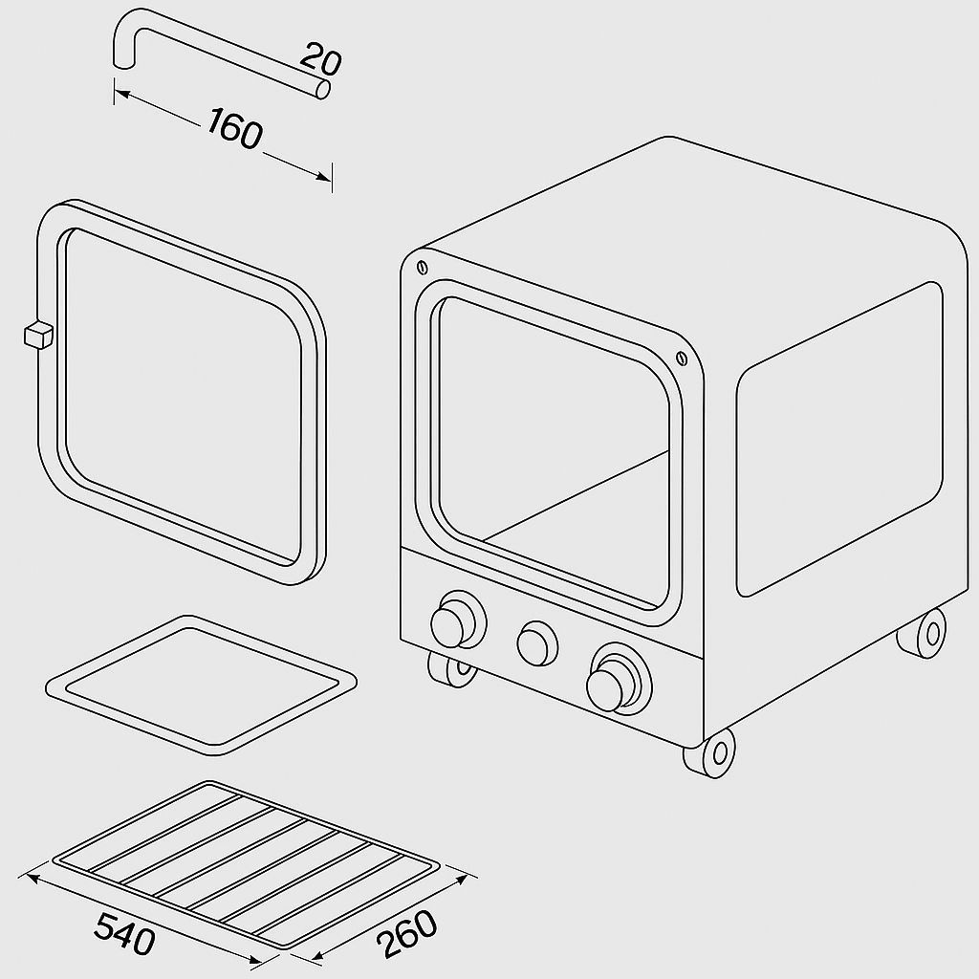
Figure 4.1: Multipurpose Gas-Powered Oven (Front View)
Scale 1:2
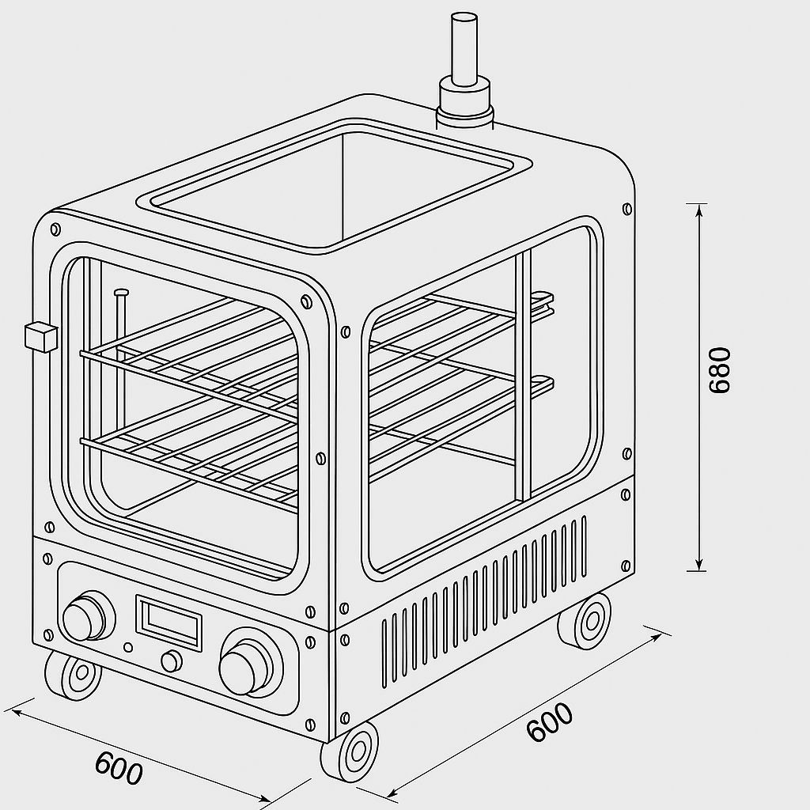
Figure 4.2: Multipurpose Gas-Powered Oven (Isometric Drawing)
Scale 1:2
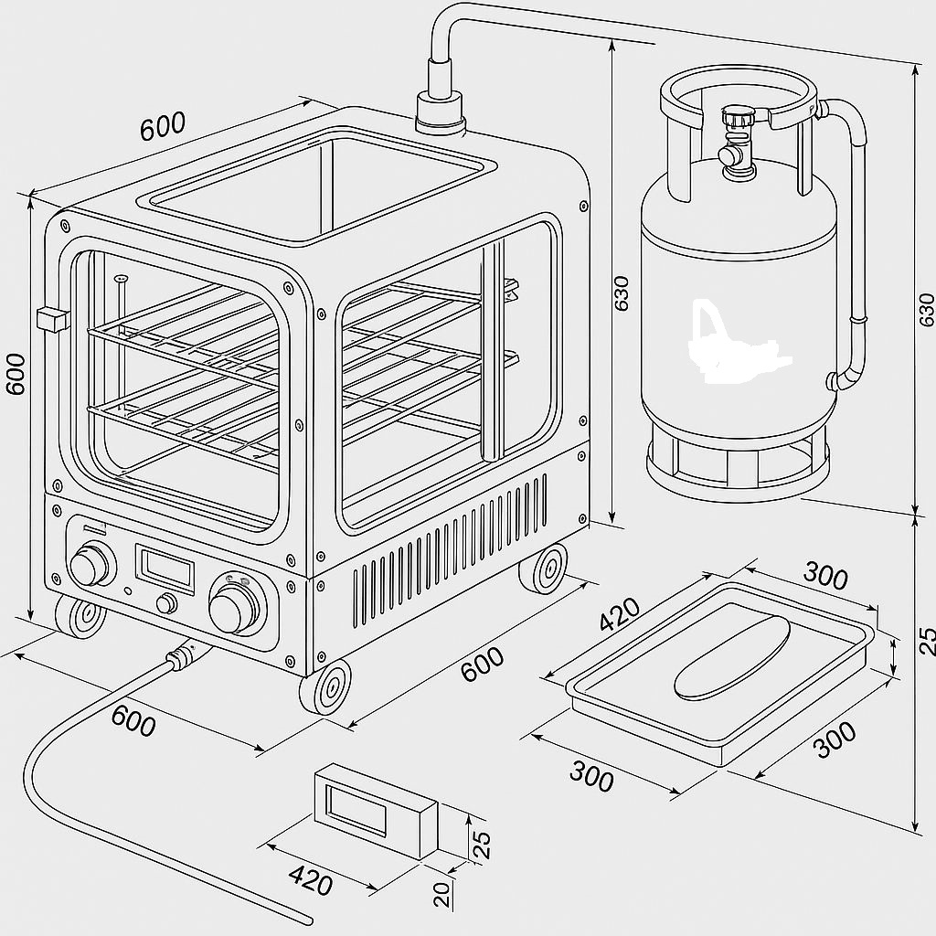
Figure 4.3: Multipurpose Gas-Powered Oven (Assembly Drawing I)
Scale 1:2
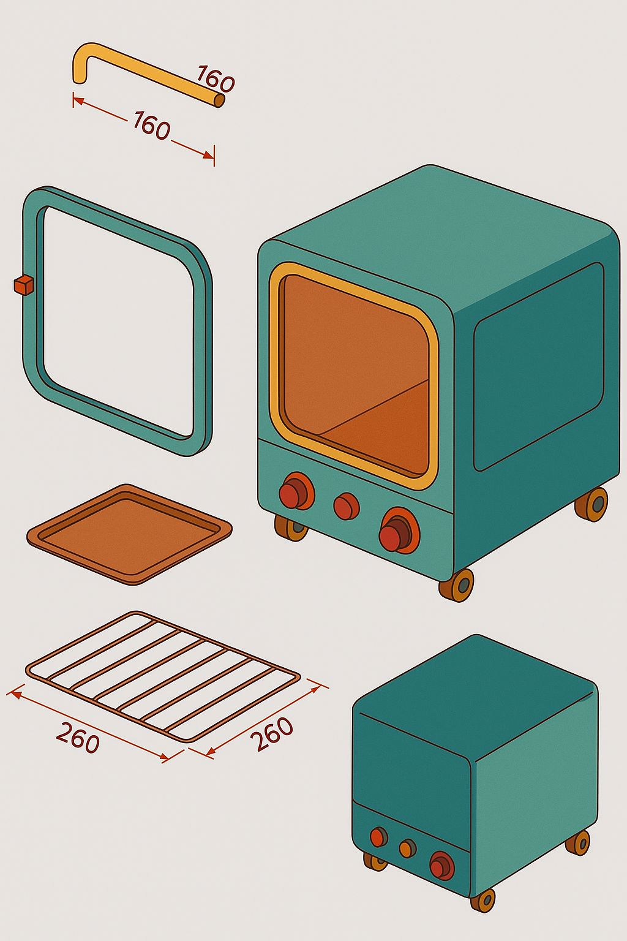
Figure 4.4: Multipurpose Gas-Powered Oven (Assembly Drawing II)
Scale 1:2
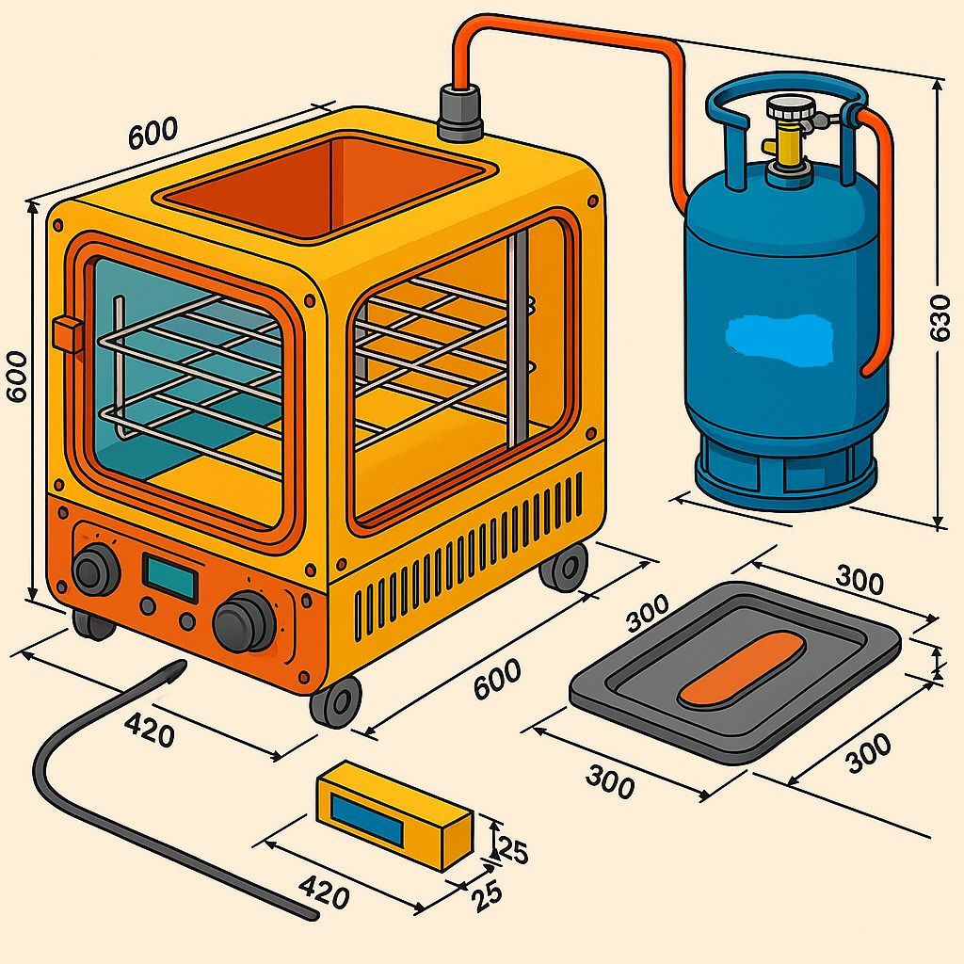
Figure 4.5: Multipurpose Gas-Powered Oven (Full Scale)
Scale 1:2

CHAPTER FIVE

5.0 CONCLUSION AND RECOMMENDATIONS

5.1 Conclusion
In conclusion, the design and fabrication of the multi-purpose gas-powered oven for domestic food processing were successfully achieved through the application of engineering principles, careful selection of locally available materials, and systematic integration of structural and thermal design features, resulting in a safe and functional appliance that demonstrated excellent performance in terms of uniform heat distribution, structural integrity, energy efficiency, and user safety; with internal temperature variation maintained within ±5°C, rapid heating achieved in under six minutes, and a high factor of safety (~8.0) confirmed through mechanical analysis of the tray supports, the oven met all expected performance criteria while offering a portable and versatile solution for baking, drying, and grilling tasks in domestic settings, thereby addressing the pressing need for reliable, gas-powered cooking equipment in regions where electricity supply is often unstable or unavailable.

5.2 Recommendations
Based on the performance of the fabricated oven and the identified observations. Due to cost, energy, and time constraints, the following recommendations are made:
- Digital Temperature Control with Timer: Installing a digital thermostat and timer will enhance precision and allow better control of the baking process.
- Automated Ignition System: Future models could integrate an automatic ignition system for easier and safer operation.
- Enhanced Insulation Materials: Though fibreglass is effective, using modern composite insulating materials may further reduce heat loss.
- Moisture Control System: Integrating a steam or humidity regulator will enable baking flexibility for a wider range of food products.
- Further Testing Under Load Conditions: Future studies could involve testing the oven under continuous operation cycles to analyse long-term durability and fuel efficiency as a performance evaluation.
- Periodic Maintenance Requirement: Although designed for ease of servicing, the oven still requires regular checks for burner performance, gas pipe integrity, and cleaning of soot or residue. This may pose a burden to users if a user guide isn’t provided or if they are unfamiliar with technical maintenance procedures.

REFERENCES
Adedeji O. F., Oyedijo G. E., Saka B. A., Oluseyi Orelaja. (2021). Design and Construction of a Two-way Gas Oven: Journal of Engineering Research and Reports (v2111017495).

Adegbola, A. A., Ogunsola, D. A., Olanrewaju, R. O., & Olaleye, O. O. (2021). Design, construction, and performance evaluation of a dual-powered cooker. J. Sci. Res. Rep., 27(8), 65-85.

Adeyinka, A., Olusegun, O., Taiye, A., Mojeed, L., & Heritage, O. (2018). Development and performance evaluation of a dual-powered baking oven. Advances in Research, 1-15.

Alao, P. O., Raji, A. A., Olajide, M. B., Jagun, Z. O., Okubanjo, A. A., & Oyedeji, A. O. (2024). Gas leakage detection system for domestic and industrial applications. Scientia Africana, 23(3), 231-240.

American National Standard for Household Cooking Gas Appliances. https://blog.ansi.org/?s=American+National+Standard+for+Household+Cooking+Gas + Appliances.

Baig, F., Beg, S., & Khan, M. F. (2012). Controlling home appliances remotely through voice command. arXiv preprint arXiv:1212.1790.

Budynas, R. G., & Nisbett, J. K. (2011). Shigley's mechanical engineering design (Vol. 9, pp. 409-473). New York: McGraw-Hill.

Cengel, Y. A., & Ghajar, A. J. (2015). Introduction and basic concepts. Heat and Mass Transfer Fundamental and Applications, 5, 7-10.

Crank, J. (1975). The Mathematics of Diffusion, 2nd edn. Clarendon Press.

Doymaz, İ. (2004). Convective air drying characteristics of thin-layer carrots. Journal of Food Engineering, 61(3), 359-364.

Fellows, P. J. (2022). Food processing technology: principles and practice. Woodhead Publishing.

Gao, W., Hu, Y., Yan, R., Yan, W., Yang, M., Miao, Q., ... & Wang, Y. (2023). Comprehensive review on thermal performance enhancement of domestic gas stoves. ACS omega, 8(30), 26663-26684.

Gloumakov, R. (2021). Intelligent Internal Temperature Control of Food in Standard Convection Ovens. arXiv preprint arXiv:2104.12162.

Hadaway, W. S. (1896). Electric stove. U.S. Patent No. 578,359. (Issued June 30, 1896; search using Hadaway 1896 electric stove patent .) https://patents.google.com/patent/US670670A/en

Henderson, S. M., & Pabis, S. (1961). Grain drying theory. 1. Temperature effect on drying coefficient.

Hincapié, F. F., & García, M. J. (2024). A Surrogate Model of Heat Transfer Mechanism in a Domestic Gas Oven: A Numerical Simulation Approach for Premixed Flames. Applied Mechanics, 5(2), 391-404.

Holman, J. P. (2010). Heat transfer, 10th ed. McGraw-Hill Higher Education.

Incropera, F. P., DeWitt, D. P., Bergman, T. L., & Lavine, A. S. (1996). Fundamentals of heat and mass transfer (Vol. 6, p. 116). New York: Wiley.

James Sharp, a British inventor, patented a gas oven in 1826. The first commercially successful enclosed gas cooker. He later established a stove factory in 1836, and gas ovens became more widespread by the early 20th century. https://www.thoughtco.com/history-of-the-oven-from-cast-iron-to-electric-1992212.

Jimoh, M. O., Ogunmoyela, O. A. B., & Ogabi, O. N. (2020). Development and performance evaluation of a multi-heat source plantain roaster. Nigerian Journal of Technological Development, 17(2), 120-126.

Kalpakjian, S., & Schmid, S. R. (2014). Manufacturing Engineering and Technology (7th ed.). Pearson Education.

Kalpakjian, S. & Schmid, S. R. (2020). Manufacturing Engineering and Technology (8th ed.). Pearson. (For oven design and energy efficiency background)

Kosemani, B. S., Ilori, A. T., & Atere, A. O. (2021). Modification and optimisation of a baking oven for small-scale bread production. Agricultural sciences, 12(6), 630-644.

Kreith, F., Manglik, R. M., & Bohn, M. S. (2011). Principles of heat transfer: Part 1.

Lewis, W. K. (1921). The rate of drying of solid materials. Industrial & Engineering Chemistry, 13(5), 427-432.

Liu, J., Sun, X., & Zhang, Y. (2022). Comprehensive review on thermal performance enhancement of porous medium combustion in gas stoves. ACS Omega, 7(20), 17824–17836.

Marra, F. (2023). Combining computer-aided food engineering and electro-heating applications as a contribution to food processing sustainability. Frontiers in Sustainability, 4, 1170467.

Mirade, P.S., Daudin, J. D., Ducept, F., Trystram, G., & Clement, J. (2004). Characterisation and CFD modelling of air temperature and velocity profiles in an industrial biscuit baking tunnel oven. Food Research International, 37(10), 1031-1039.

Mizuno, S. (Ed.). (1994). QFD: The customer-driven approach to quality planning and deployment. Asian Productivity Organisation.

Moran, S. (2016). Ethical ripples of creativity and innovation. Springer.

Mujumdar, A. S. (2006). Handbook of Industrial Drying. CRC Press.

Ojo, O., Adeleke, K., Ajayeoba, A., & Bello, K. (2021). Development of a prototype inverter-powered baking oven. Journal of Applied Engineering and Technological Science, 3(1), 26-39.

Okoronkwo, E. N., Nnam, R. E., & Adindu, P. U. (2022). Design and characterisation of a gas-powered baking oven fabricated with local engineering materials. Advanced Journal of Science, Technology and Engineering, 2(1), 63-77.

Okunji, P., Mashal, D., Strong, C., & Brown, G. (2025). The Growth of Technology in the 20th Century. Twenty-First Century Issues: Perspective on Climate Change, Pandemic, and Digital Transformation, 45.

Omoyi, C. O., Ana, R. R., Ushie, D. O., & Okokpujie, I. P. (2024). Construction and Performance Evaluation of a Dual-Powered Mini Baking Oven. FUOYE Journal of Engineering and Technology, 9(3), 481-485.

Onwude, D. I., Hashim, N., Janius, R. B., Nawi, N. M., & Abdan, K. (2016). Modelling the thin‐layer drying of fruits and vegetables: A review. Comprehensive reviews in food science and food safety, 15(3), 599-618.

Page, G. E. (1949). Factors Influencing the Maximum Rates of Air Drying Shelled Corn in Thin Layers. Purdue University.

Pahl, G., & Beitz, W. (1988). Engineering design: a systematic approach. NASA STI/Recon Technical Report A, 89, 47350.

Park, S. H., Kim, Y. H., Kim, Y. S., Park, Y. G., & Ha, M. Y. (2018). Numerical study on the effect of different hole locations in the fan case on the thermal performance inside a gas oven range. Applied Thermal Engineering, 137, 123-133.

Pongpornpradab, S., & Limtrakul, J. (2021). Modification and optimisation of a baking oven for small-scale bread production [Dual-powered oven study]. Agricultural Sciences, 12, 630–644.

Prohaska, V., & Ferrer, E. C. (2024). Spice: Smart projection interface for cooking enhancement. arXiv preprint arXiv:2412.03551.

Rani, L., Kumar, M., Kaushik, D., Kaur, J., Kumar, A., Oz, F., ... & Oz, E. (2023). A review on the frying process: methods, models, their mechanisms, and applications in the food industry. Food Research International, 172, 113176.

Rentería Peláez, J. L., Cardona Sepúlveda, L. F., & Herrera Munera, B. A. (2021). Effect of burner angle on the heat transfer of a frit furnace. Revista Facultad de Ingeniería Universidad de Antioquia, (100), 21-34.

Rohsenow, W. M., Hartnett, J. P., & Cho, Y. I. (1998). Handbook of heat transfer (Vol. 3). New York: McGraw-Hill.

Saberi, F., Kouhsari, F., Abbasi, S., Rosell, C. M., & Amini, M. (2021). Effect of baking in different ovens on the quality and structural characteristics of saltine crackers. International Journal of Food Science and Technology, 56(12), 6559-6571.

Sharp, J. (1826). Process and apparatus for cooking utilising gas. (This is the original patent title; search using Sharp 1826 gas oven patent .) https://en.wikipedia.org/wiki/Gas_stove

Shene, C., Cuhillos, F., Perez, R., & Alvarez, P. I. (1996). Modelling and simulation of a direct contact rotary dryer. Drying technology, 14(10), 2419-2433.

Sumbodo, W., Setiyawan, A., Pamiyanto, J., Hadikawuryan, D. H., Widodo, R. D., & Jamari, J. (2022). Design and production of multifunctional food ovens with energy-saving gas fuel. In IOP Conference Series: Earth and Environmental Science (Vol. 969, No. 1, p. 012023). IOP Publishing.

Tapia, S., & del Rio, J. A. (2011). One temperature model for effective ovens. arXiv preprint arXiv:1109.0664.

Toschka, H. Y. (2025). New Food Product Development: Global Strategies and Practices for Successful Innovation. CRC Press.

Ulrich, K. T., & Eppinger, S. D. (2016). Product design and development. McGraw-Hill.

Vanrooy Team. Posted on March 20, 2024. The History Of Ovens. https://vanrooy.com.au/history-of-ovens/?srsltid=AfmBOoo4LbuYqL64WJ807dVQoeKubEh2M9lSIe7436DogejpByE0SMVB.

Varghese, K. S., Pandey, M. C., Radhakrishna, K., & Bawa, A. S. (2014). Technology, applications, and modelling of ohmic heating: a review. Journal of Food Science and Technology, 51, 2304-2317.

Whiting, M. S., Van Den Bergh, W. J., Theodorakis, P. E., & Everts, M. (2024). Influence of cavity geometry on the bubble dynamics of nucleate pool boiling. Physics of Fluids, 36(8).

Wikipedia contributors. (2025, April). Gas stove. In Wikipedia. Retrieved July 2025 from Wikipedia.org. https://en.wikipedia.org/wiki/Gas_stove

Wikipedia contributors. (2025, June). Chin chin. In Wikipedia. Retrieved July 2025 from Wikipedia.org. https://en.wikipedia.org/wiki/Chin_chin

Wikipedia contributors. (2025, June). Communal oven. In Wikipedia. Retrieved July 2025 from Wikipedia.org. https://en.wikipedia.org/wiki/Communal_oven

William S. Hadaway Jr. received the first U.S. patent for an automatically‑controlled electric oven on May 4, 1896 (granted Jan 5, 1897, Patent No. 574,537). His design introduced thermostatic control mechanisms in electric ovens. https://patents.google.com/patent/US574537A.

Yang, Z., Cheng, D., Su, B., Ji, C., Huang, J., Li, H., & Zhang, K. (2023). Study on the optimisation of temperature uniformity in the oven under the forced convection mode. Scientific Reports, 13(1), 12486.

Yunus, A. Cengel. (2015). Heat and Mass Transfer: Fundamentals and Applications (5th ed.). McGraw-Hill Education.

Yu, X., Lin, W., Wei, J., Wang, S., & Ke, H. (2020). Optimisation Design of Oven Shape Based on Heat Distribution Model. Journal of Advanced Computational Intelligence and Intelligent Informatics, 24(4), 494-501.

APPENDIX A

ORTHOGRAPHIC AND ISOMETRIC DESIGN DRAWINGS
This appendix contains the detailed engineering drawings used for the design and fabrication of the multi-purpose gas-powered oven.
Drawings illustrate dimensional specifications, component locations, gas cylinder connections, and structural configuration.
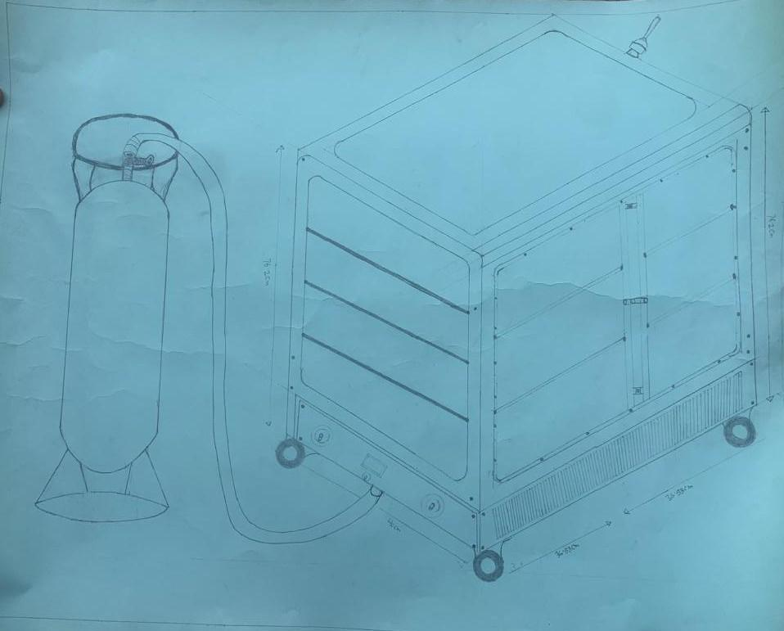
Figure A1: Front Orthographic View of the Multipurpose Gas-Powered Oven.
Scale 1:2
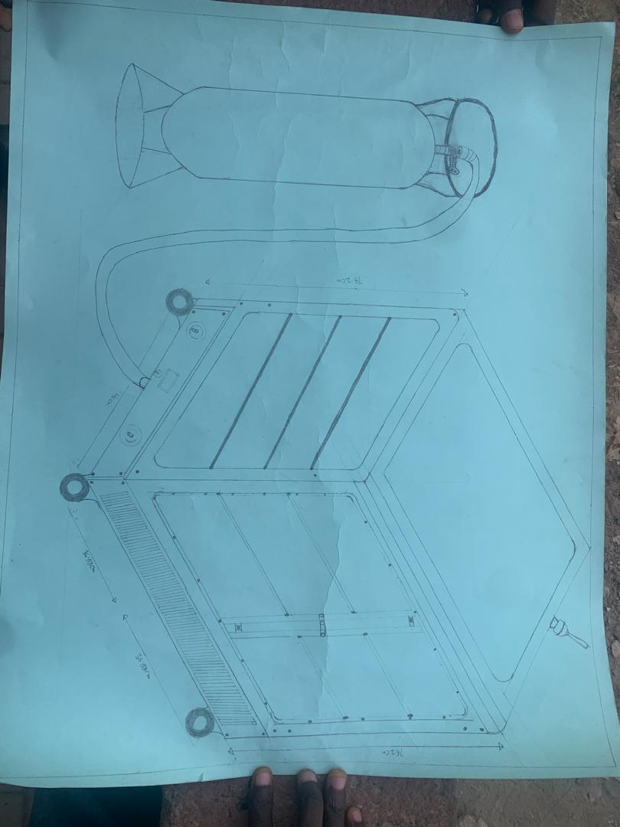
Figure A2: Side Orthographic View showing Internal Chamber Layout.
Scale 1:2
Figure A3: Top Orthographic View with Heat Distribution Channels.
Scale 1:2
Figure A4: Isometric 3D Model of the Oven Assembly.
Scale 1:2
Figure A5: Exploded View showing Individual Components and Assembly Sequence.
Scale 1:2
Figure A6: Sectional View showing Burner arrangement and Insulation Layers.
Scale 1:2
Figure A7: Detailed Diagram of Gas Burner and Control System.
Scale 1:2

