ESTIMATING AND BUDGETING FOR
A SMALL SCALE BUILDING
(A CASE STUDY OF A PROPOSED RESIDENTIAL BUILDING OF OFFICE
DEVELOPMENT FOR PASTOR SAMUEL OLADELE LOCATED AT ALAGBA
LAYOUT,IDO LGA,OYO STATE)
32

ANIMASAHUN FAROUK AYOMIDE
ND/23/QTS/FT/0004
AJASA SAMAD ALABI
ND/23/QTS/FT/0005
AREMU BUKOLA ELIZABETH
ND/23/QTS/FT/000C
BEING A RESEARCH PROJECT SUBMITTED TO THE
DEPARTMENT OF QUANTITY SURVEYING,
INSTITUTE OF ENVIRONMENTAL STUDIES,
KWARA STATE POLYTECHNIC,ILORIN.

IN PARTIAL FULFILLMENT OF THE REQUIREMENTS FOR
THE AWARD OF HIGHER NATIONAL DIPLOMA (ND)IN
QUANTITY SURVEYING
JULY,2025



CERTIFICATION

I certify that this project was carried out by ANIMASAHUN FAROUK AYOMIDE,AJASA SAMAD ALABI,AREMU BUKOLA ELIZABETH with matriculation number ND/23/QTS/FT/0004, ND/23/QTS/FT/0005,ND/23/QTS/FT/0006 respectively as meeting the requirement for the award of National Diploma in the department of Quantity Surveying,Kwara State Polytechnic,Ilorin.

QUESS.MR.ABDULRAHMAN,B.S
Project Supervisor

Date

QUESS.
Project Co-ordinator

Date

QUESS.SIDIQ LATEEF
Head of Department

Date

External

Supervisor

Date

DEDICATION

This project is dedicated to Almighty God who has seen us through from the beginning to the end of the course.And to our lovely parents who has always
been supportive.

ACKNOWLEDGMENT
All thanks due to Almighty Allah,the owner and the creator of Universe for His divine protection and guidance thrcughout my life in school and this research project work.
First and foremost,we give thanks and we appreciate the efforts of our distinguished project supervisor,QUESS.MR.ABDULRAHMAN,B.S who made sure we acquired all the necessary information and Knowledge during the course of this project work may Allah reward him abundantly.
Our gratitude goes to our beloved parents Mr and Mrs Animasaun, Ajasa and Aremu we can't thank you enough for your parental advice and financial support since the beginning of this program.

Lastly,our sincere gratitude also goes to the Head of Quantity Surveying Department,in person of QUESS.SIDIQ LATEEF,and all the lecturers of Quantity Surveying Department,Kwara State Polytechnic,llorin

*.

ABSTRACT
The main reason for this study is for estimating and budgeting Unpriced Bill of Quantity for a proposed RESIDENTIAL BUILDING OF OFFICE DEVELOPMENT FOR PASTOR SAMUEL OLADELE LOCATED AT ALAGBA LAYOUT IDO LGA OYO
STATE The following has been discussed under the mention chapter in this
project work with a view offinding solution to it.
Chapter one contain the background Infornation and the aim and objectives of the project work.Chapter two contains Site Report,the essence of preliminary items required.Chapter three deals with the Project Methodology that is taking off process and abstracting process.Chapter four contains the project Substructure and Superstructure work,Abstracting and Bill of Quantities of the project.Chapter fve is all atioul Summary,Recommendation and Conclusion of the whole project work and for further studies.
2

TABLE OF CONTENT

Title page
Certification
Dedication
Acknowledgement
Table of content
CHAPTER CNE
1.0 Background information
1.1 Description of works
1.2 Aim
1.2.1 objectives
1.3 Scope and limitation
1.3.1 Limitation
1.4 Definition of terms
CHAPTER TWO
·2.0 Title
2.1Site Description
2.2 Location
2.2.1 Accessibility
2.2.2 Nature of the land
2.3 Availability and proximity of resources
CAHPTER THREE
3.0 Taking off
3.0.1 Method of taking off
3.0.2 Selection of taking off
3.1 Abstracting

3.2 Bill of quantities
3.3 Requirement for accuracy
CHAPTER FOUR
4.0 Sub-structure
4.1 Super-structure
4.2 Abstracting
4.3 Bill of quantity
CHAPTER FIVE
5.0 Summary
5.1 Conclusion
5.2 Recommendation

CHAPTER ONE
INTRODUCTION

1.0 BACKGROUND INFORMATION
This project is based on a proposed storey building for office development for Pastor Samuel Oladele located at alagba layout Ido L.G.A oyo state.
In construction industry,cost is considered as one of the important element for constructing a project.Cost in construction includes the initial capital cost,and also the subsequent operation cost and maintenance cost. Generally,running a construction project will involve a lot of budget. Furthermore,the increasing rate of inflation by years,will affect the price of raw material,transportation,fuel,machinery,manpower and others will be a bothers for the clients such as developer to invest money for a project.Hence, to overcome this problem and alternative material or a new system will be the best option.
Construction Industry Development Board Malaysia(CIDBM)proposes cost saving method which are the Industrialized Building System (IBS)where the building component or the building system are pre-fabricated and then install on site.Moreover,it is proven not only reducing the cost but also reducing the construction time.
Furtherance to the information by Construction Industry Development Board(CIDB).There are five types of Industrialized Building System (IBS)that were introduced for the construction industry to practice which are pre-cast concrete framing:Panel and board system,steel formwork system,steel framing system,pre-fabricated timber framing system and finally the block work system.This report will focus on all sections of building works ie Block work,roof ete block made from cement laterized.
The usage of interlocking blocks as the construction materials has been proven to provide a lot of benefits.By implementing the cement laterized interlocking block for buildings will greatly reduce the wastage,volume of building materials,reducing unskilled workers,provide better quality control, promote a safer and more organized site;and last but not least will greatly reduce the construction cqst and time.

1.1 DESCRIPTION OF WORK
The building project comprises of the construction of a proposed Teaching lospital building for Kwara State Polytechnic,Ilorin Nigeria,storey

building for office development for pastor Samuel Oladeie located at alagba layout Ido 1..G.A oyo state.
The building has a rectangular shape with the land area of about 30480mm in ength and 15200mm width.
The construction is found on the plain in situ concrete foundation with over site concrete floor which is a reinforced concrete slab(150mm thick).The walls are 225mm thick hollow sanderete block.
The roofing used is long span aluminum on timber roof structure, windows are of aluminum frame sliding with two (2)side and of different sizes, doors are:double eaf double swing natural an odixed aluminum special made electronic controlled door,pretty glazed aluminum frame door,slide core flush panel doors with season wood of different sizes.
Plant: These are tools,machines and equipment needed for the smooth execution of project.
Project: This is a process of work organized carefully and designed e.g building or civil engineering work
The walls are rendered and painted with emulsion internally and textured paint externally,Floor finishing is tiles finishing on 150mm concrete floor.
Service conducted are mechanical and electrical installation as well as fire lighting and alarm system.

1.2 AIM:
The aim of the project is to estimate and budget for a proposed storey building office development for pastor Samuel Oladele located at alagba layout Ido I..G.A oyo tate.

2.0 Title:
Proposed storey building office development for pastor Samuel Oladele located at lagba layout Ido L.G.A oyo state.

1.2.1 Objectives:
1.To determine the effect of site location and construction on the cost of building project.
2.To understand the process involved in preparation of Bill of Quantities
(BOQ)

1.3 Scope and Limitations:
The scope of this project is to prepare a bill of Quantities(BOQ)for the proposed storey building office development for pastor Samuel Oladele located at lagba layout Ido L.G.A oyo state.

1.3.1 Limitation
1.Inability to conduct proper site investigation.
2.insufficient design information
3.Pricing (market survey)was not carried out to determine actual price of measured items.

1.4 Definition of Terms
Prime cost sum:This is a sum provided for work or service to be executed by nominated sub-contractor or for materials or goods to be obtained from a nominated supplier.The term includes specialist work carried out by person apart rom the main contractor (Ivor Seelay).
1.Contingency Sum:It is the sum allocated to urforeseen expenses it is expended only with the consent of the architect or supervisory engineer.
2.Provisional cost sum: This is the sum allocated to work that is subjected to change or that can't be accurately measured.The sum will later be adjusted according to the extent and true value of the work
3.Estimating: This can be defined as the technical process of predicting cost of Construction.It can also be further explained as a process by which cost of item is Carried out.
4.Preliminaries item: These are item meant for the smooth execute for smooth Execution of project.But which are not related to a particular trade section in BOQ
5.Tender: it is an offer to execute a given project at a certain amount of money and specify period of time

CHAPTER TWO
SITE REPORT

2.0 Title
A proposed storey building office development for pastor Samuel Oladele located at alagba layout Ido 1..G.A oyo state.

2.1 Site Description
The proposed project of storey building office development for pastor Samuel Oladele has a total length of 13,700mm and 68,750mm width which appear to be in a rectangular shape.
The site is located at Alagba layout Ido L..G.A oyo state.The site has small and big tress and bushes which needs to be cleared away from the site.

2.2 Location
The site is located within Alagba layout Ido 1..G.A oyo state.

2.2.1 Accessibility
There are untarred roads leading to the site from the main road in the school.So there is no problem delivery of materials to site and the labour are expected to resume work as early as possible.

2.2.2 Nature of the land
The proposed site of the building is a virgin land with a even/flat surface. This will minimize the construction cost of the foundation because of the balanced surface when compare to that of the study area which increases the constructional cost.

2.3 Availability and Proximity of Resources
Availability of construction resources simply means the extent of convenience at which the resources can be found in the market and the selling price.
While proxinity means the closeness of the materials resources of the proposed site.
The construction resources include the following:
Plant

All necessary plant needed for the proposed projects are readily available in llorin.Such plant include:concrete mixer,Bulldozer,Electric generator, Compacting machine e.te all mentioned plant can be hired in area's not far to the site.
Materials
The whole material necessary for this project all are available at oyo state,but costly to some materials price in some area of the country.
However,all the material needed for smooth execution of this proposed project is remote to the site.
To an extent preliminaries items have a great effect on construction project.Such preliminaries items are explained below.
Scaffolding
There should be a provision for scaffolding because the project requires roofing works,there will be the need for rendering and painting at the higher level of the building.
Setting out
This is the transfer of information on the building drawing to the ground with high degree of accuracy.In setting out site clearance is necessary by cutting down of rees and edges &top soil excavation before making the provisions of setting out Instruments such as profile pegs,measuring tapes, builder square e.t.c before'the commencement of site operation.
Temporary Road
This is done temporarily to provide easy access to the site during work.
Temporary fence
Temporary fence should be done to cover and protect the materials on site from vandalism.
First aid box
This is very important in any construction due to some injuries that may occur on site which might be minor or major injuries before being taken to the hospital.
Site supervision

This is the contractor's agent on the site who supervises the whole of the project.He also co-ordinates the works of sub-contractors and receives instructions from architect on behalf of the main contractor.
Setting out of the works
This contractor will set out the position of the building on the site before commencement of any actual work to the satisfaction of the Architect.
Temporary latrine
Welfare facility of this type must be provided on the site by the contractor to satisfaction of the architect.

CHAPTER THREE

PROJECT METHODOLOGY
3.0 Taking off process

Taking off process:This implies reading of dimension from drawings sctting them down in a specific order on specific paper know as dimension paper and inscrting an appropriatc description.It also refers to the process of identifying
clements of construction works that can be measured and priced.

This is necessary to produce bill of quantities and requires that the design is
complete and a specification has been prepared.

Analysis of drawing and specification allow the cost consultant(usually a Quantity Surveyor)to prepare a taking off list,which lists all of the individual clements that comprises the works.These elements can be measured in number, length,area,volume,item then collected and structured to produce an unprice bill of
quantity(BOQ).This process is sometimes referred to as"working up"

The traditional dimension sheet is divided vertically in to two identical haves cach comprising a set of four columns in effort,the ruling on the right half of the
shcet may be considered to be a continuation of these on the left side of the shects.

 | A | B | C |  | A | B | C | D

A

Column A:are the timesing columns These column are used to enter multiplicrs
when there is more than one of the particular items being measured.

 | 3 | .20

Timesing column

Column B:are the dimension columns,these columns are used to record the
dimensions in meters.Each linear dimensions is underlined.

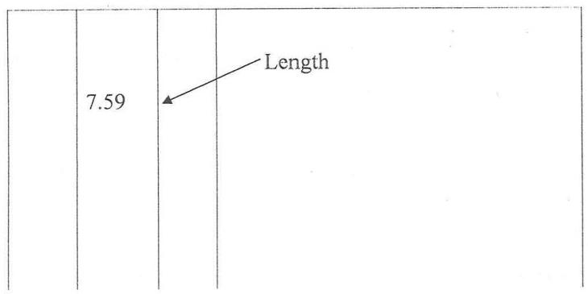
Arca
Volumc

下
Lincar

人

3

 |  | 3.45  7.59 |  | Length  Width

 |  | 3.458 4  7.59  0.75  4 |  | Length  -Width  Depth

Y

2

Numbcr

NOTI:The order of entcring dimension is strictly

1.Length
2.Width
3.Depth/height

 |  | items |  | Allow for bringing to site and removing  from site all plant required for this work  section.

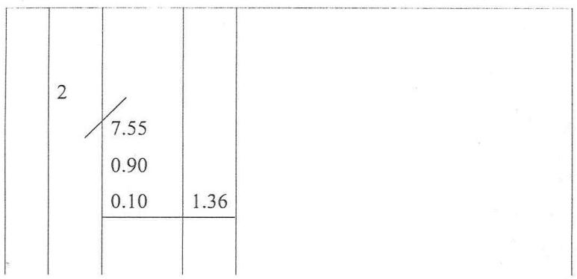
Column c:are the squaring column:the resulting area and volumes inserted in the
美
timesing and dimension columns are subsequently calculated and entered into thc
y squaring column opposite their respective dimension.

Squaring

Column D:The description column.There are many ways of inserting description on the dimension shect but the most acceptable however,is description which commence
in the same level with it's first dimension.

The example below show the dimension and description should be arranged in
dimension sheet.
.
 |   4 |   3.45  0.68  0.45 | 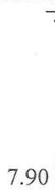  7.90

Waste calculation
This is an imaginary column occupying the right hand side of the description columns in which the taker-off inserts any preliminary calculation (waste)which may be mecessary in order to arrive at the dimensions.
All preliminary calculation must be shown in waste,they need to be set down ecurately and carefully so that they can be checked.
They should be written either above or below the description to avoid confusion.
Waste: calculate is necessary for each dimension except in the following situations:
A.When a scaled or figured dimensions,can be transferred direct from the drawing to the dimension column.
B.When the dimension has been derived from a previous waste calculations.
C.When a dimension has been inserted from a previous dimension.
D.In all other instance the preliminary calculation,should be shown on waste.
Waste calculation should be done in millimeters (mm)or in three places of decimal.Final figures are then rounded off to the nearest 10mm before bring transferred to the dimension column.

3.0.1 METHOD TAKING OFF
Nill:is a method of cancelling wrong enteries during taking-off process.
Nill may be done in three(3)ways ie on waste calculation,on framed
description and on figured dimensions.
Bracting:it is used to determine one item of measurement from another
Adding on:This is the method of connecting two or more description
related to a common dimension.

3.0.2 SELECTION OF TAKING OFF
The taking off dimension is usually divided into section under the main sub
division of
a)Sub-Structure
b)Super-Structure

c)Finishes
d)Service
e)External works
The section found in a normal building would generally comprises the
following:

A)Sub Structure 1.Sub-Structure

B)Super-Structure

2.Frame
3.Upper floors
4.Roof
5.Stairs
6.External walls

7.Windows and Doors
8.Internal walls and partitions
9.Internal doors

C)Finishes

10.Walls finishes
11.Ceiling finishes
12.Sanitary appliance

D)Services

13.Disposal installation
14.Waste installation
15.Heating installation

16.Electrical installation
17.Gas installation
18.Lift installation
19.Communication installation
20.Builder's work iri condition With service

E)External Work 21.Site work
22.Drainage

3.1 ABSTRACTING PROCESS
After the squaring process,the next process is abstracting.This is in a special mule sheet.The sheet are ruled with series of vertical line that are spaced about 250mm apart and usually on A4 in width,each abstract sheet is headed with the job reference,Sheet number and work section and possibly the sub-structure of the work to which the abstract dimension refer,the sheet may e divided into work section or element.
Abstracting id process where various items are stored out into their respective trades as they are entered on the abstract paper.
Description are usually spaced over two columns.The dimension are entered in the left hand column while any deductions are entered on the right hand column.
The order of abstracting is to commence with cubic items,followed by superficial(square),linear and finally enumerated items.Also labour items should proceed labour and materials.Smaller items proceeding larger ones and cheaper items proceeding more expensive items.

3.2 Bill of Quantities (BOQ)
Bill of quantities is a documents which set out the quantities and description of the items of labour,materials and plant require to erect and complete a building or other works in a systematic manner.
The preliminary sections of the bill sets out the practical and contractor conditions of the pruject,particular of the type of contract to be used and also the details of general matters,which may affect the price of the work together with project overheads.Project overhead are items that cannot be attributed to any particular measured work section.
The measured items are grouped in appropriate sections and each section tarts with a number of preamble clauses.
CONTENTS OF THE BILL OF QUANTITIES (BOQ)
The principal use of the bill of quantities is to obtain competitive tenders and For this purpose B.0.Q should be prepared to recognized method of measurement to tandardize the bills.Bill of quantities prepared in accordance

with a standard method of measurement,fully described and accurate respect the work to be executed and this provides a uniform basis for competitive tendering.
During the construction of the project,the client and the contractor use the bill as the basis for financial management.
Bill of Quantity may consist some all of the following:
Bill Nr.1.Preliminaries
Bill Nr.2.Preamble
Bill Nr.3.Measured works

A.CARCASS
1.Foundation(Substructure)
11.Frame (column &beam)
III.External &internal walls
IV.Partitions
V.Floors
VI.Roofs

B.FINISHING
1.External &internal finishing (walls,floor &ceiling)
II.Windows
.Doors including opening without joinery
IV.Fixtures Sundries
V.Stair &lifts
VI.Plumbing &Engineering service

C.EXTERNAL WORKS
1.Drainage
11.Roads,paths,site layout,out buildings e.t.c

D Sport items:These are items that are alteration and repair items of a

Building:
Bill Nr.4.Provisional quantities
Bill Nr.5.Prime cost &provisional sum
Bill Nr.6.General summary

PURPOSE OF A BILL OF QUANTITIES
a.It serves as a schedule on which all variation in the work may be valued.
b.To provide detailed list of every service to be performed.
c.To supply each tenders with information which will enable them to tender on a uniform basis.
d.To describe in addition to any description in the specification of the quantity of the work and the method of carrying it out.
c.It can be use for further cost investigation and cost planning information.
f.Prevent disputes as to what is and what is not included in the contract prices and the value of any work or labour which has been omitted.

PRODUCTION OF BILL OF QUANTITIES
These are several techniques of preparing bill of quantities (BOQ)
TRADITIONAL BILL METHOD:It is set down in the sequence following
he out of the building and engineering standard method of measurement |BESMM).This system provides "the taking off'with a logical system of measurement designed prevent accurate and efficient taking off.
The work is measured in series of groups,each representing a particular section of building without regard to the order in which items will finally appearing he bill.As the sequence of measurement is not related to the order of the bill the working up"process must involved the preparation of an abstract to collect and arrange the items in the order necessary for writing the defect bill.
This system is mostly used in the examination.
It comprises of the following:
i. Taking off usually group system

ii. Working-up:Squaring,abstracting,totaling,rounding off &billing.

1
OPERATIONAL BILL METHOD: It is tendering document for estimating
costs prepared by architects that describes a construction project in terms of the operations (which include labour and plant)needed to build it.This form of document contracts with that bills of quantities in which such tendering and estimation is limited to the materials in the completed work operation bills have the advantages of enhancing communication between design and production,enabling realistic tender pricing and making the preparation of critical path analysis easy for the contractor.

ACTIVITIES BILI METHOD:The activity bill was a development of operational form but without the separation of labour and materials.It was sub-divided into section based on activities or operation derived from a network analysis. The work was measured in accordance with the standard method of measurement although on site and off site activities were usually separated and specialist equipment and component of and the work of nominated specialist could be grouped in spate bills (Seelay and winifield 2005).

ELEMENT BILL METHOD: Here the work is billed in trade order not in sequence of the building and engineering standard method of measurement [BESMM]but under heading that from a breakdown of the building into the main element of the structural wall,floor and roof.Although these provide a more useful control document during the construction operation,it makes the tendering procedure more complicated (T.C onouah)
ANNOTATED BILL: It is possible for the bill of quantities to give the contract fill details of the quantities,types and quantity of materials and labour and for an accurate and complete set drawing to show him precisely where and how the work is to be executed.(Seelay and winifield 2005)
CUT AND SHUFFLE BILL METHOD: This is a faster method than the traditional method.The civil engineer or surveyor take off quantities into specially designed sheet in duplicate where the original sheet is perforated into strips which can be separated from the book and collected together to form group of items

DIVISION OF BILL PREPARATION:The traditional method of preparation of bill of quantities can be broken down into two main processes.
Taking off: Seelay 1988 defined "taking off'as the process in which dimension are scaled read from drawings and entered in a recognized form in a special ruled paper called dimension paper.
Working up: This process can be divided into two stages as follow:
Squaring:This comprises squaring the dimension and transferring the resultant lengths,area and volumes to the abstract.
Abstracting: The squared dimension are arranged in convenient order for billing and reduced to the recognized units of measure.
Other process include:

3.3 Requirement for Accuracy:
Whatever the method adopted for bill preparation,the requirement for accuracy is the same for example
Work shall be measured not as fixed in position overlaps.(General Rule 4.1)
1)Dimension used in calculating quantities shall be taken to the nearest 10mm(i.c 5mm and less than 5mm shall be disregarded).(General Rule 4.2).
All dimension shall be record to two decimal places and waste calculation are to three decimal places.
2)Quantities measured in tones shall be given to two decimal places.(General Rule 4.3).
3)Other quantities shall be given in the nearest whole except that any quantity less than ten shall be given as to the nearest first decimal.(General Rule 4.4).
4)Void or openings,which are wholly within the boundaries of measured area and voids or openings wholly at the boundaries of measured piers,column and similar member,shall always be the subject of deduction,irrespective of size (General Rule 4.5)
5)Items can be measured within a range of stated limits.
6)Average or an interpolation of level may be required for the measurement of execution.Due to problem with reprographics and the inherent inaccuracy of the process,scaling drawing should be avoided whenever possible.However, where dimension are stated on drawing there is no excuse for measurement bring anything other than correct.

PRBJECT TITLE

PROPOSED OFFICE DEVELOPMENT
FOR
PST SAMUEL OLADELE
LOCATED AT
ALAGBA LAYOUT IDO L.G.A
OYO STATE.
OCTOBER 2016 | 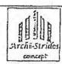  ARCHI-STRIDES CONCEPT  Designs Conslruction Tnteric;decorelicn  75h ulsh Shonping el.2 Fioo?  by Doma june Son'Woy Rd fuimarel.

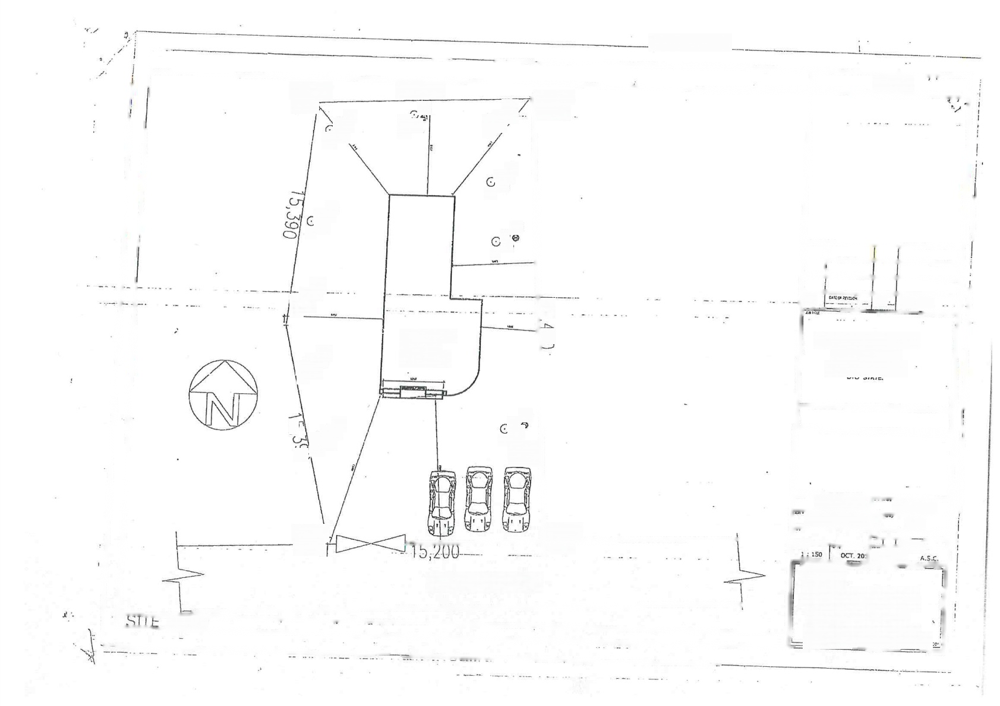
NOYES
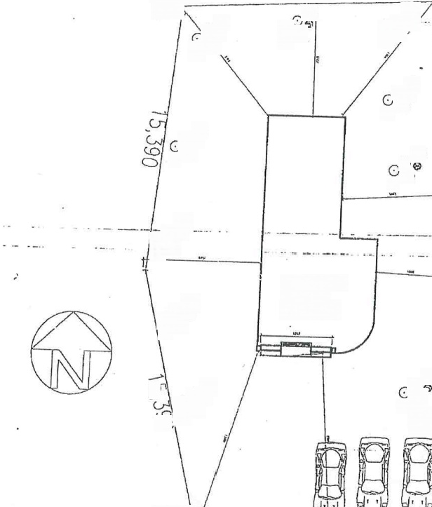  SC/AK 463!  的 | 15,200  00  8  成 |  |  | C 动 | 彩心 | SC/AL  8490  OO  SC/AL
站  ⊙ 8  常 |  |  |  |  |  | SC/AL  8490  OO  SC/AL
 |  |  |  |  |  | SC/AL  8490  OO  SC/AL | Am 1 |  |  | een(it
C  0  ⊙ |  | PROPOSED  OEFICE  COMPLEX |  |  |  | SC/AL  8490  OO  SC/AL | PRCFOSED OFFICE DEVELOPMENT  PST SANUEL OLADELE  1C=ATED AT  GBALAYQUT 1DO LG.A
C  ①已 |  |  | ( 和  OREHOLE POINTO) |  |  | SC/AL  8490  OO  SC/AL
 |  |  |  |  |  | SC/AL  8490  OO  SC/AL | ADIGUN S.M |  | CTTEPAN
 |  |  |  |  |  | SC/AL  8490  OO  SC/AL | ASCIPSOA/10/20 |  | 6  A.01
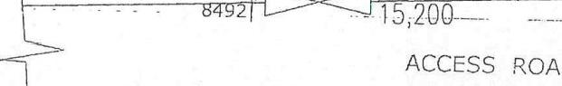  SC/Al  8492  ACCESS ROAD |  |  |  |  |  | 8491 |  |  | F,HUSBAL
 |  |  |  |  |  | 8491 | ARCHI-STRICES CCNCEPT Desleos -Constructon *Interror  r stEhelng at.25 Fto  v Oome lunsuenttot Rs Rumurclu feest Bwes slatE  65.M.H⁰03037051772.03164670123  sen20029 yaneo,cem,eissen²09?Grma
PLAN

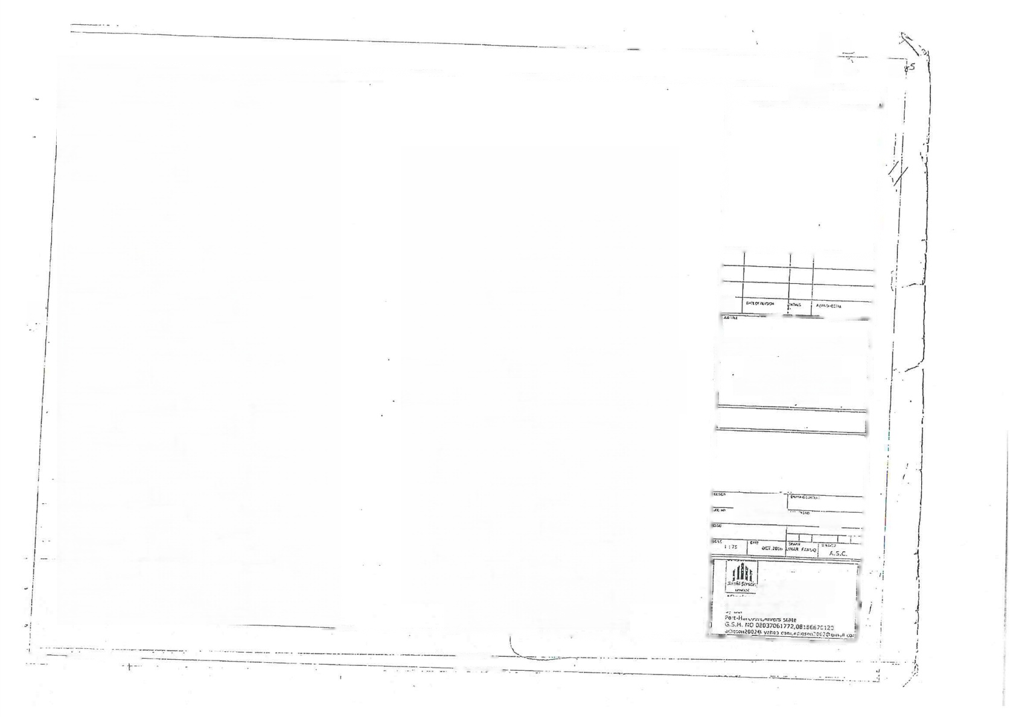
广
二 1中

 |  |  |  |  |  |  |  | NOTES
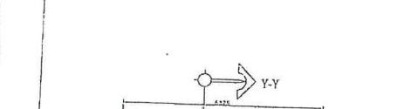  Y-Y |  |  |  | Y-Y    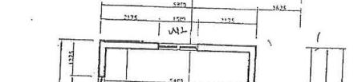
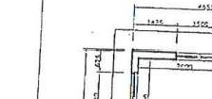  158 |  | 25ce
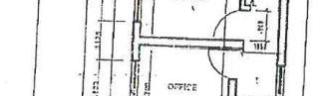  FFICE |  |  |  | 室  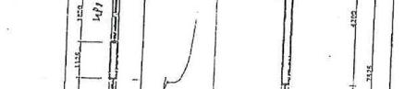
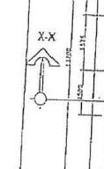  车  X-X | 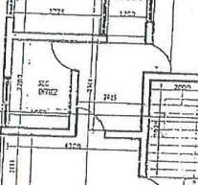  三  4  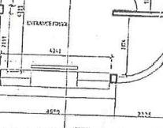 |  | -597  -  的斗  7  X-X  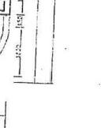  A | X-X | 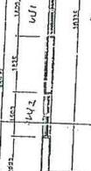  ni | 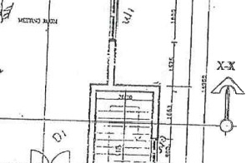  Q |  |  | PROPOSED OFFICE DEV=!OPMHFNT FOR  PST SAMUEL OLADELE  . LOCATED AT  UAGBALAYOLT 1DO L.S.A  OYO STATE  ADIGUN SA  ACCISO 4:07 016  A 00  DFutaCTR*DES FOHFEP  Fngt=inn flersth- hh₅eeme lial Zed Fin  hresrte6 d -
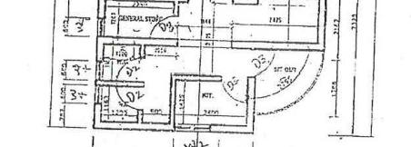
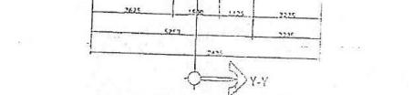
FIRST FLODR PLAN
Y.
Y-Y
SR0UAO FEOOR

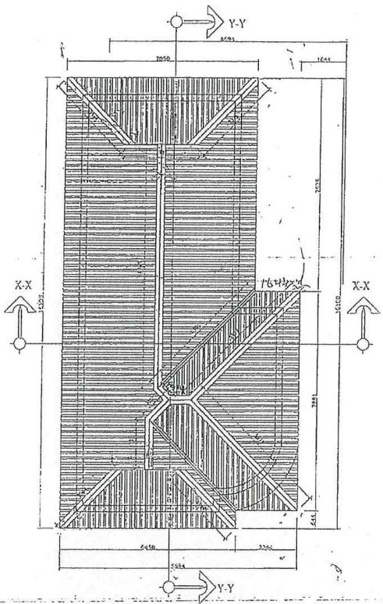    ROOF PAA | NCTES
 | tt Fevn | ptr4
PROPOSED OFFICE DEVELOPMENT FOR
PST SAMUEL OLADELE
LOCATED AT
ALAGBA LAYOUT IDO L.S.A OYO STATE
 | ADIGUN S.M
 |  | 216 A 08
 | y Doma unionWoj Rd Rumurolu G.S.M,N00e037C61772,00186570220

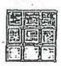
能 器

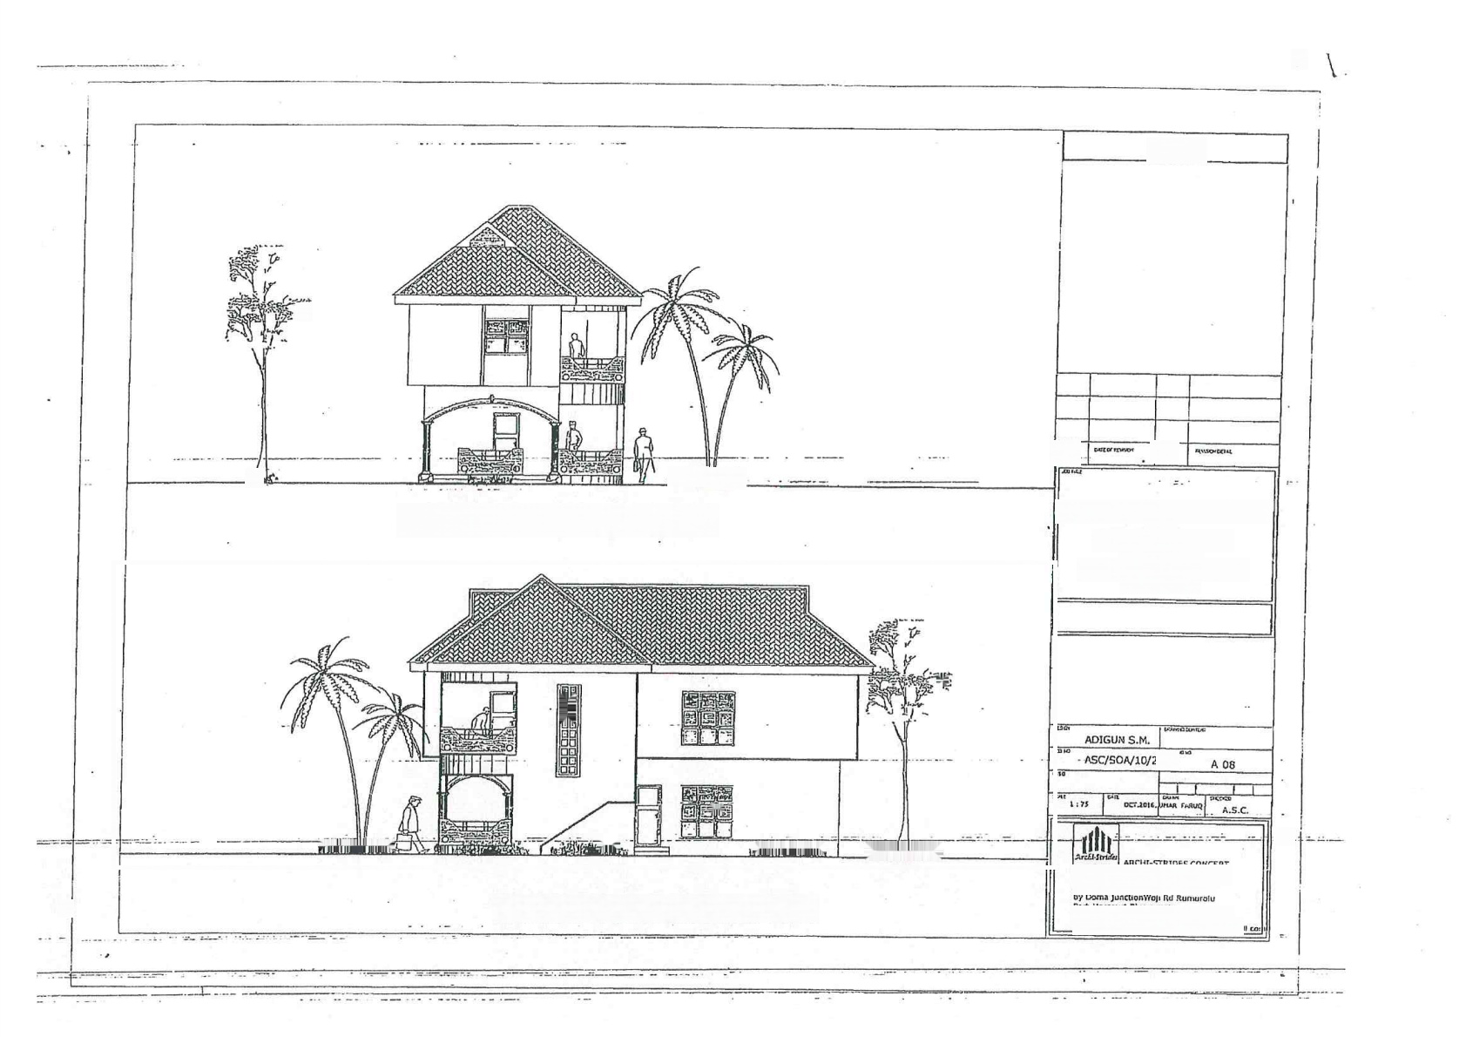
?

NOTES

品
APPROACH ELEVATICN
PROPOSED
OFFICE
FOR
DEVELOPMENT
PST SAMUEL | OLADELE
LOCATED | AT
ALAGBA LAYOUT IDO L.G.A
OYO STATE,

超

)16

病
=-
双 约
DeclnnesCanstrucion Interlor eentiShopping Ral,2ny Fecr
CE⁴N000037061772.D8105570120
“
RICHT SIDE EAEWATION
hn4nn30020 vahe2.cem 3010t0370200m

E

 | 重面道  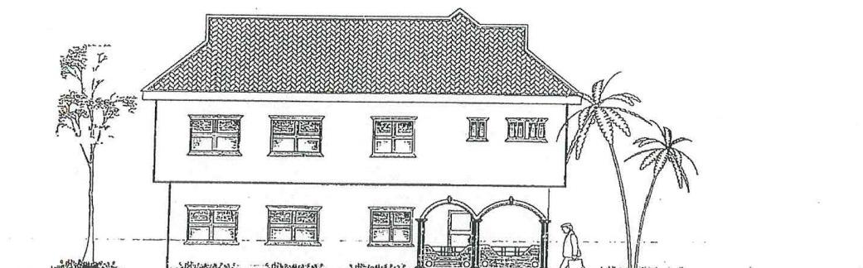 | 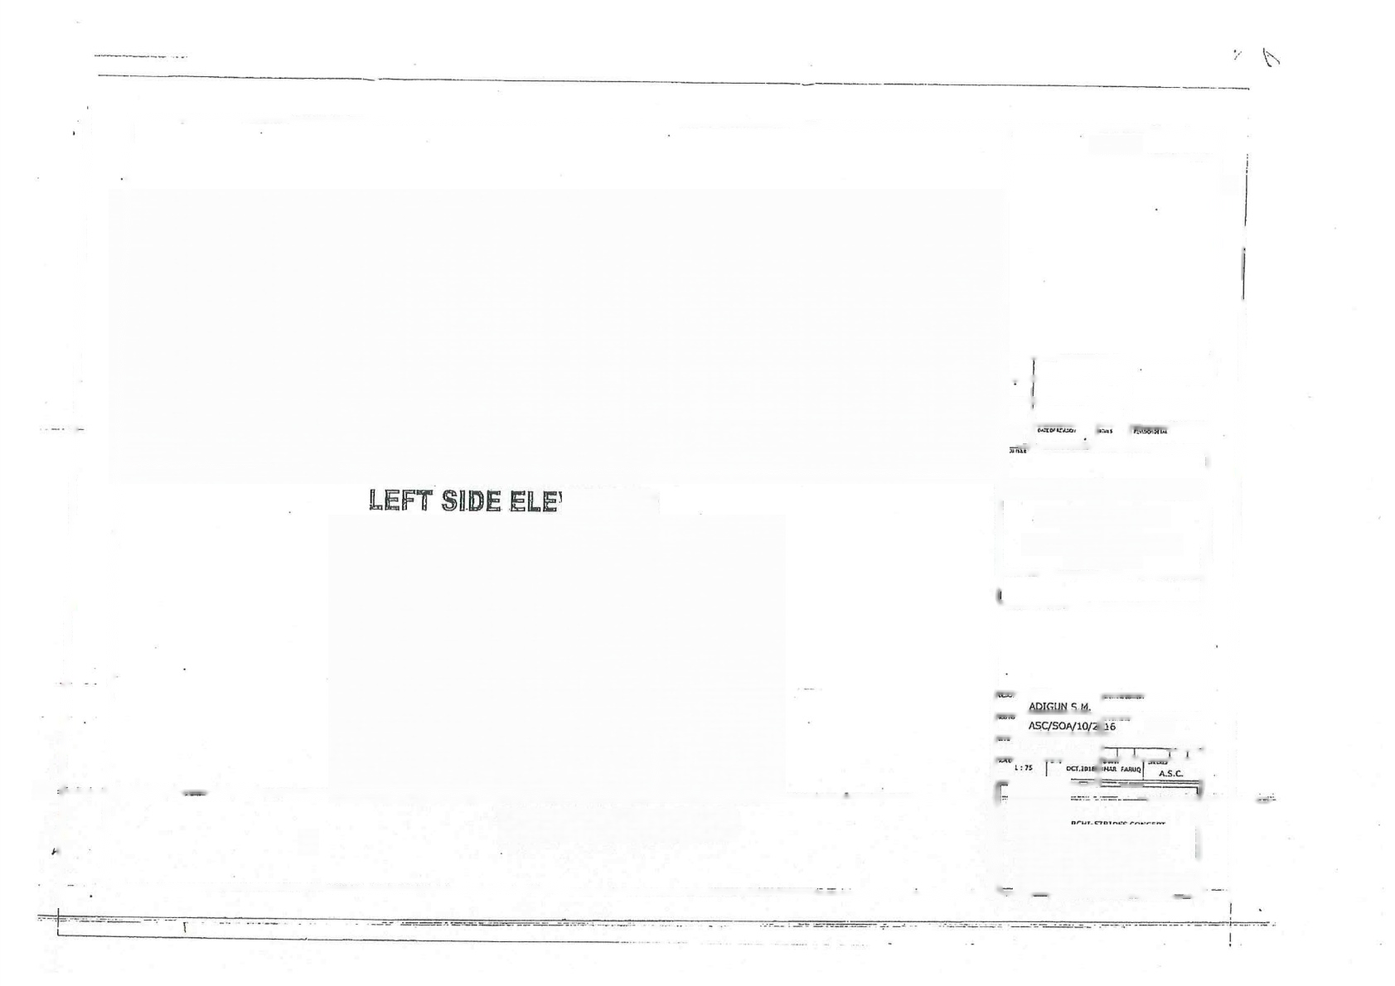  NOTES |  |  |  |  |  | !
 |  | PROPOSED  PST |  | OFFICE  FOR SAMUEL  LOCATED |  | DEVELOPMENT  OLADELE  AT |  | !
JATION
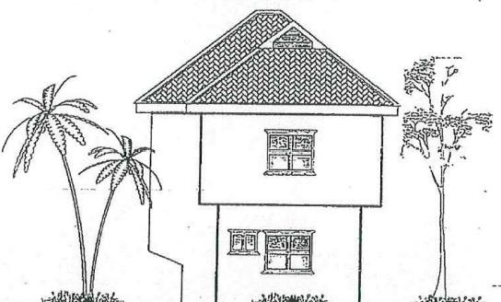
 |  | ALAGBA LAYOUT IDO L.G,A  OVO STATE. |  |  |  |  |  | !
 |  |  |  |  | A 08 |  |  | !
 | REAR ELEVATION  0 |   Deslons *Constrction *interlgr Hatifhepping Fat,2nd Roo?  y Oams jinctionvop Ro Rum;rl  Harcout,Rwers state  6.5.8005037061772,03166670120  afceen²0020 yicacem adrs:n²002Ecm2a e

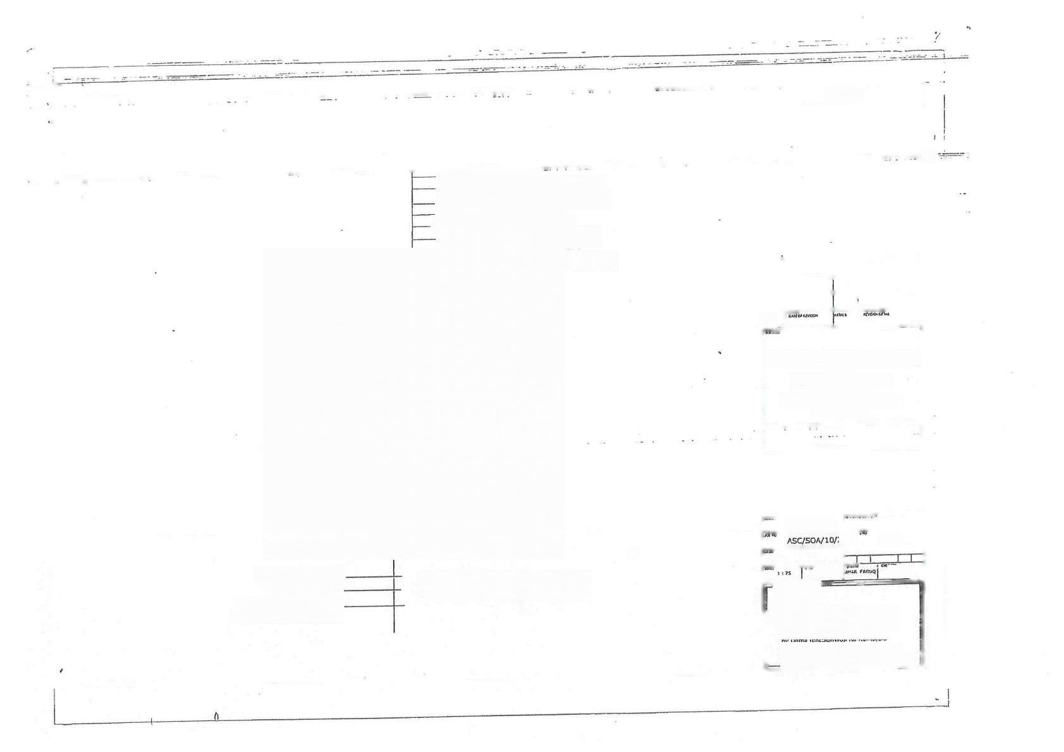
NOTES
Aluminium oafinp sneet ig en:"
216n
140
нзшшеЗбД) яшипа уэдшп раэм рицшшдє шшяд- щэшшсаЕТОО) ялцеэдшн реом риєц шшэзх шшрзр ниОип цНп рапм нц ишииК шнпиЕ-
—10mm x50mm hard woos timber root trusses
яцэ шшооЕЧСЦ) шеэфэнроамрлц шшозя шшоя-
150mm1850mn hard wood wall plale
Шшшюая СТбийоои Еища ромрлчшщоєащ
У

指
PROPOSED | OFFICE FOR | DEVELOPMENT
PST | SAMUEL | OLADELE

LOCATED AT
ALAGBA LAYOUT IDO | L.G.A
OYO STATE

 |  | 0001  9150  品 | 51p1  STAR HAU
3000
KITCHEH
 |  | 夏 |  | A3L Шооос о ЪюоеБ о ос о
 |  |  |  |  |  | ADIGUN S.M.
 |  | 25mm floor finishes 150mm concrete  foundation to structural engIneer working getalls |  |  | &  SECTION X-X |  |  |  | 026 ВО Ч
 |  |  |  |  |  | 7 |  |  | 1C
ARCHI-STRIDES COHCEPT

*Deslaas eCanstrurtien *Ietorle
Shcpgane #alt.2ng Flaet
5.S,H.K008037061772.03186570120
cloion2002P yohop.tem,acksen20029omalc

9616
60 3 9 品
1200
903
psf

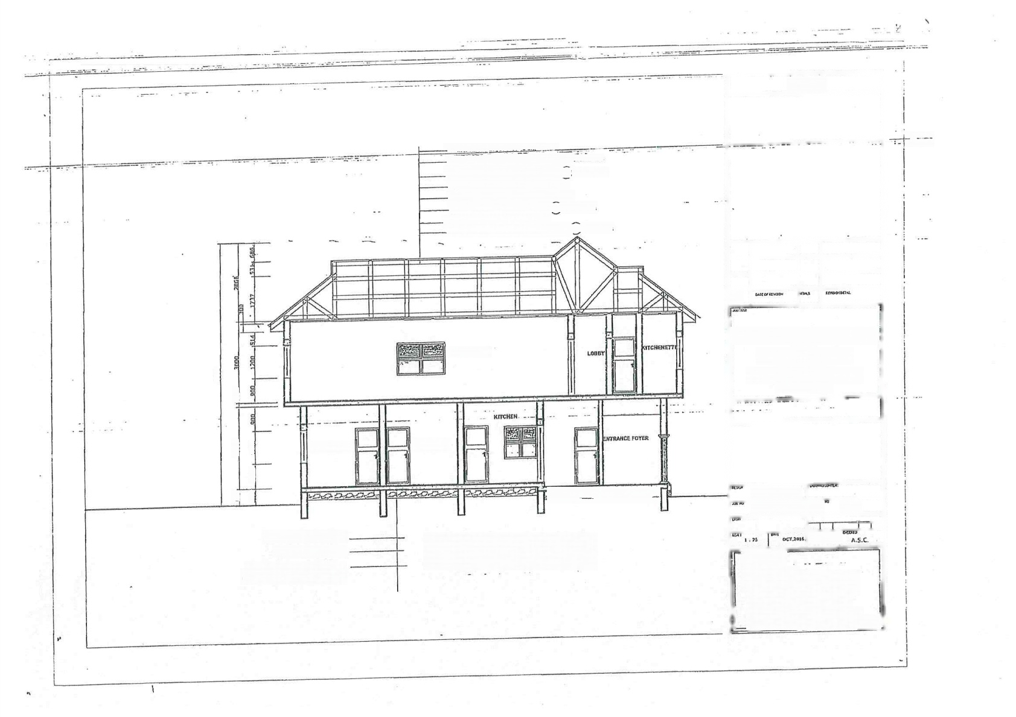
BEDROOM

25mm floor finishes
150mm concrete
foundafion to structural
епуйпеег МогШТпя осТаНъ

Aluminium ooing sheetlat en::
75mm x Somm hard wopd timber gull:(
150mmx50mm hard woo timber ranee(@ 1200mmterg
1БОтах ЕОтп БагГ чуооп йтпЫег Ктпд рояЦ
100mmat0m hardwood tlmber roof tngses
150mmx5Umm hardwood tie:beam ( (С,чгоотт сиэ
一150mm x 5omm hard woed wall pae
Ейтта Ёнтт наг мопй ссШпп поеолэя Ё(G,taonm crs

ЧЕЕПНБ НПНВЛ

ЕЕрНооМ

离国序保流感的的取后

SECTION YY

NOTES
PROPOSED OFFICE DEVELOPMENT
FOR
PST SAMUEL OLADELE
LOCATED AT
ALAGBA LAYOUT IDO L.G.A
OYO STATE
ADIGUN S.M
ASC/SON10/20 |  |  | 16 A 0B
 |  |  | FBy⁹
AACHI-STRIDES CONCFPT

*Dtsigns=Constructior intaclne
aEectekGhspping Rat 2nd Fosr
ey soms JWretlonWo/Rd Rumurolu
f eueFeef&
5.5.M,11006D37051772.03166670120
2ingon2002Q yaheb com.zdin5on2002Oameh.co

5、

 |   A 15 |  |  |  |  |  | B |  |  |  |  |  | NOTES
 | HWiC |  |  |  |  |  | 2  A  7 2225
 | 图  …的任天  圆  2)  W  ③  HWC3  图  ⑤ WC  景 |  |  | 三 | ly/lx=1.5  小 |  | BT 1 |  |  |  | EXC  B1
 |  |  |  | 三 | ly/lx=1.5  于  F.0ocg nrau  ly/hx=1.5  守  FRO3 BEH |  |  | 员WC3  Sre | 2 E  ET1  A |  | A | Exc1  盯1
 |  |  |  |  |  |  |  |  | 3  0 不 6  5 | BT1  BT 2  EXCI  NVC | gr3  x1  a  NWC4  1 |  | LOCATED AT  ALAGBA LAYOUT IDO L.G.A  OYO STATF
  PROPOSED | OFFICE FOR | DEVELOPMENT
  PST | SAMUEL | OLADELE
 |  |  |  | 三 | w/s=12宁  ly/lx=1.0  A
 | 6 | NVC
景
NMI
 | ⑦ |  | “-T  Wc: |  |  | 6  FRongaH  R3 |  |  |  | NW|C1 NWC1-NEW COLLMH 1  WC-NEN COLLRU 2  EXC1-EXISTMG CCLUNN J  tWC1
 |  |  | 7
 |  |  |  |  |  |  |  |  |  |  |  |  | ADIGUN S.M
 | F.FLOOR BEAM LAYOUT FOUNDATION LAYOUT
 |  |  |  |  |  |  |  |  |  |  |  |  | 4SC/SOA/10Y20 016 A 0B
 |  |  |  |  |  |  |  |  |  |  |  |  | A.Ce
ARCHI-STRIDES CONCEPT -Deslons -Construstion *Interigr aEetatGhopplng Hall.2nd Ragr
l tnuot
G.S,M.NO DE⁰37061772.08186620170 ay'ssen20020 yahee,com,eeeson?0stegmanc

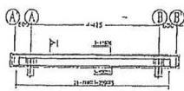
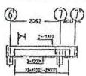

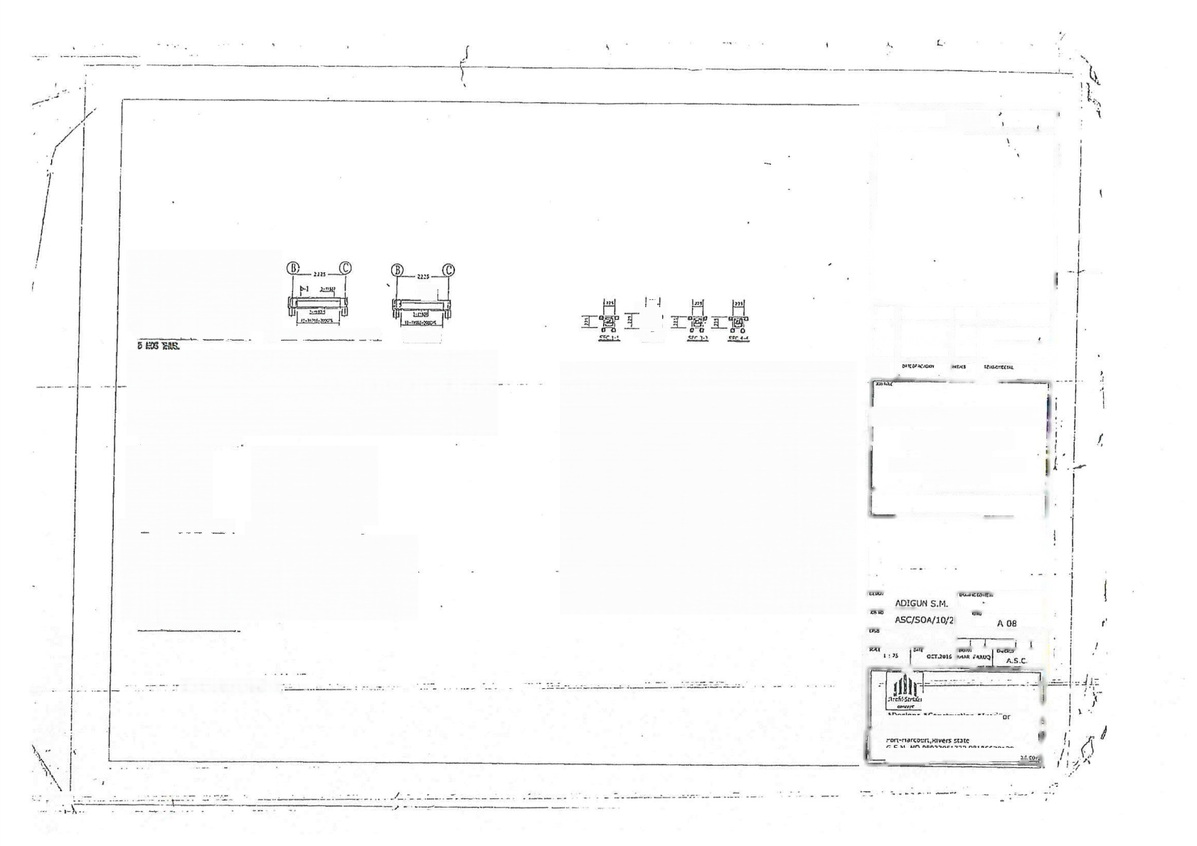
ं =

प्रन

F.10DR BFAM1(225mmx450mm) EFL00?BEAN 2(225mx(50mm)
STAR BEAN
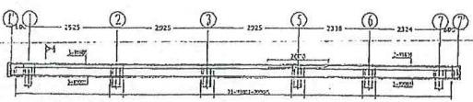
E.LB,BiAV3/22Smmx450mm)
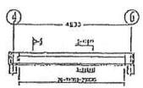
E.L00RBAN 5(225mmr₄50mm)
Tषण्ाङ्गम्षणणट्रकट् nहछ्ठ @कना्J
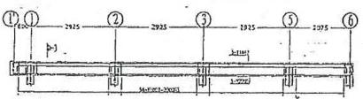
E.LR.BFANE(225mmx450mm】

:...====-.-:3-

क:
r21

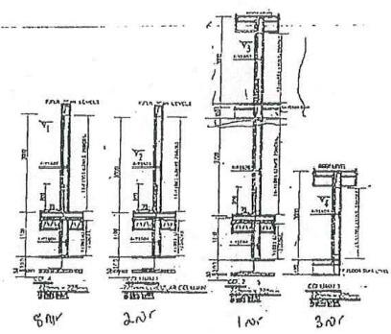

NCTES
PROPOSED OFFICE DEVELOPMENT
FOR
PGT SAMUEL OLADELE
LOCATED AT
ALAGBA LAYOUT IDO L.G.A
CNO STATE
16
ARCHL-STIUDES CONCEPT
a8chatEneeping 4ail,2nd Floar ay Doma junctlonWoji Ad Rumuro
pB a E 5A FO5B=1!5B

--
.

1
2

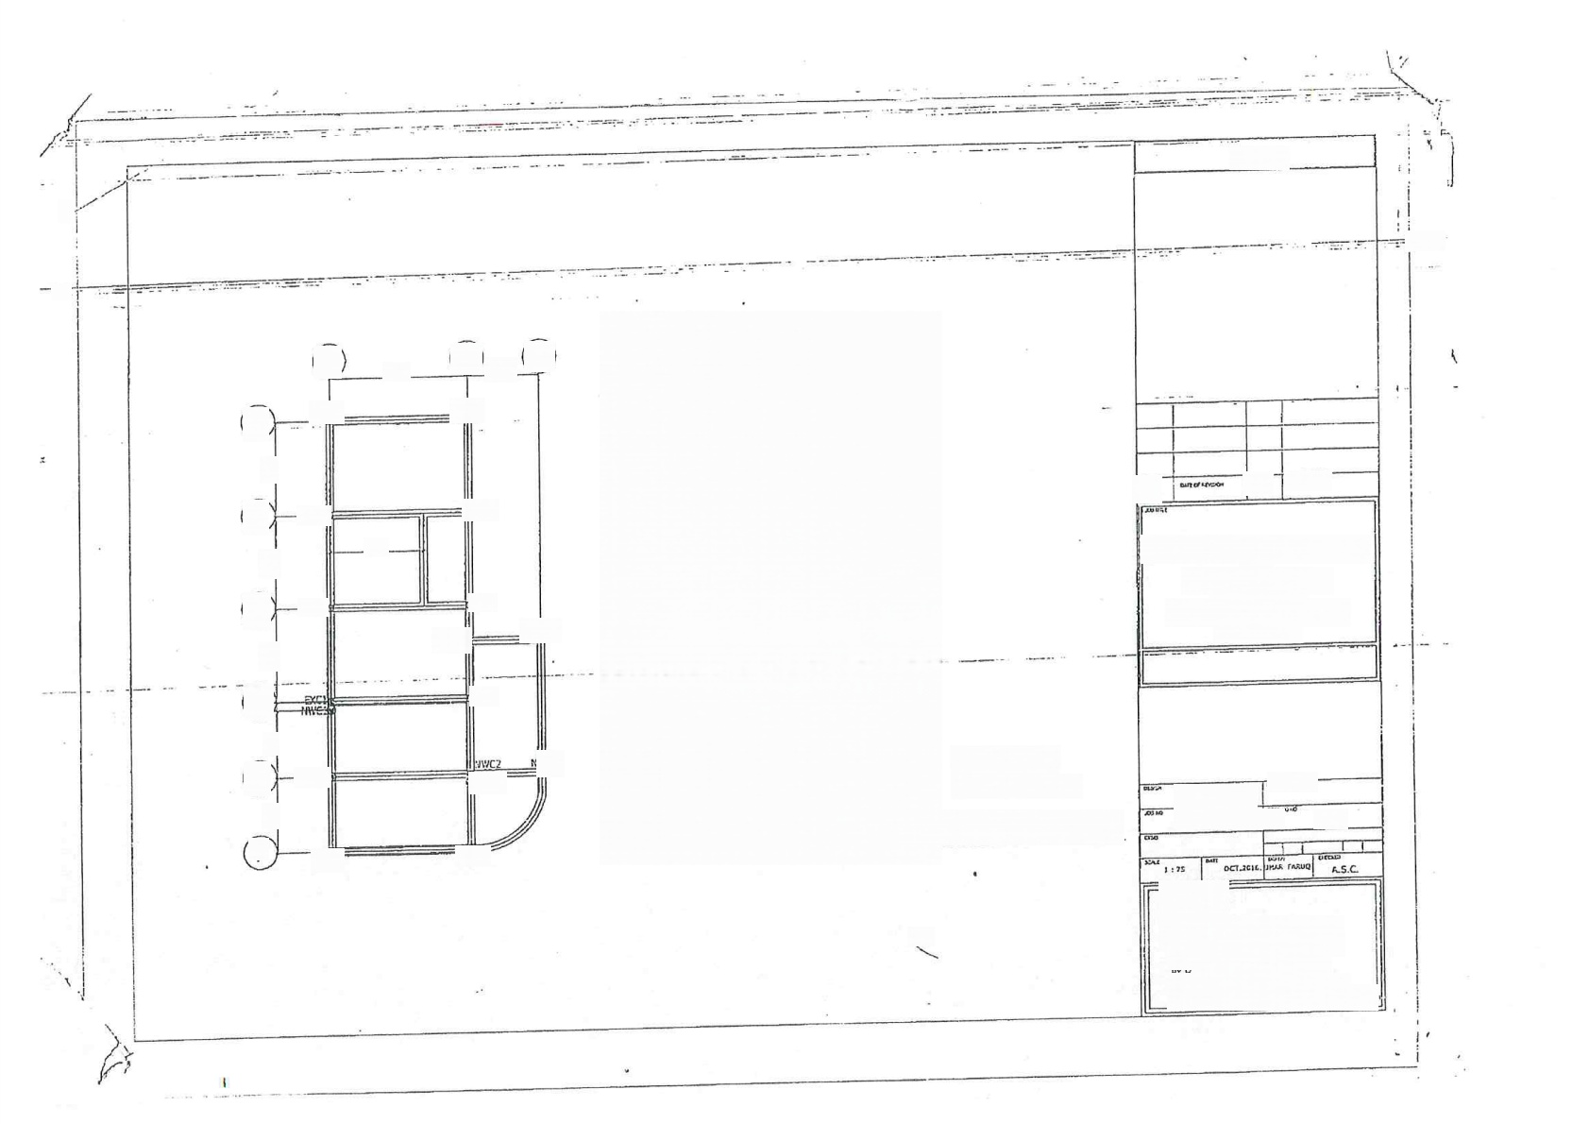
NOTES

A

ECl

e

3  图  5  6  受  7 | ej  C1  M:

C,
425
225

EGi

ExC1

EXC1

NVCa

ExC1

HWC1

ci

D

NUc

c2

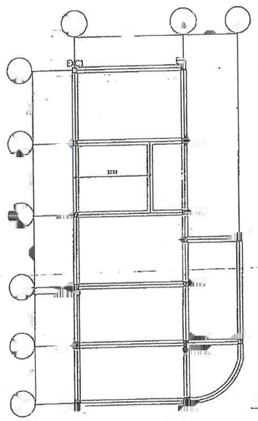
C
443
C1

装

e

ExC]

KWCF
图
EXGH
州

W 2
NWC1-NEP COLUNN 1
RWC2-NEW COLUNH 2
EXC1-EXISJHG COUHN 1
普
COLUMNS LAYOUT
W
Wci
③
ExC1
-YEH
2223
WC1
A
1
2
6
5
7
ExC1
D
E
G

rvng
u

PROPOSED OFFICE DEVELOPMENT
FOR
PST SAMUEL OLADELE
LOCATED AT
ALAGBA LAYOUT 1DO L.G,A
DYO STATE.

ADIGUN S.M.
ASC/SO/10/2 16 A.08


ARCHI-STR!DES CONCET =Destons *Construction inseripr
neglng Aal,2ny Ror na fu lclVoit ad Rmrelu
G.SM.1C 0803706172.081E56Z0:20
en²0072 Na0 20020r

 |  | 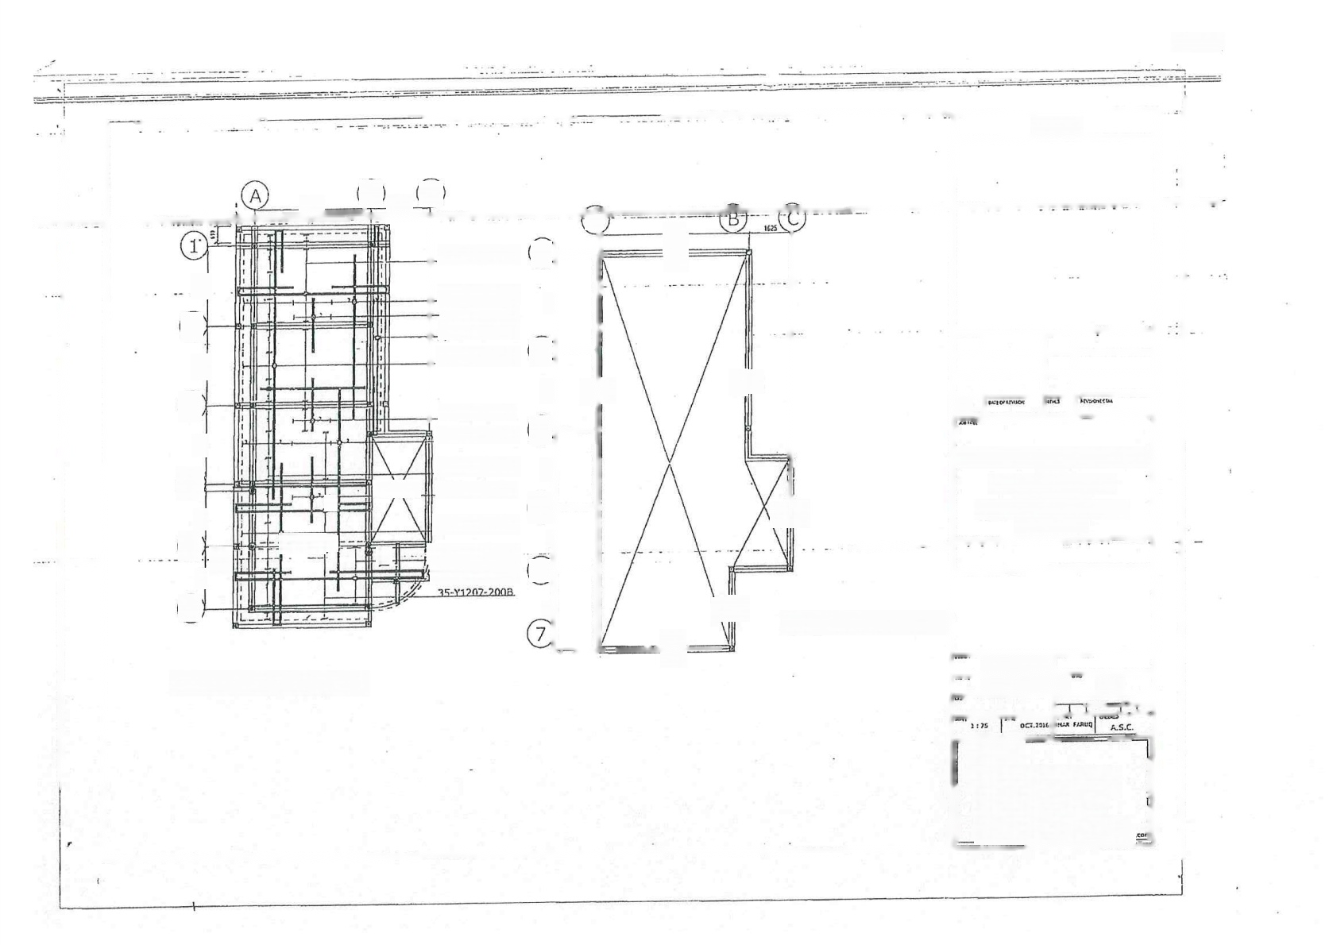  B  425 |  | 225 | C |  |  |  |  |  | NOTES
 |  | 3  圈  2  到 |  |  |  | 3G-Y1201-200B  20-Y1208-200T 7-Y1209-200T  3-Y1202-2008  25-Y1203-2008  7-Y1209-200T  17-Y1210-200T  5Q-Y1211-200T  7-Y1212-2027  25-Y1204-2008  L11-Y1205-200B  -Y1206-200Tse | 1  2  器  3  5  6  益 | A | 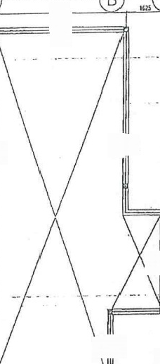  5525  (D)  G  G  G  二  G  \GG  R | 9
 |  |  |  |  |  |  |  | G |  | 9
 |  | 器  ⑤  6 E  7 | StAIrKnL  =-==T  F |  |  |  |  |  |  |  | PROPOSED OFFICE DEVFIOPMFNT FOR  PST SAMUEL OLADELE  LOCATED AT  ALAGBALAYOLT 1DOL.G.A  OY0 STATF
 |  |  |  |  |  |  |  |  |  | OOF BEAM LAYOT
 |  |  |  |  |  |  |  |  | Ol
 |  | T  F,FLOOR SLAB DETAILS |  |  |  |  |  |  |  |  | ADIGUH S.M
 |  |  |  |  |  |  |  |  |  |  | ASC/SOA/10/2 |  |  | 16 A.08
AACHI-STATPIS CONCEPT -Designs*Constructlon Tnlericr
数ah n Ma,2rd A aar
by Dama Junctlonwoj ad Rumurolt
5.SN N⁰09032061772.03186620120
clesen20020 vehoe cop,deoten²0o²sme

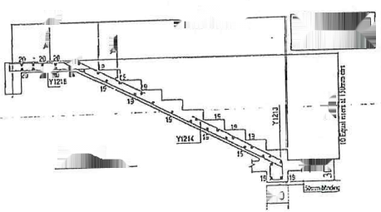
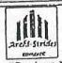
300
500
475
退 2
1500
2700
E e C t 双
强 TREADS=300mm
838
R/SERS=15Gmm
WIST =i⁵0mm
FLICHT 1
TYPICALSTARS.
Lg
30(

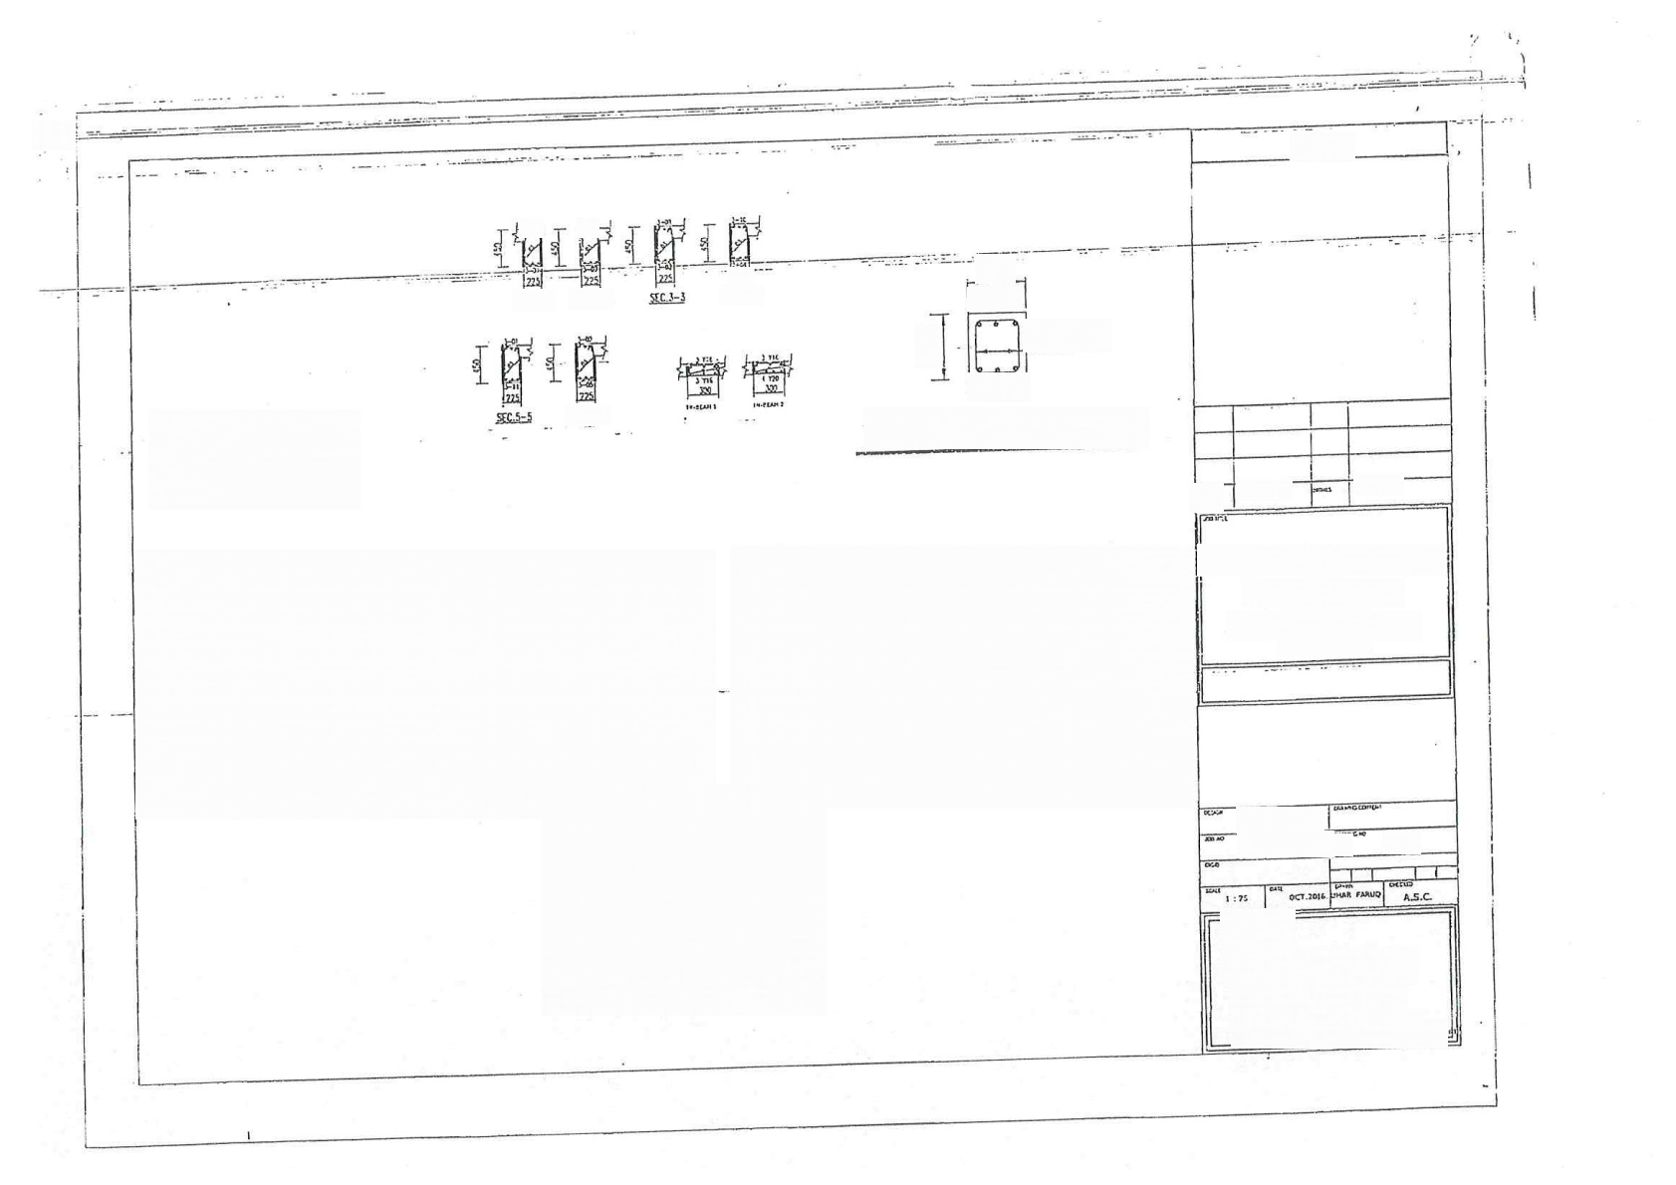
出

NOTES

5EC.1-1 SEC.2-2

SIC.6-5
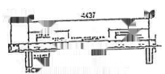
06A
150
1500 Ar

WFFDECEOHE

225
SEC.A-4

225
2Y1221
Y0602@200

3 Y1221
ypical Roof beam Section G-G

m H w

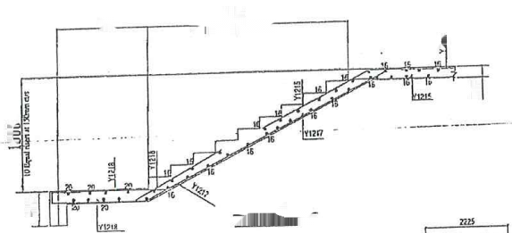
2700
836 S可医项开双

虽

FUGHT 2-2
TYHALSTARS

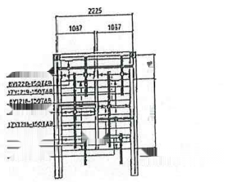
盖
GZLET

n
昌
M
Er
M=Pgr
TYPICAL STARS FLAN

PROPOSED | OFFICE FOR | DEVELOPMENT
PST | SAMUEL LOCATED | OLADELE  AT
ALAGBA | LAYOUT | IDO LG.A
OYO STATE.

ADIGUN S.M.
ASC/SOA10/2 16 A.08

ARCHI-STRIDE5
COHCEPT neg
Ctnetint
chioceang Hall.2nd Door
y Dams tnctanWpn Rd Armurglu
-Harcourt.Rlvers sate
G.5.M.NO 05037051772,08196670120
ntgs200212 yahoe com,3digsan²0c?Cgmaitg

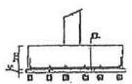
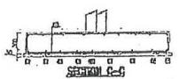
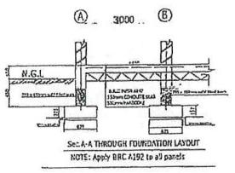
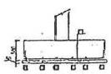
150

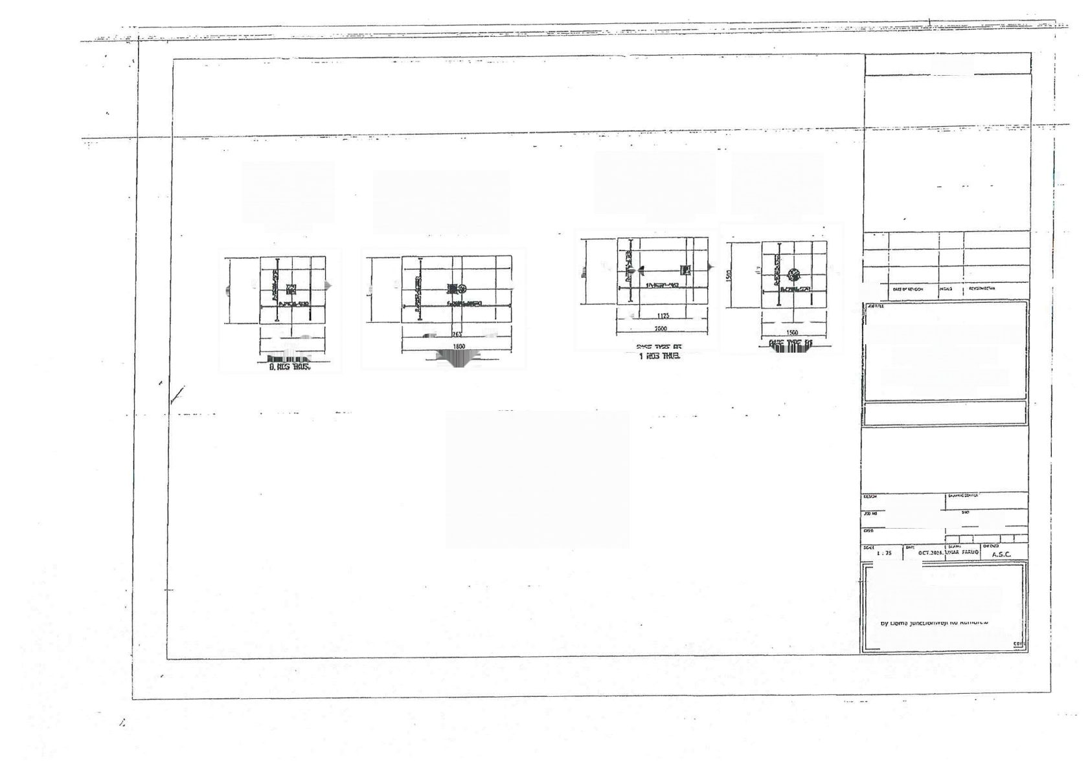
NOTES

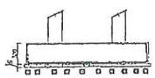
蛇配州f - G
P.
R
S
SEHFOLG-G

8
△
级
钢
正 LA
正 a
B
m
8

48 4Z
790 750.
758.5 769.5
.750
792
PROPOSED
OFFICE FOR
DEVELOPMENT
3 S
1500 E
B TE
PST
SAMUEL
LOCATED
OLADELE
AT
ALAGBA
LAYOUT
1DOLG.A
B
2 c03 THB
OYO STATE

ADIGUN S.M.
(B.
ASC/SOA/10/2026
A 08

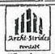
ARCHI-STR1DE5 CONCEPT
*Deslos2ConstrurtiZond"IaEtetinr
G,S.N.NQ 03037061772.08186670120 1tn2602 gihncnnaies:0)3C



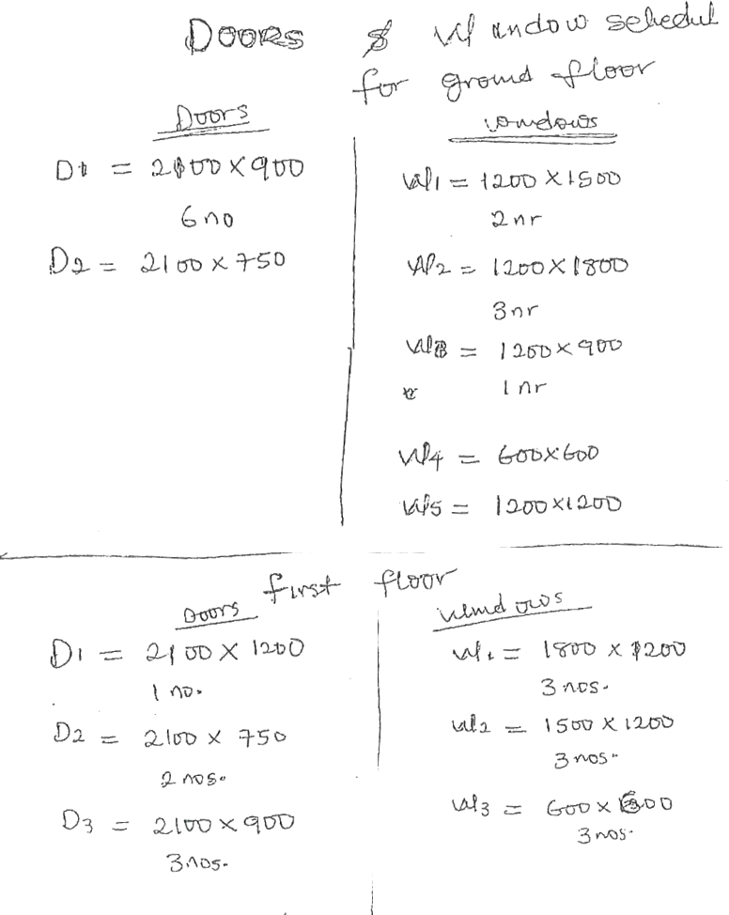

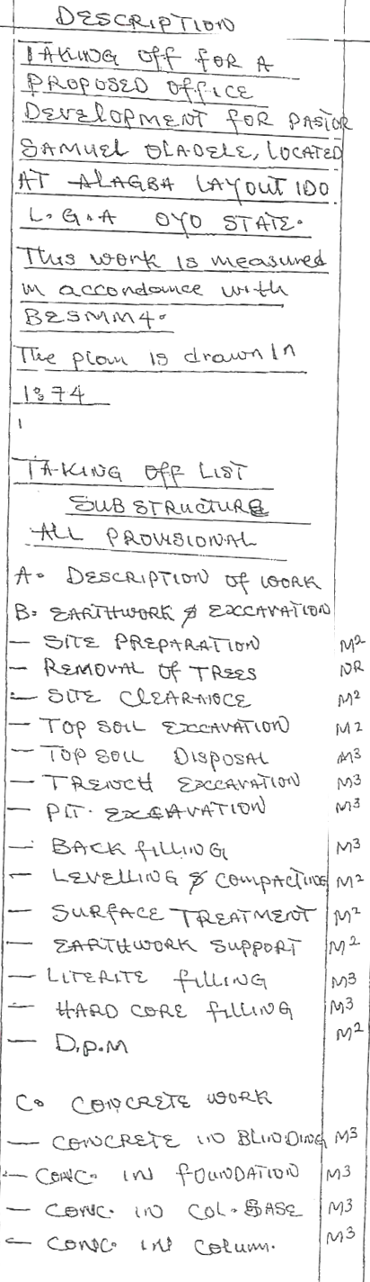
 | 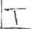 | S |  |  | S | 
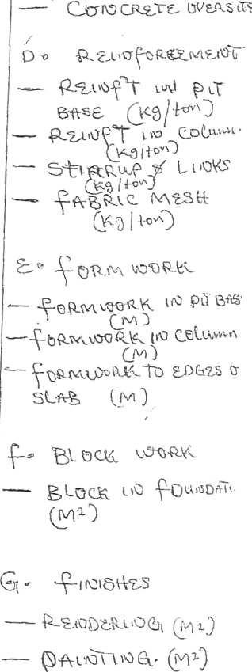

ﺩ

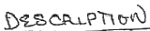
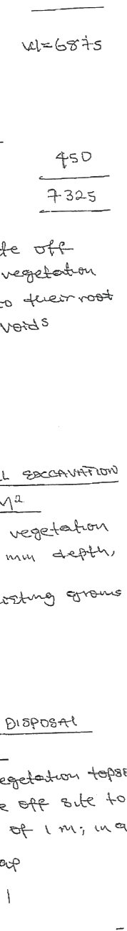

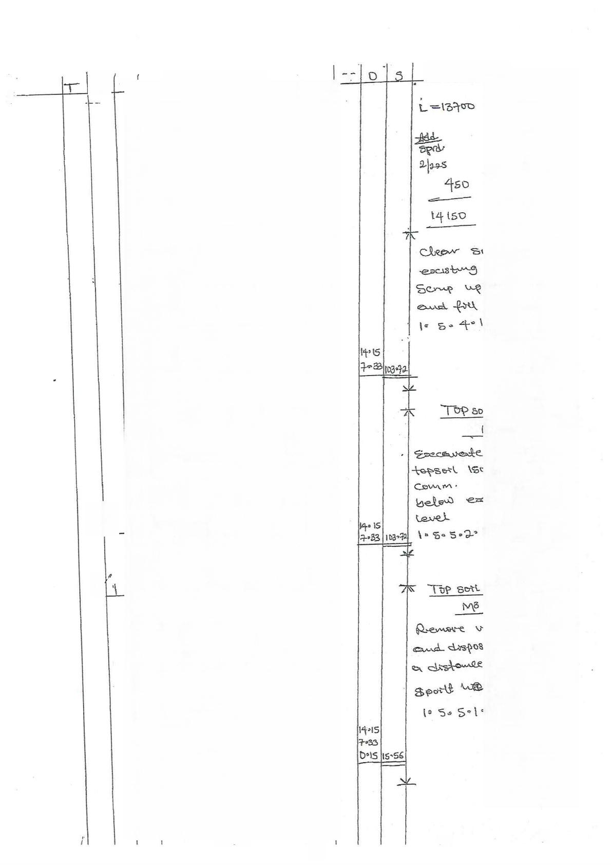
÷

S

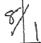

9

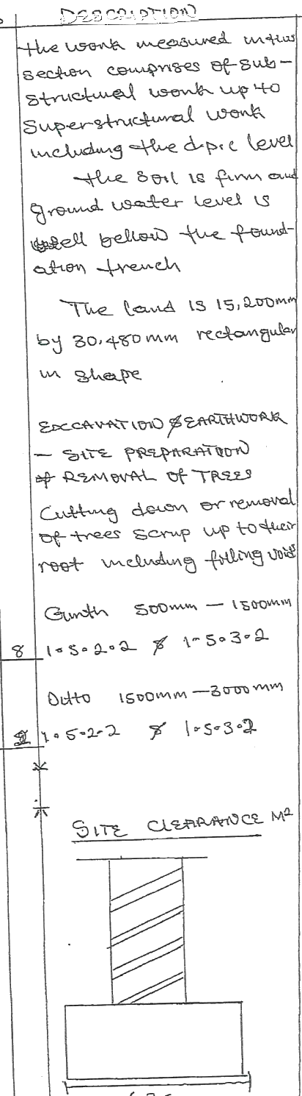
6+3 ~

T

( 2

①

Pzx

esS Celoum
pu
boxS

1)1soD=

18σD

20D0

$#.3x

6Sm

BT₂
BT3^

32S— 田 召CD

54,025

¥

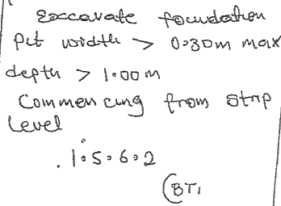
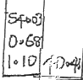


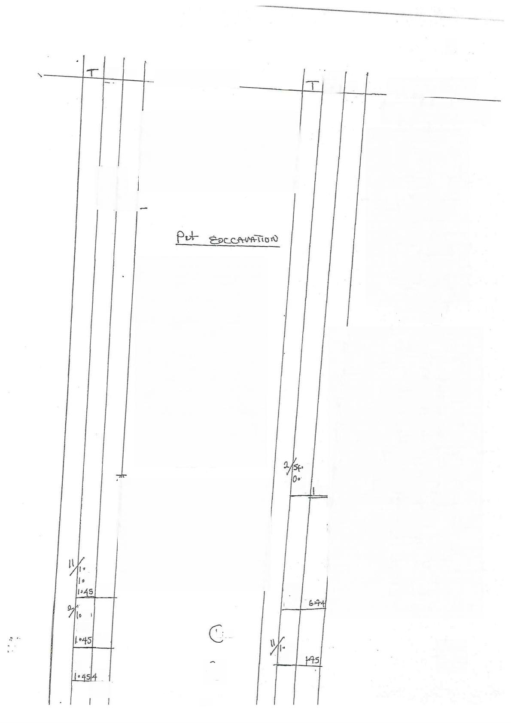
公
Ω S
3

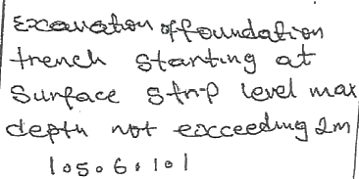

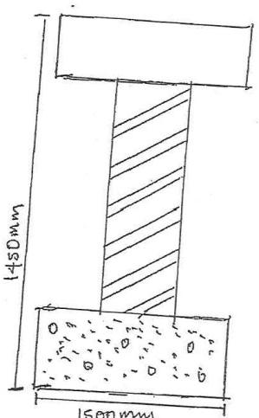
03
50
0·43 9:9

50
5o
3>26
5400
0068 31
5D
1·SD
BTa
3·93
So
135024
200
{:So
⑧
3s
云


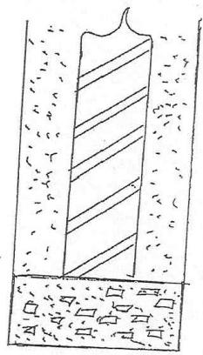
廿 = N00
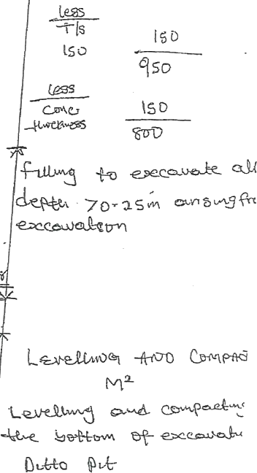

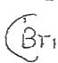

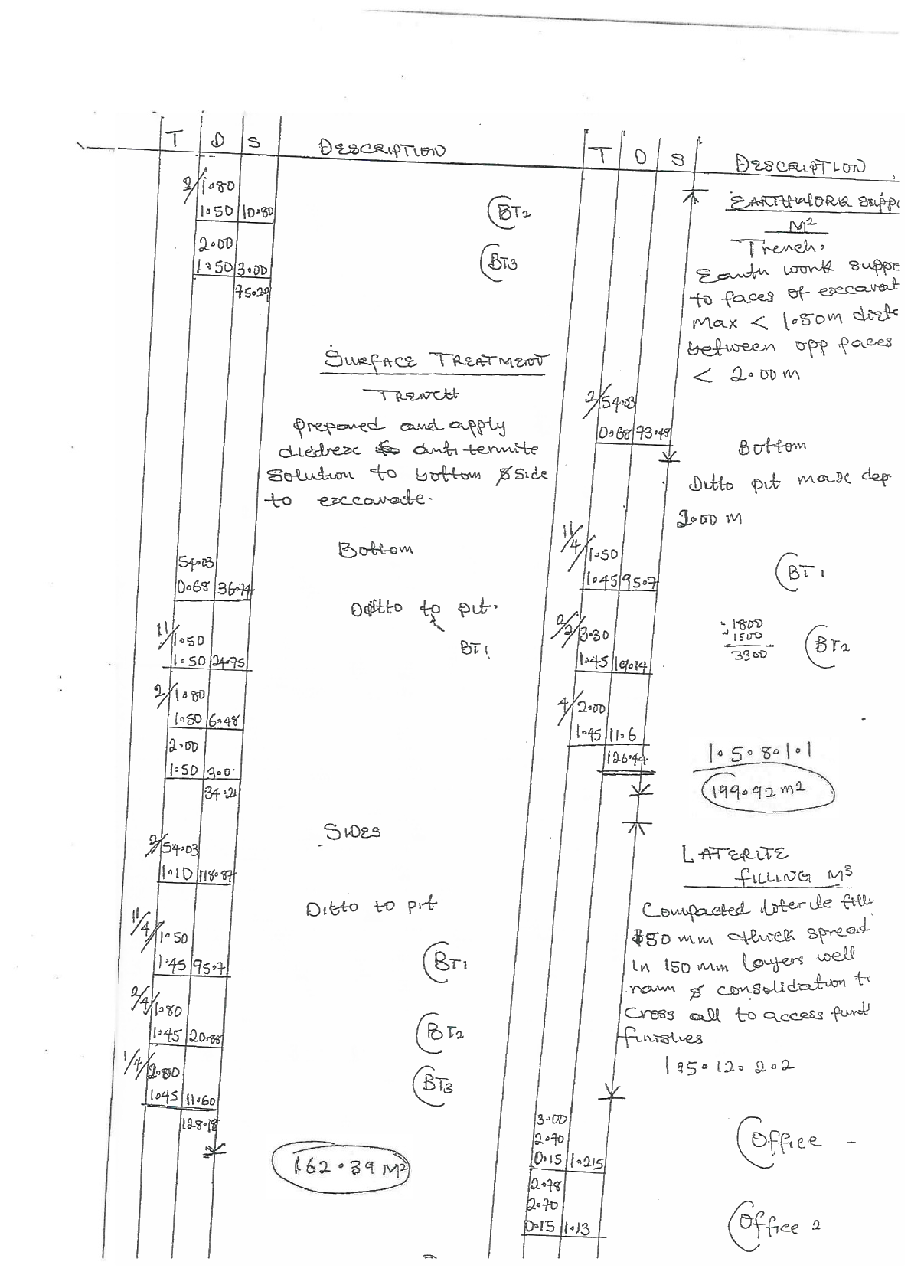


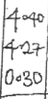

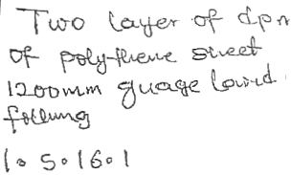
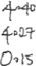





95
0·99
0|5

÷70
D 46
152D
DIS
Bcdn u=(
20 C
D
4LD

+0 S
42S
ce
15
3 88
2DD

o2q
2270
208
8*3
8ec
2B
S+
D DRf U₁0G M3
3-se 900L
3a0 mm +u
,96
makte ueto lere
9020
gteL
中 tce
ace t
9=78Gol2

+o
20
ofev
FQD
0794
2
oie 2
|2=90
300D 80C
ce
n Ljr C
1005 2 ·

2

uD*c

sec
Ce

T
rS


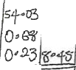

N.

S
0

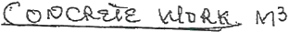

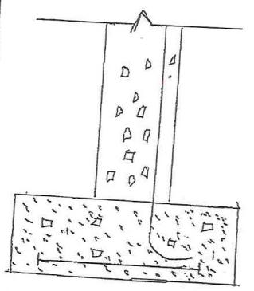
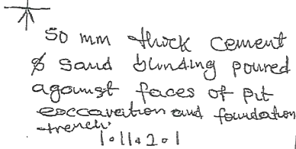

084
pt
Duto
S( 0
。SD

60
BTa
5D

DD
5 0₃15
g
SD

LV

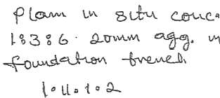



50 0SD D3D  8C | θ  013| |   8    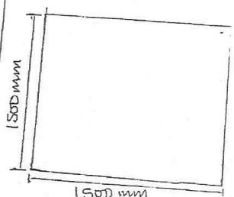  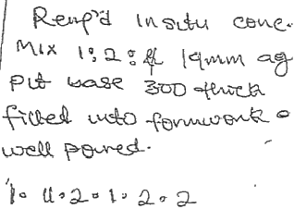

020
SC
Os 0mS4

Concpe
trù celbun M3

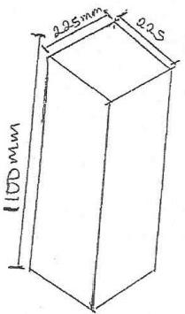


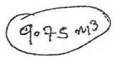




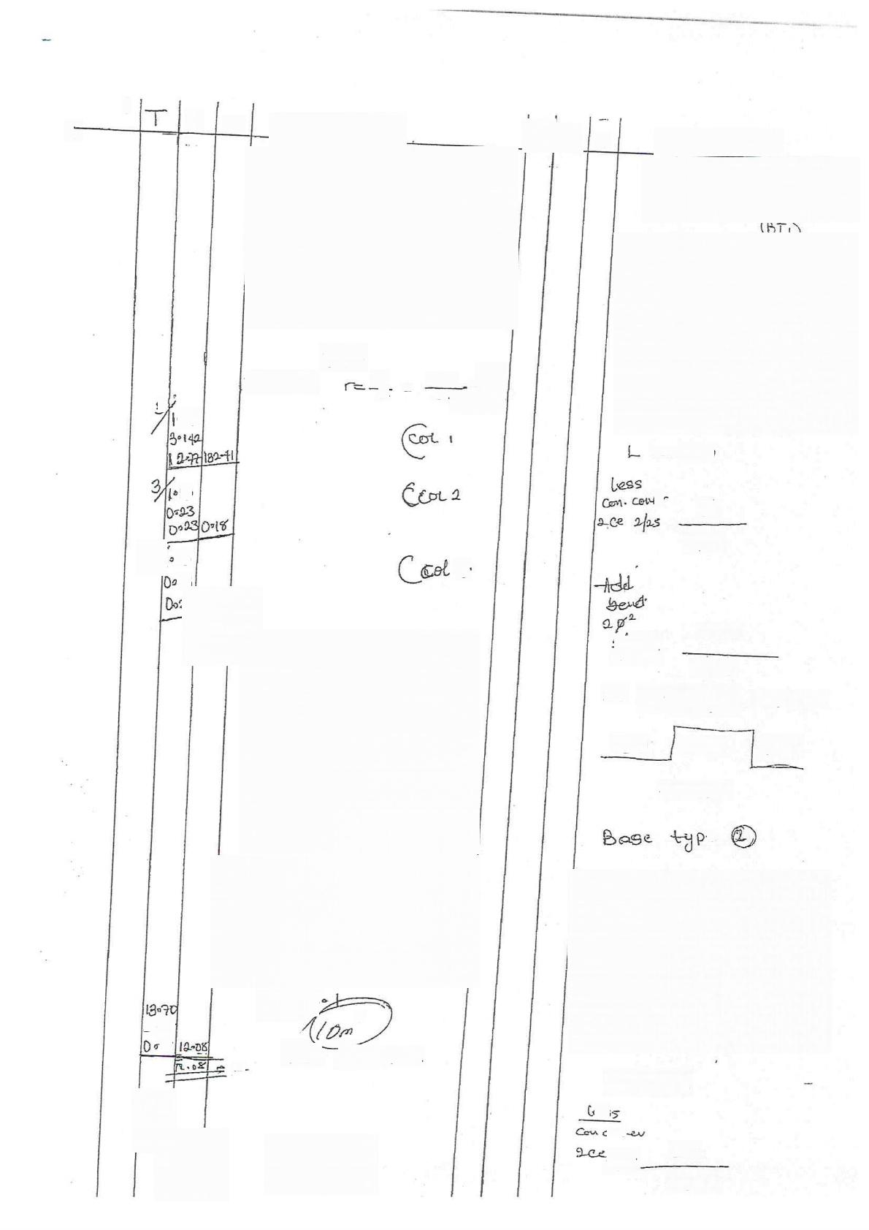
0
S
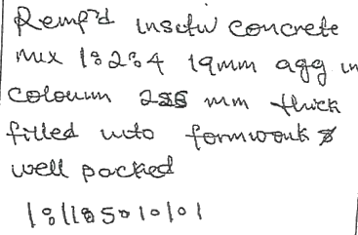
TF4
W=3142 江 2 225 11S|二
1
=12-47
3
010

ID

lo
4.
3
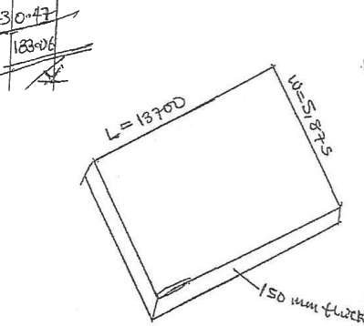
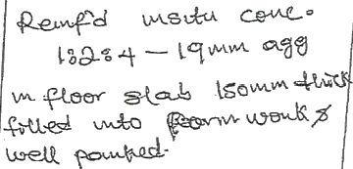
lollo
y
Dd+ vodvee
S?88 IS
2

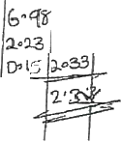

S
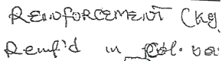
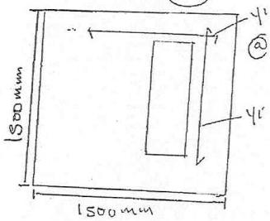
二 (S 0℃

eY
50
14so

268
2/1z|2
173s

Qo  150 | 叶 reinfd  lS o0  =llnr  ·e | reqnsed.  (0+1

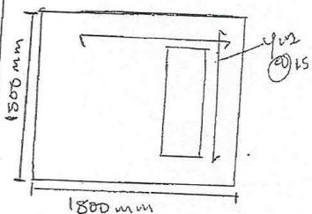

L=(Sσo  eS:  2en  21zs | S-D  14SD




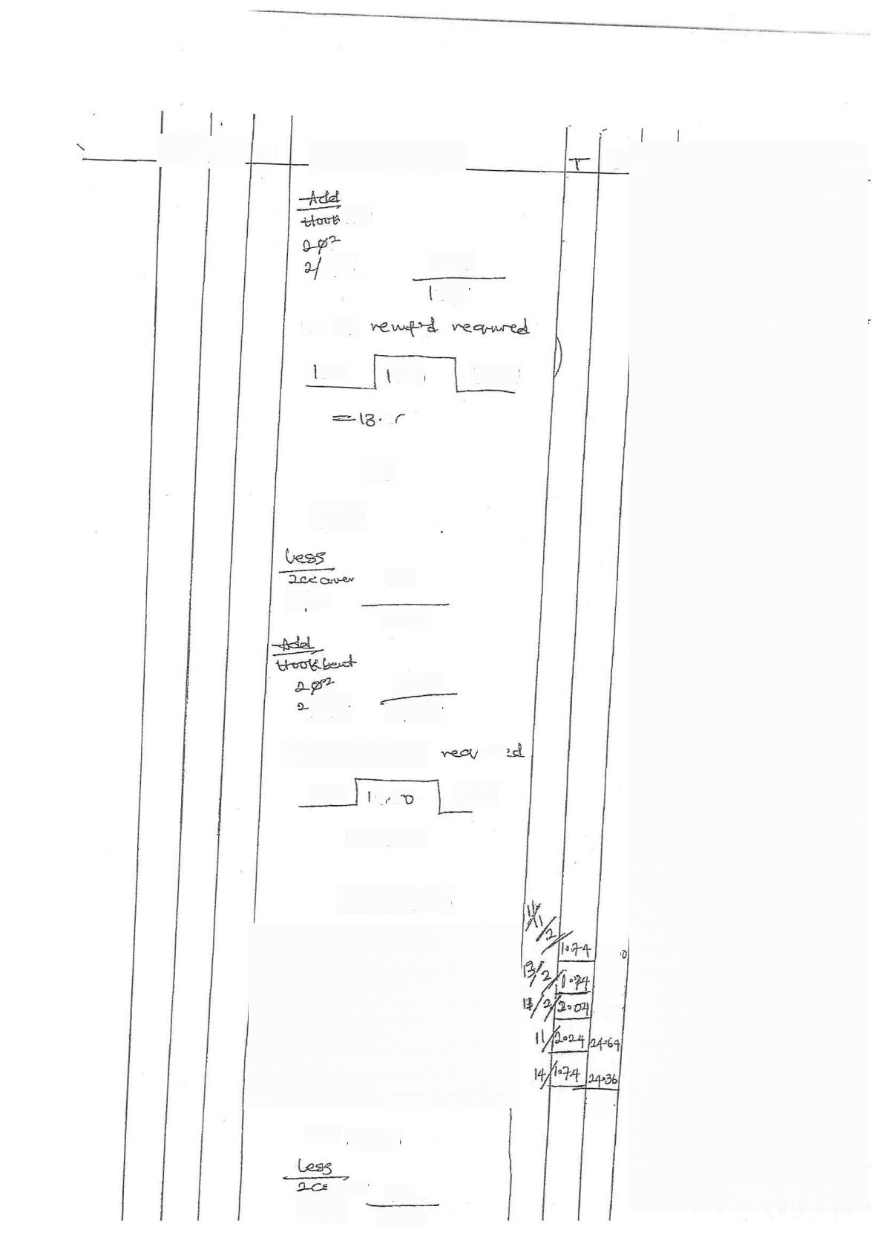
S

ﺛﺘﺪﮬﻤﻞ  |1|1-  N70  SO | 288  738  GσD  12+1

MY

w
(80D

So
A/2S
l+S0

{r|iz
28g 2,b38

|o ٤ﻕ
Mwe
veuﺣﮫa

S ·
1 0 十
{50

llnrs-

Base fyP 3
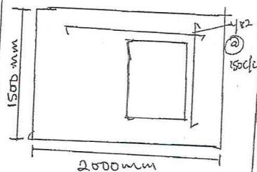
|_ = 2ﻡ 0C

ﻟﺮﺻﻦ » -
2{25
5 0
١
ﮮﮮ

D

40Li 4S·24
44-60

560c1

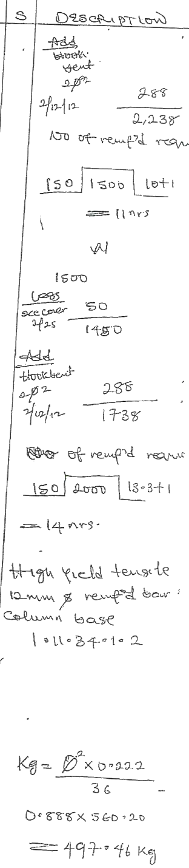


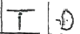

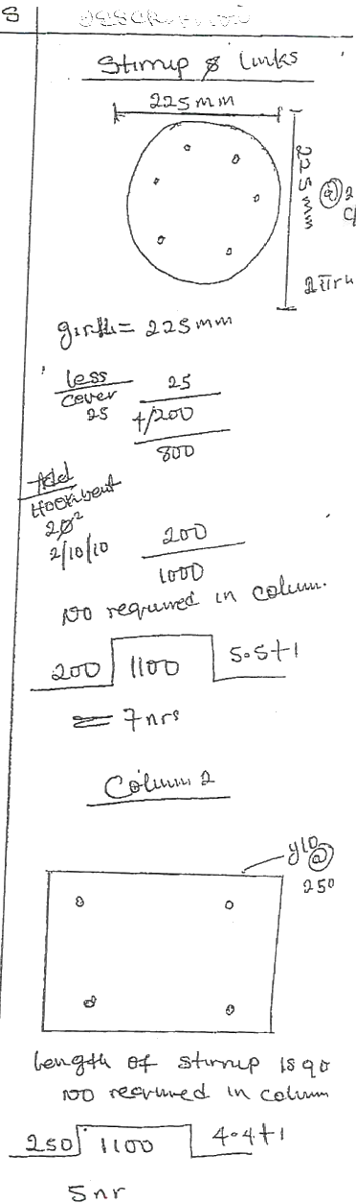
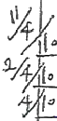
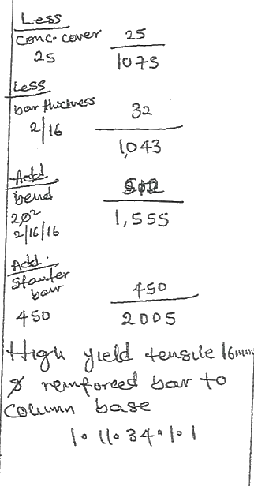


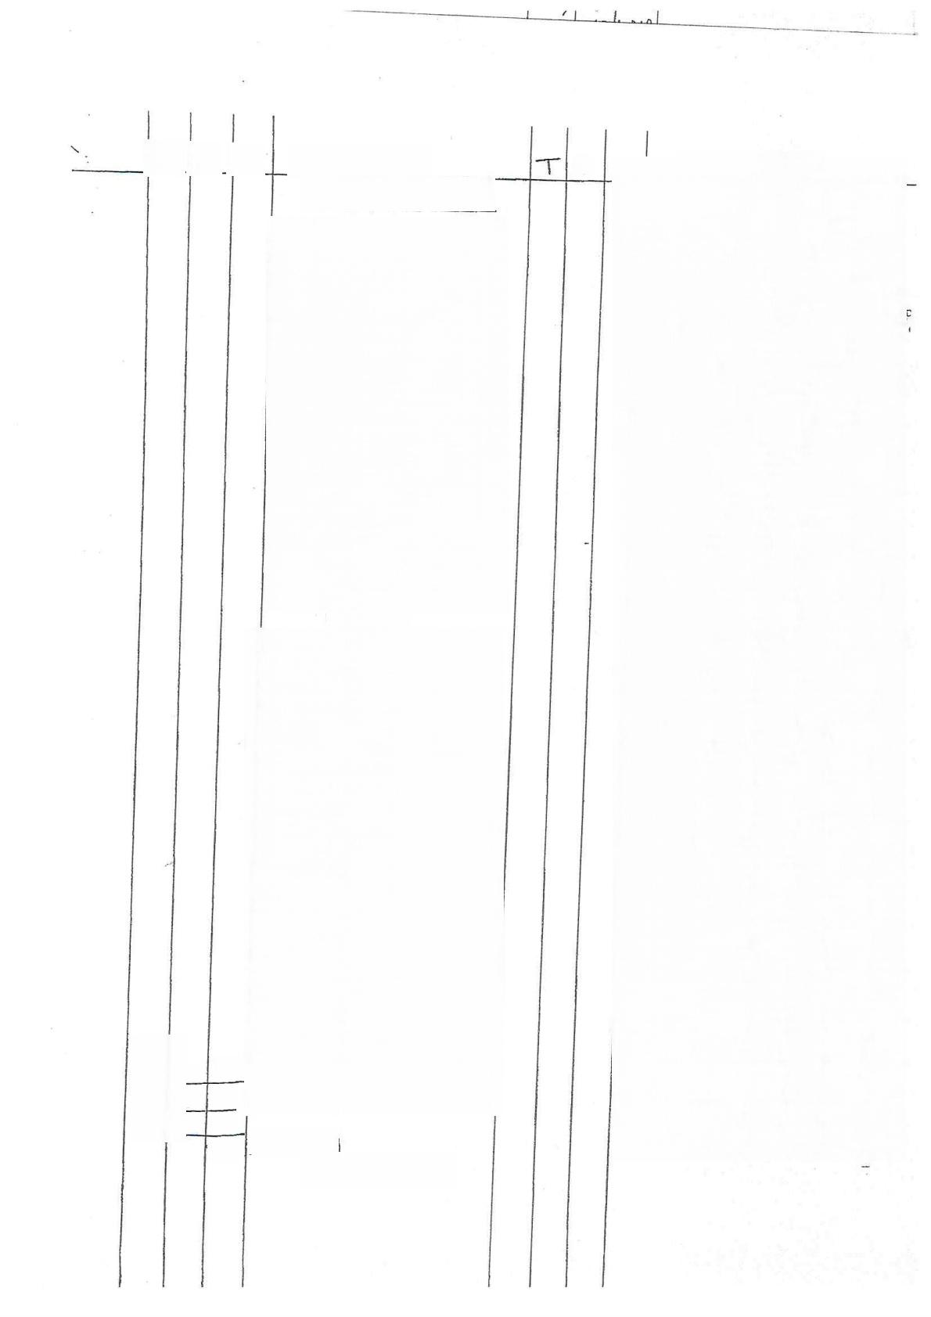
0
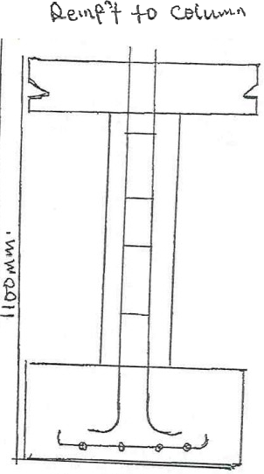
L=li00

55 68=2r
Ss 6>20
86·80X12579ke

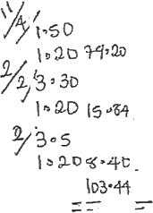
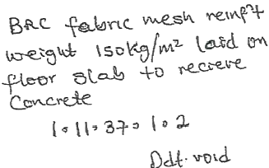
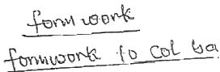
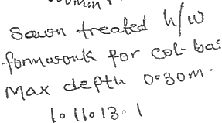
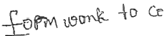
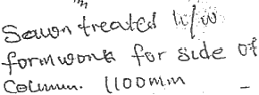
300

30.0065
 |  | 3
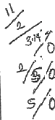 | SD | 34-56 | 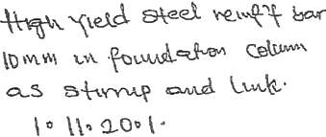  ×0*612  30.0065
 |  | :0D
 | 4℃ | 50
 | 13-7  0  6288 | 4266  94:26
 | 13-7  0  6288 | 4266  94:26 | 3toa mw  6845mw  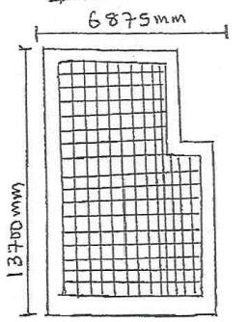  3)  M≥S+
 |  |  |  |  |  | il  1D | 8036
 | 13-7  0  6288 | 4266  94:26 | θLel  340D  50  13;650 | OLak  682s  S0  6525 |  | il  1D | 8036
 | 6-70 2·93-
 |  | 49-39 | θLel  340D  50  13;650 | OLak  682s  S0  6525 |  | 23 | 1
 |  |  |  |  |  | |D | :012
 |  | 49-39 | T- |  |  |  | 1:3

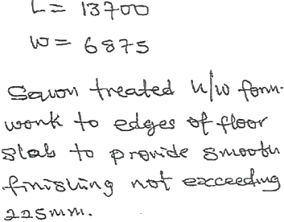
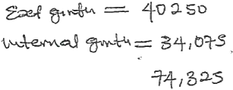

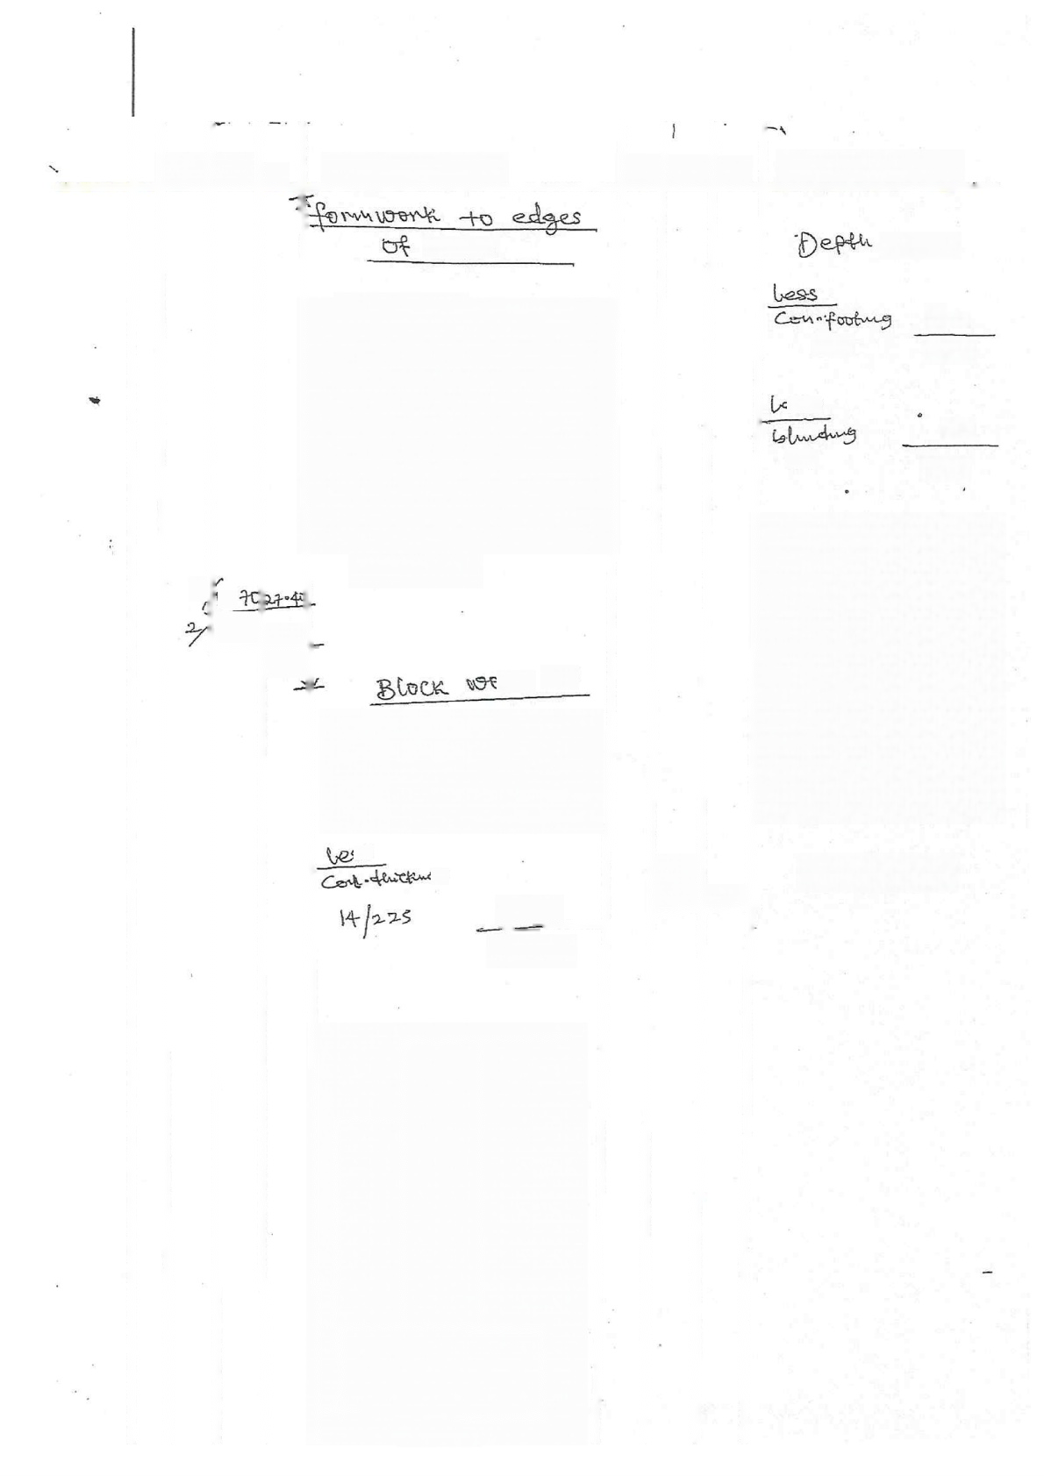
688 S
 |  |  | S
 | 2 | 5  688 | 13076 | NGL  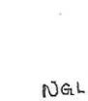 |  | R以 ²  3I5o |  |  |  | 子{18 >7S | 5331
 | 2 |  | 416
 |  |  |  |  |  | +,175
 |  |  |  |  |  |  | 心心  x  三 | 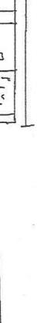
 |  |  |  | wwhv abl |   X×X
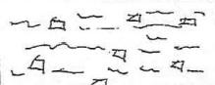
对
2

6+Smm
7{S18

-1100

名GC

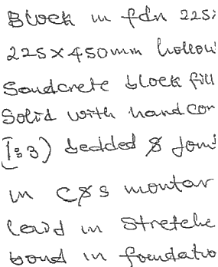



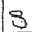

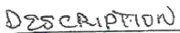
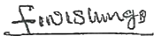
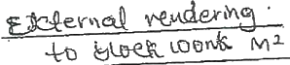
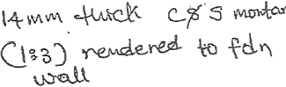

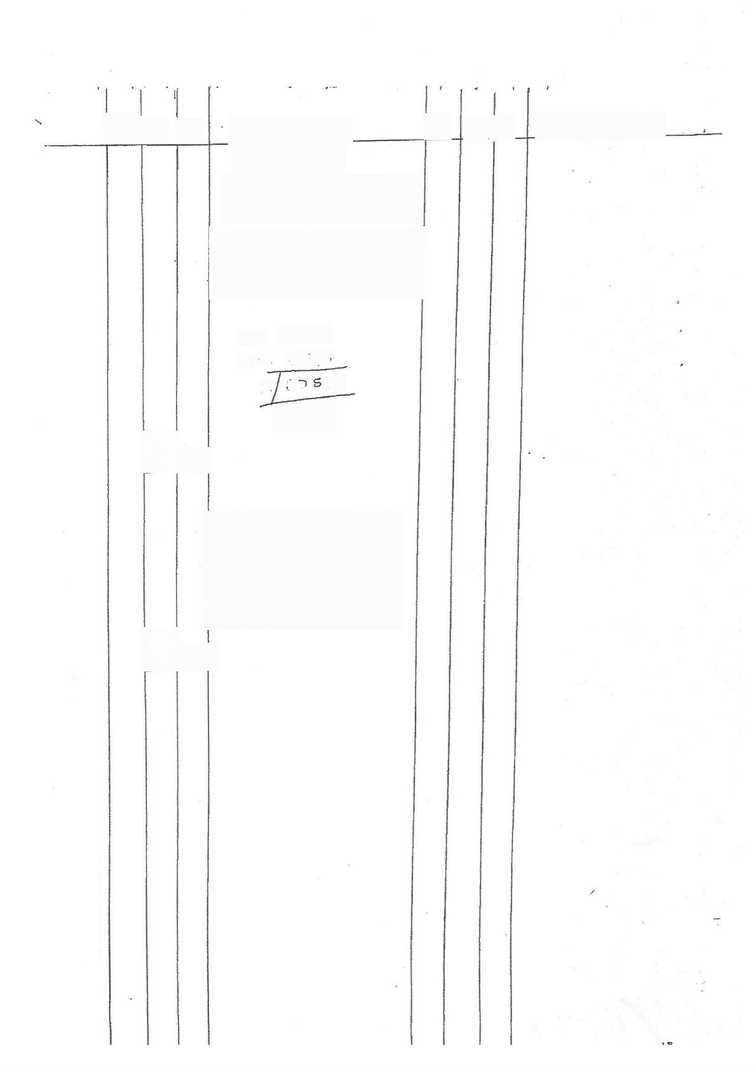
=
L
J
二
1

[3 01ﺩ
65 ?5
2ﺱِﺍ 0 75
41,1s0

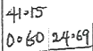

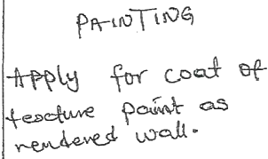
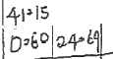

弓 eet D Munw
弓 b o a ww



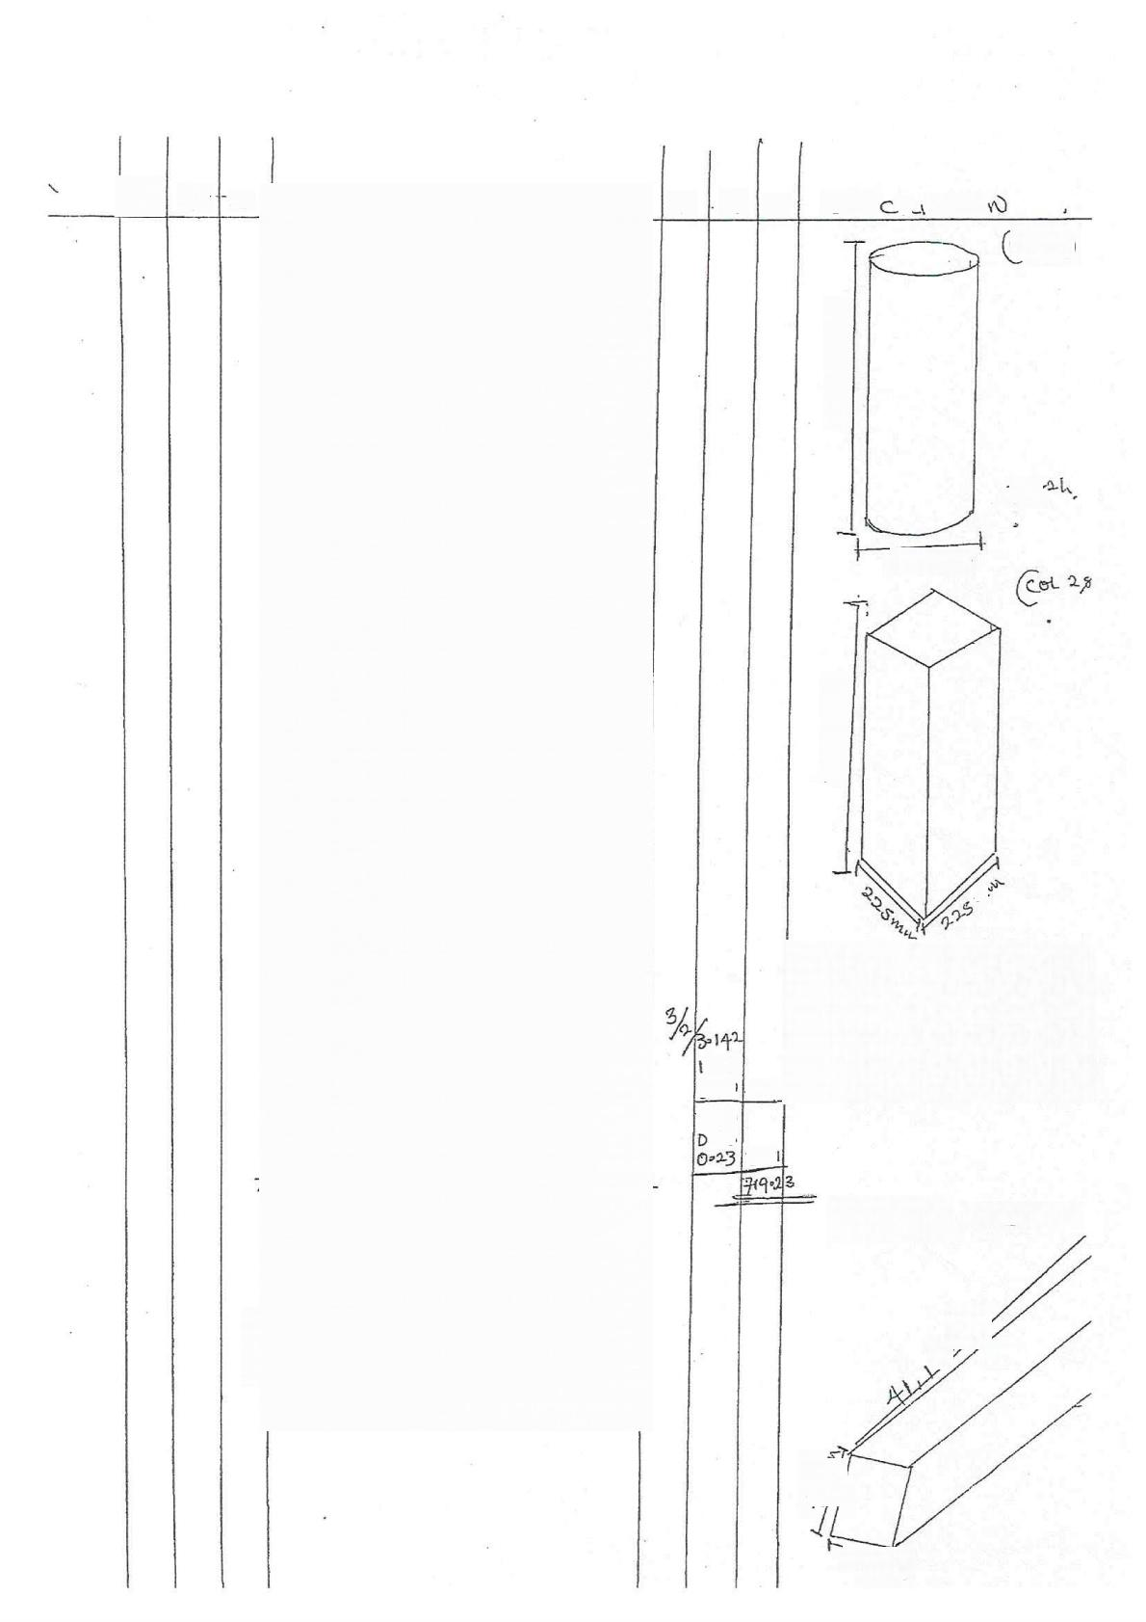
O- S

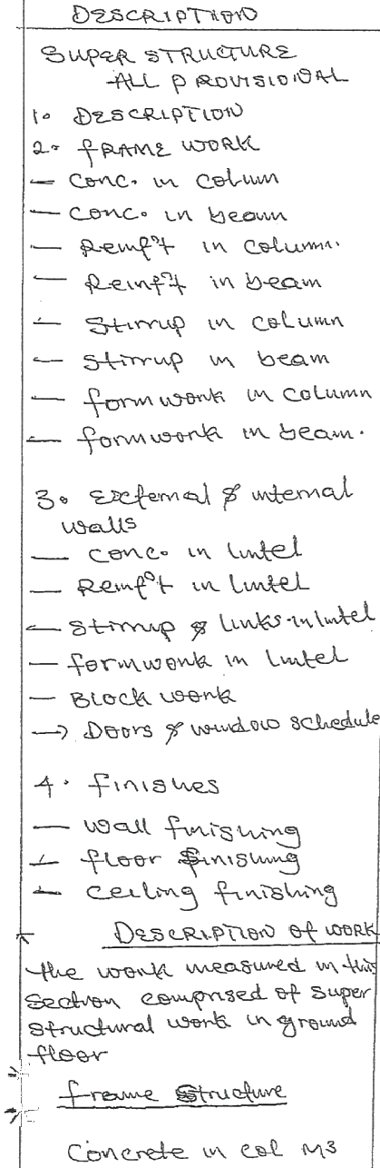

T D S

206S
3-℃ HSP
300D
023
3-6

0≥S( 只 Ptuo
Cot ()

T

20-5 wiwi

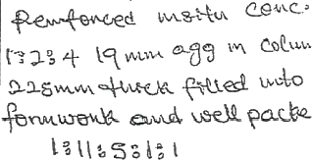

Conerede m bewu





s

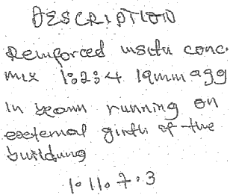
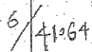
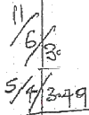

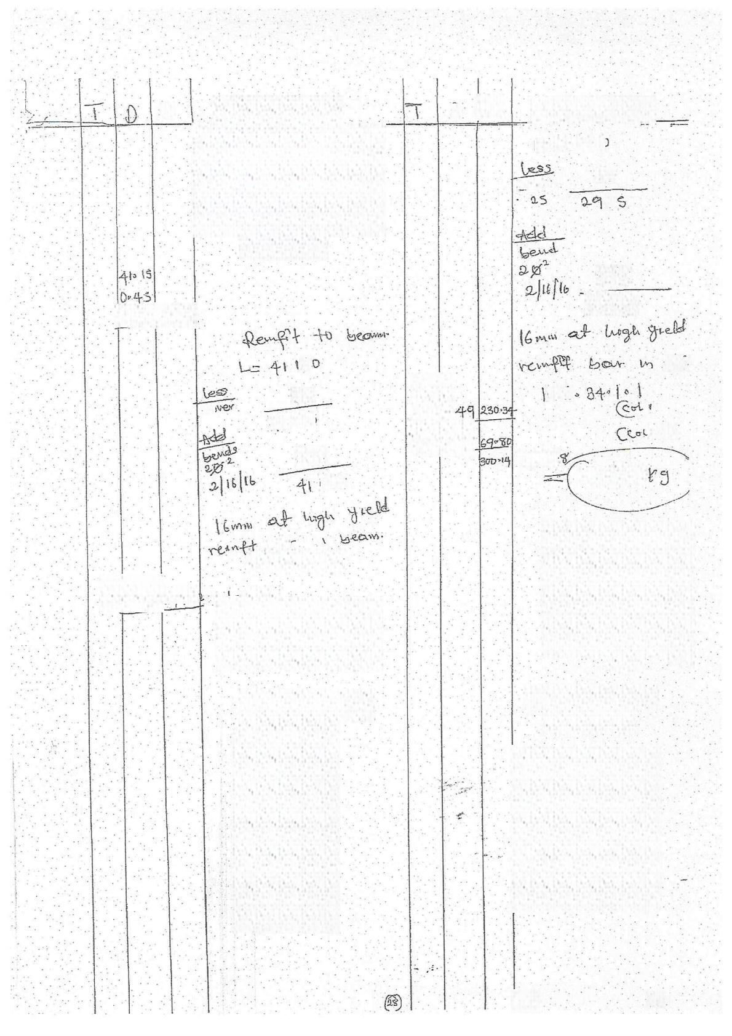
D
S

ol

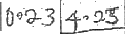

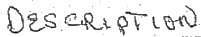
L= 390t
2S
eN
千(

S12
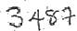

Cet
S!

25
6 ú
ﻑ
千
n
2岁4
Xles+
St2
473, 6.2
63?

LM
1olla84.|=|


X 548
24908
千·23.K9


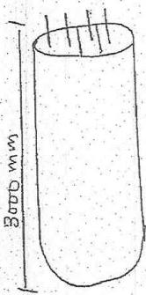

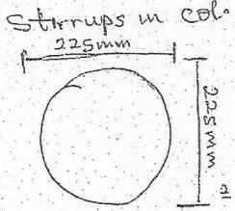
&ny
二 0:
2×3-142×12·S
二 + 0 6 ,cs

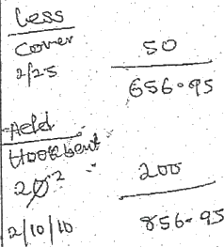

i5

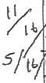

D

*6 090

 |     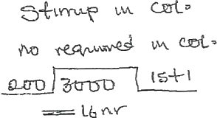  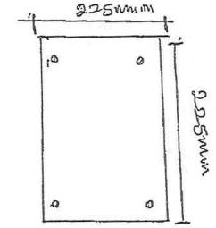  S:  So  5  HbD  200  1S+  =L6Mr  steel  tteld  Q  万 | D 3  ·45¥ | 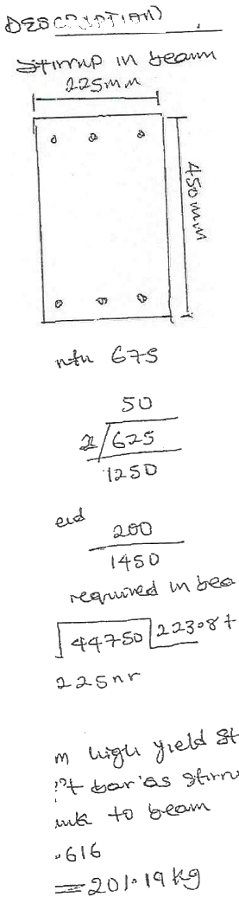
Cgtuw
101103 014
1S034
12-2
223·36
×00616
3

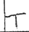
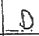

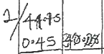
户
丽

5

3 3:00  00  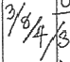  p>23 | 6-39  66·24 42·63

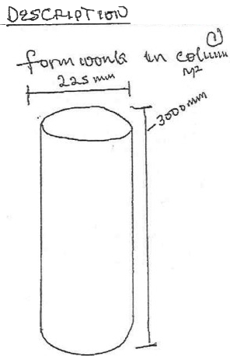
2πrL
2×30142×11005
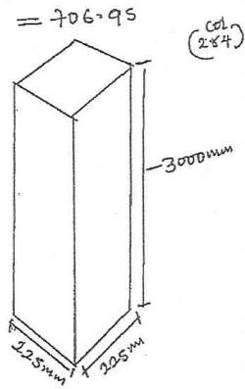
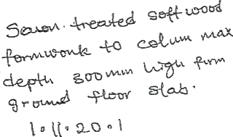

S
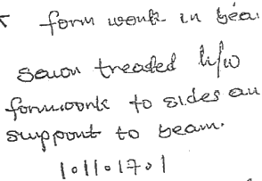

37+04
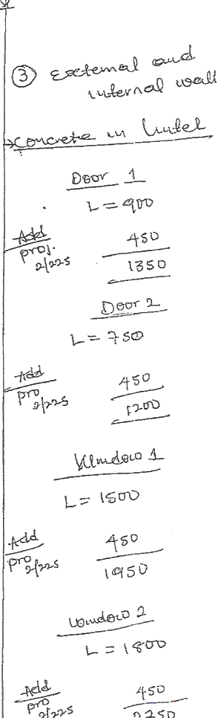

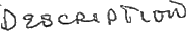
004
k7) FK

 |  |   S |  |  |  | S
6  3 | 3S 0>23 0323 | D43 | 3  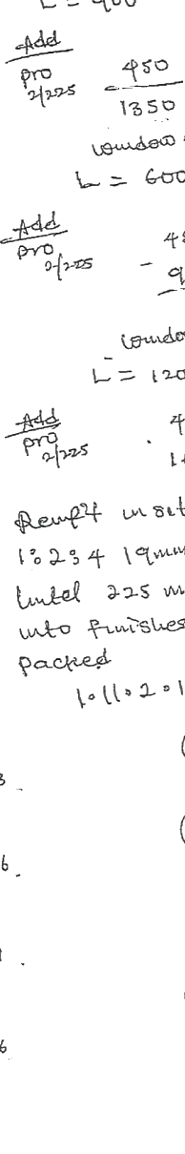 |  | O95 0023 0023 | DsDS
 |  |  |  |  | 1062 0023  D₇0 | 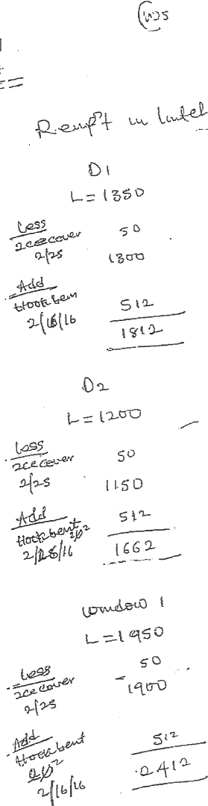  09
 |  |  |  |  |  | 1022
6  3 | -20  0023  0027 | 0
6  3 | 95 23 022: | A₂2
6  3 | 0.23 | 0·3
6  3 | 1a35 D·23 D023 | 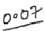

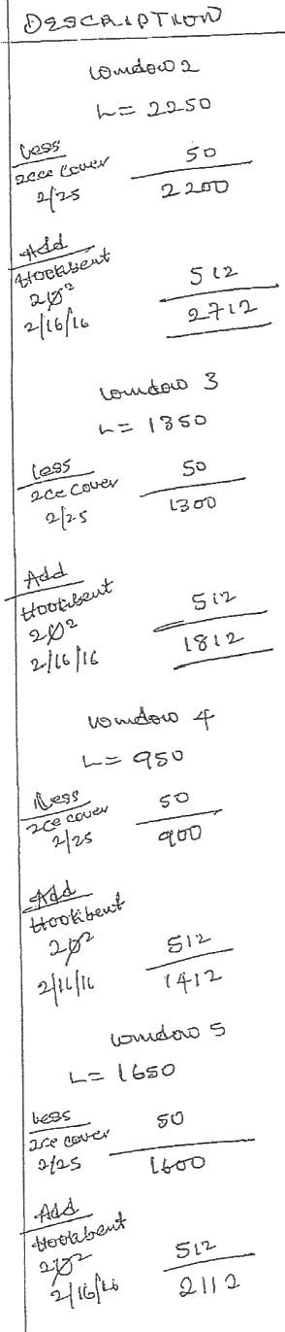
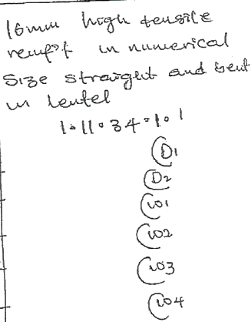
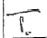
DEscRipro
T O S
D S

19028
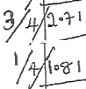

o(1 8044
19302 Xl。549
5:

u Tt
wO
TLRK
pS
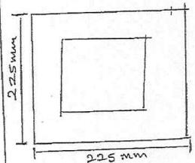

D1
lseo
Stmue
e

(812
~o6+)
Lo nr
D₂
1S9o0
叶St
jeA
m
83 +|
62
16
9nr

好
强

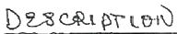

91
了D

0
3

s0
AaP

12
8
n
8·10
13
0=90
8010
108
41010 X 00 616
Sc
ug-en
35

.D
0=68
65
69 2-2S 6068
03S
0·68
S·S1
0·G2

Qe24

4:9

Jt
2
W3
5'o D
0-68
65
S
1012
)
20

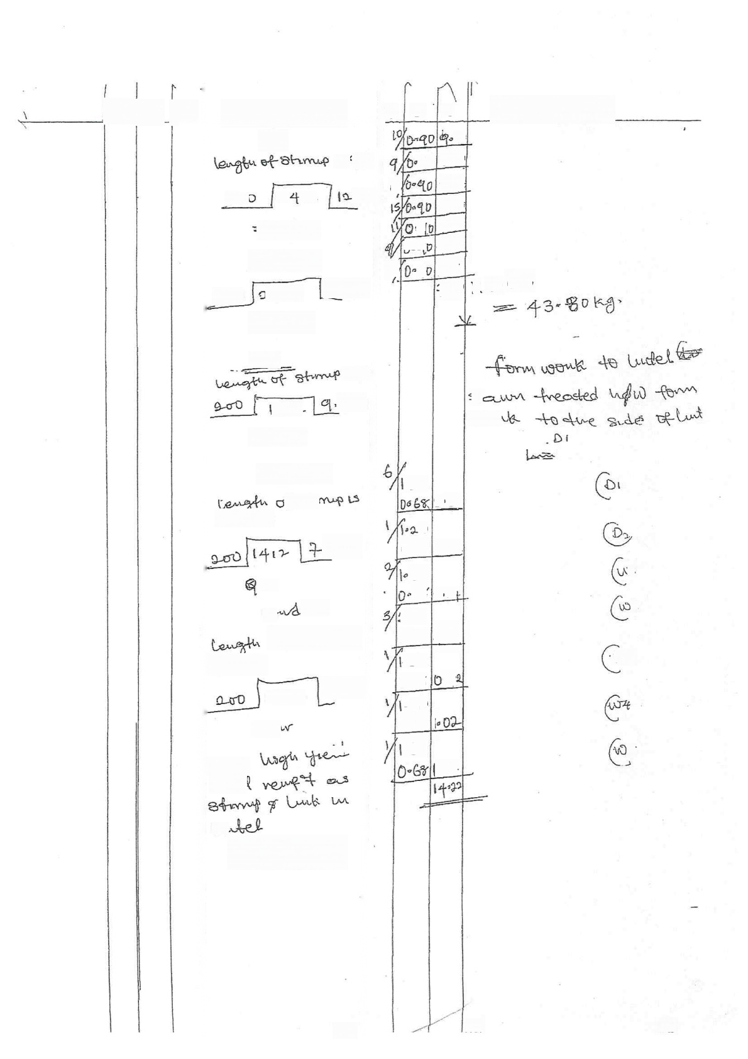  F | 四4  2 身  =B八v |  | {S 0O  06  13·6+1
ASw dap a |  |  | {S 0O  06  13·6+1
Ωec | 9-1n  [SMY |  | {S 0O  06  13·6+1
03  81  =[luy |  | 80  06+
u9wAouo4
P分中
G0O wM
σ6+1
AV  A  9R  C 0 LW  l1L |  | D s  stuo  D·56+I
{2 ·

0 Wu
Oheg

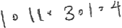


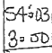
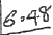
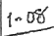
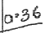
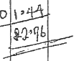
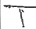
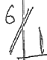
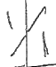
一

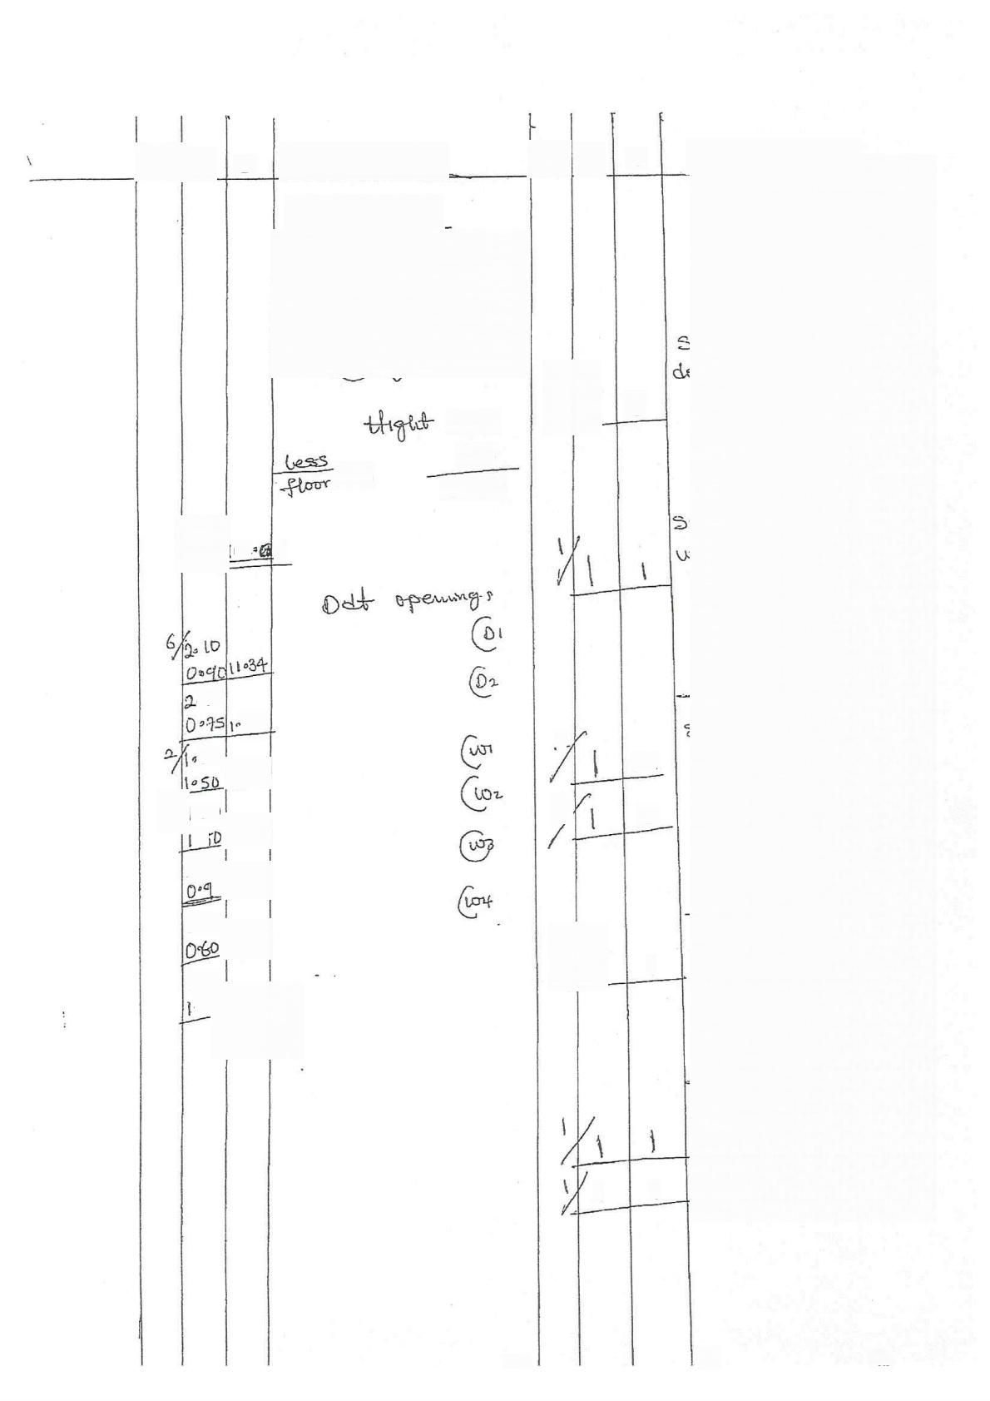
S

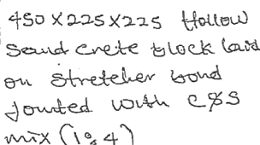

3150
lSo
Slab
3,ouu

62: q

,lo
S8
20

020
05
320
10
0·60

1020
。2

5

6

9
2

3
3

1

本

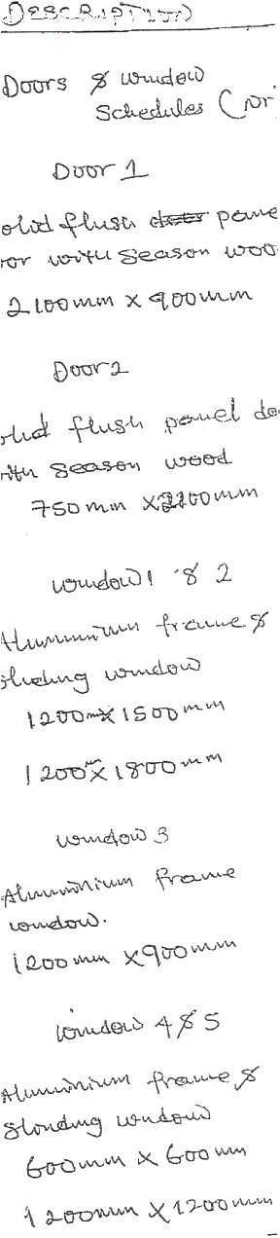

Kn lm) 91

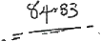
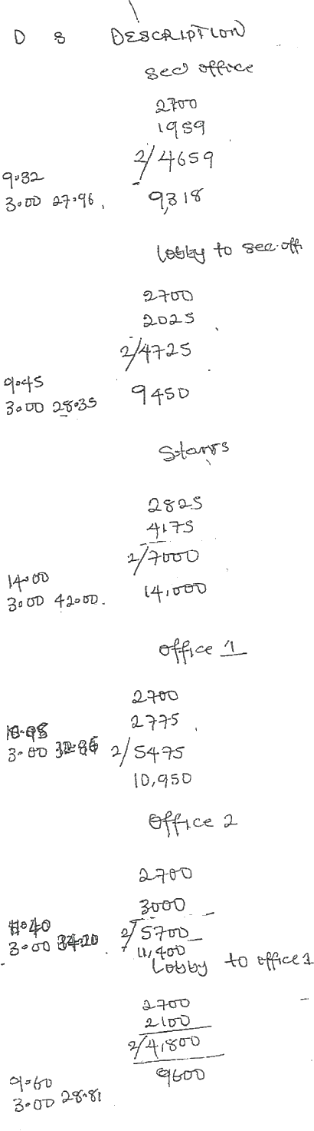
22

}
 | F=|5
 | 分O | 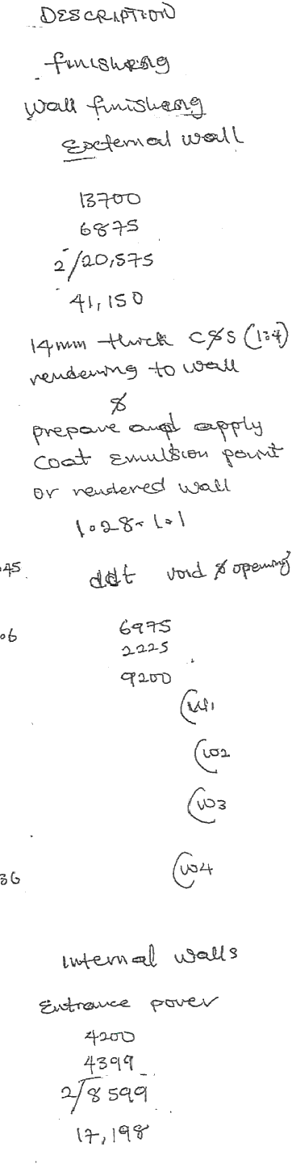  2:
(aA
AG
 | Q。  :60 | 0。
 | 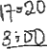

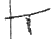

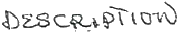
小 )

S
8c W,(
2700
los o
3 S0

+500
7050 子000
2.50
26801

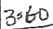  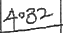    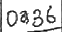  34  2₀10  0o 5%  620  0  2D  1o8D  {02D  Drg {D  0060  0060  1020  1020 | 02  uD3  4  Ws
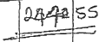
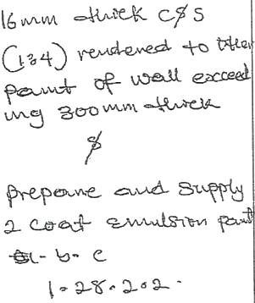

② 3

·心△OD
2~*b 8al0

2·40
rSl
2~98
20H0
o95 S=29

420  4040  |2。55 1005 | +08  18)48  2。Ge  48012

3=D
lt
207o
Q 98 +-5
2-70
10
&o
σ

8<
E
2-55
a DS
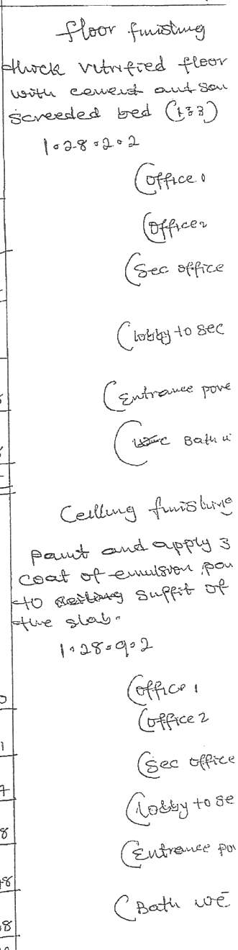



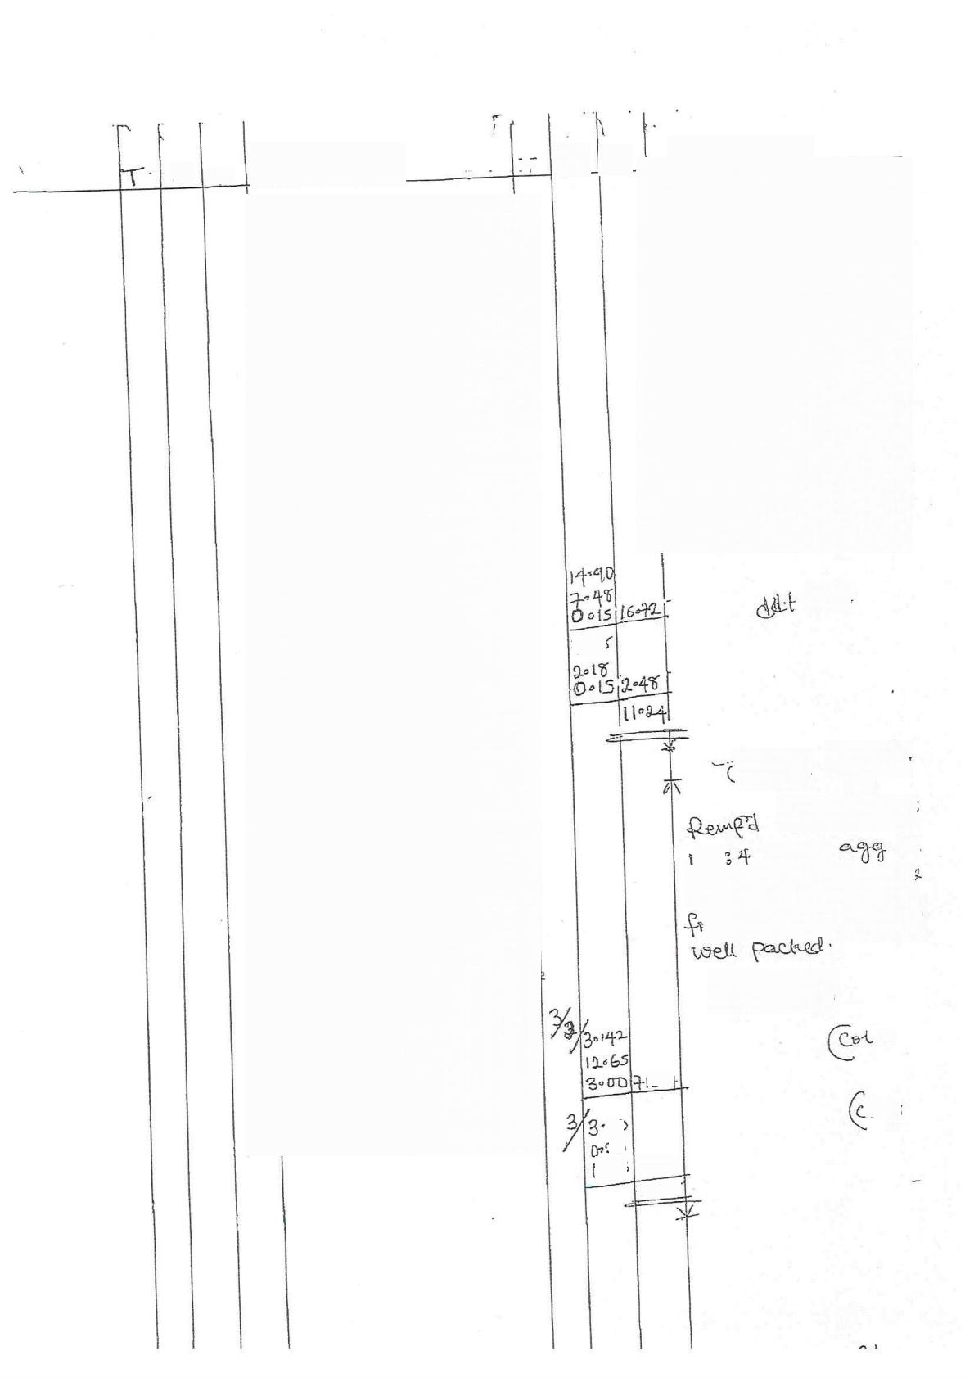
D S

工

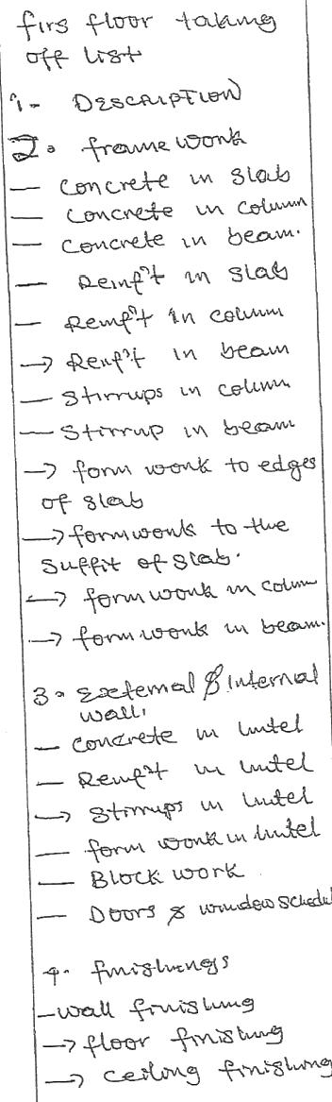

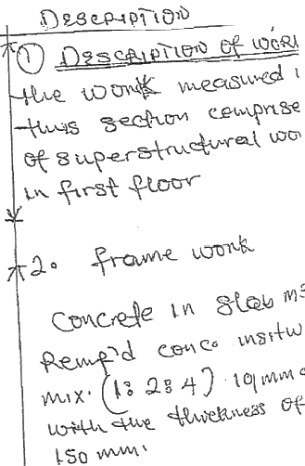

VQtd

2051

oncrete  mstu  82? qwm | w o{w MM3  eemcR  M

Caeuu 22S Mm fie
uedwdo fermwtuk ?

ls010
2

1S-4
oL 3
oD
n3
702 D*48
3H₅86

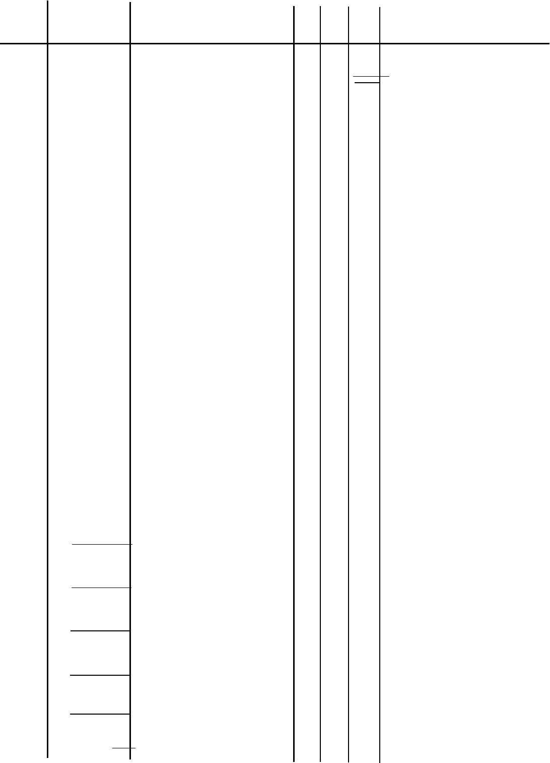
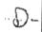
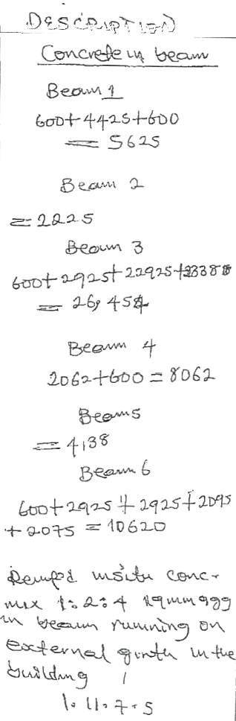
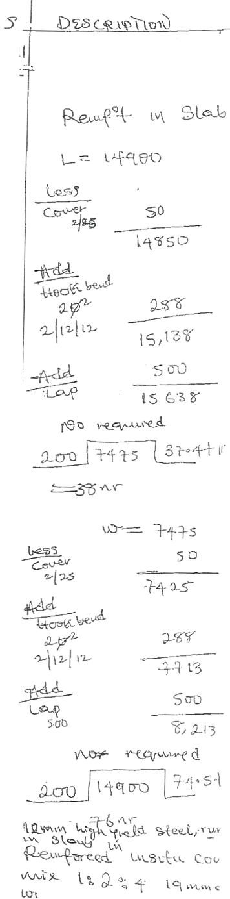

\
Saq

S--63
3|0-s8
2-23
045
0²23 023

0023
0-4s
Q83

106
。1D

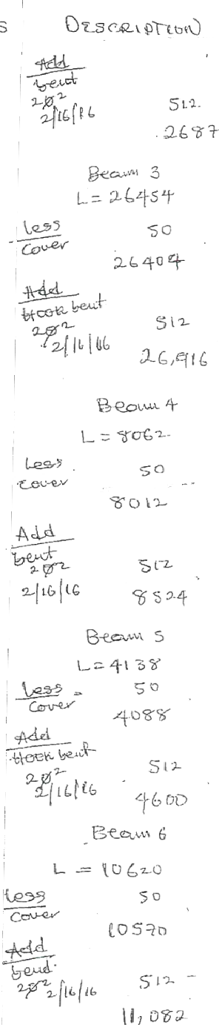

 |  |  |  |  | D
3  3 | S
3  3 | 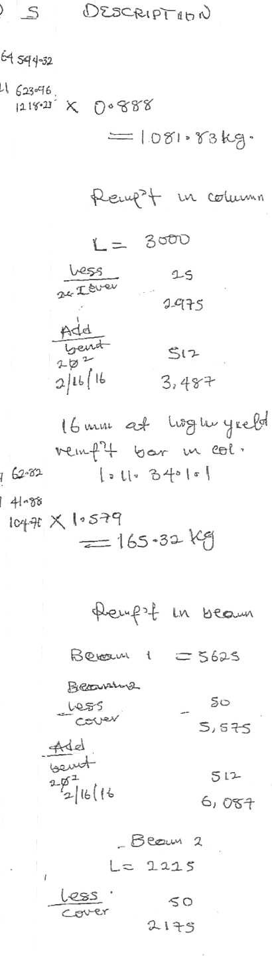  3+4
3  3 | 304

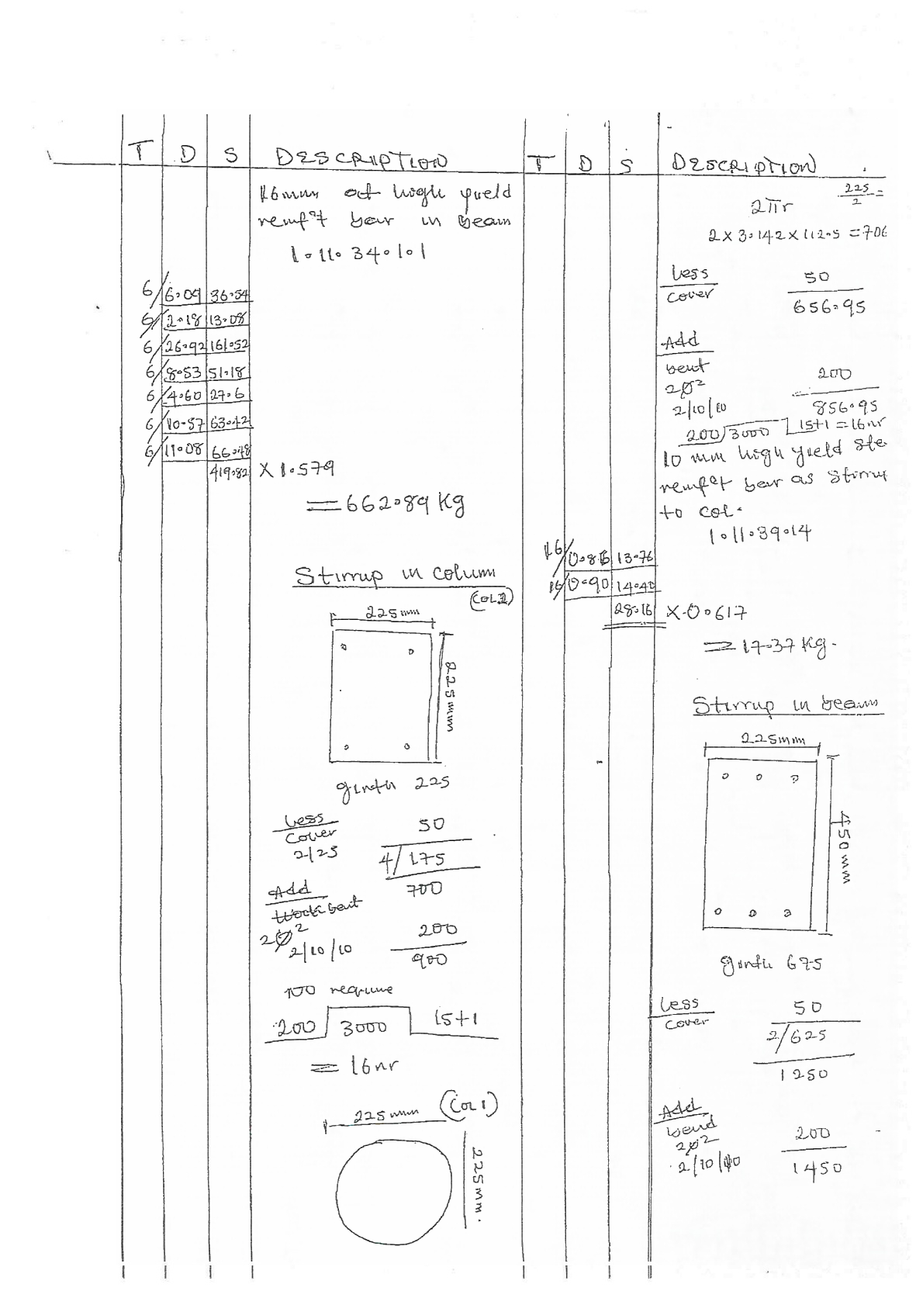

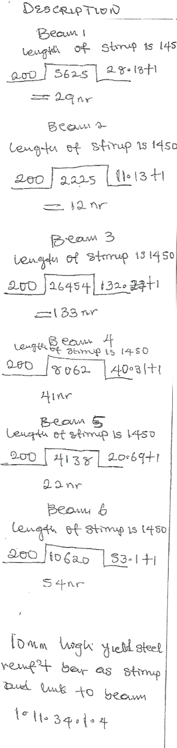

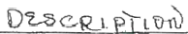
3bodmm

D S


39
42005
pe4g

190-85
5
5
n 45
s
31290
26-30
21
345
X0061+
3
二 二

VW\ LUG
to
C 22

2πr4 2×3-142×12S
— 706295
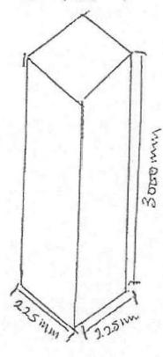


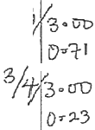
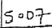

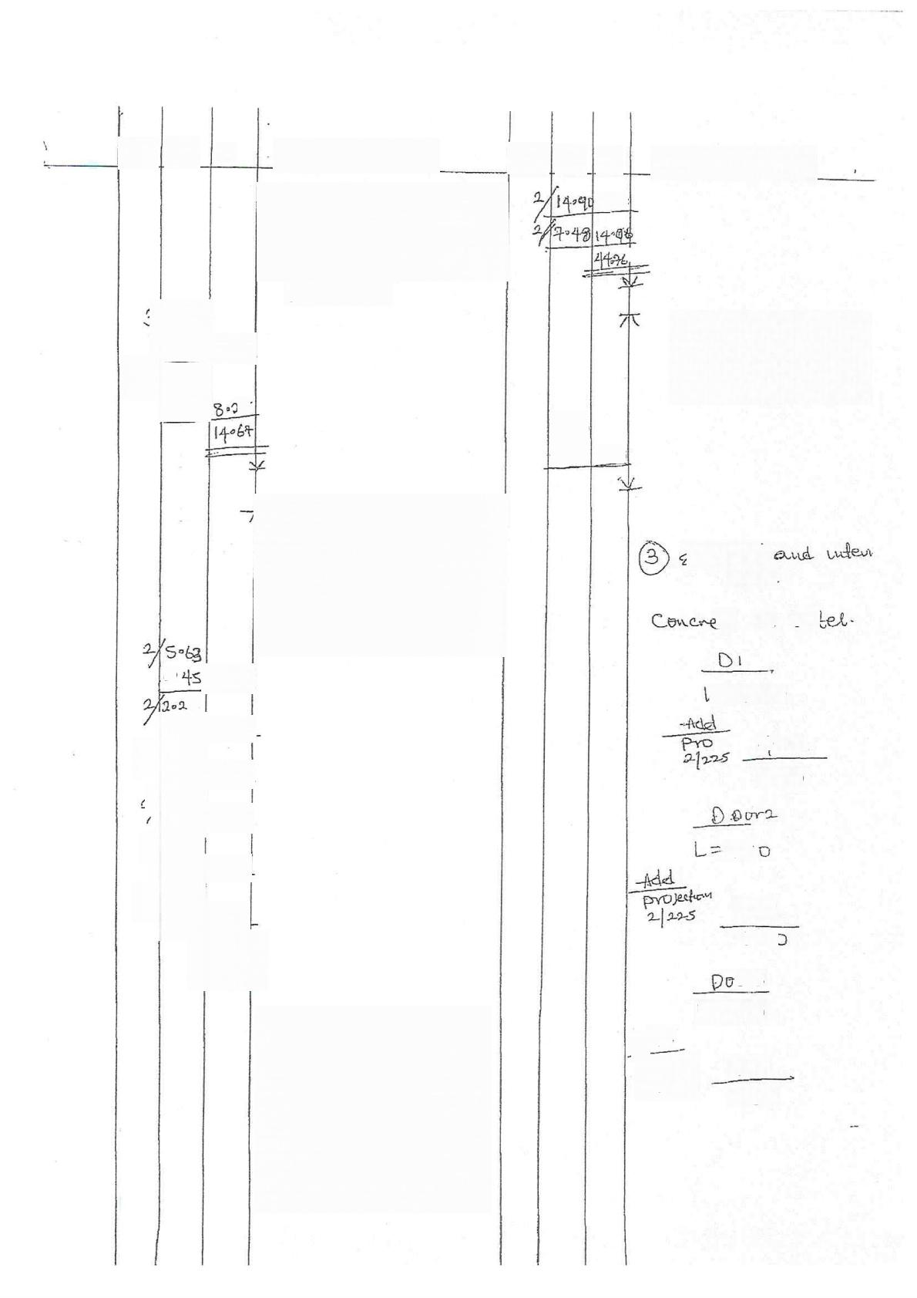
S

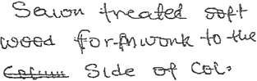
10110200

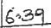

2%

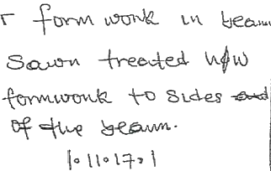
00
2
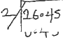
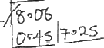
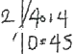
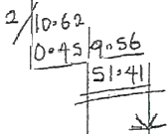

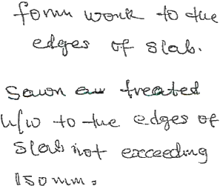


09-%


14090
7048
1119

etemel
Jx
e u ut

=120D

斗 So
16sD

子5

15D
12cC

or3
L=vo
Ad
2s tSo
1350

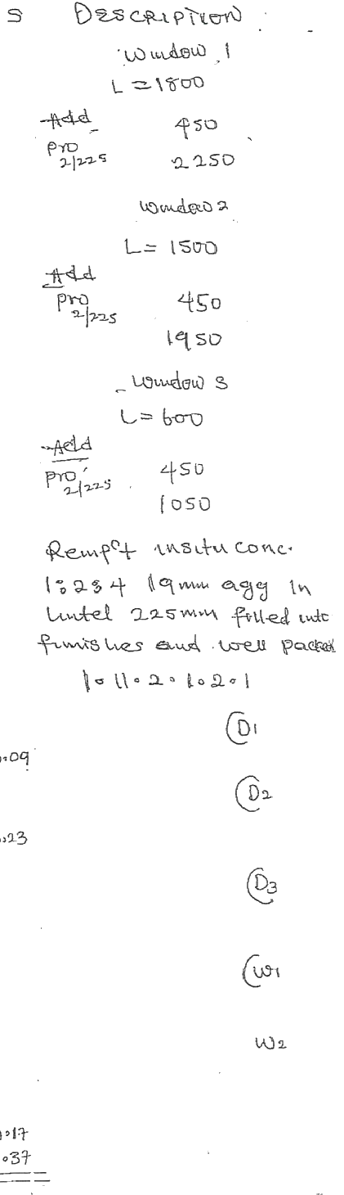
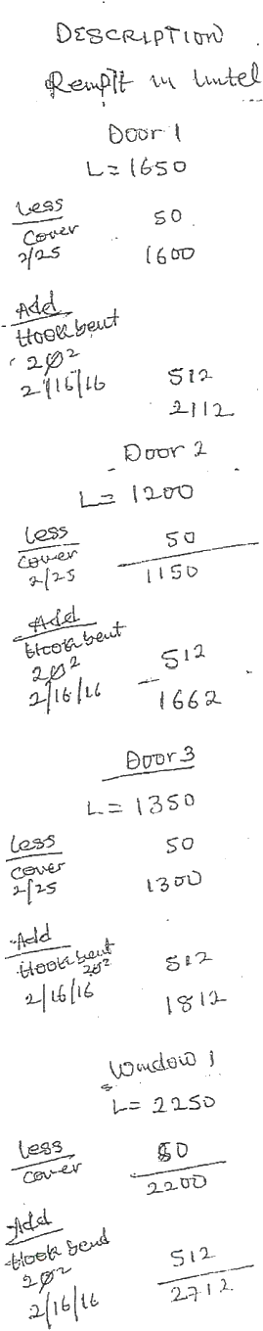


S
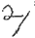

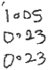




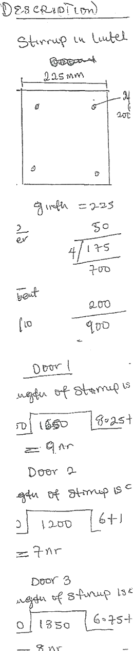
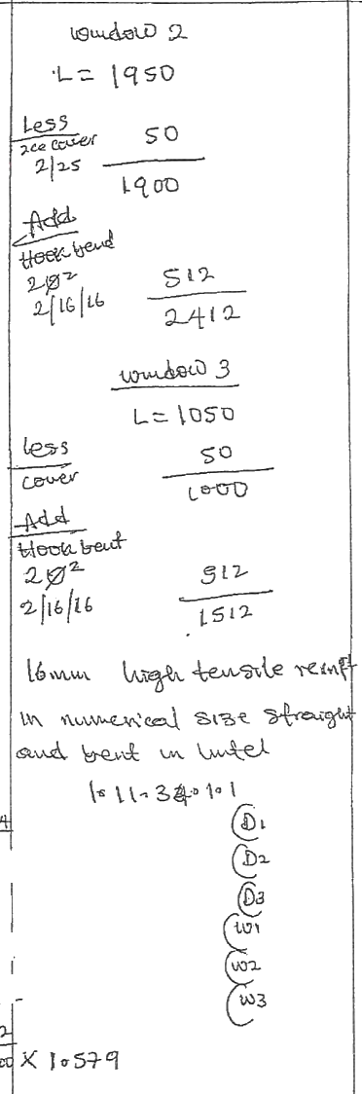
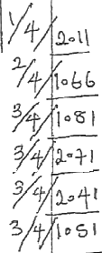

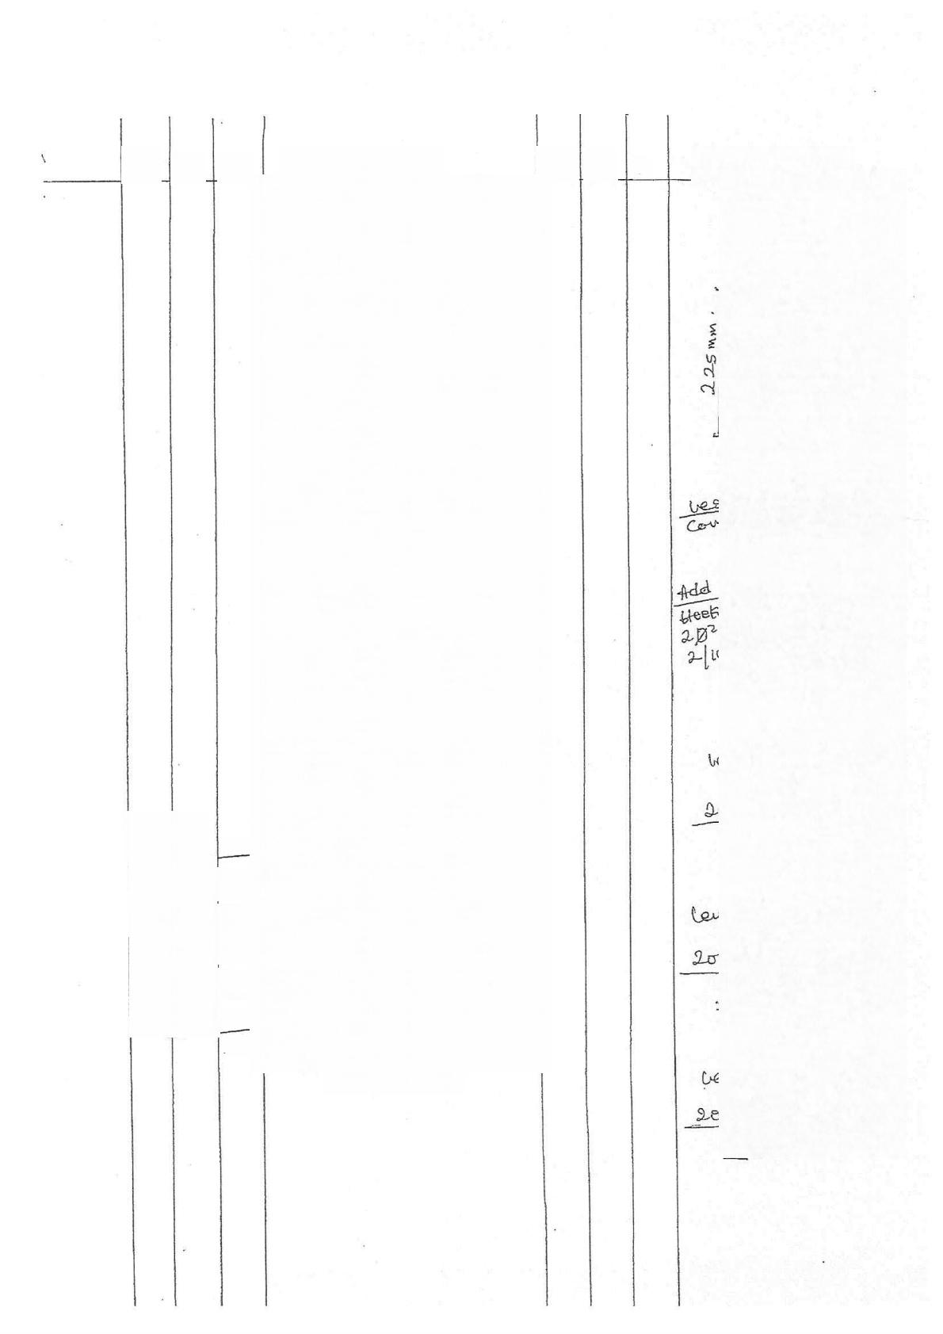
S

1난
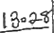
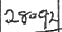
1%
123
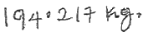

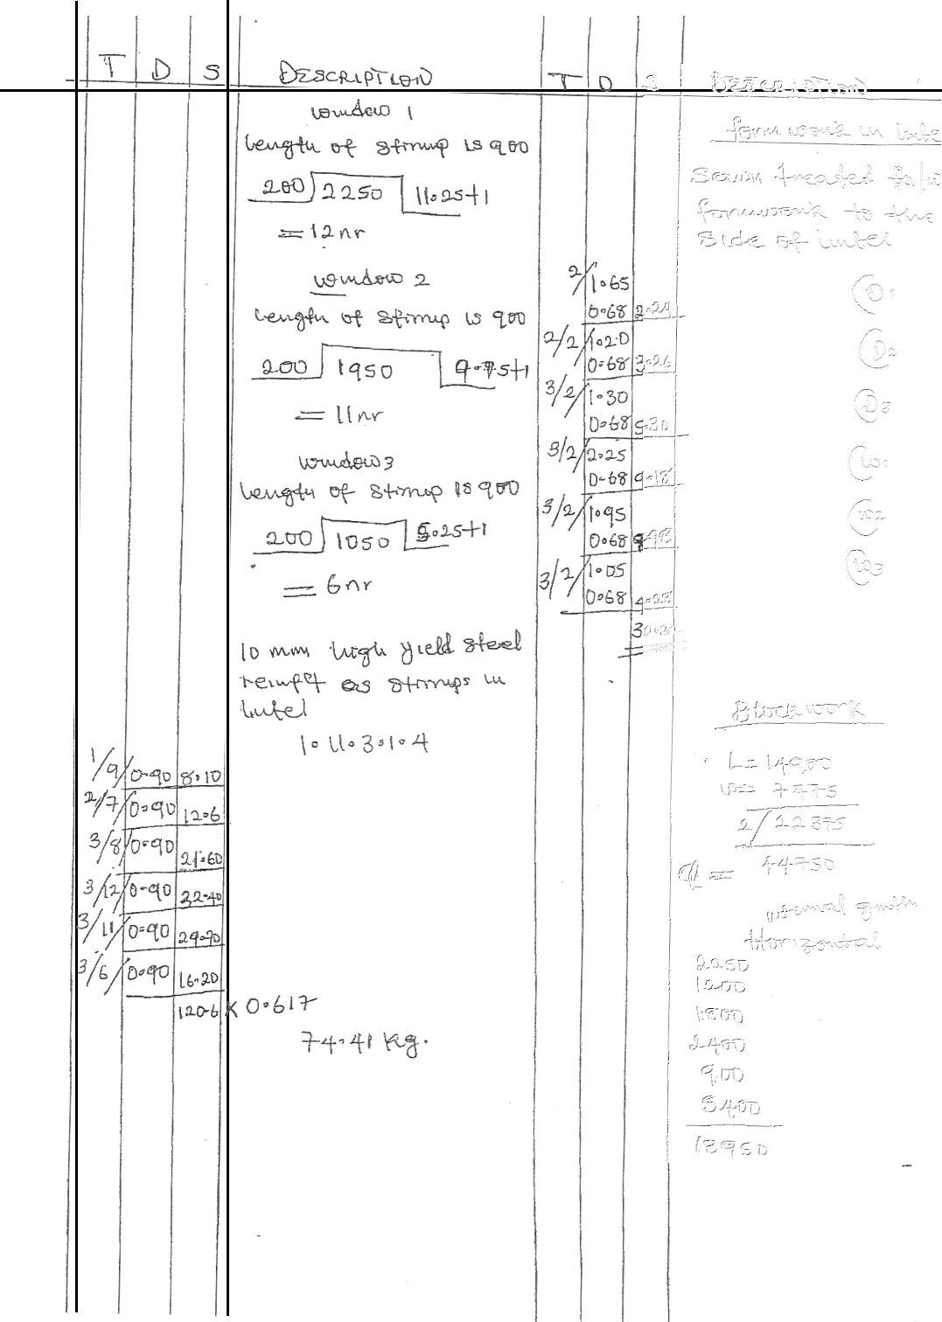

4

80
5
SO
21

126
Fwokn
NM
3c5D
9126
23076
4+50
乞X
-826
135,6S

1350
D2

2
“
225×225×480
Ba toek fitted
Wov geld Qr
dew
3.
nteY awd Ln
lu Pow
2

Dd4
2-10
3
D1
●20 2-S2
10
3
3
D₂
D3
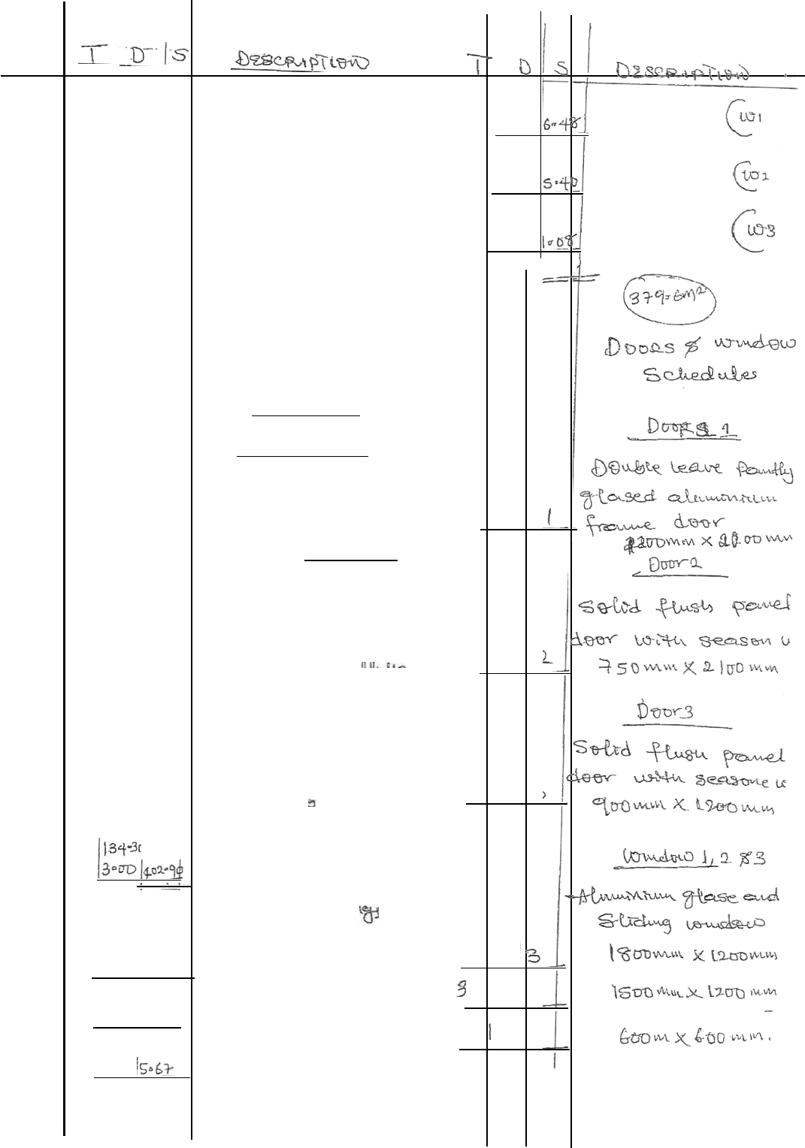
3015
3,
3 D
|00qD|

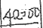
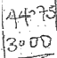
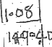
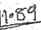
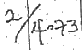

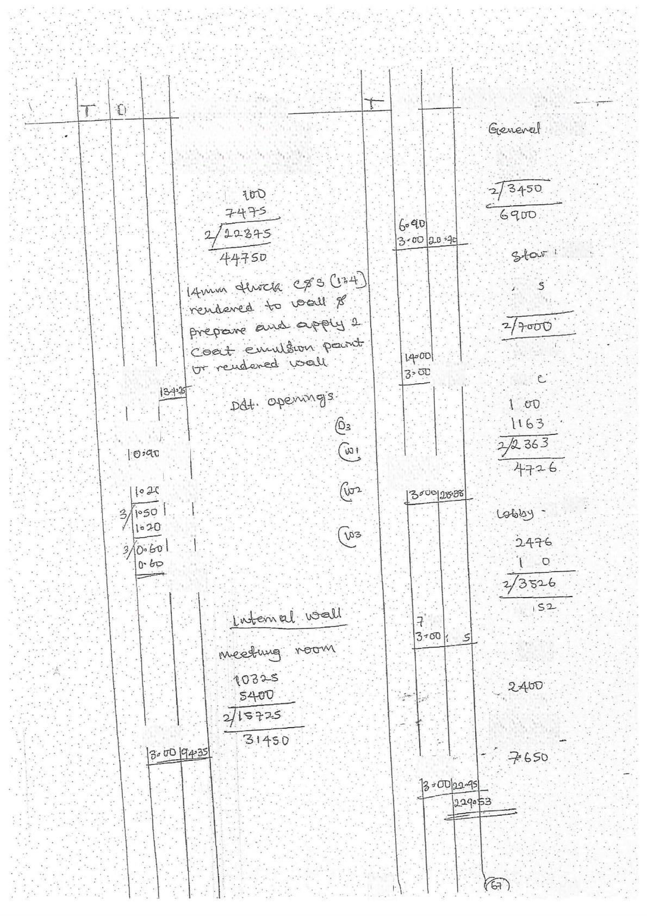
S.
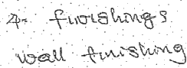
14a

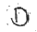 S
s-fure
2250
|2r0

r.3. wau
4t:
282.5

l410CD
u g
.2
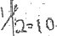

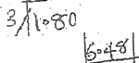
LeC
40
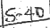

tDS

+0
005
Q1
urt

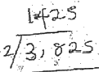

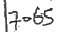

GG 2J

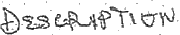




3
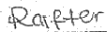
=373

x
3=0

29089
S9.84 8904

e2
luommxsonM tav
ueood CPe CL
1016010103=

[e ls eganw

W= +4+5
215
+250.

100 mw So

1016=101010

3-50

48

1i

32+3
e =?1b⁷
C 3²+3:73⁷
+13o
二 . 2 2 · 4 9
x 22~qs
40+95
SDMAM
Loe mm ree.led
Lewdureud raei
1s[b=l 。l 。]

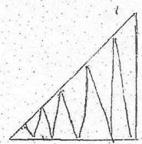
4t0
4uO
Qie-O
1$qD
lSco
{200
qo
600.
3cD
3Sc0
0O wm
etlQ n
ndweed
Struct
1016~1ol08o|


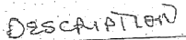

名

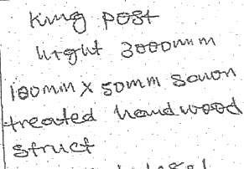
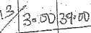 016>11o

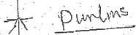

0

3,

XS0 '
wt

pw 10Q 」
016010

3r0 wul
20

2≤

i
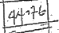
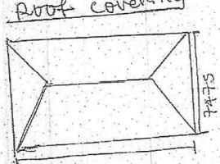
1C¹4DD

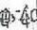  4120  p(S | )ES CRapT  +475  L=19400  12ou  120D  26,600  867S  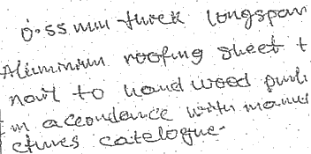

M

^GC
We
03 =111
=!8ny
600
5400=9+1=i0ny
W:

tewero|SHere
e
=3.7bs+L1=5
=243
o
5=1300
TC
=口5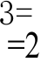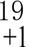3nr
awouy +o
LO(
24tb
+1=Sn
4二
T
=6nY
=9

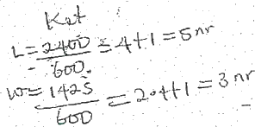



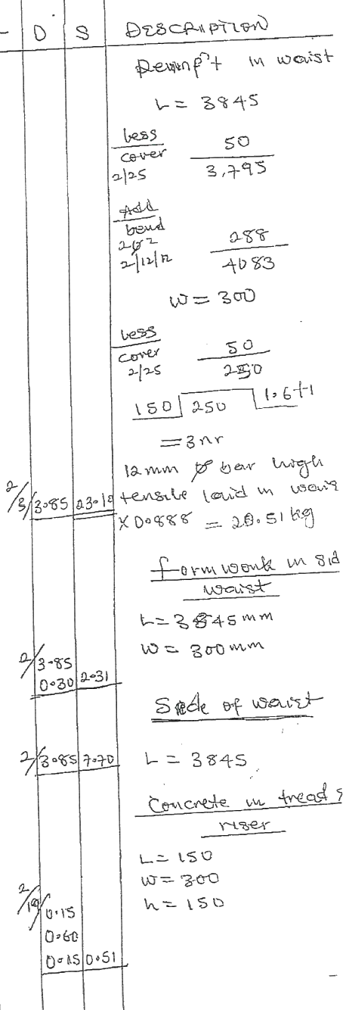
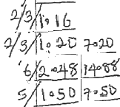
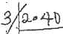
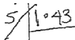
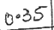
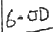
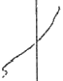

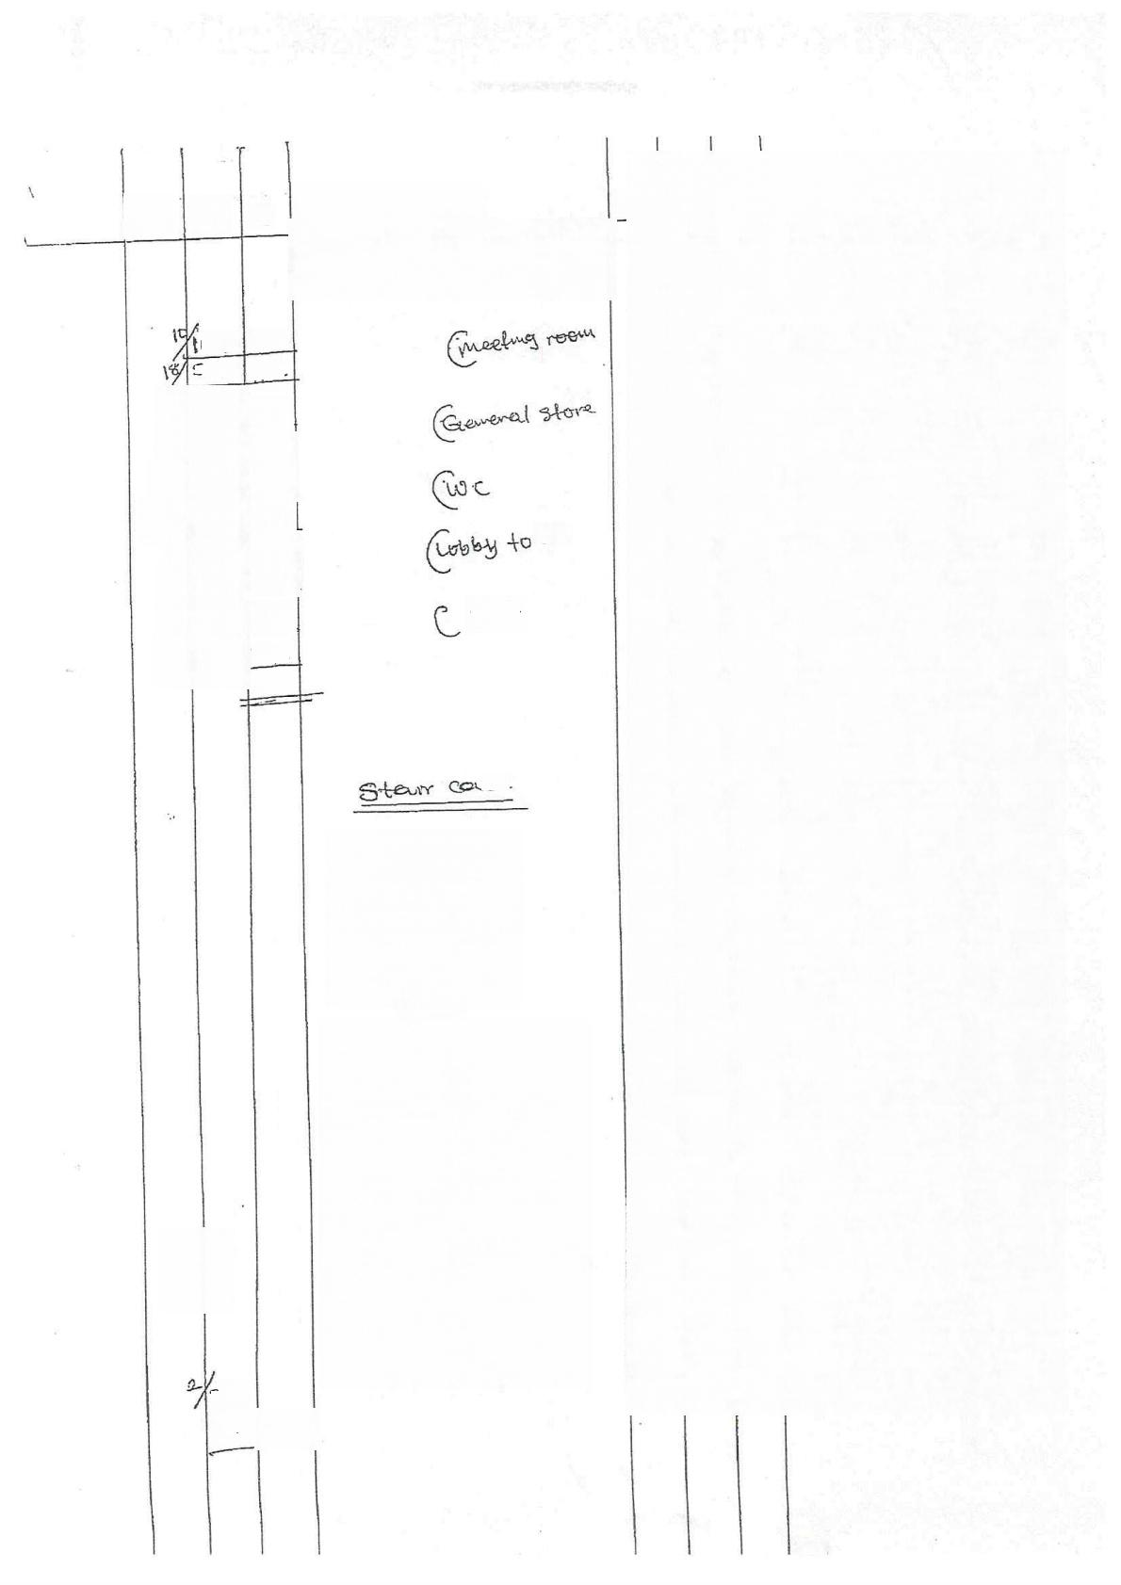
T
S
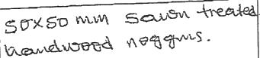

0>33 103-30
S 4D 9232
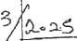
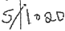
gC

vit
p5
26414

Se

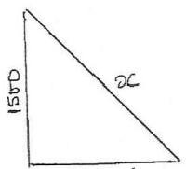
3536
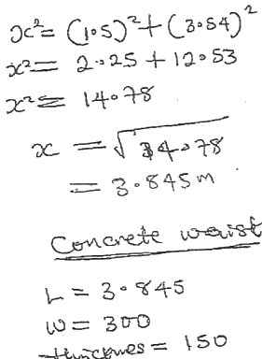
3”y85
0030
00 15

N

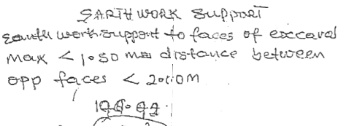
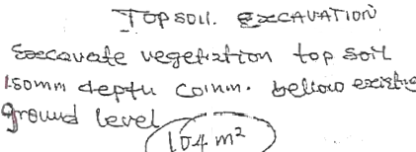
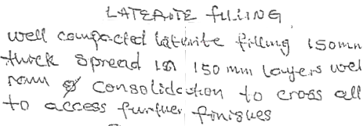
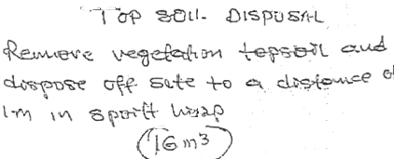
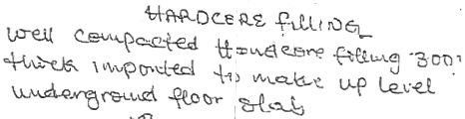
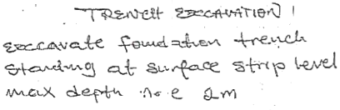

-
+B3t&NCt 合艹≥

Pf-s R sAmug!DLrDsL
؟-5
A B31Ru un u K

uPR |  |  | T Ta  W ^+ wu  - [soc wtw  A  A 3r0 nmw  ) | Bak fii  +0  M | e al crephZ  t
8١ ٤ | 1-  Smg | wuv | T Ta  W ^+ wu  - [soc wtw  A  A 3r0 nmw  ) | Bak fii  +0  M
 |  |  |  | 1SNeLoe  T | CSMLPAC-UC
M 1S otw |  |  | T Ta  W ^+ wu  - [soc wtw  A  A 3r0 nmw  ) | 1SNeLoe  T | ﻡ_ Leltou
2 Q  中 SC  O |  |  | 开 - ٤  C uﻡ ٤ﻡ ﺻﺐr rae  m¹ | 1SNeLoe  T
 |  |  | 开 - ٤  C uﻡ ٤ﻡ ﺻﺐr rae  m¹ | 2  Eneppive A  ١٥٠ ٦١٧ <؟  Th | RCAMSN  ﺀ٦ ﺑﺬ de式  sule | Quh+go  excay
 |  |  |  | 0QM
 |  |  |  | 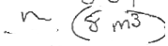
40m
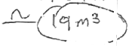
4

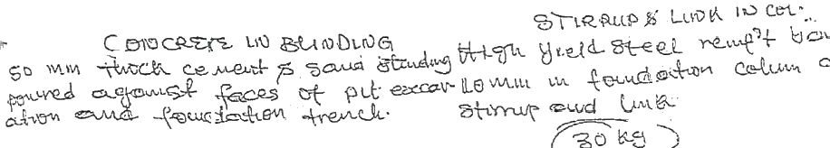

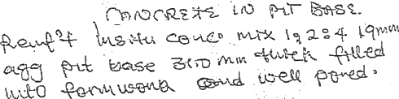
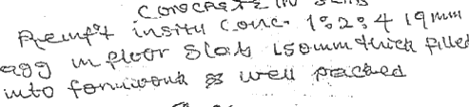


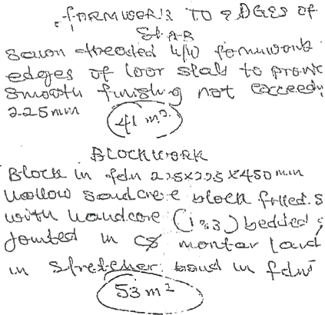
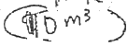
JEUES

z~73니그9  CeH , |  |  | 7?약오  1 31삶18 |  |  | 소D19A요
군*감요 상n연-1요 당nS강. 식강9C
 |  | ' |  | B- | st  HLser
M | 요Arn |  |  | B-
M | 1 8 앙.1 |  |  | B-
 |  | 건8Qnv지남 |  | (e BAS2
 |  | 403 |  | w8요A&
r
W | 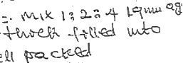 |  |  | nM Q이1
br - | 1 경8성 e363

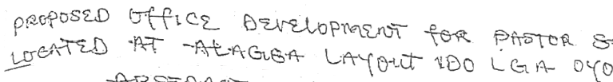
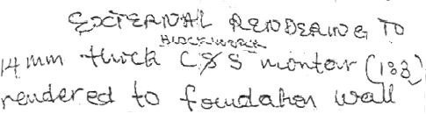


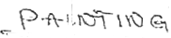

020P0SEF

=నా

N

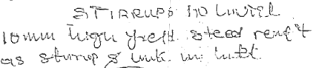
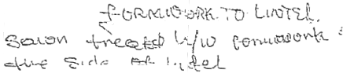
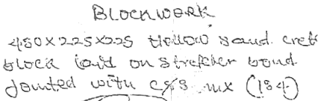
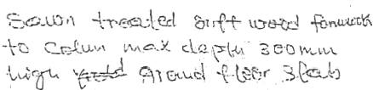
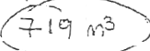
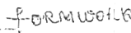

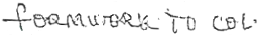
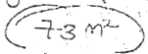


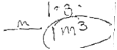

(

b811

BP MEN

RSRUCI

?
15 L008.H

 |  |  | 10 |  |  |  | LrJ 分
5? .1ﺍ 1 :  eU  iR  ) |  |  | 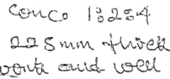 |  | ﻣﺢ  6十 |  | 2 Na  g
 |  |  |  |  | 132J0+= ﺯ |  | 11)
ﺋﻤﺎە ﭨﺪ  44  Q元    g |  |  | LND B |  | o  ١ ﺩ ٦٧ 1١ | Ws  nlu  ﭼﭻ _ | l-e! | 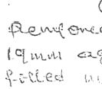
 |  |  | ﺝJ!5 ٠؛٦؟ = ٨ ، ٧ ﭺ١
 |  |  | WN | ﭺ٠ ﺍ
 |  |  | WN | ﭺ٠ ﺍ | 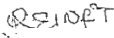 |  | 
M |   3 |  | 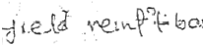 |  | 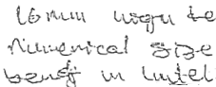 |  | S³p W
 |  |  | 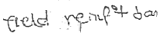
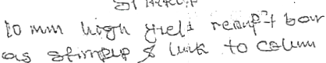
ﺏە ; ٥
 |  |  |  |  | 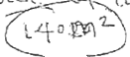
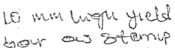 |  |  | 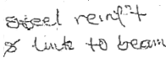 |  | ﺣﺎﺣﺎ ّ

DR0PQSS  A | CEIF²XaPKSMT |  | 0R.PASTOR ENMuS  A
元 C
PGG  (L | LN F  Bux*uodu  100X0im w |  | L 州  W |  |  | HCS
PGG  (L |  |  | 6-C  US | nl Suw |  | HCS
tA  AC Ya8M  -S0 NmX  八 | doev  M.W | W5C | 6-C  US |  |  | HCS
tA  AC Ya8M  -S0 NmX  八 | doev  M.W | W5C | 16 wust WA ^-s  300 wm  c) |  | 气R心  ~ﻝ Hute | 代 44xA1L  ACwe  emut;  M
( (n  tuAuLdtw  ond o-u  12-60MLn | 35)Pif  15o wW |  |  |  | 气R心  ~ﻝ Hute | 代 44xA1L  ACwe  emut;  M
( (n  tuAuLdtw  ond o-u  12-60MLn |  |  | e  eAMh | yRkm  GeipedoL |  | Ptc-G t 4  bed
U0空A  AAAAL I  -L280  3 Y | BLOS  F  150℃ |  | e  eAMh |  |  | Ptc-G t 4  bed
U0空A  AAAAL I  -L280  3 Y |  |  | MuuaS |  |  | iStIN
US d  W | lct0 s  lo-u.dlgu  700 Wiw |  |  |  |  | 3C004  =Tt  n-
ubwd  W | euo  1Oudu  0
usuA  u  18.00 wm | e)S  lovdlou  &taeoggm

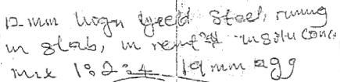


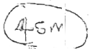

FNRLOPM?
810R Sramu24 ClAD
11

FCRSTQuRURZ RK
GN  APa | Msutu  1SDMM  3 | Mik  W | VNW  AN | (7  法
GN  APa | Msutu  1SDMM  3 | Mik  W | 2.8 | 0 110 Cn
C | 气 MN |  | o ww | P ee/
-16 | A4(A  V 3 |  | o ww | P ee/
-16 |  |  |  | 儿R H
-16 |  |  | B WwM | a heowu
 | 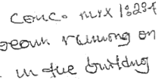 |  | 1  N | (  tA.ueeOci
 |  |  | CM4:  S N  (N | AM
?to |  |  | CM4:  S N  (N | AM
?to |  |  | CM4:  S N  (N | W evm s
 |  |  | 52919  LSg mm | acTde F)CS
 |  |  | 52919  LSg mm | AHewdd.aseod  Me-k ax:Ce
u  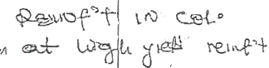  心  N |  |  | 52919  LSg mm | AHewdd.aseod  Me-k ax:Ce
 |  |  | (FH=  9W  ut ue  12 | $ 80
 |  |  | (FH=  9W  ut ue  12 | .  lio -1g tlte Su  .
f

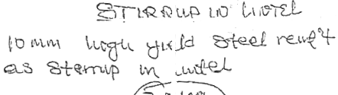
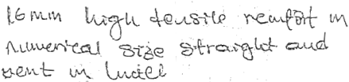
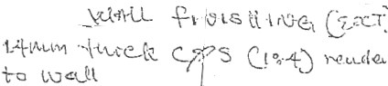
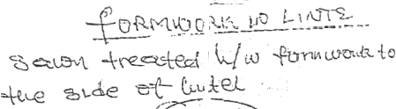

SePF U< ILEiUl 比1 |  |  | ٠٤،٠؛١ ١
-RHCLUELSGQH (bA8
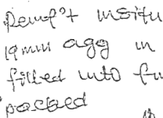 | 28MC  MW  ()e/  M3 | 1%  N  L3.0MW  AY |  |  | LC GCn:  5  ASe(  G0 MLw
 | 28MC  MW  ()e/  M3 | DcnR  feer uu  islQu Mw  +50w1t
 | j0
 |  | 300  ≥ 元 S  1000 |  | 3  deor uitt  作 R L 8 0 w
 |  | id.0  =0-  ! :٦٩u 4٥١  t$oom  1Soomm  m |  | t0 ,0.g 3  cuud slidy  Be    *X1360 wm  X Lap mm  Y  hX600m
  N | 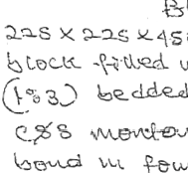  4
 |  | lem²  EMLal3 '٦ l |  | 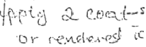


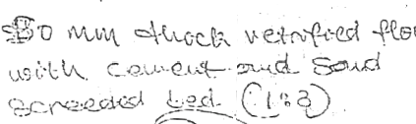
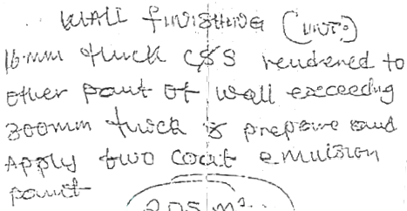

tof aMut PA
=enm
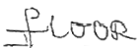    m² | 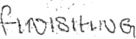
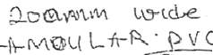  - A | 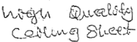  A
常

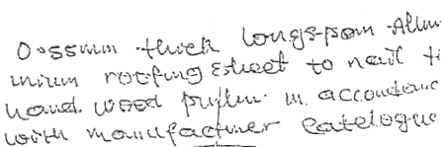
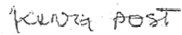
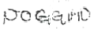
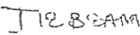

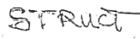
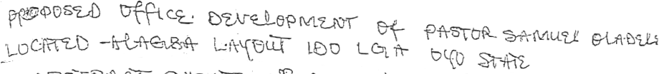

100 Ww X S W  Ptate |  | 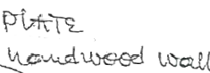  A |  |  | G  C)yw |  |  | T1  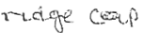
 |  |  |  |  | 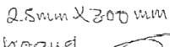 |  |  | .riL Aiiar
 |  |  |  |  |  |  |  | 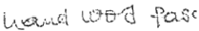
S0 Mw |  | A   | coued
 |  |  |  |  |   3 |  |  |   m△
U0ww X56MM  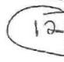 |  | M    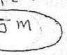
 |  |  |  |  | Seum | Xs  lDE! | pww  U  ( | kM³  Y4 | 
XSouw | e  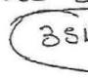 |   W
Q0 XSoww  AtoG  名 |  | S  M | L9y
rs mmXS0mm nalegk |  |   LrO-s    M

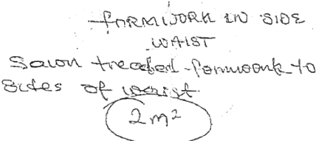
fCice  千 |  |  | HeNWopMs |  | CC  LBD( | pA2ttRS 0988(4(s08
BeRACT 己大 |  |  | +11X(=rS?
3 n 飞 | C  i F Mw  003S | 0A1S  3  C\ W  切 |  | M以 | 12 wuw  M |  |  | U | 4 QAS⁷00
 |  |  |  |  | 又 M G G R |  |  | LD(A0Dt)e
H |  | 1A :0187
LMit |  | h :engt |  |  |  |  |  | toatd.ue9d
 |  |  |  |  | l2.ww  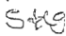 |  |  | L
 |  |  |  |  |  |  |  | eusi(
oo C 一(心  LN  十 (    5 |  | 2 艺 0 7QS:Af  SS  MeX  m⁸
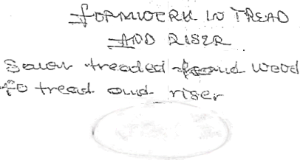  005 |  | M 2

CHAPTER FIVE

5.1 SUMMARY
This research was carried out to estimate and budget for a medium scal building for a proposed storey building office development for pastor Samuel Oladele located at alagba layout Ido L.GA oyo state.
It is also designed to show the process of taking off,abstracting and method of meparing bill of quantities.

5.2 CONCLUSION
In conclusion,we observed that estimating for medium scale building project is very iniportant.!
i. It gives an itemized list of the component parts of the building with a
full description and quantity of each part.
ii. It serve as a guidelines for the contractor.
iii. It provides a basis for a valuation of variable which often occur during the progress of the work.
iv. It enables all contractor tendering for a contract to price on exactly the same information with a minimum of effort.

5.3 RECOMMENDATIONS
From the analysis of the data in chapter four of this project,the following Commendations was be made.
The Quantity Surveyor should provide an estimate during the preliminary stage of the project in order to forecast its likely cost.
ii.It is important not to under estimate and over estimate,proper estimating procedures should be used and the layout of the estimate should be clear and logical.

REFERENCES
Building and Engineering Standard and Method of Measurements (BESMM4)

Ivor H.Seeley,(1997):Building Quantities 3“Edition Macmillan Press Ltd.

Onovah T.C(1997):Building Measurement.

